



Referral guideline for 14 birds listed as migratory species under the EPBC Act.

***eadig00605.tif***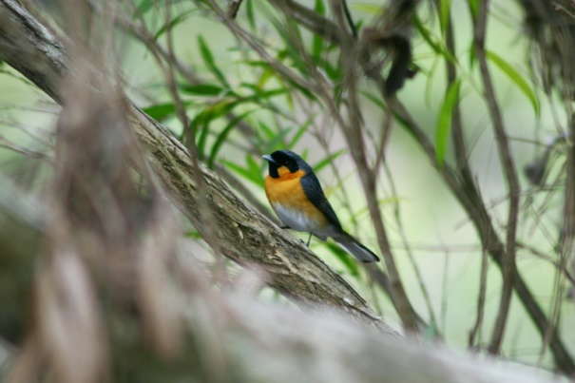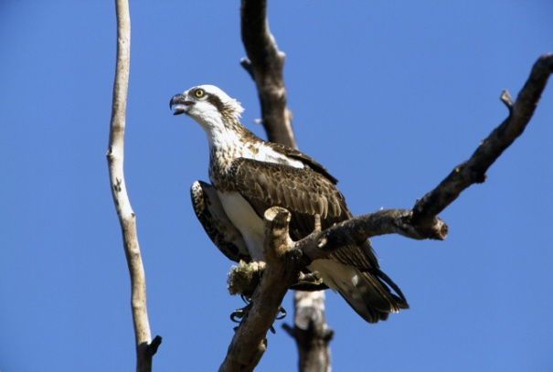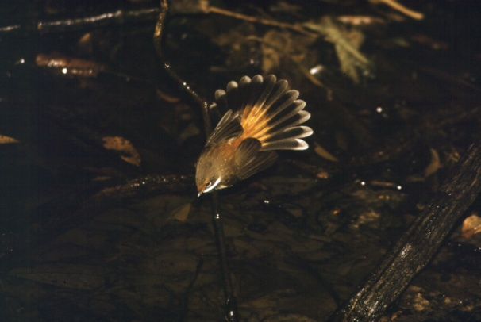

September 2015

Policy summary

All fourteen species considered in this guideline are listed under the *Environment Protection and Biodiversity Conservation Act 1999* (EPBC Act) as migratory species. Given some of these birds have widespread distributions and occupy relatively broad habitats, these species or their habitats are often detected during surveys as part of environmental impact assessments. On the other hand some are rarely sighted and create uncertainty with regard to assessment of impacts under the EPBC Act. This guideline provides information to assist proponents to assess the likelihood of a significant impact on one or more of these species. The following points and the diagram in Figure 1 summarise this guideline:

* The Australian Government’s conservation objective for these 14 migratory birds is to retain the habitats and resources necessary for them to successfully migrate and, where appropriate, breed throughout their natural range in Australia.
* The focus of assessment of likely significant impacts on these species are actions likely to have a substantial effect on important habitat; actions which will seriously disrupt the lifecycle of an ecologically significant proportion of any species population; or an action that will result in invasive species that are harmful to the migratory species becoming established in an area of important habitat.
* In most cases, significant impacts on these 14 birds are unlikely to occur and consideration for them in a referral is not required. However these guidelines should be read in their entirety to ensure that this is the case for your action as there are circumstances when a referral is recommended. These include:
  + When an action is likely to lead to substantial loss or modification of important habitat (Table 2) meeting or exceeding the upper thresholds (1%) of habitat identified in Table 4.
  + When an action is likely to lead to serious disruption to an ecologically significant proportion of a population (having predicted annual mortality rates or affecting breeding cycles of a number of individuals) meeting or exceeding the upper of the thresholds (1%) in Table 5.
* Strategic planning which would involve targeted surveys and comprehensive mitigation will be desirable where cumulative impacts are likely to approach habitat or mortality thresholds outlined in Tables 4 and 5.
* For the five non-breeding extremely uncommon migrants (Barn and Red-rumped Swallows, Grey and Yellow Wagtails, Oriental Reed-Warbler), the numbers of individuals at any one site are so small relative to their global populations that no small group of individuals is likely to be significant for either the species in Australia or the ecological attributes of a site. For these taxa lodgment of records to the Commonwealth is the only recommendation to proponents.
* In most cases, avoiding impacts to important habitat of the five breedingspecies (Satin Flycatcher, Black-faced, Black-winged and Spectacled Monarchs, Rufous Fantail) and the White-throated Needletail and implementing mitigation measures will help reduce the risk of a significant impact and therefore the need to refer an action for EPBC Act approval relating to these species.
* Given population sizes and limited distributions, the Black-winged Monarch and Spectacled Monarchs (Southern, Wet Tropics and Cape York subspecies) are likely to be most susceptible to significant impacts (Tables 4 and 5).
* Urban areas are unlikely to contain important habitat or ecologically significant proportions of the population for any of the species.
* The effect of different types of development (e.g. tall buildings, power lines, wind turbines) on species during migration is particularly hard to predict given a paucity of migration behaviour information. However, actions likely to meet or exceed the lower thresholds (0.1%) in Table 5 should be investigated further through more targeted surveys and subject to comprehensive mitigation (see section 7).
* Mitigation measures for developments that may exceed threshold mortality rates in Table 5 need to be determined on a case by case basis. Building design and wind turbine and power line placement can all be modified to reduce bird mortality if necessary.
* The thresholds in Table 5 suggest more targeted surveys may only be required for the Black-winged Monarch, White-throated Needletail and Fork-tailed Swift when wind turbines, tall buildings, airport developments etc are proposed within their range and or near important habitats.
* Future surveys may reveal new important habitats for individual species and/or assist with understanding ecologically significant proportions of each species population. Any new knowledge is welcomed by the Department and should be sent to [speciespolicy@environment.gov.au](mailto:speciespolicy@environment.gov.au).

Acknowledgements

The following people contributed to drafting these guidelines. Although the final product may not be exactly the views they offered, we are most grateful for their contribution of knowledge and input:

Greg Clancy (Osprey), Rohan Clarke, Stephen Debus (Osprey, flycatchers), Guy Dutson, Stephen Garnett, Kerryn Herman, Richard Loyn, Jeff Richardson, Ian Smales, Michael Tarburton (Swifts), Justin Watson.

Disclaimer

While reasonable efforts have been made to ensure that the contents of this publication are factually correct, the Commonwealth does not accept responsibility for the accuracy or completeness of the contents, and shall not be liable for any loss or damage that may be occasioned directly or indirectly through the use of, or reliance on, the contents of this publication.

© Copyright Commonwealth of Australia, 2015



The *Draft referral guideline for 14 birds listed as migratory species under the EPBC Act* is licensed by the Commonwealth of Australia for use under a Creative Commons Attribution 4.0 Australia licence with the exception of the Coat of Arms of the Commonwealth of Australia, the logo of the agency responsible for publishing the report, content supplied by third parties, and any images depicting people. For licence conditions see: <https://creativecommons.org/licenses/by/4.0/>

This report should be attributed as the ‘*Draft referral guideline for 14 birds listed as migratory species under the EPBC Act,* Commonwealth of Australia 2015’.

The Commonwealth of Australia has made all reasonable efforts to identify content supplied by third parties using the following format ‘© Copyright’

Image credits

Photographs of a Barn Swallow, *Hirundo rustica* ©Joyce Gross, Spectacled Monarch, *Symposiachrus trivirgatus* ©Brian Furby, Rufous fantail, *Rhipidura rufifrons* ©Brian Furby and the Eastern Osprey, *Pandion cristatus*, © Brian Furby

Important notice

Please note that this guideline is general in nature. It does do not remove your obligation to consider whether you need to make a referral to the Minister for the Environment (the Minister) under the *Environment Protection and Biodiversity Conservation Act 1999* (EPBC Act). While this guideline provides information to help you decide whether to refer your action, the possible impacts of your proposal will depend on the particular circumstances of the action. These circumstances may include issues such as the proximity of the action to habitat, indirect impacts and impact-mitigation measures.

This guideline has been developed using the best information available at the time of writing. However, impacts of proposals will be assessed by the Australian Government Department of the Environment (the Department) on the basis of the best information available at that point in time, which may differ from the information on which this guideline is based. This guideline does not provide guidance on requirements under international, state or local government laws.

How to use this guideline

The decision tree in Figure 1 and the rest of this guideline is designed to assist you in determining whether your proposed action needs to be referred. This guideline should be read in conjunction with Significant Impact Guidelines 1.1 – Matters of National Environmental Significance, which can be found on the Department’s website at [www.environment.gov.au/epbc/publications/nes-guidelines.html](http://www.environment.gov.au/epbc/publications/nes-guidelines.html).

This guideline applies to the 14 migratory birds tabled on page 8. These listed migratory species are matters of national environmental significance under the EPBC Act. If you plan to undertake an action that will have or is likely to have a significant impact on one of these migratory species, you must refer the proposal to the Minister before commencing. The Minister will then decide within 20 business days whether assessment is required under the EPBC Act. The potential significance of each action is judged on a case-by-case basis. Substantial penalties apply for undertaking an action, to which the EPBC Act applies, without approval (civil penalties up to $8.5 million or criminal penalties including up to seven years imprisonment). More information on referral, assessment and compliance is available on the Department’s website at [www.environment.gov.au/epbc/](http://www.environment.gov.au/epbc/).

You may also refer your proposed action if you are uncertain about the need to refer or contact the Department by emailing [epbc.referrals@environment.gov.au](mailto:epbc.referrals@environment.gov.au).

**Figure 1: Decision making**

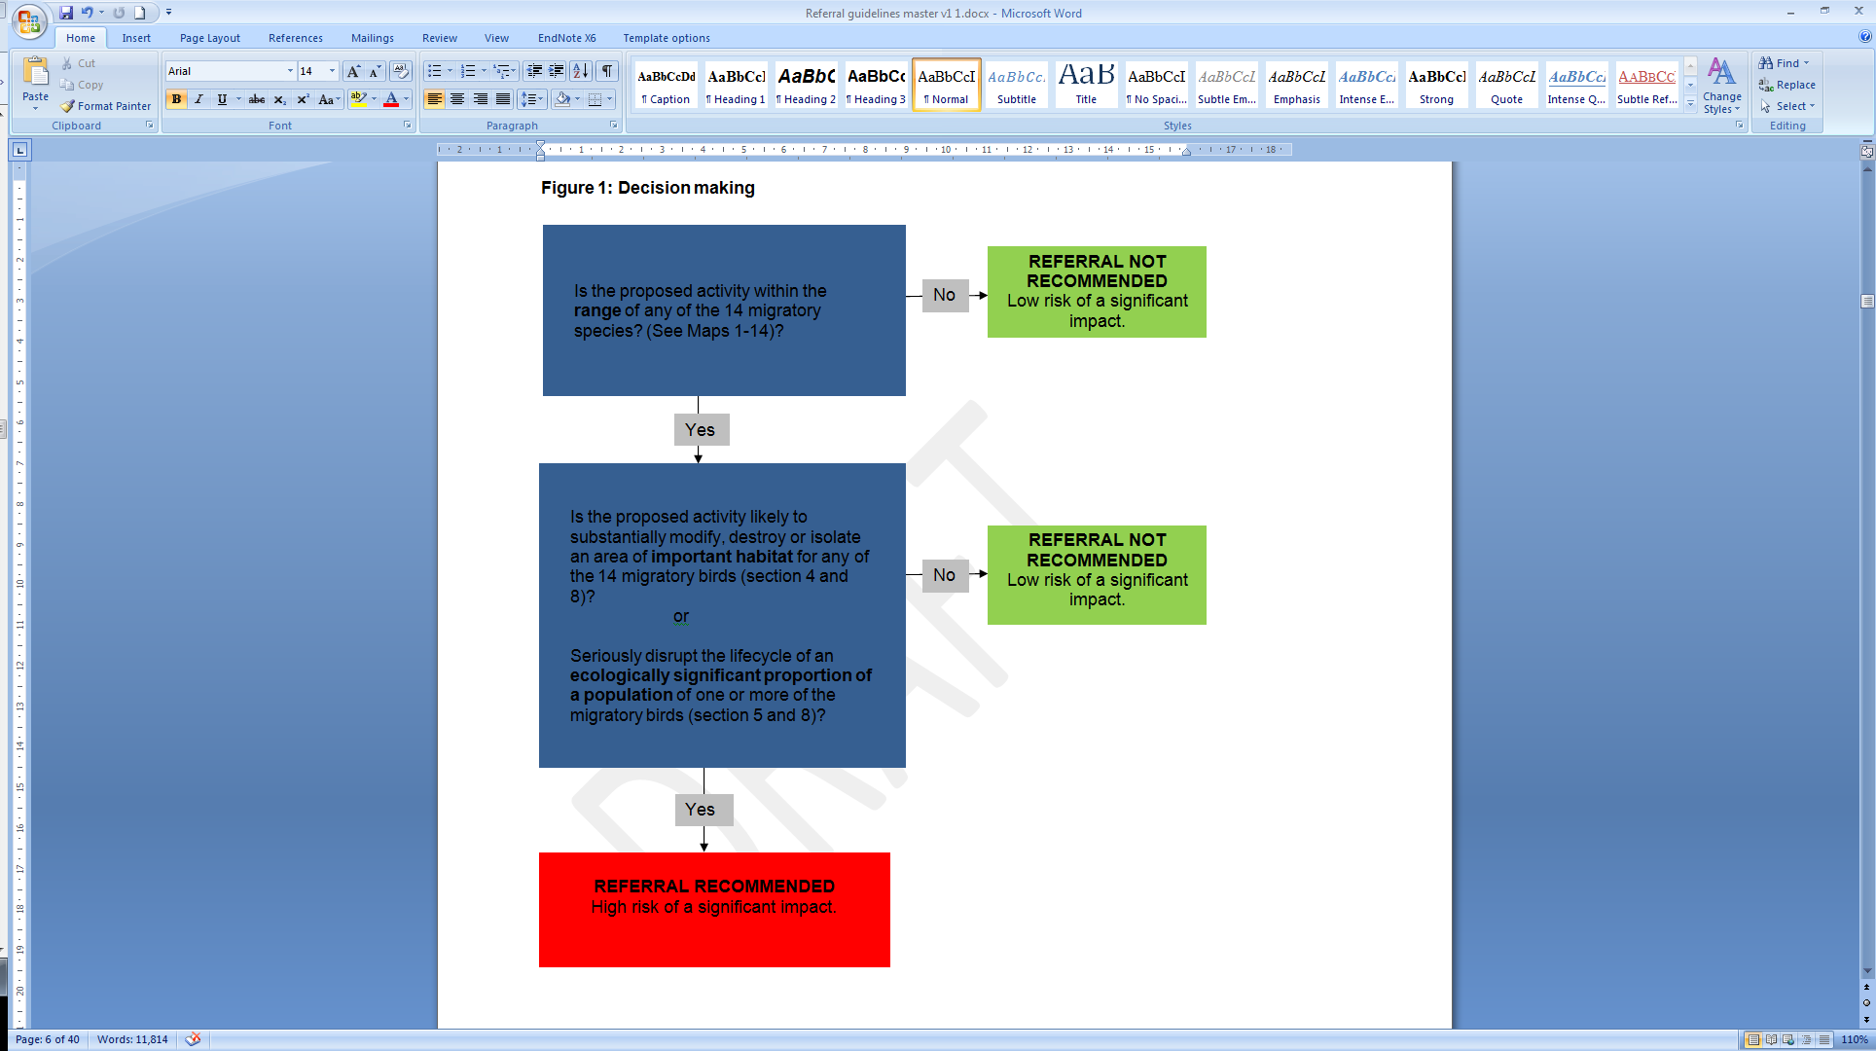

Yes

Possible exceptions to the need to refer

Yes

Certain actions are exempt from the requirement of assessment and approval under the EPBC Act. These include lawful continuation of land use that started before 16 July 2000, or actions that were legally authorised before 16 July 2000. There are a number of criteria that must be satisfied to rely on any such exemptions. More information on exemptions under the EPBC Act is available on the Department’s website at [www.environment.gov.au/epbc/publications/exemptions.html](http://www.environment.gov.au/epbc/publications/exemptions.html).

Part 3 of the EPBC Act – “Environmental Approvals” – does not apply to forestry operations undertaken in a Regional Forest Agreement (RFA) Region, where an RFA is in place, unless the operation is being undertaken in a property on the World Heritage List, in a Ramsar wetland or is incidental to another action whose primary purpose does not relate to forestry. There are clauses within the RFAs regarding continuous improvement in threatened flora and fauna management, taking recovery plans into account and establishing a comprehensive, adequate and representative (CAR) reserve system that are intended to meet the objectives of the EPBC Act. Persons carrying out forestry operations outside of an RFA region must consider their obligations under the EPBC Act.

Where to get more information

Appendix A provides the most current biological and ecological information on each of the 14 migratory species. Additional information on these species may also be accessed via the Department’s Species Profile and Threats database at [www.environment.gov.au/cgi-bin/sprat/public/sprat.pl](http://www.environment.gov.au/cgi-bin/sprat/public/sprat.pl).

Other EPBC Act policy statements are available to help you understand the EPBC Act and your obligations. They are available on the Department’s website at [www.environment.gov.au/epbc/guidelines-policies.html](http://www.environment.gov.au/epbc/guidelines-policies.html) or by contacting the Community Information Unit by email: [ciu@environment.gov.au](mailto:ciu@environment.gov.au) or by phone: 1800 803 772. The Department can provide assistance in ensuring your action complies with the EPBC Act, especially when contacted early in the planning process.

The Protected Matters Search Tool, which is available on the Department’s website at [www.environment.gov.au/epbc/pmst/index.html](http://www.environment.gov.au/epbc/pmst/index.html), can provide a good starting point for determining the likelihood of matters of national environmental significance occurring in your area. State and territory government agencies may also hold relevant information including habitat and species distribution information.

Yes

Yes

1. What migratory birds does this guideline apply to?

This guideline applies to the 14 birds outlined in Table 1 which are listed as migratory species under the *Environment Protection and Biodiversity Conservation Act 1999* (EPBC Act). These 14 birds are protected under the EPBC Act because they are included in one or more international agreements in which Australia is a party to. These agreements include the Japan-Australia Migratory Bird Agreement ([JAMBA](http://www.austlii.edu.au/au/other/dfat/treaties/1981/6.html)), China-Australia Migratory Bird Agreement ([CAMBA](http://www.austlii.edu.au/au/other/dfat/treaties/1988/22.html)) and the Republic of Korea-Australia Migratory Bird Agreement ([ROKAMBA](http://www.austlii.edu.au/au/other/dfat/treaties/2007/24.html)) or the Convention on the Conservation of Migratory Species of Wild Animals ([Bonn Convention](http://www.cms.int/)).

These birds fall into four groups: five migratory flycatchers (Satin Flycatcher, Black-faced, Black-winged and Spectacled Monarchs, Rufous Fantail) that breed largely in eastern Australian forests, three regular non-breeding migrants from Asia (Oriental Cuckoo, Fork-tailed Swift, White-throated Needletail), five extremely uncommon migrants (Barn and Red-rumped Swallows, Grey and Yellow Wagtails, Oriental Reed-Warbler) and one bird of prey, the Osprey. Appendix A provides more detailed information on each of these migratory birds.

Given these birds have widespread distributions and occupancy of relatively broad habitats, these species or their habitats are often detected during surveys for environmental impact assessments. This guideline aims to outline those circumstances where a significant impact on one or more of these species is likely. In most cases, significant impacts on these 14 birds are unlikely to occur and consideration for them in a referral is not required. However this guideline should be read in its entirety to ensure this is the case as there are circumstances when a referral for significant impacts on one or more species is recommended.

2. What are the conservation objectives for these migratory birds?

The conservation objectives for these bird species are to retain habitats and resources necessary for these species to successfully migrate and, where appropriate, breed throughout their natural range in Australia.

The objectives ensure that breeding and non-breeding (including migratory passage) environments are conserved so they do not contribute to population declines.

3. Will your proposed action occur within the modelled distribution of these migratory birds?

Maps 1-14 show the modelled distribution / observation locations of each of the migratory birds. The maps delineate vagrant range from core breeding ranges have been produced by the Department in collaboration with Birdlife Australia.

Table 1 EPBC Act-listed migratory birds addressed in this guideline.

|  |  |  |
| --- | --- | --- |
| **Common name** | **Scientific name** | **Agreement or Convention** |
| White-throated Needletail | *Hirundapus caudacutus* | Bonn, CAMBA, ROKAMBA |
| Fork-tailed Swift | *Apus pacificus* | Bonn, CAMBA, ROKAMBA |
| Oriental Cuckoo | *Cuculus saturatus* | CAMBA, ROKAMBA, JAMBA |
| Black-faced Monarch | *Monarcha melanopsis* | Bonn |
| Black-winged Monarch | *Monarcha frater* | Bonn |
| Satin Flycatcher | *Myiagra cyanoleuca* | Bonn |
| Spectacled Monarch | *Symposiachrus trivirgatus* | Bonn |
| Rufous Fantail | *Rhipidura rufifrons* | Bonn |
| Oriental Reed-warbler | *Acrocephalus orientalis* | Bonn, CAMBA, ROKAMBA |
| Barn Swallow | *Hirundo rustica* | Bonn, CAMBA, ROKAMBA |
| Red-rumped Swallow | *Cecropis daurica* | ROKAMBA |
| Grey Wagtail | *Motacilla cinerea* | CAMBA, ROKAMBA |
| Yellow Wagtail | *Motacilla flava* | CAMBA, ROKAMBA, JAMBA |
| Osprey | *Pandion cristatus* | Bonn |

Maps 1-3 Modelled distribution of the three regular non breeding migrants from Asia.

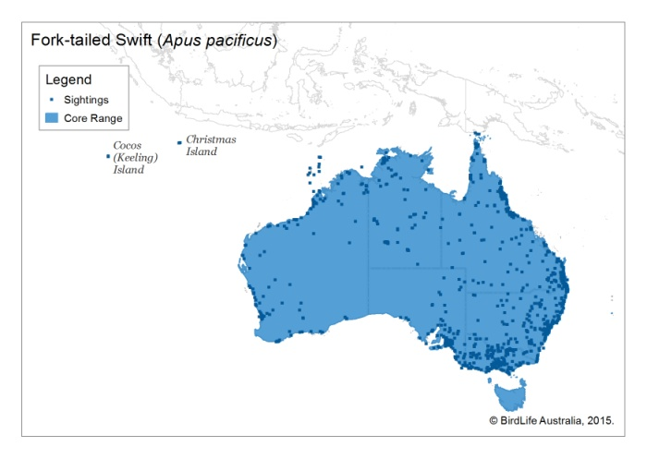 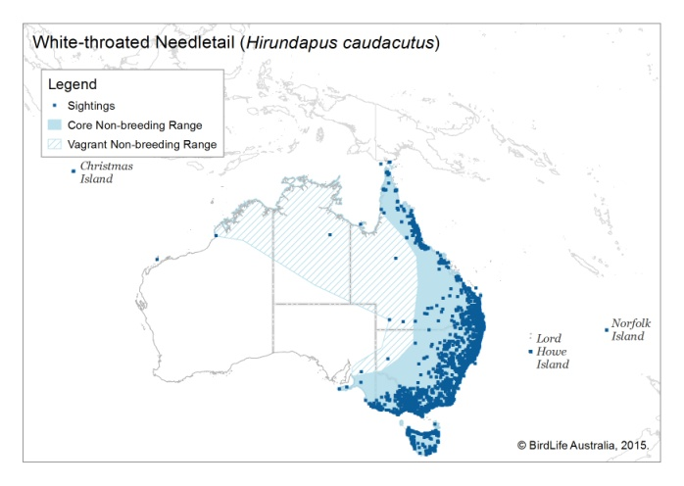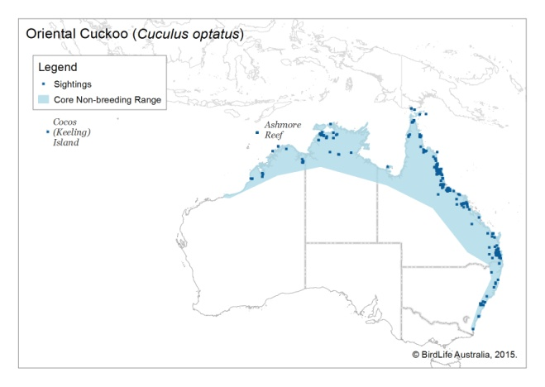

Maps 4-8 Records of the five extremely uncommon migrants (Barn and Red-rumped Swallows, Grey and Yellow Wagtails, Oriental Reed-Warbler)

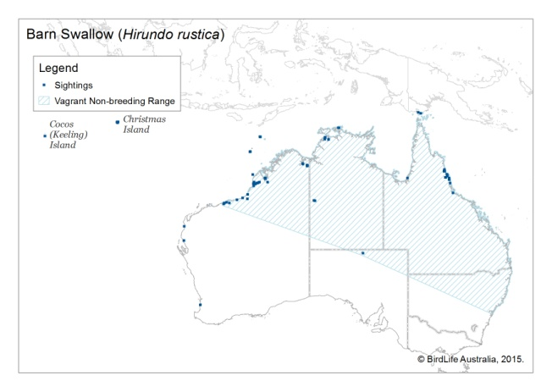 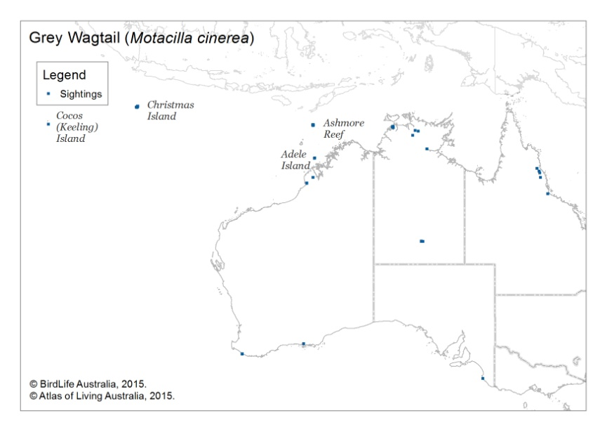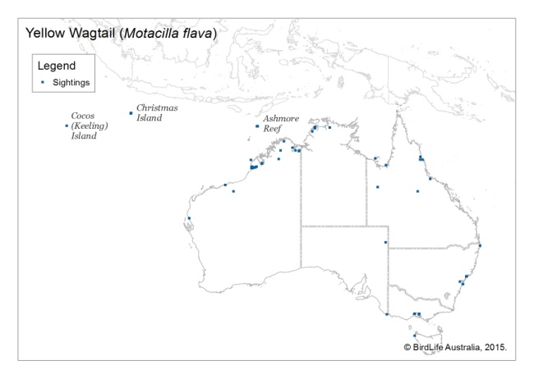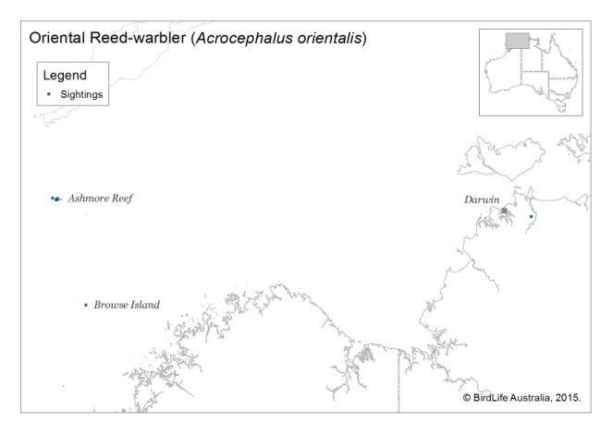

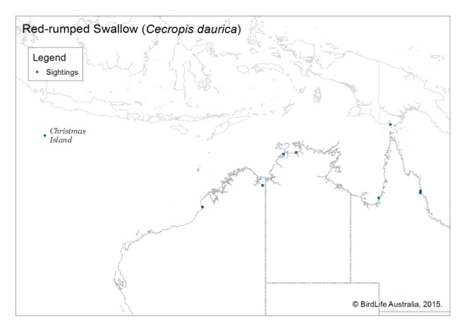

Maps 9-13 Modelled distribution of the five breeding flycatchers

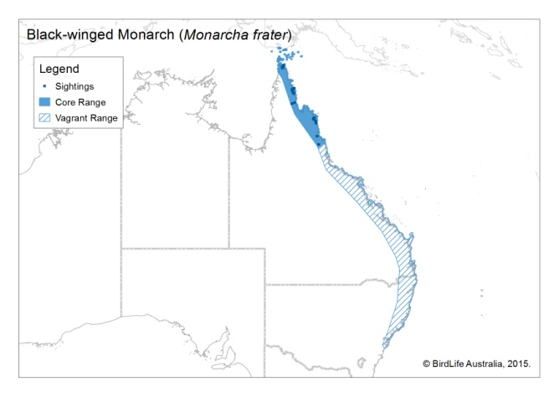 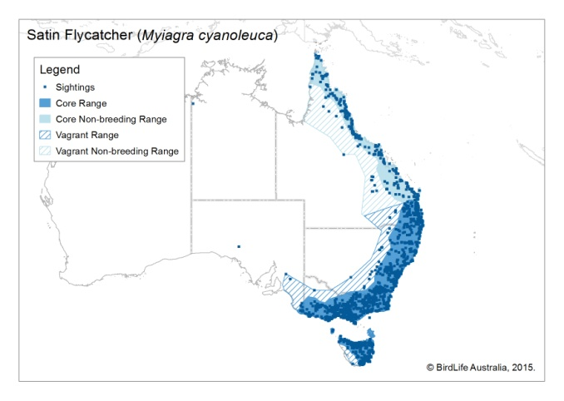

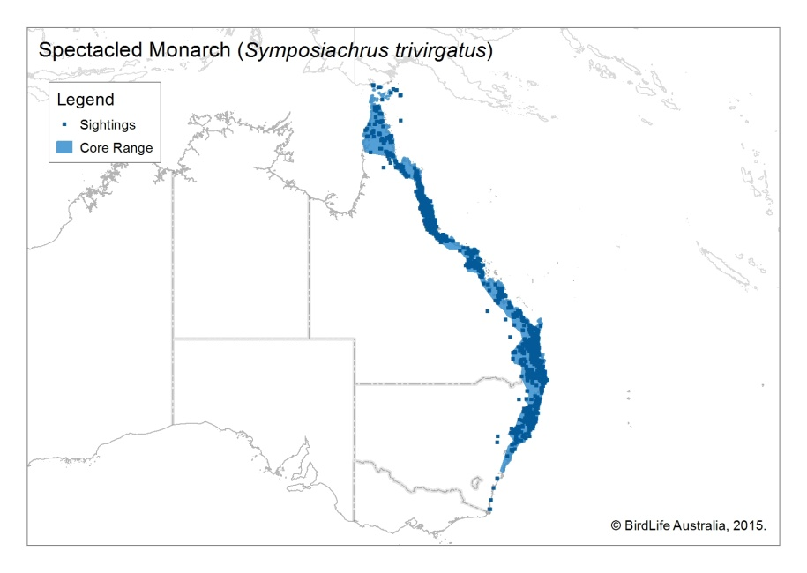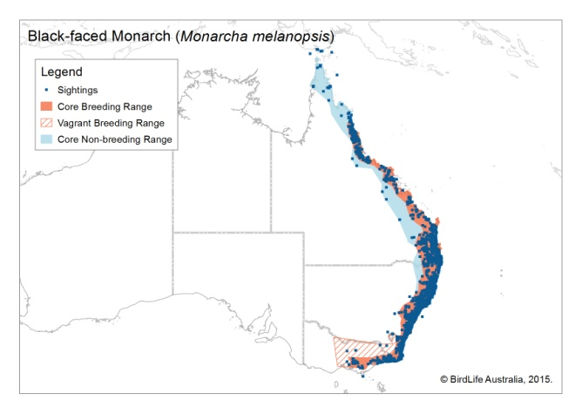

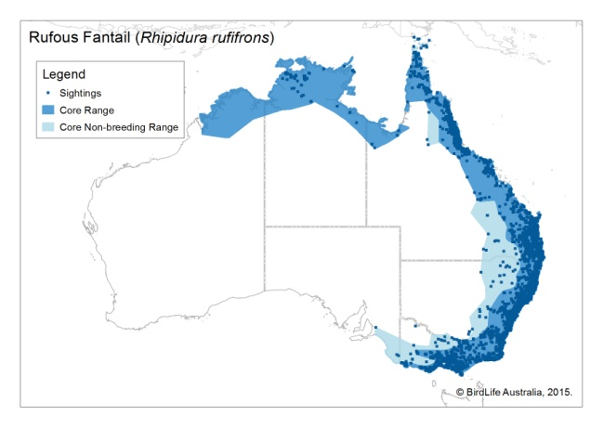

Map 14 Modelled distribution of the Osprey

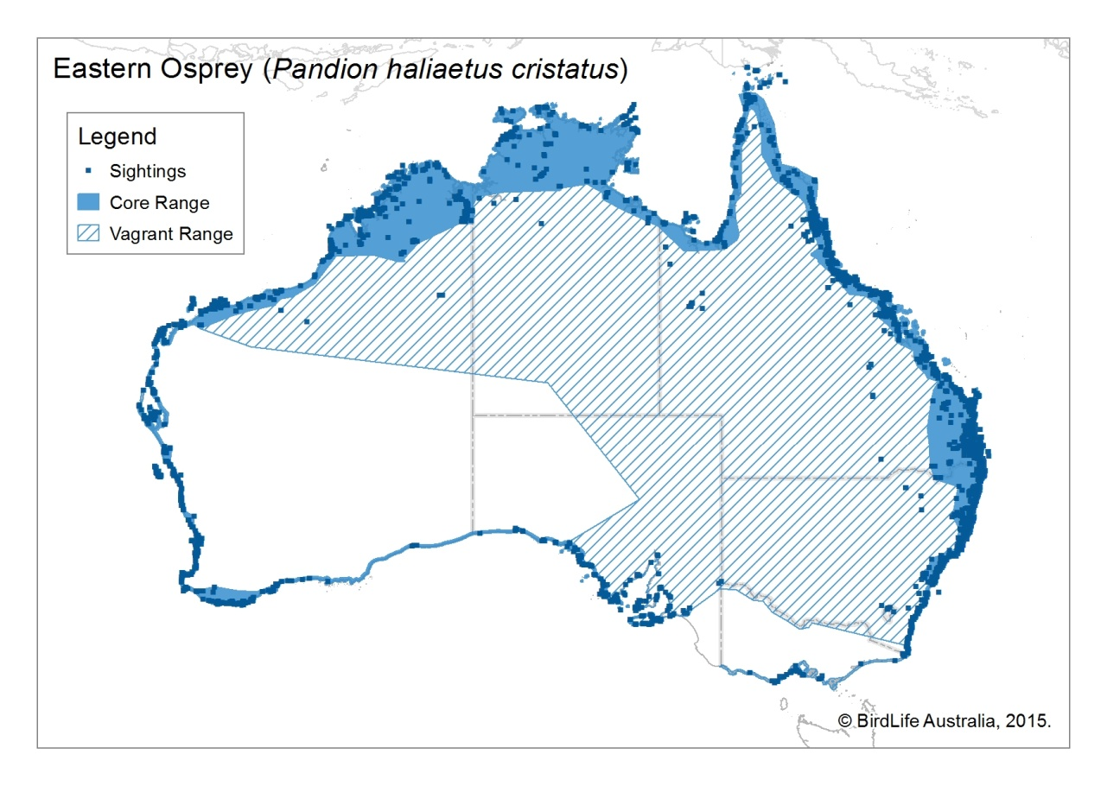

4. What is important habitat for each of the migratory birds?

An action is likely to have a significant impact on a migratory species if there is a real chance or possibility that it will:

• Substantially modify, destroy or isolate an area **of important habitat** for a migratory species, or

• Result in an invasive species that is harmful to the migratory species becoming established in an area of **important habitat** for the migratory species.

Table 2 outlines what is considered to be important habitat for each of the migratory species as well as the invasive species harmful to each species.

Table 2 Important habitat for each of the migratory species

|  |  |  |
| --- | --- | --- |
| **Species** | **Important habitat** | **Invasive species harmful to the migratory species** |
| Osprey | Bays, estuaries, along tidal stretches of large coastal rivers, mangrove swamps, coral and rock reefs, terrestrial wetlands and coastal lands of tropical and temperate Australia and off shore islands. They feed primarily in the sea or nearby estuarine waters and nest in trees (often dead or with dead tops), rocky coastlines and on artificial structures such as telecommunication towers. Ospreys are generally found on or near the coast but also range inland along large rivers, mainly in northern Australia. | Any species that greatly reduces fish abundance |
| White-throated Needletail | Non-breeding habitat only: Found across a range of habitats, more often over wooded areas, where it is almost exclusively aerial. Large tracts of native vegetation, particularly forest, may be a key habitat requirement for species. Found to roost in tree hollows in tall trees on ridge-tops, on bark or rock faces. Appears to have traditional roost sites. | Unknown |
| Fork-tailed Swift | Non-breeding habitat only: Found across a range of habitats, from inland open plains to wooded areas, where it is exclusively aerial. | Unknown |
| Oriental Cuckoo | Non-breeding habitat only: monsoonal rainforest, vine thickets, wet sclerophyll forest or open *Casuarina*, *Acacia* or *Eucalyptus* woodlands. Frequently at edges or ecotones between habitat types. Riparian forest is favoured habitat in the Kimberley region. | Unknown |
| Black-faced Monarch | Wet forest specialist, found mainly in rainforest and wet sclerophyll forest, especially in sheltered gullies and slopes with a dense understorey of ferns and/or shrubs. | Black Rat *Rattus rattus*, invasive vines of riparian habitat (e.g. rubber vine *Cryptostegia grandiflora*) |
| Black-winged Monarch | Rainforest species, but will use mixed tropical woodlands that are adjacent to rainforest. | Black Rat *Rattus rattus*, invasive vines of riparian habitat (e.g. rubber vine *Cryptostegia grandiflora*) |
| Satin Flycatcher | Eucalypt forest and woodlands, at high elevations when breeding. They are particularly common in tall wet sclerophyll forest, often in gullies or along water courses. In woodlands they prefer open, grassy woodland types. During migration, habitat preferences expand, with the species recorded in most wooded habitats except rainforests. Wintering birds in northern Qld will use rainforest - gallery forests interfaces, and birds have been recorded wintering in mangroves and paperbark swamps. | Black Rat *Rattus rattus*, invasive vines of riparian habitat (e.g. rubber vine *Cryptostegia grandiflora*) |
| Spectacled Monarch | Dense vegetation, mainly in rainforest but also in moist forest or wet sclerophyll and occasionally in other dense vegetation such as mangroves, drier forest and woodlands. | Black Rat *Rattus rattus*, invasive vines of riparian habitat (e.g. rubber vine *Cryptostegia grandiflora*) |
| Rufous Fantail | Moist, dense habitats, including mangroves, rainforest, riparian forests and thickets, and wet eucalypt forests with a dense understorey. When on passage a wider range of habitats are used including dry eucalypt forests and woodlands and Brigalow shrublands. | Black Rat *Rattus rattus*, invasive vines of riparian habitat (e.g. rubber vine *Cryptostegia grandiflora*) |
| Oriental Reed-warbler | Non-breeding habitat only: emergent aquatic vegetation along waterways and water bodies. | Unknown |
| Barn Swallow | Non-breeding habitat only: occurs in the air above open vegetated areas including native and agricultural grasslands as well as over open water areas. | Unknown |
| Red-rumped Swallow | Non-breeding habitat only: predominately forages over wetlands and open well-watered grasslands. | Unknown |
| Grey Wagtail | Non-breeding habitat only: has a strong association with water, particularly rocky substrates along water courses but also lakes and marshes. | Unknown |
| Yellow Wagtail | Non-breeding habitat only: mostly well-watered open grasslands and the fringes of wetlands. Roosts in mangroves and other dense vegetation. | Unknown |

5. What is an ecologically significant proportion of a population of each migratory bird?

An action is likely to have a significant impact on a migratory species if there is a real chance or possibility that it will seriously disrupt the lifecycle (breeding, feeding, migration or resting behaviour) of an **ecologically significant proportion of the population** of a migratory species. Proportions are estimated based on published estimates of area occupied and recorded densities published in the Handbook of Australian, New Zealand and Antarctic Birds. These are outlined in Table 3.

Table 3 Ecologically significant proportions of each species population

|  |  |  |
| --- | --- | --- |
| **Species** | **Ecologically significant proportion of a population (individuals)[1]** | |
| **1%** | **0.1%** |
| Osprey | 240 | 24 |
| White-throated Needletail | 100 | 10 |
| Fork-tailed Swift | 1,000 | 100 |
| Oriental Cuckoo | 10,000 | 1,000 |
| Black-faced Monarch | 4,600 | 460 |
| Black-winged Monarch | 1,500 | 150 |
| Satin Flycatcher | 17,000 | 1,700 |
| Spectacled Monarch | 6,500 | 650 |
| Southern Spectacled Monarch | 4,100 | 410 |
| Wet Tropics Spectacled Monarch | 3,300 | 330 |
| Cape York Spectacled Monarch | 3,900 | 390 |
| Rufous Fantail | 48,000 | 4,800 |
| Southern Rufous Fantail | 11,000 | 1,100 |
| North-eastern Rufous Fantail | 15,000 | 1,500 |
| Arafura Rufous Fantail | 22,000 | 2,200 |
| Oriental Reed-warbler | 10,000 | 1,000 |
| Barn Swallow | 10,000 | 1,000 |
| Red-rumped Swallow | 10,000 | 1,000 |
| Grey Wagtail | 10,000 | 1,000 |
| Yellow Wagtail | 10,000 | 1,000 |

7. Have you surveyed for these migratory birds?

Actions proposed within the distribution of these species and in important habitats should allocate appropriate effort and consideration to detecting these migratory species as part of bird surveys undertaken for their environmental impact assessment at a site. No formal survey guidelines exist for these species but some guidance is provided below. Surveys should be concentrated in the important habitats for each species outlined in Table 2.

*Oriental Cuckoo and five migrant flycatchers during breeding season*

The best methods of survey for the Oriental Cuckoo in non-breeding areas and the five breeding migrant flycatchers in breeding habitat is an area survey, preferably a two hectare survey in 20 minutes, over sufficient survey plots to estimate a density, and hence the population size across the proposed development area. Surveys should be undertaken in an appropriate season - spring or summer in southern Australia.

*Oriental Cuckoo and five migrant flycatchers during migration*

For any of the migrants during the migration seasons (southward: austral autumn, northward: austral spring) surveys should be undertaken over standardised timed periods. Observers should be sufficiently skilled to recognise calls as well as counting birds detected by sight. Where appropriate observers must also be able to distinguish the Black-faced from Black-winged Monarchs, and the Satin from Leaden and Broad-billed Flycatchers – all five Migratory species may occur on Cape York Peninsula, some parts of the Wet Tropics and Torres Strait. Surveys and assessments should consider habitat (and specific locations) that is suitable and important for migration passage, regardless of numbers of individuals recorded during the survey period.

*Swifts*

While there are no standard survey techniques for swifts, they should be counted by an experienced person from elevated viewpoints (if present) during the Austral summer. Prevailing weather conditions should be noted as this can greatly affect likelihood of occurrence (e.g. swifts often travel ahead of storm fronts). Fork-tailed Swifts high in the air have a distinctive vocalisation, recognisable to experienced observers. Because they are transitory at most sites, they are unlikely to be recorded on specific surveys of short duration. Records of local observers should be sought where possible. Long term databases should be examined to find relevant records.

If White-throated Needletails are known to occur, observations should be made as late as possible in the evening of birds coming into roost in tall trees along ridge tops. The availability of such roost sites is unknown and could be limiting – currently the location is known for very few.

*Oriental Reed-Warbler, swallows, wagtails*

It is not considered that surveys for the Oriental Reed-Warbler, Barn or Red-rumped Swallows or Grey or Yellow Wagtails will yield useful results at this time because of the small numbers of these birds visiting Australia, their non-threatened status, their large populations globally and the improbability of a significant proportion of their population being present at a site for changes to that site to have any significance to the conservation status of the species either in Australia or globally. However, any records of any of the species encountered during other surveys should be forwarded to the Department of the Environment for inclusion in the Atlas of Living Australia so that a greater understanding of their patterns of occurrence is possible should greater emphasis on their conservation be needed in the future. If surveys of these species are to be undertaken, they should occur across appropriate habitat between November and March. Persons surveying should be appropriately trained in bird identification as these species can be easily mistaken for more common, resident species.

*Osprey*

The Osprey is a readily identified raptor species; however inexperienced observers may confuse it with other coastal raptors such as White-bellied Sea-Eagle or Brahminy Kite. Surveys for this species should be undertaken by an experienced observer to remove the risk of mis-identification.

Ospreys are conspicuous in flight and when perched. Their nests are also conspicuous and may measure up to 2.0 m in diameter and 2.5 m in depth.

Ospreys can be detected directly by sight or call; or indirectly by signs of occupancy such as nests or prey remains. Ospreys should be surveyed using one or more of the following techniques:

• Observations from vantage points to detect birds in flight over suitable habitat;

• Area searches on foot to detect birds or signs of occupancy in suitable habitat;

• Transect surveys from vehicles to detect birds or nests in large survey areas;

• Transect surveys from boats along suitable coastal or riparian habitat;

• Aerial surveys to detect birds or nests in large survey areas.

Care should be taken to avoid nest disturbance if surveying during the breeding period (breeding period defined as eggs and young chicks in nests) (April – August in northern Australia, May – November in southern Australia). Ospreys are known to show strong site fidelity. If adult birds are observed in an area during these breeding periods, it is likely they will have an active nest. This species is not considered to be as easily disturbed at nest sites as other raptor species such as Wedge-tailed Eagles and White-bellied Sea-Eagle, so nest abandonment as a result of disturbance is infrequent. Nevertheless, observations of known nests should be made from a minimum of 100 m. Activity around nest sites should be minimised, with observers spending enough time at sites to confirm nesting and then moving away from the site in a way that minimises disturbance.

*Non detection*

For birds predicted to occur in a study area using the Department’s Protected Matters Search Tool but not recorded during surveys on site after using the guidance above, their likelihood of occurrence in the study area should be determined using the mapping and habitat information provided in this guideline (Table 2; Figures 1-14; Appendix A). If likely to occur then consideration should be given to both the thresholds in Tables 4 and 5 and mitigation.

*Surveys for actions which may or are likely to involve substantial loss or modification of important habitat or which involve large and or tall structures.*

Tall buildings, wind turbines, overhead power lines etc are all known to cause mortalities of migrating birds as they are flying through unfamiliar habitat, sometimes in conditions of poor visibility or at night. If your proposed action is likely to constitute **substantial loss or modification** of important habitat (see section 8) or involves large structures such as buildings, power lines and wind turbines then a more targeted form of surveys is recommended.

Surveys should include timed area counts of all bird species applying the guidance above and involve collision risk modelling. Collision risk modelling requires flight to be documented in height increments that are of specific relevance to the dimensions of the structure proposed.

For aerial birds, counts per hour can be used on multiple days during the migration period and the number passing through calculated from the length of the migration passage at the site. Numbers should be calculated for the population passing through a site, not just that resident within it. Australian flycatchers are likely to be mobile north of their known breeding areas in spring and autumn. For swifts movements occur daily throughout the non-breeding season.

8. Could your action have a significant impact on one or more of the migratory birds?

If you plan to undertake an action that will have or is likely to have a significant impact on a migratory species, you must refer the action to the Minister before commencing. Actions that will have or are likely to have a significant impact on one of these birds are those that **substantially** modify (including by fragmenting, altering fire regimes, altering nutrient cycles or altering hydrological cycles), destroy or isolate an area of important habitat for a migratory species and or, **seriously** disrupt the lifecycle (breeding, feeding, migration or resting) of an ecologically significant proportion of each species population.

The guidance below is intended to help you determine the likelihood of a significant impact.

**Habitat loss or modification**

Actions which constitute **substantial loss or modification** of important habitat and therefore a likely significant impact are those actions that are likely to meet or exceed the upper thresholds (1%) identified in Table 4.

Actions likely to exceed the lower threshold (0.1%) should be investigated further through more targeted surveys (section 7) to estimate population sizes in these large areas of important habitat as well as the actions likelihood of affecting an ecologically significant proportion of a species population as outlined in Table 5. Strategic regional planning will be required where cumulative loss of small patches of habitat is occurring that may collectively exceed area thresholds. Such planning should involve targeted surveys (section 7) and best practice mitigation design and implementation (section 9).

**Mortality**

Actions which constitute **serious** disruption to an ecologically significant proportion of a population are those that are predicted to have annual mortality rates or affect breeding cycles of individuals meeting or exceeding the upper of the thresholds (1%) in Table 5. Actions likely to meet or exceed the lower thresholds (0.1%) in Table 5 should also be investigated further through more targeted surveys (see section 7).

**Offshore islands**

Offshore islands that act as gathering points or stop-over points during migration for the flycatchers, cuckoo, reed-warbler or wagtails should be considered separately from mainland Australia. These islands are unlikely to support biologically significant populations, even if multiple birds pass through on passage, because migration appears to be on a broad front. This will be reviewed as further information is gathered given that islands are nevertheless likely to support, over the course of a migration season, more individuals than equivalent areas of mainland.

Table 4 Areas of important habitat for each species likely to result in a significant impact if affected.

|  |  |  |
| --- | --- | --- |
| **Species** | **Area thresholds (ha unless otherwise stated ) [2]** | |
| **1%** | **0.1%** |
| Osprey | 840 km coastline | 84 km coastline |
| White-throated Needletail | * | * |
| Fork-tailed Swift | * | * |
| Oriental Cuckoo | 250,000 | 25,000 |
| Black-faced Monarch | 2,600 | 260 |
| Black-winged Monarch | 865 | 87 |
| Satin Flycatcher | 4,400 | 440 |
| Spectacled Monarch | 2,100 | 210 |
| Southern Spectacled Monarch | 1,300 | 130 |
| Wet Tropics Spectacled Monarch | 1,100 | 110 |
| Cape York Spectacled Monarch | 1,300 | 130 |
| Rufous Fantail | 7,500 | 750 |
| Southern Rufous Fantail | 2,600 | 260 |
| North-eastern Rufous Fantail | 3,400 | 340 |
| Arafura Rufous Fantail | 4,500 | 450 |
| Oriental Reed-warbler | * | * |
| Barn Swallow | * | * |
| Red-rumped Swallow | * | * |
| Grey Wagtail | * | * |
| Yellow Wagtail | * | * |

* No threshold area can be determined at this time or has identified given lack of knowledge or rarity. Research on White-throated Needletail may reveal site thresholds in tall forest used by roosting birds.

Table 5 The proportions of each migratory species population likely to result in a significant impact if affected.

|  |  |  |
| --- | --- | --- |
| **Species** | **Thresholds ( no of individuals)** | |
| **1%** | **0.1%** |
| Osprey | 240 | 24 |
| White-throated Needletail | 100 | 10 |
| Fork-tailed Swift | 1,000 | 100 |
| Oriental Cuckoo | 10,000 | 1,000 |
| Black-faced Monarch | 465 | 47 |
| Black-winged Monarch | 150 | 15 |
| Satin Flycatcher | 1,700 | 170 |
| Spectacled Monarch | 650 | 65 |
| Southern Spectacled Monarch | 410 | 41 |
| Wet Tropics Spectacled Monarch | 330 | 33 |
| Cape York Spectacled Monarch | 390 | 39 |
| Rufous Fantail | 3,400 | 344 |
| Southern Rufous Fantail | 1,100 | 113 |
| North-eastern Rufous Fantail | 1,500 | 148 |
| Arafura Rufous Fantail | 2,200 | 219 |
| Oriental Reed-warbler | 10,000 | 1,000 |
| Barn Swallow | 10,000 | 1,000 |
| Red-rumped Swallow | 10,000 | 1,000 |
| Grey Wagtail | 10,000 | 1,000 |
| Yellow Wagtail | 10,000 | 1,000 |

9. What could be done to mitigate any impacts on these migratory birds or more generally contribute to their conservation?

The principal mitigation actions are retention of suitable habitat in patches large enough to support viable populations and resist invasion by weeds, particularly, for the rainforest species, where weeds are likely to promote fire.

Mitigation measures for developments that may exceed threshold mortality rates need to be determined on a case by case basis. Building design and wind turbine and power line placement can be modified to reduce bird mortality if necessary. For some developments, like wind turbines (see [EPBC Act Policy Statement 2.3: Wind farm industry](http://www.environment.gov.au/resource/epbc-act-policy-statement-23-wind-farm-industry)), there is an increasing body of research that enables both the prediction of mortality and potential mitigation measures.

Proponents of such actions should demonstrate that current best practice has been used to estimate impacts and to reduce and/or mitigate them.

For Ospreys, which can be iconic inhabitants of urban environments, there are many [actions and strategies](http://www.environment.gov.au/cgi-bin/sprat/public/publicspecies.pl?taxon_id=82411) to minimise impacts even if the loss of individual nests may have cause for little impact on the species or its environment.

If avoidance and mitigation are unlikely to reduce the impacts to below the thresholds in Table 4 and 5 then offsets will likely be required in accordance with the [EPBC Act Environmental Offsets Policy](http://www.environment.gov.au/epbc/publications/epbc-act-environmental-offsets-policy). Any offsets should focus on securing and protecting habitat with a similar floristic structure elsewhere in the landscape, rehabilitation of alternative areas from which habitat has been lost or undertaking management actions that improve species breeding productivity.

1. For species that aggregate in flocks, 1% of the population is considered internationally important, 0.1% as nationally important. The same threshold levels are used here for want of more specific ecological research.
2. The following habitat area thresholds apply with the upper figure representing areas of international significance, the lower figures national significance.