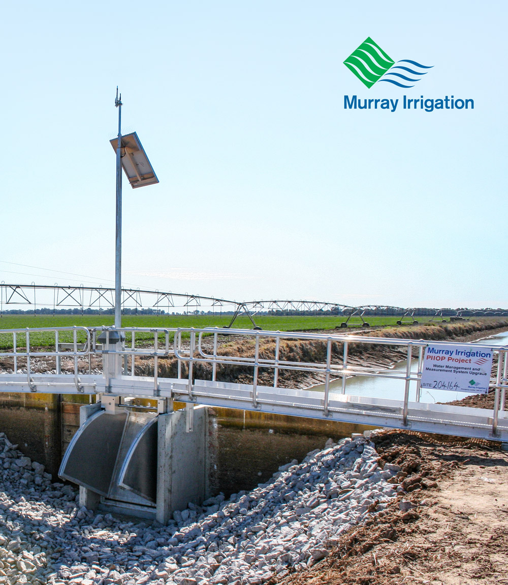

Delivering the Future

**Private Irrigation Infrastructure Operators Program in NSW (PIIOP) Round Two**

Final Report

October 2019

#### Murray Irrigation Limited

(ABN 23 067 197 933) is a Company limited by shares, incorporated and domiciled in Australia. Its registered office and principal place of business is:

443 Charlotte Street

PO BOX 528

Deniliquin NSW 2710

Telephone: 1300 138 265

Facsimile: (03) 5898 3301

[www.murrayirrigation.com.au](http://www.murrayirrigation.com.au)

[info@murrayirrigation.com.au](mailto:info@murrayirrigation.com.au)

#### Board of Directors

The current directors of the Company are:

P. Snowden  
C. Filson  
W. Van Beek  
R. Gleeson  
N. Baxter  
S. Fawns  
P. Largier  
D. Marples

#### Chief Executive Officer

Michael Renehan (2014 - June 2019)

Philip Endley (Current since August 2019)

#### Design

Thirst Creative

#### Photography

Sarah Enticknap

Peter Clarke

#### ISBN

978-0-9923511-6-8

Table of Contents

1 Chief Executive Officer’s Report 4

2 Executive Summary 5

3 Executive GM Major Engineering Projects' Report 7

BENEFITS OF MODERNISATION 9

4 Historical Insights 10

4.1 Murray Irrigation 10

4.2 Traditional irrigation practices in the southern Riverina 11

5 Executive GM Water Delivery's Report 12

6 Modernising Murray Irrigation 13

6.1 Private Irrigation Infrastructure Operators Program in NSW Round 2 (PIIOP2) 13

7 Our customers 14

7.1 Current and future farming practices 14

8 Our community 16

8.1 Investing in local contractors and suppliers 16

8.2 Uplifting local businesses 17

9 Our company 18

9.1 Future leaders 18

9.2 Revamping safety 19

DELIVERING AN EXEMPLARY PROJECT 20

10 Objectives of the modernisation works 20

10.1 Objectives 20

10.2 Budget 20

11 Upgrading water management and measurement systems (SP1) 21

11.1 Outlets program 21

11.2 Regulators program 22

11.3 Upgrading the Berriquin Irrigation Division 23

11.4 Supervisory Control and Data Acquisition (SCADA) 23

12 Network reconfigurations (SP3) 24

12.1 Reconfigurations 24

13 Optimising the footprint, driving water efficiency and reducing the network (SP4) 25

13.1 Sub-system retirement 25

14 Project management 26

14.1 Construction management 26

14.2 Design approach 27

14.3 Planning and approvals 27

14.4 HSEQ Management System 28

14.5 Challenges, amendments and lessons 30

15 Communications and marketing 32

15.1 Media 32

15.2 Internal engagement 33

15.3 External engagement 33

Post-project satisfaction 34

# 1 Chief Executive Officer’s Report

**Michael Renehan
MBA, M. Eng (Chem), MAICD
Chief Executive Officer  
Michael Renehan  
MBA, M. Eng (Chem), MAICD  
Chief Executive Officer**

When infrastructure engineers review the progress, setbacks, wins and commissioning of a major project they understandably focus on the quality and integrity of the work, the hundreds of millions expended, and the need to finish on time, in scope and on budget. But when a project is funded in partnership with government an even greater level of accountability, oversight and discipline is imposed.

In that context, and in presenting their report, I am confident that the Major Engineering Projects division of Murray Irrigation has delivered in every respect. Of particular pride is having worked 470,259 hours on PIIOP initiatives without a single hour lost to injury; a remarkable performance in any sector. We also know that our preparation leading up to transitioning from a manual to automated network paid enormous dividends with the orderly commissioning and activation of more than 3400 items without major incident or significant farm productivity losses. Murray Irrigation’s relationship with the Department of Agriculture and Water Resources has been a highly effective partnership.

The officials with whom we have dealt have been responsive and supportive and the department’s willingness to engage with our customer shareholders has been without hesitation. As proud as we may be with these macro achievements, our stakeholders and partners should not let project performance overshadow the delivery of improved services to our customers and our ability to effectively and efficiently manage the most valuable resource in agriculture: water. To that end Murray Irrigation now boasts one of the most modern irrigation networks in Australia and certainly one of the most advanced in the world. The backbone of our network is the iconic Mulwala Canal which is recognised at state and federal government level as a critical asset of national strategic significance. The benefits of our PIIOP partnership are now evident throughout the 156km-long main Mulwala Canal and the 2,778km of gravity-fed earthen channels that deliver to the 724,000ha in our operational area. As a result of PIIOP our network is now geared to merge seamlessly with current and future on-farm technology. In even a modest water allocation year, most of our farmers can fine tune their watering operations with up to four changes per day. In a low allocation year our water delivery operators can isolate sections of the network to minimise losses and maximise operations. We can also accelerate the start to an irrigation season by using our upgraded infrastructure to hold up to 14GL of water. Later in this document some of our customers have highlighted the benefits of the PIIOP project in their farm enterprises and it’s their observations and contributions that we value above all else.

# 2 Executive Summary

This Final Report to the Department of Agriculture and Water Resources represents the activities, expenditure and conduct of Murray Irrigation’s participation in Round 2 of the Australian Government’s Private Irrigation Infrastructure Operators Program in NSW (PIIOP).

The report highlights the project’s positive impact on the community, and the opportunities that participation has generated for the company and its customers.

##### The Work Site

Murray Irrigation’s infrastructure comprises 2,778km of earth-lined channels that are linked to the nation’s most significant privately owned asset: the iconic 156km-long Mulwala Canal. The company’s 2,153 landholdings operate irrigated agricultural enterprises covering 724,000ha and contribute significantly to the $1.6B of gross value agricultural production coming from the Murray region.

##### Deliverables

The Private Irrigation Infrastructure Program in NSW in its Round 2 version (PIIOP2) represents the single greatest upgrade of Murray Irrigation’s infrastructure since construction of the Mulwala Canal began in 1935.

The prime deliverables were:

* Construct over 3,400 regulators and outlets
* Supply and install the telemetry system upgrade
* Reconfigure infrastructure to reduce or change how landholdings connect to the system
* Optimise the footprint and drive water efficiency through sub-system retirements
* Satisfy our water efficiency targets

##### Customers

Murray Irrigation exists to service its customers and they remained uppermost in planning, consultation and assessment. After PIIOP2, Murray Irrigation’s customers enjoy telemetry enabled infrastructure that merges seamlessly with existing and rapidly emerging advances in on-farm technology and processes.

Water deliveries can now be managed remotely from the company’s operations centre with many customers enjoying the flexibility of requesting up to four orders each day. The upgraded infrastructure has reduced head loss (the amount of water height lost when flowing through or against a physical structure), decreased water logging and provided the company’s water delivery team with one of the world’s most advanced water management networks.

##### Community

The Australian Government continues to focus on community development and in that context, the PIIOP2 project generated considerable opportunities for diverse local businesses, many of which are featured in this report. The range of products and services provided by such a large-scale operation have been crucial in maintaining the economic sustainability of many small businesses facing the considerable downturn that flows from less than optimal agricultural seasons. Project partners like ERTECH Pty Ltd ("ERTECH"), have since opened up a district depot in Deniliquin and are working with other regional irrigation and water entities.

##### Construction

Three sub-projects focused on modernising outlets and regulators, reconfiguring existing infrastructure and retiring sub-systems where irrigated properties were converted to dryland farming.

A reset of objectives in 2014 generated a revised budget forecast of $206M, improved consultation with farmers and clear objectives that delivered the project on time and on budget. A reinvigorated and enthusiastic workforce in the latter part of the project cemented a healthy, collaborative relationship with the Department of Agriculture and Water Resources and a world-class Health, Safety, Environment and Quality (HSEQ) assurance program reduced Murray Irrigation’s Lost Time Injury Frequency Rate (LTIFR) from 20 down to zero.

The company, its partners, its customers and the community can be enormously proud of Murray Irrigation’s performance and the confidence that it has demonstrated in the healthy future of its landholders and the region in general.

The project is an exemplary public and private investment in Australian agriculture.

# 3 Executive GM Major Engineering Projects' Report

Warren Jose
BEng, MEngSc, MIE Aust
Executive GM Major Engineering Projects
  
**Warren Jose  
BEng, MEngSc, MIE Aust  
Executive GM Major Engineering Projects**

Before the PIIOP2 project started, we were dependent on Dethridge wheels, manual gate adjustment and obsolete procedures in the face of new metering standards.

We recognised the need for innovation to improve the services we provided and the chance to develop the practices that deliver water to the properties of our customers.

The PIIOP2 project has set up our network for a sustainable future environmental challenges and the increasing scarcity of water.

The project offered new business opportunities throughout the footprint, our customers can now do more with their water than ever before and the new capabilities of our network are drawing the attention of a new breed of enterprise.

It is exciting to see the benefits the project has created in such a short time.

##### Project management

The Major Engineering Project team, that oversaw the PIIOP2 design and construction phase, was created as a separate entity within Murray Irrigation. Much of the early success was an intensive program of consultation with our operational colleagues and customers.

Logistically, the project provided significant challenges due to the vast area of the Murray Irrigation footprint, stretching from Mulwala to Wakool. Supervision and site monitoring was a difficult task, with over 2,000 outlets, more than 1,000 regulators, system retirements and reconfigurations occurring throughout the area.

We contracted ERTECH, to oversee most of the project delivery, with the oversight of Murray Irrigation’s construction and engineering senior managers. Directly embedding contractor personnel into the project delivery team contributed to an excellent working culture and unencumbered decision making. The ERTECH relationship led to effective collaboration that directly contributed to the project's success.

##### Project learnings

When Murray Irrigation decided to participate in the PIIOP2 program in 2012, many of the hurdles and difficulties could not have been predicted; however, throughout the whole process, we focused on how we could adapt and learn.

From the mid-2015 project review, the project’s subsequent success and our successful application to participate in PIIOP3, we acknowledged setbacks and used them to develop ourselves further. Underpinning the success of this project has been an ongoing philosophy of learning and growing from every setback.

Our customer consultation process highlighted a greater focus on educating customers about the modernisation journey and the functions of assets would be beneficial.

Similarly, there were lessons in project management, financial scoping and internal governance. By the end of PIIOP2 and in projects since, the design, creation and installation was achieved with far greater ease and productivity.

##### Project success and where the company is now

PIIOP2 focused on the ends of our network – customer outlets, regulators and assets that connected landholdings. Through modernising how water is delivered directly on farm, we can proudly say that we have contributed to farm businesses and other customer needs throughout the region. The benefit to our customers is that it makes farming simpler and more flexible for current landowners, and the capacity of the assets makes the entire region more attractive to investment.

The company is now at an exciting precipice. The entire system is automated and can be remotely- controlled. We are achieving our water efficiency goals. Our customers are adapting their businesses to leverage the upgrades. We also have expert staff transitioning into the main business and we utilise brand new safety systems that emerged from PIIOP2.

It is with pleasure that we deliver this report to the Department.

# BENEFITS OF MODERNISATION

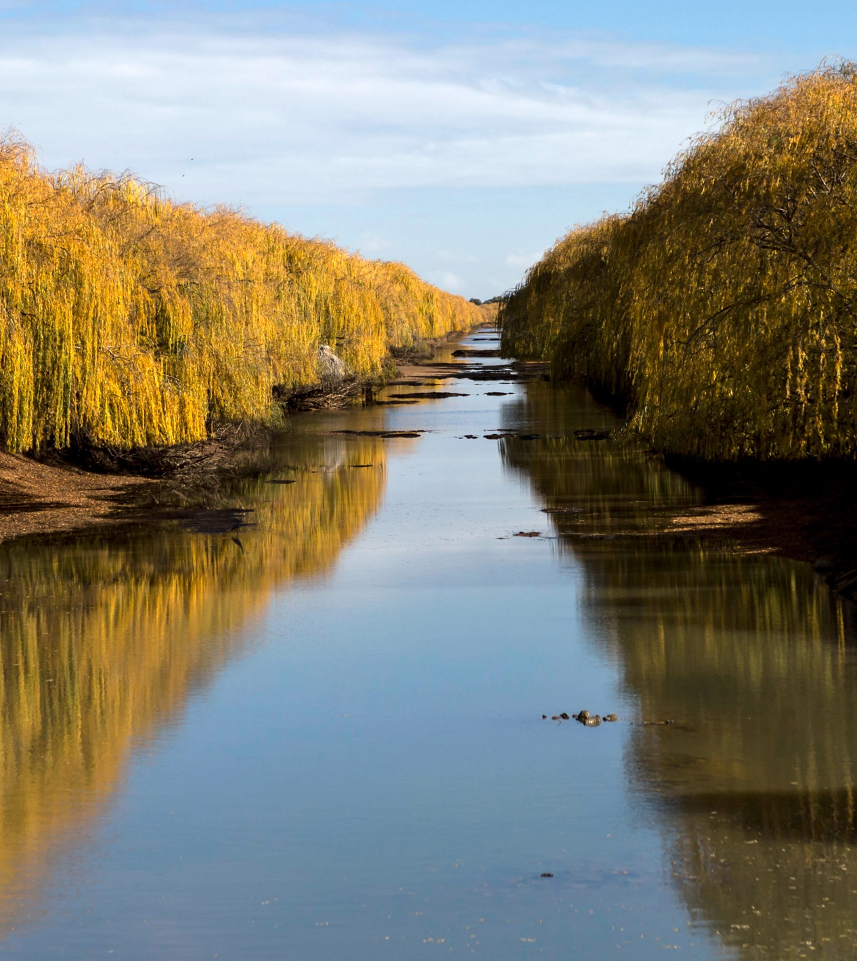

# 4 Historical Insights

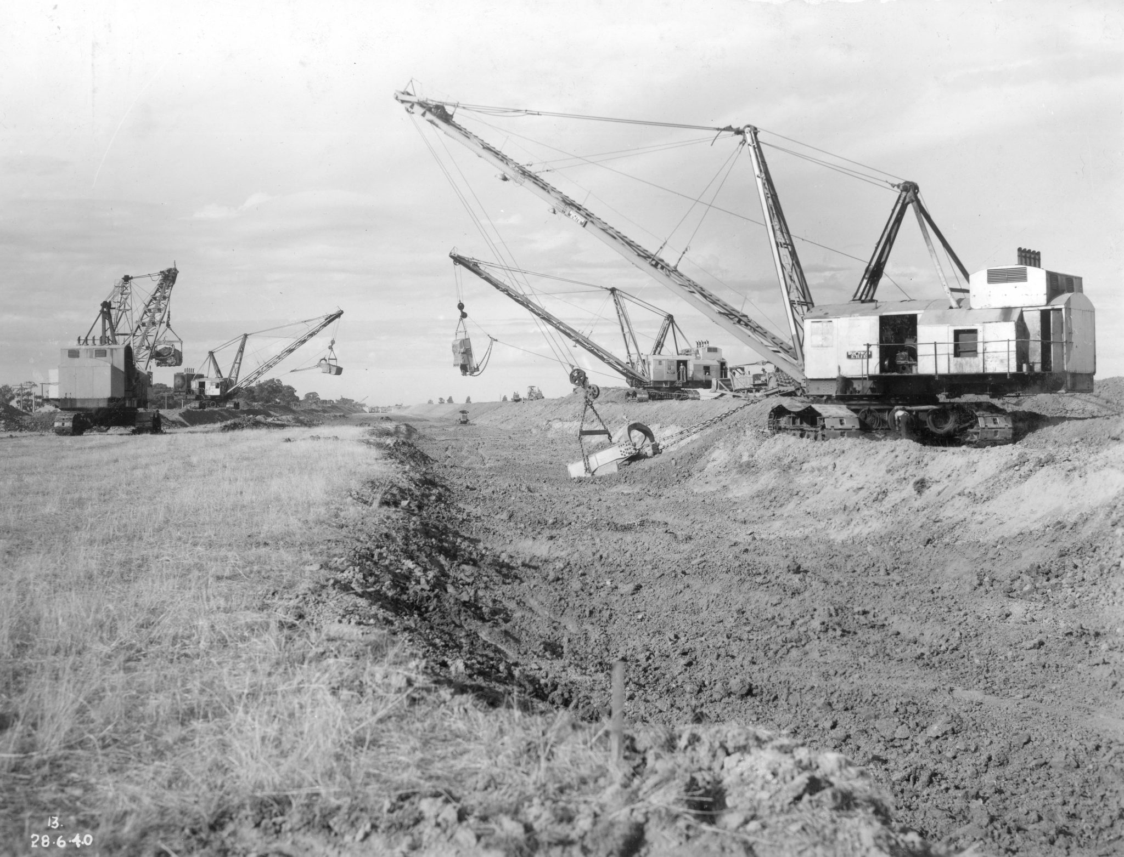

## 4.1 Murray Irrigation

Murray Irrigation’s footprint is located in the southern Riverina region of New South Wales, between Mulwala and Moulamein. The enormous infrastructural development was built between 1935 and 1964 by the then NSW Water Conservation and Irrigation Commission (WC&IC).

The initial reason for creating irrigation networks in the southern Riverina was to secure reliable stock and domestic water to an area which had been, and still is, regularly devastated by drought. Over time, landholders extended the use of water to pasture, dairy, horticulture, rice growing and cropping.

The water delivered by Murray Irrigation is supplied via the Mulwala Canal, which draws from the Murray River at Lake Mulwala. The canal stretches an immense 156km to the west through Berrigan, Finley and Deniliquin.

Construction of the canal began in 1935, using four imported 130 tonne Bucyrus Erie dragline excavators which, unbelievably, completed up to a mile a week. Employment boomed, providing welcome opportunities during the desperate times of the Depression. More than 500 labourers and contractors were working on the Mulwala Canal at the peak of its construction.

Work on this iconic irrigation infrastructure project included several significant engineering feats for the day such as the Lawson Syphon that funnels water from the Mulwala Canal for 700m underneath the Edward River to supply the Deniboota irrigation system.

In 1995, control and operation of the network was handed over from the NSW Department of Water Resources to the irrigators it served, through the formation of the unlisted public company Murray Irrigation Limited (MIL).

Murray Irrigation provides vital water to more than 2,000 properties through about 2,954kms of gravity-fed earthen channels. This is over a vast area of 724,000ha, both farmland and townships, stretching along the NSW side of the Murray River from Yarrawonga/Mulwala in the east, almost as far as Swan Hill in the west. Irrigated agriculture is the foundation of the social and economic wellbeing of towns, businesses and rural communities in the region.

In addition, the residents of Berrigan, Finley, Bunnaloo and Wakool all rely on Murray Irrigation for their town water supplies.

Murray Irrigation’s shareholders are hard-working farmers, with food and livestock the focus for both domestic and international market production.

## 4.2 Traditional irrigation practices in the southern Riverina

In a gravity-fed system, the most traditional irrigation method in the southern Riverina, water flows along the canals and channels via gravity; similar to the flow of water in a river. Within any particular section of channel, the level of water is maintained at a target height using control structures called regulators.

The regulators control height and regulate the amount of water flowing along the channel. Once the benchmark height of water in a channel is reached, it is free to flow onto the customer’s property through outlets, which control the flow rate of the water leaving the channel.

Until irrigation technology was modernised, water deliveries to customers were controlled by a team of channel attendants who would manually monitor, set and change the regulators and outlets. The main irrigation technology used was the Dethridge wheel. Consisting of a drum on an axle, with eight v-shaped vanes fixed to the outside, it sits laterally across a channel and is turned by water flow. The revolving wheel measures flow from the irrigation channels into the farm channels, providing the basis upon which irrigation farmers were charged for water.

The Dethridge wheel was invented over 100 years ago and has been widely used throughout the world, including Murray Irrigation’s footprint. Moving into an era of innovation, the Dethridge wheel does not meet the accuracy required for a modern irrigation system, does not meet the current Australian Metering Standards and does not lend itself to remote control nor automation.

Murray Irrigation’s customers place water orders four days in advance – the time it takes water in the company’s main storage, the Hume Dam, to travel to the diversion point from the Murray River at Lake Mulwala.

Murray Irrigation’s customers compete nationally and internationally with their produce. With water prices rising and constrained supply, it is essential that, to remain competitive, customers can access and use water flexibly and efficiently to maintain the viability of their businesses. As the older, manually-operated assets could not service modern irrigation practices, it became essential they were upgraded.

# 5 Executive GM Water Delivery's Report

Scott Barlow
AssocDip Applied Science Executive GM Water Delivery
  
**Scott Barlow  
AssocDip Applied Science Executive GM Water Delivery**

The focus of PIIOP2 was on our customers and they remained our paramount priority while we sought to improve flexibility and generate water efficiencies. The asset renewal program upgraded ageing infrastructure across our entire footprint improving the water delivery service and bringing direct benefits to our customers.

We focused on infrastructure that would last into the future for our customers and support the increased need for innovation and resilience.

The process was a learning curve for the whole organisation, not least of which the Customer Consultation team in their negotiations with landholders. The result is something we are proud of.

##### The project and our customers

Our Customer Consultation team collaborated with the PIIOP2 project leads, engineers and contractors to develop consultation plans to manage customer interaction. The consultation process was complex, spanning more than 1,200 landholders and more than 2,000 landholdings. Striking the balance between what the customers needed, what they expected and what the project could achieve was crucial.

The specifically tailored Customer Consultation Criteria met the requirements of our diverse customer base and our teams researched extensively before all consultations and held customer information workshops. The response to the information we disseminated was positive and we are extremely proud of our achievements.

##### The impact on our customers and our network

The project provided our customers with improved water ordering flexibility, consistent water volumes, which created opportunities previously unavailable. Our customers are telling us the upgraded outlets have reduced head loss significantly. Customers can achieve higher flow rates which will complement their investments in the improved layout of their farms. This in turn reduces the risk of crop damage from water logging and therefore improve yields.

Part of the project was to retire selected irrigation channels from our system, allowing irrigators to transition into dryland farming.

Our customers are now better equipped for future challenges and our business is now leveraging the benefits of complete modernisation. We are excited to see what these works bring to the company and the region.

# 6 Modernising Murray Irrigation

## 6.1 Private Irrigation Infrastructure Operators Program in NSW Round 2 (PIIOP2)

The Private Irrigation Infrastructure Operators Program in NSW Round 2 (PIIOP2) in partnership with the Commonwealth Government is the largest construction program ever undertaken by Murray Irrigation and the largest asset renewal project in the region since the mid-1900s.

PIIOP2 projects upgraded the way customers connect to the system, benefiting them through more accurate and flexible water delivery and innovative customer service. PIIOP2 involved:

* Mass upgrade of network regulators and farm outlets
* Functional network reconfigurations and retirement/transfers of agricultural assets
* Strategic retirement of underused sections of the irrigation system
* Advanced remote control and automation software installation across the footprint
* Intricate engineering design and professional project management services

Significant focus was put on upgrading outdated infrastructure with new, remote-controlled and automated outlets and regulators which meter and more effectively deliver water on farm.

For our company, the purposes were to:

* Arm ourselves for a strong future in the face of environmental challenges, imminent water scarcity, public policy difficulties, increased industry competition and increased food security risks
* Obtain funding to automate our network and modernise the business for the future
* Retain efficiency-generated water savings for the benefit of our company and its shareholders

In 2013, works began, upgrading network regulators and farm outlets with automated and remote-controlled technology. Regulators and outlet meters on farms throughout the operational footprint were modernised with technology that increased flow rates and improved accuracy in flow measurement. Two levels of service were developed: High Level of Service, which allows customers to change water orders up to four times per day, and Standard Level of Service, which allows for two changes. One specific project, the upgrade of the Berriquin Irrigation Division (The Blighty Pilot Project), tested High Level of Service to benchmark service levels for the entire irrigation system. The network-wide study highlighted the Standard Level of Service cost effectively met the needs of most customers.

Customer consultation included the review of on-farm assets and an evaluation of each customer's farm requirements. Consultation allowed Murray Irrigation to work with customers to progress their overall business plans through sub-system retirements, with the overall benefit of optimising Murray Irrigation's water delivery network.

Where possible, PIIOP2 reconfigured existing water delivery infrastructure to change how landholdings connect to our system. In 2016, the scope of this project was changed to reduce the channel footprint and associated assets without jeopardising the overall delivery of the project's outcomes.

# 7 Our customers

## 7.1 Current and future farming practices

Today, our customers and their needs, both current and future, dominate our decision making. The Murray Irrigation network was created to support irrigation and farming ventures in a region routinely besieged by extreme environmental conditions including drought.

PIIOP2 focused on on-farm outlets, directly improving and upgrading the way customers connect to our network and help mitigate intense environmental impacts. We now boast a modernised water delivery system that customers can leverage to enhance water efficiency in the midst of increasing water scarcity.

Customers and landowners eager to get involved experienced immediate benefits, including access to larger flows of water, a greater flexibility in ordering and reduced watering times for larger areas of production. This project has given customers options that were previously unavailable, allowing them the opportunity to engage in flexible and dynamic farming practices. Many customers noted it has allowed them to start watering earlier in the season and continue later. Others now enjoy a greater command over their property while simultaneously reducing the total number of outlets.

The benefits of network modernisation will continue to emerge over time, and feedback suggests customers have never had better control of their water use and their business operations.

“For us, the PIIOP project has meant better flows and greater ease of control. Consolidating some of our outlets and automation means that the whole process is faster and easier on both ends. The whole system, from ordering through to delivery is far more painless.”

Sam and Pete Middlebrook – Logie Brae

“We’re really pleased with the new retrofit FlumeGate™, we’re definitely getting better flows now and there’s improved control. I now order water and monitor flows on my iPhone. Once the outlet is set to auto, it will chase the ordered amount so the flow stays consistent throughout the entire period.”

Marcus Flanagan – Finley

“The PIIOP project has pretty much doubled our irrigation capacity. The new FlumeGate™ outlets allow us to water a lot quicker. It not only means we can get more water onto the property, we’re also able to water a larger area. The extra capacity also means we have the ability to water later and finish earlier. I am looking forward to the benefits automation will bring.”

Michael Moloney – Jerilderie

“We’re getting twice the amount of water out of these outlets now, which in turn, more than halves the irrigation time. There’s certainly less wastage as well, and with improved farm layouts, there’s less crop damage from things like water logging. There’s virtually no head loss through the structure, which allows you to maintain high flows. The whole system is convenient and easy to manage. It works really well.”

Les Gordon – Burraboi

“We are really happy with the [Sub- System Retirement] project. It has made genuine improvements to our property. We were looking to get out of irrigation and focus on our sheep operation, and financially, the [PIIOP Project] helped us achieve that. You’ve got to embrace it, and it has ended up being a really helpful, positive project for my operations.  
It was a win-win situation for us and Murray Irrigation.”

Ian Shippen – Moulamein

“The PIIOP project was about higher flows for me but also about achieving less head loss. We have a command problem on areas of this property. The FlumeGate™ has definitely helped with less head loss through the outlet and allows us to cover the higher ground faster. The new system is a lot more flexible.”

Neil Chalmers – Barham

# 8 Our community

## 8.1 Investing in local contractors and suppliers

PIIOP2 offered a once in a lifetime opportunity for local contractors to involve their businesses in a $206M regional development opportunity, the likes of which the region had not seen in decades.

PIIOP2 and its six years of design, construction and completion invested back in the local community and enhanced the skills and capabilities of a significant number of contractors and suppliers.

Whilst value for money was the main consideration, procurement looked to maximise involvement of local businesses to ensure the economic benefits of PIIOP2 were realised in the local community. Collaborating with other professionals who live locally lends itself to understanding local intricacies; knowing weather, terrain conditions and the impact of a successful conclusion to the project.

Contractors and suppliers included:

* Boral
* CPE Pty Ltd
* Deniliquin Irrigation Contracting (DIC)
* ERTECH
* Fuller Earthworks
* Humes
* Mawsons
* MILCast
* Millers Pipe and Civil Pty Ltd
* Moulamein Earthmoving
* Murray Trotman Services
* Northern Construction Group
* Northern Earthmoving
* PatAsh & Civil
* Rendell Construction and Civil
* Rubicon

“My team came on board to help finish off PIIOP Round 2 in 2018. We have had up to six staff working on the upgrades, enabling us to consistently send out a three- man crew. We have done similar work in the past, making the transition into this year’s winter works very smooth. The local project has been great for us and has increased our workload.”

Glenn Barnett – Director of Barnetts Deniliquin

“The partnership between MIL and our team at ERTECH was beneficial for everyone involved. In the beginning, we provided health, safety, environmental and quality management systems to support MIL in delivering a successful project. By the project's end, the scope of our services had broadened - providing construction of works, hydraulic modeling of the supply network and developing WHSE systems for the main business. It gave us an entry into the southern Riverina, an area we'd not operated in before, and we now have a depot in Deniliquin, working with others in the irrigation sector.”

Greg Stevens, Project Manager - PIIOP2, ERTECH

“I have been subcontracting to Deniliquin Irrigation Contracting (DIC) for almost four years and in that time, have been working on Murray Irrigation’s PIIOP Round 2 project. These upgrades have been a great opportunity, allowing me to bring on a young labourer and give him experience in the field. Our two-man crew has completed over 250 outlets, regulators and retrofits. We are based in Finley so being able to work for DIC consistently in our local area has been excellent.”

Anthony Bell – Owner/operator of Anthony Bell Excavations and subcontractor for Deniliquin Irrigation Contracting (DIC)

“Working on Murray Irrigation’s PIIOP Round 2 project has been great for my company. Work has been very consistent and it has allowed me to employ extra people. We have been running seven to eight crews consistently for the last four years and have installed about 2,000 outlets, regulators, and syphons. One of the best things has been having consistent work at our backdoor. In the past, we have worked all over Australia but working locally and being able to live at home has been great.”

Peter Danckert – Director of Deniliquin Irrigation Contracting (DIC)

“Initially, we delivered a successful pilot trial in Blighty of Rubicon gates, which involved designing, supplying, installing and commissioning gates and software. We then partnered with Murray Irrigation to help them revolutionise on-farm irrigation systems for their customers. More than 2000 automated farm outlets and 600 regulating gates of ours were installed in the Murray Irrigation system. We are excited about playing a crucial part in the story of Murray Irrigation's journey to modernisation."

Peter O'Donnell, Project Delivery Manager for PIIOP2, Rubicon Water

## 8.2 Uplifting local businesses

15,000 Pies consumed

21,000 Cubic metres of concrete poured

Over 300 Toolbox Talks hosted at regional venues

75,000 Cubic metres of soil excavated

2,500,000 Kilometres travelled

1 Pies Consumed per 166kms

Over 50 Milestone celebration dinners

Close to 500,000 LTI Free Labour Hours

Finley Hot Bread

“We cater for a variety of groups throughout the year. With the works program throughout winter, it allowed the business to employ extra staff to meet the needs of all our customers. All work programs have a positive impact for businesses in our district and whilst they are in progress, we are grateful for the support.”

Espressgo

“I have provided coffee for the PIIOP teams and their contractors over the years. Including businesses like mine in big projects such as this can really be a defining opportunity and offers stability in an area that doesn’t have the gift of a large population. It also helps to get your name out there, and those kinds of snowballing opportunities you can’t measure.”

The Coach House Deniliquin

“We hosted many of the team celebrations, milestone dinners and morning meetings at the Coach House. It was a great investment through Murray Irrigation and it's great to see them focus on businesses around Deniliquin.”

# 9 Our company

## 9.1 Future leaders

We understand that young people are the future of our company and our region Construction works of PIIOP2’s magnitude are rare in small, rural communities, especially when they have the potential for a vast and beneficial impact on life in the southern Riverina. On-boarding young professionals who were connected locally became a key human resources strategy that saw many advance their careers.

“Being a part of PIIOP 2 for my graduate experience in accountancy has seen me grow as a professional exponentially. Since I have started, I have learned a significant amount about supporting a large scale project. It was a great way to put my skillset to immediate use after university.”

Bruce Maunganidze – Graduate Accountant

“Working on a $206M project straight out of university is a huge opportunity. Since starting with Murray Irrigation, my skills have dramatically improved and I’m able to make valuable contributions in meetings. PIIOP Round 2 has given me experience in diverse aspects of engineering, including design, planning and construction. Learning to reach a common goal with different teams in Murray Irrigation has also been invaluable in my professional development.”

Adam Dare – Graduate Engineer

“I returned to Deniliquin in 2015 to work on the PIIOP2 project at Murray Irrigation after completing a Bachelor in Civil Engineering. The opportunity to broaden my engineering skillset and professional abilities in my hometown was unique. Living in and knowing about the community PIIOP supports is also a unique perspective into the benefits of such a large project. Now that the project is complete, I moved into the company’s main business as the Maintenance Planning Manager for the Infrastructure team.”

Jarryd Pearce – Project Lead (now: Planning Manager)

“Part of my role as Marketing Advisor, which I transitioned into while completing university, was to support the PIIOP2 team in their communications within the company and to customers and the broader community. I am from Deniliquin, and have had local marketing experience, so it was exciting to put my skills to use in an environment where I could bring local expertise to the table.”

Erica Laing – Marketing Advisor

“The opportunity to work on a $206M project at this stage in my career was invaluable and insightful. Creating content, material and strategies for a valuable agricultural and ecological infrastructure program broadened my perspective of the industry – including how it could shape my career and I even coordinated the production of this report!”

Rhys Portbury – Corporate Affairs and Marketing Intern (now: Marketing Advisor)

## 9.2 Revamping safety

The project offered a unique opportunity to thoroughly inspect the current safety culture at Murray Irrigation, trial improved and innovative practices throughout PIIOP2 and implement effective day-to-day safety benchmarks for the entire company.

A program of safety initiatives and procedures implemented with influential safety leadership were key to the excellent safety result of the project. They are now part of the company’s wellbeing and safety ethos and culture.

Along with protecting our staff, protection of the environment during works was paramount, especially given the proximity to native flora, fauna and waterways. Procedures and precautions were outlined in the Health, Safety, Environment and Quality (HSEQ) Management Plan, including land disturbance, water, flora, fauna, waste, noise, rehabilitation, indigenous and heritage protection.

Murray Irrigation engaged ERTECH as a consultative body to assist in its review and overhaul of outdated and ineffective safety systems. ERTECH is accredited under the Australian Government Building and Construction WHS Accreditation Scheme, providing assurance on their Worker Health and Safety, Quality and Environmental (WHSQ&E) system. This system was maintained throughout the life of the project, with award-winning achievements such as no Lost Time Injuries, three Medically Treated Injuries and six First Aid Injuries.

The Plan's objectives were to:

* Ensure site specific WHSE goals were achieved
* Provide managers, supervisors, employees and contractors with the information to enable them to safely and efficiently manage their areas of responsibility
* Provide a reference document to highlight specific responsibilities with regards to HSEQ
  + Identify high risk activities and tasks and manage them through the use of relevant safe work method statements and
  + Identify the procedures to be implemented and followed during the project.

470,259 Total Working Hours  
171 Total Incidents  
6 Total First Aid Injuries  
3 Total Medically Treated Injuries  
0 Total Lost Time Injuries

“A safety system and culture overhaul like the one Murray Irrigation has seen through PIIOP2 is exciting. It can also be extremely intricate. It was vital that we used the expertise of ERTECH and adapted systems used throughout the project to superimpose on the main business. Now, we use measures such as GPS tracking in company vehicles to reduce remote-area risks, monthly Toolbox Talks on safety at all office locations and an increased breadth of effective safety procedures. The significant reduction in Long Term Injury Frequency Rate (LTIFR) is indicative of how thoroughly leadership and company-wide commitment to safety can impact a business.”

Suni Campbell - B. Bus (Human Resources Mgt), GAICD Executive GM Business Services

# DELIVERING AN EXEMPLARY PROJECT

# 10 Objectives of the modernisation works

## 10.1 Objectives

Murray Irrigation submitted its finalised application to the Australian Government in July 2011 and executed the subsequent funding agreement with the administering department in September 2012.

The Australian Government’s stated purposes for PIIOP2 were:

* to obtain 46,800ML of water entitlements (34,810ML General Security and 11,990ML Conveyance entitlements);
* to progress the Australian Government's objectives under their Private Irrigation Infrastructure Operators Program in NSW (PIIOP). The program is a component of the Sustainable Rural Water Use and Infrastructure Program under the July 2008 Intergovernmental Agreement on Murray-Darling Basin Reform; and

For Murray Irrigation, the purposes were:

* to position the assets for a productive future in the face of challenges such as drought and climate change (including greater variation in water availability), changing policy environment, cross-border competition and domestic and international food security concerns;
* to receive funding to upgrade and automate irrigation assets and systems; and
* to retain generated water savings of 11,980ML (Conveyance water entitlements).

## 10.2 Budget

The original cost estimate in the funding application was $185M, the bulk of which was to be provided by the Australian Government.

Murray Irrigation's contribution was $3,880,000 on signing of the funding agreement. Under that agreement, the target completion date was 1 October 2016 for works and 1 December 2016 for the final audit report.

The new project management team who took control mid-2015 refocused the scope, reforecasting final cost at approximately $206M. The department gave approval to use bank interest generated on funding to complete the regulator sub-project following an unexpected cost overrun. However, most of the increase was contributed to by Murray Irrigation at $37M.

# 11 Upgrading water management and measurement systems (SP1)

The planned and achieved objectives for SP1 were:

* Upgrade 2,100 outlet meters to compliant metering devices.
* Upgrade 1,318 regulatory channel structures to facilitate remote operation and monitoring.
* Supply and install the telemetry system upgrade.
* SCADA Connect upgrades for 2,250 outlet meters and 1,361 regulatory structures.
* Purchase and install a new water ordering system.
* Upgrade 75 outlet meters and 43 regulatory structures in the Berriquin Irrigation division (The Blighty Pilot Project).

## 11.1 Outlets program

The outlet program upgraded 2,276 farm outlets, replacing the old Dethridge wheels with modern and efficient Rubicon FlumeGate™ and SlipMeter™ outlets.

When compared to the Dethridge wheel, the benefits of a modernised outlet include:

* Significantly higher flow rate
* A noticeable reduction in head loss when delivering an equivalent volume of water
* More accurate measurement and more consistent flow rates. The inaccuracy of a Dethridge wheel is estimated at approximately 8 to 10%, while a new meter must be within +/-5% to be compliant with current water metering standards.

In addition, an upgraded outlet can be:

* Manually or automatically controlled
* Linked to other technologies such as soil moisture monitoring and on-farm irrigation automation.

The outlet program was completed in June 2018 using six configuration designs:

* Access SlipMeterTM – a precast concrete headwall connected to the farm channel through a pipe culvert with a Rubicon SlipMeterTM attached to the channel side of the headwall.
* Face-mounted SlipMeterTM – a SlipMeterTM attached to the pre-existing headwall and pipe culvert.
* Emplacement FlumeGateTM – a precast flume box with a headwall and trailling wall.
* Retrofit FlumeGateTM – existing concrete outlet structure is fitted with a new FlumeGateTM.

This design was adopted for higher water volume requirements ranging from 15ML to 60ML per day.

* SlipGate™ magflow – used where an existing magflow meter was automated using Rubicon SlipGates™.
* SlipMeterTM Syphon – This syphon passes underneath an existing channel, which allows water to be delivered to a landholder’s property on either side of the channel. This allows one Rubicon meter to replace two existing Dethridge Wheels.

The type chosen depended on the existing outlet and whether the infrastructure needed to be replaced.

Murray Irrigation undertook extensive investigations to determine which outlets were suitable for upgrades. It was clear from the beginning that reducing the amount of outlets would increase the impact of the outlet meter subproject.

If an evaluation indicated an asset upgraded, the outlet size was determined by a combination of delivery entitlements, water entitlements and actual water use.

Customer outlet criteria

#### A minimum threshold of 50ML/year was evaluated against this table.

|  |  |  |
| --- | --- | --- |
| Outlet Size | Quantity | Number of delivery entitlements, water entitlements or megalitres (ML) history of use |
| Small  (up to 5ML/day) | 20 | Less than or equal to 70 delivery/water entitlements or 50ML/year. |
| Large  (up to 15ML/day) | 2,000 | Greater than 70 and less than or equal to 600 delivery/water entitlements or 50ML/year. |
| Extra-large  (up to 30ML/day) | 200 | Greater than 600 delivery/water entitlements and with usage of over 200ML in one irrigation season over the last three years. |
| Extra extra large  (up to 60ML/day) | 5 | Where two or more extra large outlets are eligible to be funded. |

## 11.2 Regulators program

Moving from manually operated and controlled regulators to a fully automated water delivery regime has created an operating system with enhanced measurement and management of channel flows.

The updated system offers improved water delivery that provides flexibility.

Farming is inherently difficult due to intense external catalysts, so landholders required upgrades that allowed them as much adaptability as possible.

The installation of automated regulator gates controlled by the automated system has given Murray Irrigation the ability to monitor and control water supply at the required delivery rates and levels automatically, which has flow on benefits for customers.

The regulator program includes an upgrade of concrete infrastructure along the channel system with the installation of new Rubicon regulators or the refurbishment of existing AWMA regulators. The refurbishments ensure that the sites are useable for the next 25 years. The regulator program was completed in September 2017 and comprised automating 1,278 regulators within the Murray Irrigation channel system.

There is four different installation types:

* New emplacement – installation of new precast concrete followed by fitting automated mechanical control structures; either a FlumeGateTM or SlipMeterTM supplied by Rubicon.
* Retrofit emplacement – affixing a FlumeGateTM or SlipMeterTM to an existing, reusable structure.
* Extension – installing an extension to an existing, usable structure to hold a new FlumeGateTM or SlipMeterTM.
* CRC regulator remote control upgrade – upgrading existing AWMA regulator gates to allow remote and automated control.

Construction of the sites using Rubicon meters took place during winter periods 2013 through to 2017. From the end of the winter period in 2016, construction of regulators also took place during the irrigation season.

In the case of Rubicon sites, design consisted of full a survey then civil and mechanical design. In the case of AWMA upgrades, the process involved the collection and verification of site detail, followed by retro-fitting the gates with remote controls and automating electro-mechanical equipment.

Once construction and installation were completed, sites were subject to commissioning.

This involved powering up the site, ensuring the correct parameters and site information were entered into the onsite computer (Remote Terminal Unit), ensuring sites communicated with Murray Irrigation's network of communications towers, known as nodes, and finally testing gate operation and accuracy.

## 11.3 Upgrading the Berriquin Irrigation Division

Murray Irrigation implemented a Remote Control Pilot Project for the Berriquin Irrigation Division ("The Blighty Pilot Project"), upgrading the channel control structures and outlets to allow for remote-controlled operation throughout 2012/13.

The Berriquin Irrigation Division was selected because customers in this division operate in a range of commodities including rice, dairy, cropping and livestock. It has demonstrated strong irrigation demand in years with low, medium and high water availability.

Murray Irrigation's engineering staff were the principal designers and they engaged Rubicon engineers to assist in sizing equipment. The availability and accessibility of accurate asset information significantly influenced the expediency of design development for all sites.

The project was completed in 2013, delivering innumerable positive impacts, including improvement of customers’ on-farm operations, and positive development in water efficiency for the company.

The Blighty Pilot project sought to prove a number of plans and targets and allow customers to provide feedback. Coupled with on-farm testing, Murray Irrigation now has a thorough understanding of the operational footprint and Level of Service needs of each division.

Initially, the scope of the project included expanding High Level of Service (HLOS) outlets to half of Murray Irrigation’s footprint. This was adjusted to balance the needs of customers and cost effectiveness.

The majority of landowners do not need up to four water order changes per day. Therefore, the vast majority of the footprint is under a Standard Level of Service (SLOS), while only a small number in the Berriquin Irrigation division receive HLOS.

The Blighty Pilot Project was deeply influenced by customer feedback. A customer evaluation was conducted, with 37 of the 41 customers involved in the project contributing.

We measured the impact that the Blighty Pilot Project had on customers and found that 76 percent had used their new outlet at the time of the survey and 80 percent of those reported a consistent flow rate, ability to use a higher flow rate, more flexibility with start and finish times and improved water flow. Overall, 86 percent of customers indicated that the project improved the service they received from Murray Irrigation.

## 11.4 Supervisory Control and Data Acquisition (SCADA)

The Telemetry Radio Network System is key infrastructure that enables automation of and communication with irrigation channel assets. With the addition of a substantial amount of new sites, the risk of the system overloading was high. Foreseen prior to the PIIOP2 project, significant investment in upgrading the system to accommodate the addition of more nodes avoided that risk.

The telemetry system used by Murray Irrigation can now accommodate the extra sites. It was developed to be flexible and expandable in response to changing infrastructure and new technologies.

Five licensed towers now provide total coverage of the irrigation network. The IP Link Upgrade at Green Gully now standardises the entire telemetry and redundancy systems throughout the radio telemetry network.

# 12 Network reconfigurations (SP3)

Objectives for adapting infrastructure to new purposes under the reconfigurations program, were:

* Generate 1,800ML of water savings
* Asset upgrades and decommissioning to facilitate outlet reductions over 48 channel sections
* Decommissioning of 24km of the organisation’s irrigation channel network
* Transfer of ownership of approximately 100km of irrigation channels to irrigation customers and installing compliant large flow outlet meters
* Other projects to reconfigure or transfer irrigation channels

The above initial objectives were exceeded thought the delivery of this sub-project.

## 12.1 Reconfigurations

The reconfigurations reduce our infrastructure by changing how landholdings connect to our system.

Under the reconfiguration program all related works were completed by the PIIOP construction group, while decommissioning works were completed by Murray Irrigation's Infrastructure group and subcontractors Moulamein Earthmovers.

The original reconfiguration program was executed in 2013. The company realigned it in 2016 with its strategic objectives, resulting in a revised scope that aimed to reduce the channel footprint and associated assets by transferring underused channels to customers or simply decommissioning them.

* 1,894ML Water savings
* 190 Outlets decommissioned
* 133km Channel reduction
* 93 Regulators decommissioned
* 85 Completed projects
* 76 New outlets constructed

# 13 Optimising the footprint, driving water efficiency and reducing the network (SP4)

**Objectives for optimising the network to drive water efficiency and reduce the channel network size were:**

* Moulamein West irrigation area; The permanent decommissioning of approximately 28km of delivery channel, the installation of stock and domestic water supply systems and the completion of on-farm works on 17 landholdings to facilitate retirement from Murray Irrigation.
* Southern Branch irrigation area; The permanent decommissioning of approximately 6.7km of delivery channel, the installation of stock and domestic water supply systems and the completion of on-farm works on eight landholdings to facilitate retirement from Murray Irrigation.
* Southern 8 irrigation area; The permanent decommissioning of approximately 7.3km of delivery channel, the installation of stock and domestic water supply systems and the completion of on-farm works on four landholdings to facilitate retirement from Murray Irrigation.

## 13.1 Sub-system retirement

The sub-system retirement project comprised; a strategic retirement of 30 landholdings from Murray Irrigation’s area of operations and decommissioning of specific channel delivery system infrastructure.

Participation in this project was voluntary, and the result of complex meetings with interested parties over many years. Funding was secured, enabling conversion of the landholdings to dryland farming, using piped stock and domestic water supply.

The sub-project reached finalisation when the landholdings became absolutely excluded from Murray Irrigation’s operations and the water rights were cancelled. The Water Entitlements associated with the landholdings were transferred to the Commonwealth Environmental Water Holder.

The latter part of the project boasted excellent planning and better- resourced executions. Significant increases in support coupled with a positive team culture drove every phase of the project.

* The project and concept worked well for customers who had well developed ideas for the future of their farms.
* Internally developed processes, procedures and administration to facilitate customers projects worked well.
* Murray Irrigation's decommissioning works were planned, executed and closed out in just over 12 months, when the original scope anticipated two years.
* Local contractors were used for the works which was positively accepted within the region – it offered exciting development opportunities for them.
* Customer acknowledgment of works process worked seamlessly in the vast majority of instances.
* Variations on Murray Irrigation's decommissioning works was under $50,000 on $1.5M worth of contracts (3%).

Actual completion occurred in mid- 2017. There were multiple factors that delayed the planned completion date, including:

* Poor concept and planning phases that hindered the execution.
* Multiple key process steps were finalised after Proponent Deeds were executed.
* Establishing Water Entitlement transfer, amount of channel system decommissioning and applicable conveyance water savings.

Landholdings converted to dry land farming   
30 landholdings

Stock and domestic (S&D) connections   
30 individual S&D lines, pumping directly from a river source

Murray Irrigation channels and assets decommissioned  
42km on Northern, Mallan and Southern Canals

# 14 Project management

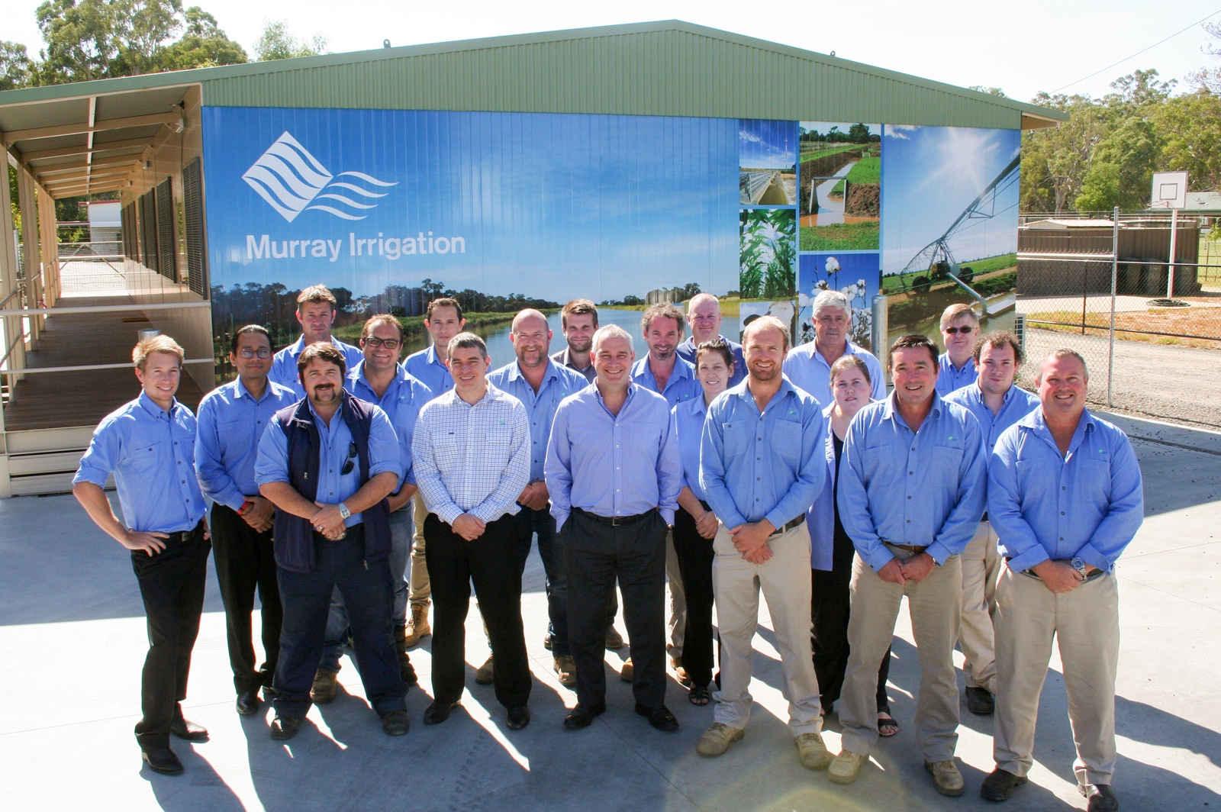

**While Murray Irrigation and its team of engineers pioneered most of the initial design, PIIOP2 engaged a civil contractor in ERTECH to assist in project management and support project leads and project/design engineers.**

Key dates for the project were:

* July 2011 - Final Submission to Government
* September 2012 - Executed Funding Agreement
* June 2014 - $206M budget approved by Board
* June 2015 - New CEO Michael Renehan appointed to MIL
* March 2016 - Project Report
* October 2017 - Project complete

## 14.1 Construction management

In mid-2014, a significant reset in project management and scope occurred, removing the Channel Lining sub-project and reviewing the economics of upgrading low demand outlets. In 2015, PIIOP2 had greater project certainty and a refocused scope, which increased the financial demand for the upgrades to $206M.

To ensure cost effectiveness together with the highest quality construction, the following processes were implemented:

#### Site inspections

All sites were inspected, photographed and surveyed for any potential issues that might impact construction. Outlet sites were inspected after consultation with the landholders.

#### Site Design Sheet (SDS)

Following site inspection, a detailed SDS was developed and once approved, passed to the construction contractors.

#### Work packs

Work packs were prepared for each site by the construction contractor. As well as the SDS, the pack also contained appropriate permits and Safe Work Method Statements (SWMS).

#### Pre-construction inspections

The inspections were undertaken by project supervisors and the construction contractor. During this inspection, work permits were identified and issued by the supervisor to the contractor.

#### Supervision

All work sites were visited by project supervisors to ensure compliance with HSEQ policies and procedures, and to ensure the site was being constructed in accordance with the SDS issued for that site. Where changes to the SDS were necessary, the supervisor would issue a Site Instruction to the contractor, a copy of which was placed within the work pack.

Finally, the construction process was completed when the site was accepted following a final compliance inspection, also copied into the work pack. After this the site was released to Murray Irrigation for commissioning.

## 14.2 Design approach

The design process was generated to create safe, premium and quality assets and products.

The process consisted of:

* Approval of design basis
* Development of standard designs for outlets and regulators
* Safety of assets in design review
* Third party asset design review
* Approval of standard designs for delivery and installation by Murray Irrigation

## 14.3 Planning and approvals

Planning and approvals during PIIOP2 were complex, with an intricate web of company, landowners and councils involved.

The company, its engineers and project leads needed to strike a subtle balance between all stakeholders in the project to deliver it on time, with quality and with minimal disturbance to third parties.

The project necessitated an integrated development application process with local councils, in particular, for sub-projects such as sub-system retirement decommissioning works. The design approval process included a Hydrology Assessment, Environmental Flow Assessment, Biodiversity Report, and Heritage Assessment. For on-farm works on individual landholdings, the local councils needed integrated development application processes.

Water and Water Access Licenses were also transferred back where necessary.

The management, planning and approvals consumed a considerable amount of project leads’ time throughout each sub-project, working closely with all government agencies and departments over a seven year period to administer the project on behalf of the customers and Murray Irrigation.

## 14.4 HSEQ Management System

Safety

Management plan and policies

Murray Irrigation engaged ERTECH as an accredited firm under the Australian Government Building Construction WHS Accreditation Scheme, providing assurance of Worker Health and Safety, Quality, Environmental (WHSQ&E) system to be introduced to the project.

A Health Safety Environment Quality (HSEQ) Management Plan adopted throughout the duration of the project, helped staff to meet the requirements of the PIIOP project.

The plan identified the processes to be controlled and Australian standards to be met throughout the life of the project.

There were five major policies in place for PIIOP:

* Traffic Management Policy
* Safety and Health Policy
* Environmental Policy
* Drug and Alcohol Policy
* Injury Management Policy

Construction safety

The list of safety initiatives, procedures and their results as they were implemented in the project are below. They produced impressively safe conditions for workers and customers during the project and many are now ratified into the company’s broader safety culture.

|  |  |  |
| --- | --- | --- |
| Safety Procedures | Objective | Implementation |
| Toolbox Talks | Toolbox meetings were informal or formal meeting held by supervisors to promote safety and discuss work-related incidents. Toolbox talks were scheduled on a regular basis to:   * Highlight safety, quality and environmental issues; or in the wider community that might impact the project and its personnel; * Discuss the implementation of the WHS management plan; and * Provide opportunities for individuals to raise concerns | Compulsory Toolbox meetings were held monthly for all members of the PIIOP2 management, technical and supervisory teams.  Weekly Toolbox meetings were held by the PIIOP2 construction team  Monthly Toolbox meetings were held by construction contractors |
| Pre-Start | Pre-start meetings provided the opportunity to discuss site or job specific safety instructions, changes in work procedures and work practices, changes in rules and regulations, and any other relevant information. | Pre-start meetings were held on every work site at commencement of work. |
| Safe Start Work Method Statements (SWMS) | The primary purpose of the SWMS is to help supervisors, workers and anyone else at the workplace to understand the requirements that have been established to carry out site works in a safe and healthy manner. The SWMS:   * describes the activities or tasks to be undertaken * identifies the resources, manpower and skills associated with the tasks * assesses and selects control measures * plans the activities so they can be completed efficiently and effectively. | SWMS documents prepared for each construction site |
| Incident | An incident is any occurrence that resulted in, or had the potential to result in, harm to people, the environment, property or reputation, or a combination of these.  All incidents were recorded, analysed and appropriate actions undertaken to reduce future risks. | A total of 171 incidents were recorded during the project. Reflecting the remote rural nature of much of the project area, it is noted that many of these incidents related to vehicles hitting or nearly hitting kangaroos while driving to or from work sites. |
| Hazob card | Hazob cards are a simple method to identify and record potential hazards and risks associated with a task or work site that could impact workers or the surrounding environment. | 977 Hazob cards completed |
| Layered Audits | Layered audits are undertaken to ensure that procedures and activities are following those described in the Management plan and SWMS. | 439 Layered audits complete |
| Inspections | Inspections are undertaken to ensure machinery and equipment is appropriate for the task and complies with relevant safety guidelines and regulations.  Examples of inspections undertaken include:   * Mobile equipment such as excavators; * Lifting equipment such as chains and shackles; * Safety equipment such as fire extinguishers. | 984 Inspections completed |
| Environmental KPIs | Mandated environmental KPIs to ensure appropriate and consistent monitoring of environmental impacts. | One environmental hazard assessed per month, one toolbox topic every six months and one layered audit every quarter |

Environment

Protection of the environment measures were outlined in the HSEQ Management Plan. Aspects included land disturbance, water, flora, fauna, waste, noise, rehabilitation, indigenous and heritage protection. Environmental Key Performance Indicators (KPIs) were also in place to ensure appropriate monitoring of environmental impacts. All relevant heritage applications were received and approved.

The KPIs for environmental protection were:

* One monthly Environmental Hazard audit
* One Environmental Toolbox Topic every six months
* No spills over 150 litres (no spills took place)
* One layered audit per quarter
* 100 percent compliance with dieback management and weed control procedure (compliance achieved)

Environmental Controls

* General
* Environmental Awareness
* Waste Management
* Clearing and Grading
* Erosion Control
* Hydrocarbon Management
* Weed Control
* Site Clean-up and Rehabilitation
* Hazardous Materials Management
* Dust, Noise and Vibration
* Aboriginal Heritage and Monitoring

Each section specified a control procedure and relevant documents for environmental issues. Most of these issues were then identified as Environmental Risks and the control measures listed in the Risk Assessment were designed to mitigate all environmental issues.

Post-construction, environmental audits were conducted on one-to-two sites for all 30 operational areas. The audits examined:

* Land disturbance
* Water bodies
* Native fauna
* Native vegetation
* Stockpiling
* Waste
* Surrounding assets and stakeholders.

The findings of the environmental audits identified:

* The PIIOP2 project has had minimal impact on the surrounding environment as most of the works were within the existing channel and its footprint.
* Native vegetation removal was minimal. Where sites did require tree removal, it was to ensure the safety of workers or the effective function of solar panels.
* Contractors needed to ensure they were removing all waste from the site at the end of construction.

## 14.5 Challenges, amendments and lessons

Challenges

* A large number of construction sites spread over an area stretching from Mulwala in the east, 75km north-north-west to Jerilderie, 160km west to Moulamein, nearly 50km towards Swan Hill then back to Mulwala. This necessitated significant attention to logistics and scheduling.
* A complex consultation process with individual landholders which lead to delays in finalising scope.
* A large number of remote sites, often with poor or difficult access, especially after rain events.
* Poor mobile phone coverage in much of the above area hampering communications with site personnel.
* Temperatures that varied from freezing to 45 degrees celsius.
* Hazards such as snakes and other wildlife.
* In 2016 the wettest winter in recorded history, culminated in floods in part of the project footprint.
* Poor initial project forecasting and management which lead to a greater than budgeted Murray Irrigation financial contribution.

Lessons learnt

* More resources dedicated to planning and customer
* Consultation to develop the outlet implementation criteria and increased consistency across the footprint.
* Align databases and procedures to connect the key stages of construction i.e. consultation, design, construction, commissioning, updating control systems.
* Investigate the operating parameters of new outlets more thoroughly to better explain to customers and reduce issues.
* Better inform customers on the stages of automation and construction to reduce misunderstandings.
* Establish a panel to consider and respond to unique circumstances and anomalies through the consultation process.

Removal of Channel Lining sub-project

The removal of Channel Lining came after a significant project reset by the Board in mid-2015. The Board did not want a liner installed with a 40 year asset lifespan. Such a small replacement window would have meant significant planning, construction and consultation costs resulting in an asset that would need to be regularly upgraded.

Murray Irrigation would bear the cost of the maintenance, which would be substantial, particularly difficult without a funding collaborator. Murray Irrigation engineers maintain that lining the channels with imported clay would be a more sustainable and cost-effective option for this type of subproject.

# 15 Communications and marketing

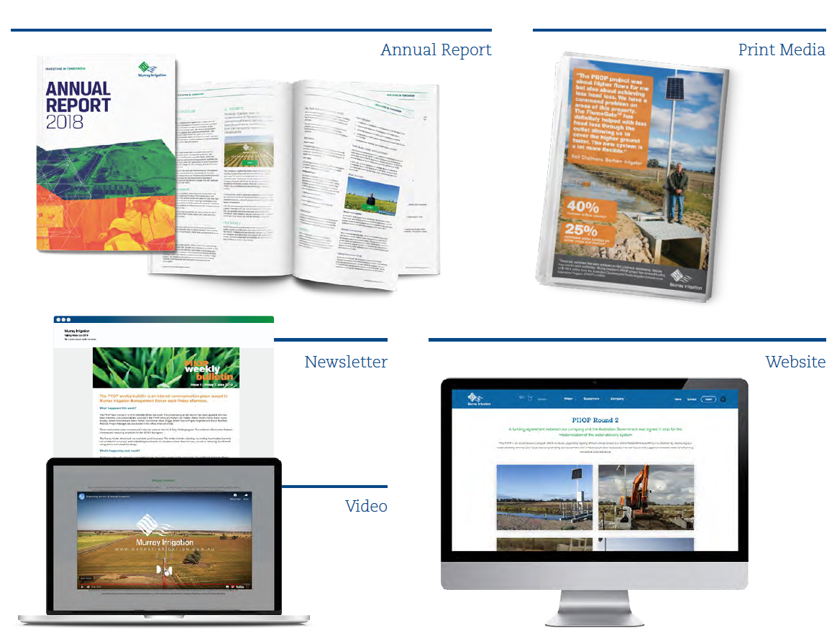

## 15.1 Media

Communications activities addressed a range of proactive and reactive needs. The most pivotal was ongoing and frequent customer engagement.

#### Print media

Focused on local newspapers (Southern Riverina News, Pastoral Times, Riverine Herald and FarmTalk) and included operational updates and testimonials from landowners positively impacted by the project.

#### Feature story

A 10 page feature story was published in four local newspapers, detailing contractors, employment opportunities, impacts on customers and the region and more.

#### Signage

High impact signs were installed at every PIIOP2 site entry point to increase safety and generate project awareness.

#### Website

Since the commencement of the project, the website hosted a PIIOP2 updates page, explaining the project's overarching purpose and featuring status reports.

#### Weekly newsletter

Murray Irrigation's Talking Water newsletter is sent directly by email and fax as well as promoted on Twitter and the Murray Irrigation website. Talking Water frequently focused on important operational project information.

#### Murray Irrigation's Annual Report

Each annual report contained at least one dedicated section to PIIOP2 explaining objectives, results and future directions.

#### ***Media releases***

Over 10 media releases were issued in support of the achievement of any major milestone.

#### Video

A suite of four video vignettes featuring visual media to show project sites, customer testimonials and relayed important operational benefits.

## 15.2 Internal engagement

MILTalk

Monthly workplace newsletter that provides news covering all areas of the business, with at least one educational column dedicated to PIIOP2.

Toolbox Talks

Regular meetings with construction managers and leads featured priority information and focused on safety.

Intranet

MILi (the Murray Irrigation intranet portal) was launched to serve as an access point and central information platform with specific sections dedicated to PIIOP.

## 15.3 External engagement

Consultation

Murray Irrigation developed Customer Consultation Criteria tailored to meet the requirements of a diverse customer base.

1. Customer information workshops

Customer feedback indicated that conducting pre- consultation information workshops helped to position the project and manage expectations. Customers’ responses to the 2016-17 consultations noted that, on average, 96 percent received the information and found it useful.

Before consultation officers visited landholdings, customers were contacted by phone. This prepared them to consider their business needs and what opportunities existed to rationalise their on-farm infrastructure.

1. Desktop assessment

The landholding that is owned by the customer was assessed and a map was produced showing the location of the asset, the Murray Irrigation channel and drainage system, the height of the asset and roads. At this point, potential for amalgamation, reconfigurations and overall water use was considered. This information defined customer eligibility and what incentives were available to rationalise infrastructure.

1. Stage 1 assessment

Information from the desktop assessment was compiled, along with maps and checklists, into a Stage 1 Assessment Form that was used in preparation for the on-farm consultation.

1. Customer meeting

The on-site meeting was held, with the opportunity to inspect the asset and clarify needs the customer had. The upgraded criteria and eligibility conditions was explained to the customer, and a checklist, covering asset types, fees, service levels, decommissioning, flow shares and restrictions was completed. An outcome was negotiated to meet customer needs, in-line with the guidelines and policies of the program.

1. Customer follow up

Follow up actions generated by onsite meetings were investigated and reported back to the customer before the Notice of Assessment was finalised.

1. Notice of Assessment

A Notice of Assessment was sent to the customer which outlined the outcome of the consultation and any further follow up. The customer was given up to 30 days to consider this outcome and respond with modifications to the agreement.

1. Design

The design commenced once the Notice of Assessment had been issued and the 30 day period had lapsed. Design was completed by engineers and all equipment required for the upgrade was procured.

1. Notification of Works

A Notification of Works was sent to the customer outlining that construction was imminent and a contractor would work with them to ensure no interruption to supply.

1. Contact by contractor

The contractor spoke with each landholder prior to installation to confirm customer approval. The priority was to ensure no interruption to the customer's watering regime.

Once the construction and upgrades were completed, the asset was commissioned and into service.

1. Customer Survey Following Construction

## Post-project satisfaction

Murray Irrigation surveyed key customers post-project to determine their level of satisfaction with consultation, construction and their user training.

Overall, the results of the survey showed a positive perspective on how contractors communicated with customers. There were slight variations between the years. The most notable is an increase in relevance of information provided to customers between 2016 and 2017:

Construction — % of customers who said 'yes'

|  |  |
| --- | --- |
| Did you receive a Notification of Works letter before construction? | |
| Apr 16 – Jun 16 | 93% |
| Jul 16 – Sep 16 | 96% |
| Oct 16 – Dec 16 | 100% |
| Jan 17 – Mar 17 | 100% |
| Apr 17 – Jan 17 | 98% |
| Was it sent in a timely manner before construction? | |
| Apr 16 – Jun 16 | 90% |
| Jul 16 – Sep 16 | 96% |
| Oct 16 – Dec 16 | 100% |
| Jan 17 – Mar 17 | 100% |
| Apr 17 – Jan 17 | 98% |
| Was the information in it useful? | |
| Apr 16 – Jun 16 | 88% |
| Jul 16 – Sep 16 | 95% |
| Oct 16 – Dec 16 | 100% |
| Jan 17 – Mar 17 | 100% |
| Apr 17 – Jan 17 | 98% |
| Did the contractor contact you before the outlet was installed? | |
| Apr 16 – Jun 16 | 93% |
| Jul 16 – Sep 16 | 95% |
| Oct 16 – Dec 16 | 100% |
| Jan 17 – Mar 17 | 100% |
| Apr 17 – Jan 17 | 98% |
| After the works were completed, were you satisfied with the overall works and the way they tidied up and left your farm? | |
| Apr 16 – Jun 16 | 98% |
| Jul 16 – Sep 16 | 96% |
| Oct 16 – Dec 16 | 100% |
| Jan 17 – Mar 17 | 100% |
| Apr 17 – Jan 17 | 98% |

Construction — Satisfaction out of five

|  |  |
| --- | --- |
| How satisfied were you with this contractor's communication with you? | |
| Apr 16 – Jun 16 | 4.25 |
| Jul 16 – Sep 16 | 4.25 |
| Oct 16 – Dec 16 | 4.75 |
| Jan 17 – Mar 17 | 4.6 |
| Apr 17 – Jan 17 | 4.5 |
| How satisfied were you with this contractor's professionalism while working on your property to install the outlet? | |
| Apr 16 – Jun 16 | 4.6 |
| Jul 16 – Sep 16 | 4 |
| Oct 16 – Dec 16 | 4.6 |
| Jan 17 – Mar 17 | 4.4 |
| Apr 17 – Jan 17 | 4.6 |

Customer Training — % of customers who said 'yes'

|  |  |
| --- | --- |
| After the outlet was installed you should have been shown how the new outlet works by your channel attendant. Did this occur? | |
| Apr 16 – Jun 16 | 48% |
| Jul 16 – Sep 16 | 55% |
| Oct 16 – Dec 16 | 88% |
| Jan 17 – Mar 17 | 100% |
| Apr 17 – Jan 17 | 46% |