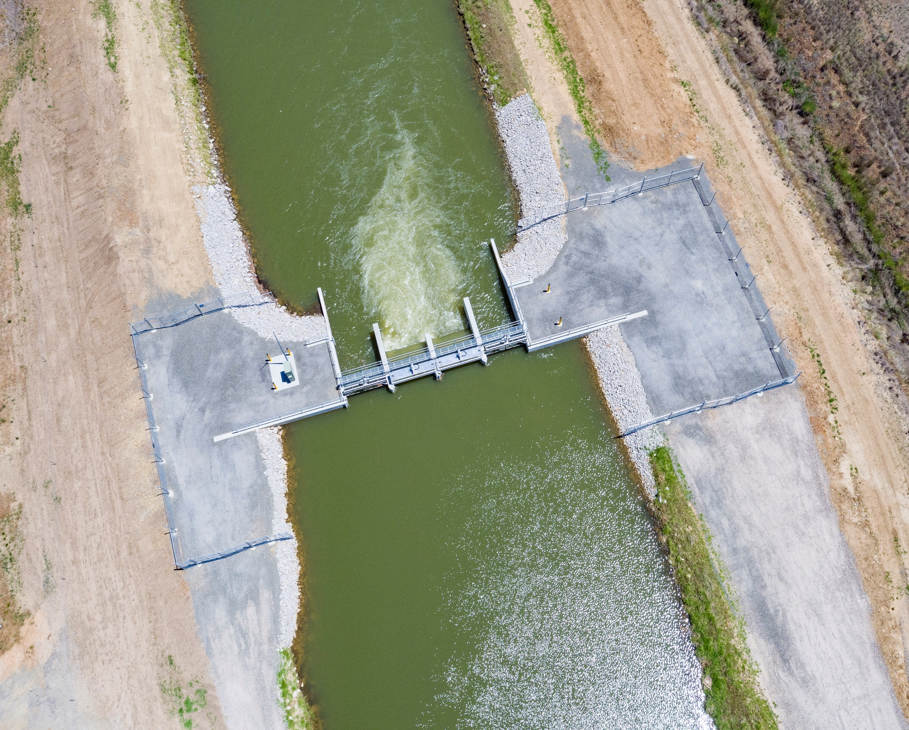

|  |
| --- |
| FUTURE PROOFING THE ARTERIES |
| PRIVATE IRRIGATION INFRASTRUCTURE OPERATORS PROGRAM IN NSW (PIIOP)  ROUND THREE  FINAL REPORT |
| OCTOBER 2019  Murray Irrigation Limited |

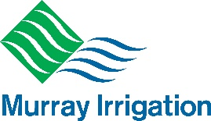

**Table of Contents**

Chief Operating Officer’s Report 3

Executive Summary 4

Executive General Manager – Major Engineering Project’s Report 5

Investing in our main arteries 8

Delivering Outcomes 11

**Scope** 11

**Delivery Methodology** 16

**Work Health and Safety** 20

**Environment** 22

**Local and Regional Industry Participation** 22

**Associated Community Benefits** 23

Communicating with Stakeholders 24

**Media** 24

**Internal communication** 26

**External communications** 26

# Chief Operating Officer’s Report

Scott Barlow

*AssocDip Applied Science*

Upgrading significant and iconic infrastructure always requires careful planning and consideration. When its primary purpose is to deliver the most precious commodity in Australian agriculture, its fast, efficient and successful implementation becomes significantly more important to the communities and businesses which it supports.

Murray Irrigations strategic plan focuses on three key areas - Water Delivery, Water Security, and Water Attraction/Retention. Accordingly, the main objective is to ensure that the quantity of water available to deliver effective services is protected and enhanced, and that the systems to deliver that water are flexible and cost effective.

The Private Irrigation Infrastructure Operators Program in NSW (PIIOP) program has previously given the company the ability to deliver class-leading irrigation strategies to its customers through Rounds one (PIIOP1) and two (PIIOP2). Our participation in the PIIOP program has set us up as one of the most efficient gravity-fed irrigation systems in Australia. Murray Irrigation now prides itself on safely delivering fast and reliable water to its customers, which combines the benefits of modern technology with innovative infrastructure which provides a comparatively low-cost, highly reliable service.

The Private Irrigation Infrastructure Operators Program in NSW Round 3 (PIIOP3) built on the achievements delivered under the company’s participation in the PIIOP2 program, and gave an opportunity to perform an extensive upgrade of major regulating structures on key canals and channels; our network’s backbone. Significant opportunity now exists within our network to further improve delivery efficiency, customer service levels and supply reliability.

The success of the project undoubtedly centred on the strength of the relationships. Our Major Engineering Projects Team along with the Department of Agriculture, have been firm, fair, flexible and responsive with both parties benefitting from regular and transparent communication. Our main contractor, Ertech Pty Ltd, and our main suppliers were brought on board early and delivered excellent results. Their efforts, coupled with our own project leads and in-house staff, minimised the impact on service levels and our customers throughout the project.

# Executive Summary

This Final Report to the Department of Agriculture represents the activities, expenditure and conduct of Murray Irrigation’s participation in the Australian Government’s Private Irrigation Infrastructure Operators Program in NSW Round 3.

**The Work Site**

Murray Irrigation’s infrastructure comprises 2,778km of earth-lined channels that are linked to the nation’s most significant privately-owned asset: the iconic 156km-long Mulwala Canal. The company’s 2,153 landholdings operate irrigated agricultural enterprises covering 724,000ha and contribute significantly to the $1.6B of gross value agricultural production coming from the Murray region.

**Deliverables**

Initially set up to deliver five sub-projects, PIIOP3 deliverables changed to represent value for money and needs for Murray Irrigation and its wider community with the approval and delivery of two sub-projects.

The two selected projects, Sub-project 1 Escapes and Sub-project 4 Upgrading main canals infrastructure, sought the upgrading of controlling assets that can generate water savings and value add to Murray Irrigation operations and infrastructure. A total of 48 assets were upgraded as follows:

* 4 Under Sub-project 1
* 44 under Sub-project 4

**Customers**

Murray Irrigation exists to service its customers and they remained uppermost in the planning, consultation and assessment processes. After PIIOP3, Murray Irrigation’s customers enjoy assets with an extended life, that control flows and water levels, to allow for greater operational flexibility and efficiency.

Overall, a complete package of works that provide a sense of achievement, pride and demonstrated water savings to all parties involved; including our community, contractors, suppliers, directors and government officials.

# Executive General Manager – Major Engineering Project’s Report

**Warren Jose**

*BEng, MEngSc, MIE Aust.*

**Overview**

Murray Irrigation is now a modern irrigation and environmental water delivery business. By investing over $250M since 2013, Murray Irrigation now has a modern fit-for-purpose, remotely-controlled, irrigation delivery network, capable of delivering over 1000GL per year.

In late 2016, Murray Irrigation secured funding from the Australian Government’s Round 3 Private Irrigation Infrastructure Operators Program in NSW for the modernisation of its irrigation regulator control structures in the main canals. The objective of the investment was to improve operational safety, decrease leakage across the structures and to enhance control of the supply levels.

The completion of PIIOP3 means that Murray Irrigation has successfully modernised the irrigation network, setting itself and its farmers up for a prosperous future.

**Innovation**

Over this journey, we applied some innovative approaches to reach our deliverables:

*Two-Step Sub-project Approval Process*

One of the key innovation steps we developed with the Department was the use of a two-step sub-project approval process, very similar to a traditional Design and Construct process. This allowed Murray Irrigation to commence spending funds to progress projects to a point where scope and budget certainty could be agreed between the parties.

*Network Optimisation Study*

The Network Optimisation Study was a comprehensive economic viability investigation of the Murray Irrigation network to understand the operational performance of our individual Operating Areas. The study was required to identify, develop and propose commercially viable sub-projects, which would enable Murray Irrigation’s Management, CEO and Board to make an informed decision on the use of the PIIOP3 funding.

As part of these activities, we:

* mapped the entire gravity irrigation network using geophysics methods, to identify sections of channels that were prone to high seepage, that could be refurbished and repaired
* conducted a review of historical water demand within the Murray Irrigation footprint to annually determine where water was delivered and where utilisation of the scheme was low
* developed a whole-of-business asset economic business model that helped determine the economic performance of each Operating Area
* developed Business Cases for the implementation of Channel Remediation – a sub-project that ultimately did not proceed.

*Irrigation Gate Technology Review*

Murray Irrigation has a mix of irrigation gate technology, with two key suppliers’ assets present in its system: AWMA and Rubicon. With engineering experts, Jacobs, we reviewed irrigation gate technology to guide our decision-making when sourcing irrigation gates for the larger regulators on the main canals. This process was very successful and we leveraged the strength of both suppliers to suit our needs.

*Channel Remediation Industry Benchmark Review*

Murray Irrigation and Jacobs, completed a benchmark review of industry projects that have employed channel remediation techniques over the last 10 to 15 years. With more than $300M spent in the sector on channel lining and remediation/rebuilding activities, this study saw a sound document on which to base future decisions. Ultimately, Murray Irrigation decided not to proceed with any channel lining activities.

*Use of ECI process for Main Canals Works*

Murray Irrigation implemented an Early Contractor Involvement (ECI) process to manage the risk of project delivery in the short 13-week winter closure period. Of all project variables to manage, the time the system could be taken off-line was considered the most important to manage. We engaged Ertech, as our construction partner, on an ECI process, including them in all design activities, undertaking pre-construction site works and managing or mitigating risks months before site works began. This successful process was used in all three Winter Works.

*Summary*

The PIIOP3 project provided Murray Irrigation with rejuvenated infrastructure in its accredited escapes and main canals. It also provided a detailed overview of the business’ finances and infrastructure through the Network Optimisation Study, which informed the viability of sub-projects.

Delivered works, specifically the escapes and main canal upgrades sub-projects, were completed on time and on budget, with zero Lost Time Injuries.

Murray Irrigation has now built upon its PIIOP2 and PIIOP3 activities and has a modernised irrigation operation which is a model of how government and private irrigation companies can deliver complex and beneficial projects together.

Congratulations to the entire team.

# Investing in our main arteries

The completion of PIIOP2 enabled remote control and partial automation of the irrigation network, connecting the company and customers through technology. This move toward automation allows greater flexibility of service levels for customers. The ability to monitor and manage channel conditions remotely 24 hours per day has increased system efficiency and flexibility.

The PIIOP2 project focused primarily on replacing customer supply points (farm outlets) and the regulator infrastructure (channel height regulators) within the lateral channel network. To maximise the benefits of the move towards automation, the main canals of the Murray Irrigation channel network which form its backbone needed to be upgraded.

Under PIIOP3 our focus moved to the main canals. The Mulwala Canal is the largest channel within the network and in conjunction with the Deniboota Channel, Berrigan and Wakool Main Canals, delivers water to the entire footprint. Historically these large channels have been operated manually, with basic remote-control technology implemented during the early 1990’s.

Upgrading the regulators along the network backbone realised improved control technology, providing an opportunity to generate water savings from time-critical events like rain and increasing efficiency while filling and draining the system. The minimal leakage coming from the new regulators also generates flexible delivery options, including retaining and delivering water over the winter period.

The Edward River Escape is one of the company’s greatest assets. This Escape delivers water into the Edward River, Deniliquin’s iconic river that splits the town in two. The Escape underpins commercial arrangements with State and Australian Government agencies on river operations and environmental watering. These agencies similarly benefit from the PIIOP3 investment and increased flexibility.

PIIOP3 has increased the life of the regulators on the network backbone which were reaching the end of their mechanical life, enabling the company to move to further automation and provide improved service standards.

**How the scope evolved**

The Major Engineering Projects department was instructed in late 2015 to continue with the assessment and proposal of the PIIOP3 funding application which finalised Murray Irrigation’s journey to modernisation.

Murray Irrigation signed the funding deed with the Australian Government for $114.8M (with the organisation contracted to contribute a further $5.8M towards Sub-projects 2,3 and 5 in December 2016 in exchange for 28GL (18GL of General Security and 10GL of Conveyance water).

The five sub-projects proposed for PIIOP3 were:

* Sub-project 1 Escapes (SP1)
* Sub-project 2 Reconfigurations (SP2)
* Sub-project 3 Sub System Retirements (SP3)
* Sub-project 4 Upgrading Main Canals Infrastructure (SP4)
* Sub-project 5 Stock and Domestic Schemes (SP5).

This agreement was structured to allow Murray Irrigation to explore the sub-projects and their feasibility. This two-step approach gave the Board the option to approve or reject sub-projects based on business viability.

In early 2017 Murray Irrigation’s Board approved two sub-projects:

* SP1 Escapes
* SP4 Upgrading main canals Infrastructure.

In the meantime, the Major Engineering Projects department began developing the ‘Network Optimisation Study’ (NOS). The NOS was designed to assess the financial viability of the entire irrigation system. With this study and the lessons learnt from PIIOP2, Murray Irrigation concluded that sub-projects two (Reconfigurations), three (Sub System Retirements) and five (Stock and Domestic Schemes) did not represent value for money and their implementation would disadvantage the organisation’s fee system and its customers.

By June 2019, Murray Irrigation announced the conclusion of PIIOP3 activities, with the final Australian Government funding reduced to $50.5M for the transfer of 8,224ML of Conveyance water entitlements linked to the Board approved sub-projects SP1 Escapes and SP4 Upgrading main canals infrastructure.

# Delivering Outcomes

## **Scope**

Under the approved sub-projects SP1 ‘Escapes’ and SP4 ‘Upgrading Main Canal Infrastructure’, a total of 48 assets were upgraded (four under SP1 and 44 under SP4).

The main objectives of these upgrades were:

* provide control of flows and water levels through upgrading gates, seals and water level sensors
* provide, at a minimum, 25-year asset design life through improving the civil structure, replacing mechanical gates (25-year aluminium gates to 50-year stainless steel gates) and refurbishing existing gates
* operate in Auto Central Remote-Control mode through upgrading the telemetry and positioning equipment (actuation and rotatory positioning sensors).

Types of scope

When assessing assets and sites to be upgraded, different types of scope were nominated by project leads:

* New asset: a complete upgrade of the existing structure. Includes civil, mechanical and electrical works.

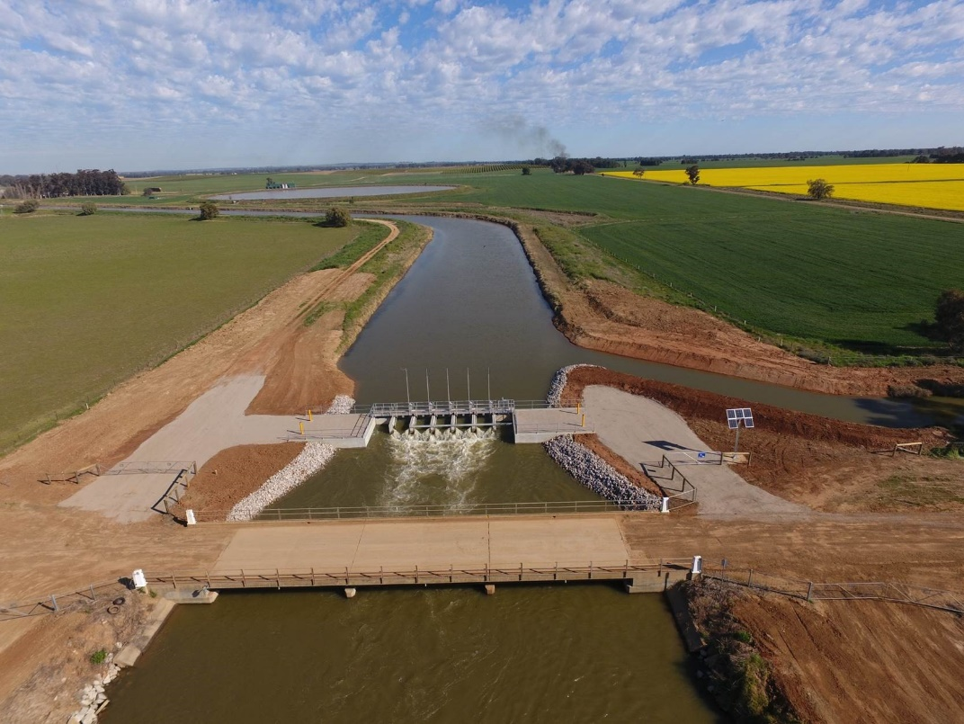

Photo 1 Berrigan 4 New Regulator

* Upstream extensions: a new addition to the existing civil structure (e.g. road bridge) that includes new civil, mechanical and electrical works.

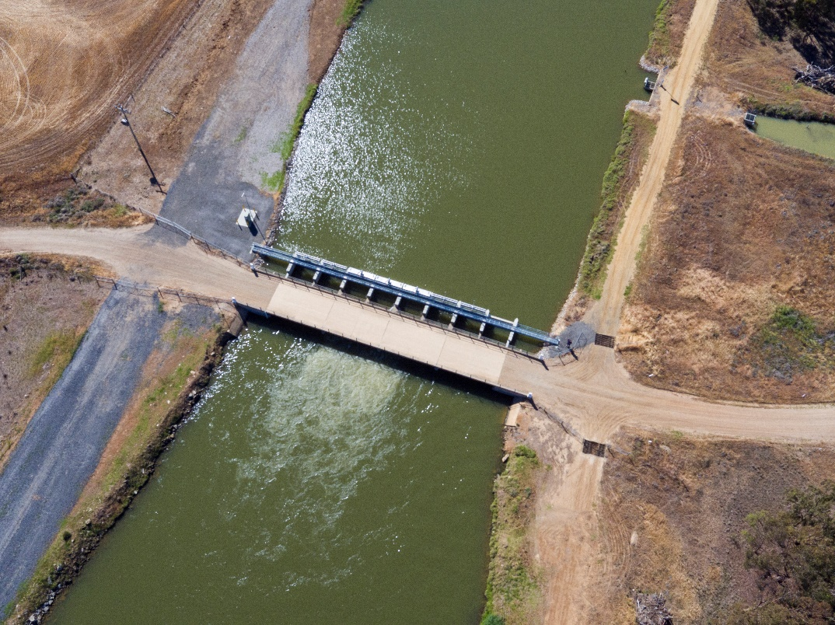

Photo 2 Sandford’s Upstream Extension Regulator

* Retrofits: minor civil modifications to the existing structure to enable new mechanical gates to be installed with electrical replacements.

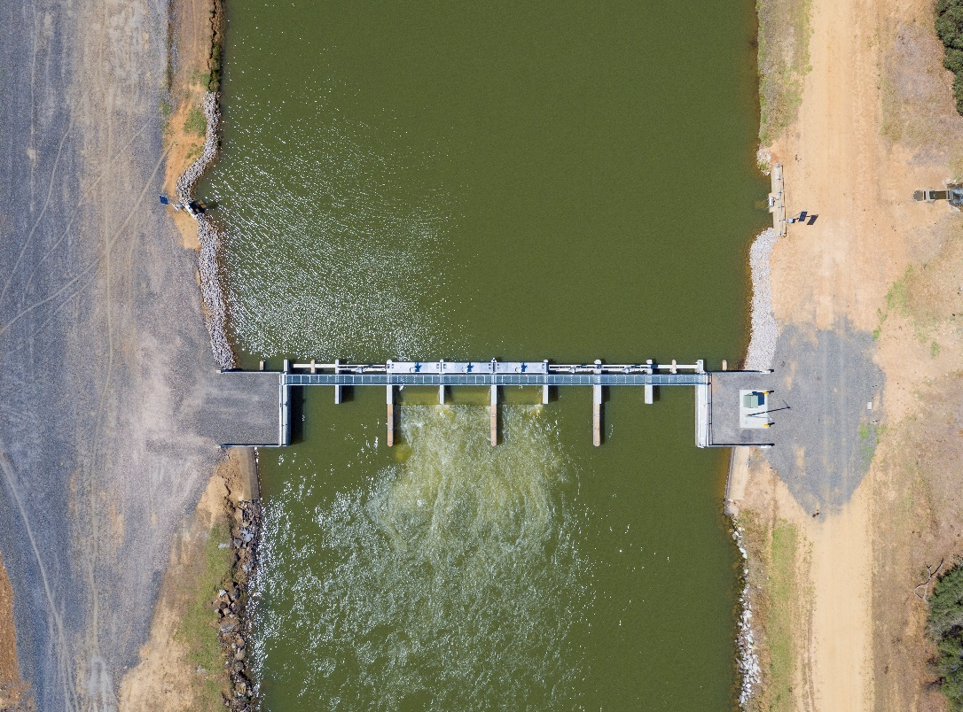

Photo 3 Alexander's Retrofit Regulator

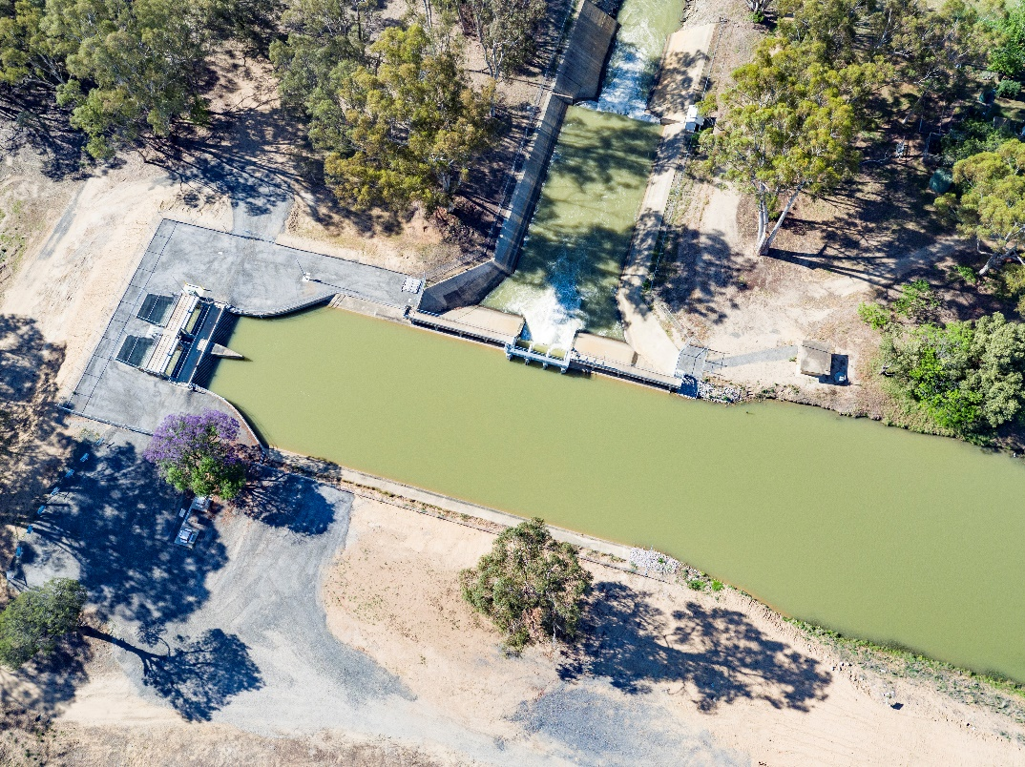

Photo 4 Lawsons Syphon and Edward River Escape Retrofits

* Mechanical and electrical: refurbishment of the existing assets by:
  + replacement of seals and sealant around the existing mechanical gates
  + replacement of electrical and telemetry components
  + installation of water level sensors and rotatory position equipment
  + replacement of existing walkways/handrails with Australian Standards-compliant walkways/handrails
  + upgrade of civil features (e.g. erosion protection and operational access).

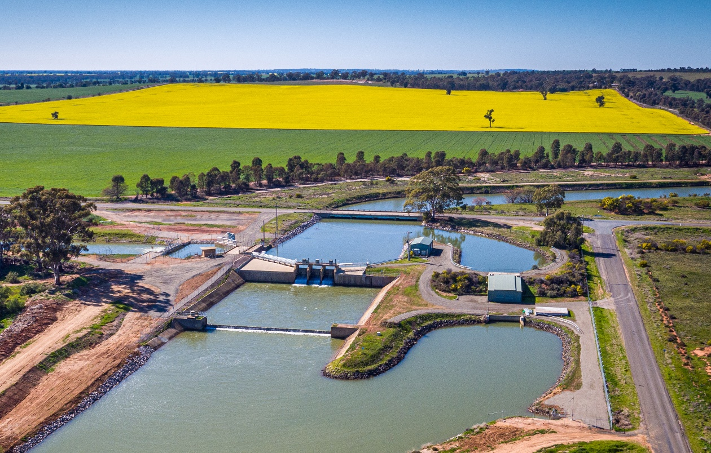

Photo 5 The drop Mechanical Electrical Upgrades

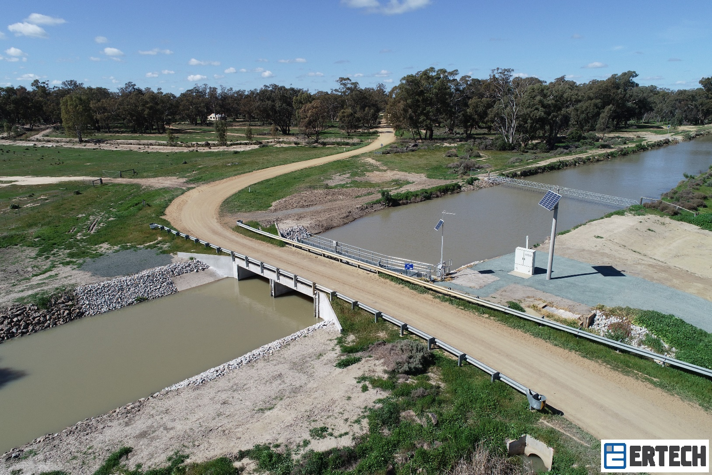

Photo 6 NBC Regulator 4 Mechanical Electrical Upgrades

Construction Key Statistics

|  |  |
| --- | --- |
| Key Item | Statistic |
| Concrete poured | 5,484m3 |
| Steel reinforcing | 292 Tonnes |
| Rock beaching spalls | 7,754 Tonnes |
| AWMA SS Gates | 91 Custom fabricated water control gates  250 Tonnes of grade 304 Stainless Steel  1.43km of Stainless Steel wire rope  27,000 Stainless Steel bolts  7.5km of weld |
| Winter program expenditure | Average $1.3M per week over 13 weeks. |

## **Delivery Methodology**

The key risks managed over the three Winter Construction Works programs were:

1. The scope of works is completed within the agreed works period. Customer requirements were considered before each Winter Construction Works period, scheduling to only allow minor disruption and/or no disruption for when the irrigation season would begin.
2. All constructed works achieve their quality outcomes, which was essentially their intended asset design life. Quality planning and implementation between Murray Irrigation and the contractors/suppliers was a key focus following the award of contracts.
3. The constructed works be delivered within budget, meaning no additional funds could be sought to complete the works.

To manage the three risk areas, two parallel procurement processes were created to select the main construction partner and key suppliers of the project.

During 2017, Murray Irrigation awarded contracts to the following companies:

* The Wedge Group as the lead designer.
* Ertech Pty Ltd as the construction partner.
* Rubicon Water as the gate supplier for the Berrigan System and accredited escapes.
* AWMA as gate supplier for the Mulwala and Wakool Main canals
* Metroid Electrical as the electrical control equipment supplier for the Mulwala Main Canal, Wakool Main Canal, Northern and Southern Branch Canals.

The team, comprising representatives from the above companies, had an objective of working collaboratively to develop a detailed scope of works and deliver the most significant asset upgrade program that Murray Irrigation had embarked upon since its irrigation network was first constructed 80 years ago.

Based on the above, the delivery of construction within the specified timeframe was determined as the most challenging activity, especially for works in the main canals. As a result, the contractual methodology implemented by Murray Irrigation’s Major Engineering Projects Team, Early Contractor Involvement (ECI), provided the following benefits:

* allowed Murray Irrigation to have a lean managing team
* allow Murray Irrigation to trial its delivery methodology progressively over the project program which resulted in contractor performance evaluation and lessons learnt for next season
* allow the scope to be clearly defined with the direct input of the construction partner, which reduced Murray Irrigation’s risk within construction and transferred it to unknown construction activities (e.g. poor soil foundations).
* allow the contractor to organise itself with enough anticipation for the winter construction works. This resulted in better management systems, high safety and quality standards, and zero impact to Murray Irrigation operations after the agreed winter construction works timeframe.
* allow Murray Irrigation to control its budget by agreeing to lump sum contracts for each of the three winter construction works programs.
* provided Murray Irrigation with no cost blow outs and contractual disputes, as the relationship between the parties matured along the journey.
* allow Murray Irrigation to secure a skilled contractor when contractors scarcity was high-risk due to major federal irrigation modernisation programs being under construction in the Victorian and Murrumbidgee regions in parallel.

Maintaining Program Integrity

To demonstrate sound governance, an independent review of the procurement and deliverables was completed as part of the delivery of the program of works. The following Tier One consultancy companies provided the following services:

|  |  |
| --- | --- |
| Company | Scope |
| JACOBS Australia | Collaborative technical review of the design outputs from the lead designer. |
| JACOBS Australia | Development of technical specification and technical compliance review as part of the mechanical gate selection for the Mulwala Canal and Wakool Main Canal. |
| AQUENTA Australia | Provision of commercial training and advice during works and review of construction partner pricing. If required, act as a mediator in case of commercial dispute. |
| AECOM Australia | Structural condition assessment and development of detail scope of works for critical assets (greater than $50M in value), being Lawson Syphon/Edward River Escape and The Drop. |

Testimony of delivery partners

Ertech

“Ertech is very proud of the work it has completed on PIIOP3 with the support of Murray Irrigation and a host of local suppliers. The collaborative approach adopted by Murray Irrigation ensured that an ambitious program of works was delivered safely, on time and in budget. We understand how critical PIIOP3 is to the long-term prosperity of the community and we are grateful to Murray Irrigation for the opportunity be involved.”

*James Giumelli*

*Chief Executive Officer*

AWMA

“Over a period of two years, AWMA delivered 91 large stainless steel regulator gates and actuation systems into the PIIOP Mulwala canal upgrade project.

The gates were manufactured to a very high specification and were an integral part of the larger civil component of the project that was delivered under extremely tight programs through the winter period. Everyone had to work and communicate harmoniously and equipment had to be ready and viable to meet the deadlines.

From AWMA‘s perspective, the project went exceptionally well. I believe the primary reason for this was the emphasis that the PIIOP delivery team put on partnership and communication from the very beginning of the project. This was not just for show at the start, it was embedded in the culture of the project (just like safety) for the duration of the project, delivering excellent results.

The project was managed professionally and therefore has delivered sustainable infrastructure that will benefit Murray Irrigation for the next 50 years and beyond.

The project provided AWMA with sustainable work over two years that will have lasting benefits within the company and local economy. The lessons learnt working on large-scale, professionally-managed projects such as the Murray Irrigation’s Mulwala Canal upgrade also brings sustainable improvement in project delivery methodology and capability to the business.”

*Brett Kelly*

*Managing Director*

Rubicon

“As part of an ongoing program of works to modernise the Murray Irrigation network and following the successful completion of the PIIOP2 project, Murray Irrigation continued its engagement with Rubicon as a key partner and supplier for the PIIOP3 project. Throughout the project, we were engaged to provide professional services, hardware and commissioning of automation equipment on the Berrigan Main Canal and Accredited Escapes, along with telemetry system hardware for the Main Canals upgrade project. In combination with our hardware installations, the implementation of our SCADA and software solutions helped underpin the operations of these sites to improve water management and efficiency within these sections of the irrigation network.

Following the successful completion of the PIIOP projects, our team will continue to support the systems installed, assisting Murray Irrigation as they transition from a manually run system to operating a modernised and automated system.”

*Peter O’Donnell*

*Commercial Operations Manager - Australia*

Metroid Electrical

“Metroid was delighted to be selected as the switchboard supplier for PIIOP3. Being involved in a high-profile project was great for our company image and an opportunity to build our experience in larger projects.

In our experience, the PIIOP3 project was very well managed, with clear direction and regular communication from Murray Irrigation and other contractors.

The team at Metroid are very thankful for the opportunity to work with Murray Irrigation on PIIOP3 and subsequent upgrade work.”

*Jim Weeks*

*Operations Manager*

## **Work Health and Safety**

To comply with our funding deed obligations, the Major Engineering Projects department sought tenders from construction companies accredited by the Office of the Federal Safety Commissioner (OFSC) to participate in the delivery of PIIOP3 works.

Ertech was appointed as our construction partner. Murray Irrigation had previously benefited through Ertech’s involvement in its PIIOP2 program. During this time, Ertech had developed a thorough understanding of Murray Irrigation’s operations and infrastructure, and had directly contributed to the improved safety performance achieved throughout the company.

Murray Irrigation is proud to have achieved zero Lost Time Injuries (LTIs) during the execution of its PIIOP3 works. Over 175,000 labour hours were worked during the three-year period. Impressively, most works were completed in three 10-week long winter periods. This time constraint was particularly complex to manage and it is a credit to all teams, contractors and suppliers involved that they completed the package of works on time every year.

Works Statistics

|  |  |
| --- | --- |
| Total Working Hours | 175,000 |
| Total Incidents | 14 |
| Total Medically Treated Injuries | 0 |
| Total Lost Time Injuries | 0 |

Murray Irrigation’s roll out of the PIIOP3 Program safety results were achieved through the effective implementation of Ertech’s comprehensive safety management system which was underpinned by a healthy workplace culture. Workers were empowered to make informed decisions, remained risk aware, were actively rewarded for safe behaviours and were held accountable.

Representatives from the Australian Government conducted a safety audit each year on the project and improvements were always observed and implemented.

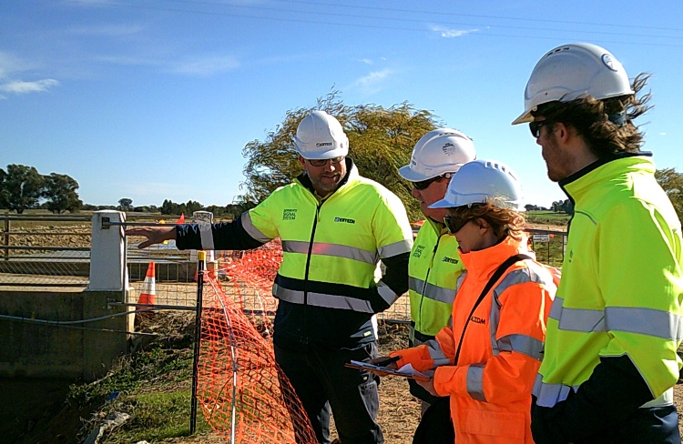

Photo 7 Department of Agriculture WHSE Audit in progress completed by AECOM

## **Environment**

To comply with its funding deed obligations, Murray Irrigationdeveloped an environmental management framework to guide its works program.

This increased focus on environmental management outcomes. Local government, road authorities, local communities and neighbouring landholders were better informed and the company’s statutory obligations to comply with cultural heritage/native flora and fauna were met.

## **Local and Regional Industry Participation**

Murray Irrigation and Ertech recognized the importance of involving local and regional businesses in the delivery of the construction works. During the three-year period the following $50M budget distribution was recorded:

* **40 percent local**: suppliers and contractors from communities within our footprint (i.e. Mulwala, Tocumwal, Cobram, Barooga, Berrigan, Finley, Deniliquin and Wakool)
* **50 percent regional**: suppliers and contractors around the region (i.e. Albury, Wodonga, Yarrawonga, Shepparton, Echuca, Moama, Bendigo, Barmah, Pyramid-Hill)
* **10 percent metropolitan**: specialist suppliers from state capital cities (i.e. Sydney and Melbourne).

At a time when drought had a significant impact on local and regional businesses, the PIIOP3 investment provided timely and effective support.

## **Associated Community Benefits**

Our positive relationships with local suppliers, developed over the three-year period, brought opportunities to ‘give back’ to the community. Redundant materials from the project such as timber formwork and scrap metal were donated to the Deniliquin Men’s Shed and Deniliquin Ram Football/Netball Club, helping to construct bird nesting boxes and complete improvements in their facilities respectively.

# Communicating with Stakeholders

## **Media**

Communication activities addressed a range of proactive and reactive needs. The most crucial was ongoing and frequent customer engagement, especially around safety.

Murray Irrigation recognised that most sites were to be delivered near major roads and our communications plan addressed this.

* Print Media
  + Focused on local newspapers and included operational updates and good news stories highlighting the positive regional impacts.

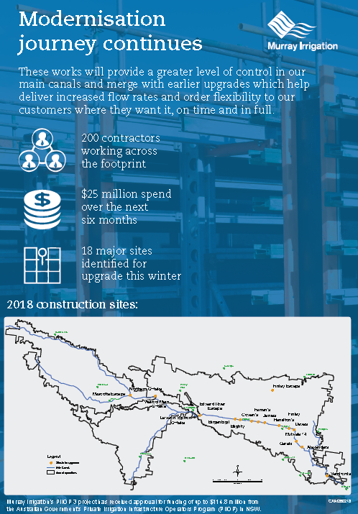

Figure 1 Sample of print media

* Billboards
  + Billboards were erected close to major infrastructure upgrade sites, aimed at highlighting safety on the roads at key work sites while simultaneously speaking to the positive impacts of the program.

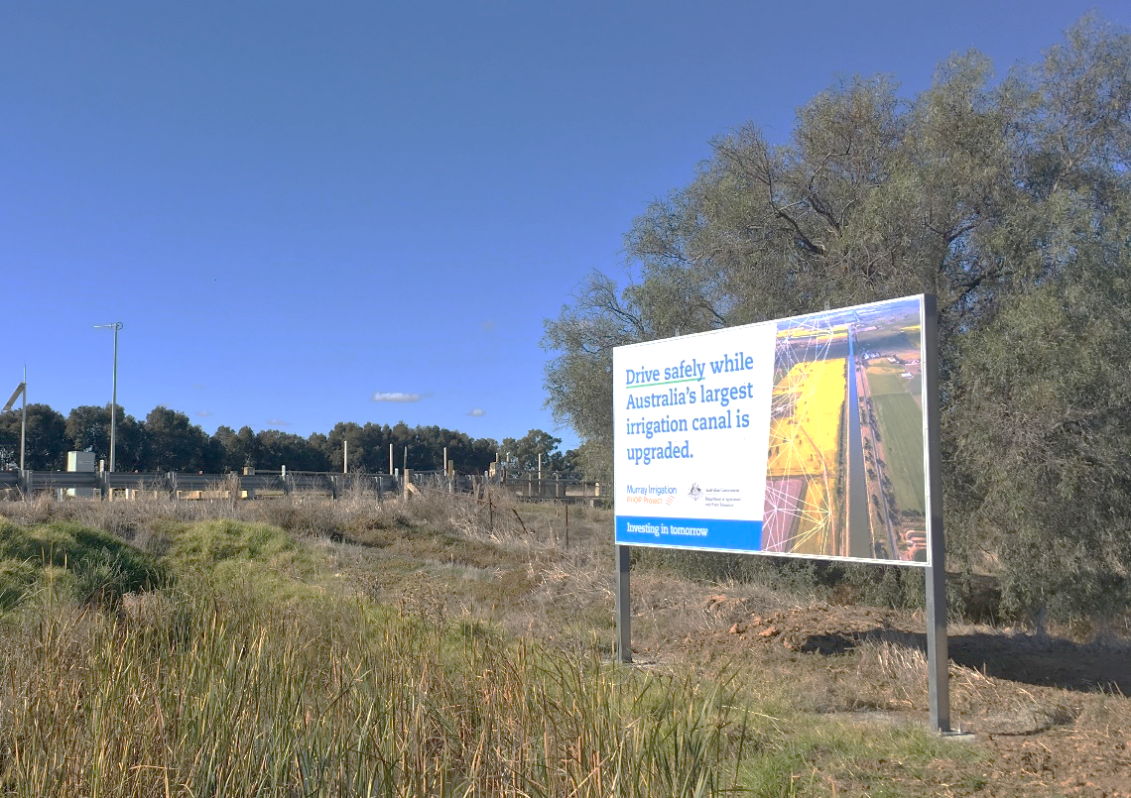

Photo 8 Billboards Sample

* Website www.murrayirrigation.com.au
  + Dedicated PIIOP3 page which housed photos and information.
* [Annual Report](https://www.murrayirrigation.com.au/wp-content/uploads/2018/10/Annual-Report-2018_Final-low-res.pdf)
  + The focus of the 2018 report was on major infrastructure success, in particular PIIOP3.
* [Talking Water](https://www.murrayirrigation.com.au/wp-content/uploads/2018/06/Talking-Water-01-05-2018.pdf) – shareholder newsletter
  + Frequent articles in the newsletter informing shareholders of impacts, successes, progress and operational updates.
* Video
  + Videos were used to deep dive into different projects to communicate to shareholders and the community.

## **Internal communication**

* MILTalk
  + Monthly workplace newsletter that provided news covering all areas of the business, including PIIOP3.
* People and Safety Bulletin
  + Weekly safety and HR communication which focused on safety aspects of PIIOP3 and was a resource used by project leads when educating contractors and staff.
* Toolbox Talks
  + Regular meetings with construction managers and leads featured priority information and focused on safety.
* Intranet
  + MILi (the Murray Irrigation intranet portal) served as an access point and central information platform with specific sections dedicated to PIIOP3.

## **External communications**

* SMS
  + Landholders were regularly messaged of changes or disruptions to their service
* Shareholder Briefings and Operational Updates
  + Shareholders were kept in the loop by progress updates sent out through MailChimp.
* Twitter
  + As Murray Irrigation modernised, it used Twitter to connect directly with shareholders, sharing Talking Water, print media, media releases and operational updates.