What you can do to minimise the impacts of H5 bird flu

- If you see sick or dead birds or other animals, do not touch them.
- Avoid contact.
- Record what you see.
- Report multiple sick or dead birds or other animals to the Emergency Animal Disease Hotline on 1800 675 888 from anywhere in Australia.

- Practice good hand hygiene by washing your hands and utensils after handling animals, eggs or raw meat.



- Keep pets away from wildlife, including preventing cats from roaming and keeping dogs on leads in wildlife areas.

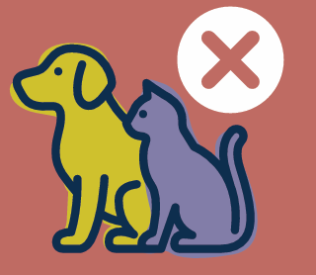

- When going to and from national parks, reserves or farms, clean your footwear, clothing and vehicle to help prevent spreading diseases between places.

- Poultry producers are reminded that on-farm biosecurity practices are crucial to protect the health of their flocks.

- If you own, care for, or work with birds or chickens, you should:
  - prevent wild birds from mingling with your birds, and accessing their feed and water
  - keep pens, aviaries, feeders and equipment clean
  - wash hands thoroughly with soap before and after handling birds
  - monitor birds for signs of disease or sudden deaths.

- Getting an annual flu vaccination is recommended by the CDC for all people older than 6 months. The seasonal flu vaccine won’t protect against bird flu but minimises the risk that people become unwell with both seasonal and bird flu viruses at the same time.

Find out more
- Information and resources about H5 bird flu are available at birdflu.gov.au.

