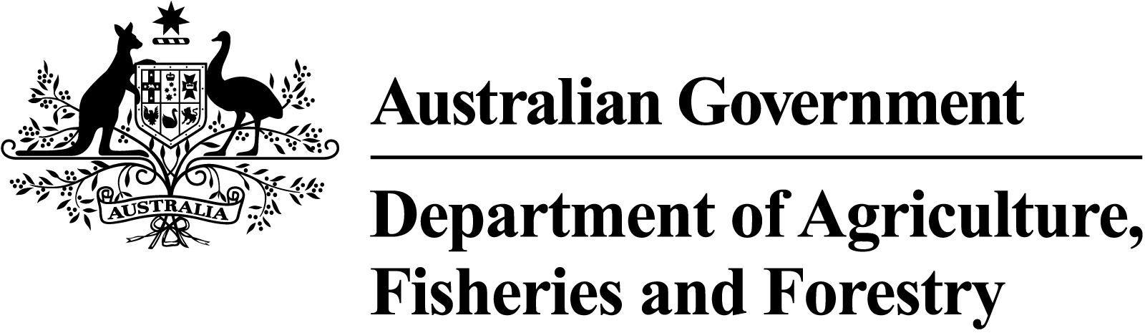

Meat notice
Meat notice number: | 2023/06
Meat notice title: | Three additional proposed legislative amendments in consolidated 2023 amendment tranche
Category: | Legal requirements

NSFS reference | Issue date | Date of effect | Review date
13 | 29 September 2023 | Immediate | 29 September 2025

Contact officers | Distribution categories
Adam Balcerak  Director  Export Meat Program  Meat Exports Branch – EVSD  Adam.Balcerak@aff.gov.au | Central and regional office  Departmental on-plant supervisory staff  Field Operational Managers,  Area Technical Managers,  National Veterinary Technical Manager
Managers, export meat establishments
State/Territory regulatory authorities
Approved Islamic organisations
Other: Please specify category
- Export Meat Industry Advisory Committee /AMIC, JBS, Teys
- Wild Game Meat Consultative Committee
- Australian Chicken Meat Federation
- Emu Industry Federation of Australia
- Official mark manufacturers

Purpose
Further to Meat Notice 2022/02, Proposed export control rule amendments 2022, the department is proposing to introduce 3 additional amendments to the 4 meat commodity export control rules as described below. These refinements improve legislative clarity and provides legislative support for current practices, while maintaining the level of regulatory oversight our trading partners expect.

Scope
This notice applies to the 4 meat commodity rules which comprise of:
- Export Control (Meat and Meat Products) Rules 2021 (Meat Rules) (meat export licensing, official marks)
- Export Control (Poultry Meat and Poultry Meat Products) Rules 2021 (Poultry Meat Rules) (official marks)
- Export Control (Wild Game Meat and Wild Game Meat Products) Rules 2021 (Wild Game Meat Rules) (official marks)
- Export Control (Rabbit and Ratite Meat and Rabbit and Ratite Meat Products) Rules 2021 (Rabbit and Ratite Meat Rules) (official marks).

3. Proposed Amendments
The 3 additional proposed amendments to be consolidated and progressed with the outstanding proposed amendments from Meat Notice 2022/02 are:

Licence maintenance condition – will occur in the Meat Rules. This legislative change confirms that meat licence holders need to maintain the requirements needed to obtain the licence for the period of holding the meat licence.
    - Benefit – little change as legislation is improved to support current licensing practices
    - Industry/Licensee impacts – no change anticipated. Licensee holders would generally be complying with requirement
Licencing renewal requirement – will occur in the Meat Rules. This legislative change clarifies that the same requirements needed to obtain a meat licence are also required to obtain a renewal of the meat licence.
    - Benefit – provides improved legislative clarity and support to current licensing processing practices
    - Industry/Licensee impacts – no change anticipated. Licensee holders would generally be complying with requirement
Official mark changes – will occur across the 4 meat commodity rules as appropriate. This legislative change allows establishment personnel, nominated in the establishment Approved Arrangement (AA), to apply certain official marks to product in accordance with the AA approval.
    - Benefit – the legislation better reflects current practices and provides more accurate legislative underpinning for the application of the following official marks:
- EU official mark (not in Poultry Meat Rules)
- carton seal
- tamper-evident strap seal
    - Industry impacts – no change anticipated. Industry would generally be complying with requirement

5. Consultation
Please provide comments, or direct any questions, to Adam.Balcerak@aff.gov.au.
Comments are due 2 weeks from publication of this notice.
There will be a further opportunity to comment during the public consultation period on the Department of Agriculture, Fisheries and Forestry Have Your Say platform. Industry will be advised of the commencement of the public consultation period.

Adam Balcerak
Director
Export Meat Program

