|  |
| --- |
| ­­­­­­­Modelling and analysis of Australia’s abatement opportunities  Report to the Department of the Environment  Meeting Australia’s 2030 emissions reduction target  May 2016 |

### Copyright

© 2016 Energetics. All rights reserved.

"Energetics" refers to Energetics Pty Ltd and any related entities.

This report is protected under the copyright laws of Australia and other countries as an unpublished work. This report contains information that is proprietary and confidential to Energetics and subject to applicable Federal or State Freedom of Information legislation, shall not be disclosed outside the recipient's company or duplicated, used or disclosed in whole or in part by the recipient for any purpose other than for which the report was commissioned. Any other use or disclosure in whole or in part of this information without the express written permission of Energetics is prohibited.

### Disclaimer

The information contained in this document is of a general nature only and does not constitute personal financial product advice. In preparing the advice no account was taken of the objectives, financial situation or needs of any particular person. Energetics is authorised to provide financial product advice on derivatives to wholesale clients under the Corporations Act 2001 AFSL No: 329935. In providing information and advice to you, we rely on the accuracy of information provided by you and your company. Therefore, before making any decision, readers should seek professional advice from a professional adviser to help you consider the appropriateness of the advice with regard to your particular objectives, financial situation and needs.

Australian Financial Services License (AFSL # 329935).

### Acknowledgements

Energetics would like to acknowledge the contribution of the following people and businesses to this report Telstra, GPT, Low Carbon Living CRC.

# Executive summary

At the UNFCCC 21st Conference of Parties (COP21) in Paris, December 2015, Australia formalised our Intended Nationally Determined Contribution (INDC) for inclusion in the Paris Agreement. This contribution is a target to reduce Australia’s domestic emissions by 26 to 28 per cent below 2005 levels by 2030.

To help illustrate a pathway for the Government to achieve the 2030 target, the Department of the Environment (the Department) engaged Energetics to analyse and model the emissions reduction opportunity.

Energetics’ analysis shows there is potentially significant low-cost abatement available to meet the 2030 target.

* Australia can reach its 2030 abatement target under the current policy framework. Large emitters must be effectively engaged and programs pursued without delay.  Energetics’ modelling of over 70 emissions reduction measures has found that approximately 960 Mt CO2-eof abatement can be achieved by 2030.
* Modelling over the period 1993 – 2015 shows the emissions intensity of the Australian economy fell on average by 2.3 percent each year, suggesting that national emissions are decoupling from economic growth.
* Australia will achieve its 2020 cumulative abatement target under the Kyoto protocol, equivalent to 5 per cent below 2000 levels by 2020. Energetics has identified further abatement opportunities that can be pursued, to reach an absolute 2020 target.

Australia’s emissions reduction potential

To assess the potential for Australia to meet this abatement target, Energetics considered over 70 abatement opportunities that could be implemented by policies existing or under consideration by the Government. Abatement opportunities were identified across all major sectors and categorised into a range of project types including land use change, fuel switching, energy productivity, renewable energy and waste management.

Energetics’ model identified an abatement potential of 154 Mt CO2-e in 2030 relative to emissions in 2020. The total cumulative abatement opportunity in the period from 2021 to 2030 was estimated to be around 960 Mt CO2-e. The scale of the potential identified abatement is consistent with Australia meeting its 2030 target.

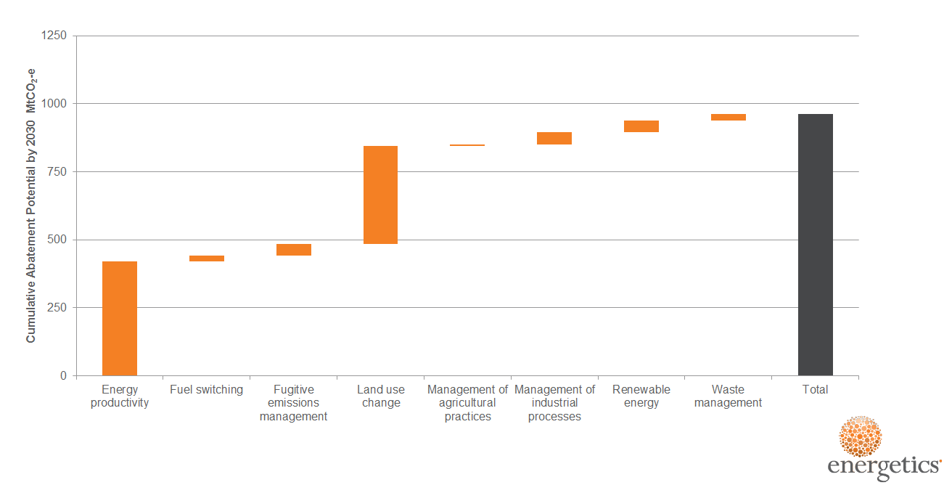

**Figure 1: Cumulative abatement potential categorised by abatement type**

Energetics’ analysis of the total abatement potential by opportunity type indicates that energy productivity and land-use change can deliver a significant portion of Australia’s cumulative abatement requirement from 2021 to 2030 (as shown in Figure 1). Abatement opportunities identified for energy productivity accounts for 44 per cent of total abatement potential, while identified abatement from land-use change opportunities can contribute a further 38 per cent in total.

Renewable energy and management of industrial processes can each contribute a further five per cent of the identified abatement potential. The remaining abatement potential has been identified in abatement opportunities related to fuel switching, agriculture, fugitive emissions and waste.

The abatement opportunities identified were allocated to one of 12 groups as shown in Figure 2. These groups were considered to provide an exhaustive coverage of all major areas of both established and emerging abatement opportunities in 2030.

Energetics’ analysis found that improved land management and low emissions farming practices (group 9) and low carbon transport (group 8) are capable of contributing the most to Australia’s total low-cost abatement by 2030. In total the two groups account for just over 50 per cent of Australia’s total identified abatement potential.

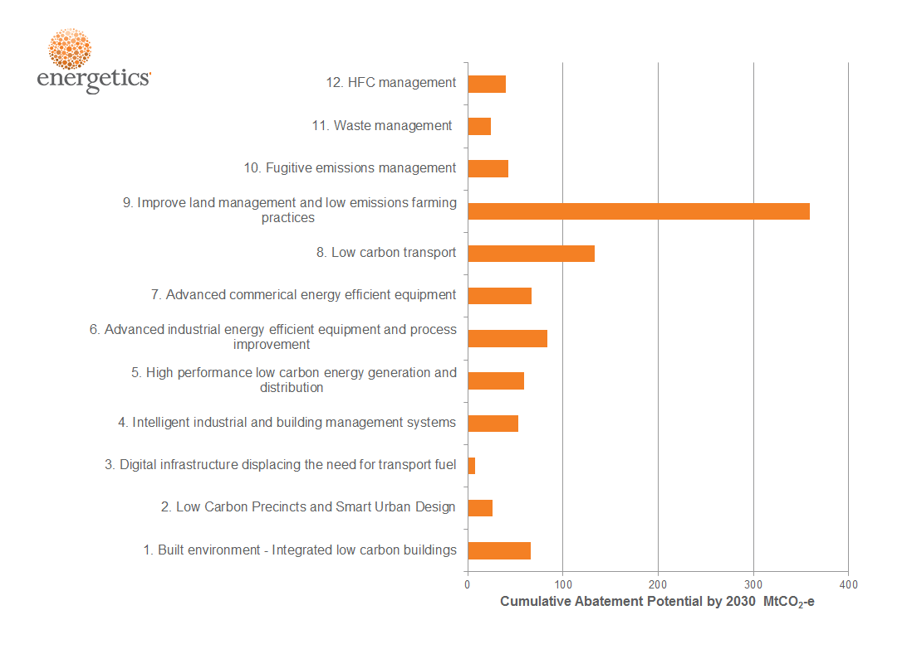

Figure 2: Cumulative abatement potential by grouping

Low carbon precincts (group 2) and digital infrastructure displacing transport fuel use (group 3) are likely to require additional support beyond that considered. These groups are forecast to deliver the lowest quantity of abatement on a per annum basis in 2030, but are likely to contribute a significant portion to the total abatement potential in the period from 2030 to 2050.

Emissions trajectory through to 2030

Energetics’ analysis of the period 1993 to 2015 revealed a consistent reduction in the intensity of emissions per unit of GDP (excluding those from the LULUCF[1] sector). The finding is robust despite the wide range of economic conditions, external shocks and climate change polices experienced over this period. The average year by year reduction in greenhouse gases per unit of GDP was 2.17 per cent[2].

The abatement potential identified by Energetics assumes a continuation of this trend in emissions intensity improvements.

Based on Australia’s emissions in 2020 being five per cent lower than in the year 2000 and a continuation of the emissions intensity reductions, Energetics estimates Australia’s domestic emissions will be 568 Mt CO2-e in 2030. This compares to the minus 28 per cent emissions reduction target of 440 Mt CO2-e in 2030. Energetics considers the difference between the emissions pathway and trajectory to the 2030 target can be achieved from the total 960 Mt CO2-e cumulative abatement potential identified.

Starting from an emissions level of 532 Mt CO2-e in 2020, the figure below demonstrates how the abatement potential identified compares to Australia’s 2030 emissions reduction target as well as against Australia’s projected emissions in the absence of any abatement.

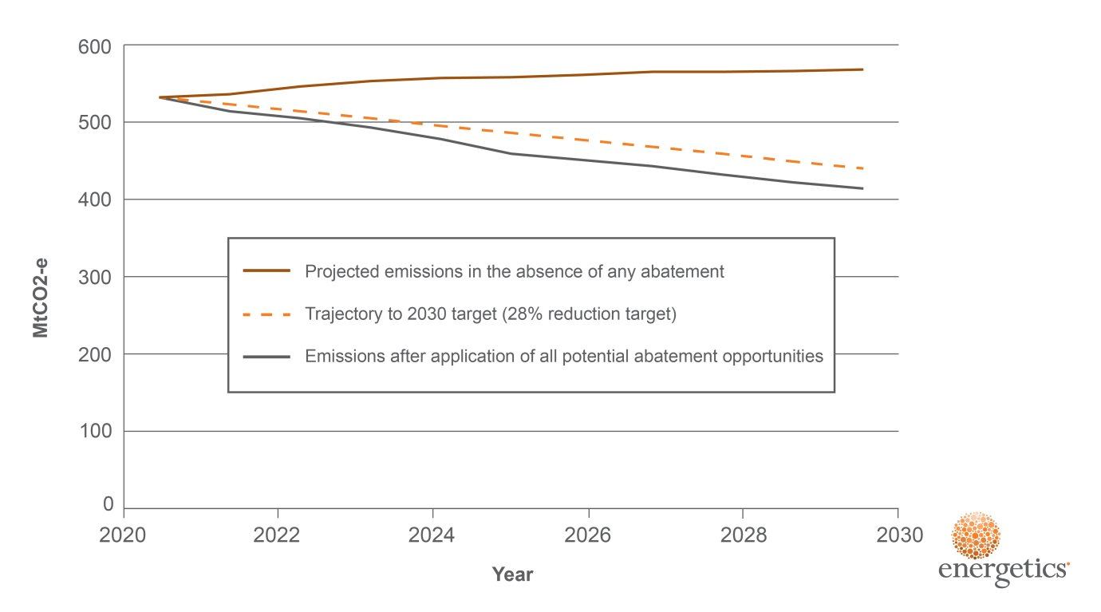

Figure 3: Australian emissions trajectory and impact of abatement

Leveraging Australian policies and programs to achieve the 2030 target

This analysis considered the potential for delivering Australia’s abatement under the following programs:

* The Emissions Reduction Fund and Safeguard Mechanism
* The National Energy Productivity Plan (energy efficiency)
* The National Energy Productivity Plan (vehicle efficiency)

The abatement opportunities were allocated to the most appropriate policy or program. Abatement opportunities that were considered to be business as usual were part of the baseline, with many attributed to technological advances.

The analysis also included emissions reduction activities that will continue to be delivered under other programs, such as ozone and HFC measures. For this assessment Energetics drew from abatement analysis undertaken by the Government.

Energetics also considered the impact of non-government movements that are capable of driving emissions reductions. For example, we see the impact of growing market and consumer pressure that influences business to reduce their carbon intensity.

Finally, where abatement opportunities achieved emissions abatement though improvements in energy productivity, they were generally allocated to the National Energy Productivity Plan (NEPP).

The contribution of potential abatement to meet the cumulative abatement potential is shown in Figure 4. Technology improvements play a key role as does the Emissions Reduction Fund (ERF) and Safeguard Mechanism.

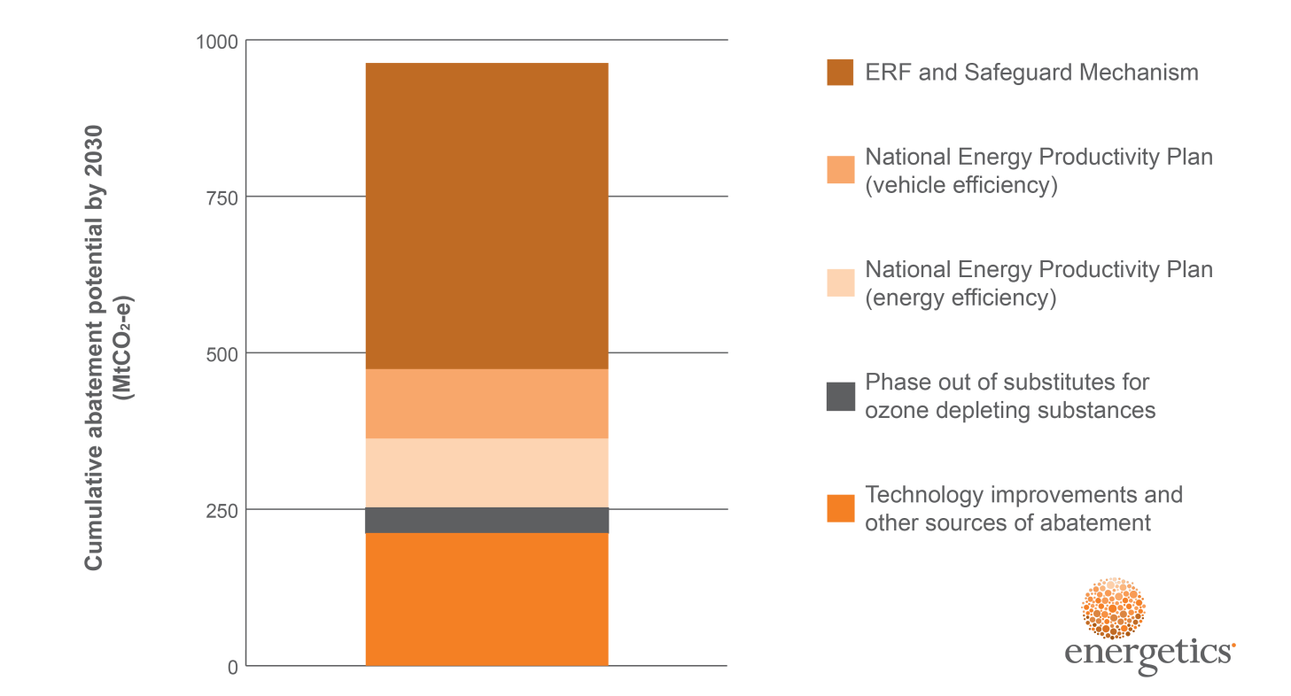

Figure 4: Cumulative abatement potential by 2030

Figure 4 above highlights the total domestic abatement opportunity identified by Energetics as can be delivered under existing policies or programs. This provides flexibility in the measures adopted, as well as room for future growth in Australia’s INDC.

Australia has world class policies and frameworks in place for calculating abatement from individual measures and for creating and managing Australian Carbon Credit Units (ACCUs). Supported by these robust frameworks, Energetics assumes that the ERF and Safeguard Mechanism are capable of generating the necessary cumulative abatement over the 2021 to 2030 period.

In addition, the NEPP is in the process of being formalised, and is expected to further drive a share of emissions reductions. Continued advances in technology and other, emerging market transformations to reduce greenhouse gases will deliver the remainder of Australia’s abatement.

Australia’s abatement cost curve

To assist with the ranking and prioritisation of more than 70 abatement opportunities identified and analysed, Energetics developed an Australian economy wide abatement cost curve. Abatement cost curves provide a useful tool, and visual guide, to demonstrate the total potential abatement for each sector, as well as the cost of the abatement in reducing Australia’s emissions.

The Australian domestic abatement cost curve for 2030 is shown in Figure 5 below – including each of the sectors considered capable of potentially contributing to Australia’s 2021 to 2030 abatement task. For each sector, Energetics considered the cost in projected 2030 AUD to the whole of Australia.

Based on this approach and due to the high net cost to Australia of imported transport fuels, the sectors that encourage improvements in the efficient use of those fuels have a high net benefit. Electricity savings have a lower net benefit to the Australian society, however many can still be achieved at a negative societal cost.

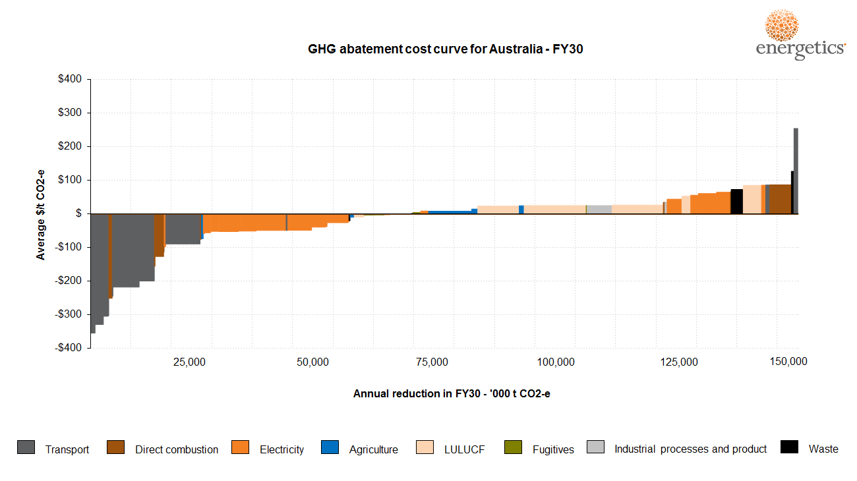

Figure 5: Australian 2030 abatement cost curve

Two examples of abatement opportunities considered in Energetics analysis are included below Section 5. The two case studies provide examples of the best practice energy management and emissions reduction currently being undertaken by leading Australian industry.

**Table of contents**

Executive summary iii

1. Background – Paris meeting of the Conference of Parties (COP21) 1

1.1. Working towards a new global agreement to limit warming to within 2oC 1

1.2. Australia’s domestic emissions trajectory 1

1.3. Meeting the 2020 emissions reduction commitment 3

2. Australia’s 2030 emissions reduction task 5

2.1. Australia’s abatement requirements to meet the 2030 emissions reduction target 5

2.2. Enabling Government policies and programs 6

3. Modelling Australia’s abatement potential 8

3.1. Overview 8

3.2. The key assumptions 9

3.3. Constraints and limitations 10

3.4. Describing the abatement opportunities 11

3.5. Categorisation of each abatement opportunity 12

3.6. Allocating measures to enabling policies and programs 14

4. Results – Australia’s abatement potential 17

4.1. Output 1: Abatement opportunities 17

4.2. Output 2: The abatement cost curve 20

4.3. Output 3: Stacked bar chart 21

5. Opportunity case studies 23

6. Key insights 27

6.1. Meeting Australia’s abatement requirement 27

7. Recommendations 29

Appendix A. Abatement and levelised cost 30

Appendix B. Assumptions 45

Appendix C. Australian 2030 abatement cost curve 49

About Energetics 50

Contact details 52

# Background – Paris meeting of the Conference of Parties (COP21)

## Working towards a new global agreement to limit warming to within 2oC

The Paris Conference of Parties (COP) was the 21st meeting of the United Nations Framework Convention on Climate Change (UNFCCC) member nations to discuss global action on climate change. The UNFCCC is a universal convention acknowledging the existence of human-induced climate change and providing pathways for limiting warming.

Australia is a signatory to the Kyoto Protocol, the current binding international agreement for emissions reduction. The Kyoto Protocol is in its second commitment period (CP2), which ends in 2020. Australia’s emissions reduction commitment during this period is 5 per cent below 2000 levels.

COP21 aimed to create a binding international consensus for post Kyoto emissions reduction. International consensus achieved during the COP21 was the culmination of a near-20 year review process following the original introduction of the Kyoto Protocol in 1997. Over 195 national participants signed the Paris Agreement – committing to a pathway limiting global warming to 2°C with an aspirational target of limiting warming to 1.5°C above pre-industrial levels.

### Australia’s Intended Nationally Determined Contribution

Prior to COP21, individual member nations of the UNFCCC submitted Intended Nationally Determined Contributions (INDCs) that established national emissions reduction targets for the post 2020 period. In August 2015, Australia announced an INDC of 26-28 per cent below 2005 levels by 2030. These were formalised into INDCs within the Paris Agreement during the Paris COP.

## Australia’s domestic emissions trajectory

The development of the abatement task for the 2021-2030 period began with the estimation of the emissions baseline, which shows the greenhouse gas emissions that can be expected in the period to 2030 in the event that there were no abatement measures in place over that period.

Energetics based the forecast on a consistent year by year reduction in the intensity of emissions per unit of GDP (excluding those from the LULUCF[3] sector). This consistent trend spans the period from 1993 to 2015, which saw a wide range of economic conditions, external shocks and climate change policies. Figure 6 shows the trend in emissions intensity per unit of GDP generally falling from year to year.

The outliers are 1990 and 1991, which were the years of the last recession in Australia. Ignoring those first two years as being unrepresentative of normal economic conditions (and more importantly, unrepresentative of anticipated conditions in the period to 2030), the emissions intensity falls on average by 2.32 per cent each year.[4]

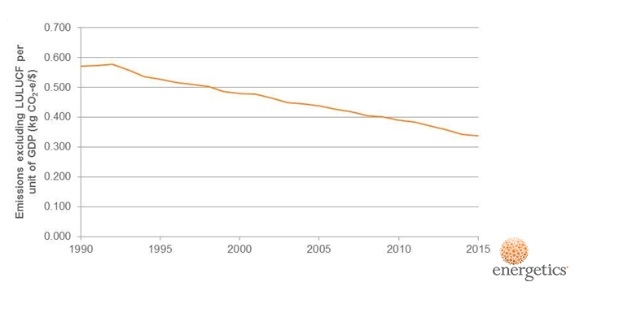

Figure 6: Historical trends in emissions intensity per unit GDP excluding LULUCF

Energetics used a constant 2.17 per cent reduction in emissions intensity (excluding emissions from the LULUCF sector) to define the business as usual case for national emissions. This figure is the average year by year reduction in emissions intensity for the period from (financial year) 1993 to 2015 excluding 2013 and 2014[5]. Business as usual captures innovation in the economy as well as abatement from government policies such as Minimum Energy Performance Standard (MEPS), the state based white certificate schemes and measures to address non-market barriers such as the Energy Efficiency Opportunities (EEO) program and the energy rating programs.

Figure 7 shows domestic emissions projected from 2021 starting at 532 Mt CO2-e in 2020. Energetics have used the Department’s forecast of emissions from LULUCF and applied a constant 2.17 per cent reduction in the intensity of emissions excluding those from the LULUCF sector. The growth in the GDP for the period to 2030 was provided by the Department.

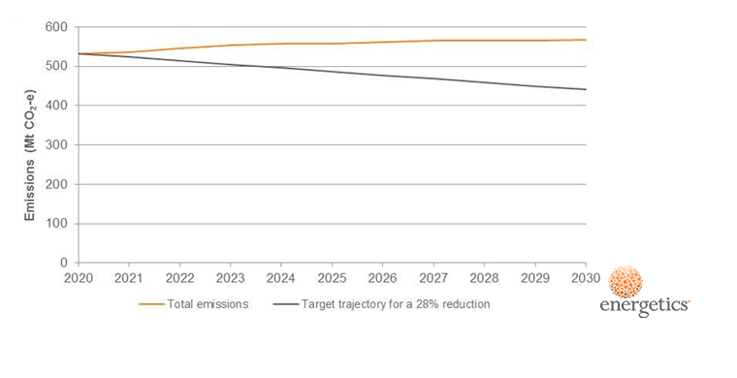

Figure 7: Projected emissions to 2030

Figure 7 also shows the target trajectory to achieve a 28 per cent reduction in emissions relative to 2005 by 2030. Together with Energetics’ projection of domestic emissions, this implies a cumulative abatement task of 759 Mt CO2-e to meet the 2030 reduction target.

## Meeting the 2020 emissions reduction commitment

As noted, Australia is currently a signatory to the second Kyoto commitment period, with an emissions reduction target of 5 per cent from 2000 levels. Based on the interim update to emissions projections from the Department (November 2015), the total CP2 cumulative emissions reduction target will be met using a combination of domestic abatement and international units, including carry over[6].

Energetics modelled a scenario where the minus 5 per cent reduction target in 2020 is met domestically. Energetics has based this assumption on reasonable additional abatement that could be delivered by 2020, as outlined in below. This creates an emissions starting point of 532.2 Mt CO2-e in 2020.

Table : Opportunities to deliver abatement to 2020

|  |  |  |
| --- | --- | --- |
| Abatement opportunities | Annual abatement in 2020 (Mt CO2-e) | Comments |
| Utilisation of biomass for power generation | 9.0 | The CEFC recently reported on the opportunities for investment in generation using biomass, and identified a potential investment opportunity of between $3.5 billion and $5 billion between now and 2020 in energy from urban waste, agricultural waste and forest residues[7]. |
| More aggressive phasing out of emissions intensive substitutes for ozone depleting gases. | 4.9 | Energetics have assumed that 50% of the savings due to the phasing out of emissions intensive substitutes for ozone depleting gases can be brought forward through Commonwealth regulations. |
| Distributed solar PV | 3.4 | This abatement opportunity would involve the more aggressive application of CEFC and ARENA funds to accelerate the deployment of distributed solar PV, especially in the commercial sector and in remote areas. |
| Accelerated deployment of low emissions vehicles | 10 | The abatement cost curve to 2030 identified savings in the transport sector of the order of 33 Mt CO2-e by 2030. The Department’s 2015 interim projections update forecasts a 10 Mt CO2-e increase in transport sector emissions in the period from 2015 to 2020. This abatement opportunity sees the bringing forward of measures in the transport sector so that emissions in the sector remain constant. Measures could include mandatory fleet fuel emissions limits for vehicles as well as measures to encourage the take-up of low emissions vehicles. For instance, the Commonwealth could work with the states to promote the introduction of lower fees, tolls and taxes on low emission vehicles. |
| Improving residential and commercial equipment efficiency | 4.8 | This abatement opportunity would involve the raising of the MEPS levels for key residential and commercial equipment and possibly the banning of certain classes of inefficient lights such a halogen downlights. |
| The Emissions Reduction Fund | 21.1 | Energetics has assumed, conservatively, that abatement purchased by the ERF in the first two auctions fits within the forecast based on data to 2015. The ERF was assumed to purchase seven years’ of abatement at the average price of the first two auctions. Energetics anticipates that the majority of the abatement delivered through the ERF will be from the land sector. |
| Other opportunities | 13.7 | These could include the more rapid introduction of the National Energy Productivity Plan, additional funding for the ERF; restrictions on land clearing; the introduction of additional state based white certificate schemes; marginal increase in the renewable energy; gas offsetting brown coal fired power generation. These measures will need to be driven by either the Commonwealth Government or state governments. |

# Australia’s 2030 emissions reduction task

## Australia’s abatement requirements to meet the 2030 emissions reduction target

Based on Australia meeting the 2020 emissions reduction target, Energetics have focused on what is needed for Australia to meet the 26-28 per cent 2030 emissions reduction target (referred to in this document as the 2030 target).

All analysis conducted within the scope of this report focuses on how abatement could be delivered within current and proposed Federal Government policies, as well as considering abatement that will be delivered through technological advances and through other programs.

outlines the unadjusted 2021-2030 emissions abatement trajectory, total cumulative and 2030 per annum emissions reduction requirements under both the 26 and 28 per cent emissions reduction targets.

Table : Australia's 2030 emissions abatement requirement[8]

|  |  |  |
| --- | --- | --- |
|  | Cumulative emissions – 2021-2030 (Mt CO2-e) | 2030 p.a emissions (Mt CO2-e) |
| Unadjusted 2030 emissions trajectory | 5,575 | 568 |
| 26 per cent emissions reduction requirement | 691 | 115 |
| 28 per cent emissions reduction requirement | 759 | 127 |

Following the initial release of Australia’s INDC, the Department developed indicative estimates of abatement from possible policy options, referred to as the ‘abatement stacked chart’. The Department required modelling and analysis of abatement opportunities to augment its understanding of the types and scale of abatement opportunities included in Figure 8.

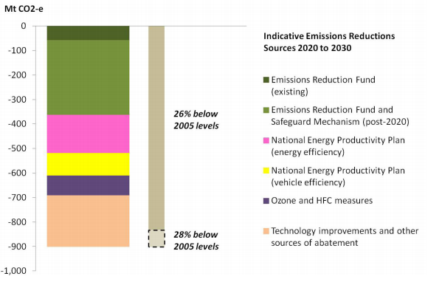

Figure 8: Department of the Environment indicative stacked bar chart[9]

As shown in Figure 8, Australia’s cumulative emissions reduction requirement between 2021 and 2030 was previously estimated at around 900 Mt CO2-e. Energetics’ modelling projects that – from a starting point of 532 Mt CO2-e in 2020, and an assumption that emissions intensity will continue to decline in relation to GDP growth – the actual cumulative abatement required for this period will be lower.

## Enabling Government policies and programs

There are a number of Federal Government policies and programs that will operate to enable Australia to meet a 26-28 per cent reduction target. Energetics’ analysis has predominantly focused on key Government programs and policies that are in existence or that have been foreshadowed. Specifically included within the analysis are:

* The Emissions Reduction Fund (ERF) and the Safeguard Mechanism
* The National Energy Productivity Plan (energy efficiency)
* The National Energy Productivity Plan (vehicle efficiency).

Abatement opportunities that are not covered by one of the above Government programs were allocated to one of the following categories:

* Technological advances – which effectively incorporates projected adoption of low emission technologies and innovation as well as shifting market forces out to 2030, and alternative regulatory and non-government drivers which also result in the creation of abatement.[10]
* Other programs – which includes the Ozone Protection and Synthetic Greenhouse Gas Management Programme

Further information on how abatement opportunities were allocated to each of the above categories is included in Section .

Expansion of the Renewable Energy Target (RET) was not considered in the analysis, however the RET has influenced both the anticipated emissions baseline, as well as the anticipated grid emissions factor out to 2030.

# Modelling Australia’s abatement potential

## Overview

Following the announcement of Australia’s INDC, Energetics was engaged by the Department to review the types of measures that are likely to deliver the abatement necessary for Australia to achieve the 28 per cent emissions reduction target. This work involved the delivery of three key outputs:

1. An assessment of abatement that could be delivered by technology breakthroughs
2. Updated abatement cost curves for Australia for 2030
3. An updated stacked bar chart assigning effective abatement opportunities over the period 2021 to 2030 to achieve the emissions reduction target.

In assessing potential abatement opportunities for Output 1, Energetics considered the following types of measures:

* Cumulative 2021-2030 abatement from commercially viable and commonly deployed measures that are currently not included in the Department’s emissions projections
* Abatement and potential abatement opportunities from low emission technologies and measures that are currently available but not widely deployed
* Low emissions technologies that are not yet commercial but on the horizon.

Energetics did not consider unforeseen technological advances that could occur over the 15 year period between 2015 and 2030. An historical example of unforeseen technological advances is the speed at which lighting technologies were upgraded in recent times. In the early 2000s halogen downlights were seen as the only option for replacing incandescent lamps. As a result, a 15 year abatement projection from the early 2000s would have failed to consider the impact of LEDs in total lighting upgrade abatement.

The abatement opportunities identified in Output 1 formed the basis of both Outputs 2 and 3. Full results for each of the outputs are available in section .

Energetics’ approach focuses on the total abatement potential and the associated levelised costs to society.

It is important to note that the work did not involve modelling an ‘abatement scheme’. Neither the abatement cost curve in Output 2, nor the stacked bar of Output 3, considered different Australian Carbon Credit Unit (ACCU) pricing scenarios or the potential market response to the uptake of different measures.

## The key assumptions

### Calculation of total abatement potential

The following assumptions were made when calculating both the cumulative abatement potential and the 2030 per annum abatement potential:

* All abatement potential was calculated based on projected 2030 annual abatement figures with deemed uptake rates to develop the cumulative abatement over the 2021 – 2030 period. Energetics focused on abatement opportunities most likely to generate meaningful abatement within this period.
* Uptake rates were assumed for each abatement opportunity based on the varying technology maturity and applied using a linear or sigmoidal approach, based on Energetics’ expert judgement. The different uptake rate types are as included in .
* Unless otherwise specified, abatement driven by Federal Government policies as outlined in section is considered to commence from 2021.
* Abatement was estimated using a bottom-up approach for all sources. The exceptions were emissions from Land Use, Land Use Change and Forestry (LULUCF), waste management and fugitive emissions.
  + Abatement from direct combustion, electricity and transport were based on potential fuel savings, and assumed total uptake across the relevant sectors based on Energetics sectoral knowledge and estimates. All assumptions made were conservative.
  + Sectoral and end-use energy data was sourced from the Office of the Chief Economist, and projected out to 2030 using the sectoral annual increases in energy consumption estimates (total percentage increase).
  + The estimates for abatement associated with LULUCF were derived from work reported by ClimateWorks in 2010[11], which in turn was built on work undertaken by CSIRO. Energetics reviewed the ClimateWorks estimates against the most recent Queensland “Estimates of Queensland’s greenhouse gas emissions from land use, land use change and forestry 2015-2030”[12] report.
  + Abatement opportunities in the waste and fugitives sectors were estimated using a top down approach based on potential emissions reduction opportunities in 2030 for the relevant Australian Greenhouse Emissions Information System (AGEIS) emissions sub-sectors.

### Calculation of levelised cost of abatement

The following assumptions were made in calculating levelised costs:

* Energetics calculated the total levelised cost of abatement using a total societal resource cost approach. The levelised cost from the perspective of investors was not considered.
* Where information was readily available, Energetics undertook a bottom up analysis of total implementation costs (capital, installation and operational costs) for each abatement opportunity.
* Where bottom up modelling was not possible, Energetics undertook a literature review to identify likely levelised costs of abatement from the best available information. These figures were peer reviewed internally and externally.
* Fuel savings associated with an abatement opportunity were calculated based on Energetics estimate of the fuel costs to society in 2030.
* The implementation cost for abatement opportunities was taken to be the net cost to Australia of the capital and labour required to implement the abatement. This was modelled through the use of a factor that captured the fraction of the implementation cost to investors that is circulated back into the Australian economy. Energetics did not use a general equilibrium model to assess the economic impact of abatement opportunities.

Appendix A contains:

* The outcomes of the assessment, including total cumulative abatement 2021-2030 and 2030 per annum for each abatement opportunity
* The levelised cost of abatement in 2030 for each abatement opportunity.

The full set of assumptions for each measure can be found in .

## Constraints and limitations

There were a number of constraints and limitations associated with the scope of work. These constraints are outlined below:

* Broad consultation was not possible within the timeframe. Instead, where further information was required on abatement opportunities, Energetics consulted directly with a number of individual stakeholders including Telstra, GPT and the Low Carbon Living CRC.
* For completeness, the levelised costs of potential abatement associated with power generation decarbonisation have been included in the abatement cost curve. However these have not been included in the stacked bar analysis as there is no post-2020 supporting government policy.
* As highlighted above, in some instances commercial information was not available to develop bottom up implementation costs. Levelised costs of potential abatement were obtained from reputable sources and subject to both internal and external peer review processes.
* The analysis did not make any assumptions regarding unforeseen[13] technological advances that could occur over the 15 year period between 2015 and 2030. However, such advances will contribute additional abatement opportunities during this time.
* The analysis did not undertake detailed policy modelling. Energetics considered only abatement opportunities that were feasibly able to be delivered within the 2021-2030 timeframe, and allocated each opportunity to the most appropriate policy or program. No modelling was undertaken of the appropriate policy mechanisms the Government could introduce to ensure these abatement opportunities are delivered under the relevant policy or program.

## Describing the abatement opportunities

Energetics’ approach to developing a comprehensive list of abatement opportunities was to focus on those that met the following criteria:

* They could feasibly generate meaningful abatement by 2030.
* Delivery is possible under one of the above mentioned Federal Government programs, an alternative program, or in extrapolated business as usual circumstances.
* The identified abatement opportunities were unlikely to face any economic or technological barriers to uptake prior to 2030.

Abatement opportunities explored fell under three categories:

* Extrapolated abatement from commercially viable and commonly deployed opportunities.
* Abatement and potential abatement from low emission technologies and activities that are currently available but not widely deployed.
* Low emissions technologies that are not yet commercial but on the horizon (for example, electric vehicles).

As previously noted, Energetics did not make any assumptions as to the impact of unforeseen technological advances. This fourth category has the potential to deliver significant additional abatement to Australia’s cumulative target.

In total over 90 abatement opportunities were identified and refined to a final list of 76 abatement opportunities[14].

Each of the abatement opportunities were allocated to one of 12 groups. Classifying potential abatement into groups enabled alignment with existing government programs, and served to highlight where additional policy support is needed over the 2021-2030 period.

1. Built environment and integrated low carbon buildings
2. Low carbon precincts and smart urban design
3. Digital infrastructure displacing transport fuel use
4. Intelligent industrial and building management systems
5. High performance, low carbon energy generation and distribution
6. Advanced industrial energy efficient equipment and process improvement (including agriculture)
7. Advanced commercial energy efficient equipment
8. Low carbon transport
9. Improved land management and low emissions farming practices
10. Fugitive emissions management
11. Waste management
12. Management of substitutes for ozone destroying substances (HFCs)

These groups were considered to provide an exhaustive coverage of all major areas of both established and emerging abatement opportunities in 2030.

Low carbon precincts (group 2) and digital infrastructure displacing transport fuel use (group 3) are likely to require additional support beyond that considered. These groups are forecast to deliver the lowest quantity of abatement on a per annum basis in 2030, but are likely to contribute a significant portion to the total abatement potential in the period from 2030 to 2050. An example of a measure that is likely to generate significant abatement in the period after 2030 is the roll out of personal autonomous vehicles. While Energetics’ analysis did not forecast any significant role for personal autonomous vehicles in the period to 2030, the analysis shows that the widespread deployment of plugin electric vehicles is likely to provide some abatement by 2030.

## Categorisation of each abatement opportunity

Each abatement opportunity was subjected to a further categorisation. Specifically for each potential abatement opportunity, Energetics considered:

* Sources of emissions that were abated
* The type of abatement as detailed below
* The enabling policy or program (based on the policies and programs outlined in section ).

### Sources of emissions abated

Each measure was allocated to a source of abatement, aligning with the Department’s definition[15].

Table : Breakdown by sources abated

|  |  |
| --- | --- |
| Sources abated | Source description |
| Electricity | Emissions from the electricity sector are largely driven by changes in demand and emissions intensity. Electricity abatement measures considered were related to reducing electricity consumption or offsetting electricity to the grid through increased renewable distribution. |
| Direct combustion | Direct combustion emissions occur when fuels are combusted for stationary energy purposes to generate heat, steam or pressure (excluding electricity generation). Direct combustion of fuels occurs across most sectors in the economy including mining, manufacturing, and construction, as well as domestically through heating and cooking. Energetics assessment of direct combustion measures related predominantly to mining and industrial measures, considering process changes within operations and the supply chain, and technological advances. Measures related to residential consumption of gas for heating and cooking were considered to be largely immaterial. The Department’s projections include emissions from mine and agricultural vehicles as direct combustion. |
| Transport | The transport sector covers emissions from the direct combustion (or end-use emissions) of fuels by road, rail, domestic aviation and domestic shipping. Within this sector, Energetics focused on abatement opportunities based on both technological advances and operational change. |
| Fugitives | The fugitives sector covers emissions associated with the production, processing, transport, storage, transmission and distribution of fossil fuels such as coal, oil and natural gas. Fugitive emissions assumptions were focused on technological advances in fugitive emissions management. |
| Industrial processes and product use | The industrial processes sector encompasses emissions generated from a range of production processes. This sector covers non-energy emissions arising from metal production, the chemical industry, mineral products, consumption of halo-fluoro-carbons and sulphur hexafluoride, and food and drink production.  Examples include nitrous oxide emissions during the manufacture of ammonium nitrate, carbon dioxide emissions from the decomposition of calcium carbonate during clinker production and carbon dioxide emissions from the reduction of metal oxides such as alumina and iron oxide. |
| Agriculture | The agriculture sector includes emissions from enteric fermentation, manure management, rice cultivation, agricultural soils, prescribed burning of savanna and field burning of agricultural residues. |
| Waste | The waste sector covers emissions from the disposal of organic materials to landfill and wastewater emissions from domestic, commercial and industrial sources. Emissions are predominantly methane, generated from the anaerobic decomposition of organic matter.  Energetics assessment of waste measures considers both improved treatments of methane, as well as potential waste to energy options, offsetting grid electricity. |
| LULUCF | The LULUCF sector includes emissions and removals from deforestation, afforestation and reforestation activities. From 2013, emissions and removals from forest management, cropland management, grazing land management and revegetation are also reflected in the LULUCF sector. |

### Abatement types considered

Energetics classified each abatement opportunity into one of the following:

* Energy productivity – encompassing all traditional energy efficiency measures as well as emerging energy productivity measures such as smart grids and system optimisation
* Renewable energy – with a focus on commercial, residential and remote distributed generation, as opposed to the decarbonisation of Australia’s stationary energy sector
* Fuel switching – within the mining, industrial and transport sectors
* Waste management – in solid waste and wastewater treatment
* Land use change
* Management of industrial processes
* Management of agricultural processes
* Fugitives emissions management

This provides an overview of the areas that are likely to deliver the greatest quantum of abatement with appropriate policy intervention through existing and proposed Federal Government initiatives as outlined in section . While there is some alignment between the categorisation to sources abated and to abatement type, the abatement types provide additional granularity on the sorts of measures that can deliver abatement within the electricity, direct combustion and transport source categories.

## Allocating measures to enabling policies and programs

Finally, each abatement opportunity considered was allocated to an enabling policy or program based on the following approach.

### Technological advances and other sources of abatement

Commercial uptake of low emission technologies and abatement opportunities were incorporated into the projections based on Energetics’ experience and insights to business behaviour. Commercial adoption of these abatements are classified as “technological advances” within the final stacked bar.

Examples of technological advances, operational changes and process changes that are considered business as usual are provided below:

* **Technological advances** – the upgrading of lighting to LEDs in the commercial building sector. Driven by significant energy cost savings, LED affordability and phase out of existing T8 fittings.
* **Operational changes** – best practice energy data management with automated response systems in commercial buildings. This practice effectively results in avoiding excess electricity use through real-time alerts. Operationally, it delivers significant energy savings for a very low return on investment. Real time energy data management is currently undertaken by best practice property portfolios, such as GPT. Energetics expects that increased market competition together with the energy savings potential, will drive this practice across all premium, Class A and Class B property managers by 2030.
* **Process changes** –autonomous mining results in significant emissions abatement through the controlled and optimised operation of mining equipment and plant. Energetics expects mines of the future to be autonomous, yet the business decision to develop autonomous mines will be underpinned by enhanced productivity, lower labour costs and continuous mining operations. Emissions reductions will be a co-benefit of process changes, not the primary driver.

The other sources of potential abatement considered within this categorisation include measures that are driven by regulatory standards, or initiatives not currently falling under the remit of the Federal Government policies and programs outlined in section . Included under this categorisation are state-based regulatory requirements; other Federal regulatory requirements and government programs; and the impact of changing market forces which may lead to emissions reduction measures that go beyond business as usual. These are outlined in further detail below:

* **State planning and regulatory requirements** – abatement opportunities related to the built environment are likely to be driven by state planning laws such as enhanced BASIX SEPP and through the State Environmental Planning Policy No 65 – Design Quality of Residential Apartment Development (SEPP 65) requirements in NSW. Also included are state based regulatory requirements resulting in incidental abatement. An example would be the harmonisation of the current Queensland coal mining operational health and safety (OHS) requirements to treat coal mine waste gas[16], with existing NSW legislation.
* **Changing market forces** – Energetics also considered the impact of shifting market forces applying pressure on organisations to achieve abatement beyond business as usual. Based on Energetics’ expertise and experience working across the Australian resources sector – particularly within the coal mining and oil and gas production sectors – the continued access to finance is one of the biggest operational and strategic risks in these sectors.
* It is difficult to anticipate the impact of such movements. However, it is likely that any further contraction of the finance pool for Australian fossil fuel projects, will influence the oil and gas, and coal mining sectors to adopt best practice fugitive emissions management practices by 2030.

### Phase out of substitutes of ozone depleting substances

This categorisation is in line with the Department’s previously released stacked bar chart and captures abatement to be delivered under the Ozone Protection and Synthetic Greenhouse Gas Management Programme. This Programme seeks to reduce emissions arising from Ozone Depleting Substances (ODS) and Synthetic Greenhouse Gases (SGGs).

### National Energy Productivity Plan

Energy and vehicle efficiency improvements that are likely to have a negative cost to society (and in many cases, a negative cost to participants) were placed in the National Energy Productivity Plan. Energetics assumed that programs will be required to address non-financial barriers through non-financial means.

Negative cost abatement opportunities relating to vehicle efficiency, better management of data in passenger transport and fuel efficiency standards were allocated to National Energy Productivity Plan as vehicle efficiency measures. Remaining abatement opportunities were captured under the broader National Energy Productivity Plan.

### The ERF and the Safeguard Mechanism

The remaining abatement opportunities were allocated to the ERF and Safeguard Mechanism. The total abatement delivered under the ERF will vary depending on the future ACCU price. ACCU prices will be influenced by a number of factors, including:

* The total implementation costs to the end-user for positive cost abatement on a $/tCO2e basis (noting that the ACCU will only need to cover the marginal cost to make the project return on investment attractive).
* The existence and prominence of a secondary ACCU market resulting from the Safeguard Mechanism.

Energetics assumed that the Safeguard Mechanism will deliver the remainder of the abatement not purchased under the ERF. Energetics expects that there will be a significant intersection between the two programs in the post-2020 period. ERF projects could help to reduce emissions at safeguard facilities; and safeguard facilities can purchase ACCUs to offset their emissions and help them to meet their safeguard obligations.

# Results – Australia’s abatement potential

The following section provides an overview of Energetics’ findings in respect of Australia’s total abatement potential for each of the three outputs.

## Output 1: Abatement opportunities

Energetics identified the order of 962 Mt CO2-e of potential abatement in the period from 2021 to 2030[17] that could be applied to the task of meeting the 2030 reduction target. This is beyond the total abatement required to meet the 28 per cent emissions reduction target in 2030[18]. Achieving the appropriate levels of abatement from within this pool of abatement options will be dependent on implementing the appropriate policy responses.

Figure 9 below demonstrates how the identified potential abatement compares with Energetics’ emissions projections, and the trajectory required to meet the 28 per cent reduction target.



Figure 9: Impact of the potential abatement opportunities

Additional abatement opportunities not currently modelled could come from areas such as decarbonisation of Australia’s electricity generation sector. All figures included below demonstrate total possible abatement to illustrate the total abatement potential of sectors, as opposed to contribution required to achieve Australia’s emissions reduction targets.

### Abatement by grouping

Energetics’ analysis has found that ‘improved land management and low emissions farming practices’ and ‘low carbon transport’ are capable of contributing the most to Australia’s total low-cost abatement by 2030. In total the two groups account for just over 50 per cent of Australia’s total identified abatement potential. A full list of the abatement opportunities included within each group is included in .

Figure 10 below shows the breakdown of Australia’s abatement by group.



Figure 10: Cumulative abatement potential by grouping

### Abatement by source

When considering abatement by source abated, the LULUCF sector is anticipated to deliver the most significant level of abatement. As demonstrated in Figure 11, the electricity sector will also potentially deliver significant abatement, followed by Transport, Fugitives and Direct Combustion.

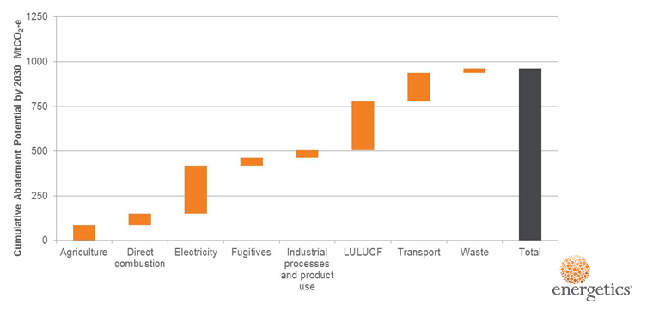

Figure 11: Cumulative abatement potential by source

### Abatement opportunities by abatement type

When considering total abatement potential by abatement type, energy productivity has the potential to deliver a significant portion of Australia’s annual emissions abatement in 2030 and cumulative 2021 to 2030 abatement needs. Of the identified abatement opportunities, energy productivity accounts for 44 per cent. As with the above, land use change follow closely behind with 37 per cent of the total identified abatement. Figure 12 below demonstrates the total abatement by abatement type.



Figure 12: Abatement opportunities by abatement type

## Output 2: The abatement cost curve



Figure 13: Australian 2030 abatement cost curve

Figure 13 above provides Australia’s 2030 per annum abatement cost curve for 2030. The levelised costs of abatement for each abatement type are based on the total societal resource cost. A full overview of each of the abatement opportunities is included in ; and a larger version of the 2030 abatement cost curve is included for reference in . The following provides an overview of the key points associated with the potential abatement cost curve

* The levelised costs of abatement in the Energetics abatement cost curve are lower than might otherwise be expected due to the total societal cost of abatement approach taken in calculating opportunity costs.
* Transport abatement opportunities present some of the most cost effective within this societal approach based on associated fuel savings. The abatement curve considers the cost from the perspective of the whole of Australia and because the net cost to Australia of imported transport fuels is high, abatement opportunities that encourage improvements in the efficient use of those fuels have a high net benefit.
* The cost benefit to Australia of reductions in electricity consumption is less than abatement opportunities within the transport sector, as it is calculated based on the opportunity cost of fuel (coal) burnt to generate electricity. As such, potential electricity savings have a lower net benefit to society.
* Most electricity abatement opportunities still present significant potential negative societal cost abatement. Electricity abatement opportunities presenting a positive societal cost in Figure 13 relate to changes within the energy generation mix.

## Output 3: Stacked bar chart

Figure 14 shows the impact of enabling policies and programs on the total cumulative abatement task from 2021 to 2030. The approach for allocating abatement opportunities to individual policies and programs is outlined in section . This figure includes emissions reductions up to Australia’s reduction target as projected by Energetics.

As shown in Figure 14, the ERF and Safeguard Mechanism are expected to deliver just over 50 per cent of the total 960 Mt CO2-e identified abatement potential, in the period from 2021 to 2030. Technology improvements and other programs that deliver abatement as a co-benefit will contribute the order of 22 per cent, with the remaining volume being driven by the National Energy Productivity Plan (energy productivity and vehicle efficiency). The exact scope of the abatement task will depend upon a range of factors including the impact of abatement opportunities funded by the ERF in the second commitment period to 2020.

As noted in section 3.3 above, Energetics did not undertake policy modelling of the options for different mechanisms within each of the current policies and programs to deliver the abatement.

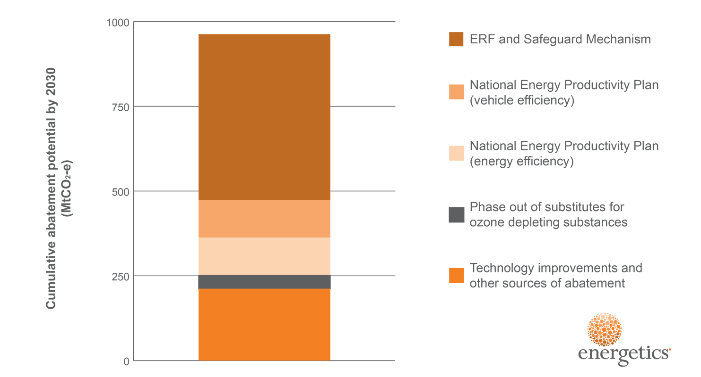

Figure 14: Cumulative abatement potential by 2030

# Opportunity case studies

|  |
| --- |
| Case study 1: Advanced buildings management systems – Australian cities in 2030  Of all the focus areas considered within the Paris Agreement, the built environment – and the impact that individual buildings and cities can play in disrupting locked-in energy and greenhouse gas (GHG) emissions patterns – is perhaps the most critical. Globally the commercial building sector alone contributes over 9% of human produced greenhouse gas[19]. In developing a strategic response to climate change, the design of our cities plays a vital role as ‘new roads, buildings and water systems built today are likely to influence living and consumption patterns for at least the next 50 to 100 years[20] . In Australia, the Commercial Buildings sector alone was reported to have contributed over 27 MtCO2-e[21] to Australia’s emissions total over the 2014/15 financial year.  Energetics’ modelling demonstrated that there is significant potential for emissions reduction across the built environment, with the role for emissions reduction from cities, infrastructure and building development playing a vital role in helping Australia meet the 26-28% 2030 emissions reduction target. Measures that Energetics considered for reducing the built environment emissions profile include building retrofits and new innovative design measures, as well as the impact of increased distributed commercial solar PV.  A crucial requirement that will drive a number of these measures is the understanding, management and optimisation of energy consumption at a building level. Energetics estimated that between now and 2030 a cumulative abatement potential of over 12 MtCO2-e can arise purely from optimising building performance using data management systems.  **The GPT example**  GPT Group (GPT) is a leading property group with broad access to capital invested in quality Australian property assets. GPT’s office, shopping centre and logistics properties are used by millions of Australians every week.  At a company level, GPT recognises that greenhouse gas emissions globally are at unsustainable levels and the property sector accounts for a significant proportion arising from energy consumed in developing and managing buildings.  From 2005 to 2014, GPT reduced the average energy intensity of its portfolio from 571 MJ/m2 to 369 MJ/m2.  In GHG emissions terms, this amounts to a reduction[22] of over 46kgCO2-e/m2. Around half of this reduction can be attributed to better energy data information and the use of it to manage buildings without the need for investment in new systems or energy efficient appliances. The remaining half of the savings would be attributed to system or appliance upgrades, but it is important to note that energy data management is the critical tool in maintaining and identifying those savings.  Ongoing building energy performance optimisation is achieved through better energy information |
| management and diagnostic systems, augmented by smarter control strategies and a rolling program of lighting and air conditioning system upgrades.  At GPT, it is standard practice to undertake efficiency upgrades alongside any lifecycle or maintenance works, thus leveraging already budgeted expenditure. In cases where there are additional efficiency upgrades or upgrades that are separate to lifecycle works, a target payback period on the additional expenditure is five years or less. Whereas many efficiency gains have also come from improved energy management practices that have required little or no extra investment, which is important in an environment where competition for capital is fierce.  Further to energy reductions, GPT reduces emissions by switching from high carbon energy supplies to low and no carbon energy from on-site and off-site sources.  By the end of 2015 the emissions intensity of GPT’s operations reduced to 50% of the 2005 baseline.  Over the ten year journey of GPT’s energy and climate change response, a cumulative total of 0.63 MtCO2-e have been avoided. Compared to baseline energy intensity levels, GPT and its tenants have avoided energy costs of over $76 million. With improvements in energy efficiency in 2015 alone, GPT and its tenants avoided $24.3 million in energy costs  Improving the uptake of data management  A key facet of optimising building energy management systems is the analysis of energy consumption data. Smarter systems turn energy data into information and knowledge that property managers can use to benchmark building performance and identify anomalies. Continuous monitoring of data provides real-time insight to equipment performance, such as office lighting and heating, ventilation and air conditioning (HVAC), ensuring that required efficiency upgrades are identified early and addressed quickly.  The GPT example demonstrates that building managers and property owners can benefit significantly from better understanding of their building energy data. A focus on building comprehensive energy management systems can provide an easily implementable and scalable option for lowering energy consumption, reducing energy spend, and creating jobs across the Australian built environment. |

|  |
| --- |
| Case study 2: Lower Emissions Aviation - Advanced transport to 2030  An important contribution that could be made towards achieving the 26-28% national emissions reduction target lies in improving the performance of Australia’s aircraft fleet. In assessing domestic emissions from Australia’s civil aviation fleet, Energetics identified over 20 MtCO2-e in cumulative potential abatement from improved aircraft performance. Broadly speaking, improved aircraft performance measures include:   * Fleet renewal and modernisation – including widespread adoption of the latest technology in jet engines; this drives a 1.5% efficiency year on year to 2020 and assumed beyond * Improved aircraft performance – including innovative route management and operational effectiveness to reduce fuel consumption.   While emissions from the two sources are traditionally accounted for and managed separately, realising the emissions reduction potential of the Australian aviation sector will require all fleet emissions to be addressed. Taking this responsibility would benefit the international community, as well as lower Australia’s domestic emissions profile.  **Qantas partners with market leaders to drive performance improvements**  An obvious major player in the Australian civil aviation space is Qantas. For the 2014/15 financial year, Qantas domestic operations reported 4.4 million tonnes[23] in Scope 1 CO2-e emissions[24]. Emissions from flying, which includes the burning of aviation fuel, constitutes the lion’s share of Qantas’ Scope 1 – over 99% of the total emissions.[25] To manage this, the Qantas Group has a strong focus on fuel efficiency and carbon emissions reduction is a cornerstone of its AU$2bn transformation strategy. This is supported by a 50% net Scope 1 emissions reduction target currently in place, based on 2005 levels, to be achieved by 2050[26].  In alignment with the International Air Transport Authority (IATA), Qantas has a vision to achieve carbon neutral growth by 2020.  To meet these targets, Qantas is exploring a number of innovative emissions reduction projects through partnerships with market leading companies and universities.  In 2012 Qantas entered into a four-year partnership with the University of Sydney to develop a flight planning system to allow the airline to fly optimised routes, reduce fuel consumption and improve operational effectiveness. The Qantas Future Flight Planning Project (QFFPP) included the integration of aerodynamics, flight mechanics, large-scale optimisation and machine-learning algorithms to design better flight planning routines and fuel prediction models[27].  Following on from the partnership with the University of Sydney, Qantas have also partnered with GE Aviation to reduce emissions through industry leading navigational techniques and technologies. GE Aviation’s Flight |
| Analytical System is currently leading the market in using a combination of flight data, with operational data, weather data, trajectory correction and the terrain of the flight region[28].  The adoption of international industry leading technology has allowed Qantas to gain improved insight into its operations and more easily identify and track efficiency opportunities. Through the partnership, GE is providing access to its Fuel Management product offering, which includes world-class operational efficiency data analytics and process improvement capabilities.  **Benefits are already being realised**  Qantas is already recognising the benefits of these industry leading measures, such as improvements to advanced navigation techniques, including Required Navigation Performance and User Preferred Routing which continues to be rolled out across the Qantas network. Qantas has increased the utilisation of available procedures which has resulted in total emissions savings of over 13 ktCO2-e[29] annually with a less than one year payback; making business sense to reduce emissions.  The partnership with the University of Sydney has also influenced improvements in the technical performance of aircraft. For example, improving engine performance by lowering Exhaust Gas Temperature (EGT) through engine compressor wash activities has led to an annual emissions reduction of 55.6 ktCO2-e[30] solely from reduction in aviation fuel use, and once again, with less than one year payback.  **How Australia can learn from this?**  Civil aviation, as an industry, is projected to continue to grow strongly out to 2030, with 279 million passengers expected to pass through Australian airports in 2030[31]. In the near term, fuel consumption will be dominated by traditional aviation fuel, as the biofuel market evolves – switching to lower emission fuel sources will be constrained by the advances made in the biofuel aviation market. In order to ensure that emissions do not grow comparatively with the projected increase in civil aviation, consistent innovation and improvements in aircraft performance and efficiency will be vital. Tailoring aviation fuel consumption at a flight specific level reduces fuel waste and emissions, while reducing operational costs. |

# Key insights

## Meeting Australia’s abatement requirement

Australia’s 2030 emissions reduction target is significant and while there are abatement options to choose from to ensure the 28 per cent emissions reduction target is met, it will be important to have the appropriate policy levers in place to deliver abatement.

This requires an understanding of both the financial and non-financial barriers currently impacting the uptake of abatement measures.

### Understanding the impact of technology change

This analysis has highlighted the impact of abatement opportunities that should become business as usual due to the impact of technology change on the cost effectiveness of abatement opportunities. This is particularly the case for potential abatement related to energy productivity.

The Government may wish to consider potential approaches to align policies to appropriate measures and remove overlap (for instance, the NEPP could deliver energy efficiency measures rather than the ERF). This would include reviewing technology advances that have become business as usual and no-longer require policy intervention.

### The National Energy Productivity Plan

Energetics’ analysis has allocated the majority[32] of potential abatement with a negative societal cost to the NEPP. This categorisation was based on two key considerations:

* The ERF and the Safeguard Mechanism cannot alone deliver all of Australia’s abatement requirements without either significant additional funding, or significant amendment to the current proposed approach to establishing baselines.
* Abatement opportunities with a negative societal cost often have non-market barriers preventing uptake that cannot be managed by only providing a financial incentive.

It was outside of the scope of this piece of work to undertake a detailed analysis of the non-market barriers impacting specific abatement opportunities. To ensure that the NEPP is developed in an appropriate manner to deliver the required levels of abatement, Energetics recommends that the Federal Government undertakes a consultation process to understand the non-market barriers associated with each of the abatement opportunities identified.

As the NEPP continues to develop, abatement opportunities considered can be refined to align with the appropriate work streams.

### Providing ERF funding to the appropriate measures

Consistent with the allocation of negative cost abatement to the NEPP, abatement opportunities with a positive societal cost have been allocated to the ERF. Analysis assumes that the ERF will continue to provide an incentive for abatement opportunities that need a financial incentive for uptake. As noted, Energetics believes that there will be a significant intersection between the role of the ERF and the Safeguard Mechanism between 2021 and 2030.

While Energetics has not modelled the projected ACCU price required to ensure uptake of the total required abatement, it is important to note that the future ACCU price range will be influenced by both direct ERF funding provided by the Federal Government and the secondary market price of ACCUs available to project proponents.

### Other policy and program options

The scope of the work considering abatement opportunities for inclusion within the stacked bar chart focused solely on abatement that could be implemented under existing Government policies, both state and Federal. However, this is not an exhaustive list and the Federal Government does have alternative options available for generating additional abatement, if this is deemed necessary. Based on the scope of the work undertaken, Energetics did not consider the following measures that may generate significant additional abatement:

* An increased Renewable Energy Target (RET)
* Mandatory efficiency standards for fossil fuel fired generators

In addition, the Federal Government may be able to drive further abatement within the “Other Programs” wedge. Abatement opportunities such as “Precinct scale designs for new developments”, which will largely be driven by changes to state planning laws, would benefit from Federal Government promotion and support for standardised practices.

# Recommendations

Further development of Government policies to deliver sufficient abatement to meet the 2030 target will rely upon the robust modelling of abatement opportunities.

The above analysis provides a good starting point for the development of these polices. However there are areas of the abatement modelling that could be more robust. The following provides an overview of additional work that could be done to benefit the abatement model and influence any future policy decisions:

* **Critical review and refinement of the underlying principles of business as usual assumptions, and harmonisation with the Department’s emissions projections**.   
  The Department projections may incorporate ongoing reductions in the energy intensity of the economy which effectively captures many of the energy efficiency opportunities. Additional harmonisation may result in the Department’s projections being revised downwards or the removal of some abatement opportunities where overlap exists.
* **Further refinement of the rate that abatement opportunities are adopted.** Uptake rates affect the cumulative abatement as well as the abatement in 2030. Energetics believes that greater consultation with stakeholders will deliver a more robust understanding of potential adoption rates. Understanding assumed uptake rates may also influence when policy levers are introduced to intervene.
* **Energetics necessarily applied a series of simplifications to deliver the abatement forecasts described in this report which leads to uncertainties in the estimates of abatement**. Energetics recommends that the Department reassess the abatement opportunities that have the potential to deliver large volumes of abatement. These can include well understood measures such as reafforestation as well as the emerging measures such as changes to the built environment and zero emissions buildings.
* **This study largely excluded abatement opportunities that drive the decarbonisation of electricity as there are no existing policies to support this beyond the existing RET.** We included the deployment of larger volumes of rooftop solar PV as we believe this to be cost effective to participants. Noting the current surplus of generation capacity in Australia, the importance of electricity decarbonisation as a means of achieving Australia’s abatement cannot be understated. The 2021 – 2030 abatement in this area may be driven by constraints on emissions imposed by the Safeguard Mechanism or any other future financial incentive introduced. This issue may be best addressed by modelling the interaction between abatement opportunities that reduce electricity demand and the national electricity market.
* **Energetics elected to use the levelised cost from the perspective of society in ranking abatement opportunities**. The societal cost indicates whether an abatement opportunity is cost effective for society but not whether it is cost effective for an investor. The latter is needed in order to understand the policy measures needed to drive abatement. Energetics recommends that the study be extended to consider the interaction between the cost to society and the cost to investors.

1. **Abatement and levelised cost**

|  |  |  |  |  |  |  |  |  |  |
| --- | --- | --- | --- | --- | --- | --- | --- | --- | --- |
| Group | Abatement opportunities | Abatement description | Uptake rate type | Source abated (segment) | Program[33] | Abatement Type | Levelised cost of abatement in 2030 ($/t CO2-e) | Annual abatement in 2030 - AGEIS sectors (‘000 t CO2-e) | Cumulative abatement potential by 2030 - AGEIS sectors (Mt CO2-e) |
| 1. Built environment - Integrated low carbon buildings | Commercial new builds | Improved electricity consumption in commercial new builds due to improved building design (for example passive heating and cooling, better insulation, more efficient base building energy consumption). | Linear 2016 to 2030 | Electricity | National Energy Productivity Plan | Energy productivity | -49.24 | 1186 | 6.6 |
| Commercial retrofits | Improved electricity consumption in commercial full building retrofits due to improved building design (for example passive heating and cooling, better insulation, more efficient base building energy consumption). | Linear 2016 to 2030 | Electricity | National Energy Productivity Plan | Energy productivity | -49.24 | 1322 | 7.4 |
| Solar PV (distributed - residential) | Differential between the projections included in the Department’s baseline, and the AEMO high solar PV projection with allowance made for WA. | Linear 2016 to 2025 | Electricity | Technology improvements | Renewable energy | -48.74 | 3084 | 25.4 |
| Residential new builds | Differential between standard residential design and 8 star efficiency residential new builds. | Sigmoid 2021 to 2030 | Electricity | National Energy Productivity Plan | Energy productivity | -49.24 | 3320 | 15.2 |
| Solar PV (distributed - commercial) | Differential between the projections included in the Department’s baseline, and the AEMO high solar PV projection with allowance made for WA. | Linear 2016 to 2025 | Electricity | Technology improvements | Renewable energy | -48.62 | 1373 | 11.3 |
| 2. Low Carbon Precincts and Smart Urban Design | Integrated urban transport system design | Abatement based on work undertaken by the Low Carbon Living CRC | Linear 2016 to 2030 | Transport | Technology improvements | Energy productivity | -328.84 | 1846 | 10.2 |
| Precinct scale designs for new developments | Abatement based on work undertaken by the Low Carbon Living CRC | Linear 2016 to 2030 | Electricity | Technology improvements | Energy productivity | -49.24 | 2920 | 16.3 |
| 3. Digital infrastructure displacing the need for transport fuel | Smart hubs / teleworking | Abatement based on work undertaken by the Low Carbon Living CRC | Linear 2016 to 2030 | Transport | Technology improvements | Energy productivity | -49.24 | 410 | 2.3 |
| Intelligent traveller information systems | Automated traveller information systems on road conditions and environmentally friendly driving. Includes eco-cruise control and eco-navigation. | Linear 2026 to 2030 | Transport | Technology improvements | Energy productivity | -304.24 | 1857 | 5.6 |
| 4. Intelligent industrial and building management systems | Advanced building management systems - Commercial | Improved management of energy data in the built environment. Time of use data monitoring with alerts/ automated options for reducing energy. Future automation of energy reduction activities. | Linear 2016 to 2030 | Electricity | Technology improvements | Energy productivity | -52.81 | 2177 | 12.1 |
| Advanced energy management systems - industrial and mining | Improved management and monitoring of electricity data in the mining/ resources and manufacturing sectors. | Linear 2016 to 2030 | Electricity | Technology improvements | Energy productivity | -55.61 | 1470 | 8.2 |
| Fuel management systems | Reduction of fuel use across the mining and resources sector through better data management and process improvements. Focus on improved driver behaviour and better data monitoring through telemetry equipment. | Linear 2016 to 2025 | Direct combustion | National Energy Productivity Plan | Energy productivity | -250.96 | 668 | 5.3 |
| Industry value chain optimisation (agriculture) | Collaborations between farms and with up and downstream supply chain partners to provide economies of scale. Examples of regional collaboration include investment in shared infrastructure such as pumps, abattoirs and cool-room storage facilities, as well as energy infrastructure. | Linear 2016 to 2030 | Direct combustion | ERF and Safeguard Mechanism | Energy productivity | 0.05 | 4.8 | 0.0 |
| Process and supply chain optimisation - natural gas savings | Supply chain and process optimisation across all industries (ex agri). Natural gas savings across the Transport, Mining, and Commercial Building sectors. | Linear 2016 to 2030 | Direct combustion | National Energy Productivity Plan | Energy productivity | -113.13 | 130 | 0.7 |
| Process and supply chain optimisation - electricity savings | Supply chain and process optimisation across all industries (ex agri). Electricity savings across the Transport, Mining, and Commercial Building sectors. | Linear 2016 to 2030 | Electricity | National Energy Productivity Plan | Energy productivity | -23.79 | 286 | 1.6 |
| Process and supply chain optimisation - diesel savings | Supply chain and process optimisation across all industries (ex agri). Diesel savings across the Transport, Mining, and Commercial Building sectors. | Linear 2016 to 2030 | Transport | National Energy Productivity Plan | Energy productivity | -244.82 | 197 | 1.1 |
| Process and supply chain optimisation - gasoline savings | Supply chain and process optimisation across all industries (ex agri). Gasoline savings across the Transport, Mining, and Commercial Building sectors. | Linear 2016 to 2030 | Transport | National Energy Productivity Plan | Energy productivity | -302.60 | 149 | 0.8 |
| Autonomous mining | Control and management of a system using technology so that its operation can occur without direct human involvement.  Technologies to be implemented include: Driverless trucks, optimised underground ventilation, more accurate targeting of ore bodies, more accurate drilling, improved communication between processes, mobile equipment monitoring | Sigmoid 2021 to 2030 | Direct combustion | Technology improvements | Energy productivity | -155.57 | 281 | 2.0 |
| Passenger transport - data management improvements | Light vehicles efficiency gains through better data management and associated driver behaviour improvements. Focus on fuel savings through training programs and access to data. | Linear 2016 to 2030 | Transport | National Vehicle Productivity Plan | Energy productivity | -328.93 | 296 | 1.6 |
| Fleet management systems | Improvement in road freight fuel efficiency through better use of data and telemetry systems resulting in improved route planning, load optimisation, and driver training. | Linear 2016 to 2030 | Transport | National Vehicle Productivity Plan | Energy productivity | -354.52 | 1157 | 6.4 |
| Reduced T&D losses | Through grid modernisation, roll out of some smart features, improvements in computational modelling and simulation and next generation transformers. | Linear 2016 to 2030 | Electricity | Technology improvements | Energy productivity | -25.83 | 2350 | 13.1 |
| 5. High performance low carbon energy generation and distribution | Operational improvements to existing gas plant thermal efficiency | Reducing gas consumption through operational improvements that will increase plant efficiency | Linear 2016 to 2025 | Electricity | ERF and Safeguard Mechanism | Energy productivity | -97.36 | 301 | 2.4 |
| Operational improvements to existing coal plant thermal efficiency | Reducing coal consumption through operational improvements that will increase plant efficiency | Linear 2016 to 2025 | Electricity | ERF and Safeguard Mechanism | Energy productivity | -25.88 | 2236 | 17.9 |
| Capital improvements to existing gas plant thermal efficiency | Reducing gas consumption through capital improvements that will increase plant efficiency | Linear 2016 to 2030 | Electricity | ERF and Safeguard Mechanism | Energy productivity | 64.41 | 118 | 0.6 |
| Capital improvements to existing coal plant thermal efficiency | Reducing coal consumption through capital improvements that will increase plant efficiency | Linear 2016 to 2030 | Electricity | ERF and Safeguard Mechanism | Energy productivity | 64.71 | 3478 | 19.1 |
| Biomass co-firing | Replacing a portion of coal consumption in coal power plants with biomass for electricity generation. | Aggressive to 2020 | Electricity | ERF and Safeguard Mechanism | Renewable energy | 56.15 | 0 | 0.0 |
| Battery storage (demand management and grid stabilisation) | Contribution of battery storage to reduced grid use though residential, commercial and utility application. Includes remote application and increased residential solar uptake due to battery storage | Sigmoid 2021 to 2030 | Electricity | Technology improvements | Fuel switching | -2.52 | 2243 | 10.2 |
| Cogeneration and trigeneration | Increased uptake of cogeneration both in commercial and industrial applications | Linear 2016 to 2030 | Electricity | National Energy Productivity Plan | Fuel switching | -37.59 | 460 | 2.6 |
| Remote area power | Replacing fossil fuel remote generation (predominantly diesel) with renewable generation | Linear 2016 to 2025 | Electricity | Technology improvements | Renewable energy | 85.71 | 825 | 6.6 |
| Coal to gas shift (gas new build)* | Assumed construction of two new CCGT plants to offset brown coal fired power generation. | Linear 2016 to 2030 | Electricity | ERF and Safeguard Mechanism | Fuel switching | 44.39 | 0 | 0.0 |
| Coal to gas shift (increased gas utilisation) | Increased utilisation of existing CCGT plants to offset existing brown coal | Linear 2016 to 2030 | Electricity | ERF and Safeguard Mechanism | Fuel switching | 60.63 | 0 | 0.0 |
| Onshore wind (best locations)* | Assumed construction of additional wind capacity to offset brown coal fired power generation. | Linear 2016 to 2030 | Electricity | ERF and Safeguard Mechanism | Renewable energy | -0.00 | 0 | 0.0 |
| 6. Advanced industrial energy efficient equipment and process improvement | Farm vehicle efficiency | Farm vehicle efficiency, primarily in diesel tractors and utes | Linear 2021 to 2027 | Direct combustion | National Vehicle Productivity Plan | Management of agricultural practices | 66.33 | 332 | 2.3 |
| Irrigation | Opportunities include VSDs, electric vs diesel pumps, solar pumps for diesel and electric irrigation systems. | Linear 2021 to 2027 | Direct combustion | National Energy Productivity Plan | Management of agricultural practices | -75.47 | 457 | 3.2 |
| Aluminium energy efficiency - coal | Abatement is calculated for alumina production and aluminium refining. Alumina is based on equipment process savings, Aluminium refining abatement is predominantly in the electrolytic process | Linear 2016 to 2025 | Direct combustion | Technology improvements | Energy productivity | - | 156 | 1.2 |
| Aluminium energy efficiency - natural gas | Abatement is calculated for alumina production and aluminium refining. Alumina is based on equipment process savings, Aluminium refining abatement is predominantly in the electrolytic process | Linear 2016 to 2025 | Direct combustion | Technology improvements | Energy productivity | -0.27 | 361 | 2.9 |
| Aluminium energy efficiency - electricity | Abatement is calculated for alumina production and aluminium refining. Alumina is based on equipment process savings, Aluminium refining abatement is predominantly in the electrolytic process | Linear 2016 to 2025 | Electricity | Technology improvements | Energy productivity | 8.93 | 1413 | 11.7 |
| Cement Clinker Substitution by Slag - CO2 from reaction | Savings from the use of supplementary cementitious materials (SCMs) instead of traditional ones at various stages of the cement-making process. | Linear 2016 to 2025 | Industrial processes and product use | Technology improvements | Management of industrial processes | 35.29 | 389 | 3.1 |
| Cement Clinker Substitution by Slag - fuel combustion | Savings from the use of supplementary cementitious materials (SCMs) instead of traditional ones at various stages of the cement-making process. | Linear 2016 to 2025 | Direct combustion | Technology improvements | Management of industrial processes | 35.02 | 317 | 2.5 |
| Manufacturing processes and fuel shift (General Efficiency) - fuel savings | General equipment based efficiency savings in manufacturing excluding non-ferrous metals (i.e. aluminium) | Linear 2016 to 2025 | Direct combustion | National Energy Productivity Plan | Energy productivity | -126.27 | 1675 | 13.4 |
| Manufacturing processes and fuel shift (General Efficiency) - electricity savings | General equipment based efficiency savings in manufacturing excluding non-ferrous metals (i.e. aluminium) | Linear 2016 to 2025 | Electricity | National Energy Productivity Plan | Energy productivity | -52.46 | 1243 | 10.2 |
| Haul road optimisation and maintenance | Optimisation of mine site haul road design and conditions. | Linear 2016 to 2025 | Direct combustion | ERF and Safeguard Mechanism | Energy productivity | 86.92 | 719 | 5.8 |
| Payload Management | Optimising mine site haulage payload and right sizing haul trucks for purpose. | Linear 2016 to 2030 | Direct combustion | ERF and Safeguard Mechanism | Energy productivity | 86.92 | 2344 | 12.9 |
| Plant (and UG vent) optimisation including | Management of compressed air systems, high efficiency motor (HEM) motor replacements and variable speed drive (VSD) optimisation. Mine ventilation upgrades and optimisation with air quality sensors. | Linear 2016 to 2030 | Electricity | ERF and Safeguard Mechanism | Energy productivity | -58.00 | 347 | 1.9 |
| Optimisation of haulage fuel use - including truck engine technologies | Optimising fuel management systems and haul truck engine upgrades. | Linear 2016 to 2030 | Direct combustion | ERF and Safeguard Mechanism | Energy productivity | 86.92 | 2255 | 12.4 |
| Selective blasting | Upgrading metal content through selective higher fragmentation of high grade material. | Linear 2016 to 2030 | Direct combustion | ERF and Safeguard Mechanism | Energy productivity | -58.00 | 43 | 0.2 |
| 7. Advanced commercial energy efficient equipment | Commercial lighting upgrades | Move from T8s and existing lighting fixtures in commercial buildings to high efficiency LEDs. | Linear 2016 to 2025 | Electricity | Technology improvements | Energy productivity | -39.36 | 2532 | 20.9 |
| Commercial HE appliances | Replacements and upgrades to commercial HVAC and refrigeration systems as the major energy consumers across the Australian commercial and retail sectors. | Linear 2016 to 2025 | Electricity | National Energy Productivity Plan | Energy productivity | -50.86 | 2859 | 23.6 |
| HE residential appliances | Upgrades and efficiency improvements to residential appliances including:   * Water heating * Cooking * Space heating * Air conditioning | Linear 2016 to 2025 | Electricity | National Energy Productivity Plan | Energy productivity | -52.46 | 2019 | 16.7 |
| Residential lighting | Shifting the market from incandescent and halogen downlights to LEDs. | Linear 2016 to 2025 | Electricity | Technology improvements | Energy productivity | -50.94 | 474 | 3.9 |
| Phase out inefficient data centres | Fade out small inefficient data centres with a push to move to larger more efficient centres. Energy efficiency improvements across centres - specifically in close control air conditioners. | Linear 2016 to 2030 | Electricity | National Energy Productivity Plan | Energy productivity | -52.32 | 403 | 2.2 |
| 8. Low carbon transport | Mandatory fuel efficiency standards for light vehicles | Mandatory best practice light vehicle fleet standards in place by 2020 driving reduction in fuel consumption. | Linear 2016 to 2025 | Transport | National Vehicle Productivity Plan | Energy productivity | -89.43 | 6680 | 53.4 |
| Improvements in aircraft performance | Fleet upgrades and logistical management improvements driving reduction in domestic aviation fuel consumption | Linear 2016 to 2025 | Transport | ERF and Safeguard Mechanism | Energy productivity | -199.51 | 2936 | 23.5 |
| Optimising existing transport systems | Articulated truck road freight mode shifting to rail freight. | Linear 2016 to 2025 | Transport | National Vehicle Productivity Plan | Energy productivity | 86.13 | 799 | 6.4 |
| Activities to improve HV efficiency | Mandatory best practice heavy vehicle fleet standards in place by 2020 driving reduction in fuel consumption. | Linear 2016 to 2025 | Transport | National Vehicle Productivity Plan | Energy productivity | -217.40 | 5102 | 40.8 |
| Biofuels in aviation | Fuel switch from standard jet fuel to biofuels in domestic aviation. | Linear 2016 to 2025 | Transport | ERF and Safeguard Mechanism | Fuel switching | 255.67 | 890 | 7.1 |
| Plug-in electric vehicles | Uptake of plug-in hybrid electric vehicle and battery electric vehicles, replacing conventional petrol passenger vehicles. | Linear 2016 to 2025 | Transport | Technology improvements | Fuel switching | 3.93 | 209 | 1.7 |
| 9. Improve land management and low emissions farming practices | Reduced cropland soil emissions | Based on previously developed Climate Works numbers. | Linear 2016 to 2030 | Agriculture | ERF and Safeguard Mechanism | Land use change | -73.53 | 505 | 2.8 |
| Pasture and grassland management | Based on previously developed Climate Works numbers. | Linear 2016 to 2030 | Agriculture | ERF and Safeguard Mechanism | Land use change | 9.12 | 11267 | 62.0 |
| Cropland Carbon Sequestration[34] | Based on previously developed Climate Works numbers. | Linear 2016 to 2030 | Agriculture | ERF and Safeguard Mechanism | Land use change | 24.41 | 1260 | 6.9 |
| Active livestock feeding | Based on previously developed Climate Works numbers. | Linear 2016 to 2030 | Agriculture | ERF and Safeguard Mechanism | Land use change | -9.71 | 1073 | 5.9 |
| Anti-methanogenic treatments | Based on previously developed Climate Works numbers. | Linear 2016 to 2030 | Agriculture | ERF and Safeguard Mechanism | Land use change | 14.71 | 1580 | 8.7 |
| Degraded farmland restoration | Based on previously developed Climate Works numbers. | Linear 2016 to 2030 | LULUCF | ERF and Safeguard Mechanism | Land use change | 85.29 | 4733 | 26.0 |
| Reforestation of marginal land with timber plantation | Based on previously developed Climate Works numbers. | Linear 2016 to 2030 | LULUCF | ERF and Safeguard Mechanism | Land use change | -8.82 | 2527 | 13.9 |
| Reforestation of Marginal Land With Environmental Forest | Based on previously developed Climate Works numbers. | Linear 2016 to 2030 | LULUCF | ERF and Safeguard Mechanism | Land use change | 25.00 | 16067 | 88.4 |
| Reduce Deforestation and Regrowth Clearing | Based on previously developed Climate Works numbers. | Linear 2016 to 2030 | LULUCF | ERF and Safeguard Mechanism | Land use change | 23.53 | 10733 | 59.0 |
| Strategic Forestation of Non-Marginal Land With Environmental Forest | Based on previously developed Climate Works numbers. | Linear 2016 to 2030 | LULUCF | ERF and Safeguard Mechanism | Land use change | 26.47 | 13267 | 73.0 |
| Improved forest management | Based on previously developed Climate Works numbers. | Linear 2016 to 2030 | LULUCF | ERF and Safeguard Mechanism | Land use change | 52.94 | 2273 | 12.5 |
| 10. Fugitive emissions | Degasification | Recovery and destruction of coal mine waste gas – flaring, injection into natural gas pipelines for use, or use on site. 40% uptake assumed for degasification. | Linear 2016 to 2030 | Fugitives | Other programs | Fugitive emissions management | -3.34 | 2707 | 14.9 |
| Enhanced degasification | Enhanced recovery of coal mine waste gas through an additional enrichment process and tighter spacing increasing recovery efficiency. 30% uptake assumed for enhanced degasification. | Linear 2016 to 2030 | Fugitives | Other programs | Fugitive emissions management | -2.74 | 2520 | 13.9 |
| Oxidation of Ventilation Air Methane (VAM) | Oxidation of ventilation air methane to CO2. Most savings arise from the destruction of methane. Low probability of VAM oxidation being used for onsite power generation. | Linear 2016 to 2030 | Fugitives | Other programs | Fugitive emissions management | 25.00 | 267 | 1.5 |
| Chronic leaks (pipelines, distribution facilities, other) - natural gas | Process and structural improvements to ensure more complete capture of natural gas. | Linear 2016 to 2030 | Fugitives | ERF and Safeguard Mechanism | Fugitive emissions management | 3.19 | 280 | 1.5 |
| Reducing flaring emissions | Based on an assumed growing commitment to zero routine flaring by 2030 across the LNG/ natural gas and oil producing sectors. | Linear 2016 to 2030 | Fugitives | Technology improvements | Fugitive emissions management | 4.26 | 1987 | 10.9 |
| 11. Waste management | Alternative Waste Treatment - waste to energy | Based on offsetting coal fired power generation, and avoided methane emissions from thermal treatment of landfill and livestock waste | Linear 2016 to 2025 | Waste | ERF and Safeguard Mechanism | Waste management | 73.00 | 2335 | 18.7 |
| Alternative Waste Treatment - solid waste alternative treatments | Alternative waste treatments including increased biological treatment/ combustion and conditioning best practices, and includes anaerobic digestion | Linear 2016 to 2025 | Waste | ERF and Safeguard Mechanism | Waste management | 127.00 | 457 | 3.7 |
| Solid waste - increased recycling | Increased recycling and management of source separated organic waste. | Linear 2016 to 2030 | Waste | ERF and Safeguard Mechanism | Waste management | -20.00 | 289 | 1.6 |
| Alternative Waste Treatment - Domestic wastewater treatment | Process improvements in domestic wastewater handling facilities | Linear 2016 to 2030 | Waste | ERF and Safeguard Mechanism | Waste management | 42.00 | 41 | 0.2 |
| 12. Management of synthetic gases | Management of synthetic gases | Based on assumptions provided by the Department. | Aggressive to 2020 | Industrial processes and product use | Other programs | Management of industrial processes | 25.00 | 4850 | 40.1 |

* Included in the MACC output for completeness but not included in stacked bar analysis as there are no policy mechanisms to support the switch from coal fired generation to gas or wind generation.

Note that some abatement opportunities that have zero annual and cumulative abatement are fully deployed by 2020 and are therefore not available to contribute to the 2030 abatement task.

1. **Assumptions**

Table : Energy content and emissions factors for energy types

|  |  |  |  |
| --- | --- | --- | --- |
| Fuel type | Units | Energy conversion factor (GJ/unit) | Emissions factor (tonnes/unit) |
| Natural Gas | GJ | 1 | 0.0513 |
| Compressed Natural Gas | GJ | 1 | 0.0513 |
| Liquefied Natural Gas | kL | 25.3 | 1.36 |
| LPG | kL | 26.2 | 1.59 |
| Gasoline | kL | 34.2 | 2.31 |
| Jet fuel | kL | 36.8 | 2.58 |
| Diesel | kL | 38.6 | 2.72 |
| Fuel Oil | kL | 39.7 | 2.92 |
| Black coal | tonnes | 27.0 | 2.43 |
| Brown coal | tonnes | 10.2 | 0.96 |
| Electricity | MWh | 3.6 | See Table 6 |

Table : Uptake rate approaches

|  |
| --- |
| Uptake rates used |
| Aggressive to 2020 |
| Linear 2016 – 2025 |
| Linear 2016 – 2030 |
| Linear 2021 – 2027 |
| Linear 2021 – 2030 |
| Linear 2026 – 2030 |
| Sigmoidal 2021 - 2030 |

Table : Emissions factors for electricity (t CO2-e/MWh)

|  |  |
| --- | --- |
| Year | Emissions factor |
| 2015 | 0.76 |
| 2016 | 0.76 |
| 2017 | 0.74 |
| 2018 | 0.7 |
| 2019 | 0.66 |
| 2020 | 0.65 |
| 2021 | 0.64 |
| 2022 | 0.64 |
| 2023 | 0.64 |
| 2024 | 0.64 |
| 2025 | 0.63 |
| 2026 | 0.63 |
| 2027 | 0.63 |
| 2028 | 0.62 |
| 2029 | 0.62 |
| 2030 | 0.62 |

Table : Societal energy prices

|  |  |  |  |  |  |  |  |  |  |  |  |  |  |  |  |  |
| --- | --- | --- | --- | --- | --- | --- | --- | --- | --- | --- | --- | --- | --- | --- | --- | --- |
| Fuel type | 2015 | 2016 | 2017 | 2018 | 2019 | 2020 | 2021 | 2022 | 2023 | 2024 | 2025 | 2026 | 2027 | 2028 | 2029 | 2030 |
| Natural Gas ($/GJ) | $12.00 | $14.00 | $12.00 | $10.00 | $9.50 | $9.50 | $9.79 | $10.08 | $10.38 | $10.69 | $11.01 | $11.34 | $11.68 | $12.03 | $12.40 | $12.77 |
| CNG ($/GJ) | $19.84 | $20.00 | $20.00 | $20.00 | $20.00 | $20.00 | $20.00 | $20.00 | $20.00 | $20.00 | $20.00 | $20.00 | $20.00 | $20.00 | $20.00 | $20.00 |
| LNG ($/kL) | $506 | $506 | $506 | $506 | $506 | $506 | $506 | $506 | $506 | $506 | $506 | $506 | $506 | $506 | $506 | $506 |
| LPG ($/kL) | $390 | $415 | $445 | $470 | $500 | $525 | $555 | $580 | $610 | $635 | $665 | $665 | $665 | $665 | $665 | $665 |
| Gasoline ($/kL) | $850 | $866 | $882 | $898 | $915 | $932 | $949 | $966 | $984 | $1,002 | $1,021 | $1,040 | $1,059 | $1,079 | $1,099 | $1,119 |
| Jet fuel ($/kL) | $655 | $700 | $745 | $795 | $840 | $885 | $930 | $975 | $1,020 | $1,070 | $1,115 | $1,115 | $1,115 | $1,115 | $1,115 | $1,115 |
| Diesel ($/kL) | $800 | $815 | $830 | $845 | $861 | $877 | $893 | $910 | $926 | $943 | $961 | $979 | $997 | $1,015 | $1,034 | $1,053 |
| Fuel Oil ($/kL) | $850 | $910 | $970 | $1,025 | $1,085 | $1,145 | $1,205 | $1,265 | $1,325 | $1,385 | $1,445 | $1,445 | $1,445 | $1,445 | $1,445 | $1,445 |
| Black coal ($/tonnes) | $40.00 | $39.00 | $38.00 | $37.00 | $36.00 | $35.00 | $34.00 | $33.00 | $32.00 | $31.00 | $30.00 | $29.00 | $28.00 | $27.00 | $26.00 | $25.00 |
| Brown coal ($/tonnes) | $15.00 | $15.00 | $15.00 | $15.00 | $16.00 | $16.00 | $16.00 | $16.00 | $16.00 | $16.00 | $16.00 | $16.00 | $17.00 | $17.00 | $17.00 | $17.00 |
| Electricity ($/MWh) | $36.00 | $38.00 | $39.00 | $40.00 | $39.00 | $40.00 | $43.00 | $43.00 | $43.00 | $43.00 | $43.00 | $44.00 | $45.00 | $45.00 | $46.00 | $47.00 |

1. **Australian 2030 abatement cost curve**



# About Energetics

**We’re more than carbon neutral. Sustainability is core to Energetics’ business.**

In June 2008, Energetics became one of Australia’s first consulting firms to achieve carbon neutrality through the Australian Government’s Greenhouse Friendly Program. We offset 100% of the greenhouse gas emissions associated with the complete lifecycle of our services. We were one of the first signatories to join the CitySwitch program, winning Green Office awards in 2010 and 2011 for our Melbourne and Brisbane offices respectively.

In keeping with our Sustainability Policy, we drive continuous improvement by identifying and implementing internal carbon mitigation, sustainable procurement and behavioural change projects. Being an environmental role model is one of our core business values. Every employee is given two days personal development time to participate in environmental activities within their own community.

Report authors

This report was prepared for the Department of the Environment by the following authors.

Name: Dr Gordon Weiss

Title: Associate

Email: [Gordon.Weiss@energetics.com.au](mailto:Gordon.Weiss@energetics.com.au)

Name: Emma Fagan

Title: Manager

Email: [Emma.Fagan@energetics.com.au](mailto:Emma.Fagan@energetics.com.au)

Name: Dr Peter Holt

Title: Associate

Email: [Peter.Holt@energetics.com.au](mailto:Peter.Holt@energetics.com.au)

# Contact details

Energetics is a carbon neutral company

**www.energetics.com.au**

|  |  |
| --- | --- |
| **Brisbane**  Level 12, 410 Queen St, Brisbane Qld 4000  Ph: +61 7 3230 8800  Fax: +61 2 9929 3922 | **Perth**  Level 3, 182 St Georges Tce, Perth WA 6000  Ph: +61 8 9429 6400  Fax: +61 2 9929 3922 |
| **Melbourne**  Level 6, 34 Queen St, Melbourne VIC 3000  PO Box 652, CSW Melbourne VIC 8007  Ph: +61 3 9691 5500  Fax: +61 2 9929 3922 | **Sydney**  Level 7, 132 Arthur St, North Sydney NSW 2060  PO Box 294 North Sydney NSW 2059  Ph: +61 2 9929 3911  Fax: +61 2 9929 3922 |
| abn 67 001 204 039  acn 001 204 039  afsl 329935 |  |



1. Land use, land use change and forestry
2. This figure excluded the years 2013 and 2014 when the carbon tax was in operation.
3. Land use, land use change and forestry
4. The emissions intensity also shows a linear trend with time, however our preference is to use a percentage fall from year to year as this better captures the physical reality – as the intensity falls, it becomes harder to achieve the same absolute reduction in emissions.
5. These latter two years (2013 and 2014) span the period when the carbon tax was in operation and so cannot be considered representative of the rest of the period.
6. Available at https://www.environment.gov.au/system/files/resources/d46b4104-0a04-4efb-9e83-df97e58eb2ff/files/tracking-2020-interim-update-emissions-projections.pdf
7. “The Australian bioenergy and energy from waste market”, A market report by the Clean Energy Finance Corporation, November 2015
8. Based on the Department of the Environment, "Tracking to 2020 - an interim update of Australia's greenhouse gas projections", December 2015 projections.
9. <https://www.environment.gov.au/system/files/resources/f52d7587-8103-49a3-aeb6-651885fa6095/files/summary-australias-2030-emissions-reduction-target.pdf> accessed November 2015.
10. An example of this additional abatement would be abatement arising from reductions in energy use in the built environment that was driven by changes to state government planning laws.
11. Estimates of Queensland’s greenhouse gas emissions from land use, land use change and forestry 2015-2030 – produced for the Inter-departmental Committee on Climate Change - As provided to Energetics by the Department of Environment on 2 November 2015
12. Ibid
13. By “unforeseen” we are referring to technology advances that are beyond greenfield; with no peer reviewed supporting material indicating that they will deliver abatement by 2030.
14. Additional electricity decarbonisation measures were included within the abatement cost curve for completeness but did not factor into the total stacked bar abatement potential as they would require an expansion of the RET to be realised.
15. <https://www.environment.gov.au/system/files/resources/51b72a94-7c7a-48c4-887a-02c7b7d2bd4c/files/abatement-task-summary-report_1.pdf> accessed November 2015
16. Note that Energetics believes that management of coal mining fugitive emissions through degasification and enhanced degasification will be driven by a combination of expanded regulatory requirements, and increasing pressure from domestic and international investors pushing for improved social licence to operate.
17. A further 1125 Mt CO2-e of emissions reduction spanning the period from 2015 to 2030 was identified during the work. This abatement was considered to be part of the baseline, and so was not included in the analysis of measures to meet the 2030 abatement task. We also excluded the abatement potential from coal to gas shift (new build) and onshore wind which were included in the abatement cost curve but were considered to be infeasible to meeting the abatement challenge within the scope of current government policies.
18. From the assumed 532.2 Mt CO2-e in 2020 start point
19. IPCC AR5, “WGIII - Chapter 9 Buildings”, available at http://www.ipcc.ch/pdf/assessment-report/ar5/wg3/ipcc_wg3_ar5_chapter9.pdf
20. Overseas Development Institute (2015) ‘Climate Finance for Cities’ Working Paper 419’ available at http://www.odi.org/sites/odi.org.uk/files/odi-assets/publications-opinion-files/9660.pdf
21. Based on NGER reported data and Energetics classification of Industry classifications into the Commercial Buildings sector.
22. Calculated using the NEM emissions factor, refer National Greenhouse Accounts Factors – August 2015, table 5(b)
23. Clean Energy Regulator, ‘Greenhouse and energy information 2014-15’
24. Scope 1 emissions relate to emissions arising directly from sources that are controlled by a particular entity. In aviation, this includes the burning of aviation fuel for domestic and international flights.
25. Qantas 2015 CDP Climate Change Response, available at https://www.cdp.net/en-US/Pages/HomePage.aspx
26. Qantas, ‘Our commitment to environmental sustainability’, available at https://www.qantas.com.au/infodetail/about/environment/our-commitment-to-environmental-sustainability.pdf
27. University of Sydney, “New partnership with Qantas will mean smarter flying”, available at http://sydney.edu.au/news/84.html?newsstoryid=10122
28. Aviation Business, “Qantas takes more services from GE”, available at http://www.aviationbusiness.com.au/news/qantas-takes-more-services-from-ge
29. Qantas 2015 CDP Climate Change Response
30. ibid
31. BITRE, “Air passenger movements through capital and non-capital city airports to 2030–31” https://bitre.gov.au/publications/2012/files/report_133.pdf
32. With the exception of LULUCF measures
33. Each abatement opportunity was allocated to key enabling policies and programs as outlined in Section 3.6. Energetics notes that some abatement opportunities require a complementary suite of policies to be achieved.
34. Note that this includes savannah burning management