Boundary Description   
and Mapping Guidelines   
(Second Edition)

Module 1 of the National Guidelines for Ramsar Wetlands –   
Implementing the Ramsar Convention in Australia

Published by

Department of the Environment  
GPO Box 787  
CANBERRA ACT 2601

Authors/Endorsement

Department of the Environment and the Wetlands and Aquatic Ecosystem Sub Group   
Endorsed by the Interim National Water Reform Committee

Copyright

© Copyright Commonwealth of Australia, 2014.

Boundary Description and Mapping Guidelines (Second Edition) is licensed by the Commonwealth of Australia for use under a Creative Commons By Attribution 3.0 Australia licence with the exception of the Coat of Arms of the Commonwealth of Australia, the logo of the agency responsible for publishing the report, content supplied by third parties, and any images depicting people. For licence conditions see:   
http://creativecommons.org/licenses/by/3.0/au/

This report should be attributed as ‘Boundary Description and Mapping Guidelines (Second Edition)’, Commonwealth of Australia 2014.

The Commonwealth of Australia has made all reasonable efforts to identify content supplied by third parties using the following format ‘© Copyright, [name of third party]’.

Requests and inquiries concerning reproduction and rights   
should be addressed to:  
Assistant Secretary  
Aquatic Systems Policy Branch  
Department of the Environment   
GPO Box 787  
CANBERRA ACT 2601

Disclaimer

The views and opinions expressed in this publication are those of the authors and do not necessarily reflect those of the Australian Government or the state or territory governments or the Minister for the Environment.

While reasonable efforts have been made to ensure that the contents of this publication are factually correct, the Commonwealth does not accept responsibility for the accuracy or completeness of the contents, and shall not be liable for any loss or damage that may be occasioned directly or indirectly through the use of, or reliance on, the contents of this publication.

Citation

Department of the Environment (2014). Boundary Description and Mapping Guidelines (Second Edition). Module 1 of the National Guidelines for Ramsar Wetlands – Implementing the Ramsar Convention in Australia. Australian Government Department   
of the Environment, Canberra.

Copies of the publication can be obtained from Department of the Environment www.environment.gov.au/

Acknowledgments

This document replaces the Mapping Specifications for Australian Ramsar Wetlands (Version 1) Module 1 of the National Guidelines for Ramsar Wetlands – Implementing the Ramsar Convention in Australia.

These guidelines were updated and revised by the Department of the Environment and the Wetlands and Aquatic Ecosystem Sub Group which is Australia’s National Ramsar Committee. The Sub Group consists of wetland experts from the relevant Commonwealth, State and Territory agencies. The guidelines were endorsed by the Interim National Water Reform Committee in April 2014.

We would like to acknowledge the Australian Government Geoscience Australia (Law of the Sea and Maritime Boundaries Advice area; Geographic Services, National Geographic Information Group; and the National Geospatial Reference Systems area) who provided comments on the guidelines. We would also like to acknowledge the ANZLIC Secretariat who also reviewed the guidelines.

# Contents

1. Introduction …………………………………………………………………………………………………………………………….7

1.1 Ramsar sites ……………………………………………………………………………………………………………………………..7

1.2 Requirement for Ramsar site boundary descriptions, spatial data and maps……………………………………………………...7

1.3 Purpose of the guidelines……………………………………………………………………………………………………………….8

1.4 Application of the guidelines……………………………………………………………………………………………………………8

1.5 Existing guidance on Ramsar site boundary descriptions, spatial data management and map production……………………..8

2. Guidelines for Ramsar site boundary descriptions……………………………………………………………………………..9

2.1 Location of the boundary description. ………………………………………………………………………………………………...9

2.2 Principles for Ramsar site boundary descriptions …………………………………………………………………………………….9

2.3 Sources of information………………………………………………………………………………………………………………….9

2.4 Data currency, quality and scale……………………………………………………………………………………………………….9

2.5 General guidance…………………………………………………………………………………………………………………….…11

2.6 Terms and phrases……………………………………………………………………………………………………………………..11

2.7 References that should not be used for boundary descriptions…………………………………………………………………....12

2.8 Cadastral references……………………………………………………………………………………………………………………12

2.8.1 How is a cadastral map different to a cadastral plan? ………………………………………………………………………………13

2.8.2 Application for Ramsar site boundaries……………………………………………………………………………………………....13

2.8.3 Ambulatory boundaries………………………………………………………………………………………………………………..19

2.8.4 Application for Ramsar site boundaries………………………………………………………………..…………..…………..…….19

2.9 Thematic…………..…………..…………..…………..…………..…………..…………..…………..…………..…………………..26

2.9.1 Application for Ramsar site boundaries…………..…………..…………..…………..…………..………………………………….26

2.10 Topographic.…………..…………..…………..…………..…………..…………..…………..…………..…………………………..30

2.10.1 Coordinates.…………..…………..…………..…………..…………..…………..…………..…………..………………….. .……..31

2.10.1.1 Map projections.…………..…………..…………..…………..…………..…………..…………..…………..…………………….31

2.10.1.2 Datums.…………..…………..…………..…………..…………..…………..…………..…………..……………………………..31

2.10.1.3 General guidance.…………..…………..…………..…………..…………..…………..…………..…………..………………….31

2.10.2 Trigonometric stations.…………..…………..…………..…………..…………..…………..…………..…………..……………….34

2.10.3 Contours.…………..…………..…………..…………..…………..…………..…………..…………..……………………………...35

2.11 Maritime boundaries.…………..…………..…………..…………..…………..…………..…………..…………..…………………36

2.11.1 Application at Ramsar sites.…………..…………..…………..…………..……….…..…………..…………..…………..…………37

2.11.2 Existing legally-defined boundaries.…………..…………..…………..…………....…………..…………..…………..…………….37

2.11.3 Coordinates.…………..…………..…………..…………..…………..…………..…..………..…………..………………………….39

2.11.4 Physical features.…………..…………..…………..…………..…………..…………….…………..…………..…………………….41

2.11.5 Lines.…………..…………..…………..…………..…………..…………..…………..…..………..………………………………….41

2.12 Exclusions from Ramsar sites.…………..…………..…………..…………..………………………..…………..…………..………42

2.13 Verification.…………..…………..…………..…………..…………..…………..…………………………………………………… 44

3. Additional spatial information required for the Ramsar Information Sheet (RIS)……………….………………………45

3.1 Geographic coordinates………………………………………………………………………………………………………………45

3.2 Area…………………………………………………………………………………………………………………………………….45

3.3 Elevation……………………………………………………………………………………………………………………………….45

4. Specifications for generating and managing spatial data for Ramsar site boundaries……………………………….46

4.1 Spatial Data……………………………………………………………………………………………………………………………46

4.2 Data custodianship, storage, management and access…………………………………………………………………………...46

5. Specifications for the production of Ramsar site maps……………………………………………………………………..48

5.1 Application……………………………………………………………………………………………………………………………..48

5.2 Including the Ramsar site map with the RIS………………………………………………………………………………………...48

5.3 Updates………………………………………………………………………………………………………………………………...48

5.4 Consistency with the detailed description……………………………………………………………………………………………48

5.5 Map format……………………………………………………………………………………………………………………………..48

5.6 Information to be mapped…………………………………………………………………………………………………………….48

5.7 Cartographic standards……………………………………………………………………………………………………………….49

5.8 Source data…………………………………………………………………………………………………………………………….49

5.9 Scale of maps…………………………………………………………………………………………………………………………..51

5.10 Size and number of maps……………………………………………………………………………………………………………..51

6. Gazettal………………………………………………………………………………………………………………………………..54  
7. Submission of Ramsar site boundary information….…………………………………………………………………………54

8. References……………………………………………………………………………………………………………………………55

Appendix 1: Glossary………………………………………………………………………………………………………………………..57

Appendix 2: Boundary Description Checklist…………………………………………………………………………………………..61

Appendix 3: Additional information about map projections and datums…………………………………………………………66

Appendix 4: Spatial data checklist……………………………………………………………………………………………………….66

Appendix 5: Ramsar site map checklist………………………………………………………………………………………………...68

# 

# Acronyms and Abbreviations

AHD Australian Height Datum

ALGA Australian Local Government Association

ANZLIC ANZLIC – the Spatial Information Council   
 for Australia and New Zealand

AusGOAL Australian Government Open Access   
 and Licensing

CC BY Creative Commons By Attribution license

CJCIOC Cross Jurisdictional Chief Information  
 Officers Committee

CR Crown Reserve

DP Deposited Plan

DEM Digital Elevation Model

DTM Digital Terrain Model

EPBC Act Environment Protection and Biodiversity  
 Conservation Act 1999

GDA Geocentric Datum of Australia

GIS Geographic Information System

GPS Global Positioning System

ICSM Intergovernmental Committee on Surveyingand Mapping

ISO International Organization for Standardisation

LEP Local Environment Plan

MGA Map Grid of Australia

MLWM Mean Low Water Mark

MHWM Mean High Water Mark

MSL Mean Sea Level

NLWRA National Land and Water Resources Audit

RIS Ramsar Information Sheet

RR Road Reserve

SEPP State Environment Planning Policy

TR Trigonometric Station

UNCLOS United Nations Convention on Law of the Sea

UTM Universal Transverse Mercator projection

WGS World Geodetic System

# 1. Introduction

The Boundary Description and Mapping Guidelines (hereafter called boundary and mapping guidelines) provide guidance material for developing an accurate, legally defensible boundary demarcation for Australian Ramsar sites which includes a written boundary description, accurate spatial data and suitable maps.

The boundary and mapping guidelines outline the requirements for describing boundaries, generating and managing spatial data and producing maps for Australian Ramsar sites. They are intended to provide guidance to managers of Ramsar sites and agencies that have a role in the preparation and approval of documentation for Ramsar sites.

The revised boundary and mapping guidelines update and replace the Mapping Specifications for Australian Ramsar Wetlands (Version 1). Module 1 of the National Guidelines for Ramsar Wetlands – Implementing the Ramsar Convention in Australia (DEWHA 2008). The document has been updated to incorporate additional guidance on describing Ramsar site boundaries and recent Ramsar Convention guidance on providing maps and spatial data (Ramsar Convention 2012).

The boundary and mapping guidelines form part of the Australian National Guidelines for Ramsar Wetlands – Implementing the Ramsar Convention in Australia series.

1.1 Ramsar sites

Ramsar sites are listed on the List of Wetlands of International Importance under the Convention on Wetlands of International Importance Especially as Waterfowl Habitat (Ramsar, Iran 1971), also known as the Ramsar Convention. Ramsar sites are matters of national environmental significance under the Commonwealth Environment Protection and Biodiversity Conservation Act 1999 (EPBC Act). The EPBC Act regulates actions that will or are likely to have a significant impact on matters of national environmental significance including the ecological character of a Ramsar site. This includes potential impacts on the ecological character of a Ramsar site from actions that occur outside the boundaries of the Ramsar site. Additional guidance on the potential impacts to Ramsar sites is provided in Matters of National Environmental Significance – Significant Impact Guidelines 1.1 (Department of the Environment 2013).

1.2 Requirement for Ramsar site boundary descriptions, spatial data and maps

The Ramsar Convention requires that the boundary of a Ramsar site needs to be precisely described and also delimited on a map (Article 2.1). Sections in the Information Sheet on Ramsar Sites, also known as the Ramsar Information Sheet (RIS), require information that describes each Ramsar site. The description and maps are essential parts of the RIS. The most up to date and suitable map of the site should be appended to the RIS (Ramsar Convention 2009 and 2012). Clear mapped information about the site is fundamental to the designation of the site and vital for site management (Ramsar Convention 2012).

Each Ramsar site should have: a legally defensible and accurate written description of the boundaries of the site; accurate spatial data; and suitable maps. For the purposes of the EPBC Act, the boundary description in the RIS, including any maps that are appended to the RIS, defines the ‘declared Ramsar wetland’ and sets the legal boundaries for the Ramsar site.

The highest practicable standard of identification should be employed when identifying Ramsar site boundaries to ensure that the exact boundaries of the Ramsar site can be easily identified. This can assist with site management and facilitate compliance and enforcement with the EPBC Act as persons undertaking activities near the site will be able to more easily locate the exact boundaries of the site.

The Australian Government Environment Minister must give notice in the Commonwealth Government Notices Gazette (Gazette) as soon as is practicable after the designation of a new site to the List of Wetlands of International Importance. The Gazette notice should describe the site boundary and area as set out in the RIS. A site map which is based on the map appended to the RIS, clearly delineating the boundary should also be included in the Gazette notice. The Minister must also give notice in the Gazette if the Commonwealth designates a new Ramsar site, extends or restricts Ramsar site boundaries, or deletes a site from the list.

To prevent ambiguity, the written description, spatial data and maps included in the RIS and the Gazette notice for the site should all match. The precise information identifying the location of a declared Ramsar site will be provided to the Ramsar Convention Secretariat using the RIS, maps and associated spatial data.

Australian, state and territory government agencies also require spatial data and maps for the purposes of legislative compliance, policy development, natural resource management, land use planning and community education and awareness. High quality spatial data and maps are essential when designating Ramsar sites to ensure that all stakeholders are aware of the boundaries of the site.

1.3 Purpose of the guidelines

The purpose of this document is to provide site owners and managers with guidance on how to describe the boundaries of Ramsar sites in an unambiguous manner and ensure they have legal integrity. The Australian Government will apply the approach set out in the guidelines at sites where it has responsibility for Ramsar site management. The guidelines also aim to establish a consistent approach to the generation and management of spatial data and the production of maps for all Ramsar sites in Australia.

The benefits of a consistent approach are to:

* ensure the requirements of the Ramsar Convention are met
* ensure the requirements of the Australian, state, territory and local governments are met
* minimise the likelihood of errors when recording the boundary of a Ramsar site
* reduce the risk of confusion, misunderstandings or disputes about the location of the boundary
* improve the efficiency with which boundary descriptions, spatial data and maps are prepared
* ensure a high standard of spatial data management and map production for Ramsar sites.

The guidelines do not replace the need to seek appropriate legal and geospatial advice when describing and mapping Ramsar site boundaries.

1.4 Application of the guidelines

These guidelines provide information on how to describe and map the boundary of a Ramsar site. They do not provide guidance on the process of deciding, consulting and agreeing on the boundary of a Ramsar site during site nomination or changing the boundary of an existing Ramsar site. The need to describe Ramsar site boundaries reflects a legislative requirement not an ecological one. Depending on how the Ramsar site boundary was determined, it may or may not reflect the extent of the wetland or other ecological boundary. Guidance on the process of deciding, consulting and agreeing on the boundary of a Ramsar site is included in the Australian Ramsar Site Nomination Guidelines (DSEWPaC 2012) and the Ramsar Handbooks (Ramsar Convention Secretariat 2010).

For new Ramsar sites, the boundary description and mapping guidelines must be followed as part of preparing the boundary description, spatial data and map(s) for provision with the RIS and other documentation required for nominating a Ramsar site (see the Australian Ramsar Site Nomination Guidelines for more information). For existing Ramsar sites, these guidelines must be applied when the RIS is updated in cases where there is a need to describe or map the site more accurately or where there has been a change to the site boundary (e.g. an extension).

The document has been divided into the following sections:

1. Guidelines for Ramsar site boundary descriptions.

2. Additional spatial information for the RIS.

3. Specifications for generating and managing spatial data for Ramsar site boundaries.

4. Specifications for the production of Ramsar site maps.

1.5 Existing guidance on Ramsar site boundary descriptions, spatial data management and map production

The Ramsar Convention Secretariat has prepared guidance on the completion of RIS documents, which includes guidelines on the provision of maps and spatial data (Ramsar Convention 2009 and 2012).

Guidance on the management of spatial data and the production of maps in Australia is available from the Australia New Zealand Land Information Council (ANZLIC) – the Spatial Information Council. ANZLIC is the peak inter-governmental council responsible for the coordination of spatial information management in Australia and New Zealand. It provides focus and leadership for the spatial information community. ANZLIC has prepared policies, protocols and guidelines for the best practice management of spatial data and map production (see www.anzlic.org.au/policies_guidelines). The Australian Local Government Association (ALGA) and ANZLIC have also prepared map production guidelines (ALGA and ANZLIC 2007).

The National Land and Water Resources Audit (1999-2009) and ANZLIC developed the Natural Resources Information Management Toolkit which provides guidance on the management of spatial data and map production (National Land and Water Resources Audit and ANZLIC 2008).

At a national level, surveying and mapping coordination and cooperation is provided by the Intergovernmental Committee on Surveying and Mapping (ICSM) represented by the Australian, state and territory government and Defence surveying and mapping agencies.

Individual state and territory governments may also have spatial data management and map production policies.

All relevant guidance should be consulted before describing Ramsar site boundaries or producing maps of a Ramsar site. Advice from legal or geospatial experts may also be useful in describing and mapping Ramsar site boundaries.

# 2. Guidelines for Ramsar site boundary descriptions

2.1 Location of the boundary description

As mentioned in Section 1.2, the boundary description in the RIS, including any maps appended to the RIS, legally defines the declared Ramsar wetland. The site needs to be described in such a way that it can withstand legal scrutiny. If the site is complex or the written description is too large to be conveniently placed within the body of the RIS, it is appropriate to provide a short description in the body of the RIS and refer to a full written description in an appendix to the RIS. The description in the appendix will form part of the description of the Ramsar wetland for the purpose of the EPBC Act.

The approach to describing the boundary of a site depends on the nature of the formally agreed boundary. To date, Australian Ramsar site boundaries have been determined in different ways for different sites. For example, they may follow: cadastral boundaries of private properties or Crown Reserves; marine reserves; an ambulatory boundary such as those formed by the ocean, creeks or rivers; the ocean at mean high water mark or mean low water mark; distance from physical features or points; a flood line; contour height or any combination of these. Therefore, there is no single way to describe the boundaries of Australia’s sites.

2.2 Principles for Ramsar site boundary descriptions

Guiding principles for written boundary descriptions that draw on Ramsar Convention guidance and legislative requirements are:

* The description should enable the boundaries of the Ramsar site to be objectively ascertained.
* The description should be unambiguous and clearly define the extent of the site.
* The description should be easy to read, but not at the expense of specific technical words or terms that provide precise meanings to the description.
* The description should reference existing legally defined boundaries, where possible (see sections 2.8 and 2.9).
* A map or plan may be referred to in the description to aid interpretation (see sections 5.1 to 5.10 for details of the mapping requirements).

2.3 Sources of information

Geospatial data is information that identifies the geographic location and characteristics of natural or constructed features and boundaries. Geospatial data includes original and interpreted geospatial data, such as those derived through remote sensing including, but not limited to, images and raster data sets, aerial photographs, and other forms of geospatial data or data sets in both digitised and non-digitised forms. Information about data quality is in section 2.4.

There is a range of geospatial data that may be referenced to develop the Ramsar site boundary description and associated maps. Key categories of geospatial data that can be used for Ramsar site boundary descriptions include (Figure 1):

* cadastral – plan of survey (see section 2.8)
* thematic – flood plans, planning zones (see section 2.9)
* topographic – maps, aerial photos, satellite images (see section 2.10)
* maritime references – nautical charts, bathymetric maps (2.11).

In many cases a combination of information sources may be required to fully describe the boundary of a Ramsar site. A checklist for describing site boundaries is provided at Appendix 2.

2.4 Data currency, quality and scale

Geospatial data may have been collected over many years and from diverse sources, including satellite, aerial photography or other imagery, local councils and landholders, state mapping agencies, field investigations, commercial map producers, government agencies and the general public. The origin, purpose, scale, date, completeness and method of collection may influence how useful the dataset is for other purposes. The way the data were gathered and collated will also influence the accuracy and precision of the dataset. For more information on accuracy and precision refer to ICSM (2013a).

Topographic data provides a two or three dimensional representation of the physical environment at a given point in time. Some features may be eliminated to prevent clutter on the map while other features may be exaggerated (e.g. widths of roads) so they can be seen. Changes to the landscape and cultural features may occur (for example, changes to roads, vegetation, and buildings) resulting in outdated spatial data. Therefore the currency of the data should be checked to determine whether they are still relevant.

Scale is a fundamental determinant of the fitness for purpose of the supporting data. The scale of the data will determine the detail of features that can be depicted and will be an important influence on the scale of the final mapping products. Currency, scale and provenance come together to indicate the quality of the source data and must be considered to determine whether the data are acceptable for describing the boundaries of the Ramsar site.

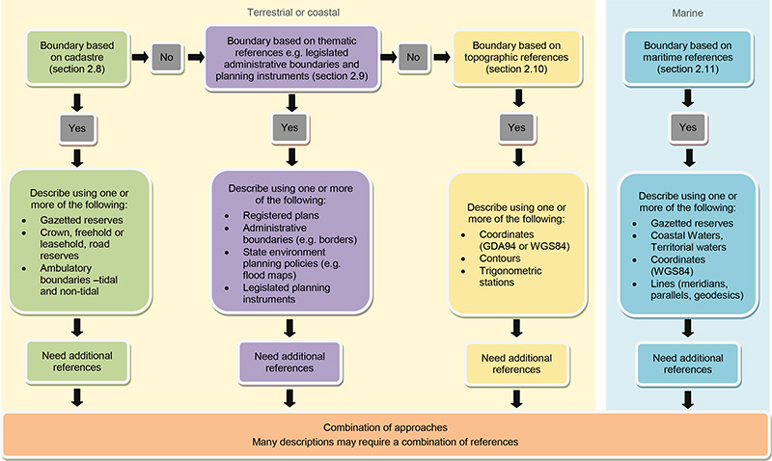

Figure 1. Decision tree showing the broad approaches that can be used to describe the boundaries of Australian Ramsar sites. Many sites may need to refer to a combination of information sources.

2.5 General guidance

Ideally, the boundary of a Ramsar site should be geographically fixed and should not be described in terms of features that are likely to change over time due to modification, demolition or wear; for example, buildings, fences, levees, dirt tracks or road pavements.

The boundary and mapping guidelines describe the preferred approach and alternative approaches to use when describing the boundary of a Ramsar site. The best way to describe a Ramsar site boundary is to refer to existing legally defined boundaries such as cadastral allotments or gazetted reserves (section 2.8).   
If cadastral references are not available then thematic maps such as legislated government planning instruments may be used (section 2.9). At some sites cadastral or legislated government planning instruments may not be applicable, in which case topographic references such as coordinates or other features can be used to describe the boundary of the site. Maritime boundaries are covered by separate laws and processes (see section 2.11). Where a combination of approaches is required, the order in Figure 1 should guide the choice of references. Whichever approach is used, it is important to consider the practical, management and legal consequences of using those features   
to describe the boundary of a Ramsar site.

General information about describing site boundaries is provided below. Not all of the following points may apply for all descriptions.

* Describe the boundary in a clockwise direction.
* A prominent reference point such as the intersection of cadastral allotment boundaries, trigonometric station or coordinates may be used as the starting point for the description, if required.
* Ensure the description includes all areas that are intended to be within the site (e.g. islands, bars, road reserves, freehold and leasehold allotments, seabed, water column etc.).
* Ensure any area excluded from the site (e.g. islands, bars, road reserves, freehold and leasehold allotments etc.) is clearly described (if applicable).
* Ensure that the boundary is a closed polygon; for example, the final point of the boundary description is coincident with the starting point.
* If using existing legally described boundaries, provide an accurate reference to the source of this boundary. Generally avoid redescribing the boundary as it can result in a boundary different to the one intended. However, check the underlying description of the boundary being referred to and ensure it can withstand legal scrutiny.
* The description should be as simple as possible, however, some descriptions by their nature are complex. Above all, it is essential to avoid any ambiguity.
* Define terms used in the written description (if applicable).
* Seek appropriate legal and geospatial advice, as required.

Additional more specific guidance is provided in subsequent sections.

2.6 Terms and phrases

To aid interpretation and avoid ambiguity, the following terms and phrases should be used, where applicable:

* The [line/area] commencing at …
* From …
* On the boundary of …
* The limit of …
* Continues on the …
* At the intersection of … with …
* Where directional terms are included in the written description, the following terms should be used: north, south, east or west and in combination (e.g. north-east, north-north-east).
* At the north-west corner of …
* To the north-east corner of …
* Mean High Water Mark or Mean Low Water Mark (if applicable in your jurisdiction)
* Following on the prolongation of the northern boundary of allotment… intersecting with… – this identifies a line that has been extended on the same bearing.
* From the point on the boundary closest to DD°MM’SS”S and DD°MM’SS”E.
* The part of Crown Reserve … that is west of the truncation line – this identifies an allotment that has been separated by a plane into two parts, one part to be included in the Ramsar site and the other part to be excluded.

2.7 References that should not be used for boundary descriptions

The following references should not be used in boundary descriptions:

* topographic features that have the potential to move over time such as unformed vehicle tracks,   
  for example, the boundary follows the eastern side of the vehicle track
* fence lines that could be removed or changed
* vegetation interfaces with beaches or tree lines
* the phrase ‘Limit of tidal influence’
* infrastructure such as power lines
* the edge or centreline of bitumen road.

2.8 Cadastral references

The cadastre is a parcel-based system of property administration containing a record of interests in land (e.g. rights, restrictions and responsibilities) established under common law (Williamson and Enmark 1996; ANZLIC 2013). It is comprised of physically delineated boundaries, being the extent of parcels or interests in parcels, and datasets containing the public record of the interests in those parcels of land (ANZLIC 2013). It usually includes a geometric description of land parcels linked to other records that may describe, among other things: the nature of the interests; the ownership or control of those interests; the value of the parcel; and any improvements (Williamson and Enmark 1996).

Land parcels are defined by formal or informal boundaries marking the extent of lands held for exclusive use by individuals and specific groups of individuals (e.g. families, corporations, government or communal groups). Each parcel is given a unique code or parcel identifier, such as an address, block and section number, coordinates or an allotment number, shown on a survey plan or map (Williamson and Enmark 1996; Figure 2). For example, identification numbers for land parcels such as allotments on registered plans relate to freehold land, leasehold land, crown reserves, easements and road reserves.

Cadastral systems support land tenure systems which protect property rights through public recognition and recording, and support effective land markets which allow property rights to be traded efficiently and effectively (Williamson and Enmark 1996). That is, they permit property rights to be bought, sold, mortgaged and leased (Williamson and Enmark 1996).

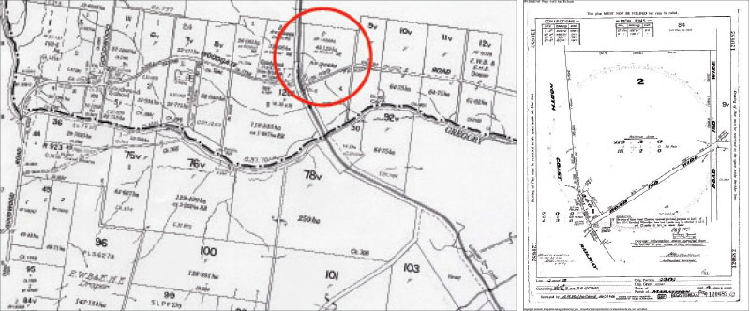

Figure 2. An example of a cadastral map and cadastral plan (the enlarged areas shows the cadastral plan for the area circled in red) (Viewed 10 September 2013, http://www.icsm.gov.au/mapping/maps_cadastral.html)

2.8.1 How is a cadastral map different to a cadastral plan?

Cadastral maps are produced by joining together individual cadastral plans (ICSM 2013b). A cadastral map is a land administrative tool which has no real legislative basis (as a cadastral plan does). It is often created on demand and may not be up to date (ICSM 2013b). These maps are used by a broad range of people (public and professional) for a range of purposes including real estate sales, valuation and Land Title Office management of the cadastre and planning (ICSM 2013b). Cadastral mapping is one of the best known forms of mapping because it shows the land parcels in relation to one another and to the adjoining roads (ICSM 2013b).

Cadastral maps show the relative location of all parcels in a given region. Cadastral plans commonly range from scales of 1:500 to 1:10 000 (Williamson and Enmark 1996). Large scale diagrams or plans showing more precise parcel dimensions and features (e.g. buildings, irrigation units, etc.) are often prepared by cadastral surveys for each parcel based on ground surveys and aerial photography (Williamson and Enmark 1996). Information in the textual or attribute files of the cadastre, such as land value, ownership, or use, can be accessed by these unique parcel codes shown on the cadastral map, thus creating a complete cadastre (Williamson and Enmark 1996).

2.8.2 Application for Ramsar site boundaries

A cadastral survey of a Ramsar site can be undertaken by a registered cadastral surveyor which must then be approved by the chief surveyor general for registration as a deposited plan. This deposited plan can be referred to in the description of the Ramsar site. In many cases, resources may not be available to undertake a cadastral survey of the boundaries. In this situation other cadastral references can be used to describe the boundaries of the Ramsar site.

References from cadastral maps and plans that may be used for the demarcation of a Ramsar site boundary can include references to allotments, blocks and sections and road reserves on a plan of survey (often called deposited or title plans). Cadastral parcels can be consolidated or subdivided, however, the history of the changes can be traced through referring to sequential plans.

Gazetted boundaries such as national parks and nature reserves and reserved Crown land can also be used. These boundaries are usually based on cadastral parcels. However, if the description of the underlying reserve is not legally defensible then alternative references should be used to describe the Ramsar site boundary. If reserves do not have a cadastral origin then these would be referred to as thematic references (section 2.9).

If gazetted reserve boundaries are referenced, it is important to include the gazetted name, number and date of gazettal in the boundary description to ensure the boundaries of the Ramsar site are accurate in the longer‑term. In the event that the reserve boundary is extended but the Ramsar site boundary is not, the boundary of the Ramsar site can still be determined by reference to gazetted name, number and date. An extension to a gazetted reserve does not constitute an extension to the Ramsar site boundary. A separate Ramsar site boundary extension process needs to be followed. Contact the Australian Government Department of the Environment for information on how to extend Ramsar site boundaries.

Ramsar sites can be described using one or more whole gazetted reserves (Figure 3 and Figure 4); one or more whole freehold or leasehold allotments; part of a gazetted reserve or freehold allotment (Figure 5); a combination of cadastral references and/or additional types of references (Figure 6 and Figure 7).

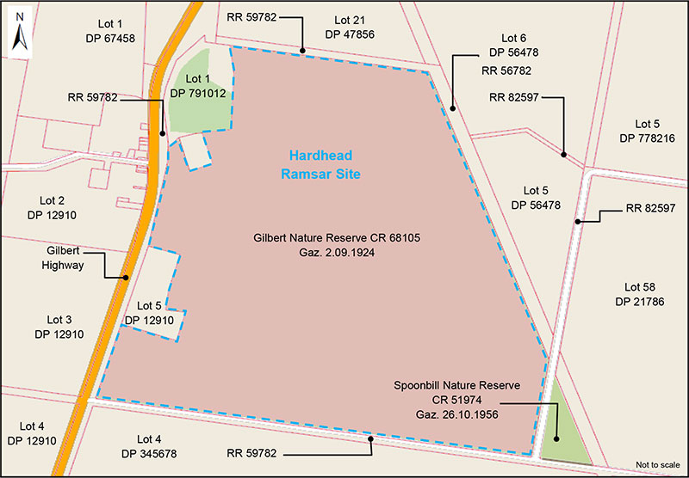

Figure 3. Fictional example of a Ramsar site that is comprised of a whole gazetted reserve. Base map modified from Department   
of the Environment, Protected Matters Search Tool, http://www.environment.gov.au/webgis-framework/apps/pmst/pmst.jsf

The Hardhead Ramsar site consists of the whole of Gilbert Nature Reserve CR 68105 gazetted on 2 September 1924.

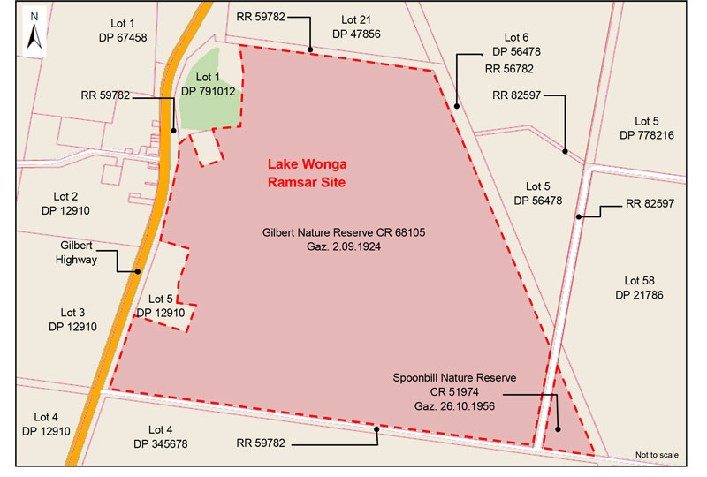

Figure 4. A fictional example of a Ramsar site that comprises two gazetted reserves and excludes a road reserve.   
Base map modified from Department of the Environment, Protected Matters Search Tool,   
http://www.environment.gov.au/webgis-framework/apps/pmst/pmst.

The Lake Wonga Ramsar site includes all of Crown Reserve CR 68105 known as Gilbert Nature Reserve gazetted on   
2 September 1924, all of all of Crown Reserve CR 51974 known as Spoonbill Nature Reserve gazetted on 26 October 1956 and excludes road reserve RR 82597.

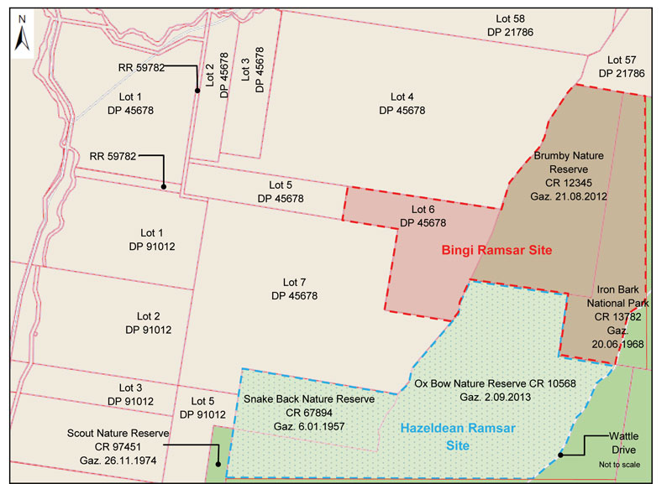

Figure 5. Fictional examples of Ramsar sites that comprises one or more whole or part gazetted reserves and/or freehold allotments. Base map modified from Department of the Environment, Protected Matters Search Tool,   
http://www.environment.gov.au/webgis-framework/apps/pmst/pmst.jsf

Description of Hazeldean Ramsar site:

The Hazeldean Ramsar site includes all of Crown Reserve CR 67894 known as Snake Back Nature Reserve gazetted on 6 January 1957 and the part of Crown Reserve CR 10568 known as Ox Bow Nature Reserve gazetted on 2 September 2013 that is west of the north-western road reserve boundary of Wattle Drive.

Description of Bingi Ramsar site:

The Bingi Ramsar site includes all of Crown Reserve CR 12345 known as Brumby Nature Reserve gazetted on 21 August 2012, allotment 6 on deposited plan DP 45678, and the part of Crown Reserve CR 13782 known as Iron Bark National Park gazetted on 20 June 1968 that is west of the adjacent Wattle Drive’s western road reserve boundary.

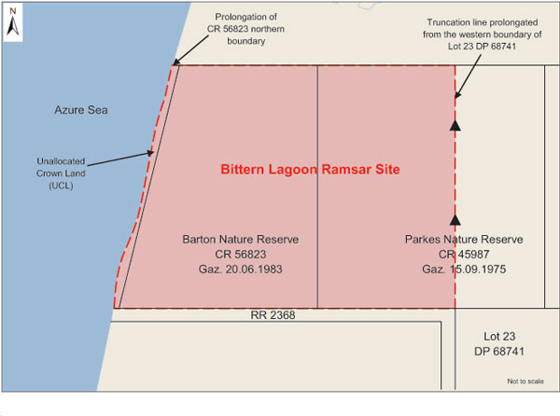

Figure 6. A fictional example of a Ramsar site boundary that shows the use of prolongation and truncation of cadastral boundaries. Base map modified from Department of the Environment, Protected Matters Search Tool,   
http://www.environment.gov.au/webgis-framework/apps/pmst/pmst.jsf

The Bittern Lagoon Ramsar site consists of:

* the whole of Barton Nature Reserve CR 56823 gazetted on 20 June 1983;
* the part of Crown Reserve CR 45987 that is west of the truncation line, formed by the prolongation of the western boundary of allotment 23 on deposited plan DP 68741 from the intersection of the northern road reserve boundary of RR 2368 and the intersection with the southern boundary of CR 45987 to the northern boundary of CR 45987; and
* the area of unallocated crown land bounded by northern boundary of road reserve RR 2368, the western boundary of Barton Nature Reserve CR 56823, the Mean Low Water Mark (MLWM) of the Azure Sea and south of the prolongation of the northern boundary of Barton Nature Reserve CR 56823.

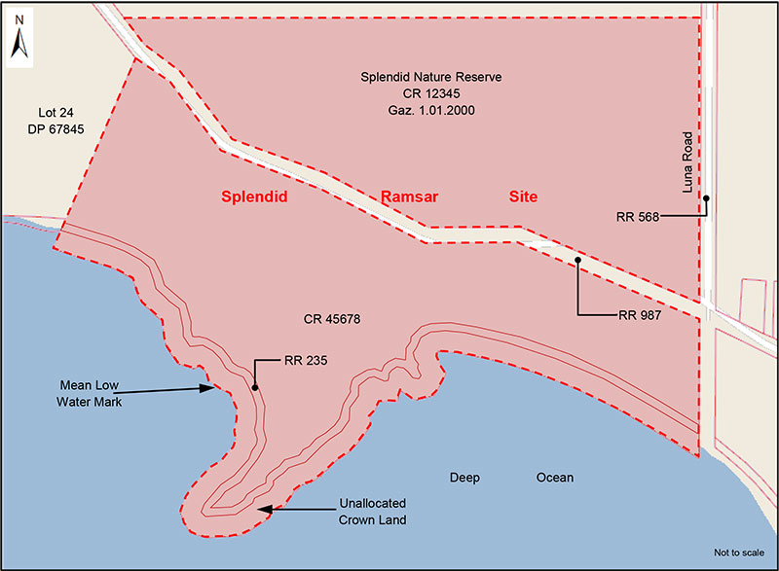

Figure 7. A fictional example of a Ramsar site boundary that is demarcated by a nature reserve, Crown Reserve, road reserve and Mean Low Water Mark. Base map modified from Department of the Environment, Protected Matters Search Tool,   
http://www.environment.gov.au/webgis-framework/apps/pmst/pmst.jsf

The Splendid Ramsar site consists of the whole of Splendid Nature Reserve (CR 12345) gazetted on 1 January 2000, Crown Reserve CR 45678, reserve road RR 235 and the unallocated crown land between road reserve RR 235 and Deep Ocean to Mean Low Water Mark (MLWM) that is truncated at the western boundary by the eastern boundary of allotment 24 on deposited plan DP 67845 and truncated at the eastern boundary by the western boundary of road reserve RR 568. Excluded from the Splendid Ramsar site is road reserve RR 987.

A summary of how to use cadastral information to describe Ramsar site boundaries is provided in Figure 8.

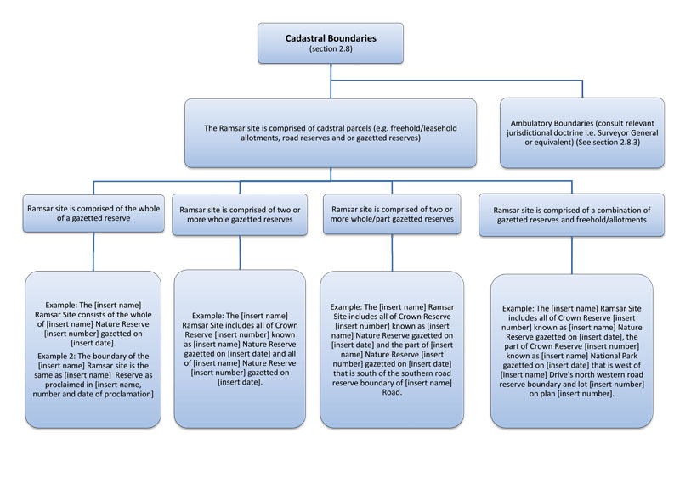

Figure 8. Diagram depicting how to use cadastral information to describe the boundaries of Australian Ramsar sites. Ambulatory boundaries are addressed in section 2.8.3.

2.8.3 Ambulatory boundaries

Ambulatory boundaries are formed at the interface of land and water such as sea, ocean, rivers and streams. Ambulatory boundaries cannot be marked on the ground and are not fixed in one place but can change position over time through slow and imperceptible accretion or erosion of the described feature (NPPL Public Land Policy Section 1993). This process is known in Common Law as the ‘Doctrine of Accretion’. It is common for natural forces to bring about changes in the boundary between land and water along the sea and waterways resulting in either accretion or loss of land (NPPL Public Land Policy Section 1993). ‘Doctrines of Accretion’ are usually found in the relevant state or territory Land Act and can vary between jurisdictions. To reference ambulatory boundaries such as creeks and rivers, refer to the relevant Surveyor General doctrine on ambulatory boundaries in your jurisdiction. These should specify the appropriate referenced position of the ambulatory boundary, such as Mean High Water Mark (MHWM), Mean High Water Springs, top of bank, bottom of bank or other reference. It is important to use correct technical terms that provide precise meaning to the description and ensure there can be no ambiguity about the location of the boundary.

2.8.4 Application for Ramsar site boundaries

Ideally, Ramsar site boundary descriptions should avoid the use of ambulatory boundaries because the boundaries may move over time or they can be difficult to actually fix on the ground. In particular, the use of ambulatory boundaries to describe the boundaries of a new Ramsar site should be avoided whenever possible. However, for some existing Ramsar sites this is not possible as the boundary has already been set. In these cases an ambulatory boundary may be used in the boundary description, providing the changes are imperceptible in time (refer to relevant State doctrine). Ambulatory boundary features referenced from cadastral maps and plans that may be referenced for the demarcation of the Ramsar site could include, for example:

* a non-tidal boundary such as a river or stream where the change to the course of the river is slow or imperceptible over the course of time (Figure 9). The description needs to specify where the boundary is, such as top or bottom of bank. An example of a non-tidal ambulatory boundary is provided in Figure 10
* tidal boundaries such as Mean Low Water Mark (MLWM) or Mean High Water Mark (MHWM). Fictional examples of Ramsar site boundaries that reference tidal ambulatory boundaries are provided in Figure 11 and Figure 12.

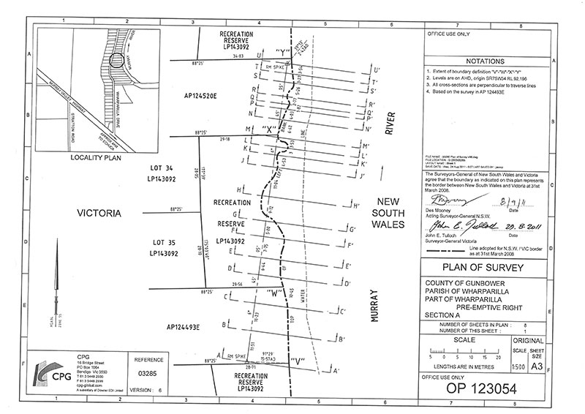

Figure 9. An example of a plan of survey including an ambulatory boundary related to the River Murray.   
(Viewed 10 September 2013, http://www.dse.vic.gov.au/__data/assets/pdf_file/0003/152247/Plan-view-OP-123054.pdf)

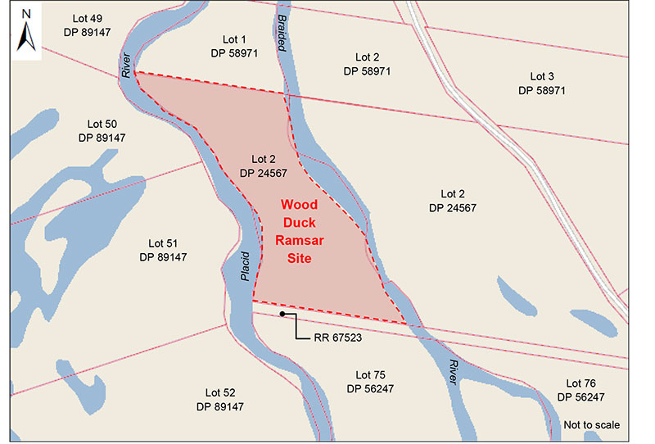

Figure 10. A fictional example of a Ramsar site boundary that includes a non-tidal ambulatory boundary (river).   
Base map modified from Department of the Environment, Protected Matters Search Tool,   
http://www.environment.gov.au/webgis-framework/apps/pmst.jsf

The boundary of Wood Duck Ramsar site commences from the intersection of the top of the eastern bank of the Placid River and the northern boundary of road reserve RR 67523. The boundary follows on the top of bank of the eastern side of the Placid River north to intersect with the north-western corner of allotment 2 of deposited plan DP 24567, continuing on the boundary east to the intersection of the top of bank on the western side of Braided River, continuing south on top of bank to intersect with the northern boundary of the road reserve RR 67523, then continues west closing at the intersection of the top of bank on the eastern side of the Placid River and the northern boundary of road reserve RR 67523.

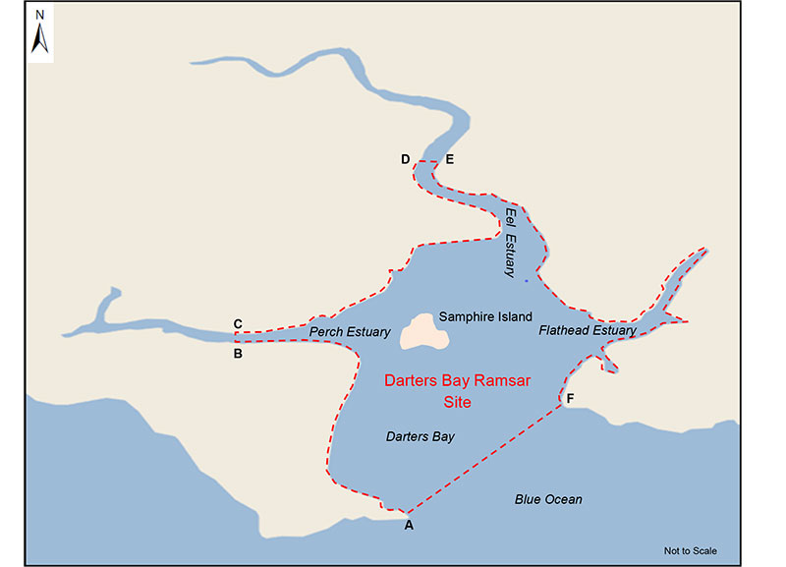

Figure 11. A fictional example of a Ramsar site that uses a combination of GDA94 coordinates and ambulatory boundaries   
to define the boundary. Base map modified from Department of the Environment, Protected Matters Search Tool,   
http://www.environment.gov.au/webgis-framework/apps/pmst/pmst.jsf.

Darters Bay Ramsar site consists of all the terrestrial land and water body* that is contained within the boundary of Darters   
Bay commencing from:

* Point A 12° 40’ 04” S, 138° 41’ 56” E following at the Mean High Water Mark (MHWM) north westerly to;
* Point B 14° 28’ 39” S, 137° 50’ 02” E at Perch Estuary then across the estuary to;
* Point C 14° 20’ 32” S, 137° 49’ 44” E continuing at the MHWM of the north-western side of Darters Bay to;
* Point D 13° 30’ 43” S, 139° 15’ 04” E at Eel Estuary, the boundary crosses Eel Estuary east to;
* Point E 13° 30’ 18” S, 139° 21’ 39” E then continues at the MHWM of the eastern side of Darters Bay to;
* Point F 14° 50’ 01” S, 140° 27’ 22” E crossing Darters Bay; and
* closing the boundary at point A.

Geographic coordinates are expressed in GDA94.

*Including the sea bed, airspace, water column and subsoil in accordance with the Coastal Waters (State Powers) Act 1980, Coastal Waters (Northern Territory Powers) Act 1980 and Seas and Submerged Lands Act 1973.

In some cases, a Ramsar site boundary may follow MHWM and then transition to MLWM (e.g. where a boundary moves from an estuary to the ocean). To transition from MHWM to MLWM the description will need to identify fixed points such as coordinates, allotments or other fixed features in order to fix the location of the boundary (Figure 13 and Figure 14).

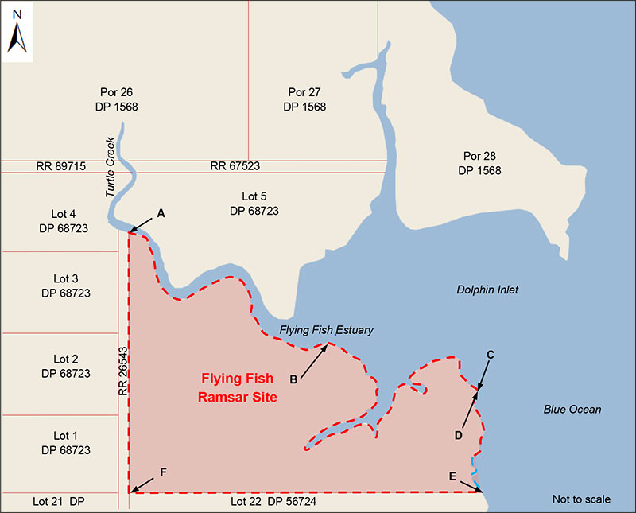

Figure 12. A fictional example of a Ramsar site boundary that includes a transitional tidal ambulatory boundary.   
Base map modified from Department of the Environment, Protected Matters Search Tool,   
http://www.environment.gov.au/webgis-framework/apps/pmst/pmst.jsf.

The boundary of Flying Fish Ramsar site commences at the intersection of the north-eastern corner of road reserve RR 26543 boundary (point A) and Mean High Water Mark (MHWM), continuing south-east on MHWM to intersect with MHWM of Dolphin inlet (point B), continuing on MHWM to the intersection of Blue Ocean MHWM (point C) at a point nearest to 32° 22’ 05”S, 149° 49’ 38”E. The boundary then transitions to Blue Ocean MLWM at point D nearest to 32° 22’ 05”S, 149° 49’ 38”E continuing at MLWM south to intersect with the north-east corner of allotment 22 on deposited plan DP 56724 (point E) and continues west on the northern boundary of allotment 22 on DP 56724 to the intersection of the north-west corner of allotment 22 of deposited plan DP 56724 and road reserve RR 26543 (point F) and then north along the eastern boundary of RR 26543 to close at point A.

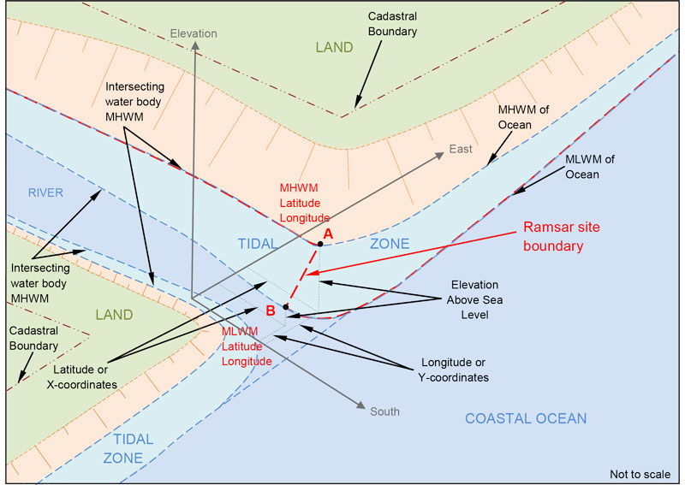

Figure 13. A three dimensional representation of a Ramsar site boundary of an intersecting water body and the ocean transitioning between point A, at Mean High Water Mark, to point B at the ocean’s Mean Low Water Mark.

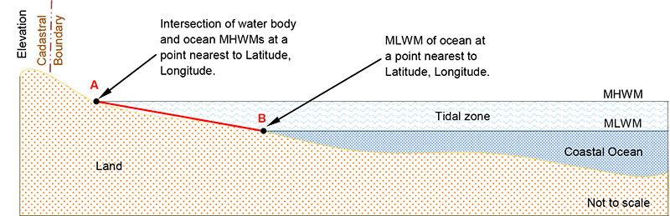

Figure 14. A cross sectional view showing the linear transition between point A, at Mean High Water Mark of the   
intersecting water body, to point B at the oceans Mean Low Water Mark.

A summary of how to use ambulatory features to describe Ramsar site boundaries is provided in Figure 15.

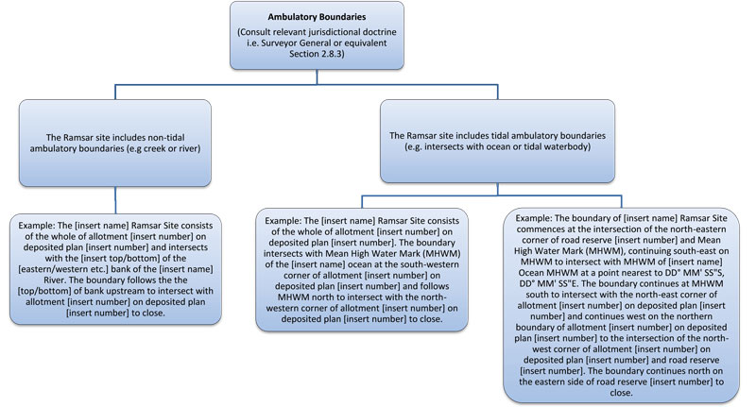

Figure 15. Diagram depicting how to use cadastral information such as ambulatory boundaries to describe the boundaries of Australian Ramsar sites.

2.9 Thematic

A thematic map is a type of map, plan or chart especially designed to show a particular theme connected with a specific geographic area. Examples include government planning instruments, biodiversity maps, climate maps, political maps and resource or economic maps, however, not all of these are appropriate for use in Ramsar site boundary descriptions.

Government planning instruments are thematic maps that show the location of planning zones or overlays relative to property boundaries. Thematic maps are generally based on cadastral maps and are used for political and administrative purposes and are often embedded into legislation. They can be used to identify the specific location of zones and overlay boundaries where these do not coincide with property boundaries. For example: flood plans; land use zones; electoral boundaries; or proposed future development. Government planning instruments vary in each state. For example, in New South Wales government planning instruments are referred to as State Environmental Plans.

2.9.1 Application for Ramsar site boundaries

The types of thematic maps and plans that may be referenced in the description of the Ramsar site boundary could include:

* State Environmental Planning Policies (SEPPs) such as Local Environment Plans (LEPs) which include flood plans (Figure 16) and other planning maps
* state, territory and local government administrative boundaries (Figure 17)
* state, territory and local government planning instruments (e.g. parks or conservation planning zones not based on gazetted cadastre which have a defensible legal standing)
* state or territory registered plans.

When using government administrative boundaries, the source and a date of endorsement should be included. To be used as references for Ramsar site boundary descriptions, these plans must be legally defensible and not based on structures (such as roads) or other features that may change.

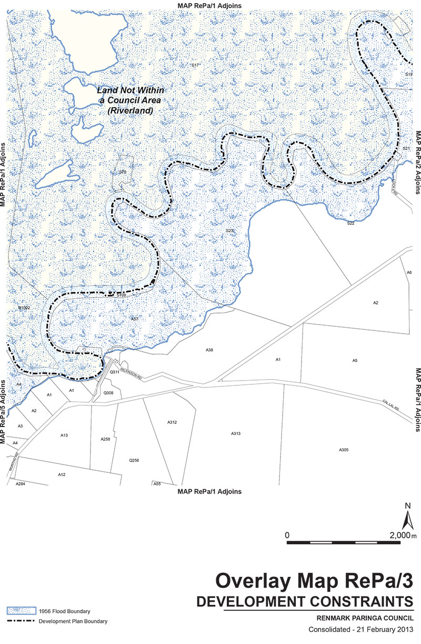

Figure 16. Example of a Development Plan flood extents map. Source: Department of Planning, Transport and Infrastructure and District Council of Renmark Paringa (2013).

The boundary of the [insert name] Ramsar site follows the [insert which flood line if more than one is shown on the map, for example, the 1 in 100 year or 1956] flood line as identified as the flood planning level on LEP flood plan [insert number] of the [insert name and date of instrument i.e. Environmental Plan 2012 made under the Environmental Planning and Assessment Act 1979, Regulation 576 as at 2 July 2013].

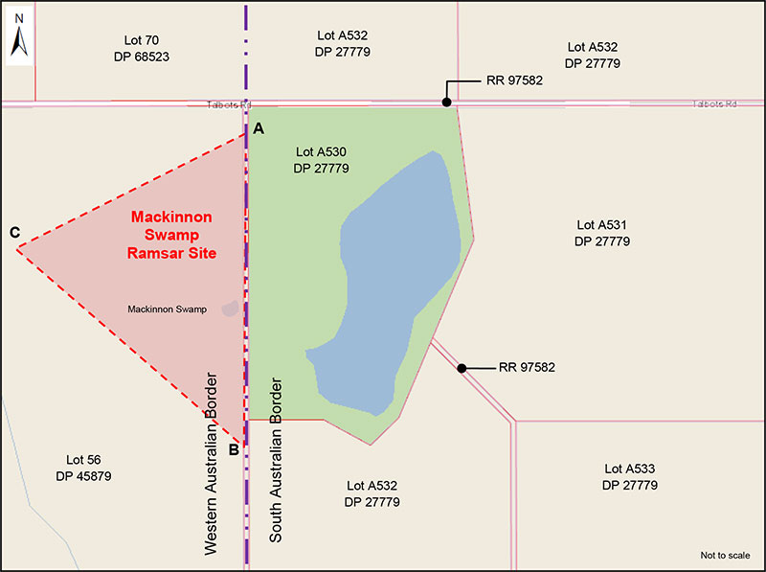

Figure 17. Fictional example of a Ramsar site that refers to a state government administrative boundary such as the state border. Base map modified from Department of the Environment, Protected Matters Search Tool,   
http://www.environment.gov.au/webgis-framework/apps/pmst/pmst.jsf

The boundary of Mackinnon Swamp Ramsar site is demarcated by GDA94 coordinates annotated on the attached map   
(Figure 17) commencing from point A on the Western Australian and South Australian border at a point nearest to 42° 22’ 05”S,   
146° 49’ 38”E following on the Western Australian and South Australian border to point B at a point nearest to 42° 22’ 06”S, 146° 50’ 52”E, to point C 42° 23’ 00”S, 146° 50’ 47”E closing back to point A on the Western Australian and South   
Australian border.

A summary of how to use thematic maps and plans to describe Ramsar site boundaries is provided in Figure 18.

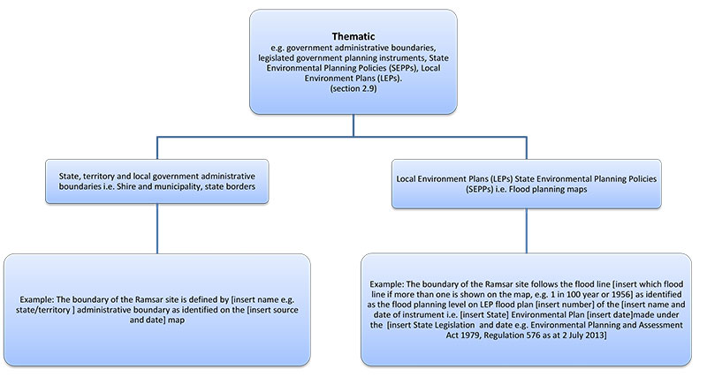

Figure 18. Diagram depicting how to use thematic information to describe the boundaries of Australian Ramsar sites.

2.10 Topographic

Topography is the graphic representation of the surface features of a place or region on a map, indicating their relative positions and elevations. The relative positions are defined by coordinates using latitude south and longitude east where each group of coordinates are used to indicate the position of a point, line or polygon.

Some sources of topographic information include topographic maps, aerial photography, satellite imagery, digital elevation models (DEM) or terrain models (DTM). Many of these data sources are imported into a Geographic Information System (GIS) for interrogation and product development.

Topographic information and maps are often used for recreational purposes, such as travelling, hiking and orienteering. They are also used by government and industry to assist with urban planning, mining, emergency management and other purposes (Geoscience Australia 2013a). Topographic maps are detailed, graphic representations of features that appear on the earth’s surface (Figure 19a).

Topographic features include:

* cultural: roads, buildings, fences, trigonometric stations, urban development, railways, airports, names of places and geographic features, administrative boundaries, state and international borders, reserves
* hydrography: lakes, rivers, streams, swamps, coastal flats, oceans, seas
* relief: mountains, valleys, slopes, contours, cliffs, depressions
* vegetation: wooded and cleared areas, plantations, vineyards and orchards (Geoscience Australia 2013a).

A map legend (or key) lists the features shown on a map and their corresponding symbols (Figure 19b).

(a) (b)

|  |  |
| --- | --- |
| Macintosh HD:Users:NoisyMac:Desktop:untitled folder:fig-19a.jpg | Macintosh HD:Users:NoisyMac:Desktop:untitled folder:fig-19b.jpg |

Figure 19. a) Example of a topographic map. (Viewed 10 September 2013, http://www.icsm.gov.au/mapping/maps_cadastral.html).   
b) Example of map legend (Viewed 8 October 2013, http://www.icsm.gov.au/mapping/cartographic.html)

Application for Ramsar site boundaries

Not all topographic features are appropriate to use in describing the boundary of a Ramsar site because they can move or be removed (e.g. fences, sealed and unsealed roads) or there may be inaccuracies in their determination. Topographic features that may be referenced for the description of a Ramsar site boundary include:

* coordinates
* trigonometric Stations with identification numbers – a point on the ground determined by geodetic survey
* contour elevations at Australian Height Datum (AHD) – noting the accuracy will be influenced by the source and collation techniques.

2.10.1 Coordinates

Coordinates are a set of two numbers on a grid that can be used to determine the position of a point on a map or chart. For the purposes of Ramsar site boundary descriptions and maps, coordinates are generally described in latitude and longitude or sometimes in easting and northing.

In many cases geospatial datasets will be used (where available) to identify coordinates. To ensure that projected coordinates are correctly mapped, the datum and map projection used must be included along with relevant projection parameters (e.g. MGA Zone number). Geographic coordinates (i.e. latitude and longitude) are not projected therefore only the datum needs to   
be specified.

2.10.1.1 Map projections

Whether the earth is treated as a sphere or a spheroid, its three-dimensional surface must be transformed to create a flat map sheet. This mathematical transformation is commonly referred to as a map projection. This representation can create distortions in shape, area, distance or direction. Some projections minimise distortions in one characteristic. When mapping Ramsar site boundaries, a projection that minimises distortions of scale should be used. For additional information see Appendix 3.

2.10.1.2 Datums

A datum is an official, fully defined, spatial reference system or surface to which measurements and/or coordinates upon the earth may be defined and related (ICSM 2013a). Datums are used for describing a point on the earth’s surface in latitude and longitude or easting and northing. A specific point on the earth can have significantly different coordinates, depending on the datum used (Geoscience Australia 2013b). For additional information see Appendix 3. Information on vertical datums is in section 3.3 and the Standard for the Australian Survey Control Network – SP1 3 Version 2.0 (ICSM 2013a).

2.10.1.3 General guidance

The following provides additional guidance when using coordinates in the description of a Ramsar site boundary:

* The preferred format for coordinates is latitude (South) and longitude (East) in degrees, minutes, seconds, for example 32° 23’ 45”S, 149° 45’ 56”E.
* When using geographic coordinates, the datum must be included. In Australia, the preferred datum for coordinates on land is the Geocentric Datum of Australia (GDA94) unless they are Global Positioning System (GPS) coordinates (see below).
* If using GPS coordinates, ensure the coordinates are identified on a site map and are accompanied by an electronic file, listing each GPS latitude and longitude way-point and the datum used. GPS coordinates often use World Geodetic System (WGS84). WGS84 should be used in marine areas (see section 2.11).
* If cadastral parcels can be referred to, such as the north-east corner of an allotment, then the same point does not also need to be described using coordinates.
* When referring to a point on a boundary that is not an intersection, coordinates can be used to fix the position of that point on the boundary. However, the terms ‘a point closest to’ needs to be used to clarify that the point being described lies on the boundary, perpendicular to the coordinates and that the boundary line takes precedence over the latitude and longitude (Figure 20). For example, ‘the boundary continues east along the northern boundary of allotment [insert number] on [insert plan number] to a point closest to GDA94 coordinates [insert DD°MM’SS”S and DD°MM’SS”E]’.

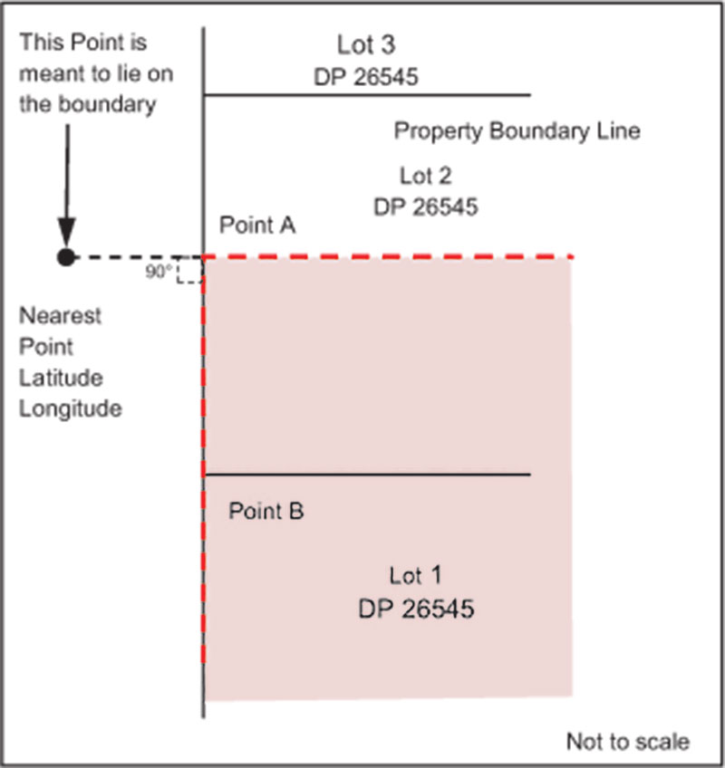

Figure 20. Shows an example of a point defined as being on an allotment boundary and not coincident with a longitude and latitude coordinates.

A summary of how to use thematic maps and plans to describe Ramsar site boundaries is provided in Figure 18.

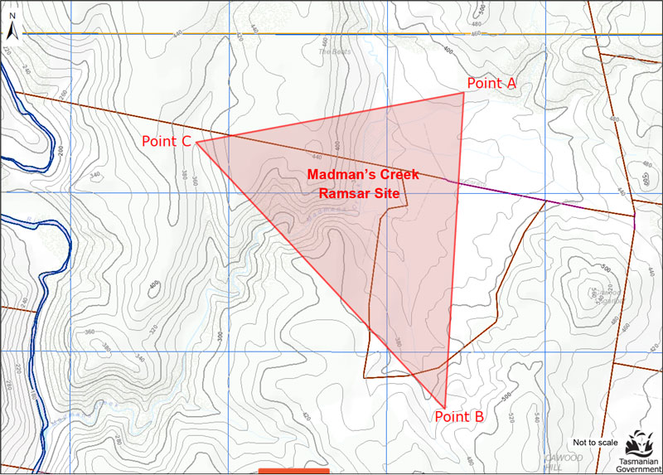

Figure 21. A fictional example of a Ramsar site boundary that has been demarcated by using coordinates (Points A-C). Base map modified from the Land Information System Tasmania (theLIST), viewed on 26 September 2013 from http://maps.thelist.tas.gov.au/listmap/app/list/map

GDA94 coordinates:

The boundary of Madman’s Creek Ramsar site is demarcated by GDA94 coordinates annotated on the attached map (Figure 21) commencing from point A at 42° 22’ 05”S, 146° 49’ 38”E to point B 42° 22’ 06”S, 146° 50’ 52”E, to point C 42° 23’ 00”S, 146° 50’ 47”E closing back to point A.

GPS coordinates:

The boundary of Madman’s Creek Ramsar site includes the contained area defined by the triangle of GPS coordinates (WGS84) from point A at 42° 22’ 05”S, 146° 49’ 38”E to point B 42º 22’ 06”S, 146° 50’ 52”E, to point C 42° 23’ 00”S, 146° 50’ 47”E closing back to point A.

It is possible to refer to a table if there are a large number of coordinates:

The boundary of Madman’s Creek Ramsar site is demarcated by GDA94 coordinates in Table 1 (Refer to Table below or attach table).

Table 1 Example of an accompanying coordinate table

|  |  |  |  |
| --- | --- | --- | --- |
| POINT | POINT LOCATION (GDA94) | | COMMENT |
|  | Latitude | Longitude |  |
| A | 42° 22’ 05”S | 146° 49’ 38”E | North-east corner of Ramsar site |
| B | 42° 22’ 06”S | 146° 50’ 52”E | South-east corner of Ramsar site |
| C | 42° 23’ 00”S | 146° 50’ 47”E | North-west corner of Ramsar site |

2.10.2 Trigonometric stations

Figure 22 provides an example of using trigonometric stations to describe Ramsar site boundaries.

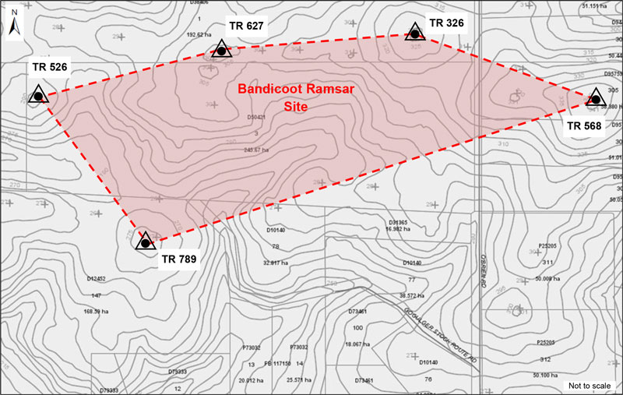

Figure 22. A fictional example of a boundary using trigonometric stations. Base map modified from Western Australian Land Information Authority (Landgate) viewed on 26 September 2013 https://www.landgate.wa.gov.au/bmvf/app/mapviewer/

The boundary of Bandicoot Ramsar site is demarcated by a polygon from trigonometric station TR 526 through trigonometric stations TR 627, TR 326, TR 568, TR 789 and closing to trigonometric station TR 526.

2.10.3 Contours

As mentioned in section 2.4, the accuracy of contour information will be affected by the way it was gathered and collated. For example, elevation data could have been digitised from a 1974 contour map or a combination of data sources such as satellite and aerial photography over a period of many years. The contours may have had an original accuracy of ±20m at 1:250 000 scale. Therefore, care should be taken when using such information for determining a point on the ground. In some situations it may be more accurate to use coordinates to mark a geometric shape around the wetland rather than using contours. An example of using contours to describe Ramsar site boundaries is provided in Figure 23.

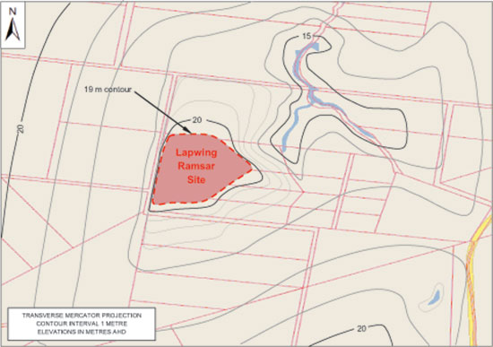

Figure 23. A fictional example of a boundary based on contour height. Base map modified from Department of the Environment, Protected Matters Search Tool, http://www.environment.gov.au/webgis-framework/apps/pmst/pmst.jsf.

The boundary of the Lapwing Ramsar site follows the 19 metre (AHD) contour line highlighted in Figure 23 as generated from the [insert description of origin, e.g. XX topographic sheet, series X (2008)].

Alternatively, the boundary of a Ramsar site may be determined using contours from a Digital Terrain Model (DTM). An example description is provided below:

The boundary of the [insert name] Ramsar site follows the 72 metre AHD contour line as generated from the [insert description of origin e.g. State map Elevation DTM 20m and DTM 10m (2008)].

A summary of how to use features from topographic maps including contours, trigonometric stations and coordinates to describe Ramsar site boundaries is provided in Figure 24.

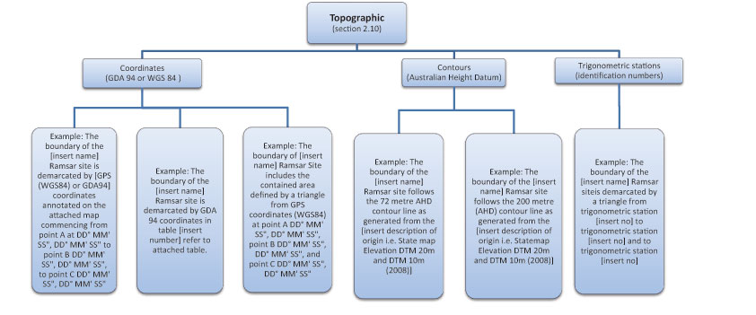

Figure 24. Diagram depicting how to use topographic information such as coordinates, contours or trigonometric stations to describe the boundaries of Australian Ramsar sites.

2.11 Maritime boundaries

Several Australian Ramsar sites are located in or adjacent to Australia’s offshore areas. Australia’s sovereignty and sovereign rights in offshore areas are declared under the Seas and Submerged Lands Act 1973, consistent with the provisions of the 1982 United Nations Convention on the Law of the Sea (UNCLOS). For additional information about the Law of the Sea and maritime boundaries contact the Office of International Law, Attorney‑General’s Department.

The dynamic nature of some coastlines, coupled with existing tidal and seasonal regimes, can complicate maritime boundary descriptions (Geoscience Australia 2009). Boundaries in the marine environment cannot be readily or permanently marked   
with pegs or walls and therefore should not be confused with cadastral boundaries (Geoscience Australia 2009). The descriptions should have a geospatial framework that is mathematically definable to enable them to withstand legal scrutiny (Geoscience Australia 2009).

The following aids may be useful to help describe a Ramsar site boundary in an offshore area:

* nautical charts and bathymetric maps for issues related to the coastal zone, water surface area, water column and seabed
* topographic maps for issues related to coastal zone, hinterland
* aeronautical charts for air space issues and aerial surveillance of offshore jurisdictional limits
* rectified aerial photography or satellite imagery is especially useful when recent or current information is required, but it may need interpretation by an expert in the field to maximise its use (Geoscience Australia 2009).

Written descriptions are the authoritative sources of boundaries in the maritime environment (Geoscience Australia 2009), supporting maps and diagrams are indicative only. Therefore it is important that boundary descriptions are unambiguous and have legal integrity. A map that complements the description is important as it helps to visualise where the boundary is located. However, for maritime boundaries, any map produced needs appropriate annotation that clearly states that it is indicative only (Geoscience Australia 2009); an exception to this is the practice by some agencies of delineating a particular boundary in terms of a specific isobath (depth contour). That form of boundary delineation is only valid if it specifies a particular hydrographic chart. It is recommended that isobaths are not used to delineate boundaries.

The Law of the Sea and Maritime Boundaries Advice area of Geoscience Australia should be consulted in the early stages about Ramsar site boundary descriptions in the marine environment.

2.11.1 Application at Ramsar sites

Ramsar site boundaries can be described by a series of lines that enclose an area (e.g. a marine park, port limit or fishing zone) and usually reference one, or a combination, of the following components:

* existing legally-defined boundaries (e.g. reserves, legally defined marine zones)
* coordinates
* physical features
* lines (e.g. meridians, parallels, geodesics etc.), if applicable. See Geoscience Australia (2009) for further information.

Ramsar site boundary descriptions should include the following information:

* the extent of the area
* any exclusions (where applicable)
* what is included in the site (e.g. water column, seabed, subsoil and air space) where applicable
* definitions of any terms used (e.g. Coastal Waters, offshore etc.)
* horizontal datum (or geodetic datum) where coordinates are used.

More specific guidance and information for describing maritime boundaries can be found in the Procedures for Describing Maritime Boundaries (Geoscience Australia 2009). These procedures provide instructions relating to the technical   
aspects of writing maritime boundary descriptions.

2.11.2 Existing legally-defined boundaries

Boundary descriptions in the marine environment can reference existing boundaries in the description such as reserves or legally defined zones. Legally defined zones in the marine environment include: the Territorial Sea Baseline; Coastal Waters (3 nautical mile limit); Territorial Sea (12 nautical mile limit); and the Contiguous Zone (24 nautical mile limit). The definitions of different maritime zones are contained within the Seas and Submerged Lands Act 1973.

The description should clearly identify the existing boundary and refer to the source of the boundary.

Figure 25 provides an example of maritime boundaries that reference existing legally defined boundaries.

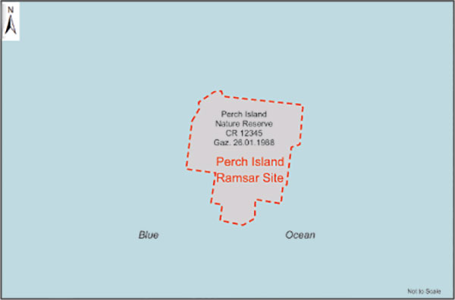

Figure 25. A fictional example of a maritime Ramsar site that is comprised of a legally defined gazetted Crown Reserve. Base map modified from Department of the Environment, Protected Matters Search Tool,

http://www.environment.gov.au/webgis-framework/apps/pmst/pmst.jsf

The boundary of Perch Island Ramsar site consists of the whole of Perch Island Nature Reserve CR 12345 gazetted on 26 January 1988.

2.11.3 Coordinates

Maritime boundaries can be described as a series of coordinates connected by lines (polygon) or as a boundary projected out to a specific distance from a point (Geoscience Australia 2009). The horizontal datum must be specified. WGS84 is the datum used for aeronautical and hydrographic navigation and charts and GPS. See Geoscience Australia (2009) for further information. For Ramsar sites in Australia’s offshore areas, coordinates should be specified in WGS84. As with other Ramsar site boundary descriptions, if the coordinate is located on an existing boundary that is not an intersection the terms ‘a point closest to’ should be used to show that the boundary line takes precedence. Examples of maritime boundaries that reference coordinates are provided in Figure 26 and Figure 27.

Where the description refers to distance from a point or feature, the distance should be described in nautical miles. A nautical mile is an Australian legal unit of measure (National Measurement Regulations 1999 – F2013C00709) and defined as being 1852 metres. It closely approximates one minute of a degree of latitude (Geoscience Australia 2009). Hydrographic charts generally use nautical miles (Geoscience Australia 2009).

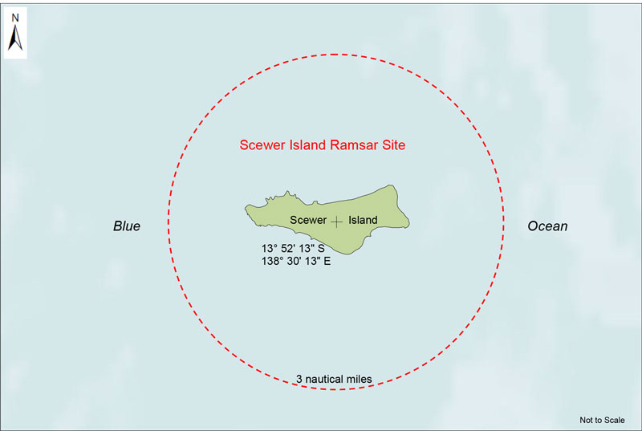

Figure 26. A fictional example of a maritime Ramsar site that uses a WGS84 coordinated center point and radius to define the boundary. Base map modified from Department of the Environment, Protected Matters Search Tool,   
http://www.environment.gov.au/webgis-framework/apps/pmst/pmst.jsf.

The limit of the Scewer Island Ramsar site is the circle of radius 3 nautical miles centred at the point of 13° 52’ 13” S, 138° 30’ 13” E and includes the sea bed, airspace, water column and subsoil in accordance with the Coastal Waters (State Powers) Act 1980, Coastal Waters (Northern Territory Powers) Act 1980 and Seas and Submerged Lands Act 1973. Geographic coordinates are expressed in WGS84.

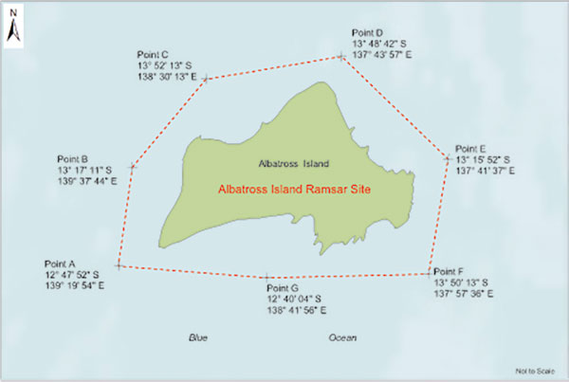

Figure 27. A fictional example of a maritime Ramsar site that uses a WGS84 coordinated polygon to define the boundary. Base map modified from Department of the Environment, Protected Matters Search Tool,   
http://www.environment.gov.au/webgis-framework/apps/pmst/pmst.jsf.

Albatross Island Ramsar site is defined as within and bounded by the following coordinates and includes the sea bed, airspace, water column and subsoil:

* Point A 40° 21’ 29” S, 147° 26’ 08” E;
* Point B 40° 18’ 24” S, 147° 26’ 25” E;
* Point C 40° 16’ 10” S, 147° 29’ 30” E;
* Point D 40° 15’ 37” “ S, 147° 35’ 32” E;
* Point E 40° 18’ 20” S, 147° 38’ 49” E;
* Point F 40° 22’ 11” S, 147° 37’ 14” E;
* Point G 40° 22’ 05S, 147° 30’ 44” E; and
* the boundary closes at point A.

Geographic coordinates are expressed in WGS84.

2.11.4 Physical features

Boundary descriptions can refer to physical features such as coastlines, the edge of a reef or an isobath (line of constant depth) (Geoscience Australia 2009). However, many of these features are dynamic and it may be difficult to physically realise the physical location of the feature. Therefore they are not recommended in Ramsar site boundary descriptions. If they are used, it is important to consider the practical, management and legal consequences of these features (Geoscience Australia 2009). Specific technical terms should be used where possible and terms should be defined. Some features such as headlands, reefs or isobaths may need to be spatially positioned using coordinates to avoid ambiguity. For more information on describing boundaries using physical features see the Procedures for Describing Maritime Boundaries (Geoscience Australia 2009).

2.11.5 Lines

Parallels of latitude or meridians of longitude or other types of mathematically definable lines are often used in maritime boundary descriptions. Given the large areas these lines may cover it is unlikely they would be used solely to describe Ramsar site boundaries but may be used in combination with other features. For more information on describing boundaries using parallels or meridians see the Procedures for Describing Maritime Boundaries (Geoscience Australia 2009).

A summary of how to describe Ramsar site boundaries in the marine environment is provided in Figure 28.

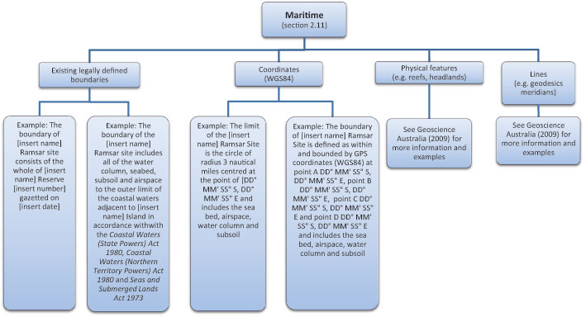

Figure 28. Diagram depicting how to use legally defined boundaries, coordinates, physical features and lines to describe the boundaries of Australian Ramsar sites in the marine environment.

2.12 Exclusions from Ramsar sites

Some Ramsar site boundaries specifically exclude certain areas such as road reserves, freehold and leasehold allotments, bars and islands. The areas that are excluded from the Ramsar site boundary need to be described clearly. Examples of areas that have been excluded from Ramsar sites are provided in Figure 29, Figure 30 and Figure 31.

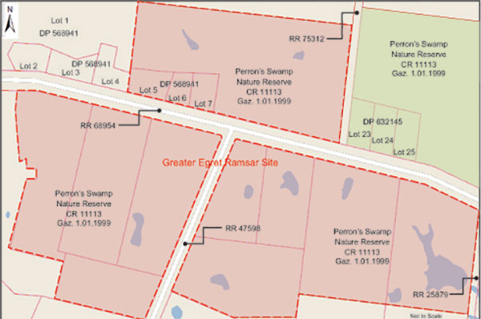

Figure 29. A fictional example of a Ramsar site boundary that excludes road reserves and an allotment. Base map modified from Department of the Environment, Protected Matters Search Tool, http://www.environment.gov.au/webgis-framework/apps/pmst/pmst.jsf

The Greater Egret Ramsar site is comprised of:

* part of Perron’s Swamp Nature Reserve CR 11113 gazetted on 1 January 1999; and
* allotments 5, 6 and 7 on deposited plan DP 568941.

Excluded from Greater Egret Ramsar site are:

* the portion of Perron’s Swamp Nature Reserve CR 11113 that is north of road reserve RR 68954 and east of road reserve RR 75312;
* the road reserves RR 68954, RR 75312, RR 47598, RR 25879; and
* allotments 23, 24 and 25 on deposited plan DP 632145.

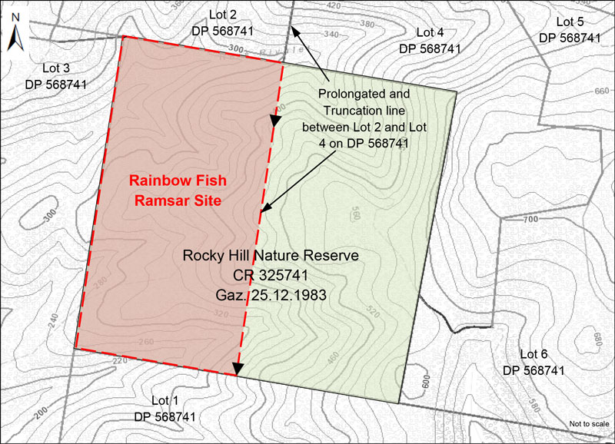

Figure 30. A fictional example of a truncation being used to exclude part of Rocky Hill Nature Reserve from the Rainbow Fish Ramsar site. Base map modified from Western Australian Land Information Authority (Landgate). Viewed on 26 September 2013 https://www.landgate.wa.gov.au/bmvf/app/mapviewer/

The Rainbow Fish Ramsar site is comprised of the part of Crown Reserve CR 325741, known as Rocky Hill Nature Reserve, that is west of the truncation formed by the prolongation of the common boundary of allotments 4 and 2 on DP 568741 from the northern boundary to the southern boundary of CR 325741.

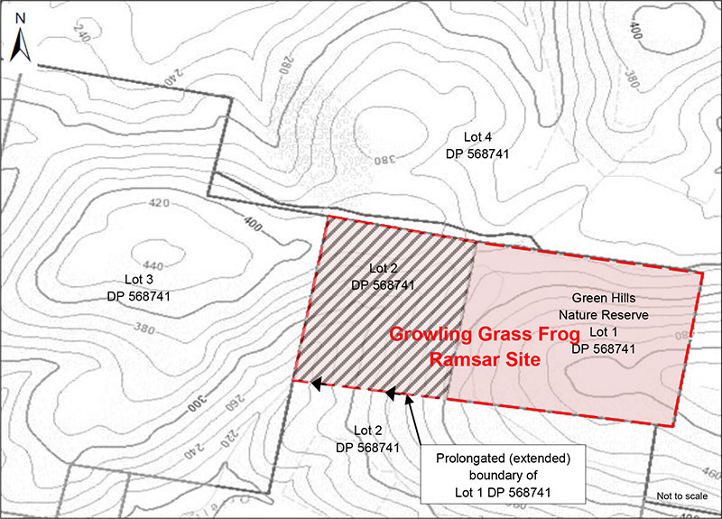

Figure 31. A fictional example of using the prolongation of the southern boundary of allotment 1 on DP 568741 to truncate part of allotment 2 on DP 568741 to demark Growling Grass Frog Ramsar site. Base map modified from Western Australian Land Information Authority (Landgate). Viewed on 26 September 2013 https://www.landgate.wa.gov.au/bmvf/app/mapviewer/

The boundary of the Growling Grass Frog Ramsar site is the same as allotment 1 on DP 568741 and part of allotment 2 on DP 568741 excluding the part of allotment 2 on DP 567841 south of the prolongation of the southern boundary of allotment 1 on DP 568741 intersecting with the eastern boundary of allotment 3 on DP 568741.

2.13 Verification

After drafting, check the description for errors, in particular, check any references to numbers. An incorrect number can significantly alter the location of the intended boundary. It is useful to have the description independently validated by a colleague or expert and tested for correctness, exactness and ease of understanding.

The boundary description should then be incorporated into the RIS for the site.

# 

# 3. Additional spatial information required for the Ramsar Information Sheet (RIS)

Several sections in the RIS require spatial information about the site. These are outlined below.

3.1 Geographic coordinates

One of the sections in the RIS requires the geographical coordinates of the approximate centre of the site in latitude and longitude in degrees, minutes and seconds (e.g. in the format: 32° 23’ 45”S, 149° 45’ 56”E).

If the site is shaped in such a way that the approximate centre point cannot be easily specified, or if such a point falls outside the site or within a very narrow portion of the site, please explain this with a note and provide the coordinates for the approximate centre point of the largest part of the site (Ramsar Convention 2012). GIS software can be used to calculate the centroid of a polygon, especially for sites with complex shapes.

If there is more than one geographically separate part to the site, specify the number of discrete units forming the site. If any such disjunct units are situated at least 1.6 km apart, the coordinates of the approximate centres of each of these units should be given separately along with the names of these units (Ramsar Convention 2012). These units should also be clearly labelled on the site map(s).

3.2 Area

The area of the site is also required in the RIS. The total area of the Ramsar site should be provided in hectares. If the site contains discrete units, the names and areas of each unit should also be provided.

The area of the site may vary depending on how it is measured. For example, the area measured from a survey of the site or a cadastral plan may differ from the area generated from a GIS system. To prevent any confusion about the area of the site,   
the system of measurement needs to be included, for example, ‘504 ha, the area was calculated using GIS and Albers Equal   
Area projection’.

3.3 Elevation

The RIS also requires the minimum and maximum elevation of the site to be recorded in metres above mean sea level (Ramsar Convention 2009 and 2012).

The Australian Height Datum (AHD71), used to measure elevation in Australia, is based on an extensive network of accurate two-way levelling adjusted to zero at Mean Sea Level (MSL) at 30 tide gauges around the mainland. Tasmania adopted a similar AHD (Tasmania) height datum using two tide gauges (ICSM 2013a).

The AHD now approximates zero at mean sea level (Geoscience Australia 2013b). Elevation in AHD approximates height above mean sea level, for example 20 metres above mean sea level approximates to 20 metres AHD. There may be some variation around Australia. For additional information see Appendix 3 and ICSM (2013a).

# 4. Specifications for generating and managing spatial data for Ramsar site boundaries

4.1 Spatial Data

The boundary of a Ramsar site, as described, should be generated and stored spatially using GIS software. GIS provides a digital representation of the real world. Points, lines and polygons are used to depict spatial features.

The boundary of a Ramsar site should be generated in vector form at a scale that is sufficiently large to ensure that the features that define the boundary of a Ramsar site are represented in an unambiguous manner. The geo-referenced polygons of the Ramsar site boundaries should be prepared at the finest scale possible. If the site contains more than one wetland unit, each unit should be stored as different records in the same GIS file (Ramsar Convention 2012). The digital Ramsar site boundary must be consistent with the written description. The spatial data should be stored as a shapefile (ESRI corporation) or a format that can be easily converted to a shapefile (Ramsar Convention 2012).

The corresponding GIS shapefile(s) must be accompanied by an attribute table (Ramsar Convention 2012). The formal name of the Ramsar site must be included in the attribute table. Other information such as the source of the GIS data, resolution, lineage process (e.g. from GPS, digitised hard copy map, field surveys etc.) and the projection system including relevant projection parameters should be included in the metadata (see section 4.2).

At a minimum, the Ramsar Convention Secretariat requests the GIS files and metadata for the boundaries of the Ramsar site (Ramsar Convention 2012). It may be useful to provide other information such as wetland types and land uses, whether vector or raster based. If included, this additional information should be submitted as one or more separate layers at the highest resolution possible (Ramsar Convention 2012).

4.2 Data custodianship, storage, management and access

The custodian of the data should be the Australian, state or territory government agency responsible for Ramsar Convention matters in the jurisdiction in which the Ramsar site is located, or an organisation approved as custodian by that government agency.

Metadata should be prepared for the Ramsar site spatial data. It should be consistent with guidelines of ANZLIC (ANZLIC 2011) and the relevant jurisdiction. The ANZLIC Metadata Profile lists such elements under the following categories:

* **Dataset, custodian, abstract and lineage** categories provide essential information about the content of the data; its capture and development; the agency responsible for its collection and maintenance; the geographic area it covers; and how the data was derived or produced.
* **Data currency and dataset status** categories establish the time frame of the data described.
* **Access** category is intended to provide potential users of datasets with sufficient information to determine if the data is in a suitable format or able to be transformed for their purpose.
* **Data quality** information is critical to determining the usefulness of a dataset for a particular application.
* **Contact information** provides address details for the contact person in the contact organisation that is responsible for delivery of the dataset to other users.
* **Metadata date**  establishes the currency of the directory entry.
* **Additional metadata** provides additional information that supports documentation of the dataset.

The spatial data should be captured, stored and managed in line with the policies, guidelines and protocols of ANZLIC (www.anzlic.org.au/policies.html) and the jurisdiction in which the Ramsar site is located.

Access to the data should be provided in accordance with the policy of the jurisdiction in which the Ramsar site is located, under appropriate licensing arrangements. Where possible the most open license should be used. Open licensing conditions facilitate ease of access to another entity or person’s information with minimal restrictions on its use. While complete freedom to use information in any way is the most open licensing condition, most information owners place some restrictions on its use. These restrictions enable the owner to keep some control, while allowing others to utilise and benefit from it. The Australian Government’s Open Access and Licensing (AusGOAL) framework is considered ‘best practice’ by the Australian Government for licensing information to other users (CJCIOC 2011). AusGOAL includes a licence suite that includes the Australian Creative Commons Version 3.0 licences, the AusGOAL Restrictive Licence Template and the BSD 3-Clause software licence.

If the Creative Commons By Attribution (CC BY) license is used, the relevant Creative Commons licence markings must be applied and displayed prominently on the material being licensed:

The following details should be displayed with the CC BY licence symbol:

* the URL for the Creative Commons licence being used
* the copyright symbol
* the organisation name
* the year of creation
* any additional information that is appropriate to   
  the circumstances.

Where a non-Creative Commons licence has been used, the licence must specify the terms and conditions of use. These licence conditions must be clearly specified with the information asset. The asset’s metadata is the most appropriate location to record the licence conditions.

The Ramsar Convention Secretariat expects to display Ramsar site boundaries publicly on the Ramsar Site Information Service database. This should be considered in the license conditions for the data.

The shapefile containing the boundary of the site will also be loaded onto the Australian Government Department of the Environment’s spatial database to ensure that accurate Ramsar site boundaries can be viewed using the Department’s relevant spatial tools. For example, the protected matters search tool is used by proponents to identify whether proposed actions will occur within or near Ramsar sites and whether they need to refer under the Environment Protection and Biodiversity Conservation Act 1999. The actual boundary shapefile cannot be downloaded from these tools.

Spatial data may be used for a range of other purposes such as compiling a national map of Ramsar sites, facilitating impact assessment or for community information.

A checklist for spatial data is provided at Appendix 4.

# 5. Specifications for the production of Ramsar site maps

5.1 Application

These specifications apply to the production of maps for a Ramsar site for inclusion with the RIS. Such maps may be used by the Australian Government for gazettal of Ramsar sites, as required under the EPBC Act.

Maps or representations of Ramsar sites may be produced for a wide range of other purposes, for example, management planning, strategic planning, statutory planning, education and community awareness. Ramsar sites may be included on online mapping portals which allow viewing and interrogation of spatial data from multiple sources such as the Ramsar Convention website.

5.2 Including the Ramsar site map with the RIS

Once a site has been designated as a Ramsar site by the Australian Government Environment Minister, the most up to date map or maps of the Ramsar site will be submitted to the Ramsar Convention Secretariat with the RIS. The RIS should specify the title of and refer to each map that is appended.

5.3 Updates

Maps are an integral part of the RIS. Every time a RIS is updated, Ramsar site maps must be reviewed and updated (if required) to ensure that they are consistent with the information in the RIS and meet the mapping requirements (sections 5.6 to 5.10).

5.4 Consistency with the detailed description

Maps appended to the RIS must be consistent with the detailed written description of the Ramsar site as set out in the RIS. If any part of the boundary depicted on the map or maps is subject to ambiguous interpretation, written notes must be made on the map and/or reference made to the written description to ensure that the boundary can be readily identified.

5.5 Map format

Maps should be prepared using GIS software and supplied in electronic format. Digital image files allow easy distribution and reproduction and aid visual communication of the boundary to interested parties. Suggested file types are JPEG, TIFF, BMP or GIFF (Ramsar Convention 2012). Information on the provision of spatial data is provided in section 4.

5.6 Information to be mapped

The maps must clearly show the boundaries of the Ramsar site and be geo-referenced such that the location of the site can be clearly identified (Ramsar Convention 2012). The map should show the Ramsar site in relation to other prominent features in the landscape, as relevant to the description of the site in the RIS and the scale of the particular map. For the purposes of the RIS, the information listed below should be mapped. Several maps, some at different scales, may be required to show the following information:

* the general location of the Ramsar site within the state or territory of the contracting party. The Australian Government can supply base maps suitable for this purpose, if required
* the precise boundary of the Ramsar site and any existing or proposed buffer zones to the Ramsar site
* the Ramsar site in the context of the surrounding environment (whether natural or modified)
* if a former Ramsar site is now included in the site, the boundaries of the former site and its current status i.e. any boundary changes to the site
* the boundaries of any adjacent or nearby Ramsar site, including neighbouring sites across jurisdictional boundaries
* basic topographical information, in particular, but not limited to:

hydrological features (e.g. streams, rivers, dams)

major landmarks (e.g. towns and roads)

administrative boundaries (e.g. state/territory)

* the full extent of wetlands included or partially included in the Ramsar site
* extent of wetland and non-wetland areas of the Ramsar site as described in the RIS
* relevant protected area boundaries
* relevant cadastral boundaries such as reserves (Crown or other), reserve numbers, allotment numbers.

The following information should be included, if available   
and relevant:

* main wetland habitat types
* water coverage in wet and dry seasons (if there is substantial seasonal variation)
* any management zones within the site
* the catchment of the Ramsar site
* distribution of land uses in the catchment.

A checklist that summarises the mapping requirements and provides some examples is at Appendix 5.

5.7 Cartographic standards

Maps should be prepared to professional cartographic standards (for example, those prepared by ALGA and ANZLIC 2007), using accepted symbols and conventions. Each map should show:

* a descriptive title that explicitly cites the official name for the Ramsar site and any key features shown on the map
* the features indicated by the title
* the precise boundaries of the Ramsar site
* a key or legend that identifies the Ramsar site boundary and other relevant features
* a scale (e.g. scale bar)
* latitudes and longitudes (e.g. displayed as tic marks or a full graticule grid in the following format: latitude (South) and longitude (East) in degrees, minutes and seconds)
* a north arrow
* a map border
* the map projection and datum used
* an acknowledgment of data sources
* the date of production
* copyright and publisher statements
* caveats and/or constraints on the use of the map
* appropriate logos
* any relevant marginal notes.

Attention should be paid to legibility, visual contrast, neatness and hierarchical organisation of spatial layers to emphasise the most important features of each particular map. Maps can be produced in colour but must also be legible in black and white. This requires using colours of increasing intensity or darkness so that the definition between different features is retained when the map is reproduced in black and white.

Maps should not be trimmed so printed marginal notes and tick marks can be consulted.

An example of a Ramsar site map is provided at Figure 32.

5.8 Source data

Maps should be prepared using the best available spatial data. The geospatial datasets required for map production should be identified and obtained. The metadata for each dataset should be checked to ascertain the origin, nature, currency and fitness for use of the data (see section 2.4 for more information).

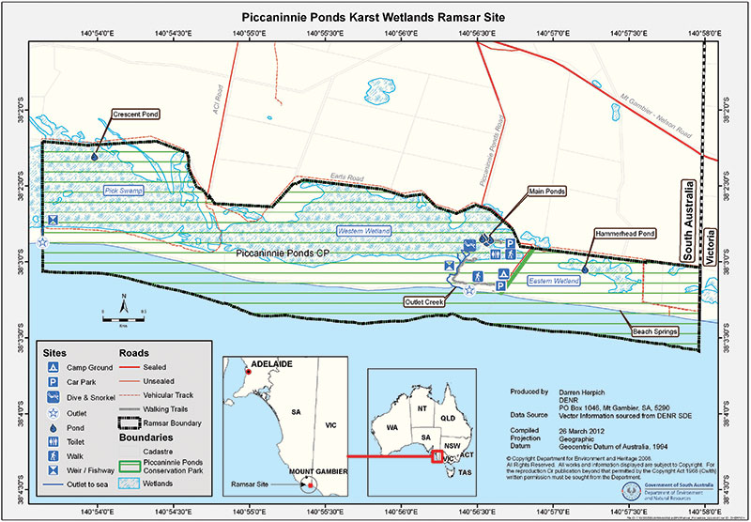

Figure 32. An example of a Ramsar site map for Piccaninnie Ponds Ramsar Site. Reproduced with permission from the South Australian Department of Environment, Water and Natural Resources.

5.9 Scale of maps

Map scale refers to the relationship (or ratio) between distance on a map and the corresponding distance on the ground. For example, on a 1:100 000 scale map, 1 cm on the map equals 1 km on the ground. Map scale should be interpreted correctly noting that the smaller the map scale, the larger the reference number and vice versa. For example, a 1:100 000 scale map is considered a larger scale than a 1:250 000 scale map.

Each map should be of a suitable scale to clearly show the features being mapped. The scale will depend on the particular information being shown. To show the precise boundary and other features of the site, the Ramsar Convention suggests optimal scales of maps for Ramsar sites of different sizes   
(Ramsar Convention 2012) (Table 1).

Table 1 Optimal scales of maps for different sizes of Ramsar sites

|  |  |
| --- | --- |
| Size of site (ha) | Preferred (minimum) scale of map |
| > 1 000 000 | 1:1,000 000 |
| 100 000 to 1 000 000 | 1:500 000 |
| 50 00063 to 100 000 | 1:250 000 |
| 25 000 to 50 000 | 1:100 000 |
| 10 000 to 25 000 | 1:50 000 |
| 1 000 to 10 000 | 1:25 000 |
| < 1 000 | 1:5 000 |

The preferred minimum scale need not be applied in the following circumstances:

* if cartographic standards can be met when depicting the required features on a map at a smaller scale, and/or
* if data has been captured at a much smaller scale than the preferred minimum and the depiction of such data at the preferred scale is inappropriate or misleading.

5.10 Size and number of maps

Maps should be of standard A4 (210 mm x 297 mm) or A3 (420 mm x 297 mm) size.

In some cases, several maps will be needed to adequately show the Ramsar site boundary and meet the requirements outlined in section 5.6. In addition, for sites that are large, complex or that consist of separate parts, a large-scale map should be provided for each part of the Ramsar site to ensure precise boundaries and other features of the site are clearly depicted. If required, a small-scale index map of the whole site can be used to show the location of each of the parts mapped at a large scale. An example of a map sheet index and an enlarged map are provided in Figure 33 and Figure 34.

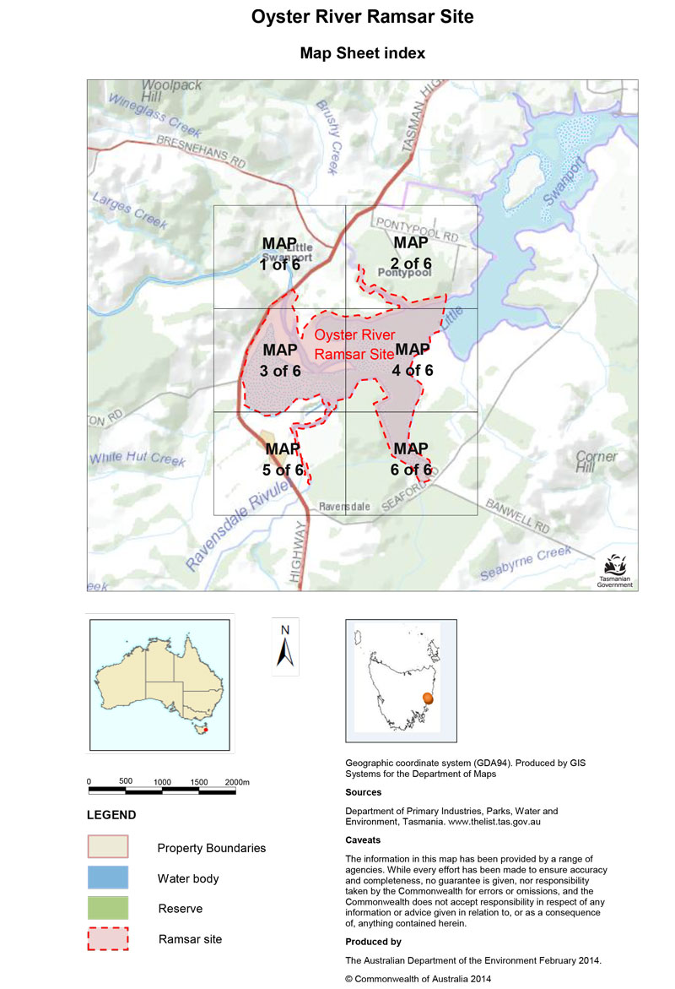

Figure 33. An example of a map sheet index for a fictional Ramsar site Base map modified from Department of Primary Industries, Parks, Water and Environment, Tasmania http://maps.thelist.tas.gov.au/listmap/app/list/map

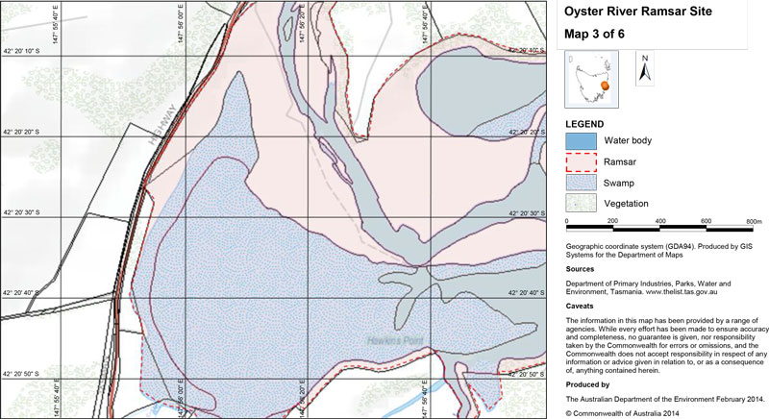

Figure 34. An example of an enlarged map from the map sheet index for a fictional Ramsar site. Base map modified from Department of Primary Industries, Parks, Water and Environment, Tasmania http://maps.thelist.tas.gov.au/listmap/app/list/map

# 6. Gazettal

Once the boundary description and maps have been finalised it may be useful to gazette the boundaries of the Ramsar site using existing processes within the jurisdiction. While there is no requirement on the relevant jurisdiction to gazette the boundaries of each Ramsar site the gazettal process gives further legal recognition to the Ramsar site boundaries.

However, as mentioned in section 1.2 the Australian Government Environment Minister must give notice in the Commonwealth Government Notices Gazette if the Commonwealth designates a new Ramsar site, extends or restricts Ramsar site boundaries, or deletes a Ramsar site from the list.

# 7. Submission of Ramsar site boundary information

For new Ramsar sites or where Ramsar site boundary information needs improving or updating, the following information should be submitted to the Australian Government Department of the Environment, at a minimum:

* a description of the boundary of the site in the RIS that meets the requirements outlined in section 2
* a shapefile of the boundary of the Ramsar site, together with the required metadata about the shapefile as outline in section 4
* Ramsar site map(s) that meet the requirements set out in section 5.

These documents will be checked against the requirements in these guidelines. The finalised Ramsar site boundary information will be provided to the Ramsar Convention Secretariat which will check the documents prior to including them in the Ramsar Sites Information Service database.

The finalised RIS will also be loaded on the Australian Wetlands Database.

# 8. References

Australian Local Government Association and Australia and New Zealand Land Information Council (2007). Local Government spatial information management tool kit version 2.0 Module 9 Map Production Guidelines., A joint initiative of the Australian Local Government Association and ANZLIC – the Spatial Information Council, viewed 16 July 2013.   
<http://alga.asn.au/?ID=136&Menu=44,64,152>

Australia New Zealand Land Information Council (2011). ANZLIC Metadata Profile Guidelines Version 1.2 ANZLIC – the Spatial Information Council, viewed 16 July 2013.   
<http://www.anzlic.org.au/policies_guidelines>

ANZLIC 2013 Land Parcel and Property. Viewed 3 March 2014. <http://www.anzlic.org.au/landparcelandproperty>

Cross Jurisdictional Chief Information Officers Committee (CJCIOC) (2011). Australian Governments Open Access and Licensing Framework (AusGOAL), viewed 23 September 2013. <http://www.ausgoal.gov.au/overview>

Department of the Environment, Water, Heritage and the Arts (2008). Mapping Specifications for Australian Ramsar Wetlands. Module 1 of the National Guidelines for Ramsar Wetlands – Implementing the Ramsar Convention in Australia. Australian Government Department of the Environment, Water, Heritage   
and the Arts, Canberra.

Department of the Environment (2013). Matters of National Significance. Significant impact guidelines 1.1. Environment Protection and Biodiversity Conservation Act 1999. Australian Government Department of the Environment, Canberra 2013. <http://www.environment.gov.au/resource/significant-impact-guidelines-11-matters-national-environmental-significance>

Department of the Environment, Protected Matters Search Tool, viewed on 26 September 2013. <http://www.environment.gov.au/webgis-framework/apps/pmst/pmst.jsf>

Department of Planning, Transport and Infrastructure and District Council of Renmark Paringa (2013). Renmark Paringa Council Development Plan. Consolidated 21 February 2013. Government of South Australia.

Geoscience Australia (2005). Map Reading Guide How to use Topographic Maps, ISBN: 0 642 46770 6, viewed 31 July 2013. <https://www.ga.gov.au/image_cache/GA7194.pdf>

Geoscience Australia (2009). Procedures for describing maritime boundaries. Prepared by the Law of the Sea and Maritime Boundaries Advice (LOSAMBA) Project, Geoscience Australia, Canberra, viewed 31 July 2013. <http://www.ga.gov.au/marine/jurisdiction/procedures-describing-maritime-boundaries.html>

Geoscience Australia (2013a). What is a topographic map? Viewed 8 October 2013. <http://www.ga.gov.au/topographic-mapping/basics/what-is-a-topographic-map.html>

Geoscience Australia (2013b). Earth Monitoring and Reference Systems, viewed 31 July 2013. <http://www.ga.gov.au/earth-monitoring/geodesy/geodetic-datums/australian-height-datum-ahd.html>

ICSM (2013a). Standard for the Australian Survey Control Network (SP1), Version 2.0, October 2013, Intergovernmental Committee on Surveying and Mapping, viewed 5 February 2014. <http://www.icsm.gov.au/geodesy/sp1.html>

ICSM (2013b).Fundamentals of Mapping – Cadastral Paps and Cadastral Plans, Intergovernmental Committee on Surveying and Mapping, viewed 31 July 2013, 10 September 2013. <http://www.icsm.gov.au/mapping/maps_cadastral.html>

Land Information System Tasmania: theLIST, viewed on 26 September 2013. <http://maps.thelist.tas.gov.au/listmap/app/list/map>

National Land and Water Resources Audit and ANZLIC (2008). Natural resources information management toolkit: version 2.0, National Land and Water Resources Audit, Canberra, ACT, viewed 19 September 2013. <http://nrmonline.nrm.gov.au/catalog/mql:2157>

NPPL Public Land Policy Section (1993) Doctrine of Accretion. DCE Guideline No: 02-20:0734-1, Victorian Department of Environment and Primary Industries, Viewed 10 September 2013.<http://www.dse.vic.gov.au/__data/assets/pdf_file/0020/104375/The_Doctrine_of_Accretion.pdf>

Ramsar Convention (2009). Information Sheet on Ramsar Wetlands (RIS) 2009-2014 version. Including Explanatory Notes and Guidelines for Completing the Information Sheet on Ramsar Wetlands. Ramsar Convention Secretariat, viewed 19 June 2013. <http://www.ramsar.org/pdf/ris/key_ris_e.pdf>

Ramsar Convention Secretariat (2010). Designating Ramsar Sites: Strategic Framework and guidelines for the future development of the List of Wetlands of International Importance, Ramsar handbooks for the wise use of wetlands, 4th edition, vol. 17. Ramsar Convention Secretariat, Gland, Switzerland. <http://www.ramsar.org/cda/en/ramsar-pubs-handbooks-handbooks4-e/main/ramsar/1-30-33%5E21323_4000_0__>

Ramsar Convention (2012). Resolution XI.8 Annex 2. Strategic framework and guidelines for the future development of the List of Wetlands of International Importance of the Convention on Wetlands (Ramsar, Iran, 1971) – 2012 revision. 11th Meeting of the Conference of the Parties to the Convention on Wetlands (Ramsar, Iran, 1971) “Wetlands: home and destination” Bucharest, Romania, 6-13 July 2012 Adopted by Resolution XI.8 (2012).

Victorian Department of Environment and Primary Industries. Doctrine of Accretion. Sample Plan – Plan view. Victorian Government Department of Environment and Primary Industries.Viewed 10 September 2013. <http://www.dse.vic.gov.au/__data/assets/pdf_file/0003/152247/Plan-view-OP-123054.pdf>

Victorian Department of Environment and Primary Industries (DEPI), viewed 10 September 2013. <http://www.dse.vic.gov.au/property-titles-and-maps/surveying-home-page/advice-and-guidelines-for-surveyors/further-reading-ambulatory-boundaries>

Western Australian Land Information Authority, viewed on 26 September 2013. <https://www.landgate.wa.gov.au/bmvf/app/mapviewer/>

Williamson, I.P. and Enmark, S (1996). Understanding Cadastral Maps. The Australian Surveyor, Vol. 41, No.1, 38-52.

# Appendix 1: Glossary

|  |  |
| --- | --- |
| Accuracy | Accuracy is defined as the level of closeness of an estimated value — measured or computed — of a quantity to its true or accepted value. |
| Administrative Authority | The agency within each contracting party charged by the national government with oversight of implementation of the Ramsar Convention within its territory.  In Australia, the Administrative Authority is the Department of the Environment. |
| Australian Height Datum (AHD) | Australian Height Datum is commonly used in reference to Australian Height Datum 1971 (AHD71) and Australian Height Datum (Tasmania) 1983 (AHD–TAS83).  The Australian Height Datum 1971 (AHD71) is the NGRS normal–orthometric height datum for mainland Australia.  The Australian Height Datum (Tasmania) 1983 (AHD–TAS83) is the National Geospatial Reference System normal–orthometric height datum for mainland Tasmania. |
| Ambulatory Boundary | Ambulatory boundaries are formed by water and land interface (e.g. sea, ocean, rivers and creeks). Ambulatory boundaries cannot be marked on the ground and are not fixed in one place but can change position over time through slow and imperceptible accretion or erosion of the described feature.  It is common for natural forces to bring about changes in the boundary between land and water along the sea and waterways. Any such change can result in an accretion of or a loss of land. |
| Cadastre | The cadastre is a parcel-based system of property (land) administration.  It is comprised of physically delineated boundaries, being the extent of parcels or interests in parcels, and datasets containing the public record of the interests (i.e. rights, restrictions and responsibilities) in those parcels.  The cadastre is used as the foundation for dealings in:   * land valuation and taxation * land registration and land transfers * land use planning * sustainable development and environmental protection * mapping * management of leases and licences * electoral boundary determinations, and * other land based administrative purposes. |
| Contracting Parties | Countries that are Member States to the Ramsar Convention on Wetlands. Membership of the convention is open to all states that are members of the United Nations (UN), one of the UN specialised agencies, or the International Atomic Energy Agency, or are a Party to the Statute of the International Court of Justice. |
| Datum | An official, fully-defined, spatial reference system or surface to which measurements  and/or coordinates upon the Earth may be defined and related. |
| Declared Ramsar wetland | An area that has been designated under Article 2 of the Ramsar Convention or declared by the Minister to be a declared Ramsar wetland under section 16 of the Commonwealth Environment Protection and Biodiversity Conservation Act 1999. |
| Demarcation | The action of fixing the boundary or limits of something. |
| Ecological character | The combination of the ecosystem components, processes, and benefits and services that characterise a wetland at a given point in time. Within this context, ecosystem benefits are defined in accordance with the Millennium Ecosystem Assessment definition of ecosystem services as “the benefits that people receive from ecosystems” (Ramsar Convention 2005, Resolution IX.1 Annex A).  The phrase ‘at a given point in time’ refers to Resolution VI.1 paragraph 2.1, which states that ‘It is essential that the ecological character of a site be described by the Contracting Party concerned at the time of designation for the Ramsar List, by completion of the Information Sheet on Ramsar Wetlands (as adopted by Recommendation IV. 7, Ramsar Convention 1990).’ |
| Geocentric Datum of Australia 1994 (GDA94) | Geocentric Datum of Australia 1994 is realised by the derived coordinates of the Australian Fiducial Network (AFN) geodetic stations, referenced to the GRS80 ellipsoid and determined with respect to International Terrestrial Reference Frame ITRF92 at epoch 1994.0. |
| Geoid | The equipotential surface of the Earth’s gravity field which best fits global mean sea level. |
| Geographic graticule | Graticules are lines showing parallels of latitude and meridians of longitude for the earth.  Graticules can be used to show location in geographic coordinates (degrees of latitude and longitude).  http://help.arcgis.com/en/arcgisdesktop/10.0/help/index.html#//00s900000010000000.htm |
| Geographic information system | A geographic information system (GIS), or geographical information system captures, stores, analyses, manages and presents data that is linked to location. Technically, GIS is geographic information systems that includes mapping software and its application with remote sensing, land surveying, aerial photography, mathematics, photogrammetry, geography and tools that can be implemented with GIS software. Still, many refer to “geographic information system” as GIS even though it does not cover all tools connected to topology (Geoscience Australia 2009) |
| List of Wetlands of International Importance (‘the Ramsar List’) | Wetlands that have been designated by the Ramsar Contracting Party and are internationally important, according to one or more of the criteria that have been adopted by the Conference of the Parties. |
| Mean high water mark | The average of all high waters observed over a sufficiently long period. |
| Mean low water mark | The average of all low waters observed over a sufficiently long period. |
| Map Grid of Australia 1994 (MGA94) | Universal Transverse Mercator projection of the Geocentric Datum of Australia 1994. |
| Mean Sea Level (MSL) | A tidal datum derived from the arithmetic mean of hourly heights of the sea at the tidal station observed over a period of time (preferably 19 years). |
| Nautical mile | A nautical mile is a unit of distance equal to 1852 metres adopted for the purposes of Australian Maritime Legislation. Refer to Schedule 1.(1) of the Seas and Submerged Lands Act 1973 as published in the Commonwealth of Australia Gazette No.S29, 9 February 1983. The length of the nautical mile is very close to the mean value of the length of 1 minute of latitude, which varies from approximately 1843 metres at the equator (Geoscience Australia 2009). |
| National Geospatial Reference System | Australia’s authoritative, reliable, highly accurate spatial referencing system for Australia. It includes the GDA94, AHD71 and AHD-TAS83 datums. |
| Precision | Precision is a term used to quantify the variability of a measurement or computed value. If several measurements are taken repeatedly to represent the same quantity, precision is used to refer to the degree of closeness or conformity of those measurements to each other. |
| Prolongation | The extension of a line on the same bearing. |
| Ramsar | City in Iran, on the shores of the Caspian Sea, where the Convention on Wetlands of International Importance was signed on 2 February 1971; thus the Convention’s short title, ‘Ramsar Convention’. |
| Ramsar Convention | Convention on Wetlands of International Importance especially as Waterfowl Habitat. Ramsar (Iran), 2 February 1971. UN Treaty Series No. 14583. As amended by the Paris Protocol, 3 December 1982, and Regina Amendments, 28 May 1987. The abbreviated names “Convention on Wetlands (Ramsar, Iran, 1971)” or “Ramsar Convention” are used more commonly. |
| Ramsar information sheet (RIS) | Form upon which Contracting Parties record relevant data on proposed Wetlands of International Importance for inclusion in the Ramsar Sites Information Service. Covers details like: geographical coordinates and surface area; criteria for inclusion in the Ramsar List; wetland types present; hydrological, ecological, and socioeconomic issues; ownership and jurisdictions; and conservation measures taken and needed. The form is updated regularly. It is also known as the Information Sheet on Ramsar wetlands. |
| Ramsar list | List of Wetlands of International Importance. |
| Ramsar sites | Wetlands designated by the Contracting Parties for inclusion in the List of Wetlands of International Importance because they meet one or more of the Ramsar Criteria. |
| Recognition on title (in relation to Ramsar listing) | While Ramsar Listing is in perpetuity, it does not automatically appear on property title. The use of covenants on property title or other formalised notification to permanently attach to Title is encouraged to ensure that future Ramsar site purchasers and the purchasers of adjacent lands are adequately informed of the site’s location and level of protection and other legal requirements. |
| Survey control mark | A monument that provides a physical realisation of one or more datums. |
| Truncate | To shorten a line on the same bearing as if cutting it off. |
| Wetlands | Areas of marsh, fen, peatland or water, whether natural or artificial, permanent or temporary with water that is static or flowing, fresh, brackish or salt, including areas of marine water the depth of which at low tide does not exceed six metres (Ramsar Convention 1987). |

# Appendix 2: Boundary Description Checklist

General guidance

General information about describing site boundaries is provided below. Not all of the following points may apply for all descriptions. The checklist should be read in conjunction with the Boundary Description and Mapping Guidelines.

Describe the boundary in a clockwise direction.

A prominent reference point such as the intersection of cadastral allotment boundaries, trigonometric station or coordinates may be used as the starting point for the description, if required.

Ensure the description includes all areas that are intended to be within the site (e.g. road reserves, freehold and leasehold allotments, islands, bars, seabed, water column etc.).

Ensure any areas excluded from the site (e.g. as road reserves, some freehold and leasehold allotments, islands, bars etc.) are clearly described.

Ensure the boundary is closed (e.g. the final point of the description is coincident with the starting point).

If using existing legally described boundaries, provide an accurate reference to the source of this boundary. Generally avoid redescribing the boundary as it can result in a boundary different to the one intended. However, check the underlying description of the boundary being referred to and ensure it can withstand   
legal scrutiny.

Define terms used in the written description (if applicable).

The description should be as simple as possible. However, this is not always possible and some descriptions by their nature are complex. Above all, it is essential to avoid any ambiguity.

Seek appropriate legal and geospatial advice, as required.

In many cases Ramsar site boundaries may need to be described using a combination of the following references. Check the requirements for each of the underlying boundary references.

| Types of references | Information to include in the description for different types of references | Examples (not complete boundary descriptions) |
| --- | --- | --- |
| Cadastral |  |  |
| Plan of a survey of the Ramsar site boundaries | Allotment/block/section number/road reserve number  Number of the deposited plan or equivalent (e.g. registered  plan (RP), title plan (TP), survey plan (SP)) | ... Allotment [insert number] on Deposited Plan [insert number] ...  ... Allotment [insert number] on Title Plan [insert number] ... |
| Land parcels on deposited plans or equivalent | Allotment/block/section number/road reserve number  Number of the deposited plan or equivalent | ... Allotment 1 on Title Plan 4352 ...  ... Road Reserve 657 on Deposited Plan 4352 ... |
| Gazetted cadastral boundaries such as national parks, nature reserves, Crown Reserves | Gazetted name of the reserve  Gazetted reserve number (e.g. Crown Reserve number or other identifier depending on the jurisdiction)  Date of gazettal/proclamation | ... Crown Reserve 67894 known as Snake Back Nature Reserve gazetted on 6 January 1957. |
| Ambulatory boundaries | Check relevant state doctrine of accretion in relevant Land Act to determine where to specify the location of the boundary:  For tidal areas use the relevant state/territory doctrine (e.g. Mean Low Water Mark or Mean High Water Mark or other reference)  For non-tidal areas ensure it is clear where the boundary is  located (e.g. top of [western/eastern/left/right etc.] bank,  bottom of [western/eastern/left/right etc.] bank or other appropriate reference) | … intersection of the north-eastern corner of road reserve [insert number] boundary and Mean High Water Mark (MHWM) of [insert name] Estuary  ... top of the western bank to intersect with the northern boundary of road reserve [insert number] ... |
| Thematic |  |  |
| Government administrative boundaries (e.g. state/territory borders; shire boundaries, electoral boundaries) | Details of the boundaries (e.g. border, shire etc.)  Source  Date if, applicable | ... East of the Western Australian and South Australian border  ... commencing from point A on the Western Australian and South Australian border at a point nearest to 42º 22’ 05”S, 146º 49’ 38”E following on the Western Australian and South Australian border to point B at a point nearest to 42º 22’ 06”S, 146º 50’ 52”E, to point C 42º 23’ 00”S, 146º 50’ 47”E closing back to point A on the Western Australian and South Australian border. |
| Government planning instruments (e.g. flood extent) | Source  Date of endorsement | ... 1956 flood line as identified on local environment plan flood extents plan 664 of the Environmental Plan 2012 made under the Environmental Planning and Assessment Act 1979, regulation 576 as at July 2013. |
| Topographic |  |  |
| Contour elevations | Contour elevation in meters Australian Height Datum (AHD)  Origin of the contours | ... 20 metre (AHD) contour line as generated from [insert name] topographic sheet, series [insert number]  ... 60 metre (AHD) contour line as generated from [insert name] Digital Terrain Model 20m [insert reference] |
| Trigonometric stations | Identification number of trigonometric station | … Trigonometric station TR 526 through trigonometric stations TR 627, TR 326, TR 568, TR 789 |
| Coordinates | Coordinates in latitude (South) and longitude (East) in degrees, minutes, seconds  Datum. Use Geocentric Datum of Australia (GDA94) unless GPS coordinates in which case use World Geodetic System (WGS84)  Map Projection (e.g. Map Grid of Australia; Albers Equal Area Conic with parameters; or other system) | GDA94 coordinates 32º 23’ 45”S, 149º 45’ 56”E  ... continues east along the northern boundary of allotment [insert number] on [insert plan number] to a point closest to GDA94 coordinates [insert DDºMM’SS”S and DDºMM’SS”E |
| Maritime |  |  |
| General | Ramsar boundaries in the marine environment need to include:  The extent of the area  What is included (e.g. seabed, subsoil, air space and water column, where applicable) |  |
| Existing legally defined boundaries:  Reserve boundaries (marine, nature reserve)  Coastal waters, territorial waters, legislated planning zones (e.g. conservation park zones, marine park planning zones, habitat protection zones). | Gazetted name of the reserve  Gazetted reserve number (e.g. Crown Reserve number or other identifier depending on the jurisdiction)  Date of gazettal/proclamation  Definition or source of the legally described boundaries  Relevant definitions | ... Shearwater Reef Commonwealth Marine Reserve as gazetted in Commonwealth of Australia Gazette, G76, 16 August 1984, as amended by Environment Protection and Biodiversity Conservation (Shearwater Reef National Nature Reserve) Amendment Proclamation 2012 (No.1) entered on the Federal Register of Legislative Instruments as instrument F2012C090909 on 19 November 2012.  ... all of the land, water column, subsoil and airspace within the outer limit of the coastal waters(1) adjacent to Caspian Tern Island and Albatross Islands.  Notes:  (1) The coastal waters are defined in relation to each State and the Northern Territory by the Coastal Waters (State Powers) Act 1980 and Coastal Waters (Northern Territory Powers) Act 1980. They comprise the territorial sea extending out to 3 nautical miles from the territorial sea baselines established under the Seas and Submerged Lands Act 1973, and the waters on the landward side of those baselines that are not within the States or the Northern Territory.  (2) Caspian Tern Island and Albatross Islands are part of the State of [insert State]. |
| Coordinates | Coordinates in latitude (South) and longitude (East) in degrees, minutes, seconds  Datum (or geodetic datum) where coordinates are used. Generally use World Geodetic System (WGS84) for maritime boundaries  Map Projection | * … from there to the point of Latitude 60°34’45.05” South, Longitude 153°47’39.87” East … * … circle of radius 2.5 nautical miles centred at the point of Latitude 12°23’45.67” South, Longitude 123°45’56.78” East. Coordinates are expressed in terms of World Geodetic System 1984 (WGS 84). |
| Physical features (coastlines, or edge of a reef, bathymetry) | Name features referenced (e.g. reef, coastline at relevant  tidal datum)  Coordinates, where appropriate, in latitude (South) and longitude (East) in degrees, minutes, seconds | * … the harbour fairway beacon nearest the point of Latitude 23°45’52.36” South, Longitude 152°26’32.51” East … Coordinates are expressed in terms of World Geodetic System 1984 (WGS 84). |
| Lines (e.g. meridians, parallels) | Point of latitude and longitude  Where the description starts  Type of line (e.g. parallels or meridians)  Direction the boundary is heading | * …east along the parallel of Latitude 18°23’45’ South to its intersection by the meridian of Longitude 123°05’03” East … * … north along that meridian to its intersection by the parallel of Latitude 18°00’52’ South… |

# Appendix 3: Additional information about map projections and datums

Map projections

Whether the earth is treated as a sphere or a spheroid, its three-dimensional surface must be transformed to create a flat map sheet. A map projection uses mathematical formulas to relate spherical coordinates on the globe to flat, planar coordinates. Representing the earth’s surface in two dimensions causes distortion in the shape, area, distance or direction of the data. Different projections cause different types of distortions. Some projections are designed to minimise the distortion of one or two of the data’s characteristics while correctly maintaining another characteristic. For example, a projection could maintain the area of a feature but alter its shape.

The following map projections are primarily used in Australia:

* Map Grid of Australia (MGA) with zone — conformal projection
* Albers Equal Area Conic with parameters — equal   
  area projection
* non-projected geographical data (latitude, longitude).

In some cases, Lamberts Conic Formal projection or the NSW Integrated Survey Grid may be used.

Horizontal Datum

The horizontal datum is the model used to measure positions on the earth. A specific point on the earth can have significantly different coordinates, depending on the datum used to make the measurement. There are multiple locally developed horizontal datums around the world, usually referenced to some convenient local false origin or reference point. Contemporary datums are based on increasingly accurate measurements of the shape of the earth.

National geodetic datum

The National Geospatial Reference System is the authoritative, reliable, high accuracy spatial referencing system for Australia and includes GDA94, AHD71 and AHDTAS83 datums.

The geodetic datum is the Geocentric Datum of Australia 1994 (GDA94). GDA94 is a three-dimensional, static coordinate datum based on the International Terrestrial Reference Frame (ITRF) 1992. It is held fixed at the reference epoch of 1 January 1994 and is referenced to the GRS80 ellipsoid (ICSM 2013a).

Coordinates of survey control marks on the Australian mainland, Tasmania, Australian islands and Australian External Territories, are computed in terms of GDA94. The Universal Transverse Mercator (UTM) projection of GDA94 is the Map Grid of Australia 1994 (MGA94), and is the officially recognised grid coordinate realisation of GDA94 (ICSM 2013a).

The World Geodetic System 1984 (WGS84) is used by Global Position System (GPS) satellite navigation systems and on most hydrographic charts. WGS84 should be used in the marine environment.

Some earlier spatial datasets and maps may use the Australian Geodetic Datum (AGD66 or AGD84). This datum was employed as a best fit for the Australian continent and water superceded by GDA94 in 1994. A comparison of GDA94 and AGD demonstrates that there is an approximate 200 m difference between GPS coordinates configured in GDA94 and AGD.

Vertical Datum

For the purpose of measuring the height of objects on land, the usual datum used is mean sea level (MSL). This is a tidal datum derived from the arithmetic mean of hourly water heights of the sea at the tidal station. This definition averages out tidal highs and lows (caused by the gravitational effects of the sun and the moon) and short term variations. It will not remove the effects of local gravity strength, and so the height of MSL, relative to a geodetic datum, will vary around the world and even around one country.

National height datum

For Australia’s National Geospatial Reference System, the height datum is the Australian Height Datum (AHD). Heights for survey control marks on the Australian mainland shall be referred to the Australian Height Datum 1971 (AHD71).

In 1971 the mean sea level for 1966–1968 was assigned the value of 0.000 m on the AHD at thirty tide gauges around the coast of the Australian continent (Geoscience Australia 2013b). The resulting AHD datum surface, with minor modifications in two metropolitan areas was adopted by the National Mapping Council as the datum to which all vertical control for mapping (and other surveying functions) is to be referred (Geoscience Australia 2013b).

The levelling network in Tasmania was adjusted in 1983 to re-establish heights on the AHD (Tasmania). Mean sea level at both Hobart and Burnie was assigned the value of zero on the AHD (Tasmania).

Heights for survey control marks on the Tasmanian mainland shall be referred to the Australian Height Datum (Tasmania) 1983 (AHD-TAS83).

ICSM (2013a) recommends the use of AUSGeoid when converting between AHD heights and GDA94 ellipsoidal heights.

In the absence of AHD survey control marks, heights for Australia’s islands and External Territories shall be clearly specified to refer to at least one of the following:

* a locally recognised height datum
* locally determined Mean Sea Level (MSL)
* “Derived AHD” using AUSGeoid or an equivalent geoid (or quasi-geoid) model and either a differential Global Navigation Satellite System connection to AHD, MSL or ellipsoidal height (ICSM 2013a).

# Appendix 4: Spatial data checklist

The boundary of the Ramsar site should be generated and stored spatially using GIS software. At a minimum, the relevant files should include the following:

Boundary generated in vector form

Boundary consistent with description

Wetland units stored as different records in the GIS file (if applicable)

Additional information (if applicable) such as wetland types as separate layer

Saved as shapefile or a format that can be converted to a shapefile

The shapefile should be geo-referenced with the datum and projection parameters

Attribute table that includes formal name of Ramsar site

Metadata in accordance with ANZLIC (2011) and section 4.2 of the Boundary Description and Mapping Guidelines.

# Appendix 5: Ramsar site map checklist

Ramsar site maps must clearly show the boundaries of the Ramsar site and be geo-referenced such that the location of the site can be clearly identified (Ramsar Convention 2012). The map should show the Ramsar site in relation to the position of other prominent features in the landscape, as relevant to the description of the site in the RIS and the scale of the particular map.

There are several elements that are required in Ramsar site maps. There are also several elements that should be included, if available and relevant. In determining if and how these elements can be mapped, consideration should be given to the location of the site, the type of site, how the boundary has been described and the size and scale of the site. Several maps, some at different scales may be required to show this information. Additional information on preparing Ramsar site maps are provided in section 5 of the Boundary Description and Mapping Guidelines.

|  |  |  |
| --- | --- | --- |
|  | The following elements are required on Ramsar site maps | Comments |
|  | The general location of the Ramsar site within the state or territory of the contracting party. The Australian Government can supply base maps suitable for this purpose, if required. | At a minimum, there should be an inset map that shows where the site is located in the state or territory and or Australia. This provides context for Ramsar Convention Secretariat and other international audiences. |
|  | The precise boundary of the Ramsar site and any existing or proposed buffer zones to the Ramsar site. | The boundary of the Ramsar site should be clearly identified on the map and in the legend or key. |
|  | The Ramsar site in the context of the surrounding environment (whether natural or modified). | The information to be mapped may depend on the location and type of site and whether there are any features used in the description that should be shown on the map. Aspects that may provide this context include topographic features, cadastral aspects, land use, man-made structures (e.g. dams, weirs) etc. |
|  | If a former Ramsar site is now included in the site, the boundaries of the former site and its current status i.e. any boundary changes to the site. | The different boundaries should be clear. Shading or patterns may be useful to demonstrate this. |
|  | The boundaries of any adjacent or nearby Ramsar site/s, including neighbouring sites across jurisdictional boundaries. |  |
|  | **The following information should be included:** |  |
|  | Basic topographical information, in particular, but not limited to:   * key hydrological features (e.g. streams, rivers, dams) * major landmarks (towns and roads) * administrative boundaries (state). |  |
|  | The full extent of wetlands included or partially included in the Ramsar site. | This shows whether all wetland environments in the locality are part of the site. |
|  | Extent of wetland and non-wetland areas of the Ramsar site as described in the RIS. | Many Ramsar site boundaries may be broader than the wetted extent of the wetland or wetland dependent vegetation areas and may include other terrestrial parts of the site. Therefore, it is useful to show both the extent of wetland and non-wetland areas of the site. |
|  | Relevant protected area boundaries. | For example, nature reserves, national parks, marine reserves, world heritage areas, game reserves, etc. |
|  | Relevant cadastral boundaries such as reserves  (Crown or other), reserve numbers, land parcels, allotment numbers. | The type of site, how the boundaries have been described, the land tenure of the site and the size of the site may influence the level of detail of cadastral information that should be mapped.  In some cases this could be as simple as showing the reserve(s) that make up the Ramsar site and including the reserve number and gazettal date on the map.  In other cases where detailed cadastral features such as allotments have been used to describe the site boundary, it is preferable to include this information on the map. Where possible include allotment and deposited plan numbers. However, for some sites the size or complexity of the site may mean that it is not practical to map cadastral boundaries or parcels at a detailed level.  For sites that consist of a mixture of land tenure types (e.g. national park, nature conservation reserves, marine reserves, defence land, Aboriginal reserve, other Crown land, mining reserves, freehold land (privately owned), Crown lease etc.) the broad categories of land tenure could be shown on the map, unless it is not practical to do so. |
|  | The following should be included if available, relevant and practical | |
|  | Main wetland habitat types. | The Ramsar Convention encourages the inclusion of maps of wetland habitat types with the RIS. Therefore wetland habitat types should be mapped, where possible. The Ramsar Convention habitat types can be found in the explanatory notes to the RIS. A separate map may be required to show wetland types.  While wetland habitat types should be mapped, if possible, it is recognised that wetland habitat data may not be available for  all wetlands. |
|  | Water coverage in wet and dry seasons  (if there is substantial seasonal variation). | Some sites have distinctive wet and dry seasons with vast differences in water coverage. Separate maps may be required to show this information, if relevant.  For many sites this will not apply. |
|  | Any management zones within the site. | Some sites have distinct management zones which are useful to include on the maps such as sanctuary zones, recreational use  zone, tourism management areas, no-take zones or other  management zones.  For other sites, this may not be relevant and therefore is not required. |
|  | The catchment of the Ramsar site. | Consider whether this is useful information for the Ramsar site. For small catchments, it may be possible to show the catchment on the Ramsar site map. In many cases a small inset map showing the location of the catchment in the state may be all that is required. |
|  | Distribution of land uses in the catchment. | Consider data availability; the location of the Ramsar site and the benefits of showing the land uses on a map; and whether it is practical to map the land uses within the entire catchment.  If land uses provide useful context for the site, but the catchment is too large, it may be useful to map land uses adjacent to the site or in the subcatchment. |

Cartographic standards

Maps should be prepared to professional cartographic standards using accepted symbols and conventions.

|  |  |
| --- | --- |
|  | Each map should show the following elements: |
|  | A descriptive title that explicitly cites the official name for the Ramsar site and any key features shown on the map, if applicable (e.g. the boundaries of the X Ramsar site; land tenure of the X Ramsar site; major wetland habitat types in the X Ramsar site) |
|  | The features indicated by the title |
|  | The precise boundaries of the Ramsar site |
|  | A key or legend that identifies the Ramsar site boundary and other relevant features |
|  | A scale (e.g. scale bar) |
|  | Latitudes and longitudes (e.g. displayed as tic marks or a full graticule grid in the following format: latitude (South) and longitude (East) in degrees, minutes and seconds) |
|  | A north arrow |
|  | A map border |
|  | The map projection and datum used |
|  | An acknowledgment of data sources |
|  | The date of production |
|  | Copyright and publisher statements |
|  | Caveats and/or constraints on the use of the map |
|  | Appropriate logos |
|  | Any relevant marginal notes |