## Anatomy

### Molluscs

#### Abalone

Figure 1 Anatomy of abalone (Haliotis sp.)—ventral view

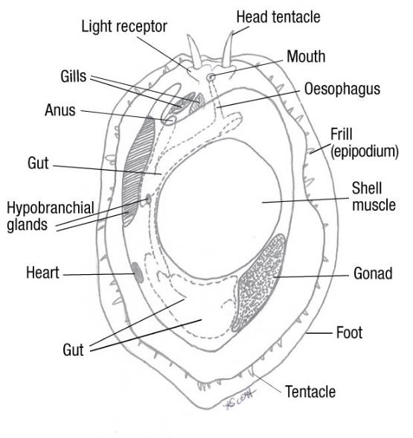

Source: K Scott

Figure 2 Anatomy of abalone (Haliotis sp.)—dorsal view

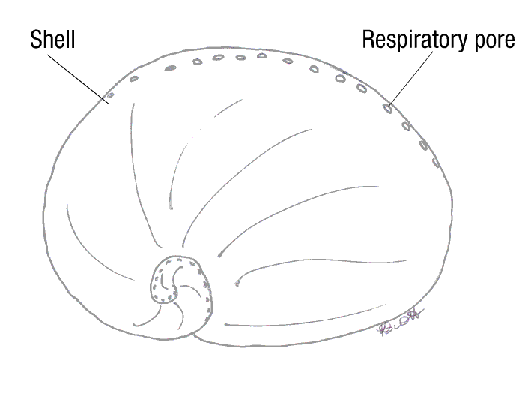

Source: K Scott

Figure 3 Abalone variations—ventral view

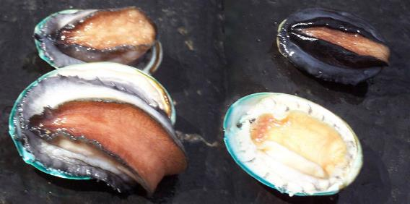

Note: Greenlip abalone, Haliotis laevigata (left). Blacklip abalone, Haliotis rubra (top right). Hybrid tiger abalone, Haliotis laevigata × H. rubra (bottom right).

Source: K Scott

#### Oysters

Figure 4 General anatomy of oyster (Ostrea sp.)

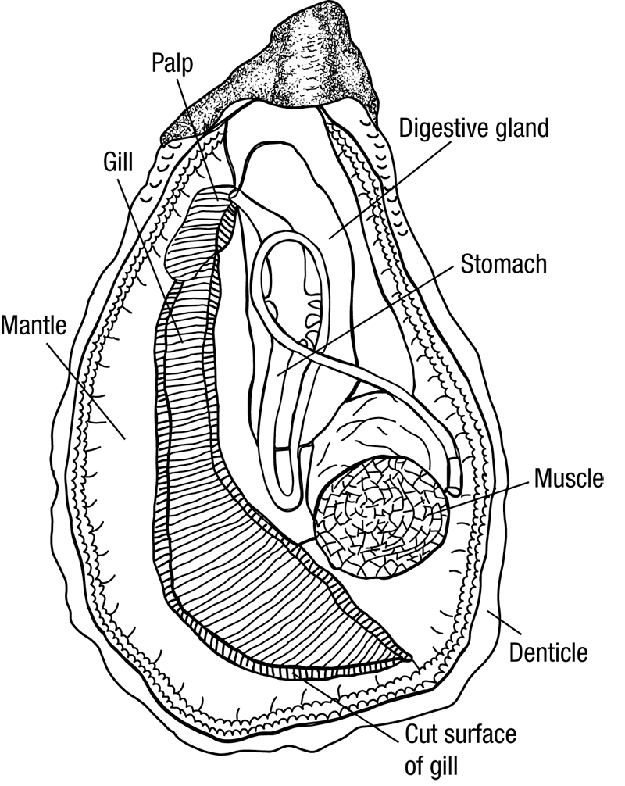

Source: Australian Government Department of Agriculture, Water and the Environment

Figure 5 Healthy European flat oyster (Ostrea edulis)

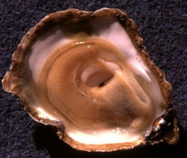

Source: I Arzul, French Research Institute for Exploration of the Sea