THE MONITOR
The National Flying-fox Monitoring Program Newsletter
Issue 02 / June 2014

Results of the sixth monitoring round – February 2014 (front page)
The 2014 summer count saw surveys conducted at a total of 269 grey-headed flying-fox camps with flying-foxes found at 118 of these.
With 95 per cent of the data submitted, the estimate for the total grey-headed flying-fox population in these camps was 610,000 animals. Of this total, 81 per cent was found in New South Wales, 11 per cent in Queensland, 7 per cent in Victoria, while less than 1 per cent was recorded in South Australia and the Australian Capital Territory.
There were five grey-headed flying-fox camps—in Kendall, Macksville, Bellingen, Fig tree, Centennial Park in NSW and Yarra Bend in Victoria—with greater than 30,000 individuals. The majority of the population was clustered along the coastline—especially in Bellingen, Macksville and Port Macquarie areas.
Spectacled flying-fox numbers totalled 56,000 animals, with 35,000 of those found in the Port Douglas camp. Unlike the grey-headed flying-fox, whose numbers were relatively high, this is much lower than the expected numbers for this time of the year.
Currently, the monitoring programme only covers part of the range of the black and little-red flying-foxes. For this reason, it must be noted that the numbers of these species surveyed and presented under the programme are not estimates of their total population size.
Thanks to the efforts of the Queensland Government and its staff in increasing the coverage of the counts in the known black and little-red flying-fox areas along the Queensland Central Coast, the monitoring programme is now covering nearly the entire east coast and adjacent inland areas of the range of flying-foxes. In total, this round of monitoring saw 131,000 black flying-foxes recorded at 96 camps and 825,000 little-red flying-foxes recorded at 34 camps. There were particularly large numbers at Noosaville and Boonah in Queensland.

Where were the flying-foxes in February?
The exact timing of the rise and fall of numbers, in the case of the spectacled flying-foxes varies slightly depending on the year. This also appears to be the case with the grey-headed flying-fox—with its population generally moving back into camps sometime after the round of surveys in November.
Exactly what drives this move in and out of camps, and the timing of this shift, is not yet clear. One prevailing theory is that it is related to patterns of flowering and fruiting. This is the sort of question that the long-term monitoring, such as that conducted under this programme, can help answer.
The National Flying-fox Monitoring Programme is collaboration between the Australian Government, the South Australian, Victorian, New South Wales, Australian Capital Territory and Queensland governments, CSIRO, local governments and volunteers.
Viewing the results of the National Flying-fox Monitoring Program
Thanks to a new interactive flying-fox web viewer, the public and programme volunteers can now have access to maps that show the camp locations and population trends of flying foxes being tracked under the National Flying-fox Monitoring Program (NFFMP).
The flying-fox web viewer was developed through the NFFMP and uses data gathered from November 2012 to present. The tool enables users to view, map and print information coming in from the monitoring programme.
For example, users can view graphs of grey-headed and spectacled flying-fox numbers at individual camps from each monitoring event. Within the eastern coastal belt, the viewer also shows black flying-fox and little red flying-fox camps and population numbers.
The flying-fox viewer is available on the Department of the Environment website:
www.environment.gov.au/node/16393
If you are aware of flying-fox camps that contain either grey-headed or spectacled flying-foxes, but are not shown on the interactive viewer, then please send details of the camp to: speciespolicy@environment.gov.au

Some examples of the viewer’s features:
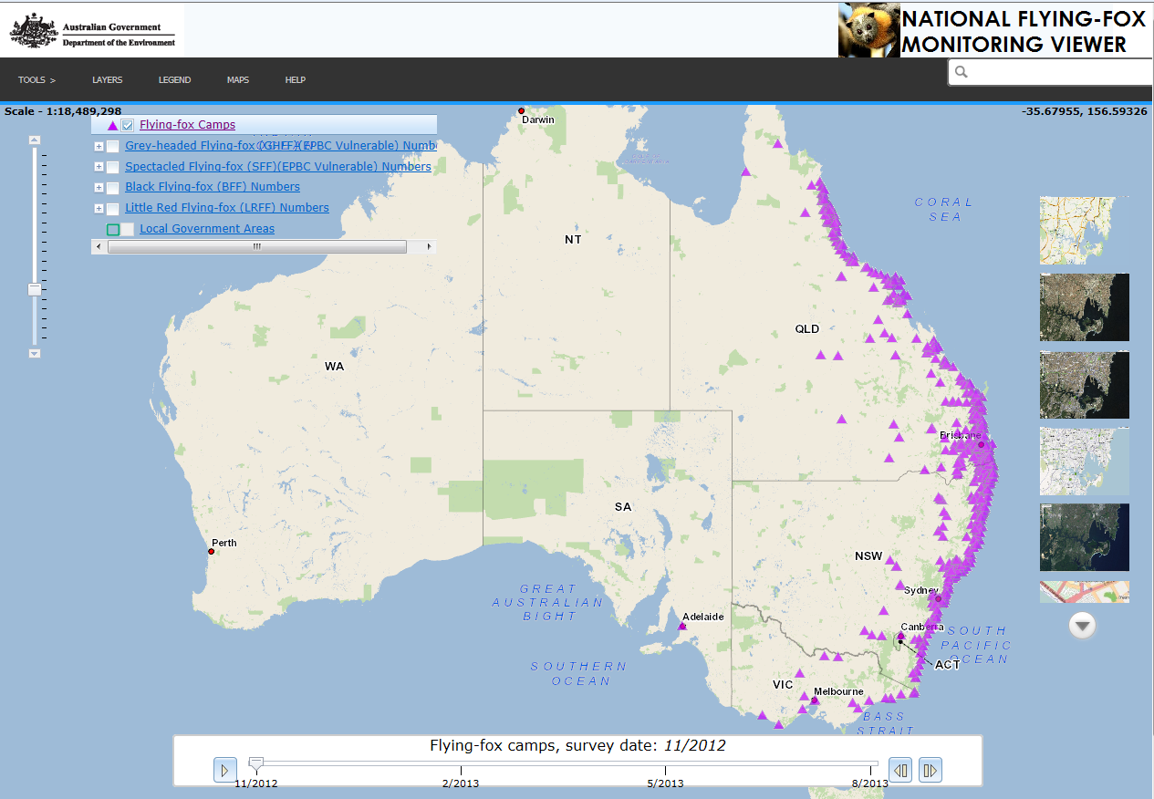 | 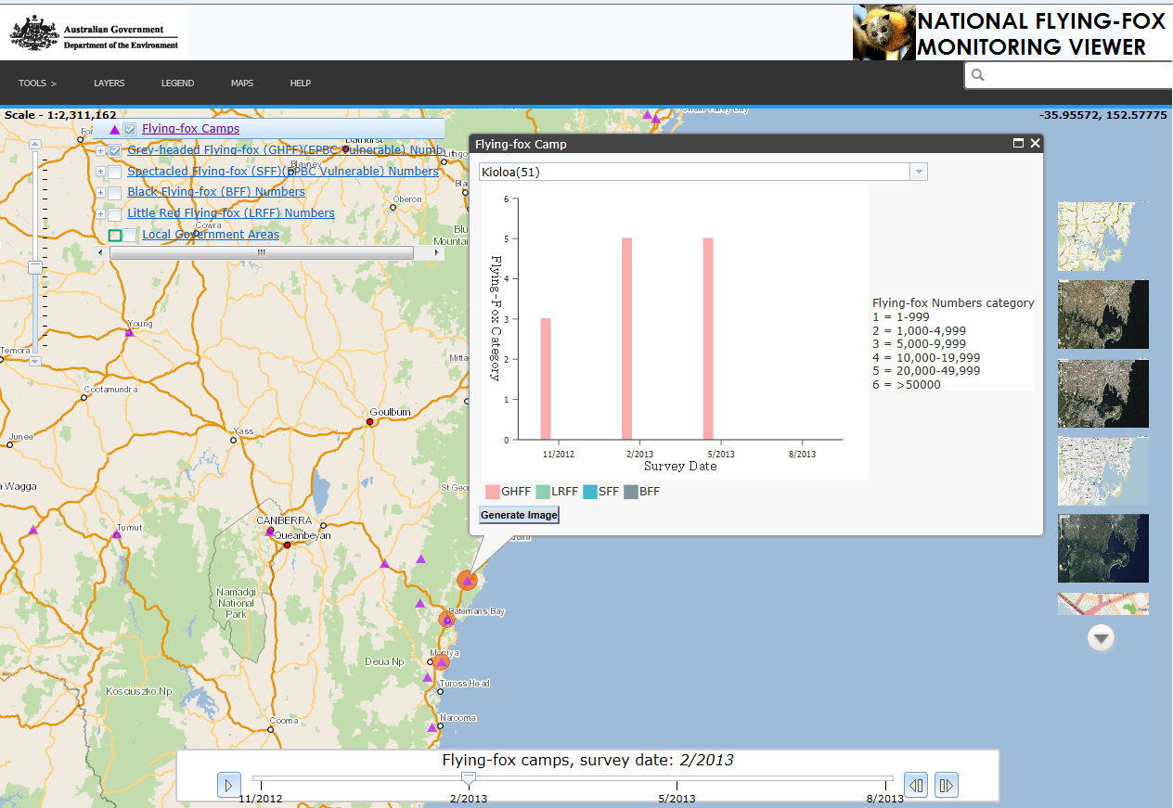
Clicking on the flying fox camps layer allows you to see all the known grey-headed and spectacled flying fox camp locations across the country. | Switching on the grey-headed flying fox layer and using the zoom bar allows you to locate a particular camp you’re interested in.  Clicking on a camp then lets you pull up a graphical display of camp numbers over the last four surveys. From there, you can also activate the viewer’s time slider function which presents the changes in the camp’s population size through a timelapse video.

Tasmania’s curious winged tourists
Despite the absence of any known flying-fox presence in Tasmania, there is a growing body of evidence that the flying-fox is quite capable of making the trip across Bass Strait.
In 2010, Michael Driessen, a Senior Zoologist with the Tasmanian Department of Primary Industries, Parks, Water and the Environment, published a paper detailing the historical and recent sightings of flying-foxes in Tasmania. He presented nine historical records, reaching back to 1938, which revealed that individual greys make occasional trips to King Island, Flinders Island and mid-to-northern Tasmania—covering distances of around 150 to 300 kilometres over open ocean and/or island-hopping. He also detailed nine grey-headed flying-fox sightings in 2010 alone, but stopped short of proposing that the number of animals coming from the mainland is increasing.
In order to shed more light on the matter, The Monitor spoke to Michael Driessen.

TM: Michael, these findings are quite amazing. What do you think drives these individual flying-foxes to travel 150 to 300 kilometres across the Bass Strait?

MD: The recent sightings in Tasmania appear to be associated with sightings of grey-headed flying-foxes in unusual locations in NSW, Victoria and South Australia in March to April 2010. These unusual observations in these states may be the result of several cyclones in Queensland between January and March 2010 that may have dispersed flying-fox colonies.

TM: Why don’t they end up staying and establishing themselves?

MD: There are a number of theories as to why there are no known camps in Tasmania, but the lack of year-round food supplies is likely to be the main reason.

TM: In what type of areas were the flying-foxes spotted? And how were they found? Were those who found them somewhat surprised by their discovery?

Yes, a number of people were surprised by their discoveries, none more so than my colleague Wendy Potts who found one entangled in netting protecting her fig tree in a Hobart suburb.

Records from the south of the state are very rare. Most reports of flying-foxes occur on islands in Bass Straits or on the northern coast of Tasmania, often associated with fruit trees. Most flying-foxes were observed live but some were found dead entangled in netting or, in one case, electrocuted on power lines.

TM: Are most flying-foxes capable of travelling those sort of distances without stopping? Or are those individual animals that get across more of an exception?

MD: I understand that flying-foxes can forage up to 50 kilometres in one night and that adults can disperse up to 750 kilometres away from camps. With the assistance of strong northerlies that Tasmania gets in summer and autumn, which also tend to bring a range of Australian mainland fauna, flying-foxes should be quite capable of flying or island-hopping across Bass Strait resulting in infrequent visits to Tasmania.

Reference: Driessen, M., 2010. Recent sightings of Flying-foxes in Tasmania. The Tasmanian Naturalist 132, p. 35-39.

Choosing the Right Survey Method
Monitoring the national population of two species of flying-foxes was always going to be a big task. The species’ mobility and ‘clustering’ in camps of various sizes mean that the traditional method of sampling part of the population and extrapolating the results is not appropriate. Therefore, the approach to the programme needed to be a ‘census’, where all potential camps are checked and counted at the same time.
Equally as important as identifying the broad monitoring approach is the selection of different count methods at each camp. Although it would be ideal to use the same count method at every camp for every quarterly census, the variable conditions experienced mean that no single method is appropriate across the board. Counters need to be able to determine what the best count method is ‘on the fly’, when they arrive at a camp. In order to assist with this decision, the CSIRO has outlined the important things to consider. The table below summarises how the decision is made.
Direct counts or point counts are the preferred methods and should be used wherever possible. In addition to selecting the most appropriate method, the following things should be considered when carrying out a count:
- Binoculars should be used, as they allow more accurate counts to be made and also allow for species and sex identification.
- The field data sheet relevant to the method chosen must be filled out and sent in, as they are important hard copy records of counts.
- Use of a rangefinder is ideal for point counts, as they avoid the need to estimate distance to trees.
- Counts should be conducted by two people, as this provides simultaneous, but independent counts.

Condition | Direct count | Point count(s) | Tree estimate | Area estimate | Fly-out count
Camp is small enough to reasonably count individuals
Camp edge and/or interior can be accessed |  |  |  |  | NA
Animals tolerate counter presence (i.e. are not constantly moving/flying)
Trees containing flying-foxes can reasonably be counted throughout the camp | NA | NA |  |  | NA
The perimeter of the camp can be mapped (to obtain area) | NA |  |  |  | NA

Note: the above information is for illustrative purposes only and the ‘Flying-fox Survey Manual’ should be referred to by counters, as it contains more detailed information about selecting and applying methods.

WHO TO CONTACT

ACT: | Murray Evans  (02) 6207 2118
NSW: | Linda Bell  (02) 9995 6735
QLD: | Rebecca Williams  (07) 3330 5512
SA:  VIC: | Angela Duffy  (08) 8463 4819  Bram Mason  (03) 9296 4645
CSIRO: | Adam McKeown  (07) 4059 5009
Australian Government: | Peter Wright  (02) 6274 1052

