cid:CC9B846B-E02B-4E56-8552-32CB5FD378B1@papermonkey.private

Monitored Outcomes

# Working in partnership

The Commonwealth Environmental Water Holder makes water available for delivery by State environmental water holders and managers, non-Government organisations, their local delivery partners and river operators.

This coordinated effort enables the Commonwealth Environmental Water Holder to manage water in the national interest by improving the connectivity between the highly variable natural systems of the Murray-Darling Basin’s rivers, floodplains and wetlands.

Over the past five years, over 4,000 gigalitres of Commonwealth water has been delivered to the environment.

# Protecting and restoring rivers, wetlands and floodplains

The Commonwealth Environmental Water Holder oversees the management and use of a large portfolio of water for the benefit of the environment. This water is the result of the Australian government’s suite of national water reforms including the modernisation of irrigation infrastructure, as part of the Murray-Darling Basin Plan.

Environmental water is helping to protect and restore rivers, floodplains, wetlands, and the wide diversity of life they support, in the interests of sustaining productive river communities throughout the Basin.

# Localism involving locals in environmental water management

We rely on local knowledge and experience to help shape watering decisions. Together with our delivery partners, we seek advice from environmental water advisory groups and committees and we regularly attend community forums within the catchments.

The Commonwealth Environmental Water Holder also has six local engagement officers working alongside State and local land and water management officers, providing outreach to local communities throughout the Basin.

# Outcomes demonstrated through monitoring and evaluation

The Commonwealth Environmental Water Holder commissions scientific monitoring and evaluation to build knowledge about environmental water use and its effectiveness over time.

The Murray-Darling Basin Authority and State agencies also invest in a range of complementary monitoring programmes.

Since 2010, short-term monitoring has helped determine whether select watering actions are meeting their intended ecological objectives. This monitoring is strengthened by the transition to longer-term projects, as part of the Commonwealth Environmental Water Holder’s $30 million investment in the Long-Term Intervention Monitoring Project.

These detailed five-year projects are being undertaken by consortiums led by Australia’s leading research institutions and locally based land and water managers and communities, where around 90 per cent of Commonwealth environmental water is held.

This work ensures that environmental water is being used to its best effect because it is not only a scientifically robust method to determine outcomes, it enables ’adaptive management’ by evaluating what has worked well and areas for improvement. By applying this information, along with local feedback, we can adapt how environmental water is managed, and improve outcomes over time.

# Recent monitored Outcomes show that good environmental results are being achieved

Environmental water is helping to restore the parts of the Basin’s natural hydrology that have been impacted by river regulation and infrastructure created for agriculture and other human needs.

Commonwealth water often supplements the environmental water delivered locally by State water holders and managers and their local delivery partners.

By restoring natural variability in flows, environmental water is reconnecting rivers and their wetlands and floodplains, providing food, habitat and breeding opportunities for native fish, waterbirds and vegetation. Environmental water is also reducing the risk of damage to the environment caused by poor water quality and salinity.

Commonwealth environmental water contributed to eight of the ten priority outcomes set out in the Basin annual environmental watering priorities, launched by the Murray-Darling Basin Authority in 2013–14.

Below is a summary of the latest outcomes from monitoring and evaluation activity that has occurred during 2013–14 in five river systems: Lower Murray, Murrumbidgee, Goulburn-Broken, Edward-Wakool and the Gwydir. These locations complement the monitoring undertaken by the Murray-Darling Basin Authority, State water holders and managers, and their local delivery partners. Full reports on all monitoring activity are available each year on our web site www.environment.gov.au/water/cewo

Map showing Abundant native fish, birds, frogs and habitat
are signs of healthy rivers and wetlands and a productive environment.

Figure 1: Coordinated flows to Lower Murray

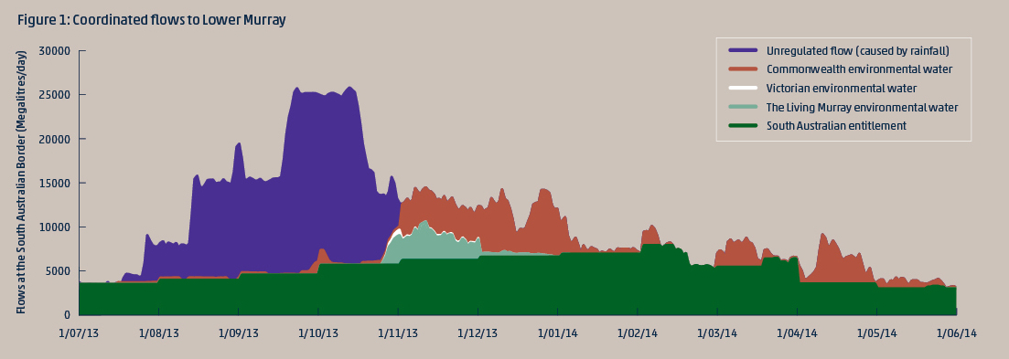

The Commonwealth Environmental Water Holder may deliver water to key assets within the Basin over the course of the watering year, carry it over for use in future years or trade. In 2013–14, the Water Holder delivered 982 gigalitres to catchments throughout the Basin.

## Summary of watering actions 2013–14

|  |  |
| --- | --- |
| Catchment | Commonwealth  Water delivered (GL) |
| Murray | 412 |
| Lower Darling | 47 |
| Loddon | 3 |
| Campaspe | 7 |
| Goulburn | 215 |
| Lower Broken Creek | 39 |
| Upper Broken Creek | <1 |
| Ovens River | <1 |
| Edward–Wakool | 17 |
| Murrumbidgee | 137 |
| Lachlan | 23 |
| Macquarie | 10 |
| Gwydir | 32 |
| Border Rivers Regulated | 4 |
| Border Rivers Unregulated (Macintyre) | <1 |
| Moonie | 1 |
| Condamine–Balonne  (Lower Balonne) | 22 |
| Barwon–Darling (Toorale) | 13 |
| Warrego | <1 |
| Total | 982 |

Coordinated flows to Lower Murray

Water use in the tributaries of the Southern Basin (Goulburn, Lower Broken and Campaspe) contribute to the multi-site watering strategy for the Murray, including the Lower Lakes and Coorong. In addition to Commonwealth water, flows from The Living Murray and the Victorian Environmental Water Holder contributed to environmental watering in the Southern Connected Basin (see Figure 1). These multi-site and multi-catchment watering events achieve outcomes locally and regionally — where the water is delivered and all the way through to the end of the system.

System-wide flows contributed to environmental outcomes throughout the length of the Murray River system including hydrological connectivity and support for vital ecosystem processes such as large scale nutrient cycling, salt export and fish larvae dispersal.

100 per cent of the environmental flows delivered into the Coorong and Murray Mouth from November 2013 to June 2014 was Commonwealth water.

Water quality continues to improve with environmental water helping to export salt into the Southern Ocean through the Murray Mouth.

Goulburn-Broken

Provided opportunities for migration and reproduction of native fish in the lower Goulburn by reinstating a variable flow regime. 2014 saw the largest spawning of golden perch since 2010.

Improved habitat by generating new growth of native plant species that support riverbank stabilisation.

Edward-Wakool

Improved connectivity between rivers and creeks allowed fish movement and dispersal to and from the Wakool Reserve refuge pool and promoted population mixing and breeding.

There has been a general improvement in native fish populations including the vulnerable Murray cod, with flows helping to maintain habitat.

Enabled submerged aquatic vegetation to persist during watering in Yallakool Creek because of gradually receding flows, which is important habitat for invertebrates and fish.

Murrumbidgee

Supported diverse food webs including algae and microinvertebrates for the benefit of fish and waterbirds native to the Lowbidgee wetlands.

Improved fish reproduction and condition that led to an increased abundance of native species including bony herring, carp gudgeon and Murray cod.

Waterbird habitat benefited from water delivered to wetlands with 52 species — including threatened blue-billed and freckled ducks — observed across 49 survey sites.

Densities of microinvertebrates increased in wetlands across the Lowbidgee floodplain.

These are critical food sources for wetland fauna including native larval fish and filter feeding duck species.

Vulnerable southern bell frogs recorded at key sites in the Nimmie-Caira following environmental watering in winter and spring in 2013.

Gwydir

Environmental water flow in the Mehi River and Carole Creek allowed full connection to the Barwon River. This resulted in increased levels of dissolved nutrients and carbon along Mehi River and Carole Creek, which stimulated the food chain for aquatic species including yabbies and Murray cod. The connection with the Barwon-Darling also improved water quality in refuges and allowed fish passage between the two river systems.

Produced a clear vegetation response in the Mallowa Creek wetland with river cooba lignum and coolibah woodlands benefiting. There was also greater coverage of flat spike-sedge and common nardoo and other native plant species. This increased plant abundance strengthens the resilience of these communities to survive dry times and bounce back quickly when conditions improve.

Enabled breeding of spangled perch and bony bream in Mehi River and Carole Creek.

Frog breeding observed for four native species (salmon-striped frog, long-thumbed frog, broad-palmed frog and eastern sign-bearing froglet) in the Mallowa Wetland.

The Commonwealth Environmental Water Holder acknowledges Australia’s traditional owners and respects their continued connection to water, land and community. We pay our respects to them and their cultures and to their elders both past and present.

© Commonwealth of Australia, 2015

For more information about Commonwealth environmental water, please contact us at:

T: +61 2 6274 1111 or 1800 218 478  
E: ewater@environment.gov.au  
W: www.environment.gov.au/water/cewo   
Twitter: @theCEWH  
www.flickr.com/photos/envirogov/sets  
Postal address: GPO Box 787, Canberra, ACT 2601