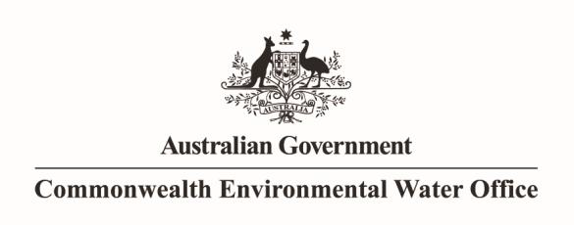

Monitoring the effects of environmental flows on hypoxic blackwater in the Murray and Murrumbidgee Rivers

December 2013 [Update

**Prepared by:** Darren S. Baldwin and Kerry L. Whitworth

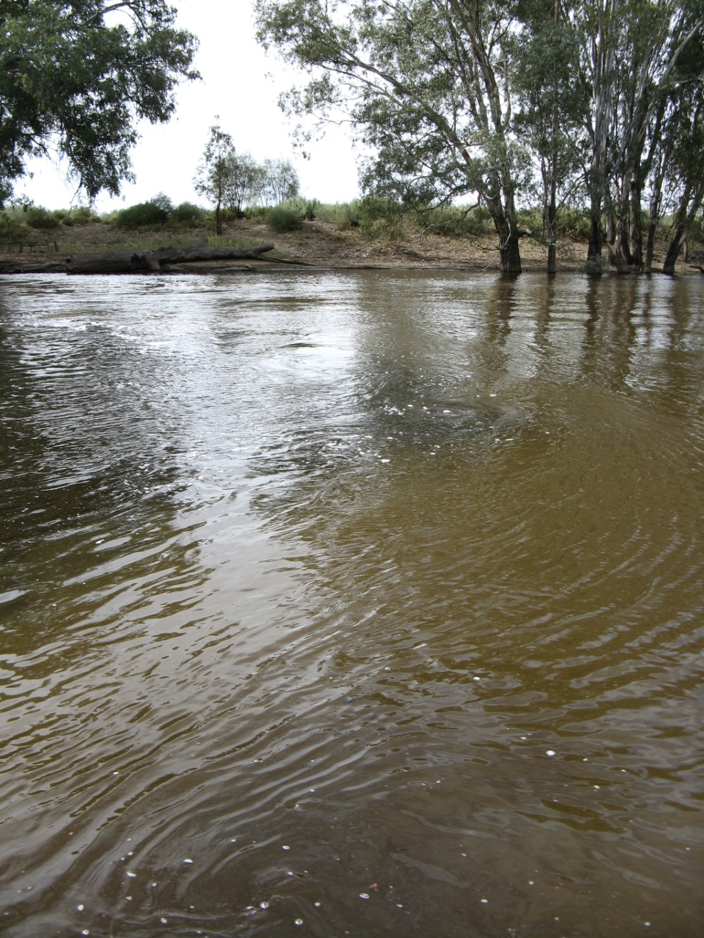



Draft Report

**MDFRC Publication XX/2011**



**Insert report title here**

**Monitoring the effects of environmental flows on hypoxic blackwater in the Murray and Murrumbidgee Rivers**

This monitoring project was commissioned by the Commonwealth Environmental Water Office.

**Copyright**

© Copyright Commonwealth of Australia, 2014



‘Monitoring the effects of environmental flows on hypoxic blackwater in the Murray and Murrumbidgee Rivers’ is licensed by the Commonwealth of Australia for use under a Creative Commons By Attribution 3.0 Australia licence with the exception of the Coat of Arms of the Commonwealth of Australia, the logo of the agency responsible for publishing the report, content supplied by third parties, and any images depicting people. For licence conditions see: <http://creativecommons.org/licenses/by/3.0/au/>

This report should be attributed as ‘Monitoring the effects of environmental flows on hypoxic blackwater in the Murray and Murrumbidgee Rivers, Commonwealth of Australia 2014’.

The Commonwealth of Australia has made all reasonable efforts to identify content supplied by third parties using the following format ‘© Copyright, [name of third party] ’.

**Disclaimer**

The views and opinions expressed in this publication are those of the authors and do not necessarily reflect those of the Australian Government or the Minister for the Environment.

While reasonable efforts have been made to ensure that the contents of this publication are factually correct, the Commonwealth does not accept responsibility for the accuracy or completeness of the contents, and shall not be liable for any loss or damage that may be occasioned directly or indirectly through the use of, or reliance on, the contents of this publication.

This report was prepared by The Murray-Darling Freshwater Research Centre (MDFRC). The aim of the MDFRC is to provide the scientific knowledge necessary for the management and sustained utilisation of the Murray-Darling Basin water resources. The MDFRC is a joint venture between the Murray-Darling Basin Authority, La Trobe University and CSIRO (through its Division of Land and Water). Additional investment is provided through the Australian Government Department of the Environment.

|  |  |  |
| --- | --- | --- |
| MDBA_AG_crest_RGB-reduced | CSIR_col(821x989) | LaTrobe Logo |

For further information contact:

**Dr Darren Baldwin**

The Murray-Darling Freshwater Research Centre

PO Box 991

Wodonga Vic. 3689

Ph: (02) 6024 9650; Fax: (02) 6059 7531

Email: darren.baldwin@latrobe.edu.au

Web: [www.mdfrc.org.au](http://www.mdfrc.org.au)  
Enquiries: [info@mdfrc.org.au](mailto:info@mdfrc.org.au)

**Report Citation:** ‘Monitoring the effects of environmental flows on hypoxic blackwater in the Murray and Murrumbidgee Rivers, Commonwealth of Australia 2014’ Baldwin, D.S. and Whitworth, K.L. (2013) Report prepared for Commonwealth Environmental Water Office by The Murray-Darling Freshwater Research Centre, MDFRC.

**Cover Image:** Confluence of the Murray and Murrumbidgee Rivers

**Photographer:** Mr David Wood (MDFRC)

**Filename and path:** Projects/CEWOO/Blackwater monitoring/Final Report/Murrumbidgee Blackwater Draft Report

**Author(s):** Darren S. Baldwin and Kerry L. Whitworth

**Project Manager:** Darren S. Baldwin

**Client:** Commonwealth Environmental Water

**Project Title:** Monitoring the effects of environmental flows on hypoxic blackwater in the Murray and Murrumbidgee Rivers

**Document Version:** Draft

**Acknowledgements:** The authors acknowledge the assistance of the NSW Office of Water, the Mallee Catchment Management Authority, Thiess Services, the Murray-Darling Basin Authority, Adrian Clements, David Wood, Braeden Lampard, Greg Cranston, Brendan Curtin and John Pengelly.

Contents

[Executive Summary 1](#_Toc374022098)

[1 Introduction 2](#_Toc374022099)

[2 Commonwealth Environmental Watering 3](#_Toc374022100)

[3 Site and event description 3](#_Toc374022101)

[4 Methods 7](#_Toc374022102)

[4.1 Existing water quality data 7](#_Toc374022103)

[4.2 Additional monitoring 7](#_Toc374022104)

[4.2.1 DOC analysis 10](#_Toc374022105)

[5 Results and Discussion 10](#_Toc374022106)

[5.1 Water quality in the Murrumbidgee River 10](#_Toc374022107)

[5.1.1 Dissolved oxygen 10](#_Toc374022108)

[5.1.2 Dissolved organic carbon 12](#_Toc374022109)

[5.2 Water quality in the Murray River 13](#_Toc374022110)

[5.2.1 Dissolved oxygen 13](#_Toc374022111)

[5.2.2 Dissolved organic carbon 16](#_Toc374022112)

[5.3 Mixing at the junction of the Murray and Murrumbidgee Rivers 17](#_Toc374022113)

[5.4 Use of mixing models to predict DO and DOC 19](#_Toc374022114)

[5.5 Impact of environmental water delivery on downstream DO 22](#_Toc374022115)

[6 Guiding principles for using environmental flows to mitigate hypoxia caused by blackwater. 24](#_Toc374022116)

[7 Conclusions 27](#_Toc374022119)

[8 Acknowledgements 27](#_Toc374022120)

[9 References 28](#_Toc374022121)

# Executive Summary

Hypoxic blackwater is characterised by a high concentration of dissolved organic carbon and low concentration of dissolved oxygen in the water column. Hypoxia can be stressful or fatal to many aquatic organisms.

Hypoxic blackwater was generated on the Murrumbidgee River floodplains during summer and autumn flooding (from rainfall) in 2012. Very low dissolved oxygen was recorded in the river channel downstream of Balranald for upwards of a month. Inflows of this water into the Murray River also posed a risk to water quality in the Murray downstream of the confluence, especially when Murray discharge began to recede while Murrumbidgee discharge remained high in April 2012.

In order to provide and maintain oxygenated refuge habitats for aquatic animals along the main stem of the Murray River, the Commonwealth Environmental Water Office delivered an environmental flow through the Murray River system of up to 120,000 megalitres. This was in addition to pre-existing environmental flows in the system. Examination of mixing patterns at and downstream of the junction revealed that Murray River water mixed completely with the hypoxic Murrumbidgee water within 5 river kilometres. Dissolved oxygen profiles also showed that a corridor of oxygenated water persisted past the junction, which would have created oxic refuges and facilitated the passage of biota upstream to oxygenated water.

The impact of the additional environmental water delivery on downstream water quality could be predicted with reasonable accuracy using simple mixing models. Under a worst case scenario the base flow in the Murray River during the hypoxic blackwater event was predicted to fall as low as 1800 megalitres per day. Modelling showed that the additional environmental water delivered in this study would have substantially improved water quality downstream of the confluence of the Murray and Murrumbidgee Rivers if base flows had fallen to 1800 megalitres per day.

# Introduction

Blackwater is characterised by a high concentration of dissolved organic carbon (DOC) in the water column. Transfer of organic carbon from floodplains to the river channel is vital for the sustenance of riverine food webs. However, microbial respiration of this carbon consumes oxygen and if oxygen consumption exceeds re-aeration, dissolved oxygen (DO) concentrations fall. This is known as hypoxic blackwater (Howitt et al. 2007). Hypoxic blackwater is often responsible for fish kills and other adverse effects on aquatic biota. Oxygen concentrations below 4 mg/L are generally considered to impose stress on aquatic biota and many biota cannot survive if DO falls below 2 mg/L (Gehrke 1988).

Blackwater events occur most frequently in lowland rivers with forested floodplains (Hladyz et al. 2011, Howitt et al. 2007). The majority of lowland river-floodplain systems in the southern Murray-Darling Basin (MDB) were impacted by a prolonged and extensive hypoxic blackwater event between September 2010 and April 2011. This was triggered primarily by unseasonal, post-drought inundation (from rainfall) of multiple lowland floodplains, both forested and agricultural (Whitworth et al. 2011, 2012). Unseasonal (summer and autumn) natural flooding occurred again in 2012 and hypoxic blackwater was again observed in several lowland regions of the Murray-Darling Basin between March and May 2012, although the event was not as extensive nor as prolonged as that recorded in 2010–11 (Whitworth and Baldwin 2012). During this event, the most severe hypoxic blackwater was recorded downstream of areas that experienced greater natural flooding extent in 2012 than in 2010–11, namely the Murrumbidgee River and Billabong Creek.

Severe hypoxia (low dissolved oxygen) began to develop in the Murrumbidgee River downstream of the Balranald Weir at the beginning of April 2012 due to drainage of hypoxic blackwater from surrounding forested floodplains. In order to mitigate the risk of hypoxia developing in the Murray River downstream of the Murrumbidgee confluence, the Commonwealth Environmental Water Office delivered a dilution flow down the Murray River system. Additional environmental water was also present in the mid-Murray system at this time. The purpose of this project is to determine the effect of the environmental water delivery on water quality in the Murray River downstream of the Murrumbidgee confluence.

# Commonwealth Environmental Watering

In response to the blackwater event in the Murrumbidgee River the Commonwealth Environmental Water Holder allocated up to 120,000 megalitres (ML) of environmental water to help mitigate the potential impact of hypoxic blackwater from the Murrumbidgee River on aquatic biota in the Murray River. The specific purpose of this water was to “provide and maintain oxygenated refuge habitats for aquatic animals along the main stem of the Murray River”. One of the principal concerns guiding the decision was that:

“[i]f environmental water is not provided from Hume Dam, operation rules require that releases from Hume are minimised so that flows below Yarrawonga are reduced from the current rate of around 7000 ML/day to around 4000 ML/day in the following weeks and could be reduced to a rate as low as 1800 ML/day if demands remain low and there is no rainfall (Damien Green, MDBA, pers. comm. 12 April 2012)”

from Appendix 1,Water Use Minute no. 87

Given that peak flows from the Murrumbidgee River were predicted to be of the order of 35000 ML/day, and DO in the Murrumbidgee River downstream of Balranald were 0 mg/L there was a substantial risk that, in the absence of environmental flows, and flows in the Murray River falling as low as 1800 ML/day, Do levels in the Murray River downstream of the confluence with the Murrumbidgee would also fall close to 0mg/L and this plume would persist for many 10-100’s of km in the main river channel. As was shown in the 2010/2011 event, such a plume of hypoxic blackwater can result in substantial fish deaths (King et al., 2012)

# Site and event description

The Murrumbidgee River originates in the Snowy Mountains of the Great Dividing Range and flows through upland forest, hilly pastoral land and finally flat land dominated by irrigated agriculture (). Several small floodplain forests are present downstream of Narrandera and a large area of river red gum forested floodplain (mostly within the boundaries of Yanga National Park) is located just upstream of Balranald. Additional areas of forested floodplain exist between Balranald and the Murrumbidgee River confluence. The floodplain area within and downstream of Yanga National Park is commonly known as the Lowbidgee floodplain.

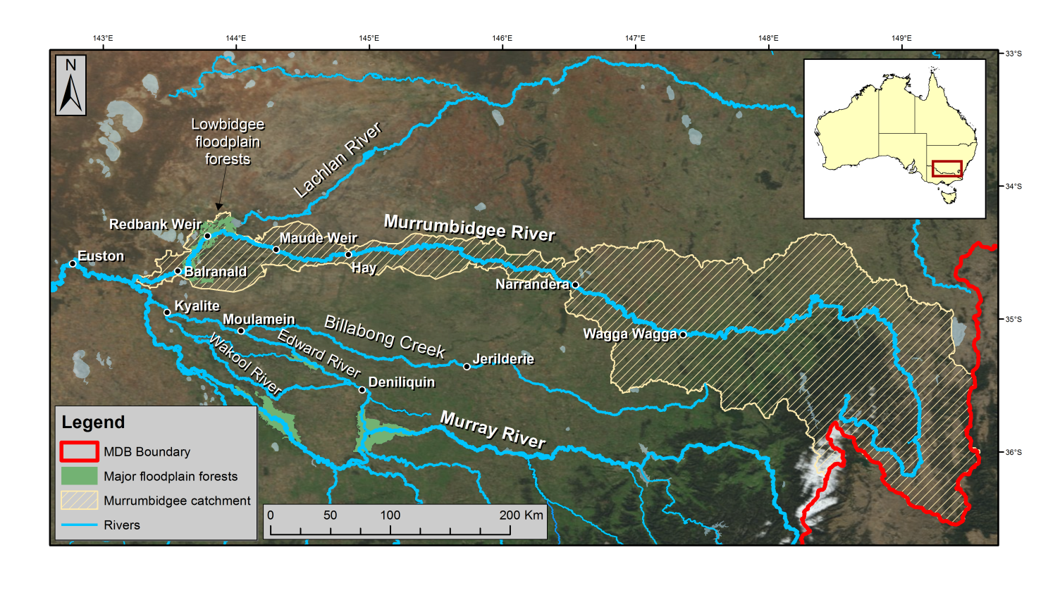

**Figure 1**: Murrumbidgee River catchment (note that the Lachlan River does not connect with the Murrumbidgee but terminates in a large wetland complex).

The Lowbidgee floodplain lies within a semi-arid climatic zone (Hutchinson et al. 2005) with an annual average rainfall of 320 mm per year (Australian Government Bureau of Meteorology 2012). This floodplain is dependent on overbank flows, primarily derived from winter and spring rainfall and snow melt in the upper catchment, for maintenance of ecological character (Bren 1992; Kingsford 2000). The region suffered both local drought and a drastic reduction in flows originating from upstream for much of 2000–2010 decade (). This situation came to an abrupt end in late 2010, with unprecedented spring and summer rainfall causing the drought to be broken not only in the Murrumbidgee River catchment but across the entire southern Murray-Darling Basin by a series of widespread flood events.



**Figure 2:** Murrumbidgee River hydrographs for **a)** Hay and **b)** Balranald from 1980–present, showing period of very low discharge 2000–2010 and flooding in 2010–11 and 2012.

High summer and autumn rainfall occurred again in 2012 and, in the Murrumbidgee River catchment, the 2012 flood magnitude exceeded that recorded in 2010–11. Hydrographs from the Murrumbidgee at Hay, Maude Weir, Redbank Weir and Balranald during the 2012 flood event (

**Figure** 3) indicate that downstream of Hay, much of the flow travelled overland, leading to extensive floodplain inundation. Leaching and subsequent decomposition of carbon from organic material on these floodplains would have caused hypoxic conditions to develop (Whitworth et al. 2012). Much of the flow returned to channel upstream of Balranald, leading to the in-channel hypoxia described in the introduction.





**Figure 3:** Murrumbidgee River hydrographs for Hay, Maude Weir, Redbank Weir and Balranald during the 2012 flood event.

# Methods

Data collection for this project consisted of two components:

1. Collation of existing water quality data from agency monitoring programs
2. Collection of additional water quality data.

## Existing water quality data

The New South Wales Office of Water (NOW) maintains a dissolved oxygen and temperature logger in the Murrumbidgee River downstream of Balranald Weir. The Mallee Catchment Management Authority (MCMA), the Victorian Department of Sustainability and Environment (via Thiess Services) and NOW also undertake routine and event-based water quality monitoring in the southern Murray-Darling Basin. Data from these sources were made available to the current project (see Figure 4 for locations of relevant monitoring sites). River discharge data were obtained from the Murray-Darling Basin Authority and NOW.

## Additional monitoring

Six optical DO and temperature probes with data loggers (D-Opto, Zebra-tech, New Zealand) were deployed in the Murray River for the collection of additional DO and temperature data during the current project. These were placed: upstream of the Wakool River junction; upstream and downstream of the Murrumbidgee River junction; at Euston (upstream of the weir); at Mildura (downstream of the weir); and at Fort Courage (downstream of the Darling River and Darling River Anabranch junctions) (**Table 1**). The loggers were deployed from 27 April until 30 May 2012 and were cleaned on a weekly basis.

**Table 1**: Locations of temporary loggers deployed for DO monitoring

|  |  |  |  |
| --- | --- | --- | --- |
| **Location description** | **Latitude** | **Longitude** | **Notes** |
| Upstream of Wakool junction (Kenley) | -34.86043° | 143.34990° | ~150 m upstream of junction |
| Upstream of Murrumbidgee junction | -34.73129° | 143.22149° | ~300 m upstream of junction |
| Downstream of Murrumbidgee junction | -34.71339° | 143.18774° | ~5 river km downstream (3.5 km direct line) of junction |
| Euston (upstream of weir) | -34.58942° | 142.75157° | ~1 km downstream of Euston Club boat ramp |
| Mildura (downstream of weir) | -34.16869° | 142.16067° | Logger located on yellow salinity structure opposite Mildura homestead |
| Fort Courage (downstream of Darling Anabranch) | -34.09806° | 141.72465° | ~1km downstream of Fort Courage boat ramp |

The New South Wales Office of Water was also commissioned to undertake additional water quality monitoring on a weekly basis (particularly measurement of DO and temperature and collection of samples for DOC analysis) between 27 April and 30 May 2012 at six sites on the Murrumbidgee River (Hay Weir, Maude Weir, Redbank Weir, Balranald Weir, Waldaria and Weimby) and three sites on the Murray River (Heywood’s Inlet, Boundary Bend and upstream of Euston weir). All relevant monitoring sites are shown in .

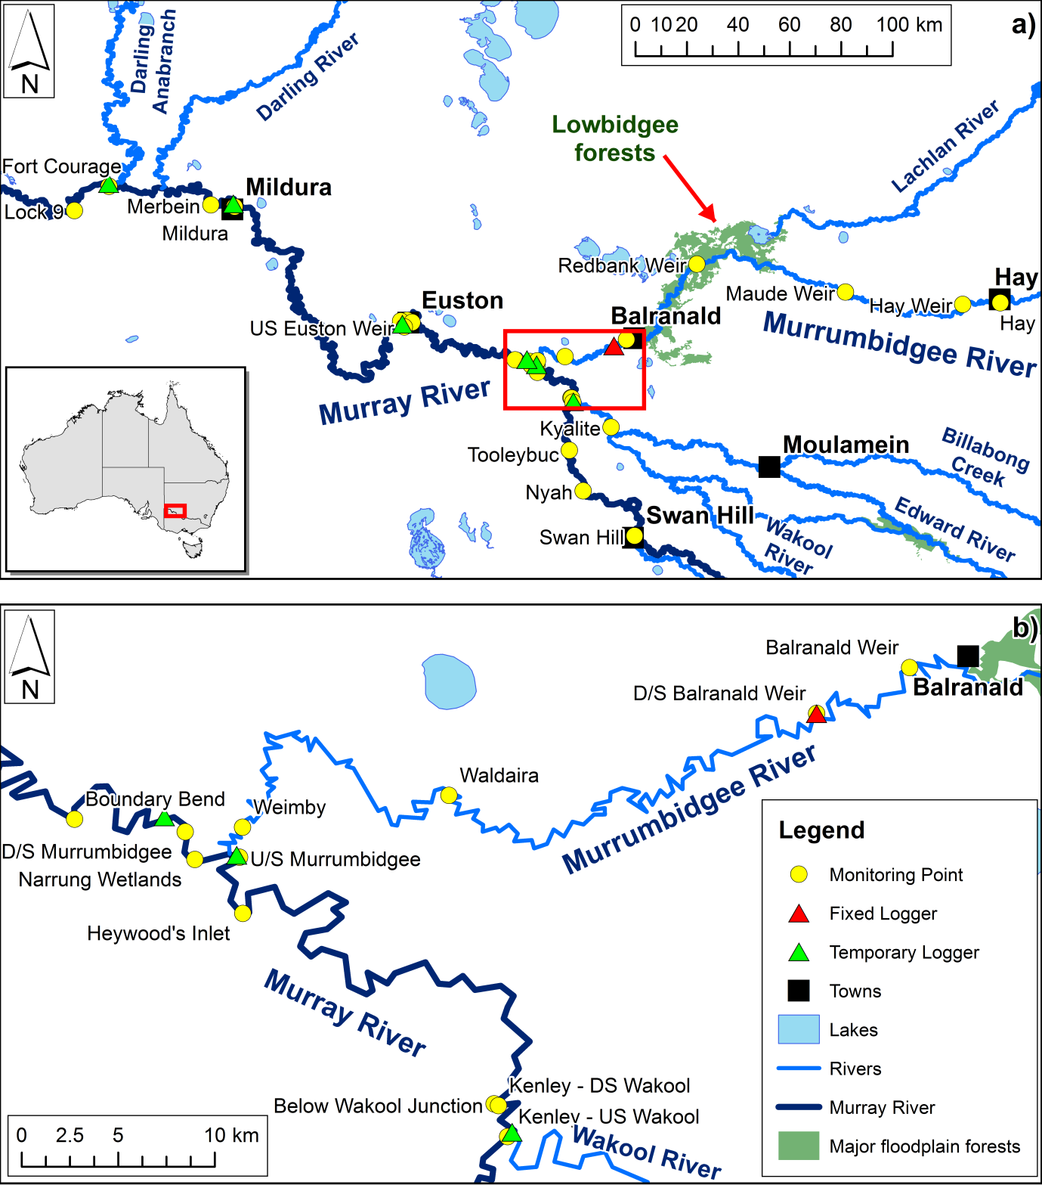

**Figure 4:** Sampling locations **a)** in the Murrumbidgee and Murray River system and **b)** detail of sites near the Murrumbidgee and Murray River junction (area marked by red box in (a)).

Additionally, an intense sampling program was undertaken on 8 May 2012 to explore the nature of the mixing processes at the confluence of the Murray and Murrumbidgee Rivers. A boat was used to traverse six transects in:

* the Murray River about 500 m upstream of the Murrumbidgee River junction
* the Murrumbidgee River about 750 m upstream of the junction
* the Murray River 170 m and 0.5, 1.0 and 5.0 km downstream of the confluence.

At approximately six points along each transect, DO and temperature were measured at 0.2, 1, 2, 3, 4 and 5 m depths using a Hydrolab Quanta water quality multi-meter (Hach Environmental).

### DOC analysis

Samples for DOC analysis were filtered (0.45 µm cellulose acetate membrane) into 30 mL poly-carbonate vials, transported on ice to the laboratory and frozen until analysis. Blanks were collected on each sampling day by treating a sample of ultra-pure water (Milli-Q; Millipore) in the same manner as the samples. Dissolved organic carbon was determined by the NATA-accredited chemical analytical laboratory at the Murray-Darling Freshwater Research Centre, using the persulfate oxidation method (APHA 2005).

# Results and Discussion

## Water quality in the Murrumbidgee River

### Dissolved oxygen

Dissolved oxygen in the Murrumbidgee River upstream of the Lowbidgee floodplain (as recorded at Hay, Maude Weir and Redbank Weir) dropped to <4 mg/L with the passage of the flood pulse in the second half of March (). Water quality at these sites prior to the flooding is unknown, as no DO data is available from these sites for the period from late January to mid-March 2012. However, the available data from further downstream at Balranald suggests that water quality was probably reasonable during this period (). As discharge receded in these middle reaches of the river, DO increased again, returning to >5 mg/L by the end of March and ~8 mg/L by mid-April at Hay and Maude Weir. At Redbank Weir the recovery was a little slower; DO remained below 5 mg/L until mid-April then steadily increased to >8 mg/L by early May.

Further downstream at Balranald, DO began to fall sharply with the first step increase in discharge in early March. By early April, DO was <1 mg/L and this situation persisted until the end of the month. After the main flow peak passed (and a concurrent decrease in temperature occurred; data not shown) DO began to steadily increase, returning to ~6 mg/L by mid-May and >7 mg/L by the end of May.



**Figure 5:** Dissolved oxygen (spot measurements and daily averages from loggers) in the Murrumbidgee River between Hay and Balranald. Also shown is river discharge at Hay and Balranald. Data: NOW.



**Figure 6:** Dissolved oxygen (spot measurements) in the Murrumbidgee River at sites between D/S Balranald Weir and the Murray River confluence on four sampling occasions during March and April 2012. Data: NOW.

Of all monitoring sites on the lower Murrumbidgee River, the site downstream of Balranald Weir yielded the most complete DO dataset for the study period, due to the presence of a fixed logger in addition to regular site visits for spot sampling. demonstrates that there is little (<0.5 mg/L) difference between the DO recorded at this monitoring site and sites further downstream towards the Murray confluence. Therefore, the more complete dataset from the downstream Balranald Weir site can be used to represent the water quality at the Murray River confluence.

### Dissolved organic carbon

Dissolved organic carbon sampling commenced in late April 2012. At this time, the main flood peak had already passed through sites upstream of the Lowbidgee floodplains. The peak in DOC concentrations at these sites may have occurred prior to the commencement of monitoring. At Hay and Maude Weirs, DOC was near 5 mg/L throughout the monitoring period (a). At Redbank Weir, DOC was approximately 10 mg/L in late April and declined to approximately 5 mg/L by early May.

The flood pulse was near its peak at Balranald at the time that DOC sampling commenced. At this time, DOC was in the 16–24 mg/L range at sites between Balranald and the Murray confluence (b). A slow downward trend was evident over the monitoring period. By the start of June, DOC at Balranald was below 10 mg/L.



**Figure 7:** Dissolved organic carbon in the Murrumbidgee River at sites **a)** upstream and **b)** downstream of Balranald between late April and early June 2012. Error bars are one standard error (*n*= 3). Data: NOW; MDFRC.

## Water quality in the Murray River

### Dissolved oxygen

Dissolved oxygen in the Murray River upstream of the Murrumbidgee junction generally remained above 4 mg/L throughout the 2012 floods (; see also Whitworth and Baldwin 2012). A drop in DO from about 8 mg/L to about 4.5 mg/L was observed both upstream and downstream of the Wakool junction with the passage of the flood pulse in the main Murray River channel in March 2012. During April, Murray River flows receded but Wakool River flows remained high. Since DO concentrations were lower in the Wakool than the Murray River at this time (data not shown), this resulted in a period of lower DO concentrations downstream of the Wakool junction. By May, discharge in the Wakool River was receding and DO in this channel had improved (data not shown) so DO values were similar both upstream and downstream of the junction.



**Figure 8:** Dissolved oxygen (spot measurements and daily averages from loggers) in the Murray River upstream of the Murrumbidgee River. Values at sites above (Swan Hill, Tooleybuc and Kenley upstream of Wakool) and below (Below Wakool Junction, Heywood’s Inlet and Kenley downstream of Wakool) the Wakool junction are shown. Also shown is discharge in the Murray River upstream (Swan Hill) and downstream of the Wakool junction (Below Wakool Junction). Data: NOW; MCMA; Victorian Department of Sustainability and Environment (via Thiess Services).

Inflows of water from the Murrumbidgee River into the Murray River represented only a minor portion of total downstream flow prior to April 2012 (). Little data is available for DO downstream of the Murrumbidgee junction for the first three months of 2012, but three data points from late March and early April suggest that DO values in the Murray River were similar both upstream and downstream of the Murrumbidgee junction until mid-April 2012 (). In mid-April Murray River discharge began to decline sharply while Murrumbidgee discharge remained high. At this time, a DO difference of approximately 2 mg/L became evident either side of the junction. With Murray flows forecast to continue decreasing while Murrumbidgee flows were predicted to remain high, it was feared that the impact of the hypoxic water emanating from the Murrumbidgee system on water quality in the Murray River would become more severe in late April and early May. To reduce this risk, environmental water was used to slow the flow recession in the Murray River. Although a DO disparity of 2–4 mg/L either side of the junction remained evident until late May, DO did not drop below 3.5 mg/L in the Murray River downstream of the junction.



**Figure 9:** Dissolved oxygen (spot measurements and daily averages from loggers) in the Murray River upstream (Below Wakool Junction, Heywood’s Inlet and Kenley downstream of Wakool) and downstream (D/S Murrumbidgee, Boundary Bend and Narrung Wetlands) of the Murrumbidgee confluence. Also shown is discharge in the Murray River upstream (Below Wakool Junction) and downstream (Boundary Bend) of the Murrumbidgee junction. Data: NOW; MCMA; Victorian Department of Sustainability and Environment (via Thiess Services).

Further downriver, DO in the Murray River downstream of the Mildura Weir was generally above 7 mg/L throughout the first half of 2012, with the exception of a brief drop to about 6 mg/L with the passage of the March/April flood pulse (). Dissolved oxygen in the lower Darling River at Tapio (data courtesy of NOW) was near 6 mg/L from January to April 2012, then gradually increased towards 8 mg/L during May. Inflows of Darling River water caused a slight decrease in DO in the Murray River channel. During the monitoring period, the daily average DO recorded by the logger at Fort Courage was 0.87 ± 0.04 mg/L (*n* = 36) lower than the value recorded at Mildura. However, since Darling River DO levels were not sufficiently low to be of concern to aquatic biota, no intervention was required at this site.



**Figure 10:** Dissolved oxygen (spot measurements and daily averages from loggers) at sites upstream (Mildura and Merbein) and downstream (Fort Courage) of the Darling River junction. Also shown is DO at Tapio in the lower Darling River and discharge in the Murray River downstream of the Murrumbidgee and in the Darling River at Burtundy. Data: NOW, MDFRC.

### Dissolved organic carbon

Dissolved organic carbon in the Murray River upstream of the Murrumbidgee confluence was approximately 13 mg/L in late April 2012 (). This elevated value is related to earlier drainage of hypoxic blackwater into the Murray River from forested floodplains including the Barmah-Millewa and Koondrook-Perricoota forests, and agricultural floodplains in the Broken and Billabong Creek catchments (Whitworth and Baldwin 2012). A downwards trend in DOC is evident over the subsequent weeks, with values stabilising near 5 mg/L by mid-May. Downstream of the Murrumbidgee confluence, DOC was consistently about 5 mg/L higher than upstream until mid-May, due to inflows of hypoxic blackwater from the Murrumbidgee system. By the end of May, DOC values upstream and downstream of the confluence differed by only about 1.5 mg/L, consistent with the decrease in both discharge and DOC concentration in the Murrumbidgee system. On each sampling occasion, DOC was slightly higher at Euston than at Boundary Bend, although the difference was not statistically significant (one-way ANOVA, p = 0.535). Since DOC was declining throughout the monitoring period, the difference may be attributable to the travel time between the two sites – the sample collected at Euston could be considered to have been drawn from a water parcel that passed Boundary Bend approximately 2 days earlier.



**Figure 11:** Dissolved organic carbon in the Murray River upstream and downstream of the Murrumbidgee confluence between late April and early June 2012. Error bars are one standard error (*n* = 3).

## Mixing at the junction of the Murray and Murrumbidgee Rivers

An intense sampling program undertaken on 8 May 2012 allowed determination of the extent of mixing of dilution water from the Murray River with hypoxic water from the Murrumbidgee River at and downstream of the confluence. Based on depth profiles recorded along each of six transects, two-dimensional DO profiles were produced for each site ().



**Figure 12:** Two-dimensional DO profiles (‘slices”) in the Murray and Murrumbidgee Rivers near the junction of the two rivers. River flow direction is into the page for each plot. The black bands represent the river bottom.

Dissolved oxygen in each river upstream of the junction was quite uniform across the channel and with depth, albeit with markedly different levels of DO. Substantial mixing of the two water bodies occurred within 170 m of the junction, although a plume of extremely hypoxic water remained evident at the bottom of the channel. It is also evident that a continuous corridor of well-oxygenated water persisted along the Murray River channel past the Murrumbidgee junction. This would have allowed fish passage past the junction without subjecting the fish to hypoxic conditions. Two distinct parcels of water remained evident up to 4 km downstream of the junction (spot measurements at this point showed that DO levels on either side of the river differed by about 2 mg/L – data not shown). Complete mixing had occurred with 5 km downstream of the junction. Based on this survey, it is evident that data from the logger located 5 river km downstream of the confluence is representative of DO immediately after complete mixing of the two waterbodies.

## Use of mixing models to predict DO and DOC

If DO downstream of a confluence is determined by simple mixing of the two flows, then:

${DO}_{ds}=\frac{\left(F_{us}×{DO}_{us}\right)+\left(F_{inf}×{DO}_{inf}\right)}{F_{us}+F_{inf}}$ Equation 1

where: - *DO* is the concentration of dissolved oxygen in each water body

* *F* is the river discharge in each waterway
* Subscripts *us, inf* and *ds* refer to flow or DO upstream of the junction, in the influent (dilution) water and downstream of the junction respectively.

This model can be applied to any other water quality parameter that is conservative upon mixing (for example, DOC) by substituting for DO in Equation 1 the concentration of that parameter.

We tested the accuracy of this model by applying it to data from the Murray River upstream and downstream of the Wakool and Murrumbidgee River confluences during the 2012 blackwater event.

The measured DO upon mixing of the Murrumbidgee and Murray flows was compared to that predicted using this mixing model. Dissolved oxygen data from the monitoring site downstream of Balranald Weir was used to represent water quality in the Murrumbidgee River at the Murray confluence and data from sites between the Murrumbidgee and Wakool junctions (Below Wakool Junction, Heywood’s Inlet and Kenley D/S Wakool; averages used where more than one value was collected on a single day) was used to represent the quality of the Murray River dilution water. Measured DO data from sites immediately downstream of the confluence (D/S Murrumbidgee, Narrung Wetlands, Boundary Bend) was used for comparison with the model outputs. Calculations were only made for days where data was available for all three regions. Discharge from Below Wakool Junction was used as the input for Murray River upstream flow. The Murrumbidgee inflow was calculated as the difference between discharge at Boundary Bend and at Below Wakool Junction (Murrumbidgee discharge data from Balranald could not be used because some flow is lost on floodplains between this site and the Murray confluence).

For the Wakool confluence, model inputs were: DO at sites above the Wakool junction (Swan Hill, Tooleybuc, Nyah, Kenley U/S Wakool); DO in the Wakool River at Kyalite; flow at Swan Hill and a calculated Wakool inflow based on the difference between discharge at Swan Hill and at Below Wakool Junction (allowing a 2 day travel time). The model output was compared with DO data from sites between the Wakool and Murrumbidgee junctions (Kenley D/S Wakool; Below Wakool Junction; Heywood’s Inlet).



**Figure 13:** Comparison of measured DO downstream of the Murrumbidgee junction with DO calculated using a simple mixing model.

Comparison of predicted and measured DO values downstream of the Murrumbidgee confluence shows good agreement (a). Regression of calculated against measured values (b) yields a good linear fit (r2 = 0.86; n = 18) with a slope not significantly different from one (1.0117 ± 0.1003) and an intercept not significantly different from zero (0.1198 ± 0.5426).

For the Wakool confluence, reasonable agreement was also obtained between measured and calculated DO values (a). Regression of calculated against measured values (b) yields a good linear fit (r2 = 0.86; n = 16) but the slope is lower than expected (0.7919 ± 0.0792) and the intercept is significantly greater than zero (1.5075 ± 0.5692). This may be because of the greater distance between the upstream sampling points (e.g. Swan Hill) and the confluence. Re-aeration or oxygen consumption processes in the reach between the monitoring site and the confluence may have resulted in the DO at the confluence being different to that used for the calculation. Use of data from a range of different sources (MCMA spot measurements, Thiess Services spot measurements, NOW spot measurements, logger daily averages) may also have affected the accuracy of the model outputs if some meters were slightly out of calibration or if daily average values from the loggers differed substantially from daytime spot measurements.



**Figure 14:** Comparison of measured DO downstream of the Wakool junction with DO calculated using a simple mixing model.

The mixing model was also applied to DOC data at the Murrumbidgee confluence, with DOC concentrations at Weimby used as inputs for inflow DOC. Although only 5 data points were available as model inputs, good agreement is shown between measured and predicted values (a). Regression of calculated against measured values (b) yields a good linear fit (r2 = 0.99; n = 5) with a slope close to one (1.0176 ± 0.1028) and an intercept not significantly different from zero (-0.8130 ± 1.2294).



**Figure 15:** Comparison of measured DOC downstream of the Murrumbidgee junction with DOC calculated using a simple mixing model.

The success of the simple mixing model in predicting downstream DO and DOC immediately after mixing hypoxic blackwater with diluent water indicates that it is reasonable to use this model to predict the impact of changes in dilution flow volumes on downstream water quality. We therefore use this model to demonstrate the impact of the environmental water delivery on DO in the Murray River downstream of the Murrumbidgee confluence.

## Impact of environmental water delivery on downstream DO

Using the dilution model we can test various scenarios of the impact of the environmental water delivery on dissolved oxygen in the Murray River downstream of the confluence with the Murrumbidgee River.

Dissolved oxygen in the Murray and Murrumbidgee Rivers are based on field measurements with linear interpolation between sampling occasions. Flows in the Murrumbidgee were estimated from the differences in flow in the Murray River between the Wakool Junction and Boundary Bend. The estimate of the amount of environmental water at Boundary bend was supplied to us by the the Murray-Darling Basin Authority based on MSM-Bigmod algorithms. The flow modelling calculations consider only the change in flow as a result of the releases ordered by CEWO. Any possible additional spill that may have subsequently been created had the CEWO release not been made has not been considered (this is equivalent to assuming that had the release volume water not been held by CEWO it would have been previously diverted for irrigation). The Commonwealth environmental water component of flow was calculated according to:

1. Route the observed releases from Hume downstream with actual releases and diversions to produce a modelled estimate of flow at Euston.
2. Route the release from Hume net of CEWO release through the system under the same conditions to produce a modelled estimate of flow at Euston without CEWO release.
3. The difference between 1 and 2 gives the CEWO component of the flow at Euston.
4. Lag CEWO component of flow at Euston by 7 days to better match flow travel times for this event.
5. Subtract values in 4 from actual Euston flow to give best estimate of Euston flow without CEWO component.

Figure 16 shows modelled DO at daily time steps downstream of the Murrumbidgee River confluence under three separate scenarios, no flow in the Murray River (black line), under the worst case scenario of a base flow in the Murray River of 1800 ML/day (red line) and, a base flows of 1800 ML/day plus the environmental water allocation. The modelling shows that oxygen levels below the confluence would have been substantially worse at base flows of 1800ML/day without the environmental flows compared to base flows with the environmental flow allocation. As it eventuated flows in the Murray River during the event were much higher than projected under the worst case scenario and actual DO levels in the Murray River downstream of the confluence were for the most part above the critical 4mg/L level where biota begin to be impacted by poor water quality.



**Figure 16:** Modelled DO downstream of the Murray River confluence with the Murrumbidgee under 3 scenarios – no water in the Murray River, a base flow of 1800 ML/day and, a flow of 1800 ML/day plus the additional environmental flows specifically delivered in 2012 to mitigate the effects of the hypoxic blackwater plume entering into the Murray River from the Murrumbidgee River.

# Guiding principles for using environmental flows to mitigate hypoxia caused by blackwater.

Environmental flows can be used to mitigate the effects of hypoxia caused by blackwater in three ways:

1. As a dilution flow,
2. For the creation of oxygenated refugia
3. To slow the flood recession slowing the rate of floodwater entering a river channel.

In the first case sufficient water (of appropriate quality) is sourced from upstream to dilute the hypoxic blackwater and hence mitigate downstream effects of hypoxia (this study). The amount of dilution flows necessary will depend on the volume of the hypoxic blackwater, the levels of dissolved oxygen in the dilution water, and the reactivity of carbon in the blackwater. A model of the immediate and downstream effect of dilution flows based on Equation 2 can be used to estimate the required dilution flow. In the second case, a plume of oxygenated water is injected into a hypoxic stream to create a local oxygenated refuge for aquatic organisms. This approach was used with some success in the 2010–11 blackwater event in the Edward Wakool River system, where water from irrigation channel escapes was used to create localised plumes of oxic water in an otherwise hypoxic environment. Environmental water was also used in the 2012 event with the aim of the slowing the recessing of floodwater off the Lowbidgee wetlands following the large flood. The primary aim of that release was therefore to slow the rate of return flows – after the natural flood peak had occurred – in order to keep the bank half full and slow the rate of return back into the Murrumbidgee River channel and then the Murray River.

Whatever the purpose when deciding on whether or not to use environmental water to mitigate hypoxia there are number of issues that need to be taken into consideration:

1. *The source of blackwater*. Knowledge of where the hypoxia is coming from will help in the decision-making process. Assuming that the hypoxic blackwater originates from a floodplain, estimates of floodplain return flow compared to current flows in the receiving channel can be used to estimate likely effects (see below). Estimates of the volume of water on the floodplain can be used to determine the likely duration of the event.
2. *The size of the receiving-water channel capacity*. Overbanking of the channel downstream of the source of hypoxic blackwater by dilution water will possibly exacerbate the problem by mobilising new DOC from the riparian zone. Estimates of the flow from upstream, the blackwater flow and the channel capacity puts an upper limit on how much dilution flow can be delivered to mitigate the hypoxic event. The blackwater dilution model can then be used to determine the potential effects of any managed dilution flows.
3. *Capacity and condition of the channel used for delivering the environmental flows*. It is preferable not exceed the capacity of the delivery channel when transporting environmental flows for hypoxia mitigation, because overbank flows risk DOC enrichment and DO depletion in the environmental flow water. If the channel used for delivering environmental water is dry prior to commencement of flows, an assessment of the risk of generating blackwater in the channel should be undertaken (e.g. see Hladyz et al. 2011). This would require estimating the amount of litter on the channel bed and comparing that with the amount of water (on a daily basis) that will be passed down the channel. If the channel is a series of pools, an assessment of the risk of lowering oxygen tension through mixing anoxic hypolimnetic water in any stratified pools with the dilution flow should be undertaken.
4. *Contingency planning:*  One of the key issues in using environmental water to mitigate the impact of hypoxic blackwater is around the restraints within the system to deliver the right amount of water in a timely fashion. Since the 2012 hypoxic blackwater event a number of tools have been developed which have increased our ability to predict and mange hypoxic blackwater. The first tool is an updated version of the original blackwater model developed by the Murray–Darling Freshwater Research Centre (Howitt et al. 2007). The original model specifically predicted dissolved oxygen in the Murray and Edward Rivers downstream of Barmah Forest and consisted of a fairly simple hydrological description of flooding of the forest which was then used to calculate downstream oxygen and carbon levels in the two rivers based on a series of process-based relationships. In order to update the original model, the original process-based components of the model were deconstructed in order to test the underlying assumptions in the model and refine the algorithms and constants used in the calculations. The refined assumptions, constants and algorithms were then supplied to the Murray–Darling Basin Authority (MDBA), who developed a computational model which could interface with more robust hydrologic models, including Bigmod and specific floodplain inundation models. This sophisticated model not only can be used to predict the likelihood of hypoxia for the whole of the Southern Connected Basin , but will also be a powerful tool for both predicting and hind-casting energy movement from the floodplain to the river channel under various flow scenarios.  
     
   The second tool developed in this project was a desktop planning tool to enable managers to assess the benefits (specifically increased carbon for fish production) and risks (hypoxia) of flooding floodplains. Like the original blackwater model, the desktop Blackwater Risk Assessment Tool consists of a simple hydrologic model coupled to a (now updated) process-based model. The third tool is a desktop module designed to help managers assess the potential of a range of intervention options for ameliorating the downstream impacts of hypoxic blackwater, if this is predicted to occur.  
     
   Used together these tools present an opportunity to effectively manage water in the basin to maximise the benefits associated with connecting a river to its floodplain while minimising the potential disbenefits like hypoxia.

# Conclusions

Discharge of hypoxic blackwater from the Murrumbidgee River system into the Murray River during autumn 2012 had a negative impact on DO concentrations in the Murray River. Examination of mixing patterns at and downstream of the junction revealed that complete mixing of the hypoxic Murrumbidgee water with the Murray water occurred within 5 river km, and that a corridor of normoxic water persisted past the junction, which would have facilitated the passage of biota . Dissolved oxygen concentrations in the Murray River downstream of the Murrumbidgee junction could be predicted with reasonable accuracy using a simple mixing model. This model shows that under the worst case scenario of a base flow of 1800 ML/day, the environmental water allocation would have substantially improved water quality downstream of the confluence of the Murray and Murrumbidgee Rivers.

# Acknowledgements

Gordon Honeyman, Gerhard Schulz, Sarah McGeogh and others from NSW Office of Water; Paula Robinson, Peter Kelly and others from the Mallee Catchment Management Authority; and Stephen Petchell, Sue Hoffmann and others from Thiess Services collected samples and/or supplied data for this project. Jim Foreman from the Murray-Darling Basin Authority provided modelled flow data. Adrian Clements, David Wood, Braeden Lampard and Greg Cranston assisted with field work and Brendan Curtin assisted with logistics. John Pengelly analysed samples for dissolved organic carbon.

# References

APHA (2005) Standard Methods for the Examination of Water and Wastewater, 21st ed. American Public Health Association, Washington, D. C.

Australian Government Bureau of Meteorology (2012) Australian Climate Averages - Rainfall. Retrieved 7/6/2012, from [www.bom.gov.au](http://www.bom.gov.au).

Bren, L.J. (1992) Tree invasion of an intermittent wetland in relation to changes in the flooding frequency of the River Murray, Australia. Australian Journal of Ecology 17(4), 395‑408.

Gehrke, P.C. (1988) Response surface analysis of teleost cardio-respiratory responses to temperature and dissolved oxygen. Comparative Biochemistry and Physiology Part A: Physiology 89, 587‑592.

Hladyz, S., Watkins, S.C., Whitworth, K.L. and Baldwin, D.S. (2011) Flows and hypoxic blackwater events in managed ephemeral river channels. Journal of Hydrology 401, 117‑125.

Howitt, J.A., Baldwin, D.S., Rees, G.N. and Williams, J.L. (2007) Modelling blackwater: Predicting water quality during flooding of lowland river forests. Ecological Modelling 203 (3‑4), 229‑242.

Hutchinson, M.F., McIntyre, S., Hobbs, R.J., Stein, J.L., Garnett, S. and Kinloch, J. (2005) Integrating a global agro-climatic classification with bioregional boundaries in Australia. Global Ecology and Biogeography 14, 197‑212.

King AJ, Tonkin Z, and Lieshcke J. (2012) Short-term effects of a prolonged blackwater event on aquatic fauna in the Murray River, Australia: considerations for future events. Marine and Freshwater Research 63, 576-586.

Kingsford, R.T. (2000) Ecological impacts of dams, water diversions and river management on floodplain wetlands in Australia. Austral Ecology 25(2), 109‑127.

Whitworth, K., Williams, J., Lugg, A. and Baldwin, D. (2011) A prolonged and extensive hypoxic blackwater event in the southern Murray-Darling Basin. Final Report prepared for the Murray-Darling Basin Authority by The Murray-Darling Freshwater Research Centre and NSW DPI (Fisheries), MDFRC Publication 30/2011, June, 127 pp.

Whitworth, K.L., Baldwin, D.S. and Kerr, J.L. (2012) Drought, floods and water quality: Drivers of a severe hypoxic blackwater event in a major river system (the southern Murray–Darling Basin, Australia). Journal of Hydrology 450–451, 190‑198.

Whitworth, K.L. and Baldwin, D.S. (2012) Blackwater in the southern Murray-Darling Basin during 2012 flood events. Report prepared for the Murray-Darling Basin Authority by The Murray-Darling Freshwater Research Centre, MDFRC Publication 16/2012, June, 34pp.