environment.nsw.gov.au

Report prepared by the Department of planning, Industry & ENVIRONMENT for the Commonwealth environmental water office

Monitoring native fish response to environmental water delivery in the lower Darling River 2020-2021

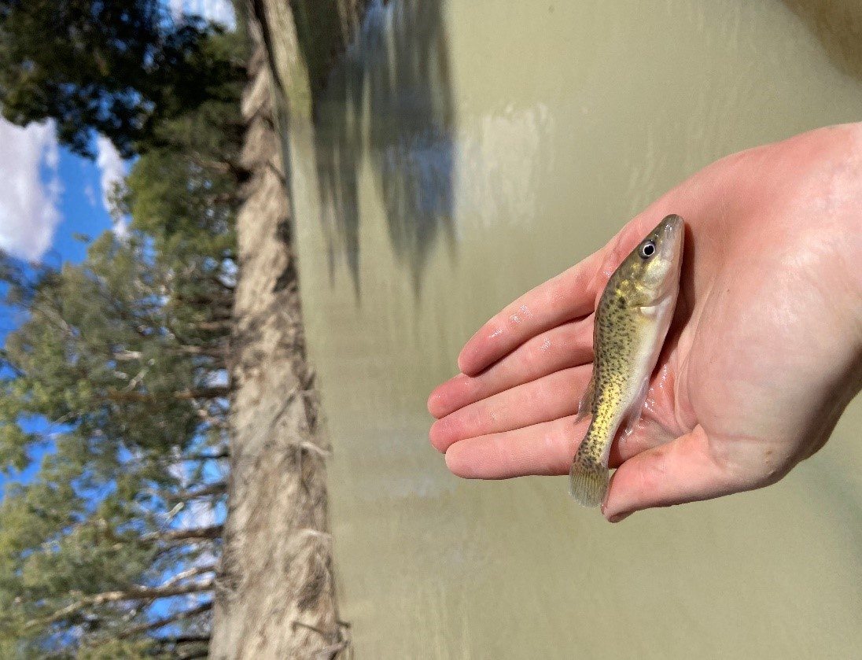

© 2021 State of NSW and Department of Planning, Industry and Environment

With the exception of photographs, the State of NSW and Department of Planning, Industry and Environment are pleased to allow this material to be reproduced in whole or in part for educational and non-commercial use, provided the meaning is unchanged and its source, publisher and authorship are acknowledged. Specific permission is required for the reproduction of photographs.

The Department of Planning, Industry and Environment (DPIE) has compiled this report in good faith, exercising all due care and attention. No representation is made about the accuracy, completeness or suitability of the information in this publication for any particular purpose. DPIE shall not be liable for any damage which may occur to any person or organisation taking action or not on the basis of this publication. Readers should seek appropriate advice when applying the information to their specific needs.

All content in this publication is owned by DPIE and is protected by Crown Copyright, unless credited otherwise. It is licensed under the [Creative Commons Attribution 4.0 International (CC BY 4.0)](http://creativecommons.org/licenses/by/4.0/deed.en), subject to the exemptions contained in the licence. The legal code for the licence is available at [Creative Commons](http://creativecommons.org/licenses/by/4.0/legalcode).

Citation: Stuart, I., D’Santos, P., Rourke, M., Ellis, I., Harrisson, K., Michie, L., Sharpe, C. and Thiem, J. 2021. Monitoring native fish response to environmental water delivery in the lower Darling River 2020-2021. State of New South Wales and Department of Planning, Industry and Environment, New South Wales, Australia.

Cover photo: Murray cod juvenile, Lower Darling River. NSW DPI Fisheries

Acknowledgements: The following NSW DPI staff assisted with field sampling, laboratory processing and data entry; Jonathon Doyle, Tim McGarry, Duncan McLay, Nick O’Brien, Rohan Rehwinkel, Bridget Smith, Ian Wooden. This research was carried out under Fisheries NSW Animal Care and Ethics permit 14/10 and Scientific Collection Permit P01/0059(A)-2.0. The authors are extremely grateful to the landholders who allowed access to their properties and the traditional owners of the lands on which this work was conducted. This work was funded by the Commonwealth Environmental Water Office and we especially thank Zarni Bear and Alana Wilkes. We appreciate valuable comments that improved the draft report by John Koehn and Rob Hale (Arthur Rylah Institute), and Alana Wilkes and Lindsay White (CEWO).

Published by:

Environment, Energy and Science   
Department of Planning, Industry and Environment  
Locked Bag 5022, Parramatta NSW 2124  
Phone: +61 2 9995 5000 (switchboard)  
Phone: 1300 361 967 (Environment, Energy and Science enquiries)  
TTY users: phone 133 677, then ask for 1300 361 967  
Speak and listen users: phone 1300 555 727, then ask for 1300 361 967  
Email: [info@environment.nsw.gov.au](mailto:info@environment.nsw.gov.au)   
Website: [www.environment.nsw.gov.au](http://www.environment.nsw.gov.au)

Report pollution and environmental incidents  
Environment Line: 131 555 (NSW only) or [info@environment.nsw.gov.au](mailto:info@environment.nsw.gov.au)  
See also [www.environment.nsw.gov.au](http://www.environment.nsw.gov.au)

ISBN 978-1-76058-466-5  
EES 2021/2022  
August 2021

Find out more about your environment at:

www.environment.nsw.gov.au

Contents

Executive summary 1

Methods 1

Results 2

Synthesis 3

Adaptive management 4

Priority management recommendations 4

Part 1: Spawning and recruitment of Murray cod and golden perch 6

Introduction 6

Methods 7

Results 18

Discussion 28

Synthesis 31

Priority recommendations 34

Part 2: Genetics of Murray cod 36

Introduction 36

Methods 36

Results 39

Synthesis 46

References 49

Appendix 53

Appendix Part 1 53

Appendix Part 2 56

List of tables

Table 1 An eco-hydraulic conceptual model of Murray cod populations in the lower Darling River based on local hydrology and the scientific literature. Highlighted are four key hydrological/hydraulic functional elements informed by the 2016-17 environmental flow implemented in 2020-21. A sharp summer flow pulse for golden perch spawning in the LDR was also included. 9

Table 2. Summary of mean catch for fish death analysis. Last column shows mean of all sites for each year. Note that 2017 had two or three replicates for each site but 2018 and 2021 only had one. 16

Table 3. Summary of the number of fish lengths for the fish deaths analysis. Note - Australian smelt was excluded to insufficient numbers. 17

Table 4. Summary of total catches of golden perch and Murray cod during larval sampling. 17

Table 5. Summary of young-of-the-year (YoY) and adults in catch for the focal species. Note - silver perch was omitted due to low sample sizes. 18

Table 6. Total numbers of larvae collected in the lower Darling River in spring-summer 2020. Numbers in round brackets () indicate juveniles and square brackets [ ] indicate eggs. An asterisk * denotes a non-native species. 25

Table 7. Table showing estimated CPUE (n/24hr) for each sampling event 27

Table 8. Subsampling summary of Murray cod larvae from the Lower Darling River used for genetic analysis. 37

Table 9: Total number of larval Murray cod sampled in the lower Darling River for each week and each site. Sites are ordered in a downstream to upstream direction (See Figure 3). 39

Table 10. Larvae full-sibling groups (N=22 sibling groups; N=30 full-sibling pairs). Prob (Inc.) is the probability that all individuals in a given full-sibling group are full-siblings. Prob (Exc.) is the probability that all individuals in a given full-sibling group are full-siblings and no other individuals are part of the full-sibling group. The site, week, net and ontogenetic stage for each member of the sibling pairs is identified. Member 1; M1, Member 2; M2, Member 3; M3, Member 4: M4. 41

Table 11. Larvae half-sibling Dyads (N=61). Member 1; M1, member 2; M2. 43

Table 12. Inferred parent-offspring pairs with the collection location of both the parent and the offspring. 46

Table 13. Colony full-likelihood method effective population size estimates (Ne) for larval samples assuming random mating and assuming non-random mating and NeEstimator effective number of breeders (NeD) estimates. Lower and upper 95% CI are reported in brackets. NeEstimator estimates of the effective number of breeders (NeD) contributing to each larvae sample and to the total larval and total adult sample. 46

Table 14. Length thresholds to define Young of Year fishes for each species. 53

Table 15. Statistical results for CPUE fish death analysis. 53

Table 16: Statistical results for length. Prefix of ‘sigma’ refers to the variance component of the model. 54

Table 17. Statistical results for proportion of sample that are recruits. 54

Table 18. Statistical results for lake larval net CPUEs for golden perch. 55

Table 19. Statistical results for LDR recruit Spring 2020 comparison. 55

Table 20. Statistical results for LDR recruit 2020 vs 2016-2017. 56

Table 21. Larval Murray cod used for genetic analysis and subsampling guide. 56

Table 22. Adult Murray cod samples used for genetic analyses. 62

List of figures

Figure 1 Pictorial representation of life history stages for Murray cod and golden perch. 5

Figure 2. The designed 2020-21 LDR hydrograph showing elements of the eco-hydraulic conceptual model (Table 1) to support native fish population processes. Note the environmental water (blue) providing greater discharge than the minimum flows contained in the water sharing plan for Weir 32 (orange). 11

Figure 3. Locations on the Darling River where river and lake fish community surveys were conducted. Electrofishing river surveys (green circle) were conducted in spring 2020 and autumn 2021, lake surveys (orange circle) were conducted in spring 2020 and autumn 2021 and larval drift river surveys (yellow diamond) were conducted from October to December 2020. 12

Figure 4. Menindee Lakes, an important golden perch nursery (photo: NSW DPI Fisheries). 12

Figure 5. Fyke nets set in the Menindee Lakes to collect juvenile golden perch (photo: NSW DPI Fisheries). 14

Figure 6. Map of sites in the Lower Darling region. Right panels show flow conditions (Weir32 - solid line; Burtundy - dashed line) and timing of surveys (coloured dots) for the whole study period (top side panel) and the 2020/2021 time period (bottom side panel). Dot colours indicate season. 15

Figure 7. Discharge (ML d-1) at Weir 32 and Burtundy historically (top) and since January 2000 (bottom) with yellow shading indicating the increasing frequency and duration of cease-to-flow events (designated as ≤15 ML d -1). Currently flows in the Darling River downstream Weir 32 up to 9,000 ML d-1 are considered within channel. 19

Figure 8. Discharge (ML day-1; blue line) and water temperature (°C; red line) in the lower Darling River at Weir 32 in 2020-21 showing the important flow components (i.e. discharge) for native fish. 20

Figure 9. Discharge (ML day-1; blue line) and water level (m; green line) in the lower Darling River at Weir 32 in 2020-21 showing the synchronous relationship between discharge and water level. A stable discharge during the spring Murray cod spawning season enabled fish to complete spawning. 20

Figure 10. Catch rates for each year for the most abundant fish species in the LDR. Green dots indicate significant differences of 2021 catch rates from 2017/2018. Error bars are 95% CI. 21

Figure 11. Length histograms for each species by year. Note - Australian smelt was omitted from analyses due to low sample size. 22

Figure 12. Proportion of fish that were young-of-the-year across years for select species. For 2021, a green dot indicates significant difference from the 2017/2018 proportion estimates. Error bars are 95% CI. 22

Figure 13. Larval catch rates (n/survey) for Spring 2020 in the Lower Darling River. Error bars are 95% CI. 23

Figure 14. Individual plots of larval counts for each site in Spring 2020. Blue dots show actual total catch for that survey and grey lines show Weir 32 and Burtundy discharge. 23

Figure 15. Catch rates for each year for golden perch and Murray cod. If 2020 dot is green, it indicates that it significantly differs from the average of 2016 and 2017 catch rates. Error bars are 95% CI. 24

Figure 16. Catch rates (n/24hr) for golden perch in fyke nets. Each point shows estimated catch rate (with 95%CI) for each sampling event. Note – no pairwise tests between sampling events were conducted. 26

Figure 17. Length distributions of golden perch for each sampling event with each panel showing a separate lake. Colour indicates sampling season/year (Green=Spring2020; Red=Autumn2021). 26

Figure 18. Young-of-the-year golden perch in the Menindee Lakes in 2020-21. These fish were spawned in upstream flowing riverine habitats, drifted into the lakes where there was rapid growth, then later dispersed both downstream and upstream into the Darling River into rivers (photo: NSW DPI Fisheries). 27

Figure 19. Young-of-the-year Murray cod sampled from the Lower Darling River in March 2020 (photos: NSW DPI Fisheries). 29

Figure 20. Abundant zooplankton collected in the Menindee Lakes which supports rapid growth and enhanced survival of young golden perch (photo: C. Sharpe). 30

Figure 21 Pictorial representation of life history stages for Murray cod and golden perch. 33

Figure 22. Locations of additional Murray cod adult fin clip samples supplied to increase sample size for genetic analysis. 65

# Executive summary

The approximately 510-km long reach of the lower Darling/Baaka River sustains a valuable and diverse native fish community. Prior to 2000 there were near-permanent flows to the lower Darling River (LDR) but in 2015-2016, and again from 2018-2020 there were two cease-to-flow events, of 524 and 555 consecutive days, respectively. The latter event led to catastrophic declines in water quality and major fish death events. From early 2020, there were northern basin inflows to the Menindee Lakes and while there remained limited water availability to the LDR this enabled the use of an environmental flow to aid the recovery of native fish populations, building upon concepts and the associated lessons developed from the 2016 environmental flow.

To support the recovery of native fish we planned an environmental flow based on the nationally vulnerable Murray cod (*Maccullochella peelii*) life-history, particularly as it related to the key hydrology (i.e. discharge; Megalitres per day (ML/d)) and hydraulic (i.e. water velocity) components. The model highlighted the need to implement near-permanent flowing habitat, effectively eliminating zero flows. In 2020-21, we evaluated this hydrograph with five major objectives:

1. determine the status of the native fish populations following the drought and fish death events

2. assess the environmental flow for supporting spawning and early life-stage recruitment responses of Murray cod and other native fish, in the LDR following recent fish kills

3. report on a recruitment event of golden perch (*Macquaria ambigua*) in the Menindee Lakes and opportunities for managing the lakes for major fish population outcomes in the connected Murray-Darling Basin (MDB) in 2021-22

4. investigate the genetic integrity of the Murray cod population in the LDR, including the number of parents producing larvae during the environmental flow

5. determine whether there was a detectable change in relative abundance or size structure of the fish community between pre-and-post fish deaths sampling.

## Methods

From our understanding of requirements of Murray cod from a previous environmental flow from 2016-2018, the 2020 LDR environmental flow regime incorporated four elements: (i) a late winter/spring increase in discharge to 350-400 ML day-1 to inundate Murray cod spawning and rearing habitats, (ii) a spring and early summer sharp increase in discharge to 1500 ML day-1 to enhance survival of larval Murray cod, (iii) to stimulate golden perch spawning, and (iv) a gradual summer/autumn recession to a winter discharge slightly exceeding the baseflows recommended by the local water sharing plan.

### Fish Sampling

To determine the composition and size structure of the fish community in the LDR, standardised in-channel boat electrofishing sampling was undertaken pre- and post- environmental water delivery in September 2020 (pre) and again in late February 2021 (post). Similarly, to determine the composition and size structure of fish in the Menindee Lakes two fyke netting events were undertaken, once in October 2020 and again in March 2021. To determine the timing of fish spawning in the LDR, as well as the spatial distribution of eggs and larvae, in-channel larval fish sampling was undertaken with drift nets on a fortnightly basis between October and December 2020 coinciding with environmental water delivery and the peak spawning period of native fish in the region. Fin-clip samples of young-of-the-year Murray cod were sent to Flinders University for analysis of genetic parentage under the FishGen program to determine if any were of hatchery origin.

## Results

### Hydrograph

Regulated outflows from the Menindee Lakes into the LDR began in July 2020 and broadly matched the planned delivery of environmental water, specifically designed to cue and protect Murray cod spawning and enhance larval survival. The environmental flow was delivered between 15 September 2020 and 15 January 2021 with a slight delay due to the removal of unauthorised modifications at Pooncarie Weir. The total water volume delivered during this period was 57,668 ML with environmental water contributing 24,713 ML.

### LDR adult fish sampling

From statistical analyses of the boat electrofishing data in 2020-2021, catch rates of golden perch and common carp (*Cyprinus carpio*) were lower than in previous environmental flow years (2016-2018) but there was no evidence of catch rate changes for Murray cod or bony herring (*Nematalosa erebi*). Similarly, there were no changes in the size structure of Murray cod or bony herring populations, but there were greater numbers of small golden perch present in 2020-21 indicating recruitment to the LDR via downstream dispersal movements from the Menindee Lakes. By contrast, the size of common carp numbers were longer in 2020-21 than in 2016-2018, indicating a recent lack of recruitment. There were too few silver perch (*Bidyanus bidyanus*) collected for similar analyses.

### LDR larval fish sampling

Ten species of fish eggs/larvae/juveniles were collected from six sampling trips at the six sites. Murray cod were collected from all sites, representing 31% of total catch and were the most abundant species sampled. Murray cod larvae were first detected on 8 October 2020 when water temperature was 17.1 °C, although spawning had occurred prior to this as they are a nesting species. No larval golden perch or silver perch were collected, although the capture of golden perch eggs at three sites was indicative of a low level of spawning output. This was likely due to a combination of loss of adult fish during the preceding death event, a migration barrier at Pooncarie Weir and the flow event being inadequate to cue remaining fish to spawn. Catch rates of larval Murray cod in 2020 were similar or greater than in previous years. Few larval carp and other non-native fish were collected in the larval nets, indicating that the environmental flow did not appear to result in substantial spawning or recruitment of non-native fish.

### Menindee Lakes sampling

Juvenile (young-of-the-year) golden perch were present in all five of the Menindee Lakes (i.e. lakes Wetherell, Pamamaroo, Tandure, Balaka and Bijijie); sampled in spring 2020 and summer 2021, highlighting the importance of the lakes as key nursery locations for the species. These fish likely recruited from several flow events originating in the northern MDB in late summer 2020. Hence, spawning events in the northern basin appear to have an important influence on golden perch populations in the LDR. When regulated outflows and environmental flows began into the LDR, young-of-the-year golden perch were then collected from the most upstream sites in the LDR highlighting their dispersal to the southern connected system.

### Murray cod genetics

Larval Murray cod collected from the LDR were analysed to determine their genetic relationships. These analyses revealed that not only were Murray cod spawning along the length of the LDR but that there was strong evidence that parents could spawn more than once in a season and that subsequent spawning events were with a different partner (polygamy). Many larvae collected were full or half siblings, suggesting that for the flows we tested (i.e. 400 ML day-1) larvae tended to remain close to spawning sites rather than dispersing over a broad spatial scale. The estimated effective breeding population size of >614 adults in the whole LDR is higher than known for many other Murray-Darling Rivers, indicative of a relatively genetically robust population of high ecological value.

### Effects of the fish deaths

The 2018-2020 fish death events were caused by a combination of a major cease-to-flow event coupled with catastrophic declines in water quality. An objective of the present study was to determine whether there was a detectable change in relative abundance or size structure of the fish community between pre-and-post fish deaths sampling. While the relative catch for some species was lower, including golden perch, carp and Australian smelt (*Retropinna semoni*), there was no detectable change in catch rates or size structure for Murray cod or bony herring. These data suggest that the LDR native fish community are continuing to recover from the fish deaths and that permanently implementing flow delivery tailored to native fish requirements will help maintain this nationally significant fish community.

## Synthesis

In the LDR, the spring/summer 2020-21 environmental flow met the life-history needs of Murray cod across broad spatial scales (i.e. >500 km). This study highlights that Murray cod populations can potentially be recovered and protected when there are baseflows, perennial flowing conditions, hydraulic complexity and prevent protracted cease-to-flow conditions – this case study has demonstrated that environmental water can play a significant role in providing these key conditions. Applying a permanent flow regime (supported by environmental flows if and when necessary) will be crucial in enabling continuing recovery of native fish following the catastrophic 2018-2020 fish death events. We also suggest that similar recovery flows could be applied at other regulated rivers (e.g. Macquarie, Murrumbidgee, Lachlan rivers and Yanco Creek) where Murray cod recovery is a priority.

The Menindee Lakes are one of few aquatic habitats in the MDB that support regular mass recruitment events for golden perch. As a result of such recruitment events, broader golden perch populations in the southern connected basin can substantially benefit from the contribution of golden perch from the Darling River. This contribution can occur unassisted during periods of major flooding, but during periods of low to moderate water resource availability, this contribution needs augmentation via managed interventions such as environmental flows or refined delivery of operational flows which target downstream dispersal. This underscores the importance of the success of the spring/summer 2020 environmental flows in dispersing juvenile golden perch cohorts into the LDR, and ultimately the Murray River population which had benefitted from the productive nursery habitat offered by the Menindee Lakes. In addition, for golden perch spawning in the LDR, continuing to refine delivery of flow pulses is also important. To maintain golden perch populations in the southern MDB, regular protection of flow events from the northern MDB into the Menindee Lakes (with subsequent dispersal of recruits from the lakes downstream) must continue to occur with sufficient frequency. Investment in complementary actions to maximise such dispersal is also required to maximise the safe and transparent fish passage of native fish past LDR weirs and Menindee lakes inlet regulators, including some returning as juveniles and adults back into the northern basin.

## Adaptive management

The 2020-2021 environmental flow was important not only for supporting seasonal processes (such as spawning, recruitment, dispersal and survival of several native fish) but in providing an adaptive management template for supporting post fish-death population recovery which included community stakeholder input. Ultimately this collaborative program has highlighted a pathway to rebuild the resilience of the LDR ecosystem and inform future environmental flow programs.

## Priority management recommendations

1. To protect and recover LDR native fish communities, implement the 2020-21 native fish hydrograph as a permanent flow regime (supported by environmental flows if and when necessary) prioritising perennial flowing habitats without cease-to-flow events. This hydrograph can be considered a ‘minimum’ and in wet, average and dry years, the relative discharge can be adjusted (i.e. spring spawning low of 400 ML d-1 for dry years and 800-1500 ML d-1 in wetter years) with flow pulses to enable downstream dispersal of golden perch and in situ spawning in the LDR. Further evaluation of the 2021-22 flow regime will enable refinement of the hydrograph and increased data continuity.
2. The Menindee Lakes are a major source of golden perch recruits that likely support broader MDB populations. Protecting northern connectivity and spawning flow events that regularly re-connect the Menindee Lakes, and contribute to southern Murray-Darling Basin via both the LDR and Great Darling Anabranch (GDA) is an essential and immediate management priority to support golden perch populations. Providing for improved fish passage in the Menindee Lakes and determining the outmigration patterns of juvenile and sub-adult golden perch into the LDR and mid-Darling is a major research/management priority.
3. To build on these environmental flow and adaptive management results and recommendations: (i) implement and monitor the fish recovery hydrograph in spring/summer 2021-2022, (ii) expand the baseline genetic results to track the trajectory of Murray cod and golden perch population recovery in spring 2021, and (iii) quantify dispersal rates of young-of-the-year golden perch from the Menindee Lakes into northern and southern MDB populations and determine the influence of outflow conditions on dispersal.

## Pictorial representation

Water is important for Murray cod and golden perch in the Darling-Baaka River and represented pictorially as Figure 1. Flows from the northern Murray-Darling Basin (1) trigger spawning by adult golden perch, and 2) a ‘boom’ of zooplankton, resulting in larvae and juvenile golden perch feeding while drifting downstream as far as Menindee, where 3) they settle into nursery habitat in the newly inundated lakes, and the main channel. Murray cod are growing and reproducing annually in the lower Darling-Baaka River under perennial flows with 4) early recruits and juveniles living within proximity of their parents. Later inflow events reconnect the Darling-Baaka River to the Menindee Lakes, enabling 5) large juvenile and subadult golden perch to repopulate the mid and lower Darling- Baaka and Murray river systems. Although we found limited evidence of golden perch spawning within the lower Darling-Baaka River during this study, earlier work conducted prior to the recent mass fish kills has documented 6) spawning downstream of the Menindee lakes in response to managed releases of water. Soon after hatching, (7–8) tiny larvae and juvenile cod feed and shelter amongst sticks and logs in shallow backwaters and eddies close to main channel flows. The inundation of in-channel benches (shallow water areas) and substantial woody debris are also important for Murray cod to spawn and 9) guard eggs during spring. Note that sub-populations of Murray cod are sustained within short reaches, whereas, the golden perch life cycle functions over hundreds to thousands of river kilometres.

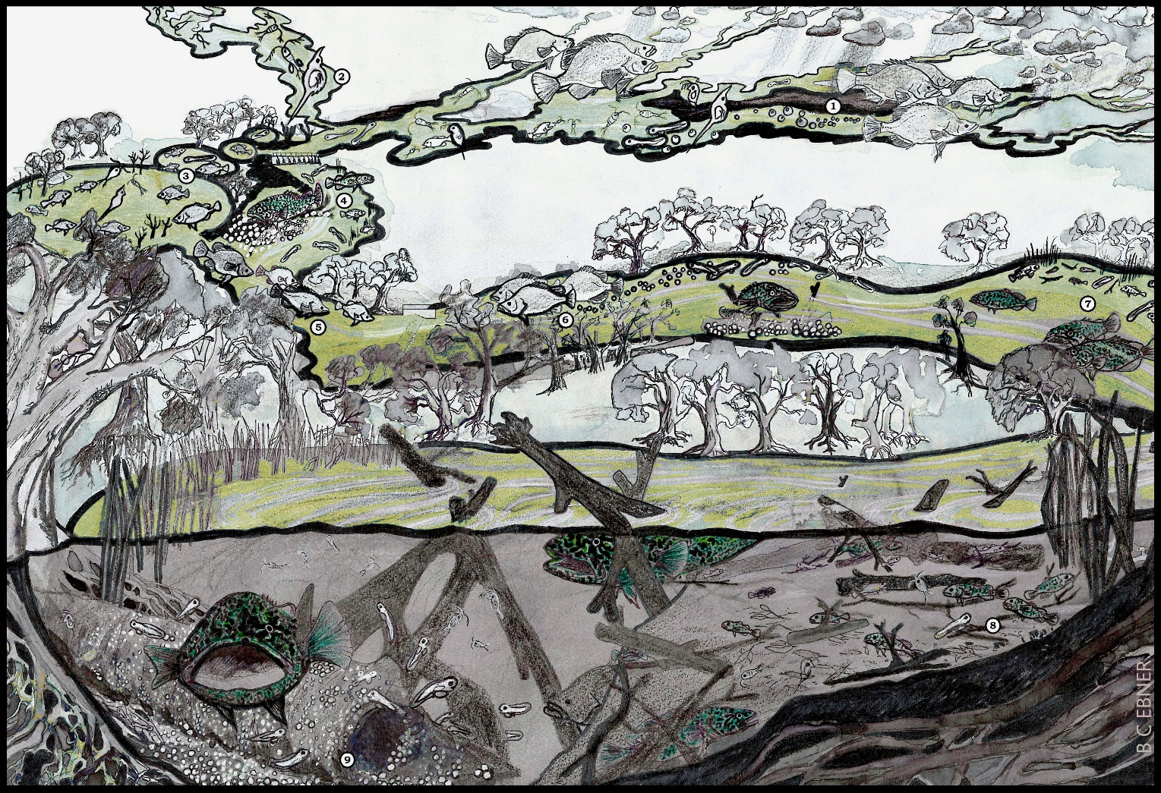

Figure Pictorial representation of life history stages for Murray cod and golden perch.

# Part 1: Spawning and recruitment of Murray cod and golden perch

## Introduction

The 510-km long lower Darling/Baaka River (hereafter referred to as ‘LDR’) supports a nationally significant population of Murray cod (*Maccullochella peelii*) as part of a valuable and diverse native fish community (Gehrke et al., 1995; Gehrke and Harris, 2001). This fish community exists because the lower Darling is characterised by: (i) long stretches of near-permanent lotic (flowing) reaches where hydraulic complexity exists even at very low flows, and (ii) abundant snag and bench habitat. Prior to 2000 there were near-permanent flows to the LDR but since then there have been several protracted low/cease-to-flow events (we refer to flows of ≤ 15 ML/day (at Burtundy) as effectively a cease to flow) with two particularly long cease to flow events of 524 and 555 consecutive days (recorded at Burtundy) in 2015-16 and 2019-20, respectively. These cease-to-flow events contributed to river disconnection and drying to isolated pools, catastrophic declines in water quality (i.e. increased water temperature and low dissolved oxygen) and major fish death events (Jackson and Head, 2020). The impacts on the local fish fauna have been the subject of two academic investigations (Australian Academy of Science, 2019; Vertessy et al., 2019) and a special edition of Marine and Freshwater Research (Ellis et al., In press; Thiem et al., 2021).

To protect, recover, and maintain native fish populations, flows are required (which may be a mix of operational and environmental allocations) and a framework for protecting the important baseflow elements of the flow regime. The Murray Lower Darling Regulated River Water Sharing Plan (hereafter referred to as the ‘local WSP’) stipulates rates of flow to achieve a baseflow (DPIE, 2020). The science knowledge for providing flow regimes to recover specific native fish species or broader native fish communities has greatly advanced in the past 5-years (Koehn et al., 2020). In particular, this includes relationships between specific elements of the flow regime, including hydrology and hydraulics, being quantitatively linked to specific fish population processes, such as fish growth, movement, spawning and survival (Koster et al., 2021; Stoffels et al., 2020; Tonkin et al., 2021). In a few cases, such as in Gunbower Creek in central Victoria, there have been dramatic recovery of Murray cod populations following implementation of a permanent flow regime based on their life-history requirements (Stuart et al., 2019).

To support the recovery of Murray cod and other native fish, environmental flows were first implemented in the LDR in 2016. The hydrograph was designed and managed with the specific ecological objective of restoring a perennial lotic ecosystem at a broad scale (i.e. > 500 km) and protecting and improving Murray cod populations after the longest period on record (i.e. ~500 days) of near-zero flow conditions experienced in the LDR. The hydrograph was developed from an eco-hydraulic conceptual model of Murray cod life-history which examined past hydrology and identified functional hydrologic/hydraulic components that could be designed and implemented within an environmental flow regime (Sharpe and Stuart, 2018). Monitoring in 2016-17 revealed successful spawning and recruitment of Murray cod, although this occurred prior to the cease-to-flow conditions and associated fish deaths of 2018-20 (Australian Academy of Science, 2019; Ellis et al., In press).

In 2020, water availability resulting from rainfall and associated managed inflows from the northern MDB into the Menindee Lakes enabled another LDR environmental flow to be designed to aid in the recovery of native fish populations. The 2020 flow was based on the hydrological and ecological results from 2016, although the discharge magnitude was ~50% lower due to less water availability. The 2020 environmental flow was important not only for supporting seasonal processes (such as spawning) but in providing an adaptive management baseline for supporting post fish-death population recovery. Ultimately this collaborative program has highlighted a pathway to rebuild the resilience of the LDR ecosystem and inform future environmental flow programs. In 2020-21, the centrepiece of the environmental flows was a hydrograph developed from an eco-hydraulic conceptual model of Murray cod life-history that identified functional hydrologic/hydraulic components to be implemented within an environmental flow regime. The eco-hydraulic conceptual model highlighted the need to implement a near-permanent protected lotic flow regime, effectively eliminating zero flows, to fully protect the nationally important native fish community.

The present study had five objectives: i) to determine the status of the native fish populations following the drought and fish death events, ii) evaluate the success of the 2020-21 LDR environmental flow in relation to spawning and early life-stage recruitment responses of Murray cod, and other native fishes; iii) report on a recruitment of golden perch (*Macquaria ambigua*) in the Menindee Lakes (the source of water for the LDR) and discuss opportunities for releasing water from Menindee Lakes into the LDR to facilitate fish dispersal, especially in 2021-22 to enhance populations in the connected MDB downstream, (iv) determine whether there was a detectable change in fish communities pre-and-post fish deaths, and v) report on genetic analysis of Murray cod spawned during the environmental flow and discuss population implications – this information is contained in Part 2 of this report.

## Methods

### Conceptual model to inform environmental flow design

Murray cod are a nationally vulnerable fish species, growing to 1.5 m in length and 50 kg in weight, with an estimated maximum life-span of 48 years (Anderson et al., 1992; Koehn et al., 2020). In the late 20th century, their populations declined dramatically due to overfishing, habitat destruction, and river regulation contributing to broad-scale loss of perennial lotic conditions, hydraulic complexity and continuous baseflows (Rowland, 2004; Rowland, 2020). There are numerous conservation efforts being undertaken throughout the range of Murray cod, including targeting physical habitat rehabilitation (Lyon et al., 2019), restoration of key components of flow regimes (Tonkin et al., 2021), mitigation of cold-water pollution (Michie et al., 2020) and stocking of hatchery reared fingerlings (Hunt and Jones, 2018). The lower 500-km reach of the Darling River is a population stronghold for several native fish species that are supported by lotic conditions and historic baseflows (Stuart and Sharpe, in press).

Murray cod select nest sites annually in spring and early summer (September-December), with spawning occurring when water temperature exceeds ~18 °C (Koehn and Harrington, 2005; 2006). Eggs are laid on hard surfaces, such as clay ledges, undercut banks, rocks and hollow logs (Rowland, 2020), and there is circumstantial evidence that nests can be in shallow water, in depths of 0.3-1.0 m. Males guard the nest for up to 18 days (Rowland, 1998) with hatching occurring 4-13 days after fertilisation depending on water temperature (Rowland, 1998). In some habitats, larvae utilise flow-assisted dispersal but they may also be retained locally (King et al., 2009; Koehn and Harrington, 2006; Stuart et al., 2019).

Juvenile recruitment (i.e. survival from eggs/larvae to 1-year old) appears to be strongest in habitats characterised by: (i) hydraulic complexity (faster- and slow-flowing water), which is largely permanent or with short periods of zero flow outside of the spawning season, (ii) a spring hydrology that includes an increase in discharge, but with no rapid or major declines in discharge during the core nesting season to maintain the viability of eggs in nests, (iii) a summer continuous baseflow for juveniles to access productive littoral habitats for rapid growth and enhanced survival, (iv) base-flows in winter to maintain lotic habitats, hydraulic complexity, connectivity and water quality and thus reduce density-dependence pressure to improve survival of juvenile fish, (v) abundant structural habitat, (vi) a natural temperature regime, and (vi) good water quality with few anoxic blackwater events. Figure 1 is a pictorial representation of some of these key aspects of Murray cod life history stages.

### 2020 Environmental flow

From the conceptual model of Murray cod life-history, the 2020 environmental flow regime incorporated four key functional components (Table 1, Figure 2):

1. a late winter/spring increase in discharge to promote broad-scale lotic (i.e. >0.3 m s-1) conditions, inundate low-lying benches and woody habitats to maximise habitat availability, hydrodynamic complexity, depth and food availability to enhance larval survival
2. spring and early summer inundation of low-lying benches and woody habitats to maximise habitat complexity, hydrodynamic complexity, depth, productivity, water quality and feeding conditions to enhance larval survival; with no major water level drops (i.e. <0.30 m total reduction) during the core spring and early summer Murray cod nesting season to enable fish to complete their nesting and for larval retention
3. an annual summer baseflow to enable juvenile fish to access productive littoral habitats for rapid growth and enhanced survival and to maintain water quality conditions
4. an annual over-winter baseflow to maintain lotic habitats, hydraulic complexity, connectivity and water quality to reduce density-dependence pressure to improve survival of juvenile fish and promote adult conditioning.

Two additional elements were also included for golden perch, these were (i) a sharp summer flow pulse to cue spawning and (ii) an attenuated summer/autumn flow recession from the Menindee Lakes to maximise downstream outmigration of juvenile fish into the LDR.

Table 1 An eco-hydraulic conceptual model of Murray cod populations in the lower Darling River based on local hydrology and the scientific literature. Highlighted are four key hydrological/hydraulic functional elements informed by the 2016-17 environmental flow implemented in 2020-21. A sharp summer flow pulse for golden perch spawning in the LDR was also included.

|  |  |  |  |
| --- | --- | --- | --- |
| Season | Hydraulic functional element:  water level (m) and mean channel velocity (m s-1) for LDR | Hydrological (ML day-1) operational criteria for the LDR at Burtundy gauge | Eco-hydraulic and spatial objectives |
| (i) Late winter/early spring (Aug-Sep) | No major reductions in water level (e.g. maximum cumulative drop <0.3 m) | Slow increase in discharge to 400 ML day-1 | * Promote broad-scale (i.e. 500 km) continuous lotic hydraulics (i.e. >0.3 m s-1) and hydraulic complexity * Enable adult fish to move and select breeding habitats * Initiate egg maturation * Inundate spawning sites including snags, undercut banks, benches and establish littoral macrophytes and food resources for larvae * Minimise cumulative water level drops (i.e. >0.3 m) drops to avoid nest abandonment * Maintain end-of-system connectivity with the Murray River |
| (ii) Spring and summer (Oct-Feb) | No major reductions in water level (e.g. maximum cumulative drop < 0.3m) | Slow spring increase in discharge to 700 ML day-1  (800 ML day-1 was preferred but there was limited water availability)  Late spring increase in discharge to 1500 ML day-1 | * Promote broad-scale (i.e. 500 km) continuous lotic hydraulics (i.e. >0.3 m s-1) and hydraulic complexity * Inundate spawning sites including snags, undercut banks and benches * Nest construction, courtship, mating, egg laying, males to guard nest * Inundate low-lying dry benches, maintain primary and secondary productivity and food for larvae along the length of the LDR (i.e. 510 km) * Minimise cumulative water level drops (i.e. >0.3 m) drops to avoid nest abandonment * Enhance egg hatching, larval feeding and survival, dispersal to nursery habitats: including submerged woody debris and littoral areas * Enable YoY to inhabit littoral zone and submerged woody debris for enhanced survival and rapid growth * Maintain end-of-system connectivity with the Murray River * Maintain dissolved oxygen and water quality conditions |
| (iii) Summer and autumn  (Jan-April) |  | Summer continuous baseflow and slow discharge and water level recession to 400 ML day-1 | * Maintain broad-scale (i.e. 500 km) continuous lotic hydraulics (i.e. >0.3 m s-1) and hydraulic complexity * Increase littoral habitats for YoY dispersal * Increase snag habitats for sub-adults and adults * Inundate low-lying benches food resources for YoY survival and growth * Maintain dissolved oxygen and water quality conditions * Maintain end-of-system connectivity with the Murray River |
| (iv) Winter  (April to August) | Slow water level (<0.15 m/24 h) recession. | Slow discharge recession to winter base flow of 500 ML day-1  (The higher winter flow, compared to summer, was due to greater water availability from northern inflows) | * Maintain broad-scale (i.e. 500 km) continuous lotic hydraulics (i.e. >0.3 m s-1) and hydraulic complexity * Maintain connectivity and enable native fish to move to permanent winter habitats (i.e. deep refuge pools) * Maintain base flow to reduce density-dependence pressure and improve survival of YoY, sub-adults and promote adult conditioning * Maintain dissolved oxygen and water quality conditions * Maintain end-of-system connectivity with the Murray River |

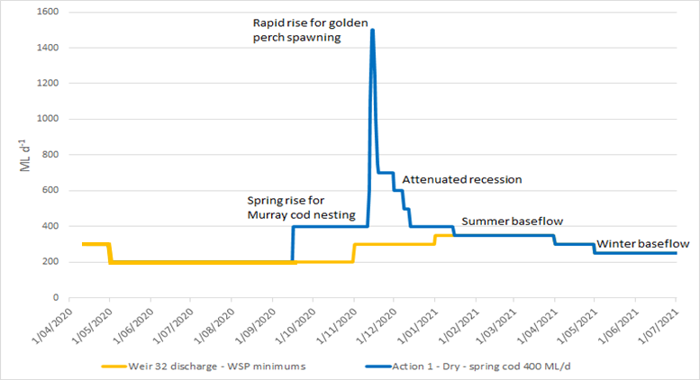

Figure 2. The designed 2020-21 LDR hydrograph showing elements of the eco-hydraulic conceptual model (Table 1) to support native fish population processes. Note the environmental water (blue) providing greater discharge than the minimum flows contained in the water sharing plan (WSP) for Weir 32 (orange).

### Fish sampling

Fish sampling comprised three components: in-channel sampling, lakes surveys and larval fish surveys. To determine the composition and size structure of the fish community in the LDR, standardised in-channel sampling was undertaken pre- and post- environmental water delivery in September/October 2020 (pre) and again in February 2021 (post) (Figure 3). Similarly, to determine the composition and size structure of fish in the Menindee Lakes two sampling events were undertaken, once in October 2020 and again in March 2021 (Figure 3, Figure 4, Figure 5). To determine the timing of fish spawning in the LDR, as well as the spatial distribution of eggs and larvae, in-channel larval fish sampling was undertaken on a fortnightly basis between October and December 2020 coinciding with environmental water delivery (Figure 2) and the peak spawning period of native fish in the region.

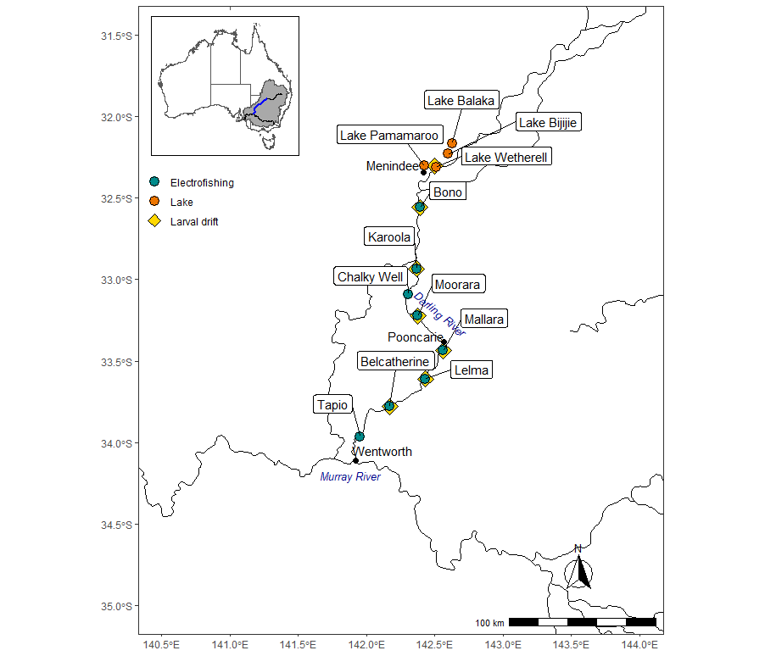

Figure 3. Locations on the Darling River where river and lake fish community surveys were conducted. Electrofishing river surveys (green circle) were conducted in spring 2020 and autumn 2021, lake surveys (orange circle) were conducted in spring 2020 and autumn 2021 and larval drift river surveys (yellow diamond) were conducted from October to December 2020.

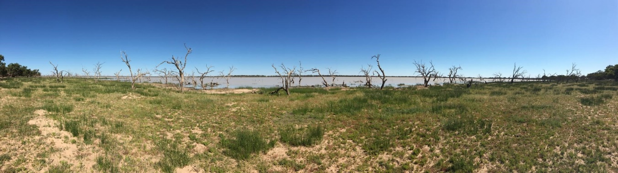

Figure 4. Menindee Lakes, an important golden perch nursery (photo: NSW DPI Fisheries).

Adult fish community data was collected from eight in-channel sites within the Lower Darling River between Weir 32 at Menindee and Wentworth on two sampling occasions (September/October 2020 and March 2021) (Figure 3). Fish were captured using standardised effort at each site comprising 12 replicate 90 second electrofishing operations (7.5 kW Smith-Root model GPP 7.5 H/L boat-mounted electrofishing unit), ten unbaited minnow traps (5-mm stretched mesh, dimensions of 250 x 250 x 480 mm and an entry diameter of 50 mm) deployed in edge habitats for a minimum of two hours and five baited opera house nets also deployed for a minimum of two hours. All fish captured were identified to species and measured for total length (TL; mm) or fork length (FL; mm). Medium to large bodied species (including juveniles of these species) were weighed (g) and for Murray cod a fin clip sample was taken using a DNA Tissue Sampling Applicator and Unit (Allflex, Australia). The fin clip samples were stored at ambient temperature until returned to the laboratory where they were refrigerated at 4°C. Water quality measurements (temperature, pH, EC and turbidity) and start and finish GPS coordinates of the electrofishing operations were recorded at each site.

Riverine larval fish communities were sampled using larval drift nets which were set overnight (approximately 18 hours) at seven in-channel river sites. Sampling was conducted on a fortnightly basis from October to December 2020, with each site being sampled on six separate occasions. On each sampling occasion three larval drift nets (500 µm mesh) were set at each site; these nets were suspended from instream wood habitat in the top 0.5 m of the water column or attached to star pickets in the absence of instream habitat. Upon both deployment and retrieval of the drift nets, date and time was recorded, water quality measurements (temperature, pH, EC and turbidity) were recorded and three water velocity measurements were taken with a hand-held velocity meter. When set, each net has an opening diameter of 50 cm and tapers over 1.5 m to an opening of 9 cm which is attached to a reducing bottle. Upon the retrieval of each net, samples were live picked, identified to species level following the keys outlined by Serafini and Humphries (2004) and enumerated before being preserved in ethanol (100%) and returned to the laboratory for further processing. In the laboratory, preserved drift net samples were rinsed through a 250 µm sieve and any fish eggs and larvae were removed. All larvae were identified to species level and counted for each sampling site and sampling occasion (all nets combined). All Murray cod were measured (TL; mm) and categorised by larval ontogenetic stage (flexion, postflexion, metalarva, juvenile) to assist with the subsampling protocol used for genetic analysis, and the first 50 golden perch and silver perch were also measured (TL or FL; mm) and identified to ontogenetic stage (Neira et al., 1998).

Fish communities were sampled at a single site within four of the Menindee Lakes on two sampling occasions (October 2020 and March 2021) using 24 large meshed fyke nets and 24 small meshed fyke nets which were set overnight (approximately 18 hours). Large fyke nets (28 mm mesh) are constructed with a single central wing (8 m long) that is connected to the first supporting hoop which contains a funnel mesh entry. Small fyke nets (2 mm mesh) are constructed with dual wings (2.5 m long) that connect to the first supporting hoop which contains a square entry and bycatch exclusion screens. Upon deployment and retrieval of the fyke nets, date and time was recorded and water quality measurements (temperature, pH, EC and turbidity) were taken. In October 2020 lakes Balaka, Bijijie, Pamamaroo and Wetherell were sampled. In March 2021 Lake Balaka was drying and unable to be sampled so was substituted with Lake Tandure. From each net, all fish captured were identified and enumerated. All native medium to large bodied species (including juveniles of these species) were measured to TL (mm) or FL (mm). The first 50 common carp were measured (FL; mm) from each lake (all nets combined).

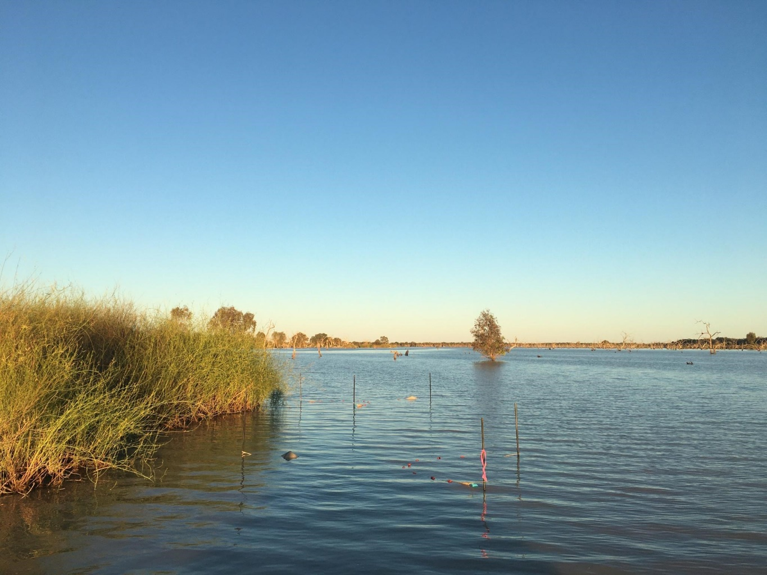

Figure 5. Fyke nets set in the Menindee Lakes to collect juvenile golden perch (photo: NSW DPI Fisheries).

### Exclusion of stocked fish

Between February and October 2019, 34 adult Murray cod were collected from the drought-affected Darling River and taken to the Narrandera Fisheries Centre to be used in a breeding program to produce fish for stocking the Darling River following the fish kills. These fish successfully spawned, and 60,000 Murray cod fingerlings were released into the LDR at 8 sites between Menindee and Wentworth in December 2020. Consequently, stocked Murray cod could potentially be present in the March electrofishing dataset, thus potentially confounding interpretation of recruitment results if they are not excluded. There is currently an MDB-wide program underway to identify stocked fish using genetic parentage analysis. This program has a database of hatchery broodfish and screens young-of-the-year fish across this database to determine if any can be matched to their parents (Brauer and Beheregaray, 2020). To determine if any of the young-of-the-year Murray cod were of hatchery (stocked) origin, we sent fin-clips from 45 young-of-the-year Murray cod (up to 125 mm) and sent them to Flinders University for parentage analysis.

### Statistical analyses

All formal data analyses were performed using R v3.6 (R Development Core Team, 2019). As flow conditions and year are tightly linked, no formal analysis of flow conditions in relation to catch rate was performed. An overview of the sampling locations, study area and flow conditions are shown in Figure 6.

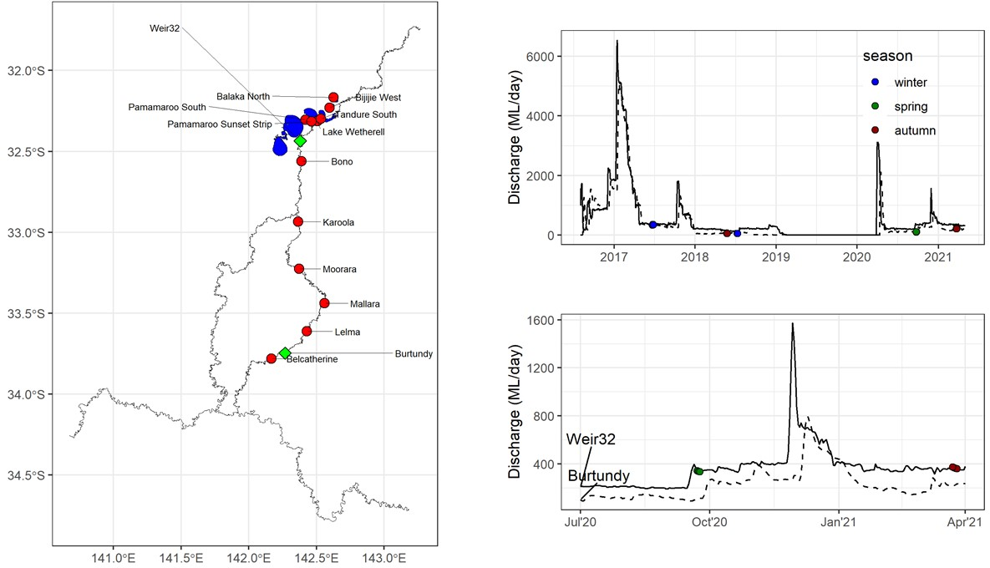





Figure 6. Map of sites in the Lower Darling region. Right panels show flow conditions (Weir32 - solid line; Burtundy - dashed line) and timing of surveys (coloured dots) for the whole study period (top side panel) and the 2020/2021 time period (bottom side panel). Dot colours indicate season.

For objective one, to evaluate the influence of the 2018-20 fish deaths on the relative abundance of fish, two separate analyses for each species were performed. First, we estimated CPUE (n/1080s, boat electrofishing) for each year (2017, 2018, 2021; Table 2) using a generalised linear mixed model (GLMM), assuming a negative binomial distribution. Number of fish caught for each survey was the response variable. We included year as a fixed effect and site as a random effect. Effort was constant across all surveys so there was no offset added. Pearson residuals were examined to assess model assumptions and for each model a linear contrast was performed comparing the average catch rate for 2021 (post-fish deaths) to 2017/2018 (pre-fish deaths) using the emmean package (Lenth et al., 2018). All linear contrast differences presented in text are presented on the link scale.

We then compared length distributions across years for each species (Table 3). We initially explored quantile regression models, but these models had convergence issues. As an alternative, we ran a Bayesian linear mixed model (bLMM) in which we modelled both the mean and variance across years for each species. By modelling variances, we can detect changes in recruits/older fish, as well as better satisfy model assumptions. We used length (log-transformed) as the response variable. We know the distributions for length did not strictly meet a Gaussian distribution and hence the estimated effect sizes should be viewed as approximate, but helpful in delineating changes in the distributions. Examination of posterior predictive distributions indicated the bimodal shape of the distributions are positioned near the mode of posterior distributions and that the distribution tails of modelled data matched well with the raw data. Similar to CPUE analyses, we performed linear contrasts comparing average 2017/2018 to 2021, but for both the mean and variation. All linear contrast differences presented in text are presented on the link scale.

Table 2. Summary of mean catch for fish death analysis. Last column shows mean of all sites for each year. Note that 2017 had two or three replicates for each site but 2018 and 2021 only had one.

|  |  |  |  |  |  |  |  |  |
| --- | --- | --- | --- | --- | --- | --- | --- | --- |
| Species | Year | Belcatherine | Lelma | Mallara | Moorara | Karoola | Bono | Mean |
| common carp | 2017 | 20.0 | 15.5 | 20.0 | 11.5 | 11.0 | 14.7 | 15.4 |
| 2018 | 28.0 | 13.0 | 7.0 | 0.0 | 15.0 | 14.0 | 12.8 |
| 2021 | 18.0 | 7.0 | 1.0 | 8.0 | 0.0 | 7.0 | 6.8 |
| Murray cod | 2017 | 3.5 | 11.0 | 8.5 | 18.5 | 9.5 | 5.0 | 9.3 |
| 2018 | 6.0 | 12.0 | 4.0 | 0.0 | 10.0 | 7.0 | 6.5 |
| 2021 | 2.0 | 18.0 | 9.0 | 7.0 | 0.0 | 1.0 | 6.2 |
| golden perch | 2017 | 12.0 | 11.5 | 36.5 | 33.5 | 34.5 | 35.0 | 27.2 |
| 2018 | 29.0 | 3.0 | 13.0 | 0.0 | 31.0 | 23.0 | 16.5 |
| 2021 | 3.0 | 0.0 | 13.0 | 9.5 | 0.0 | 11.0 | 6.1 |
| bony herring | 2017 | 6.0 | 18.5 | 9.5 | 14.5 | 24.5 | 7.3 | 13.4 |
| 2018 | 0.0 | 0.0 | 0.0 | 0.0 | 86.0 | 44.0 | 21.7 |
| 2021 | 72.0 | 6.0 | 9.0 | 49.0 | 0.0 | 108.0 | 40.7 |
| Australian smelt | 2017 | 476.0 | 235.5 | 231.0 | 10.5 | 17.0 | 0.3 | 161.7 |
| 2018 | 0.0 | 0.0 | 0.0 | 0.0 | 0.0 | 0.0 | 0.0 |
| 2021 | 0.0 | 0.0 | 0.0 | 1.0 | 0.0 | 1.0 | 0.3 |

Table 3. Summary of the number of fish lengths for the fish deaths analysis. Note - Australian smelt was excluded to insufficient numbers.

|  |  |  |  |  |
| --- | --- | --- | --- | --- |
| Species | 2017 | 2018 | 2021 | Total |
| common carp | 108 | 75 | 47 | 230 |
| Murray cod | 94 | 39 | 44 | 177 |
| golden perch | 296 | 99 | 46 | 441 |
| bony herring | 85 | 0 | 231 | 316 |
| Australian smelt | 41 | 0 | 3 | 44 |

For objective two, which evaluated the temporal patterns in larval catches in the LDR in spring 2020, two separate analyses for each species were performed. First, we compared catch rates for the six temporal sampling periods in Spring 2020 (October to December) across the six main LDR sites. We ran a GLMM assuming a negative binomial distribution. We included sampling date as a fixed factor and site as a random effect. Effort was assumed to be constant across all surveys. For any significant sampling date effect, we then ran post-hoc pairwise comparisons with a Tukey p-value adjustment.

We then compared larval catch rates in 2020 to 2016 and 2017 (Table 4). To improve the comparisons, we dropped any sampling surveys outside the October to December sampling window (e.g. January survey in 2016/2017 and September survey in 2017/2018). Similar to the fish death analysis, we included year as a fixed effect and site as a random effect. We assumed effort was constant across all surveys. Pearson residuals were examined to assess model assumptions. Then, for each model a linear contrast was performed comparing the average catch rate for 2020 to the average of 2016 and 2017 using the emmean package (Lenth et al., 2018). All linear contrast differences presented in text are presented on the link scale.

Table 4. Summary of total catches of golden perch and Murray cod during larval sampling.

|  |  |  |
| --- | --- | --- |
| Year | Murray cod | golden perch |
| 2016 | 854 | 14 |
| 2017 | 107 | 0 |
| 2020 | 1,212 | 81 |
| Total | 2,173 | 95 |

To estimate the proportion of the fish population that were young-of-the-year (i.e. the contribution of 2020-2021 recruits to overall population size; Table 5), we ran a generalised linear mixed model (GLMM) assuming a binomial distribution. We assigned young-of-the-year classification based on the defined length threshold (see Appendix for thresholds). We included year (2017, 2018, or 2021) as a fixed effect and site as a random effect. Graphical assessment of Pearson residuals was performed to confirm model assumptions were met, including overdispersion. For each model, a linear contrast was performed comparing the average catch rate for 2017/2018 to 2021 (as previously described above).

Table 5. Summary of young-of-the-year (YoY) and adults in catch for the focal species. Note - silver perch was omitted due to low sample sizes.

|  |  |  |  |  |
| --- | --- | --- | --- | --- |
| Species | Year | Num of adults | Num of YoY | % YoY |
| silver perch | 2017 | 6 | 0 | 0% |
| 2018 | 6 | 0 | 0% |
| 2021 | 0 | 0 |  |
| Murray cod | 2017 | 78 | 16 | 17% |
| 2018 | 32 | 7 | 18% |
| 2021 | 32 | 12 | 27% |
| golden perch | 2017 | 253 | 43 | 15% |
| 2018 | 98 | 1 | 1% |
| 2021 | 29 | 17 | 37% |

For objective three, to estimate golden perch recruitment in the Menindee Lakes in 2020-2021, we analysed fyke net data from Spring 2020 and Autumn 2021 from five lakes (though not every lake has multiple surveys, see below). A preliminary analysis indicated that the Spring 2020 survey for Lake Bijijie was an outlier, having much lower counts in Spring than in Autumn. We suspect this was due to the sampling occurring before peak Spring recruitment. This outlier was problematic for making inference for sites with only one sampling event (Lake Balaka and Lake Tandure). Therefore, we modelled each sampling event (lake-by-year, e.g. 2020-Balaka, 2020-Bijijie), rather than trying to make inferences based on site and sampling time (Spring2020 vs Autumn2021), which we perceive as the most transparent approach.

To analyse lake data, we ran a generalised linear model assuming a negative binomial distribution. We included sampling event (e.g. 2020-Balaka) as the fixed factors. We also included sampling effort (log) as a continuous predictor, but not as an offset due to some uncertainty in recorded efforts (Bijijie West had much longer efforts (~30 hours) with start times at 2am). Model assumptions were assessed through Pearson residuals.

## Results

### Past hydrology

Although historically the Darling River experienced occasional cease to flow events, they occurred within a broader flow regime that included regular in-channel flow pulses and overbank floods. This differs substantially from the prevailing flow regime in the last two decades, which has been characterised by protracted periods of low flow punctuated by in-channel flow pulses and fewer overbank flow events (aligned natural floods in 2011 and 2012). Furthermore, between 2002 and 2009 there were 13 low flow events (in this report we designate flow rates of ≤15 ML day-1 at Burtundy as indicators of a cease to flow event) ranging from 6 to 114 days.  Since 2015, the cease-to-flow-events have increased in severity with two of the four events exceeding 500 days (Figure 7).

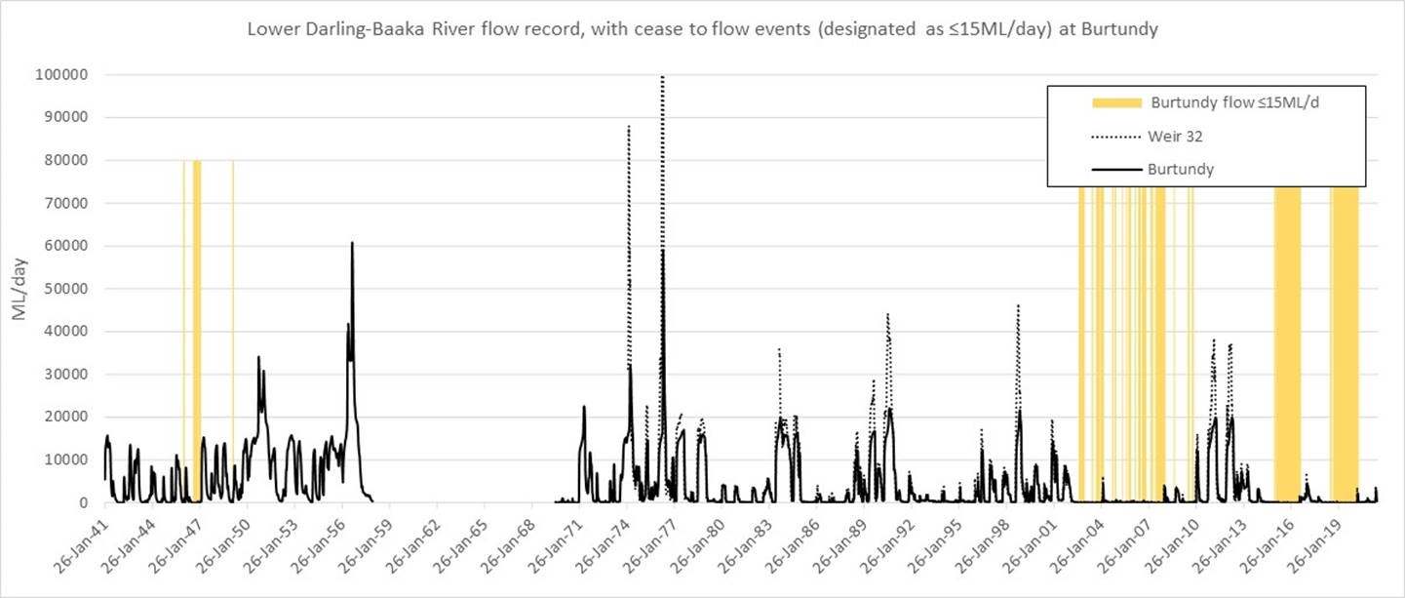

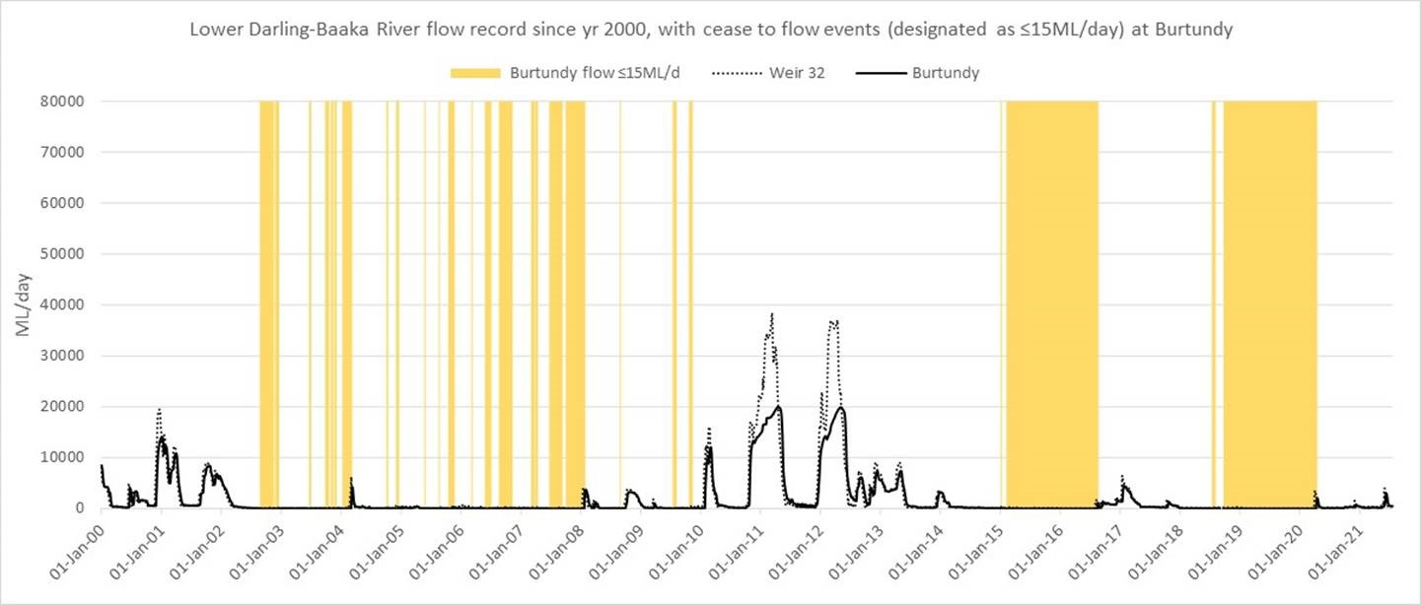

Figure 7. Discharge (ML d-1) at Weir 32 and Burtundy historically (top) and since January 2000 (bottom) with yellow shading indicating the increasing frequency and duration of cease-to-flow events (designated as ≤15 ML d-1). Currently flows in the Darling River downstream Weir 32 up to 9,000 ML d-1 are considered within channel.

### Environmental flow

During 15 September 2020 and 15 January 2021, the total volume of water delivered to the LDR was 57,688 ML of which 24,713 ML (43%) was environmental water. Changes in discharge and height at Weir 32 (gauge: 425012) on the LDR appeared to be relatively minor (i.e. maximum daily fall <0.15 m day-1; maximum cumulative seven-day fall 0.39 m) during the nesting and spawning period of Murray cod (Figure 8, Figure 9). Regulated outflows from the Menindee Lakes into the LDR began in July 2020 and broadly matched a conceptual delivery schedule of environmental water, specifically designed to protect Murray cod spawning and enhance larval survival (Figure 8, Figure 9).

Prior to the Murray cod nesting season, between June and early September 2020, discharge at Weir 32 was 200-230 ML day-1. From mid-September, discharge increased to 350-400 ML day-1 (historically exceeded 46-51% of the time since 1974 at Weir 32 gauge) for Murray cod nesting and spawning, using NSW The Living Murray and Commonwealth environmental allocations. From late November to early December, the environmental flow included a rapid increase in discharge to ~1,570 ML day-1 (historically exceeded 39% of the time since 1974 at Weir 32 gauge) to stimulate downstream out-migration of golden perch from the Menindee Lakes and stimulate spawning in the LDR. From January to May 2021, there was an attenuated flow recession in the LDR and returning to WSP baseflows (~350 - 300 ML day-1).

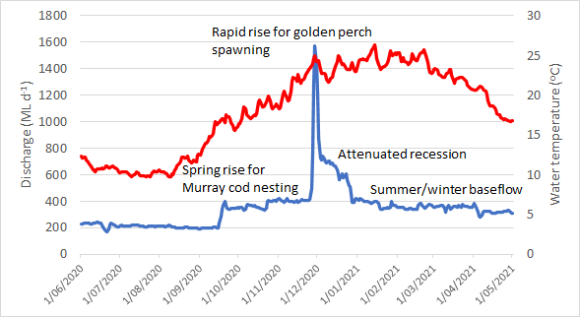

Figure 8. Discharge (ML day-1; blue line) and water temperature (°C; red line) in the lower Darling River at Weir 32 in 2020-21 showing the important flow components (i.e. discharge) for native fish.

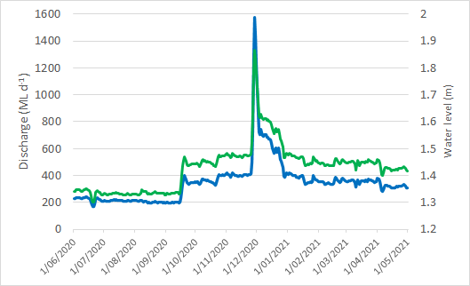

Figure 9. Discharge (ML day-1; blue line) and water level (m; green line) in the lower Darling River at Weir 32 in 2020-21 showing the synchronous relationship between discharge and water level. A stable discharge during the spring Murray cod spawning season enabled fish to complete spawning.

### Comparing 2020-2021 to 2017/2018 catch rates

For objective one, to evaluate the status of native fish populations, the overall CPUE in 2021 had declined for golden perch (-1.18 ± 0.28; p < 0.001 and common carp (-0.64 ± 0.23; p = 0.011) compared to 2017/18 (Figure 10). No changes were evident for Murray Cod (-0.29 ± 0.24; p = 0.24) or bony herring 1.07 ± 0.56; p = 0.07) (Figure 10). Australian smelt had a significant decrease from the average of 2017/2018 (-2.39 ± 1.17; p = 0.05), though 2021 was similar 2018 with a near zero catch (Figure 10).

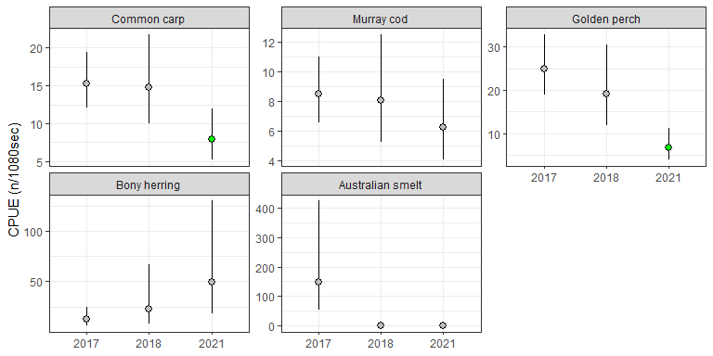

Figure 10. Catch rates for each year for the most abundant fish species in the LDR. Green dots indicate significant differences of 2021 catch rates from 2017/2018. Error bars are 95% CI.

### Comparing 2021 to 2017/2018 length distribution

Due to low sample sizes (N = 44), Australian smelt was omitted from the analyses. Murray cod length did not change in median length from 2017/2018 to 2021 (0.09 (95%: -0.26, 0.44)) or length variation (0.16 (95%: -0.1, 0.43); Figure 11). Bony herring had no change in median length (-0.01 (95%: -0.18, 0.15)), but length variation decreased in 2021 (-0.45 (95%: -0.64, -0.26); Figure 11) due to the presence of fewer, larger fish. Golden perch had decreased median length in 2021 (-0.28 (95%: -0.46, -0.1)), but no difference in variation (0.04 (95%: -0.19, 0.28); Figure 11), possibly picking up the signal of a higher proportional of recruits. This is explored further in the next section. Common carp had increased median length in 2021 (0.47 (95%:0.35, 0.58)) and a decrease in variation (-0.96 (95%: -1.21, -0.69); Figure 11). This likely reflects the lack of recruits in 2021.

For objective two, to evaluate the environmental flow for supporting spawning and recruitment, golden perch had higher proportional recruitment to 2021 compared to 2017/2018 (5.45 ± 1.28; p = 0.0029). Of the 45 Murray cod sent for parentage testing at Flinders University, five were confirmed to have been of hatchery origin. Therefore, stocked fish represented 11% of the recruits and thus the majority of recruits were of wild origin. Note that the results presented below include these stocked fish as the FishGen results were not available at the time the data for this report were being analysed. Nevertheless, we expect the stocked fish to have minimally impact on outcomes of this report given they weren’t present in large numbers. No change in Murray Cod was detected (1.02 ± 0.88; p = 0.27) (Figure 12).

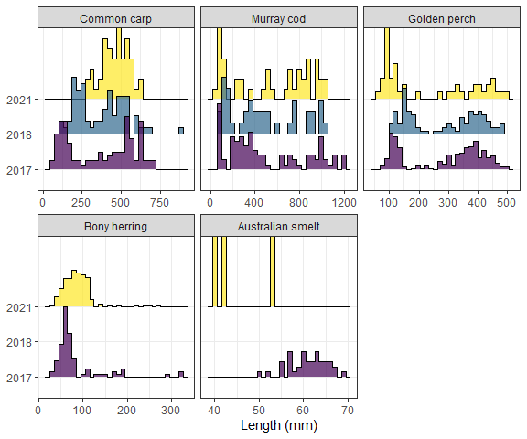

Figure 11. Length histograms for each species by year. Note - Australian smelt was omitted from analyses due to low sample size.

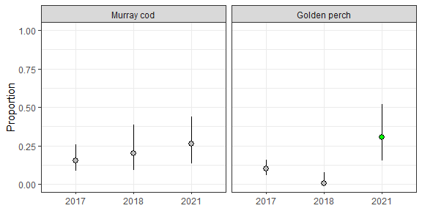

Figure 12. Proportion of fish that were young-of-the-year across years for select species. For 2021, a green dot indicates significant difference from the 2017/2018 proportion estimates. Error bars are 95% CI.

For golden perch, there were no differences in larval catches across sampling dates (*X*2 = 4.6, df = 5, p = 0.46; Figure 13, Figure 14). For Murray Cod, sampling survey was significant (*X*2 = 12.2, df = 5, p = 0.032), but no pairwise comparisons between dates were found to be significant after Tukey adjustment (Figure 13, Figure 14). Thus, no strong evidence for a difference in catch rates was present.

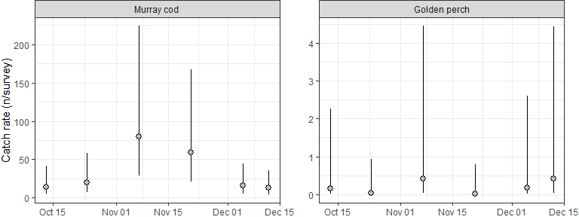

Figure 13. Larval catch rates (n/survey) for Spring 2020 in the Lower Darling River. Error bars are 95% CI.

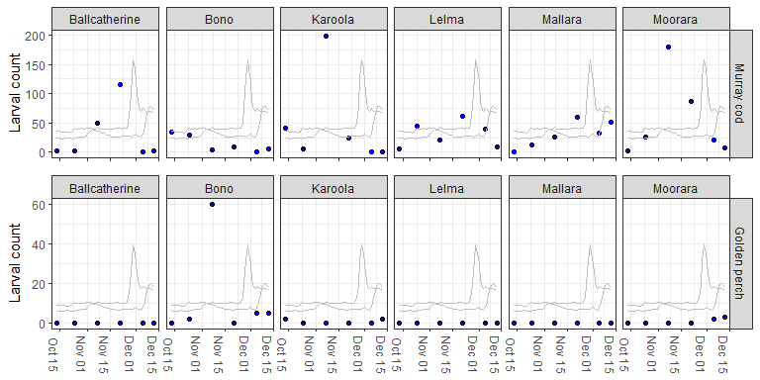

Figure 14. Individual plots of larval counts for each site in Spring 2020. Blue dots show actual total catch for that survey and grey lines show Weir 32 and Burtundy discharge.

Catch rates were higher for both golden perch (1.85 ± 0.87; p = 0.035) and Murray cod (1.04 ± 0.34; p = 0.0028) in 2020 compared to averages for 2016 and 2017. It should be noted that golden perch catches comprised either eggs or juvenile fish but not larvae. The difference in Murray cod catches was driven by low larval catch rates in 2017, with 2016 catch rates similar to 2020 (Figure 15). Golden perch had a similar low larval catch rate in 2017, but 2020 was consistently higher than both 2016 and 2017 (Figure 15).

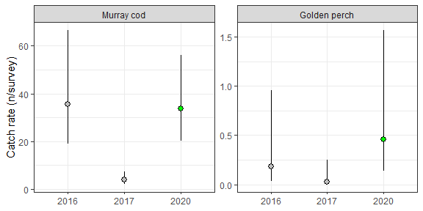

Figure 15. Catch rates for each year for golden perch and Murray cod. If 2020 dot is green, it indicates that it significantly differs from the average of 2016 and 2017 catch rates. Error bars are 95% CI.

### Larval occurrence

A total of 3461 fish eggs/larvae/juveniles were collected for ten species from six sampling trips at the six sites (Table 6). Murray cod represented 34% of total catch and were first detected on 8th October 2020 when water temperature was 17.1 °C (Figure 14). Murray cod larvae were collected from all six sites. The size range of Murray cod larvae was 5.5-22.9 mm (mean 10.63 mm; S.D. ± 2.51 mm). No larval golden perch were sampled in 2020 but golden perch eggs were captured at Bono in week 3 (n = 60 eggs) and in week 5 at Bono (n = 5) and Moorara (n = 2). Golden perch juveniles were predominantly captured at upstream sites including Lake Wetherell Outlet (n = 8), Bono (n = 7), Karoola (n = 4) and Moorara (n = 3).

Table 6. Total numbers of larvae collected in the lower Darling River in spring-summer 2020. Numbers in round brackets () indicate juveniles and square brackets [ ] indicate eggs. An asterisk * denotes a non-native species.

|  |  |  |  |  |  |  |  |  |  |  |  |  |  |
| --- | --- | --- | --- | --- | --- | --- | --- | --- | --- | --- | --- | --- | --- |
| Sampling trip | Date | Discharge (ML day-1) at Weir 32 | Murray cod | golden perch | silver perch | Australian smelt | bony herring | carp gudgeon | unspecked hardyhead | carp* | goldfish * | gambusia* | unidentified fish |
| 1 | 7-11/10/20 | 365-377 | 86 | (3) | - | 3(1) | (8) | (299) | (7) | (2) | - | - | - |
| 2 | 20-22/10/20 | 329-348 | 122 | (2) | - | (22) | 2 | (208) | 1 (7) | 2 | - | - | 5 |
| 3 | 3-5/11/20 | 388-408 | 477(1) | [61] | - | - | - | (174) | 1 (2) | - | - | - | 4 |
| 4 | 17-19/11/20 | 397-410 | 306 (51) | (4) | - | 1 (3) | - | (203) | (2) | - | - | 2 | 3 |
| 5 | 1-3/12/20 | 726-1205 | 78 (15) | (2)[7] | - | 21 (240) | 1 (21) | (584) | - | - | (1) | - | 7 |
| 6 | 8-10/12/20 | 688-702 | 23 (26) | (8) | - | (62) | 20 (2) | (266) | (1) | - | - | 1 | - |
|  |  | TOTAL | 1185 | 87 | 0 | 353 | 54 | 1734 | 21 | 4 | 1 | 3 | 19 |
|  |  | %TOTAL | 34.2% | 2.5% | 0% | 10.2% | 1.56% | 50.1% | 0.6% | 0.1% | 0.03% | 0.1% | 0.5% |

For objective three, to report on the recruitment of golden perch in the Menindee Lakes the estimated catch rates (n/24hr) are shown in Figure 16 and Table 7, which shows that all lakes recorded golden perch juveniles. Golden perch growth likely contributed to changes in length-frequencies over sampling events (Figure 17, Figure 18).

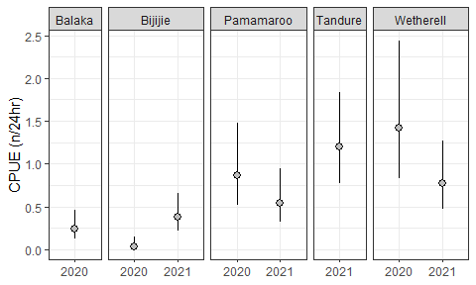

Figure 16. Catch rates (n/24hr) for golden perch in fyke nets. Each point shows estimated catch rate (with 95%CI) for each sampling event. Note – no pairwise tests between sampling events were conducted.

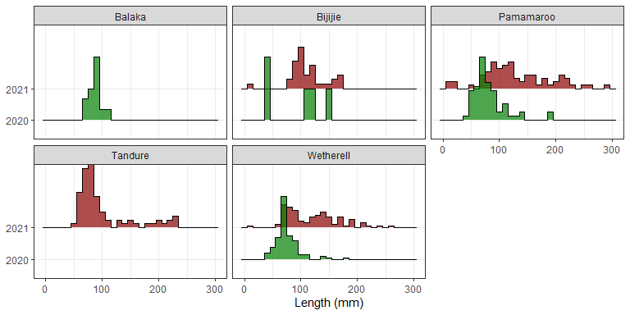

Figure 17. Length distributions of golden perch for each sampling event with each panel showing a separate lake. Colour indicates sampling season/year (Green=Spring2020; Red=Autumn2021).

Table 7. Table showing estimated CPUE (n/24hr) for each sampling event

|  |  |
| --- | --- |
| Sampling event | Estimate (95%CI) |
| Bijijie - 2020 | 0.03 (.01, 0.15) |
| Balaka - 2020 | 0.24 (0.12, 0.46) |
| Bijijie - 2021 | 0.37 (0.21, 0.66) |
| Pamamaroo - 2021 | 0.55 (0.32, 0.94) |
| Wetherell - 2021 | 0.77 (0.48, 1.26) |
| Pamamaroo - 2020 | 0.87 (0.51, 1.48) |
| Tandure - 2021 | 1.2 (0.78, 1.84) |
| Wetherell - 2020 | 1.42 (0.83, 2.44) |

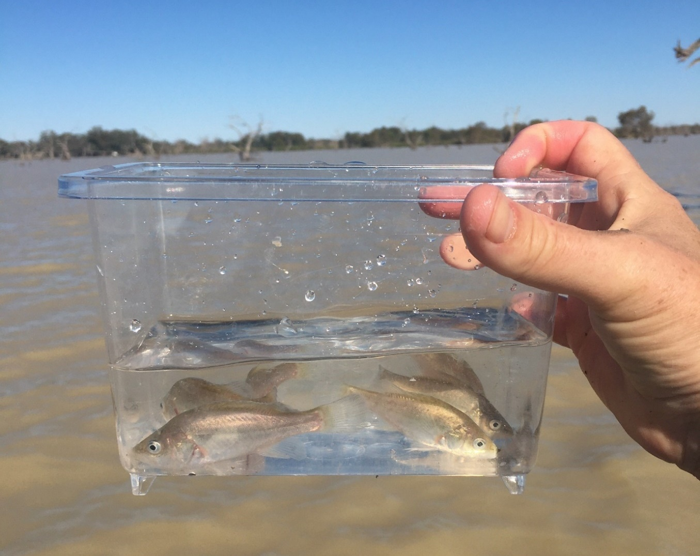

Figure 18. Young-of-the-year golden perch in the Menindee Lakes in 2020-21. These fish were spawned in upstream flowing riverine habitats, drifted into the lakes where there was rapid growth, then later dispersed both downstream and upstream into the Darling River into rivers (photo: NSW DPI Fisheries).

## Discussion

### Environmental flow and Murray cod spawning/recruitment in the LDR

In the LDR, the spring/summer 2020-21 environmental flow event contributed to a successful spawning and young-of-the-year recruitment event of Murray cod, confirming the success and knowledge generated from the similar flow event in 2016-17 (Sharpe and Stuart, 2018). Murray cod appeared to have spawned and recruited throughout the entire LDR in 2020-21 with only minimal contribution from stocked fish, suggesting the delivered flow event met their life-history needs across a broad spatial scale (i.e. >500 km). Collectively, the results from this field evaluation in combination with previous monitoring in the LDR (Sharpe and Stuart, 2018) and the scientific literature (Stuart et al., 2019; Tonkin et al., 2021), suggests that applying the conceptual hydrograph presented here as a permanent flow regime will be crucial in enabling the long-term protection and continuing recovery of Murray cod following the catastrophic 2018-2020 fish death events.

The success of the LDR environmental flow in supporting Murray cod spawning is evident with a relatively large number of Murray cod larvae collected in spring-summer 2020-21. By way of broad comparison, similar numbers of larvae were collected in spring 2016, which was a relatively strong spawning response compared to other spawning studies in the LDR and elsewhere (Ellis et al., 2015; King et al., 2009). Field collections for 2020 have clarified that spawning and recruitment occurred at broadly similar rates in for 400 ML day-1 and for 800 ML day-1 in 2016 (i.e. 2020 discharge compared to 2016), suggesting that lotic conditions in the lower Darling River, support this aspect of local fish ecology even at lower flows. We do, however, recommend a higher discharge (e.g. 800- 1500 ML day-1) for the spring hydrograph as this provides other relatively greater benefits through the inundated benches, snags, productivity and dispersal of juvenile golden perch to the LDR and southern connected Murray system. We further recommend that the gauging location for this discharge be at Burtundy Weir rather than Weir 32 as at low flows up to 50% of discharge can be lost between these gauges.

One unresolved challenge of this study was the full attribution of the Murray cod spawning-recruitment response to environmental water. The issue is constrained in that there is no directly comparable fish sampling without environmental flows and this limits a robust statistical analysis and attribution. Unlike other major rivers (i.e. the Murray River) environmental water made up nearly half (43%) of LDR flows in spring 2020, hence the designed hydrology and ecological response was more clearly linked. There are alternative techniques to model counter-factual (i.e. computer modelling of fish response to the water sharing plan minimum baseflows without environmental water) hydrological scenarios for improved attribution of the benefits of environmental flows. Hence, we highlight the need for: (i) future field sampling without environmental flows (where ecologically appropriate during dry conditions) to add further time-series data, and ii) counter-factual modelling (Hladyz et al., 2021).

Our present conceptual understanding of the life-history of Murray cod enabled an eco-hydraulic conceptual model with clear relationships to the four important functional elements of the hydrological/hydraulic flow regime of the LDR to be developed (Koehn et al., 2020). During design of the environmental flow regime, it was especially important to examine prior recruitment from 2016 and hydrological data to optimise environmental flow conditions during the short (three month) Murray cod breeding window in spring 2020. We suggest that this framework could be applied at other regulated rivers (e.g. Murrumbidgee, Lachlan rivers and Yanco Creek) where hydraulics (i.e. velocities >0.3 m s-1) are the scalable tool that can be used to optimise discharge for Murray cod recovery.

This study highlights that Murray cod populations can potentially be recovered and protected through environmental flows that promote baseflows, perennial lotic conditions, hydraulic complexity and prevent cease-to-flow conditions (see Figure 19). This is especially important given the increasing frequency and duration of cease-to-flow events in the LDR with two recent events being >500 days long each.For Commonwealth and NSW environmental water managers, the priority going forward is to implement a perennial flow regime in the LDR without cease-to-flow events (where possible), especially during the Murray cod spawning season (September – December). Each year, the flow rate can be adapted to the seasonal conditions i.e. in drier years a flow of ~ 400 ML day-1 and in wetter years a flow of 800-1500 ML day-1. Further multi-year experimental work is required to explore juvenile survival rates during summer and winter baseflows.

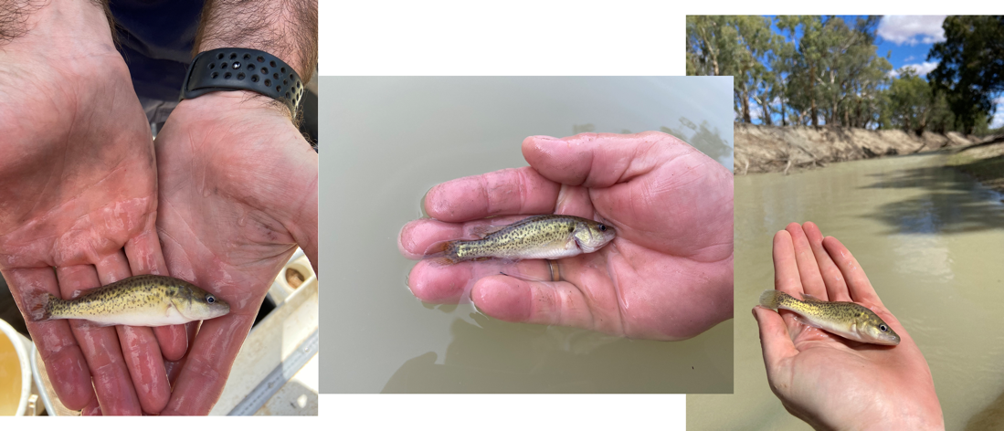

Figure 19. Young-of-the-year Murray cod sampled from the Lower Darling River in March 2020 (photos: NSW DPI Fisheries).

### Golden perch spawning and recruitment

Surveys in the Menindee Lakes in November 2020 and February 2021 confirmed the presence of young-of-the-year golden perch with the size range being consistent with an age of <1 year. The Menindee Lakes are a well-known golden perch nursery area (Brown and Neira, 1998; Ebner et al., 2009; Sharpe, 2011) and the provenance of larvae appears to stem from spawning in upstream flowing riverine habitats, including distant tributaries (Stuart and Sharpe, 2020, Jason Thiem Unpublished data). Further work is planned to estimate the age and potential spawning locations for the 2020-21 Menindee Lakes golden perch cohort and will inform evaluation of the timing and location of flows that supported successful spawning and dispersal of larvae downstream. This evaluation will inform future river management and environmental flow delivery at ecologically appropriate scales.

The Menindee Lakes, along with several semi-regulated northern tributaries, make up one of the few aquatic habitats in the MDB that support regular recruitment of golden perch (CEWO, 2020; NSW DPI Fisheries, Unpublished data; DERM, 2010; Sharpe, 2011). More broadly, golden perch populations appear reliant on cohorts that recruit in the Menindee Lakes, albeit infrequently (indicated by regular gaps in year classes) and often driven by unregulated flooding. This highlights the importance of the success of the spring/summer 2020 environmental flow in dispersing a proportion of the summer 2019-2020 golden perch cohort from the Menindee Lakes into the LDR. For environmental water managers, the protection and shepherding of the first post-drought re-connection flow from the northern basin in summer-autumn 2020 (known as the first flush event; DPIE, 2021) was critical in supporting the dispersal of the significant golden perch recruitment cohort. This highlights a key management tool for improving golden perch populations, where regular protection of flow events at large spatial scales will be required.

The nursery function of the Menindee Lakes is a major asset for the broader MDB golden perch populations. Part of the reason for fish recruitment and rapid grow in this habitat is its enormous productivity (Sharpe, 2011) (Figure 20). Golden perch populations appear strongly reliant on connection and appropriate water management of this system to maximise survival, then juvenile dispersal to the connected southern and northern MDB. Environmental flows facilitated dispersal of young fish into the LDR in 2020-21. Complementary actions to support these dispersal processes would include installing fishways on the inlet regulators of lakes Pamamaroo and Menindee to facilitate safe out-migration of juvenile fish to semi-permanent habitats, such as Lake Wetherell and the Darling River. Without fishways and dispersal flows, major golden perch recruitment cohorts often perish in the drying lakes (Sharpe, 2011).

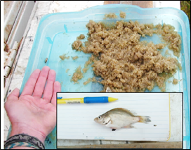

Figure 20. Abundant zooplankton collected in the Menindee Lakes which supports rapid growth and enhanced survival of young golden perch (photo: C. Sharpe).

In the LDR, spawning of golden perch on the delivered flow event in 2020-21 was not observed, whereas in spring/summer 2016 (~2,200 ML day-1) spawning did occur (Sharpe and Stuart 2018). This result can be explained by a combination of factors including (i) the flow pulse being considerably smaller in spring/summer 2020 (a brief 1,500 ML day-1 pulse), (ii) lower golden perch numbers following the fish deaths, and (iii) multiple barriers to fish movement in the LDR during the study period. This included the barrier at Pooncarie Weir (due to an inoperable fishway), and the spatial distribution of larval sampling sites covering an extended river reach (such a long stretch of river with limited spatial coverage can cause issues with detection probability). Hence, at low flows, the contribution of golden perch spawning and recruitment within the LDR is likely to be considerably less compared to facilitating upstream and downstream dispersal of young fish from the Menindee Lakes. Nevertheless, spawning in the LDR when a higher flow pulse is able to be delivered is likely to be important for local meta-population function, especially where some fish originally spawned in the Darling River return from the Murray River as adults (Thiem et al., 2021). It is likely that a combination of local spawning in the LDR, downstream movement of juveniles from the Menindee Lakes (from riverine spawning upstream of Menindee) and upstream immigration from the Murray River all contribute to maintaining golden perch populations in the LDR (Thiem et al., 2021). We suggest a pulse up to 2,200 ML day-1 at Burtundy Weir in late spring and summer can be considered a minimum for supporting ecologically significant spawning in the LDR and there is likely to be increased spawning potential with increased discharge (e.g. King et al., 2016).

### Effect of the fish deaths

The 2018-2020 fish deaths were caused by a combination of a major cease-to-flow event coupled with catastrophic declines in water quality, including water temperature and dissolved oxygen (Australian Academy of Science, 2019). An objective of the present study was to determine whether there was a detectable change in relative abundance or size structure of the fish community between sampling pre-and-post fish deaths. We do, however, note that there were no sampling sites within the primary fish death reach at Menindee. While the relative catch for some species was lower, including golden perch, carp and Australian smelt, there was no detectable change in catch rates or size structure for Murray cod or bony herring. These data suggest that the LDR native fish community are continuing to recover from the fish deaths and that permanently implementing the native fish hydrograph and supporting implementation of environmental water requirements as outlined in the Murray Lower Darling Long Term Water Plan will further improve this nationally significant fish community (DPIE, 2020).

### Non-native fish

A remarkable result from the current study was the relative lack of carp and other non-native fish collected in larval sampling. The lack of carp recruitment in the LDR in 2020-2021 is evidenced by the multi-year size structure which illustrates fish growing larger and a lack of annual recruitment. Carp are common in the LDR and are usually present at a biomass (i.e. >400 kg/ha) equivalent to other large lowland rivers (Stuart et al., 2021) which is well above accepted density-impact thresholds (i.e. 80-100 kg/ha; Brown and Gilligan, 2014). The likely primary reason for the lack of carp recruitment in the LDR in 2020-2021 was the lack of major floodplain inundation which provides the preferred spawning and nursery areas. This finding raises an interesting potential research and management opportunity. We speculate that a considerable proportion of carp in the LDR may be from upstream immigration from the Murray system or downstream dispersal from the Menindee Lakes, analogous to that for golden perch (Thiem et al., 2021). Further investigation of carp natal origins and migration life-history via otolith microchemistry may be a worth-while future initiative.

## Synthesis

In the LDR, the spring/summer 2020-21 environmental flow met the life-history needs of Murray cod across broad spatial scales (i.e. >500 km). The total water volume delivered during this period was 57,668 ML with environmental water contributing 24,713 ML (43%). This study highlights that Murray cod populations can potentially be recovered and protected under hydrologic conditions (either natural or delivered events) that promote baseflows, perennial lotic conditions, hydraulic complexity and prevent the recent spate of serious cease-to-flow conditions. Applying a permanent flow regime will be crucial in supporting continuing recovery of native fish following the catastrophic 2018-2020 fish death events. The management of environmental water can play a key role in achieving this outcome. We also suggest that similar recovery flows could be applied in other regulated rivers (e.g. Murrumbidgee, Lachlan rivers and Yanco Creek) where Murray cod recovery is a priority.

The Menindee Lakes are one of few aquatic habitats in the MDB that support regular recruitment events of golden perch. Consequently, broader golden perch populations in the southern connected basin can substantially benefit from the contribution of individuals from the Darling River. During periods of major flooding, this contribution can occur unassisted. However, during periods of low to moderate flows this contribution needs to occur through managed flow interventions. This underscores the importance of the success of the spring/summer 2020 environmental flow in dispersing a proportion of the golden perch recruitment cohort from the Menindee Lakes into the LDR and ultimately the Murray River population. A major management priority is to protect this cohort by enabling them to out-migrate from the Menindee Lakes downstream into the LDR and upstream into the mid-Darling. To facilitate this process and maintain golden perch populations, there needs to be regular protection of flow events from the northern MDB into the Menindee Lakes and LDR combined with investment in complementary actions to facilitate dispersal, such as safe and transparent fish passage past weirs and inlet regulators. Research to evaluate outmigration success for juvenile and adult golden perch would help inform this process.

## Pictorial representation

Water is important for Murray cod and golden perch in the Darling-Baaka River and represented pictorially as Figure 21. Flows from the northern Murray-Darling Basin (1) trigger spawning by adult golden perch, and 2) a ‘boom’ of zooplankton, resulting in larvae and juvenile golden perch feeding while drifting downstream as far as Menindee, where 3) they settle into nursery habitat in the newly inundated lakes, and the main channel. Murray cod are growing and reproducing annually in the lower Darling-Baaka River under perennial flows with 4) early recruits and juveniles living within proximity of their parents. Later inflow events reconnect the Darling-Baaka River to the Menindee Lakes, enabling 5) large juvenile and subadult golden perch to repopulate the mid and lower Darling- Baaka and Murray river systems. Although we found limited evidence of golden perch spawning within the lower Darling-Baaka River during this study, earlier work conducted prior to the recent mass fish kills has documented 6) spawning downstream of the Menindee lakes in response to managed releases of water. Soon after hatching, (7–8) tiny larvae and juvenile cod feed and shelter amongst sticks and logs in shallow backwaters and eddies close to main channel flows. The inundation of in-channel benches (shallow water areas) and substantial woody debris are also important for Murray cod to spawn and 9) guard eggs during spring. Note that subpopulations of Murray cod are sustained within short reaches, whereas, the golden perch life cycle functions over hundreds to thousands of river kilometres.

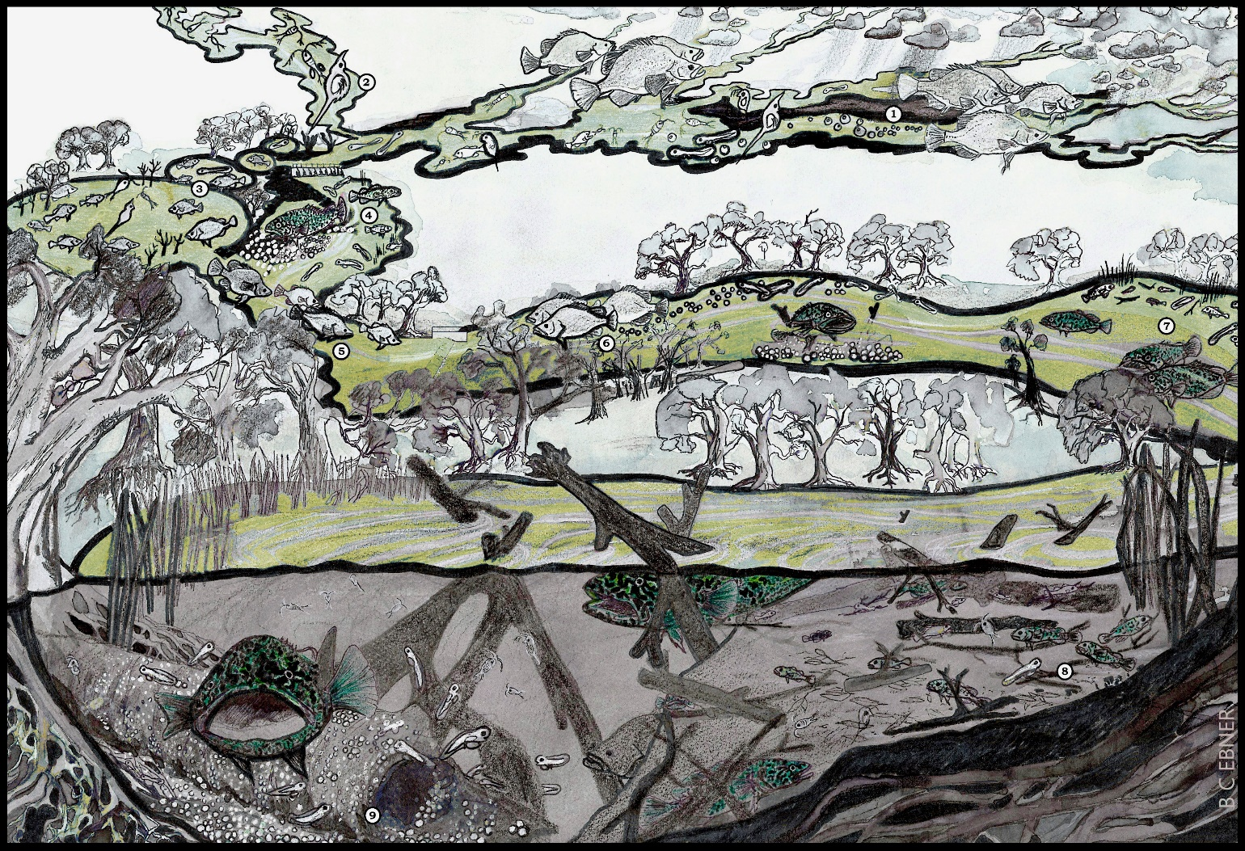

Figure 21 Pictorial representation of life history stages for Murray cod and golden perch.

### Adaptive management

The 2020-2021 environmental flow was important not only for supporting seasonal processes (such as spawning, recruitment and over-winter survival) but in providing a real time adaptive management template for supporting post fish-death population recovery. Ultimately this collaborative program has highlighted a pathway to rebuild the resilience of the LDR fish populations and the river ecosystem and inform future environmental flow programs.

## Priority recommendations

1. To protect and recover LDR native fish communities, implement the 2020-21 native fish hydrograph as a permanent flow regime (supported by environmental flows if and when necessary) prioritising perennial flowing habitats without cease-to-flow events. This hydrograph can be considered a ‘minimum’ and in wet, average and dry years, the relative discharge can be adjusted (i.e. spring spawning low of 400 ML d-1 for dry years and 800-1500 ML d-1 in wetter years) with flow pulses to enable downstream dispersal of golden perch and in situ spawning in the LDR. Further evaluation of the 2021-22 flow regime will enable refinement of the hydrograph and increased data continuity.
2. The Menindee Lakes are a major source of golden perch recruits that likely support broader MDB populations. Protecting northern connectivity and spawning flow events that regularly re-connect the Menindee Lakes, and contribute to southern Murray-Darling Basin via both the LDR and Great Darling Anabranch (GDA) is an essential and immediate management priority to support golden perch populations. Providing for improved fish passage in the Menindee Lakes and determining the outmigration patterns of juvenile and sub-adult golden perch into the LDR and mid-Darling is a major research/management priority.
3. To build on these environmental flow monitoring and adaptive management results and recommendations we suggest the following components: (i) implement and monitor the fish recovery hydrograph in spring/summer 2021-2022, (ii) expand the baseline genetic results to track the trajectory of Murray cod and golden perch recovery in spring 2021, and (iii) quantify dispersal rates of young-of-the-year golden perch from the Menindee Lakes into northern and southern MDB populations and the influence of outflow conditions on these rates.

### Supporting recommendations

1. For the permanent LDR native fish hydrograph, include end-of-system flow targets be set at Burtundy Weir (rather than Weir 32) to maximise benefits to native fish.
2. To fully attribute environmental flow benefits to native fish, additional sampling when no environmental water is present is required. The response of native fish to a ‘no environmental water’ scenario may also be modelled using counter-factual hydrological data.
3. The Murray cod component of the native fish hydrograph can be transferred to other sites (e.g. Murrumbidgee River, Lachlan River and Yanco Creek) and the hydraulics used as the scalable tool to plan discharges to suit Murray cod recovery. Monitoring and adaptive management will then be required.
4. Complementary works, including fish passage on the inlet regulators of lakes Menindee and Pamamaroo will likely be important in enabling a high biomass of juvenile golden perch to out-migrate and disperse into riverine habitats.
5. In the LDR, golden perch appear to require a significant increase in discharge (i.e. >2,200 ML day-1 at Burtundy as a minimum) for baseline spawning in the LDR and we suggest additional discharge will likely cue additional spawning.

# Part 2: Genetics of Murray cod

## Introduction

It is widely accepted that small population size is a key risk factor in the long-term persistence of a population because genetic factors such as inbreeding and loss of genetic diversity are unavoidable (Frankham 2005). Inbreeding occurs when populations are small, increasing the chance of mating between close relatives, which can lead to a wide range of negative outcomes including poor survival of offspring. One of the most serious consequences of inbreeding is reduced genetic diversity. Genetic diversity is crucial for the long-term fitness of a population and for its ability to be able to adapt to changes in their environment. However, it is not the census size of the population that is most important, rather, it is the effective population size (Ne). In an ‘ideal’ population that has equal numbers of males and females who are capable of reproducing, where all individuals are equally likely to produce offspring and there is limited variation in the number of offspring produced by each individual, population census size is equal to Ne. In reality, this rarely occurs, and Ne is typically 1/10th that of the census size. The consensus in the literature is that an Ne of >500 is considered the minimum required to avoid inbreeding, the loss of genetic diversity and the loss of adaptive potential.

The two cease-to-flow events and associated water quality declines led to a large number of Murray cod deaths in the lower Darling River. There was concern that significant population declines combined with reduced connectivity between populations of Murray cod in the lower Darling River and more broadly to other rivers in the MDB may have reduced the Ne of the wild population. Population declines could be further exacerbated if Murray cod form monogamous pairs that could potentially spawn over multiple seasons given the loss of one individual from a pair of fish could result in the remaining fish failing to spawn. There is limited data on the mating strategy of Murray cod in wild populations but there is some evidence to suggest that pair bonding may occur in both the captive and wild environment (Rourke et al 2011, Couch et al 2020). However, more recent evidence from the Murray River did not find substantial evidence for pair-bonding (O’Dwyer et al. Submitted). Consequently, further information is required on the mating strategy of Murray cod in the lower Darling River and on the Ne. If pair-bonding is an important mating strategy and if the Ne was very low, this would suggest that maintaining adequate water quality to avoid fish deaths, improving population connectivity and potentially translocating fish from other populations may be required (i.e., genetic rescue) to increase genetic diversity and reduce inbreeding over the longer-term.

This component of the project has two main aims; 1) to identify kinship relationships between larval fish to determine the mating strategy of adult fish and 2) to estimate the Ne will be estimated using two separate approaches. The first is to collect a sample of larval fish and identify full- and half-sibling pairs to estimate Ne of the parental generation. The second approach estimates Ne directly from a subset of the adult population.

## Methods

### Genetic subsampling of Murray cod

Murray cod (from the larval fish surveys conducted in Part 1 of this report) were identified to developmental/ontogenetic larval stage of either flexion, postflexion, metalarva or juvenile (Neira et al., 1998). To meet the objective of determining the minimum number of unique adults that contributed to spawning outcomes in 2020 (and without analysing all 1,185 samples), fish were subsampled to maximise the number of unique parental fish that could be detected. Firstly, one Murray cod was randomly subsampled from each ontogenetic stage present within each unique combination of net, sampling site and sampling event (n = 162 fish), based on the assumption that fish of the same ontogenetic stage captured in the same net at the same site on the same sampling event were more likely to be siblings. Additional samples were included comprising juvenile (8 fish), flexion (11 fish) and postflexion (7 fish) stages where this represented the earliest stage remaining in individual nets (resulting in a total of 188 larval or juvenile Murray cod fish contributing to this component of genetic analyses; Table 8, see also Appendix Table 20). Fish subsampled for genetic analysis were measured to TL (mm) and a 10-15 mg tissue sample of the fish was taken and stored in 100 µl of 70% ethanol in 96-well Polymerase chain reaction (PCR) plates sealed with PCR strip caps. Due to the small size of some samples the sample often included both fin and body tissue, however tissue from the gut and head regions was excluded to avoid contamination of the sample.

To determine the effective population size (a genetic measure that gives an indication of how likely a population is to avoid the loss of genetic diversity and impacts of inbreeding, i.e. fish that are the result of a spawning between close relatives), fin clips from Murray cod captured during Spring electrofishing surveys in the LDR were used (n = 26). An additional sample of fin clips collected from Murray cod in the LDR during complementary surveys undertaken in June 2016, 2019 and 2020 (n = 65 fin clips) were included to supplement sample size. Adult fin clips had already been cut to the required size (10-15 mg) in the field, so the tissue samples were directly transferred to the PCR plates in 70% ethanol. No subsampling method was applied to adult samples as all (91) available samples were analysed (see Appendix Table 21).

Table 8. Subsampling summary of Murray cod larvae from the Lower Darling River used for genetic analysis.

|  |  |  |  |  |  |
| --- | --- | --- | --- | --- | --- |
| Week | Dates | Sites sampled (sites with Murray cod) | Total number of Murray cod | Number of fish genetically subsampled | Length of fish genetically subsampled (mm) |
| 1 | 8/10/2020 – 11/10/2020 | 7 (5) | 86 | 18 | 6.75 – 12.66 |
| 2 | 20/10/2020 – 22/10/2020 | 7 (6) | 122 | 28 | 8.34 – 12.78 |
| 3 | 3/11/2020 – 5/11/2020 | 7 (6) | 478 | 45 | 7.14 – 17.96 |
| 4 | 17/11/2020 – 19/11/2020 | 7 (6) | 357 | 51 | 5.93 – 17.96 |
| 5 | 1/12/2020 – 3/12/2020 | 7 (5) | 93 | 29 | 7.9 – 26.69 |
| 6 | 8/12/2020 – 10/12/2020 | 7 (5) | 49 | 17 | 9.44 – 40.84 |

### DNA extraction and sequencing

The prepared tissue samples were sent to Diversity Arrays Technology (DArT) Pty Ltd (http://www.diversityarrays.com/) for DNA extraction and sequencing using the DArTSeq platform. This platform enables rapid and cost-effective sequencing of thousands of single nucleotide polymorphisms (SNPs) in a single assay per sample (in this case, an individual fish). The data generated can be used for a range of applications including determining parentage, sibling relationships and describing genetic diversity. The DArTSeq platform uses a form of reduced representation sequencing similar to double digest restriction-site associated DNA sequencing. Briefly, two enzymes (Pstl and Sphl) were used to digest the DNA into smaller fragments. The DNA was ligated with site-specific adapters and then amplified using methods described in (Kilian et al., 2012). Equimolar amounts of each amplified product were then pooled and sequenced on an Illumina Hiseq 2500 for 77 cycles. Samples were sequenced in batches of 94 per Illumina sequencing lane with 25% of samples rerun as technical replicates for quality control. Purpose-built software (DArTsoft was used to process sequence reads) (Kilian et al., 2012). Poor quality sequences were removed, and low-quality bases corrected using consensus sequences from multiple members as a template (Harrisson et al., 2019; Kilian et al., 2012). The quality of each sequence was scored using two different quality scores: one stringent filter applied to the barcode region (Phred pass score of 30, minimum pass % 75) and one less stringent filter applied to the whole sequence read (Phred pass score of 10, minimum pass % 50). The markers were mapped to the Murray cod genome available on GenBank (Accession number LKNJ00000000.1).

A secondary pipeline (DArTsoft14) (Kilian et al., 2012) compiled read counts into SNP loci calls with a maximum allowed difference between sequences of 3 bases. SNPs were further filtered to remove loci with allele read counts > 5-fold difference, and which scored < 95% reproducibility using the sequenced technical replicates. Following sequencing and analytics pipelines, a total of 19,072 SNPs were genotyped and returned for further analysis.

#### SNP filtering

The samples used in this study were co-analysed with an additional 1089 Murray cod samples being used by collaborators in other projects. Unfiltered SNP data provided by DArT for the subset of samples used in this project consisted of genotypes for 272 individuals at 10,953 SNP loci.

### Data analysis

Additional more stringent filters were applied to the SNP data files provided by DArT using the dartR package (Goudet, 2005) in R. We retained only individuals genotyped for at least 80% of loci (Larvae and juveniles N = 181, Adults N = 71) and only loci genotyped for at least 95% of individuals (N = 7,247). We further filtered loci to retain only one SNP per RAD tag (N = 6,997) and loci that were fully reproducible across all technical replicates (N = 4,435). After removal of monomorphic loci, 1177 loci were retained for analysis.

#### Kinship

Full-siblings, half-siblings and parent-offspring pairs were identified using kinship analysis implemented in Colony2 v2.0.6.5. Colony2 was run using the full-likelihood method (medium length) for sibship and parentage assignments, a per locus error rate of 0.001, calculate allele frequencies but not update allele frequencies, sibship scaling, assumed non-inbreeding (recommended for dioecious with no or low level of inbreeding), dioecious diploid, polygamy for both males and females (i.e. allowing half-siblings) and no sibship prior. Markers were assumed to be codominant

#### Effective population size estimates

Colony2 was also used to estimate the effective population size (Ne) of the parental generation (i.e. number of breeding adults contributing to the larval sample) for each of the larvae sampling locations and total larval sample using the sibship assignment method. This method uses information about the frequency of full-sibling and half-sibling dyads to estimate the current effective size of the population, assuming the sample of individuals is taken at random from the same cohort (Wang, 2009). Because this method assumes the sample is from a single cohort of the population, we did not apply this method to the adult population sample.

Effective population size was also estimated for larval samples and adult samples using the single-sample LD method in NeEstimator (Waples and Do, 2008). The LD method assumes that the sampled population has discrete generations. As Murray cod have overlapping generations, the Ne estimate is considered the effective number of breeders (NeD), which reflects the parental generation (Waples and Do, 2010). Thus, for the larvae, NeD estimates will reflect the number of breeding adults contributing to the larval sample. NeD estimates for the adult sample will likely be biased (likely downward biased), as the sample will consist of multiple generations that have been incompletely sampled. Total Ne of the population and NeD are considered to roughly correspond if the number of cohorts in a sample is similar to the generation length (i.e. approximately 25 cohorts for Murray cod). NeEstimator was run assuming random mating for each larvae sampling location, for the total larval sample, and for the total adult sample, using NeEstimator 2.1. Alleles with a frequency below 0.02 were removed from the analysis to reduce bias (Pcrit = 0.02) (Waples and Do, 2008). This method also assumes the sample is from a single cohort, so results from the adult population need to be interpreted with caution.

## Results

A total of 1,185 Murray cod larvae were sampled from six sites (Table 9). Larval fish were more consistently sampled in most weeks for the middle sites (Lelma, Mallara and Moorara), while the total catch across sites was highest for weeks three and four, suggesting this was the peak spawning time.

Table 9: Total number of larval Murray cod sampled in the lower Darling River for each week and each site. Sites are ordered in a downstream to upstream direction (See Figure 3).

|  |  |  |  |  |  |  |  |
| --- | --- | --- | --- | --- | --- | --- | --- |
| Site | Week | | | | | | Total |
|  | 1 | 2 | 3 | 4 | 5 | 6 |  |
| Belcatherine | 2 | 2 | 49 | 116 |  | 1 | 170 |
| Lelma | 6 | 45 | 21 | 61 | 39 | 6 | 178 |
| Mallara |  | 13 | 26 | 60 | 32 | 37 | 168 |
| Moorara | 2 | 26 | 180 | 87 | 20 | 3 | 318 |
| Karoola | 41 | 6 | 199 | 24 | 1 |  | 271 |
| Bono | 35 | 30 | 3 | 9 | 1 | 2 | 80 |
| **Total** | **86** | **122** | **478** | **357** | **93** | **49** | **1185** |

### Kinship

A total of 22 full-sibling groups were identified, which were comprised of 30 full-sibling pairs (Table 10). Of the 22 groups, most involved siblings collected at the same site, week and developmental stage. Some were sampled at the same site but in different sequential developmental stages. For example, the full-sibling group containing MacpeeGSI078 (week 4, metalarva), MacpeeGSI079 (week 4, postflexion), MacpeeGSI082 (week 4, postflexion) and MacpeeGSI084 (week 4, metalarva) sampled at Belcatherine. These siblings could have either come from the same spawning event with larvae being sampled just as they were moving from postflexion to metalarva stage, or two separate spawnings over a short time period. One full-sibling group had an individual sampled in week one as a flexion (MacpeeGSI001) and the other sampled in week three as a postflexion (MacpeeGSI042), suggesting siblings were from the same spawning but had progressed to the next developmental stage. Three full-sibling groups had individuals sampled from different sites (Table B) in either the same developmental stage (MacpeeGSI045 and MacpeeGSI055) or different but sequential developmental stages (MacpeeGSI061 and MacpeeGSI100; MacpeeGSI148 and MacpeeGSI102), with the more advanced developmental stage being detected at the most downstream site (Table 10).

Fifty-six pairs of half-siblings were detected, and these were distributed throughout the study area (Table 11). This result is conclusive evidence that polygamous spawning is occurring in Murray cod, though the sex of the parent involved can’t be determined from these data.

Four larval fish could be assigned to one parent fish (either a male or female, Table 12). Two of these larvae were full-siblings (MacpeeGSI018 and MacpeeGSI019) that were collected at Bono. Their parent (MacpeeGSI241) was also collected at Bono. One larval fish (MacpeeGSI002) was collected at Bono and its parent was collected U/S of Texas Downs. The final larval fish (MacpeeGSI127) was collected at Lelma and its parent (MacpeeGSI260) was collected at Lelma Upstream.

Table 10. Larvae full-sibling groups (N=22 sibling groups; N=30 full-sibling pairs). Prob (Inc.) is the probability that all individuals in a given full-sibling group are full-siblings. Prob (Exc.) is the probability that all individuals in a given full-sibling group are full-siblings and no other individuals are part of the full-sibling group. The site, week, net and ontogenetic stage for each member of the sibling pairs is identified. Member 1; M1, Member 2; M2, Member 3; M3, Member 4: M4.

|  |  |  |  |  |  |  |  |  |
| --- | --- | --- | --- | --- | --- | --- | --- | --- |
| Member1 | Member2 | Member3 | Member4 | Prob  (Inc.) | Prob  (Exc.) | Site | Week(Net) | Ontogenetic stage |
| MacpeeGSI001 | MacpeeGSI042 | . | . | 0.9862 | 0.9862 | M1: Belcatherine  M2: Belcatherine | M1: 1(1)  M2: 3(2) | M1: Flexion  M2: Postflexion |
| MacpeeGSI082 | MacpeeGSI084 | MacpeeGSI078 | MacpeeGSI079 | 1 | 1 | M1: Belcatherine  M2: Belcatherine  M3: Belcatherine  M4: Belcatherine | M1: 4(2)  M2: 4(3)  M3: 4(1)  M4: 4(1) | M1: Postflexion  M2: Postflexion  M3: Metalarva  M4: Postflexion |
| MacpeeGSI044 | MacpeeGSI186 | . | . | 1 | 1 | M1: Belcatherine  M2: Belcatherine | M1: 3(3)  M2: 3(2) | M1: Postflexion  M2: Postflexion |
| MacpeeGSI089 | MacpeeGSI087 | . | . | 1 | 1 | M1: Bono  M2: Bono | M1: 4(3)  M2: 4(2) | M1: Postflexion  M2: Flexion |
| MacpeeGSI018 | MacpeeGSI019 | . | . | 1 | 1 | M1: Bono  M2: Bono | M1: 2(2)  M2:2(2) | M1: Flexion  M2: Postflexion |
| MacpeeGSI003 | MacpeeGSI004 | MacpeeGSI005 | . | 1 | 1 | M1: Bono  M2: Bono  M3: Bono | M1: 1(2)  M2: 1(2)  M3: 1(3) | M1: Flexion  M2: Postflexion  M3: Postflexion |
| MacpeeGSI020 | MacpeeGSI021 | MacpeeGSI166 | . | 0.9971 | 0.9971 | M1: Bono  M2: Bono  M3: Bono | M1: 2(3)  M2: 2(3)  M3: 2(1) | M1: Flexion  M2: Postflexion  M3: Flexion |
| MacpeeGSI009 | MacpeeGSI182 | . | . | 0.9995 | 0.9995 | M1: Karoola  M2: Karoola | M1: 1(3)  M2: 1(3) | M1: Flexion  M2: Postflexion |
| MacpeeGSI025 | MacpeeGSI022 | . | . | 0.9998 | 0.9998 | M1: Karoola  M2: Karoola | M1: 2(3)  M2: 2(1) | M1: Postflexion  M2: Metalarva |
| MacpeeGSI049 | MacpeeGSI168 | . | . | 1 | 1 | M1: Karoola  M2: Karoola | M1: 3(1)  M2: 3(1) | M1: Postflexion  M2: Flexion |
| MacpeeGSI050 | MacpeeGSI047 | . | . | 0.9998 | 0.9998 | M1: Karoola  M2: Karoola | M1: 3(2)  M2: 3(1) | M1: Flexion  M2: Flexion |
| MacpeeGSI054 | MacpeeGSI048 | . | . | 0.9999 | 0.9999 | M1: Karoola  M2: Karoola | M1: 3(3)  M2: 3(1) | M1: Metalarva  M2: Metalarva |
| MacpeeGSI027 | MacpeeGSI028 | . | . | 1 | 1 | M1: Lelma  M2: Lelma | M1: 2(1)  M2: 2(2) | M1: Postflexion  M2: Postflexion |
| MacpeeGSI065 | MacpeeGSI062 | . | . | 0.9999 | 0.9999 | M1: Mallara  M2: Mallara | M1: 3(3)  M2: 3(1) | M1: Flexion  M2: Postflexion |
| MacpeeGSI066 | MacpeeGSI064 | . | . | 1 | 1 | M1: Mallara  M2: Mallara | M1: 3(3)  M2: 3(2) | M1: Postflexion  M2: Postflexion |
| MacpeeGSI075 | MacpeeGSI068 | . | . | 0.9999 | 0.9999 | M1: Moorara  M2: Moorara | M1: 3(3)  M2: 3(1) | M1: Metalarva  M2: Metalarva |
| MacpeeGSI069 | MacpeeGSI072 | . | . | 1 | 1 | M1: Moorara  M2: Moorara | M1: 3(1)  M2: 3(2) | M1: Postflexion  M2: Postflexion |
| MacpeeGSI113 | MacpeeGSI116 | . | . | 1 | 1 | M1: Moorara  M2: Moorara | M1: 4(1)  M2: 4(2) | M1: Postflexion  M2: Postflexion |
| MacpeeGSI045 | MacpeeGSI055 | . | . | 0.9997 | 0.9997 | M1: Bono  M2: Karoola | M1: 3(1)  M2: 3(3) | M1: Postflexion  M2: Postflexion |
| MacpeeGSI061 | MacpeeGSI100 | . | . | 1 | 1 | M1: Mallara  M2: Lelma | M1: 3(1)  M2: 4(3) | M1: Flexion  M2: Juvenile |
| MacpeeGSI148 | MacpeeGSI102 | . | . | 1 | 1 | M1: Belcatherine  M2: Lelma | M1: 6(1)  M2: 4(3) | M1: Juvenile  M2: Postflexion |

Table 11. Larvae half-sibling Dyads (N=61). Member 1; M1, member 2; M2.

|  |  |  |  |  |  |
| --- | --- | --- | --- | --- | --- |
| Member 1 | Member 2 | Probability | Site | Week(Net) | Ontogenetic stage |
| MacpeeGSI001 | MacpeeGSI041 | 1 | M1: Belcatherine  M2: Belcatherine | M1: 1(1)  M2: 3(2) | M1: Flexion  M2: Flexion |
| MacpeeGSI089 | MacpeeGSI085 | 1 | M1: Bono  M2: Bono | M1: 4(3)  M2: 4(1) | M1: Postflexion  M2: Metalarva |
| MacpeeGSI017 | MacpeeGSI004 | 1 | M1: Bono  M2: Bono | M1: 2(1)  M2: 1(2) | M1: Postflexion  M2: Postflexion |
| MacpeeGSI017 | MacpeeGSI005 | 1 | M1: Bono  M2: Bono | M1: 2(1)  M2: 1(3) | M1: Postflexion  M2: Postflexion |
| MacpeeGSI049 | MacpeeGSI055 | 1 | M1: Karoola  M2: Karoola | M1: 3(1)  M2: 3(3) | M1: Postflexion  M2: Postflexion |
| MacpeeGSI057 | MacpeeGSI096 | 1 | M1: Lelma  M2: Lelma | M1: 3(1)  M2: 4(1) | M1: Postflexion  M2: Postflexion |
| MacpeeGSI018 | MacpeeGSI016 | 1 | M1: Bono  M2: Bono | M1: 2(2)  M2: 2(1) | M1: Flexion  M2: Flexion |
| MacpeeGSI026 | MacpeeGSI028 | 1 | M1: Lelma  M2: Lelma | M1: 2(1)  M2: 2(2) | M1: Metalarva  M2: Postflexion |
| MacpeeGSI026 | MacpeeGSI080 | 1 | M1: Lelma  M2: Belcatherine | M1: 2(1)  M2: 4(2) | M1: Metalarva  M2: Juvenile |
| MacpeeGSI034 | MacpeeGSI146 | 1 | M1: Moorara  M2: Moorara | M1: 2(1)  M2: 5(3) | M1: Postflexion  M2: Metalarva |
| MacpeeGSI019 | MacpeeGSI016 | 1 | M1: Bono  M2: Bono | M1: 2(2)  M2: 2(1) | M1: Postflexion  M2: Flexion |
| MacpeeGSI020 | MacpeeGSI016 | 1 | M1: Bono  M2: Bono | M1: 2(3)  M2: 2(1) | M1: Flexion  M2: Flexion |
| MacpeeGSI028 | MacpeeGSI080 | 1 | M1: Lelma  M2: Belcatherine | M1: 2(2)  M2: 4(2) | M1: Postflexion  M2: Juvenile |
| MacpeeGSI060 | MacpeeGSI181 | 1 | M1: Lelma  M2: Belcatherine | M1: 3(3)  M2: 4(2) | M1: Flexion  M2: Juvenile |
| MacpeeGSI085 | MacpeeGSI087 | 1 | M1: Bono  M2: Bono | M1: 4(1)  M2: 4(2) | M1: Metalarva  M2: Flexion |
| MacpeeGSI021 | MacpeeGSI016 | 1 | M1: Bono  M2: Bono | M1: 2(3)  M2: 2(1) | M1: Postflexion  M2: Flexion |
| MacpeeGSI045 | MacpeeGSI168 | 1 | M1: Bono  M2: Karoola | M1: 3(1)  M2: 3(1) | M1: Postflexion  M2: Flexion |
| MacpeeGSI079 | MacpeeGSI167 | 1 | M1: Belcatherine  M2: Belcatherine | M1: 4(1)  M2: 3(1) | M1: Postflexion  M2: Flexion |
| MacpeeGSI055 | MacpeeGSI168 | 1 | M1: Karoola  M2: Karoola | M1: 3(3)  M2: 3(1) | M1: Postflexion  M2: Flexion |
| MacpeeGSI063 | MacpeeGSI170 | 1 | M1: Mallara  M2: Mallara | M1: 3(2)  M2: 3(1) | M1: Flexion  M2: Flexion |
| MacpeeGSI016 | MacpeeGSI166 | 1 | M1: Bono  M2: Bono | M1: 2(1)  M2: 2(1) | M1: Flexion  M2: Flexion |
| MacpeeGSI032 | MacpeeGSI184 | 1 | M1: Mallara  M2: Mallara | M1: 2(3)  M2: 2(2) | M1: Postflexion  M2: Postflexion |
| MacpeeGSI095 | MacpeeGSI097 | 1 | M1: Lelma  M2: Lelma | M1:4(1)  M2: 4(2) | M1: Metalarva  M2: Metalarva |
| MacpeeGSI113 | MacpeeGSI173 | 1 | M1: Moorara  M2: Moorara | M1: 4(1)  M2: 4(3) | M1: Postflexion  M2: Flexion |
| MacpeeGSI153 | MacpeeGSI155 | 1 | M1: Lelma  M2: Mallara | M1: 6(3)  M2: 6(1) | M1: Metalarva  M2: Juvenile |
| MacpeeGSI098 | MacpeeGSI102 | 1 | M1: Lelma  M2: Lelma | M1: 4(2)  M2: 4(3) | M1: Postflexion  M2: Postflexion |
| MacpeeGSI116 | MacpeeGSI173 | 1 | M1: Moorara  M2: Moorara | M1: 4(2)  M2: 4(3) | M1: Postflexion  M2: Flexion |
| MacpeeGSI082 | MacpeeGSI167 | 0.999 | M1: Belcatherine  M2: Belcatherine | M1: 4(2)  M2: 3(1) | M1: Postflexion  M2: Flexion |
| MacpeeGSI037 | MacpeeGSI038 | 0.999 | M1: Moorara  M2: Moorara | M1: 2(3)  M2: 2(3) | M1: Metalarva  M2: Postflexion |
| MacpeeGSI031 | MacpeeGSI032 | 0.999 | M1: Mallara  M2: Mallara | M1: 2(2)  M2: 2(3) | M1: Postflexion  M2: Postflexion |
| MacpeeGSI111 | MacpeeGSI110 | 0.999 | M1: Mallara  M2: Mallara | M1: 4(3)  M2: 4(3) | M1: Postflexion  M2: Metalarva |
| MacpeeGSI046 | MacpeeGSI054 | 0.998 | M1: Bono  M2: Karoola | M1: 3(3)  M2: 3(3) | M1: Postflexion  M2: Metalarva |
| MacpeeGSI137 | MacpeeGSI147 | 0.998 | M1: Mallara  M2: Moorara | M1: 5(3)  M2: 5(3) | M1: Juvenile  M2: Juvenile |
| MacpeeGSI084 | MacpeeGSI167 | 0.997 | M1: Belcatherine  M2: Belcatherine | M1: 4(3)  M2: 3(1) | M1: Postflexion  M2: Flexion |
| MacpeeGSI053 | MacpeeGSI046 | 0.997 | M1: Karoola  M2: Bono | M1: 3(3)  M2: 3(3) | M1: Flexion  M2: Postflexion |
| MacpeeGSI043 | MacpeeGSI077 | 0.994 | M1: Belcatherine  M2: Belcatherine | M1: 3(3)  M2: 4(1) | M1: Flexion  M2: Juvenile |
| MacpeeGSI006 | MacpeeGSI008 | 0.991 | M1: Karoola  M2: Karoola | M1: 1(1)  M2: 1(2) | M1: Flexion  M2: Postflexion |
| MacpeeGSI177 | MacpeeGSI105 | 0.991 | M1: Lelma  M2: Mallara | M1: 5(2)  M2: 4(1) | M1: Juvenile  M2: Postflexion |
| MacpeeGSI030 | MacpeeGSI096 | 0.99 | M1: Mallara  M2: Lelma | M1: 2(1)  M2: 4(1) | M1: Postflexion  M2: Postflexion |
| MacpeeGSI056 | MacpeeGSI148 | 0.989 | M1: Lelma  M2: Balcatherine | M1: 3(1)  M2: 6(1) | M1: Flexion  M2: Juvenile |
| MacpeeGSI041 | MacpeeGSI042 | 0.987 | M1: Belcatherine  M2: Belcatherine | M1: 3(2)  M2: 3(2) | M1: Flexion  M2: Postflexion |
| MacpeeGSI037 | MacpeeGSI141 | 0.987 | M1: Moorara  M2: Moorara | M1: 2(3)  M2: 5(2) | M1: Metalarva  M2: Flexion |
| MacpeeGSI056 | MacpeeGSI102 | 0.985 | M1: Lelma  M2: Lelma | M1: 3(1)  M2: 4(3) | M1: Flexion  M2: Postflexion |
| MacpeeGSI066 | MacpeeGSI060 | 0.975 | M1: Mallara  M2: Lelma | M1: 3(3)  M2: 3(3) | M1: Postflexion  M2: Flexion |
| MacpeeGSI160 | MacpeeGSI118 | 0.97 | M1: Mallara  M2: Moorara | M1: 6(3)  M2: 4(3) | M1: Juvenile  M2: Juvenile |
| MacpeeGSI026 | MacpeeGSI027 | 0.939 | M1: Lelma  M2: Lelma | M1: 2(1)  M2: 2(1) | M1: Metalarva  M2: Postflexion |
| MacpeeGSI120 | MacpeeGSI115 | 0.936 | M1: Moorara  M2: Moorara | M1: 4(3)  M2: 4(2) | M1: Postflexion  M2: Metalarva |
| MacpeeGSI015 | MacpeeGSI126 | 0.917 | M1: Belcatherine  M2: Lelma | M1: 2(3)  M2: 5(2) | M1: Postflexion  M2: Metalarva |
| MacpeeGSI140 | MacpeeGSI117 | 0.908 | M1: Moorara  M2: Moorara | M1: 5(1)  M2: 4(3) | M1: Metalarva  M2: Flexion |
| MacpeeGSI053 | MacpeeGSI048 | 0.894 | M1: Karoola  M2: Karoola | M1: 3(3)  M2: 3(1) | M1: Flexion  M2: Metalarva |
| MacpeeGSI071 | MacpeeGSI121 | 0.884 | M1: Moorara  M2: Bono | M1: 3(2)  M2: 5(2) | M1: Metalarva  M2: Flexion |
| MacpeeGSI029 | MacpeeGSI124 | 0.881 | M1: Lelma  M2: Lelma | M1: 2(3)  M2: 5(1) | M1: Postflexion  M2: Metalarva |
| MacpeeGSI029 | MacpeeGSI165 | 0.879 | M1: Lelma  M2: Lelma | M1: 2(3)  M2: 1(1) | M1: Postflexion  M2: Flexion |
| MacpeeGSI023 | MacpeeGSI187 | 0.87 | M1: Karoola  M2: Bono | M1: 2(2)  M2: 3(3) | M1: Flexion  M2: Postflexion |
| MacpeeGSI031 | MacpeeGSI184 | 0.865 | M1: Mallara  M2: Mallara | M1: 2(2)  M2: 2(2) | M1: Postflexion  M2: Postflexion |
| MacpeeGSI146 | MacpeeGSI164 | 0.839 | M1: Moorara  M2: Karoola | M1: 5(3)  M2: 1(1) | M1: Metalarva  M2: Flexion |

|  |  |  |  |  |
| --- | --- | --- | --- | --- |
| Offspring | Inferred parent | Probability | Offspring | Parent |
| MacpeeGSI018* | MacpeeGSI241 | 1.0000 | Bono, Week 2, Flexion | Bono (24/09/2020) |
| MacpeeGSI019* | MacpeeGSI241 | 1.0000 | Bono, Week 2, Postflexion | Bono (24/09/2020) |
| MacpeeGSI002 | MacpeeGSI209 | 1.0000 | Bono, Week 1, Postflexion | U/S Texas Downs (19/6/2020) |
| MacpeeGSI127 | MacpeeGSI260 | 0.9987 | Lelma, Week 5, Postflexion | Lelma Upstream (22/9/2020) |

Table 12. Inferred parent-offspring pairs with the collection location of both the parent and the offspring.

*These larval fish are full-siblings, see Table 10.

### Effective population size estimates

Site-based estimates of the effective number of breeders contributing to the larvae population samples ranged from Ne 41(CI 24-72) and NeD 39 (CI24-72) for Bono to Ne 351 (CI 198-1246) and NeD 340 (CI 187-1131) for Mallara (Table 13). Effective population size estimates generated by Colony and NeEstimator were very consistent (Table 13). The NeD estimate for the adult population (71 individuals spread across 8 sites, Fig.20) was 614 (CI 522.9- 743.1) (Table 13)

Table 13. Colony full-likelihood method effective population size estimates (Ne) for larval samples assuming random mating and assuming non-random mating and NeEstimator effective number of breeders (NeD) estimates. Lower and upper 95% CI are reported in brackets. NeEstimator estimates of the effective number of breeders (NeD) contributing to each larvae sample and to the total larval and total adult sample.

|  |  |  |  |  |
| --- | --- | --- | --- | --- |
|  |  | Colony estimates | | NeEstimator estimates |
| Site | N | Ne (Non-random mating) | NeD (Random mating) | NeD |
| Belcatherine | 20 | 54 (29-130) | 51 (29-127) | 44.3 (41.6- 47.4) |
| Bono | 23 | 41 (24-72) | 39 (24-72) | 42.3 (40.1- 44.6) |
| Karoola | 25 | 110 (63-274) | 100 (58-238) | 148.0 (130.3- 170.9) |
| Lelma | 39 | 329 (193-1049) | 329 (190-903) | 358.7 (296.1- 453.2) |
| Mallara | 35 | 351 (198-1246) | 340 (187-1131) | 256.6 (217.5- 311.8) |
| Moorara | 39 | 240 (147-541) | 247 (149-565) | 263.0 (228.1- 309.8) |
| All larvae | 181 | 449 (369-561) | 476 (394-589) | 391.5 (372.6- 412.2) |
| All adults | 71 | NA | NA | 614.4 (522.9- 743.1) |

## Synthesis

### Full siblings

One full-sibling pair, MacpeeGSI045 and MacpeeGSI055, were caught in the same week (3) at two sites (Bono and Karoola) in the same developmental stage (Post flexion), suggesting a nest was located at or above Bono and there was rapid downstream drift of larvae from Bono to Karoola. The second two full-sibling pairs (MacpeeGSI061 and MacpeeGSI100 and MacpeeGSI148 and MacpeeGSI102) were caught in different sampling weeks and different sampling locations (both in adjacent sites) and had progressed from flexion to juvenile in one week and post flexion to juvenile in two weeks respectively. Again, these data suggest larval fish drifted or actively moved downstream from the spawning location while continuing to develop. There is a possibility that the latter two pairs could have hatched from two separate batches of eggs produced by the same parents at different timepoints. Data from captive populations has shown that both male and female Murray cod are capable of spawning multiple times in a spawning season as little as two days apart (Rourke et al., 2011). Thus, the presence of full-siblings at different developmental stages could indicate pair-bonding, which has been previously observed in captive and wild Murray cod (Couch et al., 2020; Rourke et al., 2009). However, in the captive environment this could be due to limited mate choice rather than pair-bonding. The data from a wild population from the Murrumbidgee River is more compelling given wild fish would have greater mate choice and thus less likely to pair across multiple years due to chance alone (Couch et al., 2020). However, a similar study in three different river reaches did not find substantial evidence for pair-bonding (O’Dwyer et al., submitted). Consequently, there is still no consensus around the prevalence of pair-bonding and whether it is an important mating strategy. In order to unequivocally answer this question for the current study, a combination of genetic and ageing data is required to determine if full-siblings at different developmental stages were the result of separate spawning events. Fortunately, otoliths were retained from the larval fish that were genotyped. Therefore, we will be able to unequivocally answer this question once the ages of the fish have been determined from their otoliths.

### Half siblings

This study has provided unequivocal evidence that a proportion of the adult Murray cod in the study area are polygamous, i.e. one or both parents spawned more than once in a spawning season with a different partner. Polygamy has previously been reported in captive and wild populations of Murray cod in the southern Murray – Darling Basin (O’Dwyer et al., submitted; Rourke et al., 2009). The majority of the half-siblings detected were at the same developmental stage. The most likely explanation is that there were multiple Murray cod contributing to a single nest at the same time, which has been described previously in captive populations (Rourke et al., 2009). In captive populations, this is most commonly due to two females laying eggs in a nest that were fertilised by one male (polygyny). But a single instance of one or two males fertilising the eggs of a single female in a single nest (polyandry) also occurred. Thus, we cannot determine with certainty if the Murray cod in the study reach are polygynous, polyandrous or a mix of both. Half-siblings can also be the result of the male or female parent spawning multiple times in a season with a different mate in different nests. Again, this has been observed in captive populations (Rourke et al., 2009) and therefore, could potentially be occurring in the wild.

This study has contributed to the mounting evidence that polygamy commonly occurs in the wild and demonstrates that Murray cod have a flexible mating strategy. This is an important finding as if Murray cod were strictly monogamous, the removal of one fish from a pair due to recreational fishing could result in the failure of the other to spawn that season.

Of the 71 adult fish analysed, only three were identified as a parent of four larvae despite the adult fish being sampled at a similar time to the larval fish. This is not an unexpected finding given electrofishing does not efficiently sample all fish at a sampling location (Lyon et al., 2014) and the distance between sampling sites means that offspring could have drifted downstream from a spawning location that was not sampled. Nevertheless, these results do illustrate the potential for genetic methods to be used to identify parents of larval fish if more intensive sampling was carried out.

Here we have shown that Ne and NeD does not approach 500 in any of the individual locations where larval fish were sampled. The three sites containing the lowest Ne (Belcatherine, Bono and Karoola) had fewer larval fish sampled in some weeks, while Lelma, Mallara and Moorara consistently had higher numbers of larvae in most weeks, especially weeks 5 and 6 (Table 9), which resulted in more larvae being subsampled for the analysis. This means that more adults contributed to the larval fish collected at Lelma, Mallara and Moorara and consequently inflated the Ne estimates of these populations. However, each of these sampling locations is not acting as an isolated population given they are all taken from the one river reach and Murray cod can undertake movement over substantial distances (Koehn et al., 2009). Thus, we pooled the larval fish and calculated the Ne, which resulted in an estimate of 391-476 breeding adults contributing to the total larval sample. When assessed with the adult population estimate (NeD 614, CI 522.9- 743.1), the outlook for the long-term persistence of Murray cod in the study system based on genetic factors is positive. Furthermore, the adult estimate is likely to be an underestimate given that the NeEstimator analysis assumes a single generation is included in the data set.

The estimate of Ne for the total larval population and the total adult population are higher than the majority of estimates for Murray cod in other rivers across the MDB, with the exception of the Murray Riverina (Rourke et al., 2009). The estimates in that study are comparable to the current study as they were calculated using the LD method, which is similar to the NeEstimator method applied here. The estimates presented here for the Murray cod population in the Darling River are also substantially higher than the median estimate (260) reported from 83 studies of natural populations (Palstra and Ruzzante, 2008). In that study, it was highlighted that the negative genetic impacts of low Ne could be tempered if there was gene flow among populations. Therefore, maintaining population connectivity in the Darling River (and indeed all other rivers) is crucial to maintaining effective population size and minimise the risk of population extinction due to genetic impacts such as inbreeding, low genetic diversity and loss of adaptive potential.

References

Anderson, J., Morison, A. and Ray, D. 1992. Age and growth of Murray cod, *Maccullochella peelii* (Perciformes: *Percichthyidae*), in the lower Murray-Darling Basin, Australia, from thin-sectioned otoliths. Marine and Freshwater Research 43(5), 983-1013.

Australian Academy of Science 2019. Investigation of the causes of mass fish kills in the Menindee region NSW over the summer of 2018-2019., p. 158.

Brauer, C.J. and Beheregaray, L.B. 2020. Final report for the Murray Darling Basin Fisheries Genetic Resource Program (FishGen 3). Adelaide, Molecular Ecology Lab, Flinders University: 37.

Brown, P. and Gilligan, D. 2014. Optimising an integrated pest-management strategy for a spatially structured population of common carp (*Cyprinus carpio*) using meta-population modelling. Marine and Freshwater Research 65(6), 538-550.

Brown, P. and Neira, F.J. 1998 Larvae of temperate Australian fishes. Neira, F.J., Miskiewicz, A.G. and Trnski, T. (eds), pp. 259-265, University of Western Australia Press.

CEWO 2020 Commonwealth Environmental Water Office Monitoring, Evaluation and Research Program: Junction of the Warrego and Darling Rivers Selected Area Monitoring, Evaluation and Research Annual Summary Report (2019-2020), Commonwealth of Australia, Canberra.

Couch, A.J., Dyer, F. and Lintermans, M. 2020. Multi-year pair-bonding in Murray cod (*Maccullochella peelii*). PeerJ 8, e10460.

Department of Environmental Resource Management (DERM), QLD, 2010. Environmental conditions and spawning of golden perch (*Macquaria ambigua* Richardson, 1845) in the Border Rivers, State Government of Queensland, Brisbane, Queensland, Australia.

Department of Planning, Industry and Environment (DPIE), N.S.W. June 2019. Water Sharing Plan for the New South Wales Murray and Lower Darling Regulated Rivers Water Sources 2016.

Department of Planning, Industry and Environment (DPIE), N.S.W. 2021 Northern Basin flow event environmental review: Review of temporary water restrictions January-April 2020.

Ebner, B., Scholz, O. and Gawne, B. 2009. Golden perch *Macquaria ambigua* are flexible spawners in the Darling River, Australia. New Zealand Journal of Marine and Freshwater Research 43, 571-578.

Ellis, I., Bates, W.B., Martin, S., McCrabb, G., Koehn, J.D., Heath, P. and Hardman, D. *In press*. How fish kills affected traditional (Barkandji) and non-traditional communities on the Lower Darling Baaka River. Marine and Freshwater Research.

Ellis, I., Brown, P., Huntle, y.S., Wood, D. and Sharpe, C. 2015 Assessment of water quality, Murray cod spawning and survival of early life stages in the lower Darling River during spring and summer 2014–2015, p. 39, Final report prepared for the Murray–Darling Basin Authority by The Murray–Darling Freshwater Research Centre.

Gehrke, P., Brown, P., Schiller, C., Moffatt, D. and Bruce, A. 1995. River regulation and fish communities in the Murray‐Darling river system, Australia. Regulated Rivers: Research & Management 11(3‐4), 363-375.

Gehrke, P. and Harris, J. 2001. Regional‐scale effects of flow regulation on lowland riverine fish communities in New South Wales, Australia. Regulated Rivers: Research & Management: An International Journal Devoted to River Research and Management 17(4‐5), 369-391.

Goudet, J. 2005. Hierfstat, a package for R to compute and test hierarchical F‐statistics. Molecular Ecology Notes 5(1), 184-186.

Harrisson, K.A., Magrath, M.J.L., Yen, J.D.L., Pavlova, A., Murray, N., Quin, B., Menkhorst, P., Miller, K.A., Cartwright, K. and Sunnucks, P. 2019. Lifetime Fitness Costs of Inbreeding and Being Inbred in a Critically Endangered Bird. Current Biology 29(16), 2711-2717.e2714.

Hladyz, S., Baumgartner, L., Bice, C., Butler, G., Fanson, B., Giatas, G., Koster, W., Lyon, J., Stuart, I., Thiem, J., Tonkin, Z., Ye, Q., Yen, J.D.L. and Zampatti, B. 2021. 2021 Evaluation of Commonwealth environmental water: Fish. Flow-MER Program, Commonwealth Environmental Water Office (CEWO), Monitoring, Evaluation and Research Program, Department of Agriculture, Water and the Environment, Australia.

Hunt, T.L. and Jones, P. 2018. Informing the great fish stocking debate: An Australian case study. Reviews in Fisheries Science and Aquaculture 26(3), 275-308.

Jackson, S. and Head, L. 2020. Australia’s mass fish kills as a crisis of modern water: Understanding hydrosocial change in the Murray-Darling Basin. Geoforum 109, 44-56.

Kilian, A., Wenzl, P., Huttner, E., Carling, J., Xia, L., Blois, H., Caig, V., Heller-Uszynska, K., Jaccoud, D. and Hopper, C. 2012. Data production and analysis in population genomics, pp. 67-89, Springer.

King, A.J., Gwinn, D.C., Tonkin, Z., Mahoney, J., Raymond, S. and Beesley, L. 2016. Using abiotic drivers of fish spawning to inform environmental flow management. Journal of Applied Ecology 53(1), 34-43.

King, A.J., Tonkin, Z. and Mahoney, J. 2009. Environmental flow enhances native fish spawning and recruitment in the Murray River, Australia. River Research and Applications 25(10), 1205-1218.

Koehn, J., McKenzie, J., O’mahony, D., Nicol, S., O’connor, J. and O’connor, W. 2009. Movements of Murray cod (*Maccullochella peelii)* in a large Australian lowland river. Ecology of Freshwater Fish 18(4), 594-602.

Koehn, J.D. and Harrington, D. 2005. Collection and distribution of the early life stages of the Murray cod (*Maccullochella peelii*) in a regulated river. Australian Journal of Zoology 53(3), 137-144.

Koehn, J.D. and Harrington, D. 2006. Environmental conditions and timing for the spawning of Murray cod (*Maccullochella peelii*) and the endangered trout cod (*M. macquariensis*) in southeastern Australian rivers. River Research and Applications 22(3), 327-342.

Koehn, J.D., Raymond, S.M., Stuart, I., Todd, C.R., Balcombe, S.R., Zampatti, B.P., Bamford, H., Ingram, B.A., Bice, C.M. and Burndred, K. 2020. A compendium of ecological knowledge for restoration of freshwater fishes in Australia’s Murray–Darling Basin. Marine and Freshwater Research 71(11), 1391-1463.

Koster, W.M., Stuart, I., Tonkin, Z., Dawson, D. and Fanson, B. 2021. Environmental influences on migration patterns and pathways of a threatened potamodromous fish in a regulated lowland river network. Ecohydrology 14(2), e2260.

Lenth, R., Singmann, H., Love, J., Buerkner, P. and Herve, M. 2018. Emmeans: Estimated marginal means, aka least-squares means. R package version 1(1), 3.

Lyon, J.P., Bird, T., Nicol, S., Kearns, J., O’Mahony, J., Todd, C., Cowx, I. and Bradshaw, C. 2014. Efficiency of electrofishing in turbid lowland rivers: implications for measuring temporal change in fish populations. Canadian Journal of Fisheries and Aquatic Sciences 71, 871-886.

Lyon, J.P., Bird, T.J., Kearns, J., Nicol, S., Tonkin, Z., Todd, C.R., O'Mahony, J., Hackett, G., Raymond, S. and Lieschke, J. 2019. Increased population size of fish in a lowland river following restoration of structural habitat. Ecological Applications 29(4), e01882.

Michie, L.E., Thiem, J.D., Boys, C.A. and Mitrovic, S.M. 2020. The effects of cold shock on freshwater fish larvae and early-stage juveniles: implications for river management. Conservation physiology 8(1), coaa092.

Neira, F.J., Miskiewicz, A.G. and Trnski, T. 1998. Larvae of temperate Australian fishes: laboratory guide for larval fish identification, UWA Publishing.

O’Dwyer, J., Harrisson, K., Tonkin, Z., Lyon, J., Zampatti, B., Koster, W., Raymond, S., Dawson, D., Bice, C. and Murphy, N. 2021. Novel use of sibship and parental reconstruction sheds light on the mating system of an iconic Australian freshwater fish. Molecular Ecology.

Palstra, F.P. and Ruzzante, D.E. 2008. Genetic estimates of contemporary effective population size: what can they tell us about the importance of genetic stochasticity for wild population persistence? Molecular ecology 17(15), 3428-3447.

R Development Core Team 2019 R: A language and environment for statistical computing, R Foundation for Statistical Computing, Vienna, Austria.

Rourke, M., McPartlan, H., Ingram, B. and Taylor, A. 2011. Variable stocking effect and endemic population genetic structure in Murray cod *Maccullochella peelii*. Journal of Fish Biology 79(1), 155-177.

Rourke, M.L., McPartlan, H.C., Ingram, B.A. and Taylor, A.C. 2009. Polygamy and low effective population size in a captive Murray cod (*Maccullochella peelii*) population: genetic implications for wild restocking programs. Marine and Freshwater Research 60(8), 873-883.

Rowland, S. 1998. Aspects of the reproductive biology of Murray cod, Maccullochella peelii peelii. Proceedings of the Linnean Society Of New South Wales 120, 147-162.

Rowland, S.J. 2004. Management of Murray Cod in the Murray Darling Basin: Statement, Recommendations, and Supporting Papers, pp. 3-4.

Rowland, S.J. 2020. The Codfather. A life dedicated to the study and conservation of Australian freshwater fish, Optima Press, Perth Western Australia.

Serafini, L.G. and Humphries, P. 2004. Preliminary Guide to the Identification of Larvae of Fish, with a Bibliography of Their Studies, from the Murray-Darling Basin: Presented at the Taxonomy Workshop, Lake Hume Resort, 10 & 11 February 2004, Cooperative Research Centre for Freshwater Ecology.

Sharpe, C. and Stuart, I. 2018. Assessment of Murray cod recruitment in the lower Darling River in response to environmental flows 2016-18, CPS Enviro technical report to The Commonwealth Environmental Water Office.

Sharpe, C.P. 2011. Spawning and recruitment ecology of golden perch (*Macquaria ambigua* Richardson 1845) in the Murray and Darling Rivers, Griffith University.

Stoffels, R.J., Weatherman, K.E., Bond, N.R., Morrongiello, J.R., Thiem, J.D., Butler, G., Koster, W., Kopf, R.K., McCasker, N. and Ye, Q. 2020. Stage‐dependent effects of river flow and temperature regimes on the growth dynamics of an apex predator. Global Change Biology 26(12), 6880-6894.

Stuart, I., Sharpe, C., Stanislawski, K., Parker, A. and Mallen-Cooper, M. 2019. From an irrigation system to an ecological asset: adding environmental flows establishes recovery of a threatened fish species. Marine and Freshwater Research 70(9), 1295-1306.

Stuart, I.G. and Sharpe, C.P. 2020. Riverine spawning, long distance larval drift, and floodplain recruitment of a pelagophilic fish: A case study of golden perch (*Macquaria ambigua*) in the arid Darling River, Australia. Aquatic Conservation: Marine and Freshwater Ecosystems 30(4), 675-690.

Stuart, I., Fanson, B., Lyon, J., Stocks, J., Brooks, S., Norris, A., Thwaites, L., Beitzel, M., Hutchison, M. and Ye, Q. 2021. Continental threat: How many common carp (*Cyprinus carpio*) are there in Australia? Biological Conservation 254, 108942.

Stuart, I. and Sharpe, C. in press. An eco-hydraulic model for designing environmental flows supports recovery of imperilled Murray cod (*Maccullochella peelii*) in the lower Darling/Baaka River following catastrophic fish kills. Marine and Freshwater Research.

Thiem, J.D., Baumgartner, L.J., Fanson, B., Sadekov, A., Tonkin, Z. and Zampatti, B.P. 2021. Contrasting natal origin and movement history informs recovery pathways for three lowland river species following a mass fish kill. Marine and Freshwater Research.

Tonkin, Z., Yen, J., Lyon, J., Kitchingman, A., Koehn, J.D., Koster, W.M., Lieschke, J., Raymond, S., Sharley, J. and Stuart, I. 2021. Linking flow attributes to recruitment to inform water management for an Australian freshwater fish with an equilibrium life-history strategy. Science of the Total Environment 752, 141863.

Vertessy, R., Barma, D., Baumgartner, L., Mitrovic, S., Sheldon, F. and Bond, N. 2019 Independent assessment of the 2018-19 fish deaths in the lower Darling, p. 99.

Wang, J. 2009. A new method for estimating effective population sizes from a single sample of multilocus genotypes. Molecular ecology 18(10), 2148-2164.

Waples, R.S. and Do, C. 2008. LDNE: a program for estimating effective population size from data on linkage disequilibrium. Molecular ecology resources 8(4), 753-756.

Waples, R.S. and Do, C. 2010. Linkage disequilibrium estimates of contemporary Ne using highly variable genetic markers: a largely untapped resource for applied conservation and evolution. Evolutionary applications 3(3), 244-262.

# Appendix

## Appendix Part 1

Table 14. Length thresholds to define Young of Year fishes for each species.

|  |  |  |
| --- | --- | --- |
| Common name | Species | Length (mm) cutoff |
| Murray cod | *Maccullochella peelii* | 140 |
| golden perch | *Macquaria ambigua* | 110 |
| silver perch | *Bidyanus bidyanus* | 90 |
| common carp | *Cyprinus carpio* | 110 |

Table 15. Statistical results for CPUE fish death analysis.

|  |  |  |  |  |  |  |
| --- | --- | --- | --- | --- | --- | --- |
| Species | Effect | Estimate | SE | Lower | Upper | sig |
| common carp | (Intercept) | 2.73 | 0.14 | 2.45 | 3.01 | * |
| f_year2018 | -0.04 | 0.22 | -0.47 | 0.40 |  |
| f_year2021 | -0.66 | 0.23 | -1.11 | -0.21 | * |
| Murray cod | (Intercept) | 2.14 | 0.23 | 1.67 | 2.61 | * |
| f_year2018 | -0.05 | 0.24 | -0.53 | 0.43 |  |
| f_year2021 | -0.31 | 0.23 | -0.78 | 0.15 |  |
| golden perch | (Intercept) | 3.21 | 0.25 | 2.71 | 3.72 | * |
| f_year2018 | -0.26 | 0.26 | -0.78 | 0.25 |  |
| f_year2021 | -1.31 | 0.27 | -1.86 | -0.76 | * |
| bony herring | (Intercept) | 2.53 | 0.34 | 1.85 | 3.21 | * |
| f_year2018 | 0.59 | 0.61 | -0.62 | 1.80 |  |
| f_year2021 | 1.36 | 0.57 | 0.23 | 2.50 | * |
| Australian smelt | (Intercept) | 5.01 | 0.50 | 4.00 | 6.01 | * |
| f_year2018 | -6.62 | 1.38 | -9.38 | -3.85 | * |
| f_year2021 | -5.70 | 1.06 | -7.83 | -3.57 | * |

Table 16: Statistical results for length. Prefix of ‘sigma’ refers to the variance component of the model.

|  |  |  |  |  |  |  |
| --- | --- | --- | --- | --- | --- | --- |
| Species | Effect | Estimate | SE | Lower | Upper | sig |
| Murray cod | Intercept | 5.99 | 0.18 | 5.65 | 6.38 | * |
| sigma_Intercept | -0.16 | 0.07 | -0.31 | -0.01 | * |
| f_year2018 | -0.16 | 0.17 | -0.50 | 0.19 |  |
| f_year2021 | 0.01 | 0.18 | -0.34 | 0.35 |  |
| sigma_f_year2018 | -0.05 | 0.14 | -0.33 | 0.23 |  |
| sigma_f_year2021 | 0.13 | 0.13 | -0.12 | 0.40 |  |
| bony herring | Intercept | 4.42 | 0.11 | 4.21 | 4.67 | * |
| sigma_Intercept | -0.72 | 0.08 | -0.88 | -0.55 | * |
| f_year2021 | -0.01 | 0.08 | -0.18 | 0.15 |  |
| sigma_f_year2021 | -0.45 | 0.10 | -0.64 | -0.26 | * |
| golden perch | Intercept | 5.51 | 0.14 | 5.21 | 5.79 | * |
| sigma_Intercept | -0.58 | 0.04 | -0.66 | -0.50 | * |
| f_year2018 | 0.00 | 0.06 | -0.12 | 0.12 |  |
| f_year2021 | -0.28 | 0.09 | -0.46 | -0.11 | * |
| sigma_f_year2018 | -0.17 | 0.08 | -0.33 | 0.00 | * |
| sigma_f_year2021 | -0.05 | 0.12 | -0.27 | 0.20 |  |
| common carp | Intercept | 5.72 | 0.15 | 5.44 | 6.03 | * |
| sigma_Intercept | -0.37 | 0.07 | -0.50 | -0.22 | * |
| f_year2018 | 0.15 | 0.08 | -0.01 | 0.31 |  |
| f_year2021 | 0.54 | 0.08 | 0.39 | 0.70 | * |
| sigma_f_year2018 | -0.58 | 0.11 | -0.80 | -0.36 | * |
| sigma_f_year2021 | -1.25 | 0.14 | -1.52 | -0.97 | * |

###### 

Table 17. Statistical results for proportion of sample that are recruits.

|  |  |  |  |  |  |  |
| --- | --- | --- | --- | --- | --- | --- |
| Species | Effect | Estimate | SE | Lower | Upper | sig |
| Murray cod | (Intercept) | -1.71 | 0.34 | -2.40 | -1.02 | * |
| f_year2018 | 0.32 | 0.52 | -0.72 | 1.37 |  |
| f_year2021 | 0.67 | 0.45 | -0.23 | 1.57 |  |
| golden perch | (Intercept) | -2.21 | 0.56 | -3.34 | -1.09 | * |
| f_year2018 | -2.66 | 1.03 | -4.71 | -0.60 | * |
| f_year2021 | 1.40 | 0.40 | 0.59 | 2.21 | * |

Table 18. Statistical results for lake larval net CPUEs for golden perch.

|  |  |  |  |  |  |  |
| --- | --- | --- | --- | --- | --- | --- |
| Species | Effect | Estimate | SE | Lower | Upper | sig |
| golden perch | (Intercept) | 0.72 | 1.46 | -2.20 | 3.64 |  |
| site_yrBijijie_2020 | -1.92 | 0.79 | -3.51 | -0.33 | * |
| site_yrBijijie_2021 | 0.46 | 0.44 | -0.41 | 1.33 |  |
| site_yrPamamaroo_2020 | 1.30 | 0.39 | 0.53 | 2.08 | * |
| site_yrPamamaroo_2021 | 0.84 | 0.40 | 0.03 | 1.64 | * |
| site_yrTandure_2021 | 1.62 | 0.42 | 0.79 | 2.45 | * |
| site_yrWetherell_2020 | 1.79 | 0.38 | 1.03 | 2.56 | * |
| site_yrWetherell_2021 | 1.19 | 0.39 | 0.41 | 1.97 | * |
| log(effort_hr) | -0.68 | 0.48 | -1.64 | 0.29 |  |

###### 

Table 19. Statistical results for LDR recruit Spring 2020 comparison.

|  |  |  |  |  |  |  |
| --- | --- | --- | --- | --- | --- | --- |
| Species | Effect | Estimate | SE | Lower | Upper | sig |
| Murray cod | (Intercept) | 2.66 | 0.51 | 1.63 | 3.69 | * |
| f_date2020-10-24 | 0.35 | 0.73 | -1.10 | 1.80 |  |
| f_date2020-11-07 | 1.72 | 0.72 | 0.27 | 3.16 | * |
| f_date2020-11-21 | 1.42 | 0.72 | -0.02 | 2.87 |  |
| f_date2020-12-05 | 0.08 | 0.73 | -1.38 | 1.53 |  |
| f_date2020-12-12 | -0.14 | 0.73 | -1.60 | 1.32 |  |
| golden perch | (Intercept) | -1.91 | 2.17 | -6.25 | 2.42 |  |
| f_date2020-10-24 | -1.74 | 1.94 | -5.61 | 2.13 |  |
| f_date2020-11-07 | 1.01 | 1.52 | -2.03 | 4.06 |  |
| f_date2020-11-21 | -2.32 | 2.12 | -6.57 | 1.92 |  |
| f_date2020-12-05 | 0.22 | 1.59 | -2.95 | 3.40 |  |
| f_date2020-12-12 | 1.01 | 1.53 | -2.04 | 4.06 |  |

###### 

Table 20. Statistical results for LDR recruit 2020 vs 2016-2017.

|  |  |  |  |  |  |  |
| --- | --- | --- | --- | --- | --- | --- |
| Species | Effect | Estimate | SE | Lower | Upper | sig |
| Murray cod | (Intercept) | 3.57 | 0.31 | 2.94 | 4.20 | * |
| f_year2017 | -2.19 | 0.44 | -3.08 | -1.31 | * |
| f_year2020 | -0.06 | 0.41 | -0.87 | 0.76 |  |
| golden perch | (Intercept) | -1.70 | 1.39 | -4.48 | 1.08 |  |
| f_year2017 | -1.85 | 1.28 | -4.40 | 0.70 |  |
| f_year2020 | 0.93 | 0.96 | -1.00 | 2.86 |  |

## Appendix Part 2

Table 21. Larval Murray cod used for genetic analysis and subsampling guide.

|  |  |  |  |  |  |  |
| --- | --- | --- | --- | --- | --- | --- |
| Genotype sample identifier | Week | Site | Net | Ontogenetic stage | Total number of fish represented by subsampled individual | Total length (mm) |
| MacpeeGSI001 | 1 | Belcatherine | 1 | Flexion | 2 | 8.91 |
| MacpeeGSI002 | 1 | Bono | 1 | Postflexion | 10 | 11.17 |
| MacpeeGSI003 | 1 | Bono | 2 | Flexion | 6 | 8.93 |
| MacpeeGSI004 | 1 | Bono | 2 | Postflexion | 9 | 10.5 |
| MacpeeGSI005 | 1 | Bono | 3 | Postflexion | 10 | 9.92 |
| MacpeeGSI006 | 1 | Karoola | 1 | Flexion | 8 | 10.24 |
| MacpeeGSI007 | 1 | Karoola | 1 | Postflexion | 7 | 12.66 |
| MacpeeGSI008 | 1 | Karoola | 2 | Postflexion | 18 | 12.28 |
| MacpeeGSI009 | 1 | Karoola | 3 | Flexion | 3 | 9.06 |
| MacpeeGSI010 | 1 | Karoola | 3 | Postflexion | 5 | 11.79 |
| MacpeeGSI011 | 1 | Lelma | 1 | Flexion | 3 | 8.47 |
| MacpeeGSI012 | 1 | Lelma | 2 | Flexion | 3 | 9.12 |
| MacpeeGSI013 | 1 | Moorara | 1 | Postflexion | 1 | 11.23 |
| MacpeeGSI014 | 1 | Moorara | 2 | Postflexion | 1 | 10.45 |
| MacpeeGSI015 | 2 | Belcatherine | 3 | Postflexion | 2 | 9.35 |
| MacpeeGSI016 | 2 | Bono | 1 | Flexion | 4 | 9.74 |
| MacpeeGSI017 | 2 | Bono | 1 | Postflexion | 2 | 10.6 |
| MacpeeGSI018 | 2 | Bono | 2 | Flexion | 6 | 9.33 |
| MacpeeGSI019 | 2 | Bono | 2 | Postflexion | 4 | 10.78 |
| MacpeeGSI020 | 2 | Bono | 3 | Flexion | 10 | 8.95 |
| MacpeeGSI021 | 2 | Bono | 3 | Postflexion | 4 | 12.78 |
| MacpeeGSI022 | 2 | Karoola | 1 | Metalarva | 2 | 11.99 |
| MacpeeGSI023 | 2 | Karoola | 2 | Flexion | 1 | 9.96 |
| MacpeeGSI024 | 2 | Karoola | 2 | Postflexion | 2 | 11.61 |
| MacpeeGSI025 | 2 | Karoola | 3 | Postflexion | 1 | 11.66 |
| MacpeeGSI026 | 2 | Lelma | 1 | Metalarva | 1 | 11.5 |
| MacpeeGSI027 | 2 | Lelma | 1 | Postflexion | 10 | 10 |
| MacpeeGSI028 | 2 | Lelma | 2 | Postflexion | 19 | 9.3 |
| MacpeeGSI029 | 2 | Lelma | 3 | Postflexion | 15 | 8.88 |
| MacpeeGSI030 | 2 | Mallara | 1 | Postflexion | 1 | 9.94 |
| MacpeeGSI031 | 2 | Mallara | 2 | Postflexion | 4 | 9.23 |
| MacpeeGSI032 | 2 | Mallara | 3 | Postflexion | 8 | 9.48 |
| MacpeeGSI033 | 2 | Moorara | 1 | Metalarva | 4 | 10.13 |
| MacpeeGSI034 | 2 | Moorara | 1 | Postflexion | 2 | 11.74 |
| MacpeeGSI035 | 2 | Moorara | 2 | Metalarva | 7 | 11.76 |
| MacpeeGSI036 | 2 | Moorara | 2 | Postflexion | 8 | 9.95 |
| MacpeeGSI037 | 2 | Moorara | 3 | Metalarva | 3 | 12.18 |
| MacpeeGSI038 | 2 | Moorara | 3 | Postflexion | 2 | 10.04 |
| MacpeeGSI039 | 3 | Belcatherine | 1 | Flexion | 16 | 8.73 |
| MacpeeGSI040 | 3 | Belcatherine | 1 | Postflexion | 7 | 11.41 |
| MacpeeGSI041 | 3 | Belcatherine | 2 | Flexion | 8 | 7.14 |
| MacpeeGSI042 | 3 | Belcatherine | 2 | Postflexion | 9 | 11.94 |
| MacpeeGSI043 | 3 | Belcatherine | 3 | Flexion | 1 | 9.35 |
| MacpeeGSI044 | 3 | Belcatherine | 3 | Postflexion | 8 | 10.87 |
| MacpeeGSI045 | 3 | Bono | 1 | Postflexion | 1 | 9.17 |
| MacpeeGSI046 | 3 | Bono | 3 | Postflexion | 2 | 9.52 |
| MacpeeGSI047 | 3 | Karoola | 1 | Flexion | 6 | 9.57 |
| MacpeeGSI048 | 3 | Karoola | 1 | Metalarva | 2 | 12.18 |
| MacpeeGSI049 | 3 | Karoola | 1 | Postflexion | 33 | 10.7 |
| MacpeeGSI050 | 3 | Karoola | 2 | Flexion | 11 | 8.44 |
| MacpeeGSI051 | 3 | Karoola | 2 | Metalarva | 4 | 13.29 |
| MacpeeGSI052 | 3 | Karoola | 2 | Postflexion | 57 | 10.22 |
| MacpeeGSI053 | 3 | Karoola | 3 | Flexion | 11 | 9.91 |
| MacpeeGSI054 | 3 | Karoola | 3 | Metalarva | 6 | 12.86 |
| MacpeeGSI055 | 3 | Karoola | 3 | Postflexion | 69 | 10.61 |
| MacpeeGSI056 | 3 | Lelma | 1 | Flexion | 8 | 8.17 |
| MacpeeGSI057 | 3 | Lelma | 1 | Postflexion | 2 | 10.37 |
| MacpeeGSI058 | 3 | Lelma | 2 | Flexion | 2 | 8.21 |
| MacpeeGSI059 | 3 | Lelma | 2 | Postflexion | 4 | 8.56 |
| MacpeeGSI060 | 3 | Lelma | 3 | Flexion | 5 | 9.1 |
| MacpeeGSI061 | 3 | Mallara | 1 | Flexion | 8 | 8.7 |
| MacpeeGSI062 | 3 | Mallara | 1 | Postflexion | 5 | 11.65 |
| MacpeeGSI063 | 3 | Mallara | 2 | Flexion | 5 | 8.72 |
| MacpeeGSI064 | 3 | Mallara | 2 | Postflexion | 3 | 10.16 |
| MacpeeGSI065 | 3 | Mallara | 3 | Flexion | 1 | 9.2 |
| MacpeeGSI066 | 3 | Mallara | 3 | Postflexion | 4 | 11.12 |
| MacpeeGSI067 | 3 | Moorara | 1 | Flexion | 9 | 9.04 |
| MacpeeGSI068 | 3 | Moorara | 1 | Metalarva | 3 | 14.55 |
| MacpeeGSI069 | 3 | Moorara | 1 | Postflexion | 9 | 11.12 |
| MacpeeGSI070 | 3 | Moorara | 2 | Flexion | 21 | 9.55 |
| MacpeeGSI071 | 3 | Moorara | 2 | Metalarva | 4 | 14.1 |
| MacpeeGSI072 | 3 | Moorara | 2 | Postflexion | 50 | 10.85 |
| MacpeeGSI073 | 3 | Moorara | 3 | Flexion | 18 | 8.96 |
| MacpeeGSI074 | 3 | Moorara | 3 | Juvenile | 1 | 17.96 |
| MacpeeGSI075 | 3 | Moorara | 3 | Metalarva | 6 | 15.28 |
| MacpeeGSI076 | 3 | Moorara | 3 | Postflexion | 59 | 11.01 |
| MacpeeGSI077 | 4 | Belcatherine | 1 | Juvenile | 4 | 16.11 |
| MacpeeGSI078 | 4 | Belcatherine | 1 | Metalarva | 51 | 10.84 |
| MacpeeGSI079 | 4 | Belcatherine | 1 | Postflexion | 6 | 10.74 |
| MacpeeGSI080 | 4 | Belcatherine | 2 | Juvenile | 3 | 16.47 |
| MacpeeGSI081 | 4 | Belcatherine | 2 | Metalarva | 28 | 11.09 |
| MacpeeGSI082 | 4 | Belcatherine | 2 | Postflexion | 9 | 10.37 |
| MacpeeGSI083 | 4 | Belcatherine | 3 | Metalarva | 1 | 11.91 |
| MacpeeGSI084 | 4 | Belcatherine | 3 | Postflexion | 14 | 10.61 |
| MacpeeGSI085 | 4 | Bono | 1 | Metalarva | 1 | 10.53 |
| MacpeeGSI086 | 4 | Bono | 1 | Postflexion | 2 | 8.47 |
| MacpeeGSI087 | 4 | Bono | 2 | Flexion | 2 | 5.93 |
| MacpeeGSI088 | 4 | Bono | 2 | Postflexion | 2 | 10.42 |
| MacpeeGSI089 | 4 | Bono | 3 | Postflexion | 2 | 10.54 |
| MacpeeGSI090 | 4 | Karoola | 2 | Postflexion | 10 | 11.11 |
| MacpeeGSI091 | 4 | Karoola | 3 | Flexion | 1 | 8.79 |
| MacpeeGSI092 | 4 | Karoola | 3 | Postflexion | 13 | 10.63 |
| MacpeeGSI093 | 4 | Lelma | 1 | Flexion | 4 | 8.13 |
| MacpeeGSI094 | 4 | Lelma | 1 | Juvenile | 2 | 14.82 |
| MacpeeGSI095 | 4 | Lelma | 1 | Metalarva | 5 | 14.67 |
| MacpeeGSI096 | 4 | Lelma | 1 | Postflexion | 7 | 9.96 |
| MacpeeGSI097 | 4 | Lelma | 2 | Metalarva | 4 | 12.9 |
| MacpeeGSI098 | 4 | Lelma | 2 | Postflexion | 15 | 9.23 |
| MacpeeGSI099 | 4 | Lelma | 3 | Flexion | 2 | 8.27 |
| MacpeeGSI100 | 4 | Lelma | 3 | Juvenile | 4 | 16.3 |
| MacpeeGSI101 | 4 | Lelma | 3 | Metalarva | 5 | 12.48 |
| MacpeeGSI102 | 4 | Lelma | 3 | Postflexion | 13 | 9.88 |
| MacpeeGSI103 | 4 | Mallara | 1 | Juvenile | 1 | 15.47 |
| MacpeeGSI104 | 4 | Mallara | 1 | Metalarva | 2 | 13.59 |
| MacpeeGSI105 | 4 | Mallara | 1 | Postflexion | 1 | 11.3 |
| MacpeeGSI106 | 4 | Mallara | 2 | Juvenile | 4 | 17.63 |
| MacpeeGSI107 | 4 | Mallara | 2 | Metalarva | 6 | 15.07 |
| MacpeeGSI108 | 4 | Mallara | 2 | Postflexion | 6 | 9.15 |
| MacpeeGSI109 | 4 | Mallara | 3 | Juvenile | 7 | 16.27 |
| MacpeeGSI110 | 4 | Mallara | 3 | Metalarva | 18 | 12.87 |
| MacpeeGSI111 | 4 | Mallara | 3 | Postflexion | 15 | 9.16 |
| MacpeeGSI112 | 4 | Moorara | 1 | Metalarva | 4 | 12.64 |
| MacpeeGSI113 | 4 | Moorara | 1 | Postflexion | 4 | 10.14 |
| MacpeeGSI114 | 4 | Moorara | 2 | Juvenile | 12 | 20.17 |
| MacpeeGSI115 | 4 | Moorara | 2 | Metalarva | 9 | 12.22 |
| MacpeeGSI116 | 4 | Moorara | 2 | Postflexion | 9 | 10.34 |
| MacpeeGSI117 | 4 | Moorara | 3 | Flexion | 4 | 9.16 |
| MacpeeGSI118 | 4 | Moorara | 3 | Juvenile | 14 | 21.56 |
| MacpeeGSI119 | 4 | Moorara | 3 | Metalarva | 16 | 12.69 |
| MacpeeGSI120 | 4 | Moorara | 3 | Postflexion | 15 | 10.11 |
| MacpeeGSI121 | 5 | Bono | 2 | Flexion | 1 | 7.9 |
| MacpeeGSI122 | 5 | Karoola | 3 | Postflexion | 1 | 12.65 |
| MacpeeGSI123 | 5 | Lelma | 1 | Juvenile | 1 | 18.23 |
| MacpeeGSI124 | 5 | Lelma | 1 | Metalarva | 3 | 13.5 |
| MacpeeGSI125 | 5 | Lelma | 2 | Juvenile | 2 | 22.17 |
| MacpeeGSI126 | 5 | Lelma | 2 | Metalarva | 10 | 18.9 |
| MacpeeGSI127 | 5 | Lelma | 2 | Postflexion | 7 | 12.65 |
| MacpeeGSI128 | 5 | Lelma | 3 | Juvenile | 1 | 19.88 |
| MacpeeGSI129 | 5 | Lelma | 3 | Metalarva | 9 | 17.84 |
| MacpeeGSI130 | 5 | Lelma | 3 | Postflexion | 6 | 12.64 |
| MacpeeGSI131 | 5 | Mallara | 1 | Juvenile | 3 | 25.91 |
| MacpeeGSI132 | 5 | Mallara | 1 | Metalarva | 7 | 16.37 |
| MacpeeGSI133 | 5 | Mallara | 1 | Postflexion | 5 | 12.38 |
| MacpeeGSI134 | 5 | Mallara | 2 | Juvenile | 2 | 24.89 |
| MacpeeGSI135 | 5 | Mallara | 2 | Metalarva | 4 | 16.71 |
| MacpeeGSI136 | 5 | Mallara | 2 | Postflexion | 7 | 10.72 |
| MacpeeGSI137 | 5 | Mallara | 3 | Juvenile | 1 | 18.88 |
| MacpeeGSI138 | 5 | Mallara | 3 | Metalarva | 3 | 14.65 |
| MacpeeGSI139 | 5 | Moorara | 1 | Juvenile | 1 | 18.44 |
| MacpeeGSI140 | 5 | Moorara | 1 | Metalarva | 3 | 14.25 |
| MacpeeGSI141 | 5 | Moorara | 2 | Flexion | 1 | 8.56 |
| MacpeeGSI142 | 5 | Moorara | 2 | Juvenile | 1 | 19.86 |
| MacpeeGSI143 | 5 | Moorara | 2 | Metalarva | 4 | 15.06 |
| MacpeeGSI144 | 5 | Moorara | 2 | Postflexion | 3 | 12.41 |
| MacpeeGSI145 | 5 | Moorara | 3 | Juvenile | 3 | 26.69 |
| MacpeeGSI146 | 5 | Moorara | 3 | Metalarva | 3 | 14.83 |
| MacpeeGSI147 | 5 | Moorara | 3 | Postflexion | 1 | 12.75 |
| MacpeeGSI148 | 6 | Belcatherine | 1 | Juvenile | 1 | 15.53 |
| MacpeeGSI149 | 6 | Bono | 1 | Juvenile | 1 | 40.84 |
| MacpeeGSI150 | 6 | Bono | 2 | Juvenile | 1 | 32.42 |
| MacpeeGSI151 | 6 | Lelma | 1 | Metalarva | 1 | 19.49 |
| MacpeeGSI152 | 6 | Lelma | 3 | Juvenile | 1 | 30.71 |
| MacpeeGSI153 | 6 | Lelma | 3 | Metalarva | 2 | 17.06 |
| MacpeeGSI154 | 6 | Lelma | 3 | Postflexion | 2 | 10.69 |
| MacpeeGSI155 | 6 | Mallara | 1 | Juvenile | 4 | 17.57 |
| MacpeeGSI156 | 6 | Mallara | 1 | Metalarva | 2 | 12.47 |
| MacpeeGSI157 | 6 | Mallara | 1 | Postflexion | 1 | 9.44 |
| MacpeeGSI158 | 6 | Mallara | 2 | Juvenile | 5 | 20.48 |
| MacpeeGSI159 | 6 | Mallara | 2 | Metalarva | 5 | 14.83 |
| MacpeeGSI160 | 6 | Mallara | 3 | Juvenile | 10 | 35.78 |
| MacpeeGSI161 | 6 | Mallara | 3 | Metalarva | 10 | 14.01 |
| MacpeeGSI162 | 6 | Moorara | 1 | Juvenile | 3 | 29.95 |
| MacpeeGSI163 | 1 | Bono | 2 | Flexion | 6 | 6.75 |
| MacpeeGSI164 | 1 | Karoola | 1 | Flexion | 8 | 9.13 |
| MacpeeGSI165 | 1 | Lelma | 1 | Flexion | 3 | 10.45 |
| MacpeeGSI166 | 2 | Bono | 1 | Flexion | 4 | 8.34 |
| MacpeeGSI167 | 3 | Belcatherine | 1 | Flexion | 16 | 7.74 |
| MacpeeGSI168 | 3 | Karoola | 1 | Flexion | 6 | 8.9 |
| MacpeeGSI169 | 3 | Lelma | 1 | Flexion | 8 | 8.69 |
| MacpeeGSI170 | 3 | Mallara | 1 | Flexion | 8 | 9.76 |
| MacpeeGSI171 | 3 | Moorara | 1 | Flexion | 9 | 9.77 |
| MacpeeGSI172 | 4 | Lelma | 1 | Flexion | 4 | 9.62 |
| MacpeeGSI173 | 4 | Moorara | 3 | Flexion | 4 | 10.02 |
| MacpeeGSI174 | 6 | Moorara | 1 | Juvenile | 3 | 15.37 |
| MacpeeGSI175 | 6 | Mallara | 1 | Juvenile | 4 | 20.63 |
| MacpeeGSI176 | 5 | Mallara | 2 | Juvenile | 2 | 20.05 |
| MacpeeGSI177 | 5 | Lelma | 2 | Juvenile | 2 | 19.6 |
| MacpeeGSI178 | 4 | Moorara | 3 | Juvenile | 14 | 18.06 |
| MacpeeGSI179 | 4 | Mallara | 3 | Juvenile | 7 | 17.96 |
| MacpeeGSI180 | 4 | Lelma | 3 | Juvenile | 4 | 15.38 |
| MacpeeGSI181 | 4 | Belcatherine | 2 | Juvenile | 3 | 15.23 |
| MacpeeGSI182 | 1 | Karoola | 3 | Postflexion | 5 | 12.18 |
| MacpeeGSI183 | 2 | Lelma | 1 | Postflexion | 10 | 10.18 |
| MacpeeGSI184 | 2 | Mallara | 2 | Postflexion | 4 | 9.37 |
| MacpeeGSI185 | 2 | Moorara | 1 | Postflexion | 2 | 10.8 |
| MacpeeGSI186 | 3 | Belcatherine | 2 | Postflexion | 9 | 9.99 |
| MacpeeGSI187 | 3 | Bono | 3 | Postflexion | 2 | 10.55 |
| MacpeeGSI188 | 4 | Bono | 1 | Postflexion | 2 | 9.98 |

Table 22. Adult Murray cod samples used for genetic analyses.

|  |  |  |  |  |
| --- | --- | --- | --- | --- |
| Genotype sample identifier | Date sampled | Site | Ontogenetic stage | Fish length (mm) |
| MacpeeGSI189 | 28/06/2019 | Moorara Upstream | Adult | 911 |
| MacpeeGSI190 | 28/06/2019 | Moorara Upstream | Adult | 747 |
| MacpeeGSI191 | 28/06/2019 | Moorara Upstream | Adult | 112 |
| MacpeeGSI192 | 28/06/2019 | Moorara Upstream | Adult | 323 |
| MacpeeGSI193 | 28/06/2019 | Moorara Upstream | Adult | 322 |
| MacpeeGSI194 | 28/06/2019 | Moorara Upstream | Adult | 102 |
| MacpeeGSI195 | 28/06/2019 | Moorara Upstream | Adult | 93 |
| MacpeeGSI196 | 20/06/2019 | Moorara | Adult | 110 |
| MacpeeGSI197 | 20/06/2019 | Moorara | Adult | 236 |
| MacpeeGSI198 | 20/06/2019 | Moorara | Adult | 225 |
| MacpeeGSI199 | 20/06/2019 | Moorara | Adult | 381 |
| MacpeeGSI200 | 20/06/2019 | Moorara | Adult | 204 |
| MacpeeGSI201 | 20/06/2019 | Moorara | Adult | 83 |
| MacpeeGSI202 | 20/06/2019 | Moorara | Adult | 101 |
| MacpeeGSI203 | 20/06/2019 | Moorara | Adult | 91 |
| MacpeeGSI204 | 20/06/2019 | Moorara | Adult | 165 |
| MacpeeGSI205 | 20/06/2019 | Moorara | Adult | 370 |
| MacpeeGSI206 | 20/06/2019 | Moorara | Adult | 412 |
| MacpeeGSI207 | 20/06/2019 | Moorara | Adult | 232 |
| MacpeeGSI208 | 20/06/2019 | Moorara | Adult | 89 |
| MacpeeGSI209 | 19/06/2019 | U/S Texas Downs | Adult | 854 |
| MacpeeGSI210 | 20/06/2019 | 2km D/S Menindee M | Adult | 495 |
| MacpeeGSI211 | 27/06/2019 | Venturi Upstream | Adult | 310 |
| MacpeeGSI212 | 27/06/2019 | Venturi Upstream | Adult | 99 |
| MacpeeGSI213 | 27/06/2019 | Venturi Upstream | Adult | 199 |
| MacpeeGSI214 | 27/06/2019 | Venturi Upstream | Adult | 336 |
| MacpeeGSI215 | 27/06/2019 | Venturi Upstream | Adult | 94 |
| MacpeeGSI216 | 25/06/2019 | Karoola South | Adult | 1000 |
| MacpeeGSI217 | 25/06/2019 | Karoola South | Adult | 88 |
| MacpeeGSI218 | 25/06/2019 | Karoola South | Adult | 331 |
| MacpeeGSI219 | 25/06/2019 | Karoola South | Adult | 126 |
| MacpeeGSI220 | 25/06/2019 | Karoola South | Adult | 285 |
| MacpeeGSI221 | 25/06/2016 | Menincourt Two | Adult | 154 |
| MacpeeGSI222 | 25/06/2016 | Menincourt Two | Adult | 894 |
| MacpeeGSI223 | 25/06/2016 | Menincourt Two | Adult | 938 |
| MacpeeGSI224 | 25/06/2016 | Menincourt Two | Adult | 952 |
| MacpeeGSI225 | 25/06/2016 | Menincourt Two | Adult | 211 |
| MacpeeGSI226 | 25/06/2016 | Menincourt Two | Adult | 155 |
| MacpeeGSI227 | 25/06/2016 | Menincourt Two | Adult | 156 |
| MacpeeGSI228 | 25/06/2016 | Karoola New | Adult | 334 |
| MacpeeGSI229 | 25/06/2016 | Karoola New | Adult | 131 |
| MacpeeGSI230 | 25/06/2016 | Karoola New | Adult | 94 |
| MacpeeGSI231 | 25/06/2016 | Karoola New | Adult | 92 |
| MacpeeGSI232 | 26/06/2019 | Karoola Tolarno | Adult | 110 |
| MacpeeGSI233 | 26/06/2019 | Karoola Tolarno | Adult | 291 |
| MacpeeGSI234 | 26/06/2019 | Karoola Tolarno | Adult | 295 |
| MacpeeGSI235 | 26/06/2019 | Karoola Tolarno | Adult | 871 |
| MacpeeGSI236 | 26/06/2019 | Karoola Tolarno | Adult | 806 |
| MacpeeGSI237 | 26/06/2019 | Karoola Tolarno | Adult | 593 |
| MacpeeGSI238 | 26/06/2019 | Karoola Tolarno | Adult | 358 |
| MacpeeGSI239 | 24/09/2020 | Bono | Adult | 725 |
| MacpeeGSI240 | 24/09/2020 | Bono | Adult | 828 |
| MacpeeGSI241 | 24/09/2020 | Bono | Adult | 871 |
| MacpeeGSI242 | 24/09/2020 | Moorara | Adult | 128 |
| MacpeeGSI243 | 24/09/2020 | Moorara | Adult | 155 |
| MacpeeGSI244 | 24/09/2020 | Moorara | Adult | 190 |
| MacpeeGSI245 | 24/09/2020 | Moorara | Adult | 910 |
| MacpeeGSI246 | 24/09/2020 | Moorara | Adult | 1000 |
| MacpeeGSI247 | 24/09/2020 | Moorara | Adult | 962 |
| MacpeeGSI248 | 24/09/2020 | Karoola Top | Adult | 1080 |
| MacpeeGSI249 | 24/09/2020 | Karoola Top | Adult | 645 |
| MacpeeGSI250 | 24/09/2020 | Karoola Top | Adult | 827 |
| MacpeeGSI251 | 23/09/2020 | Chalky Well Windmill | Adult | 618 |
| MacpeeGSI252 | 23/09/2020 | Mallara | Adult | 970 |
| MacpeeGSI253 | 23/09/2020 | Mallara | Adult | 644 |
| MacpeeGSI254 | 23/09/2020 | Mallara | Adult | 745 |
| MacpeeGSI255 | 23/09/2020 | Mallara | Adult | 751 |
| MacpeeGSI256 | 22/09/2020 | Lelma Upstream | Adult | 451 |
| MacpeeGSI257 | 22/09/2020 | Lelma Upstream | Adult | 475 |
| MacpeeGSI258 | 22/09/2020 | Lelma Upstream | Adult | 705 |
| MacpeeGSI259 | 22/09/2020 | Lelma Upstream | Adult | 136 |
| MacpeeGSI260 | 22/09/2020 | Lelma Upstream | Adult | 1015 |
| MacpeeGSI261 | 22/09/2020 | Belcatherine | Adult | 494 |
| MacpeeGSI262 | 22/09/2020 | Belcatherine | Adult | 421 |
| MacpeeGSI263 | 22/09/2020 | Belcatherine | Adult | 558 |
| MacpeeGSI264 | 24/06/2020 | Karoola South | Adult | 698 |
| MacpeeGSI265 | 24/06/2020 | Karoola South | Adult | 820 |
| MacpeeGSI266 | 23/06/2020 | Karoola | Adult | 171 |
| MacpeeGSI267 | 23/06/2020 | Karoola | Adult | 303 |
| MacpeeGSI268 | 25/06/2020 | Moorara | Adult | 1015 |
| MacpeeGSI269 | 25/06/2020 | Moorara | Adult | 189 |
| MacpeeGSI270 | 25/06/2020 | Moorara | Adult | 243 |
| MacpeeGSI271 | 25/06/2020 | Moorara | Adult | 150 |
| MacpeeGSI272 | 25/06/2020 | Moorara | Adult | 152 |
| MacpeeGSI273 | 26/06/2020 | Shooters | Adult | 653 |
| MacpeeGSI274 | 26/06/2020 | Shooters | Adult | 830 |
| MacpeeGSI275 | 26/06/2020 | Shooters | Adult | 635 |
| MacpeeGSI276 | 24/06/2020 | Karoola Tolarno | Adult | 152 |
| MacpeeGSI277 | 24/06/2020 | Karoola Tolarno | Adult | 150 |
| MacpeeGSI278 | 24/06/2020 | Karoola Tolarno | Adult | 950 |
| MacpeeGSI279 | 24/09/2020 | Bono | Adult | 773 |

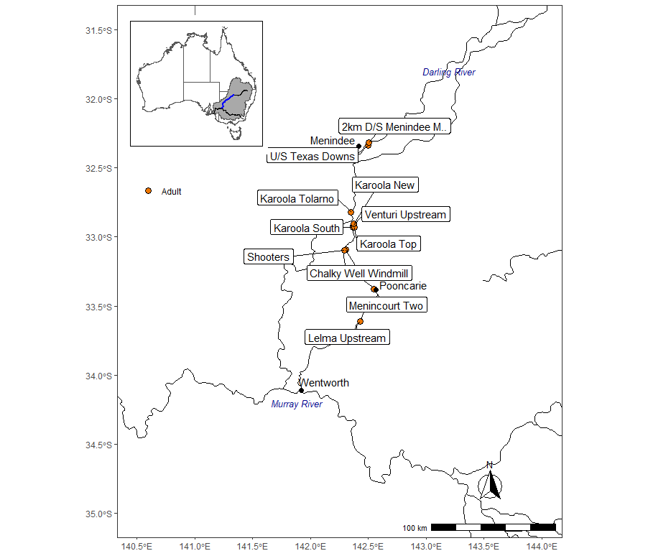

Figure 22. Locations of additional Murray cod adult fin clip samples supplied to increase sample size for genetic analysis.