**Monitoring of waterbird, invertebrate and nutrient responses to environmental water delivery in the Lowbidgee floodplain in 2015-16 and 2016-17**

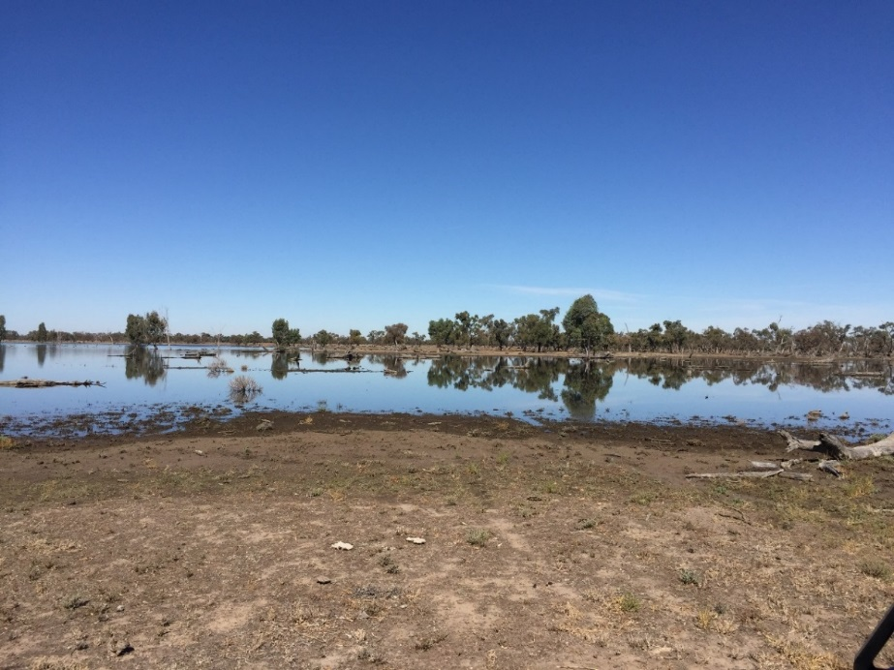

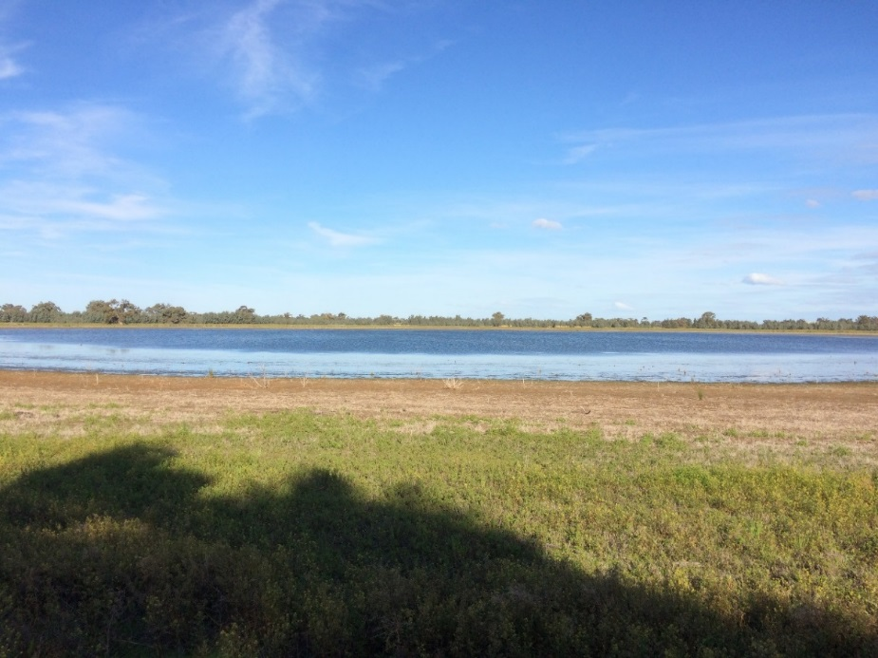

**Monitoring of waterbird, invertebrate and nutrient responses to Commonwealth environmental water delivery in the Lowbidgee floodplain in 2015-16 and 2016-17**

Prepared by: Jenkins, K.a, b, Spencer, J.a,b,c, Wolfenden, B.a, Bino, G.b, Kobayashi, Ta,c,Wassens, S.a,Lenon, E.f, Amos, C.c, Sives, C.b, McPhan, L.b and Hay, S.b

|  |  |
| --- | --- |
| S:\Research\Institute for Land, Water & Society\ILWS Templates and Guidelines\InstLandWaterSociety_LOGOS\InstLandWaterSociety Logo RGB.jpg | a Institute for Land, Water and Society. Charles Sturt University, PO Box 789, Albury, NSW 2640 |
| CES.png | b Centre for Ecosystem Science, University of New South Wales, Sydney, NSW, 2052 |
| OEH2Colour | c Water and Wetlands Team, Science Division, NSW Office of Environment and Heritage, PO Box A290, Sydney South, NSW 1232 |
| TI logo colour rgb | d NSW Trade and Investment Narrandera Fisheries Centre, PO Box 182, Narrandera NSW 2700 |
|  | f Commonwealth Environmental Water Office  GPO Box 787, Canberra ACT 2601 | Australia |

**Funding:** This monitoring project was commissioned and funded by Commonwealth Environmental Water Office with additional cash and in-kind support from the NSW Office of Environment and Heritage, and Charles Sturt University. We are grateful to private landholders for allowing access to their properties.

**Copyright:** © Copyright Commonwealth of Australia, 2017

‘Commonwealth Environmental Water Office Short-Term Intervention Monitoring of the Western Lakes report, 2016-17 is licensed by the Commonwealth of Australia for use under a Creative Commons By Attribution 3.0 Australia licence with the exception of the Coat of Arms of the Commonwealth of Australia, the logo of the agency responsible for publishing the report, content supplied by third parties, and any images depicting people. For licence conditions see: <http://creativecommons.org/licenses/by/3.0/au/>

This report should be attributed as ‘**Monitoring of waterbird, invertebrate and nutrient responses to Commonwealth environmental water delivery in the Lowbidgee floodplain in 2015-16 and 2016-17**. The Commonwealth of Australia has made all reasonable efforts to identify content supplied by third parties using the following format ‘© Copyright, [name of third party] ’.

**Disclaimer:** The views and opinions expressed in this publication are those of the authors and do not necessarily reflect those of the Australian Government or the Minister for the Environment and Energy. While reasonable efforts have been made to ensure that the contents of this publication are factually correct, the Commonwealth does not accept responsibility for the accuracy or completeness of the contents, and shall not be liable for any loss or damage that may be occasioned directly or indirectly through the use of, or reliance on, the contents of this publication.

**Acknowledgement**: The Commonwealth Environmental Water Office acknowledges the efforts of all partners in delivering the Western Lakes Short-Term Intervention Monitoring project and preparing this report. The authors of this report as well as the Commonwealth Environmental Water Office respectfully acknowledge the traditional owners, their Elders past and present, their Nations of the Murray-Darling Basin, and their cultural, social, environmental, spiritual and economic connection to their lands and waters. In particular the Wiradjuri, Narri Narri and Muthi Muthi peoples, traditional owners of the land on which this publication is focused.

Contents

[Executive Summary 6](#_Toc493276708)

[Background 8](#_Toc493276709)

[Project scope and objectives 9](#_Toc493276710)

[Evaluation questions 11](#_Toc493276711)

[Predictions: 12](#_Toc493276712)

[Methods 12](#_Toc493276713)

[Site locations and timing 12](#_Toc493276714)

[Invertebrate, nutrient and water quality sampling 13](#_Toc493276715)

[Waterbird surveys 14](#_Toc493276716)

[Data analyses 15](#_Toc493276717)

[Results 15](#_Toc493276718)

[Water quality responses 15](#_Toc493276719)

[Nutrient responses 16](#_Toc493276720)

[Macroinvertebrate responses 18](#_Toc493276721)

[Microinvertebrate responses 20](#_Toc493276722)

[Waterbird responses 24](#_Toc493276723)

[Discussion 31](#_Toc493276724)

[Adaptive management and recommendations for future water delivery 34](#_Toc493276725)

[Acknowledgements 35](#_Toc493276726)

[References 36](#_Toc493276727)

[Appendices 38](#_Toc493276728)

[Appendix 1 Site locations 38](#_Toc493276729)

[Appendix 2 Wetland-dependent bird species recorded during wetland surveys October 2015 to October 2016 41](#_Toc493276730)

Index of figures and tables

[**Figure 1** Survey sites in the Western Lakes 1) Penarie Creek, 2) Hobblers Lake, 3) Cherax Swamp, 4) Paika Lake (inset) and 5) Wagourah Lake in Yanga National Park. 10](#_Toc497203018)

[**Figure 2** Mean water quality results collected during the present study (Apr-16, Aug-16 and Oct-16) and previous data collected from October 2012-2014 in the Western Lakes (Note that no data prior to 2016 has been collected in Wagourah Lake). Bars are standard error. 16](#_Toc497203019)

[**Figure 3** Chlorophyll-a and nutrient results collected during the present study (Apr-16, Aug-16 and Oct-16) and previous data collected from October 2012-2014 in the Western Lakes (Note that no data prior to 2016 has been collected in Wagourah Lake). Bars are standard error. All values are presented on a log base 10 scale. 17](#_Toc497203020)

[**Figure 4** Model estimates of wetland nutrient (µg/L) and carbon (mg/L) concentrations (log scale) in three previously dry wetlands (Hobblers, Cherax and Penarie) and two previously wet wetlands (Paika and Wagourah) sampled in April, August and October 2016. Model estimates are also provided in Appendix 3. Bars are 95% confidence interval. 18](#_Toc497203021)

[**Figure 5** Model estimates of total macroinvertebrate abundance CPUE (log scale) in three previously dry wetlands (Hobblers, Cherax and Penarie) and two previously wet wetlands (Paika and Wagourah) sampled in April, August and October 2016. Bars are 95% confidence interval. 19](#_Toc497203022)

[**Figure 6** Model estimates of macroinvertebrate taxa abundance CPUE (log 10 scale) following inundation of three previously dry wetlands (Hobblers, Cherax and Penarie) and two previously wet wetlands (Paika and Wagourah) sampled in April, August and October 2016. Bars are 95% confidence interval. 20](#_Toc497203023)

[**Figure 7** Model estimates of benthic microinvertebrate taxa density (individuals/L, log 10 scale) in three previously dry wetlands (Hobblers, Cherax and Penarie) and two previously wet wetlands (Paika and Wagourah) sampled in April, August and October 2016. Bars are 95% confidence interval. 22](#_Toc497203024)

[**Figure 8** Model estimates of pelagic microinvertebrate taxa density (individuals/L, log 10 scale) in three previously dry wetlands (Hobblers, Cherax and Penarie) and two previously wet wetlands (Paika and Wagourah) sampled in April, August and October 2016. Bars are 95% confidence interval. 23](#_Toc497203025)

[**Figure 9** Model estimates of the biovolume (length of individual microinvertebrates x width of individual microinvertebrates x density of total microinvertebrates, (µm2L-1, log scale)) from benthic and pelagic habitats in three previously dry wetlands (Hobblers, Cherax and Penarie) and two previously wet wetlands (Paika and Wagourah) sampled in April, August and October 2016. Bars are 95% confidence interval. 23](#_Toc497203026)

[**Figure 10** Overall waterbird community composition (max count per waterbird guild) observed during surveys of the five wetland sites from April-October 2016. 25](#_Toc497203027)

[**Figure 11** Total waterbird abundance (adjusted as maximum count/surveyed area (ha)) in each of the five wetlands from October 2015-October 2016. Note that no surveys were completed in Wagourah Lake in February 2016 prior to the watering event in April 2016 but surveys were completed at Wagourah Lake (this site only) in December 2015. 25](#_Toc497203028)

[**Figure 12** Total waterbird abundance (adjusted as maximum count/surveyed area (ha)) in each of the five wetlands from April-October 2016. Note the difference in scale for the y-axis between the upper and lower figures. 26](#_Toc497203029)

[**Figure 13** Model estimates of total waterbird abundance, species richness (SPR) and abundance in each waterbird guild in three previously dry wetlands (Hobblers, Cherax and Penarie) and two previously wet wetlands (Paika and Wagourah) sampled in April, August and October 2016. Bars are 95% confidence interval. 29](#_Toc497203030)

[**Figure 14** Model estimates of waterbird species abundance in three previously dry wetlands (Hobblers, Cherax and Penarie) and two previously wet wetlands (Paika and Wagourah) sampled in April, August and October 2016. Bars are 95% confidence interval. 29](#_Toc497203031)

[**Figure 15** Model estimates of previously dry versus wet of waterbird functional guilds surveyed in five wetlands (Hobblers, Cherax, Penarie, Paika and Wagourah) surveyed in April, August and October 2016. Species with a preference for previously dry sites have a negative coefficient whereas species with a preference for previously wet sites have a positive coefficient. Confidence intervals are 95%. 30](#_Toc497203032)

[**Figure 16** Model estimates of previously dry versus wet for waterbird species surveyed in five wetlands (Hobblers, Cherax, Penarie, Paika and Wagourah) surveyed in April, August and October 2016. Species with a preference for previously dry sites have a negative coefficient whereas species with a preference for previously wet sites have a positive coefficient. Confidence intervals are 95%. See species codes in Appendix 2. 30](#_Toc497203033)

[**Table 1** Total abundance CPUE of aquatic macroinvertebrates in previously dry and wet wetlands from the Western Lakes in April, August and October. 18](#_Toc497203092)

[**Table 2** Mean and standard error of total density (individuals/L) of aquatic microinvertebrates in previously dry and wet wetlands from the Western Lakes in April, August and October 2016. 21](#_Toc497203093)

[**Table 3** Maximum count of each waterbird species recorded in the five wetlands in the April-October 2016 surveys. 27](#_Toc497203094)

# Executive Summary

This report presents findings from a collaborative project funded by the Commonwealth Environmental Water Office (CEWO) and led by Charles Sturt University (CSU), the NSW Office of Environment and Heritage (OEH) and the University of New South Wales (UNSW). The aim of this project was to monitor waterbird, nutrient and invertebrate responses to environmental water delivery in the Lowbidgee floodplain, in south-western NSW, in 2015-16 and 2016-17. The CEWO in conjunction with OEH delivered 5000 ML and 910 ML of Commonwealth and NSW environmental water respectively to four sites in the Western Lakes system (Hobblers Lake, Paika Lake, Cherax Lake and Penarie Creek).In addition OEH delivered 966 ML to Wagourah Lake, in March and April 2016. The aim of these watering actions was to create foraging habitat for dabbling ducks and shorebird species that autumn, winter and in the following spring.

We expected environmental water delivered in autumn would inundate previously dry habitats in the wetlands releasing and transporting nutrients that stimulate productivity and diversity of microinvertebrate and macroinvertebrate communities. The success of these watering actions depends on the response of these invertebrate communities which are important food sources for fish, frogs, and waterbirds. Microinvertebrates are the key prey in floodplain river food webs for filter-feeding ducks, and macroinvertebrates are important food sources for other ducks and shorebirds. However, due to cool temperatures with the watering event in autumn, we did not expect as large a response as if the watering action occurred in spring or summer. As the ecological outcomes for waterbirds from watering actions undertaken in autumn are uncertain, this monitoring project was initiated to assess waterbird and invertebrate responses to guide the adaptive management of future watering actions.

Our surveys showed that the delivery of environmental water in autumn can benefit a suite of waterbird species, with more than 33 species detected in our study, as well as high densities of diverse invertebrate prey. We observed increases in both waterbird abundance and diversity in response to the delivery of environmental water in the Lowbidgee Floodplain. Overall, numbers of dabbling and filter feeding duck were higher in wetlands that were dry prior to the delivery of environmental water compared to sites that were already wet. The influx of dabbling and filter feeding ducks coincided with high numbers of microinvertebrate and macroinvertebrate prey following the wetting of the previously dry wetlands. Nutrient levels and water quality supported these responses, although we did not detect a pulse in nutrients in April 2016 as predicted.

Our data showed that although spring is the preferred timing for wetland inundation, there are benefits from delivering environmental water to wetland habitats in autumn. Waterbird numbers pulsed at two of the three newly inundated wetlands, especially compared to the previously wet wetlands. Increasing the area of newly inundated wetland at the start of autumn and winter could enable managers to sustain habitat for waterbirds over winter. If wetlands are filled so they are drying down in spring, the shallow productive edge habitat would support high shorebird numbers. Our study also demonstrated that drying wetlands between environmental watering events triggers a greater response in invertebrate prey. Where possible watering strategies aimed to create feeding habitat for dabbling and filter feeding ducks and shorebird species should account for natural flooding and drying cycles to promote invertebrate food supplies.

By delivering environmental water during autumn months there are also other potential benefits, such as provision of foraging habitat for migratory shorebirds which migrate north during the February-May period. Where habitat is maintained into spring this can potentially provide habitat for migratory shorebird species on their return trip to Australia from August-October. The depth of water is also important for many dabbling duck and shorebird species that feed on the water’s edge as water depth determines the accessibility of invertebrate prey.

# Background

Waterbird numbers have declined since 1983 at key sites across the Murray-Darling Basin (MDB) (Porter *et al.* 2016). Water abstraction and regulation throughout the Basin have reduced the extent and frequency of inundation of wetland habitats (Kingsford and Auld 2005, Kingsford and Thomas 2004). With fewer habitats available less often there are reduced nutrients and food to support waterbirds and fewer opportunities for recruitment. Recognising the role that rivers and wetlands play for waterbirds and other wetland-dependent species in the MDB, the Australian Government has recovered water for the environment through a combination of water purchases, infrastructure investments, and other state and federal recoveries. This environmental water is used to protect and maintain the health of important water dependent ecosystems of the MDB, which includes targeting specific objectives for wetland-dependent species including the provision of feeding and breeding habitat for waterbirds.

More than 120 waterbird species have been recorded in the MDB (MDBA 2014) and this includes threatened waterbird species and species recognised under international bilateral agreements that Australia has signed with Japan, China and the Republic of Korea. Many of these waterbird species are highly responsive to flows and rely on a network of wetland habitats within and outside of the MDB. The availability of shallow wetland habitat in spring and autumn also coincides with the movement of migratory shorebird species through south-eastern Australia during their non-breeding season.They can move to newly flooded wetland habitats to exploit aquatic food resources which can be highly variable in space and time (Kingsford and Norman 2002).

Both microinvertebrates and macroinvertebrates provide food resources for many waterbird species, and these invertebrates respond strongly to inundation (Jenkins and Boulton 2003). Booms in invertebrates following flooding are fuelled by their emergence from dormant egg-banks that reside in floodplain soils (Jenkins and Boulton 2007), and by the release of nutrients from newly inundated floodplain sediments that supports both primary and secondary production (Junk et al. 1989). Microinvertebrates are the key prey in floodplain river food webs for filter-feeding ducks, and macroinvertebrates are important food sources for other dabbling ducks and shorebirds (small waders) (Timms 1996; Briggs *et al.* 1985).

The link between waterbirds and their food supply is used to classify them into functional groups (guilds) according to their water requirements for feeding (see Brandis *et al.* 2009). Water depth is a key driver for habitat use by waterbirds. For example, large waders such as spoonbills tend to feed in shallow vegetated floodplain habitats, while fish-eating waterbirds can forage in deeper more open waterbodies, and small waders which include migratory and resident shorebird species, and dabbling ducks prefer open shallow waterbodies with muddy shorelines. Water depth and duration are key ecological variables that can be manipulated using environmental water. The timing of flows is also critical for the succession of waterbird guilds. Depending on season both inundation and recession may trigger a different succession depending on season of the nutrients, plants and animals that support waterbird food webs (e.g. Taft *et al.* 2002). For example, the timing and rate of drawdown in water levels determine whether critical shallow water and exposed mudflat habitat is available. In this study, we examined whether environmental watering of wetland habitats in autumn supports abundant populations of waterbirds and invertebrates in autumn, winter or the subsequent spring. We also investigated whether the response in waterbirds and invertebrates differed between wetlands that were dry at the time of inundation compared to wetlands that were already wet.

## Project scope and objectives

This is a collaborative project led by Charles Sturt University (CSU), the NSW Office of Environment and Heritage (OEH) and the University of New South Wales (UNSW). The aim of this project was to monitor waterbird, nutrient and invertebrate responses to environmental water delivery in the Lowbidgee floodplain, in south-western NSW, in 2015-16 and 2016-17. In March and April 2016, the Commonwealth Environmental Water Office (CEWO) in conjunction with OEH delivered 5000 ML and 910 ML of Commonwealth and NSW environmental water respectively to four sites in the Western Lakes system (Hobblers Lake, Penarie Creek, Paika Lake and Cherax Lake see Figure 1). In addition OEH delivered 966 ML to Wagourah Lake (see Figure 1 and Appendix 1), in March and April 2016. The aim of these watering actions was to create foraging habitat for dabbling ducks and shorebird species in the following spring 2016.

We expected environmental water delivered in autumn would inundate previously dry habitats in the wetlands releasing and transporting nutrients that stimulate productivity and diversity of microinvertebrate and macroinvertebrate communities. However, due to cool temperatures with the watering event in autumn, we did not expect as large a response as would be expected if the watering action occurred in spring or summer. As the ecological outcomes for waterbirds from watering actions undertaken in autumn are uncertain, this monitoring project was initiated to assess waterbird and invertebrates to guide the adaptive management of future watering actions. At the time of watering three wetlands (Hobblers, Penarie and Cherax) were dry and two wetlands (Paika and Wagourah) were wet. We expected a larger response from biota in the previously dry than wet wetlands.

Within the Lowbidgee, floodplain wetlands in the Western Lakes, Nimmie-Caira and Redbank wetland zones, are widely recognised for their importance for waterbirds including shorebird species (MDBA 2014). Shorebird species that have been recorded in the wetlands include migratory sharp-tailed sandpipers Calidris acuminate (listed under migratory bird agreements Australia has with Japan (Japan-Australia Migratory Bird Agreement (JAMBA)), China (China-Australia Migratory Bird Agreement (CAMBA)) and the Republic of Korea (Republic of Korea-Australia Migratory Bird Agreement (ROKAMBA))), and Australian resident shorebirds including dotterels and stilts (see Appendix 2).

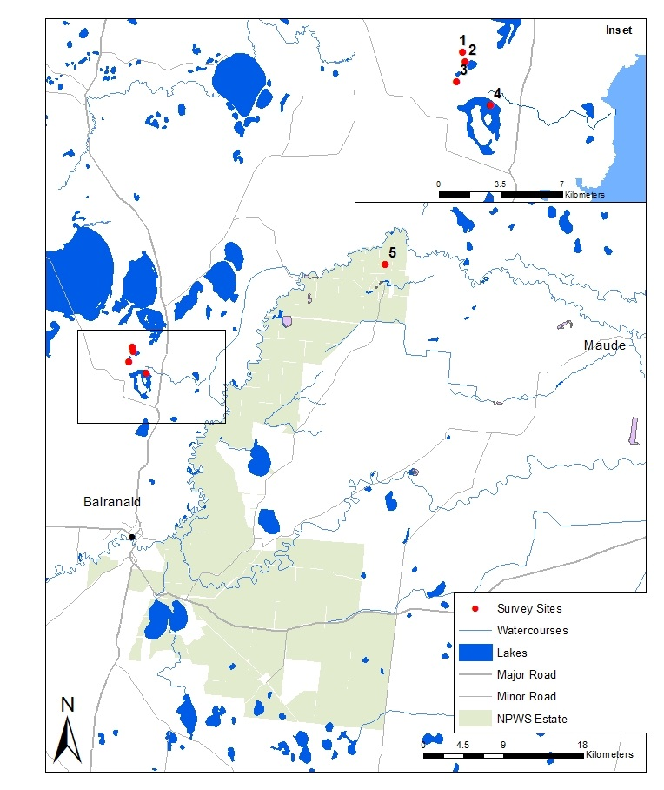

**Figure 1** Survey sites in the Western Lakes 1) Penarie Creek, 2) Hobblers Lake, 3) Cherax Swamp, 4) Paika Lake (inset) and 5) Wagourah Lake in Yanga National Park.

A key objective of the 2015-16 Commonwealth environmental watering actions through the Western Lakes, Redbank and Nimmie-Caira zones, in relation to waterbirds was “*the provision of suitable habitat for waterbirds, native fish and frogs and improvements in riparian vegetation*”. The success of these watering actions depends on the response of macro- and microinvertebrate communities which are important food sources for fish, frogs, and waterbirds. Microinvertebrates are the key prey in floodplain river food webs for filter-feeding ducks, and macroinvertebrates are important food sources for other ducks and shorebirds.

Both micro- and macroinvertebrates respond strongly to flow pulses and inundation, mediated by antecedent conditions and season. Pulses in invertebrates following inundation are fuelled by the release of nutrients and subsequent primary production and microbial activity. The key objectives of the 2015-16 Commonwealth environmental watering actions that relate to micro- and macroinvertebrates and nutrients in wetlands were to “*provide habitat to support the survival and maintain condition of native fish, waterbirds, and other aquatic vertebrates*.”

## Evaluation questions

The aim of this short-term intervention monitoring project was to evaluate the contribution of environmental water to waterbird communities in the Lower Murrumbidgee and inform future water deliveries to enhance foraging opportunities for waterbird species (namely dabbling ducks and shorebirds) that feed on invertebrate prey. The primary actions in early autumn 2016 were to water five sites in the Lowbidgee floodplain (see **Figure 1**). Monitoring was undertaken to determine how invertebrate and waterbird communities responded to these watering actions and to determine whether watering sites in autumn can promote sufficient food supplies to support dabbling duck and shorebird species, and other waterbirds in autumn, winter or the subsequent spring months when waterbird and invertebrate activity is likely to be greater in response to warmer day time temperatures.

The specific evaluation questions for this project were:

1. What did environmental water contribute to waterbird populations in nominated wetlands?
2. What did environmental water contribute to waterbird species diversity in nominated wetlands?
3. What did environmental water contribute to concentrations of nutrients in nominated wetlands?
4. What did environmental water contribute to microinvertebrate productivity and diversity in nominated wetlands?
5. What did environmental water contribute to macroinvertebrate diversity and productivity in nominated wetlands?

We predicted there would be the following responses to the delivery of environmental water.

## Predictions:

* Local increases in waterbird diversity in response to environmental watering
* Local increases in waterbird abundance in response to environmental watering
* Local increases in waterbird species of conservation significance (i.e. threatened species, JAMBA, CAMBA and ROKAMBA species) in spring in response to environmental watering in previous months (autumn-winter).
* Nutrient availability will increase in response to delivery of environmental water.
* Environmental water delivered to wetlands will transport microinvertebrates as well as trigger their emergence, establishing communities with densities and community composition changing over time in relation to wetland filling and draw-down.
* Environmental water delivered to wetlands in autumn will stimulate increased productivity and diversity of macroinvertebrates and microinvertebrates in the following spring when waterbird and invertebrate activity is likely to be greater in response to warmer day time temperatures.

# Methods

## Site locations and timing

The Western Lakes is a 3,459 ha complex of open lakes in the Lowbidgee floodplain (**Figure 1**). These lakes along with similar lake systems in the Nimmie-Caira and Redbank zones are recognised as significant environmental assets within the Murray-Darling Basin and were identified in the Monitoring and Evaluation Plan for the Murrumbidgee Selected Area as part of the Long-Term Intervention Monitoring (LTIM) program (Wassens et al. 2014). The Western Lakes and associated open lake systems in the Redbank and Nimmie-Caira zones are not routinely monitored by the Murrumbidgee LTIM program and therefore additional funding is required to monitor outcomes of Commonwealth environmental water delivery.

Environmental water was delivered to four wetland sites, Paika Lake, Penarie Creek, Cherax Swamp and Hobblers Lake, in the Western Lakes (15/3/16 – 13/4/16, 5,000 ML of Commonwealth and 910 ML of NSW environmental water) and Wagourah Lake (29/3/16 – 9/4/16, 966 ML of NSW environmental water) in Yanga National Park in autumn 2016. Cherax Swamp, Penarie Creek and Hobblers Lake are managed as ephemeral wetlands that are dried on a relatively frequent basis. Paika Lake is one of the deepest lakes in the Lowbidgee floodplain and can potentially hold water for more than two years (Sharpe and Dyer 2016).The first delivery of environmental water to Paika Lake occurred during the winter of 2011 and subsequent top up flows occurred in May 2013, May 2014 and June 2015.

Paika Lake and Wagourah Lake were wet prior to the delivery of environmental water in autumn 2016, while Penarie Creek, Cherax Swamp and Hobblers Lake were dry. Hobblers Lake and Penarie Creek previously received environmental water from October-December 2013, while Cherax received inflows in November 2015.

Wetland monitoring following the flow events was undertaken during three survey periods: 13-15 April, 3-5 August and 17-19 October 2016 (see site locations in Figure 1 and Appendix 1). Ground surveys for waterbirds were completed in April, August and October 2016 following the watering of the Western Lakes and Wagourah Lake over March and April 2016. The waterbird diversity and abundance data was collected alongside simultaneous macroinvertebrate, microinvertebrate and nutrient sampling in the five survey wetland sites (). Waterbird surveys were completed at all five wetland sites during the three survey periods. Invertebrate, nutrient and water quality sampling was completed at all five wetland sites in the April and August survey periods, and three wetland sites during the October survey period. Penarie Creek and Cherax Swamp dried down between the August and October surveys and so water quality, invertebrate and nutrient sampling was not completed at these sites during the October surveys.

## Invertebrate, nutrient and water quality sampling

Water samples were collected using the same methods as those used in the Murrumbidgee LTIM project (Wassens *et al.* 2014) for Total Phosphorus (TP), Total Nitrogen (TN) and Dissolved Organic Carbon (DOC). Samples were processed in the National Association of Testing Authorities, Australia (NATA) accredited laboratory at Monash University. Chlorophyll A samples were processed at the NATA accredited Environmental and Analytical Laboratory (CSU Wagga Wagga). In contrast with LTIM methods designed to assess overall nutrient concentrations, additional sampling of bio-available nutrients was undertaken to address short term monitoring objectives relating to the short-term release and accrual of bio-available nutrients, and to determine whether drying leads to higher concentrations of available nutrients upon inundation. Food availability in spring is associated with increased production afforded by the leaching of bio-available nutrients. In addition, high ammonia concentrations have been previously reported for lakes in the Lowbidgee and may present an ecological health hazard (particularly under high pH) that could be adaptively managed using top-up flows. Lakes also have high concentrations of algae and are prone to blooms of cyanobacteria - total and bio-available nutrients would help explain patterns of algae accrual and risk of blue-green algal (BGA) blooms.

At each wetland site, a water quality sample was taken from each of three sub-sites to estimate variation within a wetland site. For the largest site Paika Lake, the three sub sites were located within an equivalent sized area (approx. 5 ha) in the wetland site (as per Halse *et al.* 2000) so that all wetland sites were equivalent in size. NSW OEH waterbird data collected from 2008-2015 was used to determine areas frequented by dabbling ducks and shorebirds within the lakes so as to guide sampling locations. At one sub-site within each wetland, three filtered (0.45 µm) water samples were collected for analysis of DOC and bio-available nutrients comprising ammonia nitrogen (NH3 or Amm),oxidised nitrogen (NOx) and Filterable Reactive Phosphorus (FRP) as well as Total Dissolved Nitrogen (TDN), Total Dissolved Phosphorus (TDP) and Chlorophyll A. Three unfiltered samples were analysed for TN and TP. Spot measurements of pH and conductivity were undertaken with a calibrated sensor.

Specimens of benthic and pelagic microinvertebrates were collected using the quantitative techniques followed for LTIM (Wassens *et al.* 2014), except three sub-sites within a wetland were sampled rather than one sub-site as with the methods used in LTIM. The addition of two extra sub-sites were sampled to estimate the variability within a wetland site. With LTIM sampling, four sites (wetlands) are sampled in a region and our replication is at the site level. Variation within a site is averaged across sites. However, as this environmental watering inundated three lakes and one creek it was not possible to replicate at the site (wetland) scale and without sub-sites there is a risk of sampling at a low or high density part of the lake and getting an inaccurate estimate of productivity. A composite benthic sample of 5 benthic cores was collected at three sub-sites within each site. A composite pelagic sample of 10 x 9 litre buckets was collected at three sub-sites within each site. Samples were processed in the laboratory using the same approach as with LTIM, with the channels within the Bogorov counting tray divided into 1-cm cells and individuals in every second cell enumerated and identified. The lengths and widths of first 10 individuals of each taxa were measured to calculate invertebrate biovolume (length x width x density, where density is measured in individuals per litre).

Macroinvertebrates were sampled using a sweep net to gather one composite sample from each wetland site comprising sweeps from the main habitats available (e.g. fringing vegetation, course woody debris, open water and benthic samples). Benthic macroinvertebrate samples were taken by disturbing sediments while sweeping. Sweeps were taken over a 6 x 2 meter area per site to standardise sampling effort between wetland sites. Data were recorded as a single value per taxa for each site (wetland) and sampling event (i.e. total catch for each taxa from a site was pooled from a range of habitats) and are represented as catch per unit effort (CPUE; macroinvertebrate abundance per 6 x 2 m composite sweep sample from a range of habitats).

## Waterbird surveys

Waterbirds were monitored using the ground survey techniques followed for the Murrumbidgee LTIM project (Wassens *et al.* 2014) and by OEH during ground surveys across inland wetlands in NSW (Spencer *et al*. 2014; 2016). Two replicate ground counts (am, pm) were conducted over two separate days within the three survey periods to estimate maximum total waterbird abundance and species diversity in each survey wetland. Birds were observed using binoculars and/or a telescope. Total counts for each waterbird species, any evidence of breeding activity (including number of nests/ broods/ immatures) were recorded during each survey. Observers spent at least 20 minutes at each survey site. Site coverage (in hectares) was estimated for each site and used to calculate total abundance per hectare for subsequent analyses.

Additional surveys were completed by NSW OEH as part of annual monitoring in the five wetlands prior to autumn environmental watering in October 2015 (all five sites), December 2015 (Wagourah Lake only), and February 2016 (all sites except Wagourah Lake). This data was used to compare waterbird responses prior to and after the environmental watering in April 2016. Maximum waterbird abundances from each AM\PM replicate were summed across subsites to provide a total measure for each wetland and then divided by total survey area to calculate total number of birds per hectare.

## Data analyses

We analysed responses of invertebrates and waterbirds in relation to antecedent condition (i.e., dry or wet) along with month and wetland by fitting a linear mixed-effects model (LMM) using the lmer function in the lme4 package in R (Bates et al., 2015; R version 3.2.1, R Core Team, 2015). Antecedent conditions and month were incorporated as an interaction term to account for different responses over time while wetland was a random effect in the model. Prior to analysis, all our response variables except pH were ln(x+1) transformed to reduce skewness and stabilize error variances. We tested the effects of water quality and nutrient metrics on invertebrate responses by incorporating an additional and separate continuous term to the linear mixed-effects model. To draw generalizations about the effects of antecedent conditions (i.e., dry or wet) and month from the samples collected, we present model estimates of responses for ease of interpretation and inference. Model estimates are presented in Appendix 3.

# Results

## Water quality responses

Dissolved oxygen largely remained within the normal range for floodplain wetlands (>4mg/L), trending slightly below 4 mg/L at Waugorah Lake (during all sample occasions) and at Hobbler’s Lake during the April 2016 survey (Figure 2). Values in excess of 10 mg/L are commonly reported for wetlands in the Murrumbidgee and at the Western Lakes. pH was largely consistent for individual sites across time, with small differences among the survey sites (Figure 2). During the present study, pH was significantly lower during April 2016 across all sites, averaging 7.00 (+/-S.E. 4.16) in the April, 8.75 (+/- S.E. 3.82) in the August and 8.30 (+/- S.E. 5.49) in the October sampling. Electrical conductivity (EC) was most consistent at Hobblers and Paika Lakes. There is a slight trend of increasing EC at Paika Lake across time (Figure 2). Previous data has shown that it is rare for EC to exceed 0.8 mS/cm. Previous data and results of turbidity testing from this study all fell within the normal range for wetlands in the Murrumbidgee Catchment. Paika Lake consistently showed the highest turbidity across the five sampled wetlands (Figure 2).

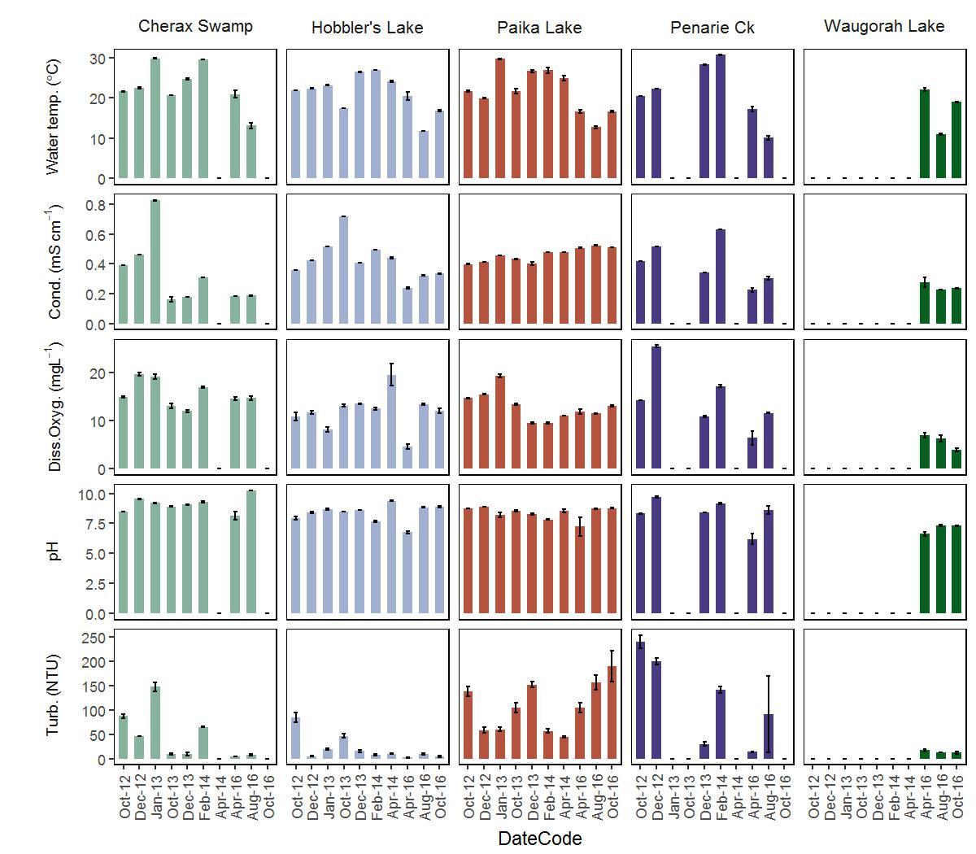

**Figure 2** Mean water quality results collected during the present study (Apr-16, Aug-16 and Oct-16) and previous data collected from October 2012-2014 in the Western Lakes (Note that no data prior to 2016 has been collected in Wagourah Lake). Bars are standard error.

## Nutrient responses

Overall, the concentrations of TN, TP and DOC were less variable than concentrations of bio-available nutrients. Excluding Cherax Swamp, all sites showed occasional spikes in NH3 and NOx. Overall Hobblers Lake contained significantly higher concentrations of NH3. The sampling from 2016 and previous data collected for Hobblers Lake shows that this site often has higher concentrations of bio-available nutrients, particularly FRP, than other sites in the Western Lakes system (Figure 3). We found no evidence of increased nutrient concentrations at previously dry vs previously inundated sites (Figure 4).

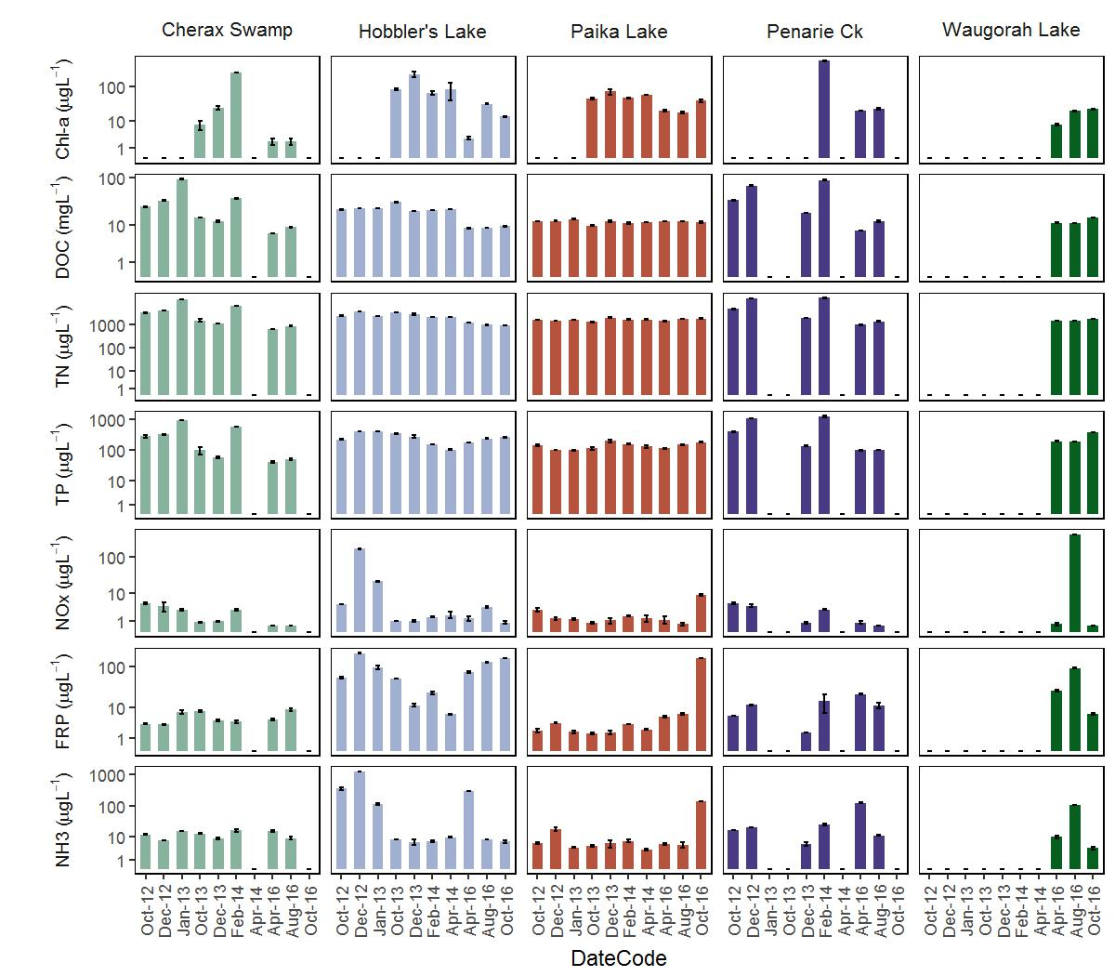

**Figure 3** Chlorophyll-a and nutrient results collected during the present study (Apr-16, Aug-16 and Oct-16) and previous data collected from October 2012-2014 in the Western Lakes (Note that no data prior to 2016 has been collected in Wagourah Lake). Bars are standard error. All values are presented on a log base 10 scale.

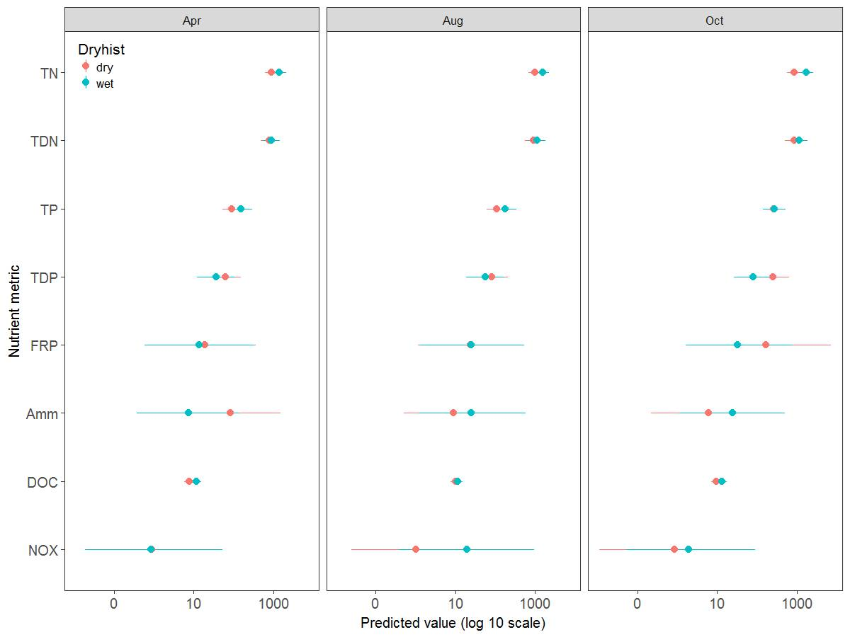

**Figure 4** Model estimates of wetland nutrient (µg/L) and carbon (mg/L) concentrations (log scale) in three previously dry wetlands (Hobblers, Cherax and Penarie) and two previously wet wetlands (Paika and Wagourah) sampled in April, August and October 2016. Model estimates are also provided in Appendix 3. Bars are 95% confidence interval.

## Macroinvertebrate responses

Following the inundation of wetlands in the Western Lakes zone with environmental water, a total of 171 aquatic macroinvertebrate taxa were collected from the five wetlands sampled. In April the highest abundances recorded were from the previously dry wetlands, particularly Cherax and Hobblers Lakes (Table 1). Abundances in the previously wet wetlands were generally low (~100 CPUE), apart from Wagourah Lake where abundances were an order of magnitude higher in October (Table 1). Wagourah Lake received overbank natural flooding in late September-early October, whereas Paika and Hobblers did not offering a possible explanation for this pattern.

**Table 1** Total abundance CPUE of aquatic macroinvertebrates in previously dry and wet wetlands from the Western Lakes in April, August and October.

|  |  |  |  |  |
| --- | --- | --- | --- | --- |
| **Wetland** | **Antecedent condition** | **April** | **August** | **October** |
| Cherax Lake | Dry | 1078 | 743 | 1. dry |
| Hobblers Lake | Dry | 716 | 90 | 104 |
| Penarie Creek | Dry | 181 | 556 | 1. dry |
| Paika Lake | Wet | 129 | 89 | 47 |
| Wagourah Lake | Wet | 16 | 75 | 1094 |

The abundance of macroinvertebrates was marginally greater in previously dry wetlands in April and August 2016 compared to previously wet wetlands (Figure 5). In contrast, in October 2016 two of the previously dry wetlands were dry (Cherax and Penarie) with inferred zero abundance of aquatic macroinvertebrates. At this time, macroinvertebrates were more abundant in the previously wet wetlands (Figure 5). A significant reduction in macroinvertebrates in previously dry wetlands was observed in October. This was due in part to two of these wetlands being dry, with Hobblers Lake the only previously dry wetland remaining wet with an abundance around 100 CPUE (Table 1).

The differences observed in total abundance were driven by Anisops (backswimmers), micronecta (water boatmen), chironomids and hydracarina (water mites) that were more abundant in previously dry wetlands in April (Figure 6). In August a number of other taxa contributed, but by October these taxa all tended to be more abundant in the previously wet wetlands (Figure 6).

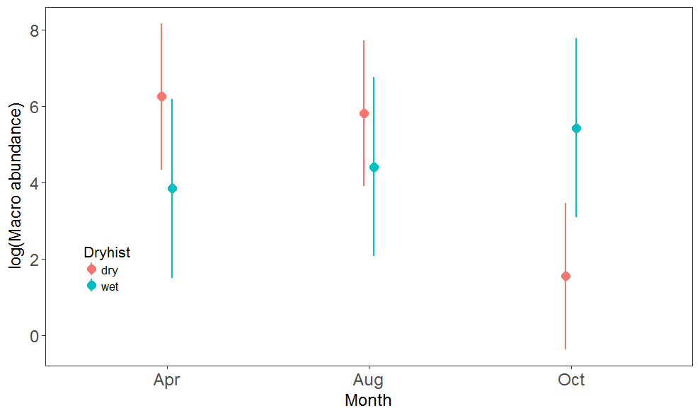

**Figure 5** Model estimates of total macroinvertebrate abundance CPUE (log scale) in three previously dry wetlands (Hobblers, Cherax and Penarie) and two previously wet wetlands (Paika and Wagourah) sampled in April, August and October 2016. Bars are 95% confidence interval.

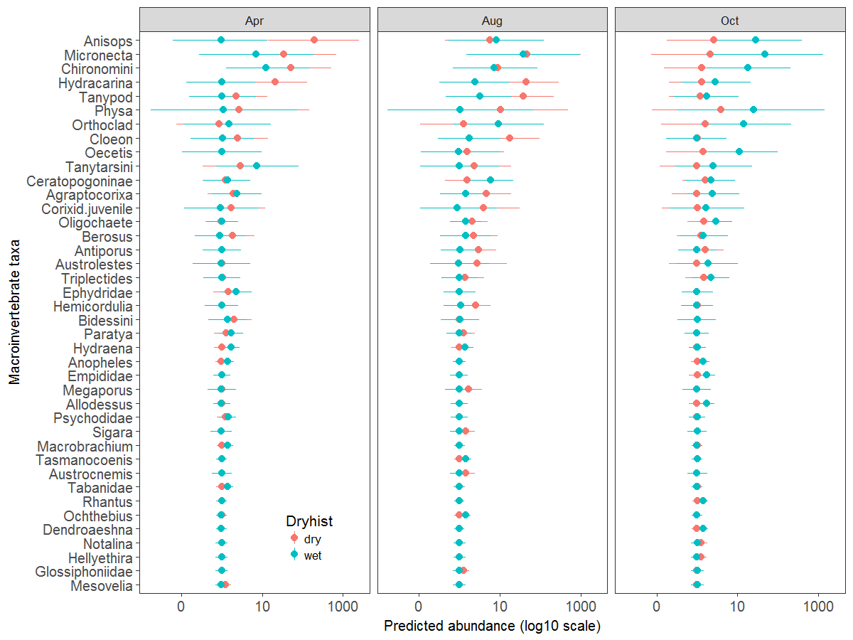

**Figure 6** Model estimates of macroinvertebrate taxa abundance CPUE (log 10 scale) following inundation of three previously dry wetlands (Hobblers, Cherax and Penarie) and two previously wet wetlands (Paika and Wagourah) sampled in April, August and October 2016. Bars are 95% confidence interval.

## Microinvertebrate responses

Following the inundation of wetlands in the Western Lakes zone with environmental water, the density of benthic microinvertebrates was significantly higher in previously dry wetlands in April 2016 compared to previously wet wetlands (t=1.9, p=0.09,Figure 7). Pelagic microinvertebrates showed the same trend, but the difference was not significant (Figure 8). This pattern persisted in the pelagic habitat in August, but was reversed for all metrics in both habitats by October 2016 when two of the previously dry wetlands (Cherax and Penarie) were dry (with inferred zero abundance) (Figure 7 and Figure 8). At this time the mean benthic density in Hobblers Lake, the only previously dry wetland that remained wet, was 99.6 individuals/L in October compared to 4294.3 individuals/L in April and 196.9 individuals/L in August. In previously dry wetlands, microinvertebrate density was significantly lower in October compared with previous months, with the drying of two of these wetlands contributing to this outcome. In the previously wet wetlands productive densities (more than 500 individuals/L) of benthic copepods and chydorid cladocerans were present in August in Wagourah Lake (Figure 7 and Figure 8). The mean benthic density in August 2016 in Wagourah Lake was similar to that observed in the previously dry Cherax Lake (Table 2). The highest density recorded in this study at Paika Lake occurred in August 2016 (399.5 individuals/L) when a density of 831 individuals/L was observed in one site (Table 2).

**Table 2** Mean and standard error of total density (individuals/L) of aquatic microinvertebrates in previously dry and wet wetlands from the Western Lakes in April, August and October 2016.

|  |  |  |  |  |  |  |  |
| --- | --- | --- | --- | --- | --- | --- | --- |
| **Wetland** | **Antecedent condition** | **April 2016**  **Benthic** | **April 2016 Pelagic** | **August 2016 Benthic** | **August 2016 Pelagic** | **October 2016 Benthic** | **October 2016 Pelagic** |
| Cherax Lake | Dry | 4254.1+2959.1 | 445.3+110.4 | 1412.6+446.4 | 531.3+500.9 | 0 (Dry) | 0 (Dry) |
| Hobblers Lake | Dry | 4294.3+2966.8 | 472.4+278.1 | 196.9+43.0 | 25.5+4.5 | 99.6+26.1 | 51.1+3.2 |
| Penarie Creek | Dry | 1567.6+606.6 | 405.8+28.9 | 194.1+93.9 | 84.7+15.6 | 0 (Dry) | 0 (Dry) |
| Paika Lake | Wet | 81.5+25.7 | 12.9+4.6 | 399.5+253.0 | 33.6+2.9 | 89.4+55.5 | 36.7+9.6 |
| Wagourah Lake | Wet | 311.3+118.8 | 251.9+129.4 | 1023.2+359.7 | 42.1+15.9 | 198.3+58.9 | 117.2+19.6 |

The differences observed in total benthic density were driven by copepods at densities greater than 200 individuals/L (calanoid, naupli and cyclopoids) and a number of cladocerans including *Bosmina meriodonalis*, *Ceriodaphnia* sp., *Daphnia* sp. *Macrothrix* sp., *Daphnia carinata*, *Moina micrura*, *Daphnia projecta* and *Diaphanosoma excisum* that were more abundant in previously dry wetlands in April (**Figure 7**). The difference was significant only for *Bosmina meriodonalis* recorded at extremely high densities (1000 to 10,000 individuals/L), reflected also in the pelagic habitat (**Figure 7** and **Figure 8**). Similar taxa drove the pattern in the pelagic habitat including ostracods and *Daphnia lumholtzi* that was significantly higher in previously dry wetlands in April compared to previously wet wetlands (**Figure 8**).

Patterns in benthic and pelagic microinvertebrate biovolume reflected those for density, with only benthic biovolumes significantly higher in previously dry habitats in April 2016 (t=2.5, p=0.03, **Figure 9**). By August, benthic biovolume increased in previously wet wetlands before returning to April levels in October 2016 (**Figure 9**). Biovolume tended to be higher in previously wet wetlands from August (**Figure 9**).

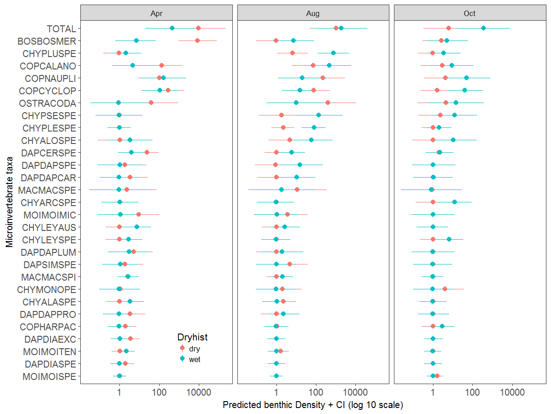

**Figure 7** Model estimates of benthic microinvertebrate taxa density (individuals/L, log 10 scale) in three previously dry wetlands (Hobblers, Cherax and Penarie) and two previously wet wetlands (Paika and Wagourah) sampled in April, August and October 2016. Bars are 95% confidence interval.

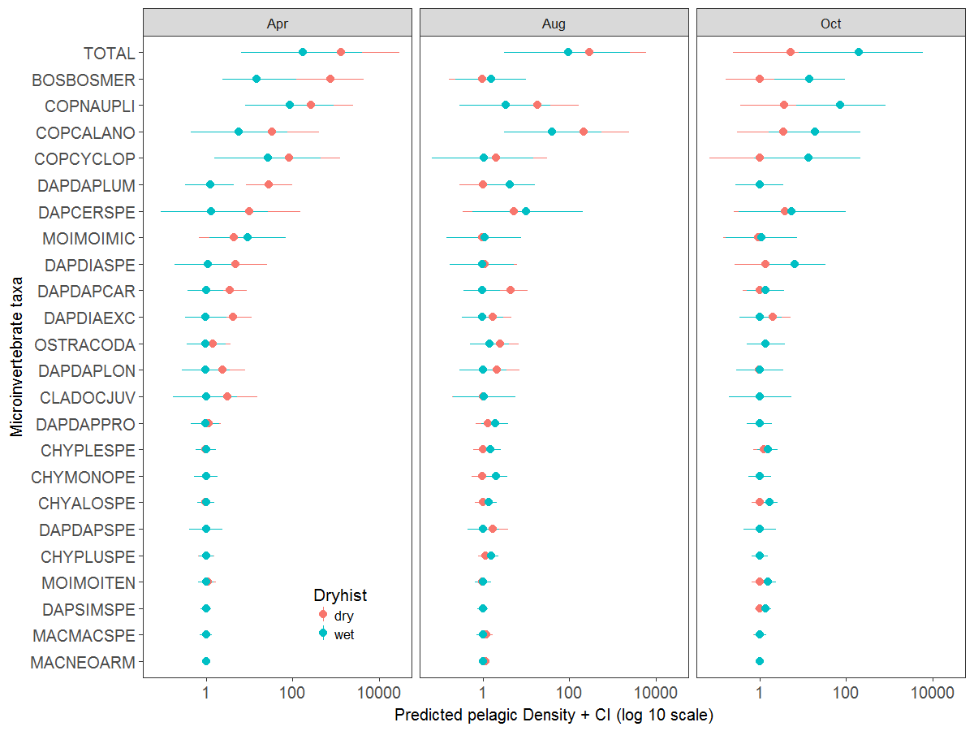

**Figure 8** Model estimates of pelagic microinvertebrate taxa density (individuals/L, log 10 scale) in three previously dry wetlands (Hobblers, Cherax and Penarie) and two previously wet wetlands (Paika and Wagourah) sampled in April, August and October 2016. Bars are 95% confidence interval.

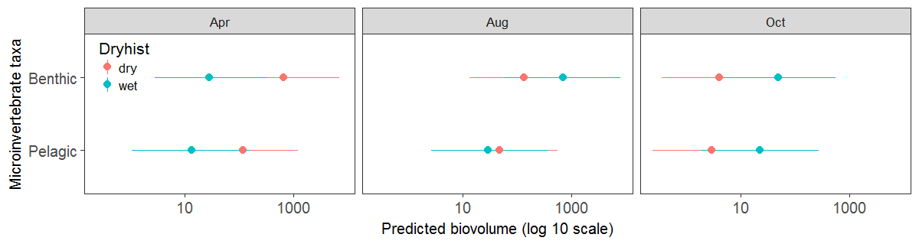

**Figure 9** Model estimates of the biovolume (length of individual microinvertebrates x width of individual microinvertebrates x density of total microinvertebrates, (mm2L-1, log scale)) from benthic and pelagic habitats in three previously dry wetlands (Hobblers, Cherax and Penarie) and two previously wet wetlands (Paika and Wagourah) sampled in April, August and October 2016. Bars are 95% confidence interval.

## Waterbird responses

In total 33 waterbird species were observed across the five surveyed wetlands (). This included blue-billed duck *Oxyura australis*(a diving duck species) which is listed as vulnerable in NSW (*Threatened Species Act 1995*), and JAMBA-listed Caspian tern *Hydroprogne caspia* and eastern great egret *Ardea alba modesta* (both fish-eating waterbird species). Hobblers Lake supported threatened blue-billed duck during both the April and August 2016 surveys ().

The newly watered Hobblers Lake and Penarie Creek supported diverse waterbird assemblages including target species from the dabbling duck, filter-feeding and shorebird guilds ( ,). Dabbling and filter feeding ducks made up more than 70% of total waterbird numbers in Penarie Creek and Hobblers Lake, while resident shorebirds at their peak density only made up more than 5% of site composition for Cherax Swamp, Paika Lake and Penarie Creek (). Resident shorebird species detected in the survey area in the 2016 surveys included small numbers of black-winged stilt *Himantopus himantopus* and black-fronted dotterel *Elseyornis melanops.* Although no migratory shorebirds were detected at the survey sites during the April-October 2016 surveys which followed the environmental watering, small numbers of migratory shorebirds were detected in the months prior. Sharp-tailed sandpipers were detected at Paika Lake during surveys in October 2015 and red-necked stint Calidris ruficollis were detected at Paika Lake during surveys in February 2016.

The wetlands also supported diverse assemblages of non-target species from the other waterbird guilds. Fish-eating waterbirds (Piscivores) were observed at all sites, and made up the greatest proportion of waterbird communities at the deeper Paika and Wagourah Lakes. Large waders (ibis and spoonbills) were only observed in Cherax Swamp, Penarie Creek and Paika Lake. Grazing waterfowl and diving ducks were seen in small numbers at all five wetland sites ().

Total numbers of waterbirds and total numbers of waterbird species changed in response to the delivery of environmental water ( and ). There was a large influx of dabbling and filter feeding ducks recorded in the newly inundated habitats in Hobblers Lakes and Penarie Creek in April 2016. In total, more than 650 pink-eared ducks *Malacorhynchus membranaceus* were recorded in Hobblers Lake and over 1300 grey teal *Anas gracilis* were observed in Penarie Creek during the April surveys. Large waders were also observed feeding in Cherax Swamp as it dried down in late winter (during the August surveys) including ibis and spoonbills (). Surveys in February 2016, prior to the delivery of environmental water, indicated that Hobblers Lake and Penarie Creek were dry and did not support any waterbird species ().

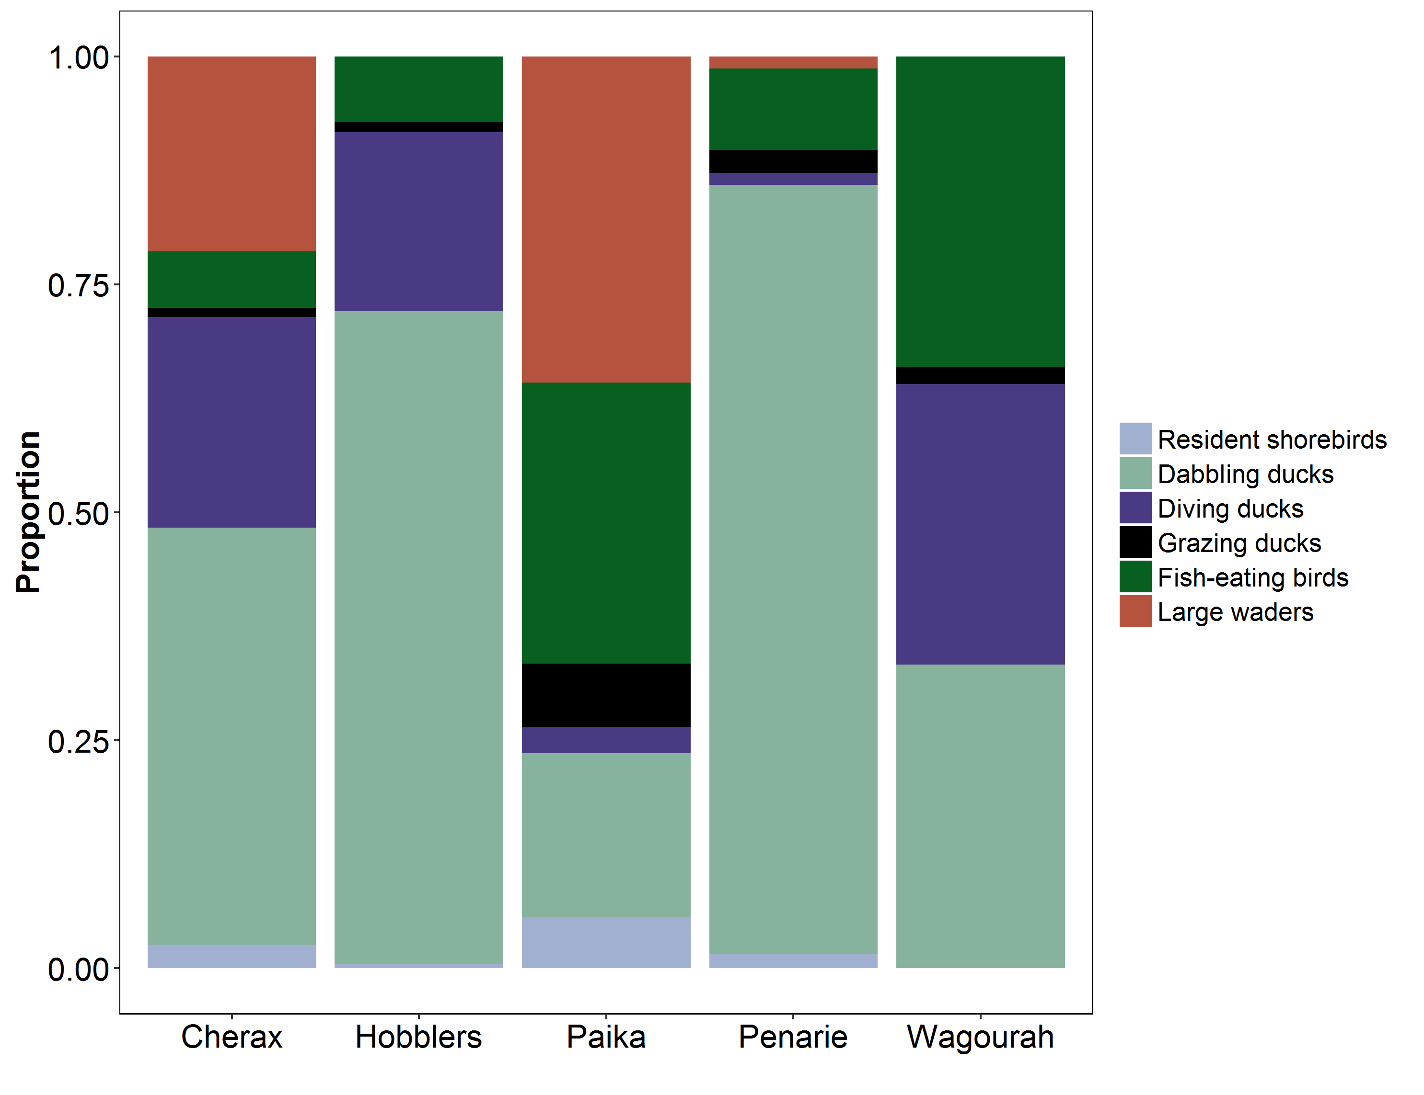

**Figure 10** Overall waterbird community composition (max count per waterbird guild) observed during surveys of the five wetland sites from April-October 2016.

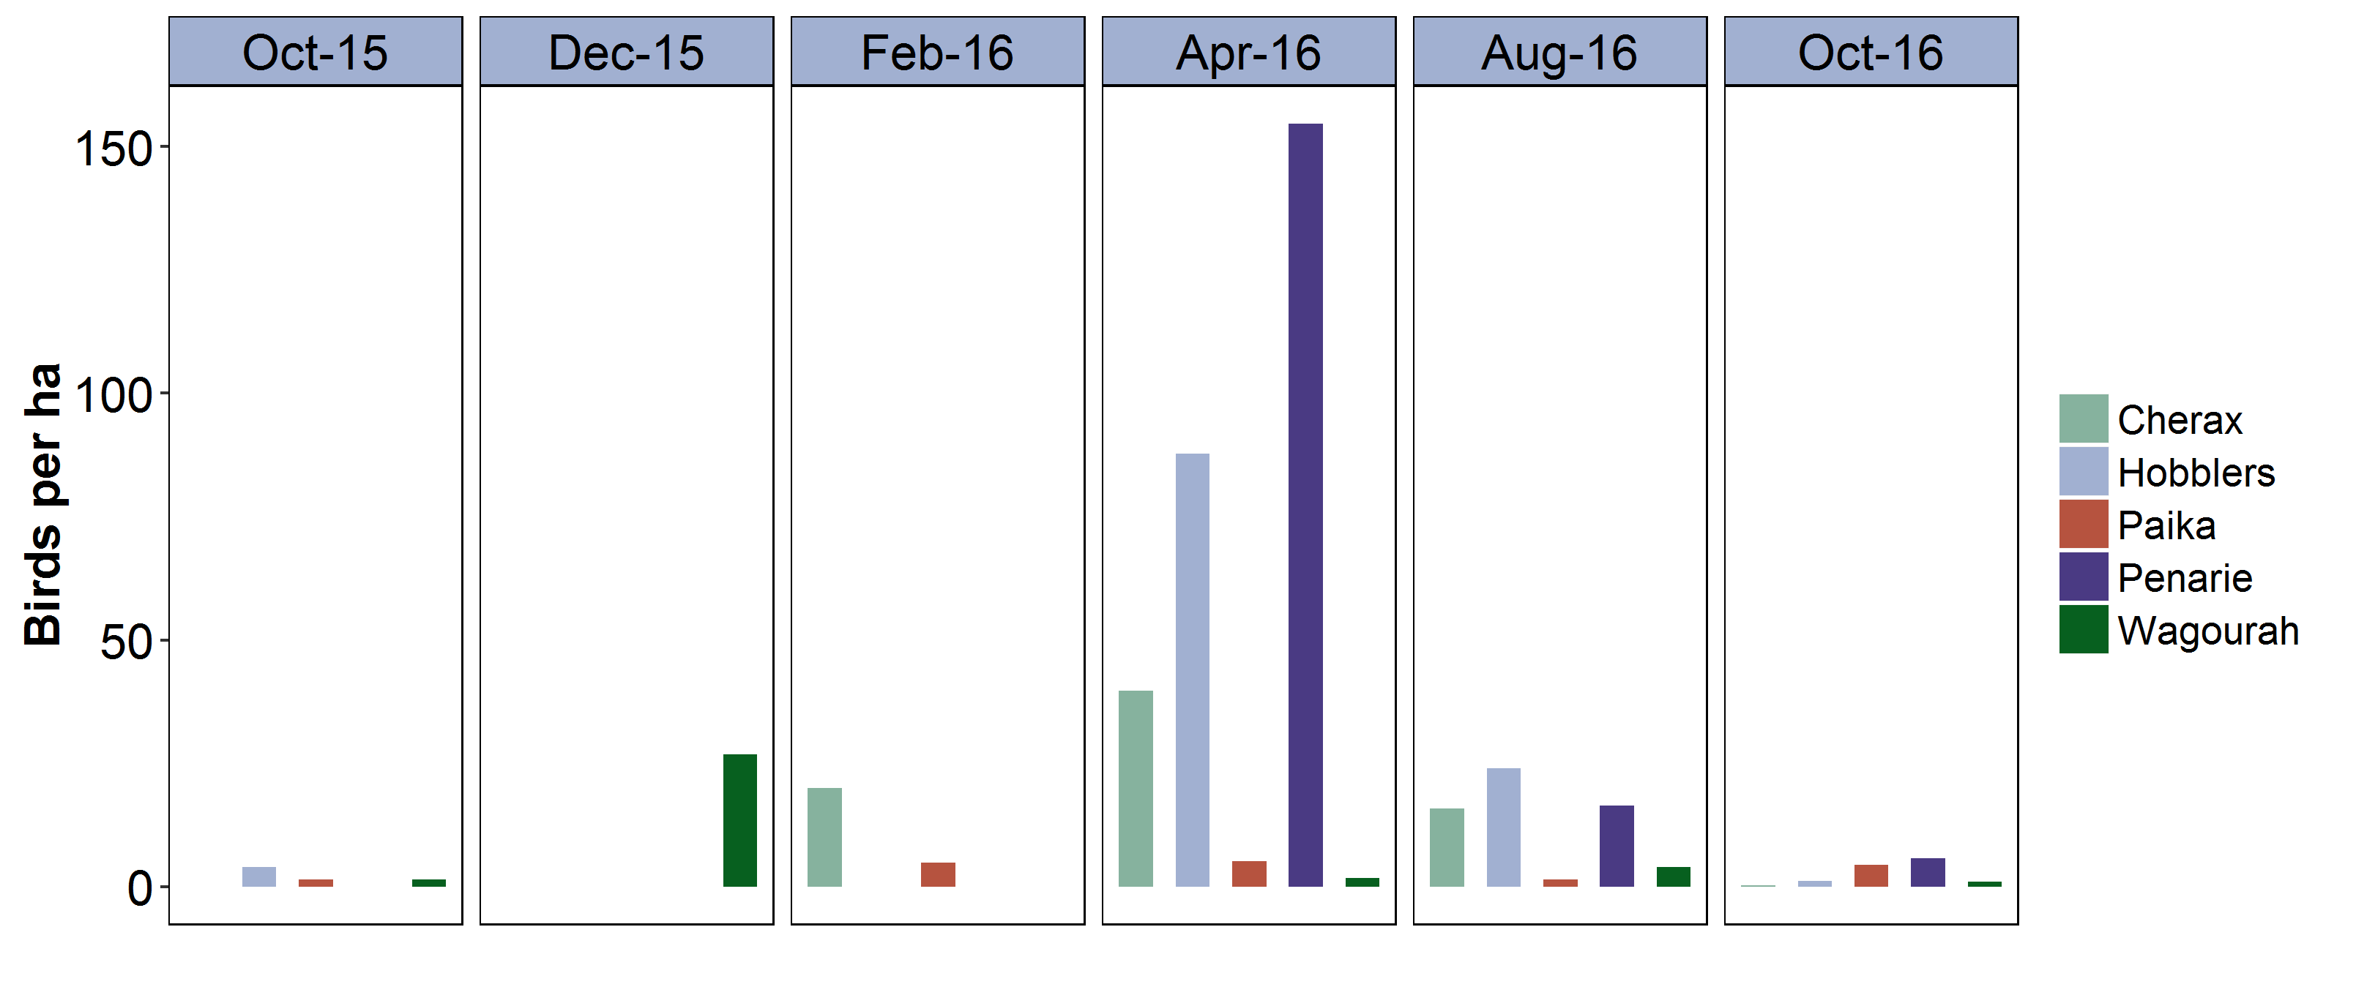

**Figure 11** Total waterbird abundance (adjusted as maximum count/surveyed area (ha)) in each of the five wetlands from October 2015-October 2016. Note that no surveys were completed in Wagourah Lake in February 2016 prior to the watering event in April 2016 but surveys were completed at Wagourah Lake (this site only) in December 2015.

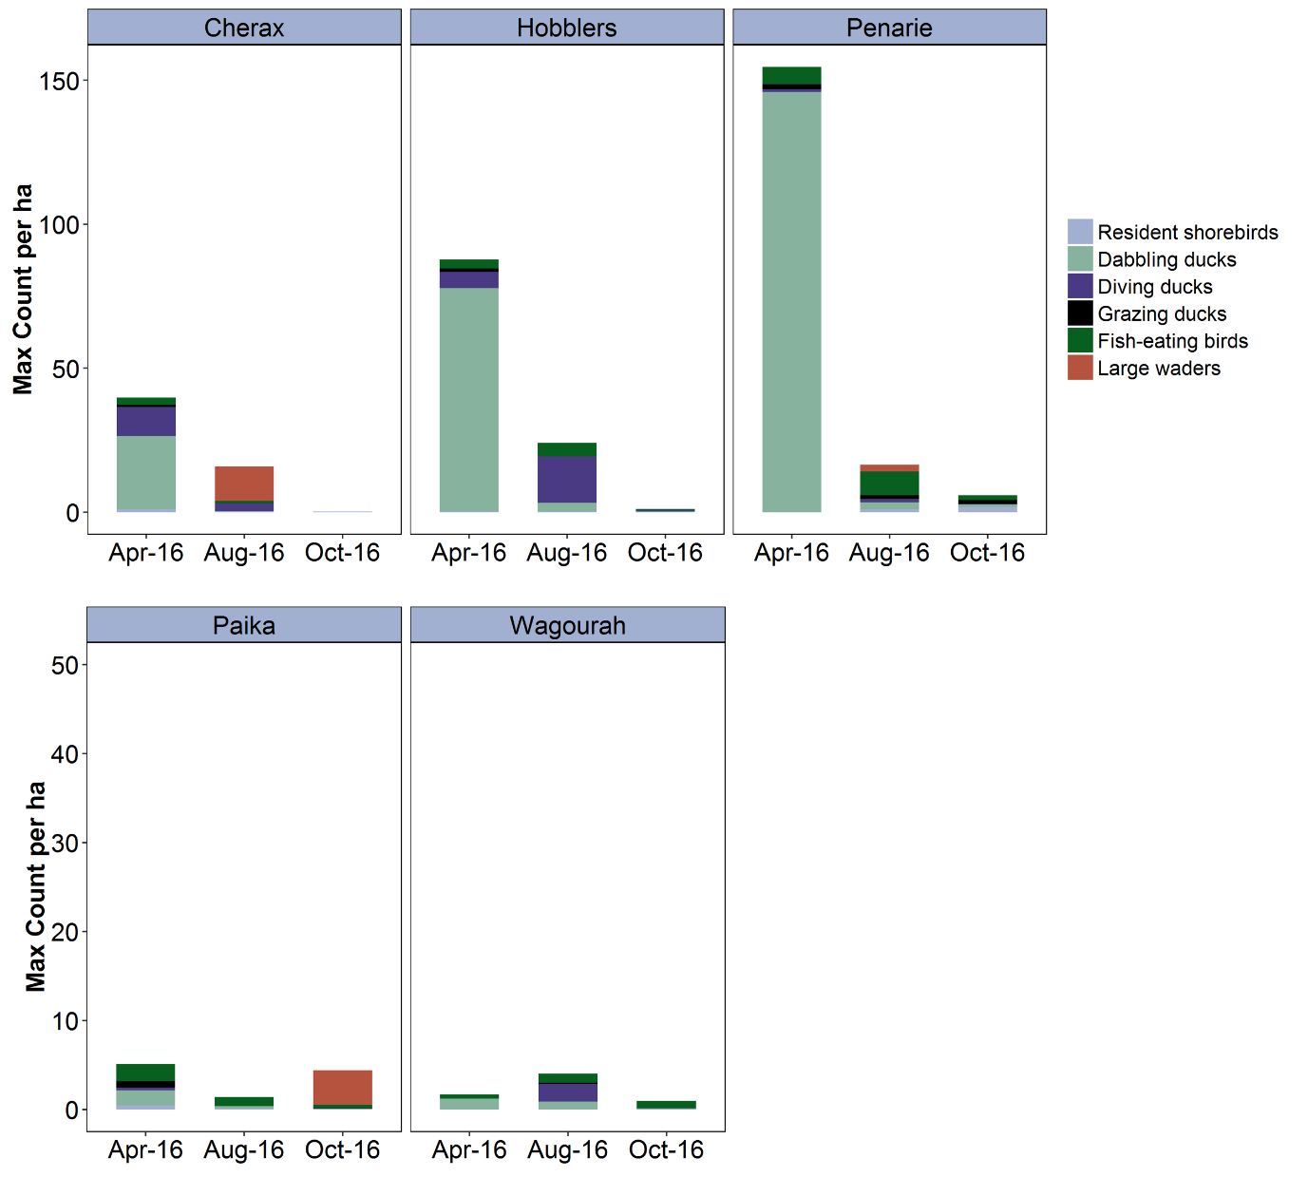

**Figure 12** Total waterbird abundance (adjusted as maximum count/surveyed area (ha)) in each of the five wetlands from April-October 2016. Note the difference in scale for the y-axis between the upper and lower figures.

**Table 3** Maximum count of each waterbird species recorded in the five wetlands in the April-October 2016 surveys.

|  |  |  |  |  |  |
| --- | --- | --- | --- | --- | --- |
| **Common Name** | **Cherax** | **Hobblers** | **Paika** | **Penarie** | **Wagourah** |
| Australasian Darter |  | 1 | 33 |  | 1 |
| Australasian Grebe | 12 | 4 |  | 6 | 5 |
| Australasian Shoveler | 5 | 40 | 30 | 6 |  |
| Australian Pelican |  |  | 62 |  | 3 |
| Australian Shelduck |  | 1 | 25 | 13 |  |
| Australian White Ibis | 5 |  |  |  |  |
| Australian Wood Duck | 17 | 35 | 50 | 16 | 5 |
| Banded Lapwing | 6 |  |  |  |  |
| Black Swan | 257 | 70 | 31 | 11 |  |
| Black-fronted Dotterel |  | 2 | 6 |  |  |
| Black-winged Stilt | 26 | 4 | 33 | 15 |  |
| Blue-billed Duck V |  | 48 |  |  |  |
| Caspian Tern J |  | 1 | 4 |  |  |
| Eastern Great Egret J | 1 |  | 3 |  |  |
| Eurasian Coot | 48 | 390 |  |  | 74 |
| Great Cormorant |  | 5 | 3 | 3 | 7 |
| Great Crested Grebe |  | 10 | 4 | 5 | 5 |
| Grey Teal | 750 | 1540 | 146 | 1350 | 47 |
| Hardhead | 2 | 26 |  |  | 8 |
| Hoary-headed Grebe | 31 | 122 | 1 | 65 | 38 |
| Little Black Cormorant |  |  | 119 |  | 5 |
| Little Pied Cormorant | 4 | 1 | 2 |  | 11 |
| Masked Lapwing | 4 | 4 | 15 | 9 |  |
| Musk Duck |  | 7 |  |  |  |
| Pacific Black Duck | 11 | 8 | 4 | 4 | 3 |
| Pied Cormorant |  |  | 12 |  |  |
| Pink-eared Duck | 4 | 672 |  |  | 24 |
| Red-necked Avocet |  |  | 5 |  |  |
| Silver Gull |  | 10 | 34 | 8 |  |
| Straw-necked Ibis | 350 |  | 410 | 22 |  |
| Unidentified Duck |  |  |  |  | 2 |
| Unidentified Egret |  |  |  |  | 1 |
| White-faced Heron | 32 |  | 2 | 2 | 1 |
| White-necked Heron | 1 |  |  |  | 1 |
| Yellow-billed Spoonbill | 6 |  | 4 |  |  |

^ Status: J = JAMBA (listed under international migratory bird agreements Australia has with Japan), listing under the NSW TSC Act 1995 (v = vulnerable). Common names are based on Chrisitidis and Boles (2008) and species groupings are described in Appendix 2.

Total waterbird abundance (waterbirds/hectare) was significantly higher (t = -5.9, P<0.001) in previously dry wetlands after the delivery of Commonwealth environmental water (as observed in the April 2016 surveys) compared to wetlands that were already wet when they received environmental water in autumn 2016 (Figure 13). Waterbird density remained higher at these sites during the winter surveys (August 2016). By spring (October 2016), all sites excluding Paika Lake, began to dry down and total waterbird density did not differ across the two types of wetlands (previously dry or wet) (Figure 13).

The responses in total waterbird density in April 2016 were driven by the dabbling ducks, particularly grey teal (GT) and to a lesser extent the filter feeding pink-eared duck (PED)(Figure 13 and Figure 14). Dabbling duck density only differed significantly between the two wetland types during the April 2016 surveys, but remained higher in previously dry wetlands in August and October (Figure 13). We did not observe any significant difference in the other waterbird guilds including the shorebird guild, across the two types of wetlands and three survey periods (Figure 13 and Figure 14).

There was no difference in the total number of waterbird species observed in the two wetland types (Figure 13), with around 16-17 species observed total in each wetland over the 2016 surveys. Only Hobblers Lake was the exception where 22 species was recorded in total. Overall, the waterbird guilds and most of the waterbird species observed during the 2016 surveys had a preference for the sites that had undergone a period of drying prior to the delivery of environmental water (Figure 15 and Figure 16). At a species level, there was some indication that some fish-eating waterbird species (three species in total: pied cormorant *Phalacrocorax varius* (PCO), little black cormorant *Phalacrocorax sulcirostris* (LBC) and Australian pelican *Pelecanus conspicillatus* (PEL)) were found in greater densities in the wet, deeper wetlands than the previously dry, shallow sites (Figure 16). There was also a suite of waterbird species that had significantly higher densities in the previously dry sites including grey teal (GT), black swan *Cygnus atratus* (BWS), hoary-headed grebe *Poliocephalus poliocephalus* (HHG), Australian wood duck *Chenonetta jubata* (WDU), Australasian shoveler *Anas rhynchotis* (BWS), white-faced heron *Egretta novaehollandiae* (WFH), Australasian grebe *Tachybaptus novaehollandiae* (ALG) and Pacific black duck *Malacorhynchus membranaceus* (BDU) (Figure 16).

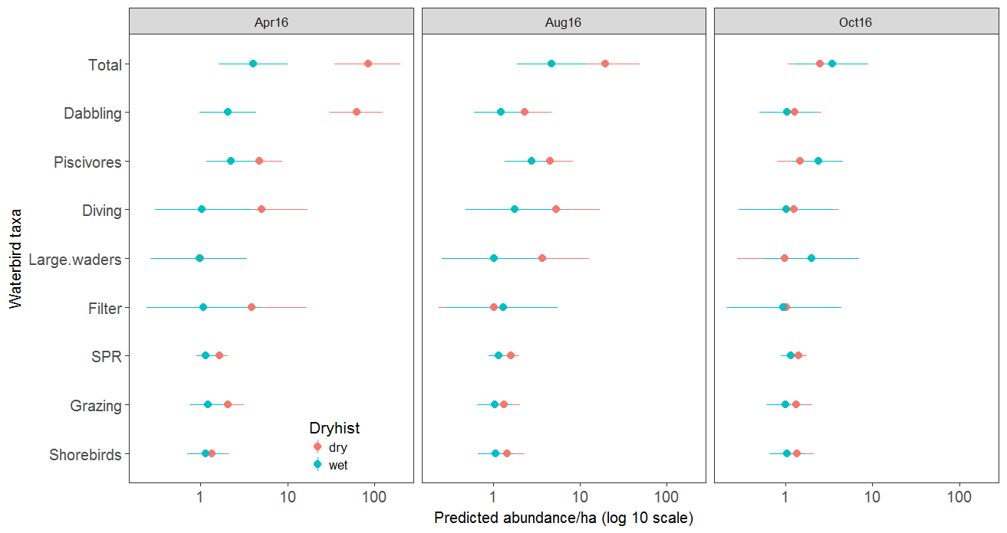

**Figure 13** Model estimates of total waterbird abundance, species richness (SPR) and abundance in each waterbird guild in three previously dry wetlands (Hobblers, Cherax and Penarie) and two previously wet wetlands (Paika and Wagourah) sampled in April, August and October 2016. Bars are 95% confidence interval.

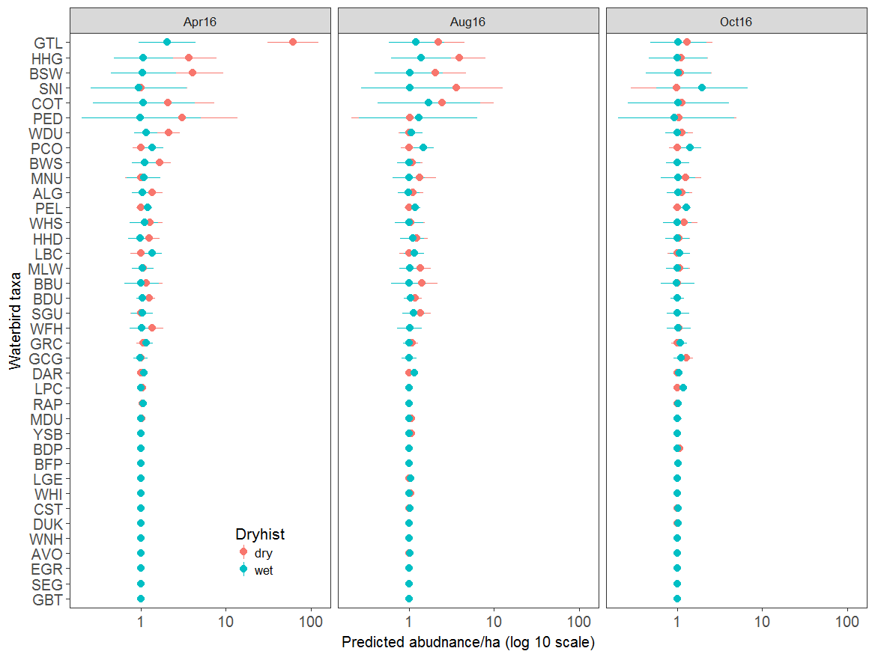

**Figure 14** Model estimates of waterbird species abundance in three previously dry wetlands (Hobblers, Cherax and Penarie) and two previously wet wetlands (Paika and Wagourah) sampled in April, August and October 2016. Bars are 95% confidence interval.

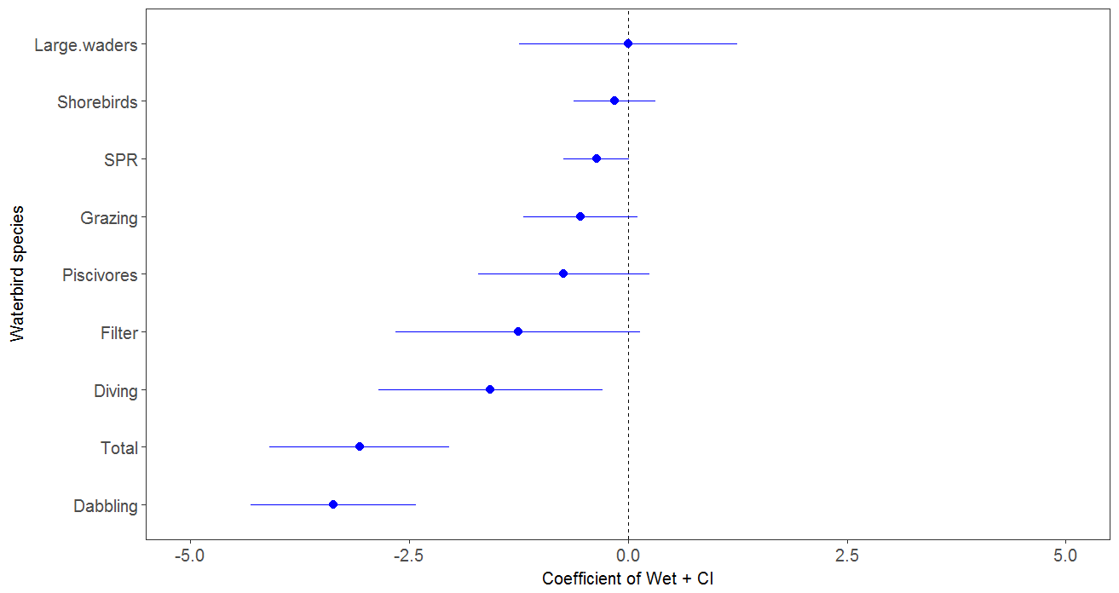

**Figure 15** Model estimates of previously dry versus wet of waterbird functional guilds surveyed in five wetlands (Hobblers, Cherax, Penarie, Paika and Wagourah) surveyed in April, August and October 2016. Species with a preference for previously dry sites have a negative coefficient whereas species with a preference for previously wet sites have a positive coefficient. Confidence intervals are 95%.

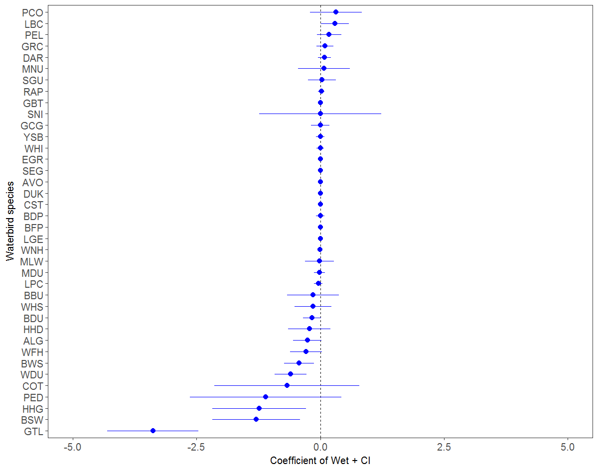

**Figure 16** Model estimates of previously dry versus wet for waterbird species surveyed in five wetlands (Hobblers, Cherax, Penarie, Paika and Wagourah) surveyed in April, August and October 2016. Species with a preference for previously dry sites have a negative coefficient whereas species with a preference for previously wet sites have a positive coefficient. Confidence intervals are 95%. See species codes in Appendix 2.

# Discussion

**Summary of Evaluation questions, predictions and measured outcomes**

|  |  |  |  |
| --- | --- | --- | --- |
| Evaluation questions | Predictions | Measured outcomes | Was the objective achieved? |
| What did environmental water contribute to waterbird populations in nominated wetlands? | *Local increases in waterbird abundance in response to environmental watering* | The newly watered Hobblers Lake and Penarie Creek supported diverse waterbird assemblages including target species from the dabbling duck, filter-feeding and shorebird guilds. Total waterbird abundance was significantly higher (t = -5.9, P<0.001) in previously dry wetlands after the delivery of Commonwealth environmental water (as observed in the April 2016 surveys) compared to wetlands that were already wet when they received environmental water in autumn 2016 | Yes |
| What did environmental water contribute to waterbird species diversity in nominated wetlands? | *Local increases in waterbird diversity in response to environmental watering* | Total species diversity increased in sites in response to environmental watering. There was no significant difference in total numbers of species between the wetland types, although Hobblers Lake supported a higher diversity of bird species (22 species) than the other survey sites where between 16-17 species were recorded in total. | Yes |
| *Local increases in waterbird species of conservation significance (i.e. threatened species, JAMBA, CAMBA and ROKAMBA species) in spring in response to environmental watering in previous months (autumn-winter)* | Hobblers Lake, which received environmental water in March 2016, supported threatened blue-billed duck (NSW TSC Act 1995) during both the April and August 2016 surveys. Only very small numbers of migratory shorebird species (<10) were recorded in the watered sites during the surveys. | Partly |
| What did environmental water contribute to concentrations of nutrients in nominated wetlands? | *Nutrient availability will increase in response to delivery of environmental water* | Nutrient levels and water quality supported the invertebrate and bird responses, although we did not detect a pulse in nutrients in response to watering as predicted. | No |
| What did environmental water contribute to microinvertebrate and macroinvertebrate productivity and diversity in nominated wetlands? | *Environmental water delivered to wetlands will transport microinvertebrates as well as trigger their emergence, establishing communities with densities and community composition changing over time in relation to wetland filling and draw-down* | We detected high numbers of benthic microinvertebrate and macroinvertebrate prey following the wetting of the previously dry wetlands. Densities of benthic microinvertebrates were also high at Wagourah Lake in August 2016 due to calanoid copepods and chydorids with some daphnid cladocerans. The high densities of microinvertebrates in April were primarily due to Bosminid cladocerans and copepods. In August in the previously dry wetlands, high densities were driven by a more diverse fauna including chydorid and macrothricid cladocerans and ostracods.  Densities of microinvertebrates were not high in spring following inundation in autumn. The highest density of 198.3 individuals/L (comprising mainly chydorid cladocerans and copepods) was recorded in Wagourah Lake, a previously wet wetland that received floodwaters prior to sampling. | Yes  No |
| *Environmental water delivered to wetlands in autumn will stimulate increased productivity and diversity of macroinvertebrates and microinvertebrates in the following spring when waterbird and invertebrate activity is likely to be greater in response to warmer day time temperatures* |

**What did environmental water contribute to waterbird and invertebrate populations in nominated wetlands?**

Our surveys showed that the delivery of Commonwealth environmental water in autumn can benefit diverse suites of waterbird species and invertebrate taxa. There were more than 33 waterbird species detected in our study, as well as extremely high densities of microinvertebrate prey (1000 to 10,000 individuals per litre) and abundant macroinvertebrates. The highest abundances of macroinvertebrates were recorded in April and August at Cherax Lake, in April at Hobblers Lakes, in August at Penarie Creek and then in October at Wagourah Lake. It is not known why the density increased from April to August at Penarie, but if sampling was close to the timing of inundation in April perhaps biota had not reproduced and increased in density. The high density at Wagourah Lake in October was likely due to an influx of macroinvertebrates with floodwaters prior to sampling. The microinvertebrate densities were an order of magnitude higher than recorded on intermittent lakes inundated in winter and spring on the Darling River floodplain (Jenkins and Boulton 2003, Jenkins and Boulton 2007), but matched previously records from spring inundation on the productive Macquarie Marshes (Jenkins and Wolfenden 2006, Jenkins et al. 2011). The densities recorded here were also double to an order of magnitude higher than those recorded on wetlands sampled in spring-autumn in the Murrumbidgee (Wassens et al 2016).

As we predicted, total numbers of waterbirds and invertebrates increased in response to the delivery of environmental water. Overall, densities of dabbling and filter-feeding ducks were higher in wetlands that were dry prior to the delivery of environmental water compared to sites that were already wet. These patterns have been observed in other lake systems, for example, in Menindee Lakes where waterbird densities were higher in intermittent wetlands compared to regulated lakes (Kingsford *et al.* 2004). Although waterbirds showed a strong response to inundation in the Western Lakes, the watering in autumn was not part of a large scale inundation event (such as the flood event in spring 2016) and the bird response was not large for the lowbidgee scale. At a local scale there were however, a large number of dabbling ducks at Hobblers Lake. The influx of dabbling and filter feeding ducks in our study coincided with high numbers of microinvertebrate and macroinvertebrate prey following the wetting of the previously dry wetlands. This supports earlier studies that found filter-feeding ducks, such as the pink-eared duck, respond strongly to peaks in zooplankton abundance when dry wetlands are inundated (Timms 1996; Briggs et al. 1985).

The delivery of environmental water benefited other waterbird guilds, including fish-eating waterbirds where flows are delivered to maintain water levels at sites that are already inundated. Permanent lake systems in the Lowbidgee floodplain can have well-established fish populations (Jenkins *et al.* 2012; Sharpe and Dyer 2016) and are therefore attractive to this guild of waterbirds. Large waders, including ibis and spoonbills, were also observed feeding in Cherax Swamp as it dried down during the August surveys. These colonially-nesting species bred in small numbers in neighbouring wetlands in the Redbank system in summer 2015-16 and so the provision of foraging habitat over autumn and winter 2016 is likely to have benefited juvenile birds that fledged from these small breeding events.

The high densities of microinvertebrates at previously dry wetlands in April 2016 were driven by *Bosmina meriodonalis* and copepods, whereas a more diverse fauna contributed in August including chydorid and macrothricid cladocerans and ostracods at Cherax, Hobblers and Penarie. High densities of microinvertebrates at Wagourah Lake in August were driven by calanoid copepods and chydorid cladocerans, with Daphnid cladocerans also contributing. Densities at all wetlands in October were dominated by copepods and chydorid cladocerans.

**What did environmental water contribute to concentrations of nutrients in nominated wetlands?**

The consequences for nutrient cycles in response to the timing of wetland inundation are thought to largely stem from water temperature, but also from the lifecycles of wetland biota. Despite being hydrologically connected to Paika Lake and Cherax Swamp, Hobblers Lake contained higher concentrations of available nutrients, a pattern that is reinforced by past sampling occasions. Hobblers Lake is also known to contain dense mats of water milfoil. These mats provide attractive habitat for small-bodied native fish such as carp gudgeons and macroinvertebrates which exploit newly flooded habitats and provide a potential food source for small grebes (Marchant and Higgins 1990; Fjeldsa 1988). In this study, macroinvertebrates were recorded in high abundance in Hobblers Lake (716 individuals CPUE in April) and the highest densities of microinvertebrates were also recorded in Hobblers Lake (see Tables 1 and 2), suggesting that the high nutrients and milfoil contribute to productivity of invertebrates. Macrophytes are also a potential source of available nutrients that can be liberated from soils after the plants have senesced and the wetland has dried (Baldwin and Mitchell 2000). Matching the high nutrient productivity in Hobblers Lake, a benthic microinvertebrate *Bosmina meriodonalis* pulsed at 9993 individuals per litre at one site in April 2016. Previously this high density had only been recorded in the Macquarie Marshes after intermittent creeks were inundated in spring (Jenkins and Wolfenden 2006).

We were unable to detect a significantly higher concentration of nutrients at previously dry versus previously wet sites. It is possible that nutrients were either quickly assimilated into living biomass prior to sampling, or that nutrients were liberated from newly inundated wetland areas at previously wet sites despite their being wetted habitats already. We also note that water is delivered to the Western Lakes via forested wetland (i.e. Narwie) and so nutrients that arrive with the delivered water may be homogenising concentrations across sites, masking the influence of wet versus dry inundation. The time dry between inundation events is likely to influence the release of nutrients from sediments, but thresholds are not known.

Although we were unable to detect a positive response in shorebird numbers in our study, complementary waterbird monitoring by NSW OEH and CEWO in 2016-17 (Spencer *et al.* 2017) indicated that neighbouring wetlands surveyed in spring 2016 alongside the five survey sites in this project provided diverse habitat for waterbird species including migratory and resident shorebird species and dabbling ducks. For example Kia Lake and Loorica Lake, which are similar large open wetland systems only about 20 kilometres direct distance from the Western Lakes, have been targeted with environmental water in recent years to create habitat for waterbirds (Spencer *et al.* 2017).

Our surveys showed that once the habitats had dried down in the following spring total waterbird abundance decreased at all wetlands even those that continued to be wet (i.e. Paika and Wagourah Lakes). The drying down of the wetlands coincided with greater habitat availability across the Murrumbidgee Catchment. Environmental watering from August 2016 inundated neighbouring wetlands in the Redbank and Nimmie-Caria zones and natural spring flooding inundated many wetlands from September 2016 onwards in the Murrumbidgee and neighbouring Lachlan and NSW Murray catchments (see Wassens *et al.* 2017).

# Adaptive management and recommendations for future water delivery

Key drivers for the provision of feeding habitat for waterbirds are timing, water depth and the duration of inundation including the rate of draw-down (Taft *et al*. 2002). The timing of the initial inundation is particularly important for shorebird species which migrate through southern Australia during the austral spring and summer. By delivering environmental water during autumn months there are also potential benefits, providing foraging habitat for these migratory shorebirds which migrate north during the February-May period. The depth of water is important for many dabbling duck and shorebird species, which feed on the water’s edge and water depth determines the accessibility of invertebrate prey.

Our data showed there are benefits from delivering environmental water to wetland habitats in autumn for waterbirds and invertebrates as densities pulsed at two of the three newly inundated wetlands, especially compared to the previously wet wetlands. Increasing the area of wetland newly inundated at the start of autumn and winter could enable water managers to sustain habitat for waterbirds over winter with complete drawdowns in spring when shorebird numbers increase, rather than have earlier draw-downs in winter months (see Taft 2002). Our study also demonstrated that drying wetlands between environmental watering events triggers a greater response in invertebrate prey when inundation occurs again. Where possible watering strategies aimed to create feeding habitat for dabbling and filter feeding ducks and shorebird species should account for natural flooding and drying cycles to promote invertebrate food supplies.

Maintaining a suite of different types of wetlands are important for creating diversity of habitats for waterbirds, providing heterogeneity at a landscape-scale that is more able to support a higher diversity of species. This includes open deep waterbodies in the floodplain such as Yanga and Paika Lakes, recognising where environmental water is delivered at appropriate intervals (where there is provision for some periods of drying to maintain productivity) to intermittently flooded open lakes such as Kia and Loorica Lakes and vegetated floodplain wetlands, these sites can support a high diversity of waterbird species. Large permanent waterbodies will be of less value as waterbird feeding habitat to species that rely on invertebrate and aquatic vegetation (dabbling ducks and large waders for example), but can provide feeding habitat for fish-eating species including cormorants and pelicans. Where these deep lakes are managed as semi-permanent wetlands and allowed to dry down to some degree between events to create shallow muddy shorelines, this can provide feeding habitat for resident and migratory shorebirds, and also support outcomes for large-bodied native fish species (Sharpe and Dyer 2016).

As waterbird species are highly mobile they are likely to access a wide range of inundated habitats across the Lowbidgee and neighbouring catchments in response to habitat availability. They can respond to the availability of habitat in a range of spatial scales including landscape (mosaic of wetland patches), wetland and microsite scales (foraging areas within wetlands). The sequencing of inundation is likely to be important. Where possible wetlands targeted for environmental water for creating and /or maintaining waterbird feeding habitat should be watered at the same time rather than at staggered intervals as this is likely to provide landscape scale cues for waterbirds.

This approach to creation and maintaining a diversity of wetland habitats for waterbirds in the Lowbidgee Floodplain will contribute to maintaining waterbird diversity and increasing waterbird abundance across the Murray-Darling Basin.

# Acknowledgements

Many thanks to Michael Todd and Amy Stephens (NSW OEH) for assistance with our fieldwork, and Joanne Ocock (NSW OEH) for assistance with preparing figures. Our thanks also to NSW NPWS for providing field accommodation and assistance with access to Wagourah Lake, and to landholders Peter Morton, Ron Hoare and Diane Williams for allowing access to the Western Lakes sites. Waterbird surveys were approved under NSW NPWS Scientific Licence SL100100 and the OEH Animal Care and Ethics Committee (Approval 091214/01).

# References

Baldwin DS., Mitchell AM. (2000). The effects of drying and re-flooding on the sediment and soil nutrient dynamics of lowland river–floodplain systems: a synthesis. *Regulated Rivers Research and Management*. **16**, 457–467

Brandis, K., Roshier, D., and Kingsford, R.T. (2009). Environmental Watering For Waterbirds in The Living Murray Icon Sites – A literature review and identification of research priorities relevant to the environmental watering actions of flow enhancement and retaining floodwater on floodplains. Report to the Murray-Darling Basin Authority. Project number MD1248.

Briggs, SV, Maher, MT and Palmer, RP (1985). Bias in Food Habits of Australian Waterfowl. *Australian Wildlife Research***12**, 507–514.

Christidis, L., and Boles, W. (2008). *Systematics and Taxonomy of Australian Birds*. CSIRO Publishing, Colllingwood, VIC, Australia.

Fjeldsa, J. (1988). *Comparative ecology of the Australasian grebes (Aves: Podicipedidae).* Royal Australasian Ornithologists Union, 1988.

Hale, J., Stoffels, R., Butcher, R., Shackleton, M., Brooks, S., Gawne, B., and Stewardson, M. (2014). Commonwealth Environmental Water Office Long Term Intervention Monitoring: Standard Methods. Final Report prepared for the Commonwealth Environmental Water Holder by the Murray-Darling Freshwater Research Centre. MDFRC Publication 29.2/2014.

Halse, S.A., Shiel, R.J., Storey, A.W., Edward, D.H.D., Lansbury, I., Cale, D.J., and Harvey, M.S. (2000). Aquatic invertebrates and waterbirds of wetlands and rivers of the southern Carnarvon Basin, Western Australia. *Records of the Western Australian Museum Supplement*. **61**, 217-265.

Hansen, M.A. and Butler, M.G. (1994). Responses to food web manipulation in a shallow waterfowl lake. Hydrobiologia **279** (1): 457-466.

Jenkins K.M., and Boulton A.J. (2003). Ecological connectivity in a dryland river: short-term aquatic micoinvertebrate recruitment following floodplain inundation. Ecology 84(10): 2708-2723.

Jenkins K.M., and Wolfenden, B.J. (2006). Invertebrates, fish and river flows: historical and baseline data analysis for the Macquarie Marshes Environmental Management Plan. Report to DEC. University of New England, Armidale, NSW, Australia. (119 pages).

Jenkins, K.M., and Boulton, A.J. (2007). Detecting impacts and setting restoration targets in arid-zone rivers: aquatic microinvertebrates responses to loss of floodplain inundation. Journal of Applied Ecology **44,** 823-832

Jenkins, K.M., Kingsford, R.T., Wolfenden, B.J., Ren, S. and Driver, P. (2011). Invertebrate monitoring and modeling in the Macquarie Marshes, Final report to the NSW Office of Water, University of New South Wales, Sydney, NSW, Australia. (120 pages).

Jenkins, K.M., Smith, J., Becker, A., and Iles, J. (2012). Surveying fish assemblages in Paika, Yanga and Tala Lakes, Lowbidgee wetlands. Report to the NSW Office of Environment and Heritage. Australian Wetlands, Rivers and Landscapes Centre, University of New South Wales.

Junk, W.J., Bayley, P.B., and Sparks, R.E. (1989). The flood pulse concept in river-floodplain systems. Canadian Journal of Fisheries and Aquatic Sciences.**106**, 110–127.

Kingsford, R.T., and Auld, K.M. (2005). ‘Waterbird breeding and environmental flow management in the Macquarie Marshes, arid Australia’. *River Research and Applications***21**,187–200.

Kingsford, R.T., Jenkins, K.M., and Porter, J.L. (2004). Imposed hydrological stability on lakes in arid Australia and effects on waterbirds. Ecology **85** (9), 2478-2492.

Kingsford, R.T., and Norman, F.J. (2002). ‘Australian waterbirds – products of the continent’s ecology’. *Emu* **102**, 47-69.

Kingsford, R.T., Porter, J.L. (2009). Monitoring waterbird populations with aerial surveys—what have we learnt? *Wildlife Research* **36**, 29-40.

Kingsford, R.T., and Thomas, R.F. (2004). ‘Destruction of wetlands and waterbird populations by dams and irrigation on the Murrumbidgee River in arid Australia’. *Environmental Management***34**, 383-396.

MDBA (2014). *Basin-wide environmental watering strategy.* Murray-Darling Basin Authority. November 2014.

Marchant, S., and Higgins, P.J. (1990). *Handbook of Australian, New Zealand and Antarctic Birds.* Volume 1. Oxford University Press, Melbourne.

Porter, J.L, Kingsford, R.T., and Brandis, K. (2016). *Aerial Survey of Wetland Birds in Eastern Australia – October 2016. Annual Summary Report.* Centre for Ecosystem, University of New South Wales.

Sharpe, C. and Dyer, J. (2016). Fish surveys of Paika Lake and associated wetlands, western NSW, following environmental watering in 2015. Summary of findings. Report for NSW Office of Environment and Heritage by CPS Enviro P/L.

Spencer, J., Hosking, T., Ewin, P., Webster, R., Hutton, K., Allman, R., Thomas, R., Humphries, J., Berney, P. and Mullohand, M. (2014). Waterbird Monitoring in Inland NSW: Summary Report 2012-13. Sydney, Leeton, NSW Office of Environment and Heritage, Department of Premier and Cabinet and Pelican Consulting.

Spencer, J., Ocock, J., Hosking, T., Webster, R., Humphries, J., Todd, M., Hutton, K., and Berney, P. (2016). *Monitoring Waterbird Outcomes in NSW: Summary Report 2015-16.* Unpublished report. NSW Office of Environment and Heritage, Sydney.

Spencer, J., Ocock, J., Amos, C., Hosking, T., Humphries, J., Borrell, A., Suter, S., Keyte, P., Preston, D., Hutton, K., and Berney, P. (2017). DRAFT *Monitoring Waterbird Outcomes in NSW: Summary Report 2016-17.* Unpublished report. NSW Office of Environment and Heritage, Sydney. June 2017.

Taft, O.W., Cowlwell, M.A., Isola, C.R., Safran,R.J. (2002). Waterbird responses to experimentaldrawdown: implications for the multispeciesmanagement of wetland mosaics. *Journal of AppliedEcology* **39**, 987–1001.

Timms, B.V. (1996). A comparison between saline and freshwater wetlands on Bloodwater Station, the Paroo, Australia, with special reference to their use by waterbirds.*International Journal of Salt Lake Research***5**(4), 287-313.

Wassens, S., Jenkins, K., Spencer, J., Thiem, J., Kobyashi, T., Bino, G., Lenon, E., Thomas, R., Baumgartner, L., Brandis, K., Wolfenden, B. and Hall, A.(2014). Murrumbidgee Monitoring and Evaluation Plan. Commonwealth of Australia.

Wassens, S., Spencer, J., Thiem, J., Wolfenden, B., Thomas, R., Jenkins, K., Brandis, K., Lenon, E., Hall, A., Ocock, J., Kobayashi, T, Bino, G., Heath, J., and Callaghan, D. (2017).Commonwealth Environmental Water Office Long-Term Intervention Monitoring project Murrumbidgee River System Selected Area evaluation report, 2014-17. Report prepared for the Commonwealth Environmental Water Office.

# Appendices

## Appendix 1 Site locations

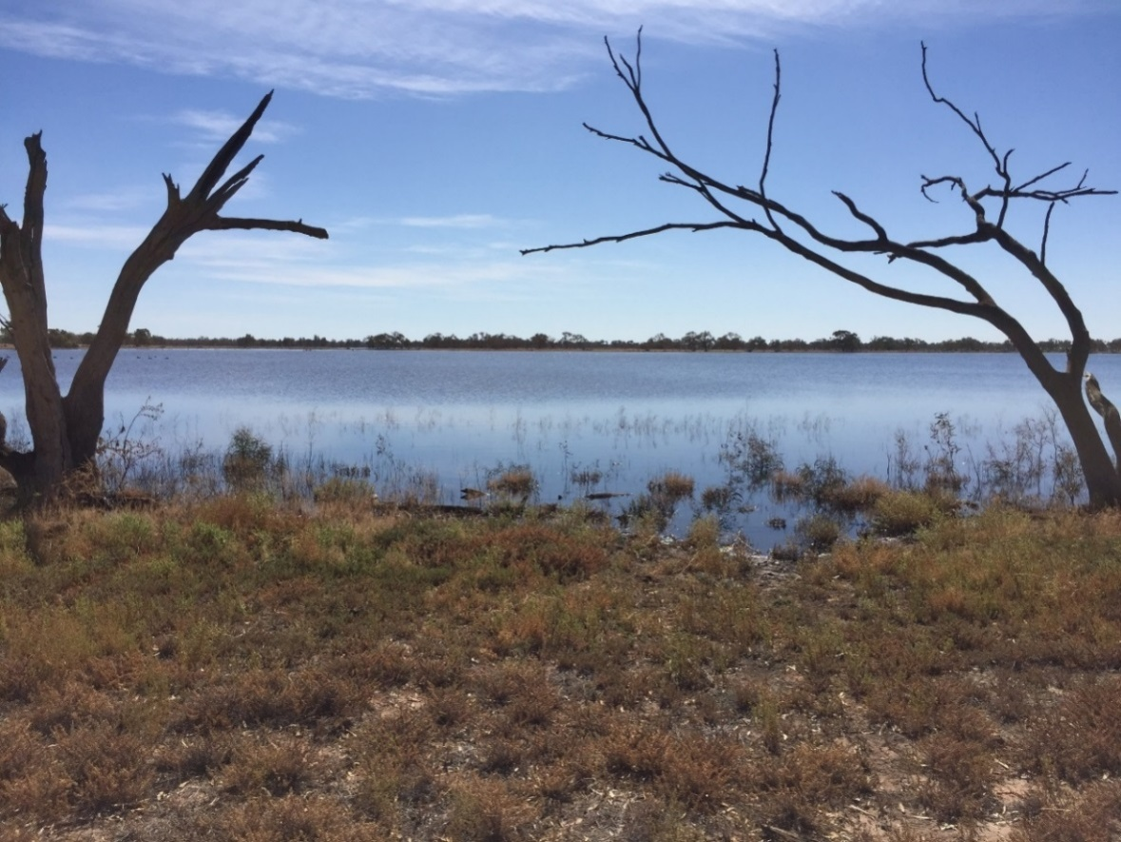

Plate 1: Hobblers Lake survey site, 13 April 2016 (Credit: Carmen Amos, NSW OEH)

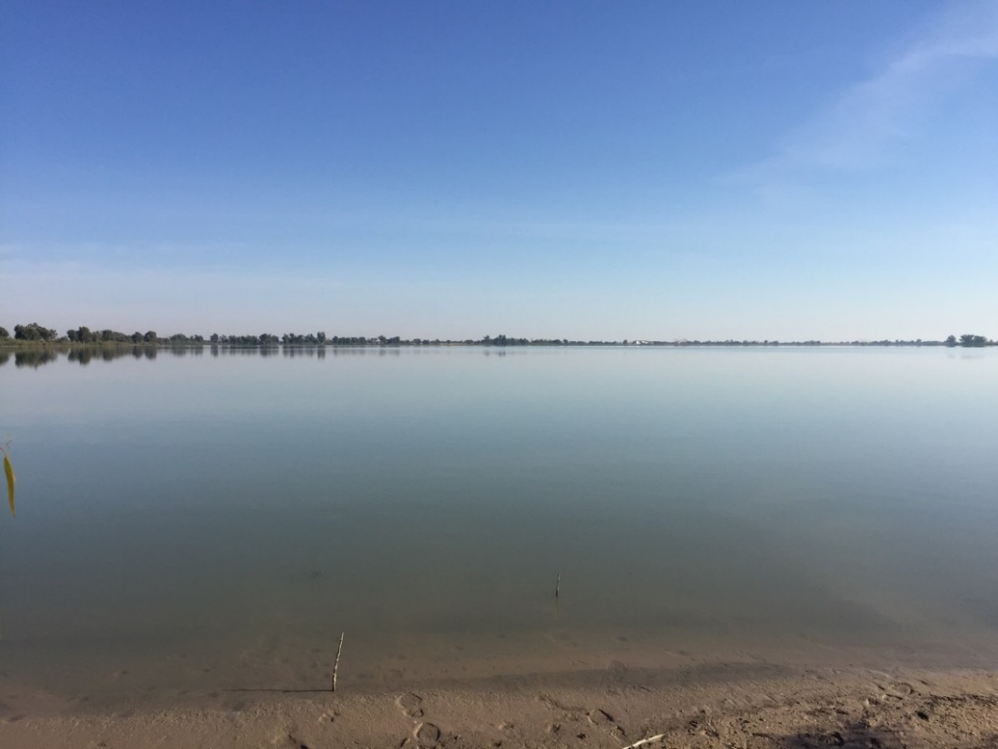

Plate 2: Paika Lake survey site, 14 April 2016 (Credit: Carmen Amos, NSW OEH)

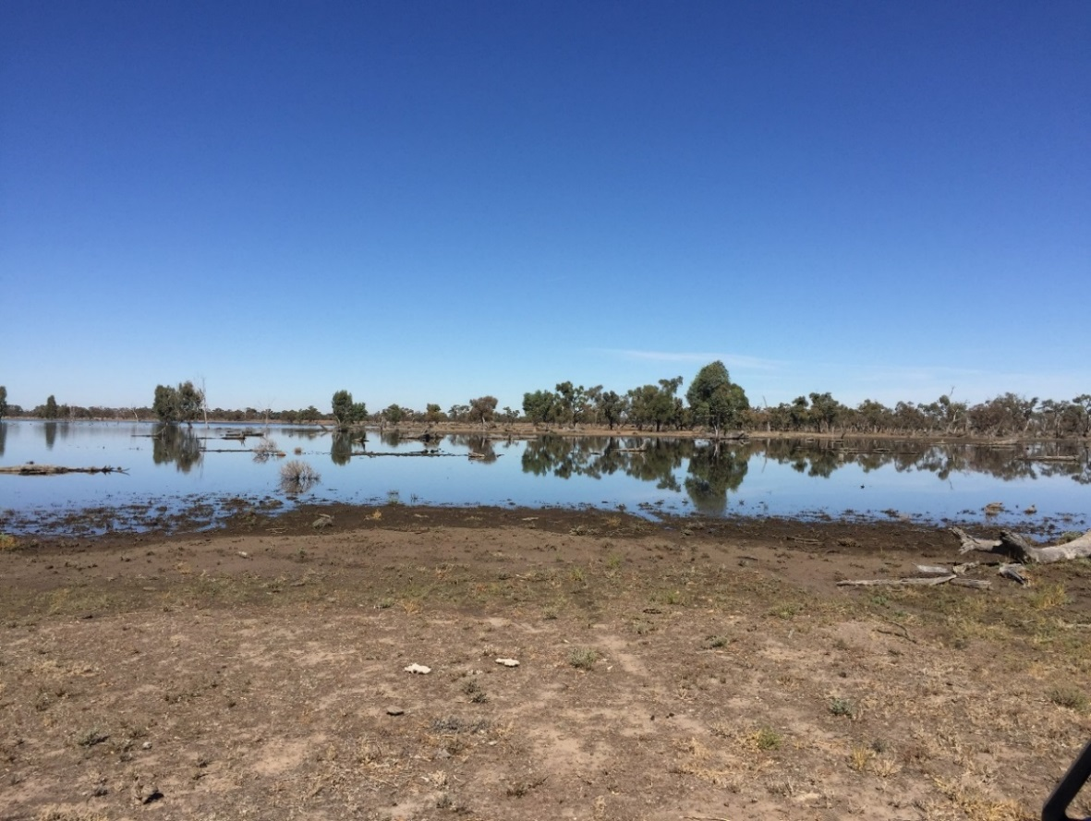

Plate 3: Penarie Creek survey site, 13 April 2016 (Credit: Carmen Amos, NSW OEH)

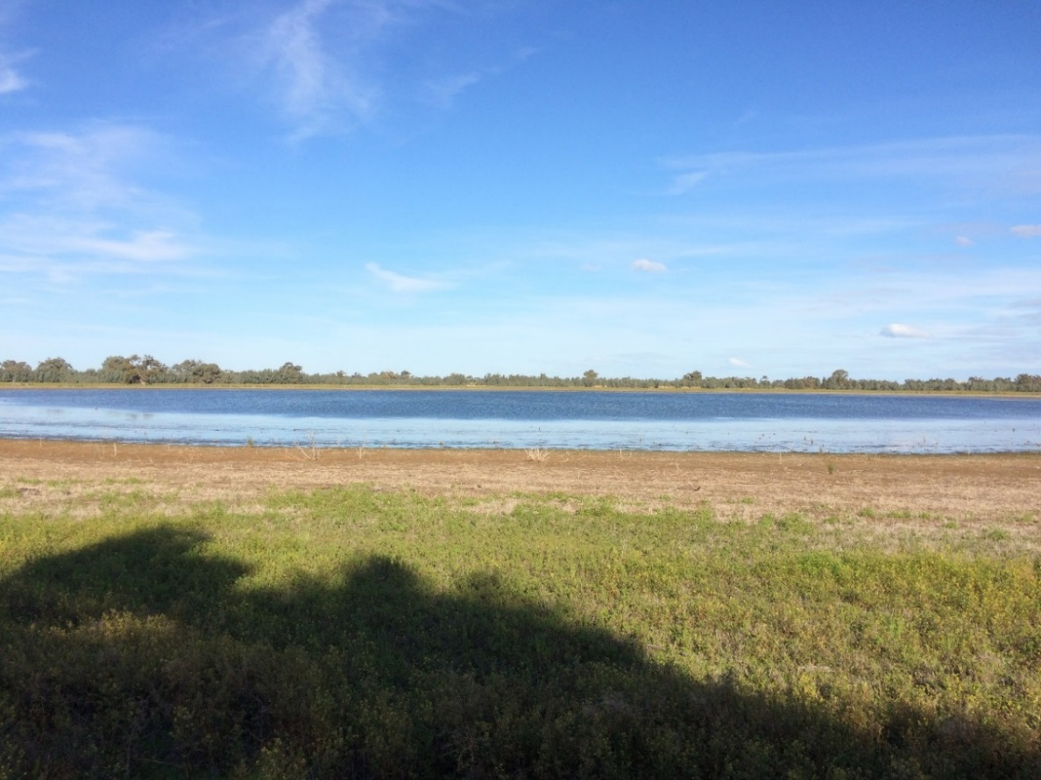

Plate 4: Cherax Swamp survey site, 10 August 2016 (Credit: Carmen Amos, NSW OEH)

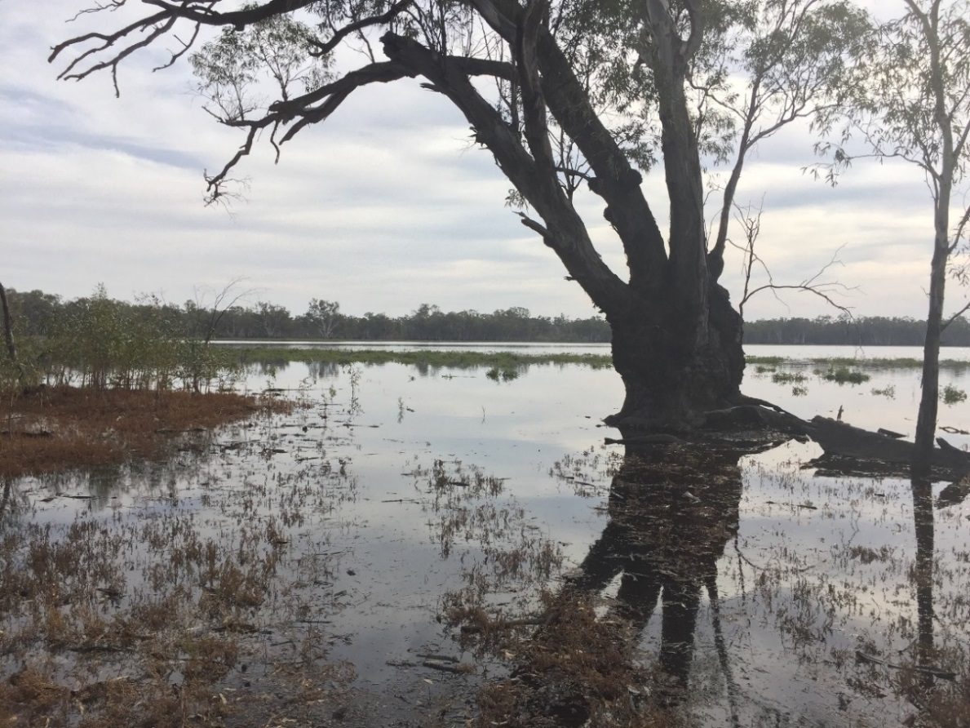

Plate 5: Wagourah Lake survey site, 14 April 2016 (Credit: Carmen Amos, NSW OEH)

## Appendix 2 Wetland-dependent bird species recorded during wetland surveys October 2015 to October 2016

| Family | Common name\* | *Species name* | Waterbird code | Functional Guild^ |
| --- | --- | --- | --- | --- |
| Accipitridae | Black-shouldered kite | *Elanus axillaris* |  | Raptor |
| Whistling kite | *Haliastur sphenurus* |  | Raptor |
| White-bellied sea-eagle V | *Haliaeetus leucogaster* |  | Raptor |
| Anatidae | Australian shelduck | *Tadorna tadornoides* | MNU | Grazing ducks and geese |
| Australian wood duck | *Chenonetta jubata* | WDU | Grazing ducks and geese |
| Black swan | *Cygnus atratus* | BSW | Diving ducks, aquatic gallinules and swans |
| Blue-billed duck V | *Oxyura australis* | BBU | Diving ducks, aquatic gallinules and swans |
| Hardhead | *Aythya australis* | HHD | Diving ducks, aquatic gallinules and swans |
| Musk duck | *Biziura lobata* | MDU | Diving ducks, aquatic gallinules and swans |
| Australasian shoveler | *Anas rhynchotis* | BWS | Dabbling and filter-feeding ducks |
| Grey teal | *Anas gracilis* | GTL | Dabbling and filter-feeding ducks |
| Pacific black duck | *Anas superciliosa* | BDU | Dabbling and filter-feeding ducks |
| Pink-eared duck | *Malacorhynchus membranaceus* | PED | Dabbling and filter-feeding ducks |
| Anhingidae | Australasian darter | *Anhinga novaehollandiae* | DAR | Piscivores (including grebes, cormorants, egrets, bitterns, terns and kingfisher) |
| Ardeidae | Eastern great egret J | *Ardea alba modesta* | LGE | Piscivores (including grebes, cormorants, egrets, bitterns, terns and kingfisher) |
| White-faced heron | *Egretta novaehollandiae* | WFH | Piscivores (including grebes, cormorants, egrets, bitterns, terns and kingfisher) |
| White-necked heron | *Ardea pacifica* | WNH | Piscivores (including grebes, cormorants, egrets, bitterns, terns and kingfisher) |
| Charadriidae | Banded lapwing | *Vanellus tricolor* | BDP | Australian-breeding Charadriiform shorebirds |
| Black-fronted dotterel | *Elseyornis melanops* | BFP | Australian-breeding Charadriiform shorebirds |
| Masked lapwing | *Vanellus miles* | MLW | Australian-breeding Charadriiform shorebirds |
| Red-capped plover | *Charadrius ruficapillus* | RCP | Australian-breeding Charadriiform shorebirds |
| Red-kneed dotterel | *Erythrogonys cinctus* | RKD | Australian-breeding Charadriiform shorebirds |
| Falconidae | Peregrine falcon | *Falco peregrinus* |  | Raptor |
| Nankeen kestrel | *Falco cenchroides* |  | Raptor |
| Halcyonidae | Sacred kingfisher | *Todiramphus sanctus* |  | Piscivores (including grebes, cormorants, egrets, bitterns, terns and kingfisher) |
| Laridae | Caspian tern J | *Hydroprogne caspia* | CST | Piscivores (including grebes, cormorants, egrets, bitterns, terns and kingfisher) |
| Silver gull | *Chroicocephalus novaehollandiae* | SGU | Piscivores (including grebes, cormorants, egrets, bitterns, terns and kingfisher) |
| Whiskered tern | *Chlidonias hybrida* | MST | Piscivores (including grebes, cormorants, egrets, bitterns, terns and kingfisher) |
| Pelicanidae | Australian pelican | *Pelecanus conspicillatus* | PEL | Piscivores (including grebes, cormorants, egrets, bitterns, terns and kingfisher) |
| Phalacrocoracidae | Great cormorant | *Phalacrocorax carbo* | GRC | Piscivores (including grebes, cormorants, egrets, bitterns, terns and kingfisher) |
| Little black cormorant | *Phalacrocorax sulcirostris* | LBC | Piscivores (including grebes, cormorants, egrets, bitterns, terns and kingfisher) |
| Little pied cormorant | *Microcarbo melanoleucos* | LPC | Piscivores (including grebes, cormorants, egrets, bitterns, terns and kingfisher) |
| Pied cormorant | *Phalacrocorax varius* | PCO | Piscivores (including grebes, cormorants, egrets, bitterns, terns and kingfisher) |
| Podicepidae | Australasian grebe | *Tachybaptus novaehollandiae* | ALG | Piscivores (including grebes, cormorants, egrets, bitterns, terns and kingfisher) |
| Great crested grebe | *Podiceps cristatus* | GCG | Piscivores (including grebes, cormorants, egrets, bitterns, terns and kingfisher) |
| Hoary-headed grebe | *Poliocephalus poliocephalus* | HHG | Piscivores (including grebes, cormorants, egrets, bitterns, terns and kingfisher) |
| Rallidae | Eurasian coot | *Fulica atra* | COT | Diving ducks, aquatic gallinules and swans |
| Recurvirostridae | Black-winged stilt | *Himantopus leucocephalus* | WHS | Australian-breeding Charadriiform shorebirds |
| Red-necked avocet | *Recurvirostra novaehollandiae* | AVO | Australian-breeding Charadriiform shorebirds |
| Scolopacidae | Red-necked stint | *Calidris ruficollis* | RNS | Migratory Charadriiform shorebirds |
| Sharp-tailed sandpiper | *Calidris acuminata* | STS | Migratory Charadriiform shorebirds |
| Threskiornithidae | Australian white ibis | *Threskiornis moluccus* | WHI | Storks, cranes, ibis and spoonbills (large wading birds) |
| Royal spoonbill | *Platalea regia* | RSB | Storks, cranes, ibis and spoonbills (large wading birds) |
| Straw-necked ibis | *Threskiornis spinicollis* | SNI | Storks, cranes, ibis and spoonbills (large wading birds) |
| Yellow-billed spoonbill | *Platalea flavipes* | YSB | Storks, cranes, ibis and spoonbills (large wading birds) |

\*Status: J = JAMBA (listed under international migratory bird agreements Australia has with Japan), listing under the NSW *TSC Act 1995* (v = vulnerable). ^Functional groups as described by Hale *et al.* (2014). Non-waterbird species are shaded and were excluded from the functional group analysis. Nomenclature follows Christidis and Boles (2008).

## Appendix 3 Response models

### Nutrients:

|  |  |  |  |  |  |
| --- | --- | --- | --- | --- | --- |
| Amm | Estimate | se | df | t | p |
| Intercept | 4.43 | 0.88 | 7.0 | 5.03 | 0.002 |
| MonthAug | -2.22 | 1.25 | 7.0 | -1.78 | 0.118 |
| MonthOct | -2.54 | 1.76 | 7.0 | -1.44 | 0.194 |
| Dryhistwet | -2.46 | 1.39 | 7.0 | -1.76 | 0.121 |
| MonthAug:Dryhistwet | 3.40 | 1.97 | 7.0 | 1.73 | 0.128 |
| MonthOct:Dryhistwet | 3.70 | 2.33 | 7.0 | 1.58 | 0.157 |
| DOC | Estimate | se | df | t | p |
| Intercept | 2.02 | 0.08 | 7.0 | 25.64 | 0.000 |
| MonthAug | 0.27 | 0.11 | 7.0 | 2.40 | 0.048 |
| MonthOct | 0.24 | 0.16 | 7.0 | 1.50 | 0.178 |
| Dryhistwet | 0.43 | 0.12 | 7.0 | 3.48 | 0.010 |
| MonthAug:Dryhistwet | -0.28 | 0.18 | 7.0 | -1.60 | 0.154 |
| MonthOct:Dryhistwet | -0.11 | 0.21 | 7.0 | -0.53 | 0.614 |
| FRP | Estimate | se | df | t | p |
| Intercept | 2.98 | 0.93 | 7.0 | 3.22 | 0.015 |
| MonthAug | 0.17 | 1.31 | 7.0 | 0.13 | 0.901 |
| MonthOct | 2.11 | 1.85 | 7.0 | 1.14 | 0.292 |
| Dryhistwet | -0.49 | 1.47 | 7.0 | -0.33 | 0.750 |
| MonthAug:Dryhistwet | 0.55 | 2.07 | 7.0 | 0.27 | 0.798 |
| MonthOct:Dryhistwet | -1.12 | 2.45 | 7.0 | -0.46 | 0.661 |
| NOX | Estimate | se | df | t | p |
| Intercept | -0.20 | 1.15 | 7.0 | -0.17 | 0.870 |
| MonthAug | 0.17 | 1.63 | 7.0 | 0.10 | 0.921 |
| MonthOct | 0.01 | 2.31 | 7.0 | 0.01 | 0.995 |
| Dryhistwet | 0.07 | 1.82 | 7.0 | 0.04 | 0.970 |
| MonthAug:Dryhistwet | 2.76 | 2.58 | 7.0 | 1.07 | 0.321 |
| MonthOct:Dryhistwet | 0.86 | 3.05 | 7.0 | 0.28 | 0.785 |
| TDN | Estimate | se | df | t | p |
| Intercept | 6.67 | 0.15 | 6.5 | 43.57 | 0.000 |
| MonthAug | 0.16 | 0.19 | 3.7 | 0.86 | 0.442 |
| MonthOct | 0.02 | 0.28 | 4.9 | 0.08 | 0.942 |
| Dryhistwet | 0.13 | 0.24 | 6.5 | 0.55 | 0.599 |
| MonthAug:Dryhistwet | 0.04 | 0.30 | 3.7 | 0.13 | 0.902 |
| MonthOct:Dryhistwet | 0.22 | 0.37 | 4.4 | 0.60 | 0.579 |
| TDP | Estimate | se | df | t | p |
| Intercept | 4.10 | 0.59 | 3.2 | 6.90 | 0.005 |
| MonthAug | 0.31 | 0.22 | 4.0 | 1.43 | 0.226 |
| MonthOct | 0.47 | 0.34 | 4.1 | 1.38 | 0.239 |
| Dryhistwet | -0.45 | 0.94 | 3.2 | -0.48 | 0.660 |
| MonthAug:Dryhistwet | 0.08 | 0.34 | 4.0 | 0.23 | 0.829 |
| MonthOct:Dryhistwet | 0.28 | 0.43 | 4.0 | 0.64 | 0.556 |
| TN | Estimate | se | df | t | p |
| Intercept | 6.78 | 0.13 | 5.4 | 51.09 | 0.000 |
| MonthAug | 0.13 | 0.14 | 3.7 | 0.92 | 0.415 |
| MonthOct | -0.09 | 0.22 | 4.4 | -0.40 | 0.708 |
| Dryhistwet | 0.46 | 0.21 | 5.4 | 2.19 | 0.076 |
| MonthAug:Dryhistwet | -0.03 | 0.23 | 3.7 | -0.15 | 0.889 |
| MonthOct:Dryhistwet | 0.29 | 0.28 | 4.1 | 1.04 | 0.355 |
| TP | Estimate | se | df | t | p |
| Intercept | 4.52 | 0.37 | 3.2 | 12.29 | 0.001 |
| MonthAug | 0.17 | 0.12 | 4.0 | 1.37 | 0.242 |
| MonthOct | 0.33 | 0.19 | 4.0 | 1.72 | 0.159 |
| Dryhistwet | 0.49 | 0.58 | 3.2 | 0.84 | 0.459 |
| MonthAug:Dryhistwet | -0.04 | 0.19 | 4.0 | -0.20 | 0.854 |
| MonthOct:Dryhistwet | 0.23 | 0.24 | 4.0 | 0.97 | 0.386 |

### Macroinvertabrates (total and family level)

|  |  |  |  |  |  |
| --- | --- | --- | --- | --- | --- |
| SPR | Estimate | se | df | t | p |
| Intercept | 10.33 | 3.03 | 9.00 | 3.41 | 0.008 |
| Dryhistwet | -1.83 | 4.79 | 9.00 | -0.38 | 0.711 |
| MonthAug | 3.67 | 4.29 | 9.00 | 0.86 | 0.415 |
| MonthOct | -5.33 | 4.29 | 9.00 | -1.24 | 0.245 |
| Dryhistwet:MonthAug | -2.67 | 6.78 | 9.00 | -0.39 | 0.703 |
| Dryhistwet:MonthOct | 9.33 | 6.78 | 9.00 | 1.38 | 0.202 |
| Total | Estimate | Se | Df | t | p |
| Intercept | 6.25 | 0.98 | 9.00 | 6.40 | 0.000 |
| Dryhistwet | -2.40 | 1.54 | 9.00 | -1.56 | 0.154 |
| MonthAug | -0.44 | 1.38 | 9.00 | -0.32 | 0.758 |
| MonthOct | -4.70 | 1.38 | 9.00 | -3.41 | 0.008 |
| Dryhistwet:MonthAug | 1.00 | 2.18 | 9.00 | 0.46 | 0.657 |
| Dryhistwet:MonthOct | 6.29 | 2.18 | 9.00 | 2.88 | 0.018 |
| Atyidae | Estimate | Se | Df | t | p |
| Intercept | 0.23 | 0.21 | 9.00 | 1.08 | 0.310 |
| Dryhistwet | 0.32 | 0.34 | 9.00 | 0.94 | 0.373 |
| MonthAug | 0.00 | 0.30 | 9.00 | 0.00 | 1.000 |
| MonthOct | -0.23 | 0.30 | 9.00 | -0.76 | 0.466 |
| Dryhistwet:MonthAug | -0.55 | 0.48 | 9.00 | -1.14 | 0.282 |
| Dryhistwet:MonthOct | -0.32 | 0.48 | 9.00 | -0.66 | 0.524 |
| Baetidae | Estimate | Se | Df | t | p |
| Intercept | 0.92 | 0.55 | 9.00 | 1.67 | 0.129 |
| Dryhistwet | -0.92 | 0.87 | 9.00 | -1.06 | 0.318 |
| MonthAug | 1.88 | 0.78 | 9.00 | 2.41 | 0.039 |
| MonthOct | -0.92 | 0.78 | 9.00 | -1.18 | 0.268 |
| Dryhistwet:MonthAug | -1.33 | 1.24 | 9.00 | -1.08 | 0.309 |
| Dryhistwet:MonthOct | 0.92 | 1.24 | 9.00 | 0.75 | 0.474 |
| Brachytronidae | Estimate | Se | Df | t | p |
| Intercept | 0.00 | 0.09 | 9.00 | 0.00 | 1.000 |
| Dryhistwet | 0.00 | 0.15 | 9.00 | 0.00 | 1.000 |
| MonthAug | 0.00 | 0.13 | 7.14 | 0.00 | 1.000 |
| MonthOct | 0.00 | 0.13 | 7.14 | 0.00 | 1.000 |
| Dryhistwet:MonthAug | 0.00 | 0.21 | 7.14 | 0.00 | 1.000 |
| Dryhistwet:MonthOct | 0.35 | 0.21 | 7.14 | 1.64 | 0.144 |
| Caenidae | Estimate | Se | Df | t | p |
| Intercept | 0.00 | 0.09 | 9.00 | 0.00 | 1.000 |
| Dryhistwet | 0.00 | 0.15 | 9.00 | 0.00 | 1.000 |
| MonthAug | 0.00 | 0.13 | 6.56 | 0.00 | 1.000 |
| MonthOct | 0.00 | 0.13 | 6.56 | 0.00 | 1.000 |
| Dryhistwet:MonthAug | 0.35 | 0.21 | 6.56 | 1.64 | 0.147 |
| Dryhistwet:MonthOct | 0.00 | 0.21 | 6.56 | 0.00 | 1.000 |
| Ceratopogonidae | Estimate | Se | Df | t | p |
| Intercept | 0.23 | 0.42 | 9.00 | 0.55 | 0.598 |
| Dryhistwet | 0.12 | 0.67 | 9.00 | 0.17 | 0.867 |
| MonthAug | 0.23 | 0.60 | 9.00 | 0.39 | 0.708 |
| MonthOct | 0.23 | 0.60 | 9.00 | 0.39 | 0.708 |
| Dryhistwet:MonthAug | 1.27 | 0.95 | 9.00 | 1.34 | 0.214 |
| Dryhistwet:MonthOct | 0.23 | 0.95 | 9.00 | 0.24 | 0.816 |
| Chironominae | Estimate | Se | Df | t | p |
| Intercept | 4.06 | 0.73 | 9.00 | 5.53 | 0.000 |
| Dryhistwet | -1.09 | 1.16 | 9.00 | -0.94 | 0.371 |
| MonthAug | -1.68 | 1.04 | 9.00 | -1.62 | 0.140 |
| MonthOct | -3.83 | 1.04 | 9.00 | -3.69 | 0.005 |
| Dryhistwet:MonthAug | 0.76 | 1.64 | 9.00 | 0.46 | 0.654 |
| Dryhistwet:MonthOct | 4.13 | 1.64 | 9.00 | 2.52 | 0.033 |
| Coenagrionidae | Estimate | Se | Df | t | p |
| Intercept | 0.00 | 0.17 | 9.00 | 0.00 | 1.000 |
| Dryhistwet | 0.00 | 0.27 | 9.00 | 0.00 | 1.000 |
| MonthAug | 0.37 | 0.24 | 7.42 | 1.50 | 0.175 |
| MonthOct | 0.00 | 0.24 | 7.42 | 0.00 | 1.000 |
| Dryhistwet:MonthAug | -0.37 | 0.39 | 7.42 | -0.95 | 0.373 |
| Dryhistwet:MonthOct | 0.00 | 0.39 | 7.42 | 0.00 | 1.000 |
| Corduliidae | Estimate | Se | Df | t | p |
| Intercept | 0.00 | 0.29 | 9.00 | 0.00 | 1.000 |
| Dryhistwet | 0.00 | 0.46 | 9.00 | 0.00 | 1.000 |
| MonthAug | 0.92 | 0.41 | 6.88 | 2.27 | 0.058 |
| MonthOct | 0.00 | 0.41 | 6.88 | 0.00 | 1.000 |
| Dryhistwet:MonthAug | -0.92 | 0.64 | 6.88 | -1.43 | 0.195 |
| Dryhistwet:MonthOct | 0.00 | 0.64 | 6.88 | 0.00 | 1.000 |
| Corixidae | Estimate | Se | Df | t | p |
| Intercept | 1.06 | 0.72 | 7.62 | 1.48 | 0.180 |
| Dryhistwet | -0.16 | 1.13 | 7.62 | -0.14 | 0.889 |
| MonthAug | 1.23 | 0.85 | 6.00 | 1.45 | 0.198 |
| MonthOct | -1.06 | 0.85 | 6.00 | -1.25 | 0.259 |
| Dryhistwet:MonthAug | -1.78 | 1.34 | 6.00 | -1.33 | 0.233 |
| Dryhistwet:MonthOct | 1.20 | 1.34 | 6.00 | 0.90 | 0.405 |
| Culicidae | Estimate | Se | Df | t | p |
| Intercept | 0.00 | 0.13 | 6.00 | 0.00 | 1.000 |
| Dryhistwet | 0.35 | 0.21 | 6.00 | 1.64 | 0.151 |
| MonthAug | 0.00 | 0.13 | 6.00 | 0.00 | 1.000 |
| MonthOct | 0.00 | 0.13 | 6.00 | 0.00 | 1.000 |
| Dryhistwet:MonthAug | -0.35 | 0.21 | 6.00 | -1.64 | 0.151 |
| Dryhistwet:MonthOct | 0.00 | 0.21 | 6.00 | 0.00 | 1.000 |
| Dytiscidae | Estimate | Se | Df | t | p |
| Intercept | 0.69 | 0.54 | 9.00 | 1.28 | 0.234 |
| Dryhistwet | -0.35 | 0.86 | 9.00 | -0.40 | 0.696 |
| MonthAug | 0.58 | 0.77 | 9.00 | 0.75 | 0.472 |
| MonthOct | -0.23 | 0.77 | 9.00 | -0.30 | 0.770 |
| Dryhistwet:MonthAug | -0.92 | 1.21 | 9.00 | -0.76 | 0.467 |
| Dryhistwet:MonthOct | 0.58 | 1.21 | 9.00 | 0.48 | 0.645 |
| Empididae | Estimate | Se | Df | t | p |
| Intercept | 0.00 | 0.15 | 9.00 | 0.00 | 1.000 |
| Dryhistwet | 0.00 | 0.24 | 9.00 | 0.00 | 1.000 |
| MonthAug | 0.00 | 0.21 | 7.17 | 0.00 | 1.000 |
| MonthOct | 0.00 | 0.21 | 7.17 | 0.00 | 1.000 |
| Dryhistwet:MonthAug | 0.00 | 0.33 | 7.17 | 0.00 | 1.000 |
| Dryhistwet:MonthOct | 0.55 | 0.33 | 7.17 | 1.64 | 0.143 |
| Ephydridae | Estimate | Se | Df | t | p |
| Intercept | 0.37 | 0.28 | 9.00 | 1.31 | 0.222 |
| Dryhistwet | 0.44 | 0.44 | 9.00 | 0.99 | 0.346 |
| MonthAug | -0.37 | 0.39 | 7.33 | -0.93 | 0.383 |
| MonthOct | -0.37 | 0.39 | 7.33 | -0.93 | 0.383 |
| Dryhistwet:MonthAug | -0.44 | 0.62 | 7.33 | -0.70 | 0.504 |
| Dryhistwet:MonthOct | -0.44 | 0.62 | 7.33 | -0.70 | 0.504 |
| Glossiphoniidae | Estimate | Se | Df | t | p |
| Intercept | 0.00 | 0.11 | 9.00 | 0.00 | 1.000 |
| Dryhistwet | 0.00 | 0.17 | 9.00 | 0.00 | 1.000 |
| MonthAug | 0.23 | 0.15 | 7.04 | 1.50 | 0.177 |
| MonthOct | 0.00 | 0.15 | 7.04 | 0.00 | 1.000 |
| Dryhistwet:MonthAug | -0.23 | 0.24 | 7.04 | -0.95 | 0.374 |
| Dryhistwet:MonthOct | 0.00 | 0.24 | 7.04 | 0.00 | 1.000 |
| Hydracarina | Estimate | Se | Df | t | p |
| Intercept | 3.02 | 0.62 | 8.70 | 4.87 | 0.001 |
| Dryhistwet | -3.02 | 0.98 | 8.70 | -3.08 | 0.014 |
| MonthAug | 0.78 | 0.82 | 6.00 | 0.96 | 0.376 |
| MonthOct | -2.79 | 0.82 | 6.00 | -3.41 | 0.014 |
| Dryhistwet:MonthAug | 0.02 | 1.29 | 6.00 | 0.02 | 0.986 |
| Dryhistwet:MonthOct | 3.83 | 1.29 | 6.00 | 2.96 | 0.025 |
| Hydraenidae | Estimate | Se | Df | t | p |
| Intercept | 0.00 | 0.15 | 9.00 | 0.00 | 1.000 |
| Dryhistwet | 0.55 | 0.24 | 9.00 | 2.32 | 0.045 |
| MonthAug | 0.00 | 0.21 | 7.10 | 0.00 | 1.000 |
| MonthOct | 0.00 | 0.21 | 7.10 | 0.00 | 1.000 |
| Dryhistwet:MonthAug | 0.14 | 0.33 | 7.10 | 0.43 | 0.680 |
| Dryhistwet:MonthOct | -0.55 | 0.33 | 7.10 | -1.64 | 0.144 |
| Hydrophilidae | Estimate | Se | Df | t | p |
| Intercept | 0.60 | 0.44 | 8.86 | 1.35 | 0.209 |
| Dryhistwet | -0.60 | 0.70 | 8.86 | -0.86 | 0.414 |
| MonthAug | 0.20 | 0.59 | 6.00 | 0.34 | 0.746 |
| MonthOct | -0.37 | 0.59 | 6.00 | -0.62 | 0.561 |
| Dryhistwet:MonthAug | 0.14 | 0.94 | 6.00 | 0.15 | 0.883 |
| Dryhistwet:MonthOct | 0.71 | 0.94 | 6.00 | 0.76 | 0.477 |
| Hydroptilidae | Estimate | Se | Df | t | p |
| Intercept | 0.00 | 0.11 | 9.00 | 0.00 | 1.000 |
| Dryhistwet | 0.00 | 0.17 | 9.00 | 0.00 | 1.000 |
| MonthAug | 0.00 | 0.15 | 7.69 | 0.00 | 1.000 |
| MonthOct | 0.23 | 0.15 | 7.69 | 1.50 | 0.173 |
| Dryhistwet:MonthAug | 0.00 | 0.24 | 7.69 | 0.00 | 1.000 |
| Dryhistwet:MonthOct | -0.23 | 0.24 | 7.69 | -0.95 | 0.372 |
| Leptoceridae | Estimate | Se | Df | t | p |
| Intercept | 0.00 | 0.77 | 9.00 | 0.00 | 1.000 |
| Dryhistwet | 0.00 | 1.21 | 9.00 | 0.00 | 1.000 |
| MonthAug | 0.54 | 1.08 | 9.00 | 0.50 | 0.632 |
| MonthOct | 0.60 | 1.08 | 9.00 | 0.55 | 0.595 |
| Dryhistwet:MonthAug | -0.54 | 1.71 | 9.00 | -0.31 | 0.761 |
| Dryhistwet:MonthOct | 1.85 | 1.71 | 9.00 | 1.08 | 0.308 |
| Lestidae | Estimate | Se | Df | t | p |
| Intercept | 0.00 | 0.51 | 9.00 | 0.00 | 1.000 |
| Dryhistwet | 0.00 | 0.81 | 9.00 | 0.00 | 1.000 |
| MonthAug | 1.05 | 0.73 | 7.01 | 1.44 | 0.194 |
| MonthOct | 0.00 | 0.73 | 7.01 | 0.00 | 1.000 |
| Dryhistwet:MonthAug | -1.05 | 1.15 | 7.01 | -0.91 | 0.394 |
| Dryhistwet:MonthOct | 0.55 | 1.15 | 7.01 | 0.48 | 0.648 |
| Mesoveliidae | Estimate | Se | Df | t | p |
| Intercept | 0.23 | 0.11 | 9.00 | 2.12 | 0.063 |
| Dryhistwet | -0.23 | 0.17 | 9.00 | -1.34 | 0.213 |
| MonthAug | -0.23 | 0.15 | 7.24 | -1.50 | 0.176 |
| MonthOct | -0.23 | 0.15 | 7.24 | -1.50 | 0.176 |
| Dryhistwet:MonthAug | 0.23 | 0.24 | 7.24 | 0.95 | 0.373 |
| Dryhistwet:MonthOct | 0.23 | 0.24 | 7.24 | 0.95 | 0.373 |
| Micronectidae | Estimate | Se | Df | t | p |
| Intercept | 3.55 | 1.01 | 9.00 | 3.52 | 0.007 |
| Dryhistwet | -1.49 | 1.60 | 9.00 | -0.93 | 0.375 |
| MonthAug | 0.39 | 1.43 | 9.00 | 0.27 | 0.791 |
| MonthOct | -2.78 | 1.43 | 9.00 | -1.95 | 0.083 |
| Dryhistwet:MonthAug | 1.15 | 2.26 | 9.00 | 0.51 | 0.621 |
| Dryhistwet:MonthOct | 4.64 | 2.26 | 9.00 | 2.05 | 0.070 |
| Notonectidae | Estimate | Se | Df | t | p |
| Intercept | 5.28 | 0.83 | 9.00 | 6.33 | 0.000 |
| Dryhistwet | -5.28 | 1.32 | 9.00 | -4.00 | 0.003 |
| MonthAug | -3.49 | 1.18 | 9.00 | -2.96 | 0.016 |
| MonthOct | -4.40 | 1.18 | 9.00 | -3.73 | 0.005 |
| Dryhistwet:MonthAug | 5.59 | 1.86 | 9.00 | 3.00 | 0.015 |
| Dryhistwet:MonthOct | 7.80 | 1.86 | 9.00 | 4.19 | 0.002 |
| Oligochaeta | Estimate | Se | Df | t | p |
| Intercept | 0.00 | 0.31 | 7.90 | 0.00 | 1.000 |
| Dryhistwet | 0.00 | 0.49 | 7.90 | 0.00 | 1.000 |
| MonthAug | 0.77 | 0.38 | 6.00 | 2.04 | 0.087 |
| MonthOct | 0.37 | 0.38 | 6.00 | 0.98 | 0.367 |
| Dryhistwet:MonthAug | -0.42 | 0.59 | 6.00 | -0.71 | 0.505 |
| Dryhistwet:MonthOct | 0.67 | 0.59 | 6.00 | 1.13 | 0.300 |
| Palaemonidae | Estimate | Se | Df | t | p |
| Intercept | 0.00 | 0.09 | 9.00 | 0.00 | 1.000 |
| Dryhistwet | 0.35 | 0.15 | 9.00 | 2.32 | 0.045 |
| MonthAug | 0.00 | 0.13 | 6.16 | 0.00 | 1.000 |
| MonthOct | 0.00 | 0.13 | 6.16 | 0.00 | 1.000 |
| Dryhistwet:MonthAug | -0.35 | 0.21 | 6.16 | -1.64 | 0.150 |
| Dryhistwet:MonthOct | -0.35 | 0.21 | 6.16 | -1.64 | 0.150 |
| Physidae | Estimate | Se | Df | t | p |
| Intercept | 0.90 | 1.26 | 9.00 | 0.72 | 0.492 |
| Dryhistwet | -0.90 | 1.99 | 9.00 | -0.45 | 0.662 |
| MonthAug | 1.39 | 1.78 | 9.00 | 0.78 | 0.456 |
| MonthOct | 0.47 | 1.78 | 9.00 | 0.26 | 0.799 |
| Dryhistwet:MonthAug | -1.39 | 2.82 | 9.00 | -0.49 | 0.634 |
| Dryhistwet:MonthOct | 2.58 | 2.82 | 9.00 | 0.91 | 0.385 |
| Psychodidae | Estimate | Se | Df | t | p |
| Intercept | 0.23 | 0.14 | 9.00 | 1.60 | 0.143 |
| Dryhistwet | 0.12 | 0.23 | 9.00 | 0.51 | 0.624 |
| MonthAug | -0.23 | 0.20 | 6.84 | -1.13 | 0.295 |
| MonthOct | -0.23 | 0.20 | 6.84 | -1.13 | 0.295 |
| Dryhistwet:MonthAug | -0.12 | 0.32 | 6.84 | -0.36 | 0.731 |
| Dryhistwet:MonthOct | -0.12 | 0.32 | 6.84 | -0.36 | 0.731 |
| Tabanidae | Estimate | Se | Df | t | p |
| Intercept | 0.00 | 0.09 | 9.00 | 0.00 | 1.000 |
| Dryhistwet | 0.35 | 0.15 | 9.00 | 2.32 | 0.045 |
| MonthAug | 0.00 | 0.13 | 6.24 | 0.00 | 1.000 |
| MonthOct | 0.00 | 0.13 | 6.24 | 0.00 | 1.000 |
| Dryhistwet:MonthAug | -0.35 | 0.21 | 6.24 | -1.64 | 0.150 |
| Dryhistwet:MonthOct | -0.35 | 0.21 | 6.24 | -1.64 | 0.150 |
| Tabanidae | Estimate | Se | Df | t | p |
| Intercept | 0.83 | 0.92 | 9.00 | 0.90 | 0.391 |
| Dryhistwet | -0.48 | 1.45 | 9.00 | -0.33 | 0.748 |
| MonthAug | 2.82 | 1.30 | 9.00 | 2.17 | 0.058 |
| MonthOct | -0.23 | 1.30 | 9.00 | -0.18 | 0.863 |
| Dryhistwet:MonthAug | -0.42 | 2.06 | 9.00 | -0.20 | 0.844 |
| Dryhistwet:MonthOct | 2.57 | 2.06 | 9.00 | 1.25 | 0.243 |

### Macroinvertabrates (species level)

|  |  |  |  |  |  |
| --- | --- | --- | --- | --- | --- |
| Physa | Estimate | se | df | t | p |
| Intercept | 0.90 | 1.26 | 9.00 | 0.72 | 0.492 |
| Dryhistwet | -0.90 | 1.99 | 9.00 | -0.45 | 0.662 |
| MonthAug | 1.39 | 1.78 | 9.00 | 0.78 | 0.456 |
| MonthOct | 0.47 | 1.78 | 9.00 | 0.26 | 0.799 |
| Dryhistwet:MonthAug | -1.39 | 2.82 | 9.00 | -0.49 | 0.634 |
| Dryhistwet:MonthOct | 2.58 | 2.82 | 9.00 | 0.91 | 0.385 |
| Glossiphoniidae | Estimate | se | df | t | p |
| Intercept | 0.00 | 0.11 | 9.00 | 0.00 | 1.000 |
| Dryhistwet | 0.00 | 0.17 | 9.00 | 0.00 | 1.000 |
| MonthAug | 0.23 | 0.15 | 7.04 | 1.50 | 0.177 |
| MonthOct | 0.00 | 0.15 | 7.04 | 0.00 | 1.000 |
| Dryhistwet:MonthAug | -0.23 | 0.24 | 7.04 | -0.95 | 0.374 |
| Dryhistwet:MonthOct | 0.00 | 0.24 | 7.04 | 0.00 | 1.000 |
| Oligochaete | Estimate | se | df | t | p |
| Intercept | 0.00 | 0.31 | 7.90 | 0.00 | 1.000 |
| Dryhistwet | 0.00 | 0.49 | 7.90 | 0.00 | 1.000 |
| MonthAug | 0.77 | 0.38 | 6.00 | 2.04 | 0.087 |
| MonthOct | 0.37 | 0.38 | 6.00 | 0.98 | 0.367 |
| Dryhistwet:MonthAug | -0.42 | 0.59 | 6.00 | -0.71 | 0.505 |
| Dryhistwet:MonthOct | 0.67 | 0.59 | 6.00 | 1.13 | 0.300 |
| Hydracarina | Estimate | se | df | t | p |
| Intercept | 3.02 | 0.62 | 8.70 | 4.87 | 0.001 |
| Dryhistwet | -3.02 | 0.98 | 8.70 | -3.08 | 0.014 |
| MonthAug | 0.78 | 0.82 | 6.00 | 0.96 | 0.376 |
| MonthOct | -2.79 | 0.82 | 6.00 | -3.41 | 0.014 |
| Dryhistwet:MonthAug | 0.02 | 1.29 | 6.00 | 0.02 | 0.986 |
| Dryhistwet:MonthOct | 3.83 | 1.29 | 6.00 | 2.96 | 0.025 |
| Paratya | Estimate | se | df | t | p |
| Intercept | 0.23 | 0.21 | 9.00 | 1.08 | 0.310 |
| Dryhistwet | 0.32 | 0.34 | 9.00 | 0.94 | 0.373 |
| MonthAug | 0.00 | 0.30 | 9.00 | 0.00 | 1.000 |
| MonthOct | -0.23 | 0.30 | 9.00 | -0.76 | 0.466 |
| Dryhistwet:MonthAug | -0.55 | 0.48 | 9.00 | -1.14 | 0.282 |
| Dryhistwet:MonthOct | -0.32 | 0.48 | 9.00 | -0.66 | 0.524 |
| Macrobrachium | Estimate | se | df | t | p |
| Intercept | 0.00 | 0.09 | 9.00 | 0.00 | 1.000 |
| Dryhistwet | 0.35 | 0.15 | 9.00 | 2.32 | 0.045 |
| MonthAug | 0.00 | 0.13 | 6.16 | 0.00 | 1.000 |
| MonthOct | 0.00 | 0.13 | 6.16 | 0.00 | 1.000 |
| Dryhistwet:MonthAug | -0.35 | 0.21 | 6.16 | -1.64 | 0.150 |
| Dryhistwet:MonthOct | -0.35 | 0.21 | 6.16 | -1.64 | 0.150 |
| Allodessus | Estimate | se | df | t | p |
| Intercept | 0.00 | 0.15 | 9.00 | 0.00 | 1.000 |
| Dryhistwet | 0.00 | 0.24 | 9.00 | 0.00 | 1.000 |
| MonthAug | 0.00 | 0.21 | 7.17 | 0.00 | 1.000 |
| MonthOct | 0.00 | 0.21 | 7.17 | 0.00 | 1.000 |
| Dryhistwet:MonthAug | 0.00 | 0.33 | 7.17 | 0.00 | 1.000 |
| Dryhistwet:MonthOct | 0.55 | 0.33 | 7.17 | 1.64 | 0.143 |
| Antiporus | Estimate | se | df | t | p |
| Intercept | 0.00 | 0.33 | 9.00 | 0.00 | 1.000 |
| Dryhistwet | 0.00 | 0.53 | 9.00 | 0.00 | 1.000 |
| MonthAug | 1.07 | 0.47 | 9.00 | 2.27 | 0.049 |
| MonthOct | 0.46 | 0.47 | 9.00 | 0.98 | 0.353 |
| Dryhistwet:MonthAug | -1.07 | 0.75 | 9.00 | -1.44 | 0.184 |
| Dryhistwet:MonthOct | -0.46 | 0.75 | 9.00 | -0.62 | 0.551 |
| Megaporus | Estimate | se | df | t | p |
| Intercept | 0.00 | 0.25 | 9.00 | 0.00 | 1.000 |
| Dryhistwet | 0.00 | 0.40 | 9.00 | 0.00 | 1.000 |
| MonthAug | 0.54 | 0.36 | 6.69 | 1.50 | 0.179 |
| MonthOct | 0.00 | 0.36 | 6.69 | 0.00 | 1.000 |
| Dryhistwet:MonthAug | -0.54 | 0.57 | 6.69 | -0.95 | 0.376 |
| Dryhistwet:MonthOct | 0.00 | 0.57 | 6.69 | 0.00 | 1.000 |
| Rhantus | Estimate | se | df | t | p |
| Intercept | 0.00 | 0.09 | 9.00 | 0.00 | 1.000 |
| Dryhistwet | 0.00 | 0.15 | 9.00 | 0.00 | 1.000 |
| MonthAug | 0.00 | 0.13 | 7.14 | 0.00 | 1.000 |
| MonthOct | 0.00 | 0.13 | 7.14 | 0.00 | 1.000 |
| Dryhistwet:MonthAug | 0.00 | 0.21 | 7.14 | 0.00 | 1.000 |
| Dryhistwet:MonthOct | 0.35 | 0.21 | 7.14 | 1.64 | 0.144 |
| Bidessini | Estimate | se | df | t | p |
| Intercept | 0.69 | 0.34 | 9.00 | 2.04 | 0.072 |
| Dryhistwet | -0.35 | 0.54 | 9.00 | -0.64 | 0.535 |
| MonthAug | -0.69 | 0.48 | 6.95 | -1.44 | 0.193 |
| MonthOct | -0.69 | 0.48 | 6.95 | -1.44 | 0.193 |
| Dryhistwet:MonthAug | 0.35 | 0.76 | 6.95 | 0.46 | 0.662 |
| Dryhistwet:MonthOct | 0.35 | 0.76 | 6.95 | 0.46 | 0.662 |
| Hydraena | Estimate | se | df | t | p |
| Intercept | 0.00 | 0.18 | 6.40 | 0.00 | 1.000 |
| Dryhistwet | 0.55 | 0.28 | 6.40 | 1.97 | 0.094 |
| MonthAug | 0.00 | 0.19 | 6.00 | 0.00 | 1.000 |
| MonthOct | 0.00 | 0.19 | 6.00 | 0.00 | 1.000 |
| Dryhistwet:MonthAug | -0.20 | 0.29 | 6.00 | -0.69 | 0.515 |
| Dryhistwet:MonthOct | -0.55 | 0.29 | 6.00 | -1.88 | 0.110 |
| Ochthebius | Estimate | se | df | t | p |
| Intercept | 0.00 | 0.09 | 9.00 | 0.00 | 1.000 |
| Dryhistwet | 0.00 | 0.15 | 9.00 | 0.00 | 1.000 |
| MonthAug | 0.00 | 0.13 | 6.56 | 0.00 | 1.000 |
| MonthOct | 0.00 | 0.13 | 6.56 | 0.00 | 1.000 |
| Dryhistwet:MonthAug | 0.35 | 0.21 | 6.56 | 1.64 | 0.147 |
| Dryhistwet:MonthOct | 0.00 | 0.21 | 6.56 | 0.00 | 1.000 |
| Berosus | Estimate | se | df | t | p |
| Intercept | 0.60 | 0.44 | 8.86 | 1.35 | 0.209 |
| Dryhistwet | -0.60 | 0.70 | 8.86 | -0.86 | 0.414 |
| MonthAug | 0.20 | 0.59 | 6.00 | 0.34 | 0.746 |
| MonthOct | -0.37 | 0.59 | 6.00 | -0.62 | 0.561 |
| Dryhistwet:MonthAug | 0.14 | 0.94 | 6.00 | 0.15 | 0.883 |
| Dryhistwet:MonthOct | 0.71 | 0.94 | 6.00 | 0.76 | 0.477 |
| Ceratopogoninae | Estimate | se | df | t | p |
| Intercept | 0.23 | 0.42 | 9.00 | 0.55 | 0.598 |
| Dryhistwet | 0.12 | 0.67 | 9.00 | 0.17 | 0.867 |
| MonthAug | 0.23 | 0.60 | 9.00 | 0.39 | 0.708 |
| MonthOct | 0.23 | 0.60 | 9.00 | 0.39 | 0.708 |
| Dryhistwet:MonthAug | 1.27 | 0.95 | 9.00 | 1.34 | 0.214 |
| Dryhistwet:MonthOct | 0.23 | 0.95 | 9.00 | 0.24 | 0.816 |
| Anopheles | Estimate | se | df | t | p |
| Intercept | 0.00 | 0.13 | 6.00 | 0.00 | 1.000 |
| Dryhistwet | 0.35 | 0.21 | 6.00 | 1.64 | 0.151 |
| MonthAug | 0.00 | 0.13 | 6.00 | 0.00 | 1.000 |
| MonthOct | 0.00 | 0.13 | 6.00 | 0.00 | 1.000 |
| Dryhistwet:MonthAug | -0.35 | 0.21 | 6.00 | -1.64 | 0.151 |
| Dryhistwet:MonthOct | 0.00 | 0.21 | 6.00 | 0.00 | 1.000 |
| Empididae | Estimate | se | df | t | p |
| Intercept | 0.00 | 0.15 | 9.00 | 0.00 | 1.000 |
| Dryhistwet | 0.00 | 0.24 | 9.00 | 0.00 | 1.000 |
| MonthAug | 0.00 | 0.21 | 7.17 | 0.00 | 1.000 |
| MonthOct | 0.00 | 0.21 | 7.17 | 0.00 | 1.000 |
| Dryhistwet:MonthAug | 0.00 | 0.33 | 7.17 | 0.00 | 1.000 |
| Dryhistwet:MonthOct | 0.55 | 0.33 | 7.17 | 1.64 | 0.143 |
| Ephydridae | Estimate | se | df | t | p |
| Intercept | 0.37 | 0.28 | 9.00 | 1.31 | 0.222 |
| Dryhistwet | 0.44 | 0.44 | 9.00 | 0.99 | 0.346 |
| MonthAug | -0.37 | 0.39 | 7.33 | -0.93 | 0.383 |
| MonthOct | -0.37 | 0.39 | 7.33 | -0.93 | 0.383 |
| Dryhistwet:MonthAug | -0.44 | 0.62 | 7.33 | -0.70 | 0.504 |
| Dryhistwet:MonthOct | -0.44 | 0.62 | 7.33 | -0.70 | 0.504 |
| Psychodidae | Estimate | se | df | t | p |
| Intercept | 0.23 | 0.14 | 9.00 | 1.60 | 0.143 |
| Dryhistwet | 0.12 | 0.23 | 9.00 | 0.51 | 0.624 |
| MonthAug | -0.23 | 0.20 | 6.84 | -1.13 | 0.295 |
| MonthOct | -0.23 | 0.20 | 6.84 | -1.13 | 0.295 |
| Dryhistwet:MonthAug | -0.12 | 0.32 | 6.84 | -0.36 | 0.731 |
| Dryhistwet:MonthOct | -0.12 | 0.32 | 6.84 | -0.36 | 0.731 |
| Tabanidae | Estimate | se | df | t | p |
| Intercept | 0.00 | 0.09 | 9.00 | 0.00 | 1.000 |
| Dryhistwet | 0.35 | 0.15 | 9.00 | 2.32 | 0.045 |
| MonthAug | 0.00 | 0.13 | 6.24 | 0.00 | 1.000 |
| MonthOct | 0.00 | 0.13 | 6.24 | 0.00 | 1.000 |
| Dryhistwet:MonthAug | -0.35 | 0.21 | 6.24 | -1.64 | 0.150 |
| Dryhistwet:MonthOct | -0.35 | 0.21 | 6.24 | -1.64 | 0.150 |
| Chironomini | Estimate | se | df | t | p |
| Intercept | 3.97 | 0.73 | 9.00 | 5.44 | 0.000 |
| Dryhistwet | -1.35 | 1.15 | 9.00 | -1.17 | 0.272 |
| MonthAug | -1.75 | 1.03 | 9.00 | -1.70 | 0.124 |
| MonthOct | -3.74 | 1.03 | 9.00 | -3.62 | 0.006 |
| Dryhistwet:MonthAug | 1.18 | 1.63 | 9.00 | 0.72 | 0.488 |
| Dryhistwet:MonthOct | 4.04 | 1.63 | 9.00 | 2.48 | 0.035 |
| Tanytarsini | Estimate | se | df | t | p |
| Intercept | 1.06 | 0.72 | 8.62 | 1.47 | 0.177 |
| Dryhistwet | 0.88 | 1.14 | 8.62 | 0.77 | 0.462 |
| MonthAug | -0.23 | 0.94 | 6.00 | -0.25 | 0.814 |
| MonthOct | -1.06 | 0.94 | 6.00 | -1.13 | 0.303 |
| Dryhistwet:MonthAug | -1.70 | 1.49 | 6.00 | -1.15 | 0.295 |
| Dryhistwet:MonthOct | 0.02 | 1.49 | 6.00 | 0.01 | 0.990 |
| Orthoclad | Estimate | se | df | t | p |
| Intercept | 0.00 | 0.81 | 9.00 | 0.00 | 1.000 |
| Dryhistwet | 0.35 | 1.29 | 9.00 | 0.27 | 0.794 |
| MonthAug | 0.23 | 1.15 | 9.00 | 0.20 | 0.845 |
| MonthOct | 0.54 | 1.15 | 9.00 | 0.47 | 0.652 |
| Dryhistwet:MonthAug | 1.59 | 1.82 | 9.00 | 0.87 | 0.405 |
| Dryhistwet:MonthOct | 1.80 | 1.82 | 9.00 | 0.99 | 0.349 |
| Tanypod | Estimate | se | df | t | p |
| Intercept | 0.83 | 0.59 | 8.63 | 1.40 | 0.198 |
| Dryhistwet | -0.83 | 0.94 | 8.63 | -0.88 | 0.401 |
| MonthAug | 2.82 | 0.77 | 6.00 | 3.64 | 0.011 |
| MonthOct | -0.60 | 0.77 | 6.00 | -0.77 | 0.470 |
| Dryhistwet:MonthAug | -1.67 | 1.22 | 6.00 | -1.36 | 0.223 |
| Dryhistwet:MonthOct | 1.15 | 1.22 | 6.00 | 0.94 | 0.385 |
| Cloeon | Estimate | se | df | t | p |
| Intercept | 0.92 | 0.55 | 9.00 | 1.67 | 0.129 |
| Dryhistwet | -0.92 | 0.87 | 9.00 | -1.06 | 0.318 |
| MonthAug | 1.88 | 0.78 | 9.00 | 2.41 | 0.039 |
| MonthOct | -0.92 | 0.78 | 9.00 | -1.18 | 0.268 |
| Dryhistwet:MonthAug | -1.33 | 1.24 | 9.00 | -1.08 | 0.309 |
| Dryhistwet:MonthOct | 0.92 | 1.24 | 9.00 | 0.75 | 0.474 |
| Tasmanocoenis | Estimate | se | df | t | p |
| Intercept | 0.00 | 0.09 | 9.00 | 0.00 | 1.000 |
| Dryhistwet | 0.00 | 0.15 | 9.00 | 0.00 | 1.000 |
| MonthAug | 0.00 | 0.13 | 6.56 | 0.00 | 1.000 |
| MonthOct | 0.00 | 0.13 | 6.56 | 0.00 | 1.000 |
| Dryhistwet:MonthAug | 0.35 | 0.21 | 6.56 | 1.64 | 0.147 |
| Dryhistwet:MonthOct | 0.00 | 0.21 | 6.56 | 0.00 | 1.000 |
| Corixid.juvenile | Estimate | se | df | t | p |
| Intercept | 0.54 | 0.73 | 7.49 | 0.74 | 0.484 |
| Dryhistwet | -0.54 | 1.15 | 7.49 | -0.47 | 0.655 |
| MonthAug | 0.88 | 0.85 | 6.00 | 1.03 | 0.342 |
| MonthOct | -0.54 | 0.85 | 6.00 | -0.63 | 0.552 |
| Dryhistwet:MonthAug | -0.88 | 1.35 | 6.00 | -0.65 | 0.538 |
| Dryhistwet:MonthOct | 1.09 | 1.35 | 6.00 | 0.81 | 0.451 |
| Agraptocorixa | Estimate | se | df | t | p |
| Intercept | 0.69 | 0.49 | 7.78 | 1.40 | 0.199 |
| Dryhistwet | 0.20 | 0.78 | 7.78 | 0.26 | 0.802 |
| MonthAug | 0.87 | 0.59 | 6.00 | 1.46 | 0.194 |
| MonthOct | -0.69 | 0.59 | 6.00 | -1.17 | 0.287 |
| Dryhistwet:MonthAug | -1.42 | 0.94 | 6.00 | -1.51 | 0.181 |
| Dryhistwet:MonthOct | 0.69 | 0.94 | 6.00 | 0.74 | 0.488 |
| Micronecta | Estimate | se | df | t | p |
| Intercept | 3.55 | 1.01 | 9.00 | 3.52 | 0.007 |
| Dryhistwet | -1.49 | 1.60 | 9.00 | -0.93 | 0.375 |
| MonthAug | 0.39 | 1.43 | 9.00 | 0.27 | 0.791 |
| MonthOct | -2.78 | 1.43 | 9.00 | -1.95 | 0.083 |
| Dryhistwet:MonthAug | 1.15 | 2.26 | 9.00 | 0.51 | 0.621 |
| Dryhistwet:MonthOct | 4.64 | 2.26 | 9.00 | 2.05 | 0.070 |
| Sigara | Estimate | se | df | t | p |
| Intercept | 0.00 | 0.17 | 9.00 | 0.00 | 1.000 |
| Dryhistwet | 0.00 | 0.27 | 9.00 | 0.00 | 1.000 |
| MonthAug | 0.37 | 0.24 | 7.42 | 1.50 | 0.175 |
| MonthOct | 0.00 | 0.24 | 7.42 | 0.00 | 1.000 |
| Dryhistwet:MonthAug | -0.37 | 0.39 | 7.42 | -0.95 | 0.373 |
| Dryhistwet:MonthOct | 0.00 | 0.39 | 7.42 | 0.00 | 1.000 |
| Mesovelia | Estimate | se | df | t | p |
| Intercept | 0.23 | 0.11 | 9.00 | 2.12 | 0.063 |
| Dryhistwet | -0.23 | 0.17 | 9.00 | -1.34 | 0.213 |
| MonthAug | -0.23 | 0.15 | 7.24 | -1.50 | 0.176 |
| MonthOct | -0.23 | 0.15 | 7.24 | -1.50 | 0.176 |
| Dryhistwet:MonthAug | 0.23 | 0.24 | 7.24 | 0.95 | 0.373 |
| Dryhistwet:MonthOct | 0.23 | 0.24 | 7.24 | 0.95 | 0.373 |
| Anisops | Estimate | se | df | t | p |
| Intercept | 5.28 | 0.83 | 9.00 | 6.33 | 0.000 |
| Dryhistwet | -5.28 | 1.32 | 9.00 | -4.00 | 0.003 |
| MonthAug | -3.49 | 1.18 | 9.00 | -2.96 | 0.016 |
| MonthOct | -4.40 | 1.18 | 9.00 | -3.73 | 0.005 |
| Dryhistwet:MonthAug | 5.59 | 1.86 | 9.00 | 3.00 | 0.015 |
| Dryhistwet:MonthOct | 7.80 | 1.86 | 9.00 | 4.19 | 0.002 |
| Dendroaeshna | Estimate | se | df | t | p |
| Intercept | 0.00 | 0.09 | 9.00 | 0.00 | 1.000 |
| Dryhistwet | 0.00 | 0.15 | 9.00 | 0.00 | 1.000 |
| MonthAug | 0.00 | 0.13 | 7.14 | 0.00 | 1.000 |
| MonthOct | 0.00 | 0.13 | 7.14 | 0.00 | 1.000 |
| Dryhistwet:MonthAug | 0.00 | 0.21 | 7.14 | 0.00 | 1.000 |
| Dryhistwet:MonthOct | 0.35 | 0.21 | 7.14 | 1.64 | 0.144 |
| Austrocnemis | Estimate | se | df | t | p |
| Intercept | 0.00 | 0.17 | 9.00 | 0.00 | 1.000 |
| Dryhistwet | 0.00 | 0.27 | 9.00 | 0.00 | 1.000 |
| MonthAug | 0.37 | 0.24 | 7.42 | 1.50 | 0.175 |
| MonthOct | 0.00 | 0.24 | 7.42 | 0.00 | 1.000 |
| Dryhistwet:MonthAug | -0.37 | 0.39 | 7.42 | -0.95 | 0.373 |
| Dryhistwet:MonthOct | 0.00 | 0.39 | 7.42 | 0.00 | 1.000 |
| Hemicordulia | Estimate | se | df | t | p |
| Intercept | 0.00 | 0.29 | 9.00 | 0.00 | 1.000 |
| Dryhistwet | 0.00 | 0.46 | 9.00 | 0.00 | 1.000 |
| MonthAug | 0.92 | 0.41 | 6.88 | 2.27 | 0.058 |
| MonthOct | 0.00 | 0.41 | 6.88 | 0.00 | 1.000 |
| Dryhistwet:MonthAug | -0.92 | 0.64 | 6.88 | -1.43 | 0.195 |
| Dryhistwet:MonthOct | 0.00 | 0.64 | 6.88 | 0.00 | 1.000 |
| Austrolestes | Estimate | se | df | t | p |
| Intercept | 0.00 | 0.51 | 9.00 | 0.00 | 1.000 |
| Dryhistwet | 0.00 | 0.81 | 9.00 | 0.00 | 1.000 |
| MonthAug | 1.05 | 0.73 | 7.01 | 1.44 | 0.194 |
| MonthOct | 0.00 | 0.73 | 7.01 | 0.00 | 1.000 |
| Dryhistwet:MonthAug | -1.05 | 1.15 | 7.01 | -0.91 | 0.394 |
| Dryhistwet:MonthOct | 0.55 | 1.15 | 7.01 | 0.48 | 0.648 |
| Hellyethira | Estimate | se | df | t | p |
| Intercept | 0.00 | 0.11 | 9.00 | 0.00 | 1.000 |
| Dryhistwet | 0.00 | 0.17 | 9.00 | 0.00 | 1.000 |
| MonthAug | 0.00 | 0.15 | 7.69 | 0.00 | 1.000 |
| MonthOct | 0.23 | 0.15 | 7.69 | 1.50 | 0.173 |
| Dryhistwet:MonthAug | 0.00 | 0.24 | 7.69 | 0.00 | 1.000 |
| Dryhistwet:MonthOct | -0.23 | 0.24 | 7.69 | -0.95 | 0.372 |
| Notalina | Estimate | se | df | t | p |
| Intercept | 0.00 | 0.11 | 9.00 | 0.00 | 1.000 |
| Dryhistwet | 0.00 | 0.17 | 9.00 | 0.00 | 1.000 |
| MonthAug | 0.00 | 0.15 | 7.69 | 0.00 | 1.000 |
| MonthOct | 0.23 | 0.15 | 7.69 | 1.50 | 0.173 |
| Dryhistwet:MonthAug | 0.00 | 0.24 | 7.69 | 0.00 | 1.000 |
| Dryhistwet:MonthOct | -0.23 | 0.24 | 7.69 | -0.95 | 0.372 |
| Oecetis | Estimate | se | df | t | p |
| Intercept | 0.00 | 0.70 | 9.00 | 0.00 | 1.000 |
| Dryhistwet | 0.00 | 1.11 | 9.00 | 0.00 | 1.000 |
| MonthAug | 0.37 | 1.00 | 9.00 | 0.37 | 0.722 |
| MonthOct | 0.37 | 1.00 | 9.00 | 0.37 | 0.722 |
| Dryhistwet:MonthAug | -0.37 | 1.58 | 9.00 | -0.23 | 0.821 |
| Dryhistwet:MonthOct | 2.06 | 1.58 | 9.00 | 1.31 | 0.223 |
| Triplectides | Estimate | se | df | t | p |
| Intercept | 0.00 | 0.33 | 9.00 | 0.00 | 1.000 |
| Dryhistwet | 0.00 | 0.52 | 9.00 | 0.00 | 1.000 |
| MonthAug | 0.37 | 0.46 | 9.00 | 0.79 | 0.450 |
| MonthOct | 0.37 | 0.46 | 9.00 | 0.79 | 0.450 |
| Dryhistwet:MonthAug | -0.37 | 0.73 | 9.00 | -0.50 | 0.630 |
| Dryhistwet:MonthOct | 0.44 | 0.73 | 9.00 | 0.60 | 0.565 |

### Microinvertabrates (biovolumne)

|  |  |  |  |  |  |
| --- | --- | --- | --- | --- | --- |
| Benthic\_biovol | Estimate | se | df | t | p |
| Intercept | 6.57 | 0.79 | 8.88 | 8.33 | 0.000 |
| MonthAug | -1.66 | 1.07 | 6.00 | -1.56 | 0.171 |
| MonthOct | -5.18 | 1.07 | 6.00 | -4.84 | 0.003 |
| Dryhistwet | -3.11 | 1.25 | 8.88 | -2.49 | 0.034 |
| MonthAug:Dryhistwet | 4.81 | 1.69 | 6.00 | 2.85 | 0.029 |
| MonthOct:Dryhistwet | 5.64 | 1.69 | 6.00 | 3.34 | 0.016 |
| Pelagic\_biovol | Estimate | se | df | t | p |
| Intercept | 4.78 | 0.78 | 9.00 | 6.13 | 0.000 |
| MonthAug | -0.90 | 1.10 | 9.00 | -0.81 | 0.436 |
| MonthOct | -3.62 | 1.10 | 9.00 | -3.28 | 0.010 |
| Dryhistwet | -2.25 | 1.23 | 9.00 | -1.83 | 0.101 |
| MonthAug:Dryhistwet | 1.82 | 1.74 | 9.00 | 1.04 | 0.324 |
| MonthOct:Dryhistwet | 4.16 | 1.74 | 9.00 | 2.39 | 0.041 |

### Microinvertabrates (family)

|  |  |  |  |  |  |
| --- | --- | --- | --- | --- | --- |
| B\_BOSMINID | Estimate | se | df | t | p |
| Intercept | 9.05 | 0.85 | 7.09 | 10.65 | 0.000 |
| MonthAug | -9.05 | 0.96 | 6.00 | -9.46 | 0.000 |
| MonthOct | -8.03 | 0.96 | 6.00 | -8.39 | 0.000 |
| Dryhistwet | -7.15 | 1.34 | 7.09 | -5.32 | 0.001 |
| MonthAug:Dryhistwet | 9.20 | 1.51 | 6.00 | 6.08 | 0.001 |
| MonthOct:Dryhistwet | 7.73 | 1.51 | 6.00 | 5.11 | 0.002 |
| B\_CHYDORID | Estimate | se | df | t | p |
| Intercept | 0.00 | 1.16 | 8.99 | 0.00 | 1.000 |
| MonthAug | 2.61 | 1.62 | 6.00 | 1.61 | 0.158 |
| MonthOct | 1.47 | 1.62 | 6.00 | 0.91 | 0.399 |
| Dryhistwet | 2.23 | 1.83 | 8.99 | 1.21 | 0.255 |
| MonthAug:Dryhistwet | 2.13 | 2.56 | 6.00 | 0.83 | 0.439 |
| MonthOct:Dryhistwet | 1.39 | 2.56 | 6.00 | 0.54 | 0.608 |
| B\_COPEPODA | Estimate | se | df | t | p |
| Intercept | 6.37 | 0.89 | 8.43 | 7.15 | 0.000 |
| MonthAug | -0.35 | 1.14 | 6.00 | -0.31 | 0.768 |
| MonthOct | -4.83 | 1.14 | 6.00 | -4.24 | 0.005 |
| Dryhistwet | -0.62 | 1.41 | 8.43 | -0.44 | 0.672 |
| MonthAug:Dryhistwet | 0.87 | 1.80 | 6.00 | 0.48 | 0.648 |
| MonthOct:Dryhistwet | 3.90 | 1.80 | 6.00 | 2.16 | 0.074 |
| B\_DAPHNIDA | Estimate | se | df | t | p |
| Intercept | 4.21 | 1.03 | 9.00 | 4.09 | 0.003 |
| MonthAug | -2.71 | 1.46 | 9.00 | -1.86 | 0.095 |
| MonthOct | -3.52 | 1.46 | 9.00 | -2.42 | 0.039 |
| Dryhistwet | -1.84 | 1.63 | 9.00 | -1.13 | 0.287 |
| MonthAug:Dryhistwet | 4.02 | 2.30 | 9.00 | 1.75 | 0.114 |
| MonthOct:Dryhistwet | 1.90 | 2.30 | 9.00 | 0.82 | 0.431 |
| B\_MACROTHR | Estimate | se | df | t | p |
| Intercept | 1.88 | 1.24 | 8.37 | 1.52 | 0.165 |
| MonthAug | 0.57 | 1.57 | 6.00 | 0.36 | 0.729 |
| MonthOct | -1.88 | 1.57 | 6.00 | -1.20 | 0.276 |
| Dryhistwet | -0.85 | 1.95 | 8.37 | -0.44 | 0.673 |
| MonthAug:Dryhistwet | -0.57 | 2.48 | 6.00 | -0.23 | 0.826 |
| MonthOct:Dryhistwet | 0.85 | 2.48 | 6.00 | 0.34 | 0.742 |
| B\_MOINIDAE | Estimate | se | df | t | p |
| Intercept | 2.21 | 0.87 | 9.00 | 2.54 | 0.032 |
| MonthAug | -0.89 | 1.23 | 9.00 | -0.72 | 0.488 |
| MonthOct | -1.71 | 1.23 | 9.00 | -1.39 | 0.197 |
| Dryhistwet | -1.47 | 1.37 | 9.00 | -1.07 | 0.314 |
| MonthAug:Dryhistwet | 0.15 | 1.94 | 9.00 | 0.08 | 0.941 |
| MonthOct:Dryhistwet | 0.97 | 1.94 | 9.00 | 0.50 | 0.629 |
| B\_OSTRACOD | Estimate | se | df | t | p |
| Intercept | 3.72 | 1.06 | 8.70 | 3.52 | 0.007 |
| MonthAug | 2.31 | 1.39 | 6.00 | 1.66 | 0.148 |
| MonthOct | -2.23 | 1.39 | 6.00 | -1.60 | 0.160 |
| Dryhistwet | -3.72 | 1.67 | 8.70 | -2.23 | 0.054 |
| MonthAug:Dryhistwet | -0.01 | 2.20 | 6.00 | -0.01 | 0.996 |
| MonthOct:Dryhistwet | 4.79 | 2.20 | 6.00 | 2.18 | 0.072 |
| P\_BOSMINID | Estimate | se | df | t | p |
| Intercept | 6.58 | 0.59 | 9.00 | 11.08 | 0.000 |
| MonthAug | -6.58 | 0.84 | 9.00 | -7.83 | 0.000 |
| MonthOct | -6.58 | 0.84 | 9.00 | -7.83 | 0.000 |
| Dryhistwet | -3.80 | 0.94 | 9.00 | -4.04 | 0.003 |
| MonthAug:Dryhistwet | 4.22 | 1.33 | 9.00 | 3.18 | 0.011 |
| MonthOct:Dryhistwet | 6.45 | 1.33 | 9.00 | 4.85 | 0.001 |
| P\_CHYDORID | Estimate | se | df | t | p |
| Intercept | 0.00 | 0.24 | 9.00 | 0.00 | 1.000 |
| MonthAug | 0.12 | 0.33 | 9.00 | 0.37 | 0.721 |
| MonthOct | 0.21 | 0.33 | 9.00 | 0.64 | 0.540 |
| Dryhistwet | 0.00 | 0.37 | 9.00 | 0.00 | 1.000 |
| MonthAug:Dryhistwet | 1.31 | 0.53 | 9.00 | 2.49 | 0.035 |
| MonthOct:Dryhistwet | 0.49 | 0.53 | 9.00 | 0.94 | 0.372 |
| P\_CLADOCER | Estimate | se | df | t | p |
| Intercept | 1.12 | 0.53 | 9.00 | 2.12 | 0.063 |
| MonthAug | -1.12 | 0.74 | 3.33 | -1.50 | 0.222 |
| MonthOct | -1.12 | 0.74 | 3.33 | -1.50 | 0.222 |
| Dryhistwet | -1.12 | 0.83 | 9.00 | -1.34 | 0.213 |
| MonthAug:Dryhistwet | 1.12 | 1.18 | 3.33 | 0.95 | 0.406 |
| MonthOct:Dryhistwet | 1.12 | 1.18 | 3.33 | 0.95 | 0.406 |
| P\_COPEPODA | Estimate | se | df | t | p |
| Intercept | 6.11 | 0.94 | 9.00 | 6.51 | 0.000 |
| MonthAug | -0.47 | 1.33 | 9.00 | -0.35 | 0.734 |
| MonthOct | -4.65 | 1.33 | 9.00 | -3.51 | 0.007 |
| Dryhistwet | -1.13 | 1.48 | 9.00 | -0.76 | 0.467 |
| MonthAug:Dryhistwet | -0.76 | 2.10 | 9.00 | -0.36 | 0.727 |
| MonthOct:Dryhistwet | 4.66 | 2.10 | 9.00 | 2.22 | 0.053 |
| P\_DAPHNIDA | Estimate | se | df | t | p |
| Intercept | 4.18 | 0.93 | 7.37 | 4.52 | 0.002 |
| MonthAug | -1.61 | 1.07 | 6.00 | -1.51 | 0.182 |
| MonthOct | -2.75 | 1.07 | 6.00 | -2.57 | 0.042 |
| Dryhistwet | -3.68 | 1.46 | 7.37 | -2.52 | 0.038 |
| MonthAug:Dryhistwet | 4.63 | 1.69 | 6.00 | 2.74 | 0.034 |
| MonthOct:Dryhistwet | 4.52 | 1.69 | 6.00 | 2.67 | 0.037 |
| P\_MACROTHR | Estimate | se | df | t | p |
| Intercept | 0.00 | 0.13 | 9.00 | 0.00 | 1.000 |
| MonthAug | 0.28 | 0.19 | 6.92 | 1.50 | 0.178 |
| MonthOct | 0.00 | 0.19 | 6.92 | 0.00 | 1.000 |
| Dryhistwet | 0.00 | 0.21 | 9.00 | 0.00 | 1.000 |
| MonthAug:Dryhistwet | -0.28 | 0.30 | 6.92 | -0.95 | 0.375 |
| MonthOct:Dryhistwet | 0.00 | 0.30 | 6.92 | 0.00 | 1.000 |
| P\_MOINIDAE | Estimate | se | df | t | p |
| Intercept | 1.51 | 0.64 | 8.29 | 2.38 | 0.044 |
| MonthAug | -1.51 | 0.80 | 6.00 | -1.89 | 0.108 |
| MonthOct | -1.51 | 0.80 | 6.00 | -1.89 | 0.108 |
| Dryhistwet | 0.69 | 1.00 | 8.29 | 0.69 | 0.510 |
| MonthAug:Dryhistwet | -0.69 | 1.27 | 6.00 | -0.55 | 0.605 |
| MonthOct:Dryhistwet | -0.18 | 1.27 | 6.00 | -0.14 | 0.891 |
| P\_OSTRACOD | Estimate | se | df | t | p |
| Intercept | 0.34 | 0.34 | 8.07 | 1.00 | 0.346 |
| MonthAug | 0.54 | 0.42 | 6.00 | 1.28 | 0.248 |
| MonthOct | 0.00 | 0.42 | 6.00 | 0.00 | 1.000 |
| Dryhistwet | -0.34 | 0.54 | 8.07 | -0.63 | 0.544 |
| MonthAug:Dryhistwet | -0.22 | 0.66 | 6.00 | -0.33 | 0.753 |
| MonthOct:Dryhistwet | 0.32 | 0.66 | 6.00 | 0.48 | 0.648 |

### Waterbirds (family)

|  |  |  |  |  |  |
| --- | --- | --- | --- | --- | --- |
| Dabbling | Estimate | se | df | t | p |
| Intercept | 4.12 | 0.30 | 5.07 | 13.57 | 0.000 |
| MonthAug16 | -3.26 | 0.26 | 6.00 | -12.36 | 0.000 |
| MonthOct16 | -3.86 | 0.26 | 6.00 | -14.63 | 0.000 |
| Dryhistwet | -3.36 | 0.48 | 5.07 | -7.01 | 0.001 |
| MonthAug16:Dryhistwet | 2.72 | 0.42 | 6.00 | 6.52 | 0.001 |
| MonthOct16:Dryhistwet | 3.17 | 0.42 | 6.00 | 7.59 | 0.000 |
| Diving | Estimate | se | df | t | p |
| Intercept | 1.67 | 0.41 | 8.30 | 4.03 | 0.004 |
| MonthAug16 | -0.02 | 0.52 | 6.00 | -0.04 | 0.973 |
| MonthOct16 | -1.47 | 0.52 | 6.00 | -2.82 | 0.030 |
| Dryhistwet | -1.57 | 0.65 | 8.30 | -2.40 | 0.042 |
| MonthAug16:Dryhistwet | 0.48 | 0.82 | 6.00 | 0.58 | 0.581 |
| MonthOct16:Dryhistwet | 1.38 | 0.82 | 6.00 | 1.68 | 0.144 |
| Grazing | Estimate | se | df | t | p |
| Intercept | 0.75 | 0.21 | 4.26 | 3.54 | 0.022 |
| MonthAug16 | -0.45 | 0.15 | 6.00 | -3.02 | 0.023 |
| MonthOct16 | -0.46 | 0.15 | 6.00 | -3.05 | 0.023 |
| Dryhistwet | -0.54 | 0.33 | 4.26 | -1.62 | 0.176 |
| MonthAug16:Dryhistwet | 0.31 | 0.24 | 6.00 | 1.31 | 0.240 |
| MonthOct16:Dryhistwet | 0.27 | 0.24 | 6.00 | 1.15 | 0.295 |
| Large.waders | Estimate | se | df | t | p |
| Intercept | 0.00 | 0.40 | 9.00 | 0.00 | 1.000 |
| MonthAug16 | 1.28 | 0.57 | 6.00 | 2.26 | 0.064 |
| MonthOct16 | 0.00 | 0.57 | 6.00 | 0.00 | 1.000 |
| Dryhistwet | 0.00 | 0.64 | 9.00 | 0.00 | 1.000 |
| MonthAug16:Dryhistwet | -1.27 | 0.90 | 6.00 | -1.42 | 0.207 |
| MonthOct16:Dryhistwet | 0.66 | 0.90 | 6.00 | 0.74 | 0.487 |
| Piscivores | Estimate | se | df | t | p |
| Intercept | 1.56 | 0.31 | 4.05 | 4.95 | 0.007 |
| MonthAug16 | -0.04 | 0.21 | 6.00 | -0.18 | 0.865 |
| MonthOct16 | -1.17 | 0.21 | 6.00 | -5.61 | 0.001 |
| Dryhistwet | -0.73 | 0.50 | 4.05 | -1.47 | 0.214 |
| MonthAug16:Dryhistwet | 0.21 | 0.33 | 6.00 | 0.64 | 0.543 |
| MonthOct16:Dryhistwet | 1.18 | 0.33 | 6.00 | 3.58 | 0.012 |
| Shorebirds | Estimate | se | df | t | p |
| Intercept | 0.29 | 0.15 | 9.00 | 1.95 | 0.083 |
| MonthAug16 | 0.07 | 0.21 | 9.00 | 0.35 | 0.733 |
| MonthOct16 | 0.01 | 0.21 | 9.00 | 0.03 | 0.977 |
| Dryhistwet | -0.15 | 0.24 | 9.00 | -0.64 | 0.540 |
| MonthAug16:Dryhistwet | -0.17 | 0.34 | 9.00 | -0.52 | 0.618 |
| MonthOct16:Dryhistwet | -0.12 | 0.34 | 9.00 | -0.37 | 0.720 |
| Filter | Estimate | se | df | t | p |
| Intercept | 1.35 | 0.45 | 9.00 | 2.98 | 0.015 |
| MonthAug16 | -1.27 | 0.64 | 9.00 | -1.99 | 0.078 |
| MonthOct16 | -1.35 | 0.64 | 9.00 | -2.11 | 0.064 |
| Dryhistwet | -1.26 | 0.71 | 9.00 | -1.76 | 0.113 |
| MonthAug16:Dryhistwet | 1.41 | 1.01 | 9.00 | 1.40 | 0.196 |
| MonthOct16:Dryhistwet | 1.26 | 1.01 | 9.00 | 1.24 | 0.245 |
| Total | Estimate | se | df | t | p |
| Intercept | 4.45 | 0.33 | 7.05 | 13.44 | 0.000 |
| MonthAug16 | -1.46 | 0.37 | 6.00 | -3.93 | 0.008 |
| MonthOct16 | -3.55 | 0.37 | 6.00 | -9.58 | 0.000 |
| Dryhistwet | -3.07 | 0.52 | 7.05 | -5.86 | 0.001 |
| MonthAug16:Dryhistwet | 1.59 | 0.59 | 6.00 | 2.71 | 0.035 |
| MonthOct16:Dryhistwet | 3.39 | 0.59 | 6.00 | 5.78 | 0.001 |
| SPR | Estimate | se | df | t | p |
| Intercept | 0.51 | 0.12 | 3.89 | 4.21 | 0.014 |
| MonthAug16 | -0.04 | 0.08 | 6.00 | -0.48 | 0.651 |
| MonthOct16 | -0.18 | 0.08 | 6.00 | -2.35 | 0.057 |
| Dryhistwet | -0.36 | 0.19 | 3.89 | -1.87 | 0.137 |
| MonthAug16:Dryhistwet | 0.04 | 0.12 | 6.00 | 0.34 | 0.748 |
| MonthOct16:Dryhistwet | 0.17 | 0.12 | 6.00 | 1.44 | 0.199 |

### Waterbirds (species)

|  |  |  |  |  |  |
| --- | --- | --- | --- | --- | --- |
| ALG | Estimate | se | df | t | p |
| Intercept | 0.32 | 0.09 | 8.70 | 3.42 | 0.008 |
| MonthAug16 | -0.21 | 0.12 | 6.00 | -1.70 | 0.141 |
| MonthOct16 | -0.20 | 0.12 | 6.00 | -1.63 | 0.154 |
| Dryhistwet | -0.26 | 0.15 | 8.70 | -1.77 | 0.111 |
| MonthAug16:Dryhistwet | 0.15 | 0.19 | 6.00 | 0.77 | 0.469 |
| MonthOct16:Dryhistwet | 0.17 | 0.19 | 6.00 | 0.86 | 0.425 |
| AVO | Estimate | se | df | t | p |
| Intercept | 0.00 | 0.00 | 9.00 | 0.00 | 1.000 |
| MonthAug16 | 0.00 | 0.01 | 7.22 | 0.00 | 1.000 |
| MonthOct16 | 0.00 | 0.01 | 7.22 | 0.00 | 1.000 |
| Dryhistwet | 0.00 | 0.01 | 9.00 | 0.00 | 1.000 |
| MonthAug16:Dryhistwet | 0.02 | 0.01 | 7.22 | 1.64 | 0.143 |
| MonthOct16:Dryhistwet | 0.00 | 0.01 | 7.22 | 0.00 | 1.000 |
| BBU | Estimate | se | df | t | p |
| Intercept | 0.15 | 0.17 | 7.03 | 0.87 | 0.413 |
| MonthAug16 | 0.18 | 0.19 | 6.00 | 0.95 | 0.378 |
| MonthOct16 | -0.15 | 0.19 | 6.00 | -0.78 | 0.466 |
| Dryhistwet | -0.15 | 0.27 | 7.03 | -0.55 | 0.599 |
| MonthAug16:Dryhistwet | -0.18 | 0.30 | 6.00 | -0.60 | 0.569 |
| MonthOct16:Dryhistwet | 0.15 | 0.30 | 6.00 | 0.49 | 0.640 |
| BDP | Estimate | se | df | t | p |
| Intercept | 0.00 | 0.03 | 9.00 | 0.00 | 1.000 |
| MonthAug16 | 0.00 | 0.04 | 6.33 | 0.00 | 1.000 |
| MonthOct16 | 0.06 | 0.04 | 6.33 | 1.50 | 0.182 |
| Dryhistwet | 0.00 | 0.04 | 9.00 | 0.00 | 1.000 |
| MonthAug16:Dryhistwet | 0.00 | 0.06 | 6.33 | 0.00 | 1.000 |
| MonthOct16:Dryhistwet | -0.06 | 0.06 | 6.33 | -0.95 | 0.378 |
| BDU | Estimate | se | df | t | p |
| Intercept | 0.22 | 0.06 | 9.00 | 3.79 | 0.004 |
| MonthAug16 | -0.05 | 0.08 | 9.00 | -0.57 | 0.584 |
| MonthOct16 | -0.21 | 0.08 | 9.00 | -2.54 | 0.032 |
| Dryhistwet | -0.17 | 0.09 | 9.00 | -1.86 | 0.096 |
| MonthAug16:Dryhistwet | 0.05 | 0.13 | 9.00 | 0.36 | 0.728 |
| MonthOct16:Dryhistwet | 0.16 | 0.13 | 9.00 | 1.25 | 0.242 |
| BFP | Estimate | se | df | t | p |
| Intercept | 0.00 | 0.01 | 7.52 | 0.00 | 1.000 |
| MonthAug16 | 0.01 | 0.02 | 6.00 | 0.72 | 0.497 |
| MonthOct16 | 0.02 | 0.02 | 6.00 | 1.42 | 0.205 |
| Dryhistwet | 0.00 | 0.02 | 7.52 | 0.00 | 1.000 |
| MonthAug16:Dryhistwet | -0.01 | 0.02 | 6.00 | -0.46 | 0.664 |
| MonthOct16:Dryhistwet | 0.00 | 0.02 | 6.00 | 0.04 | 0.968 |
| BSW | Estimate | se | df | t | p |
| Intercept | 1.39 | 0.29 | 8.24 | 4.84 | 0.001 |
| MonthAug16 | -0.69 | 0.36 | 6.00 | -1.92 | 0.104 |
| MonthOct16 | -1.33 | 0.36 | 6.00 | -3.68 | 0.010 |
| Dryhistwet | -1.29 | 0.45 | 8.24 | -2.85 | 0.021 |
| MonthAug16:Dryhistwet | 0.60 | 0.57 | 6.00 | 1.06 | 0.332 |
| MonthOct16:Dryhistwet | 1.23 | 0.57 | 6.00 | 2.16 | 0.074 |
| BWS | Estimate | se | df | t | p |
| Intercept | 0.52 | 0.10 | 8.99 | 5.38 | 0.000 |
| MonthAug16 | -0.45 | 0.14 | 6.00 | -3.30 | 0.016 |
| MonthOct16 | -0.52 | 0.14 | 6.00 | -3.86 | 0.008 |
| Dryhistwet | -0.43 | 0.15 | 8.99 | -2.80 | 0.021 |
| MonthAug16:Dryhistwet | 0.35 | 0.21 | 6.00 | 1.65 | 0.149 |
| MonthOct16:Dryhistwet | 0.43 | 0.21 | 6.00 | 2.01 | 0.091 |
| COT | Estimate | se | df | t | p |
| Intercept | 0.67 | 0.47 | 8.05 | 1.43 | 0.191 |
| MonthAug16 | 0.21 | 0.58 | 6.00 | 0.37 | 0.725 |
| MonthOct16 | -0.58 | 0.58 | 6.00 | -0.99 | 0.360 |
| Dryhistwet | -0.67 | 0.75 | 8.05 | -0.90 | 0.393 |
| MonthAug16:Dryhistwet | 0.31 | 0.92 | 6.00 | 0.33 | 0.751 |
| MonthOct16:Dryhistwet | 0.59 | 0.92 | 6.00 | 0.64 | 0.546 |
| CST | Estimate | se | df | t | p |
| Intercept | 0.00 | 0.01 | 7.65 | 0.00 | 1.000 |
| MonthAug16 | 0.01 | 0.01 | 6.00 | 1.14 | 0.298 |
| MonthOct16 | 0.00 | 0.01 | 6.00 | 0.00 | 1.000 |
| Dryhistwet | 0.00 | 0.01 | 7.65 | 0.00 | 1.000 |
| MonthAug16:Dryhistwet | 0.01 | 0.02 | 6.00 | 0.35 | 0.741 |
| MonthOct16:Dryhistwet | 0.02 | 0.02 | 6.00 | 1.07 | 0.327 |
| DAR | Estimate | se | df | t | p |
| Intercept | 0.00 | 0.04 | 4.64 | 0.00 | 1.000 |
| MonthAug16 | 0.01 | 0.03 | 6.00 | 0.34 | 0.749 |
| MonthOct16 | 0.00 | 0.03 | 6.00 | 0.00 | 1.000 |
| Dryhistwet | 0.08 | 0.07 | 4.64 | 1.22 | 0.280 |
| MonthAug16:Dryhistwet | 0.04 | 0.05 | 6.00 | 0.81 | 0.452 |
| MonthOct16:Dryhistwet | -0.04 | 0.05 | 6.00 | -0.69 | 0.519 |
| DUK | Estimate | se | df | t | p |
| Intercept | 0.00 | 0.01 | 9.00 | 0.00 | 1.000 |
| MonthAug16 | 0.00 | 0.01 | 7.42 | 0.00 | 1.000 |
| MonthOct16 | 0.00 | 0.01 | 7.42 | 0.00 | 1.000 |
| Dryhistwet | 0.00 | 0.01 | 9.00 | 0.00 | 1.000 |
| MonthAug16:Dryhistwet | 0.00 | 0.01 | 7.42 | 0.00 | 1.000 |
| MonthOct16:Dryhistwet | 0.02 | 0.01 | 7.42 | 1.64 | 0.142 |
| EGR | Estimate | se | df | t | p |
| Intercept | 0.00 | 0.00 | 9.01 | 0.00 | 1.000 |
| MonthAug16 | 0.00 | 0.00 | 6.58 | 0.00 | 1.000 |
| MonthOct16 | 0.00 | 0.00 | 6.58 | 0.00 | 1.000 |
| Dryhistwet | 0.00 | 0.01 | 9.01 | 0.00 | 1.000 |
| MonthAug16:Dryhistwet | 0.01 | 0.01 | 6.58 | 1.64 | 0.147 |
| MonthOct16:Dryhistwet | 0.00 | 0.01 | 6.58 | 0.00 | 1.000 |
| GBT | Estimate | se | df | t | p |
| Intercept | 0.00 | 0.00 | 9.08 | 0.00 | 1.000 |
| MonthAug16 | 0.00 | 0.00 | 7.54 | 0.00 | 1.000 |
| MonthOct16 | 0.00 | 0.00 | 7.54 | 0.00 | 1.000 |
| Dryhistwet | 0.00 | 0.00 | 9.08 | 2.32 | 0.045 |
| MonthAug16:Dryhistwet | 0.00 | 0.00 | 7.54 | -1.64 | 0.141 |
| MonthOct16:Dryhistwet | 0.00 | 0.00 | 7.54 | -1.64 | 0.141 |
| GCG | Estimate | se | df | t | p |
| Intercept | 0.00 | 0.06 | 9.00 | 0.00 | 1.000 |
| MonthAug16 | 0.00 | 0.08 | 9.00 | 0.00 | 1.000 |
| MonthOct16 | 0.24 | 0.08 | 9.00 | 2.85 | 0.019 |
| Dryhistwet | 0.00 | 0.09 | 9.00 | 0.00 | 1.000 |
| MonthAug16:Dryhistwet | 0.01 | 0.13 | 9.00 | 0.10 | 0.923 |
| MonthOct16:Dryhistwet | -0.13 | 0.13 | 9.00 | -0.98 | 0.350 |
| GRC | Estimate | se | df | t | p |
| Intercept | 0.05 | 0.05 | 9.00 | 0.97 | 0.357 |
| MonthAug16 | 0.04 | 0.08 | 9.00 | 0.52 | 0.613 |
| MonthOct16 | -0.05 | 0.08 | 9.00 | -0.69 | 0.510 |
| Dryhistwet | 0.10 | 0.09 | 9.00 | 1.12 | 0.292 |
| MonthAug16:Dryhistwet | -0.18 | 0.12 | 9.00 | -1.48 | 0.174 |
| MonthOct16:Dryhistwet | -0.01 | 0.12 | 9.00 | -0.08 | 0.937 |
| GTL | Estimate | se | df | t | p |
| Intercept | 4.12 | 0.30 | 5.43 | 13.83 | 0.000 |
| MonthAug16 | -3.32 | 0.27 | 6.00 | -12.09 | 0.000 |
| MonthOct16 | -3.87 | 0.27 | 6.00 | -14.07 | 0.000 |
| Dryhistwet | -3.38 | 0.47 | 5.43 | -7.19 | 0.001 |
| MonthAug16:Dryhistwet | 2.76 | 0.43 | 6.00 | 6.36 | 0.001 |
| MonthOct16:Dryhistwet | 3.17 | 0.43 | 6.00 | 7.29 | 0.000 |
| HHD | Estimate | se | df | t | p |
| Intercept | 0.22 | 0.14 | 4.75 | 1.60 | 0.173 |
| MonthAug16 | -0.01 | 0.11 | 6.00 | -0.08 | 0.939 |
| MonthOct16 | -0.18 | 0.11 | 6.00 | -1.59 | 0.163 |
| Dryhistwet | -0.22 | 0.22 | 4.75 | -1.01 | 0.360 |
| MonthAug16:Dryhistwet | 0.10 | 0.18 | 6.00 | 0.56 | 0.598 |
| MonthOct16:Dryhistwet | 0.18 | 0.18 | 6.00 | 1.00 | 0.354 |
| HHG | Estimate | se | df | t | p |
| Intercept | 1.29 | 0.31 | 5.64 | 4.22 | 0.006 |
| MonthAug16 | 0.06 | 0.29 | 6.00 | 0.21 | 0.838 |
| MonthOct16 | -1.20 | 0.29 | 6.00 | -4.11 | 0.006 |
| Dryhistwet | -1.23 | 0.48 | 5.64 | -2.55 | 0.046 |
| MonthAug16:Dryhistwet | 0.23 | 0.46 | 6.00 | 0.49 | 0.640 |
| MonthOct16:Dryhistwet | 1.14 | 0.46 | 6.00 | 2.47 | 0.048 |
| LBC | Estimate | se | df | t | p |
| Intercept | 0.00 | 0.09 | 8.41 | 0.00 | 1.000 |
| MonthAug16 | 0.00 | 0.11 | 6.00 | 0.00 | 1.000 |
| MonthOct16 | 0.00 | 0.11 | 6.00 | 0.00 | 1.000 |
| Dryhistwet | 0.30 | 0.14 | 8.41 | 2.08 | 0.070 |
| MonthAug16:Dryhistwet | -0.15 | 0.18 | 6.00 | -0.85 | 0.426 |
| MonthOct16:Dryhistwet | -0.23 | 0.18 | 6.00 | -1.25 | 0.257 |
| LGE | Estimate | se | df | t | p |
| Intercept | 0.01 | 0.01 | 8.23 | 1.02 | 0.337 |
| MonthAug16 | -0.01 | 0.01 | 6.00 | -0.81 | 0.447 |
| MonthOct16 | -0.01 | 0.01 | 6.00 | -0.81 | 0.447 |
| Dryhistwet | 0.00 | 0.02 | 8.23 | -0.05 | 0.964 |
| MonthAug16:Dryhistwet | 0.03 | 0.02 | 6.00 | 1.59 | 0.162 |
| MonthOct16:Dryhistwet | 0.00 | 0.02 | 6.00 | 0.04 | 0.972 |
| LPC | Estimate | se | df | t | p |
| Intercept | 0.04 | 0.03 | 9.00 | 1.47 | 0.175 |
| MonthAug16 | -0.03 | 0.04 | 9.00 | -0.76 | 0.468 |
| MonthOct16 | -0.04 | 0.04 | 9.00 | -1.04 | 0.325 |
| Dryhistwet | -0.04 | 0.04 | 9.00 | -0.85 | 0.415 |
| MonthAug16:Dryhistwet | 0.03 | 0.06 | 9.00 | 0.43 | 0.681 |
| MonthOct16:Dryhistwet | 0.21 | 0.06 | 9.00 | 3.28 | 0.009 |
| MDU | Estimate | se | df | t | p |
| Intercept | 0.02 | 0.04 | 7.77 | 0.62 | 0.550 |
| MonthAug16 | 0.05 | 0.04 | 6.00 | 1.17 | 0.287 |
| MonthOct16 | -0.02 | 0.04 | 6.00 | -0.52 | 0.621 |
| Dryhistwet | -0.02 | 0.06 | 7.77 | -0.33 | 0.747 |
| MonthAug16:Dryhistwet | -0.05 | 0.07 | 6.00 | -0.79 | 0.460 |
| MonthOct16:Dryhistwet | 0.02 | 0.07 | 6.00 | 0.28 | 0.789 |
| MLW | Estimate | se | df | t | p |
| Intercept | 0.06 | 0.09 | 8.79 | 0.67 | 0.519 |
| MonthAug16 | 0.25 | 0.13 | 6.00 | 1.95 | 0.098 |
| MonthOct16 | 0.00 | 0.13 | 6.00 | 0.01 | 0.992 |
| Dryhistwet | -0.02 | 0.15 | 8.79 | -0.10 | 0.922 |
| MonthAug16:Dryhistwet | -0.27 | 0.20 | 6.00 | -1.35 | 0.227 |
| MonthOct16:Dryhistwet | -0.05 | 0.20 | 6.00 | -0.25 | 0.811 |
| MNU | Estimate | se | df | t | p |
| Intercept | 0.00 | 0.17 | 6.30 | 0.00 | 1.000 |
| MonthAug16 | 0.29 | 0.17 | 6.00 | 1.67 | 0.146 |
| MonthOct16 | 0.22 | 0.17 | 6.00 | 1.25 | 0.258 |
| Dryhistwet | 0.08 | 0.27 | 6.30 | 0.29 | 0.778 |
| MonthAug16:Dryhistwet | -0.37 | 0.28 | 6.00 | -1.34 | 0.229 |
| MonthOct16:Dryhistwet | -0.28 | 0.28 | 6.00 | -1.00 | 0.355 |
| PCO | Estimate | se | df | t | p |
| Intercept | 0.00 | 0.17 | 3.05 | 0.00 | 1.000 |
| MonthAug16 | 0.00 | 0.03 | 6.00 | 0.00 | 1.000 |
| MonthOct16 | 0.00 | 0.03 | 6.00 | 0.00 | 1.000 |
| Dryhistwet | 0.32 | 0.27 | 3.05 | 1.19 | 0.317 |
| MonthAug16:Dryhistwet | 0.08 | 0.04 | 6.00 | 1.90 | 0.107 |
| MonthOct16:Dryhistwet | 0.04 | 0.04 | 6.00 | 0.94 | 0.382 |
| PED | Estimate | se | df | t | p |
| Intercept | 1.10 | 0.49 | 9.00 | 2.23 | 0.053 |
| MonthAug16 | -1.10 | 0.70 | 6.23 | -1.58 | 0.164 |
| MonthOct16 | -1.10 | 0.70 | 6.23 | -1.58 | 0.164 |
| Dryhistwet | -1.10 | 0.78 | 9.00 | -1.41 | 0.192 |
| MonthAug16:Dryhistwet | 1.33 | 1.11 | 6.23 | 1.21 | 0.271 |
| MonthOct16:Dryhistwet | 1.10 | 1.11 | 6.23 | 1.00 | 0.356 |
| PEL | Estimate | se | df | t | p |
| Intercept | 0.00 | 0.08 | 3.02 | 0.00 | 1.000 |
| MonthAug16 | 0.00 | 0.01 | 6.01 | 0.00 | 1.000 |
| MonthOct16 | 0.00 | 0.01 | 6.01 | 0.00 | 1.000 |
| Dryhistwet | 0.18 | 0.13 | 3.02 | 1.42 | 0.251 |
| MonthAug16:Dryhistwet | -0.01 | 0.01 | 6.01 | -1.29 | 0.245 |
| MonthOct16:Dryhistwet | 0.05 | 0.01 | 6.01 | 5.85 | 0.001 |
| RAP | Estimate | se | df | t | p |
| Intercept | 0.04 | 0.02 | 9.00 | 2.17 | 0.058 |
| MonthAug16 | -0.04 | 0.03 | 9.00 | -1.54 | 0.159 |
| MonthOct16 | -0.04 | 0.03 | 9.00 | -1.54 | 0.159 |
| Dryhistwet | 0.02 | 0.03 | 9.00 | 0.61 | 0.555 |
| MonthAug16:Dryhistwet | -0.02 | 0.05 | 9.00 | -0.43 | 0.675 |
| MonthOct16:Dryhistwet | 0.00 | 0.05 | 9.00 | 0.00 | 0.998 |
| SEG | Estimate | se | df | t | p |
| Intercept | 0.00 | 0.00 | 9.02 | 0.00 | 1.000 |
| MonthAug16 | 0.00 | 0.00 | 4.84 | 0.00 | 1.000 |
| MonthOct16 | 0.00 | 0.00 | 4.84 | 0.00 | 1.000 |
| Dryhistwet | 0.00 | 0.00 | 9.02 | 0.00 | 1.000 |
| MonthAug16:Dryhistwet | 0.00 | 0.00 | 4.84 | 0.00 | 1.000 |
| MonthOct16:Dryhistwet | 0.01 | 0.00 | 4.84 | 1.64 | 0.163 |
| SGU | Estimate | se | df | t | p |
| Intercept | 0.00 | 0.09 | 8.97 | 0.00 | 1.000 |
| MonthAug16 | 0.31 | 0.13 | 6.00 | 2.40 | 0.053 |
| MonthOct16 | 0.00 | 0.13 | 6.00 | 0.00 | 1.000 |
| Dryhistwet | 0.04 | 0.15 | 8.97 | 0.25 | 0.810 |
| MonthAug16:Dryhistwet | -0.21 | 0.20 | 6.00 | -1.06 | 0.330 |
| MonthOct16:Dryhistwet | -0.04 | 0.20 | 6.00 | -0.18 | 0.864 |
| SNI | Estimate | se | df | t | p |
| Intercept | 0.00 | 0.40 | 9.00 | 0.00 | 1.000 |
| MonthAug16 | 1.27 | 0.56 | 7.25 | 2.26 | 0.057 |
| MonthOct16 | 0.00 | 0.56 | 7.25 | 0.00 | 1.000 |
| Dryhistwet | 0.00 | 0.63 | 9.00 | 0.00 | 1.000 |
| MonthAug16:Dryhistwet | -1.27 | 0.89 | 7.25 | -1.43 | 0.195 |
| MonthOct16:Dryhistwet | 0.66 | 0.89 | 7.25 | 0.75 | 0.479 |
| WDU | Estimate | se | df | t | p |
| Intercept | 0.75 | 0.10 | 7.93 | 7.18 | 0.000 |
| MonthAug16 | -0.75 | 0.13 | 6.00 | -5.90 | 0.001 |
| MonthOct16 | -0.63 | 0.13 | 6.00 | -4.96 | 0.003 |
| Dryhistwet | -0.60 | 0.16 | 7.93 | -3.65 | 0.007 |
| MonthAug16:Dryhistwet | 0.66 | 0.20 | 6.00 | 3.31 | 0.016 |
| MonthOct16:Dryhistwet | 0.48 | 0.20 | 6.00 | 2.40 | 0.053 |
| WFH | Estimate | se | df | t | p |
| Intercept | 0.31 | 0.10 | 8.96 | 2.95 | 0.016 |
| MonthAug16 | -0.28 | 0.14 | 6.00 | -1.99 | 0.094 |
| MonthOct16 | -0.27 | 0.14 | 6.00 | -1.90 | 0.107 |
| Dryhistwet | -0.29 | 0.16 | 8.96 | -1.75 | 0.114 |
| MonthAug16:Dryhistwet | 0.27 | 0.23 | 6.00 | 1.20 | 0.275 |
| MonthOct16:Dryhistwet | 0.27 | 0.23 | 6.00 | 1.20 | 0.274 |
| WHI | Estimate | se | df | t | p |
| Intercept | 0.00 | 0.02 | 9.00 | 0.00 | 1.000 |
| MonthAug16 | 0.05 | 0.03 | 6.95 | 1.50 | 0.178 |
| MonthOct16 | 0.00 | 0.03 | 6.95 | 0.00 | 1.000 |
| Dryhistwet | 0.00 | 0.04 | 9.00 | 0.00 | 1.000 |
| MonthAug16:Dryhistwet | -0.05 | 0.05 | 6.95 | -0.95 | 0.375 |
| MonthOct16:Dryhistwet | 0.00 | 0.05 | 6.95 | 0.00 | 1.000 |
| WHS | Estimate | se | df | t | p |
| Intercept | 0.25 | 0.12 | 9.00 | 2.07 | 0.069 |
| MonthAug16 | -0.20 | 0.17 | 9.00 | -1.15 | 0.281 |
| MonthOct16 | -0.07 | 0.17 | 9.00 | -0.43 | 0.680 |
| Dryhistwet | -0.15 | 0.19 | 9.00 | -0.78 | 0.456 |
| MonthAug16:Dryhistwet | 0.10 | 0.27 | 9.00 | 0.35 | 0.733 |
| MonthOct16:Dryhistwet | -0.03 | 0.27 | 9.00 | -0.10 | 0.920 |
| WNH | Estimate | se | df | t | p |
| Intercept | 0.01 | 0.01 | 9.00 | 1.78 | 0.109 |
| MonthAug16 | -0.01 | 0.01 | 6.72 | -1.26 | 0.250 |
| MonthOct16 | -0.01 | 0.01 | 6.72 | -1.26 | 0.250 |
| Dryhistwet | -0.01 | 0.01 | 9.00 | -1.13 | 0.290 |
| MonthAug16:Dryhistwet | 0.02 | 0.01 | 6.72 | 1.69 | 0.137 |
| MonthOct16:Dryhistwet | 0.01 | 0.01 | 6.72 | 0.80 | 0.453 |
| YSB | Estimate | se | df | t | p |
| Intercept | 0.00 | 0.03 | 9.00 | 0.00 | 1.000 |
| MonthAug16 | 0.06 | 0.04 | 6.94 | 1.49 | 0.181 |
| MonthOct16 | 0.00 | 0.04 | 6.94 | 0.00 | 1.000 |
| Dryhistwet | 0.00 | 0.05 | 9.00 | 0.00 | 1.000 |
| MonthAug16:Dryhistwet | -0.05 | 0.06 | 6.94 | -0.73 | 0.488 |
| MonthOct16:Dryhistwet | 0.00 | 0.06 | 6.94 | 0.00 | 1.000 |