# Phasing out and phasing down substances controlled by the Montreal Protocol

Australia’s 2020 progress report

Ozone and Climate Protection



© Commonwealth of Australia 2021

**Ownership of intellectual property rights**

Unless otherwise noted, copyright (and any other intellectual property rights) in this publication is owned by the Commonwealth of Australia (referred to as the Commonwealth).

**Creative Commons licence**

All material in this publication is licensed under a [Creative Commons Attribution 4.0 International Licence](https://creativecommons.org/licenses/by/4.0/legalcode) except content supplied by third parties, logos and the Commonwealth Coat of Arms.

Inquiries about the licence and any use of this document should be emailed to [copyright@awe.gov.au](mailto:copyright@awe.gov.au).



**Cataloguing data**

This publication (and any material sourced from it) should be attributed as: DAWE 2021, *Phasing out and phasing down substances controlled by the Montreal Protocol*, Department of Agriculture, Water and the Environment, Canberra. CC BY 4.0.

ISBN 978-1-76003-464-1

This publication is available at [environment.gov.au/protection/ozone/publications](http://www.environment.gov.au/protection/ozone/publications).

Department of Agriculture, Water and the Environment

GPO Box 858 Canberra ACT 2601

Telephone 1800 900 090

Web [awe.gov.au](https://www.awe.gov.au/)

**Disclaimer**

The Australian Government acting through the Department of Agriculture, Water and the Environment has exercised due care and skill in preparing and compiling the information and data in this publication. Notwithstanding, the Department of Agriculture, Water and the Environment, its employees and advisers disclaim all liability, including liability for negligence and for any loss, damage, injury, expense or cost incurred by any person as a result of accessing, using or relying on any of the information or data in this publication to the maximum extent permitted by law.

Contents

Summary v

Introduction 1

HCFCs 2

Australian HCFC bulk imports 2

Australia’s bulk HCFC imports compared with other countries 3

HCFC imported into Australia in pre-charged equipment 3

Destruction of HCFCs and CFCs by Refrigerant Reclaim Australia 5

Methyl bromide 6

Quarantine and pre-shipment uses of methyl bromide (MB) 6

Non-quarantine and pre-shipment uses of methyl bromide 7

Imports of ozone depleting substances used as feedstock into Australia 8

Imports of halon in equipment 9

HFCs 10

Bulk imports of HFCs into Australia 10

HFC equipment imports into Australia 11

Destruction of HFCs 13

Background 14

**Tables**

Table 1 Bulk HCFC imported in metric tonnes, 2012 to 2020 2

Table 2 Australia’s HCFC consumption in ODP tonnes compared with global consumption, 2011 to 2019 3

Table 3 HCFC-22 equipment imports in ODP tonnes, 2010 to 2020 4

Table 4 HCFC and CFC destruction in metric tonnes, 2010 to 2020 5

Table 5 Australian QPS imports versus global imports in metric tonnes, 2010 to 2019 6

Table 6 Australian non-QPS methyl bromide versus global non-A5 imports in metric tonnes, 2011 to 2020 7

Table 7 Main HFC species imported into Australia in CO2 k tonnes, 2016 to 2020 11

Table 8 Australia’s imports of HCFCs, 2008 to 2030 15

**Figures**

Figure 1 Bulk HCFC-22 imported in metric tonnes, 2011 to 2020 2

Figure 2 Global consumption of HCFC in ODP tonnes, 2011 to 2019 3

Figure 3 HCFC-22 equipment imports from in ODP tonnes, 2010 to 2020 4

Figure 4 HCFC and CFC destruction in metric tonnes, 2010 to 2020 5

Figure 5 Australian QPS imports of methyl bromide versus global imports, 2005 to 2019 6

Figure 6 Australian non-QPS methyl bromide imports versus all non-A5 imports, 2011 to 2020 7

Figure 7 Australian feedstock use in metric tonnes, 2010 to 2020 8

Figure 8 Australia’s imports in pre-charged equipment in ODP tonnes, 2012 to 2020 9

Figure 9 Australia’s HFC phase-down schedule, 2018 to 2036 10

Figure 10 Imports of main HFC species in CO2 k tonnes, 2016 to 2020 11

Figure 11 Main HFC equipment imports by category in 2020 12

Figure 12 Main HFC equipment import trends in metric tonnes, 2016 to 2020 12

Figure 13 Main HFCs destroyed by species in metric tonnes, 2016 to 2020 13

Figure 14 Trend of main HFCs destroyed in metric tonnes, 2016 to 2020 13

Figure 15 Australia’s HCFC phase-out schedule compared with our Montreal Protocol obligation, 1996 to 2031 15

**Photographs**

Photograph 1 Weather balloon launch, Davis Research Station, Antarctica v

## Summary

Australia has met or exceeded all of its phase-out obligations under the Montreal Protocol on Substances that Deplete the Ozone Layer. This report provides an update on Australia’s progress with phasing out ozone depleting substances and phasing down hydrofluorocarbons (HFCs) under the Montreal Protocol as of 2020. Australia is in the last stage of phasing out hydrochlorofluorocarbons (HCFCs) and at the start of its phase down of HFCs.

This report provides data and information for the past 10 years on those ozone depleting substances controlled by the Montreal Protocol that are imported and used in Australia. This includes those substances being phased out (HCFCs), those substances still permitted to be used for specific purposes (such as for feedstock uses) and those substances controlled, but not being phased out (such as some uses of methyl bromide and used halon).

Photograph Weather balloon launch, Davis Research Station, Antarctica



## Introduction

The Montreal Protocol on Substances that Deplete the Ozone Layer sets out a mandatory timetable for the phase-out of the manufacture and import of ozone depleting substances. This timetable has been reviewed regularly, with phase-out dates accelerated in accordance with scientific understanding and technological advances.

Ozone depleting substances are those substances that deplete the ozone layer and are widely used in refrigerators, air conditioners, fire extinguishers, in dry cleaning, thermal insulation in foam products, propellant in aerosols such as asthma inhalers, as solvents for cleaning electronic equipment and as fumigants in agricultural and quarantine applications. Their potency to destroy ozone is measured by their ozone depleting potential (ODP).

Australia acceded to the Vienna Convention for the Protection of the Ozone Layer in 1987 and ratified the Montreal Protocol originally in 1989, and then again for each of the 5 amendments agreed between 1990 and 2016.

As one of the early countries to ratify the Montreal Protocol, Australia continues to be a leader in the phase-out of ozone depleting substances. In many cases, Australia is well ahead of the Montreal Protocol requirements. Australia’s approach has been based on a cooperative partnership between industry, community and all levels of government.

Science tells us that, thanks to the Montreal Protocol and its 198 signatory nations, the ozone layer is on track to recover to 1980 levels if all countries continue to meet their phase out obligations:

* by the 2030s for northern hemisphere mid-latitudes
* by around the mid-century for southern hemisphere mid-latitudes
* the Antarctic ozone hole is expected to return to 1980 values in the 2060s.

## HCFCs

### Australian HCFC bulk imports

From 1 January 2020, HCFC imports for developed countries can only be imported to service existing refrigeration and fire equipment and for a couple of other niche uses. In 2030 the import limit goes to zero for all developed countries.

Australia reached the second last step in its HCFC phase-out in 2016, 4 years earlier than Montreal Protocol obligations. The annual import limit for HCFCs from 2016 to 2029 is 2.5 ODP tonnes, which equates to around 45 tonnes of HCFC-22 annually.

Importers have changed the mix of HCFC species they import in response to market requirements and opportunities. Since 2018 the only HCFC imported has been HCFC-22. HCFC-123 was last imported in 2017 (Figure 1 and Table 1).

Figure Bulk HCFC-22 imported in metric tonnes, 2011 to 2020

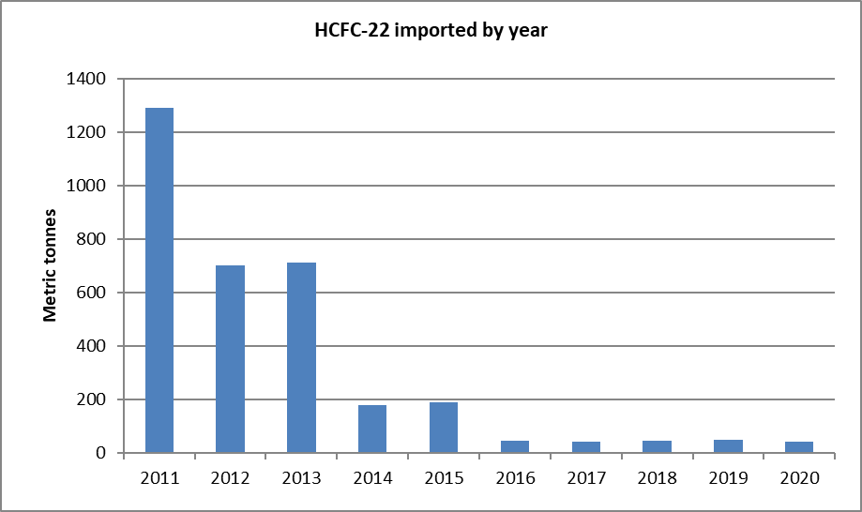

Table Bulk HCFC imported in metric tonnes, 2012 to 2020

| Species | 2012 | 2013 | 2014 | 2015 | 2016 | 2017 | 2018 | 2019 | 2020 |
| --- | --- | --- | --- | --- | --- | --- | --- | --- | --- |
| HCFC-22 | 702 | 711 | 178 | 190 | 45 | 42.8 | 45.4 | 46.06 | 43.1 |
| HCFC-123 | 26 | 8 | 8.8 | 0 | 0 | 1.8 | 0 | 0 | 0 |
| HCFC-124 | 4 | 3 | 0.5 | 1.5 | 0 | 0 | 0 | 0 | 0 |
| HCFC-142b | 1 | 1 | 0.3 | 0 | 0 | 0 | 0 | 0 | 0 |
| HCFC-225 | 0.5 | 0 | 0 | 0.3 | 0.3 | 0 | 0 | 0 | 0 |

### Australia’s bulk HCFC imports compared with other countries

Australia’s phase-out of HCFC is similar to or ahead of other developed countries (non-Article 5 or ‘non-A5’ parties) that are on the same phase-out schedule (Figure 2 and Table 2). All developed countries reached their 99.5% reduction step in 2020.

The HCFC phase-out in developing countries (Article 5 or ‘A5’ parties) commenced in 2013 with a 10% reduction step in 2015 and a 35% reduction step in 2020. This is reflected in the drop in HCFC imports in 2014 for Article 5 parties and a steady reduction thereafter. The next phase-out step for developing countries is a 65% reduction in consumption in 2025.

2020 HCFC consumption data for all countries will be available at the end of 2021.

Figure Global consumption of HCFC in ODP tonnes, 2011 to 2019

This line graph shows that both Article 5 and non Article 5 countries have decreased HCFC consumption between 2011 and 2019. Article 5 countries have seen a gradual decline after an initial spike in 2012.
Australia's consumption reduction is ahead of its other non Article 5 counterparts.

Table Australia’s HCFC consumption in ODP tonnes compared with global consumption, 2011 to 2019

| Region | 2011 | 2012 | 2013 | 2014 | 2015 | 2016 | 2017 | 2018 | 2019 |
| --- | --- | --- | --- | --- | --- | --- | --- | --- | --- |
| Australia | 70 | 40 | 40 | 10 | 10 | 2.5 | 2.5 | 2.5 | 2.5 |
| Non-A5 global | 3,893 | 2,605 | 2,716 | 2,207 | 1,117 | 904 | 760 | 805 | 653 |
| A5 global | 37,015 | 39,137 | 29,283 | 29,690 | 25,278 | 24,822 | 24,423 | 23,445 | 22,904 |

### HCFC imported into Australia in pre-charged equipment

HCFCs imported into Australia in equipment are not counted against Australia’s consumption by the Montreal Protocol. Instead, they are accounted for in the country where the equipment was manufactured. Australia regulates imports of pre-charged HCFC refrigeration and air conditioning equipment under the OPSGGM Act to provide data on the bank of HCFC equipment and the HCFCs required to service the equipment.

Import and manufacture of refrigeration and air conditioning equipment charged with HCFCs was largely banned in Australia in 2010, except for a few exemptions. From 2016, exemptions are limited to replacement parts for existing equipment and the import of equipment for private or domestic use that has been owned by a person for more than 12 months.

Since 2017 the only HCFC imported in equipment has been HCFC-22 (Figure 3 and Table 3).

Figure HCFC-22 equipment imports from in ODP tonnes, 2010 to 2020

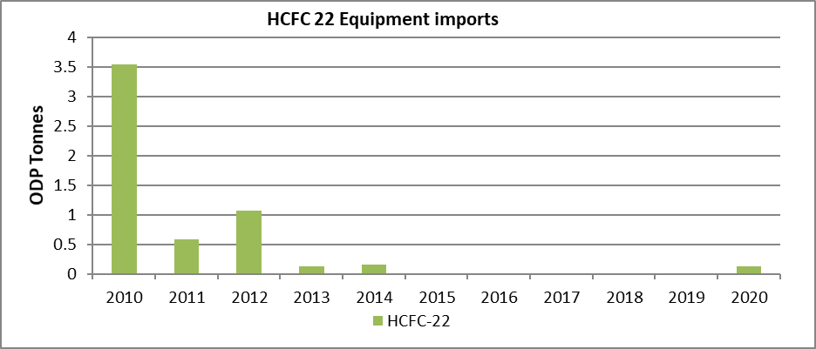

Table HCFC-22 equipment imports in ODP tonnes, 2010 to 2020

| Species | 2012 | 2013 | 2014 | 2015 | 2016 | 2017 | 2018 | 2019 | 2020 |
| --- | --- | --- | --- | --- | --- | --- | --- | --- | --- |
| HCFC-22 | 1.06 | 0.12 | 0.16 | 0 | 0 | 0.02 | 0.02 | 0.01 | 0.21 |
| HCFC-123 | 0.87 | 0.87 | 0.28 | 0.02 | 0 | 0 | 0 | 0 | 0 |
| HCFC-122 | 0 | 0 | 0 | 0 | 0.08 | 0 | 0 | 0 | 0 |

### Destruction of HCFCs and CFCs by Refrigerant Reclaim Australia

Under the product stewardship program run by Australian industry to manage waste refrigerants at end of their life, thousands of tonnes of HCFCs and CFCs have been destroyed after being returned to Refrigerant Reclaim Australia (RRA). RRA also collects and destroys waste HFC (hydrofluorocarbon) refrigerant. These substances are destroyed using Montreal Protocol approved technologies.

Figure 4 and Table 4 charts the amount of HCFCs and CFCs destroyed since 2010. The reduced amounts of HCFC destroyed from 2012 onwards reflect the greater re-use of recovered HCFCs as import limits reduce. Despite imports of CFCs being banned from 1996, a few tonnes of CFC are still being returned for destruction, largely from decommissioning of old equipment. This data includes a small amount of used refrigerant imported from New Zealand for destruction.

Figure HCFC and CFC destruction in metric tonnes, 2010 to 2020

This bar graph shows the decrease in the destruction of HCFCs and CFCs over the past 10 years. 
The graph shows that the destruction of HCFCs decreased dramatically in 2012 and then again in 2013, since then it has remained relatively consistent.
The graph shows that the destruction of CFCs over the same period has been gradual, with no dramatic drops, as its starting point was much lower.

Table HCFC and CFC destruction in metric tonnes, 2010 to 2020

| ODS | 2010 | 2011 | 2012 | 2013 | 2014 | 2015 | 2016 | 2017 | 2018 | 2019 | 2020 |
| --- | --- | --- | --- | --- | --- | --- | --- | --- | --- | --- | --- |
| CFC | 24 | 30 | 15 | 7 | 15 | 9 | 7 | 7.5 | 2.3 | 3 | 2.1 |
| HCFC | 263 | 296 | 134 | 37 | 60 | 34 | 31 | 40 | 27 | 28 | 32 |

## Methyl bromide

### Quarantine and pre-shipment uses of methyl bromide (MB)

Quarantine and pre-shipment (QPS) uses of methyl bromide are controlled by the Montreal Protocol. However, QPS uses of methyl bromide are not subject to phase-out because there is a lack of alternatives and they play an important role in preventing the spread of invasive pests and diseases and in facilitating trade. The amount of methyl bromide imported for QPS uses in Australia varies from year to year depending on growing conditions, export markets, sources of imports and pests being targeted. Figure 5 also illustrates that MB QPS imports vary on a global level from year to year and no clear trend on use is evident.

Figure Australian QPS imports of methyl bromide versus global imports, 2005 to 2019

**This line graph shows that the import of methyl bromide QPS imports in Australia have gradually increased over the past ten years - though the overall increase is not a substantial one.
The graph also shows that Methyl bromide QPS imports vary on a global level from year to year and no clear trend on use is evident.**

Table Australian QPS imports versus global imports in metric tonnes, 2010 to 2019

| Region |  | 2010 | 2011 | 2012 | 2013 | 2014 | 2015 | 2016 | 2017 | 2018 | 2019 |
| --- | --- | --- | --- | --- | --- | --- | --- | --- | --- | --- | --- |
| A5 parties |  | 5,601 | 5,888 | 5,835 | 5,520 | 4,961 | 4,686 | 5,867 | 6,616 | 6,597 | 6,159 |
| Non-A5 parties |  | 5,355 | 3,812 | 3,025 | 4,307 | 6,165 | 3,488 | 2,483 | 3,337 | 4,493 | 2,806 |
| Australia |  | 472 | 690 | 676 | 618 | 588 | 864 | 708 | 898 | 682 | 849 |

### Non-quarantine and pre-shipment uses of methyl bromide

Non-quarantine and pre-shipment uses of methyl bromide were phased out under the Montreal Protocol in developed countries (non-Article 5 parties) from 2005, except for critical uses approved by parties to the Montreal Protocol. Australia started with 6 critical uses in 2005 and by 2020 is down to one critical use for strawberry runners in Victoria. A possible alternative is being considered for registration in Australia in early 2022.

Australia’s critical uses of methyl bromide have been small compared with the total amount of methyl bromide sought globally through the critical use process. However, the difficulties in transitioning strawberry runners in Victoria to alternatives due to the soil type and temperatures means this use is now one of only a few remaining globally. Canada is the only other non-Article 5 country that was granted a critical use exemption in 2020, also for use on strawberry runners.

Figure Australian non-QPS methyl bromide imports versus all non-A5 imports, 2011 to 2020

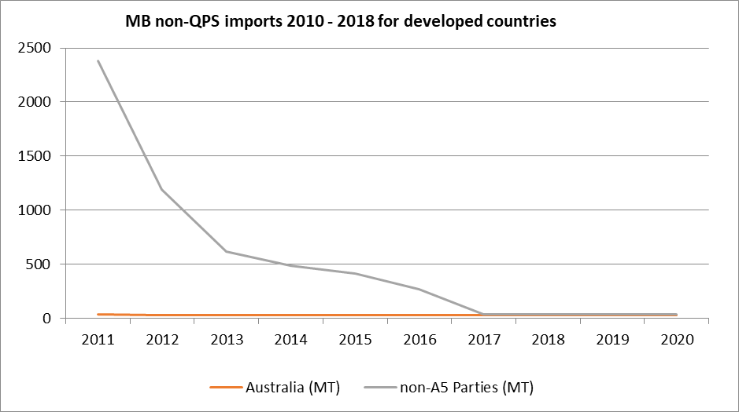

Table Australian non-QPS methyl bromide versus global non-A5 imports in metric tonnes, 2011 to 2020

| Region | 2011 | 2012 | 2013 | 2014 | 2015 | 2016 | 2017 | 2018 | 2019 | 2020 |
| --- | --- | --- | --- | --- | --- | --- | --- | --- | --- | --- |
| Australia | 33 | 33 | 31 | 30 | 30 | 30 | 30 | 30 | 29 | 29 |
| Global | 2,377 | 1,192 | 616 | 484 | 412 | 270 | 35 | 35 | 34 | 34 |

## Imports of ozone depleting substances used as feedstock into Australia

Feedstock uses of ozone depleting substances are those uses of ozone depleting substances where they are transformed in a manufacturing process to another chemical. The resulting chemicals are no longer ozone depleting and are therefore not included in a country’s official consumption figures. Australia has very few feedstock uses of ozone depleting substances – and since 2005 has only imported two ozone depleting substances for feedstock uses (HCFC-123 and methyl bromide). Since 2010, HCFC-123 predominantly has been imported for feedstock use. There have been no feedstock uses reported for 2019 and 2020 (Figure 7).

Figure Australian feedstock use in metric tonnes, 2010 to 2020

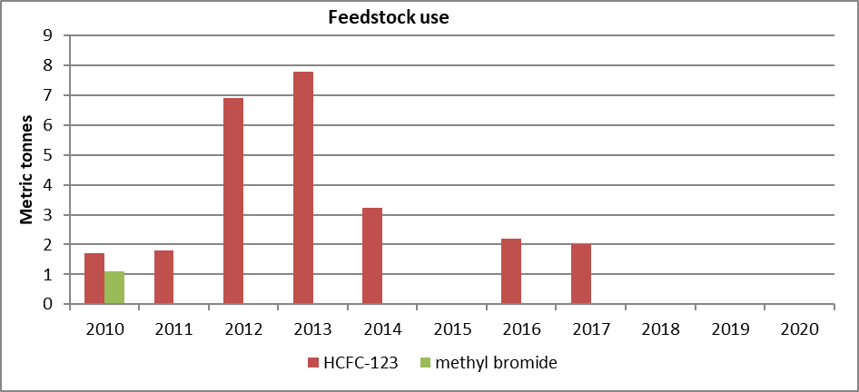

## Imports of halon in equipment

The manufacture and import of new halon in bulk into developed countries has been prohibited under the Montreal Protocol since 1994 and in developing countries since 2010. Halon imports in equipment is not prohibited under the Montreal Protocol. Halon charged into new equipment is sourced from halon recovered from decommissioned equipment. This allows used halon to be retained for essential uses like fire suppression. Australia has banned the import of halon in equipment but allows an exemption for the import of halon in products where they are necessary for medical, veterinary, defence or public safety and no alternatives available.

Figure 8 provides data on equipment containing halon imported since 2012, mainly for aircraft and defence uses. It is worth noting that the ozone depleting potential (ODP) value of halon-1301 is 10 (i.e. it is 10 times more potent than CFC 11 at destroying ozone in the stratosphere) and the ODP value of halon-1211 is 3. There is an overall declining trend in the import of equipment containing halon. The amount of halon-1301 imported in 2017 was higher than usual due to the used halon imported into Australia that year being exported for reprocessing at a later time.

Figure Australia’s imports in pre-charged equipment in ODP tonnes, 2012 to 2020

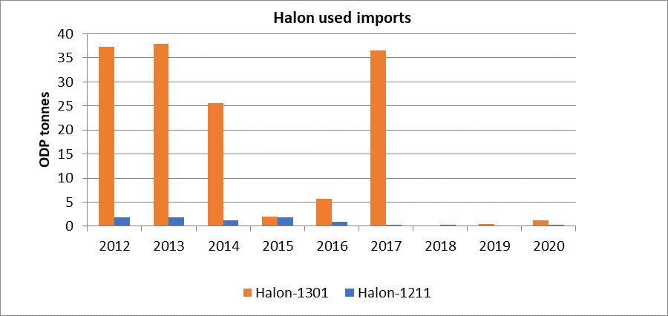

## HFCs

Australia ratified the Kigali Amendment in 2017. The Kigali amendment phases down hydrofluorocarbons (HFCs). The agreement mandates:

* an 85% phase-down in developed countries by 2036
* an 80% phase-down in most developing countries (including China) by 2045
* and the remaining developing countries reaching an 85% phase-down by 2047

### Bulk imports of HFCs into Australia

The OPSGGM Act established a quota system for the import of HFCs as bulk gas. The annual import quota will gradually reduce over 18 years. The end point of the phase-down, 15% of the baseline level, will be reached on 01 January 2036.

Australia’s HFC phase-down started on 01 January 2018 a year earlier than Montreal Protocol controls, which commenced in 2019. Australia also started with a baseline of 8 MT CO2e-, compared to the Montreal Protocol calculated baseline of 10.8 MT CO2e- (Figure 9).

Figure Australia’s HFC phase-down schedule, 2018 to 2036

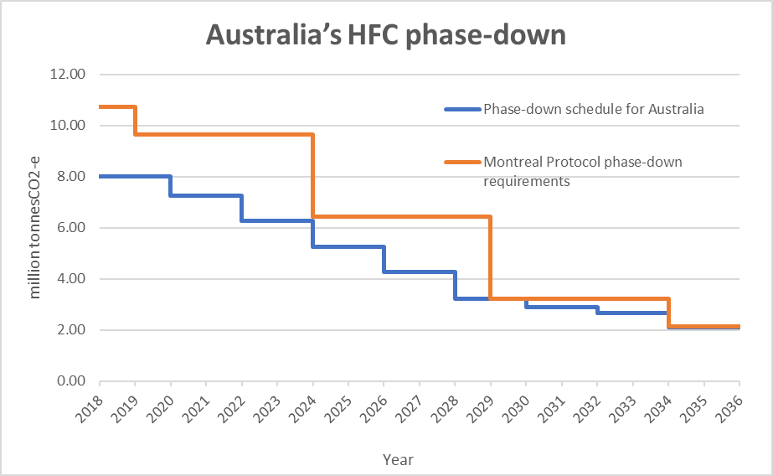

In 2017, ahead of the implementation of the HFC phase-down in Australia, data shows a dramatic increase in the import of HFC-404a which has a higher global warming potential (GWP) than the majority of HFC species imported into Australia. Imports of HFC-125, HFC-134a and HFC-407c also peaked in 2017 (Table 7 and Figure 10).

Upon commencement of the HFC phase-down in 2018, importers are making adjustments to the HFC mix they are importing. HFC-32, with the lowest GWP, has seen a gradual increase in import volume between 2016 and 2020, while higher GWP species are already seeing reductions in imports.

Table Main HFC species imported into Australia in CO2 k tonnes, 2016 to 2020

| Species |  | GWP | 2016 | 2017 | 2018 | 2019 | 2020 |
| --- | --- | --- | --- | --- | --- | --- | --- |
| HFC-32 |  | 675 | 17 | 22 | 46 | 43 | 64 |
| HFC-134a |  | 1,430 | 2,060 | 2,624 | 2,223 | 1,909 | 1,949 |
| HFC-407c |  | 1,774 | 320 | 549 | 273 | 317 | 193 |
| HFC-410a |  | 2,088 | 1,193 | 1,987 | 2,085 | 1,855 | 1,275 |
| HFC-438a |  | 2,264 | 208 | 153 | 144 | 149 | 116 |
| HFC-125 |  | 3,500 | 21 | 935 | 484 | 0 | 24 |
| HFC-404a |  | 3,922 | 3,235 | 7,510 | 2,607 | 3,182 | 3,086 |
| HFC-507a |  | 3,985 | 401 | 347 | 144 | 104 | 139 |

Figure Imports of main HFC species in CO2 k tonnes, 2016 to 2020

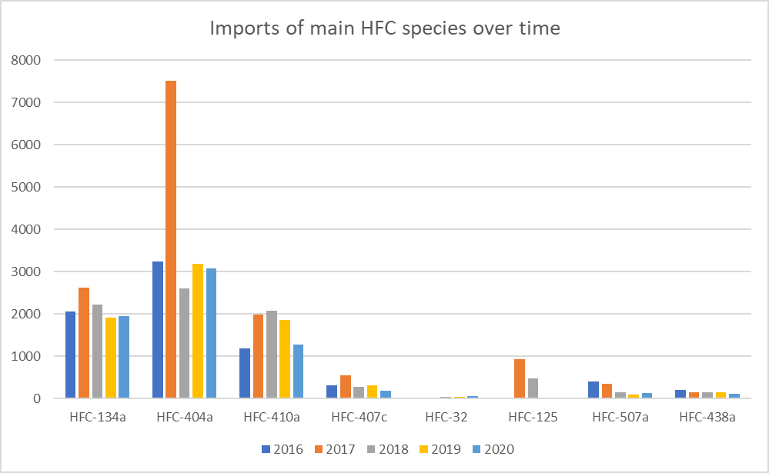

### HFC equipment imports into Australia

The Montreal Protocol does not cover gas imported in pre-charged equipment. HFCs contained in imported equipment are accounted for in the country of manufacture.

The OPSGGM Act, however, controls the import of equipment that contains or uses controlled substances, in addition to the import of HFCs as bulk gas.

The major HFC equipment imports into Australia in 2020 fit into various air-conditioning categories as indicated in Figure 11.

Figure Main HFC equipment imports by category in 2020

This bar graph shows that the top 3 imports by category are different types of air-conditioning, with domestic use air-conditioning being the highest annual import.

After air-conditioning there is a substantial drop to the next category which is commercial use refrigeration. From here there is a gradual decrease across the remaining categories.

As air-conditioning is the predominant import category, examining the HFCs associated with air-conditioning illustrates the clearest story of how HFC imports have changed over time. The core HFCs used in air-conditioning are HFC-32, HFC-410a, HFC-134a and HFC-404a.

There has been a steady increase in the import of equipment that contains or uses HFC-32; the HFC with the lowest GWP. Consistent with this, equipment containing HFC-134a and HFC-410a (higher GWPs) have decreased after an initial peak in 2017 (Figure 12).

Figure Main HFC equipment import trends in metric tonnes, 2016 to 2020

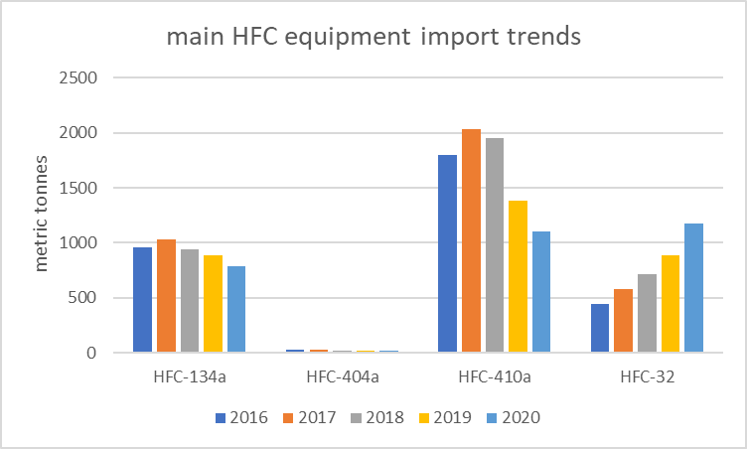

### Destruction of HFCs

Refrigerant Reclaim Australia (RRA) collects waste HFC refrigerants that it then destroy using Montreal Protocol approved technologies. The destruction of HFCs between 2016 and 2020 follows a similar trend to HFC imports, though the peak in destruction is reached a little later. It is logical the import and destruction of HFCs have a strong correlation (Figure 13 and Figure 14).

Figure Main HFCs destroyed by species in metric tonnes, 2016 to 2020

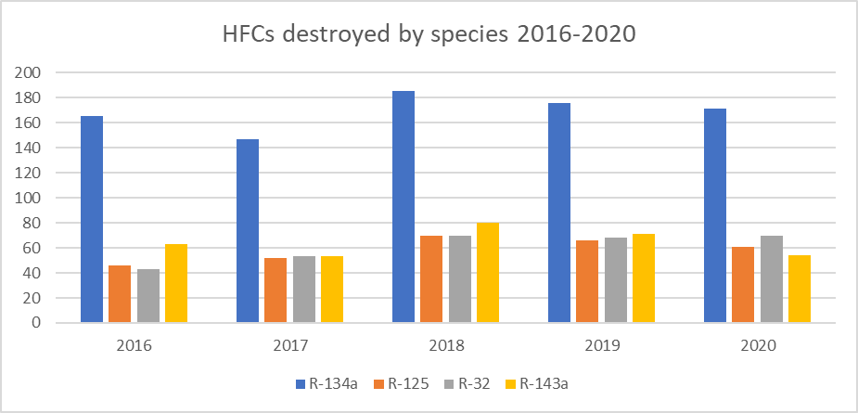

Figure Trend of main HFCs destroyed in metric tonnes, 2016 to 2020

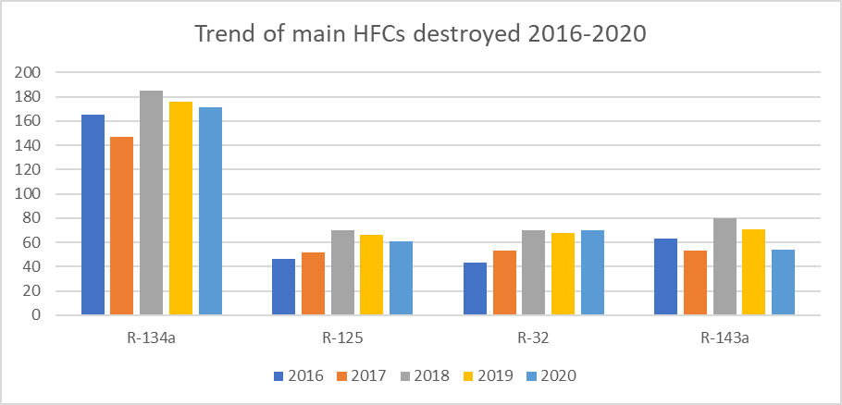

## Background

The Montreal Protocol sets out a mandatory timetable for the phase-out of the manufacture and import of ozone depleting substances and phase down HFCs. This timetable has been reviewed regularly, with phase-out dates accelerated in accordance with scientific understanding and technological advances. Science tells us that thanks to the Montreal Protocol and its 198 signatory nations, the ozone layer is on track to recover to 1980 levels by the 2030s for northern hemisphere mid-latitudes, and by around the mid-century for southern hemisphere mid-latitudes. The Antarctic ozone hole is expected to return to 1980 values in the 2060s.

The Montreal Protocol sets binding progressive phase-out obligations for developed and developing countries for all the major ozone depleting substances, including chlorofluorocarbons (CFCs), halons and less damaging transitional chemicals such as hydrochlorofluorocarbons (HCFCs).

The Ozone Protection and Synthetic Greenhouse Gas Act (OPSGGM Act) implements Australia’s international obligations to reduce emissions of ozone depleting substances and synthetic greenhouse gases under the Montreal Protocol on Substances that Deplete the Ozone Layer (Montreal Protocol) and the United Nations Framework Convention on Climate Change.

Ozone depleting substances are those substances which deplete the ozone layer and are widely used in refrigerators, air conditioners, fire extinguishers, in dry cleaning, thermal insulation in foam products, propellant in aerosols such as asthma inhalers, as solvents for cleaning electronic equipment and as fumigants in agricultural and quarantine applications. Their potency to destroy ozone is measured by their ozone depleting potential (ODP).

Ozone depleting substances controlled by Montreal Protocol include:

* CFCs
* halon
* carbon tetrachloride
* methyl chloroform
* hydrobromofluorocarbons (HBFCs)
* HCFCs
* methyl bromide
* bromochloromethane.

There are other ozone depleting substances, but their ozone depleting effects are very small in comparison to these controlled substances.

The Montreal Protocol also controls the phase-down of HFCs under the Kigali amendment, which was agreed in October 2016. The phase-down commenced in 2019 for developed countries, like Australia, and is to commence in 2024 for developing countries. HFCs are not ozone depleting, but are high GWP alternatives to ozone depleting substances. HFCs are used in many of the same products; such as in refrigeration and air conditioning equipment.

#### Australian obligations under the Montreal Protocol

Australia acceded to the Vienna Convention for the Protection of the Ozone Layer in 1987 and ratified the Montreal Protocol on Substances that Deplete the Ozone Layer originally in 1989, and then again for each of the 5 amendments agreed between 1990 and 2016.

As one of the early countries to ratify the Montreal Protocol, Australia continues to be a leader in the phase-out of ozone depleting substances. In many cases, Australia is well ahead of the Montreal Protocol requirements. Australia’s approach has been based on a cooperative partnership between industry, community and all levels of government.

Australia has met or exceeded all of its phase-out obligations under the Montreal Protocol. For example, Australia largely phased out consumption of HCFCs in 2016, 4 years ahead of the schedule required under the Montreal Protocol (Figure 9). In doing so, Australia will consume 61% less HCFC in the period 1996 to 2020 than permitted under the Montreal Protocol – even after the parties to the Montreal Protocol agreed in 2007 to accelerate HCFC phase-out globally.

Figure Australia’s HCFC phase-out schedule compared with our Montreal Protocol obligation, 1996 to 2031

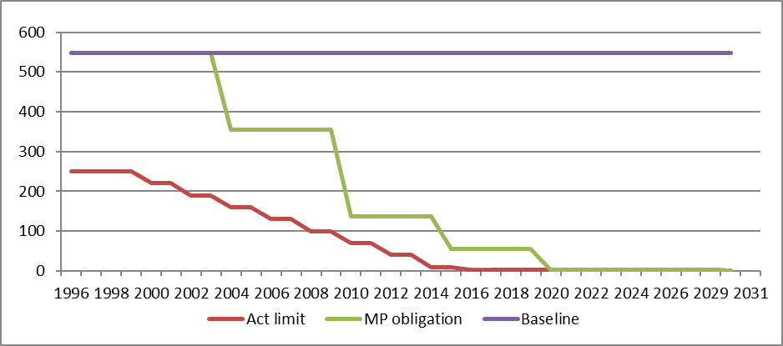

In 1996 Australia adopted an accelerated phase-out of HCFCs. The level of permitted imports and manufacture decreases every 2 years, as specified in Table 7.

Table Australia’s imports of HCFCs, 2008 to 2030

| Year | Annual import limit (ODP tonnes) |
| --- | --- |
| 2008, 2009 | 100 |
| 2010, 2011 | 70 |
| 2012, 2013 | 40 |
| 2014, 2015 | 10 |
| 2016 to 2029 | 2.5 |
| 2030 | 0 |

#### Australian legislation

The Ozone Protection and Synthetic Greenhouse Gas Act (OPSGGM Act) implements Australia’s international obligations to reduce emissions of ozone depleting substances and synthetic greenhouse gases under the Montreal Protocol on Substances that Deplete the Ozone Layer (Montreal Protocol) and the United Nations Framework Convention on Climate Change.

The OPSGGM Act controls the manufacture, import, export and end use of ozone depleting substances and synthetic greenhouse gases and equipment containing these gases.

The import, export and manufacture of these ‘controlled substances’, and the import and manufacture of most equipment containing these substances, is prohibited in Australia unless the correct licence or exemption is held. The OPSGGM Act prohibits the import of all equipment containing ozone depleting substances such as CFCs and HCFCs unless an exemption has been granted.

There are 4 types of import/export licences under the OPSGGM Act:

1. **Ozone depleting substances and synthetic greenhouse gas equipment licences (EQPL) –** used to import equipment that contains synthetic greenhouse gases, a limited range of refrigeration and air conditioning equipment that contain a HCFC, and some types of equipment ordinarily banned, such as a halon fire suppression system aboard an aircraft.
2. **Controlled substances licences –** used to import (in bulk), export and manufacture HCFCs and methyl bromide, and synthetic greenhouse gases (HFCs (hydrofluorocarbons), PFCs (perfluorocarbons), sulfur hexafluoride (SF6) and nitrogen trifluoride).
3. **Essential uses licences –** The OPSGGM Act prohibits the import, export and manufacture of CFCs, halons, methyl chloroform, carbon tetrachloride and bromochloromethane, and the import of HBFCs without an essential uses licence. Such licences are only granted for a strictly limited range of essential uses approved by the parties to the Montreal Protocol.
4. **Used substance licences –** The OPSGGM Act prohibits the import and export of used or recycled HCFCs, methyl bromide, bromochloromethane, CFCs, halon, carbon tetrachloride, methyl chloroform and synthetic greenhouse gases without a used substance licence. Import of these substances is generally only permitted for their disposal.

Australia reports its consumption (manufacture plus imports, minus exports) of bulk ozone depleting substances and HFCs to the Montreal Protocol on a calendar year basis. This data is reported in accordance with Article 7 of the Montreal Protocol and is called ‘Article 7 data’. Most of the information presented in this document is based on Australia’s, or global, Article 7 data. Australia does not manufacture controlled substances. See the Ozone Secretariat’s [Article 7 data for all countries](https://ozone.unep.org/countries/data-table).