

Department of Agriculture, Fisheries and Forestry

**Multi Factor Authentication SETUP**

Version 2.0

1 August 2024

# First-time sign-up process

### Step One

On the DAFF Forms portal click on the Sign in button on the top right of the screen

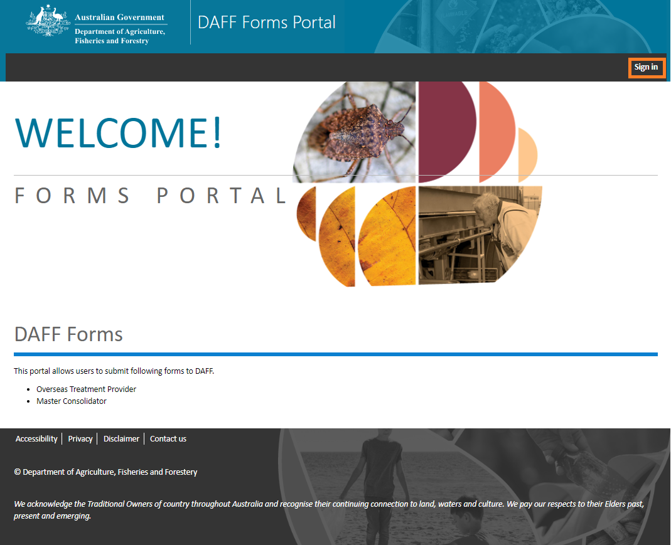

### Step Two

On the ‘Sign in’ screen click on ‘Sign up’ hyperlink.

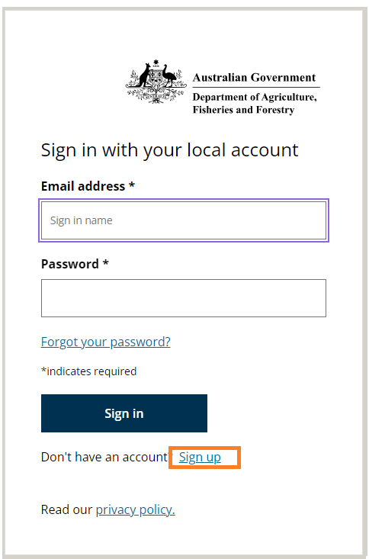

### Step Three

Enter email address and click on ‘Send verification code’ button.

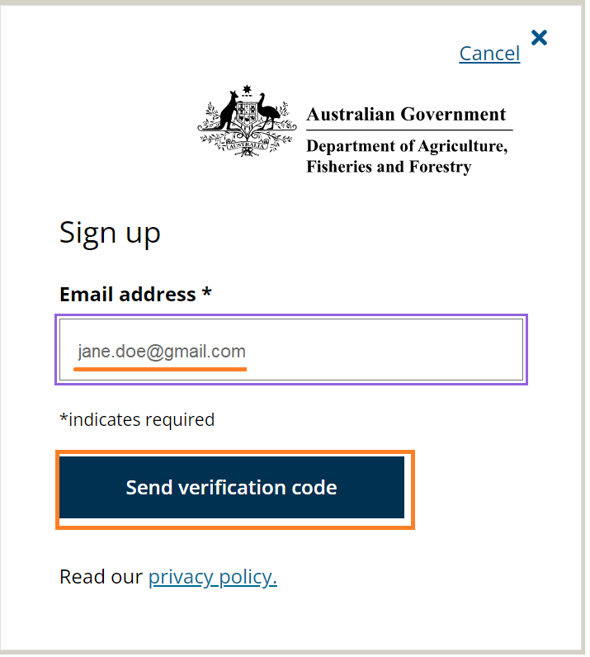

### Step Four

System will send an email to the above email address. Open it and find the verification code (6 digit code). Enter that code when prompted and press on Submit button.

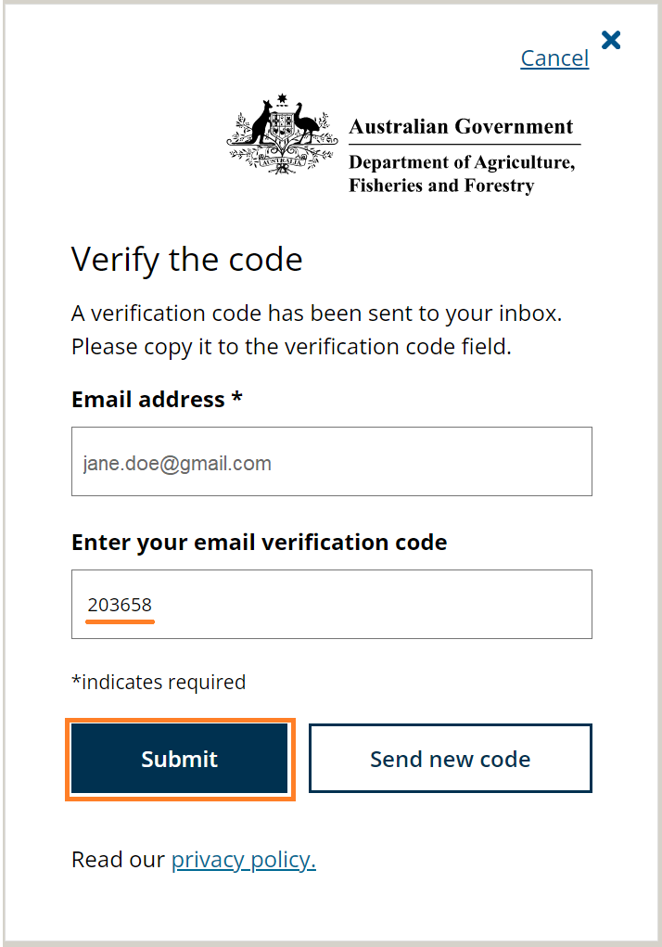

### Step Five

1. Complete the information on the next page (new password, first and last name).

Password requirements are:

* 8-32 characters, containing 3 out of 4 of the following:
* Lowercase characters,
* uppercase characters,
* digits (0-9), and
* one or more of the following symbols: @ # $ % ^ & * - _ + = [ ] { } | \ : ' , ? / ` ~ " ( ) ; .

1. Values in ‘New password’ and ‘Confirm new password’ must be the same.
2. Press ‘Create account’ button.

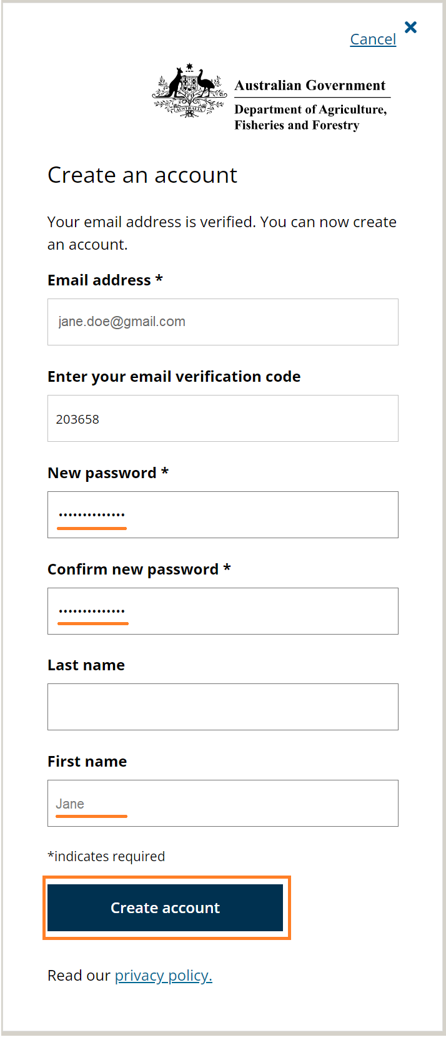

### Step Six

System will ask you to scan the QR code using the Microsoft Authenticator app.

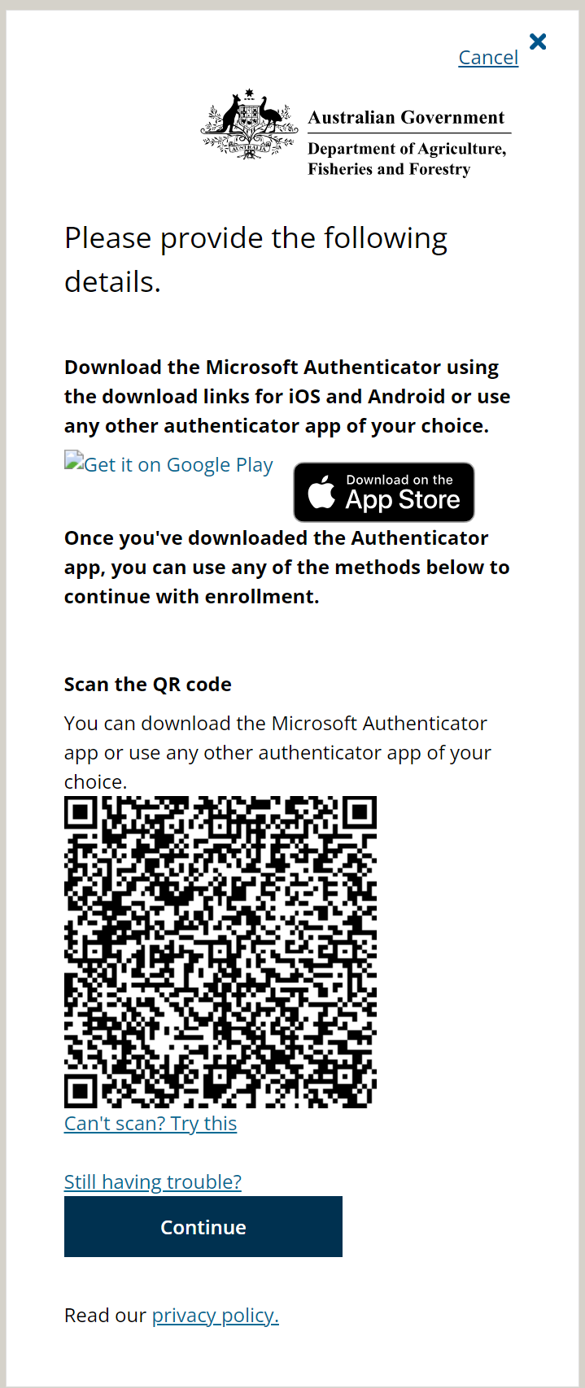

### Step Seven

1. Download Microsoft Authenticator app to your smart phone.
2. Set up your account in Microsoft Authenticator app. If prompted, allow notifications.
3. Add Account (press on + on the top of the Microsoft Authenticator screen) and point the phone at the QR code on the computer screen. The Authenticator will display the home tab on which it will show a line with DAFF heading and your email address under it.

### Step Eight

Once the Authenticator shows a line with a DAFF heading, go to the computer screen and click on the Continue button. System will ask you to enter the verification code from the Authenticator.

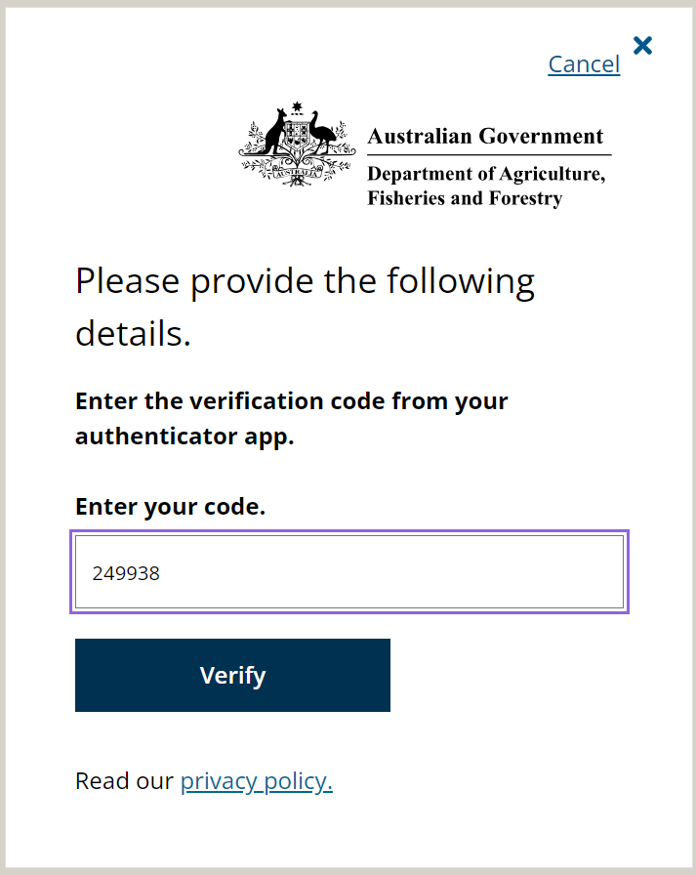

### Step Nine

On the Authenticator app click on the DAFF line. It will take you to another screen which contains a one-time password code. Enter this 6 digit code on the computer screen and click Verify. This code is only valid for 30 seconds. If time runs out, the Authenticator with show another 6 digit code and you need to enter that code.

This completes initial sign-up. At this point you are signed into the DAFF Forms portal.

### Step Ten

It is a good idea to have your authenticator app back up your account credentials to the cloud. You can then use the app to recover your information on a new device, potentially avoiding getting locked out or having to recreate accounts.

If your authenticator account is not backed up, when you upgrade or change devices, the code that is generated on your new device may not be accepted when you login to portal. If this is the case, please email [spp@aff.gov.au](mailto:spp@aff.gov.au) to have your account reset, you will then have to setup a new authenticator account via a new QR code provided upon login.

More information on this process can be found via [Microsoft Support - Back up account credentials in Microsoft Authenticator](https://support.microsoft.com/en-us/account-billing/back-up-account-credentials-in-microsoft-authenticator-bb939936-7a8d-4e88-bc43-49bc1a700a40).

# Subsequent sign in process

### Step One

On the DAFF Forms portal click on the Sign in button on the top right of the screen.



### Step Two

On the ‘Sign in’ screen enter the email address with which you signed up and password. Click on ‘Sign in’ button.

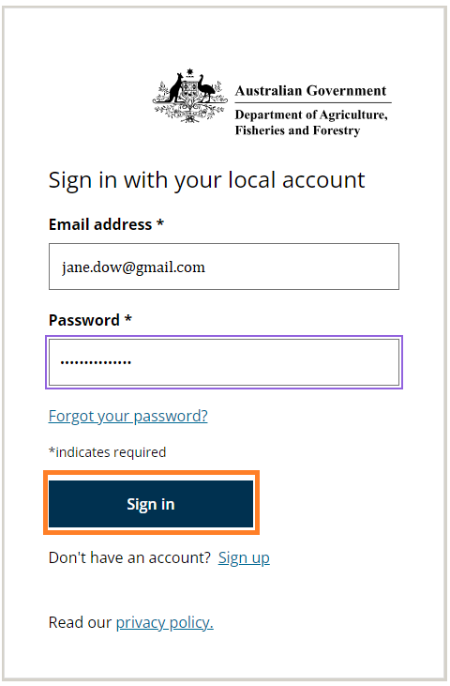

### Step Three

System will ask you to enter the verification code from your Authenticator app.

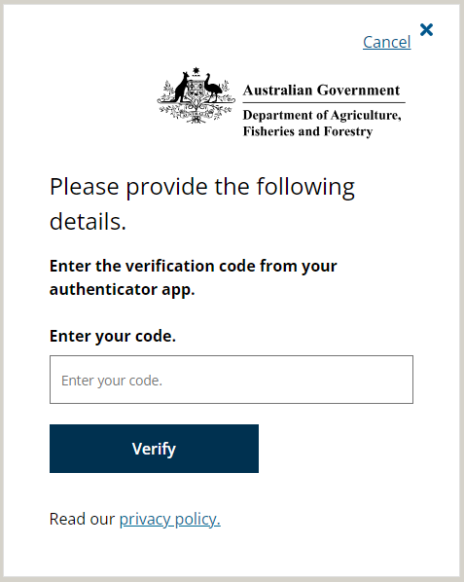

### Step Four

On the Authenticator app on your phone click on the DAFF line. It will take you to another screen which contains a one-time password code. Enter this 6 digit code on the computer screen and click Verify. This code is only valid for 30 seconds. If time runs out, the Authenticator with show another 6 digit code and you need to enter that code.

This completes the sign-in. At this point you are signed into the DAFF Forms portal.