**Environmental flows to support Murray cod spawning in the lower Darling River 2017**

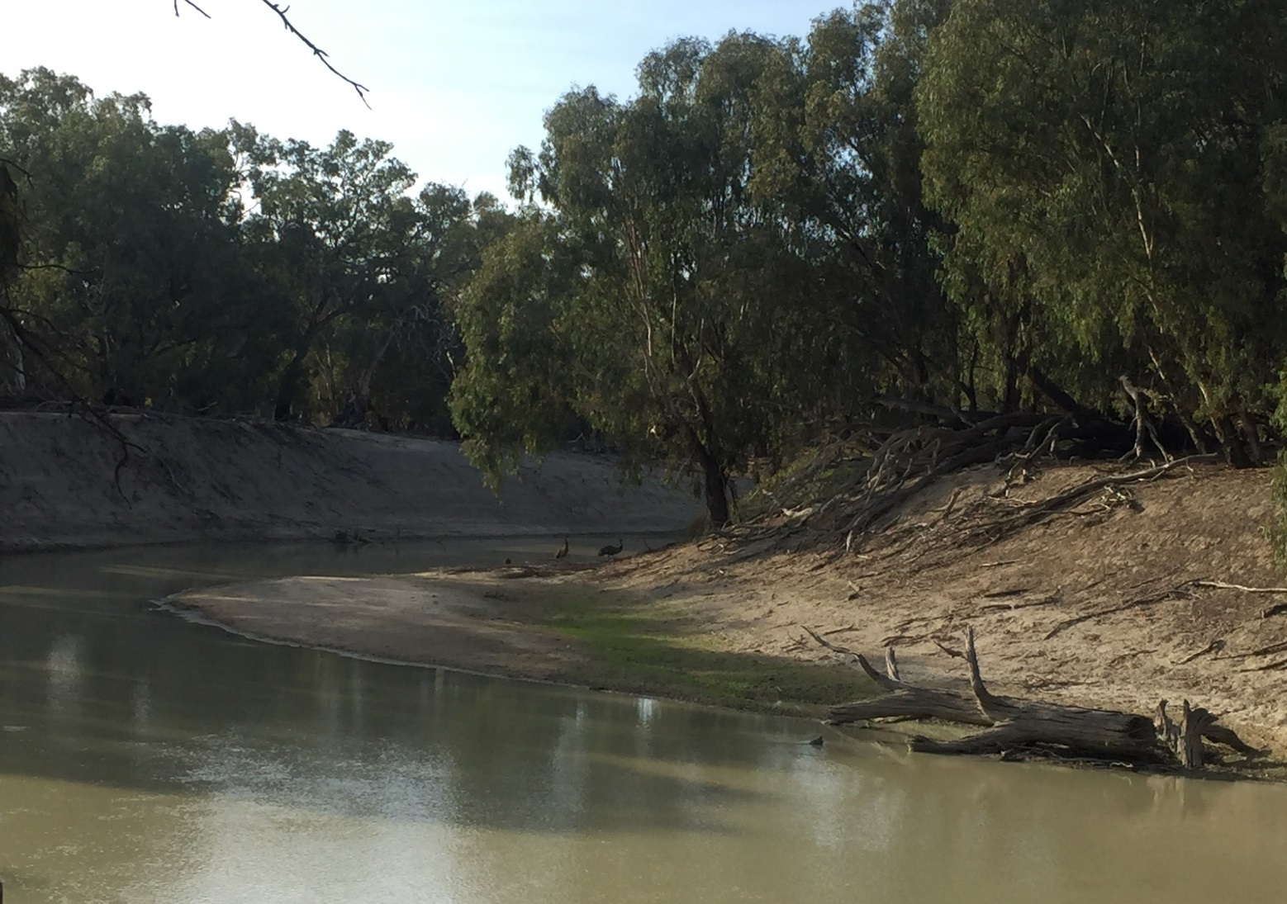



**Citation**:

Sharpe, C. (2019). Murray cod spawning in the lower Darling River 2017. CPS Enviro report to The Commonwealth Environmental Water Office.

**Acknowledgements**:

This project was funded by the Commonwealth Environmental Water Office (CEWO), NSW Office of Environment and Heritage (OEH) and the Murray–Darling Basin Authority’s The Living Murray Program (TLM). From NSW Department of Planning, Industry and Environment (DPIE) Biodiversity and Conservation Division (formerly NSW OEH); Paula D’Santos and Sascha Healy who led the planning and coordination of flows to the lower Darling River and inter-agency and community engagement of the project findings. From NSW DPIE Fisheries; Iain Ellis provided expert input and support to flow planning. From CEWO; Irene Wegener, Hilton Taylor, Hilary Johnson, and Sean Kelly and from the Murray–Darling Basin Authority; Adam Sluggett, Adam McLean, Kerry Greenwood, John Waterworth and Tristan Skinner provided high level, institutional support and operational guidelines for hydrograph development and water delivery. From CPS Enviro, Sheridan Stephens for project administration and data management and Eden Sharpe for laboratory preparation of drift net and light trap samples for identification. Jason Healy (CPS) provided technical support in field sampling of the lower Darling River. We thank landholders along the Darling for access through their properties. This work followed the requirements of NSW Fisheries Permit P12/0004 and Griffith University ACEC ENV0414AEC.

**Disclaimer**:

The results and comments contained in this report have been provided on the basis that the recipient assumes the sole responsibility for the interpretation and application of them. The author gives no warranty, express or implied, or assumes any legal liability or responsibility for the accuracy, completeness or use of the results and comments contained in this report by the recipient or any third party.

© CPS Enviro P/L  
With the exception of the Commonwealth Coat of Arms, photographs and logos, all material presented in this document is provided under a Creative Commons Attribution 4.0 International licence. (<https://creativecommons.org/licenses/by/4.0/>) .  
For the avoidance of any doubt, this licence only applies to the material set out in this document.

The details of the licence are available on the Creative Commons website (accessible using the links provided) as is the full legal code for the CC BY 4.0 licence (<https://creativecommons.org/licenses/by/4.0/legalcode>).

**Contact** **Details**:

Commonwealth Environmental Water Office

John Gorton Building

King Edward Terrace

Parkes ACT 2600

Australia

P: +61 2 6274 1111

E: [ewater@environment.gov.au](mailto:ewater@environment.gov.au)

# Summary

This project follows an extensive study of fish spawning and recruitment dynamics in the lower Darling River in association with environmental flows (LDR) from November 2016 – June 2017 (Sharpe and Stuart 2018). That study aimed to support the ecology of Murray cod (*Maccullochella peelii*) spawning by matching specific flow characteristics to particular elements of breeding ecology. Flow management avoided rapid drops and oscillating water levels during the breeding period (September-December) by providing stable water levels to optimise nesting and spawning success and, increased water levels post December to inundate low lying benches with the aim of promoting food availability and nursery habitat for newly settled larvae. By recording an extraordinarily high abundance of Murray cod larvae relative to similar studies conducted elsewhere, the 2016 study demonstrated that Murray cod spawning can be enhanced by accommodating these key elements of life history ecology with strategic flow delivery schedules.

In 2017, environmental flows were again planned and delivered to support the ecology of Murray cod spawning in the LDR. In 2017, environmental flow delivery commenced in September and was completed by mid-December 2017. The present study documents the spatial and temporal dynamics of Murray cod spawning in the LDR, defines the Murray cod spawning period and compares findings to patterns of spawning observed in previous years.

* A strong Murray cod spawning response was recorded in 2017 with 136 larvae collected.
* The spawning season occurred over a period of 47 days. Based upon the estimated ages of larvae collected, the Murray cod spawning period in the LDR was broadly defined as 9 October- 28 November.
* This knowledge provides river managers with important information to inform the timing of future environmental flows to support the breeding ecology of Murray cod in the LDR.

The spawning response of Murray cod in 2017, gauged by the number of larvae collected, was considerably lower than that recorded in 2016. The number of larvae was however much higher than in 2014, when conditions in the LDR were not optimised to support spawning, flows were low and oscillating (~150-200 ML/d) and only 26 Murray cod larvae were recorded (Ellis et al. 2015). The schedule of the 2017 environmental flow therefore demonstrates that flow planning to match the ecology of Murray cod spawning was successful and, that when flow is not optimised, such as in 2014, spawning intensity is lower. This may be due to a number of factors including increased availability of suitable spawning sites when water levels are higher during the breeding period; fast flowing water supporting optimal nesting habitats, or a lower investment of energy into spawning during unfavourable conditions.

The level of spawning in 2017, which coincided with a flow release volume typical for the LDR (whole of system flowing water, base flow 400-800 ML/d), can be considered a benchmark for predicting spawning responses to future flow conditions. For years when antecedent conditions are considered favourable, i.e. in association with upstream flooding (as in 2016), a ‘boom’ in reproductive effort may be accommodated and environmental flow schedules can be constructed to maximise spawning potential for Murray cod. For years when a ‘bust’ might be predicted, such as occurred in 2014 leading into a dry period, flows might be better directed to maintaining other ecological priorities, such as providing perennial base flows to maintain the condition of adult populations in the lower Darling.

# INTRODUCTION

In 2017, environmental flows were delivered to the lower Darling River (LDR) in a pattern that aimed to match the requirements of Murray cod breeding ecology supporting courtship, nest selection, spawning and nest retention by avoiding rapid drops and rises in river levels throughout the breeding period (September to December 2017; Table 1). A detailed conceptual model of Murray cod ecology, which formed the basis for the 2016 and 2017 LDR environmental flow delivery schedules, is shown in Appendix 1. The flow delivery schedule, or Murray cod hydrograph, was tested and refined in Gunbower Creek (Victoria) in 2013 and in the LDR in 2016, when an extraordinarily high level of spawning success was associated with its application (Sharpe and Stuart 2018). Environmental flow delivery to the LDR in 2017 aimed to build upon the success of the previous year by re-applying the Murray cod hydrograph throughout the September-December breeding period.

The first aim of this study was to define the Murray cod spawning season by relating the occurrence of Murray cod larvae to describe the initiation, peak and duration of the spawning period in 2017. The second aim was to provide context to the extraordinarily high level of spawning observed in 2016 by Sharpe and Stuart (2018) and in doing so, enable refinement of future environmental flow delivery schedules to optimise spawning and population level outcomes for the LDRs nationally significant Murray cod population.

**Table 1.** Key elements of the 2016–17 LDR environmental flow plan, based on conceptual models of Murray cod population function.

|  |  |  |  |  |
| --- | --- | --- | --- | --- |
| Temporal scale (season) | Spatial scale for LDR objectives | Water level | Mean channel velocity | Ecological objectives  Murray cod |
| Early spring  (early Sep) | ~500 km  LDR from Weir 32 – Wentworth | Slowly rising (e.g. 0.15 m per day) to ¾ to full channel  No major reductions in water level (e.g. net drop < 0.3 m)  450 ML/d | > 0.4 m/s | * Enable adult fish to move to breeding habitats * Initiate egg maturation * Inundate spawning sites including snags, undercut banks, benches and establish littoral macrophytes and food resources for larvae * Minimise sudden drops to avoid nest abandonment |
| Mid-spring to late summer (Oct-Feb) | Smooth slowly rising (e.g. 0.15 m per day) to ¾ to full channel  Minimise hydraulic disturbance  No major reductions in water level (e.g. net drop < 0.3m)  600-800 ML/d | > 0.4 m/s | * Nest construction, courtship, mating, egg laying, males to guard nest * Minimise sudden drops to avoid nest abandonment * Enhance egg hatching and maintain larval drift and nursery areas |
| Late spring – early summer (Nov-end Dec) | ~600 km  LDR from Weir 32 – Wentworth and Murray River | Increase 800-1200 ML/d, avoid water level reductions | > 0.4 m/s | * Inundate low-lying benches, promote primary and secondary productivity and food for larvae * Enable YOY to inhabit littoral zone and snag habitats |
| Late summer and autumn  (Jan-April) | Slow recession to ¼ full channel  800-6000 ML/d flow pulse | > 0.4 m/s | * Increase littoral habitats for YOY dispersal * Increase snag habitats for sub-adults and adults * Inundate low lying benches food resources for YOY |
| Winter  (April to August) | ¼ to full channel  Slow recession to winter base flow (e.g. fall of <0.15 m/24 h)  400 ML/d | > 0.4 m/s | * Enable native fish to move to permanent winter habitats (i.e. deep refuge pools) * Maintain base flow for survival of YOY juveniles, sub-adults and adults |

See Appendix 1 for further Murray cod life-history information.

# METHODS

The spatio-temporal occurrence and peak intensity and of Murray cod spawning was evaluated by sampling for their larvae from 22 September to 20 December 2017, at six sampling sites throughout 500 km of the LDR, from Menindee to Wentworth (Figure 1). Sampling was conducted approximately fortnightly and coincided with the delivery of environmental flows from September to December 2017.

Six sampling sites were selected for their spatial separation (Figure 1). Sites were ~80 km apart and were located at various pastoral stations;

1. 50 km downstream Weir 32 and downstream of all Menindee water outlets
2. 140 km downstream Weir 32, near the old anabranch offtake
3. 230 km downstream Weir 32, upstream of the influence of Pooncarie Weir
4. 310 km downstream Weir 32, 5 km downstream of Pooncarie Weir
5. 385 km downstream Weir 32, upstream of the influence of Burtundy Weir
6. 475 km downstream Weir 32, 25km upstream of the Lock 10 influence

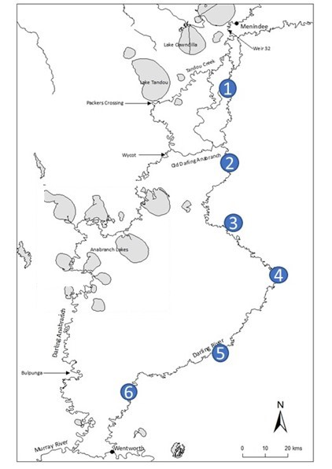

**Figure 1.** Larval sampling sites on the lower Darling River from ~50 km downstream of Weir 32 near Menindee to the Wentworth weir pool.

At each sampling site and time, three replicates each of drift nets and light traps were used to catch Murray cod larvae (Figure 2). Drift nets were tied off snags in flowing water and were weighted to be positioned just below the surface to filter larvae drifting downstream (Figure 2). Drift nets were deployed from late afternoon, left overnight and collected the following morning. Light traps incorporated a ‘glow stick’ to emit light to attract larvae and were deployed late in the evening into slack water areas of the main river channel, where larvae might accumulate, and were collected the following morning (Figure 2). The light traps and drift nets were identical to those used in the LDR in 2016 (Sharpe and Stuart 2018).

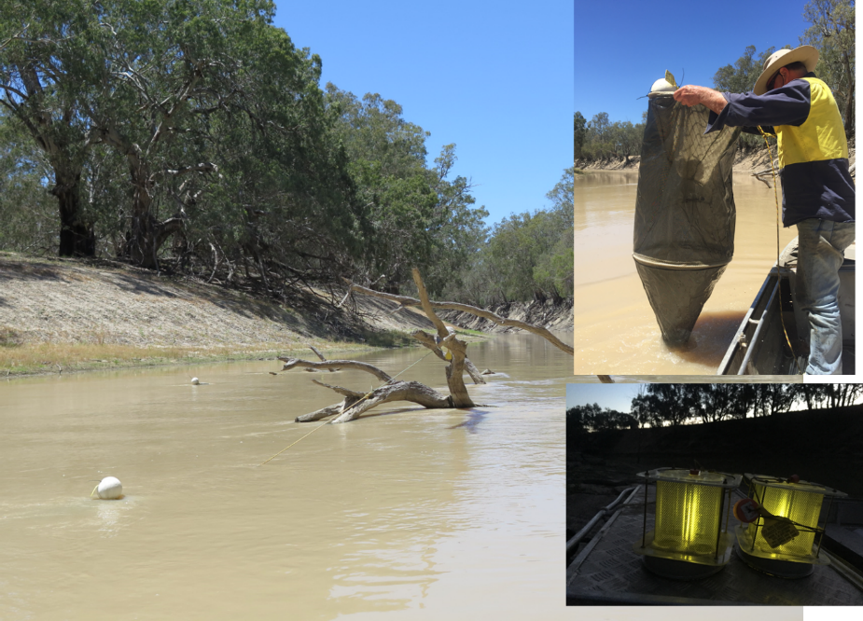

**Figure 2.** A drift net suspended from a snag (left) and being retrieved (top right). Light traps prior to deployment (bottom right), showing the light emitted from glow sticks that attract fish.

**Sample processing**

All samples were ‘live picked’ in the field immediately following their collection and preliminary findings reported directly back to river managers (Figure 3). The findings informed real-time adaptive management of flows to optimise fish outcomes and meet strategic water accounting targets. All samples were then preserved and returned to the laboratory for processing.

All larvae were identified according to published keys and descriptions (Serafini and Humphries 2004). Larval developmental stage and length were recorded for each individual Murray cod. Developmental stage and length at age was then used to estimate the timing of spawning, after Serafini and Humphries (2004). Larval catch was reported as raw abundance relative to the soak time of nets and traps at each sampling site and sampling event (range 16-19.5 hrs per net/trap).

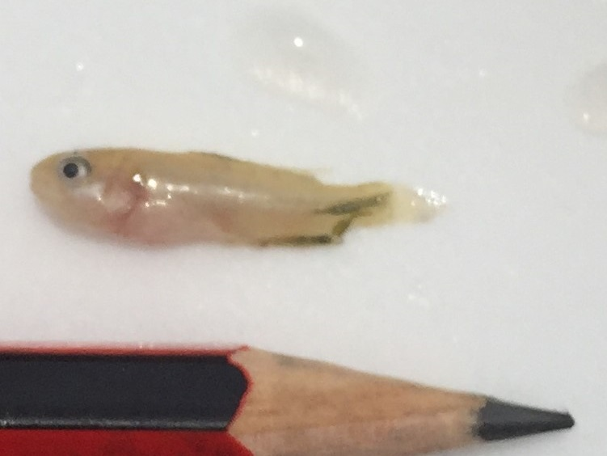

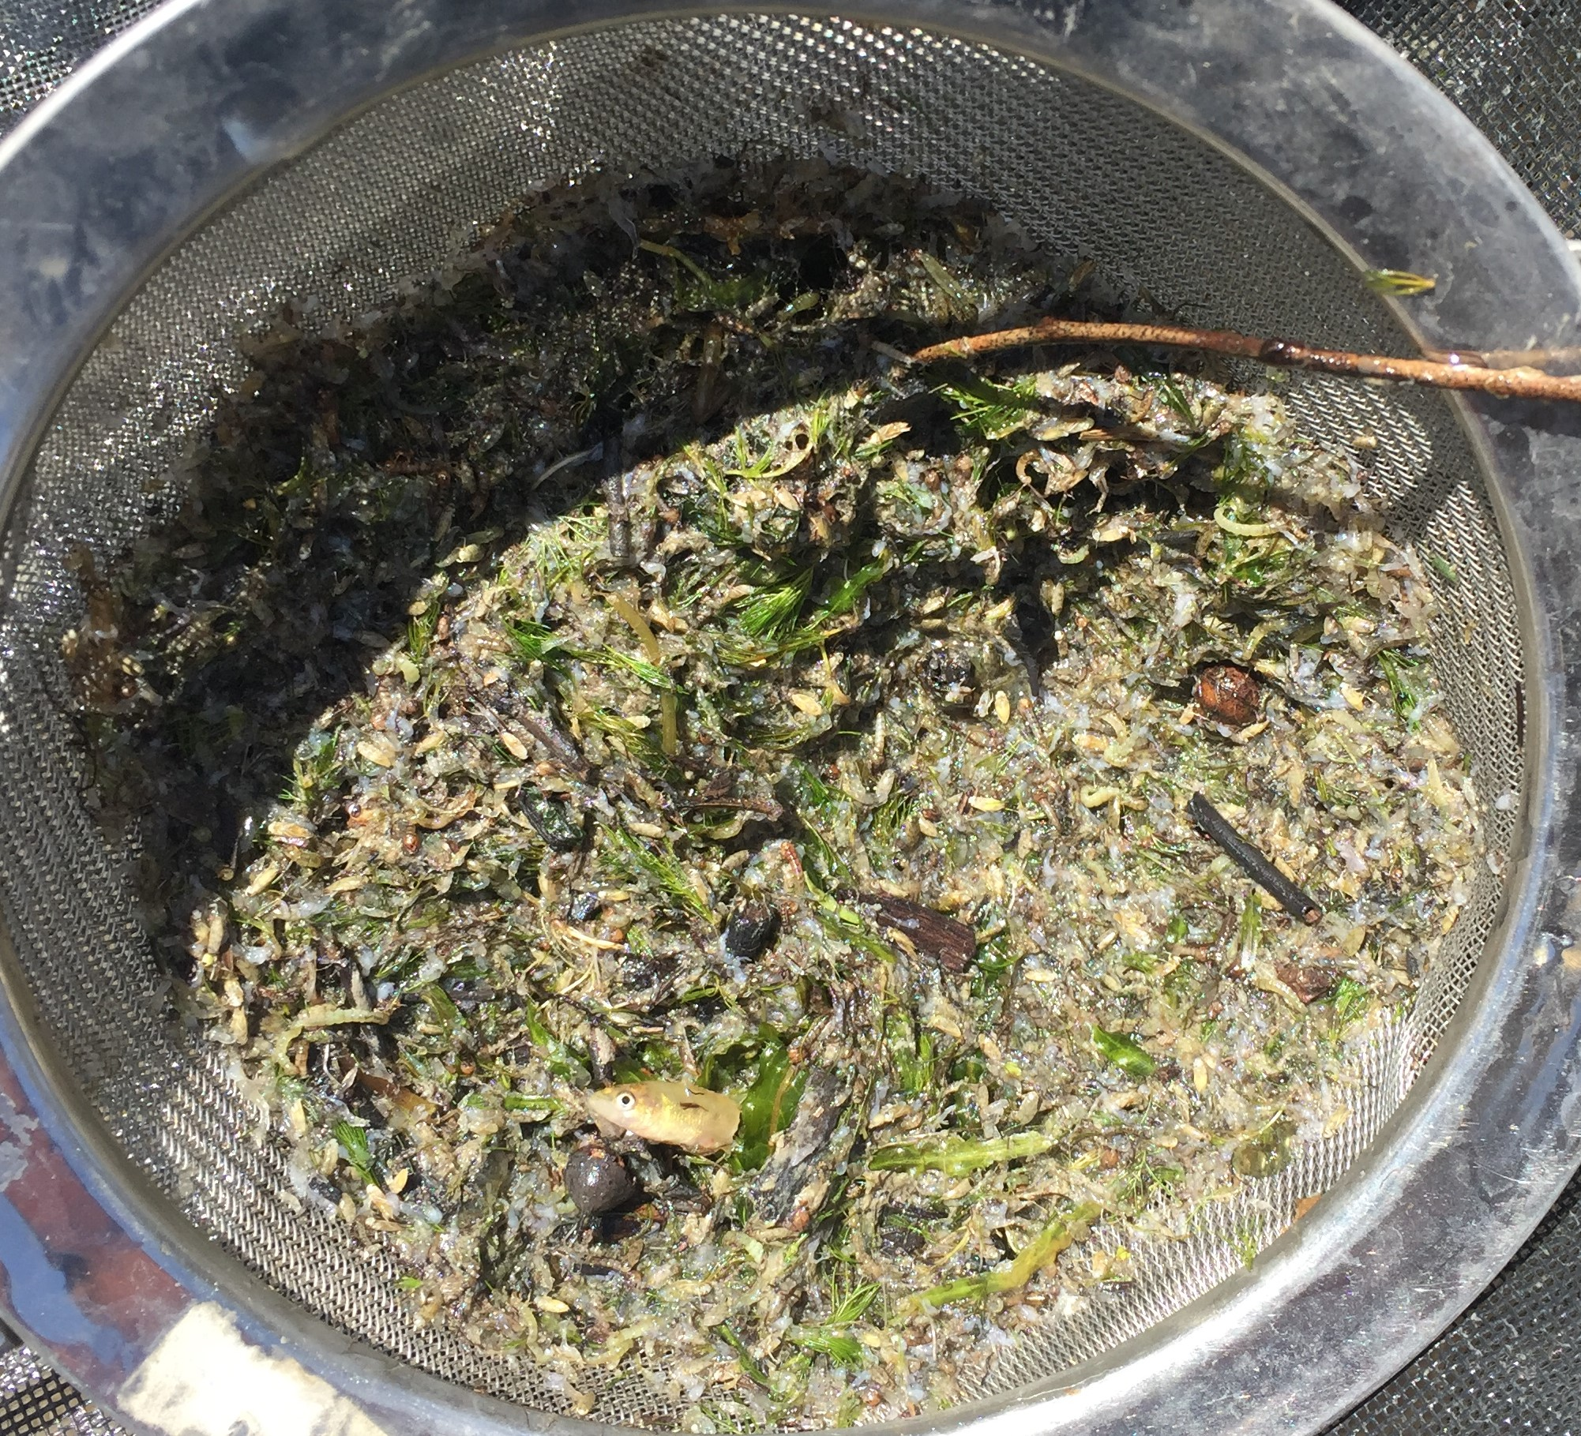

**Figure 3.** The contents of a drift net sample (left) showing a live-picked Murray cod larvae (right) collected from the lower Darling River during November 2017.

# RESULTS AND DISCUSSION

## Hydrology

From July – December 2017, 25 810 ML of environmental water was delivered to the LDR. This consisted of water held by the Murray–Darling Basin Authority (MDBA) The Living Murray (TLM): 23 072 ML, and CEWO: 2 738 ML (Figure 4). The TLM component of water was delivered 1 July – 29 September and 28 November – 15 December 2017 and CEWO water 21 – 28 November 2017 (Figure 4).

In early November 2017, MDBA River Operations increased operational releases from 1 000 ML/d at Weir 32 to 1 800 ML/d (Figure 4). Following advice from the LDR Technical Advisory Group (TAG), the rate of operational releases was reduced to 700 ML/d and attenuated to accommodate the ecology of Murray cod spawning (Figure 4). By mid-December, field sampling confirmed that Murray cod spawning was completed, no further environmental flows were released to the LDR and management of the Menindee Lakes returned to NSW.

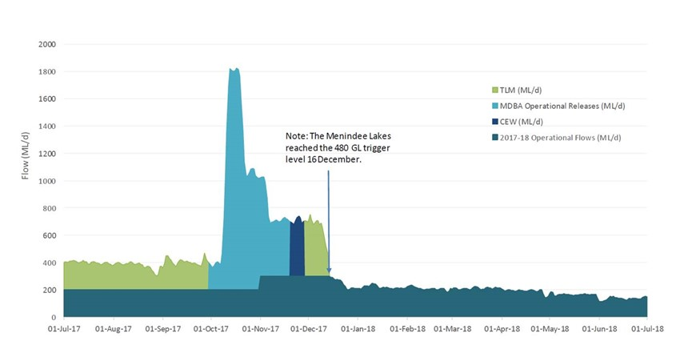

**Figure 4.** Flow (ML/d) at Weir 32 delivered to the lower Darling River throughout 2017–18. In 2017–18, the volume of environmental water delivered was 25.8 GL. The dark green represents WaterNSW operational flow for LDR. The light green represents TLM, light blue MDBA Operational Releases, dark blue CEW. The main elements of the environmental flow plan were to increase discharge and water levels above the WaterNSW operational flows to promote inundation of potential spawning sites and avoid rapid drops and rises in water level so as to support nesting success during the Murray cod breeding period (September-December).

**Larval fish abundance**

A total of 1 852 fish larvae from seven species; five native and two non-native, were collected across eight sampling trips (23 September – 20 December 2017) (Table 2). Amongst the native species, Australian smelt (*Retropinna semoni*) was the most abundant followed by carp gudgeon (*Hypseleotris* spp.), bony herring (*Nematalosa erebi*), Murray cod and silver perch (*Bidyanus bidyanus*) (Table 2). Non-native species were generally less abundant than natives and included Common carp (*Cyprinus carpio*), followed by eastern gambusia (*Gambuisa holbrookii*) (Table 2).

Australian smelt larvae were recorded on each sampling occasion indicating a protracted spawning period spanning from at least late September (from the first sampling event) – late December (the last sampling event) (Table 2). Bony herring and carp gudgeon likewise exhibited spawning over a protracted period with larvae first collected in early October and continuing through to at least the completion of sampling in late December (Table 2). The abundance of silver perch larvae recorded was low relative to other species, with collection times indicating that spawning occurred over a brief period of 32 days with larvae collected from 28 October – 29 November (Table 2). Silver perch larvae were only collected at sites downstream of Pooncarie Weir (sites 4- 6), the same as in 2016 (Sharpe and Stuart 2018). The abundance of silver perch larvae collected in the LDR was similar to 2013 and 2016 (Sharpe and Stuart 2018). While a low level of spawning relative to other species in the LDR has been regularly reported, the occurrence of silver perch spawning in the LDR is significant, indicating a viable breeding population is present. It is a recommendation of this study that the population ecology of silver perch in the LDR; e.g. distribution, abundance and population demography be determined.

Overall species diversity in 2017 was lower than 2016 albeit by only two species; the native golden perch and non-native goldfish were not collected as larvae in 2017 (Table 2) although are known to occur and were collected as larvae in 2016 (Sharpe and Stuart 2018). Overall abundance among species was considerably lower in 2017 compared to 2016, with less than half as many larvae collected in 2017, despite consistency in sampling techniques being applied across the same study sites (Table 2).

**Table 2.** Overall abundance of native and exotic fish larvae collected in the lower Darling River from September-December 2017.



## Murray cod spawning in the LDR September – December 2017.

There were far fewer Murray cod larvae collected in 2017 (n = 136) compared to 2016 (n = 885). The size and developmental range of larvae collected was 8.0- 25 mm (mean 12.01 ± 2.86 s.d.) (developmental range Flexion- Metalarvae).

The spatial occurrence of Murray cod larvae was similar between years, with larvae collected at each of the six sampling sites, indicating that Murray cod spawning occurred throughout the ~ 500 km length of the LDR, from ~50 km downstream of Weir 32 to ~25km upstream of the Wentworth weir pool.

## Temporal occurrence of larvae and the Murray cod spawning period

In 2016, Murray cod larvae were collected on the first sampling event in early November (Sharpe and Stuart 2018). That finding prevented the initiation and hence duration of the Murray cod spawning period to be defined in the LDR (Sharpe and Stuart 2018). In 2017, larval sampling was initiated earlier, prior to the first collection of larvae, and completed later, after the last larvae were collected, addressing the aim of defining the Murray cod spawning period in the LDR.

In 2017, Murray cod larvae were not collected on sampling events during September and were first collected 18 October 2017 (Table 2). The time of first collection was also the peak in larval abundance (Table 2). The abundance of Murray cod larvae declined thereafter, being recorded on three subsequent sampling events and none were collected post 28 November 2017 (Table 2). Considering the time from spawning to hatching (~10 days), in relation to larval collection times and developmental stages of larvae, Murray cod spawning was likely initiated around 8October and completed by about 28 November 2016, with the spawning period spanning approximately 47 days.

**‘B**oom and bust’ ecology for Murray cod in the Darling River?

The boom and bust nature of Australia’s ecological systems, particularly for riverine biota in arid rivers, is well known (Walker et al. 1997; Kingsford et al. 1999; Arthington and Balcombe 2011). The boom-bust concept describes the phenomenon of biota aligning their reproductive effort with favourable conditions for the survivorship progeny, such as during wet years and flood periods, while reproductive effort is reduced during unfavourable periods, such as during drought. The boom-bust concept may help explain differences in the abundance of Murray cod larvae between survey years (Table 3), particularly between the 2016 and 2014 spawning seasons, which can be interpreted as differences in the intensity of spawning in relation to antecedent, or boom-bust conditions.

In 2016, the highest larval abundance yet recorded in the LDR could be considered to reflect a ‘boom’ in Murray cod reproductive effort, which coincided with favourable flow conditions, upstream floods and abundant food resources for adults and progeny (Sharpe and Stuart 2018). The 2016 spawning period was preceded by an extended period of unfavourable, protracted cease to flow conditions in the LDR and a ‘bust’ in 2014, when very low larval abundances were recorded (n = 26; Table 3) and the river had contracted back to a series of isolated water holes (Ellis et al. 2015). While larval abundance was lower in 2017 relative to the boom recorded in 2016 (Table 3), it is not considered that abundance in 2017 reflected a ‘bust’, rather, spawning intensity was high relative to the ‘bust’ years of 2013 and 2014 (Table 3).

**Table 3.** Non-standardised abundance of Murray cod larvae collected in the LDR across four sampling years. Sampling sites were consistent across survey years albeit fewer sites were surveyed in 2013–14.



Flow conditions from 2016–2017 were relatively stable in the LDR (Figure 1) and the abundance of Murray cod larvae recorded in 2017 was similar to that observed from other rivers and streams where stable, perennial flow regimes prevail, such as the nearby lower Murray River and Mullaroo Creek (Vilizzi 2012), mid-Murray and Ovens River’s (Koehn and Harrington 2005) and in Gunbower Creek (Stuart et al. 2019). In those systems, researchers have applied similar sampling efforts and techniques to the present study and recorded similar levels of Murray cod larval abundance across consecutive years. Hence, in comparison to findings to rivers with more stable flow, which is also typical of the LDR, a bust pattern of reproductive effort was not apparent from the level of spawning observed in 2017.

The level of spawning intensity in 2017, which coincided with the more typical, perennial pattern of flow for the LDR, provides a useful a benchmark for predicting spawning responses to future flow schedules. For years when antecedent conditions are considered favourable, and a ‘boom’ in reproductive effort might be predicted, environmental flows can be built into flow delivery schedules with the aim of maximising spawning potential for Murray cod. For years when a ‘bust’ might be predicted, such as occurred in 2014, environmental water might be better directed to maintaining other ecological priorities, such as maintaining a base level of connectivity and habitat for a lower level of spawning, while maintaining condition of the adult population, rather than attempting to maximise spawning opportunities.

Optimising the flow regime to enhance spawning and recruitment opportunities for Murray cod was the primary aim of the environmental flow plan in 2017 and a strong spawning response was observed. The delivery schedule of the 2017 environmental flow to the LDR was therefore successful; meeting the primary management aim of supporting the ecology of Murray cod spawning in the LDR.

# Key Learnings

The evaluation of Murray cod spawning undertaken by this study demonstrates the value that environmental water can have for fish populations in one of the Basin’s most operationally challenging river systems. Murray cod spawning intensity and larval abundance was high in 2016 and 2017 in conjunction with environmental flow delivery, and a ‘boom’ response was observed in 2016, while a more stable level of spawning intensity was observed in 2017. This is in contrast to ‘bust’ conditions, such as in 2014, when the river had reduced to a series of isolated water holes, conditions for spawning were poor and very few larvae were collected. The targeted and sophisticated use of environmental water in 2016 and 2017 has therefore provided excellent value in supporting the Murray cod population, demonstrating that environmental managers are able to maximise spawning and recruitment opportunities for Murray cod in the LDR, thus building the populations resilience to bust disturbances into the future.

**References (including for Appendix 1).**

Anderson, J.R., Morison, A.K., and Ray, D.J. (1992a). Age and growth of Murray cod, *Maccullochella peelii* (Perciformes: Percichthyidae), in the lower Murray-Darling Basin, Australia, from thin-sectioned otoliths. Marine and Freshwater Research 43(5), 983-1013.

Anderson, J.R., Morison, A.K. and Ray, D.J. (1992b). Validation of the use of thin-sectioned otoliths for determining the age and growth of golden perch, *Macquaria ambigua*, in the lower MDB. Marine and Freshwater Research 43, 1103-1128.

Arthington, A. H., & Balcombe, S. R. (2011). Extreme flow variability and the ‘boom and bust’ ecology of fish in arid‐zone floodplain rivers: a case history with implications for environmental flows, conservation and management. Ecohydrology, 4(5), 708-720.

Baumgartner, L. J. (2007). Diet and feeding habits of predatory fishes upstream and downstream of a low‐level weir. Journal of Fish Biology 70(3), 879-894.

Baumgartner, L., Reynoldson, N., and Gilligan, D. (2006). Mortality of larval Murray cod (*Maccullochella peelii peelii*) and golden perch (*Macquaria ambigua*) associated with passage through two types of low-head weirs. *Marine and Freshwater Research* 57(2), 187-191

Baumgartner, L.J., Conallin. J, Wooden, I, Campbell, B., Gee, R, Robinson, W.A. & Mallen-Cooper, M. (2013). Using flow guilds of freshwater fish in an adaptive management framework to simplify environmental flow delivery for semi-arid riverine systems. Fish and Fisheries.

Baumgartner, L., Zampatti, B., Jones, M., Stuart, I. and Mallen-Cooper, M. (2014a). Fish passage in the Murray-Darling Basin: not just an uphill battle. Ecological Management and Restoration 15, 28-39.

Ebner, B. (2006). Murray cod an apex predator in the Murray River, Australia. Ecology Freshwater Fish 15, 510–520.

Ellis I, Brown P, Huntley S, Wood D, Sharpe C (2015). Assessment of water quality,

Murray cod spawning and survival of early life stages in the lower Darling River during spring and

summer 2014–2015. Final report prepared for the Murray–Darling Basin Authority by The Murray–

Darling Freshwater Research Centre, MDFRC Publication 85/2015, June, 39 pp

Forbes, J., Watts, R.J., Robinson, W.A., Baumgartner, L.J., McGuffie, P., Cameron, L.M. and Crook, D.A. (2015). Assessment of stocking effectiveness for Murray cod (*Maccullochella peelii*) and golden perch (*Macquaria ambigua*) in rivers and impoundments of south-eastern Australia. Marine and Freshwater Research 67, 1410-1419

Henderson, M., Campbell C., Johns, C., Sharpe, S., Kattel, G. and Wallace T. (2009). The Living Murray Condition Monitoring at Lindsay, Mulcra and Wallpolla Islands 2008/09. Report prepared for the Department of Sustainability and Environment by The Murray-Darling Freshwater Research Centre, July, 261pp.

Jones, M.J. and Stuart, I. G. (2008). Regulated floodplains – a trap for unwary fish. Fisheries Management and Ecology 15, 71–79.

King, A.J. and O’Connor, J.P. (2007). Native fish entrapment in irrigation systems: A step towards understanding the significance of the problem. Ecological Management and Restoration 8(1), 32-37

King, A., Z. Tonkin, et al. (2009). "Environmental flow enhances native fish spawning and recruitment in the Murray River, Australia." River Research and Applications 25(10): 1205-1218.

King, A.J., Ward, K.A., O’Connor, P., Green, D., Tonkin, Z. And Mahoney, J. (2010). Adaptive management of an environmental watering event to enhance native fish spawning and recruitment. Freshwater Biology 55, 17-31

Kingsford, R. T., Curtin, A. L., & Porter, J. (1999). Water flows on Cooper Creek in arid Australia determine ‘boom’and ‘bust’ periods for waterbirds. Biological Conservation, 88(2), 231-248.

Koehn, J.D. and Harrington, D.J. (2005). Collection and distribution of the early life stages of the Murray cod (*Maccullochella peelii peelii*) in a regulated river. Australian Journal of Zoology 53, 137-144.

Koehn, J., McKenzie, J., O'Mahony, D., Nicol, S., O'Connor, J., and O'Connor, W. (2009). Movements of Murray cod (*Maccullochella peelii peelii*) in a large Australian lowland river. Ecology of Freshwater Fish 18(4), 594-602.

Koehn, J.D., King, A.J., Beesley, L., Copeland, C., Zampatti, B. And Mallen-Cooper, M. (2014). Flows for native fish in the Murray-Darling Basin: lessons and considerations for future management. Ecological Management & Restoration 15, 40-50.

Leigh, S.J. and Zampatti, B.P. (2011). Movement and spawning of Murray cod, *Maccullochella peelii* and golden perch *Macquaria ambigua* in response to a small-scale flow manipulation in the Chowilla anabranch system. SARDI report.

Leigh, S.J. and Zampatti, B.P. (2013). Movement and mortality of Murray cod, *Maccullochella peelii*, during overbank flows in the lower Murray River, Australia. Australian Journal of Zoology 6, 160-169.

Lintermans, M. (2007). Fishes of the Murray-Darling Basin: An introductory guide. Canberra, The Murray-Darling Basin Commission.

Mallen-Cooper, M. (1999). Developing fishways for non-salmonid fishes; a case study from the Murray River in Australia. In ‘Innovations in Fish Passage Technology’. (Ed. M. Odeh.) pp. 173-195. (American Fisheries Society: Bethesda, Maryland.)

Mallen‐Cooper, M. and Zampatti, B.P. (2017). History, hydrology and hydraulics: rethinking the ecological management of large rivers. Ecohydrology.

Mallen-Cooper M, and Zampatti, B. (2015b). Background Paper: Use of life history conceptual models in flow management in the Murray-Darling Basin. Report prepared for the Murray-Darling Basin Authority. 31 p

Mallen-Cooper, M., Stuart, I.G., Sharpe, C. (2013). A Sustainable Irrigation – Native Fish Recovery Plan; A New Partnership for Working Rivers. Report prepared for the North Central Catchment Management Authority.

National Murray Cod Recovery Team (2010). Background and Implementation Information for the National Recovery Plan for the Murray Cod *Maccullochella peelii peelii*. Department of Sustainability and Environment, Melbourne.

Serafini, L. G. and P. Humphries (2004). "Preliminary guide to the identification of larvae of fish, with a bibliography of their studies, from the Murray-Darling Basin. Cooperative Research Centre for Freshwater Ecology, Murray-Darling Freshwater Research Centre, Albury, and Monash University, Clayton. CRCFE Identification and Ecology Guide No. 48

Stuart, I, Sharpe, C., Stanislawski, K., Parker, A., and Mallen-Cooper, M. (in press) From an irrigation system to an ecological asset: adding environmental flows establishes recovery of a threatened fish species. Marine and Freshwater Research.

Sharpe, C., Stuart, I. and Mallen-Cooper, M. (2015). Monitoring of fish spawning in response to variable flow releases in the lower Darling River 2013/14. A summary of findings report for the Murray-Darling Basin Authority by CPS Enviro.

Sharpe, C. and Stuart, I. (2018). Environmental flows in the Darling River to support native fish populations. CPS Enviro report to The Commonwealth Environmental Water Office

Tonkin, Z., Stuart, I., Kitchingman, A., Jones, M., Thiem, J., Zampatti, B., Hackett, G., Koster, W. and Koehn, J. (2017). A review of the effects of flow on silver perch population dynamics in the Murray River. Unpublished Client Report for the Murray Darling Basin Authority March 2017. Arthur Rylah Institute for Environmental Research, Department of Environment, Land, Water and Planning, Heidelberg, Victoria.

Vilizzi, L. (2012). Abundance trends in floodplain fish larvae: the role of annual flow characteristics in the absence of overbank flooding. Fundamental and Applied Limnology/Archiv für Hydrobiologie, 181(3), 215-227.

Walker, K. F. and Puckridge, J. T., & Blanch, S. J. (1997). Irrigation development on Cooper Creek, central Australia—prospects for a regulated economy in a boom‐and‐bust ecology. Aquatic Conservation: Marine and Freshwater Ecosystems, 7(1), 63-73.

## Appendix 1. Conceptual models for Murray cod

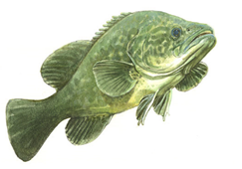Murray cod occasionally grow to 1.5 m long and 50 kg and can live for up to 50 years. Murray cod inhabit many of the waterways of the Murray-Darling Basin (MDB) (ACT, SA, NSW, Qld and Vic) and live in a wide range of aquatic habitats that range from clear, rocky streams to slow flowing turbid rivers and billabongs (Lintermans, 2007).

Conceptual model Murray cod

|  |
| --- |
| Habitat use |
| 1. Prefer permanent flowing river reaches and creeks with hydraulic complexity/diversity. 2. Require woody debris (snags), debris piles and bank side vegetation (Koehn and Harrington 2005). 3. In the southern reaches of the MDB, the status of Murray cod populations is influenced by habitat availability, flow regime, hydrodynamic diversity (water velocity, depth and turbulence) and connectivity (Henderson et al. 2010a,b; Mallen-Cooper et al., 2013; Mallen-Cooper and Zampatti, 2015a; Mallen-Cooper and Zampatti 2017). 4. Recruitment potential may be increased when additional habitat resources such as food and shelter are created as river benches, snags and rocks and riparian zones are inundated by rising flows. 5. Eggs and larvae require a steady flow increase and very little daily variations in water level (e.g. 0.1 m) to maximise spawning success. |
| Diet |
| 1. Diet changes with age with the typical adult diet consisting of spiny crayfish, yabbies and shrimps (National Murray Cod Recovery Team 2010) 2. Predominantly piscivorous and feed on native and exotic fish species e.g. [native species - other cod (*Maccullochella* spp.), golden perch, bony bream (*Nematalosa erebi*), freshwater catfish, western carp gudgeon (*Hypseleotris klunzingeri*)], [exotic species - redfin perch (*Perca fluviatilis*), carp (*Cyprinus carpio*) and goldfish (*Carassius auratus auratus*)]. 3. Less common animals found in the diet include ducks, cormorants, grebes, tortoises, water dragons, snakes, mice, frogs and mussels (Rowland, 1996). 4. Upon hatching, larvae are 5–8 mm long and within 8–10 days can feed on zooplankton. After reaching a length of 15–20 mm, they begin to feed on aquatic insects (King, 2005). |
| Spawning |
| 1. Occurs annually during October, November and December each year (Humphries, 2005; Koehn and Harrington, 2005), occurs during base flows and during river rises (King et al., 2009a; Ye et al., 2008). 2. Display complex pre-spawning courtship behaviour (during winter and spring) and females may spawn with more than one male. 3. Females lay their eggs into nests. The male guards the nest for up to two weeks while the eggs hatch. Juveniles leave the nest and move into littoral or snag habitats. 4. Despite often being classified as a ‘flow independent spawner’ Murray cod do require permanent flowing water for optimal recruitment (Sharpe and Stuart 2015). 5. Can spawn and recruit during low stable flows, rising flows and floods. 6. Floods are not necessary for spawning but in some cases, appear to enhance subsequent recruitment (King et al., 2009a). |
| Recruitment |
| 1. There is high mortality of young fish but those that survive their first summer and winter and grow to 90-140 mm long tend to have a good chance of recruiting into the sub-adult population (250-600 mm long) (Baumgartner et al., 2006). 2. Mature late (3-5 years) and at a reasonably large size (>600 mm long) but females have relatively low egg numbers (fecundity). 3. Long-lived (>40 years) and can grow to a large size (e.g. 1.4 m and 45 kg) where they become the apex aquatic predator (Anderson et al., 1992a; Ebner, 2006). 4. Where riverine stocking occurs there can be significant augmentation of natural populations (Forbes et al., 2016). |
| Movement and migration |
| 1. May move large distances (e.g. up to 120 km) but are usually only a few kilometres (e.g. commonly up to 30 km), (Leigh and Zampatti, 2011; 2013). 2. Move from their home snag to spawning areas in July/August/September on rising water temperature in winter and early spring (Jones and Stuart, 2007; Saddlier et al. 2008). 3. Both adult and juvenile fish are strongly associated with snags with a ‘home’ snag with adult fish often returning to the same snag (Koehn, 2009). 4. In recent years, the need to provide fish passage for Murray cod to escape anoxic black water events has been demonstrated in the lower Murray, most recently in late 2016, when large numbers of fish were killed in the lower and mid-Murray River, Edward-Wakool system, Frenchman’s Creek, Rufus River and Mullaroo Creek (Tonkin et al., 2017). |
| Implications for environmental flows |
| 1. A specific Murray cod hydrograph should be implemented where population recovery is required. 2. Flowing riverine sites can be considered ecological priorities for Murray cod recovery 3. Application of the Murray cod hydrograph, especially winter base-flows, is required on an annual basis (Sharpe and Stuart 2015; Sharpe and Stuart 2018) |
| Implications for flow monitoring |
| 1. Flow-event monitoring is crucial to identify the specific components of the hydrograph (shape, timing, frequency, duration, height, discharge, velocity) that influence population dynamics. |
| Threats |
| 1. Lack of flowing water habitats with a high density of snags because of past de-snagging, regulation transforming the hydrodynamic nature of many rivers from flowing rivers to weir pools and cold water discharge from high dams (Mallen-Cooper and Zampatti 2017. 2. Loss of permanent flows when rivers and anabranches are de-watered during winter. 3. In many regulated rivers and anabranches (e.g. Gunbower Creek, Gulpa Creek, Edward River, Mullaroo Creek) there are two major hydrological constraints on Murray cod population recovery  * intense fluctuation in river discharge causing rapid decreases in river level and interruption of spawning/recruitment processes, * low or zero winter flows that appear to be population ‘bottlenecks’ because this forces all fish into the deeper refuge pools each year (Sharpe and Stuart, 2015). |
| Knowledge and data limitations |
| 1. Wide-scale implementation, refinement and evaluation of the Murray cod hydrograph |