# Murray–Darling Communities Investment Package

First report into implementation March 2021

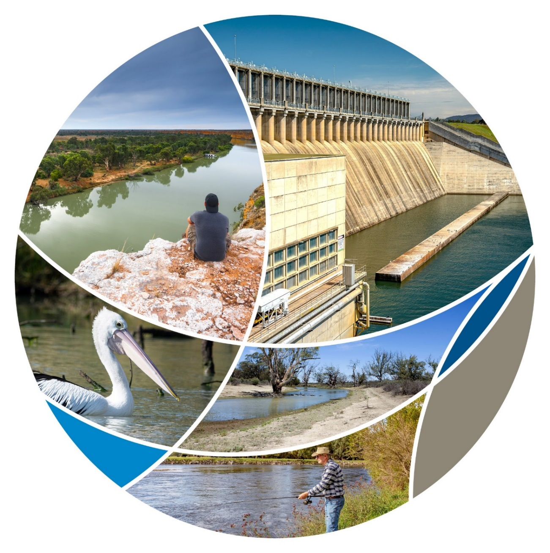

## Progressing Community Investment Package implementation report

The Australian Government’s $270 million Murray–Darling Communities Investment Package was announced on 4 September 2020 to put communities at the heart of the Basin Plan. The Department of Agriculture, Water and the Environment undertook to report publicly on progress with implementing the package three times a year to ensure accountability to communities. This is the first report.

The Investment Package responds to needs identified by the community, stakeholders and governments and centers on three key themes:

* Investing in community resilience and river health
* Building trust, transparency and accountability in governments, and
* Improving implementation of the Basin Plan

The Australian Government's new approach to implementing the Basin Plan through the Investment Package includes practical and realistic measures:

* ending water buybacks
* shifting the focus of water efficiency programs to off-farm projects to protect communities and economies, and
* ensuring that the projects to avoid 605 GL of water buybacks are flexible, succeed and have community support.

The next report into implementation of the Murray–Darling Communities Investment Package is due in July 2021.

Investing in community resilience and river health

The 3rd round of the Murray–Darling Basin Economic Development Program opened for applications on 3 March 2021 following a 4 week consultation process seeking feedback on the program guidelines. The 3rd round makes $34 million available to communities in grants valued at between $50,000 and $1 million. The program is focused on 38 communities that have been most impacted by past water recovery and recognises that they know how best to tackle the challenges they face, and what kinds of economic activity would best support them.

The $20 million Healthy Rivers Program also opened for applications on 3 March and is designed to turn local knowledge into action for Basin farmers, landholders and community organisations. Practical, on-ground projects to improve the health of rivers and wetlands across the entire Basin are eligible under the 1st $6 million round which offers small grants valued between $5,000 and $50,000.

An outcome of the consultations was to redouble efforts to make sure all interested parties have the opportunity and support they need to apply for the grant programs.

### Invest in community resilience and river health

| What we are doing | How we will do it | By when | What have we done |
| --- | --- | --- | --- |
| Maximising the benefits of the Basin Plan for communities | Deliver $34 million for economic assistance to communities struggling with the effects of water recovery by extending the successful competitive grants Murray–Darling Basin Economic Development Program.  Grants may be used to provide eligible communities impacted by water recovery programs with practical assistance to boost tourism and recreation and to diversify economically. | Q1 2021 – round 3  Q1 2022 – round 4 | Eligible communities can apply for round 3 of the EDP from 3 March to 12 April 2021.  The government is making all the funding available through round 3 to maximise the benefits earlier for communities and contribute to regional stimulus.  Consultation on the guidelines was undertaken from 18 December 2020 to 22 January 2021. |
| Improving river health for all users | Deliver $20 million to fund community-driven grants for on-ground projects that will improve the health of rivers and wetlands.  This builds on existing commitments to the environment of:   * $6 million for fish ways in the Lower Darling * $10 million to establish hatcheries at St George and Menindee * $15 million to fence Northern Basin riverbanks * $9.2 million to modify and decommission water infrastructure at Toorale. | Q1 2021 | Round one of the $20 million Healthy Rivers grants program opened on 3 March and closes on 31 March 2021. This is a $6 million small grant round. Two further grant rounds are expected to be available to the community in the middle of this year.  $1.1 million to NSW to progress planning for improved fish passage in the Lower Darling announced 23 February 2021.  About $200,000 to the Central Darling Shire Council and the South West Indigenous Corporation for feasibility studies to establish the native fish hatcheries at St George and Menindee respectively.  Over $7 million to NSW for the Fencing Northern Riverbank Program was announced on 22 January 2021 – work is continuing for pilot works in Queensland.  NSW is progressing the preparatory work to modify the Boera and Homestead Dams at Toorale. |
| Delivering environmental outcomes in the Riverland | Deliver $37.6 million in practical projects to sustain Riverland environments. We will work with the South Australian Government to deliver projects. This action recognises that there have been delays in progress towards securing an additional 450 GL of water to improve river health and habitats on the lower Murray.  Recover the 450 GL of water for the environment in ways that support Basin communities. | Q4 2020  – establish  Q2 2022 | Projects have been agreed with the South Australian Government to achieve landscape-scale improvements and benefit important fish species:   * Restoring natural river patterns in the Lock 6 reach * River infrastructure and operational investments in the Lock 3 reach * Reinstating natural habitat conditions in the Bookmark Creek area.   Landowners and other stakeholders will be consulted as planning and implementation of these works proceed.  The Off-farm Efficiency Program will progress Basin Plan river health targets without reducing the consumptive pool. The new approach is demonstrated through the Goulburn Murray Water $177.5 million project that will generate 15.9 GL of water for the environment. |
| Supporting First Nations Australians to play an active role in river health | Deliver $3.1 million for four new First Nations River Rangers teams, creating around 20 jobs.  Agree the framework for implementing the $40 million Aboriginal water entitlements program with Aboriginal communities.  Appointment of an Indigenous board member to the Murray–Darling Basin Authority. | Q3 2021  – establish  Q1 2021  – establish  Q4 2020  – appoint | The National Indigenous Australians Agency will open a grants round to progress this measure at the end of March 2021.  An implementation framework is expected to be agreed with Basin Indigenous peak organisations in mid 2021.  Mr Rene Woods was appointed as the first dedicated Indigenous member of the board of the Murray-Darling Basin Authority by Minister Keith Pitt on 18 December 2020. |

### Build trust, transparency and accountability in government

The Australian Government is delivering the highest accountability regarding management of our scarce water resources by establishing a statutory and independent Inspector-General of Water Compliance. This brings together the water compliance role of the Murray-Darling Basin Authority with the assurance role of the Interim Inspector-General of Water Compliance that replaced the Interim-Inspector General of Murray–Darling Basin Water Resources. The Hon. Troy Grant was appointed to the role on 16 December 2020.

Establishing the role requires amendments to the Water Act 2007 and the Basin Plan 2012. These reforms are being developed in consultation with Basin states and the ACT. The Australian Government will introduce a Bill this year. Subject to the legislation passing a statutory Inspector-General will be appointed later in 2021.

The new role brings together the Commonwealth's responsibility into a single statutory office to:

* improve trust and transparency in implementing the Commonwealth's Basin water reform agenda
* deliver greater consistency and harmonisation of water regulation across the Basin; and
* strengthen Basin Plan compliance and enforcement.

### Build trust, transparency and accountability in government

| What we are doing | How we will do it | By when | What have we done |
| --- | --- | --- | --- |
| Providing stronger leadership | Build a culture of genuine engagement and trust with communities and between governments.  Maximising the benefits of the Basin Plan for all communities.  Lead the Murray-Darling Basin Ministerial Council in empowering communities to determine their own future and to keep governments accountable.  Report 3 times a year on progress against the Package.  Use the outcomes of the Sefton report to inform future work and decisions on implementing the Basin Plan.  Appointed Air Chief Marshal Sir Angus Houston AK, AFC (Ret’d) to provide strong and strategic leadership as Chair of the Murray–Darling Basin Authority. | Q4 2020  – ongoing  Ongoing | An inaugural joint Basin Officials Committee, Murray-Darling Basin Authority board and the Basin Community Committee meeting was held 21 October 2020 to deepen relationships and identify ways to work better for communities.  The Department of Agriculture, Water and the Environment has established a new stakeholder function to support refocusing our business on building relationships with communities to improve water reform.  On 27 November 2020 ministers agreed that implementation of the Communities Investment Package was a priority.  The first progress report has been delivered on time.  The Australian Government response to the Sefton report was published on 2 October 2020. The report informed the development of the Investment Package and continues to be a key reference in the implementation of the Package.  Sir Angus Houston continues to meet with a cross section of stakeholders virtually and in person.  On 11 and 12 March the MDBA held a Basin Climate Resilience Summit that brought together leaders from a number of fields to share climate adaptation knowledge and innovations to help communities and the environment adjust to the impacts of climate change in the Murray–Darling Basin. |
| Ensuring stronger compliance | Establish a statutory and independent Inspector-General of Water Compliance. This will bring together the water compliance role of the Murray–Darling Basin Authority with the assurance role of the Interim Inspector-General of Murray–Darling Basin Water Resources.  Deliver $38.7 million to improve Commonwealth water compliance functions. This builds on the Commonwealth’s existing commitment of $60 million for improvements in water metering and remote sensing. | Q3 2021  – ongoing | Draft legislation to establish the statutory Inspector-General is being developed in consultation with Basin states and the Interim Inspector-General.  An interim Inspector-General of Water Compliance, Mr Troy Grant, was appointed on 16 December 2020 to strengthen accountability and compliance with the Water Act and the Basin Plan and building greater confidence in the integrity of water management.  Work to transition MDBA compliance functions into the Office of the Inspector-General of Water Compliance is underway. |
| Providing better information | Bring together water information from across governments in a more accessible format for water users and communities.  The detailed platform will provide a one-stop shop for water storage, in-stream flows and trade information.  This builds on the existing investment of $4.9 million to the Bureau of Meteorology to improve real-time reporting on water flows. | Q3 2021 | A first release of an interim interface is due in the middle of the year. User needs analysis is now complete, and is informing the staging and design of the single source platform.  User needs analysis is complete. |
| Better monitoring and reporting of social, economic and environment conditions | Deliver $7.5 million to monitor social, economic and environmental conditions in the Basin.  This action builds on a $20 million investment in Basin-specific research so river management can be based on the best available science. | Q3 2021  – establish | Work to establish the priority areas for monitoring social, economic and environmental conditions in the Basin is underway. A team of expert consultants has been engaged to develop an integrated monitoring and evaluation program.  A panel to oversee the $20 million Murray-Darling Water and Environment Research Program has been established by the Murray-Darling Basin Authority. Two consortia have been selected through an open tender process – one led by the CSIRO and the other led by La Trobe University. |

Improving implementation of the Basin Plan

The Australian Government has put an end to water buybacks and has shifted the focus of water recovery to off-farm projects, to avoid any impacts on farmer’s water licenses.

The Australian Government has closed the Water Efficiency Program and replaced it with a new Off-farm Water Efficiency program to recover water off-farm for enhanced environmental outcomes as part of Murray–Darling Basin Plan implementation.

This delivers on the Australian Government’s commitment to focus efforts on off-farm water efficiency rather than on-farm.

An example of the potential of the new off-farm focus is the $177.5 million investment to modernize and upgrade ageing off-farm water infrastructure in the Goulburn-Murray Irrigation district in Victoria to save 15.9 GL. This is a demonstration of the sort of projects that will provide significant economic stimulus for local and regional communities by creating hundreds of fulltime jobs during the construction phase while also delivering significant environmental outcomes.

### Improving implementation of the Basin Plan

| What we are doing | How we will do it | By when | What have we done |
| --- | --- | --- | --- |
| Designing and delivering water programs in partnership with communities | More effectively seek community input and demonstrate how that feedback has been used in the design, delivery and evaluation of programs. | From Q4 2020  – ongoing | The Department has sought community views concerning the intended outcomes and eligibility requirements of the new Healthy Rivers Grants and the Economic Development Program’s third round. The feedback received was considered and publicly reported on to show how it was used to inform the design and delivery of the programs. |
| Investing in off-farm water efficiency projects to increase water recovery | Shift the focus away from on-farm water efficiencies and buybacks.  Work with the states and irrigation networks to identify projects to generate water savings through off-farm infrastructure. | Q4 2020  – ongoing | |  | | --- | | The Water Efficiency Program was closed on 2 March 2021. The Australian Government will now focus the $1.54 billion in the Water for the Environment Special Account on off-farm efficiency projects.  A stocktake of potential off-farm projects to generate water savings was presented to the Ministerial Council on 27 November, 2020. This stocktake identified about 50 concept proposals including 10 that are shovel ready. |   The Goulburn Murray Water Water Efficiency Project will receive $177.5 million from the Australian Government to modernise and upgrade ageing off-farm water infrastructure in the Goulburn-Murray Irrigation District generating 15.9 GL of water for the environment. |
| Strengthening working relationships between the Australian Government, states and local government to improve delivery of the Basin Plan | Work with Basin states to accelerate planning and delivery of supply and constraints projects that are at risk of not being delivered by 2024. We will partner with the National Water Grid Authority on these projects.  This action builds on the government’s existing commitment of $1.5 billion for these projects.  Develop a new National Partnership agreement between the Australian and Basin state governments to provide funding for new and ongoing activities required to implement the Basin Plan. | Q4 2020  – ongoing | Ministers confirmed on 27 November 2020 that community engagement and support for supply and constraints projects remains vitally important to all Basin governments. A ministerial council meeting is planned for April to consider pathways for dealing with at-risk projects.  The National Water Grid is providing support on best practice project planning, management and governance.  At the Ministerial Council meeting of 27 November 2020, Basin Ministers agreed the principles for collective action to improve Basin Plan outcomes. |