# Murray–Darling Communities Investment Package

Second report into implementation September 2021

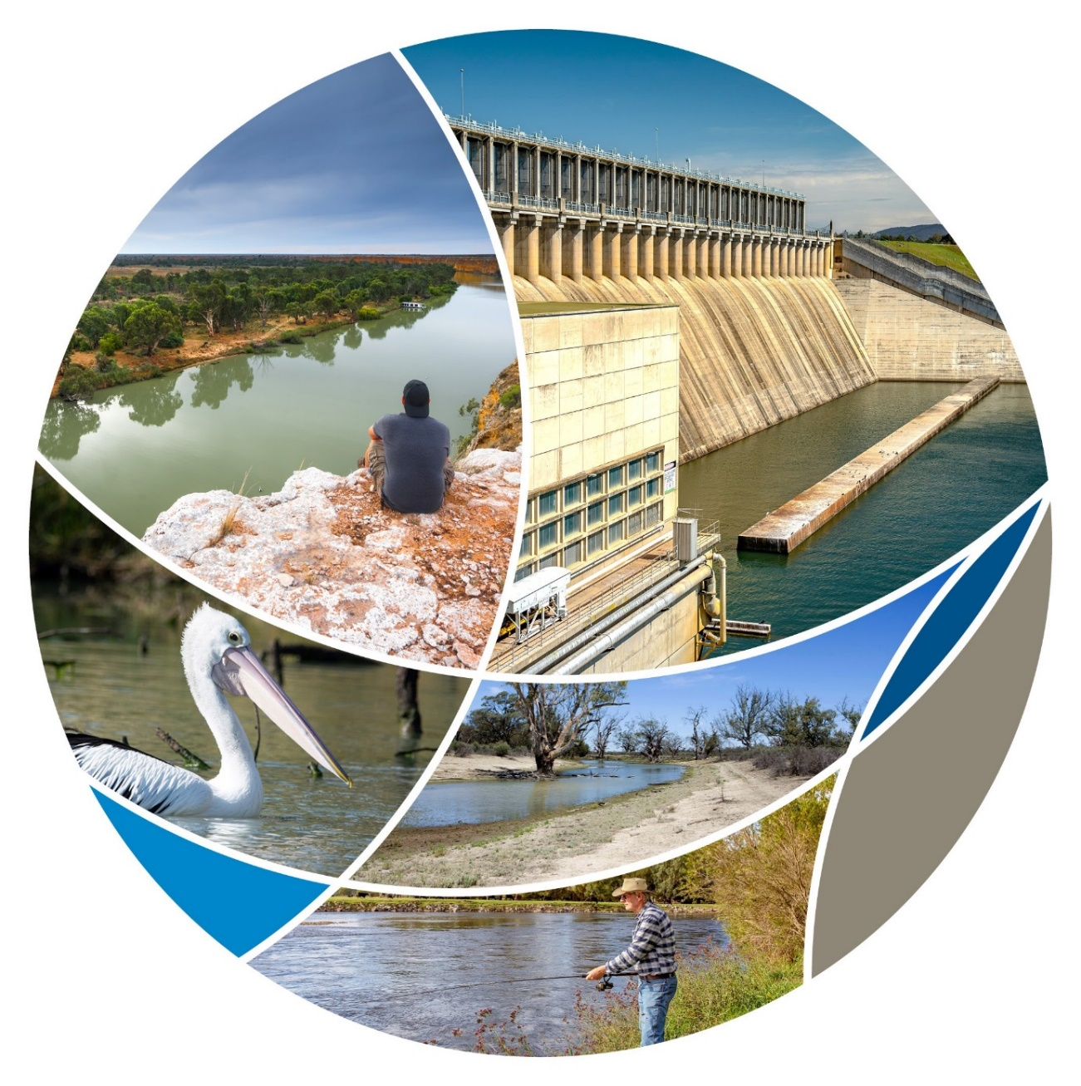

## Progressing Community Investment Package implementation report

Delivery of the Australian Government’s $270 million Murray–Darling Communities Investment Package (Investment Package) is continuing. Since the package was announced, on 4 September 2020, good progress has been made.

This is the second public report from the Department of Agriculture, Water and the Environment on progress in the implementation of the Investment Package, putting communities back at the centre of the Murray–Darling Basin Plan (Basin Plan).

The Investment Package responds to needs identified by the community, stakeholders and governments across 3 key themes:

* investing in community resilience and river health
* building trust, transparency and accountability in governments
* improving implementation of the Basin Plan.

The Investment Package is about practical and realistic measures that will support Murray–Darling Basin (Basin) governments to deliver on their Basin Plan commitments by:

* ending water buybacks
* shifting the focus of water efficiency programs to off-farm projects to protect communities and economies
* putting funds into the hands of communities to grow their economic resilience
* establishing a statutory and independent Inspector-General of Water Compliance to improve trust and confidence in Basin water management systems
* working together to deliver a suite of projects that keep 605 GL of water in productive use while achieving the environmental outcomes of the Basin Plan.

The next report into implementation of the Murray–Darling Communities Investment Package is due before the end of the year.

## Investing in community resilience and river health

The 3rd round of the Murray–Darling Basin Economic Development Program is supporting nearly 60 projects in communities across the Basin most impacted by historic water recovery. Outcomes from the $39 million approved under rounds 1 and 2 of the program show local people have the best ideas to help their local communities. The projects receiving round 3 funding have demonstrated that they will generate jobs and economic activity in the towns and regions that put them forward. They provide additional employment benefits because grant recipients must use local suppliers and resources when they’re implementing the projects.

The first round of small grants (between $5,000 and $50,000) of the Healthy Rivers grants program have been awarded. 73 of these grants will be used by community groups, including schools, Scouts, Landcare groups, people living with disabilities and First Nations to make a difference to their stretch of the river. Grants can be used to improve the health of local rivers by funding things like revegetation, constructing riverbank fencing, and controlling invasive species. These grants are also required to be spent locally. Two further rounds – consisting of a small grants round and a large grants round – opened recently.

### Invest in community resilience and river health

| What we are doing | How we will do it | By when | Status | What have we done |
| --- | --- | --- | --- | --- |
| Maximising the benefits of the Basin Plan for communities | Deliver $34 million for economic assistance to communities struggling with the effects of water recovery by extending the successful competitive grants Murray–Darling Basin Economic Development Program. | Q1 2021 | COMPLETE | 58 projects were awarded a total of $34 million in funding in June and July 2021. Grant applications were received between 3 March 2021 and 12 April 2021 following consultation on the guidelines. |
| Improving river health for all users | Deliver $20 million to fund community-driven grants for on-ground projects that will improve the health of rivers and wetlands.  This builds on existing commitments to the environment of:   * $6 million for fish ways in the Lower Darling * $10 million to establish hatcheries at St George and Menindee * $15 million to fence Northern Basin riverbanks * $9.2 million to modify and decommission water infrastructure at Toorale. | Q1 2021 | Round 1 COMPLETE  ONGOING | Round 1 of Healthy Rivers grants program awarded $3.08 million to community groups to improve their stretch of river. The grants were open for applications between 3 March and 31 March 2021.  Round 2 of Healthy Rivers grants program was launched in August 2021 with the remaining $17 million in grants available to community groups.  New South Wales is progressing planning for improved fish passage in the Lower Darling following the February 2021 announcement releasing $1.1 million in funding.  Work continues with the Menindee and St George communities on proposals for native fish hatcheries.  The rollout of the Fencing Northern Riverbanks Program in Queensland and New South Wales is underway. The Commonwealth has provided $2.1 million to support a pilot program in Queensland, and develop long-term strategic plans and program roll out activities in both states.  On-ground works to modify the Boera and Homestead dams at Toorale are underway and expected to take 12 months. |
| Delivering environmental outcomes in the Riverland | Deliver $37.6 million in practical projects to sustain Riverland environments. We will work with the South Australian Government to deliver projects. This action recognises that there have been delays in progress towards securing an additional 450 GL of water to improve river health and habitats on the lower Murray. | Q4 2020 | ONGOING | Projects have been agreed with the South Australian Government to achieve landscape-scale improvements and benefit important fish species:   * restoring natural river patterns in the Lock 6 reach * river infrastructure and operational investments in the Lock 3 reach * reinstating natural habitat conditions in the Bookmark Creek area.   The implementation plan covering all projects is complete to now progress with environmental works and stakeholder engagement. |
| Recover the 450 GL of water for the environment in ways that support Basin communities. | Q2 2022 | ONGOING | Basin states can nominate infrastructure projects through the $1.33 billion Off-farm Efficiency Program, to generate water savings for the environment without taking water from farmers. This follows [consultation on the Off-farm Efficiency Program’s](https://haveyoursay.awe.gov.au/off-farm-efficiency-grants-program) $150 million grant component that closed on 20 August.  The new approach is demonstrated through the Goulburn Murray Water $177.5 million project that will generate 15.9 GL of water for the environment. |
| Supporting First Nations Australians to play an active role in river health | Deliver $3.1 million for 4 new First Nations River Rangers teams, creating around 20 jobs. | Q3 2021 | COMPLETE | Five new Indigenous River Ranger Groups were announced on 31 July 2021 creating 27 positions. They are Border Ranges Contractors; Dharriwaa Elders Group; First People of the Millewa-Mallee Aboriginal Corporation; Yarkuwa Indigenous Knowledge Centre Aboriginal Corporation; and Nari Nari Tribal Council. |
| Agree the framework for implementing the $40 million Aboriginal water entitlements program with Aboriginal communities. | Q1 2021 | ONGOING | The department and the Minister continue to consider delivery options. |
| Appointment of an Indigenous board member to the Murray–Darling Basin Authority. | Q4 2020 | COMPLETE | Mr Rene Woods was appointed as the first dedicated Indigenous member of the board of the Murray-Darling Basin Authority by Minister Keith Pitt on 18 December 2020. |

## Build trust, transparency and accountability in government

The statutory appointment of Australia’s first Inspector General for Water Compliance was finalised on 5 August 2021, along with the establishment of the Office of Water Compliance. The legislation, that passed the Australian Parliament on 24 June, establishes a strong and independent regulator to monitor and oversee water compliance in the Murray–Darling Basin. It delivers on the Australian Government’s commitment to increase trust and transparency with Basin communities by providing them with assurance that water is well managed in the Murray–Darling Basin. The statutory Inspector-General, the Hon Troy Grant, is independent of the department and Minister and controls his workplan and budget. A key role for the Inspector–General will be to encourage greater consistency in the guidelines and standards across the Basin – so all water users are held to the same high bar.

The first iteration of the [Murray–Darling Basin Water Information Portal](https://mdbwip.bom.gov.au/) has been released. The portal, hosted by the Bureau of Meteorology, provides information on available water, allocation volumes, water use, water trade and prices, environmental water and weather. It also provides a directory to other resources hosted by other state and federal agencies for those seeking more detailed information. Feedback on this version is encouraged so future releases can improve on function and information.

### Build trust, transparency and accountability in government

| What we are doing | How we will do it | By when | Status | What have we done |
| --- | --- | --- | --- | --- |
| Providing stronger leadership | Build a culture of genuine engagement and trust with communities and between governments. | Q4 2020 | ONGOING | The second joint Basin Officials Committee, Murray–Darling Basin Authority board and Basin Community Committee meeting was held in Griffith on 10 June 2021, focused on increasing transparency of decision making for communities. An outcome of the meeting was a commitment to publish [Basin Officials Committee outcomes](https://www.mdba.gov.au/publications/governance/basin-officials-committee-decisions-activities) with the first published on 11 June 2021. |
| Maximising the benefits of the Basin Plan for all communities. |  | ONGOING | The Department of Agriculture, Water and the Environment sponsored the Murray–Darling Association’s conference in May 2021. The Murray–Darling Basin Authority’s conference in Griffith, June 2021 was another opportunity to connect with Basin communities and hear their views. |
| Lead the Murray-Darling Basin Ministerial Council in empowering communities to determine their own future and to keep governments accountable. |  | ONGOING | The Ministerial Council held a strategic discussion on 29 April and reconfirmed its shared commitment to progressing projects that keep 605 gigalitres (GL) of water in productive use in the southern Murray–Darling Basin. The council agreed to publish [quarterly update reports](https://www.mdba.gov.au/publications/independent-reports/sustainable-diversion-limit-adjustment-mechanism-program) to ensure communities have up to date information about how projects are tracking. |
| Report 3 times a year on progress against the Package. |  | ONGOING | This is the second report. |
| Use the outcomes of the Sefton report to inform future work and decisions on implementing the Basin Plan. |  | ONGOING | There is ongoing consideration of the report in developing policy and programs. |
| Appointed Air Chief Marshal Sir Angus Houston AK, AFC (Ret’d) to provide strong and strategic leadership as Chair of the Murray–Darling Basin Authority. |  | COMPLETE | Sir Angus Houston continues to meet with a cross section of stakeholders virtually and in person. |
| Ensuring stronger compliance | Establish a statutory and independent Inspector-General of Water Compliance. This will bring together the water compliance role of the Murray–Darling Basin Authority with the assurance role of the Interim Inspector-General of Murray–Darling Basin Water Resources. | Q3 2021 | COMPLETE | The statutory Office of the Inspector General of Water Compliance was established on 5 August following the passage of the legislation through the Australian Parliament with bi-partisan support on 24 June 2021.  The Inspector-General of Water Compliance, Mr Troy Grant, has been appointed as the first statutory and independent office holder. The Inspector General has a role monitoring Commonwealth and Basin state agencies in relation to their obligations in managing Basin water resources to make sure no one is marking their own homework. |
| Deliver $38.7 million to improve Commonwealth water compliance functions. This builds on the Commonwealth’s existing commitment of $60 million for improvements in water metering and remote sensing. | Q3 2021 | COMPLETE | The transition of compliance functions from the MDBA to the Office of Inspector-General of Water Compliance has taken place. The Office has 33 staff located in 5 locations across the Basin. |
| Providing better information | Bring together water information from across governments in a more accessible format for water users and communities.  The detailed platform will provide a one-stop shop for water storage, in-stream flows and trade information. This builds on the existing investment of $4.9 million to the Bureau of Meteorology to improve real-time reporting on water flows. | Q3 2021 | COMPLETE | The first version of the [Murray–Darling Basin Water Information Portal](https://mdbwip.bom.gov.au/) was released by the Bureau of Meteorology on 30 June 2021.  The bureau is seeking user feedback to improve the portal over the next three years.  This brings together the work with New South Wales and Queensland, to improve northern Basin water information through the Enhanced Water Monitoring and Information Program, with the MDB single source information platform work which is also being developed in collaboration with all Basin states. |
| Better monitoring and reporting of social, economic and environment conditions | Deliver $7.5 million to monitor social, economic and environmental conditions in the Basin. | Q3 2021 | ONGOING | The Murray–Darling Basin Authority is progressing the 3-year program’s design and implementation plan. |
| This action builds on a $20 million investment in Basin-specific research so river management can be based on the best available science. | Q3 2021 | ONGOING | A panel to oversee the $20 million Murray–Darling Water and Environment Research Program was established by the Murray–Darling Basin Authority. Two consortia were selected through an open tender process, one led by the CSIRO and the other by La Trobe University. The program aims to strengthen scientific knowledge of the Murray–Darling Basin, inform water and environment management decisions and improve outcomes for the Basin and communities. |

## Improving implementation of the Basin Plan

All Basin jurisdictions are redoubling efforts to deliver the suite of projects to keep 605 GL of water in productive use while delivering Basin Plan outcomes. These projects, known as the Sustainable Diversion Limit Adjustment Mechanism projects, improve water use and management, to enable the same environmental benefits but with less water recovery.

New South Wales, with Commonwealth support, is accelerating 5 key projects to secure approximately 45 GL of the Sustainable Diversion Limit Offset before 2024. Victoria is receiving more than $70 million for projects to improve flows in the Goulburn and Murray Rivers and to help restore 9 key floodplains. The funding demonstrates the shared commitment to fast-track the implementation of projects critical for delivering the Murray–Darling Basin Plan and maximising positive environmental outcomes.

The Australian Government continues to work with Basin jurisdictions and irrigation networks to develop projects that can recover 450 GL of additional water for the environment. Efficiency measures, that result in new or upgraded off-farm infrastructure, improve the environmental outcomes under the Basin Plan. These projects generate water savings from water that would otherwise be lost or wasted, recovering it for use by the environment.

### Improving implementation of the Basin Plan

| What we are doing | How we will do it | By when | Status | What have we done |
| --- | --- | --- | --- | --- |
| Designing and delivering water programs in partnership with communities | More effectively seek community input and demonstrate how that feedback has been used in the design, delivery and evaluation of programs. | Q4 2020 | ONGOING | The department has consulted on the Off-farm Efficiency Program grant component that will make $150 million available to irrigation infrastructure organisations to improve infrastructure and return water to the environment. The Basin Community Committee is providing advice from a community perspective.  The Department also sought community views concerning the intended outcomes and eligibility requirements of the new Healthy Rivers Grants and the Economic Development Program’s third round. The feedback received was considered and publicly reported on to show how it was used to inform the design and delivery of the programs. |
| Investing in off-farm water efficiency projects to increase water recovery | Shift the focus away from on-farm water efficiencies and buybacks.  Work with the states and irrigation networks to identify projects to generate water savings through off-farm infrastructure. | Q4 2020 | COMPLETE | Through the Off-farm Efficiency Program there is $1.33 billion available to fund projects that generate water savings off-farm through the State Led Off-farm stream. These projects will generate jobs, improve delivery of water to farms and increase water available to grow crops and contribute water to deliver enhanced environmental outcomes.  This follows a stocktake of potential off-farm projects to generate water savings was presented to the Ministerial Council on 27 November 2020. This stocktake identified about 50 concept proposals including 10 that are shovel ready. The Goulburn Murray Water Efficiency Project will receive $177.5 million from the Australian Government to modernise and upgrade ageing off-farm water infrastructure in the Goulburn-Murray Irrigation District generating 15.9 GL of water for the environment  The Water Efficiency Program closed to new applications in March 2021. All project proposals lodged before the program ceased are being assessed and finalised. 25 projects, valued at $10.1 million are now contracted to generate 709 ML of water savings for the environment. |
| Strengthening working relationships between the Australian Government, states, and local government to improve delivery of the Basin Plan | Work with Basin states to accelerate planning and delivery of supply and constraints projects that are at risk of not being delivered by 2024. We will partner with the National Water Grid Authority on these projects. | Q4 2020 | ONGOING | The Ministerial Council strategic discussion on 29 April 2021 heard that 30 of the 36 projects were on track to deliver 75% of the required offset.  Ministers agreed that the Menindee Lakes and Yanco Creek Offtake projects needed to be rescoped, taking account of community views. |
| This action builds on the government’s existing commitment of $1.5 billion for these projects. | Q4 2020 | ONGOING | Minister Pitt has provided $330 million to New South Wales to accelerate delivery of:   * Koondrook-Perricoota Flow Enabling Works (part of the Yarrawonga to Wakool constraints) * Mid-Murray Anabranches Constraints Demonstration Reach (part of the Yarrawonga to Wakool constraints) * Sustainable Diversion Limits offsets in the Lower Murray: Locks 8 and 9 project * Murrumbidgee and Murray National Park Project * Modernising Supply Systems for Effluent Creeks Project (Yanco Creek Modernisation Project) |
| Develop a new National Partnership agreement between the Australian and Basin state governments to provide funding for new and ongoing activities required to implement the Basin Plan. | Q4 2020 | COMPLETE | A new $60 million federation funding agreement for 2021-24 provides on-going support for Basin state governments to implement the Basin Plan. |