# Murray–Darling Communities Investment Package

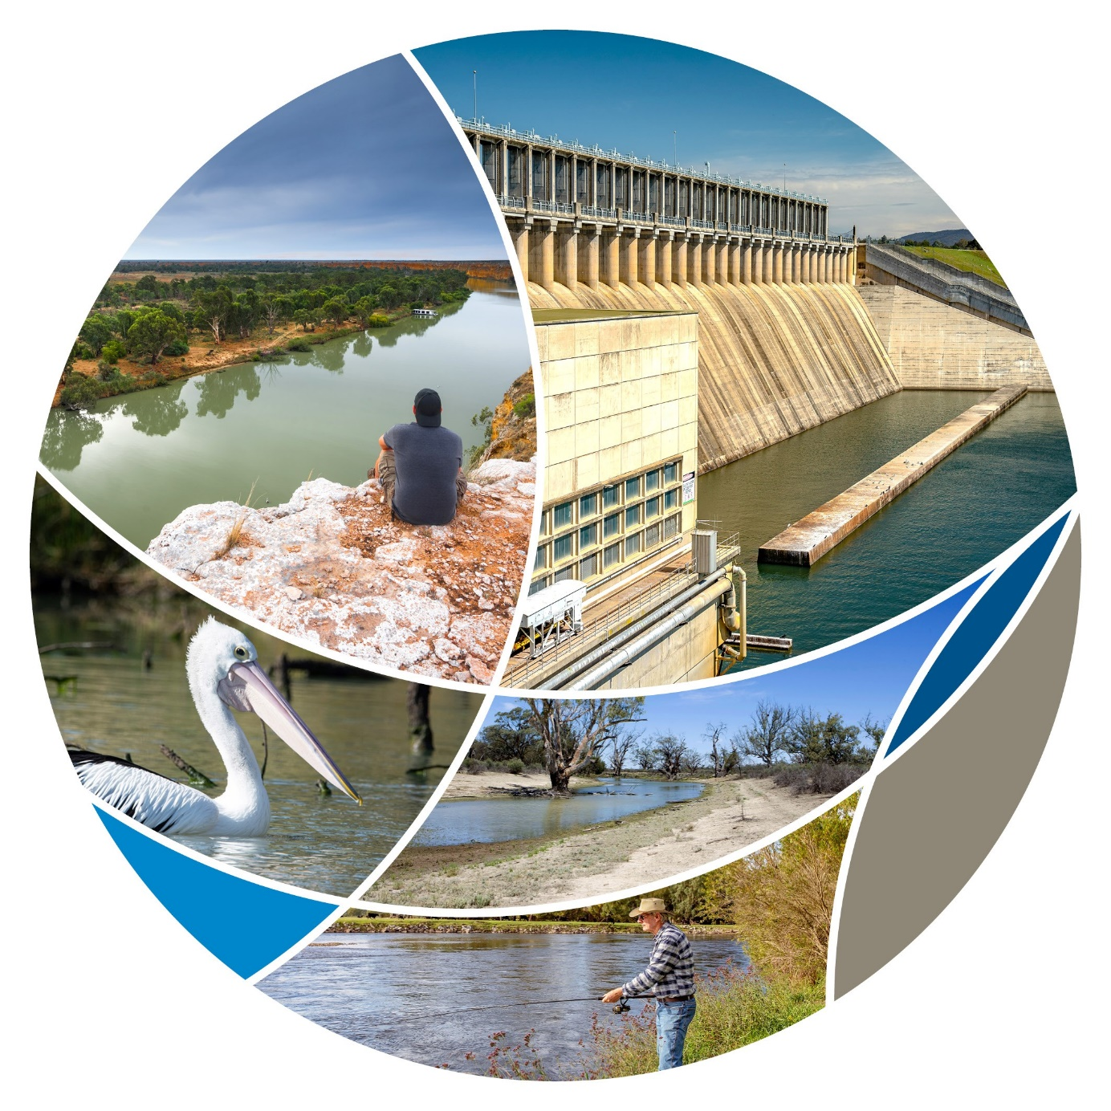

© Commonwealth of Australia 2020

**Ownership of intellectual property rights**

Unless otherwise noted, copyright (and any other intellectual property rights) in this publication is owned by the Commonwealth of Australia (referred to as the Commonwealth).

**Creative Commons licence**

All material in this publication is licensed under a Creative Commons Attribution 4.0 International Licence except content supplied by third parties, logos and the Commonwealth Coat of Arms.

Inquiries about the licence and any use of this document should be emailed to copyright@awe.gov.au.



**Cataloguing data**

This publication (and any material sourced from it) should be attributed as: Department of Agriculture, Water and the Environment 2020, *Murray-Darling Communities Investment Package,* Department of Agriculture, Water and the Environment, Canberra, September. CC BY 4.0.

ISBN 978-1-76003-320-0

This publication is available at www.agriculture.gov.au/water/mdb.

Department of Agriculture, Water and the Environment

GPO Box 858 Canberra ACT 2601

Telephone 1800 900 090

Web awe.gov.au

The Australian Government acting through the Department of Agriculture, Water and the Environment has exercised due care and skill in preparing and compiling the information and data in this publication. Notwithstanding, the Department of Agriculture, Water and the Environment, its employees and advisers disclaim all liability, including liability for negligence and for any loss, damage, injury, expense or cost incurred by any person as a result of accessing, using or relying on any of the information or data in this publication to the maximum extent permitted by law.

## Foreword

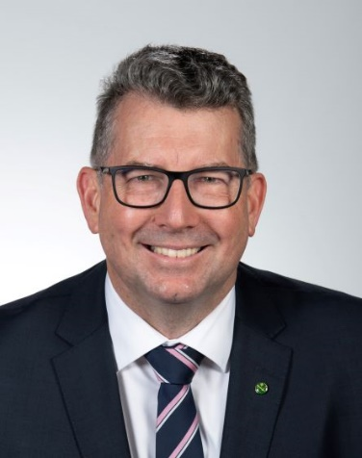This investment package is about putting communities and jobs at the heart of the Murray–Darling Basin Plan. At a time when Basin communities have endured years of drought, a summer of terrible bushfires and while the COVID-19 pandemic continues to eat away at household confidence we need to invest in the people and the places that generate our nation’s wealth.

In the 8 years since the Basin Plan was legislated a number of eminent reviews have identified improvements to water reform. Some communities have lost faith because this historic reform has become a catch-all for rural and regional decline. Its impacts have been highly variable – causing distress for some communities while others have prospered. We need to remember the original purpose of the Plan – to ensure a certain and sustainable future for communities, industries and the environment. We need a vibrant and profitable irrigated agricultural sector. The time for reviews has passed and it’s time now to take practical action and demonstrate leadership.

The Australian Government is investing over $230 million in new actions to create jobs and economic activity. The actions we undertake must benefit communities as well as the rivers and wetlands that make up our shared natural heritage. All the actions have been designed to avoid any need for future additional water buybacks. Instead the Government will focus on recovering water for the environment by modernising off-farm water delivery infrastructure.

The Basin is an economic and ecological powerhouse and protecting it is a shared responsibility. The Australian Government is one of six governments that agreed in 2012 to restore the Basin's health at a time when the devastation of the millennium drought was at the forefront of the collective consciousness. I look forward to working with communities and my Murray-Darling Basin Ministerial Council colleagues, to deliver a Basin Plan for communities. I have tasked my department to work with Basin jurisdictions and communities to realise the actions set out in this Package.

This Package outlines the Australian Government’s refreshed approach and reaffirms our commitment to the Basin Plan – because it is about making sure future generations have a sustainable and certain future. It’s an investment that puts people at the centre of the reform and provides a pathway to achieve a sustainable Basin for all Australians.

The Hon. Keith Pitt MP

Minister for Resources, Water and Northern Australia



Contents

Foreword iii

Shifting the focus 1

Progress to date 1

Case for change 1

A new approach 3

Investment package 4

Invest in community resilience and river health 4

Build trust, transparency and accountability 5

Improving implementation of the Basin Plan 6

## Shifting our focus

### Progress to date

The Murray–Darling Basin Plan is a long-term $13 billion investment in Australia’s most important food bowl, its people and its environment. It was legislated in 2012 to give communities and industries certainty by limiting the volume of water that could be taken from the Basin at a time when scientific evidence about the likelihood of more frequent and severe droughts was strengthening.

Since 2012 significant progress on implementing key elements of the Basin plan has been made and the job is nearly complete.

* $9 billion has been invested to increase agricultural productivity, modernise infrastructure and return water to the environment.
* More than 97 per cent of the water required to meet the sustainable diversion limits set by the Basin Plan is now recovered putting the Basin on a more sustainable footing.
* Thirteen Water Resource Plans, that set limits on the amount of water that can be extracted from Basin catchments, have been accredited by the Commonwealth. This includes all plans for South Australia, Queensland, Victoria and the ACT. New South Wales has submitted all of its 20 WRPs to the Australian Government for assessment and accreditation.

However, some challenges remain. These include completing the Sustainable Diversion Limit adjustment projects that protect environmental outcomes without needing to recover 605 gigalitres (GL) of water and improving progress against the Basin Plan target of 450 GL of additional water that will improve flows to the end of the Basin.

### Case for change

Recent reviews have shown that Basin governments are at risk of not fully meeting some Basin Plan targets by 2024. They have found that some Basin communities are simply not seeing the benefits from the Basin Plan after many years of change and reform. The Australian Government established these reviews to ensure that its approach to implementation of the Basin Plan continued to be based on sound evidence and advice.

The *Independent assessment of social and economic conditions in the Basin (2020)* (the Sefton report) found that the impacts of water reform have been variable and that some communities were more vulnerable than others to a range of pressures, including drought, commodity price fluctuations and water recovery. The panel, led by Ms Robbie Sefton, was appointed in June 2019 and consulted closely with Basin communities to form its recommendations. The Australian Government has accepted 20 of the panel’s 22 recommendations in full, in principle or in part and will use its insights to inform priority strategic work areas with Basin states. The recommendations focused on:

* rebuilding trust and accountability
* investing in regional communities to stimulate long-term economic growth
* reducing the effects of water recovery on communities
* improving access for First Nations Australians to water for economic and cultural needs.

The *First review of the Water for the Environment Special Account* (*2020)* considered whether the Special Account has sufficient funds to enable the recovery of 450 GL of additional environmental water and to ease or remove constraints to environmental water delivery by 30 June 2024. The statutory review, led by Ms Sally Farrier, found that the recovery of 450 GL of additional environmental water and constraints projects are not on track to be achieved by 30 June 2024 without significant intervention.

The Australian Competition and Consumer Commission (ACCC) has recently released its *Murray–Darling Basin water markets inquiry: interim report (2020).* The interim report highlights that the current water regulatory framework has not evolved rapidly enough to match the complexities of Murray-Darling Basin water markets. The interim ACCC report does not include final recommendations, and the Australian Government will not pre-empt additional community contributions to that enquiry by making early responses. However, some of the issues raised by the ACCC, such as transparency of information and improving confidence in water governance systems, are likely to be addressed in part by actions in this Package, with more specific responses to follow the delivery of the final ACCC report and recommendations.

### A new approach

The Australian Government’s commitment is to work with communities and Basin governments to bring communities back to the heart of the Basin Plan. We will work with Basin states within existing legislation to ensure that our approach protects the interests of Basin communities. The Basin needs a vibrant irrigated agricultural sector, along with a healthy and sustainable river system that supports the industries and people that live along it.

The Australian Government’s investments in the Basin are designed to stimulate long-term and sustainable economic growth. They are about promoting innovative ways to deliver water recovery that support, instead of damage, Basin communities.

While some Basin communities are doing well, others that are more reliant on irrigated agriculture have proved more vulnerable to the negative effects of water recovery. The recent Sefton report highlighted the need to invest in regional communities to stimulate long-term economic growth and ensure future water recovery does not outstrip communities’ capacity to adjust.

The Australian Government’s new approach to implementing the Basin Plan is focused around three high level objectives that are supported by practical and realistic actions:

* **Invest in community resilience and river health** 
  + Investment is needed in communities as well as in infrastructure and river health to maximize the benefits of the Basin Plan. That means involving communities in identifying and implementing local solutions to local problems.
* **Build trust, transparency and accountability in government** 
  + Government at all levels need to provide transparent and accountable leadership. Communities have asked for and deserve strong leadership; they need access to reliable and trustworthy information and they need confidence in the institutions that manage water in the Basin.
* **Improving implementation of the Basin Plan**
  + Basin government’s need to redouble efforts to achieve Basin Plan water recovery by 30 June 2024 to give the community the certainty it has been calling for. They need to do this in a way that maximises water recovery for the environment while minimising impacts on farmers and communities.

The Australian Government is committed to work with Basin governments on the objectives and actions in this Package.

## Investment package

### Invest in community resilience and river health

| **What we are doing** | **How we will do it** | **By when** |
| --- | --- | --- |
| Maximising the benefits of the Basin Plan for communities | Deliver $34 million for economic assistance to communities struggling with the effects of water recovery by extending the successful competitive grants Murray–Darling Basin Economic Development Program.  Grants may be used to provide eligible communities impacted by water recovery programs with practical assistance to boost tourism and recreation and to diversify economically.  This action responds to needs identified in the Sefton report and builds on the $40 million investment to date from 2 rounds of the Murray–Darling Basin Economic Development Program.  This action responds to recommendations of the Sefton report. | Quarter 1 2021 – round 3  Quarter 1 2022 – round 4 |
| Improving river health for all users | Deliver $20 million to fund community-driven grants for on-ground projects that will improve the health of rivers and wetlands.  This builds on existing commitments to the environment of:   * $6 million for fish ways in the Lower Darling * $10 million to establish hatcheries at St George and Menindee * $15 million to fence Northern Basin riverbanks * $9.2 million to modify and decommission water infrastructure at Toorale. | Quarter 1 2021 |
| Delivering environmental outcomes in the Riverland | Deliver $37.6 million in practical projects to sustain Riverland environments. We will work with the South Australian Government to deliver projects. This action recognises that there have been delays in progress towards securing an additional 450 GL of water to improve river health and habitats on the lower Murray.  Recover the 450 GL of water for the environment in ways that support Basin communities.  This action responds to the findings of the WESA report and the recommendations of the Sefton report. | Quarter 4 2020 |
| Supporting First Nations Australians to play an active role in river health | Deliver $3.1 million for four new First Nations River Rangers teams, creating around 20 jobs.  Agree the framework for implementing the $40 million Aboriginal water entitlements program with Aboriginal communities.  Appointment of an Indigenous board member to the Murray–Darling Basin Authority.  This action partly responds to recommendations of the Sefton report. | Quarter 3 2021  Quarter 1 2021  Quarter 4 2020 |

### Build trust, transparency and accountability in government

| **What we are doing** | **How we will do it** | **By when** |
| --- | --- | --- |
| Providing stronger leadership | Build a culture of genuine engagement and trust with communities and between governments.  Maximising the benefits of the Basin Plan for all communities.  Lead the Murray-Darling Basin Ministerial Council in empowering communities to determine their own future and to keep governments accountable.  Report 3 times a year on progress against the Package.  Use the outcomes of the Sefton report to inform future work and decisions on implementing the Basin Plan.  Appointed Air Chief Marshal Sir Angus Houston AK, AFC (Ret’d) to provide strong and strategic leadership as Chair of the Murray–Darling Basin Authority.  This action responds to recommendations of the Sefton report. | Quarter 4 2020  Complete |
| Ensuring stronger compliance | Establish a statutory and independent Inspector-General of Water Compliance. This will bring together the water compliance role of the Murray–Darling Basin Authority with the assurance role of the Interim Inspector-General of Murray–Darling Basin Water Resources.  Deliver $38.7 million to improve Commonwealth water compliance functions. This builds on the Commonwealth’s existing commitment of $60 million for improvements in water metering and remote sensing.  This action responds to recommendations of the Sefton report and the interim ACCC report. | Quarter 3 2021 |
| Providing better information | Bring together water information from across governments in a more accessible format for water users and communities.  The detailed platform will provide a one-stop shop for water storage, in-stream flows and trade information.  This builds on the existing investment of $4.9 million to the Bureau of Meteorology to improve real-time reporting on water flows.  This action responds to recommendations of the Sefton report and the interim ACCC report. | Quarter 3 2021 |
| Better monitoring and reporting of social, economic and environment conditions | Deliver $7.5 million to monitor social, economic and environmental conditions in the Basin.  This action builds on a $20 million investment in Basin-specific research so river management can be based on the best available science.  This action responds to recommendations of the Sefton report. | Quarter 1 2021 |

### Improving implementation of the Basin Plan

| **What we are doing** | **How we will do it** | **By when** |
| --- | --- | --- |
| Designing and delivering water programs in partnership with communities | More effectively seek community input and demonstrate how that feedback has been used in the design, delivery and evaluation of programs.  This action responds to recommendations of the Sefton report. | From Quarter 4 2020 – ongoing |
| Investing in off-farm water efficiency projects to increase water recovery | Shift the focus away from on-farm water efficiencies and buybacks.  Work with the states and irrigation networks to identify projects to generate water savings through off-farm infrastructure.  This action responds to the findings of the WESA report and the recommendations of the Sefton report. | Quarter 4 2020 |
| Strengthening working relationships between the Australian Government, states and local government to improve delivery of the Basin Plan | Work with Basin states to accelerate planning and delivery of supply and constraints projects that are at risk of not being delivered by 2024. We will partner with the National Water Grid Authority on these projects.  This action builds on the government’s existing commitment of $1.5 billion for these projects.  Develop a new National Partnership agreement between the Australian and Basin state governments to provide funding for new and ongoing activities required to implement the Basin Plan.  This action responds to the findings of the WESA report and the recommendations of the Sefton report. | Quarter 4 2020 |