# Murray–Darling Healthy Rivers – Community feedback

Murray–Darling Communities Investment Package

Water Division

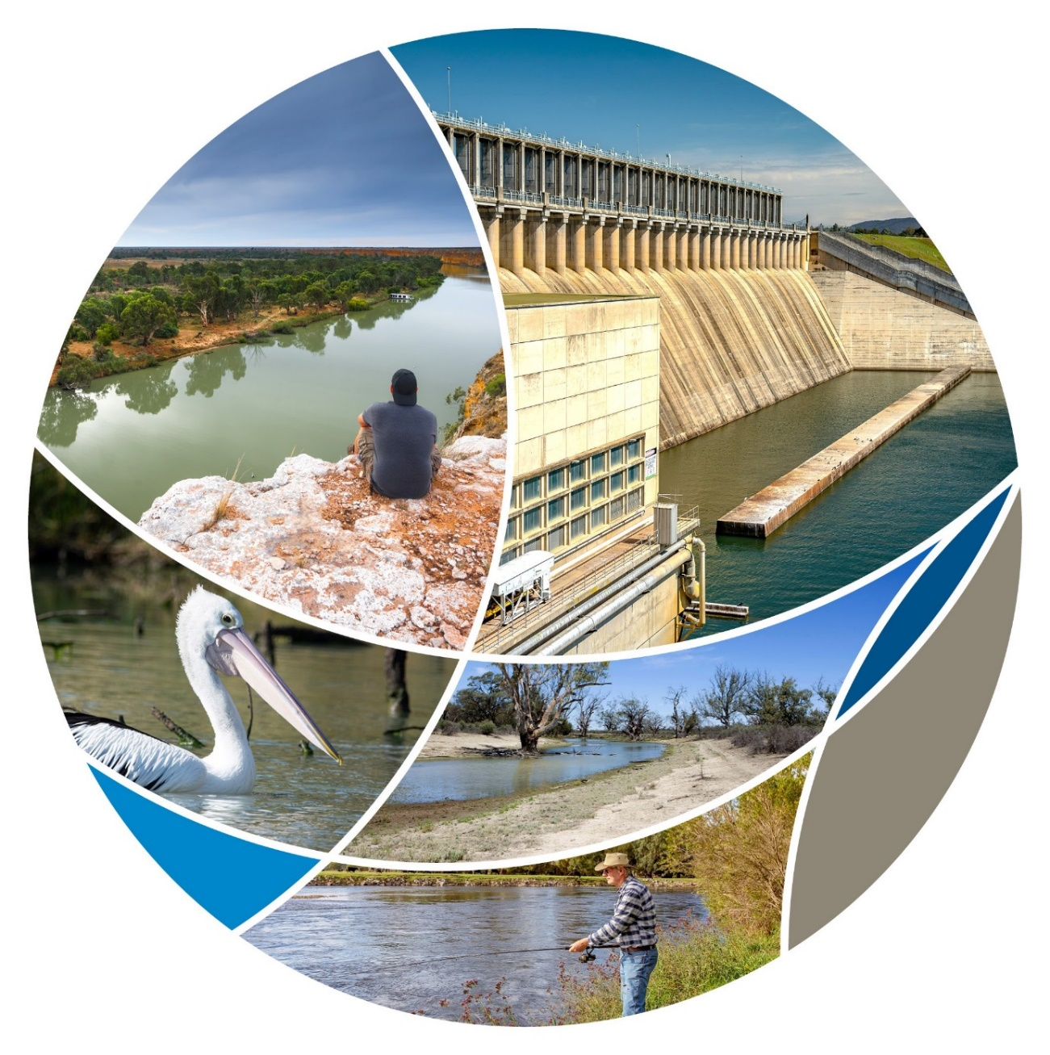

© Commonwealth of Australia 2020

**Ownership of intellectual property rights**

Unless otherwise noted, copyright (and any other intellectual property rights) in this publication is owned by the Commonwealth of Australia (referred to as the Commonwealth).

**Creative Commons licence**

All material in this publication is licensed under a [Creative Commons Attribution 4.0 International Licence](https://creativecommons.org/licenses/by/4.0/legalcode) except content supplied by third parties, logos and the Commonwealth Coat of Arms.

Inquiries about the licence and any use of this document should be emailed to [copyright@awe.gov.au](mailto:copyright@awe.gov.au).

Creative Commons Attribution 4.0 International Licence

**Cataloguing data**

This publication (and any material sourced from it) should be attributed as: Department of Agriculture, Water and the Environment, *Murray–Darling Healthy Rivers – Community feedback*, Canberra, February 2021. CC BY 4.0.

ISBN 978-1-76003-382-8

This publication is available at [agriculture.gov.au/water/mdb/programs/basin-wide/healthy-rivers-program](https://www.agriculture.gov.au/water/mdb/programs/basin-wide/healthy-rivers-program).

Department of Agriculture, Water and the Environment

GPO Box 858 Canberra ACT 2601

Telephone 1800 900 090

Web [awe.gov.au](http://agriculture.gov.au/)

The Australian Government acting through the Department of Agriculture, Water and the Environment has exercised due care and skill in preparing and compiling the information and data in this publication. Notwithstanding, the Department of Agriculture, Water and the Environment, its employees and advisers disclaim all liability, including liability for negligence and for any loss, damage, injury, expense or cost incurred by any person as a result of accessing, using or relying on any of the information or data in this publication to the maximum extent permitted by law.

**Acknowledgements**

The authors thank everyone who took the time to make a submission for their input.

Contents

Summary v

Introduction 1

Getting the word out there 1

Who responded 1

Overview of results 3

Readability and ease of use 3

Red tape 3

Application period 4

Community participation 4

Eligibility of organisations 5

Mix of eligible activities 5

Key themes 7

Length of application period 7

Application process 7

Alignment with existing environmental plans and strategies 7

Geographical distribution of projects 8

Funding for education, surveying, monitoring and evaluation 8

First Nations engagement 8

Length of completion period 8

Appendix A: Survey results 9

Appendix B: Map of where comments came from 26

Appendix C: Response to suggested changes to guidelines 27

Glossary 33

**Tables**

Table C1 Suggested entities that should or should not be eligible 27

Table C2 Suggested activities that should or should not be eligible 28

Table C3 Suggested changes we could make to the small grants to make it easier to participate 29

Table C4 Other suggestions received 31

**Figures**

Figure A1 State or territory of respondent 9

Figure A2 Stakeholder type of respondent 9

Figure A3 Is respondent considering applying 11

Figure A4 Previous participation in NRM programs 11

Figure A5 Format for submitting feedback 12

Figure A6 Readability of guidelines 12

Figure A7 Eligibility requirements are clear 13

Figure A8 How to apply 13

Figure A9 Assessment criteria 14

Figure A10 Appropriateness of contractual and grant management arrangements 14

Figure A11 List of eligible entities 15

Figure A12 Eligibility of state and territory government for small grants 15

Figure A13 Eligibility of the 56 NRM organisations for small grants 16

Figure A14 Entities which should be included or excluded 16

Figure A15 Ability to find an organisation to partner with 17

Figure A16 What is an eligible activity 17

Figure A17 Range of eligible activities 18

Figure A18 Identification of potential projects 18

Figure A19 Range of funding amounts 19

Figure A20 Organisations will be able to undertake eligible activities 19

Figure A21 Linkage between the eligible activities and improving river and wetland health 20

Figure A22 Maximum funding for small grants 20

Figure A23 Activities which should be included or excluded 21

Figure A24 Sourcing of local goods and services 21

Figure A25 Partnership with other groups 22

Figure A26 Barriers to participation 22

Figure A27 Application period 24

Figure A28 Other changes to small grants 24

Figure A29 Other feedback 25

**Maps**

Map B1 Location of respondents to Have Your Say based on postcodes 26

## Summary

The new $20 million Murray–Darling Healthy Rivers Program is part of the Australian Government’s $269.7 million Murray–Darling Communities Investment Package. Minister for Resources, Water and Northern Australia, the Hon Keith Pitt MP, announced the program as a core action of the package that aims to achieve a sustainable and certain future for the Basin, its people, industries, and the environment. The Murray–Darling Healthy Rivers Program will fund farmers, landholders and community organisations to deliver practical, on-ground projects to improve the health of rivers and wetlands.

From 18 December 2020 to 22 January 2021, we sought public comment to inform the grant guidelines for program to improve the health of rivers and wetlands across the Basin. Over 270 emails to stakeholders were sent, with print media advertising in in key regional papers. We also undertook social media advertising to raise awareness that people could provide feedback.

There were:

* over 4,500 unique views of the consultation page
* over 500 copies of guidelines downloaded
* 278 interactions with the survey tool.

We received 48 surveys – including 10 written submissions – and a further 8 emailed submissions. The responses spanned the whole Basin and had a mixture of farmers and land holders, as well as community organisations.

Overall, the responses told us we are on the right track with the design and delivery of the program:

* 80% of respondents agreed or strongly agreed that they can identify potential projects that will address river and wetland health in their community
* 64% of respondents agreed or strongly agreed that the draft guidelines were easy to read and understand, with only 11% disagreeing

Additionally, 65% of respondents agreed or strongly agreed that they can see a clear linkage between the eligible activities and improving river and wetland health. This is a good indicator that the program is on-track to achieve its outcomes.

We value all of the feedback we received and have taken comments on board as much as possible. Our response to each piece of feedback is at Appendix C: Response to suggested changes to guidelines. We received several specific suggestions and have made several changes to the guidelines as a result. We have not been able to incorporate some comments into the guidelines but have provided an explanation for each.

Supporting Murray–Darling communities is at the heart of the Healthy Rivers Program. All the feedback received will guide decision making, administration and implementation of the grants so that local communities can reap the benefits of this important environmental program.

## Introduction

The Australian Government is putting communities and jobs at the heart of the Basin Plan by investing $269.7 million through the Murray–Darling Communities Investment Package. The Communities Investment Package aims to achieve a sustainable and certain future for the Basin, its people, industries, and the environment.

As part of the package, the government is establishing the $20 million Murray–Darling Healthy Rivers Program. The program will fund community-led grants for on-ground projects that improve the health of rivers and wetlands across the Basin.

As part of our renewed commitment to engaging with Basin communities, the draft grant opportunity guidelines were released for public comment on 18 December 2020 to 22 January 2021. This is an important step to include community participation in the program design.

### Getting the word out there

The start of the consultation period was announced by Mr Damian Drum MP, Member for Nicholls, on 21 December 2020. Mr Tony Pasin MP, Member for Barker, also issued a media release during the consultation period inviting the community to participate in the consultations.

We advertised the consultations through:

* emails sent to 270 stakeholders through the Australian Government’s Notify platform
* print media advertising in The Australian, The Weekly Times, The Koori Mail, Country News and The Land
* social media advertising on Instagram, Twitter, and LinkedIn.

In total, during the consultation period there were:

* 4,590 visits to the Have Your Say page
* 513 document downloads
  + 313 small project stream guidelines
  + 200 large project stream guidelines
* 278 interactions with the survey tool.

### Who responded

We received 48 surveys completed through Have Your Say – including 10 written submissions – and an additional 8 emails providing feedback.

For those that completed the survey through Have Your Say, 75% were from New South Wales and Victoria.

For more detail refer to:

* Figure A1 State or territory of respondent
* Map B1 Location of respondents to Have Your Say based on postcodes.

There was a good mix of respondents, noting respondents could identify as more than one category:

* 13 identified as private citizens
* 10 identified as not-for-profits and 8 as natural resource management organisations.
* 9 identified as land managers, 7 as irrigators and 7 as dryland farmers
* 6 identified as Indigenous organisations.

For more detail refer to Figure A2 Stakeholder type of respondent.

Interestingly, only 54% of respondents were considering applying, with 58% reporting that they had not previously received funding under an Australian Government natural resource management program such as Landcare.

For more detail refer to:

* Figure A3 Is respondent considering applying
* Figure A4 Previous participation in NRM programs.

## Overview of results

### Readability and ease of use

There were many indications that we are on the right track with creating user-friendly guidelines:

* 64% of respondents agreed or strongly agreed that the draft guidelines were easy to read and understand, with only 11% disagreeing
* 70% of respondents agreed or strongly agreed that the draft guidelines clearly explain eligibility requirements, with only 15% disagreeing
* 72% of respondents agreed or strongly agreed that the draft guidelines clearly explain how to apply, with only 11% disagreeing.

Despite this, 15 respondents or 31% identified that difficulty understanding the guidelines (funding jargon and interpreting criteria) was a barrier to their participation in the program.

For more detail refer to:

* Figure A6 Readability of guidelines
* Figure A7 Eligibility requirements are clear
* Figure A8 How to apply
* Figure A26 Barriers to participation.

### Red tape

We were also pleased to see that, in general, respondents thought we were striking the right balance between reducing red tape and having appropriate oversight of grants:

* 62% of respondents agreed or strongly agreed that the assessment criteria (section 6 of both draft guidelines) for both streams are appropriate for the value of the grants, with only 17% disagreeing
* 63% of respondents agreed or strongly agreed that the proposed contractual and grant management arrangements (section 10 of both draft guidelines) for both streams are appropriate for the value of the grants, with only 13% disagreeing
* 60% of respondents agreed or strongly agreed that $50,000 is a suitable maximum funding amount for the small grants stream, with only 22% disagreeing.

Notwithstanding these pleasing results, red tape continues to be a considerable barrier to participation:

* 38% of respondents identified that red tape in managing the grant was a barrier to their participation in the program
* 10% of respondents identified that work health and safety and other requirements was a barrier to their participation in the program.

However, 50% of respondents said they would be able to find and partner with another eligible entity to apply for a grant if they didn’t have the capacity to.

Around 57% of respondents suggested other changes we could make to the small grants to make it easier to participate.

For more detail refer to:

* Figure A9 Assessment criteria
* Figure A10 Appropriateness of contractual and grant management
* Figure A15 Ability to find an organisation to partner with
* Figure A22 Maximum funding for small grants
* Figure A26 Barriers to participation
* Figure A28 Other changes to small grants.

### Application period

There were mixed views on the length of the application period needed to apply under the small grants program, noting we are seeking to spend money in communities as soon as possible:

* 52% of respondents indicated they needed 4 weeks (as provided for under the current draft guidelines)
* 13% of respondents indicated they needed 6 weeks
* 17% of respondents indicated they needed 8 weeks (note that funding will not be provided to successful applicants this financial year under this option).

Additionally, in relation to the top 3 barriers to participation in the program:

* 33% of respondents identified time needed to apply
* 38% of respondents identified confidence in the application and assessment process.

For more detail refer to:

* Figure A26 Barriers to participation
* Figure A27 Application period.

### Community participation

The most exciting result was that 80% of respondents agreed or strongly agreed that they can identify potential projects that will address river and wetland health in their community. This is a good indicator of potential community engagement with the program.

Additionally, there was a good result for if respondents believed they would be able to source local goods and services to deliver a project under the program:

* 69% said yes, they could source all goods and services locally
* 22% said yes, but only some of the goods and services
* 9% they could not.

This is a good indication that the economic stimulus aspect of the program outcomes can be delivered.

For more detail refer to:

* Figure A18 Identification of potential projectsFigure A18 Identification of potential projects
* Figure A24 Sourcing of local goods and services.

### Eligibility of organisations

The results for eligible organisations also indicated we are generally on the right track with 64% of respondents agreeing or strongly agreeing that the lists of eligible entities in both the small and large grants guidelines (section 4.1 of the draft guidelines) are broad enough to enable wide community participation, with only 13% disagreeing.

However other results were more mixed:

* 50% of respondents agreed or strongly agreed that state and territory agencies and local governments should be excluded from small grants to ensure farmers and small organisations have access to funding, with 26% undecided and 24% disagreeing
* 48% of respondents agreed or strongly agreed that 56 NRM organisations should be excluded from the small grants round to ensure that smaller community-based organisations have a greater chance of being successful, with 35% undecided and 17% disagreeing.

Around 38% of respondents suggested entities which should be included or excluded from the eligible list not currently in the guidelines.

For more detail refer to:

* Figure A11 List of eligible entities
* Figure A12 Eligibility of state and territory government for small grants
* Figure A13 Eligibility of the 56 NRM organisations for small grants
* Figure A14 Entities which should be included or excluded.

### Mix of eligible activities

The survey also indicated a pleasing level of satisfaction with eligible activities:

* 67% of respondents agreed or strongly agreed that guidelines clearly indicate what is an eligible or ineligible activity, with only 20% disagreeing
* 58% of respondents agreed or strongly agreed that there is a broad range of eligible activities under the program, with only 28% disagreeing
* 51% of respondents agreed or strongly agreed that their organisation will be able to undertake eligible activities under the guidelines, however 31% indicated a neutral response with a further 18% disagreeing.

Additionally, 65% of respondents agreed or strongly agreed that they can see a clear linkage between the eligible activities and improving river and wetland health. This is a good indicator that the program is on-track to achieve its outcomes.

Around 56% of respondents gave further suggestions on activities which should be included or excluded from the eligible list not currently in the draft guidelines.

For more detail refer to:

* Figure A11 List of eligible entities
* Figure A16 What is an eligible activity
* Figure A17 Range of eligible activities
* Figure A20 Organisations will be able to undertake eligible activities
* Figure A21 Linkage between the eligible activities and improving river and wetland health
* Figure A23 Activities which should be included or excluded.

## Key themes

Respondents to the Have Your Say survey and those who provided a written submission have suggested minor changes to the program design and guidelines. In response to this feedback, we have made several changes as detailed in Appendix C: Response to suggested changes to guidelines. The main recurring concepts of these suggestions are organised into key themes below.

### Length of application period

As noted in Application period above, some respondents expressed concerns that the proposed 4 week timeframe to submit an application was insufficient. In addition, written responses have suggested allowing some flexibility for late applications if applications are complex and require agreement from multiple parties. Respondents also advocate for clarity around when applications for each round will open. While we are considering the best opening period length for applications, any delay in timeframes may delay provision of funding to support communities in their recovery from COVID-19.

### Application process

Respondents have told us that the proposed application process is generally not too difficult (see Red tape) but could be simplified further. Suggestions to achieve this include minimising jargon in the guidelines and allowing a downloadable application form so that those with limited internet can continue to work on their application offline. We have sought to simplify the language of the guidelines where we can, and we are considering options to make the application form as accessible as possible.

Some submissions requested that we also provide support to grant applicants throughout the application process. One common suggestion was that applications which proposed valuable activities are not excluded because of small issues and mistakes. We are unfortunately unable to assist applicants to submit their applications as this poses a high probity risk and could be seen as providing favourable treatment to specific organisations.

### Alignment with existing environmental plans and strategies

Stakeholders have emphasised the importance of ensuring funding provided is complementary to existing environmental and natural resource management activities occurring in the Murray–Darling Basin and aligns with relevant environmental plans and strategies. This would help to maximise the outcomes achieved from each grant and enable clear reporting against specific goals. Additionally, respondents told us that the expertise of local natural resource management bodies could help best secure environmental outcomes.

We agree with the importance of the strategic alignment of grant funding with natural resource management and conservation strategies. The guidelines currently recommend applications reference several strategies their activities would contribute to, and we have added more strategies and plans to the guidelines based on respondents’ feedback. Consortia applications that could incorporate the support of natural resource management bodies are currently eligible under both the small and large grants streams of the program.

### Geographical distribution of projects

Some submissions proposed that the funding awarded be targeted to areas that have experienced the most negative impacts because of water recovery under the Murray–Darling Basin Plan. Support for specific communities in the Basin that have been negatively impacted under the Basin Plan is currently provided for in other programs, including the Murray–Darling Basin Economic Development Program. In assessing applications, the extent to which a reasonable spread of grant activities is achieved across the whole Basin will be considered, but there are no specific allocations of funding per state or territory, catchment or sustainable diversion limit resource unit.

### Funding for education, surveying, monitoring and evaluation

Multiple respondents have suggested that funding be available for educating communities in natural resource management and conservation under the program. This is proposed through involving communities in activities such as population surveys and monitoring and maintaining completed projects, to increase community involvement in and support of local projects and build a knowledge base for future environmental projects. We are proposing to allow these activities, as long as they are part of a project including practical, on-ground works to make physical improvements in river and wetland health.

Similarly, respondents have emphasised the importance of monitoring and evaluation activities to ensure the objectives of projects remain beyond their completion date. We agree with the importance of monitoring and evaluation, and is developing a thorough monitoring, evaluation, reporting and improvement framework which will guide how we evaluate the outcomes of the program. Funding is currently available for reporting activities for up to 5% of the total grant value.

### First Nations engagement

Feedback was received about engaging with First Nations in the development of the program and individual projects. This included the procurement of goods and services from Indigenous businesses. We recognise that First Nations are important stakeholders.

### Length of completion period

Several submissions stated that the 12-month period to complete the grant activities was too short and that lengthening the grant completion period could allow for better outcomes from the funding. The Australian Government has decided to restrict the completion period to 12-months to fast track funding to communities to support them in their recovery from COVID‑19. However, if applicants can demonstrate that factors outside of their control delayed completion time, we may approve a 12-month extension to the completion period.

## Appendix A: Survey results

Figure A1 State or territory of respondent

Figure A2 Stakeholder type of respondent

Options for the type of stakeholder the respondent identified as were:

* state government organisation
* local government organisation
* Indigenous organisation
* non-profit non-government organisation
* company
* natural resource management organisation
* industry representative body
* academic
* environmental group
* irrigator
* dryland farmer
* land manager
* sole trader
* private citizen
* other.

Responses for other included:

* ag (sic) teacher
* husband and wife partnership who own and manage a property entirely for conservation
* incorporated community organisations.

Figure A3 Is respondent considering applying

Figure A4 Previous participation in NRM programs

Figure A5 Format for submitting feedback

Figure A6 Readability of guidelines

Figure A7 Eligibility requirements are clear

Figure A8 How to apply

Figure A9 Assessment criteria

Figure A10 Appropriateness of contractual and grant management arrangements

Figure A11 List of eligible entities

Figure A12 Eligibility of state and territory government for small grants

Figure A13 Eligibility of the 56 NRM organisations for small grants

Figure A14 Entities which should be included or excluded

Comments received in relation to which entities which should be included or excluded from the program and the department’s response to each comment is at Table C1.

Figure A15 Ability to find an organisation to partner with

Figure A16 What is an eligible activity

Figure A17 Range of eligible activities

Figure A18 Identification of potential projects

Figure A19 Range of funding amounts

Figure A20 Organisations will be able to undertake eligible activities

Figure A21 Linkage between the eligible activities and improving river and wetland health

Figure A22 Maximum funding for small grants

Figure A23 Activities which should be included or excluded

Comments received in relation to activities which should be included or excluded from the program and the department’s response to each comment is at Table C2.

Figure A24 Sourcing of local goods and services

Figure A25 Partnership with other groups

Figure A26 Barriers to participation

Options for the three biggest barriers to participating in the program included:

* literacy and numeracy issues
* lack of IT skills and internet access
* time needed to apply
* time available to deliver the projects
* availability of volunteers
* difficulty understanding the guidelines (funding jargon and interpreting criteria)
* confidence in the application and assessment process
* work health and safety and other requirements
* concerns about red tape in managing the grant
* other.

Responses for other included:

* Co-ordination/administration expertise preferably by a professional environmental officer. Especially where this work is not an organisation's core business / area of expertise.
* No cultural protocol attached, No first nations involve at the start.
* 1) proving environmental (or economic) benefits when the project is due to complete in June 2022. 2) delivering environmental benefits from water saved when the control of the water saved lies with the Commonwealth (CEWO). 3) meeting both criterion 1 and 4 of the Large Grants is difficult - water has been saved from agriculture and returned to the environment. This on face value is an economic loss and environmental gain. What you are asking for is for a project that achieves both an economic and environmental gain, and for this to be done in only 12 months, presumably with lasting benefits. One way to do this would be to shift water use on almonds from below the Choke in the Riverland/Sunraysia, to above the Choke delivered from Lake Mulwala, by creating investment incentive to develop permanent plantings on either side of the river in the central Murray. This would remove the flow constraint in the Choke, preserve natural flows downstream of Mulwala, enhance icon sites at Barmah/Millewa, Perrcoota/Kondrook and Werai forests, save in-stream delivery losses from irrigation and return them to the environment, and enhance capital tied up in irrigation delivery infrastructure in GMW and MIL - as well as supporting ""losing"" irrigation communities in the central Murray by converting them from low-value broad-acre cropping and dairy to high value horticulture. Such a project would have real merit, but appears to be impossible under the funding guidelines for these grants, which appear to be all about getting money out the door than delivering real outcomes for communities."
* Inability for supporting processes with application. Disadvantages for smaller organisations where application processes may not lead to successful outcomes. Encourage application support during process and also a review process to provide further information once an application is lodged.

Note: Community feedback is published as received on Have Your Say, including spelling and grammatical errors. Comments where the submission is marked confidential, or not did wish for it to be published, or where the submission did not include a privacy declaration have not been included in the list above. However, these comments have still been considered.

Figure A27 Application period

Figure A28 Other changes to small grants

Comments received on what changes we could make to the guidelines for the small grants to make it easier to participate and our response to each comment is at Note: Community feedback is published as received on Have Your Say, including spelling and grammatical errors. Comments where the submission is marked confidential, or not did wish for it to be published, or where the submission did not include a privacy declaration have not been included in the list above. However, these comments have still been considered.

Table C3.

Figure A29 Other feedback

All other feedback received and our response to each comment is at Table C4.

## Appendix B: Map of where comments came from

Map B1 Location of respondents to Have Your Say based on postcodes

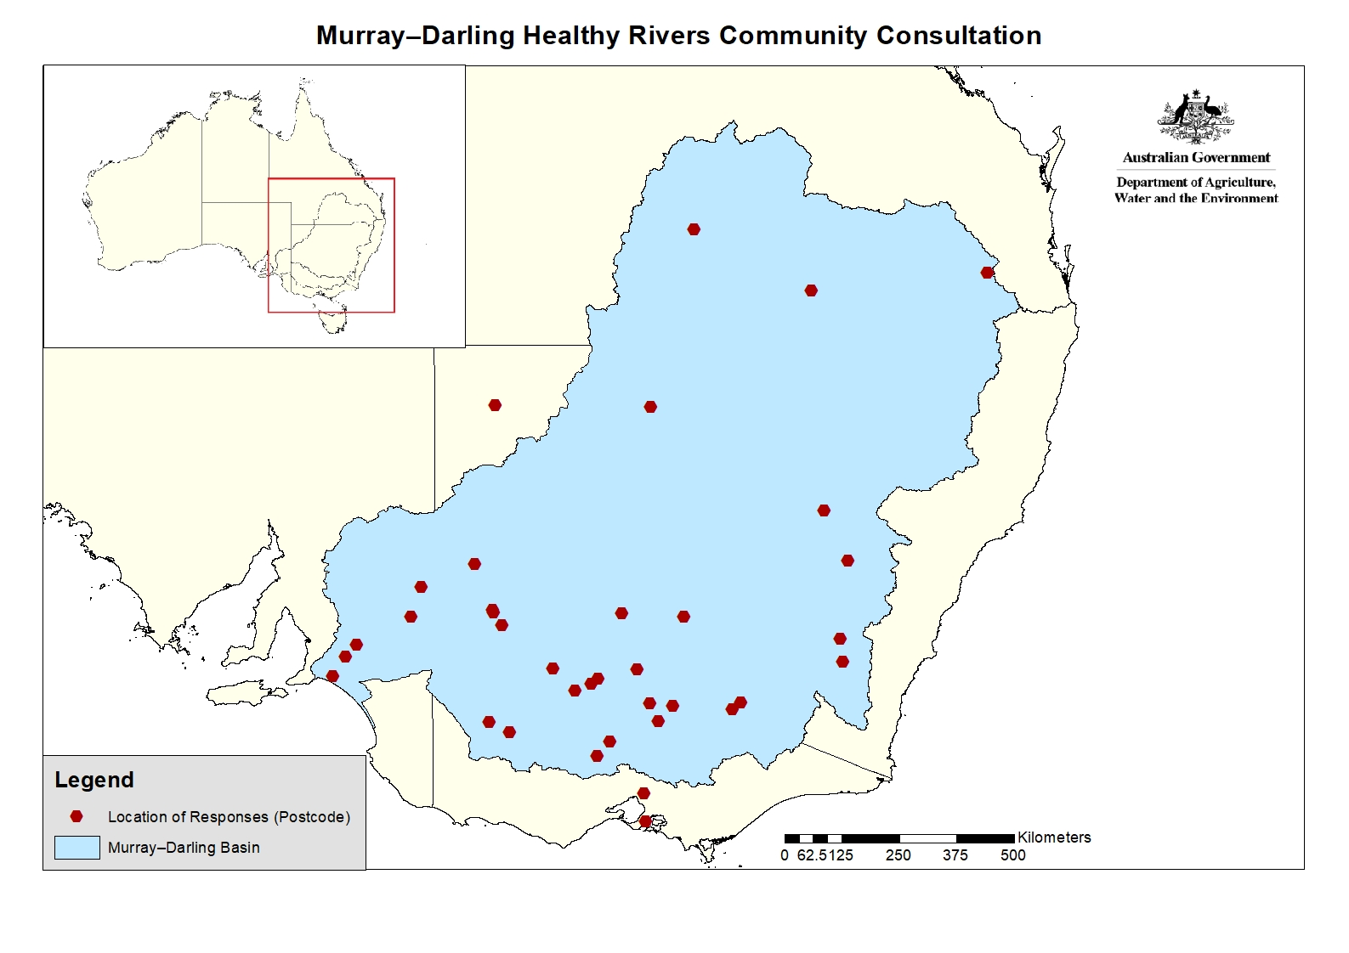

## Appendix C: Response to suggested changes to guidelines

Table C1 Suggested entities that should or should not be eligible

| Community feedback | Response |
| --- | --- |
| Need to ensure Irrigation Infrastructure Operators such as irrigation trusts would not be excluded irrespective of their corporate structure | Agreed  Section 4.1 of the guidelines now states “Note: Irrigation infrastructure operators, and public and private schools, are eligible regardless of their organisational structure.” |
| Companies (large corporates). Those large enough to employ professional grant writers. | Not agreed  Farmers commonly use corporate structures to manage their agricultural business and defining what is “large” may exclude some land managers which are needed to achieve ecological outcomes. |
| Local councils | Noted  It is unclear if the respondent was advocating for local councils to be included in the small grants or excluded from all grants. |
| anyone or anything foreign | Noted  International Entity has been removed from list of eligible organisations at section 4.1 of the guidelines and been added to the list of ineligible organisations. |
| Farmers earning above 100k/year or with properties larger than 1000ha | Not agreed  Defining what is “large” may exclude some land managers which are needed to achieve ecological outcomes. |
| Excluding state government organisations means that public schools would be ineligible, while private schools could apply. This is inequitable. | Agreed  Section 4.1 of the guidelines now states “Note: Irrigation infrastructure operators, and public and private schools, are eligible regardless of their organisational structure.” |
| Incorporated community associations. | Noted  These are eligible organisations captured under “Incorporated Association” at section 4.1 of the guidelines. |
| to fix the water and river issue you need to do good cultural protocol an start with talking to the original people of the land, No matter where they are in the Murray : Darling Basin. If you want to get this issue right then Listen to their advice and act on it....there is the original law for the rivers that is a good place to start. | Noted  Indigenous Corporations are eligible organisations at section 4.1 of the guidelines. |
| Organisations that already received funding for Basin Plan unless those organisations are part of a consortium with broader stakeholder/community groups that submit an application and are partners in co-designed stakeholder/community projects | Not agreed  This would potentially make farmers who upgraded infrastructure under programs such as the On-Farm Irrigation Efficiency Program and the Healthy Headwaters Water Use Efficiency Program or irrigation infrastructure operators who received funding ineligible. This would limit the ecological outcomes that could be achieved. |

Note: Community feedback is published as received on Have Your Say, including spelling and grammatical errors. Comments where the submission is marked confidential, or not did wish for it to be published, or where the submission did not include a privacy declaration have not been included in the list above. However, these comments have still been considered.

Table C2 Suggested activities that should or should not be eligible

| Community feedback | Response |
| --- | --- |
| Masterplanning and implementation funds for controlling access, installing appropriate walking trails and signage on community owned floodplains. Controlling access could involve gates, installing vehicle barriers, etc. | Agreed  Added to Appendix A. Examples of eligible activities. |
| Tree planting needs to have follow watering and should be paid on success rate after 12 months. | Noted  This will be considered as part of the monitoring, evaluation, reporting and improvement strategy for the program currently being developed. |
| Please make grazing exclusion fences clearly eligible. (Section 5.4) | Agreed  Added to Appendix A. Examples of eligible activities. |
| no boats. or any activity involving one if having an engine, rivers health is critical at this point seeing the overflow of waste you guys kept allowing in | Not agreed  Motorised boats may be needed to undertake in-stream works. |
| Ecotourism and natural resources education | Not agreed  Advertising and promotion of ecotourism is not an activity within the scope of the main project outcome. However, infrastructure which supports ecotourism (for example: boardwalks, sand ladders, visitor access trails and interpretative signs) are eligible activities. |
| Major Capital works are currently ineligible, in some instances this may be required to enable removal of barriers to fish passage. | Agreed  This has been removed from the list of ineligible activities. |
| follow good protocol and the projects will make a difference. | Noted |
| Stakeholder/community partnerships or individual entities that have a project application that meets multiple criteria but appears not specifically eligible under draft criteria should be permitted. To this extent flexibility is needed when considering applications that may/or may not be limited to criteria identified but do achieve a regionally relevant environmental outcomes | Noted  The Appendix A. Examples of eligible activities states “Note: This list is not exhaustive and other activities may be considered on merit provided they contribute toward one or more of the program objectives/outcomes. Applications must include sufficient information. The program assessment will consider grant activities that expand, or supplement existing activities or programs funded by other government entities or programs.” |
| The eligibility requirements provide no indication of where projects are actually needed to help river health in the Basin and where they add to water recovery. It seems like the Government doesn't know where investments will best help improve the health of the Basin and deliver outcomes alongside water recovery. Should we be looking at areas where water is still to be recovered? should we be looking at areas where climate change impacts are expected to mean water availability will decline? Te guidelines lack a strategy, at the moment they (incorrectly) suggest that any project in the Basin will deliver outcomes under the Basin Plan. the guidelines should provide regionally specific information on priorities and at worst further guidance around what kinds of projects / areas are high priority. While it makes sense to also seek this information from applicants, applicants do not have the detailed understanding of where the Basin Plan and water recovery is working / delivering outcomes and where it is deficient. | Not agreed  This would add a layer of complexity that would provide a barrier for farmers and small organisations to apply.  As per the guidelines, we will consider the extent to which a reasonable spread of grant activities is achieved across the whole Basin.  Criterion 1 of the guidelines for both streams also asks applicants to link their proposal to environmental plans where possible. |
| Environmental Education programming via active community monitoring, evaluation and reporting on restoration projects. | Noted  A monitoring, evaluation, reporting and improvement strategy for the program is being developed. |
| I wish to apply for funds to investigate the prospect of building 2 large, solar covered, ponds(500 x 500 x 5 metres deep) near Mt Isa to catch tropical storm water & gravity feed it-via pipelines(1,000 Kms long)into the Darling River. I have designed horizontal solar panels, fitted in rows, so as to rotate vertically (open up)when it rains & to close over & eliminate evaporation when not raining - being within the tropics ,these solar panels will provide enough solar energy to power all residences in Mt Isa. This annual supply of water will refresh the river throughout future droughts experienced regularly in the Murray/Darling river system. | Not agreed  The activity is not located within the Murray–Darling Basin and appears to be for feasibility assessment rather than on-ground works. |

Note: Community feedback is published as received on Have Your Say, including spelling and grammatical errors. Comments where the submission is marked confidential, or not did wish for it to be published, or where the submission did not include a privacy declaration have not been included in the list above. However, these comments have still been considered.

Table C3 Suggested changes we could make to the small grants to make it easier to participate

| Community feedback | Response |
| --- | --- |
| Listen | Noted  We have considered all feedback received through the consultation process. |
| Online forums, allowing for Q&A sessions | Agreed in principle  Organisations will be able to submit written questions and receive answers through the Community Grants Hub. |
| Please make sure there is a pdf available which shows all the grant application questions. It is very frustrating to have to answer each question in order to progress to the next page. | Noted  This feedback has been passed to the Community Grants Hub. |
| open it up to more individuals. | Agreed  Individuals are already able to apply. |
| The problem has always been the applications themselves, particularly for Indigenous. orgs. I.L.M.F. 's USED to provide this but no more. More's the pity | Noted  We understand ILMF stands for Indigenous Land Management Facilitator. |
| Can the grants be for two years, rather than one year, or at least 18 months. I say this as Governments generally take so long to get the grant contracts out that there is often far less than a year to deliver. Two years takes the pressure off and enables far better quality and quantity of community involvement. | Not agreed  The program aims to increase economic activity and employment in Basin communities as result of grant funding. As such, we need to get funding into communities as soon as possible to help with recovery from drought and the impacts of COVID–19.  Additionally, the guidelines provide that “The Department of Agriculture, Water and the Environment may approve a further 12 months extension provided you can demonstrate there were factors outside your control which prevented you from completing the project (for example, extreme weather events).” |
| Different timelines and a heads up on when this will be available. 8 weeks and you can’t find groups? What do you do exactly? | Noted |
| Pay a living wage for people to organise and carry out their projects. | Noted  All grant recipients are required to comply with the *Fair Work Act 2009* and other workplace relations legislation, including offering pay and conditions consistent with the Award or relevant industrial agreement. |
| allow FIRST the First Nations to be the voice of this program/project. | Noted  We recognise that First Nations are important stakeholders. |

Note: Community feedback is published as received on Have Your Say, including spelling and grammatical errors. Comments where the submission is marked confidential, or not did wish for it to be published, or where the submission did not include a privacy declaration have not been included in the list above. However, these comments have still been considered.

Table C4 Other suggestions received

| Community feedback | Response |
| --- | --- |
| Compliance is a real concern. They're all out to rip you off :) | Noted  The Community Grants Hub has existing arrangements to manage compliance with the grant agreement. |
| In addition to adding a steady annual supply of water to the Darling River, I believe the above proposal has the potential to supply(by gravity),fresh drinking water to a number of inland towns with a lower height than Mt Isa(eg: Walgett, Bourke, etc) where it could be piped directly into the town's reservoir, then via their filtration system into their town's distribution layout. This supply of tropical annual rain water is consistently dependable and a reliable resource yet to be used in the National Water Supply System. The system will use existing infrastructure wherever possible and have minimum repair & maintenance requirements throughout its length. | Not agreed  This is out of the program’s scope. |
| Unless you address the elephant in the room, water extraction, all these grants are meaningless. You would know this simply by looking back at previous projects. Good intentions little impact in comparison to the rape and pillage of the river | Not agreed  The program will not recover water for the environment and will not reduce farmers’ access to water. |
| There is so much that needs to be done and can be done, lots of wonderful ideas already happening, but the way we live now means we cannot rely on volunteers for the enormous amount that could be done. Restoring the environment to health and finding sustainable ways to live are the most important work that needs to be done now. More people would be able to contribute and get more done if they were paid. It is vital work and the attitude to providing grant money should not be ‘the govt is doing you a favour by allowing you money’ | Noted |
| Multiple Traditional Owner Groups have been working with Catchment Management Authorities on EC5 project proposals. We need to understand what is funded under EC5, what didn't get funded and then potentially fund those projects under this program. Traditional Owner Groups are typically funded for on-ground works but we should also be funded as part of the Project Control Group for these types of projects, notably the large grants. | Noted  We understand that EC5 refers to Victorian Department of Environment, Land, Water and Planning – Environmental Contribution Funding Tranche 5. This feedback has been passed onto that agency.  Indigenous Organisations are eligible under both the small and large grants streams. |
| My concern, particularly for the large grant program, but to a lesser extent the small grant programme, is the requirement as part of the application to have the written permission of all participating landholders.  I can envisage us applying for a project that will deliver outcomes on numerous properties and it would be a very major undertaking to communicate specifically with all landholders that may wish to be involved, and develop a specific plan to a level of detail that would give them confidence to provide access permission, all during the application phase, when there is obviously no guarantee that the project will get approval.  In the type of project I am envisaging, I think the applicant should just need to nominate either the hectares of land, or kilometres of watercourse frontage that will be improved, and the identification of the exact participating landholders made once the grant is approved. The applicantion would have to identify the catchment/catchments the project would operate in, and the general geographic area within the catchment. | Agreed  Section 4.2 of the guidelines which required up-front consent from the site owner/manager for your project where you are not the site owner/manager has now been removed. |
| Encourage improved acknowledgement in funding process that recognises areas most disadvantaged by the Murray Darling Basin Plan and support community driven solutions to maximise environmental outcomes and social and economic benefits. Encourage the funding guidelines to exclude regions that have benefitted from the Basin Plan and additional flows achieve via Federally funded 'water recovery already for the environment' (eg local government areas in South Australia) and also exclude areas on the Darling where NSW Water Sharing Plans do not permit 'connectivity flows to the Murray or Lower Darling. This does not mean exclusion of indigenous programs on the Darling , but this statement reflects the ongoing concerns about loss of connectivity flows from the Darling River (via extractions levels) and that funding should not be directed to regions where levels of 'take' remain of concern. | Not agreed  As part of the assessment process, we will consider the extent that a reasonable spread of grant activities is achieved across the whole Basin. However, there are no specific allocations of funding per:   * state or territory * catchment, or * Sustainable Diversion Limit resource unit. |
| Copies of water plan and supporting information | Noted  Information on Water Resource Plans is publicly available from the Murray–Darling Basin Authority [mdba.gov.au/basin-plan-roll-out/water-resource-plans](https://www.mdba.gov.au/basin-plan-roll-out/water-resource-plans). |

Note: Community feedback is published as received on Have Your Say, including spelling and grammatical errors. Comments where the submission is marked confidential, or not did wish for it to be published, or where the submission did not include a privacy declaration have not been included in the list above. However, these comments have still been considered.

## Glossary

| Term | Definition |
| --- | --- |
| CEWO | Commonwealth Environmental Water Office |
| MDB | Murray–Darling Basin |
| NRM | natural resource management |