|  |  |  |
| --- | --- | --- |
|  |  |  |

Murrumbidgee Monitoring, Evaluation and Research Program, ecological responses to Commonwealth environmental water, Field Report. June 2021

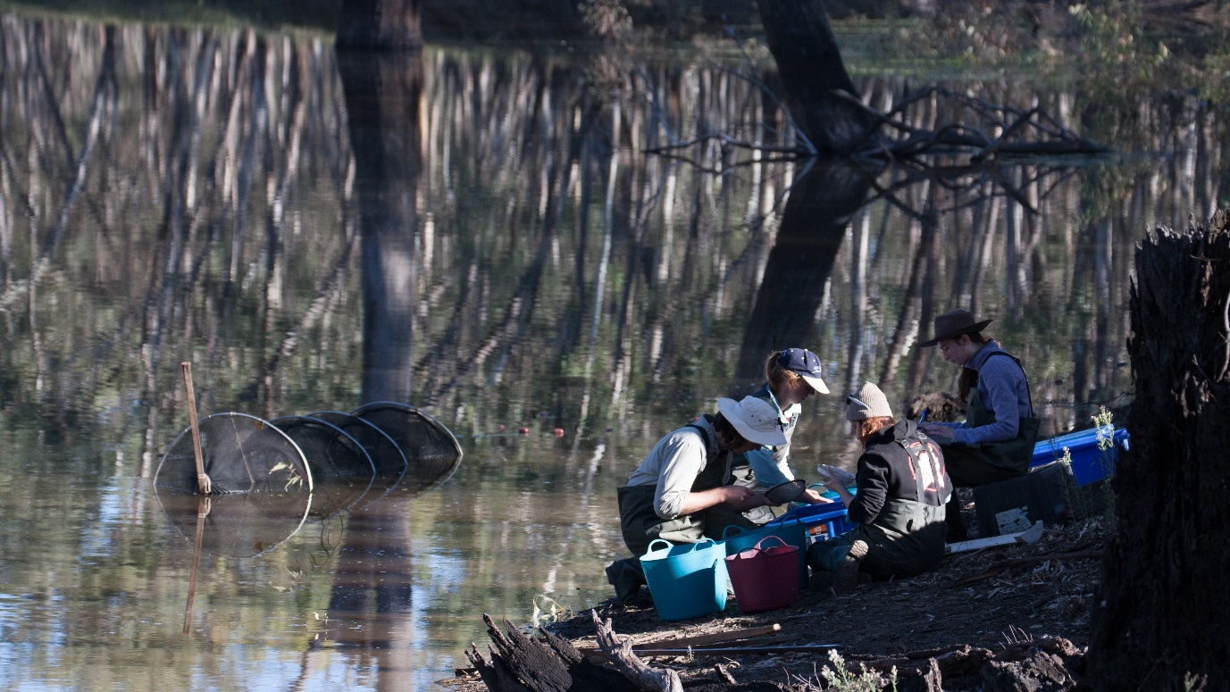

The team processing the morning’s catch at Coonancoocabil Lagoon, March 2021. Left to right: Paul Tomczyk, Anna Turner, Sarah Talbot and Eva Moore.

Bourke, G., Turner, J.M., Michael, D. and Wassens, S. (2021). Murrumbidgee Monitoring, Evaluation and Research Program, ecological responses to Commonwealth environmental water, Field report. Number 8, June 2021. Charles Sturt University, Institute for Land, Water and Society. Prepared for the Commonwealth Environmental Water Office.

**Further information:**

Dr Skye Wassens

School of Agricultural, Environmental and Veterinary Sciences and Institute for Land, Water and Society

Charles Sturt University, PO Box 789, Albury NSW 2640

Ph: +61 2 6051 9513 Email: [swassens@csu.edu.au](mailto:swassens@csu.edu.au)

**Copyright**© Copyright Commonwealth of Australia, 2021



Murrumbidgee Monitoring Evaluation and Research Program, ecological responses to Commonwealth environmental water Field report. Number 8, June 2021 is licensed by the Commonwealth of Australia for use under a Creative Commons By Attribution 3.0 Australia licence with the exception of the Coat of Arms of the Commonwealth of Australia, the logo of the agency responsible for publishing the report, content supplied by third parties, and any images depicting people. For licence conditions see: <http://creativecommons.org/licenses/by/3.0/au/>

**Disclaimer**

The views and opinions expressed in this publication are those of the authors and do not necessarily reflect those of the Australian Government or the Minister for the Environment. While reasonable efforts have been made to ensure that the contents of this publication are factually correct, the Commonwealth does not accept responsibility for the accuracy or completeness of the contents, and shall not be liable for any loss or damage that may be occasioned directly or indirectly through the use of, or reliance on, the contents of this publication.

Ecological responses to Commonwealth environmental water in the Murrumbidgee system as of 30 June 2021

This report describes preliminary outcomes of Commonwealth environmental watering actions at selected wetlands in the mid and lower Murrumbidgee. These surveys are conducted four times a year as part of the Murrumbidgee Monitoring, Evaluation and Research Program (MER) and include assessment of ecological outcomes in the Murrumbidgee River and connected wetlands through the mid-Murrumbidgee and Lowbidgee floodplain wetlands as outlined in [the Murrumbidgee Monitoring and Evaluation Plan.](http://www.environment.gov.au/water/cewo/publications/murrumbidgee-me-plan)

Routine monitoring of birds, fish, frogs, tadpoles, water quality and vegetation diversity was undertaken at the 12 MER wetland monitoring sites in the Murrumbidgee Selected Area over four monitoring trips during the 2020-21 fieldwork season. This report summarises the activities and outcomes of trips conducted in September 2020, November 2020, January 2021 and March 2021. Most of the monitoring sites in Redbank and Gayini Nimmie-Caira held water throughout the monitoring season, except Mercedes Swamp (Redbank), where the main swamp held insufficient water for nets over most of the season. In the mid-Murrumbidgee, Yarradda and Gooragool Lagoons retained sufficient water for sampling throughout the season. As in previous years, Mantangery Lagoon was monitored in place of McKenna’s Lagoon, which remained dry. Sunshower Lagoon held insufficient water to set nets in September and November. Additional monitoring of fish, frogs and birds at Coonancoocabil Lagoon was conducted, which enabled us to obtain information on the size range and density of carp and the occurrence of native fish species in a residual pool of water. Vegetation surveys and water bird surveys were completed at all wetlands in conjunction with netting and other monitoring activities.

**Watering update**

The Murrumbidgee catchment received above average annual rainfall during the 2020-21 year resulting in moderate to high water availability. Watering actions took place from late winter 2020 until winter 2021, commencing in the Lowbidgee region in July 2020, with water delivery targeting Gayini Nimmie-Caira and Yanga National Park wetlands. In the mid-Murrumbidgee, Mantangery, Gooragool, Yarradda and Sunshower Lagoons all received pumped water deliveries from December 2020 through to May 2021.

- Mid-Murrumbidgee: Three of the four core monitoring sites were wet. Mantangery Lagoon was surveyed in place of McKenna’s Lagoon. The water level at the usual monitoring site at Gooragool Lagoon was too low to set nets, therefore monitoring was conducted closer to the connecting channel throughout the monitoring season. Sunshower Lagoon held insufficient water to set nets in September and November, however small inflows were sufficient for small fyke nets In January and March.

- Gayini Nimmie-Caira: Nap Nap Swamp, Telephone Creek and Eulimbah Swamp were high to full throughout the monitoring season. Avalon Dam progressively spilled out into the surrounding lagoon, resulting in almost 100% inundation of the main horseshoe lagoon by late January.

- Redbank (Yanga NP): Water levels at Waugorah Lagoon were moderate to high, and both Two Bridges Swamp and Piggery Lake were full throughout the monitoring period. Mercedes Swamp was low to dry in the main swamp although water was spilling along the side channels from the 1AS regulator. The water level was sufficient to deploy small fyke nets in November.

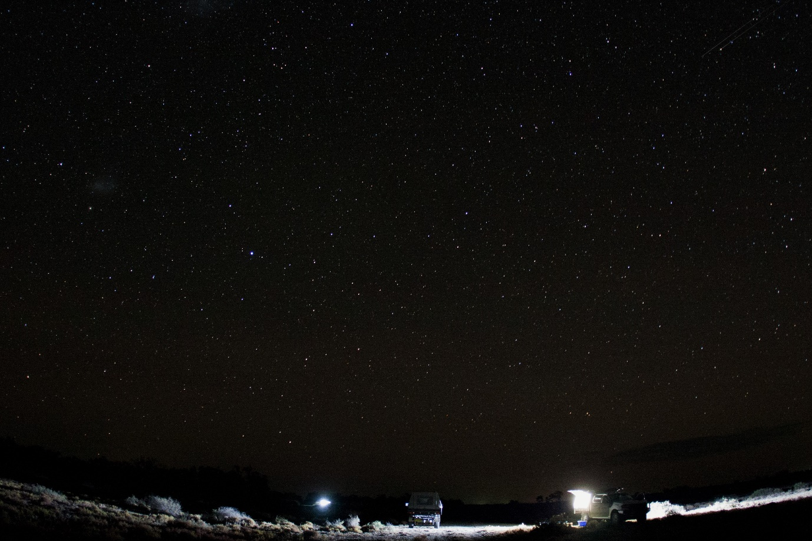

Spotlighting for frogs at Nap Nap Swamp, March 2021

**Key outcomes**

The restoration of annual watering at key wetlands within the mid and lower Murrumbidgee floodplain has contributed to the recovery of vegetation communities as well as increasing abundance and occurrence of southern bell frogs.

Frogs and tadpoles: Frogs were heard calling at most wetland sites across the three regions over the monitoring period. Calling activity continued into March at many sites, particularly those that had recently received top-up environmental water, including Piggery Lake and Two Bridges Swamp (Redbank), and Eulimbah Swamp, Nap Nap Swamp and Telephone Creek (Gayini Nimmie-Caira). Call diversity was particularly high across Redbank and Gayini Nimmie-Caira, with calling activity recorded in all six frog species at multiple wetlands (Nap Nap Swamp, Telephone Creek, Piggery Lake, Two Bridges Swamp, Mercedes Swamp).

Southern bell frogs (*Litoria raniformis*, EPBC Act listed as Vulnerable) were detected at multiple wetlands in Redbank and Gayini Nimmie-Caira. Most individuals were observed in Gayini Nimmie Caiia (313), primarily at Nap Nap Swamp (231 individuals). Small numbers were also observed at Two Bridges Swamp and Mercedes Swamp in Redbank. Southern bell frog numbers have now reached pre-Millennium drought levels with activity recorded at 8 wetlands.

Tadpoles were recorded in record numbers during the 2020-21 monitoring season, including 1986 *Limnodynastes* spp tadpoles at Two Bridges Swamp and 433 Peron’s tree frog tadpoles at Mercedes Swamp in November. Tadpoles were detected at nine wetlands across all three monitoring zones, with tadpole diversity highest at Piggery Lake where all five species were recorded (cannot distinguish between the two *Limnodynastes* species in the field). Southern bell frog tadpoles were recorded at six wetlands, including all four Gayini Nimmie-Caira sites, and two Redbank sites (Piggery Lake and Two Bridges).

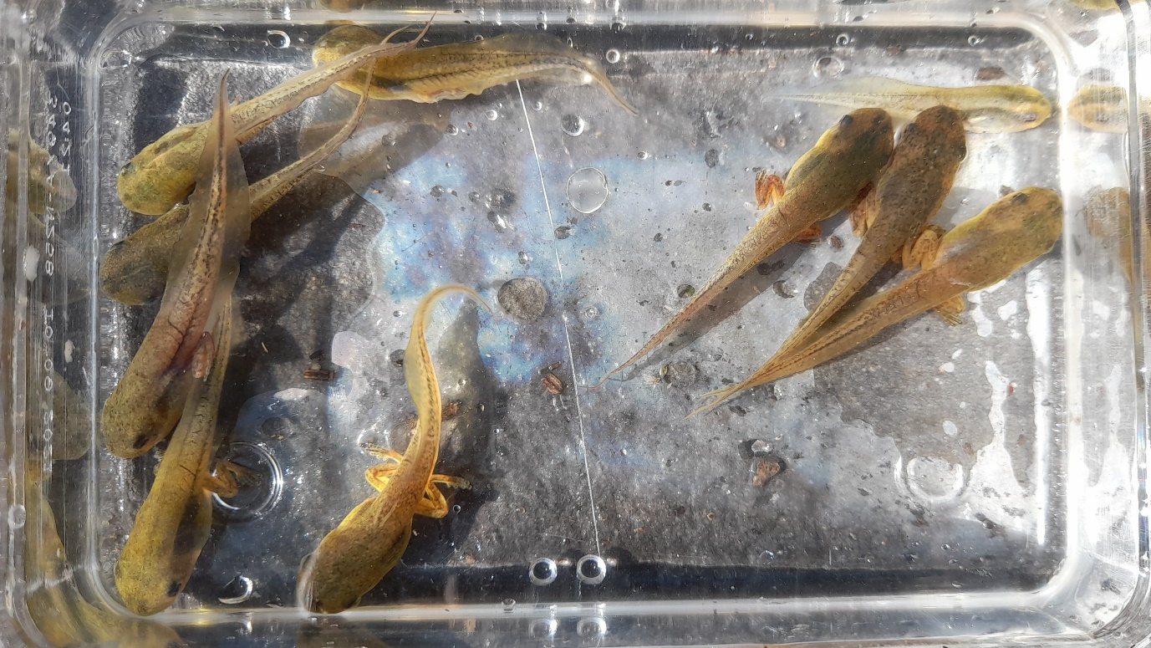

Peron’s tree frog tadpoles at Yarradda West Lagoon, March 2021.

Turtles: Turtle numbers and species diversity were high across all monitoring zones during the 2020-21 season. Eastern long-necked turtles were the most commonly recorded species. The highest numbers were found at Nap Nap Swamp in Gayini Nimmie-Caira (18 individuals) and Two Bridges Swamp in Redbank (28 individuals), including a single juvenile captured at Mercedes Swamp in November 2020. Broad-shelled turtles were recorded in high numbers at Waugorah Lagoon (12), and were also detected at Two Bridges Swamp (1) and Yarradda Lagoon (1). Murray River short-necked turtles were recorded in low numbers at multiple wetlands in Redbank (including a single juvenile recorded at Two Bridges Swamp) and the mid-Murrumbidgee, with the highest number recorded at Gooragool (5). Notably, this is the first time this species has been detected at Gooragool since the 2015-16 water year. All three species of turtle were recorded in moderate numbers at Mantangery and Coonancoocabil Lagoons in the mid-Murrumbidgee.

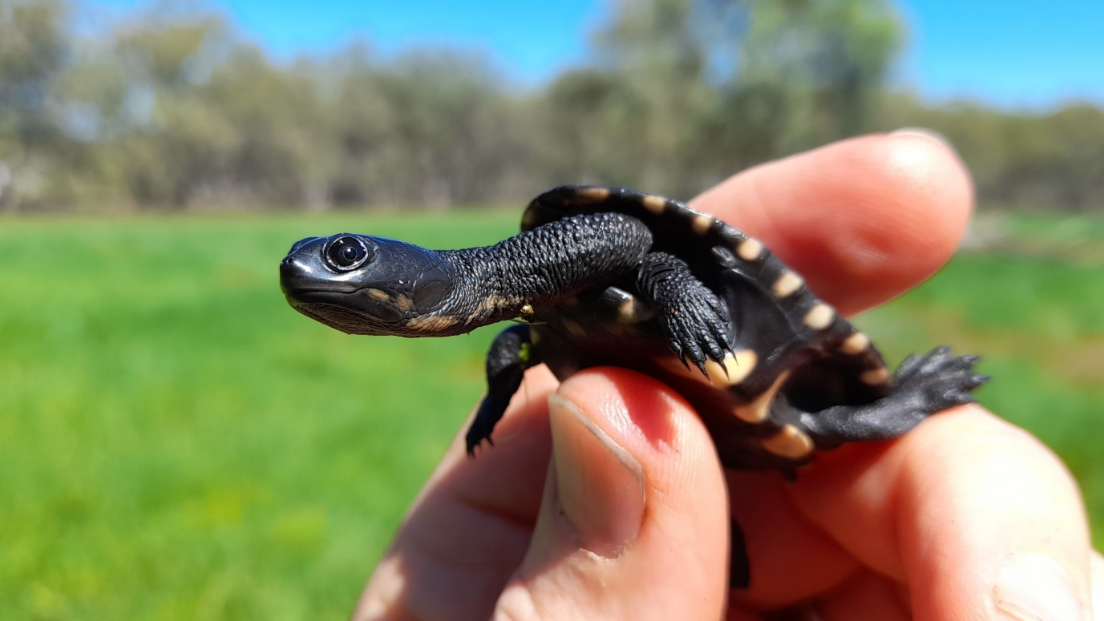

Juvenile eastern long-necked turtle in Mercedes Swamp, November 2020.

Wetland fish: Notable fish captures during the 2020-21 monitoring season included two Murray cod, a 63 cm adult at Waugorah Lagoon (Redbank), and a 21cm juvenile at Yarradda Lagoon in the mid Murrumbidgee. A total of seven un-specked hardyhead were captured in November and January at Coonancoocabil Lagoon (mid-Murrumbidgee).

Native fish captures were dominated by carp gudgeon and this was the most abundant species recorded in over half of the monitored wetlands. Fish diversity was highest (5 species) at Waugorah Lagoon, Avalon Dam and Yarradda Lagoon. Small native fish, including rainbowfish, flathead gudgeon and Australian smelt, were regularly recorded across all three monitoring zones. Exotic fish were dominated by juvenile carp, which were recorded in high numbers at Two Bridges, Piggery Lake, Eulimbah Swamp and Nap Nap Swamp. Weather loach were recorded at most wetlands, with highest numbers at Avalon Dam (436), and is becoming increasingly a common component of the fish captures in the system. Carp have not been detected at Sunshower Lagoon since screens were installed.

|  |  |
| --- | --- |
|  |  |

Murray cod detections at Waugorah Lagoon and Yarradda Lagoon (pictured – juvenile) were highlights of fyke-netting over the 2020-21 monitoring season.

Wetland birds: The 2020-21season was dominated by the spectacular colonial waterbird breeding event at Eulimbah Swamp where over 18,000 pairs of straw-necked and glossy ibis, among other species, arrived at the wetland to nest in the lignum. Additional highlights included the detection of Australasian bitterns which were heard calling at Eulimbah Swamp, Two Bridges and Telephone Creek. Colonial waterbird breeding activity was recorded at multiple wetlands from November including Piggery Lake, Two Bridges Swamp, Telephone Creek and Gooragool. Nesting species recorded included darters, great cormorants, yellow-billed spoonbills, white-necked herons and nankeen night herons at Telephone Creek. Little pied, little black and great black cormorants, along with Australasian darters were recorded nesting at Piggery Lake, which also supported black swans and their cygnets, and great crested grebes. In the mid-Murrumbidgee, two little pied cormorant chicks were sighted at the small Gooragool colony, and two small colonies of little pied cormorants established at Yarradda Lagoon following a top up flow.

Royal spoonbills were observed at multiple wetlands including Gooragool Lagoon, Mercedes Swamp, Eulimbah Swamp and Avalon Dam. In addition, a flock of 30 plumed whistling ducks, a small flock of unidentified sandpipers and glossy ibis were seen near Suicide Swamp in Gayini Nimmie-Caira. Piggery Lake supported the largest number of overall bird species, including one blue-billed duck, several dozen great crested grebes, hardhead ducks, glossy ibis, intermediate egrets and black swans.

Little pied cormorant nest at Gooragool Lagoon, November 2020.

Wetland vegetation: Wetland vegetation responded well to winter rainfall and environmental water delivery. At Redbank spike rush meadows emerged at Two Bridges Swamp and numerous aquatic vegetation species were recorded at Piggery Lake in September, including nardoo, water primrose, pondweed and water ribbons. A new species of terrestrial plant was recorded at McKennas Lagoon in the mid-Murrumbidgee in response to above average rainfall - Australian hollyhock, with dense stands emerging around the eastern bank. Overall, inundation depth and duration has been longer in 2020-21 compared to previous years, and this is reflected in the increased abundance of deep-water tolerant species including common watermilfoil and red watermilfoil. At Gayini Nimmie-Caira the inundation of wetlands bordering Telephone Creek triggered emergence of common spike rush and water primrose, and beds of common and red water milfoil, water primrose and nardoo established at Eulimbah Swamp. Avalon Swamp received a substantial fill which inundated the entire wetland and triggered new lignum growth and flowering of black box and the establishment of nardoo and water primrose. In the mid-Murrumbidgee, areas of spiny mudgrass and slender knotweed established at Yarradda Lagoon as it filled during the monitoring season.

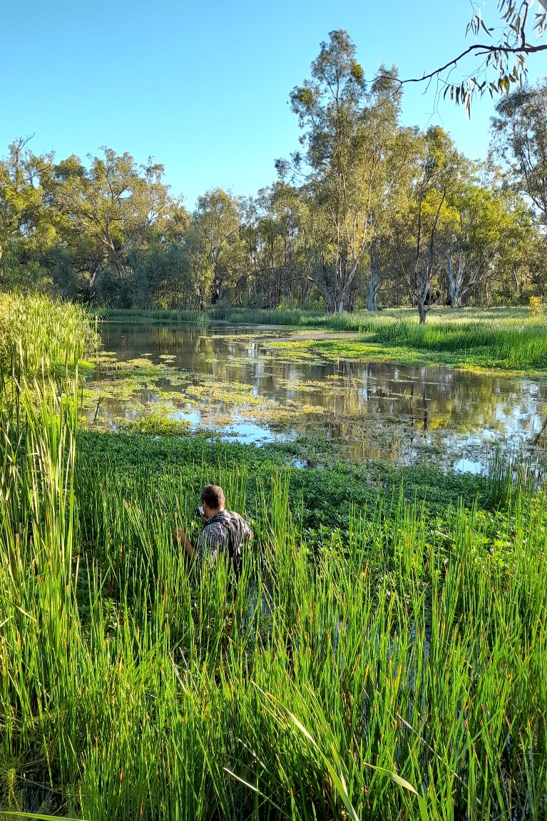

|  |  |
| --- | --- |
|  | Spike rush meadows emerged at Two Bridges Swamp, November 2020 |

The next monitoring trip is scheduled for October 2021.