|  |  |  |
| --- | --- | --- |
|  |  |  |

Murrumbidgee Monitoring, Evaluation and Research Program, ecological responses to Commonwealth environmental water, Field Report. November 2021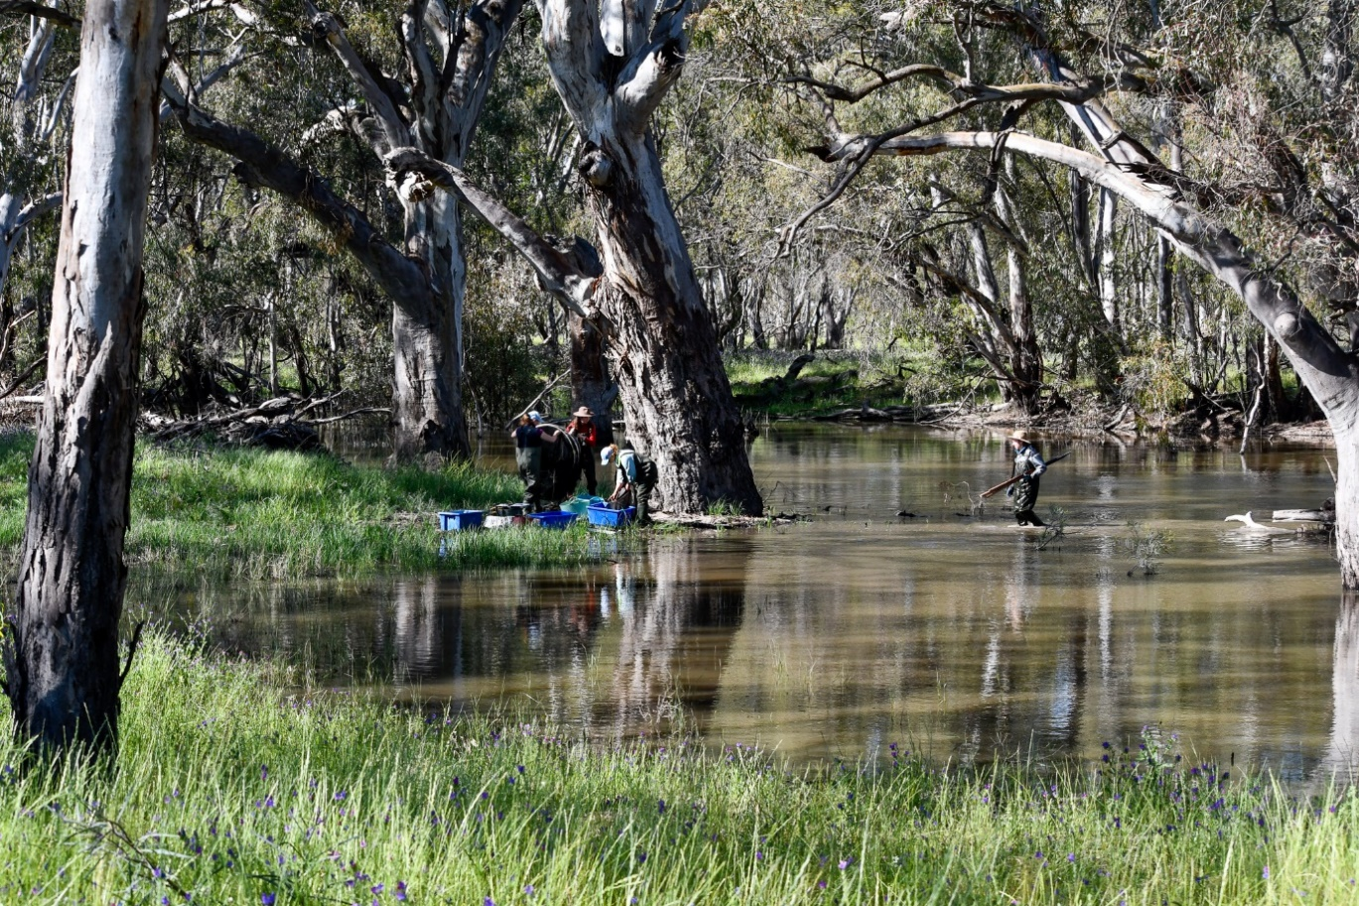

The team processing the morning’s catch at on the Yanco Creek, Bundure, October 2021. Left to right: Emmalie Sanders, Eva Moore, Anna Turner and Lachlan Spalding. Photo credit: Andrea Mitchell.

Turner, A.T., Moore, E., Michael, D. and Wassens, S. (2021). Murrumbidgee Monitoring, Evaluation and Research Program, ecological responses to Commonwealth environmental water, Field report. Number 9, November 2021. Charles Sturt University, Institute for Land, Water and Society. Prepared for the Commonwealth Environmental Water Office.

**Further information:**

Dr Skye Wassens

School of Environmental Sciences, and Institute for Land, Water and Society

Charles Sturt University, PO Box 789, Albury NSW 2640

Ph: +61 2 6051 9513 Email: [swassens@csu.edu.au](mailto:swassens@csu.edu.au)

**Copyright**© Copyright Commonwealth of Australia, 2020



Murrumbidgee Monitoring Evaluation and Research Program, ecological responses to Commonwealth environmental water Field report. Number 8, June 2021 is licensed by the Commonwealth of Australia for use under a Creative Commons By Attribution 3.0 Australia licence with the exception of the Coat of Arms of the Commonwealth of Australia, the logo of the agency responsible for publishing the report, content supplied by third parties, and any images depicting people. For licence conditions see: <http://creativecommons.org/licenses/by/3.0/au/>

**Disclaimer**

The views and opinions expressed in this publication are those of the authors and do not necessarily reflect those of the Australian Government or the Minister for the Environment. While reasonable efforts have been made to ensure that the contents of this publication are factually correct, the Commonwealth does not accept responsibility for the accuracy or completeness of the contents, and shall not be liable for any loss or damage that may be occasioned directly or indirectly through the use of, or reliance on, the contents of this publication.

Ecological responses to Commonwealth environmental water in the Murrumbidgee system as of 18 November 2021

This report describes preliminary outcomes of Commonwealth environmental watering actions at selected wetlands in the mid and lower Murrumbidgee. These surveys are conducted four times a year as part of the Murrumbidgee Monitoring, Evaluation and Research Program (MER) and include assessment of ecological outcomes in the Murrumbidgee River and connected wetlands through the mid-Murrumbidgee and Lowbidgee floodplain wetlands as outlined in [the Murrumbidgee Monitoring and Evaluation Plan.](http://www.environment.gov.au/water/cewo/publications/murrumbidgee-me-plan) For the first time we include results of monitoring in the Yanco Creek system in which surveys are being conducted during the 2021/22 water year in alignment with the ongoing MER surveys of the mid and lower Murrumbidgee.

Due to high water levels, Covid19 restrictions and wet weather conditions routine monitoring for the 2021/22 field-season was delayed until October/November. As a result, surveys for the entire season will be conducted one month later than in recent years with the following surveys planned for December, February and April. In October and early November routine monitoring of birds, fish, frogs, tadpoles, water quality and vegetation diversity was undertaken across the four core sites in the mid Murrumbidgee (Yarrada, Sunshower, Gooragool and McKenna’s Lagoon) and five sites in the lower Murrumbidgee (Waugorah, Banim (Avalon) Swamp, Bala (Eulimbah) Swamp, Bayil (Telephone) Creek and Nap Nap). Access to Piggery, Two bridges and Mercedes was not possible during this survey occasion due to high water levels preventing access. New surveys sites were established in the Yanco Creek system including four wetland sites with paired riverine sites for which survey methods follow those of the mid and lower Murrumbidgee (Rhyola, Wanganella, Bundure and Broome). Bat recorders have been deployed at an additional ten sites in the Yanco Creek system along with camera traps targeting rakali. Platypus surveys will be conducted in early 2022.

This report summarises the activities and outcomes of monitoring in the mid and lower Murrumbidgee as well as the Yanco reek system conducted in October/November. Vegetation surveys and water bird surveys were completed at all wetlands in conjunction with netting and other monitoring activities.

**Watering update**

The Murrumbidgee catchment received above average rainfall in the lead up to the 2021-22 monitoring season. This resulted in very high water levels in all of the mid and lower Murrumbidgee monitoring sites, in some cases preventing access. Despite delaying the monitoring trips, access was still not possible to Piggery, Two Bridges and Mercedes during the October/November surveys.

- Mid-Murrumbidgee: The four core monitoring sites were wet. McKenna’s Lagoon was surveyed for the first time since 2016. Large and small fyke nets were set at all sites due to high water levels. At Gooragool Lagoon monitoring was conducted closer to the connecting channel consistent with the 2020/21 field season.

- Gayini Nimmie-Caira: Large and small fyke nets were set at all sites. At Banim swamp the dam was full and overflowing into surrounding wetland. Bala Swamp was full with water flowing out into Fairfax Swamp (Suicide Bank). Bayil Creek was full and overflowing into surrounding lignum/blackbox woodland. Lignum swamp surrounding the main Nap Nap wetland were full but the wetland itself retained residual water at 60cm deep and as a result nets were set on western side near the regulator.

- Redbank (Yanga NP): Water levels at Waugorah Lagoon were very high; large and small fyke nets were set. Two Bridges Swamp, Piggery Lake and Mercedes were inaccessible due to high water levels.

-Yanco Creek system (YCS): Wetlands were paired with near-by creek sites in the YCS. Rhyola wetland was dry however large and small nets were still set in the neighbouring Billabong Creek. At Wanganella, nets were set in the southern part of the wetland east of the Cobb Highway and in the adjacent Forest Creek. Riverbanks were too steep and deep to set nets in the Billabong Creek at Wanganella. At Broom and Bundure, large and small fyke nets were set in the wetland and nearby in Yanco Creek.

Large fyke nets being set at Wanganella swamp by Lachlan Spalding, October 2021. Photo credit: Andrea Mitchell.

Table 1- Site Summary

|  |  |  |  |
| --- | --- | --- | --- |
|  | | Status | Notes |
| Mid Murrumbidgee | | | |
| McKennas | | Full | Small catch, mostly carp gudgeon and smelt with <5 carp in all nets. |
| Gooragool | | Full | Golden perch (114mm) and one bony bream (279mm), carp gudgeon, smelt and shrimp. Large catch of exotic species with >20 carp in each large net, gambusia, goldfish and weather loach. |
| Sunshower | | Full | Moderate catch of carp gudgeon, shrimp gambusia, < 5 carp (60-90mm) across all nets, and oriental weather loach. |
| Yarradda | | Full | One golden perch (138mm), shrimp yabbies, <5 carp, and oriental Weather loach. |
| Lower Murrumbidgee | | | |
| Nap Nap | | Full | Large number small smelt (20-30mm), carp gudgeon and one Murray-Darling rainbow fish. Carp, oriental weather loach and gambusia. Large catch of yabbies (>200). Southern bell frog tadpoles, giant banjo frog tadpoles and Limnodynastes sp. Tadpoles in nets. Small numbers of southern bell frog calling and small number of adult frogs observed. |
| Banim  (Avalon) Swamp | | Dam full and overflowing into wetland which is ½ full | Large number of southern bell frog tadpoles (>140) in nets. Carp gudgeon, flathead gudgeon, smelt and one Murray-Darling rainbow fish. Massive catch of small carp (>19,000) in one large net, net was set in the in-let channel facing into the dam. |
| Bala (Eulimbah) Swamp | | Full. Channel and lignum wet | Three Australasian bittern calling. Large number southern bell frog calling and some detected in surveys. Large number small smelt (<30mm) and carp gudgeon. Carp, gambusia, oriental weather loach, yabbies, shrimp and goldfish were caught. One adult southern bell frog and southern bell frog and *Limnodynastes sp.* Tadpoles caught. |
| Bayil (Telephone)  Creek | | Full | Two eastern -longnecked turtles, smelt, carp gudgeon, shrimp, yabbies, carp, gambusia and Oriental weather loach. Southern bell frogs calling. |
| Waugorah | | Full/ overflowing into second wetland | Southern bell frog tadpoles caught in net for the first time at this site. Large numbers of carp gudgeon, some smelt, one Murray-Darling rainbow fish, shrimp, yabbies, carp, gambusia, oriental weather loach and goldfish. One eastern long-necked turtle. |
| Piggery | | Full | Not surveyed, inaccessible due to high water levels |
| Two Bridges | | Full | Not surveyed, inaccessible due to high water levels |
| Mercedes | | Full | Not surveyed, inaccessible due to high water levels |
| Yanco Creek system | | | |
| Rhyola | Wetland | Dry | Not surveyed |
|  | Paired | Full | Two Murray cod (500 and 535mm in size), one Murray-Darling rainbow fish, carp gudgeon, shrimp and one large carp. |
| Wanganella | Wetland | ¾ | One Murray-Darling rainbow fish, small catch of smelt, carp gudgeon and shrimp and oriental weather loach. |
|  | Paired | Low 60cm | Nets set on junction in Forest creek near junction with Billabong creek. One golden perch, carp gudgeon, carp and shrimp caught. |
| Broome | Wetland | ¾ | One Murray-Darling rainbow fish, carp gudgeon, yabbies, carp, oriental weather loach and shrimp. One eastern long-necked turtle. Southern bell frogs not detected despite being detected in January 2020 surveys. |
|  | Paired | Full | Nets set in Yanco creek, downstream of wetland. Carp gudgeon, yabbies, shrimp, carp, oriental weather loach and one broad-shelled turtle. |
| Bundure | Wetland | Full | Carp gudgeon, yabbies, carp, oriental weather loach and shrimp caught. One eastern long-necked turtle caught. |
|  | Paired | Full | Nets set in Yanco creek, six Murray-Darling rainbow fish caught along with carp gudgeon, shrimp, yabbies, carp, and gambusia. |
| China | | Full | Depth loggers and bat call recorders deployed at sites early August 2021. Data downloaded during September and October. Call recorders will be downloaded and redeployed again in January.  Rakali monitoring ongoing across sites. |
| Quiamong | | ½ |
| Hartwood | | Full |
| Wangamong Creek | | ½ |
| Mundoora | | Full |
| Cocketgedong | | Full |
| The Yanco | | Full |
| Coonong | | Full |
| Sheepwash | | Full |
| New Era | | Full |

**Key outcomes**

Routine wetland monitoring activities targeting vegetation, water quality, fish, frog and tadpoles were completed at four sites in the mid Murrumbidgee, five sites in the lower Murrumbidgee and eight sites in the Yanco creek system. Water levels were high across all sites due to above average rainfall in 2021. Piggery, Mercedes and Two Bridges were not accessible during this survey period due to high water levels. Monitoring surveys were conducted in the Yanco creek system for the first time.

Wetland fish:

Total numbers of fish recorded were generally low as expected in the cooler months. Banim Swamp however had a massive catch of small carp. Native fish captures were dominated by carp gudgeon and Australian smelt. Small native fish, including Murray-Darling rainbow fish, flathead gudgeon and Australian smelt, were regularly recorded across all mid and lower Murrumbidgee sites. Only one bony bream was detected during this survey period (Gooragool). Exotic fish were dominated by juvenile carp, with gambusia and oriental weather loach recorded at most wetlands. Carp were detected at Sunshower Lagoon despite no detection in 2020/21 due to installation of carp screen.

In the Yanco Creek system (YCS), fish numbers were generally low. One golden perch was caught in the creek at Wanganella and two Murray cod caught in the creek at Rhyola. Murray-Darling rainbow fish were caught in both wetland and riverine sites in the YCS. No gambusia were caught however carp and oriental weather loach were.

Frogs and tadpoles:

In the mid and lower Murrumbidgee, frogs were heard calling at most wetland sites across the survey regions in October/November. All six frog species were recorded calling across the sites, however diversity varied between sites with southern bell frogs (*Litoria raniformis*, EPBC Act listed as Vulnerable) heard at Nap Nap, Bayil Creek, Bala Swamp and Banim Swamp in Gayini Nimmie-Caira. Most notable is the detection of southern bell frog tadpoles at Waugorah, the first time this has been reported.

Large numbers of southern bell frog tadpoles (>140) were caught in fyke nets at Banim Swamp. Giant banjo frog, Peron’s tree frog and Limnodynastes sp. tadpoles were also caught across multiple sites in the lower Murrumbidgee. In the Yanco Creek system only Limnodynastes sp. tadpoles were captured in nets.

In the Yanco Creek system frog species detected included Peron’s tree frog, giant banjo frog, spotted marsh frog and eastern sign-bearing froglet. No southern bell frogs were detected despite being recorded during targeted surveys in January 2020. Landholders also report not having heard them yet this season.

Peron’s tree frog at Wanganella, October 2021. Photo credit: A. Turner

Turtles: Small numbers of turtles were recorded across sites in the mid and Lower Murrumbidgee and the YCS. Eastern long-necked turtles were the most commonly recorded species. Eastern long-necked turtles are recorded at McKennas, Gooragool, Waugorah, Wanganella, Broome and Bundure. Gooragool was busy with turtles with three Murray River short-necked, two eastern long-necked and one broad-shelled turtle caught in the large nets. Broad shell and Macquarie River turtles were detected in the river site at Rhyola.

Yabbies caught at Nap Nap Swamp, November 2021. Photo credit: A.Turner

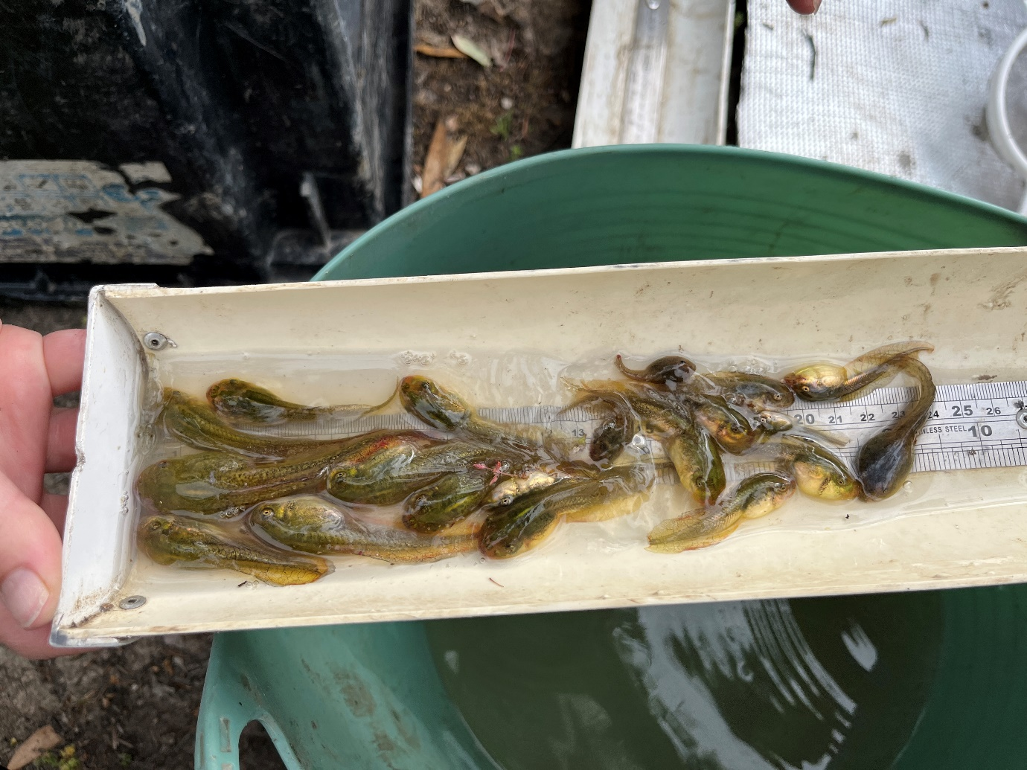

Bucket full of bell frog tadpoles at Banim Swamp, Gayini Nimmie Caira, lower Murrumbidgee, November 2021. Photo credit: A. Turner

|  |  |
| --- | --- |
|  |  |

Murray-Darlin Rainbow fish detected at Waugorah and Banim Swamp in the lower Murrumbidgee and Wanganella, Rhyola, Broome and Bundure in the Yanco creek system, October 2021. Photo credit: A. Turner

Wetland birds:

Highlights include the Australasian bittern heard calling at Bala (n=3) and Bayil creek (n=1).

High waterbird diversity was seen throughout mid and lower Murrumbidgee. Little pied cormorant, intermediate egret, Australian white ibis, dusky moorhen, Pacific black duck, sacred kingfisher, straw-necked Ibis, white-necked heron, white-faced heron, great cormorant, Australian wood duck, Australian pelican, pied cormorant, Eurasian coot, grey teal and royal spoonbill in the mid Murrumbidgee. Additional species observed in the lower Murrumbidgee include whiskered tern, nankeen night herons, native hen and Clamorous reed warblers. A flyover of a total of 54 straw-necked ibis was a highlight at Bala Swamp reflective of the large breeding colony deeper in the lignum wetland.

In the Yanco creek system, waterbird diversity was considerably lower with the most diversity observed at Wanganella swamp. Pink-eared ducks, black swans, black winged stilt, red-kneed dotterels and red necked avocet were the highlight. At Bundure wetland a cacophony of Clamorous reed warblers was heard.

Black swans at Wanganella, October 2021. Photo credit: A. Mitchell

Wetland vegetation:

Very high-water level occurred in September 2021 with 11 of the 12 monitoring sites receiving a complete fill beyond the tree line this is the first complete fill at the majority if sites since 2016. Continued unregulated overbank flows in Yanga National Park mean that we have not been able to access Mercedes, Two Bridges or Piggery.

|  |  |
| --- | --- |
|  | Wagourah T3 Q10  Water levels were at their highest since 2016 and all three transects have been inundated with water levels declining slight from the peak.  Aquatic cover was generally low due to high water levels, but water ribbon, Elatine, and water primrose were recorded on transect 1. |
|  | Bayil T3 Q1  Water levels were at their highest since 2016 and all three transects have been inundated with water levels declining slightly from the peak. Transect three was very diverse with red water milfoil, swamp daisy, nardoo, common spike rush and old man weed the most commonly recorded species |
|  | Bala T2 Q1  Bala is very deep and water levels have been stable over spring. There is high cover of common water milfoil and curse water milfoil. Cumbungi is recovering in cover along the margins and is now similar to 2000 levels |
|  | Banim T2 Q10  Banim was filling and approximately half full with water reaching 40 scm at transect 2 while transect 3 was still dry. There was high cover of red water milfoil, nardoo, azolla and water primrose. |
|  | Nap Nap T2 Q1  Water levels were low in the main swam although soil was still damp along the majority of the transects. Common spike rush, small spike rush, nardoo, common water milfoil and azolla were all common. |
|  | Mckenna T2 Q20  All transects had been completely inundated in spring and water levels are declining slightly. Cover of aquatic species was low, but spiny mudgrass was recorded along transect 2 and areas of common spike rush were also noted. |
|  | Yarradda T2 Q20  All transects had been completely inundated in spring and water levels are declining slightly. The percentage cover of tall spike rush continues to increase. Spiny mud grass was also abundant. |
|  | Gooragool T1 Q1  All transects had been completely inundated in spring and water levels are declining with approximately ½ of the transect length inundated. Diversity was low, common spike rush was the most common species |
|  | Sunshower T2 Q1 All transects had been completely inundated in spring and water levels are declining with approximately 3/4 of the transect length inundated. Common spike rush, small spike rush spiny mudgrass and old man weed were common. there was a very high diversity of annual native forbs higher in the tree line |

The next monitoring trip is scheduled for December 2021.