**Why do we still need water for the environment in wet times?**

There are several reasons for this. Before river regulation, water would drain from the top of the catchment, and water levels would fall slowly downstream, which was vital for some species like fish and waterbirds to complete their breeding cycles. Today, when the weather begins to warm, we take water out of rivers downstream to provide water to crops and other consumptive uses. So the downstream parts of river systems dry down much faster, disrupting breeding cycles for many animals and plants even in wet years.

We use water for the environment to either build on unregulated flows if the job hasn’t quite been done, to target high value areas that have missed out, to top wetlands up that may be drying down too quickly, or to get water into an area at a particular time of year to meet natural cues. By doing this we can improve the chance for fish or waterbirds to finish breeding. Wet years allow us to use our water to build some resilience back into the system so that it can survive the next dry period. This gives these important sites, plants and animals the best chance to rebound and flourish in wetter times.

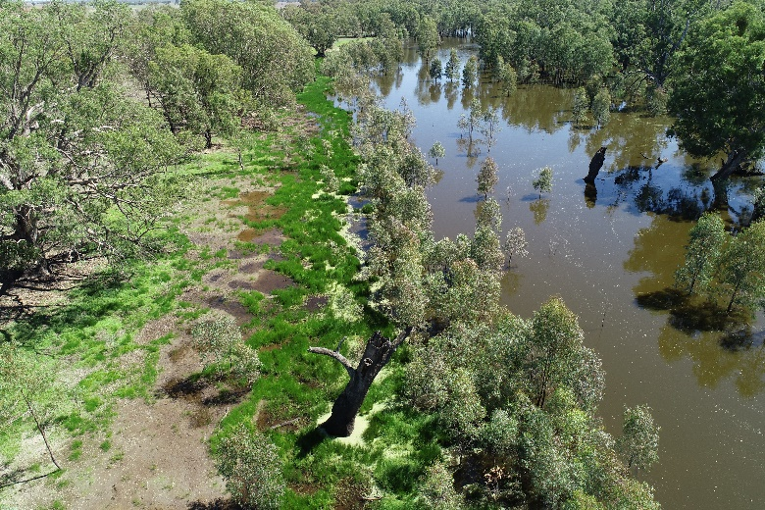

*Sunshower Lagoon. Photo Vince Bucello*

**Objectives** support breeding of birds, fish, frogs, turtles and water bugs

improve health of riverbank, wetland and floodplain native plants

maintain breeding and food habitat for waterbirds

help native fish to move

**Timing** July 2021 – June 2022

**Target areas** Mid-Murrumbidgee -Murray/Murrumbidgee confluence

In wetter times, and as allocations allow, we scale-up the delivery of water for the environment to target ‘whole of system’ objectives such as: broader floodplain watering; reconnecting wetlands to the river to encourage the movement of nutrients and fish; and supporting breeding opportunities for fish, waterbirds, frogs, turtles and many other aquatic dependent plants and animals.

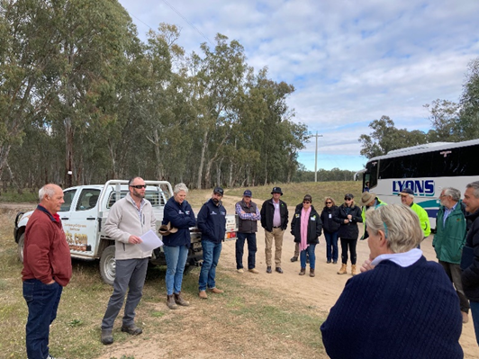

*Environmental Water Managers & Local Government inspecting a site that currently is hard to water*. *Photo Michele Groat*

When we deliver water for the environment in wetter times, we work closely with the community and state agencies to ensure water for the environment is not delivered where it may exacerbate the impacts of naturally flood-affected land.

**Watering actions**

This year, the highly-variable Murray-Darling Basin has lived up to its reputation as ‘a land of droughts and flooding rains’. This is the reason that environmental water managers plan every year for a range of different climatic conditions from extreme dry to very wet.

Our plans have to be dynamic and change to suit the conditions. At this stage we are planning to use our allocations in the following ways:

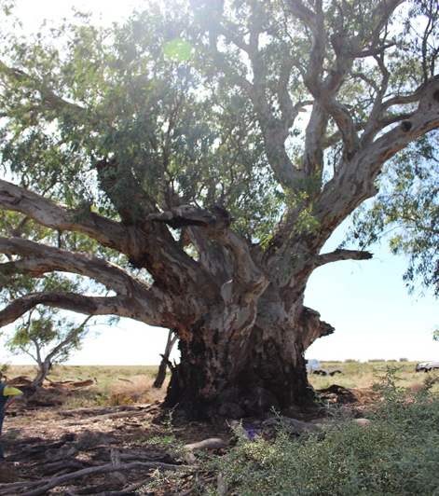

*Red Gum several hundred years old, Yanga National Park. Photo Michele Groat*

* A reconnection flow for the mid-Murrumbidgee wetlands (between Wagga and Carathool) is a high priority for next autumn as the majority of these wetlands are in poor condition due to lack of repeat inundation. These wetlands have been given a good drink by the high unregulated flows (from dam air space releases and high tributary flows) currently in the river but will need a top up in autumn to build their condition and resilience. This will also energise the river system by returning food and nutrients to the river for fish and other water animals.
* Monitoring has found that water for the environment in recent years has successfully supported native fish spawning, growth, and recruitment (particularly golden perch) in Yanga National Park’s floodplain deep creeks and lakes. Later this spring, we are hoping to use our water to connect the floodplain with the river channel and to open up weirs in the Lowbidgee to encourage not only spawning but also the movement of fish and nutrients back into the main river channel – hopefully all the way from Hay to the River Murray.

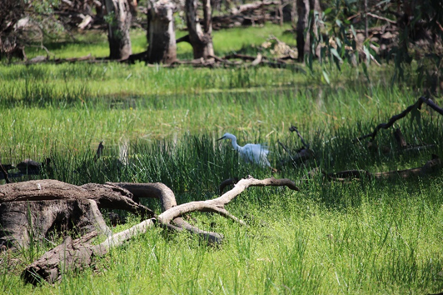

*Greater Egret North Redbank. Photo Michele Groat*

* High rainfall and large areas of wet floodplain present the perfect conditions for colonial waterbird breeding events. If a breeding event commences later this year, water for the environment will again be used to maintain water levels around the waterbirds' nests in the wetlands until early to mid-February by which time chicks will have developed enough to fly. If water levels are not maintained, there is a real risk adult birds will abandon their nests in response to the dropping water levels before their young can fly, and the nests will be at greater risk of predation by feral animals such as foxes, pigs and cats.

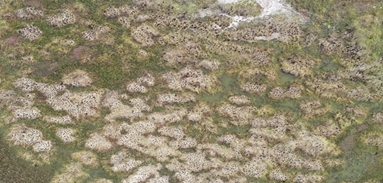

*Bird breeding events like this one in the Lowbidgee need stable water levels. Photo Roxanne Francis*

* The high unregulated flows haven’t reached everywhere important in the Murrumbidgee that needs a drink. For example, the Ramsar listed wetlands of Fivebough and Tuckerbil Swamps will require water for the environment to maintain their ecological character and look after the many important waterbirds and other animals dependent on them.
* Supplementary flows also play an important role in meeting environmental objectives for the Murrumbidgee, particularly due to the nutrients and natural cues they provide for native fish and other native animals to do their thing. Large volumes of Lowbidgee Supplementary water are planned to be directed into the Gayini Nimmie-Caira, Yanga National Park and North Redbank

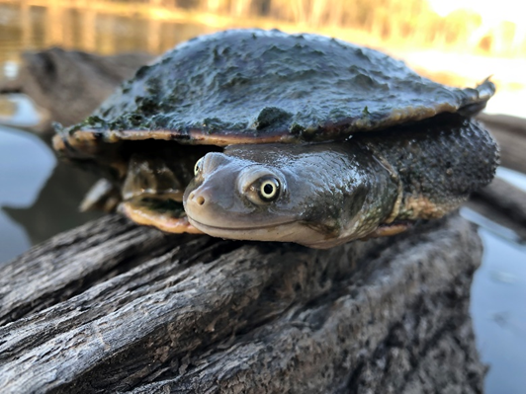

*Chelodina longicollis. Photo Damian Michael, CSU*

* Wet conditions can also increase the risk of low oxygen (or hypoxic) blackwater events occurring in the hotter months. Hypoxic blackwater events happen when large amounts of carbon are washed into the river system; bacteria break this material down using oxygen in the process meaning less is available for other animals in the system. Pre river regulation, the floodplains would have been flushed more regularly and carbon loads would not have been as high. Carbon in the right quantities is good for feeding the smaller critters in the food web which then provides food for larger animals, however, because the wetlands and floodplains are no longer inundated as frequently, carbon loads can easily build-up which can lead to devastating fish deaths when we do get high flows or floods. In such cases we may use our water, to provide refuge for native fish and other aquatic animals where we can.

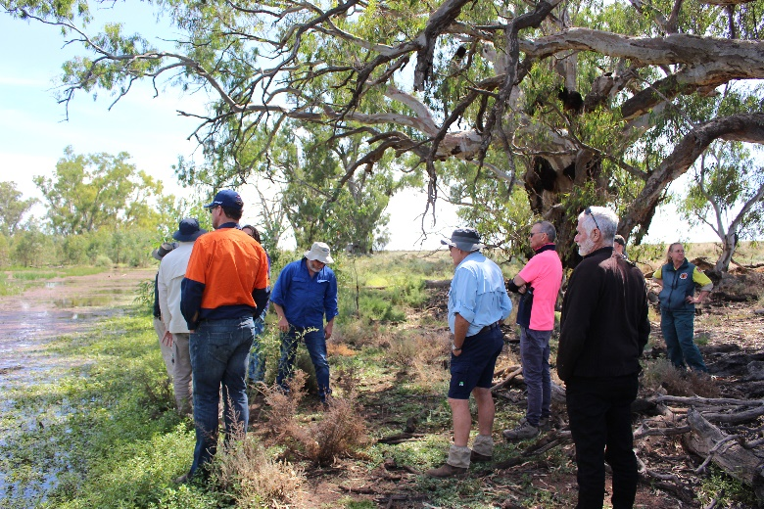

*Murrumbidgee Environmental Water Advisory Group Yanga National Park. Photo Michele Groat*

**Working together**

We work together with local communities, Traditional Owners, landholders, the NSW Department of Planning, Industry and Environment, NSW Fisheries, WaterNSW, and scientists to plan, deliver and monitor water for the environment actions.

More information: [www.environment.gov.au/water/cewo/catchment/murrumbidgee/monitoring](http://www.environment.gov.au/water/cewo/catchment/murrumbidgee/monitoring)

**Local Engagement Officers**

**Erin Lenon** (Wagga Wagga, NSW)  
 0417 965 714

**Email** [erin.lenon@environment.gov.au](mailto:erin.lenon@environment.gov.au)

**Michele Groat** (Griffith, NSW)  
 0427 682 309

**Email** [michele.groat@environment.gov.au](mailto:michele.groat@environment.gov.au)