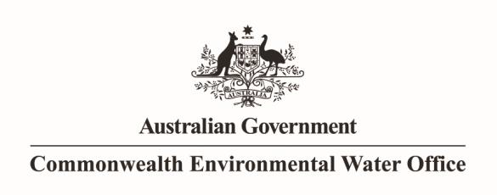Port

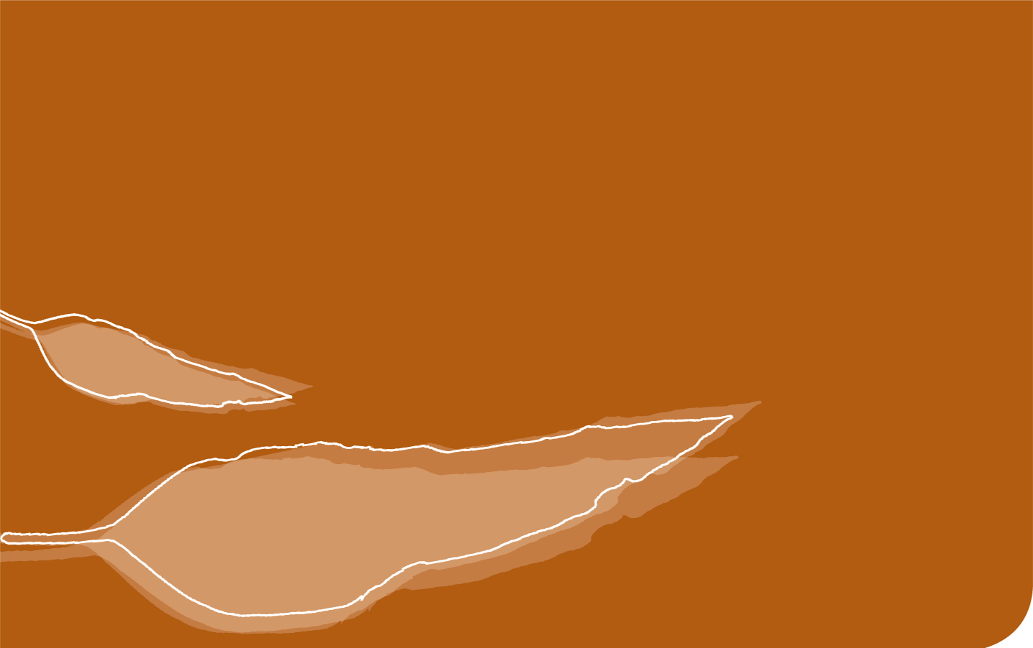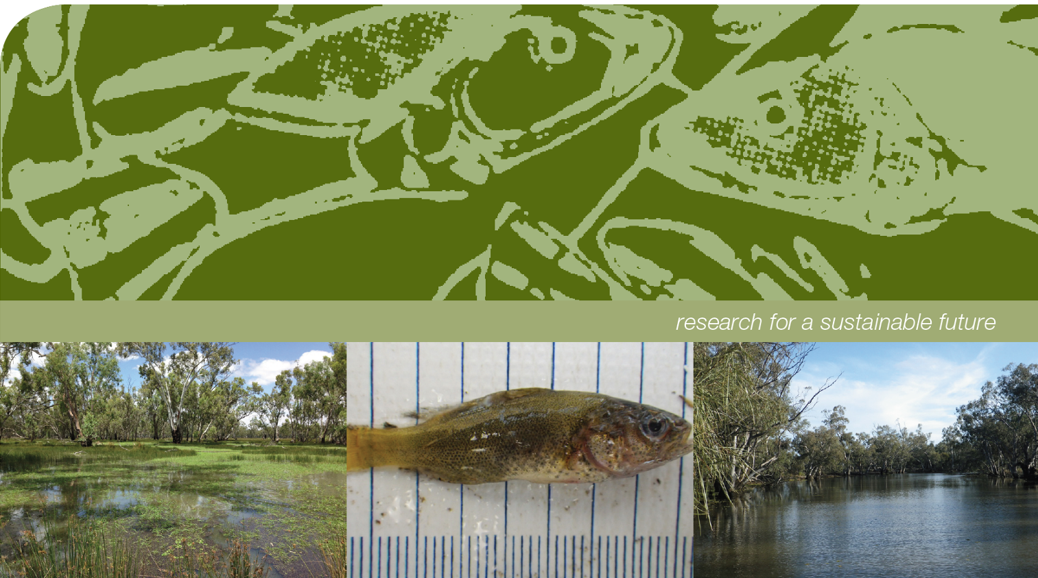

**Commonwealth Environmental Water Office long-term intervention monitoring program Murrumbidgee River system Selected Area**

**Synthesis Report**

**Commonwealth Environmental Water Office long-term intervention monitoring program Murrumbidgee River system Selected Area, 2014-15 Synthesis report. January 2016**

Prepared by: Wassens, S.a, Bino, G.b, Spencer, J.c, Thiem, J.d, Wolfenden, B.a, Jenkins, K.a, Thomas, R.c, Hall, A.a, Ocock, J.c, Lenon, E.f, Kobayashi, Tc, Heath, J. c and Cory, Fe.

|  |  |
| --- | --- |
| S:\Research\Institute for Land, Water & Society\ILWS Templates and Guidelines\InstLandWaterSociety_LOGOS\InstLandWaterSociety Logo RGB.jpg | a Institute for Land, Water and Society. Charles Sturt University, PO Box 789, Albury, NSW 2640 |
| CES.png | b Centre for Ecosystem Science, University of New South Wales, Sydney, NSW, 2052 |
| OEH2Colour | c Water and Wetlands Team, Science Division, NSW Office of Environment and Heritage, PO Box A290, Sydney South, NSW 1232 |
| TI logo colour rgb | d NSW Trade and Investment Narrandera Fisheries Centre, PO Box 182, Narrandera NSW 2700 |
| images.jpg | e Murrumbidgee Local land Services, Level 1, 42-45 Johnston Street (PO Box 5224). Wagga Wagga NSW 2650 |
|  | f Commonwealth Environmental Water Office  PO Box 156, Leeton NSW 2705 | Australia |

This monitoring project was commissioned and funded by Commonwealth Environmental Water Office with additional in-kind support from the NSW Office of Environment and Heritage, Murrumbidgee Local land Services, and Charles Sturt University. We are grateful to private landholders for allowing access to their properties.

**Copyright**© Copyright Commonwealth of Australia, 2016

‘Commonwealth Environmental Water Office long-term intervention monitoring program Murrumbidgee River system Selected Area, 2014-15 Synthesis report ‘ is licensed by the Commonwealth of Australia for use under a Creative Commons By Attribution 3.0 Australia licence with the exception of the Coat of Arms of the Commonwealth of Australia, the logo of the agency responsible for publishing the report, content supplied by third parties, and any images depicting people. For licence conditions see: <http://creativecommons.org/licenses/by/3.0/au/>

This report should be attributed as ‘Commonwealth Environmental Water Office long-term intervention monitoring program Murrumbidgee River system Selected Area, Synthesis report, Commonwealth of Australia 2016’. The Commonwealth of Australia has made all reasonable efforts to identify content supplied by third parties using the following format ‘© Copyright, [name of third party] ’.

**Disclaimer**

The views and opinions expressed in this publication are those of the authors and do not necessarily reflect those of the Australian Government or the Minister for the Environment.

While reasonable efforts have been made to ensure that the contents of this publication are factually correct, the Commonwealth does not accept responsibility for the accuracy or completeness of the contents, and shall not be liable for any loss or damage that may be occasioned directly or indirectly through the use of, or reliance on, the contents of this publication.

# Executive summary

In this report we evaluate the extent to which Commonwealth in combination with State environmental watering actions achieved the outcomes defined in both the [Murrumbidgee Monitoring and Evaluation Plan](https://www.environment.gov.au/system/files/resources/bc51ee00-ac5f-4e65-910d-38f23416823e/files/murrumbidgee-me-plan.pdf) ([Wassens, Jenkins et al. 2014](#_ENREF_41)) and the Commonwealth Environmental Water Office 2014-15 annual watering plan. Evaluations were undertaken with respect to riverine productivity and water quality, river and wetland fish communities, riverine larval fish, riverine and wetland microinvertebrates, wetland vegetation, frogs and tadpoles and waterbirds. A wide range of watering activities, targeting multiple aquatic ecosystems were undertaken using a combination of Commonwealth and State environmental water holdings. Three of these watering actions are evaluated in this report. These relate to environmental watering actions undertaken in the lower Murrumbidgee (Lowbidgee) floodplain and mid-Murrumbidgee wetlands. There were no environmental watering actions undertaken in the Murrumbidgee River, although significant volumes of environmental water in transit to target assets in the Lowbidgee floodplain may have secondary benefits for in-channel environments. Monitoring in the Murrumbidgee River provides a baseline on ecological response undertaken during normal river operations, including the delivery of water for irrigation, consumptive and environmental purposes.

Managed environmental watering was the primary mechanism by which wetlands and floodplains in the Murrumbidgee received water in 2014-15. In combination with State agencies, Commonwealth environmental watering actions made a highly significant contribution to ecological outcomes across the monitoring zones. These included the successful re-establishment of spiny mud grass at Yarradda Lagoon in the mid-Murrumbidgee, establishment of diverse aquatic vegetation communities through the Lowbidgee floodplain, promotion of successful breeding by frogs, including the southern bell frog which is listed as vulnerable under the Commonwealth *Environmental Protection and Biodiversity Conservation Act 1999* (EPBC Act 1999) in the Nimmie-Caria and establishment of highly productive microinvertebrate communities that support communities of filter-feeding waterbirds. Return flows in the Lowbidgee floodplain also contributed to improvements in water quality across the river red gum wetlands, reducing the risks of future hypoxic blackwater events. While there were no targeted environmental watering actions in the Murrumbidgee River, the monitoring project identified spawning by key native fish species including golden and silver perch (critically endangered, EPBC Act), cod species (Murray cod (vulnerable EPBC Act) and trout cod (endangered, EPBC Act)) and Australian smelt as well as extremely high densities of microinvertebrates.

For other indicators, waterbird diversity was low at monitored sites compared to previous years, reflecting the relatively small volumes of water utilised during 2014-15. While southern bell frog populations remain in the Nimmie-Caria, there has been a continued decline of southern bell frog populations through the Redbank system.

### Key recommendations

The Murrumbidgee LTIM monitoring program considerers only a very small fraction of freshwater habitats within the Murrumbidgee Selected Area, specific recommendations provided are therefore restricted to four habitat types, persistent oxbow lagoons in the mid-Murrumbidgee, lignum-black box wetlands through the Nimmie-Caria, River red gum spike rush wetlands in the Redbank system and in channel habitats in the mid-reaches of the Murrumbidgee River. There are a few key recommendations that could be undertaken to maximise positive ecological, cultural and community outcomes during environmental watering actions.

**Identify and maintain persistent off-river refuges and then forward allocate environmental water to maintain persistent refuges even during years of very low water availability.**

The 2014-15 monitoring program identified persistent off-channel refuges as being critical for native fish, freshwater turtles and frogs. Forward allocating environmental water to maintain persistent refuges even during years of very low water availability will help support populations of native floodplain species, such as the southern bell frog.

**Maintain viable southern bell frog populations**

The continued decline of southern bell frog populations noted in 2014-15 is a serious concern and watering actions specifically targeting this federally listed species should be a priority. Target watering actions to maintain and recover southern bell frog populations through the Nimmie-Caria floodways including Telephone Creek, Eulimbah and Suicide Swamp, Avalon Swamp and Nap Nap Swamp. It is critical to note that the LTIM monitoring only covers a small fraction of potential southern bell frog habitats through the Lowbidgee floodplain, other opportunities for watering actions to maintain southern bell frog habitat should also be explored. It is important to note that mapping of southern bell frog population through the Murrumbidgee has been carried out in various areas by a range of different groups, but this data has not been consolidated into a form that could be used to direct watering actions across the catchment.

**Support waterbird breeding and habitats in the mid- and Lowbidgee floodplain**

The Murrumbidgee supports many south eastern Australia’s key waterbird breeding sites, key sites across the Nimmie-Caria floodway including Eulimbah, Suicide, Telephone Creek, Nap Nap Swamp are critical rookery sites for colonial nesting waterbirds with up to 60 000 birds breeding through these wetlands in 2010-11([Brandis, Ryall et al. 2011](#_ENREF_6)). However, over the past three decades the frequency and size of waterbird breeding events have declined through the Murrumbidgee. While small colonises of fish eating waterbirds have established over recent years, no waterbird breeding were recorded in 2014-15 at the LTIM monitoring sites and waterbird diversity in general was low compared to previous years. Preliminary analysis of past breeding events through the Lowbidgee floodplain have shown that the probability of successful breeding by colonial nesting waterbird species increases with increasing inundation area, with approximately 40,000ha of inundation required to trigger successful breeding by colonial nesting waterbird species ([Wassens, Jenkins et al. 2014](#_ENREF_41)). To achieve these volumes, contingency allowances can be used to support colonial waterbird breeding in the Mid-Murrumbidgee, Nimmie-Caira and Redbank zones to ensure colony sites and surrounding foraging habitats are flooded for long enough to allow birds to raise and fledge their young successfully. In the Nimmie-Caria aim to achieve 40,000ha of habitat consisting of smaller areas of persistent stable water levels through the rookery sites, for example Nap Nap, Telephone Creek, Eulimbah and Suicide Swamp integrated within a with a mosaic of less persistent, high productivity foraging grounds. To achieve this level of inundation it may be necessary to include areas agent to the floodway’s where lignum has been previously cleared.

Where possible, time these environmental flows in the Murrumbidgee Selected Area to inundate wetlands over late winter through spring and summer to coincide with peak activity of most waterbird species. With the rookery sites being maintained through spring and summer. Note that this watering actions is likely to provide significant benefits for other waterbird species (waterbird diversity) vegetation diversity, frogs and turtles (other vertebrate diversity) through the Nimmie-Caria floodplain.

**Recovering wetland vegetation**

Vegetation communities in the Lowbidgee floodplain are diverse and respond rapidly to environmental watering. In the mid-Murrumbidgee vegetation communities at the two wetlands that received environmental water are improving, with increased diversity and percent cover of aquatic species, however the majority of wetlands in the mid-Murrumbidgee are in very poor condition with a high proportion of introduced terrestrial species. Many are also subject to river red gum encroachment. Reinstating the natural hydrological regime to wetlands in the mid-Murrumbidgee floodplain, with seasonal inundation and occasional, brief drying periods, is critical for the restoration of aquatic vegetation communities and associated wetland fauna.

Increase water depth and duration in wetlands impacted by river red gum encroachment to facilitate selective thinning of river red gum seedlings, for seriously impacted wetlands such as McKenna’s lagoon, permanent inundation for periods of up to three years may be required ([Roberts and Marston 2011](#_ENREF_34)).

# Murrumbidgee Long Term Intervention Monitoring Project

The Commonwealth Environmental Water Holder (CEWH) is responsible under the *Water Act 2007* (Commonwealth) for managing Commonwealth environmental water holdings. The holdings are managed to protect and restore the environmental assets of the Murray-Darling Basin, and other areas where the Commonwealth holds water, so as to give effect to relevant international agreements. The Basin Plan (2012) further requires that the holdings must be managed in a way that is consistent with the Basin Plan’s Environmental Watering Plan. The *Water Act 2007* and the Basin Plan also impose obligations to report on the contribution of Commonwealth environmental water to the environmental objectives of the Basin Plan.

Monitoring and evaluation are critical for achieving effective and efficient use of Commonwealth environmental water. They provide important information to support the CEWH’s reporting obligations in addition to demonstrating overall effectiveness at meeting conservation objectives.

The Long-Term Intervention Monitoring Project (LTIM Project) is the primary framework by which the Commonwealth Environmental Water Office (CEWO) will undertake monitoring and evaluation of the ecological outcomes of Commonwealth environmental watering and its objectives. The LTIM Project is implemented at seven selected areas over a five year period from 2014-15 to 2018-19 to deliver five high-level outcomes (in order of priority):

* Evaluate the contribution of Commonwealth environmental watering to the objectives of the Murray-Darling Basin Authority’s (MDBA) Environmental Watering Plan
* Evaluate the ecological outcomes of Commonwealth environmental watering at each of the seven selected areas
* Infer ecological outcomes of Commonwealth environmental watering in areas of the Murray-Darling Basin not monitored
* Support the adaptive management of Commonwealth environmental water
* Monitor the ecological response to Commonwealth environmental watering at each of the seven selected areas.

This synthesis report outlines the ecological outcomes of environmental watering actions in the Murrumbidgee selected area undertaken in 2014-15, the first year of the five year LTIM project. This report draws on information presented in the **Murrumbidgee Monitoring and Evaluation Plan** ([Wassens, Jenkins et al. 2014](#_ENREF_41)) and is complemented by the **Murrumbidgee Long-Term Intervention Monitoring 2014-15 Technical report (hereafter referred to as the “technical report”),** which provides a comprehensive assessment of ecological outcomes to environmental flows in the Murrumbidgee Selected Area in 2014-15 including details on data analysis techniques and statistical outputs.

# Summary of monitoring activities -Murrumbidgee Selected Area

Over 1,000 wetlands make up more than 4% (370,000 ha) of the Murrumbidgee Catchment ([Murray 2008](#_ENREF_30)). Nationally important wetlands, including the mid-Murrumbidgee and Lowbidgee floodplain, cover over 208,000 ha (2.5% of the total catchment area)([Hardwick and Maquire 2012](#_ENREF_20)). Monitoring activities under the current project occur within broad ecological zones (zones) that represent areas with common ecological and hydrological characteristics.

In the Murrumbidgee River, monitoring activities are undertaken within three zones, Narrandera (187 km), Carrathool (358 km) and Balranald (241 km) (Figure 1). The major monitoring emphasis is on the Narrandera and Carrathool zones. Monitoring in the Murrumbidgee River consists of six core monitoring locations in the Narrandera (3 sites) and Carrathool (3 sites) zones targeting larval fish, microinvertebrates, nutrients, carbon and Chlorophyll-a, with additional sites making up the fish community monitoring locations (; see ).

On the floodplain six ecological zones have been identified; the mid-Murrumbidgee wetlands (82,800 ha), Redbank (92,504 ha), Nimmie-Caira (98,138 ha), Pimpama–Wagourah (55,451 ha), Fiddlers-Uara (75,285 ha), and Western Lakes (3,459 ha) ([Wassens, Jenkins et al. 2014](#_ENREF_41)). The LTIM project includes 12 fixed wetland sites focused on three zones; the Redbank (4 sites), Nimmie-Caira (4 sites) and the mid-Murrumbidgee (4 sites) (See Figure 1, Table 3). The wetland monitoring project covers waterbird diversity, vegetation diversity, frogs, fish community, microinvertebrates, nutrients, carbon and chlorophyll-a with monitoring undertaken four times per year in September 2014, November 2014, January 2015 and March 2015.

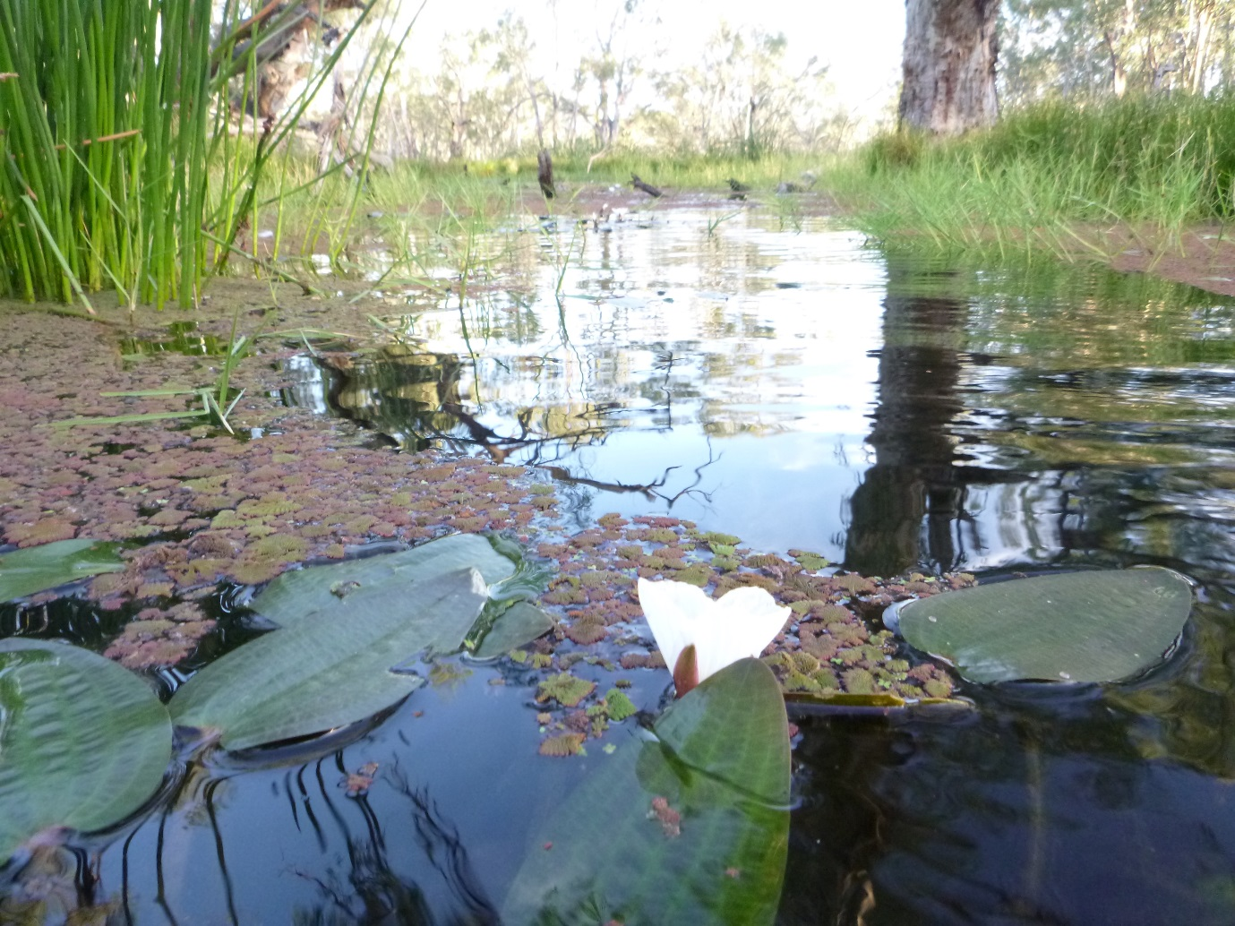

Plate 1 Aquatic vegetation at Two Bridges Swamp in the Redbank zone, March 2015

Table 2 Summary of monitoring activities and location in the Murrumbidgee River (in channel sites) (see Figure 1)

|  |  |  |  |  |  |  |  |  |  |
| --- | --- | --- | --- | --- | --- | --- | --- | --- | --- |
| **Site Name** | **Zone** | **ANAE classification** | **Stream metabolism** | **Nutrients carbon** | **Microinvertebrate** | **Larval fish C1** | **Larval Fish SA** | **Fish community (C1)** | **Fish community (C3)** |
| Baupile Escape (River) | Balranald | Permanent lowland streams |  |  |  |  |  |  | X |
| Glen Avon (River) |  |  |  |  |  |  | X |
| Maude |  |  |  |  |  |  | X |
| Nap Nap |  |  |  |  |  |  | X |
| Redbank Weir |  |  |  |  |  |  | X |
| Willow Isles |  |  |  |  |  |  | X |
| Wynburn |  |  |  |  |  |  | X |
| Yarradda (River) |  | Permanent transitional zone streams |  | X | X | X | X | X | X |
| McKennas (River) | Carrathool | Permanent lowland streams | X | X | X | X | X | X | X |
| Bringagee |  | X | X | X | X | X | X |
| Birdcage |  |  |  |  |  | X | X |
| Gundaline claybar |  |  |  |  |  | X |  |
| Gundaline US |  |  |  |  |  | X |  |
| Hay Boat Ramp |  |  |  |  |  |  | X |
| Pevensey |  |  |  |  |  |  | X |
| Rudds Point |  |  |  |  |  | X |  |
| Toganmain DS |  |  |  |  |  | X |  |
| Toganmain Homestead |  |  |  |  |  | X |  |
| Toganmain US |  |  |  |  |  | X |  |
| Wyreema |  |  |  |  |  |  | X |
| The Dairy | Narrandera | Permanent lowland streams |  | X | X |  | X |  | X |
| Euroley Bridge |  | X | X |  | X |  | X |
| Narrandera | X | X | X |  | X |  | X |
| Buckingbong Station |  |  |  |  |  |  | X |
| Berembed Weir DS |  |  |  |  |  |  | X |
| Gogeldrie Weir US |  |  |  |  |  |  | X |
| Lamonts Beach |  |  |  |  |  |  | X |

US = upstream, DS = downstream, River = distinguishes site from comparable Wetland site with the same name see Table 4, C1 = Category 1 LTIM standard methods, C3 = Category 3 LTIM standard methods).

Table 3 Summary of monitoring activities and locations across three wetland zones in the Murrumbidgee floodplain (see Figure 1)

|  |  |  |  |  |  |  |  |  |
| --- | --- | --- | --- | --- | --- | --- | --- | --- |
| **Site Name** | **Zone** | **ANAE classification** | **Nutrients , carbon, chl a** | **Microinvertebrate** | **Fish community (C3)** | **Frogs** | **Waterbird Diversity** | **Vegetation Diversity** |
| Gooragool Lagoon | mid-Murrumbidgee | Permanent floodplain wetland | X | X | X | X | X | X |
| McKennas Lagoon | Intermittent river red gum floodplain swamp | X | X | X | X | X | X |
| Sunshower Lagoon | Intermittent river red gum floodplain swamp | X | X | X | X | X | X |
| Yarradda Lagoon | Intermittent river red gum floodplain swamp | X | X | X | X | X | X |
| Avalon Swamp | Nimmie-Caira | Temporary floodplain lakes | X | X | X | X | X | X |
| Eulimbah Swamp | Temporary floodplain wetland | X | X | X | X | X | X |
| Nap Nap Swamp | Intermittent river red gum floodplain swamp | X | X | X | X | X | X |
| Telephone Creek | Permanent floodplain wetland | X | X | X | X | X | X |
| Mercedes Swamp | Redbank | Intermittent river red gum floodplain swamp | X | X | X | X | X | X |
| Piggery Lake | Permanent floodplain tall emergent marshes | X | X | X | X | X | X |
| Two Bridges Swamp | Intermittent river red gum floodplain swamp | X | X | X | X | X | X |
| Waugorah Lagoon | Permanent floodplain wetland | X | X | X | X | X | X |





Figure 1 Distribution of riverine zones (top) and wetland (bottom) zones and key monitoring locations in the Murrumbidgee Selected Area

# Commonwealth environmental watering activities and ecological objectives 2014-15

### Climate and water context

Environmental watering actions are determined by a combination of catchment and climate conditions as well as the volume of water holdings. These also provide the context in which the ecosystem responses to watering can be evaluated. The Murrumbidgee River catchment has undergone significant long-term modifications to the dominant hydrological regime, including alterations to the timing of high flow periods and significant reductions in the frequency of moderate and high flow events ([Frazier, Page et al. 2005](#_ENREF_17), [Frazier and Page 2006](#_ENREF_16)). Significant drought between 2000 and 2010 exacerbated the effects of river regulation leading to significant declines in the condition of floodplain vegetation ([Wen, Ling et al. 2009](#_ENREF_45)). Large scale flooding occurred in 2010 and 2011 which was followed by moderate water availability between 2012 and 2014. While river flows remain relatively stable, the extent of inundation across floodplain habitats remains relatively small compared to conditions prior to 2000.

### 2014-15 Watering Actions

*Commonwealth environmental water use options 2014–15: Murrumbidgee River* outlines watering options for the use of Commonwealth environmental water in the Murrumbidgee River Valley in 2014-15 ([Commonwealth Environmental Water Office 2014](#_ENREF_14)). Nine high level water use options were identified targeting the mid-Murrumbidgee wetlands, Lowbidgee floodplain and the Murrumbidgee River and creek system, under a range of hydrologic conditions. Individual actions were identified based on climate conditions, water availability, environmental demands, constraints and risks.

The priority watering action was the mid-Murrumbidgee piggyback action. This action was dependent on the occurrence of a suitably sized rainfall generated flow event as a trigger, which did not occur at a suitable time. Mid-Murrumbidgee watering would have delivered a range of downstream, including in-channel, outcomes. As a result, alternative uses of Commonwealth environmental water were implemented including pumping to isolated wetlands in the mid-Murrumbidgee, watering of Lowbidgee wetlands and floodplain assets and the Yanco Creek system.

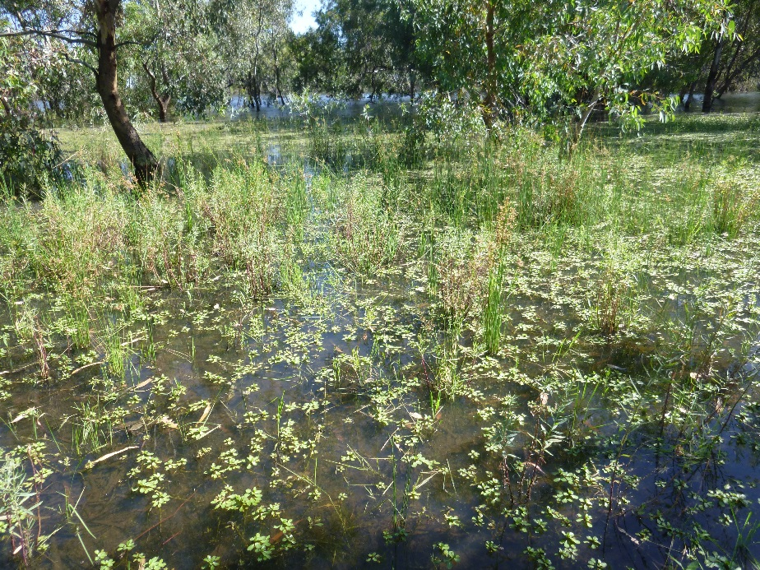

Plate 2 Telephone Creek, Nimmie-Caira zone November 2014

Table 4 2014-15Murrumbidgee environmental water use by entitlement (updated to 30/06/14) (Murrumbidgee 2014-15 Water use Acquittal Report)

|  |  |  |  |  |  |  |  |  |  |
| --- | --- | --- | --- | --- | --- | --- | --- | --- | --- |
|  |  |  | Water Use Volume (ML) | | | | | | |
| Wetland Zone | Start – End Date | Event Name | NSW AEW | NSW EWA | NSW LTIM | CEWH GS | CEWH SUPP | NSW SUPP | Total Volume delivered (ML) |
| Nimmie-Caira | 06/07/14-30/08/14 | Nap Nap Swamp to Waugorah Ck |  | 630 |  |  |  | 18565 | 19195 |
| 04/07/14-30/08/14 | Uara Creek to Yanga |  |  |  |  |  | 21757  LSAL | 21757 |
| 04/07/14-30/08/14 | North Caira Floodways |  |  |  |  |  | 7849  LSAL | 7489 |
| 22/10/14-31/12/14 | Kia Lake |  | 10000 |  |  |  |  | 10000 |
| 20/10/14-28/02/15 | Telephone Bank Swamp |  | 4930 |  |  |  |  | 4930 |
| 27/11/14-28/02/15 | Nimmie-Caira Southern Bell Frog Wetlands |  | 2000 |  |  |  | 3113 LSAL | 5113 |
| 23/03/15-30/04/15 | Nimmie Creek |  | 343 |  |  |  |  | 343 |
| Western Lakes | 25/05/15-25/06/15 | Paika Lake |  | 1459 | 1535 | 8498 |  |  | 11492 |
| Redbank | 12/08/14-31/01/15 | Mid North Redbank, return flows | 3136 | 13204 |  | 40000 |  |  | 56340 |
| 01/10/14-30/06/15 | Upper North Redbank |  | 6648 |  | 20000 |  |  | 26648 |
| 04/05/15-29/06/15 | Juanbung |  | 4667 |  | 5688 |  |  | 10355 |
| 23/10/14-31/03/15 | Yanga National Park | 6280 | 19070 |  | 70000 | 4512  LSAL |  | 99862 |
| 20/02/15-13/04/15 | South Yanga | 7885 | 5893 |  |  |  |  | 13778 |
| Yanco | 23/06/15-30/06/15 | Yanco Creek |  | 245 |  |  | 2462 | 1372 | 5732 |
| Mid-Murrumbidgee | 03/12/14-31/01/15 | Yarradda Lagoon |  |  |  | 1150 |  |  | 1150 |
| 22/03/15-01/04/15 | Sandy Creek |  | 130 |  | 250 |  |  | 380 |
| 12/09/14-01/01/15 | MIA wetlands |  | 2472 |  |  |  |  | 2472 |
| 02/12/14-01/01/15 | Coonancoocabil wetlands |  | 720 |  |  |  |  | 720 |
| 09/02/15-08/03/15 | Old Man Creek |  | 840 |  |  |  |  | 840 |
| 10/03/15-01/04/15 | Gras Innes and Oak Creek |  | 1278 |  |  |  |  | 1,278 |

# 

Commonwealth environmental water contributed to eight watering actions within the Murrumbidgee Valley in 2014-15. These actions were anticipated to achieve the following expected outcomes.

1. protect, maintain, and in some cases improve the condition and extent of floodplain, riparian and wetland native vegetation
2. maintain and improve the diversity and condition of native aquatic fauna including fish, waterbirds, frogs, turtles and invertebrates through maintaining suitable habitat and providing/supporting opportunities to move, breed and recruit
3. support the habitat requirements of waterbirds
4. support the habitat requirements of native fish
5. support the habitat requirements of other vertebrates
6. support ecosystem functions, such as mobilisation, transport and dispersal of biotic and abiotic material (e.g. macroinvertebrates, nutrients and organic matter) through longitudinal and lateral hydrological connectivity
7. improve ecosystem and population resilience through supporting ecological recovery and maintaining aquatic habitat.

Table 5 identifies each of these watering actions and which of these expected outcomes relate to each of the watering actions that occurred.

Three watering actions, that used Commonwealth environmental water, were monitored as part of the Murrumbidgee LTIM project in 2014-15. These actions were: Pumping to Yarradda Lagoon in the mid-Murrumbidgee; wetland watering in Yanga National Park (Redbank); return flows from North Redbank to the Murrumbidgee River Channel. There were no watering actions specifically targeting in-channel ecological outcomes implemented in the Murrumbidgee selected area in 2014-15, although some watering actions were undertaken outside the monitoring area in Yanco Creek. This report considers ecological outcomes occurring under normal river operations in the Murrumbidgee selected area including flows delivered for irrigation and environmental purposes on the floodplain, and inter-valley transfers (IVTs).

Table 5 Summary of Commonwealth environmental watering actions and expected outcomes. Also see Murrumbidgee Monitoring and Evaluation plan (M&E Plan)([Wassens, Jenkins et al. 2014](#_ENREF_41))

|  |  |  |
| --- | --- | --- |
| **Target asset** | **Expected outcomes for 2014-15** | **Basin Plan (bold) and longer term objectives (M&E Plan)** |
| **LTIM MONITORED SITES/ACTIONS** | | |
| Yarradda Lagoon  Action 2  Zones  Mid-Murrumbidgee (Yarradda Lagoon) | Primary  – protect and maintain wetland and riparian native vegetation  Secondary  – provide feeding habitat for waterbirds, native fish, other aquatic vertebrates (turtles, frogs) and invertebrates. | Vegetation diversity  Fish diversity  Waterbird diversity  Other vertebrate diversity  Microinvertebrates |
| Mid North Redbank and Return Flows  (only the return flows were monitored for this action)  Action 9 | Mid North Redbank  ‑ protect, maintain, and in some cases improve the condition and extent of floodplain, riparian and wetland native vegetation  ‑ maintain and improve the diversity and condition of native aquatic fauna including fish, waterbirds, frogs, turtles and invertebrates through maintaining suitable habitat and providing/supporting opportunities to move, breed and recruit  – support habitat requirements for waterbird, frog and native fish  Return flows  ‑ support ecosystem functions, such as mobilisation, transport and dispersal of biotic and abiotic material (e.g. macroinvertebrates, nutrients and organic matter) through longitudinal and lateral floodplain-river connectivity | Water quality  Ecosystem function  Biotic dispersal and movement  Sediment transport  Nutrient and carbon cycling  Microinvertebrates |
| Yanga National Park  Action 6  Zones  Redbank  (Mercedes, Piggery, Two Bridges, Waugorah Lagoon)  Nimmie-Caira  (Avalon, Nap Nap, Eulimbah, Telephone Creek) | Primary  ‑ protect, maintain, and in some cases improve the condition and extent of floodplain, riparian and wetland native vegetation  ‑ maintain and improve the diversity and condition of native aquatic fauna including fish, waterbirds, frogs, turtles and invertebrates through maintaining suitable habitat and providing/supporting opportunities to move, breed and recruit  – additional water supplied to support identified waterbird (egret) breeding event  Secondary  – support ecosystem functions  – provide habitat for native fish, frogs and other vertebrates  – support habitat requirements for waterbird, frog and native fish | |  | | --- | | Vegetation diversity | | Fish diversity | | Waterbird diversity | | Other vertebrate diversity  Microinvertebrates | |

Table 5 continued. Summary of Commonwealth environmental watering actions and expected outcomes. Also see Murrumbidgee Monitoring and Evaluation plan (M&E Plan)([Wassens, Jenkins et al. 2014](#_ENREF_41))

|  |  |  |
| --- | --- | --- |
| **SITES/ACTIONS NOT MONITORED AS PART OF LTIM** | | |
| Upper North Redbank | Primary  ‑ protect, maintain, and in some cases improve the condition and extent of floodplain, riparian and wetland native vegetation  ‑ maintain and improve the diversity and condition of native aquatic fauna including fish, waterbirds, frogs, turtles and invertebrates through maintaining suitable habitat and providing/supporting opportunities to move, breed and recruit  Secondary  – support ecosystem functions  – support habitat requirements for waterbird, frog and native fish | Vegetation diversity  Waterbird diversity  Other vertebrate diversity  Waterbird diversity  Fish diversity  Ecosystem function   |  | | --- | |  | |
| Sandy Creek | Primary  – protect and maintain wetland and riparian native vegetation  Secondary  – provide feeding habitat for waterbirds  – provide feeding habitat for frogs | Vegetation diversity  Waterbird diversity  Other vertebrate diversity  Waterbird diversity |
| Juanbung | Primary  – water stressed river gum floodplain and riparian native vegetation  Secondary  – provide feeding habitat for waterbirds  – provide feeding habitat for frogs | Vegetation diversity  Waterbird diversity  Other vertebrate diversity  Waterbird diversity |
| Paika Lake | Primary  – Maintenance of open water habitat for waterbirds  Secondary  – inundate fringing aquatic vegetation communities  – Support habitat requirements for waterbird, frog and native fish | Vegetation diversity  Waterbird diversity  Fish diversity  Waterbird diversity |
| Yanco Creek | Primary  ‑ protect, maintain, and in some cases improve the condition and extent of floodplain, riparian and wetland native vegetation  ‑ maintain and improve the diversity and condition of native aquatic fauna including fish, waterbirds, frogs, turtles and invertebrates through maintaining suitable habitat and providing/supporting opportunities to move, breed and recruit  Secondary  – Support habitat requirements for waterbird, frog and native fish  – provide feeding longitudinal and lateral connectivity | Vegetation diversity  Other vertebrate diversity  Fish diversity  Waterbird diversity  Biotic dispersal and movement |

# Evaluation of ecological outcomes in response to Commonwealth environmental water use

### Summary of Riverine hydrology

While no environmental watering targeted in-channel flows, delivery of Commonwealth environmental water to floodplain habitats may have contributed secondary benefits to in-channel habitats. It is therefore informative to consider the ecological outcomes in the Murrumbidgee River in the context of normal operations, involving irrigation, consumptive and environmental water deliveries to provide a baseline for future years. Monitoring was undertaken in two hydrological zones: the Carrathool Zone and The Narrandera Zone (see Figure 2). As monitoring was undertaken fortnightly on six occasions (see Section 2, Murrumbidgee LTIM technical report ([Wassens, Thiem et al. 2015](#_ENREF_43)), we used the cumulative flows (mean discharge over 14 days). Overall, cumulative flows were considerably higher in the Narrandera zone (Narrandera gauge) compared to that measured for the Carrathool zone (Carrathool gauge) which is down stream of major irrigation off-takes (Figure 2). In Carrathool, flows were relatively stable over the six survey occasions between October and January, while in Narrandera flows decreased slightly in mid-December and then peaked in late December 2014.

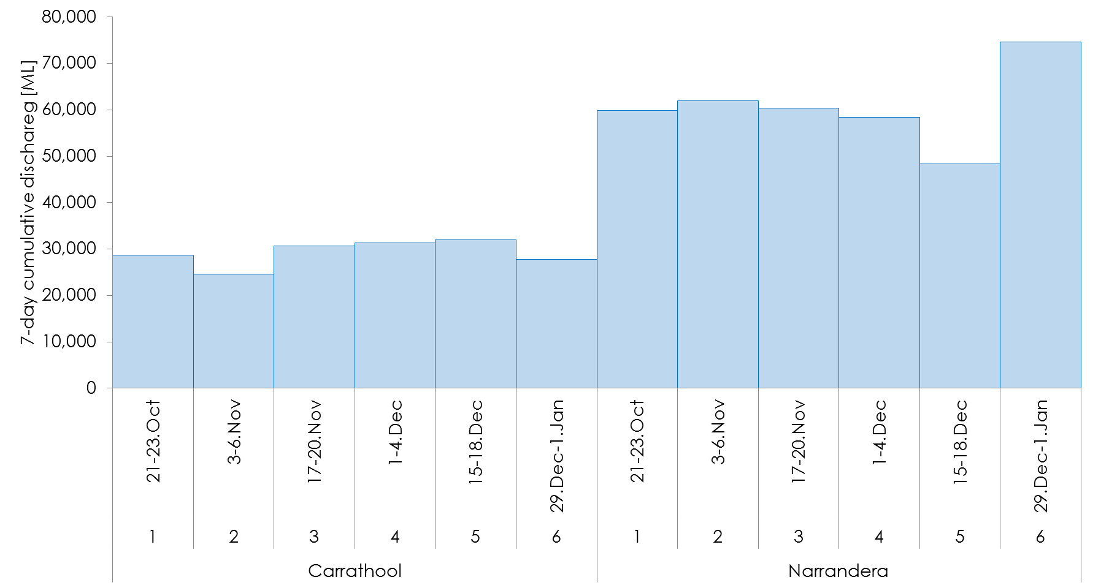

Figure 2 Fourteen day cumulative flows [ML] in the two river zones and six survey occasions

### Summary of wetland hydrology

There were two watering actions targeting floodplains and wetlands in the Murrumbidgee Selected Area; Action 2 involved infrastructure assisted delivery of water to Yarradda Lagoon in the mid-Murrumbidgee, while Action 6 involved large-scale watering of wetlands across the Lowbidgee floodplain. Only two of the four wetlands in the mid-Murrumbidgee received watering in 2014-15, with Gooragool Lagoon receiving small volumes of irrigation drainage through November and January, while Yarradda Lagoon received environmental watering in December 2014, and remained relatively deep between January and March 2015 (). In the Lowbidgee (Action 6) wetlands received water between June 2014 and April 2015, although monitoring was only undertaken between September 2014 and March 2015. There was a high level of variability between individual wetlands with respect to both water depths and percent of the wetland inundated (Figure 4). In the Nimmie-Caira zone, overall water depth was higher with varying fluctuations over the four survey periods but the lowest water depths were recorded in March 2015. In the Redbank zone similar fluctuations were observed with September 2014 having the lowest water levels in the Redbank sites (MER, PIG, and TBR) not including Waugorah Lagoon (Figure 4) which had the highest measured water depth (3 m) in September 2014 and decreased in following survey periods.

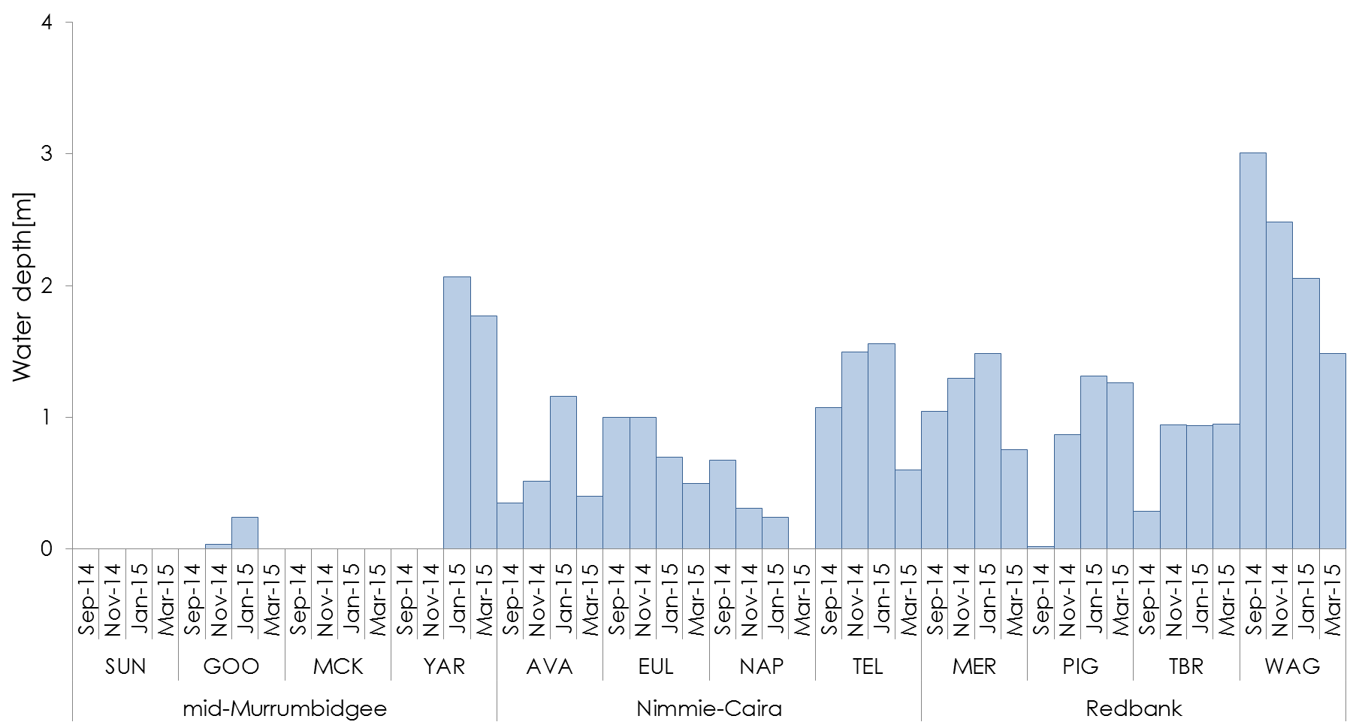

Figure 4 Water depth in each of the three wetland zones, 12 survey sites and four survey occasions in 2014-15.

## Stream metabolism

### Introduction

Concentrations of nutrients, carbon and chlorophyll-a as well as rates of Gross Primary Production (GPP) and Ecosystem Respiration (ER) are key factors that account for variability in primary producers (e.g. photosynthetic algae and plants) and dependent higher-trophic indicator organisms such as invertebrates and fish ([Wassens, Jenkins et al. 2013](#_ENREF_40)). Samples of nutrients, carbon and chlorophyll-a were collected fortnightly between October 2014 and January 2015 at six sites across the Narrandera and Carrathool zones of the Murrumbidgee River. Monitoring was carried out to address the following evaluation questions:

1. What did Commonwealth environmental water contribute to patterns and rates of decomposition?
2. What did Commonwealth environmental water contribute to patterns and rates of primary productivity?

#### We predicted that:

* Nutrient availability would increase in response to pulsed delivery of Commonwealth environmental water.
* By inundating adjacent riparian habitat, pulsed environmental flows will increase carbon availability in-stream, shifting metabolism towards net heterotrophy that is, the ecosystem is using more energy than it is creating via photosynthesis
* Gross primary production and respiration would increase in response to pulsed delivery of Commonwealth environmental water.

### Results

In 2014-15 there were no direct Commonwealth environmental watering events targeting in-channel habitats and no pulsed deliveries of environmental water were undertaken in the Murrumbidgee River. Cumulative fortnightly discharge levels were relatively stable during the monitoring period (see Figure 3), and flows remained within channel. As there were no watering actions undertaken, it was not possible to evaluate (1) the contribution of Commonwealth environmental water to patterns and rates of decomposition (environmental respiration) or (2) the contribution of Commonwealth environmental water to patterns and rates of primary productivity (gross primary productivity). However, variability in hydrology between the two monitoring zones (Narrandera and Carrathool) provided some evidence to support the prediction that nutrient availability may increase in response to increased discharge, with phosphate concentrations significantly higher in the Narrandera zone, which also had higher rates of discharge than the Carrathool zone. This pattern was not repeated for nitrogen.

We predicted environmental flows which inundate adjacent riparian habitat, will increase carbon availability in-stream, shifting metabolism towards net heterotrophy. Between October 2014 and January 2015 dissolved organic carbon concentrations were slightly higher in the Carrathool zone, compared to the higher discharge Narrandera zone, however these differences in dissolved organic carbon did not appear to influence rates of gross primary productivity and environmental respiration which were of similar scale across the two zones. In the Carathool zone, data was collected for a longer period (6 months) and there were peaks in gross primary productivity and environmental respiration which coincided with minor increases of in-channel discharge (less than 1m), providing some indication that pulsed flows, delivered during summer, may contribute to enhanced productivity outcomes in-stream.

### Discussion

As there were no direct Commonwealth environmental watering actions targeting in channel habitats in 2014-15 we compared baseline patterns and rates of environmental respiration and gross primary productivity between the Carathool and Narrandera zones as well as responses to in-channel variations in discharge during the sampling period. Peak gross primary productivity and environmental respiration were observed in the Carrathool zone during late October 2014, January and late February 2015, coinciding with both small flow peaks and periods of low flow. Increasing discharge, even when contained within the channel, could inundate dry sediment and with sufficient drying between wetting cycles it might provide small pulses of nutrients. Conversely, low flows may increase light availability and nutrient retention times ([Hilton, O'Hare et al. 2006](#_ENREF_21)). Both of these processes are likely to enhance aspects of ecosystem metabolism. These trends were not as apparent in the Narrandera zone which experienced higher discharge levels overall. It is possible that drying cycles were not long enough to drive nutrient pulses, following rewetting by relatively stable high flows in the Narrandera zone during irrigation delivery.

### Adaptive management and recommendations

Pulsed environmental flows have the potential to affect both gross primary productivity and environmental respiration, however the response is influenced by the dominant hydrological regime. In areas where river discharge rates are already high, as is the case in the Narrandera zone, further increases in discharge which remain within channel may have little impact on primary productivity or respiration. Conversely in areas where discharge rates are low, even relatively small pulsed flows may inundate substantial areas of dry sediments facilitating increases in nutrient availability and driving increases in primary productivity and respiration. In this respect it is critical to understand the geomorphology and dominant hydrological regime of the river zone where environmental flows are being targeted, with watering aiming to restore components of the hydrograph that have been removed due to regulation and extraction. At this stage it is not possible to provide definitive recommendations on how in-channel environmental water delivery could be altered to increase in channel productivity, however reconnecting wetlands and allowing the return of water from the floodplain can increase nutrient availability supporting increased productivity (see Return flows 5.3).

## Microinvertebrates

Microinvertebrates play a key role in floodplain river food webs, and respond strongly to flow pulses and inundation, mediated by antecedent conditions and season ([Jenkins and Boulton 2003](#_ENREF_23), [Jenkins and Boulton 2007](#_ENREF_24)). Microinvertebrate communities were monitored with larval fish surveys in the Murrumbidgee River from October 2014 to January 2015, and in wetlands and the river from the Lowbidgee (Nimmie-Caira, Redbank) and mid-Murrumbidgee coinciding with wetland fish and tadpole monitoring from September 2014 to May 2015.

The key objectives of the Commonwealth environmental watering actions in 2014-15 that relate to microinvertebrates in wetlands were Action 2 (mid-Murrumbidgee) and Action 6 (Lowbidgee floodplain) to “*provide feeding habitat for waterbirds, native fish, other aquatic vertebrates (turtles, frogs) and invertebrates*” and “*maintain and improve the diversity and condition of native aquatic fauna including fish, waterbirds, frogs, turtles and invertebrates*.” In 2014-15 there were no targeted in-channel environmental watering actions. However, water deliveries contributed to hydrological variability, providing baseline information to inform the use of environmental flows to support food webs and maintain water quality in the river. We predicted that environmental flows in late winter, spring and summer will inundate previously dry habitats in wetlands and also in rivers (i.e. backwaters, in-channel benches), releasing and transporting nutrients that stimulate productivity and diversity of microinvertebrate communities.

The long-term (five year) Murrumbidgee Selected Area evaluation questions related to wetland microinvertebrates were;

1. What did Commonwealth environmental water contribute to microinvertebrate productivity?
2. What did Commonwealth environmental water contribute to microinvertebrate community composition?

Based on recent environmental watering of wetland sites (2013-14), we predicted;

* Commonwealth environmental water delivered to wetlands would transport microinvertebrates as well as trigger their emergence, establishing communities with densities and community composition changing over time in relation to wetland filling and draw-down.
* There would be modest bursts of microinvertebrate productivity relative to previous water years.

The long-term (five year) Murrumbidgee Selected Area evaluation questions related to riverine microinvertebrates were;

1. What did Commonwealth environmental water contribute to microinvertebrate productivity in benthic and pelagic habitats?
2. What did Commonwealth environmental water contribute to microinvertebrate community composition in benthic and pelagic habitats?

Based on recent environmental watering of riverine sites (2013-14), we predicted;

* Commonwealth environmental water would increase densities and biovolume of microinvertebrates in benthic habitats.
* Peaks in the density and biovolume of microinvertebrates would be matched to the timing of peak numbers of fish larvae

### Results

Densities of benthic microinvertebrates in wetlands from the Nimmie Caira were high in September and again in January 2015 along with the mid-Murrumbidgee and Murrumbidgee River, while Redbank densities were highest in November 2014. The high densities in spring relate to rapid emergence and reproduction following delivery of Commonwealth environmental water (Action 2 and 6), demonstrating the role of this water in providing habitat to support the survival and maintain condition of native fish, waterbirds, and other aquatic vertebrates.

High peak densities in January 2015 of copepods and cladocerans in the mid-Murrumbidgee wetlands, Nimmie-Caira and Murrumbidgee River demonstrate the importance of Commonwealth environmental water providing an ongoing abundant food supply for native fish, filter-feeding waterbirds and other vertebrates such as tadpoles during their critical growth and reproductive periods.

In the Murrumbidgee River, microinvertebrate densities were higher in the Carrathool than the Narrandera zone, largely due to the extremely high densities at the Yarradda and McKennas sites in December (respective peaks of 4886 and 3991 per litre). Densities above the critical threshold of 100/L to support larval fish feeding were also observed in the Narrandera zone, although peaks of copepods only occurred in the Carrathool zone.

### Discussion

In wetlands, Commonwealth environmental water (Action 6) contributed to peaks in microinvertebrate densities in January 2015 in the Nimmie-Caira, and Lowbidgee River. It is likely that high temperatures in January contributed to increased productivity in wetlands. The peak in sites in the lower Murrumbidgee River matches peaks observed in the independently sampled larval fish riverine sites. Wetlands receiving Commonwealth environmental water via infrastructure in the mid-Murrumbidgee (Action 2) had similar densities of microinvertebrates as those in the Lowbidgee floodplain (Nimmie-Caira) and were higher than wetlands in the Redbank zone, indicating that the mode of water delivery has little impact on microinvertebrate density or diversity.

There were no environmental watering actions directly targeting in-channel habitats during 2014-15. Nevertheless, volumes of environmental water delivered to the Lowbidgee wetlands (Action 6) and inter-valley transfers contributed to the overall volume, timing and magnitude of flows. For example, the peaks in benthic microinvertebrates at two of the larval fish sites in December 2014 and January 2015 coincided with inter-valley transfers that also matched peaks in chlorophyll-a and nutrients. However, the largest peaks in microinvertebrate densities were observed in the Carathool zone where overall discharge was lower and it is likely the January 2015 peak was due to a spike in temperature coupled with lower water levels.

### Adaptive management and recommendations

Environmental watering of the mid-Murrumbidgee and Lowbidgee systems in 2014-15 facilitated ecosystem functioning, enhancing habitat suitability for high ecological value species that rely on wetland food-webs. The area of wetland inundated determines the extent of the microinvertebrate food supply available to support predators such as filter feeding waterbirds and small bodied native fish.

Microinvertebrates are not themselves a target for environmental watering and populations and communities can vary widely in their responses to inundation across wetlands and over time. From the data collected to date the microinvertebrate communities in wetlands watered using infrastructure assisted delivery were broadly similar to those water via channels and through natural river reconnects, suggesting that the mode of delivery has little impact on microinvertebrate communities in the short term.

## Return flows

During 2014-15, parts of the north Redbank system were inundated with Commonwealth environmental water (Action 6 and Action 9). A proportion of these flows were allowed to flow back into the river (called “return flows”) from a regulator located approximately half way between Redbank Weir and Balranald (the Wynburn Escape). This use of environmental water aimed *to**“contribute to the maintenance or improvement of water quality, to support ecosystem functions, such as mobilisation, transport and dispersal of biotic and abiotic material through longitudinal and lateral floodplain-river connectivity”.* We expected that this use of environmental water would augment riverine nutrient and carbon concentrations and possibly promote changes in ecosystem processes. Monitoring focussed on quantifying the transfer of nutrients and microinvertebrates from wetlands into the Murrumbidgee River and detecting subsequent ecological responses. The aim of this monitoring was to evaluate the following questions:

1. What did Commonwealth environmental water contribute to patterns and rates of decomposition in riverine habitats adjacent to return flows?
2. What did Commonwealth environmental water contribute to patterns and rates of primary productivity in riverine habitats adjacent to return flows?
3. What did Commonwealth environmental water contribute to hypoxic blackwater risk in wetlands and riverine habitats?

#### During return flows we predicted:

* Increased rates of primary production and respiration in reaches downstream from wetlands receiving Commonwealth environmental water
* Increased use and fixing of carbon and nutrients in reaches downstream from wetlands receiving Commonwealth environmental water
* Longer- term reduction in carbon accumulation and subsequent reduction in the risk of hypoxic black water events across the floodplain following Commonwealth environmental watering actions in wetlands and floodplains.

### Results

Return flows were delivered as two separate actions, one in October 2014, and the other in February 2015. Each return flow was monitored on four separate occasions (Before, During 1, During 2, After).River discharge levels were high during both return flows, and as a result the nutrient levels in water being returned from wetlands was rapidly diluted upon entering the river. We predicted that during the return flows there would be increased use and fixing of carbon and nutrients in reaches downstream from wetlands receiving Commonwealth environmental water. This prediction was partly supported by the data and we detected an increase in phosphate and dissolved organic carbon for up to 3km downstream of the return flow in the Murrumbidgee River during October but this pattern was not repeated in February.

We predicted that during return flows there would be increased rates of primary production and respiration in reaches downstream from wetlands receiving Commonwealth environmental water, however this prediction was not supported by the data and there was little evidence of increases in the rates of either primary productivity or environmental respiration in October or February.

We predicted that there would be a longer- term reduction in carbon accumulation and subsequent reduction in the risk of hypoxic black water events across the floodplain following Commonwealth environmental watering actions in wetlands and floodplains. This prediction was supported, and our results indicate that successive years of watering led to a reduction in the amount of dissolved and available nutrients in floodplain habitats culminating in an improvement in water quality conditions between 2013-14 and 2014-15 ([Wassens, Jenkins et al. 2014](#_ENREF_42), [Wassens, Thiem et al. 2015](#_ENREF_43)).

### Discussion

Ecological responses to return flows are expected to scale with the degree of nutrient enrichment. In this case the small volumes of water release relative to the total river volume meant that while significant differences in Dissolved organic carbon (DOC) and Phosphate were achieved, the concentrations were not sufficient to drive a measurable increase in primary productivity or environmental respiration downstream of the release. As a result of the small release volumes, Commonwealth environmental watering actions related to return flows did not influence (1) the rates of decomposition in riverine habitats adjacent to return flows or (2) the rates of primary productivity in riverine habitats adjacent to return flows.

The 2014-15, return flows contributed to the removal of carbon and nutrients from the North Redbank wetlands both within and between water years. Concentrations of dissolved organic carbon and phosphate decreased between October (first return flow) and February (second return flow) and this decrease can be attributed to a combination of flushing flows in October removing carbon and nutrients from the floodplain and increased fixing of nutrients on the floodplain due to the extended period of inundation, as well as the proportionally small volumes of water released during the second return flow. Our results suggest that successive years of watering has led to a reduction in the amount of dissolved and available nutrients in floodplain habitats culminating in an improvement in water quality conditions between 2013-14 and 2014-15 ([Wassens, Jenkins et al. 2014](#_ENREF_42), [Wassens, Thiem et al. 2015](#_ENREF_43)). Decreasing concentrations of dissolved organic carbon and nutrients demonstrate that Commonwealth environmental water did contribute to a reduction in hypoxic blackwater risk in wetlands and riverine habitats (3).

### Adaptive management and recommendations

Return flows are a means of replicating floodplain-derived inputs of nutrients and organic matter into rivers, although there is still large uncertainty in predicting the quantitative response of river metabolism and other ecological processes to managed return flows. Considering the results of returns flows to the Murrumbidgee during 2014-15, and the findings of Cook et al. (2015), we predict return flows that are able to increase river carbon concentrations from a baseline of 2 mg/L to above 6-8 mg/L may be able to elicit a measurable response in ecosystem metabolism. It may be effective to deliver return flows after successive years of watering in floodplain habitats if the management aim is to reduce the risk of blackwater events but at the same time to maintain or enhance the river metabolism and other associated ecological processes.

Concentrations of dissolved organic carbon in the North Redbank System have been much higher in the past (i.e. >30 mg/L) and with the release volumes achieved during the present study (up to 100 ML/day) it is possible to use return flows to stimulate ecosystem productivity without risking a hypoxic blackwater event. Given the low risk of a hypoxic blackwater event, return flows should seek to coincide releases with high wetland nutrient concentrations and low river discharge volumes. Further trials of return flows and follow-up monitoring is recommended under various Commonwealth environmental water scenarios.

The management of future return flows will be dependent on the goal of the specific watering action, the available release points, and local weather conditions, the carbon and nutrient concentrations in the river and projected carbon and nutrient concentration on the floodplain. In general where the goal is to flush carbon and nutrients from the floodplain to reduce future risks of hypoxic black water and prepare the floodplain for future watering and return flows, it is recommended that water is returned in winter and early spring when water temperatures are lower which limits microbial action, or that return flow discharge volumes are managed to ensure river carbon levels do not increase above 6 mg/L. Where the goal is to stimulate in-channel productivity, spring and summer returns can be undertaken, with the higher release volumes relative to the baseline river levels with a goal of achieving carbon concentrations above 6mg/L. In all cases specific release volumes should be calculated prior to any releases following assessment of floodplain carbon levels, river levels, channel capacity and the potential for downstream impacts on other water users.

## Fish diversity

Native fish communities in the Murrumbidgee Catchment are severely degraded, exhibiting declines in abundance, distribution and species richness ([Gilligan 2005](#_ENREF_18)). Further, alien species (specifically common carp *Cyprinus carpio*) have been reported as occupying up to 90 per cent of the total biomass in some areas (Gilligan 2005). In addition, small-bodied floodplain species such as the Murray hardyhead (*Craterocephalus fluviatilis*), southern pygmy perch (*Nannoperca australis*), southern purple-spotted gudgeon (*Mogurnda adspersa*) and olive perchlet (*Ambassis agassizii*) were historically abundant throughout Murrumbidgee River wetland habitats ([Anderson 1915](#_ENREF_1), [Cadwallader 1977](#_ENREF_10)) but are now considered locally extinct from the mid and lower Murrumbidgee ([Gilligan 2005](#_ENREF_18)).

River regulation has significantly contributed to native fish declines in the Murrumbidgee Catchment. Reductions in the frequency and duration of small-medium natural flow events prevent regular connections between the river and off-channel habitats ([Arthington and Pusey 2003](#_ENREF_2)).

The LTIM project is designed to evaluate both long and short term outcomes of environmental watering actions at the basin scale (undertaken separately to this report) and selected area evaluation (this report). Fish communities in three wetland zones (Nimmie-Caira, Redbank and mid-Murrumbidgee) were sampled on four occasions in 2014-15 (September, November, January and March). In-channel fish communities were sampled once in March 2015 across three river zones (Narrandera, Carrathool and Balranald). Evaluation of long-term outcomes will be undertaken in year five with 2014-15 representing the baseline against which future changes will be compared.

#### The long-term (five year) Murrumbidgee Selected Area evaluation questions related to riverine fish addressed here are;

1. What did Commonwealth environmental water contribute to native fish populations?
2. What did Commonwealth environmental water contribute to native fish diversity?

#### We predicted that:

* Commonwealth environmental watering would increase fish body condition in the Murrumbidgee River
* Commonwealth environmental watering maintains or increases native fish recruitment in the Murrumbidgee River
* Commonwealth environmental watering maintains or increases native fish biomass in the Murrumbidgee River
* Commonwealth environmental watering facilitates recovery of rare native species in the Murrumbidgee River through recruitment
* Commonwealth environmental watering facilitates recovery of the fish community through recolonisation

The long-term (five year) Murrumbidgee Selected Area evaluation questions related to wetland fish addressed here are:

1. What did Commonwealth environmental water contribute to native fish populations and native fish diversity?
2. What did Commonwealth environmental water contribute to native fish community resilience and native fish survival?

We predicted that:

* Native fish diversity would increase in wetlands targeted for Commonwealth environmental watering between year 1 and 5
* Native fish recruitment (Young-Of-year) would increase within and between water years
* The distribution of native species would increase across wetlands of the Murrumbidgee Selected Area

### Results

River fish communities

Evaluation of ecological outcomes relating to the contribution of Commonwealth environmental water to native fish populations and native fish diversity must be undertaken over the long-term with this single sampling event representing a snap shot of populations and species diversity. A total of 1,041 fish comprising ten native and three exotic species were captured across 21 river sampling sites. This included three species listed as threatened; trout cod (*Maccullochella macquariensis*) (endangered; NSW Fisheries Management Act, EPBC Act), silver perch (*Bidyanus bidyanus*) (vulnerable; NSW Fisheries Management Act, critically endangered; EPBC Act) and Murray cod (*Maccullochella peelii*) (vulnerable; EPBC Act). Bony herring (*Nematolosa erebi)*, common carp (*Cyprinus carpio*), Australian smelt (*Retropinna semoni*) and carp gudgeon (*Hypseleotris* spp.) were the most abundant species in the river sites. Less commonly recorded species (<10 individuals recorded during surveys) included un-specked hardyhead (*Craterocephalus stercusmuscarum fulvus*), trout cod, silver perch and river blackfish (*Gadopsis marmoratus*). Un-specked hardyhead were captured at one site in each hydrological zone. Trout cod were captured in the Narrandera zone only. Silver perch were captured at one site within each of the river zones. River blackfish were captured at one site in the Narrandera zone. As rates of fish growth and population changes are slow, evaluation of Commonwealth environmental water contribution to native fish populations and native fish diversity, will be undertaken after a further four years of monitoring to determine if there is a significant change in the abundance, biomass or diversity of native fish communities following successive environmental watering actions.

Recruitment was evident for native species, including Murray cod, Australian smelt and silver perch. In the Murrumbidgee River, Murray cod recruits were more abundant in the Carrathool zone, and this potentially corresponds to the higher food resources available to larvae at first feed in this zone compared with Narrandera. Despite spawning of golden and silver perch in both the Narrandera and Carrathool zones, only one silver perch recruit was captured (Carrathool zone) and no golden perch recruits were captured.

Wetland fish communities

This report presents the first year (year 1) benchmark against which we will test the prediction that there will be an increase in native fish diversity in wetlands targeted for Commonwealth environmental watering between year 1 and 5. Overall, 38,979 fish comprising six native and four exotic species were captured across 10 LTIM wetland survey sites that contained water between September 2014 and May 2015. Carp gudgeon, bony herring and Australian smelt were the most abundant native species, while gambusia *(Gambusia holbrooki),* common carp and oriental weatherloach *(Misgurnus anguillicaudatus)* were the most commonly recorded exotic species. Despite being filled via pumping, fish were present in Yarradda Lagoon in the mid-Murrumbidgee with the community dominated by bony herring and gambusia. This indicates fish travelled through the pump into the wetland. Fish communities differed significantly between the three wetland zones. In the Redbank zone, relatively high numbers (>100 Catch Per Unit Effort (CPUE), which is a standardise measure of the number of fish captured in a net over a standard time period) of oriental weatherloach were observed in November 2014 and January 2015, while the native carp gudgeon were most abundant in January and March 2015. In the Nimmie-Caira zone, total catches were dominated by carp gudgeon and with smaller numbers of common carp (Figure 5).

Our results lend some support to the prediction that there would be an increase in distribution of native species across wetlands of the Murrumbidgee Selected Area following environmental watering. When considered separately, the statistical analysis to identify key thresholds that drive differences in fish occurrence and numbers (CART models) (see technical report) for native fish abundance in the wetland sites indicated a greater sensitivity to water depth than exotic species. Native fish numbers were highest when water depths were greater than 0.91 m compared to 0.24 m for exotic fish. Water temperature contributed to native fish abundance, with abundances higher at wetlands when temperatures were above 240C. In contrast to native fish species, exotic fish species more abundant in wetlands that were only partially inundated (less than 80 per cent full).

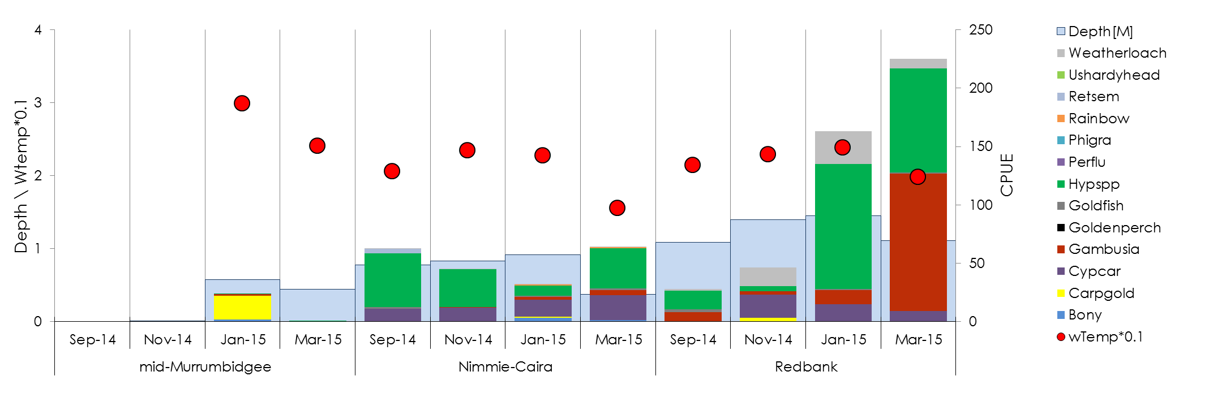

Figure 5 Total fish abundance (CPUE), water temperature and water depth in the three wetland zones over the four survey occasions in 2014-15. Legend codes for fish species recorded included: Weatherloach- oriental weatherloach, Ushardyhead- unspecked hardyhead, RetSim -Australian smelt, rainbow-Murray-darling rainbowfish, phigar –flathead gudgeon, perflu - redfin perch (exotic), hypspp - Carp gudgeon, Goldfish-goldfish, Goldenperch- golden perch, Gambusia- gambusia, cypcar –common carp (exotic), carpgold-juvenile carp or goldfish less than 20mm, Bony-bony herring

We predicted that there would be an increase in native fish recruitment (Young-Of-year) within and between water years. In the mid-Murrumbidgee, bony herring were significantly smaller in January 2015 (four weeks after initial fill) compared to March 2015 reflecting an increase in body size (growth and survival) following environmental watering. However it is not possible to determine whether these individuals were spawned in the Murrumbidgee River and transferred into the wetland as larvae or spawned in the wetland itself. Recruitment was also evident for carp gudgeon in the Nimmie-Caira and Redbank zones.

### Discussion

Native fish communities in the Murrumbidgee River and wetlands are in moderate to poor condition, in terms of low diversity of native species (for full assessments and details of Sustainable Rivers Audit (SRA) methodology see Technical report, section 3.9), with wetland species being particularly impacted by altered frequency of overbank flow events and the loss of permanent off channel refuge habitats. The majority of the evaluation questions relating to wetland fish represent long-term changes in communities and population and it is not possible to evaluate outcomes with only a single year of monitoring.

As would be expected, the availability of water was the principle factor influencing fish community responses through wetland and floodplain habitats. Importantly, while all fish species responded to watering, increasing the area of wetland inundated (proportion inundation) resulted in a lower overall abundance of exotic species, implying a benefit of inundating larger areas of wetland. Native fish abundance was higher at deep sites (greater than 0.91 m), reflecting the higher diversity and abundances of native fish typically observed in permanent waterbodies.

### Adaptive management and recommendations

The provision of persistent off-channel habitats contributes to the maintenance of native fish diversity and the loss of permanent off-channel habitats is likely to have contributed to declines of a number of native fish species including the Murray hardyhead ([Wedderburn, Walker et al. 2007](#_ENREF_44)). While many wetlands are seasonal, a significant number historically retained persistent pools which provided refuge for native fish and other vertebrates on the floodplain.

There are a number of important recommendations that have the capacity to improve outcomes for native fish species. Firstly, prior to regulation and increased water diversions for consumptive purposes, low lying wetlands in the mid-Murrumbidgee and Lowbidgee floodplain were frequently reconnected with the river allowing native fish to move into and out of wetlands. Increasing the frequency of reconnections and ensuring that follow up reconnections are included as part of the planning process may improve outcomes for native fish species in the long-term.

In situations where frequent connections cannot be maintained, the maintenance of persistent off river refuges becomes even more critical for native fish. In the Lowbidgee floodplain, Telephone creek in the Nimmie-Caira zone and Wagourah Lagoon in the Redbank zone are good examples of permanent off channel habitats that require annual environmental watering actions to prevent them from drying out. Through the mid-Murrumbidgee, while some natural draw-down is beneficial, maintaining a core area of persistent habitat in the deeper sections of the wetlands would be beneficial for both native fish and freshwater turtles.

## Larval fish

Flow plays a critical role in the early life-cycle of native fish, and aspects including the duration, magnitude and timing of flows strongly influence adult spawning and subsequent survival and growth of larvae. Six in-channel larval fish sampling events were undertaken fortnightly between 20 October 2014 until 1 January 2015 at three sites in each of two hydrological zones (Narrandera and Carrathool) in the Murrumbidgee River. There were no direct in-channel environmental watering actions targeting fish reproduction or recruitment undertaken in 2014-15. However, environmental water deliveries to the Lowbidgee floodplain (Actions 6 and 9) contributed to patterns of hydrological variability in the Murrumbidgee River, providing baseline information to inform how environmental flows can be delivered to support food webs and maintain water quality in the river.

Evaluation of larval fish responses to Commonwealth environmental watering is being undertaken at the Basin scale and requires the integration of multiple datasets from a number of different catchments over a long time period and is being undertaken separately from this report.

The basin wide long-term (five year) evaluation questions related to larval fish are (evaluated in a separate report):

1. What did Commonwealth environmental water contribute to native fish populations?
2. What did Commonwealth environmental water contribute to native fish species diversity?

Short-term (one year) questions:

1. What did Commonwealth environmental water contribute to native fish reproduction?
2. What did Commonwealth environmental water contribute to native larval fish growth?
3. What did Commonwealth environmental water contribute to native fish survival?

In this report we evaluate a single selected area question:

1. What did Commonwealth environmental water contribute to native fish reproduction?

We predicted that:

* Native fish reproduction will be dependent on the shape of the hydrographs and the timing of flow delivery.
* In-channel base flows (stable water levels) delivered in late spring and summer provide suitable conditions for the reproduction of equilibrium species (Murray cod and trout cod)
* In-channel freshes and bankfull events delivered in late spring and summer stimulate golden perch and silver perch reproduction
* Wetland inundation and in-channel base flows contribute to opportunistic species reproduction

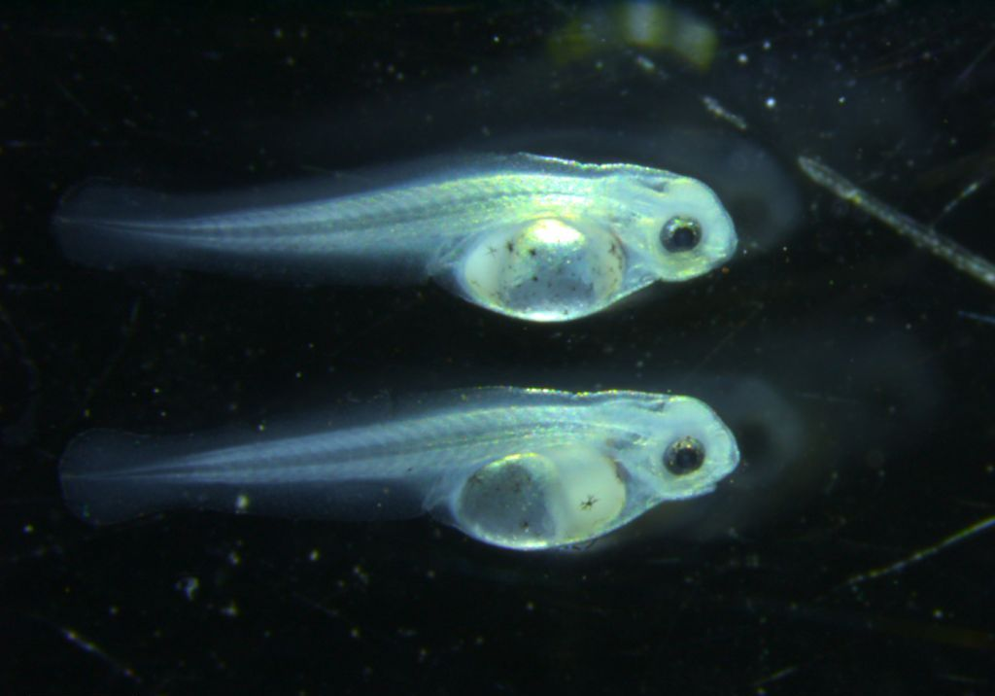

Plate 3 Golden perch larvae from the Murrumbidgee River

### Results

No environmental watering actions were targeted at native fish spawning in the Murrumbidgee River in 2014-15. We predicted that native fish reproduction would be dependent on the shape of the hydrographs and the timing of flow delivery. Although no direct watering actions were undertaken, at least seven native fish species (Australian smelt, carp gudgeon, golden perch (*Macquaria ambigua)*, Murray cod, silver perch, trout cod and un-specked hardyhead) and two alien species (common carp and redfin perch (*Perca fluviatilis*)) were recorded spawning in the Murrumbidgee River in 2014-15. Larval fish catches were dominated by cod (*Maccullochella* spp.) and Australian smelt with abundances of both species peaking in November 2014. Overall there was limited evidence to support our prediction that the shape of the hydrographs and the timing of flow delivery would influence fish spawning, with key species including cod, golden perch and silver perch responding more strongly to water temperature and potentially day length cues than differences in river discharge ( see technical report).

We predicted that in-channel base flows (stable water levels) delivered in late spring and summer provide suitable conditions for the reproduction of equilibrium species (species that do not require flow peaks to trigger spawning; Murray cod and trout cod). Larval cod species were captured in the greatest abundance (*n* = 809), occurring at all six monitoring sites and were recorded over a relatively long period between October and December 2014. Cod species had the highest Catch Per Unit Effort in the Carrathool zone which had lower and more stable discharge rates during the monitoring period. As expected, water temperature was the key determinant of cod species larvae abundance, which increased with increasing temperature.

We predicted that in-channel freshes and bankfull events delivered in late spring and summer stimulate golden perch and silver perch reproduction. Based on egg captures, multiple spawning events occurred for both golden (November and December) and silver perch (December only) (Figure 6). A large peak in drift net CPUE in the Narrandera zone in early December was driven by high numbers of silver perch eggs (see Figure 6). Following a similar pattern to drift nets, light trap CPUE was initially high over the months of October and November with early catches dominated by Australian smelt in both zones. While CPUE was higher overall in the Narrandera zone, there was no evidence to support the prediction that silver perch or golden perch spawning required a specific peak in the hydrograph, with spawning occurring during normal irrigation and environmental water deliveries through the Narrandera and Carrathool zones. Based on the CART models, water temperature was the key driver of spawning by both silver and golden perch in the Murrumbidgee during periods of normal water operations.

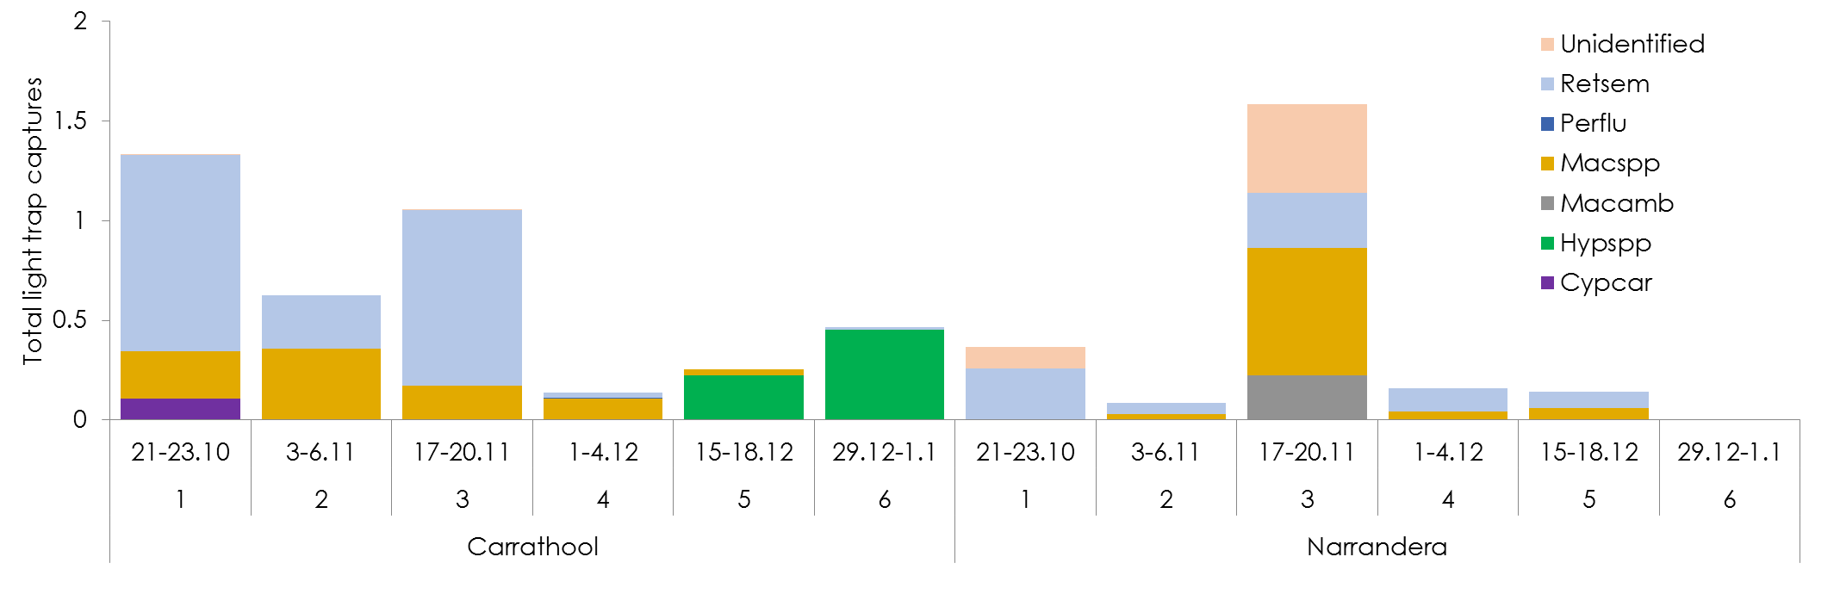

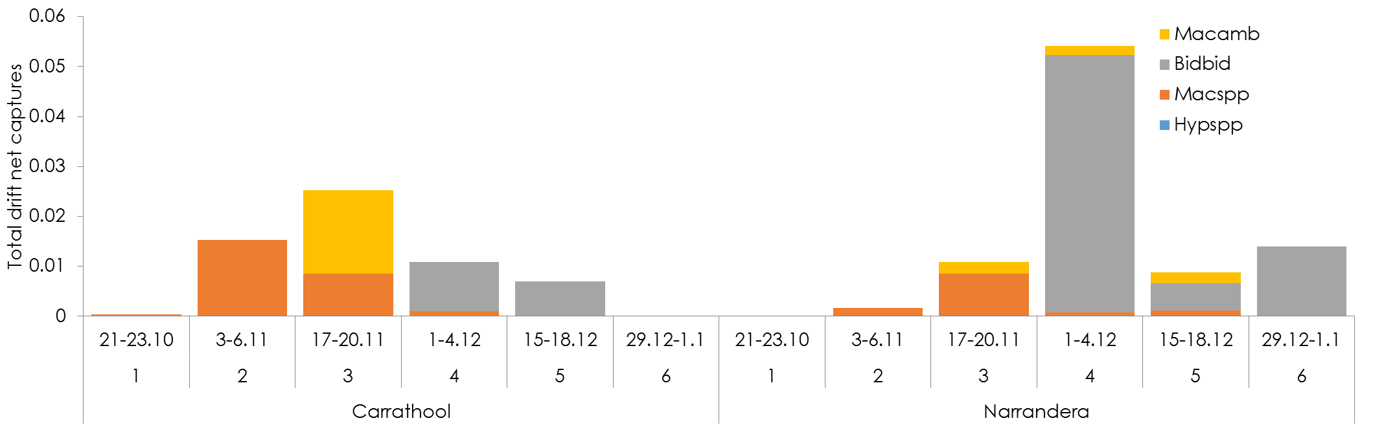

Figure 6 Total light trap CPUE (top) and total drift net CPUE (bottom) in the Carrathool and Narrandera zones over the six survey occasions between October and December 2014. Codes for fish larvae recorded included: Macamb - golden perch, bidbid- silver perch, Macspp.- Cod, RetSim -Australian smelt, perflu - redfin perch (exotic), hypspp - Carp gudgeon, cypcar –common carp (exotic). Note differences in scales on the y-axis

### Discussion

No targeted in-channel environmental watering occurred in the Murrumbidgee River in 2014-15. Nevertheless, positive identification of spawning through the capture of eggs, larvae and juveniles of at least seven native species of fish in 2014-15, encompassing both the Narrandera and Carrathool hydrological zones, represented an increase of two native species in comparison to previous in-channel monitoring during short-term intervention projects. For example, in 2013-14 Australian smelt, carp gudgeon and cod (*Maccullochella* spp.) larvae were captured at in-channel sites, but no silver or golden perch were recorded ([Wassens, Jenkins et al. 2014](#_ENREF_42)).

Larval cod species have been the most abundant species captured over the past three years of sampling in the Murrumbidgee River, demonstrating consistent peaks in captures from early-mid November in all years ([Wassens, Jenkins et al. 2013](#_ENREF_40), [Wassens, Jenkins et al. 2014](#_ENREF_42)). This synchronisation is an indication of consistent spawning responses to broad stimuli such as temperature or day length, and is characteristic of equilibrium species ([King, Humphries et al. 2013](#_ENREF_26)). The observed response in 2014-15 is consistent with our prediction that flow is not a major contributor to spawning by equilibrium species such as cod.

Given the short hatch times of golden perch and silver perch (~ 36 hrs; [Rowland (1983)](#_ENREF_36) ,[Rowland (1984)](#_ENREF_37)) and generally discrete spawning events, we would assume that fortnightly sampling under represents the level of spawning intensity by these species that occurred in 2014-15 in the Murrumbidgee River. Our data does not support the prediction that in-channel freshes and overbank flows were required to trigger spawning by these two species, with temperature cues being the most significant driver of spawning. However, given that few significant freshes or overbank flows have been monitored to date, it is still possible that spawning and larval survival would be higher in years when freshes and overbank flows coincide with the key spawning window for these species.

### Adaptive management and recommendations

Both golden and silver perch have been observed to spawn and recruit within river channels during a range of flows, and across a broad range of water temperatures ([Humphries, King et al. 1999](#_ENREF_22), [Mallen-Cooper and Stuart 2003](#_ENREF_29), [Balcombe, Arthington et al. 2006](#_ENREF_3), [Roberts and Rahel 2008](#_ENREF_35), [Ebner, Scholz et al. 2009](#_ENREF_15)). The triggers that stimulate in-channel spawning remain contentious, and records of spawning of both species occurred independently of any discernible river level rise and at stable bankfull summer irrigation flows in the Murray River (e.g. [Gilligan and Schiller (2003)](#_ENREF_19), [King, Crook et al. (2005)](#_ENREF_25), [Koster, Dawson et al. (2014)](#_ENREF_28). [Zampatti, Wilson et al. (2015)](#_ENREF_46) reported spawning of golden perch from October-December 2013 in the Goulburn, mid and lower Murray and lower Darling rivers coinciding with both the rising and descending limbs of the hydrograph. In the Murrumbidgee River as with other systems a range of factors including the size and condition of adult populations, water temperature and hydrological regime all potentially interact to influence spawning in a given year. Importantly the outcomes of 2014-15 indicate that spawning of large bodied native fish species can occur during years of normal river operations, in zones where discharge levels are already relatively high due to irrigation and water in transit (environmental water, Inter Valley Transfers or consumptive purposes.) to other parts of the system. It is important to note that this monitoring project is restricted to the Narrandera and Carrathool zones of the Murrumbidgee River and does not include assessment of spawning further downstream, in areas which may be affected by reduced discharge levels. Further assessment of the extent of hydrological alterations, the status of resident fish communities and spawning patterns under a range of flow conditions would improve our capacity to plan environmental water deliveries to areas downstream of Carrathool and predict ecological outcomes. The key recommendation that can be drawn from 2014-15 when planning in-channel flows to target native fish responses is the importance of assessing the dominant hydrological regime and identifying the critical components of the hydrograph that have changed due to river regulation. In the absence of high irrigation flows that provide in-channel hydrodynamic diversity, in other river systems targeted environmental flow has been linked to spawning in flow-cued species such as golden and silver perch.

## Vegetation diversity

Plants growing in rivers, wetlands and floodplains are influenced by a range of factors including climate, geomorphology and inundation history ([Brock, Nielsen et al. 2003](#_ENREF_8)). The water regime controls hydrological conditions specific to a site (depth, timing, and duration) interacting with the local climate conditions such as temperature and light to influence the growth of plants ([Brock and Casanova 1997](#_ENREF_7), [Brock, Smith et al. 1999](#_ENREF_9), [Casanova and Brock 2000](#_ENREF_12), [Capon and Brock 2006](#_ENREF_11)). Through the Murrumbidgee wetlands and floodplains, changes to water management including the construction of large headwater dams, regulation of flow and water diversions has reduced the natural frequency of inundation of wetlands and floodplains, and these impacts were exacerbated by the millennium drought 2000-2010. With the exception of (less frequently occurring) unregulated flow events, environmental watering is currently the principle mechanism by which low to mid-level wetlands and floodplains receive water. The response of understorey vegetation communities to two environmental watering actions were assessed in the mid-Murrumbidgee, Redbank and Nimmie-Caira zones on four occasions (September 2014, November 2014, January 2015 and March-May 2015).

We considered two key questions in our evaluation:

1. What did Commonwealth environmental water contribute to vegetation species diversity?
2. What did Commonwealth environmental water contribute to vegetation community diversity?

We predicted that:

* Commonwealth environmental watering actions that increase water levels within wetlands and inundate fringing habitats will promote the germination, growth and flowering of aquatic and semi-aquatic vegetation.
* Commonwealth environmental watering actions will contribute to the reestablishment and maintenance of diverse native aquatic and semi-aquatic vegetation communities, with the rate of reestablishment also influenced by historical management of flows (historical wetting and drying patterns).
* The response of aquatic and semi-aquatic vegetation communities following Commonwealth environmental watering actions will play a key role in providing habitat to support breeding and recruitment of wetland species, including frogs, small-bodied native fish, and waterbirds.

### Results

Species diversity is a measure of the number of individual plant species recorded across each wetland over the four survey occasions. Commonwealth environmental water can contribute to vegetation species diversity by enabling growth and reproduction of wetland species, contributing to the replenishment of wetland seedbanks, and maintaining the viability of perennial species. As predicted, Commonwealth environmental watering actions that increased water levels within wetlands and inundated fringing habitats promoted the germination, growth and flowering of aquatic and semi-aquatic vegetation.

Across all surveys and wetlands 169 predominantly understory plants were recorded, including 122 native species and 47 exotic species. There have been no published studies on native species diversity across the Lowbidgee floodplain and as a result it is not possible to comment on the level of nativeness, however trends in species richness will be explored in future years. Environmental watering in the mid-Murrumbidgee wetland, Yarradda Lagoon, promoted the emergence and growth of important native wetland species including slender knotweed (*Persicaria decipien*s), spiny mudgrass (*Pseudoraphis spinescens*) and common spikerush (*Eleocharis acuta*). The presence of spiny mudgrass in Yarradda Lagoon following environmental watering in 2014-15 is highly significant as this is the first record of this species in Yarradda Lagoon since monitoring commenced in 2010 ([Wassens, Bindokas et al. 2013](#_ENREF_39)), demonstrating the value of repeated watering as a means of re-establishing key native species. The presence of spiny mud grass at Yarradda Lagoon demonstrates that Commonwealth environmental watering actions can contribute to the reestablishment and maintenance of diverse native aquatic and semi-aquatic vegetation communities, with the rate of reestablishment influenced by historical management of flows (historical wetting and drying patterns). As this is the first year of vegetation surveys in the Redbank and Nimmie-Caira wetlands we are unable to make an assessment on reestablishment rates at this stage.

Two wetlands in the mid-Murrumbidgee, Sunshower and McKenna’s lagoons, that remained dry throughout the monitoring period were dominated by exotic weed species including spear thistle (*Cirsium vulgare*), prickly lettuce (*Lactuca serriola*), exotic grasses, as well as river red gum encroachment (*Eucalyptus camaldulensis*)().

In the Lowbidgee floodplain wetlands the response to environmental watering actions was rapid (), driven largely by the growth in spike rush from perennial rhizomes. The aquatic communities established with a range of native aquatic and semi-flood dependent species recorded (see technical report for full details). The culturally significant species, common sneezeweed (*Centipeda cunninghamii*) (Gukwonderuk, Budhaay) was also abundant at all wetlands that received environmental water.

***Vegetation communities***

A vegetation community is a distinct association of species, and maintaining a diversity of vegetation communities requires environmental watering to be undertaken across a range of different areas or wetland types. In 2014-15 watering actions targeted a range of wetland types, each supporting its own unique vegetation community. Vegetation communities were monitored across three distinct areas (zones), Redbank, Nimmie-Caira and mid-Murrumbidgee (Plate 6*.*)). As expected, each zone supported its own unique mix of native flora (see ([Wassens, Thiem et al. 2015](#_ENREF_43)) Murrumbidgee Technical report section 3.10). Commonwealth environmental watering contributed to germination, growth and reproduction across multiple vegetation communities, thereby helping to maintain their unique character.

|  |
| --- |
| **Mckenna Lagoon 2000 image1 (2).jpg 2001** |
| **D:\Users\swassens\Documents\Photopoints\Feild sites\Murrumbidgee\MCkennas JR quadrat markers 9th Feb 2011 024 (2).jpg 2011** |
| **D:\Users\swassens\Documents\Photopoints\Feild sites\Murrumbidgee\January 2015\MCK3nw.JPG 2015** |

Plate 4 McKenna’s Lagoon 2001(photo James Maguire) (top), 2011 (middle) and 2015 (bottom) showing progression of river red gum following hydrological modification.

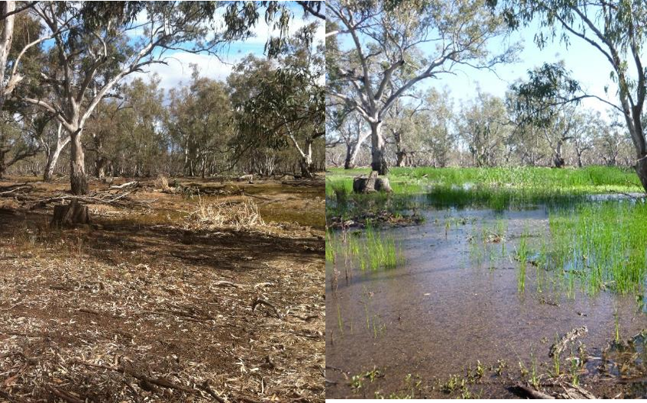

Plate 5 Rapid growth of common spikerush (*E. acuta*) at Two Bridges Swamp in the Redbank system from September 2014 (left) to November 2014 (right).

|  |  |
| --- | --- |
| Twin Bridges Swamp nov 08 003.jpg  (a) River red gum- spike rush community (Redbank) | lignum veg community.jpg  (b) Lignum-black box (Nimmie-Caira) |
| 061.JPG  (c) Seasonally inundated oxbow lagoon river red gum (mid-Murrumbidgee) |  |

Plate 6 Examples of water dependent vegetation communities in the Murrumbidgee Selected Area from ([Wassens, Jenkins et al.](#_ENREF_41))

### Discussion

The majority of wetlands in the mid-Murrumbidgee contain substantially different communities when compared to previous monitoring in 2000 ([Chessman 2003](#_ENREF_13)). There have been losses of key wetland species including common spike rush, and river red gum encroachment and weed invasion is a significant problem at dry wetlands. These declines can be directly attributed to long-term changes in the wetland hydrological regime, including significant reductions in the frequency of inundation ([Frazier, Page et al. 2005](#_ENREF_17), [Page, Read et al. 2005](#_ENREF_31), [Frazier and Page 2006](#_ENREF_16)), cumulating in dry periods that far exceeded the tolerance limits of perennial rhizomes and wetland seedbanks ([Reid and Capon 2011](#_ENREF_33)). The mid-Murrumbidgee wetlands make a significant contribution to the diversity of vegetation species and communities across the Murrumbidgee Selected Area. Reinstating natural hydrological regimes at a sufficient number of sites to represent the range of aquatic vegetation communities present across the Murrumbidgee is critical if Commonwealth environmental water is to make a significant contribution to maintaining the diversity of vegetation communities. Key sites in the Murrumbidgee including Yarradda, Gooragool, Sunshower and McKenna’s Lagoons should be a high priority for future watering activities.

There have been no published assessments of vegetation communities in the Lowbidgee floodplain (Redbank and Nimmie-Caira). Therefore, it is not possible to evaluate outcomes of the 2014-15 watering actions relative to previous years. These evaluations will be undertaken in 2019 when a longer-term dataset has been established. However, the rapid growth of dominant wetland species such as tall spike rush and common spike rush were consistent with observations in previous studies e.g. ([Reid and Capon 2011](#_ENREF_33)) and indicate the perennial rhizomes of these taxa remain in good condition. It is not possible to make an assessment on the quality of the response of vegetation communities as there have been no similar studies addressing positive or negative characteristics of vegetation responses in freshwater wetlands.

### Adaptive management and recommendations

This monitoring project demonstrated that relatively small scale infrastructure assisted water deliveries aided the recovery at Yarradda Lagoon this year allowing for the reestablishment of spiny mud grass. Spiny mud grass only persists for short period (approximately 2-3 years) when the wetland is dry and requires annual or near annual watering to persist ([Roberts and Marston 2011](#_ENREF_34)). Given this it is likely that the seeds or fragments originated from another area and were transferred into the wetland during watering. It is noted that high abundances of spiny mudgrass occur along irrigation canals used to transfer water to Yarradda Lagoon and it is possible that the delivery of water via the canals and pump might have facilitated the transfer of seeds or propagules into the wetland. However, common spike rush was formerly common and widespread in the mid-Murrumbidgee wetlands ([Chessman 2003](#_ENREF_13)), while today it is rare. There have been no studies on the rate of recovery of common spike rush following reinstatement of the hydrological regime, but there is strong evidence that the loss of perennial rhizomes and diminished seed banks have contributed to the poor rate of recovery in some wetlands of the mid-Murrumbidgee, as recorded in more frequently watered wetlands through the Lowbidgee floodplain (e.g. ([Reid and Capon 2011](#_ENREF_33)). Reinstatement of the natural hydrological regime, with seasonal inundation and occasional, brief drying periods is critical to promote reestablishment and maintain resilience of aquatic vegetation communities in the mid-Murrumbidgee. Where natural flow regimes cannot be achieved through reconnection with the river, infrastructure facilitated delivery of water may be a viable means of maintaining vegetation communities, although this is impracticable as a means of maintaining the majority of sites (CEWO pers. comm.).

River red gum encroachment is a serious problem at wetlands where the natural wetting and drying regime has been altered, resulting in wetlands remaining dry for extended periods. There is evidence of significant encroachment at both McKenna’s and Sunshower Lagoons in the mid-Murrumbidgee. Repeat environmental watering is one of the principle mechanisms for controlling river red gum encroachment into wetlands and is a high priority for encroached sites in the mid-Murrumbidgee. The tolerance of river red gums to inundation duration increases with age, once seedlings achieve a height of 50 cm they can tolerate six months of inundation ([Roberts and Marston 2011](#_ENREF_34)). River red gums at McKenna’s and Sunshower Lagoons are now over 130cm and as a result may require far longer periods of inundation to promote natural thinning processes. Once thinning has been achieved, reinstating the natural hydrological regime, which through the mid-Murrumbidgee LTIM monitoring sites consisted of annual or near annual inundation will assist in preventing future river red gum encroachment and promote the recovery of aquatic species. The key recommendations arising from monitoring in 2014-15 is to reinstate the natural hydrological regime to wetlands in the mid-Murrumbidgee floodplain. For the LTIM monitoring wetlands, Gooragool, Mckennas and Sunshower this involves seasonal inundation and occasional, brief drying periods, while for Yarradda Lagoon this involves seasonal inundation and the maintenance of permanent refuge pool. Restoring natural hydrological regimes will encourage natural thinning of river red gum seedlings, prevent river red gum encroachment and promote reestablishment and maintain resilience of aquatic vegetation communities.

## Waterbird diversity

Wetlands in the Murrumbidgee Catchment are widely recognised for their importance for waterbirds, providing breeding habitat for colonially-nesting waterbirds and habitat for waterbird species listed as threatened under the Commonwealth EPBC Act 1999 or under migratory bird agreements Australia has with Japan (JAMBA), China (CAMBA) and the Republic of Korea (ROKAMBA). In 2014-15 the key objective of the Commonwealth environmental watering actions in the Murrumbidgee Catchment in relation to waterbirds was to “*provide habitat for waterbirds, native fish and other aquatic vertebrates*” across Actions 2 and 6, where Action 2 involved the use of infrastructure to reconnect parts of the mid-Murrumbidgee wetlands and Action 6 aimed to inundate wetlands within the Lowbidgee floodplain. We undertook quarterly ground surveys for waterbirds in the mid-Murrumbidgee, Nimmie-Caira and Redbank zones in 2014-15 alongside wetland fish, frog, microinvertebrate and nutrient monitoring in the 12 Murrumbidgee LTIM wetland sites. These surveys ultimately contributed to adaptive management of several watering actions, by building a case for expanded watering in terms of duration and the number of sites targeted.

The results of these surveys were used to assess responses in waterbird species diversity, abundance and breeding activity to the delivery of Commonwealth environmental water. These surveys followed on from quarterly monitoring of waterbirds across the Murrumbidgee Catchment since 2008. The 2014-15 surveys were complemented by regular surveys by NSW OEH and CEWO staff during the same time period across a greater spread of sites in the three zones and the neighbouring Western Lakes.

#### The Basin scale evaluation questions that relate to waterbirds across the long-term (five year) are:

1. What did Commonwealth environmental water contribute to waterbird populations?
2. What did Commonwealth environmental water contribute to waterbird species diversity?

#### Predictions:

* Local increases in waterbird diversity in response to Commonwealth environmental watering
* Local increases in waterbird abundance in response to Commonwealth environmental watering
* Local increases in waterbird species of conservation significance (i.e. threatened species, JAMBA, CAMBA and ROKAMBA species) in response to Commonwealth environmental watering.

### Results

We predicted that local increases in waterbird diversity would occur in response to Commonwealth environmental watering and this prediction was supported by the data. Overall, 36 waterbird species were observed across the 12 Murrumbidgee LTIM wetland survey sites. Waterbird diversity and abundance peaked in January 2015 when the extent of flooding was greatest.

We predicted that Commonwealth environmental watering would contribute to local increases in waterbird species of conservation significance (i.e. threatened species, JAMBA, CAMBA and ROKAMBA species). This prediction was supported in the Lowbidgee floodplain (Action 6) with records of two species listed on two or more international bilateral migratory bird agreements (JAMBA, CAMBA and ROKAMBA), the Eastern great egret (Ardea modesta) and sharp-tailed sandpiper (Calidris acuminata)) along with the nationally endangered Australasian bittern (Botaurus poiciloptilus) (EPBC Act).

We predicted that there would be local increases in waterbird abundance in response to Commonwealth environmental watering and this was supported by the data for both Yarradda Lagoon (Action 2) in the mid-Murrumbidgee and the Lowbidgee floodplain (Action 6). When Yarradda Lagoon received water in December 2014, large numbers of pink-eared ducks (*Malacorhynchus membranaceus)* were recorded. Overall fish-eating waterbirds and dabbling ducks were the most abundant functional groups and we tested the relationship between the abundance of these key groups and wetland hydrology, food availability, vegetation cover, and water quality using CART models (see technical report). This analysis identified that wetlands with water depth greater than 0.51 m and the highest densities of fish supported more fish-eating waterbirds compared to shallow, drying wetlands. In contrast, water depth was not a significant driver of the abundance of filter-feeding duck species, such as pink-eared ducks and Australasian shovelers (*Anas rhynchotis)* but the availability of food resources, mainly benthic microinvertebrates, was the key driver for total numbers of this feeding guild.

These results support our prediction that local increases in waterbird abundance would occur in response to environmental watering.

### *Discussion*

Overall waterbird diversity was lower than in previous years ([Wassens, Jenkins et al. 2013](#_ENREF_40), [Wassens, Jenkins et al. 2014](#_ENREF_42)), reflecting the comparably small extent of environmental water across the entire Lowbidgee and mid-Murrumbidgee floodplain compared to previous years. Previous spring ground survey data collected in the Lowbidgee floodplain has shown an increase in waterbird diversity, abundance and number of broods in response to greater wetland area ([Spencer, Thomas et al. 2011](#_ENREF_38)) which aligns with the findings of broader scale annual aerial surveys ([Bino, Jenkins et al. 2013](#_ENREF_4)) across the Murray-Darling Basin. Equally, colonial waterbird breeding, including the total number of nesting birds and number of active colony sites, can be linked to total wetland area, with large-scale waterbird breeding occurring in years when total wetland area and associated wetland productivity is high across the Murrumbidgee selected area ([Wassens, Jenkins et al. 2014](#_ENREF_41)). With respect to the evaluation of the contribution of Commonwealth environmental water to (1) waterbird populations; breeding activity and long-term population trends are a more important indicator than the local abundance of waterbirds within individual wetlands and this question can be addressed following multiple years of environmental water use across the Murray-Darling Basin as more data is collected through complementary aerial surveys conducted by the University of New South Wales across the MDBA targeted wetlands and long-term aerial waterbird surveys of Eastern Australia ([Bino, Steinfeld et al. 2014](#_ENREF_5)).

The evaluation of waterbird responses to watering in 2014-15 did demonstrate the importance of food availability and underlying wetland productivity in supporting waterbird diversity particularly for species relying on fish and microinvertebrates. Demonstrating which Commonwealth environmental watering actions maintain or improve the overall condition of the floodplain is likely to assist in demonstrating which actions have follow on benefits for waterbirds.

Although waterbird breeding was not monitored in 2014-15, small-scale egret, heron and cormorant breeding was reported following aerial and ground surveys by NSW OEH and CEWO staff at seven sites across the Lowbidgee floodplain, including Two Bridges Swamp, in the Redbank system and Telephone Creek in the Nimmie-Caira. The duration of flooding was extended in these sites through the delivery of Commonwealth environmental water allowing birds to complete their nesting cycles. Waterbird breeding, including the total number of nesting birds and number of active breeding sites is linked to the total flooded area. Large-scale waterbird breeding does not occur in years when only small areas are inundated. Successful waterbird breeding contributes to the persistence of waterbird populations and the successful small scale breeding events recorded across the floodplain, attributed to Commonwealth environmental water in 2014-15, indicate that Commonwealth environmental water could make a significant contribution to waterbird populations at a larger scale.

### Adaptive management and recommendations

Several approaches to environmental water management can be taken to maximise outcomes for waterbirds depending on the water availability scenario for a given water year. Using environmental flows to inundate large areas, covering a range of wetland types to varying depths can cater for the water requirements of a range of waterbird species and therefore maximise waterbird diversity outcomes ([Bino, Steinfeld et al. 2014](#_ENREF_5)). Creating a diversity of habitats including areas of shallow water and muddy wetland margins can also support species such as sharp-tailed sandpipers recognised by international migratory agreements (JAMBA, CAMBA and ROKAMBA) as observed over summer months in parts of the Nimmie-Caira.

Timing flows to inundate these types of shallow habitats in spring with a long draw-down phase over autumn has the potential to provide feeding habitat for migratory shorebirds during both their southward and northward migrations ([Kingsford and Auld 2005](#_ENREF_27)), as well as potentially stimulating high densities of microinvertebrate prey for filter feeding ducks. In all cases, considering the historical wetting and drying regime is essential for each wetland type so that they can be watered to maximise the associated wetland vegetation and the food sources on which waterbirds depend. It is important to note that large-scale colonial waterbird breeding in the Murrumbidgee generally requires large areas of wetland (>20,000 ha) to be inundated ([Wassens, Jenkins et al. 2014](#_ENREF_41)). In years of high and median water availability large-scale watering over winter and spring in the Murrumbidgee and neighbouring catchments can be used to prime the systems for potential breeding in subsequent spring-summer months, particularly if environmental watering is followed by natural tributary flows in the system.

For active sites, the use of contingency allowances to support waterbird breeding can be crucial for ensuring the colony sites and surrounding foraging habitats are flooded for long enough to allow birds to fledge their young successfully. This approach can also keep key breeding and feeding sites in ‘event-ready’ condition in intervening years between large-scale natural flooding, particularly in parts of the Nimmie-Caira floodways and associated feeding grounds which traditionally can support some of the largest ibis colonies in Australia.

To maximise outcomes for waterbirds in subsequent water years we recommend Commonwealth environmental water be delivered:

1. where possible, to inundate wetlands in the Murrumbidgee Selected Area over late winter through spring and summer to coincide with peak activity of most waterbird species.
2. to support colonial waterbird breeding in the Mid-Murrumbidgee, Nimmie-Caira and Redbank zones to ensure colony sites and surrounding foraging habitats are flooded for long enough to allow birds to raise and fledge their young successfully.
3. to inundate a range of wetland types to varying depths as this can maximise waterbird diversity outcomes by satisfying the water requirements of a range of waterbird species.
4. where practical, to create a long draw-down phase over summer-autumn in shallow open wetlands to provide feeding habitat for resident and migratory shorebirds.
5. strategically to maintain and/restore vegetation in known waterbird breeding sites and maximise productivity in feeding habitats so that they are ‘breeding ready’ in the event of natural flooding.

## Other vertebrate diversity - Frogs and tadpoles

Frogs and their tadpoles are important components of wetland ecosystems. The response of frogs to environmental watering is influenced by the timing and duration of the inundation, as well as wetland characteristics such as aquatic vegetation cover and flooding frequency. Most frog species in the mid and lower Murrumbidgee catchment wetlands prefer still or slow moving water, particularly for breeding. Environmental watering actions targeting wetlands can provide benefits for frogs and their tadpoles and are important to the survival of flow-specialist species, such as the vulnerable southern bell frog (*Litoria raniformis*).

#### Commonwealth environmental watering actions for the Murrumbidgee River system in 2014-15 related to frogs were Action 2 – mid-Murrumbidgee reconnection (infrastructure assisted) and Action 6 – Lowbidgee – wetlands. Nine of the 12 LTIM monitoring wetlands received environmental water in 2014-15, while one, Gooragool Lagoon in the mid-Murrumbidgee received drainage water from nearby irrigation operations. The remaining two wetlands, McKenna’s and Sunshower lagoons in the mid-Murrumbidgee zone remained dry. The LTIM project is designed to evaluate both long (5 year) and short (1 year) contributions of Commonwealth environmental water:

Long-term (five year) questions:

1. What did Commonwealth environmental water contribute to other aquatic vertebrates (frog and turtle) diversity and populations?

Short-term (one year) questions:

1. What did Commonwealth environmental water contribute to breeding and recruitment of other vertebrates?
2. What did Commonwealth environmental water contribute to the provision of habitat to support breeding and recruitment of other vertebrates?
3. What did Commonwealth environmental water contribute to the maintenance of refuge habitats for other aquatic vertebrates?

With respect to these evaluation questions we predicted that there would be:

* Increases in tadpole abundance at wetlands receiving Commonwealth environmental water (within year)
* Increases in abundance of key species (including southern bell frog) between year 1 and year 5
* Increases in distribution of frogs species across wetlands targeted with Commonwealth environmental water

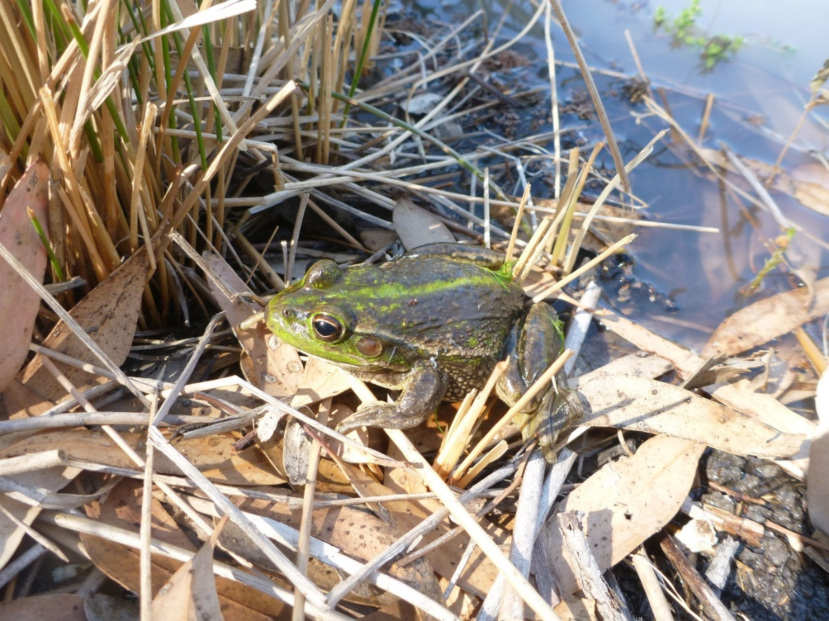

Plate 7 Southern bell frog (*Litoria raniformis*) Vulnerable EPBC Act (Commonwealth) 1999, Avalon Swamp November 2014

### Results

We predicted that there would be an increase in the distribution of frog species across wetlands targeted with Commonwealth environmental water and this prediction was supported by the data. Overall 2,212 adult frogs (seen and heard) and 1,100 tadpoles of six species were recorded between September 2014 and May 2015 across 10 LTIM monitoring sites, with two sites remaining dry throughout 2014-15. Adult barking marsh frogs (*Limnodynastes fletcheri*), spotted marsh frogs (*Limnodynastes tasmaniensis*), plains froglets (*Crinia parinsignifera*) were recorded in all three zones. Peron’s tree frogs (*Litoria peronii*), inland banjo frogs (*Limnodynastes* *interioris*) were less widespread, while the vulnerable southern bell frog (*Litoria raniformis*) had the most restricted distribution, only occurring across the four Nimmie-Caira sites.

New South Wales environmental watering targeted known habitats of the southern bell frog in the Nimmie-Caira zone. We predicted that there would be an increase in abundance of key species (including southern bell frog) between year 1 and year 5. Calls and tadpoles of southern bell frogs and other frog species were recorded at all four LTIM monitoring wetlands in the Nimmie-Caira, indicating that these flows were successful in creating breeding opportunities for this nationally vulnerable species, and other floodplain frog species (see technical report). Commonwealth environmental watering targeted one wetland (Yarradda Lagoon) in the mid-Murrumbidgee wetland systems (Action 2). Inland banjo frog adults and tadpoles were recorded in this wetland for the first time since monitoring commenced in 2010. Large numbers of Peron’s tree frog tadpoles were also recorded. Five freshwater turtles were recorded.

Twenty-eight freshwater turtles were captured during the study. Twenty-seven of these were eastern long neck turtles, distributed across all the sites, with one broad shelled turtle recorded at Wagourah Lagoon.

***Tadpoles***

We predicted that there would be an increase in tadpole abundance at wetlands receiving Commonwealth environmental water. This prediction was supported, with frog breeding outcomes strongly linked to the proportion of the wetland inundated area. The average tadpole abundance was highest once environmental watering of wetlands inundated more than 65 per cent of the total wetland area. Some breeding did occur at sites with lower levels of inundation, including Yarradda Lagoon in the mid-Murrumbidgee zone, and in these instances the high abundance of tadpoles could be linked to high biomass of pelagic microinvertebrates.

### Discussion

While it is too early in the project to make a definitive assessment of the contribution of Commonwealth environmental water to the diversity and populations of other aquatic vertebrates (frog and turtle), our monitoring recorded all key wetland species and noted an increase in frog diversity at Yarradda Lagoon in the mid-Murrumbidgee due to the re-colonisation of the site by the inland banjo frog. As predicted frog breeding responses (tadpole abundance) were strongly influenced by the area of wetland inundation with frogs requiring a minimum of 65 per cent of the wetland to be inundated before a strong breeding response was triggered. Commonwealth environmental water made a significant contribution to breeding and recruitment of other vertebrates as well as providing supporting habitat.

New South Wales environmental watering targeted known habitats of the southern bell frog in the Nimmie-Caira zone (Action 6). Calling and tadpoles of southern bell frogs and other frog species were recorded at all four LTIM monitoring wetlands in the Nimmie-Caira, indicating that these flows were successful in created breeding opportunities for this nationally vulnerable species and other floodplain frog species. These outcomes provide a baseline for our prediction that there will be an increase in abundance of key species (including southern bell frog) between year 1 and year 5 and demonstrate that Commonwealth environmental water has the potential to contribute to the provision of habitat to support breeding and recruitment of other vertebrates as well as contributing to the maintenance of refuge habitats for other aquatic vertebrates.

### Adaptive management and recommendations

Environmental water is the principle mechanism by which wetlands through the mid–Murrumbidgee and Lowbidgee floodplain currently receive water and careful management of water regimes is critical to the persistence of populations of the vulnerable southern bell frog and other frog species. Southern bell frogs in particular have highly specialised requirements, including both areas of persistent water to act as a refuge during dry period and large areas of shallow, intermittently inundated wetlands that retain water for a minimum of four to six months over late spring and summer. In addition, water temperature can influence breeding, and in the Redbank zone there is some anecdotal indication that lower water temperatures related to greater water depth might have contributed to reductions in breeding activity by southern bell frog, as has been shown for the closely related green and golden bell frog ([Pyke and White 1996](#_ENREF_32)), but this requires further study to fully test this relationship.

Commonwealth environmental watering targeted one wetland (Yarradda Lagoon) in the mid-Murrumbidgee wetland systems (Action 2). Yarradda Lagoon received water in summer 2014-15 and the dominant species responding to this watering action was the Peron’s tree frog which is most active in summer months. Considerably more tadpoles were recorded in Yarradda Lagoon in 2014-15 than recorded in previous surveys, potentially because the pumping of water also resulted in very low abundance of common carp, compared to previous years.

There are a number of recommendations that can be drawn from the 2014-15 monitoring. (1) During dry periods, permanent refuge habitat in the form of dams, creek lines and deep sections of seasonally inundated wetlands are critical to the persistence of southern bell frog populations. Identification of refuges, such as Telephone Creek and Wagourah Lagoon and the forward allocation of environmental water to maintain persistent refugees even during years of very low water availability is critical for southern bell frogs along with native fish and freshwater turtles. (2) Southern bell frogs have declined through river red gum wetlands in the Redbank system, where they were historically abundant and widespread. Such a large decline of a listed vulnerable species is a serious concern. There are a number of factors that may have contributed to these declines including altered wetland hydrology, periods of hypoxic black water and the establishment of oriental weather loach populations.

# References

Anderson, H. K. (1915). "Rescue Operations on the Murrumbidgee River." The Australian Zoologist **1**: 157-160.

Arthington, A. H. and B. Pusey (2003). "Flow restoration and protection in Australian rivers." River Research and Applications **19**(5-6): 377-395.

Balcombe, S. R., A. H. Arthington, N. D. Foster, M. C. Thoms, G. G. Wilson and S. E. Bunn (2006). "Fish assemblages of an Australian dryland river: abundance, assemblage structure and recruitment patterns in the Warrego River, Murray-Darling Basin." Marine and Freshwater Research **57**: 619-633.

Bino, G., K. Jenkins and R. T. Kingsford (2013). Adaptive management of Ramsar wetlands. Gold Coast., National Climate Change Adaptation Research Facility.

Bino, G., C. Steinfeld and R. T. Kingsford (2014). "Maximizing colonial waterbirds' breeding events using identified ecological thresholds and environmental flow management." Ecological Applications **24**(1): 142-157.

Brandis, K., S. Ryall and R. T. Kingsford (2011). Lowbidgee 2010/2011 Colonial Waterbird Breeding. Final Report prepared for the Lowbidgee League, Australian Wetland and Rivers Centre, University of New South Wales.

Brock, M. A. and M. T. Casanova (1997). Plant life at the edge of wetlands: ecological responses to wetting and drying patterns. Frontiers in ecology: building the links. N. Klomp and I. Lunt. Oxford, UK.

Brock, M. A., D. L. Nielsen, R. J. Shiel, J. D. Green and J. D. Langley (2003). "Drought and aquatic community resilience: the role of eggs and seeds in sediments of temporary wetlands." Freshwater Biology **48**(7): 1207-1218.

Brock, M. A., R. G. B. Smith and P. J. Jarman (1999). "Drain it, dam it: alteration of water regime in shallow wetlands on the New England Tableland of New South Wales, Australia." Wetlands Ecology and Management **7**(1): 37-46.

Cadwallader, P. L. (1977). J.O. Langtry's 1949-50 Murray River investigations, Fisheries and Wildlife Division, Victoria.

Capon, S. J. and M. A. Brock (2006). "Flooding, soil seed bank dynamics and vegetation resilience of a hydrologically variable desert floodplain." Freshwater Biology **51**(2): 206-223.

Casanova, M. T. and M. A. Brock (2000). "How do depth, duration and frequency of flooding influence the establishment of wetland plant communities?" Plant Ecology **147**(3): 237-250.

Chessman, B. (2003). Integrated monitoring of environmental flows: state summary report 1998-2000. NSW, NSW Department of Infrastructure, Planning and Natural Resources.

Commonwealth Environmental Water Office (2014). Commonwealth environmental water use options 2014-15: Murrumbidgee River Valley. Canberra, Commonwealth of Australia.

Ebner, B. C., O. Scholz and B. Gawne (2009). "Golden perch Macquaria ambigua are flexible spawners in the Darling River, Australia." New Zealand Journal of Marine and Freshwater Research **43**(2): 571-578.

Frazier, P. and K. Page (2006). "The effect of river regulation on floodplain wetland inundation, Murrumbidgee River, Australia." Marine and Freshwater Research **57**(2): 133-141.

Frazier, P., K. Page and A. Read (2005). "Effects of flow regulation in flow regime on the Murrumbidgee River, South Eastern Australia: an assessment using a daily estimation hydrological model." Australian Geographer **36**(3): 301-314.

Gilligan, D. (2005). "Fish communities of the Murrumbidgee catchment: status and trends." NSW Department of Primary Industries. Fisheries final report series(75): 138.

Gilligan, D. and S. Schiller (2003). "Downstream transport of larval and juvenile fish." Fisheries Final Report Series **No. 50**: 66pp.

Hardwick, L. and J. Maquire (2012). Environmental water needs of the Lower Murrumbidgee (Lowbidgee) floodplain: Discussion Paper 1 - Approach and ecological considerations, NSW Office of Water.

Hilton, J., M. O'Hare, M. J. Bowes and J. I. Jones (2006). "How green is my river? A new paradigm of eutrophication in rivers." Science of the Total Environment **365**(1): 66-83.

Humphries, P., A. J. King and J. D. Koehn (1999). "Fish, flows and floodplains: links between freshwater fishes and their environment in the Murray-Darling River System, Australia." Environmental Biology of Fishes **56**(1): 129-151.

Jenkins, K. M. and A. J. Boulton (2003). "Connectivity in a dryland river: short-term aquatic microinvertebrate recruitment following floodplain inundation." Ecology **84**(10): 2708-2723.

Jenkins, K. M. and A. J. Boulton (2007). "Detecting impacts and setting restoration targets in arid-zone rivers: aquatic micro-invertebrate responses to reduced floodplain inundation." Journal of Applied Ecology **44**(4): 823-832.

King, A. J., D. A. Crook, W. M. Koster, J. Mahoney and Z. Tonkin (2005). "Comparison of larval fish drift in the Lower Goulburn and mid-Murray Rivers." Ecological Management & Restoration **6**(2): 136-139.

King, A. J., P. Humphries and N. G. McCasker (2013). Reproduction and early life history. Ecology of Australian Freshwater Fishes. Melbourne, CSIRO Publishing**:** 159-193.

Kingsford, R. T. and K. M. Auld (2005). "Waterbird breeding and environmental flow management in the Macquarie Marshes, arid Australia." River Research and Applications **21**(2-3): 187-200.

Koster, W. M., D. R. Dawson, D. J. O'Mahony, P. D. Moloney and D. A. Crook (2014). "Timing, frequency and environmental conditions associated with mainstem-tributary movement by a lowland river fish, golden perch (Macquaria ambigua)." PloS one **9**(5).

Mallen-Cooper, M. and I. G. Stuart (2003). "Age, growth and non-flood recruitment of two potamodromous fishes in a large semi-arid/temperate river system." River research and applications **19**(7): 697-719.

Murray, P. (2008). Murrumbidgee wetlands resource book. New South Wales, Murrumbidgee Catchment Management Authority.

Page, K., A. Read, P. Frazier and N. Mount (2005). "The effect of altered flow regime on the frequency and duration of bankfull discharge: Murrumbidgee River, Australia." River research and applications **21**: 567-578.

Pyke, G. H. and A. W. White (1996). "Habiat requirements for the green and golden bell frog *Litoria aurea* (Anura: Hylidae)." Australian Zoologist **30**(2): 224-232.

Reid, M. and S. Capon (2011). "Role of the soil seed bank in vegetation responses to environmental flows on a drought-affected floodplain." River Systems **19**(3): 249-259.

Roberts, J. and F. Marston ( 2011). Water regime for wetland and floodplain plants: a source book for the Murray-Darling Basin. Canberra, National Water Commission.

Roberts, J. J. and F. J. Rahel (2008). "Irrigation canals as sink habitat for trout and other fishes in a Wyoming drainage." Transactions of the American Fisheries Society **137**(4): 951-961.

Rowland, S. J. (1983). "Spawning of the Australian freshwater fish Murray cod, *Maccullochella peeli* (Mitchell), in earthen ponds." Journal of Fish Biology **23**: 525-534.

Rowland, S. J. (1984). "The hormone-induced spawning of silver perch, Bidyanus bidyanus (Mitchell)(Teraponidae)." Aquaculture **42**(1): 83-86.

Spencer, J., R. Thomas, S. Wassens, Y. Lu, L. Wen, J. Iles, Y. Kobayashi, S. Hunter, B. Alexander and N. Saintilan (2011). Testing wetland resilience: monitoring and modelling of flows in the Macquarie Marshes and Lowbidgee wetlands in 2009-11. Final report to the NSW Catchment Action Program, NSW Office of Environment and Heritage and Charles Sturt University.

Wassens, S., J. Bindokas, K. Jenkins, E. Lenon, J. Spencer, R. J. Watts, T. Kobyashi, J. Iles, L. Baumgartner, R. Thomas and A. Hall (2013). Monitoring the ecological response of Commonwealth environmental water delivered in 2012-13 to the Murrumbidgee River. Report 1. Canberra, Commonwealth of Australia 2013.

Wassens, S., K. Jenkins, J. Spencer, J. Bindokas, T. Kobayashi, G. Bino, R. J. Watts, E. Lenon, R. Thomas, L. Baumgartner and A. Hall (2013). Monitoring of ecosystem responses to the delivery of environmental water in the Murrumbidgee River and connected wetlands, 2012-13. Final report 2 Commonwealth Environmental Water Office., Institute for Land, Water and Society, Charles Sturt University.

Wassens, S., K. Jenkins, J. Spencer, J. Thiem, T. Kobyashi, G. Bino, E. Lenon, R. Thomas, L. Baumgartner, K. Brandis, B. Wolfenden and A. Hall (2014). Murrumbidgee Monitoring and Evaluation Plan Canberra, Commonwealth of Australia

Wassens, S., K. Jenkins, J. Spencer, B. Wolfenden, J. Ocock, J. D. Thiem, E. Lenon, T. Kobayashi, G. Bino, R. Thomas, L. Baumgartner and A. Hall (2014). Monitoring and evaluating ecological responses to Commonwealth environmental water use in the Murrumbidgee River Valley, in 2013-14. Final Report. Canberra, Albury, Commonwealth Environmental Water Office and Charles Sturt University

Wassens, S., J. Thiem, J. Spencer, G. Bino, A. Hall, R. Thomas, K. Jenkins, B. Wolfenden, J. Ocock, E. Lenon, T. Kobayashi, J. Heath and F. Cory (2015). Long Term Intervention Monitoring Murrumbidgee Selected Area 2014-15 draft Technical report Canberra, Commonwealth of Australia

Wedderburn, S. D., K. F. Walker and B. P. Zampatti (2007). "Habitat separation of Craterocephalus (Atherinidae) species and populations in off-channel areas of the lower River Murray, Australia." Ecology of Freshwater Fish **16**(3): 442-449.

Wen, L., J. Ling, N. Saintilan and K. Rogers (2009). "An investigation of the hydrological requirements of River Red Gum (*Eucalyptus camaldulensis*) Forest, using Classification and Regression Tree modelling." Ecohydrology **2**(2): 143-155.

Zampatti, B. P., P. J. Wilson, L. Baumgartner, W. Koster, J. P. Livore, N. McCasker, J. Thiem, Z. Tonkin and Q. Ye (2015). Reproduction and recruitment of golden perch (Macquaria ambigua ambigua) in the southern Murray-Darling Basin in 2013-2014: an exploration of river-scale response, connectivity and population dynamics. Adelaide, South Australian Research and Development Institute (Aquatic Sciences).