# Namoi River watering event update 2

This is the second update on a watering event in the Namoi River downstream of Wee Waa (west of Narrabri). The flow commenced on Friday 9 November 2018, and will support native fish by refreshing and re-connecting waterholes for around 100 river km, to beyond Bugilbone.

## Objectives of this flow event

|  |  |  |  |
| --- | --- | --- | --- |
|  | Maintain and provide access to refuge habitat, increase connectivity, and improve water quality in pools. |  | Provide opportunities for the movement of native fish, and increase native fish survival. |

## Flows re-connecting waterholes

2018 has been very dry in the northern Murray-Darling Basin. The inflows into the Namoi system have been near record lows. Even under natural conditions, the lower reaches of the Namoi River are likely to have ceased-to-flow for extended periods this year.

|  |  |
| --- | --- |
| For over 55% of days so far in 2018, the flow downstream of Gunidgera Weir (near Wee Waa) has been less than 1 ML/day (effectively cease- to-flow). The Namoi River downstream of Gunidgera Weir last flowed in August. | Current flow  Cease-to-flow periods  Flow (ML/day) |

So - the Namoi River downstream of Wee Waa has been a tough place for even hardy native fish to live this year. Fish have spent most of the year in stagnant waterholes. Very soon there would be no remaining waterholes available for refuge unless they are refilled.

During extreme dry times such as these, the goal of use of water for the environment is often to avoid damage to key environmental assets. Native fish in the Namoi downstream of Wee Waa are a key environmental asset, and include endangered species listed under international, national and/or NSW law, including silver perch, and Murray cod. Freshwater catfish is also listed and may also be present. The aquatic community of the Namoi River also forms part of an ecological community that is listed as endangered under the *NSW Fisheries Management* Act 1994.

Tens of kilometres of habitat in the Namoi River have been replenished in the last week by a flow typically between 100 and 400 ML/day downstream of Gunidgera Weir. As a result of this use of water for the environment, the chance of fish survival will increase significantly, particularly between Wee Waa and Bugilbone.

|  |  |
| --- | --- |
| cid:9D1BDC99-F23D-4B3A-86D2-873F9D19B902 | C:\Windows\System32\config\systemprofile\Downloads\IMG_2539 (2).jpg |
| 18 September 2018 (0 ML/day) | 13 November 2018 (around 300 ML/day) 1 |

The distance downstream of Gunidgera Weir that the head of the flow has moved this week is shown below. This flow is expected to reach Bugilbone late next week.

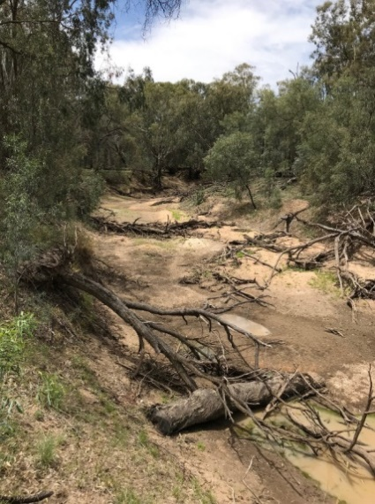2

Distance covered by the flow this week

When the flow passes, it will result in improved water quality and habitat within the replenished pools, and connection between pools. It will provide an improved opportunity for the remaining native fish to move and seek better refuges, either upstream or downstream of their current location.

## Water delivery – fitting in with the needs of others

The first update on this watering event (23 October 2018) reported that the plan was to deliver 5,500 ML to the river downstream of Gunidgera Weir, with a peak flow of 450 ML/day. This volume of water was about 15 percent of water being delivered in November and December: the rest being mainly for irrigation.

The Namoi storages (Keepit and Split Rock) have received ongoing near record low inflows in recent months. WaterNSW had challenges delivering the orders, and sought flexibility. Many water users, including the Commonwealth Environmental Water Office, have voluntarily agreed to modify their water orders. The CEWO agreed that the start of delivery of its water be delayed, with a lower peak flow.

Following persistence of dry conditions, on Wednesday 14 November, WaterNSW announced that tougher drought measures were necessary. The announcement included that Lower Namoi regulated river general security users have access to 85 percent of the water orders placed by 5 November 2018. This restriction applies to Commonwealth environmental water as well. Therefore, a reduced volume, of about 4,600 ML, will now be delivered. This means that the flow will not push as far downstream as previously hoped, with less chance of it reaching Walgett. Nonetheless, around 100 km of river habitat and aquatic life will benefit, which includes waterholes supporting endangered fish, so this is important. Some of the remaining water for the environment after the current watering action (around 1,300 ML) may be used to support silver perch between Gunnedah and Narrabri later in the year.

Some farmers with stock and domestic water licences between Wee Waa and Bugilbone may order water on top of this water for the environment. This is of mutual benefit, and will assist the flow to travel further. Flows are currently expected to conclude in mid-December. It is possible that the Namoi downstream of Wee Waa will revert to having disconnected waterholes during summer. However, in many years, there are additional summer flows from unregulated streams such as the Mooki River and Cox’s Creek, which can be very important.

## Fish in the Namoi

Native fish are important for social and cultural values, as well as environmental values. Overall, the fish community in the Namoi in 2015 was assessed as is in fair to poor condition. No spawning and recruitment has been recorded in the Namoi downstream of Wee Waa in the last few years.

However, looking back in time, an oral history titled ‘Talking Fish’ in the Namoi reported:

* *Fish are in great plenty on the Namoi, and several excellent catches have lately been made; Murray cod, yellowbellies and bream [silver perch] amply rewarding the disciple of the gentle art.* (clipping from The Maitland Mercury and Hunter River General Advertiser, 7 October 1873)
* *You’d see the…old catfish…you could see them through the water…it was that clear.* (1930s)
* *We used to catch a lot of fish. You know, catfish, the yellowbelly and the cod. You’d always get a feed of fish from the river, no trouble.* (1970s)

Over the last 20 years there have been relatively good catches of freshwater catfish between Keepit and Boggabri. However, there are currently thought to be very low numbers of catfish below Boggabri, as none have been detected during recent sampling over the last 3 years.

Endangered fish such as silver perch and Murray cod were sampled in the Namoi downstream of Wee Waa in autumn 2018.

|  |  |  |
| --- | --- | --- |
| Silver perch | | 3  Murray cod |
|  | In addition to the endangered species, smaller species such as bony bream and carp gudgeon are present in the Namoi River downstream of Wee Waa. Carp gudgeon are small opportunistic native fish that are unrelated to carp despite its name! Carp gudgeon are an important food source for larger fish. Carp gudgeons were photographed in late October in the waterhole just downstream of Gunidgera Weir (to the left) – seeking to move upstream even before the flow arrived. This highlights the need for effective fish passage for all shapes and sizes of fish. 4 | | |

## Monitoring currently underway in the Namoi

It is important to learn from reconnection flow events such as this. Monitoring is underway.

*Flow monitoring:* the event is being monitored using the gauge network and satellite tracking. The flow as passed Weeta Weir, and is on route to Bugilbone.

Water quality monitoring is being undertaken in an effort to better understand the quality of water within remnant waterholes in the river reach downstream of Gunidgera and risks associated with delivering environmental flows (potentially creating negative water quality impacts). DOI Water and WaterNSW are monitoring of dissolved oxygen, salinity and temperature within remnant waterholes before, during and after the passage of the flow. Initial findings include that most of the remaining waterholes are less than a metre deep, and the water temperature is rising (currently between 23 and 26oC) and in some waterholes. Dissolved oxygen concentrations in some waterholes are at the lower threshold of suitability for native fish.

*Fish:* NSW DPI Fisheries is undertaking long-term monitoring in the Namoi River as part of the Basin Plan Environmental Outcomes Monitoring. DPI Fisheries will continue monitoring waterholes as part of long-term monitoring. An additional existing research project being undertaken by DPI Fisheries in partnership with NSW DoI Water will also see fish sampling being completed in the Namoi downstream of Wee Waa throughout the flow event.

*Fish movement:* As part of an existing project, NSW DoI Water and DPI Fisheries installed an acoustic array to monitor movement of tagged fish in the Namoi downstream of Gunidgera Weir. This array may record fish movement during the planned watering event. The array is a set of 20 receivers spaced approximately 1 river km apart. Acoustic tags have been surgically implanted into 50 native fish: 30 golden perch and 20 Murray cod. The tag transmits signal that can be recorded by a receiver, which is suspended below buoys in the river. The data are downloaded onto computers as shown below.

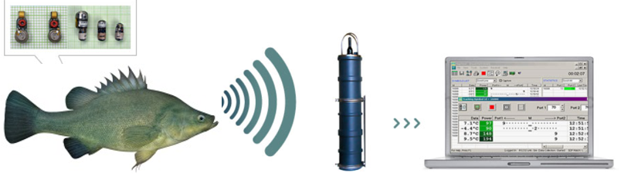5

Steps in the monitoring of fish movement using the acoustic array are shown below.

|  |  |
| --- | --- |
|  | C:\Windows\System32\config\systemprofile\Downloads\IMG_2557.jpgAbove left - An acoustic tag being implanted into a Murray cod, and a tagged Murray cod being released back into the Namoi 6  Left – a receiver being assembled and connected to a white buoy 7  Above - one of the deployed receivers in the Namoi River at Miloo, between Wee Waa and Bugilbone Water quality was also being sampled at the same time. The water was highly turbid, and the depth was less than a metre. 8 |

We look forward to sharing the results from this monitoring with the community in future updates and discussions.

## Government agencies working together

Governments are working together to care for our rivers and wetlands. The Commonwealth Environmental Water Office works with NSW DPI Fisheries, NSW Office of Environment and Heritage, and NSW DoI Water to plan and manage the delivery of water for the environment in the Namoi catchment. NSW DPI Fisheries are undertaking fieldwork and have kindly provided considerable information for this update. WaterNSW are delivering the water. The Natural Resource Access Regulator and the Murray-Darling Basin Authority are tracking the flows – and say conduct on-ground visits, and use satellite images to keep an eye on the flow.

The CEWO’s local engagement officers, Jason Wilson (Walgett) and Neal Foster (Tamworth) will be out and about during the flow event. Contact details are below.

## Contacts

|  |  |
| --- | --- |
| **CEWO Local Engagement Officers:**  **Neal Foster**  0437 141 495  **Jason Wilson**  0418 210 389 | **CEWO media line:** [media@environment.gov.au](mailto:media@environment.gov.au)   02 6275 9880  **CEWO:** [ewater@environment.gov.au](mailto:ewater@environment.gov.au) |
| **CEWO Website:**  <http://www.environment.gov.au/water/cewo/catchment/namoi/catchment-updates> | |

## Additional information

Updates on the Namoi

<http://www.environment.gov.au/water/cewo/catchment/namoi/catchment-updates>

Updates on the recent northern connectivity event along the Barwon-Darling

<http://www.environment.gov.au/water/cewo/northern-rivers>

Oral history

<https://www.fishhabitatnetwork.com.au/pdfs/namoi_FINAL-26Octt11.pdf>

2018-19 Portfolio management plan for the Namoi

<http://www.environment.gov.au/water/cewo/publications/portfolio-mgt-plan-namoi-2018-19>

Media release from WaterNSW on current river operations in the Namoi River

<https://www.waternsw.com.au/media/newsroom/2018/drought-measures-toughen-to-conserve-namoi-water>

## Photo and image credits

1, 2, 8 – Commonwealth Environmental Water Office (Neal Foster)

3, 4, 5, 6, 7 – NSW DPI Fisheries