# Namoi River watering event update 4

This is the fourth and final update on a flow to refresh disconnected waterholes in the Namoi River between Wee Waa and Bugilbone, to help native fish survive drought conditions. The flow commenced from near Wee Waa on 9 November, and a small volume of water reached Walgett in mid January 2019.

## Objectives of this flow event

|  |  |  |  |
| --- | --- | --- | --- |
|  | Maintain and provide access to refuge habitat, increase connectivity, and improve water quality in pools. |  | Provide opportunities for the movement of native fish, and increase native fish survival. |

## Flow summary

In spring 2018, the remnant fish populations in the Namoi River downstream of Wee Waa were at risk, as waterholes became very shallow or began to dry out. As the water dried down, the dissolved oxygen became very low in a number of pools, which had the potential to impact fish survival.

Water for the environment and the drawdown of Gunidgera weir pool replenished water holes along an estimated 150–200 km long section of the Namoi River between Wee Waa and Walgett. The Namoi flow reached Walgett for the first time in over nine months, bringing some short-term relief along this stretch of river. The photo below shows the ‘head’ of the flow trickling along the Namoi riverbed a few kilometres upstream of Walgett.

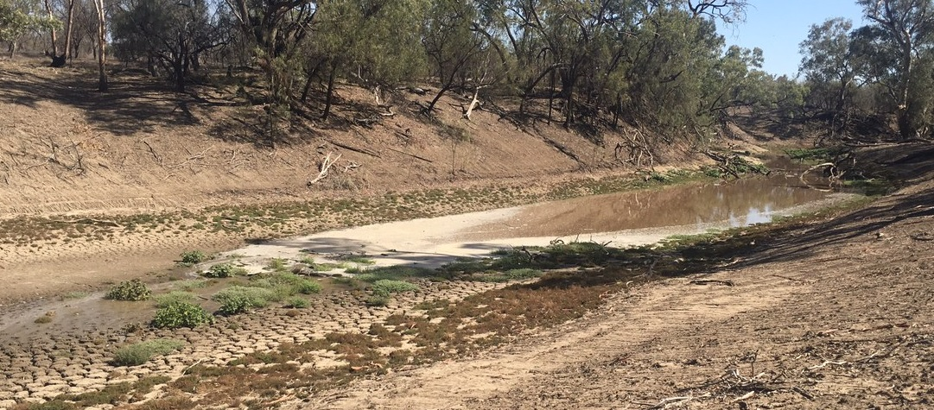

1

**Flow direction**

1

|  |  |  |  |
| --- | --- | --- | --- |
| The progress of the head of the flow along the Namoi was also observed from space using satellite imagery (right).  Prior to the flow, the riverbed was bare and pools were shallow in many sections of the river downstream of Wee Waa. There were some deeper pools persisting on some river bends. On the ground, a comparison of the river bed near the Yarrandool crossing both before and after the flow is shown below. | 2  2 | | |
|  | | 3 |

Further downstream at the Walgett ‘cattle crossing’, the bed of the river channel before and after the arrival of the flow is shown below. Vegetation had grown in the riverbed in the nine months since the previous flow.

|  |  |
| --- | --- |
| G:\Environment\Environmental Water\CEWH\Photos\2019\20190109 - Lindsay White - Namoi\Namoi River at the cattle crossing, just upstream of Walgett (1).JPG | 4 |

As conditions continue to remain very hot and dry, it is likely that the river will return to cease to flow conditions.

The flow downstream of Gunidgera Weir was a small part of significantly larger block release from Keepit Dam for irrigation, communities, mines, and the environment. The flow downstream of Gunidgera Weir comprised 5,500 megalitres of Commonwealth environmental water, and additional water from the lowering of Gunidgera weir pool, as shown on the chart below. The first pulse was the water for the environment – which made it past Bugilbone and Goangra and did ‘the initial work’ of filling up dry waterholes and seepage into the river bed. The second pulse provided additional flow to reach Walgett.

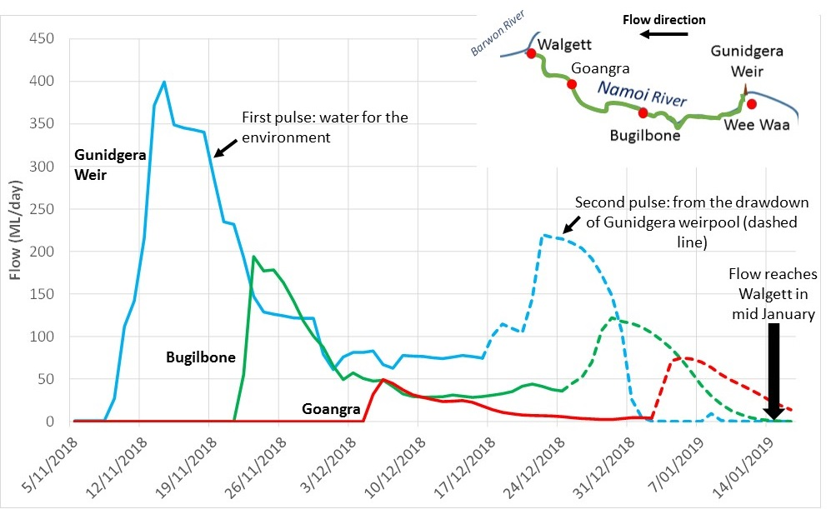

5

The flow also provided benefit to communities along the river, lifting spirits during the severe drought. Some water users also benefited from access to water for stock and domestic purposes.

## Results from monitoring of dissolved oxygen and fish

*Water quality monitoring:* NSW and Commonwealth government agencies worked together to deliver and monitor the delivery of environmental water in the Namoi River. NSW agencies (WaterNSW and the Department of Industry – Water) undertook water quality monitoring before and during the flow.

Before the flow arrived, some of the waterholes had dissolved oxygen levels of 3 milligrams per litre (mg/L) or less. Native fish can become stressed when dissolved oxygen levels drop below 4 mg/L, and cannot tolerate prolonged periods where dissolved oxygen is less than 3 mg/L. It was expected that as water temperature in these isolated waterholes increased in summer, the risk to the fish population would increase. The aim was to increase the chance of survival of these native fish.

|  |  |
| --- | --- |
| 6 | (Milloo sites are located between Wee Waa and Bugilbone)  7 |

Water quality monitoring demonstrated the benefits of the flow to native fish by increasing dissolved oxygen levels in refuge pools (as shown in the graph). This substantially improved conditions for native fish.

*Fish monitoring: The* NSW DPI – Fisheries monitoring team caught golden perch (dhagaay in the traditional Gamilaroi language) and bony bream (baraa), and a number of big Murray cod (guduu) like the one pictured below in this section of the Namoi.

Yellow-belly (dhagaay)

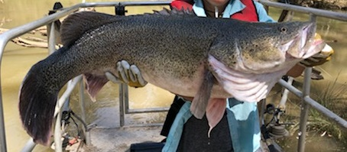The presence of some large fish like this in the lower Namoi highlight the importance of maintaining and connecting refuge pools during dry times to increase the chance of survival for these fish.

8

Juvenile native fish were not expected and not observed. Fish recruitment in this part of the Namoi was last detected in 2017, which followed a large flow event in 2016. Flows are needed to help many native fish species put on condition to breed, and then to trigger spawning but these conditions have not been experienced recently in the lower Namoi River below Gunidgera.

In summary, the flow event connected waterholes, increased the dissolved oxygen in the water, and increased the depth of water in waterholes. This would have improved the persistence of pools and refuge habitat and chance of survival of native fish through summer. The objectives of this flow event were achieved.

## Contacts

|  |  |
| --- | --- |
| **CEWO Local Engagement Officer:**  **Jason Wilson**  0418 210 389  **CEWO Website:**  http://www.environment.gov.au/water/cewo | **CEWO media line:** [media@environment.gov.au](mailto:media@environment.gov.au)   02 6275 9880  **CEWO:** [ewater@environment.gov.au](mailto:ewater@environment.gov.au) |
| Additional information Updates on the Namoi watering action  <http://www.environment.gov.au/water/cewo/catchment/namoi/catchment-updates>  2018–19 Portfolio management plan for the Namoi  <http://www.environment.gov.au/water/cewo/publications/portfolio-mgt-plan-namoi-2018-19> | |

## Photo and image credits

1, 4 – Commonwealth Environmental Water Office (Jason Wilson, Lindsay White)

2 – Source: <https://apps.sentinel-hub.com/sentinel-playground/> from the European Space Agency.

3, 6 – WaterNSW (Tracy Fulford)

5 – Source: WaterNSW Real-time Water Data <https://realtimedata.waternsw.com.au/>

7 – Source: WaterNSW dissolved oxygen – Water water quality monitoring

8 – NSW DPI Fisheries (Anthony Fowler)