# Namoi River watering event update 1

This is the first update about the delivery of water for the environment in the Namoi River commencing in November. The Namoi River has ceased-to-flow for over 150 km of river downstream of Gunidgera Weir, near Wee Waa. This water for the environment will support native fish and river health by refreshing and re-connecting refuge pools, and improving water quality.

## Why deliver water for the environment in the Namoi River now?

Despite some rainfall over the last weekend, very dry conditions have persisted across much of western NSW during the current drought. This has resulted in parts of the Namoi River system not flowing, for example between Wee Waa and Walgett. The satellite image below shows some refuge pools (dark blue areas) and extensive gaps between them (dry river bed) in parts of the river downstream of Wee Waa.

|  |
| --- |
| The blue spots are disconnected refuge pools  **N**  *Namoi River*  **Wee Waa** |

Satellite image of the Namoi River downstream of Wee Waa on 15 October 2018 (Source: Sentinel Hub Playground).

When rivers ‘cease-to-flow’ they dry back to a series of disconnected pools. These pools provide important refuge habitat for a variety of animals including fish. These refuges can help these fish survive until wetter times return. However, as pool volume decreases and temperature increases then the quality of refuge habitat and water can deteriorate. This puts the fish at increasing risk of stress, disease and possibly death. Delivery of water for the environment aims to refresh the remaining refuge pools. This may benefit over 100 km of Namoi River downstream of Wee Waa, like the habitat shown below, depending on seepage and evaporation on the dry river bed. This is the first flow along some of the lower Namoi River for several months.

|  |  |
| --- | --- |
| cid:9D1BDC99-F23D-4B3A-86D2-873F9D19B902 | A2C4D8ED-A239-49D0-9672-EA96D10535E8 |
| Namoi River downstream of Gunidgera, Sept. 2018 | Namoi River at Bugilbone, September 2018 |
| G:\Environment\Environmental Water\CEWH\Photos\2018\20180912-19 - Namoi - Neal Foster\Namoi at Goangra - NFoster.jpg |  |
| Namoi River at Goangra, September 2018 | Namoi River at Walgett, October 2018 |

## Objectives of this flow event

|  |  |  |  |
| --- | --- | --- | --- |
|  | Maintain and provide access to refuge habitat, increase connectivity, and improve water quality in pools. |  | Provide opportunities for the movement of native fish, and increase native fish survival. |

## Fish in the Namoi River

The Namoi fish community includes about 13 native species including a number of threatened fish species, such as Murray cod, silver perch, and freshwater catfish. It has been assessed as being in a 'fair' condition. The aquatic community of the Namoi River forms part of an ecological community that is listed as endangered under the *NSW Fisheries Management Act 1994*.

Sampling by NSW Department of Primary Industry – Fisheries (DPI Fisheries) in autumn 2018 detected nine native fish species and three introduced species in the Namoi River downstream of Wee Waa. The community was dominated by bony bream. Other species such as golden perch, silver perch, and Murray cod were also present (see over).

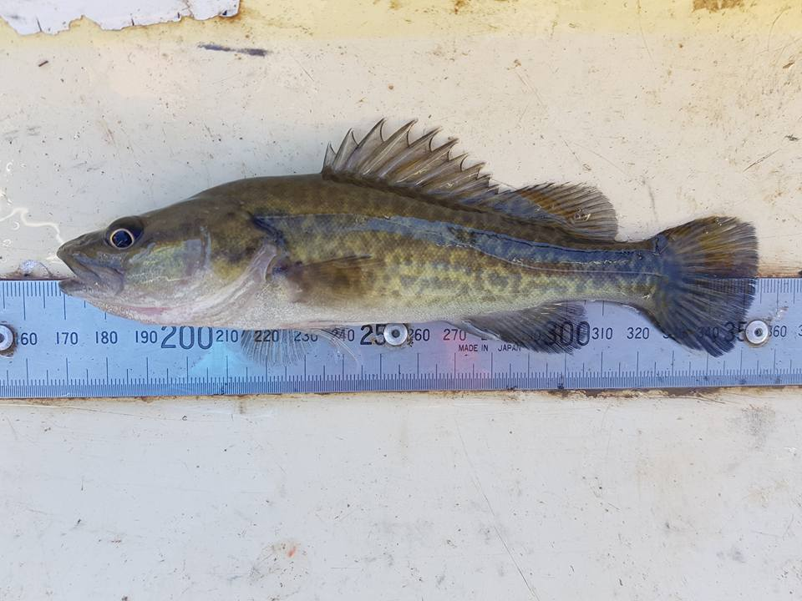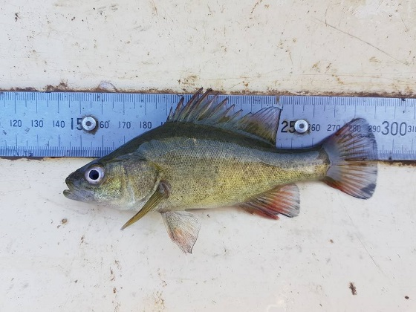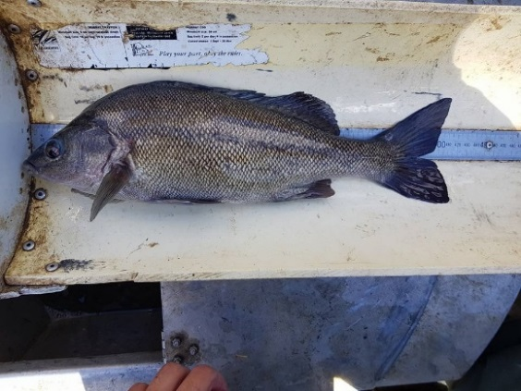

Silver perch, golden perch and Murray cod sampled in the Namoi River downsream of Wee Waa in May 2018. Photos: NSW DPI Fisheries.

## Water delivery details

Water for the environment will be delivered in November and December in conjunction with a block release managed by WaterNSW. This will increase the efficiency of water use and the outcomes that can be achieved. The volume of water being delivered for the environment is expected to be about 15 percent of the general security water delivered in the block release.

**The Namoi River and storages.**

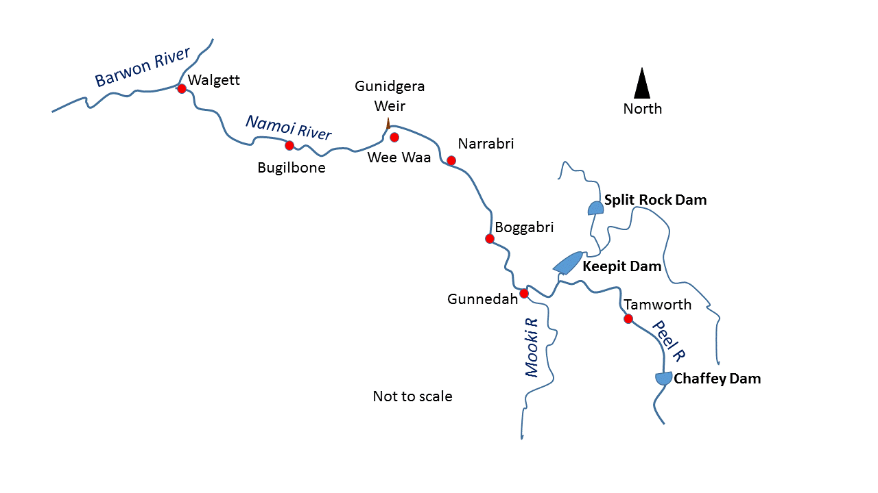WaterNSW started making the block release from Keepit Reservoir on 18 October. This water is for towns, irrigation, and the environment. Prior to this date, the volume of total water stored in Keepit and Split Rock reservoirs has been just over 100,000 ML. The Commonwealth currently manages about 6 per cent of this volume, the majority of which is being used in this flow event.

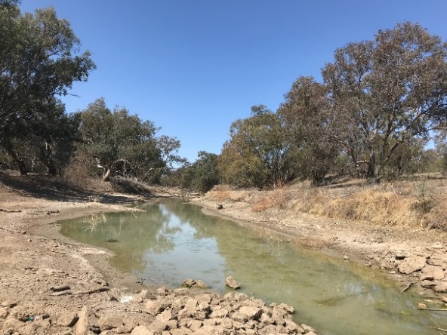For the flow event, around 5,500 ML will be delivered along the Namoi River downstream of Gunidgera Weir. The remaining water will be set aside for now to provide flexibility for future use to benefit the environment.

A small ‘pulse’ at the beginning of the event aims to assist flushing pools. The flows downstream of Gunidgera Weir will rise over a few days to reach around 450 ML/day. The flow will then taper back to a baseflow of about 50 ML/day about two weeks later. These lower flows will maintain connection for a longer duration. Flows are currently expected to conclude in early to mid-December.

As with other water users in the Namoi, given the extreme dry conditions and low water availability, plans may be adjusted to fit in with what the WaterNSW river operators can deliver. Plans may also be adjusted depending on the response of the environment, as there is some chance that mixing of pools will result in low oxygen levels. However, the risk to fish of low oxygen is lower than that from pools drying out.

Namoi River

## Monitoring

*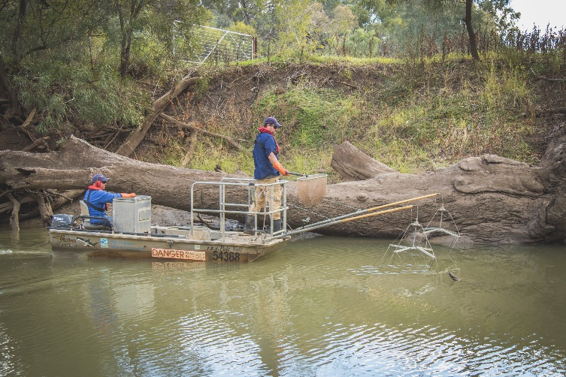Flow monitoring:* the event will be monitored using the gauge network and satellite tracking.

*Fish:* NSW DPI – Fisheries is undertaking long-term monitoring in the Namoi River as part of the Basin Plan Environmental Outcomes Monitoring.

*Fish movement:* As part of an existing project, Department of Industries – Water and DPI – Fisheries installed an acoustic array to monitor movement of tagged fish in the Namoi downstream of Gunidgera Weir. This array may record fish movement during the planned watering event.

Electrofishing in Namoi River. Photo: Tom Rayner

*Water quality*: monitoring undertaken by DOI - Water and WaterNSW may provide water quality information during the event.

## Government agencies working together

Governments are working together to care for our rivers and wetlands. The Commonwealth Environmental Water Office works with NSW DPI – Fisheries, NSW Office of Environment and Heritage and DoI – Water to plan and manage the delivery of water for the environment in the Namoi catchment. WaterNSW was also consulted during the development of the delivery.

## Next steps

Further updates will be prepared as the flow moves through the Namoi River system. Our local engagement officers, Neal Foster (Tamworth) and Jason Wilson (Walgett) look forward to creating opportunities to share the flow event with the community – including face to face opportunities. Further information will be provided in the next update, due in a few weeks.

## Contacts

|  |  |
| --- | --- |
| **CEWO Local Engagement Officers:**  **Neal Foster**  0437 141 495  **Jason Wilson**  0418 210 389 | **CEWO media line:** [media@environment.gov.au](mailto:media@environment.gov.au)   02 6275 9880  **CEWO:** [ewater@environment.gov.au](mailto:ewater@environment.gov.au) |
| **CEWO Website:**  <http://www.environment.gov.au/water/cewo/catchment/namoi/catchment-updates> | |