# Safeguarding our home and way of life

30 years of co-operative biosecurity in northern Australia

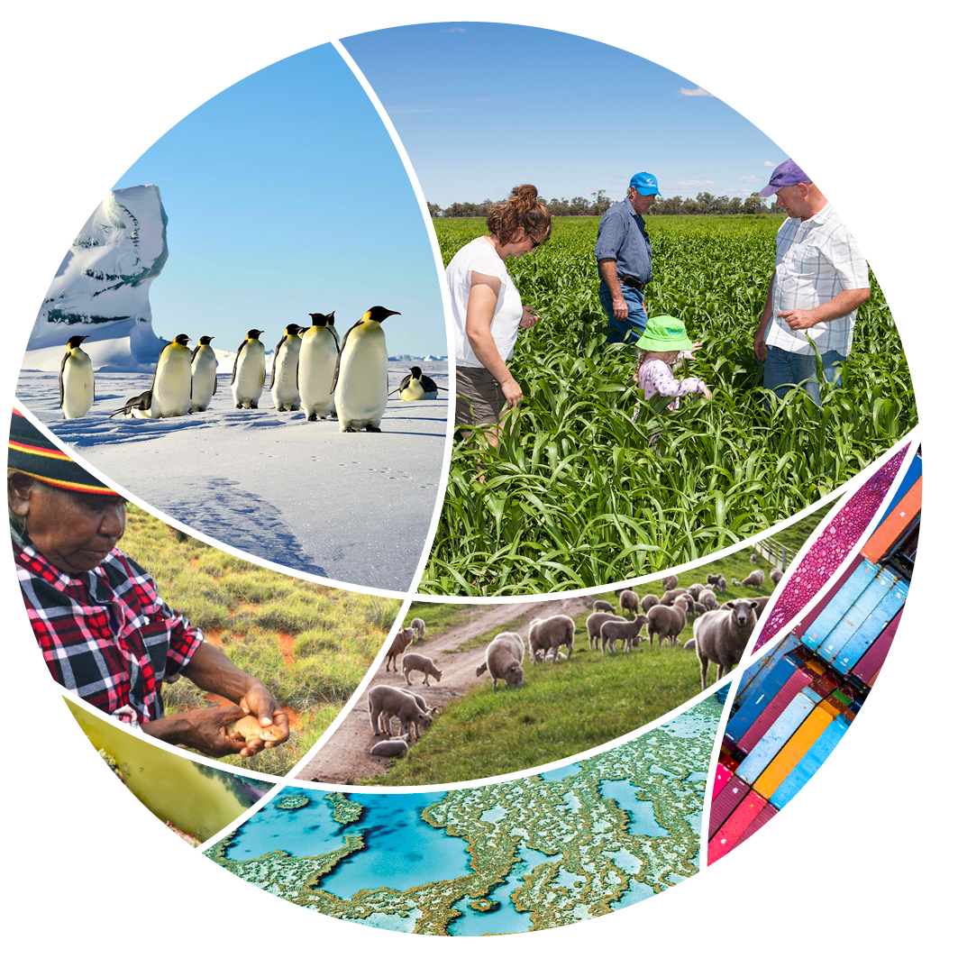

© Commonwealth of Australia 2020

**Ownership of intellectual property rights**

Unless otherwise noted, copyright (and any other intellectual property rights) in this publication is owned by the Commonwealth of Australia (referred to as the Commonwealth).

**Creative Commons licence**

All material in this publication is licensed under a [Creative Commons Attribution 4.0 International Licence](https://creativecommons.org/licenses/by/4.0/legalcode) except content supplied by third parties, logos and the Commonwealth Coat of Arms.

Inquiries about the licence and any use of this document should be emailed to [copyright@awe.gov.au](mailto:copyright@awe.gov.au).



**Cataloguing data**

This publication (and any material sourced from it) should be attributed as: Department of Agriculture, Water and the Environment 2020, Safeguarding our home and way of life: *30 years of co-operative biosecurity in northern Australia*, Canberra. CC BY 4.0.

This publication is available at [agriculture.gov.au/biosecurity/australia/naqs/significant-events](https://www.agriculture.gov.au/biosecurity/australia/naqs/significant-events)

Department of Agriculture, Water and the Environment

GPO Box 858 Canberra ACT 2601

Telephone 1800 900 090

Web [awe.gov.au](http://agriculture.gov.au/)

**Disclaimer**

The Australian Government acting through the Department of Agriculture, Water and the Environment has exercised due care and skill in preparing and compiling the information and data in this publication. Notwithstanding, the Department of Agriculture, Water and the Environment, its employees and advisers disclaim all liability, including liability for negligence and for any loss, damage, injury, expense or cost incurred by any person as a result of accessing, using or relying on any of the information or data in this publication to the maximum extent permitted by law.

**Warning**

We wish to advise that names and photographs of people who may have passed on are in this document.

## Foreword

Here is our story, one marking thirty years of co-operative surveillance and front-line biosecurity measures delivered through the Northern Australia Quarantine Strategy (NAQS). It’s a story of innovation, dedication and diverse partners working together for a cause critical to our national interests. Safeguarding our agricultural production, trade and unique environment is an ongoing challenge as our country, region and world grow more complex. Increasing volumes of international trade, changing climate, integrated transport networks and varying patterns of human and natural movements bring new and emerging threats of unwanted arrivals of pests, diseases and weeds which threaten our economy, our communities and way of life.

Since its inception in 1989, the NAQS has facilitated close collaboration between the Australian Government, state and territory agencies, communities and industry participants across Western Australia, the Northern Territory and Queensland. We all share a common goal of early detection and mitigation of biosecurity risks arising from the arrival and establishment of target pest species.

Our story doesn’t end here. If we are going to remain effective and support our national vision to grow agriculture and foster a healthy environment and communities, it is critical that our biosecurity controls remain effective and adaptable. This requires continued vigilance, co-operation and support. The Department of Agriculture, Water and the Environment and its partners are committed to the task and look forward to meeting the challenges ahead.

Lyn O’Connell

Head of Biosecurity

Department of Agriculture, Water and the Environment

Contents

Foreword iii

Northern Australia – a biosecurity frontline 7

Farmers are our future 9

Melinee Leather – 2019 Farm Biosecurity Producer of the Year Award winner and industry biosecurity champion 9

The Northern Australia Quarantine Strategy – a history 10

1989 10

1990 10

1991 11

1992 11

1993 11

1994 11

1995 12

1996 12

1997 12

1998 13

1999 13

2000 13

2001 13

2002 14

2003 14

2004 14

2005 14

2006 14

2008 15

2009 15

2010 15

2011 15

2012 15

2014 15

2015 16

2016 16

2017 16

2018 17

2019 17

Barbara Waterhouse PSM – fond memories yet always looking forward 17

Science drives it all 19

Joe Schmidt – northern vet 20

Offshore surveillance and capacity building 20

Exotic fruit fly trapping and monitoring 21

Benefit cost analysis of management interventions 22

Biosecurity regulation in Torres Strait 23

It’s a family affair – generations of biosecurity in Torres Strait 25

It’s all about relationships 27

With industry 27

With state and territory counterparts 27

With universities and research organisations 27

With community 28

Keeping a Top Watch in your Community! 28

Biosecurity. It’s everyone’s business 29

Biosecurity ‘champs’ doing their bit! 29

Indigenous rangers – a special partnership 29

Government White Papers improving biosecurity 31

Papua New Guinea Treaty Village surveys 32

People and Country – Yirrganydji Land and Sea Ranger Program 33

New partners joining the fold – the Torres Strait and Northern Peninsula Area Biosecurity Strategy 36

Innovation a key to success 36

The Ranger App 37

Small vessel traffic surveys 37

Improving information and communications technology in Torres Strait 37

Modern diagnostics skilling for the future 38

Biosecurity collaboration – beyond the first 30 years 40

Pest, disease and weed threats to northern Australia 41

Animal diseases 42

Insect pests 42

Plant diseases 42

Marine pests 43

Weeds 43

**Figures**

Figure 1 Goods requiring a permit 24

**Maps**

Map 1 Australia’s proximity to northern neighbours 7

Map 2 The Torres Strait biosecurity monitoring zones 25

## Northern Australia – a biosecurity frontline

With our neighbours on our doorstep, so is the threat of exotic pests, diseases and weeds. Without proactive and continued surveillance, pest species can arrive and establish populations at levels that are uneconomical or unfeasible to control.

Murray Korff, Director, Torres Strait and Field Operations

Welcome to northern Australia, our frontline biosecurity surveillance zone where officers delivering the NAQS and their communities call home.

Northern Australia is vast. There is almost 10,000km of coastal areas between Cairns and Torres Strait in Queensland to Darwin in the Northern Territory and across to Broome in Western Australia.

It’s not only big, the region is sparsely populated, largely undeveloped, includes areas inaccessible during the wet season and, importantly, provides a critical defence and focus for Australia’s biosecurity effort.

There are numerous pathways through which exotic pests, diseases and weeds can arrive from overseas or other areas within Australia. Some of these pathways are natural, such as wind and tide movements and animal migrations. Others relate to human activities, either through accidental or deliberate actions. According to ABARES, northern Australia’s proximity to our northern neighbours heightens the possibility of exotic threats to our agricultural industries reaching our shores and establishing. Risk pathways in the region are unique and necessitate novel approaches to help manage prevailing biosecurity risks (Map 1).

Map 1 Australia’s proximity to northern neighbours

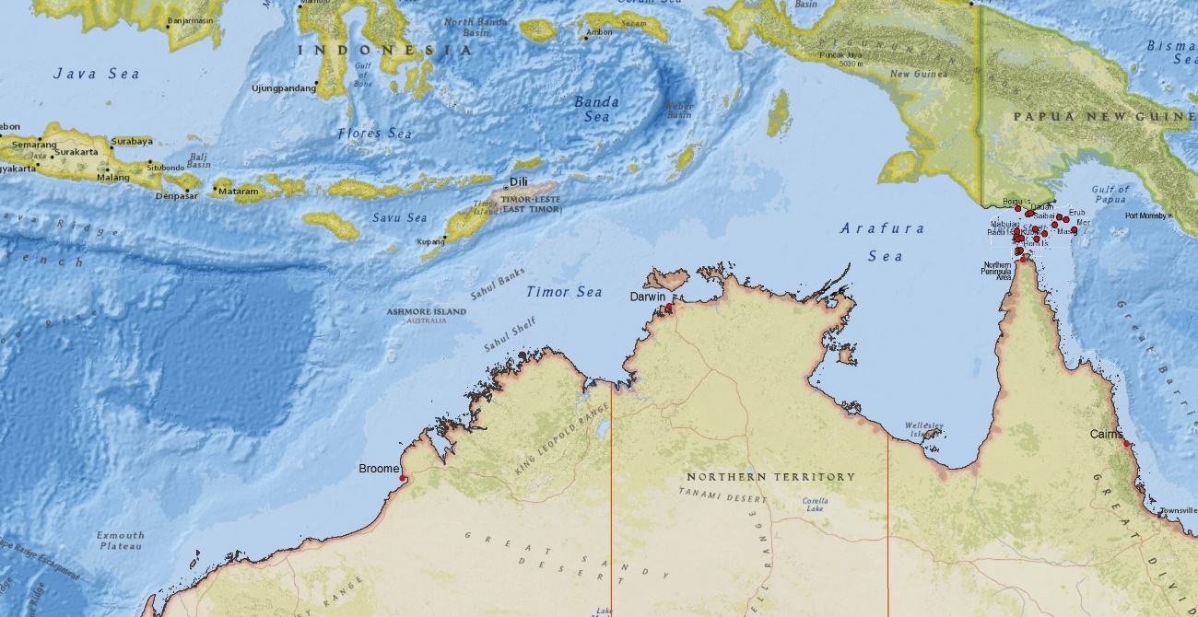

The NAQS commenced in 1989 in recognition of the unique challenges facing the region with the primary objectives of:

* early detection of target pests, weeds and diseases of national significance
* regulation functions focussed on arrivals into, and movements from, legislated biosecurity zones in Torres Strait
* support to Australian export trade in agricultural products through data pertaining to the presence, distribution or absence of target species across northern Australia
* engagement with Indigenous rangers, remote communities and other critical stakeholders to enable delivery of the NAQS.

This brochure marks a thirty year milestone in continuous, collaborative animal and plant health surveillance and regulation delivered through the NAQS framework. It acknowledges the critical partnerships involved and necessary for effective biosecurity in the north, and describes a selection of achievements through the Australian Government’s Agricultural Competitiveness White Paper and Our North, Our Future: White Paper on Developing Northern Australia measures for the benefit of all Australians.

The Australian Government Department of Agriculture, Water and the Environment undertakes surveillance for exotic pests, diseases and weeds in northern Australia in collaboration with diverse stakeholders through the Northern Australia Quarantine Strategy.

## Farmers are our future

Farmers and farming communities are critical to Australia’s current and future prosperity. As land stewards and producers, farmers and their families are key contributors to effective biosecurity for their businesses, their industries and the broader Australian community. Over time, strong relationships with the pastoral industry and other agricultural sectors have been developed and continue to evolve and adapt to changing threats and opportunities.

Industry and community participation in animal health surveillance includes supporting a network of sentinel cattle herds in strategic locations across northern Australia. Regular sampling of the cattle helps to test for the presence (or otherwise) of serious animal diseases and supports early detection and response measures as necessary. Data obtained from blood sampling of the herds and associated traps for Culicoides species (biting midges that can act as vectors of disease) contributes to the National Arbovirus (insect-borne virus) Monitoring Program (NAMP). In turn, information generated through the NAMP assists Australian export trade through helping to confirm the status of target diseases throughout the country.

In recognition of the importance of sentinel herd monitoring, the number of sentinel herds has been increased in recent times. They are operated under fee-for-service arrangements with remote property owners and indigenous community enterprises. Herds typically consist of up to twelve young, disease-free animals which are replaced after each northern wet season. Sentinel herd animals are examined regularly and blood samples taken for testing for exotic strains of bluetongue virus (BTV) and other target diseases. The presence of exotic strains of bluetongue virus in southern sheep populations would result in the loss of key export markets for ruminants and other forms of livestock.

### Melinee Leather – 2019 Farm Biosecurity Producer of the Year Award winner and industry biosecurity champion

Biosecurity is critical to our business and we work hard to prevent foreign pests, diseases and weeds from entering our property. Implementing biosecurity measures is essential to protect our future.

My name is Melinee Leather. My family breeds and finishes beef cattle for the organic, European Union and natural, pasture-fed markets at our property, Barfield Station, in Central Queensland. My family is passionate about naturally raised, grass-fed beef. We have spent 30 years in this beautiful part of the country creating a sustainable business we can pass down through the generations.

Australia is one of the world’s largest and most efficient producers of commercial livestock in the world and I am extremely proud to be part of it. In 2016 there were 25 million head of cattle on Australian soil and the red meat industry employed around 405,000 people. All of this is at risk if we don’t protect Australia from biosecurity threats.

## The Northern Australia Quarantine Strategy – a history

In December 1987 the Quarantine Review Committee headed by Professor David Lindsay published the interim ‘Report on Aerial Littoral Surveillance and Northern Australian Quarantine Strategy’ recommending establishment of a strategy focused on the unique biosecurity risks in northern Australia.

As a result of the Lindsay Review the Australian, Queensland, Northern Territory and Western Australian governments committed to establishing the Northern Australia Quarantine Strategy.

In 1989, the NAQS was formed with a small, dedicated and enthusiastic team of scientific specialists and biosecurity officers and has since forged an enduring foundation legacy.

### **1989**

* The first NAQS coordinator, Colin Fish, is appointed and remains in the role until 1994.
* First NAQS field officers are appointed in Torres Strait and include Ted Mosby (later Anglican Bishop of Torres Strait). Initial appointments are quickly followed by the appointment of Jackson Sailor in Bamaga.
* Kevin Hyde, first NAQS plant pathologist is appointed in Queensland (QLD).
* The (then) Australian Quarantine and Inspection Service (AQIS) begins conducting surveys in PNG and Irian Jaya, the easternmost province of Indonesia adjacent to PNG. These early surveys were funded by the Commonwealth but delivered by NAQS personnel who were state employees at the time.

### **1990**

* First NAQS veterinary officers, John Curran, Western Australia (WA) and Andrew von Berky, (QLD) appointed.
* Judy Grimshaw is appointed as the first NAQS entomologist, closely followed by Barbara Waterhouse, first NAQS botanist.
* Spiralling whitefly observed in coastal villages of Western Province PNG closest to Torres Strait.
* First feral animal survey conducted.
* Mealy bug pest Planococcus lilacinus detected by NAQS officer on Boigu, QLD.
* NAQS veterinary officers commence a range of animal health surveillance activities to detect the presence of exotic animal diseases. Activities include monitoring sentinel cattle herds, feral animal health surveys, domestic animal surveys, trapping for adult screw worm flies, trapping for exotic Culicoides, domestic bird health surveys and responding to reports of unusual animal health incidents.

### **1991**

* Spiralling whitefly is detected on Boigu during a NAQS plant health survey. It subsequently spread to most inhabited Torres Strait islands but its impacts were mitigated by a biological control program using a parasitic wasp.

### **1992**

* Sampling of migratory birds for target diseases such as Newcastle disease, avian influenza and Japanese encephalitis virus (JEV), commences.
* Siam weed, Chromolaena odorata detected by NAQS botanist near Vanimo during joint Commonwealth and PNG government plant and animal health survey of Western and Sandaun Provinces, PNG. This leads to confirmation of Siam weed’s presence elsewhere on the PNG mainland and the inclusion of PNG in an Australian Centre for Agricultural Research-funded program for biological control of Siam weed.
* The Commonwealth government establishes a sentinel cattle herd at Kalumburu, WA. The herd is operated and managed by the Department of Agriculture, Water and the Environment to this day and has been the site of several Australian-first detections of exotic serotypes and vectors.

### **1993**

* Asian honey bee Apis cerana is detected in Torres Strait for the first time and becomes established on Boigu, Saibe and Dauan, QLD. The eradication of this pest is considered infeasible because of the proximity of these islands to PNG.
* In March, exotic oriental fruit fly (OFF) Bactrocera dorsalis is trapped on Boigu, Dauan, Saibe, Erub and Ugar in QLD, sparking an intensive collaborative response program.
* Joint Indonesian and Australian Government survey of Irian Jaya records presence of Asian citrus psyllid, vector of huanglongbing disease of citrus (HLB).

### **1994**

* Siam weed is detected by a NAQS botanist at Bingil Bay, far north QLD. This detection triggers a nationally-funded eradication attempt.
* Sentinel cattle herd, established at York Downs Station near Weipa, QLD. This herd continues to operate.

### **1995**

* An independent scientific review of the NAQS, chaired by Professor Malcolm Nairn, is commissioned. The report, The Nairn-Muirhead Review, confirms the value of the NAQS contribution to biosecurity in northern Australia and leads to an increase in NAQS activities and resourcing.
* A staged transition of responsibility for the NAQS service delivery begins, moving from state and territory authorities to the Commonwealth.
* Spiralling whitefly is detected by NAQS entomologist at Seisia near the tip of Cape York Peninsula during a plant health survey.
* An outbreak of OFF (referred to as papaya fruit fly Bactrocera papayae at the time) near Cairns is confirmed. NAQS officers provide scientific support in the early stages of the outbreak. The detection triggered a successful eradication program over four years at a cost of $34 million.
* JEV detected for the first time in Torres Strait and PNG by Queensland Health (QH) following the death of two people on Badu. NAQS officers assist in conducting surveillance for the disease in domestic pigs, feral pigs and wading birds which are the amplifying host for the virus.

### **1996**

* A JEV surveillance program using small herds of sentinel pigs is established at a range of locations in the Torres Strait and Northern Peninsula Area (TS&NPA).
* Establishment of the Torres Strait Fruit Fly Technical Advisory Panel (TAP) incorporating representatives of the department, the (then) Queensland Department of Primary Industries (QDPI) and external specialists. TAP focuses on developing and implementing a ‘Long Term Containment Strategy for Exotic Fruit Flies in Torres Strait’.

### **1997**

* NAQS survey activities detect spiralling whitefly and mango leafhopper at Weipa. The detections result in the establishment of the Cape York Biosecurity Centre at Coen on the only road leading into and out of the Cape to limit southward vehicular movement of pests.

### **1998**

* The Quarantine Proclamation 1998 (enacted 2000) defines the Special Quarantine Zone boundaries and lists items including plants that can’t be moved from PNG into Torres Strait, or from the Protected Zone to the Special Quarantine Zone or from either zone to the mainland.
* Black Sigatoka is detected by NAQS staff at Bamaga during a plant health survey, triggering a successful QDPI eradication program.
* The presence of a nest of Asian honeybees is confirmed in Darwin and a successful surveillance and eradication program is subsequently developed.
* A member of the public notifies NAQS botanist regarding a potential biosecurity risk. This report leads to the detection of the target weed Mikania micrantha at Mission Beach, QLD and triggers a national eradication program.
* JEV detected for the first time on the Australian mainland in one human and in populations of feral pigs.

### **1999**

* Large numbers of OFF intercepted in traps on the northernmost islands leads to modification of the Containment Strategy to include pre-emptive male annihilation blocking on Boigu, Dauan, Saibe and Erub, QLD. This action reduces the likelihood of establishment of OFF on these islands and successful seasonal eradication is maintained.
* Transfer of the NAQS from state and territory administration to the Commonwealth completed.

### **2000**

* An Aboriginal Communications Strategy is enacted leading to the employment of a full time Aboriginal Liaison Officer in Darwin and an undertaking to develop formal relationships with Land Councils.
* NAQS target weed Cleome rutidosperma detected at Darwin wharf area, the first record for Australia.

### **2001**

* NAQS botanist identifies target weed yellow burrhead Limnocharis flava in Cairns, triggering a nationally-funded eradication program.
* NAQS plant pathologist detects target pathogen grape vine rust in suburban Darwin. An eradication program is implemented and in July 2007 the NT is declared free of this serious plant disease.

### **2002**

* Led by Dr David Banks, NAQS staff begin trials of mosquito traps for JEV.
* Joint Papua New Guinea and Australian Government survey of Sandaun Province PNG, accompanied by the Chief of Plant Quarantine Papua Province (Indonesia) records presence of HLB and its vector Asian citrus psyllid.

### **2003**

* Co-operative Research Centre (CRC) for Weeds co-funds appointment of an Indigenous Liaison Officer in Darwin and subsequently in Bamaga.
* Mosquito trapping field trials commence in Torres Strait in collaboration between the Commonwealth and QH to detect JEV using Taqman polymerase chain reaction (PCR) diagnostics.
* Commonwealth government and Queensland state government agencies conduct surveillance for Nipah and Hendra virus in bat populations on Cape York using mist netting to capture bats for sampling and fit with satellite tracking collars.

### **2004**

* The Australian Government provides specific funding to the NAQS to support regular surveys for highly pathogenic strains of avian influenza in bird populations across northern coastal areas of Australia.
* Target weed Croton hirtus identified by NAQS botanist at Scherger RAAF base during a plant health survey, triggering a localised containment and eradication program funded by the Department of Defence.

### **2005**

* Surveillance for highly pathogenic avian influenza in wild magpie geese and ducks commences under the NAQS using cannon netting in Cape York.
* The scope of the NAQS is expanded to enhance surveillance and monitoring measures in relation to the biosecurity risks posed by foreign fishing vessel activity in northern Australia. Increased engagement measures include the establishment of a network of Indigenous ranger groups across northern Australia delivering biosecurity monitoring and support services under fee-for-service contracts.
* NAQS staff mourn the loss of highly respected Dr David Banks in the Lockhart River airline tragedy. Widely regarded as one of the most energetic advocates of NAQS, Dr Banks played a major role in its development since joining AQIS in 1990. During a 15 year association with NAQS he worked tirelessly to guide the scientific focus, promote achievements and support continued resourcing to remain an effective and contemporary surveillance framework.

### **2006**

* Mango gall midge is detected by NAQS entomologist during a survey on Erub.

### **2008**

* Vegetable leaf miner is detected by NAQS plant team during a survey on Warraber, QLD.
* Commonwealth biosecurity officers continue to support QDPI surveillance for Nipah and Hendra viruses through collection of bat urine.
* Australian Government and the PNG Government’s National Agriculture and Quarantine Inspection Authority (NAQIA) collaboration leads to the discovery of a completely new lethal wilt disease of cooking banana plants associated with a phytoplasma.

### **2009**

* The Commonwealth establishes the first Indigenous-owned and managed sentinel cattle herd in Arnhem land at Garrithiya, NT. It is still operational.

### **2010**

* Vegetable leaf miner detected by NAQS plant team during surveys on Masig and Mabuyag, QLD.
* Sentinel cattle herd to monitor for bluetongue virus (BTV) and its vectors established at Seisia, QLD. The herd is still operational.

### **2011**

* Mealybug pests, Planococcus lilacinus and Pseudococcus jackbeardsleyi are detected on a number of Torres Strait islands. NAQS entomologists participate in the national scientific advisory panel to analyse the significance of the detections.
* The sentinel pig surveillance program for JEV ceased. Risk-based JEV surveillance continued through mosquito trapping and testing of samples from domestic animals.

### **2012**

* A NAQS entomologist identifies a single exotic biting midge, Culicoides nudipalpis, from a single trap collection of almost 8000 midges at Kalumburu, WA. The exotic vector for BTV was thought to have been blown in during Tropical Cyclone Lua in March 2012.
* Dr John Curran completes a PhD on the surveillance and risk assessment of wild birds in northern Australia for highly pathogenic avian influenza H5N1 virus, determining that entry of the virus via shorebird migration is negligible to very low risk. This research contributes to the ongoing surveillance strategy for avian influenza in wild birds in Australia.

### **2014**

* A new surveillance method for JEV each wet season is implemented through collaboration between the Commonwealth and QH. Adult mosquito trapping is replaced with traps that use FTA cards® to collect the saliva of mosquitoes when they feed. These cards are then tested using PCR diagnostics for a range of flaviviruses of public health concern, including JEV, and the endemic Murray Valley encephalitis, Ross River and Kunjin viruses.

### **2015**

* The Biosecurity Act 2015 is passed into law, replacing the Quarantine Act 1908. The new act takes effect from June 2016.
* The Australian Government announces the Agricultural Competitiveness White Paper (White Paper) and Our North, Our Future White Paper on Developing Northern Australia. Funding was provided over four years to improve Australia’s national biosecurity system and included investments supporting expanded surveillance and compliance activities in northern Australia by Indigenous ranger groups.
* Panama disease tropical race 4 confirmed near Tully in far north QLD. NAQS officers provide a range of emergency response and monitoring assistance to the control effort.
* Bluetongue virus serotype 5 (BTV-5) is detected in Australia for the first time through sentinel herd monitoring in Northern Territory. This detection was found to have also infected the sentinel herd at Kalumburu, WA.

### **2016**

* The Queensland Biosecurity Act 2014 comes into effect and includes a ‘General Biosecurity Obligation’.
* A NAQS entomologist identifies four exotic biting midges, Culicoides orientalis from a single trap collection of approximately 400 midges collected at Kalumburu, WA, thought to have been blown in during Tropical Cyclone Yvette in December 2015.
* Two new sentinel cattle herds established through White Paper funding, bringing sites managed under NAQS to a total of six including one at Merepah Station, near Coen, QLD and one at Gunbalanya, West Arnhem Land, NT.

### **2017**

* Funding under the White Paper enables a joint department and NAQIA plant and animal health survey of the western Treaty Villages, PNG.
* White Paper funding supports expanded aquatic biosecurity surveillance measures through the NAQS. New measures include the engagement of a full time aquatic biosecurity officer and delivery of aquatic biosecurity training to Indigenous ranger groups and the aquaculture sector.

### **2018**

* A NAQS plant pathologist identifies citrus canker in Darwin prompting a territory-wide ban on movement of citrus fruit and plant material and a national response plan. NAQS officers provide a range of emergency response, monitoring and diagnostic assistance to the control effort.
* Australian Government and NAQIA plant and animal health scientists complete surveys of the eastern Treaty Villages, Western Province, PNG supported by funding from the White Paper.
* White Paper funding enables trialling of underwater acoustic monitoring and remote operated vehicles (ROVs) for aquatic biosecurity surveillance.
* Asian green mussel detected in Weipa Harbour, QLD. NAQS officers and Indigenous rangers assist the Queensland Government with the response effort.

### **2019**

* Changing risk management strategies saw the retirement of the department’s last quarantine launch in February 2019. The Al Jordan was named in honour of a popular biosecurity officer who sadly passed due to illness.
* Asian green mussel detected at Mornington Island and Escape River, QLD. NAQS officers assist with the QLD Government’s response effort.
* The NAQS celebrates 30 continuous years of collaborative biosecurity in the north of Australia, activities under the White Papers concluded and an expanded ranger engagement program commences.

### Barbara Waterhouse PSM – fond memories yet always looking forward

For me, visits to the Torres Strait Islands, PNG and the Solomon Islands will always feel like ‘coming home’.

Barbara Waterhouse, PSM, NAQS Senior Botanist

In mid-1990, a few months into what I expected to be a 15 month contract as botanist with the nascent NAQS, I had to pinch myself as a reminder that this exciting and rewarding job was really mine for a few months longer. There were no work instructions or guidelines on how we should accomplish our objectives, we more or less made it up as we went along. Three decades on, much has changed and the NAQS continues to forge new directions and is still going strong.

As a consequence of its vast remote coastline, close geographic proximity to neighbouring countries with different plant, animal and human health status and seasonal climatic factors, northern Australia will continue to face new and significant biosecurity challenges that cannot be fully mitigated within our well-regulated biosecurity system.

Early detection, verification and reporting of suspected new incursions is the key to successful intervention and is an area I am proud to have made a significant contribution towards. I would also like to think that part of my legacy will be having encouraged, enthused and supported the next generation of plant health and weed scientists, biosecurity officers and rangers in the importance of early detection to ensure that new incursions are quickly recognised and reported.

Collaborative offshore surveillance in places like PNG, Indonesia, Timor-Leste and the Solomon Islands over time has provided an ideal training ground in recognition of pests, diseases and weeds not known or widespread in Australia. I strongly believe that opportunities for participation in offshore surveys by new generations of NAQS scientists will continue to ensure effective surveillance at home and also to promote understanding of the reasons why it is unlikely that biosecurity threats from offshore are going to cease anytime soon.

My personal credo and primary motivator has always been to make a difference and I would like to think that this is as valid for my work with the department as with my previous although somewhat briefer careers.

Along the way I have been privileged to meet and work alongside a wonderful array of dedicated and inspirational colleagues and collaborators, many of whom have also become firm friends. I feel particularly fortunate to have experienced the wisdom, generosity and patience of Traditional Owners across northern Australia.

## Science drives it all

The Department of Agriculture, Water and the Environment employs dedicated teams of specialised plant, animal and aquatic health scientists responsible for identifying and evaluating biosecurity risks in Australia. This is done by conducting regular field surveillance, monitoring, and community awareness activities.

Biosecurity surveillance work is challenging. In areas of low population density, difficult terrain over vast areas and ideal conditions suitable for exotic species to become established, it requires a risk-based strategy to effectively achieve surveillance outcomes. The range and frequency of plant and animal health surveys are guided by discipline-specific target lists and risk-area documentation describing the relative biosecurity risks between surveillance zones across the north. Target lists and risk area documentation are reviewed annually by subject matter experts within the department and are subject to periodic external expert review.

Regular risk review is central to remaining synchronised with changing risk profiles across northern Australia. Factors influencing changing risk profiles include distribution of target pests and diseases such as African swine fever (ASF) and rabies, varying frequency of unauthorised foreign fishing vessel visits to Australian waters, increasing trade and people movements through Torres Strait, as well as advances in the understanding of risk creating behaviours.

Many of the exotic pest, disease or weed detections in Australia’s north have been detected through surveillance activities carried out under the NAQS. Plant health surveys, inclusive of community and private gardens, are conducted by botanists, plant pathologists and entomologists working collaboratively to identify exotic weeds, plant pests and diseases. Exotic fruit fly trapping and monitoring is carried out in TS&NPA.

Animal health surveillance activities include surveys of domestic animal health in Torres Strait, feral populations of pigs, buffalo and cattle as well as wild bird populations. Regular testing of a network of sentinel cattle herds, JEV monitoring by mosquito trapping, Culicoides (biting midge) and screw worm fly trapping are carried out in strategic locations across the north.

Supported by state-of-the-art laboratories and diagnostic equipment, regular testing and monitoring forms the foundation of Australia’s ‘early detection system’ for the presence, or absence, of exotic animal and plant pests and diseases.

What is biosecurity surveillance?

Surveillance is a co-ordinated set of measures aimed at early detection of exotic pests, diseases and weeds.

It comprises combinations of scientific surveys, community awareness and other engagement measures based on target species behaviours and potential for arrival and establishment.

### Joe Schmidt – northern vet

I am a Darwin-based veterinary officer for the Department of Agriculture, Water and the Environment. I joined the department in 2006 as a field vet. My role has evolved into conducting animal health surveys of domestic and wild animal populations in remote areas of the Northern Territory and PNG. During surveys I work closely with Indigenous ranger groups, pastoralists, park rangers and the general public to create awareness of the threats posed by exotic pests and disease.

My career highlights to date include securing a memorandum of understanding between Bradshaw and Yampi Sound military training bases and Kakadu National Park, allowing NAQS staff to survey these restricted areas for exotic pests and diseases. I was also directly involved in the establishment of the first Indigenous-run sentinel cattle herd at Garrithiya, East Arnhem Land, in the Northern Territory.

Although we work behind the scenes, the surveillance and capacity building we deliver is very important, especially public awareness to help maintain our international agricultural trade and Australia’s freedom from disease status.

Equally important as my work, I have made many life-long friends throughout northern Australia’s remote communities and PNG and I am privileged to be part of a proactive biosecurity surveillance strategy and the responsibilities that come with it, which are huge when you think about it.

### Offshore surveillance and capacity building

Surveillance activities are carried out across the north as well as offshore. Projects funded by AusAid between 1999 and 2004 helped biosecurity capacity-building in East Timor (now Timor-Leste). The projects enabled Australia to collaborate with offshore biosecurity agencies and officials in a lasting relationship that has provided substantial benefits, including:

* improving the management of biosecurity risks offshore
* sharing surveillance and diagnostic expertise
* generating regional pest and disease intelligence
* early detection of threat species to enable response preparation by Australian authorities and vulnerable industries across the north
* ensuring Australian scientists gain familiarity with NAQS target species that are established offshore but not present in Australia.

Since the early 2000’s the department has expanded its offshore surveillance and capacity development programs to include new regions in PNG and the Solomon Islands. Offshore surveillance helps to track the changing health status in nearby countries and provides opportunities to train biosecurity counterparts, strengthening capability where there is often limited pest and disease knowledge.

Detections made offshore under the NAQS banner have led to benefits for our neighbours. For example, the detection of HLB and its vector the Asian citrus psyllid in Sandaun Province in 2002 led PNG authorities to restrict citrus movement in the region. Nearly twenty years later, HLB and the psyllid still haven’t been recorded outside the Vanimo district.

Detection of Siam weed near Vanimo in PNG in 1992 led to PNG’s inclusion in an ACIAR-funded biological control program which has delivered excellent control in some parts of the country.

Detection of banana blood disease in Papua Province, Indonesia, in 1999 has led to heightened monitoring for this serious disease in PNG.

### Exotic fruit fly trapping and monitoring

Oriental fruit fly established in mainland Queensland in 1995 and cost $34 million (1995 values) to eradicate. It threatened Australian export markets for fresh produce and brought the movement of many horticultural commodities in and out of far north Queensland to a standstill. If it happens again, the cost to industry and government would be far greater.

Each year exotic fruit flies are blown into Torres Strait from PNG on north-westerly monsoon winds and managed using a program of bait spraying, trapping and blocking (fibreboard blocks containing a lure to attract the fruit fly and insecticide).

There are many species of fruit flies already present in Australia but there are others present in PNG, Indonesia and Timor-Leste that would seriously damage Australia’s fruit and vegetable production and trade if they arrived and established here. Early detection of these species, Oriental fruit fly Bactrocera dorsalis, New Guinea fruit fly Bactrocera trivialis and melon fly Zeugodacus cucurbitae makes it easier to get rid of them. Human movement of infested fruit and natural dispersal of adult flies are the most likely way exotic fruit flies could reach the Australian mainland via Torres Strait.

Throughout TS&NPA and other locations across northern Australia the department maintains a network of fruit fly traps to detect incursions of exotic fruit flies. Samples are sent to Cairns laboratory facilities for identification.

The Queensland Department of Agriculture and Fisheries has worked closely with the NAQS since 1993 to eradicate annual incursions of exotic fruit flies. These flies are blown onto the islands of Torres Strait each summer and could have a devastating impact on horticultural production and trade if they were to establish on the Australian mainland. Dedicated NAQS officers play a pivotal role in the eradication through their surveillance, diagnostics, operational response and technical expertise. The unique partnership between state and federal agencies ensures the delivery of efficient and effective biosecurity outcomes for the nation. The NAQS is an integral part of the Queensland biosecurity system and I congratulate them on reaching their 30 year milestone.

Mike Ashton, Chief Plant Health Manager of Queensland

Biosecurity officers in Torres Strait also deliver some elements of fruit fly response measures in Torres Strait on behalf of the Queensland government, including installation and monitoring of response traps and regular bait spraying throughout the communities. Male annihilation blocking (both pre-emptive and as part of response) activities are carried out by the Queensland government.

The Response Plan for Exotic Fruit Fly in Torres Strait (Response Plan) is an annual program nationally cost-shared between industry and all Australian governments under the Emergency Plant Pest Response Deed.

### Benefit cost analysis of management interventions

The Australian Bureau of Agricultural and Resources Economics (ABARES) has completed a benefit cost analysis building on the earlier work of ABARES and the Queensland government. This analysis shows that the potential cost of a significant incursion of exotic fruit flies on the Australian mainland ranges between $442.9 million to $3.3 billion with a benefit cost ratio ranging from 63:1 to 335:1 depending on the probability of successful eradication with producers’ losses ranging from $269 million to $2.1 billion.

The Response Plan has been successful in managing repeated incursions of exotic fruit fly species in Torres Strait at a relatively modest cost. A benefit cost analysis (Franco-Dixon & Francis, 2009) found a benefit to cost ratio of 228:1 over a 10 year period. This analysis only included the potential benefits for the banana industry.

Overall, the analysis found that the Response Plan provides the whole community with an expected benefit of $297.9 million to $1.2 billion, based on a cost of $200,000 per annum. All values are based on present values over 100 years.

Based on the above analyses, it is considered to be cost beneficial to eradicate melon fly, Oriental fruit fly and New Guinea fruit fly, even if eradication costs were to increase significantly. Even at 95% probability of eradication and response costs of $600,000 per year, the investment in the program has a positive ratio of 21:1.

## Biosecurity regulation in Torres Strait

The closest Australia has to a land border with a neighbouring country is Saibe in Torres Strait. Several of the outer Torres Strait islands are less than four kilometres from the PNG coastline and the island chain is naturally aligned to potentially allow exotic pests to ‘island hop’ across the 150km between PNG and the Australian mainland at the tip of Cape York Peninsula.

Monsoon winds blow exotic fruit flies from PNG into Torres Strait every wet season. Mosquitoes and migrating birds can carry serious diseases from neighbouring countries, such as potentially fatal JEV. The tides can carry driftwood harbouring pests like exotic borers and termites. For all of these reasons and more, Torres Strait is at the forefront of Australia’s biosecurity defences.

Torres Strait is divided into two legislated biosecurity zones under provisions of the Biosecurity Act 2015 (Map 2). These zones provide the framework for Commonwealth biosecurity regulations: the Torres Strait Protected Zone, aligned to Australia’s Treaty with PNG (The Treaty between Australia and the Independent State of Papua New Guinea concerning Sovereignty and Maritime Boundaries in the Area between the Two Countries, Including the Area Known as Torres Strait and Related Matters, otherwise known as The Torres Strait Treaty) and the Torres Strait Permanent Biosecurity Monitoring Zone. Within the zones, the department employs biosecurity officers on most of the inhabited islands to regulate the movement of certain goods from PNG into Torres Strait and south from either zone onto mainland Australia with the aim of preventing or minimising the movement of unwanted species into and through the zones.

The Torres Strait Treaty allows for traditional trade and people movements between thirteen specified villages in PNG and the outer Torres Strait islands. Upon arrival at approved first points of call, biosecurity officers check for pests and advise traditional visitors of the potential biosecurity threats to the region using a range of communication strategies.

Biosecurity officers in the Torres Strait Protected Zone work closely with community and counterparts from the Department of Home Affairs under agreement for joint biosecurity services.

You need a permit from the Department of Agriculture to move certain goods from:

* the Torres Strait Protected Zone to the Torres Strait permanent biosecurity monitoring zone (Thursday Island group)
* Papua New Guinea, the Torres Strait Protected Zone (outer islands) or the Torres Strait permanent biosecurity monitoring zone to mainland Australia. Department of Agriculture officers inspect vessels, mail, cargo, aircraft and passengers’ baggage travelling south between the two Torres Strait zones and mainland Australia.

Figure 1 shows goods that require a permit:

* Animals
* Fresh fruit, including mangoes, citrus and tropical fruit
* Fresh vegetables
* Live plants including cuttings or seedlings or plant products
* Meat or dairy excluding canned items
* Poultry products including eggs, or feathers with skin attached
* Soil or goods with soil attached
* Untreated hides or skins or other animal products.

Figure 1 Goods requiring a permit

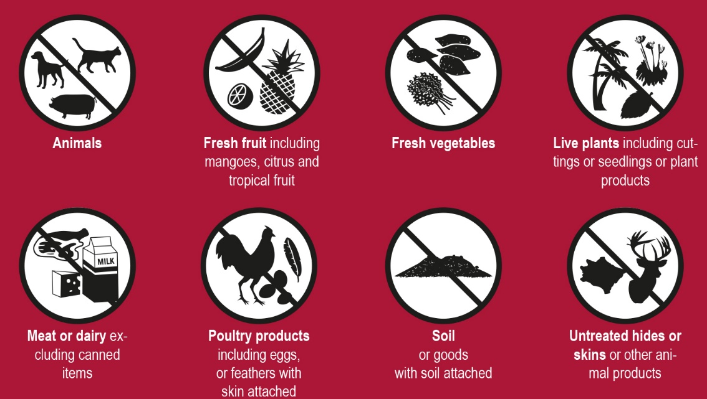

Waiben is the largest town and administrative centre for Torres Strait and features a suburb named Quarantine after the original quarantine wharf that was located there. It forms one of the five original TRAWQ settlements (Tamwoy, Rosehill, Aplin, Waiben and Quarantine) on the island. This highlights the community’s strong historical link to quarantine and its contribution to effective biosecurity as a vital function to protect local people and produce from exotic threats, a task local biosecurity officers continue to proudly perform.

Since the inception of the NAQS the department and its state and Commonwealth government counterparts have developed special relationships with Torres Strait communities, with many residents either related to, or knowing the biosecurity officers working to safeguard their home.

Map 2 The Torres Strait biosecurity monitoring zones

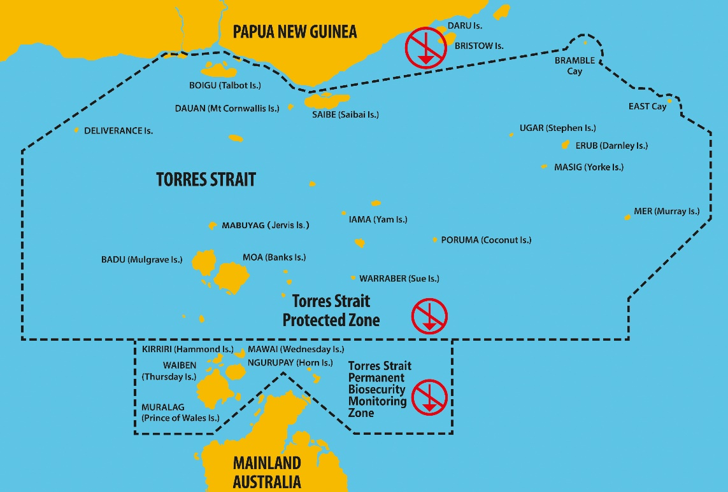

The NAQS plays a key role in the Department of Agriculture, Water and the Environment’s contribution to reconciliation through providing avenues for a range of employment, engagement and training of Aboriginal and Torres Strait Islander people across northern Australia. As at the date of publication, all of the department’s workforce throughout the Torres Strait and Northern Peninsula Area of Cape York are Aboriginal or Torres Strait Islander people.

### It’s a family affair – generations of biosecurity in Torres Strait

Family means everything in Torres Strait culture, and this is also true for biosecurity. Biosecurity operations in the region have been richly rewarded through contributions of generations of prominent and extended Torres Strait families.

The Mosby family can boast two generations directly associated with biosecurity throughout the TS&NPA, with family representatives continuing to perform key leadership roles within the department.

Bishop Ted Mosby was a leading figure in the establishment of the NAQS. Whilst living on Masig, he worked as a quarantine officer for AQIS and was very enthusiastic about his quarantine work, which rubbed off on the family, including his children and relative Hilda Mosby. Today, Danny Mosby, Assistant Director Torres Strait Operations, Nancy Mosby-Kirk, Operations Manager and Laurie Mosby, Senior Biosecurity Officer work in the Waiben office.

Danny, speaking with a grin, expresses that he has two families. ‘There is my Mosby family and there is my biosecurity family. Together, we have an important role in our community and in Australia. The effectiveness of biosecurity operations in Torres Strait is directly linked back to many families here. As well as the Mosby family, other important family names associated with biosecurity operations include Nona, Billy, Stephen, Banu, Anau, Babia, Sailor, Loban, Lui and Bond. These families are the bedrock of the NAQS community in Torres Strait and NPA.’

Reflecting on his time with the department, Danny recalls ‘I’ve had a good career in the department and I’ve been blessed working with some tremendous people, both Indigenous and non-Indigenous, looking to make a positive difference’.

Danny has fond memories of his father working for the NAQS which include helping to bleed sentinel chickens during school holidays checking for the presence of exotic bird diseases, and his father’s distinctive carving of pigs during family and community events.

‘At NAQS, Dad learned how to check pigs for exotic animal pests and diseases and when we were cooking pigs for a feast he would cut the pig’s facial area to check for cysts and also check the organs for signs for disease’.

Nancy adds: ‘Dad and his pioneering NAQS colleagues set a foundation of quarantine and biosecurity work in the region. This encourages Laurie, Danny, myself and our fellow colleagues in the important job we do, just like Dad and his team. We have a responsibility to continue the great work that was established during the ground-breaking time of 1989’.

Another influential family member was Hilda Mosby, who was a (then) quarantine officer on Masig. Hilda is now the Masig representative on the Torres Strait Regional Authority (TSRA) and the Portfolio Member for Environmental Management, which Hilda is very passionate about, especially given her wealth of experience in this field gained from her time with the Commonwealth government.

‘I will always treasure the wonderful memories of working for NAQS as a Quarantine Officer on Masig’, Hilda proudly recalls. ‘I also welcomed the opportunity to act in a higher position, providing me with greater experience, and to address the department’s Middle Manager’s conference in Sydney in 2012, where I shared my experiences on how our culture contributes to the department’.

‘Strong cultural knowledge and the importance of understanding the work between the NAQS officers and their communities has become imperative over the years. Today I would like to applaud the department in commemorating 30 years and acknowledge the team, past, present and future, who protect our islands, our way of life and our country’.

30 years of biosecurity operations under the NAQS banner has seen meaningful work handed down through generations of workers. This has been an important part of biosecurity accomplishments and the ongoing work throughout the years and into the future.

Nancy Mosby-Kirk, Torres Strait Operations Manager

## It’s all about relationships

### With industry

Industry representatives are playing increasing roles in planning, management and implementation of biosecurity activities to protect their individual businesses and broader industry sectors. Biosecurity measures are being integrated into normal business practice as a means to protect profitability and assist domestic and export trade in agricultural products. Industry representatives are also increasingly involved in the direction and prioritisation of surveillance measures with government counterparts and are investing in research and surveillance of their own.

Both the citrus and mango industries have been involved in surveillance for pests and diseases of concern in major production areas such as the Ord River Irrigation Area in Western Australia and, through partnerships with northern biosecurity authorities, have collected quality data that has been able to demonstrate area freedom. This data helps those industries to maintain and create new domestic and international trade markets.

Smaller, niche industries have also been engaged on biosecurity. For example, growers of Asian vegetables in the Northern Territory have a low level of biosecurity awareness, yet have strong cultural connections to south-east Asia. Increasing biosecurity awareness has been made possible through a range of measures promoted by the NT Farmers Association including engagement of Vietnamese speaking biosecurity liaison officers within the organisation. This has led to better biosecurity outcomes (general surveillance, awareness) for industry and biosecurity in northern Australia.

### With state and territory counterparts

The cornerstones of the Northern Australia Quarantine Strategy have been the three state jurisdictions of Queensland, Northern Territory and Western Australia. Today strong historical bonds between the department and its state and territory counterparts continue to thrive.

State and territory governments are critical to effective biosecurity in the north and nationally. They coordinate response measures in the event of significant incursions of threat species, conduct domestic biosecurity operations aligned to state and/or territory priorities and work closely with national bodies and the Commonwealth on co-ordinated national measures.

### With universities and research organisations

NAQS animal and plant scientists have long contributed to, and benefited from, enduring relationships with a range of universities and scientific research organisations. Alongside agencies such as the Commonwealth Scientific and Industrial Research Organisation (CSIRO), Plant Health Australia, Animal Health Australia, Cesar Pty Ltd, the Universities of Melbourne, Sydney, James Cook and Charles Darwin, the department through NAQS has provided guest lectures, and at times practicals, to students in the biological sciences, hosted students, collaborated on industry-funded projects and worked on the development of diagnostics and national and international studies.

The NAQS framework has always facilitated strong links between industries and government agencies working to address pest and disease threats subject to surveillance.

As industries improve their biosecurity plans and mature their focus towards proactive investments the relationship with NAQS will become more important. Not only will early detection of exotic threats remain a priority, but demonstrating absence will emerge as an important component of the future relationship.

Greg Owens, CEO, NT Farmers Association

### With community

The NAQS provides an effective vehicle for government and industry engagement with people living and working in remote and coastal areas in support of the surveillance operation of the department. The NAQS encourages and supports participation by a diverse range of groups including residents, visitors to the regions, travellers, transport industries and local operators.

In the Northern Territory, Western Australia, Torres Strait and mainland Queensland much of the land is owned by Aboriginal and Torres Strait Islander people who have special roles in caring for country and supporting the broader biosecurity effort. The department employs teams of Community Liaison Officers (CLOs) whose core function is to develop and nurture effective and co-operative relationships with land stewards on the ground.

CLOs work to ensure ongoing support for early detection reporting within communities and facilitate access to surveillance areas in collaboration with landowners and native title holders, CLOs work closely with contracted Indigenous ranger groups to provide support, mentoring, exotic pest and disease awareness and training to assist the important monitoring and surveillance activities the rangers perform.

Public awareness resources are developed to facilitate community reporting of target species, adherence to biosecurity regulations and reflect the cultural and geographic diversity of communities in northern Australia.

### Keeping a Top Watch in your Community!

Keep a Top Watch has been a unifying and consistent call-to-action supporting early detection for exotic pest, disease and weed arrivals for over twenty years. The request encourages people living, working or visiting northern Australia to remain vigilant for and report suspected biosecurity threats to the Department of Agriculture, Water and the Environment or national plant and animal disease hotlines.

Participation and support by local communities in vast and largely uninhabited areas is vital to the early detection of unwanted arrivals. It maximises the chance of successful eradication, containment or industry preparation before the relevant species establish at levels that are uneconomical or biologically impossible to manage.

Activities and public awareness resources delivered under the Top Watch initiative recognise locals as best placed to notice unusual changes in landscapes and their communities. Innovative awareness and education strategies aim to capitalise on this specialist knowledge to assist the early detection system and ensure understanding and support for surveillance operations on lands that are privately owned or subject to native title.

### Biosecurity. It’s everyone’s business

Biosecurity. It’s everyone’s business represents the broader, collaborative biosecurity work between community, industry and Commonwealth, state and territory agencies across northern Australia.

Collectively, these two catch-cries embody the important messages that biosecurity is everyone’s business because it can affect all of us and to prevent a biosecurity incursion from affecting us, it is important we all remain vigilant for, and report biosecurity threats.

Pigs are known carriers of serious diseases that can threaten our livelihoods and pork industries. In 2014 a traditional visitor attempted to illegally import a pig into Darnley Island (Erub) Torres Strait. We received multiple reports from the community within a matter of hours of its arrival which enabled a quick response and location of the animal. You can’t buy public support like that!

Danny Mosby, Assistant Director, Torres Strait Operations

### Biosecurity ‘champs’ doing their bit!

Biosecurity ‘champions’ are helping to connect with communities and strengthen the biosecurity awareness message.

Over time, high profile individuals and industry leaders have been engaged by industry and government entities to increase public awareness and support for biosecurity. Key contributors to the effort include well-known and much loved characters such as famed conservationist Steve Irwin, NRL legend Mal Meninga, singer/songwriters Christine Anu and John Williamson, media personalities Mary G and more recently Catriona Rowntree and celebrity chefs Maggie Beer and Matt Moran, all doing their part to help keep Australia safe from the negative impacts of exotic pests, diseases and weeds.

### Indigenous rangers – a special partnership

Indigenous communities in northern Australia make up a substantial proportion of the region’s population. They are significant landholders and are the oldest custodians of land in the world. They have retained much of their traditional culture, continuing a strong and proud practice of custom on country, places like the top end of Northern Territory - Arnhem Land, the Tiwi Islands, Groote Eylandt, the Kimberley in Western Australia and Torres Strait.

Effective working relationships with Indigenous communities are based on the natural alliance between the concepts of protecting against invasive threats and looking after island and coastal homes and country. Similarly, the partnering of Indigenous ranger groups in biosecurity operations helps to safeguard their communities and contribute their expertise and resources to assist animal and plant health surveillance.

Indigenous communities have played critical roles in supporting and enabling the NAQS surveillance since its inception. Since 2004, Indigenous ranger groups have delivered a range of biosecurity services under fee-for-service arrangements with the department, carrying out key roles in the frontline of animal, plant and aquatic health monitoring. They are critical to Australia’s ability to maintain an early detection system for exotic pests and diseases in remote coastal areas across the north. Increasing over time, current services provided by rangers include participating in animal, plant and aquatic health surveys, insect trapping/surveillance, plant host mapping, collection and destruction of biosecurity risk material and biosecurity awareness activities in remote communities.

## Government White Papers improving biosecurity

In 2015 the Australian Government announced two major commitments supporting improved national biosecurity capability. Aimed at growing the Australian economy through a range of strategic investments, the Agricultural Competitiveness White Paper committed approximately $200 million over four years to biosecurity measures through collaborative inputs from the Department of Agriculture, Water and the Environment and diverse partners including other Commonwealth agencies, state and territory governments, non-government researchers, and industry and community representatives.

Further funding made available through the Our North, Our Future: White Paper on Developing Northern Australia enabled the investment of an additional $12.4 million over four years to expand and enhance Indigenous ranger contributions to biosecurity surveillance and response preparedness in northern Australia.

Achievements through the investments supporting improved biosecurity in northern Australia included:

Improved surveillance for exotic plant, animal and aquatic health risks through:

* follow-up off-shore surveillance to determine presence or absence of pest or disease recorded in earlier surveillance
* establishing closer ties between state, territory and Commonwealth agencies and industry on collaborative surveillance measures
* improving data on new and emerging risk pathways
* enhanced co-ordination of surveillance measures targeting high impact, exotic threats to Australian aquaculture and marine environments.

Increased involvement of Indigenous ranger groups, supported by improvements in tools and training to enable the biosecurity services they perform. Key achievements included:

* engaging additional ranger groups for contracted services
* developing an accredited training package in biosecurity
* delivering Biosecurity Fundamentals training to improve awareness of biosecurity principles and the important contributions of rangers to protecting our agricultural sectors.

Improved community engagement through:

* engaging high profile individuals in developing communications products to raise awareness and advise on practical measures industry and community can do to assist animal, plant and aquatic health surveillance
* fostering closer collaboration between state and territory and Commonwealth agencies, agricultural producers and communities to coordinate biosecurity messaging and increase industry capacity to prepare for and mitigate biosecurity threats to their businesses and broader industries
* engaging new partners in biosecurity strategies including local governments and other community representatives in Torres Strait and other high risk regions.

Improved data and systems supporting biosecurity surveillance, operations, preparedness planning and capacity to demonstrate presence or absence of target exotic pests and diseases in northern Australia. The improved technologies and systems include:

* the award winning Ranger App enabling real time data reporting by Indigenous Rangers
* surveillance data quality reviews and enhancements aligned to applicable national reporting and analytical standards.
* the Torres Strait Information System (TSIS) supporting improved risk-based biosecurity regulation in Torres Strait.

Strengthened diagnostic capability through:

* investing in training and skill sharing across networks
* developing better diagnostic tools to address specific diagnostic challenges associated with agriculture in northern Australia
* investing in laboratory capability for northern Australia.

The following pages provide case studies of some of the major achievements through the White Papers.

### Papua New Guinea Treaty Village surveys

Residents and local authorities within the Treaty Villages demonstrated strong awareness of the biosecurity implications of living in the border region between three countries, but when faced with the rigours of a subsistence way of life, having adequate food is a daily concern.

Barbara Waterhouse, NAQS Senior Botanist

The Torres Strait Treaty protects the way of life of traditional inhabitants of the Torres Strait Protected Zone in Queensland and thirteen nominated villages in coastal Western Province PNG bordering Torres Strait. Residents of these villages have close family, cultural and trading ties with residents of Torres Strait. The Treaty Villages extend from close to the Indonesian border in the west to the mouth of the Fly River in the east. The villages of Sigabaduru and Buzi are only four and seven kilometres respectively from the nearest Torres Strait islands.

The villages are remote and difficult to access for both PNG and Australian authorities, with no all-season roads or airstrips in near vicinity. Coastal waters in the region are mostly uncharted, limiting access by larger vessels. Most travel in the region is by small dinghy.

Unlike the Torres Strait islands, Treaty Village residents do not have mains power, running water, or ready access to health care, education and supermarkets. Hunting (sea and land) and subsistence agriculture provide the main sources of food. There is significant unregulated trade eastwards from Indonesia into the Treaty Villages, and many residents also have family living on the Indonesian side of the border.

Historically, many of the new plant pest and disease incursions into Torres Strait have arrived first in the Treaty Villages. Some important examples include black Sigatoka disease of bananas, red banded mango caterpillar, spiralling whitefly, Asian honey bee and its parasitic mite Varroa jacobsoni and OFF.

Since 2001 the cost and complex logistics associated with visiting the villages had become prohibitive and limited capacity for regular joint Australian/PNG biosecurity surveillance. In the interim, several new pests, namely vegetable leaf miner, mango gall midge and the erythrina gall wasp turned up unexpectedly in Torres Strait. For this reason, follow up surveys to investigate what else might be in the Treaty Villages were identified as very high priority under White Paper initiatives and two joint Australian and PNG Government surveys were completed in early 2017 and 2018 respectively.

The surveys confirmed the presence of those pests and revealed the presence of a new pest, the capsicum whitefly, in several villages. This insect pest has a wide host range including crops in the tomato/potato family, as well as the widespread ornamental shrub Duranta. More recently in June 2018, capsicum whitefly has been detected on Boigu.

The Treaty Village surveys also revealed unregulated cross-border movement of crop plants and other biosecurity risk material from both Indonesia and Australia into PNG. Examples include the introduction of coconuts and sweet potatoes from Torres Strait into the villages, and trade of bulk supplies of culinary rice grown in the Merauke area of Indonesia along with weed seed contaminants.

Survey teams were unable to determine the source of a distinctive variety of sweet potato observed in many villages. Novel crops such as rice were being trialled on a small scale in several villages. The surveys found no evidence of citrus canker in any of the villages, although known to be present in nearby Daru, nor of banana blood disease, known from neighbouring Papua Province, nor HLB or its vector the Asian citrus psyllid, known from elsewhere in Papua Province and PNG.

Intelligence data obtained through the above activities continues to provide important guidance in Australia’s domestic surveillance and preparation measures.

### People and Country – Yirrganydji Land and Sea Ranger Program

Funding provided through the Agricultural Competitiveness White Paper and the Our North, Our Future: White Paper on Developing Northern Australia (2016 to 2019) enabled a significant expansion of the ranger biosecurity network. Initiatives were designed to increase biosecurity surveillance capability, support early identification and proactive management of biosecurity threats as well as build and maintain skills and increase employment opportunities in Indigenous communities across the north.

Through the White Paper measures Indigenous organisations have increased active participation in hosting annual Indigenous ranger forums with a focus on enabling consistent and effective biosecurity service delivery through up to date training, information sessions and infield participation in surveillance activities with scientific subject matter experts. Targeted biosecurity training increases connectivity and the sharing of knowledge between the groups and demonstrates the active partnership between Indigenous communities, governments and scientists, on country.

Together these collaborators help protect, maintain and build cultural heritage, environmental assets, functioning ecosystems, prosperous agricultural industries and Australia’s enviable biosecurity status.

Established in 2018 the Biosecurity Fundamentals Training provides rangers with skills in biosecurity monitoring and response measures, familiarisation of regulated pathways in Torres Strait, unregulated risk pathways through which biosecurity threats can travel and increased understanding of biosecurity risks in northern Australia and what to look for.

Brian Singleton, Senior Ranger with the Dawul Wuru Aboriginal Corporation states ‘building and maintaining relationships is really important to the program. Without partnerships we don’t have a ranger program.’

Under the Yirrganydji Land and Sea Ranger Program, rangers collaborate with the wider community and undertake a range of cultural and natural resource management activities within the Cairns and Port Douglas region. Rangers also work with a number of organisations to undertake training and professional development to increase capacity and skills competency. Turtle and dugong monitoring, weed management and biosecurity monitoring and surveillance are essential in building the knowledge base for caring for country.

‘It’s all about nurturing relationships,’ says Brian. ‘Genuine relationships with individuals; Department of Agriculture, Water and the Environment delegates who take the time to learn about our Country, getting a feel for our Country and see why we do what we do; Community Liaison Officers like Harry and Aaron who provide mentoring and training; generates interest from our own people in what we are doing and makes them feel comfortable in reporting what they see’.

‘Working with the department changes our work, making it easier and more efficient’ says Gavin Singleton, Project Manager with the Yirrganydji Land and Sea Ranger Program. ‘We are supporting each other to manage and look after our country for everyone’.

#### Country Handle with Care

In the Country Handle with Care web video series, ABC TV eco-warriors Costa the Garden Gnome, dirtgirl and scrapboy, along with NAQS officers, travel throughout northern Australia from Cardwell to Torres Strait and across to the Kimberley.

Along the way they discover the beauty of our country, meet with dedicated biosecurity officers, scientists and Indigenous rangers at the forefront of protecting Australia from biosecurity threats, learn how to reduce the risks and report anything unusual.

##### We are vectors – spoken word

by Costa the Garden Gnome and dirtgirl

We are vectors, intersectors, pathways and super highways

For pests and disease. So please,

Stop and connect with country

Know. And then care

It’s only fair to protect the plants, the birds, the fish

The marine life, all creatures of the sea

Those on land that you see

And those you won’t

So don’t think it’s no big deal

But do be brave and connect with country with your heart

And see the beauty of the land

On which we stand. Understand

The traditions and culture

At hand

Bring nothing. Take nothing

See and feel everything

Ask for guidance

Listen

Ask if you don’t know

And explore with respect

And always be willing to connect

And care.

For country

Yeah

Costa the Garden Gnome, dirtgirl and scrapboy appear in the department’s ‘Country Handle with Care’ video series that can be seen online.

[Costa and dirtgirl tackle biosecurity](https://www.agriculture.gov.au/biosecurity/australia/northern-biosecurity/country-handle-with-care%23episode--1--the-big-farm)

### New partners joining the fold – the Torres Strait and Northern Peninsula Area Biosecurity Strategy

Threats of pest, disease and weed arrivals from PNG into Torres Strait are real and ever present. Torres Strait’s proximity to neighbouring countries where diverse pest species occur, and vulnerability to movements of endemic pests from mainland Australia, provide unique challenges to those working to protect the region’s pristine environment and communities.

An integrated Torres Strait and Northern Peninsula Area Biosecurity Strategy was announced in 2018 to guide collaborative biosecurity measures in this beautiful but fragile part of the world. The strategy and working forums underpinning the measure provide a unifying framework for co-operation and reflect the goodwill between biosecurity and associated agencies operating in the region. The measures further increase opportunities for local authorities and community representatives to contribute their expertise and efforts to the biosecurity cause.

‘The strategy is an important step in increasing community participation in biosecurity’ says Malcolm Letts, Deputy Director-General and Chief Biosecurity Officer, Queensland. ‘It enables us to guide and participate in practical actions that reflect community priorities and the continuing expression of local culture and traditional practices. Working together gives communities the best chance to continue to access healthy food important for traditional practices and for children to thrive in the pristine and abundant environments they currently enjoy’.

For millennia, since bepor taim, Indigenous peoples of the Torres Strait and Northern Peninsula Area have practiced traditional land and sea management in accordance with Ailan Kastom, Aboriginal Lore/Law and native title rights and interests. Because of this continuing stewardship, the region remains one of the richest and most intact environments on earth.

Torres Strait and Northern Peninsula Area Biosecurity Strategy

### Innovation a key to success

Effective surveillance in a dynamic risk environment requires innovation and an adaptive approach. The establishment of the NAQS in 1989 was an innovation for the time, establishing an effective model and platform for collaboration which continues to this day. Biosecurity practitioners work hard to continually improve the system across the north and ensure scientific surveillance techniques and the Top Watch! message remain contemporary and accessible, aligned to evolving risks and community expectations.

Effective data and information systems are crucial to evaluating risk profiles and good decision making on surveillance and response strategies. Investments through the White Paper have, accordingly, prioritised collaborative research, improved data collection and information and communications technology (ICT) systems. The investments include innovative technologies to better target risks and adjust surveillance and intervention strategies based on improved understanding of current and emerging threats. Achievements have included 3D audio-visual experiences provided to schools and communities across northern Australia to build biosecurity awareness, online tools to simplify biosecurity incident reporting and issuing of permits for goods subject to biosecurity controls and increasing utilisation of remote sensing and targeted data tools, such as the award-winning Ranger App.

There’s work still to be done, but we’ve made great improvements. Risk patterns overseas are changing, the task is becoming more complex. We need to continue to innovate to continue to be effective.

Marion Healy, Department of Agriculture, Water and the Environment, Head of Biosecurity Plant Division

### The Ranger App

Developed to streamline data collection, reporting and to meet the specialised requirements and connectivity challenges faced by Indigenous rangers working on country, the app is a modern tool that enables timely submission of animal, plant and aquatic health intelligence information and suspect detections of pest species in remote areas. Users can check files and monitor the status of data collection activities.

Once back in areas with network coverage the stored data can be submitted to the department’s network where it can be accessed by biosecurity officers for further analysis and distribution to external entities as required.

In 2018 the app was successful at the ACT iAwards and took out a merit award in the Public Sector and Government category at the National iAwards, the digital industry’s ‘night of nights’. The app also qualified for the Asia Pacific ICT Alliance (APICTA) International awards held in Guangzhou, China.

### Small vessel traffic surveys

Small vessels, including dinghies and banana boats can facilitate the movement of biosecurity risk materials by conveying goods and traditional visitors between PNG, Torres Strait and the mainland. Funding through the White Paper between 2016 and 2019 enabled improved monitoring of high risk small vessel movements utilising specialist contractor services and novel underwater monitoring devices. Information obtained through the activities have helped to establish improved baseline risk data to support better targeting of risks associated with the small vessel movements.

Underwater sensors were placed strategically along known vessel corridors to capture acoustic data to establish small vessel movement patterns. The analysis of this data has helped to determine numbers, directions, times and approximate sizes of vessels. Paired with visual observations of surface movements recorded to verify and calibrate the acoustic recordings, the data will be used to inform regulatory operations, public awareness and contribute to future biosecurity risk assessments and international strategies.

### Improving information and communications technology in Torres Strait

For many of us, reliable ICT is part of everyday life and can often be taken for granted. For biosecurity officers in TS&NPA, reliable access to services is a relatively recent occurrence and good ICT has been revolutionary.

Long-standing and highly respected biosecurity officer, Jerry Babia from Saibe at the top of Torres Strait is literally at the forefront of Australia’s biosecurity network. ‘Looking back 10 years, our biggest challenge was reliable communications and recording our paperwork’, Jerry recalls. ‘We had just a landline and a fax machine, the only way to communicate between Thursday Island, Cairns, NPA and the outer Torres Strait islands. Even then we regularly had technical issues. Every bit of paperwork was manually recorded onto different forms, faxed and then filed.’

As recently as 2006 the department’s operations base on Waiben was upgraded from one computer on dial-up to four on ISDN. Over the next 10 years, the department embarked on major ICT upgrades which included contributing approximately $2 million to an $8 million improvement of the Torres Strait network. In 2017 a dedicated ICT specialist on Waiben was engaged and by 2019, all TS&NPA staff were issued with mobile tablets to better take advantage of improving ICT connectivity in the region.

‘Things have changed a lot. We now record our operational data directly onto our tablets or phone and send directly to the department’s Torres Strait Information System (TSIS). We are very thankful for positive and helpful resources invested throughout Torres Strait and the NPA to make our work much more efficient’, Jerry concluded.

### Modern diagnostics skilling for the future

Diagnostics provides the foundation of Australia’s biosecurity surveillance capability. The White Paper initiative strengthened this capability through increasing connectivity between diagnosticians, enhancing diagnostic skills and tools and improving relevant scientific infrastructure.

White Paper measures prioritised areas of improvement required in entomology and plant pathology diagnostics identified by expert working groups made up of senior diagnosticians.

Significant outcomes of the initiatives include:

* provision of funding to support ten diagnostic workshops for over 150 diagnosticians from across Australia
* funding for 15 laboratory residentials through the National Plant Biosecurity Diagnosticians Network
* development of interactive identification tools (LucID keys) to twelve priority insect families that include northern pest taxa and eight further projects, the outputs from which include genetic sequence data to facilitate accurate and timely diagnostics for high priority pests and diseases
* new assays help to detect novel strains of arbovirus in northern Australia
* a pilot trial was conducted utilising FTA Cards® for surveillance in a well-monitored NAMP sentinel herd to enable comparison of BTV detection in sentinel cattle over a complete arbovirus season
* a series of priority animal disease projects that reviewed the northern Australian priority animal disease laboratory specimen requirements as well as the current laboratory diagnostic capability and screening test availability for priority animal diseases in each state/territory-operated veterinary laboratory in Western Australia, Northern Territory and Queensland
* a joint funding agreement between the Commonwealth and the Northern Territory governments was reached during the 2017 / 2018 financial year which will see the construction of a new shared diagnostic facility in northern Australia
* provision of funding to develop the Sample Tracking and Reporting System Network (STARS) model with the aim of developing greater functionality and efficiency in sample submission, identification, tracking and reporting.

To ensure the legacy of the White Paper investments, products such as LucID keys and data and sequences from downy mildew and Elsinoe plant pathogen projects, for example, will be published and permanently hosted on web platforms to be publicly available to diagnosticians nationally.

## Biosecurity collaboration – beyond the first 30 years

Changing patterns of pest, weed and disease movements offshore and within Australia remain an ongoing threat to our animal, plant and aquatic health. Safeguarding our unique environment, communities and trade in agricultural products requires continued vigilance and adaptive approaches though innovation and co-operation by willing and capable partners in the national biosecurity effort. For thirty years, the Northern Australia Quarantine Strategy has provided a quiet but unifying framework for cooperation and effective surveillance for threats that can arrive and establish in our beautiful north. The NAQS story is one of partners across Commonwealth, state, territory and local governments, remote communities, industry and visitors working together for Australia’s national interest. This is all driven by the complex and challenging science of risk evaluation and targeted allocation of biosecurity resources and mitigation strategies.

Northern Australia remains an important defence in efforts to protect our environment and agricultural trade in safe, reliable and healthy agricultural produce and the benefits they provide for all Australians in a competitive and ever-changing world. As long as threats of unwanted arrivals through natural and other pathways exist, collaboration and partnerships remain key to biosecurity success.

We hope you’ve enjoyed our journey through the first 30 years of co-operative surveillance, engagement and regulation in our beautiful north.

Biosecurity is everyone’s business so remember to Keep a Top Watch! and help keep Australia safe.

## Pest, disease and weed threats to northern Australia

NAQS surveillance targets exotic insect pests, diseases and weeds that are considered serious threats to Australia’s agricultural productivity, export markets or the environment and have potential to enter northern Australia by non-conventional pathways. Target species are reviewed regularly to ensure NAQS surveillance is risk-based and aligned to national animal, plant and aquatic health priorities.

Target species included on the NAQS target list consider the following criteria:

* **Probability of entry** – there is a reasonable probability of entry of a pest, disease or weed into northern Australia. These include
  + Whether the organism is known to be present in locations near to northern Australia
  + Method of spread and number of viable arrival pathways (natural or non-conventional transmission / dispersal must be possible)
  + Known history of international spread and biosecurity concern
* **Probability of establishment** – there is a significant probability of establishment if a pest or disease enters northern Australia. These include
  + The availability of suitable hosts/habitat
  + The ecology of the pest, disease or weed
  + The likelihood of survival
  + Cultural practices and control measures likely to impact establishment
* **Probability of spread after establishment** – there should be considerable likelihood of spread after establishment in and beyond northern Australia. This is determined after considering the following
  + Suitability of the overall environment for natural spread and hosts
  + Presence of natural barriers to dispersal
  + Potential for movement outside of the NAQS surveillance zone via trade, people or natural transmission
  + Potential vectors of the pest in northern Australia
  + Potential predators or natural controls of the particular pest
* **Potential significant adverse impact** – the pest, disease or weed must have the potential to cause a significant impact to agriculture, the environment or the Australian public.

Listed are just a few pests, diseases and weeds that could have severe consequences if they established in Australia.

Always go to [awe.gov.au](https://www.awe.gov.au/) for the most up to date information.

### Animal diseases

#### African and classical swine fever

These are severe diseases of pigs that are spread by infected live pigs, in fresh, frozen, cured or salted (such as ham or bacon) pig meat. Infected pigs may appear weak, drowsy, trembling and pigs often die suddenly. The virus can stay alive in the environment for months and can be carried on vehicles, clothing and shoes.

#### Rabies

A viral disease that can affect all warm-blooded animals, including humans, affecting the central nervous system and transmitted through saliva of an infected animal. Infection usually occurs through the bite of an infected animal such as a dog, or infected saliva entering an open wound or mucous membranes in the eyes or mouth. If not treated, exposed humans or animals are likely to develop symptoms weeks or months after exposure. If they do, it is always fatal.

#### Avian influenza and Newcastle disease

Highly pathogenic avian influenza and virulent Newcastle disease are exotic diseases of birds that can spread rapidly and kill thousands of native and introduced bird species. These diseases can severely damage Australia’s egg, chicken meat and avian industries. Symptoms include groups of birds in respiratory distress, lethargy, coughing or large numbers of dead birds in an area.

### Insect pests

#### Sugarcane borer

Sugarcane borers are caterpillars that burrow inside sugarcane stalks. Some species may kill the growing tip and others can severely damage the stem, causing loss of sugar production. Many of these pest species are native to, and widespread in PNG. They have also been found on some Torres Strait islands. Some species also attack rice, maize, grain sorghum and other grasses.

### Plant diseases

#### Huanglongbing (HLB)

Transmitted by insect vectors, the Asian citrus psyllid, this bacterial disease is the worst disease of citrus trees in the world. Early signs of infection are hard to pick as leaf symptoms look like nutrient stress. Yellowing starts in only one branch or section of the tree, then spreads through the canopy causing decline, then death. Long before the tree dies, fruit turn odd shaped and taste bad.

#### Banana wilt diseases

Several devastating banana wilt diseases in neighbouring countries threaten Australia’s banana industry. These diseases are Panama disease, caused by a soil-borne fungus, bacterial wilts called moko disease, blood disease and one caused by a very unusual bacteria called phytoplasmas. Wilt diseases turn banana leaves yellow and kill the plant. Bacterial wilt diseases also make fruits go brown inside.

### Marine pests

#### Black-striped false mussel

Black-striped false mussels are not established in Australian waters. Originating in Central and South America, the mussel has spread to several countries in the Indo-Pacific region and are considered a serious pest because of their ability to rapidly establish huge populations and cause significant environmental and economic impacts. They are usually found in dense clusters and rarely as a single mussel.

#### Asian green mussel

The fast growing mussel can out-compete native species and foul hard surfaces, including vessel hulls, seawater systems, industrial intake pipes, wharves and buoys. The mussel can also attach to organic matter such as seagrass, roots and shells. They accumulate toxins and heavy metals which can cause shellfish poisoning if eaten by humans. They can occur individually or in massive clusters.

### Weeds

#### Spiked pepper

This ornamental shrub invades pastures and plantations, forming impenetrable stands and replacing beneficial pasture and forestry species. It is shallow-rooted and can exacerbate soil erosion on steep slopes. The tiny dark seeds can be carried long distances by birds, fruit bats and other mammals or on vehicles and machinery.