Future-proofing Australian hay production: global insights for local action
Natalie Schlitz, 2024 Nuffield Drought Resilience Scholar, Victoria
Nuffield Australia project number 2419
October 2026
© Commonwealth of Australia 2026
Ownership of intellectual property rights
Unless otherwise noted, copyright (and any other intellectual property rights) in this publication is owned by the Commonwealth of Australia (referred to as the Commonwealth).
Creative Commons licence
All material in this publication is licensed under a Creative Commons Attribution 4.0 International Licence except content supplied by third parties, logos and the Commonwealth Coat of Arms.

Cataloguing data
This publication (and any material sourced from it) should be attributed as: Schlitz, N 2026, Future-proofing Australian hay production: global insights for local action, report for Nuffield Australia and Department of Agriculture, Fisheries and Forestry, Canberra. CC BY 4.0.
This publication is available at Nuffield Australia Scholar Reports and at agriculture.gov.au/Drought Resilience Scholarship Program.
Drought Resilience Scholarship Program
The program is funded by the Australian Government’s Future Drought Fund. In submitting this report, the 2024 Nuffield Scholar Natalie Schlitz has agreed to Nuffield Australia and Department of Agriculture, Fisheries and Forestry publishing this material in its edited form.
Natalie Schlitz
Telephone 0421 532 112
Email natalie.schlitz@outlook.com
Nuffield Australia
38 Walker Drive, Worongary QLD 4213
Web Nuffield.com.au
Email enquiries@nuffield.com.au
Department of Agriculture, Fisheries and Forestry
GPO Box 858 Canberra ACT 2601
Telephone 1800 900 090
Web agriculture.gov.au
Disclaimer
The views and opinions expressed in this publication are those of the authors and do not necessarily represent the views of Nuffield Australia, the Australian Government or the portfolio ministers for the Department of Agriculture, Fisheries and Forestry.
The content of this publication does not constitute advice to any third party. Although due care and skill have been applied in the preparation and compilation of the information and data in this publication, no reliance may be placed on it by any other party. No representation expressed or implied is made by Nuffield Australia or the Australian Government as to the currency, accuracy, reliability, completeness or fitness for purpose of the information contained in this publication. The reader should rely on its own inquiries to independently confirm any information and comment on which they may intend to act.
Nuffield Australia, the Commonwealth of Australia, its officers, employees, agents and the other parties involved in creating this report disclaim, to the maximum extent permitted by law, responsibility to any other party for any liability, including liability for negligence and for any loss, damage, injury, expense or cost incurred by any person as a result of accessing, using or relying upon any of the information or data in the publication.
Acknowledgement of Country
We acknowledge the continuous connection of First Nations Traditional Owners and Custodians to the lands, seas and waters of Australia. We recognise their care for and cultivation of Country. We pay respect to Elders past and present, and recognise their knowledge and contribution to the productivity, innovation and sustainability of Australia’s agriculture, fisheries and forestry industries.

Executive summary
Of droughts and flooding rains — Dorothea Mackellar
The Millennium Drought (2001 to 2009) stands as the most severe and prolonged drought on record for southeast Australia, profoundly impacting the region’s hydrological, ecological, economic, and social systems. Unlike shorter, seasonal droughts, this multi-year event was preceded by a series of relatively dry years, a rapid increase in urban and rural water use (Van Dijk et al 2013) and as such, could be considered the first major Australian drought that interacted significantly with the slower influence of climate change (BOM 2025).
Van Dijk et al (2013) identified that this drought marked a turning point in the national conversation, shifting perspectives from drought as a natural disaster to a recurrent and predictable feature of the Australian landscape. While the consensus was that drought is a repeatable risk, it is the combination of an inability to gauge the duration, severity and spatial extent and the compounding effects of unstable climatic drivers that poses the greatest risk to agricultural productivity and profitability.
In response to the increasing frequency and severity of droughts and the recognition that Australian farm businesses needed to adopt self-reliant approaches to manage climate variability (Australian Government 2025), the Australian Government established the Future Drought Fund (FDF); an annual investment aimed at building resilience across agriculture, landscapes, and communities. This commitment clearly recognises the enduring nature of drought in Australian agricultural communities and the need to proactively prepare in order to respond and recover (Australian Government 2025b).
At the time of writing this report, south-eastern Australia was suffering the effects of sustained drought while simultaneously the East coast was encountering intermittent, widespread flooding. Subsequently, the demand for feed across these regions increased exponentially as livestock producers attempted to maintain the productive capacity of their herd or flock.
Fodder, broadly defined as hay, straw or silage, is fundamental to Australian farming systems and it is not unrealistic to suggest that “almost every farmer in Australia touches fodder regardless of their farming system” (AFIA 2023). As such, fodder production is a critical tool that remains undervalued, particularly at a national level. While its importance during droughts and floods is well recognised and quantifiable; hay plays a strategic role during favourable seasons by supporting farm profitability, productivity, and operational flexibility, all of which are key factors that build long-term resilience to climate variability.
This report explores global hay production, focusing on the necessity for future climate resilience in Australian agricultural systems.
Keywords: hay, fodder, drought resilience, Future Drought Fund, dryland, broadacre

Contents
Executive summary iii
Foreword vi
Acknowledgements ix
Abbreviations x
Objectives xi
Introduction 1
Industry analysis 3
Strengths 3
Weaknesses 3
Opportunities 5
Threats 5
Our future climate 7
My Climate View 7
Data analysis: How does our future impact hay production? 7
Key learning for Australia 8
United States of America 10
Farming in the desert 10
Responding to a drying climate 12
Socioeconomic impacts of drought 15
Key learning for Australia 16
Canada 17
Innovative mindset 17
Key learning for Australia 19
Central Europe 20
German engineering 21
Heuwirtschaft 22
Key learning for Australia 24
Future hay 26
The search for a “future climate” equivalent 26
Key learnings for Australia 28
Making progress 29
Conclusions 30
Recommendations 31
References 32

Figures
Figure 1 A selection of Nuffield Scholars exploring Brazil during the 2024 Contemporary Scholars Conference. Source: Niall Hurson, 2024 Nuffield Scholar vi
Figure 2 Jens Rausch, German artist and creator of this artwork ‘Interfaces’ (2023), was one of the vibrant individuals the author met on her journey ix
Figure 3 Tarp-covered haystacks destined for export are prolific in El Centro, California. (Source: the author) 10
Figure 4 Change in water level at Hoover Dam, Lake Mead (1980 to 2025). (Source: Bureau of Reclamation 2025) 11
Figure 5 Small handwritten notes are tied to irrigation delivery gates and contain daily operational records. (Source: the author) 12
Figure 6 JR Echard, General Manager of the Palo Verde Irrigation District generously showcased the PVID Colorado River diversion. (Source: Peter Moller) 13
Figure 7 Rubicon Water offers a range of solutions to optimise water movement and delivery. (Source: Peter Moller) 14
Figure 8 Left to Right: Peter Moller, Rubicon Water, the author and Grant Chaffin, Chaffin Farms and Vice President of the PVID Board of Trustees. (Source: Peter Moller) 15
Figure 9 Imperial CA Climate Data from 1991 to 2020. (Source: US National Weather Service 2025) 16
Figure 10 Lethbridge, AB climate data from 1991 to 2020. (Source: Government of Canada 2025) 17
Figure 11 Example of value-added products from Canadian exporters Green Prairie. (Source: the author) 18
Figure 12 Example of value-added products from Canadian exporters Barr Ag. (Source: the author) 18
Figure 13 The author and her husband Jarred (left) visited Nuffield Germany advocate Andi and Lisa Liebl and their children in Bavaria. (Source: the author) 20
Figure 14 Left to right: Meinke Ostermann, 2023 Nuffield Germany Scholar, the author and her husband Jarred; and members of the Krone leadership team Jan Horstmann and Peter Weiss. (Source: Meinke Ostermann) 21
Figure 15 The LASCO round bale drying system. (Source: the author) 24
Figure 16 The Stiegerhof Farm hay drying shed. (Source: the author) 24
Figure 17 Oats destined for the export hay market in August 2024. (Source: the author) 27
Figure 18 Hay production at the author’s family property in Normanville, Victoria, Australia in 2022. (Source: Kerry McFarlane Photography) 30

Foreword
Nuffield is a mid-life crisis for the intellectual type. — Ken Coles, 2022 Nuffield Canada Scholar
A self-proclaimed, self-deprecating humour as a “Jack of all trades, a master of none” was how I light-heartedly felt after my first ten years in agriculture. While my roles in livestock health and welfare, commercial agronomy and more recently as an agricultural project lead have been varied, it has provided incredible exposure to a range of industries I had not grown-up in or around. As a result, I have developed a proactive, pragmatic and flexible approach to both my professional and personal pursuits.
When applying for Nuffield I never once thought of exploring another topic, and while I had initially planned to delve into the intricacies of the export hay industry at a market level, I acknowledged one’s circle of influence and for me, that was my own backyard.
As I navigate stepping into the family farming business in a formal capacity, I am acutely aware of the skills required to drive a thriving enterprise and position it in a way that can withstand the pressures associated with a hotter, drier and more extreme climate. In the 10 years I have worked in agriculture in northern Victoria, I have witnessed the repeated demand for high-quality hay by both domestic and export markets as short-term droughts and repeated floods decimate grain and fodder yields.
So, while I understood the merit in hay production agronomically, the value to our family mixed farming business and to the livestock industries more broadly; what I struggle to comprehend is why hay production is repeatedly undervalued at a national level.
I have not an inch of doubt that hay will continue to play its part as an integral agronomic, economic and thus resilience tool in farming systems. The more exposure high-quality hay production has, the greater chance we have for its recognition as one of the fundamental pillars of Australian agriculture.
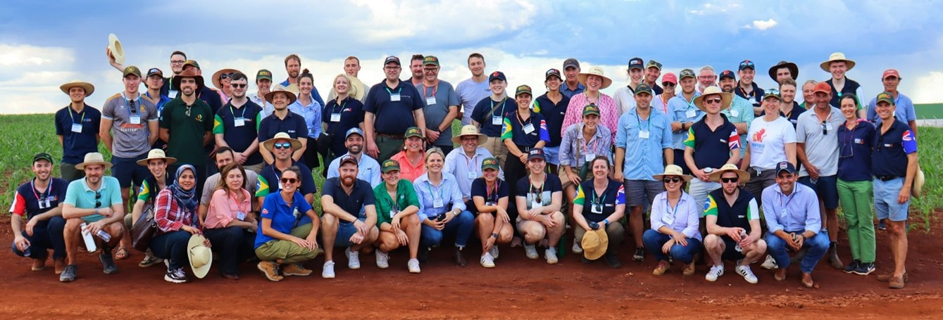
Figure 1 A selection of Nuffield Scholars exploring Brazil during the 2024 Contemporary Scholars Conference. Source: Niall Hurson, 2024 Nuffield Scholar
Table 1 Travel Itinerary
Travel date | Location | Visits/contacts
4 to 7 March 2024 | Canberra, Australia | Pre-Contemporary Scholars Conference
9 to 17 March 2024 | Campo Grande/Bonito, Brazil | Contemporary Scholars Conference
18 to 25 March 2024 | California, United States of America | Hosted by Peter Moller, Rubicon Water  Gerard Irungaray, Triple I Press  Oli Bachie, University of California  Salton Sea Project  Anthony Merten, Krone  Ronnie & Andrew Leimgruber, Leimgruber Farms  Benjamin W. Brock, IID  Grant Chaffin, Chaffin Farms  JR Echard, PVID
26 March to 3 April 2024 | Alberta, Canada | Hosted by Ken Coles, Farming Smarter  Jordan van Hierden & Jaap van de Pol, Green Prairie  Barry & Taylor Schmitt, Barr Ag  Ryan Mercer, Mercer Seeds  Dave Walner, New Rockport Colony
2 to 6 June 2024 | Western Australia | Global Focus Program
7 to 16 June 2024 | Zimbabwe | Global Focus Program
17 to 24 June 2024 | England | Global Focus Program
24 June to 1 July 2024 | The Netherlands | Global Focus Program
1 to 8 July 2024 | Georgia | Global Focus Program
23 to 25 July 2024 | Queensland, Australia | 2024 Australian Fodder Industry Association Conference
3 to 9 August 2024 | Western Australia, Australia | Dani Whyte, Braeleigh Consulting  Brad Atkinson, Atkinson Group  Danielle Trappitt, Narrogin Hay  Leigh Dolton,Totadijn Farming Company  Leon Ryan, Glenrowan Farms  Garren Knell, ConsultAg  Mark Graham, Minabbie  Ashley Forrest, Yarranabee  Lachlan McCabe, Balco  Andrew Bolt, Demeter Grain
8 to 14 February 2025 | Germany | Jan Horstmann & Peter Weiss, Krone  Claas Harvest Centre  Meinke Ostermann, Nuffield Germany  Andi Liebel, Nuffield Germany
14 to 22 February 2025 | Austria | Michael Eder & Johanna Gerhalter, Hirtl  Aloise & Isabella Dick, Stiegerhof Farm
Other – Virtual Meetings/Correspondence | – | Adrian Cannon, Tayler and Fletcher  Amy Fay, Murray Dairy  Annie Lane, AgriFutures Australia  Bryce Riddell, Multicube  Colin Peace, Jumbuck Ag  Craig Myall, Synergy Seeds  Dale Grey, Agriculture Victoria  Denis McGrath, AEXCO  Dr Noel Cogan, Agriculture Victoria Research  Geoff Walker, Hay Australia  Lily Johnson, JT Johnson  Dr Paul (Long) Cheng, University of Melbourne  Paula Fitzgerald, AFIA  Scott Waldron, University of Queensland  Shayne Eals, Balco  Stuart Nagel, SARDI  Tim Bateman, GRDC  Vanessa Curtis, AFIA  Yvette Williams, Murray Dairy

Acknowledgements
My grandfather, 97 years young at the time of writing, often said to me while growing up “don’t be a sheep, be a goat”. While I understood the general gist of his wisdom, it was not until adulthood that I understood the true meaning of his words and that was to have confidence in oneself, embrace one’s individuality, not be afraid of stumbling and to carve a path that is uniquely your own.
My Nuffield journey has given me the opportunity to do exactly this, and I would like to extend my gratitude to Nuffield Australia and the Australian Government for their support and investment in Australian agricultural professionals nationwide.
As I take the time to reflect on the last two years, I feel a deep warmth when I think about the people I have met, the places I have been to, and the adventures along the way. Many of these moments were shared with others, while others were mine alone, but all are now woven permanently into the fabric of my memory. Most were filled with joy and wonder, although a few brought challenge and discomfort. Even then, never once did I feel alone in this world as I was swiftly and gently embraced by my Nuffield family.
To my husband and best friend Jarred, I thank you with all my heart for giving me the time and space to explore who I was as a person and for only ever being supportive of my endeavours over the last two years. We are on the most wild and wonderful journey together and we are only just at the beginning of what may be the best decade yet.
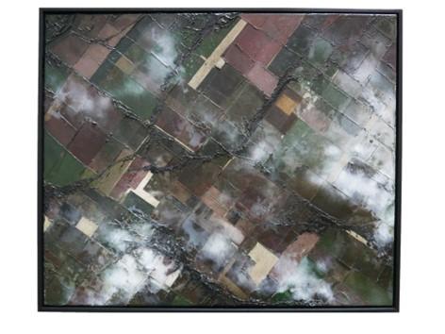
And finally, to my late grandfather and grandmother, this report is wholeheartedly dedicated to you – thank you for demonstrating over a lifetime the most admirable human qualities, including the acceptance of others as they are, a curious mind, a forgiving heart and a lifelong love of travel and learning.
Figure 2 Jens Rausch, German artist and creator of this artwork ‘Interfaces’ (2023), was one of the vibrant individuals the author met on her journey

Abbreviations
Term | Definition
AFIA | Australian Fodder Industry Association
AVR | Agriculture Victoria Research
BOM | Bureau of Meteorology
CAP | Common Agricultural Policy
CSIRO | Commonwealth Scientific and Industrial Research Organisation
DIP | Deficit Irrigation Program
ETo | Evapotranspiration
EU | European Union
FAO | Food and Agriculture Organisation
FDF | Future Drought Fund
FECP | Farm Efficiency Conservation Program
GRDC | Grains Research and Development Corporation
IID | Imperial Irrigation District
MRL | Maximum Residue Limit
MWD | Metropolitan Water District
NDF | Neutral Detergent Fibre
NSW | New South Wales
NVD | National Vendor Declaration
PIRSA | Department of Primary Industries and Regions South Australia
PVID | Palo Verde Irrigation District
RDC | Research and Development Corporation
SA | South Australia
UQ | University of Queensland
USD | United States Dollar
WA | Western Australia

Objectives
- Summarise the current challenges and opportunities in Australian hay production.
- Assess the potential impacts of future climate scenarios on hay production in the Victorian Southern Mallee region.
- Explore global hay production systems and highlight the unique challenges these systems face in maintaining business resilience.
- Identify key recommendations that the Australian hay industry can leverage to improve productivity and profitability.

Introduction
Hay production is rarely associated with export markets. However, in 2021–22, Australia exported approximately 10% to 15% of the 5.2 million tonnes of fodder produced locally to countries such as Japan, China, Korea, Taiwan, and the Middle East (AFIA 2021).
It is estimated of the 38,000 farm businesses that produce fodder, a mere 1,500 to 2,000 of those grow hay for the export market. The value of Australian export hay has increased exponentially, from a value of $271.5 m in 2010 to $563.4 m in 2020 (AgriFutures Australia 2021).
The single greatest challenge Australian hay producers face is the ability to generate a consistent, high-quality product despite climate and seasonal variability. Australian hay production in general has always prioritised “quality over quantity” (Cheng 2023), however there has been a notable push towards greater professionalism in how hay destined for the export market is produced in the last 10 years.
Australian hay production varies across the country to suit regionally specific environmental, agronomic and market considerations. An example of this is the production differences between lucerne (alfalfa) and vetch. While lucerne has traditionally performed well in the Australian landscape, vetch is more resilient in water-limited, dryland conditions and provides growers with the flexibility to plant annually depending on seasonal forecasts. Importantly, the versatility of vetch has transformed beyond being seen as solely a “break crop” and is now considered a marketable product in its own right. However, while the value of vetch as a high protein hay in Australian livestock systems is well-recognised, there is a significant knowledge and perception gap in international markets that mistakes vetch as an inferior animal feed (Nagel 2023). Overcoming these tightly held beliefs would require improved stakeholder relationships and a targeted, long-term campaign to position vetch as a premium, safe and valuable commodity.
The domestic market, supported by Australia’s varied animal industries that are often conveniently located near key growing regions, “demands high-quality, heavy, large square bales [with] minimal variation in colour, energy and protein” (Smith 2024). To achieve this, growers are encouraged to “bale to an export standard” (Ford 2024) suggesting that establishment and storage practices unlock flexibility for growers in that they produce a superior product and therefore can sell into both domestic and export markets.
Australia’s export hay industry is well established but is not immune to the challenges of international trade. Scott Waldron (2023) from the University of Queensland (UQ) notes that the Chinese dairy sector is enabled by a huge demand for feed, yet China’s production capacity domestically is constrained. Despite efforts to increase production locally, Waldron believes it is unlikely that China will dramatically increase the production of fodder in place of grain due to the opportunity cost.
Waldron (2023) adds that long-term engagement with China is essential as “China is here to stay [and will] likely [be] our biggest partner moving forward forever”. However, the degree to which Australia trades with China will be largely driven by shifts in Chinese policy, particularly around land use, subsidies and trade regulations, not market demand alone.
While the Australian fodder industry is robust, responsive and innovative, there is a lingering sense that the hay industry remains fragmented. The Australian Fodder Industry Association’s (AFIA) Paula Fitzgerald (2023) asked “How do we get [the export industry] to hold hands towards a common cause?” and suggests that a united strategic vision is missing in what is a complicated interplay between domestic and export production. Without it, opportunities, especially in industry growth, innovation or a generalised uplift in hay production across Australia, may be missed or delayed.

Industry analysis
An analysis was conducted by the author to assess the current state of the Australian hay industry following engagement with professionals throughout the hay supply chain. It identified the industry faces a range of challenges that hinder its growth and stability. These issues are often interconnected and demonstrate an urgent need for a more cohesive, well-supported industry to drive productivity and profitability.

Strengths
The Australian hay industry possesses several strengths that support its competitiveness in both domestic and global markets alike.
A distinct advantage is the industry’s focus and commitment to oaten hay. It could be said that nowhere else in the world is there such an emphasis on developing and refining oaten hay varieties, leading to notable improvements in both agronomic and nutritional qualities (McGrath 2023). Oaten hay has allowed Australian producers to capitalise on its agronomic value in annual rotations. For example, weed control is a direct benefit of harvesting a whole crop, particularly following the rise of herbicide resistant ryegrass in intensive cropping systems (Fay 2025). Most notably however, is the ability to retain soil moisture for successive crops, with large oat crops cut for hay eliminating the moisture demands required to produce oats for grain.
The Australian eagerness to adopt technology, such as high-density balers, have significantly enhanced efficiency, product handling and ultimately created a refined end product.
Importantly, Australia’s export hay is globally regarded as a high-quality, consistent product. Anecdotally, it has been observed that livestock will sort through a mixed feed offering to actively seek out Australian-produced oaten hay given its high-water soluble carbohydrates (Peace 2023).
In comparison, while vetch is not widely exported, it holds a strong value domestically, particularly for buyers seeking out a high-protein animal feed; whereby low Neutral Detergent Fibre (NDF) in comparison to cereal hay, is directly correlated with obtaining higher overall forage digestibility and thus improved feed efficiency in dairy cattle (Williams 2025).

Weaknesses
One key issue is the lack of a domestic levy on fodder which limits the collective effort and funds available to improve and promote the industry. Since 2016, AgriFutures Australia has received and administered the export fodder charge of 50 cents per tonne and directed these funds into research and development of the export industry (Australian Government 2025c). This constrains research and development priorities to projects that are directly linked to export fodder products and while it is an exceptional opportunity for the export industry, and through no fault of its own, does not reflect the vast amount of hay produced and used domestically on farms or traded privately. While introducing an additional charge would be divisive, and an initiative industry would need to drive, capturing levies from even a portion of domestic hay produced in Australia could generate sufficient funds to support an ongoing research, development, and extension program. It’s important to note that industry could put a proposal to government to establish a research and development levy, and that the proposal would need to demonstrate support from the majority of levy payers (Australian Government 2026).
Nevertheless, before domestic levies can be considered, the industry must implement systems that account for transparency regarding the quantity of hay produced, traded and stored annually. While these figures would be incredibly challenging to account for given the quantity of hay utilised on-farm or traded privately, the failure to accurately report on the quantity and quality of hay produced renders the industry unable to communicate its scale and significance more broadly. Consequently, a lack of quantitative data reduces the industry's ability to advocate for its needs, most importantly the research, development and extension that is pivotal to progressive, innovative systems.
Regarding breeding, Stuart Nagel (2023) from South Australia’s Department of Primary Industries and Regions (PIRSA), highlights an industry conundrum with relevance to the development of export legume hay markets: should the industry invest in breeding premium varieties before a solid market exists, or wait until demand is proven? He likens it to a “chicken and egg” dilemma. Currently, the Australian Grains Research and Development Corporation (GRDC) funds breeding efforts, but there are concerns within the grains industry as to why other Research and Development Corporations (RDCs) do not contribute to its development; especially considering its demand by ruminant industries.
On the ground, there is a notable shift in the reliance on the private industry to maintain expertise in quality hay production following what seems to be a mass exodus of agricultural extensionists out of the state public sector. However, very few commercial service providers specialise in hay and this hampers the industry's ability to provide consistent, localised and timely solutions. Given buyers continuously seek reliability and consistency in both supply and quality, a producer's inability to source specialist knowledge risks negatively impacting on productivity and ultimately profitability.
Growers noted a struggle to understand the wide fluctuations in hay prices, contributing to uncertainty in the market. Further confusion exists around the nuances between the models that support both in-field and laboratory feed testing; along with the analysis variation that can occur both within and between paddocks (McGrath 2023).
In terms of day-to-day management, hay producers face a myriad of challenges that are not dissimilar to primary producers nationwide in that there is a lack of skilled labour and a large capital outlay required to support high quality, high yielding production (Walker 2023). More specifically, while there are preventative, not curative, fungicides that can be used on at-risk legume crops, there is essentially no germplasm resistance in Australian vetch seed to devastating fungal diseases such as botrytis grey mould (Nagel 2023).
With export businesses competing for a limited pool of product, there has been a notable and positive shift in their professionalism and contribution back to primary producers in the last ten years. This shift has not necessarily been seen in the domestic market and this is likely due to the often-opportunistic nature of production, which could make it challenging to administer and R&D levy and design and ongoing R&D program (Australian Government 2026). Paula Fitzgerald (2023) drew attention to a cultural challenge in the domestic market whereby there is a lack of formalised processes; most often where no contracts are provided, undermining professionalism and increasing both buyer and sellers' exposure to legal risk. Furthermore, assumptions made by both buyers and sellers regarding crop type and quality specifications often inhibits the production of hay that meets the actual needs of the end user (Murray Dairy 2023).
Beyond the farm gate, the export market will continue to face challenges around shipping due to the reliance on the uninterrupted movement of containers internationally; as well as the efficiencies associated with running hay plants, particularly the sustainable consumption of power, mechanisation and labour (Walker 2023).

Opportunities
The Australian hay industry has several promising opportunities that could enhance its growth and stability.
If growers can sell into both domestic and export markets, it can provide greater business flexibility and diversified profitability. Strengthening relationships with domestic consumers, particularly dairy farmers, who demand a product of high nutritional value, presents a valuable pathway for farming enterprises to build more reliable and diversified markets. These local relationships can also help foster a greater understanding of quality standards and drive consistent demand (Murray Dairy 2023).
Initiatives like NextGen AFIA have been well attended and positively received, highlighting the potential to attract and develop the next generation of industry producers and professionals through education, networking, and mentorship (Fitzgerald 2023).
Furthermore, while there is now an almost complete reliance on the private industry for knowledge transfer, this presents major opportunities for driven and determined individuals in key hay producing regions. Dr. Noel Cogan (2023), Research Leader of Molecular Genetics within Agriculture Victoria Research (AVR), acknowledges the complexities around the pasture seed (including lucerne) industry including its relatively low value, the push toward breeding for the European market and the limited genetic gain that has occurred in lucerne seed breeding for 30 years for yield or biomass. Hence the provision of high-quality, tailored agronomic advice is imperative to supporting the production of high quality, high yielding hay crops for domestic and export markets alike.

Threats
The Australian hay industry faces several threats that could hinder its progress and professionalism.
A major concern is the limited use of Fodder National Vendor Declarations (NVDs) and formal fodder contracts, which undermines transparency, traceability, and accountability across the supply chain (Fitzgerald 2023). This lack of consistent and formalised processes is particularly risky as market scrutiny around Maximum Residue Limits (MRL) intensifies, potentially threatening access to premium markets if compliance isn't met (McGrath 2023).
Perhaps one of the greatest threats to hay production is the impact of our future climate and the associated variability that we will encounter. The Fodder for the Future Project (2023) delivered by the Murray regional office of Dairy Australia noted that “a number of times target yields and quality had to be abandoned as they were not possible to be achieved due to seasonal conditions”. Thus, to improve consistency and performance across the industry, managing the controllables that enable the production of high-quality hay will become increasingly difficult (Fay 2025). Hence there is a need to prioritise cross-industry research, development and extension in this space to ensure production and quality can be maintained into the future.

Our future climate
In recent years, the Australian Government has released numerous programs to support farmers to make more informed decisions regarding our changing climate with the aim of encouraging preparedness to respond and recover from more frequent extreme events such as drought.
My Climate View (myclimateview.com.au) is focused on understanding and communicating the impacts of climate change, emphasising local perspectives by articulating future climate projections at a local level. In comparison, the CSIRO Climate Analogue Programs utilise climate models to identify locations that may endure similar conditions under future climate scenarios (see Future hay).
Together, these initiatives enhance awareness and preparedness for the impact of climate change and in particular, encourage agricultural businesses to make evidence-based, informed decisions around climate adaptation.
Hay production carries inherent risks given seasonal conditions significantly impact both the quality, quantity but also the visual appeal of the end product. Consequently, I utilised data from My Climate View under a medium emissions scenario (see Table 2) to explore what impact our future climate may have on the Victorian Southern Mallee region and as such, how hay production may be impacted.

My Climate View
Table 2 Medium Emission Scenario for Normanville, Victoria, Australia
Climate indicator | Impact
Potential Evapotranspiration | Categorised as minimal change (but an increase in all figures)
Rainfall | Figures are largely inconclusive due to insignificant changes in projected rainfall
Average maximum temperature | 1 degree higher
Average minimum temp | 1 degree higher
Annual hot days | 8 days more
Annual cold days | 14 days fewer
Heat damage at flowering grainfill | +3 days or +5 days (high emissions)

Data analysis: How does our future impact hay production?
Annual Hot Days: Increase
Hot days, defined as temperatures equal to or greater than 35 degrees Celsius, will impact hay production. When sporadic heat events occur during spring, they significantly reduce the window between cutting and baling by reducing hay curing time. This condenses the activities that must take place and therefore creates challenges for farmers completing large hay programs in that they simply cannot cut, rake and bale the same amount of land, with the same equipment, in the same amount of time and with the same number of labour units. The ramifications of this are two-fold: the need to invest in more machinery or contract labour and the potential impact to health and safety as agricultural workers may need to work longer hours to maintain quality and output. Assumptions can be made that due to seasonal variability in yield, quality and market demand, investment in an optimal level of machinery can be difficult as farmers balance the risk of over capitalisation in machinery versus not having enough resources to complete operations quickly and safely (Fay 2025).
While sporadic hot days in spring may also bring with it an increased risk of storm or wind events and therefore crop loss, the greatest risk is sun bleaching of the hay – a key marketing trait that exporters rely heavily on (McCabe 2024).
In contrast, if hot days coincide with critical reproductive stages such as flowering, there may be an increase in the number of grain crops, such as wheat, cut for hay. While this could lead to greater hay production, there is a real risk that quality may be compromised due to poor or inexperienced decision-making. For example, decision making that is reactive to seasonal conditions may result in late cutting, producing poor quality hay that is stalky or has poor colour and thus reduces saleability.
Annual Cold Days: Decrease
Rising average maximum temperatures throughout the growing season present several challenges for hay production.
Increased temperatures lead to higher evapotranspiration (ETo), which in turn raises the amount of rainfall or irrigation needed throughout the season. Without adequate moisture, particularly during establishment, early crop development may suffer, limiting overall yield potential.
Additionally, if temperatures remain too high during winter or early spring, insufficient vernalisation, critical for some species, can reduce biomass production.
Average Maximum & Minimum Temperature: Increase
Rising average maximum temperatures throughout the growing season present several challenges for hay production.
Increased temperatures across the season lead to higher ETo, which in turn increases the amount of rainfall or irrigation required as mentioned previously. In dryland systems, this may hamper autumn establishment because warm air and soil temperatures intensify moisture loss and thus yield potential is limited from the outset. This may put increased pressure on farmers to sow within a contracted window to optimise moisture use.
Warmer conditions also reduce the frequency of dew formation, which in turn could make harvest more challenging in inland, arid regions such as the Victorian Mallee, that rely on the dew to soften hay that is made brittle during warm spring conditions. Furthermore, increased maximum temperatures can accelerate drying and shorten the optimal window for baling.

Key learning for Australia
The risk of not acting, far outweighs the risk of acting. — Greg Cravan, Author
For Australian hay producers, particularly those in inland arid regions, this data highlights the need to proactively adapt to climate variability to maintain high-quality production. The increase in hot days and rising average temperatures indicate that hay production as we know it will need to evolve to continue to meet market demand. These same challenges will be faced by those in agriculture more broadly in the immediate region and may be felt to a greater degree further afield. Thus, to guarantee high-quality hay production in 2050 and beyond, producers need to make a concerted effort to understand climate projections and make data-driven decisions or investments today that will impact the long-term longevity, resilience and viability of their businesses.

United States of America
Located on the California-Mexico border, the Imperial Valley is renowned for its agricultural productivity, rich sources of lithium and vast surrounding desert and dunes.
The crop rotation is simple, with farmers alternating between perennial hay stands (alfalfa/lucerne, Bermuda grass or Sudan grass) and an array of salad and vegetable crops. It is estimated that the greater region (including the Coachella Valley, California and Yuma, Arizona) produces up to 90% of America’s leafy greens, carrots and other fresh vegetables over winter (Vegetable Growers News 2024). In 2022, the Imperial alone produced US$269 million worth of alfalfa (Imperial County 2022).
The region is of undeniable importance to the American agricultural industry, however a critical question arises: where does one source these products if this region doesn’t exist? And can the same production standards be maintained if buyers are forced to source equivalent products internationally?
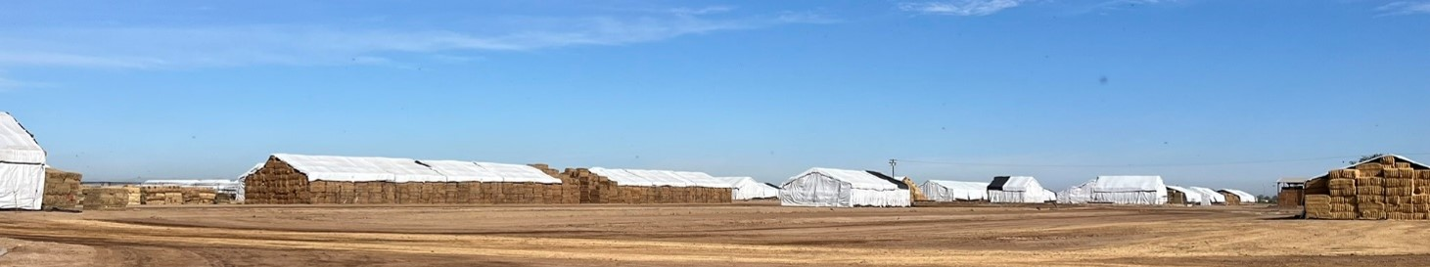
Figure 3 Tarp-covered haystacks destined for export are prolific in El Centro, California. (Source: the author)

Farming in the desert
With an average annual rainfall of a mere 60 mm, the production of over 100 agricultural commodities is enabled by only one thing – water.
The estimated 3.7 million megalitres (Imperial Irrigation District 2025) delivered annually to the Imperial Valley became a public source of contention when decades of drought resulted in drastically reduced snowpack and spring rainfall inflows into the Colorado River.
While mild rumblings of public discontent had simmered for some time, it was in 2022 when Lake Mead edged closer to “dead pool”, when the amount of water in storage cannot flow downstream, that the significance of the issue made headlines. Those concerned included the seven states the Colorado supplies, including the Upper Basin (Colorado, Wyoming, Utah and New Mexico) and Lower Basin States (California, Arizona and Nevada).
With 25 million people relying on water from Lake Mead to survive including the cities of Los Angeles, San Diego, Las Vegas and Phoenix (The Conversation 2022), the significance of this issue must not be understated.
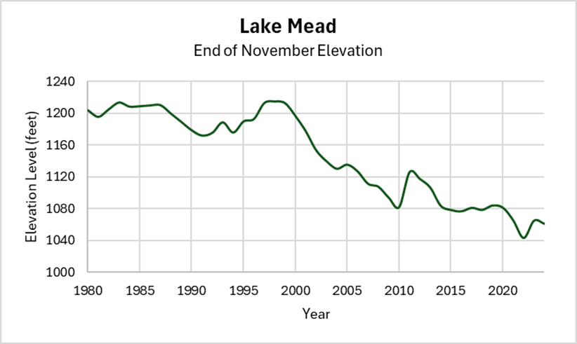
Figure 4 Change in water level at Hoover Dam, Lake Mead (1980 to 2025). (Source: Bureau of Reclamation 2025)
In November 2023, the Desert Sun and ProPublica published a scathing article on hay production in the Imperial Valley, prompting producers to question the extent of their remaining social license (Desert Sun 2023).
The article was likened to a witch hunt as journalists used satellite data and public records to estimate water use, resulting in 20 extended families being named. The piece highlighted that these families' water usage surpassed that of entire American states, raising concerns about equity and the sustainability of water resources amid ongoing drought conditions.
Critics argued that the article unfairly targeted individual farmers without addressing broader issues influencing water allocation, such as the Doctrine of Prior Appropriation, which grants water rights based on seniority or “first in time, first in right” (Californian Water Board 2025); suggesting that water priority is essentially generational priority. Additionally, the piece placed no recognition on the economic and environmental roles these farms play in the region, nor did it acknowledge the complexities of water rights and usage.
Only a year earlier, a white paper released by the Family Farm Alliance (2022) clearly articulated that the production of alfalfa was a foundation of rural agriculture in Western rural communities, was a major energy source for both beef and dairy cattle, facilitates the production of more honey than any other crop and is a valuable agronomic tool for nitrogen fixation and minimising soil erosion through an eliminated need for ploughing. The paper identified that these benefits extend beyond agriculture, with alfalfa fields providing habitats for insects, songbirds, rodents and predators such as hawks. Importantly, the paper readily acknowledged that water is indeed required for alfalfa to grow and that water consumption of a crop in peak summer production is indeed high.

Responding to a drying climate
On-farm water conservation in the form of subsidy programs and automation and modernisation are evolving in Southern California and are being sought out in response to drying conditions.
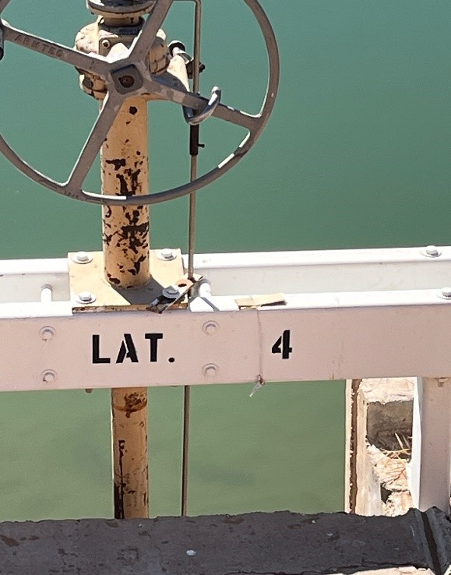
Figure 5 Small handwritten notes are tied to irrigation delivery gates and contain daily operational records. (Source: the author)

To conserve, reduce productivity or fallow?
The Imperial Irrigation District (IID) has implemented various programs aimed at promoting water efficiency and conservation. One of the key initiatives is the Farm Efficiency Conservation Program (FECP), which encourages agricultural water users to adopt more efficient irrigation practices. Projects have included the installation of drip systems, soil moisture sensors and tailwater recovery systems (IID 2025).
In comparison, rather than incentivising innovation as per the FECP, the Deficit Irrigation Program (DIP) aims to conserve water through reduced productivity. The program requires those growing established hay crops (alfalfa, Bermuda or Kleingrass) to voluntarily suspend irrigation during the peak of summer, where evapotranspiration and therefore water use is at its highest and yields lowest. In exchange, farmers receive an appropriate water conservation payment (IID 2025b).
In 2024, the IID announced a more drastic water conservation program whereby farmers would be compensated for fallowing paddocks. These programs have been previously enacted to manage the state’s water resources. In 2005, the nearby Palo Verde Irrigation District (PVID) became part of a 35-year agreement with the Metropolitan Water District (MWD) to conserve agricultural water for urban use through a voluntary fallowing program. This program proved successful between 2005 and 2021 when 1,850 gigalitres of water was supplied to urban areas. In return, farmers received US$180 million in compensation payments (MWDSC 2022).
In a typical year, the Palo Verde Valley plants a third of its land to lucerne. With these programs enabling up to 28% of the Valley’s land fallowed there is no doubting the impact these programs have on the quantity of hay produced (MWDSC 2022).
The feedback regarding these programs is generally positive and this is largely because the price of compensation covered costs and therefore eliminated the need for alternative sources of income.
However, the question remains as to whether on-farm conservation through these methods can conserve enough water when it remains fed through an entirely manual network.
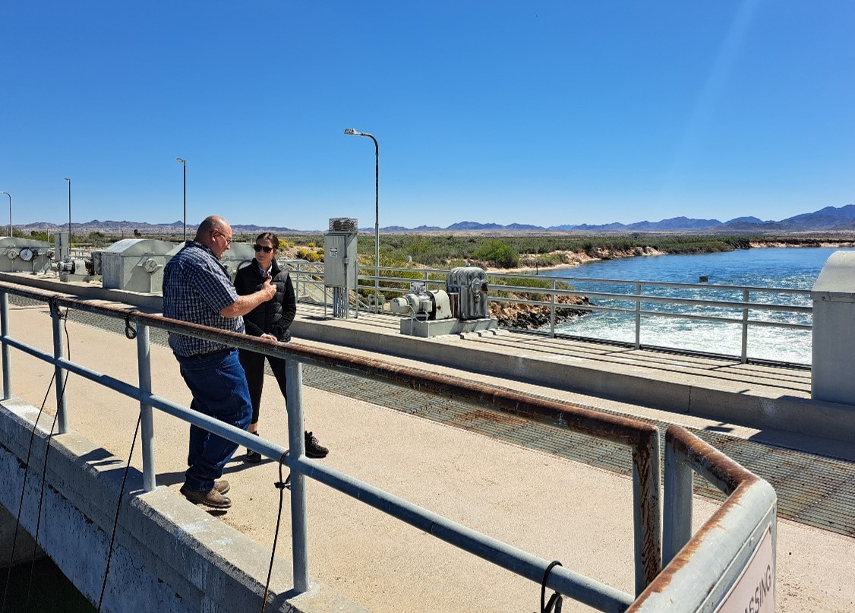
Figure 6 JR Echard, General Manager of the Palo Verde Irrigation District generously showcased the PVID Colorado River diversion. (Source: Peter Moller)

Commercial solutions
Commercial enterprises such as Australia’s Rubicon Water see tremendous opportunity to optimise production and increase water retention on-farm while simultaneously improving environmental sustainability.
Automation and modernisation are integral to the evolution of worldwide farming systems and by leveraging innovation from Australia, Rubicon has built trust in the American market. Modernisation of manual irrigation systems is the solution to not only reducing water use, but also increasing yields by ensuring that water applied to a crop is optimised in that it is strategic, timely and matches crop ETo.
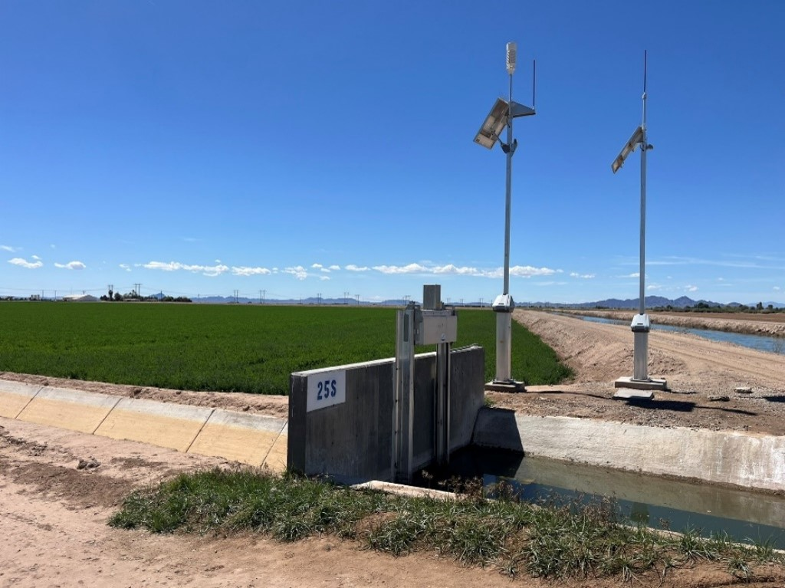
Figure 7 Rubicon Water offers a range of solutions to optimise water movement and delivery. (Source: Peter Moller)
To turn technology from concept to commercialisation, Rubicon's Peter Moller (2024) follows a straightforward, human-centered design process: first, identify the problem, then ensure the innovation can be effectively applied on-farm, and finally, understand the benefits it will bring. When these factors are clearly defined and supported by data, the next step is to engage with early adopters and those willing to test the innovation. These individuals are typically proactive and decisive individuals that are crucial to technology adoption.
Rubicon’s impact goes beyond commercial success. The company has also focused on developing its employees' technical capabilities and building regional capacity, improving farmers' knowledge and decision-making skills. This, in turn, supports the successful integration of modernisation technology into farming systems and increases the likelihood of long-term success.
Despite the massive risks to social license, both the Palo Verde and Imperial Irrigation Districts seem hesitant to develop their manual irrigation systems.
Thus, producers in these districts are proactively working towards farming with less, acknowledging the challenges will simply not disappear. As such, they have relied on engaging commercial companies such as Rubicon Water to retrofit advanced surface irrigation solutions to their existing systems. These solutions utilise modernised system design, high flow rates and sensor technology to improve the scheduling and application of water. In turn, the result is greater water use efficiency, decreased waterlogging and therefore improved yield and profitability.
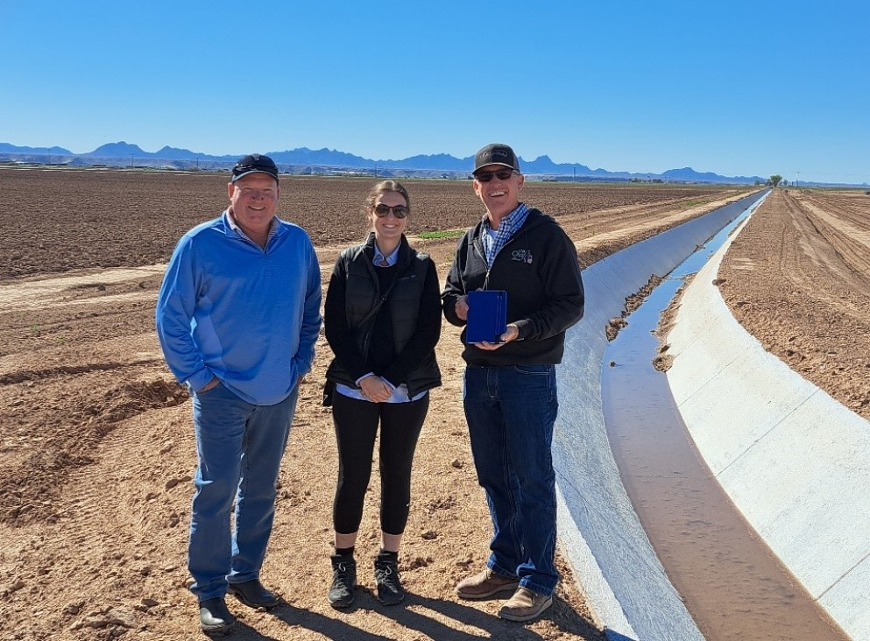
Figure 8 Left to Right: Peter Moller, Rubicon Water, the author and Grant Chaffin, Chaffin Farms and Vice President of the PVID Board of Trustees. (Source: Peter Moller)

Socioeconomic impacts of drought
While the aforementioned subsidy programs have successfully conserved and optimised water use, the impact of these programs should not be underestimated.
Located to the north of the Palo Verde Irrigation District, the township of Blythe historically thrived on agriculture, particularly due to the production of intensive hay crops like alfalfa. However, the impact of the 1997 Fallowing Program was publicly identified as a key contributing factor to the socio-economic demise of Blythe (RivCo 2022). This is largely because the County’s manual irrigation systems require extensive labour to operate. Thus, the social impact of reduced productivity operated by an entirely manual irrigation system, is massive.
Unfortunately, these cases are not isolated and highlight the tousle between rural and metropolitan water use. Similar devastation to rural communities occurred as far back as the early 1900’s when Los Angeles secured land to protect its rights as a growing city, reducing irrigated land in the Owens Valley by almost 70% in 20 years (SoCal Water 2024). In turn, not only was there at times violent disruption to community peace (County of Inyo California 2008), but flow on affects such as air pollution and decimation of the Owens Lake that depended on a high-water table. While restoration and rehabilitation efforts continue today, the impact is steeped in history.
In an increasingly variable climate, the decisions made to guarantee water for the heavily populated American cities will, without a doubt, impact hay production. Proactive, well-thought-out and collaborative policy can lessen the risk to agriculture while simultaneously effectively managing natural, finite resources.
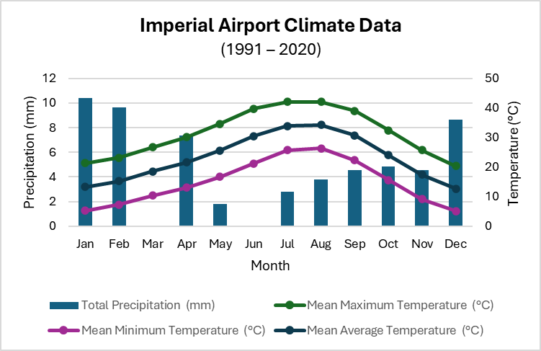
Figure 9 Imperial CA Climate Data from 1991 to 2020. (Source: US National Weather Service 2025)

Key learning for Australia
In California, public perception turned sharply against hay producers when media scrutiny highlighted water-use amid drought, even though producers were operating within their legal right.
While a large percentage of the hay produced in Australia is dryland, Australian agriculture must actively build and maintain social license, particularly around resource use (e.g. water, land, emissions) and the export of product overseas. To do this, we must be proactive, not reactive and the hay industry needs to communicate their environmental, economic, and social contributions clearly and consistently to the public. Furthermore, investments in transparency, predominantly through the collation of robust, timely data can help build internal and external trust.

Canada
The Immediate reaction and need of drought forces innovation — Ken Coles, 2022 Nuffield Canada Scholar.

Innovative mindset
Hay production in Alberta, Canada, is under significant environmental, economic, and social pressure.
The Southern Alberta plains are renowned for high performing agricultural enterprises. Winters see the region blanketed with snow and there is a reliance on the snowpack to replenish soil water and irrigation reservoirs.
With temperatures ranging from −15°C in the depths of winter to over 30°C in peak summer, farmers in this region understand the need to conserve soil moisture at all costs. As such, producers invest in new minimum-till machinery such as the Australian-designed stripper front and varying disc seeders.
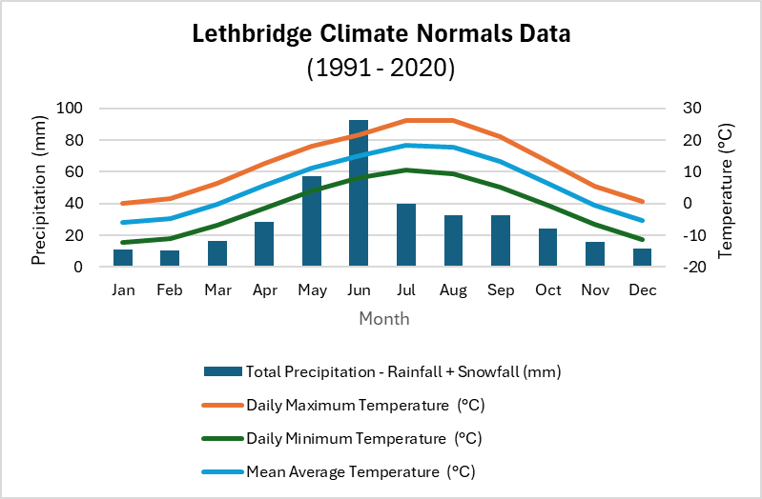
Figure 10 Lethbridge, AB climate data from 1991 to 2020. (Source: Government of Canada 2025)
Considered more destabilising than ever before, the greatest environmental challenges the Alberta producer faces are generally sporadic and intense rain or hailstorm events. Producers are opting to derisk their business through extensive land purchases both near their home base but also across provincial borders.
Without a doubt the greatest pressure for Canadian hay exporters is the proximity to the United States. However, despite the sheer scale of American alfalfa exports, Canadian irrigated alfalfa and timothy, a grass with similar feed value to oaten hay, are sought after by buyers. Furthermore, there has been a growing shift towards product diversification with innovative dried silage, pellets, and the utilisation of waste materials to ensure product consistency and buffer against market volatility. Hay exporters are finding that producers are increasingly planting competing higher-value crops such as potatoes, and this is limiting the export plant's ability to reach peak throughput. As such, seasonal variability has ripple effects throughout the business including the retention of staff. While labour at these sites is generally local, some exporters are turning to European working holidaymakers to account for shortfalls. The desire to involve high quality, high performing individuals at both sites was obvious.
This extended to the integration of adult children, as part of succession, into the management of these evolving family businesses, with the mantra in both to master something, champion it and subsequently bring growth and opportunity to the business.
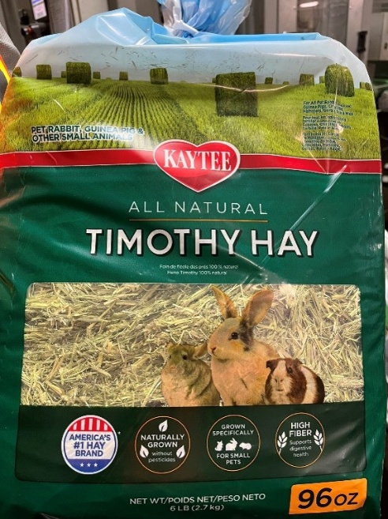
Figure 11 Example of value-added products from Canadian exporters Green Prairie. (Source: the author)
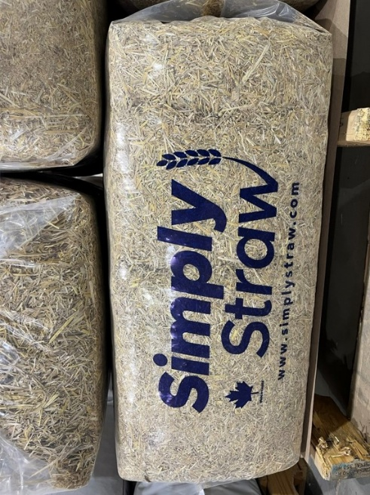
Figure 12 Example of value-added products from Canadian exporters Barr Ag. (Source: the author)

Key learning for Australia
Every company should grow, not to become more rich, but to become more creative. — Rob Baan, Koppert Cress
Canadian hay exporters are developing strong business cultures by recruiting high-performing staff, integrating the next generation into management early and encouraging individuals to master and champion a segment of the business.
Developing leadership capacity and capability is critical in developing resilience in agricultural businesses. As such, industry should encourage young employees or family members to take on leadership early, allowing them to develop their expertise and business acumen while giving them time to grow as individuals.
There must also be acceptance that workforce management is rarely an innate trait and thus is a skillset that must be nurtured and developed over time; often through working alongside exceptional examples or being coached by mentors.

Central Europe
Farming in Germany and Europe more broadly operates under strict environmental regulations aimed at preserving the environment. Farming businesses are often multi-faceted, with one enterprise producing potatoes, while simultaneously running a piggery, chickens for meat production and a methane digester. The often-housed nature of livestock across Europe lends itself to a demand for high-quality silage, hay and straw.
Under the European Union's (EU) Common Agricultural Policy (CAP), which Germany subscribes to, farmers are incentivised to adopt environmentally friendly practices. One major requirement is that 80% of agricultural soil must be covered during winter, typically with cover crops like mustard and radish, which are not harvested but instead serve to protect and maintain the soil.
With metres of topsoil, Germany has rich growing potential, but recent droughts have reduced average rainfall from 700–750 mm to just 500 mm in some areas, placing added pressure on irrigation to achieve pre-drought yields. However, the German Government strongly supports innovation, and there are often financial incentives or grants for growers to improve business resilience by upgrading their systems or implements such as sprayer machinery.
Notably, water access is increasingly regulated, with farmers allowed to irrigate between 5 pm and 10 am to manage evapotranspiration. Regulations extend to infrastructure, whereby no new wells are permitted, and water that was previously free is now charged at 10 cents per cubic metre.
These evolving regulations highlight only some of the decisions European farmers must navigate to balance productivity and perceived sustainability.
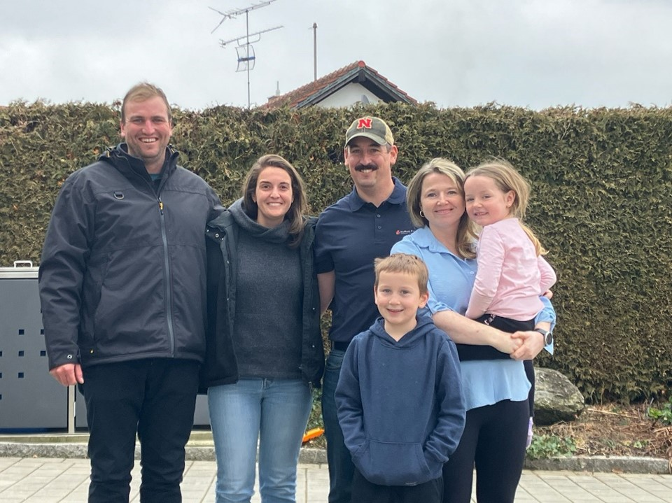
Figure 13 The author and her husband Jarred (left) visited Nuffield Germany advocate Andi and Lisa Liebl and their children in Bavaria. (Source: the author)

German engineering
Germany’s agricultural machinery sector is globally recognised for its engineering excellence with companies like Krone and Claas producing locally and trading globally. Both family-founded firms have built enduring reputations by combining cutting-edge technology with embedded values of craftsmanship, community development, and innovative design.
Krone, established in 1906, continues to position itself as a global leader in agricultural machinery, with a strong focus on user-driven innovation. Krone’s vision is to produce the world’s best baler in terms of capacity and throughput (Horstmann 2025). However, their team is realistic and acknowledge openly that pushing capacity performance to the last 5% to 10% requires disproportionate engineering, energy and thus cost, making it impractical and unlikely to thrive commercially.
With over 400 engineers developing innovations for varying global markets, Krone actively pursues feedback, with a preference for seeking it directly from farmers and contractors. Operating and selling into countries, such as Northern Europe, with limited spring sunshine and thus optimal haymaking conditions, Krone understands the challenges of short harvest windows and unpredictable weather.
Krone is expanding into emerging markets such as India, where straw burning is increasingly taboo, creating new opportunities for hay and straw production and thus market infiltration. Similarly, there is stable but growing opportunities in developed economies like Brazil and Argentina.
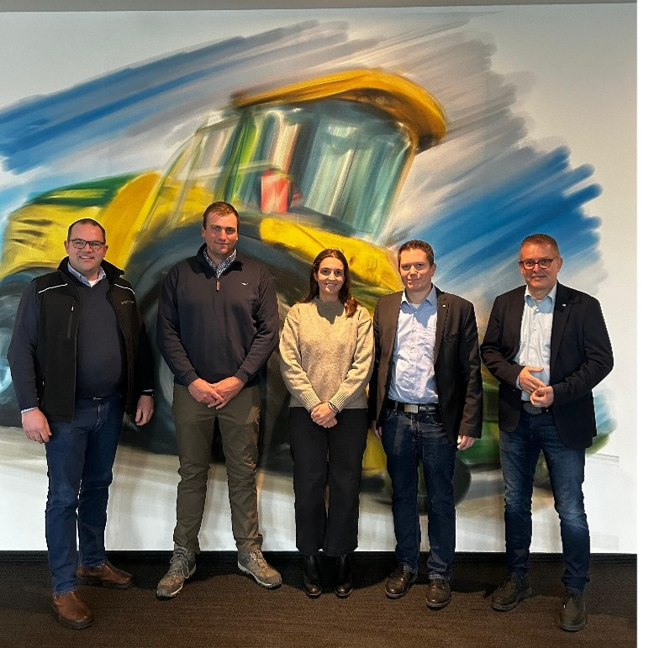
Figure 14 Left to right: Meinke Ostermann, 2023 Nuffield Germany Scholar, the author and her husband Jarred; and members of the Krone leadership team Jan Horstmann and Peter Weiss. (Source: Meinke Ostermann)
Similarly committed to innovation, Claas, founded in 1913, has grown into a global machinery powerhouse with around 12,000 employees worldwide and a strong presence in more than 100 countries.
Renowned for its engineering prowess, Claas holds over 4,000 active patents, having made its mark early on by improving American baler technology to better suit European farming conditions. Their innovation helped reduce labour dramatically, cutting crew sizes from 15 to just 3 in some instances. Even during wartime restrictions, Claas continued to develop harvesters, eventually releasing its first combine, part of a legacy that now stands at over 500,000.
Overwhelming, both companies' workforce is at the heart of their business whereby a deeply embedded culture of brand-commitment and long-term employment is fostered. Targeting youth, Krone chases brand awareness by providing public access to their museums, developing and supporting school programs, providing traineeships for school-leavers and inviting long-standing staff to return in their retirement to guide factory tours; all of which reflect a strong sense of pride and fostering deep community ties. Despite generalised challenges around workforce shortages, career growth within the company is actively supported with opportunities to work internationally. Similar opportunities exist with Claas, whereby the business strives to build a reputation as a respected local employer, often with multiple generations of family working side by side. Furthermore, the Technoparc centre in Harsewinkel welcomes upwards of 13,000 visitors annually. Each day, Claas raises the flags outside the facility to acknowledge the nationality of their guests, reflecting a genuine culture of warmth.
What sets Krone and Claas apart isn’t just their engineering skill or technological progress, but the way they integrate innovation with a grounded company culture, one that values humility, curiosity, and a genuine desire for continued improvement and learning.

Heuwirtschaft
Over the border in Austria, “Heuwirtschaft”, or hay farming, is typically the conservation of natural grasslands for feed. The paddocks are not generally ploughed, nor are they fenced, and instead wooden posts denote the boundaries. It is listed in Austria’s CAP Strategic Plan as a method by which emissions and biodiversity loss can be mitigated. By incentivising grassland hay production, “there is [also] a reduced risk of conversion [to] intensive fodder or dairy farming operations” (Austrian Government 2021). Acknowledged as important carbon sinks, these grasslands are considered a mechanism to “strengthen climate change adaptation” and “improve...the health of agricultural soils and their capacity to sequester carbon” (Austrian Government 2021).
Furthermore, the Austrian CAP Strategic Plan identifies the positive biodiversity effect that hay production has on the environment due to ‘later first cut timing and a lower usage intensity [when] compared to farms [producing] silage’. It also incentivises farmers to retire mower-conditioners and instead adopt insect-friendly mowing techniques to minimise the impact on grasshoppers, beetles and caterpillars to in turn, “directly benefit farmland birds and other insectivores”.

Heumilch
In the small Austrian town of Dorfbeuern, Michael Eder and Johanna Gerhalter produce milk for the esteemed organic “heumilch” or hay-milk market, utilising hay farming techniques.
In 2024, the Food and Agriculture Organisation (FAO) formally recognised the practice of hay milk farming as a Globally Important Agricultural Heritage System (FAO 2024). Considered the original form of milk production (Advantage Austria 2025), hay milk is celebrated for its deep cultural roots whereby Austrian cattle typically graze alpine meadows during summer and return to small scale housed dairies during the winter months, their diet consistently almost completely of grassland hay. If utilising supplementary feed, numerous restrictions exist in that the quantity is limited, it must be GMO-free and come from Europe, whereas silage is strictly prohibited (Advantage Austria 2025).
The products are well marketed, utilising research that suggests hay milk has superior nutritional benefits when compared to conventional dairy products (Heumilch n.d); while also being more environmentally sustainable.
The peak industry body, ARGE Heumilch, represents hay milk farmers, processors and marketers, and administers the associated compliance to maintain the quality standards associated with the hay milk logo. With 6,500 producers in Austria, on average a hay milk farmer maintains a herd of 17 cows. Nearly 40% of production is organic and 60% is exported to Germany alone (Advantage Austria 2025).
Hay milk farms were traditionally family-run, with one partner often employed off-farm. Today, Michael and Johanna continue this whereby Michael, an Assistant Professor of Agricultural Economics at BOKU University, splits his time between Salzburg and the farm, while Johanna manages the daily operations.
During summer, their retained young stock, usually between 7 and 15 animals, are agisted on alpine pastures. Given their rainfall often exceeds 1,000 mm per annum, hay quality is pivotal to maintaining their herds nutrition over winter. Grassland hay is cut and baled within two days, then dried using a simple yet effective system. Hot, dehumidified air circulates through vented ducts beneath the hay (see Figure 15), reducing moisture from 40% to 15%. This relatively low-cost, solar-assisted drying method ensures high-quality feed can be produced despite the often-humid baling conditions. More complex hay drying systems exist and are commonplace, such as drying sheds, as seen at the Stiegerhof Farm (see Figure 16).
Michael and Johanna operate a successful two-person enterprise and have no plans to expand their herd. Their business remains viable due to fair milk prices and support from the European Union’s CAP for maintaining sustainable agricultural practices (European Commission n.d).
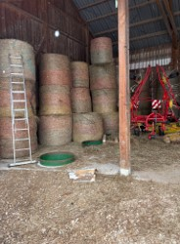
Figure 15 The LASCO round bale drying system. (Source: the author)
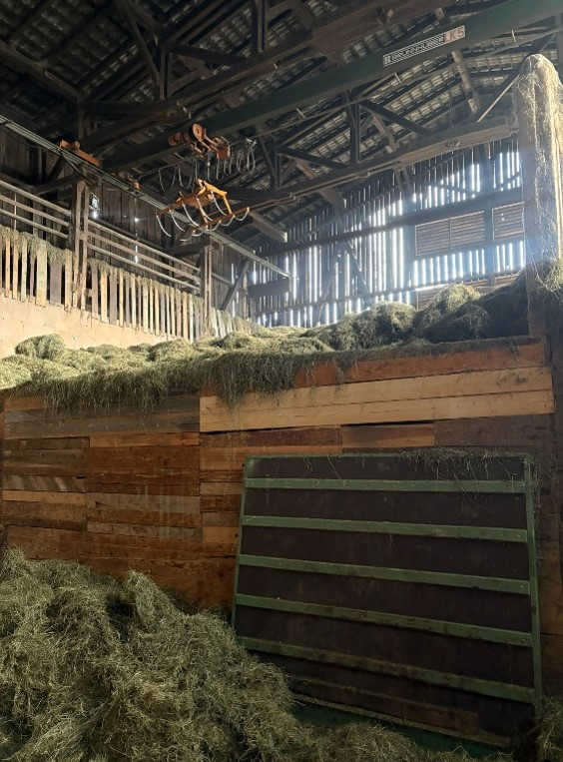
Figure 16 The Stiegerhof Farm hay drying shed. (Source: the author)

Key learning for Australia
No-one is truly sustainable unless [they’re] making money out of it. — Charles Steer, 2019 Nuffield Scholar
While the European Union’s Common Agricultural Policy has been instrumental in sustaining traditional farming systems like Austria’s hay milk industry, the model presents challenges when considered in the Australian context.
In Europe, policies are designed to incentivise specific farming practices, such as grassland preservation, biodiversity maintenance, and silage-free dairying, thus providing financial support for farmers. This model has proven essential for regions with limited land availability, high population density, and cost structures that could otherwise render small-scale agriculture unviable.
However, this blueprint does not easily translate to Australian hay production systems, and it is unlikely it can be replicated for several reasons:
- Australian hay production is predominantly sown, involving either annual or perennial species, rather than relying on long-established, natural grasslands as is typical in Alpine regions.
- Australian producers do not receive direct incentives for adhering to specific agricultural practices.
- Climatic variability in Australia, despite its challenges, encourages innovation, adaptability, and market-driven decision-making. A policy model that emphasises compliance with predetermined criteria could risk stifling innovation or limiting the ability of an individual to respond flexibly to financial, environmental, or climatic pressures.
Thus, while the CAP supports sustainability and cultural preservation in Europe, particularly for systems like hay milk farming, its structure may not align with the more market driven, innovation-reliant model of Australian agriculture. For Australian systems, especially those facing high climatic variability and market pressures, policies that encourage resilience through research-driven solutions may be more appropriate than fixed-practice subsidies.

Future hay
The Analogue Towns Tool suggests that by 2050, under a high emissions scenario with a 2°C increase in temperature and a 5% reduction in annual rainfall, Normanville, Victoria, will experience a climate similar to that of several towns in Australia (Climate Change in Australia 2025). These towns include:
- Merredin, Wyalkatchem, Kellerberin, Kambalda, Balladonia, Norseman, Southern Cross, Quairading, Coolgardie, Kalgoorlie-Boulder (WA)
- Cobar, Balranald, Ivanhoe, Menindee (NSW)
- Hawker, Port Pirie, Wudinna (SA).
These towns are in arid or semi-arid regions that typically experience hot, dry conditions, and face challenges such as low rainfall and water scarcity.
Understanding these "analogues" or equivalents allows farmers to anticipate potential future impacts and adapt their strategies for water management, agriculture, and infrastructure to enhance resilience to these changes.
To better understand the Victorian Southern Mallee’s future climate, Western Australia’s wheatbelt was identified as a climate analogue.

The search for a “future climate” equivalent
Hay creates hard working, innovative farmers. — Garren Knell, Agronomist
The export hay industry in Western Australia (WA) is a prime example of elite hay production despite climatic volatility. In this region, hay production plays a significant role in the local farming economies and provides a mechanism for international trade.
The industry has seen growing challenges and opportunities due to environmental factors, market dynamics, and shifting farming practices.

Supply and demand
Western Australia is a leading producer of oats for both grain and hay markets. Demand for hay can range from 600,000 to 1.2 million tonnes annually, while grain oats demand is similarly significant (300,000 to 700,000 tonnes) (Bolt 2024). However, the lack of a large Western Australian dairy industry reduces the opportunities producers have for offloading lesser-quality or excess hay, making export markets crucial (Bolt 2024).
Garren Knell (2024), an agronomist and advocate for hay production in Western Australia, echoes the concerns shared throughout the supply chain in that there is no reliable and consistent way to measure how much hay is produced and thus no ability to leverage its importance at a national level.
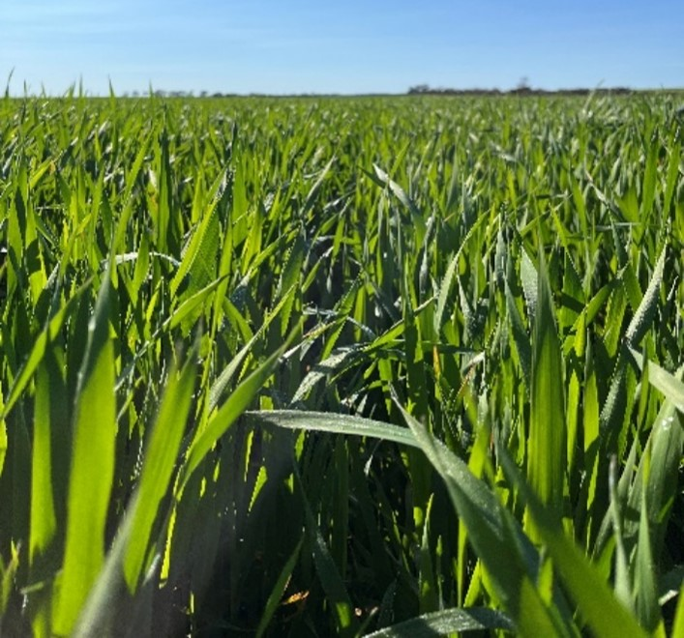
Figure 17 Oats destined for the export hay market in August 2024. (Source: the author)

Market and economic challenges
West Australian hay is typically produced under contract prior to planting to minimise financial risk and a risk of carrying surplus hay. The production of the highest quality hay possible is incredibly important, as local demand is limited to a small West Australian dairy market and at the time of writing a sheep industry in turmoil (ABC News 2025).
Western Australia’s hay industry faces fluctuating market prices, often driven by external factors like global demand and the exchange rate. The Chinese market, while significant, typically demands lower prices for hay, while Japan remains a higher-value market (McCabe 2024).
Prices fluctuate seasonally based on hay quality, with factors like visual appeal (colour and fineness) and sugar content influencing demand. Farmers readily identified that smaller exporters or those unwilling to provide some level of price certainty to farmers at the beginning of the season, add a layer of risk and concern to the export hay producer. As such, compared to the Eastern states, Western Australian producers are more inclined to plant an oat crop and decide its end use during the growing season. If that end use was hay, the exporter with the highest price would win their business, even if it meant carting it further (as financial incentives were in place to do so).

Farming with the environment
Turning oats into high-quality hay requires knowledge of harvesting and curing techniques that differ from those for grain production and thus, successful hay farming demands a specific set of skills (Knell 2024).
These skills are strongly sought after, with hay buyers seeking to create long-term relationships with proficient producers that prioritise proactive farm management (Atkinson 2024).
Agronomically, crop establishment is vital in the region with practices such as earlier sowing times seen to increase yields and reduce risk (Graham 2024). Similarly, farmers rely on diversified rotations to not only maximise yield, but also mitigate the risk of weather impacts, with oats for hay often being a key crop in rotation with wheat and oats for grain (Dolton 2024). This is because environmental conditions such as frost and flooding can complicate production and quickly reduce quality. Farmers, particularly around Merredin, noted that frosts are increasing in frequency and could be considered more detrimental than drought. Those in the Merredin region acknowledged that oats were more frost tolerant than wheat and were well suited to early sowing to produce the greatest kilograms per millimetre of rainfall (Dolton 2024).

Infrastructure and technology
The capital outlay required for improvements such as hay-specific sheds can be a barrier for farming operations, however the investment in machinery, such as balers, and the construction of hay sheds, is considered essential for producing and protecting a high-quality product. While owner-operators are commonplace, some farmers, particularly those who are opportunistic hay producers or new entrants, are reluctant to invest in machinery, opting instead to use contractors. Unfortunately, those who choose to build hay sheds often encounter barriers regarding insurance.
The consideration around business size was a decision largely driven by an individual's values, beliefs and behaviours associated with building and maintaining a profitable farming enterprise (Ryan 2024). It was apparent that land expansion is often driven by the belief that land is the best long-term investment. However, those that are not chasing land, often because they were at the upper limit of what they are capable of with their current machinery or workforce, are equally driven and focused on optimising their business and profit with what they had.
Regarding technology, those engaged advised a concern with the lack of transparent and repeatable grading systems, which remain somewhat subjective and seemingly vary depending on market requirements. Interestingly, those concerns are replicated across the country, with hay producers concerned that hay buyers purchasing can be inconsistent and highly variable depending on seasonal or subjective conditions.
It seems exporters are quietly leading the way with improvements to traceability and quality control; and while innovations are yet to become business as usual processes, the intention is to reduce the need for growers to tag individual bales and instead incorporate this task as part of the baling process.

Key learnings for Australia
In the long term, Western Australia will continue to incorporate hay production as part of a diversified rotation.
When asked how drought preparedness impacts one’s business, Mark Graham (2024) questioned whether a business can operate with the expectation that drought is imminent, given that consistently planning for drought could discourage expenditure on inputs such as fertiliser or long-term capital investment; ultimately constraining a business’s productive and financial potential. Instead, a realistic planning approach that consists of a feedback loop of constant reflection and analysis can mitigate some of the risk associated with short-term dry spells but also fosters a proactive, aggressive and decisive mindset.
It was this mindset that was apparent across the numerous visits across the Wheatbelt. Producers with a long-term vision of or desire to farm beyond 2050 must adopt a forward-thinking, risk-conscious mindset to navigate our future climate.

Making progress
In the past two years, there has been a significant rise in opportunities for hay producers to expand both their knowledge and networks.
The “Hay Kings” podcast, which is supported by an active Facebook group of the same name, began its eighth season in 2025. Each hour-long episode offers growers around the world the chance to gain deeper insights into US hay production, covering topics ranging from planting techniques to feed quality. Australia’s Feed Central has also launched a podcast called “Hay Matters”.
In response to the release of its R, D, and E stocktake, AFIA has adopted a proactive strategy to grow membership and foster connections across the fodder industry. There is a renewed focus on bridging the divide between domestic and export participants to encourage mutual growth and shared learnings. This approach includes extension initiatives such as in-person “Meetups” and webinars; while simultaneously taking a more strategic and driven approach to seeking out funding opportunities to account for the absence of levy investment (Curtis 2025).
While Australian hay producers may argue that fodder production continues to be underprioritised by all Australian end-user RDCs, Australian hay exporters appear to have taken a step in addressing the chronic gap in extension, demonstrating leadership in their approach through grower field days and demonstration sites.
However, in an industry with such limited research and extension, the question remains: how can we enable transformational change, that is change greater than incremental adjustments in agricultural practices, in the Australian hay industry to significantly increase productivity and profitability?
At the time of writing, there were 500 or more usable, published, peer-reviewed literature regarding lucerne hay. In comparison, only 10 equivalent papers exist on oaten hay (Cheng 2023). This highlights the chronic research gap and opportunities that exist to develop the Australian oaten hay industry.
Research aside, there is a noticeable lack of collaboration among international hay-producing regions. Identifying and engaging with high-performing businesses globally proved challenging, and in some cases, there was a sense of hesitation or reluctance. It is important to emphasise that while broad insights can be gained from international counterparts, Australia's hay production systems are specifically tailored to our local and incredibly unique conditions. Therefore, significant gains in Australian hay production as a direct result of global engagement are unlikely. Consequently, industry efforts should be directed toward fostering a collaborative global network that encourages peer-to-peer learning, particularly when all agricultural systems are faced with needing to produce the same or more, with less.

Conclusions
Global hay production is a critical yet often undervalued component of the broader agricultural landscape.
As climate variability intensifies, the importance of resilient, high-quality fodder production, both domestically and for export, has and will become increasingly clear. It provides essential feed during climatic extremes, bolsters farm profitability in good years, and supports a diverse range of domestic and export markets. However, as this report outlines, the industry operates in a complex landscape marked by social license challenges and limited research and extension investment.
International case studies provide both warning signs and lessons in resilience:
- In California, public scrutiny over water use during drought conditions saw hay producers face reputational damage despite operating within legal water rights. This reinforces the importance of proactively building and maintaining a social license, particularly when they are resource intensive.
- In Canada, harsh climatic conditions and market pressures have led to innovation and diversification through investment in various new product lines but also by creating pathways for forward thinking individuals into business leadership.
- In Europe, the EU’s Common Agricultural Policy has preserved heritage systems like Austria’s hay milk industry. While inspiring, this model is largely incompatible with the commercial, market-driven nature of Australian agriculture. However, it highlights the increasing pressure for public investment to prioritise and achieve environmental objectives.
To ensure long-term resilience and growth, the industry must address its systemic weaknesses through targeted investment and engagement across the supply chain. A united, forward-thinking approach is essential when preparing the sector to withstand climate variability while concurrently lifting the standard of hay production nationwide.
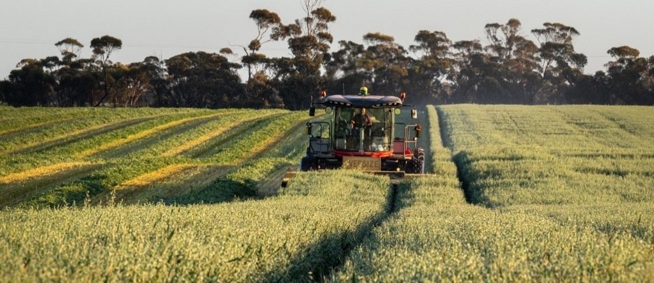
Figure 18 Hay production at the author’s family property in Normanville, Victoria, Australia in 2022. (Source: Kerry McFarlane Photography)

Recommendations
- Integrate climate resilience extension into existing offerings to repeatedly expose producers to the principles around proactive anticipation and mitigation of future climate risks.
- Prioritise policy support for flexible, evidence-based initiatives, instead of relying on rigid long-term compliance models.
- Agricultural grants in general should support capital investment and drive innovation to strengthen farm business resilience and support a considered long-term vision, rather than short-term assistance with limited lasting benefit.
- Earn and maintain social license by committing to transparency by using robust data, and clearly demonstrating the hay industry’s economic, environmental, and social contributions.
- Develop workforce capability across the hay supply chain by identifying and nurturing future leaders, building skills, and fostering positive workplace cultures.
- Leverage existing cross-RDC and private networks to coordinate hay-specific research, development and extension; with a specific focus on the domestic market to lift the quality and quantity produced nationwide.
- Strengthen international networks to expose individuals to new perspectives and challenge their views of processes, systems, practices and the world more broadly.

References
ABC News (2025). Agriculture Minister Julie Collins denies 'flying under the radar' with live export transition announcement, Australian Broadcasting Corporation.
Advantage Austria (2025). Hay Milk - Sustainable World Cultural Heritage. Retrieved from Austrian hay milk for the world – FRESH VIEW
AFIA. (2021). Australia’s Fodder Exports. Retrieved from Australia's Fodder Exports - Australian Fodder Industry Association
AFIA. (2023). Productivity Commission Enquiry – Future Drought Fund (Interim Report) Submission 72 - Australian Fodder Industry Association (AFIA) - Future Drought Fund - Public inquiry
AFIA. (2024). Fodder RD&E Stocktake. Australia. Retrieved from Fodder-RDE-Stocktake-Report-2024.pdf
AgriFutures Australia. (2021). AgriFutures Export Fodder Program Strategic RD&E Plan. Canberra, Australia. Retrieved from PDF VIEW | 21-088
Atkinson, Brad. (2024). Interview by author. Merredin, Western Australia. 05/08/2024.
Australian Government (2025). History of Drought Policy. Retrieved from History of drought policy - DAFF
Australian Government. (2025b). Future Drought Fund. Retrieved from Future Drought Fund - DAFF
Australian Government. (2025c). Fodder Export Charge. Retrieved from Fodder export charge - DAFF
Australian Government. 2026. Interview by author. Online. 08/07/2026.
Austrian Government (2021). CAP Strategic Plan Austria 2023-2027. Retrieved from bmluk.gv.at/dam/jcr:ea385170-f6ef-437b-8865-782bd6257366/GAP_1_2.pdf
Bolt, Andrew. 2024. Interview by author. Bunbury, Western Australia. 08/08/2024
BOM. (2025). Previous Droughts. Retrieved from Previous droughts
Bureau of Reclamation (2025). Lower Colorado River Operations. Retrieved from Lower Colorado River Operations | Lower Colorado Region | Bureau of Reclamation
Californian Water Board (2025). Water Rights. Retrieved from Water Rights FAQs | California State Water Resources Control Board
Chaffin, Grant. 2024. Interview by author. Palo Verde County California, USA. 25/05/2024.
Cheng, Paul. 2023. Interview by author. Online. 31/10/2023.
Climate Change in Australia. (2025). Climate Analogues. Retrieved from Analogues Explorer
Cogan, Noel. 2023. Interview by author. Online. 08/11/2023
County of Inyo California. (2008). Owens Valley Water History (Chronology). Retrieved from https://www.inyowater.org/documents/reports/owens-valley-water-history-chronology/
Curtis, Vanessa. 2025. Interview by author. Online. 31/11/2025.
Desert Sun. (2023). The 20 farming families who use more water from the Colorado River than some states. California, USA. Retrieved from 20 Calif. farm families use more Colorado River water than some states
Dolton, Leigh. (2024). Interview by author. Merredin, Western Australia. 05/08/2024.
European Commission (n.d). Common Agricultural Policy. Retrieved from Common agricultural policy - European Commission
Family Farm Alliance. (2022). Our Food Supply at Risk. California, USA. Retrieved from Alfalfa-Report-FINAL-111522.pdf
FAO. (2024). FAO Liaison Office with the European Union and Belgium. Retrieved from Glückwunsch! Hay Milk in Austria celebrated FAO recognition as a Globally Important Agricultural Heritage System.
Fay, Amy. 2025. Interview by author. Online. 22/07/2025.
Fitzgerald, Paula. 2023. Interview by author. Online. 18/10/2023.
Ford, Robert. Feed Central Regional Round Up. Feed Central, 04/09/2024. No URL supplied. Webinar.
Graham, Mark. 2024. Interview by author. Narrogin, West Australia. 07/08/2024.
Heumilch (n.d). Benefits of hay milk. Retrieved from The numerous advantages of hay milk | Simply urgut! | Heumilch
Horstmann, Jan. 2025. Interview by author. Spelle, Germany. 11/02/2023.
IID. (2025.) On-Farm Efficiency Conservation Program (OFECP). Retrieved from On-Farm Efficiency Conservation Program (OFECP) | Imperial Irrigation District
IID. (2025b.) Deficit Irrigation Program (DIP). Retrieved from Deficit Irrigation Program (DIP) | Imperial Irrigation District
Imperial County. (2022). Imperial County Agricultural Crop & Livestock Report. California, USA. Retrieved from https://agcom.imperialcounty.org/wp-content/uploads/2023/10/2022-Crop-Report-Updated.pdf
Imperial Irrigation District. (2025). All-American Canal. California, USA. Retrieved from All-American Canal | Imperial Irrigation District
Irungaray, Gerard. 2024. Interview by author. Imperial County, California, USA. 20/05/2024.
Knell, Garren. 2024. Interview by author. Narrogin, Western Australia. 07/08/2024.
Leimgruber, Ronnie. 2024. Interview by author. Imperial County, California, USA. 22/05/2024.
McCabe, Lachlan. 2024. Interview by author. Brookton, Western Australia. 06/08/2024.
McGrath, Denis. 2023. Interview by author. Online. 20/10/2023.
Moller, Peter. 2024. Interview by author. Imperial County, California, USA. 20/05/2024.
Murray Dairy. (2023). Fodder for the Future. Retrieved from 91e325af70984bf8a95ac9e735728ae5.
MWDSC. (2022). Fact Sheet: Securing Colorado River Supplies. California, United States of America. Retrieved from PVID-fact-sheet.pdf
My Climate View. (2025). Australian Government. Retrieved from My Climate View
Nagel, Stuart. 2023. Interview by author. Online. 25/10/2023.
Peace, Colin. 2023. Interview by author. Online. 03/11/2023.
Rivco. (2022). City in Peril Blythe is Dying. Retrieved from Blythe_report_final_5-26-2022.pdf
Ryan, Leon. 2024). Interview by author. Brookton, Western Australia. 06/08/2024.
Smith, Robert. Feed Central Regional Round Up. Feed Central, 04/09/2024. No URL supplied. Webinar.
SoCal Water. (2024). Ecological Impacts of Southern California’s Thirst on the Owens Valley Region. Retrieved from Ecological Impacts of Southern California’s Thirst on the Owens Valley Region - SoCal Water Sierra Club
The Conversation. (2022). What is dead pool? A water expert explains. Retrieved from What is dead pool? A water expert explains
Van Dijk, A.I.J.M, Beck H.E, Crosbie R.S, de Jeu R.A.M, Liu Y.Y, Podger G.M, Timbal B, Viney N.R. (2013). The Millennium Drought in Southeast Australia (2001–2009): Natural and Human Causes and Implications for Water Resources, Ecosystems, Economy, and Society. Water Resources Research 49 (2): 1040–1057. The Millennium Drought in southeast Australia (2001–2009): Natural and human causes and implications for water resources, ecosystems, economy, and society
Vegetable Growers News. (2024). California winter vegetables thriving in Imperial Valley. Retrieved from: California winter vegetables thriving in Imperial Valley - Vegetable Growers News
Waldron, Scott. 2023. Interview by author. Online. 26/10/2023.
Walker, Geoff. 2023. Interview by author. Online. 24/11/2023.
Williams, Yvette. 2025. Interview by author. Online. 25/07/2025.

