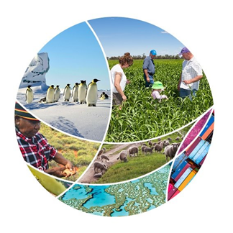

# ****2020 NATIONAL BIOSECURITY FORUM****

# **9 to 12 November 2020**

## COMMUNIQUE

The 2020 National Biosecurity Forum was held online from Monday 9 to Thursday 12 November 2020.

The annual event brings together key stakeholders to discuss the challenges and opportunities for Australia’s biosecurity. The national forum is hosted by the Department of Agriculture, Water and the Environment (the department) on behalf of the National Biosecurity Committee (NBC).

The forum commenced with a plenary session on Monday 9 November, with Ngunnawal woman Jude Barlow giving the Welcome to Country.

Andrew Tongue, Deputy Secretary of the department and NBC Chair, gave the opening address and spoke of the current complexities and challenges in protecting Australia’s biosecurity status, and the efforts underway to meet these challenges.

‘The thing that strikes me about biosecurity in Australia is that it’s a shared enterprise. It isn’t just delivered by government, industry or community – it's delivered by all of us and we have to work together.’

*Andrew Tongue Deputy Secretary and Head of Biosecurity, Department of Agriculture, Water and the Environment*

Dr Gabrielle Vivian-Smith, Acting Chief Plant Protection Officer gave a tribute to Dr Kim Ritman, who passed away in 2020. The tribute recognised the significant contributions Dr Ritman made to agricultural science and plant biosecurity over his distinguished career.

Following an introduction from The Hon David Littleproud MP, Minister for Agriculture, Drought and Emergency Management, the [winners](https://www.agriculture.gov.au/biosecurity/australia/public-awareness/aba/winners#round-2) of round 2 of the 2020 Australian Biosecurity Awards were announced.

Key topics covered over the four-day program included:

* The importance of innovation, research and development to strengthen biosecurity and manage growing biosecurity risks – and current innovation projects underway.
* The illegal wildlife trade and e-commerce biosecurity risks, and how stakeholders are collaborating and adopting new approaches and technologies to address these challenges.
* Innovations in detector dog capability across the country to manage emerging biosecurity risks and support national conservation efforts.
* Community and industry engagement initiatives to educate and build awareness of biosecurity, so everyone understands the importance of biosecurity and their role.
* The use of research and engagement to support biosecurity management planning and inform effective biosecurity communication campaigns.
* Indigenous environmental biosecurity and the importance of Aboriginal and Torres Strait Islander and Māori communities in protecting our biosecurity status and biodiversity.
* A showcase of 2020 Australian Biosecurity Award winners. Award recipients spoke of the importance of innovation, partnering with communities and a greater focus on preparedness.
* Managing in a crisis, lessons learnt and supporting future directions – including how to support first responders, manage the control of misinformation and collaborate to support emergency responses.

The full program and details of presenters are available on the department’s [website](https://www.agriculture.gov.au/biosecurity/partnerships/nbc/national-biosecurity-forum).

Further engagement on the themes explored as part of the 2020 forum will be undertaken over the next twelve months. The department, as a member of the NBC, will continue to look for opportunities to partner with key stakeholders more effectively in these areas to strengthen and build Australia’s biosecurity.

The next National Biosecurity Forum will be held in early November 2021.

**Department of Agriculture, Water and the Environment**