# NATIONAL BIOSECURITY STRATEGY

**Connected**

**Resilient**

**Shared**

**2022-2032**

© Commonwealth of Australia 2022

**Ownership of intellectual property rights**

Unless otherwise noted, copyright (and any other intellectual property rights) in this publication is owned by the Commonwealth of Australia (referred to as the Commonwealth).

**Creative Commons licence**

All material in this publication is licensed under a [Creative Commons Attribution 4.0 International Licence](https://creativecommons.org/licenses/by/4.0/legalcode) except content supplied by third parties, logos and the Commonwealth Coat of Arms.

Inquiries about the licence and any use of this document should be emailed to [copyright@agriculture.gov.au](mailto:copyright@agriculture.gov.au).



**Cataloguing data**

This publication (and any material sourced from it) should be attributed as: DAFF 2022, *National Biosecurity Strategy*, Department of Agriculture, Fisheries and Forestry, Canberra, August. CC BY 4.0.

This publication is available at [agriculture.gov.au/publications](https://www.agriculture.gov.au/publications).

Department of Agriculture, Fisheries and Forestry

GPO Box 858 Canberra ACT 2601

Telephone 1800 900 090

Web [agriculture.gov.au](https://www.agriculture.gov.au/)

**Disclaimer**

The Australian Government acting through the Department of Agriculture, Fisheries and Forestry has exercised due care and skill in preparing and compiling the information and data in this publication. Notwithstanding, the Department of Agriculture, Fisheries and Forestry, its employees and advisers disclaim all liability, including liability for negligence and for any loss, damage, injury, expense or cost incurred by any person as a result of accessing, using or relying on any of the information or data in this publication to the maximum extent permitted by law.

**Acknowledgement of Country**

We acknowledge the Traditional Custodians of Australia and their continuing connection to land and sea, waters, environment and community. We pay our respects to the Traditional Custodians of the lands we live and work on, their culture, and their Elders past and present.

Contents

Ministerial foreword 5

Purpose of the National Biosecurity Strategy 7

What is the National Biosecurity Strategy? 7

Executive Summary 8

Evolving Australia’s Biosecurity System 8

6 priority areas to evolve our system 8

Our way forward: driving collaborative action 10

Why Australia needs biosecurity 13

Case study: Foot-and-mouth disease 13

How our biosecurity system works 16

Overseas 16

At our border 16

Within Australia 16

Australia’s Biosecurity System 16

Our biosecurity system in action 20

Case study: Khapra Beetle 23

We are facing a changing biosecurity environment 25

Changing or increasing biosecurity risks 25

Our opportunities for meaningful change 33

It’s time to evolve how we work together 35

Where we’re going 35

How we’ll get there 35

Priorities and actions to realise our vision 35

Our way forward: Driving collaborative action 40

Implementation principles 41

Coordinated implementation 42

Appendix 44

Our biosecurity system architecture 44

**Tables**

Table 1: Biosecurity system activities 20

**Figures**

Figure 1: How our system works – roles and responsibilities diagram 19

Figure 2: Biosecurity system activities diagram 23

Figure 3: A collaborative approach will drive implementation to achieve our vision and purpose 40

Figure 4: Overview of the implementation process 43

Figure 5: Our biosystem architecture diagram 47

**Images**

Image 1: Foot and mouth disease (Mark Stevenson) 14

Image 2: Red imported fire ants 28

Image 3: Lumpy Skin Disease 29

Image 4: Charru Mussel 30

Image 5: Varroa Mite (Varroa destructor) 31

Image 6: Panama TR4 (T. Pattison, DAF) 32

**Boxes**

Box 1: Signatories of the National Strategy 5

Box 2: National Biosecurity Strategy Reference Group 6

Box 3: Vision and purpose 8

Box 4: Key biosecurity terms 11

Box 5: Why Australia needs biosecurity 13

Box 6: Case study: Red imported fire ant 27

Box 7: Case study: Lumpy skin disease 28

Box 8: Case study: Charru mussel 29

Box 9: Case study: Varroa Mite 30

Box 10: Case study: Panama TR4 31

Box 11: Vision and purpose 35

Box 12: Engaging with our stakeholders 42

Box 13: Monitoring our progress 42

## Ministerial foreword

We are pleased to present Australia's first National Biosecurity Strategy – our strategic roadmap for Australia’s biosecurity system over the next 10 years.

Our biosecurity system plays a critical role in maintaining a strong agricultural sector, supporting our environment, biodiversity and the way of life we all enjoy. However, the risks we’re facing are closer and more threatening than ever before. This has never been clearer than current efforts to combat foot-and-mouth disease outbreaks in neighbouring countries.

Our system – collectively – needs to be continually strengthened so that we can better address these challenges as they emerge. This national strategy – a product of the combined thinking of government, industry and the community, and developed with the support of a reference group of biosecurity stakeholders – provides the path ahead, guided by 6 priority areas to coordinate our efforts.

We look forward to working with industry, environmental groups, Indigenous Australians, research organisations, and the community to develop a more connected, resilient and shared national biosecurity system that is up to the task of countering the threats facing Australia.

Box 1: Signatories of the National Strategy

**Senator the Hon Murray Watt**

Minister for Agriculture, Fisheries and Forestry

**The Hon Dugald Saunders MP**

Minister for Agriculture, New South Wales

**The Hon Gayle Tierney MP**

Minister for Agriculture, Victoria

**The Hon Mark Furner MP**

Minister for Agricultural Industry Development and Fisheries, Queensland

**The Hon Alannah MacTiernan MLC**

Minister for Agriculture and Food, Western Australia

**The Hon Clare Scriven MLC**

Minister for Primary Industries and Regional Development, South Australia

**The Hon Jo Palmer MLC**

Minister for Primary Industries and Water, Tasmania

**Ms Rebecca Vassarotti MLA**

Minister for the Environment and Heritage, Australian Capital Territory

**The Hon Paul Kirby MLA**

Minister for Agribusiness and Fisheries, Northern Territory

Box 2: National Biosecurity Strategy Reference Group

* Australian Banana Growers’ Council
* CSIRO
* Freight and Trade Alliance
* Invasive Species Council
* National Farmers’ Federation
* Seafood Industry Australia
* Torres Strait Regional Authority
* Rural Research and Development Corporations representative – Australian Pork Limited.

## Purpose of the National Biosecurity Strategy

### What is the National Biosecurity Strategy?

**The biosecurity risks facing us are becoming increasingly complex and harder to manage. In this challenging and changing environment, we need to continually evolve our system to ensure our biosecurity remains strong.**

**The National Biosecurity Strategy will guide this evolution.**

Our national system is greater than the sum of its parts. It’s a multilayered network of people, critical infrastructure and technology, partnerships, processes and regulatory activities that function cohesively overseas, at our border and within Australia to protect our national interests.

Our strategy builds from this solid foundation, uniting us behind a collective vision and purpose to enhance the significant capability already within our biosecurity system.

As we all share the benefits of our biosecurity system, we all have a valuable role to play in supporting it. The strategy will help us to work more effectively together, driving improved collaboration, innovation, awareness and behavioural change at local, regional, national and international levels.

This strategy outlines the current and future biosecurity environment and includes priority areas with initial actions for implementation. Importantly, it also sets the approach for us to work together to develop additional actions, drive its implementation and monitor our progress.

This strategy’s scope covers exotic and established pests, weeds and diseases, including zoonotic diseases, but does not extend to human biosecurity.

It is informed by, and builds on, existing strategies and plans and the considerable efforts already being undertaken by the Australian, state and territory governments, industry, Indigenous Australians, landowners and managers, environmental groups and the community. The strategy was developed in consultation with these stakeholders, overseen by the National Biosecurity Committee (NBC).

Our 10-year strategy is a living document that will be reviewed every 5 years or sooner if there is a significant change to the risks, challenges or opportunities facing us.

## Executive Summary

### Evolving Australia’s Biosecurity System

Our land, air, seas and waterways are deeply interwoven with our way of life – our people, environment and economy – which is why our biosecurity system is so valuable.

It’s what protects us and the communities we live in from the harmful impacts of exotic and established pests, weeds and diseases. Even a single outbreak can have potentially devastating, costly and far-reaching impacts for Australia.

While our biosecurity system has served us well, biosecurity risks are growing and increasing in complexity, driven by factors such as climate change, unpredictable trade and travel patterns and changes in land use.

More than ever before – as highlighted by foot-and-mouth disease and lumpy skin disease outbreaks on our doorstep – we are dealing with multiple risks, on multiple fronts, at the same time.

To ensure we continue to meet the challenges of today and tomorrow, we must act now and evolve how we work together.

Box 3: Vision and purpose

Our vision for Australia’s future biosecurity system

A biosecurity system that protects Australia and our way of life – connected, resilient and shared.

Shared purpose bringing us together

A risk-based system underpinned by science that protects Australia’s people, our environment, economy and lifestyle from the biosecurity threats of today and tomorrow.

### 6 priority areas to evolve our system

To achieve our vision and purpose, we will act in 6 priority areas. Our 6 priority areas have guided the development of initial actions and will help us to focus our efforts in the areas with the biggest impact.

* **Shared biosecurity culture**
  + We will enhance our **culture of biosecurity action** so that everyone understands its importance and plays their part.
* **Strong partnerships**
  + We will strengthen and expand **partnerships and networks** between all stakeholders at local, regional, national and international levels.
* **Highly skilled workforce** 
  + We will develop and sustain a **highly skilled workforce** to ensure we have the right capability and capacity, in the right place, at the right time.
* **Coordinated preparedness and response**
  + We will boost our system’s **adaptability and its capacity** to prevent, detect, manage, respond to and recover from outbreaks.
* **Sustainable investment**
  + We will ensure **funding and investment** is sufficient, co-funded, transparent, targeted to our priorities and sustainable for the long term.
* **Integration supported by technology, research and data**
  + We will create a more **connected, efficient and science-based** system to facilitate more timely, informed and risk-based decisions.

#### We will take action in our 6 priority areas

* **Shared biosecurity culture**
  + Build on and develop national awareness and education programs
  + Drive positive biosecurity behaviours and incentivise compliance
  + Revitalise national communication, engagement and reporting mechanisms
  + Determine opportunities to embed biosecurity as a consideration into broader decision-making, risk and business planning
* **Stronger partnerships**
  + Enhance partnerships and engagement with Indigenous Australians
  + Collaboratively review and refine roles and responsibilities
  + Review governance arrangements to ensure they include relevant stakeholders
  + Strengthen the involvement of environmental agencies and environmental and community groups
  + Identify and implement opportunities for greater industry and community involvement in decision-making bodies
  + Deepen international partnerships and capacity building
  + Strengthen understanding of antimicrobial and pesticide resistance and zoonotic pathways
  + Coordinate our international advocacy efforts to help shape global standards, rules and conditions
* **Highly skilled workforce** 
  + Identify current and future skills needs in key areas
  + Develop a national workforce strategy to build, retain and deploy capability
  + Build upon and expand existing cooperative and partnership arrangements
  + Strengthen professional development programs
* **Sustainable investment**
  + Work together to identify funding needs and determine priorities
  + Strengthen frameworks to agree and deliver priority investments
  + Advance co-funding and investment strategies with stakeholders
  + Increase the transparency of biosecurity funding
  + Complete the development of a system performance and evaluation framework
* **Coordinated preparedness and response** 
  + Undertake and promote regular national preparedness exercises
  + Advance regionally based planning activities
  + Continually review and update risk information to inform priorities
  + Actively embed continuous learning
  + Strengthen traceability arrangements
  + Enhance our national surveillance and early detection arrangements
  + Evolve our national information management frameworks
* **Integration supported by technology, research and data**
  + Continue to invest in and roll out transformative technologies to digitise and automate processes
  + Increase stakeholder coordination to prioritise, drive and deliver national research outcomes
  + Actively share data and research widely
  + Enhance the accessibility and use of surveillance and interception data
  + Further support innovations to build science and research capacity
  + Encourage the uptake of existing and emerging technologies, systems and processes
  + Increase the use of citizen science, Indigenous knowledge and on the ground insights
  + Encourage greater private sector investment in the development and delivery of biosecurity innovations

### Our way forward: driving collaborative action

More than 30 initial actions across our 6 priority areas have been developed in collaboration with stakeholders.

Our next steps will be to:

* identify those initial actions that can be implemented immediately
* design a national implementation plan that sets out governance arrangements and guides future planning
* develop a national action plan that builds upon our initial actions and establishes a framework for monitoring and evaluation to keep us accountable.

As we all share in the success of our biosecurity system, a diverse range of stakeholders will be involved in developing, delivering and reviewing progress against the national action plan.

The plan will also be complemented by sector based, regional and other action plans developed by stakeholders.

The NBC will ultimately oversee the strategy’s implementation, working with a National Biosecurity Strategy Implementation Committee comprised of biosecurity stakeholders.

#### What is biosecurity?

Australia is free from many harmful pests, weeds and diseases found elsewhere in the world. Our animal, plant, human and environmental health outcomes rely on strong biosecurity – that is, the controls and measures to manage the risk of these pests, weeds and diseases entering, emerging, establishing or spreading within Australia.

Box 4: Key biosecurity terms

Exotic: A pest, weed or disease that is not currently known to be present in Australia, or, if present, is subject to a nationally agreed eradication program.

Established: A self-sustaining pest, weed or disease that occurs in Australia and is not regarded as eradicable. An established pest, weed or disease may be widely distributed across Australia or regionally distributed. A regionally distributed established pest, weed or disease may be the subject of management measures to mitigate further spread.

#### The reach and impact of our biosecurity system

* Scale of biosecurity activity across Australia
  + 115 million mail items received on average each year over five years (2016-17 to 2020-21)
  + 2.6 million shipping containers arrived in Australia (2020-21)
  + Over 15,100 inspections were conducted on international vessels (2020-21)
  + Over 2,600 detections made post biosecurity control (2020-21)
* Safeguarding Australia’s industries, environment, livelihoods and way of life
  + 1.6 million jobs across the agricultural supply chain
  + $251.5 billion total flow of benefits per year arising from assets vulnerable to biosecurity hazards, including infrastructure, agriculture, forestry and seafood industries and companion animals (2021 estimate)
  + $73.5 billion in gross value of agricultural, forestry and seafood production (2020-21 estimate)
  + $52.3 billion in agricultural, forestry and seafood exports (2020-21 estimate)
  + $50.4 billion direct tourism contribution to Australia’s GDP (2019-20 estimate)
* Actual and potential impacts of outbreaks and incursions
  + $80 billion direct economic impact to Australia over 10 years in present value terms in the event of a large multi state foot-and-mouth disease outbreak (2020-21 estimate)
  + $5 billion annual cost to Australia for weed control measures and lost production (2018 estimate)
  + $5.2 billion potential cost to our producers and consumers of pollination-dependent crops over 30 years in the event of a varroa mite incursion (2022 estimate)
  + $390 billion cost of damages due to invasive species over the past 6 decades (2021 estimate)
  + More than 380 native species of plants have proved capable of being infected by myrtle rust, with this number likely to grow (2020 estimate)
  + $7.8-$11.1 billion potential cost to Australian horticultural industries over 50 years in present value terms if a worst-case *Xylella fastidiosa* incursion occurred (2021 estimate)

## Why Australia needs biosecurity

**We all enjoy the benefits of biosecurity. It protects our plants, animals and ecosystems, enables us to generate high-quality primary produce, provides access to export markets and supports our trusted international reputation with trading partners.**

Strong biosecurity also supports other strategic priorities for Australia, from bioterrorism and national security, through to pandemic management and global food security.

As the risk landscape rapidly changes, our natural and productive ecosystems are becoming increasingly vulnerable to biosecurity risks. These risks can devastate native wildlife, impact our agricultural, seafood and forestry industries and compromise our clean air, water and land.

Box 5: Why Australia needs biosecurity

Even though our biosecurity system has served us well, we face the challenge of managing a range of growing and changing threats. We can’t reduce our biosecurity risk to zero and even a single outbreak has the potential to affect our prosperity, environment, national security, ability to trade and way of life.

Pest, weed and disease outbreaks can potentially lead to:

* devastating impacts to agricultural and horticultural industries and their supply chains through lower yields or damage to crops, produce, livestock or fisheries, as well as increased costs for protection, response or ongoing management activities. These costs are often passed onto customers
* damage to our unique natural environment and ecosystems, plants and animals
* an inability for Australian primary producers to access export markets, as well as possible reputational damage to our premium, high-quality produce
* detrimental impacts to land and sea Country of value to Indigenous Australians and the wider community
* delays in access to essential produce due to supply chain disruptions and the impact of biosecurity response activities on stock levels or distribution channels
* negative impacts on our amenity, cultural heritage, way of life and human health. COVID-19, for example, demonstrated the significant impact zoonoses can have on our health, economy and day-to-day lives

A strong, resilient and adaptable biosecurity system is critical to ensure we manage these increasingly complex risks.

### Case study: Foot-and-mouth disease

**Key impacts: economy.**

**Key priorities:** **highly skilled workforce, partnerships, coordinated preparedness and response, sustainable investment.**

Foot-and-mouth disease (FMD) is a highly contagious animal disease that affects all cloven-hoofed animals, in particular cattle, sheep, pigs, goats and deer. FMD is of major concern because of the number of susceptible species and its highly contagious nature which makes it more difficult to control and eradicate. The virus can be spread via aerosols, in saliva, faeces and semen, on equipment, vehicles and footwear, as well as in meat and dairy products.

A widespread outbreak of FMD would have significant consequences for Australia’s animal industries, with the closure of export markets potentially resulting in a direct economic impact of around $80 billion over 10 years (2021-21 estimate). Additionally, large numbers of animals may have to be slaughtered and many farmers, livestock and feed transporters, meat processors and other industry members would be severely affected, with significant flow-on effects to regional communities.

Australia has strict, well-established processes to manage the biosecurity risks associated with travellers, crews, and livestock vessels returning to Australia from countries with FMD. These include profiling for biosecurity screening, detailed assessments and inspections by biosecurity officers of passengers upon arrival at their first point of entry in Australia. These measures have been expanded given the presence of FMD in Indonesia.

The most significant risk for the entry of FMD into Australia is through the illegal importation of meat and dairy products from infected animals that is then fed to pigs (known as swill feeding). The Australian Government has worked with states and territories as well as industry to establish nationally agreed definitions of swill feeding, and to improve compliance with the ban on swill feeding in Australia.

Australia maintains a FMD vaccine bank internationally. This contains enough FMD antigens to provide protection against the circulating strains of FMD that pose a risk to Australia’s livestock industries.

The Australian, state and territory governments, together with the affected production industries, have rapid and effective emergency response plans in place to manage potential outbreaks. These have been, and continue to be, exercised to ensure we can act effectively should this be required.

The Australian Government continuously works with our closest neighbours, including Indonesia, Timor-Leste and Papua New Guinea to help improve their FMD preparedness and response capability and the early diagnosis of the disease, by providing technical expertise and assistance in vaccine procurement.

Image 1: Foot and mouth disease (Mark Stevenson)

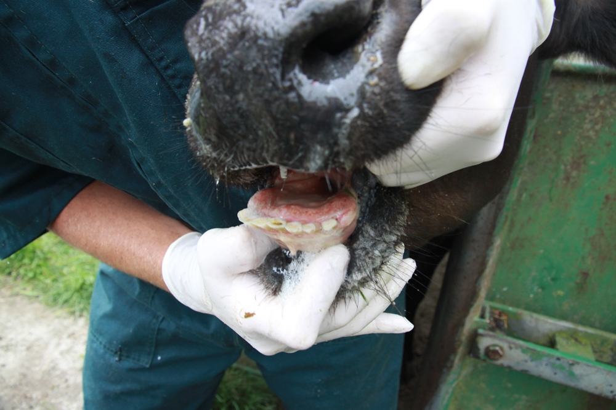

## How our biosecurity system works

Australia’s biosecurity system is multilayered with prevention, management and response activities undertaken overseas, at and within our borders, including our external territories. Our system relies heavily on the support of all stakeholders, such as governments, industry, research organisations, agricultural and environmental groups, Indigenous communities and individuals.

**Without strong partnerships at all levels, we can’t have a strong biosecurity system.**

### Overseas

The Australian Government and importers work with overseas counterparts to identify and mitigate biosecurity risks before they reach our border, while also undertaking capacity building activities, including in the Indo-Pacific region, to further our biosecurity, trade, security and national interests. Officials facilitate trade in line with our international obligations, apply import conditions and controls, and engage in risk and intelligence gathering, analysis and horizon scanning. Our overseas partners and industry provide vital intelligence on risks and traceability of products to support this work.

### At our border

Robust regulatory, surveillance and quarantine arrangements are in place to prevent, detect and intercept risks at our national border before they can do us harm. The Australian Government operates border controls, including screening, assessment, inspections and quarantine processes, to support this effort. Travellers have a role to play through their awareness of the importance of biosecurity and declaring goods if required. Industry also helps to protect us by having systems in place to proactively manage risks, applying treatments where needed and participating in surveillance activities.

### Within Australia

Industry, governments, Natural Resource Management (NRM) organisations, environmental groups, landowners and managers and the wider community work at regional and local levels to prevent, plan for, detect and respond to outbreaks. The Australian, state and territory governments lead regulatory activities. Industry and governments coordinate and fund management and response activities under a range of deeds and agreements and all system participants work together on the ground to reduce the possibility and impact of further spread within and across borders. The general public plays a critical role in surveillance and the reporting of pest, weed and disease outbreaks. Research organisations work to enhance our understanding of biosecurity risks and examine new approaches to improve our system in areas like diagnostics, containment and treatments.

### Australia’s Biosecurity System

The [National Biosecurity Statement](https://www.awe.gov.au/sites/default/files/sitecollectiondocuments/biosecurity/national-biosecurity-statement.pdf) mapped the roles we play within the biosecurity system as illustrated below. The national strategy will build from this strong foundation. Through the consultation phase, we want to hear your feedback to ensure that everyone’s roles are clear and reflect the future needs of our system.

Our biosecurity system includes a wide range of stakeholders, from Traditional Owners, veterinarians, park rangers, landowners, farmers, entomologists and many more. The National Biosecurity Statement (2018) provided an overview of stakeholder roles and the national strategy builds from this strong foundation. One of our initial actions will see us work together to ensure everyone’s roles are clear and reflect the future needs of our system.

* Federal regulatory functions
  + Primaries responsibilities: Australian Government
  + Managing matters relating to the movement of people and goods at the national border. Regulating biosecurity controls to facilitate trade and market access, and fulfilling international convention obligations, including monitoring and reporting pest and disease status and protecting biodiversity. Exercising powers for biosecurity emergencies of national significance.
* Research and capacity building
  + Primary responsibilities: Australian Government, state, territory and local governments, industry, representative bodies (e.g. peak bodies, NRM organisations, environmental and community groups), research organisations.
  + Maintaining and enhancing capacity to prepare for, detect and respond to pests, weeds and diseases, and the management of those already established. Includes support for research and innovation to underpin Australia’s science-based approach to biosecurity.
* Awareness and information
  + Primary responsibilities: Australian Government, state, territory and local governments, industry, representative bodies (e.g. peak bodies, NRM organisations, environmental and community groups), research organisations, individuals and communities.
  + Raising awareness and understanding of the biosecurity system and everyone’s roles and responsibilities. Including publishing information about Australia’s biosecurity system and responsibility for emergency response communications.
* On the ground
  + Primary responsibilities: Australian Government, state, territory and local governments, industry, representative bodies (e.g. peak bodies, NRM organisations, environmental and community groups), research organisations, individuals and communities.
  + Performing tasks for everyday management of biosecurity risks. Includes surveillance, complying with biosecurity obligations and managing pests, weeds and diseases. Contributing to the protection of the Australian environment and economy through practical biosecurity measures.
* Leadership and coordination
  + Primary responsibilities: Australian Government, state, territory and local governments, industry, representative bodies (e.g. peak bodies, NRM organisations, environmental and community groups).
  + Providing leadership and coordination to proactively manage biosecurity risk reduction and analysis. Includes developing partnerships with biosecurity participants and fostering biosecurity awareness.
* Domestic regulatory functions
  + Primary responsibilities: State, territory and local governments.\
  + Managing biosecurity within Australia’s border. Includes undertaking enforcement actions, regulatory interventions, emergency responses and negotiating and facilitating domestic trade.

Figure 1: How our system works – roles and responsibilities diagram

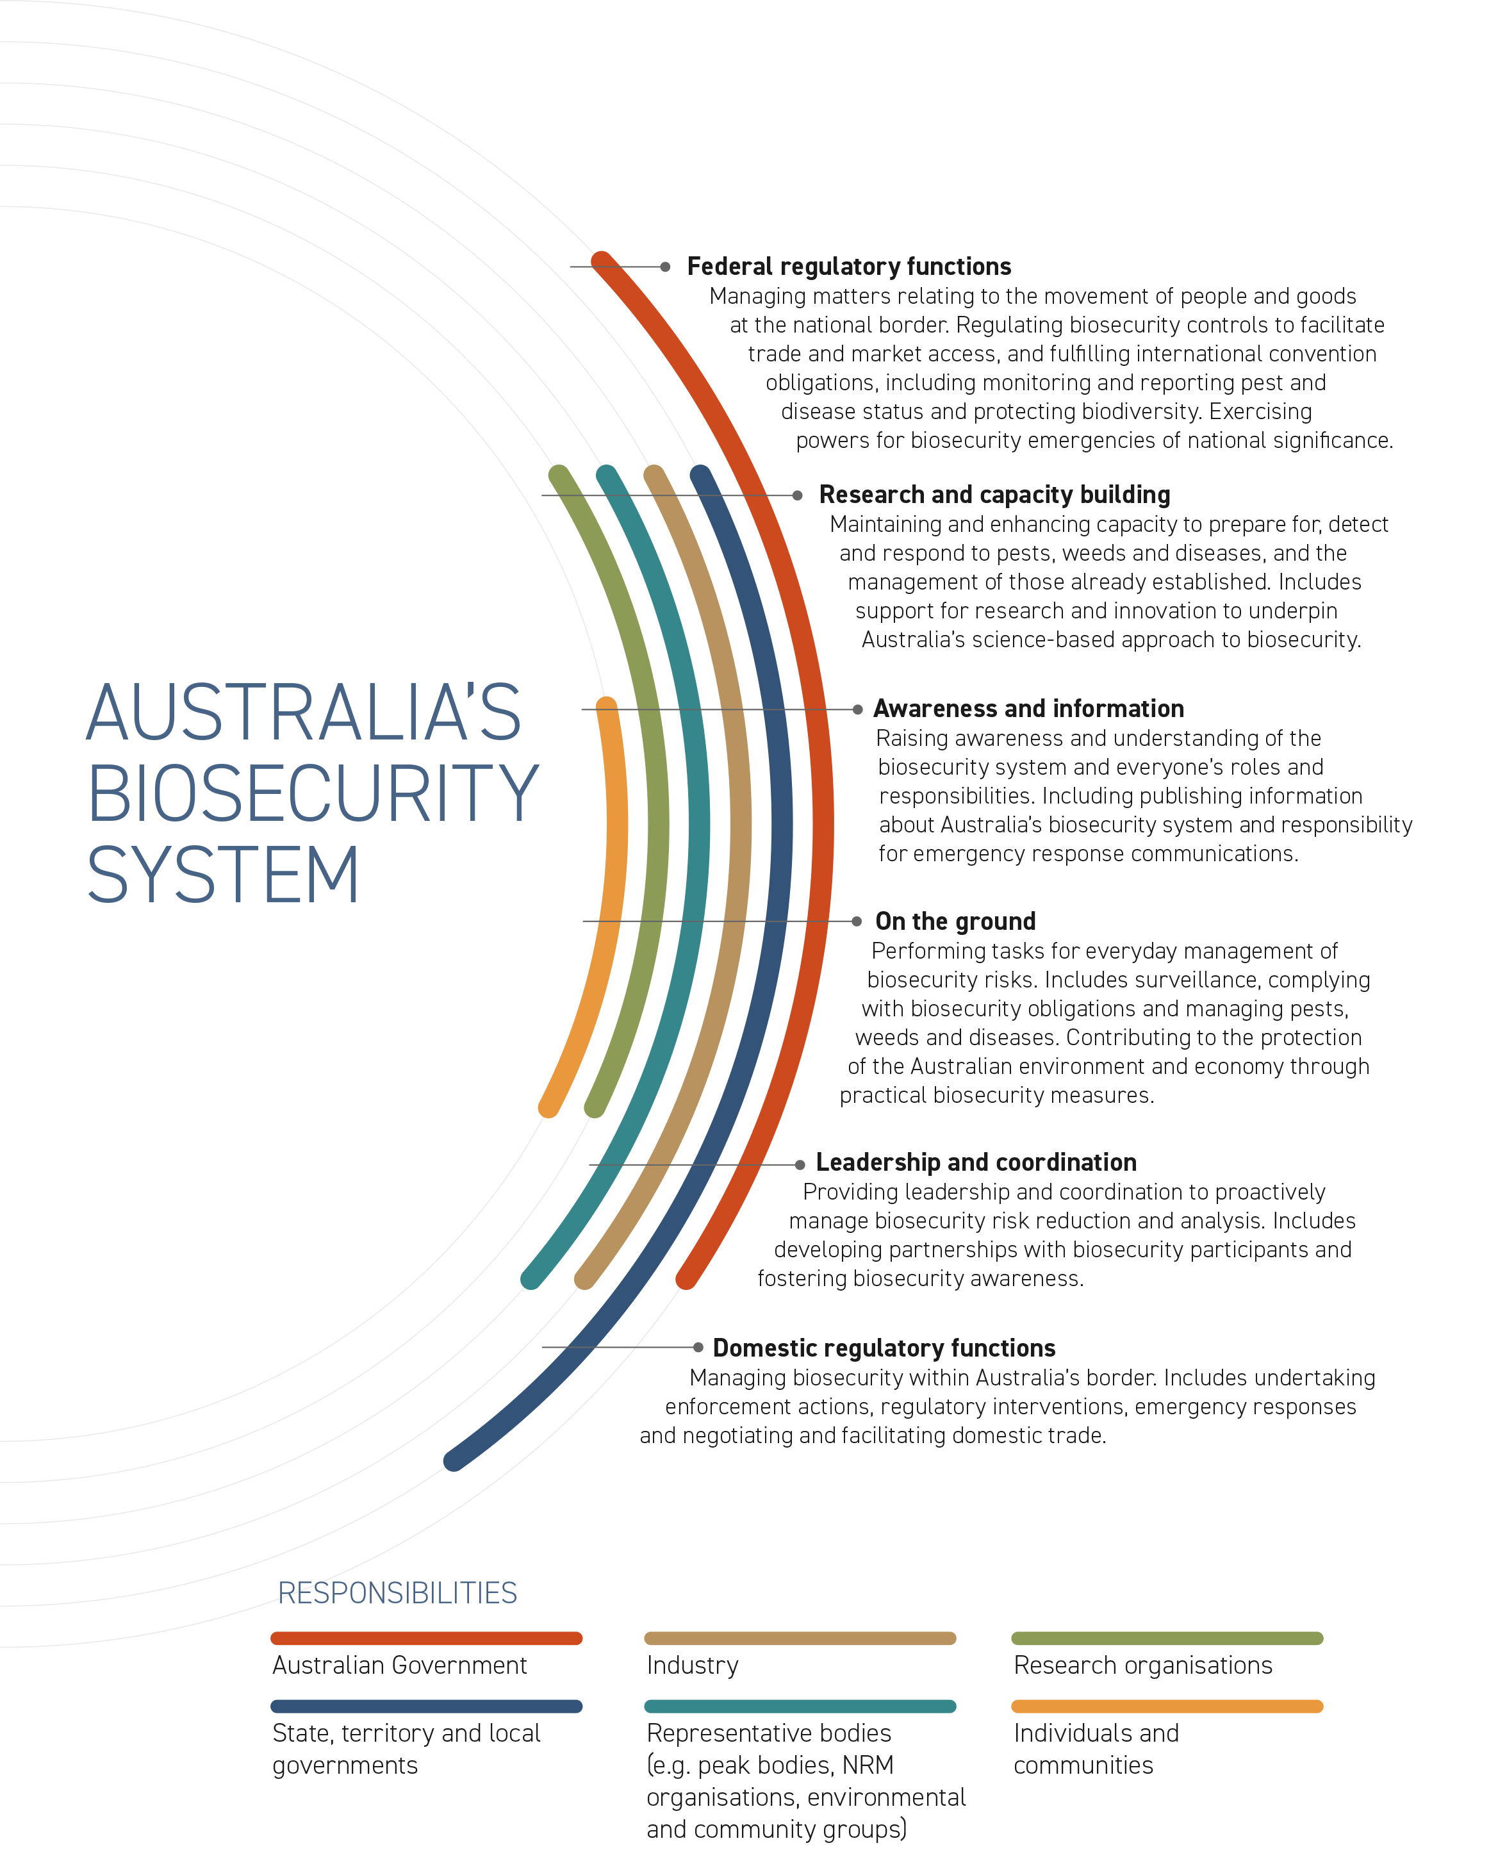

### 

### Our biosecurity system in action

Biosecurity activity categories sourced from Centre of Excellence for Biosecurity Risk Analysis (CEBRA), Year 1 Report: Valuing Australia’s Biosecurity System, Project 1607A – Milestone 6, 28 November 2017, University of Melbourne.

Table 1: Biosecurity system activities

|  | Australian Government | Industry | Research organisations | State, territory and local governments | Representative bodies (e.g. peak bodies, NRM organisations, environmental and community groups) | Individuals and communities |
| --- | --- | --- | --- | --- | --- | --- |
| Anticipate | | | | | | |
| Environmental scanning | X |  | X | X | X |  |
| Offshore surveillance | X | X |  | X |  |  |
| Collaboration / programs with offshore industries and authorities | X | X | X | X | X |  |
| Import risk analysis / review of import conditions | X |  |  |  |  |  |
| Modelling | X | X | X | X | X |  |
| OIE notifiable disease lists | X |  |  |  |  |  |
| Prevent | | | | | | |
| Engagement and awareness | X | X | X | X | X | X |
| Offshore treatments / verification and certification | X | X |  | X |  |  |
| International arrangements | X |  | X |  |  |  |
| Import conditions / permits | X |  |  |  |  |  |
| Capability building in neighbouring countries | X |  | X | X | X |  |
| Partnerships | X | X | X | X | X | X |
| Screen | | | | | | |
| Inspections | X |  |  | X |  |  |
| Post entry quarantine | X | X |  |  |  |  |
| International mail screening | X |  |  |  |  |  |
| Diagnostics | X |  | X | X |  |  |
| Border assessments | X |  |  |  |  |  |
| Storage / destruction: Approved arrangements for storage / destruction of goods | X | X | X |  |  |  |
| Treatments | X | X |  | X |  |  |
| Screening | X |  |  | X |  |  |
| Prepare | | | | | | |
| Risk analysis | X | X | X | X | X |  |
| Contingency planning and training | X | X | X | X | X |  |
| Domestic border assessment |  |  |  | X |  |  |
| Traceability | X | X | X | X | X |  |
| Response plans (e.g. Deeds, PlantPlan and AusVetPlan) | X | X |  | X | X |  |
| On-farm biosecurity plans |  | X |  | X | X | X |
| Simulations exercises | X | X |  | X | X | X |
| Detect | | | | | | |
| Domestic border inspections |  |  |  | X |  |  |
| Onshore surveillance | X | X |  | X | X | X |
| Indigenous Rangers | X |  |  | X | X | X |
| Sentinel herds / plantings | X |  |  | X | X |  |
| Tracing | X | X |  | X |  |  |
| Identification and reporting of pests, weeds and diseases |  | X | X | X | X | X |
| Diagnostics | X | X | X | X | X | X |
| Respond | | | | | | |
| Awareness raising | X | X | X | X | X | X |
| Initial investigation |  |  |  | X |  |  |
| Emergency responses (e.g. movement controls) | X | X | X | X | X | X |
| Pest risk analysis | X |  |  | X |  |  |
| Response plan activation | X | X |  | X | X |  |
| Community engagement and education | X |  |  | X | X | X |
| Recover and/or Adapt | | | | | | |
| Proof of freedom | X |  | X | X |  |  |
| Domestic quarantine |  | X | X | X |  |  |
| Community / industry / government led programs (e.g. weed management) | X | X | X | X | X | X |
| Certification schemes for product movement |  |  |  | X | X |  |
| Business continuity planning | X | X | X | X | X |  |
| On the ground management and control of existing pests, weeds and diseases | X | X |  | X | X | X |

Figure 2: Biosecurity system activities diagram

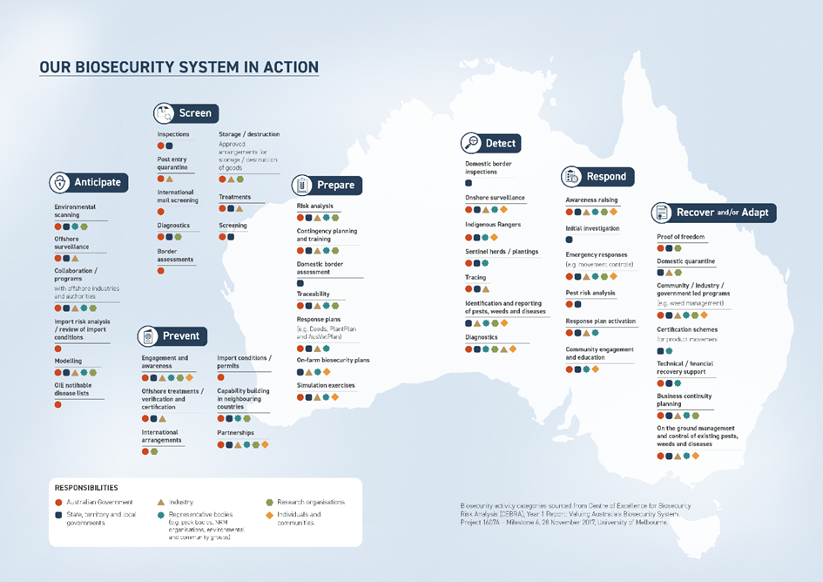

### Case study: Khapra Beetle

**Biosecurity outbreaks can have far reaching impacts.**

**Khapra beetle could cost Australia $15.5 billion over 20 years if it became established (2014 estimate).**

**In 2020-21, responses to 20 interceptions of the khapra beetle (*Trogoderma granarium*) were managed across Australia.**

Changes in global trade patterns, such as increased volumes of goods, container movements and declining container hygiene are some of the drivers of recent increases in khapra beetle interceptions.

**Khapra beetle:** Smaller than a grain of rice, khapra beetle is a serious pest that can contaminate stored grains, rice, oilseeds and dried foodstuffs. It is not established in Australia. Khapra beetle can cause losses of up to 75% from direct feeding. Infested produce also becomes contaminated with beetles, cast skins and hairs from larvae, which can pose a health risk and are difficult to remove from storage structures and transport vessels.

If khapra beetle were to establish here, many of our trading partners would refuse to buy our stored produce, particularly grains. Given Australia exports 65 to 75% of the grain we grow to more than 50 countries, this could cause significant economic losses.

Responding to a khapra beetle (or another exotic pest, weed or disease) outbreak can have wide ranging impacts across the supply chain.

**A detection in imported goods:** In October 2020, the Australian, state and territory governments began investigating and managing a detection of khapra beetle in a container of goods imported by a large retailer. This detection was initially reported by a member of the public who found khapra beetle in packaging material and notified biosecurity officials.

**Immediate action was taken across our biosecurity system:** The retailer worked closely with the Australian Government to remove the goods that were in this consignment from sale across Australia. It secured those goods that had made their way through the supply chain – from the port to the warehouse, to the distributor, to retailers and to customers’ homes.

**Affected customers had their purchases replaced and the goods were fumigated:** The incident affected around 300 retail customers across Australia who had their homes and cars inspected and treated with insecticides, with some of their food and pet food collected for destruction. This response prevented the pest from establishing in Australia which could have been severely damaging to our domestic grain producers.

**Further biosecurity measures were implemented:** Additional urgent measures were developed by the Australian Government in consultation with industry to better safeguard our agricultural sector and economy. This included stricter import conditions for high-risk goods and changes to container management. State and territory governments continue to undertake further monitoring and surveillance activities.

## We are facing a changing biosecurity environment

Managing biosecurity risks is becoming more complicated as we face a range of compounding challenges on multiple fronts.

### Changing or increasing biosecurity risks

#### Climate change

Climate change is impacting the global environment, causing changes in weather patterns and more extreme weather events. It is altering the habitat, range and distribution of many pests, weeds and diseases, as well as increasing their ability to spread and establish in new areas.

For example, the buffalo fly, a harmful parasite that can irritate beef cattle, interrupt feeding and cause sores, is already present in Australia’s north and has been moving further south as the climate changes. It is predicted that it will establish itself in South Australia and Western Australia by 2030.

Established pests, weeds and diseases reduce the ability of our natural ecosystems, plants and animals to cope with changing climatic conditions. As climate change increasingly affects global plant and animal habitats, it will have flow-on impacts for biosecurity risks associated with changes in trade and travel patterns and the effectiveness of our existing control measures.

#### Changing land uses

Changing land uses are altering the interface between urban and non-urban areas and the environment. As our population grows and spreads, it brings people closer to wildlife, natural habitats and agricultural areas, potentially increasing biosecurity risks. COVID-19 restrictions have accelerated this change in some areas, acting as a driver for Australians to relocate from our cities to regional centres in search of a different lifestyle.

As cities grow and peri-urban environments change, the risk of the introduction and spread of pests, weeds and diseases may increase through land development, habitat loss and the movement of people and goods into new areas. These changes to our urban and natural environment will also expose new people to biosecurity who may have limited awareness of its importance.

#### Shifting trade and travel patterns

Shifting trade and travel patterns have seen Australia’s supply chains, trading partners and demand for goods continuously evolve and increase in complexity. This is changing the biosecurity risks reaching our international and domestic borders, while impacting how we work with trading partners and each other.

The increased movement of people, equipment and goods increases biosecurity risks, by providing more opportunities for pests, weeds and diseases to spread. Within Australia, interstate road freight is predicted to increase by 1.7% every year until 2030. Additionally, predicted increases in trade and vessel movements will result in a greater likelihood of the introduction of marine pests like Asian green mussel (*Perna viridis*), which poses a serious threat to our aquaculture, native species and ability to export seafood.

#### Decreasing biodiversity

Decreasing biodiversity driven by invasive species, climate change and changing land uses weakens the resilience of our ecosystems to future outbreaks. It is estimated that 8 out of 10 land-based threatened species are at risk due to invasive species. This is a growing problem in Australia, and our external territories, which have unique and fragile ecosystems.

Around 20 new weed species are unintentionally introduced or become unmanaged populations each year, displacing native plant life and changing entire ecosystems, while creating fuel for bushfires and choking our waterways.

Additionally, the loss of genetic diversity in certain crops such as bananas, which are 95% Cavendish variety in Australia, exposes us to higher levels of risk in the event of a pest, weed or disease outbreak.

#### Illegal activity

Illegal activity has increased in recent years, leading to a higher risk of biosecurity threats. The growth and increasing complexity of trade and online shopping – exacerbated by the COVID-19 pandemic – has inadvertently opened new pathways for illegal plants and animals to reach Australia, impacting biosecurity risks. The increasingly lucrative illegal trade in plants and animals was valued at US$7-23 billion per year globally in 2016.

Additionally, increasing illegal fishing practices heighten the risk of exotic marine animals invading Australian waters, with poorly maintained vessels often harbouring marine pests on their infrastructure above and below the waterline.

#### Increasing biosecurity risks overseas

Increasing biosecurity risks overseas, including in the Indo-Pacific, make us more susceptible to pests, weeds and diseases entering Australia. We have so far kept out many high-risk animal diseases such as rabies, foot-and-mouth disease, lumpy skin disease and African swine fever. These diseases have the potential to spread rapidly and will have devastating impacts if they were to enter Australia due to the movement and location of livestock and the presence of pest animals, like feral pigs. Geographically some of these diseases are only 5 km from Australian shores, with the movement of people, goods and marine infrastructure creating additional risk.

Climate change is altering the movement patterns of some species and increasing arrival risks through natural pathways like wind and tide. Pests such as fall armyworm, citrus canker, fruit flies and rust species can be wind borne, making them harder to track and limiting prevention and risk management options.

Australia’s vast northern coastline is the frontline for many of these risks, with modern biosecurity infrastructure, trained people and strong surveillance activities critical to protecting our nation.

#### Major global disruptions

Major global disruptions, such as the COVID-19 pandemic, can shock supply chains and impact the movement of goods and people. While these changes are often temporary, they can act as a catalyst for permanent changes in behaviour and supply chain pathways. For example, retailers may seek to change or diversify suppliers to improve supply chain reliability and manage business continuity risks. Other global events, such as war and natural disasters, can also impact trade and pathways, increasing or changing the biosecurity risks that can reach our border. System resilience, adaptability and responsiveness are critical to maintaining strong biosecurity in the face of an uncertain and changing environment.

Box 6: Case study: Red imported fire ant

**Key impacts: Amenity, Economy, Environment**

**Key priorities: Shared biosecurity culture, stronger partnerships, sustainable investment, coordinated preparedness and response**

Discovered in South East Queensland (SEQ) in 2001, red imported fire ants (fire ants) are highly destructive. They can destroy crops, damage machinery, render land unusable and hurt or kill animals and humans.

Studies have shown that there is the potential for fire ants to cost our economy $45 billion over 30 years if their spread is left uncontrolled (2017 estimate).

Measuring just 2–6mm, fire ants are small, and their nests are often difficult to detect, especially during the warmer months. Fire ants are also extremely mobile and adaptable, flying, rafting on water and hitching a ride in organic materials.

Unlike other countries, including the United States and China, Australia is committed to eradicating fire ants through the National Fire Ant Eradication Program. The program is Australia’s largest biosecurity eradication initiative and is committed to ridding the nation of one of the world’s most invasive pests.

Funded by all state and territory governments and the Australian Government, the program is governed by a National Steering Committee made up of representatives from each of the funding partners and led by an independent chair.

In partnership with local landowners, the program has stopped fire ants from spreading at rates experienced overseas and confined them to a small area of SEQ. It is estimated that without the interventions undertaken by the program, fire ants would have spread as far north as Bowen, west to Longreach and south to Canberra by 2022.

Image 2: Red imported fire ants

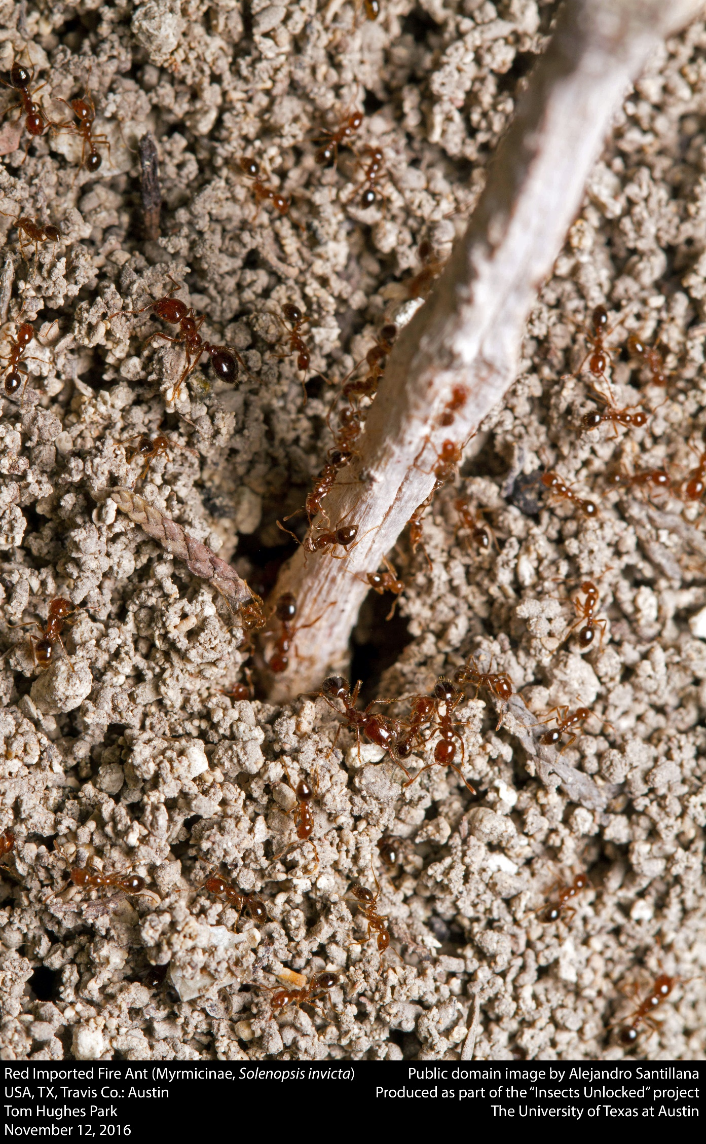

Box 7: Case study: Lumpy skin disease

**Key impact: Economy**

**Key priorities: Shared biosecurity culture, stronger partnerships, coordinated preparedness and response**

Lumpy skin disease (LSD) is a highly infectious disease of cattle and water buffalo. It can cause painful skin lesions on infected animals, with animal health, welfare and production impacts. The disease is spread primarily by biting insects like flies, mosquitos and ticks and can also be spread by contaminated equipment.

LSD is not present in Australia. However, it poses a serious and increasing threat given its rapid spread throughout Asia and its ability to be transmitted by wind borne insects. If LSD reaches our shores it will significantly impact domestic and international trade and cause severe economic losses for our cattle and water buffalo industries. If wild buffalo populations and cattle in northern Australia’s extensive rangelands were exposed to LSD, reservoirs of the virus could establish, making eradication extremely difficult.

Biosecurity stakeholders are working closely together to prepare for an outbreak of LSD. Efforts are being focused in northern Australia, and include enhanced surveillance activities, dedicated public awareness campaigns, training of producers and Indigenous and park rangers, additional animal inspections, partnering with Indigenous landowners and more.

The Australian Government is also supporting our near neighbours in their ongoing efforts to prevent and control the spread of LSD within the region.

Image 3: Lumpy Skin Disease

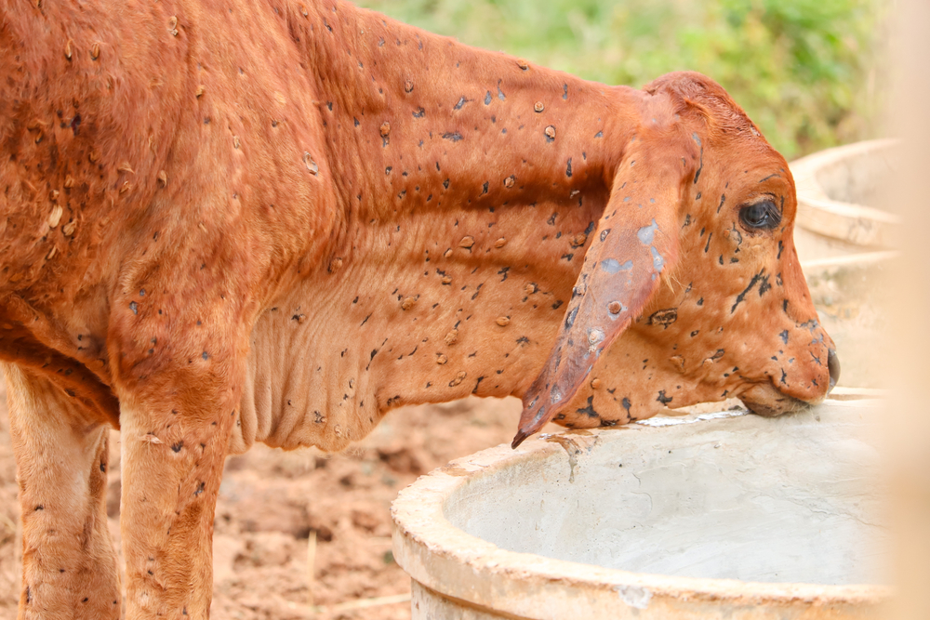

Box 8: Case study: Charru mussel

**Key impacts: Amenity, economy, environment**

**Key priorities: Shared biosecurity culture, integration supported by technology, research and data, coordinated preparedness and response**

The charru mussel (*Mytella strigata*) is an exotic marine pest not present in Australia that is spread through international shipping and threatens Australia’s unique marine ecosystems and economy. The mussel forms dense clusters that outcompete native marine species, impact aquaculture production, damage infrastructure and foul vessels.

Native to the waters of South and Central America, the charru mussel has spread rapidly through North America and Asia. Like many marine pests, charru mussels can hitch a ride on boats and ships, either as biofouling or as larvae in a ship’s ballast water. Charru mussels have been detected on vessels heading to Australia but have been successfully eradicated.

A combination of national regulations and surveillance activities are used to keep this pest out of Australian waters. As a further line of defence to prevent the introduction of this and other marine pests, surveillance programs are also run by Australian, state and territory governments around the country.

Innovative tools like underwater drones and analysis of environmental DNA are used to support these activities. National education and engagement activities are employed to engage communities and users of Australia’s vast coastline and marine environments in biosecurity.

Image 4: Charru Mussel

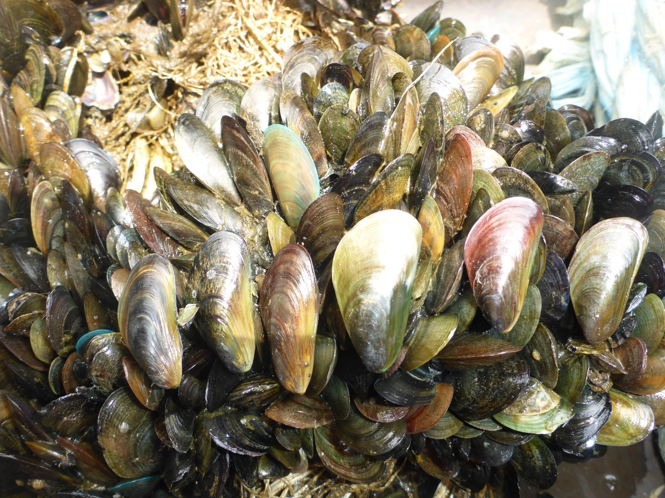

Box 9: Case study: Varroa Mite

**Key impacts: Economy, environment**

**Key priorities: Shared biosecurity culture, stronger partnerships, highly skilled workforce, sustainable investment, integration supported by technology, research and data, coordinated preparedness and response**

Internal and external mites of bees, including varroa mite (*Varroa destructor* and *Varroa jacobsoni*), are National Priority Plant Pests. Varroa mite, particularly Varroa destructor, weakens and eventually kills European honeybees (*Apis mellifera*). An outbreak, like the June 2022 detection in Newcastle, NSW, could have significant repercussions for our economy, potentially costing producers and consumers of pollination-dependent crops – like almonds and pears – $5.2 billion over 30 years (2022 estimate).

Australia is currently the only inhabited continent to successfully prevent the pest from establishing itself. While varroa mites have been detected on arrived bee swarms several times at ports across Australia, such as at the Port of Townsville (2016, 2019, 2020 – *Varroa jacobsoni*) and the Port of Melbourne (2018 – *Varroa destructor*), each time the swarms and the mites have been successfully eradicated or destroyed upon entry. This success is due to our strong partnerships, robust surveillance methods and coordinated preparedness activities across the system. National response arrangements were similarly agreed for the 2022 Newcastle outbreak.

The National Varroa Mite Eradication Program was established in 2016 after varroa mite (*Varroa jacobsoni*) was detected in Townsville. It was co-funded by industry, including the Australian Honey Bee Industry Council, state and territory governments and the Australian Government under national response arrangements. This covered important surveillance activities like GPS tracking, community awareness campaigns and extensive inspections of bees and their colonies, including the examination by entomologists of around 880,000 honeybee wings in 2019-20 alone. *Varroa jacobsoni* was declared eradicated in 2021 following the success of the program.

Across Australia, the close collaboration between governments, industry and the community has allowed for the rapid and transparent sharing of resources and information to effectively prepare for and eradicate this pest. The 2022 outbreak highlighted the importance of such relationships, with response activities addressing potential impacts to commercial industries, recreational beekeepers and the environment.

Image 5: Varroa Mite (*Varroa destructor*)

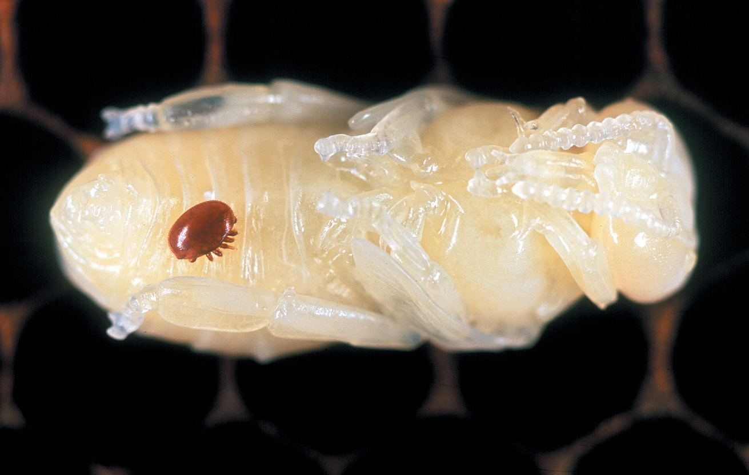

Box 10: Case study: Panama TR4

**Key impacts: Economy**

**Key priorities: Shared biosecurity culture, stronger partnerships, sustainable investment, coordinated preparedness and response**

Panama disease tropical race 4 (TR4) is a National Priority Plant Pest that affects bananas and is present in parts of Australia. The pest blocks the tissues that carry water and nutrients in banana plants, eventually killing them. Without management, it could devastate Australia’s banana industry. Panama TR4 can live in soil for decades without a host and is spread easily in contaminated soil, plant material and water. There is currently no cure for the disease and our only defence is to implement effective separation and decontamination processes. The success of these prevention and management measures relies on strong partnerships and awareness of system stakeholders, as well as sustainable funding to support ongoing activities.

The Panama TR4 Program is a joint initiative between the Queensland Government and the Australian Banana Growers’ Council (ABGC) to control and contain the disease. Since the region’s first detection in 2015, the program has focused on early detection through surveillance on commercial banana farms in Far North Queensland and compliance activities on known infested properties. The program also seeks to generate community support for efforts to protect against the disease through communications and engagement activities.

With the ABGC co-funding the Panama TR4 Program since 2019, a management board of equal government and industry representation has been established to govern and deliver the program’s strategic direction until mid-2023. Beyond July 2023, industry will lead disease management. Continued success will require us to harness the potential of our shared biosecurity culture, supported by broad community engagement and awareness activities.

Image 6: Panama TR4 (T. Pattison, DAF)

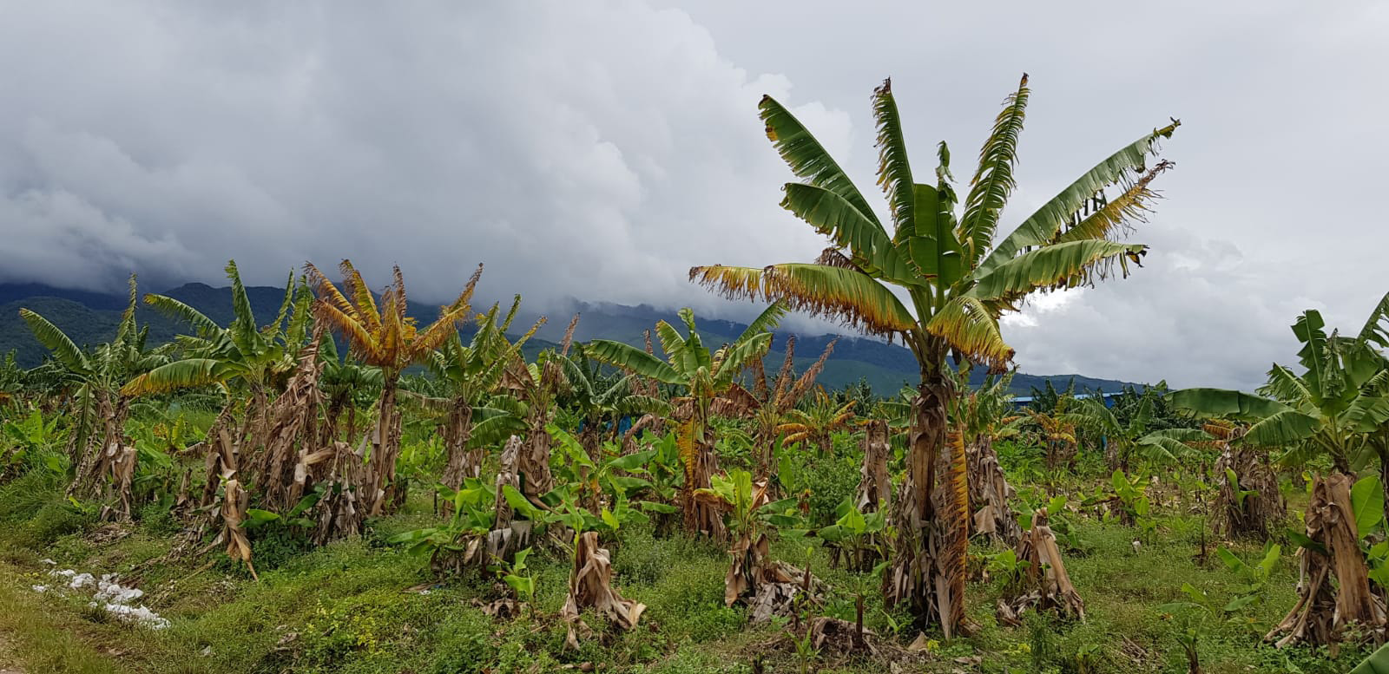

## Our opportunities for meaningful change

To meet the biosecurity risks of today and arm ourselves for the new and increasing risks coming our way, we must continue to evolve our system. This requires us to go beyond scaling our current efforts to enhance how we work together and leverage opportunities for improvement.

**Engaging everyone in the biosecurity system** is a fundamental opportunity to create a stronger system that is action oriented and raises awareness of risks, shared benefits and outcomes. This will rely on fostering a greater understanding and valuing of biosecurity, as well as behavioural change across the entire system to enhance prevention, preparedness, surveillance and reporting activities. The National Biosecurity Statement, developed in 2018, provides a solid starting point for the sharing of ownership across the biosecurity system.

Engaging at a grassroots level by promoting on-farm and on-land biosecurity, utilising citizen science and working more closely with Indigenous Australians, provides an opportunity to improve our system. Additionally, enhancing our engagement with international organisations and trading partners on biosecurity can help us to mitigate risks before they reach our shores. We have a significant opportunity to build upon and complement previous and existing activities (such as the Decade of Biosecurity) to connect, motivate and empower a broader range of stakeholders, including the community.

**Opportunities exist in the north** to support and enhance existing biosecurity efforts. The north of Australia, home to some of our key primary production and tourism growth areas, faces a high risk of threats entering via natural pathways. The Northern Australia Biosecurity Strategy provides a platform for us to focus our efforts on high priority activities. These activities include expanding our Indigenous Ranger programs and capability, increasing surveillance and diagnostic capacity and capabilities, addressing regional skills needs in key areas and improving data collection.

**A more flexible, improved risk-based regulatory system** is needed to drive more efficient and harmonised processes using targeted and adaptable regulatory frameworks that provide benefits to all stakeholders. We have significant opportunities to facilitate coordinated data sharing and operationalise innovations in technology to support faster, risk-based decision-making and traceability. Co-regulation with industry can also provide material benefits to all stakeholders in managing risk and streamlining processes when they are carefully designed and supported by harmonised compliance frameworks.

**Enhancing environmental biosecurity efforts** will help us to conserve, restore and care for our land, sea and aquatic ecosystems, protect native plants and animals and support our biodiversity. We have the opportunity to improve outcomes through targeted awareness and engagement with environmental groups and the wider community, better coordinated research activities and enhanced risk analysis and biosecurity management for pests, weeds and diseases that impact our environment.

**Funding and investment** is currently sourced from all levels of government, industry and the community through a variety of models, reducing the transparency of system-wide investment. Funding has been under recent strain due to the evolving risk environment and growing demand for resourcing. We have the opportunity to work together across government, industry and the community to assess and reset our funding and investment frameworks to ensure they are fit for purpose, targeted to our priorities, sustainable in the longer term and that all biosecurity participants contribute equitably. Increased funding and investment transparency will help to keep us accountable for achieving our priorities.

**Closer collaboration at regional and local levels** through on the ground coordination and locally driven solutions could support better biosecurity outcomes. In addition to the potential to improve collaboration amongst the state and territory governments and with the Australian Government, opportunities exist for diverse stakeholder groups to work more closely together at regional and local levels. This includes industry, NRM organisations, landowners and managers, local governments, farmers and Traditional Owners. This collaboration will help to implement biosecurity priorities matched to regional needs, support prevention and preparedness activities, collect data and measure results consistently, coordinate mutually beneficial activities and maintain open and continuous communication.

**Additional skills and infrastructure** are required to support a more responsive biosecurity system as the skills of our people and the infrastructure that supports them are the foundation of our system. We have a skilled workforce with deep and diverse technical expertise, but there are capacity constraints and recruitment and retention challenges, particularly in a range of specialist capabilities and in regional areas across Australia.

Our laboratories, research facilities, national collections and quarantine centres are critical biosecurity assets for our nation. We need to continue to modernise national infrastructure to support emerging technologies and achieve a more adaptive system. We will only realise the benefits of new approaches and innovative technologies, like High-Throughput Sequencing and environmental DNA, if we have the skilled people and the supporting infrastructure necessary to operationalise them. We have an enormous opportunity to plan for the skills and critical infrastructure needed going forward and to create an environment where innovation and new and more efficient ways of working are actively encouraged.

**Understanding the changing risk environment** and enhancing the way we share threat information is critical to maintaining a strong system. Biosecurity risks are constantly evolving and as threats change, our risk profile and the way we need to work together changes. For example, climate risks will be important to consider to improve our decision making and mitigate risks. Improved outcomes can also be achieved by continuing to leverage the One Health approach, recognising that the health of our people, animals and shared environment are interconnected. This is particularly important for antimicrobial resistance and zoonotic pathways. The early 2022 outbreak of the viral zoonotic disease Japanese encephalitis clearly demonstrates the importance of using a One Health approach to addressing risks.

We have the opportunity to better share risk information and threat assessments with a wider range of biosecurity stakeholders to improve our understanding of the changing environment and support investment, preparedness activities and research prioritisation.

## It’s time to evolve how we work together

The only way we can build an even stronger biosecurity system is to evolve how we work together.

Australia’s biosecurity is underpinned by the 2019 Intergovernmental Agreement on Biosecurity, which provides a strong foundation to focus our collective efforts and supports wide-ranging partnerships.

However, as the challenges facing us continue to build, we need a renewed focus on enhancing our national biosecurity capacity and capability and fostering an action-focused and inclusive culture.

Box 11: Vision and purpose

Our vision for Australia’s future biosecurity system

A biosecurity system that protects Australia and our way of life – connected, resilient and shared.

Shared purpose bringing us together

A risk-based system underpinned by science that protects Australia’s people, our environment, economy and lifestyle from the biosecurity threats of today and tomorrow.

### Where we’re going

In the future, we will more efficiently and effectively manage biosecurity risks.

Key to our success will be the adaptability and sustainability of our prevention, preparedness, surveillance, response, management and recovery systems, combined with a collaborative culture that encourages action and embeds continuous learning.

Everyone will know why biosecurity is important, care about it, understand their role and how they should play their part to ensure that our biosecurity remains strong.

### How we’ll get there

We will work together to act in 6 priority areas. These priorities will guide our efforts so that we have the biggest impact and remain on track as we move into implementation planning.

### Priorities and actions to realise our vision

**Enhancing our capability and embedding advancements in technology and research are key enablers of our strategy. However, improving our system will also rely heavily on strengthening our biosecurity culture – the way we think, behave and work together – to promote awareness, drive coordinated action and complement efforts already underway, such as the Decade of Biosecurity.**

Initial actions in our 6 priority areas have been collaboratively developed to support our vision and purpose and will be further built upon as part of implementation planning. Our next steps will be to identify initial actions for immediate implementation and to work together to develop a national implementation plan and national action plan that will drive the delivery of our priorities.

**We will take action in 6 priority areas:**

#### Shared biosecurity culture

We will ensure all Australians understand what biosecurity is and are empowered to act to support our system. We will create a culture of action in which we all care about, contribute to and are responsible for, our biosecurity. We all enjoy the benefits that effective biosecurity brings, just as we all share the consequences of our system’s failures.

Initial actions:

* Build on and develop national awareness and education programs – including introducing biosecurity into curricula – to deepen understanding of, and commitment to, Australia’s biosecurity and encourage community and industry stewardship in the system.
* Progress innovative approaches to drive positive biosecurity behaviours and incentivise compliance, including through social and behavioural research, leveraging community and other networks and exploring new channels of engagement, such as with culturally and linguistically diverse communities.
* Revitalise and continue to collaborate through national communication, engagement and reporting mechanisms, as well as relevant fora and symposia, to encourage greater knowledge sharing, build trust and increase transparency.
* Determine opportunities to embed biosecurity as a consideration into all levels of government, community, industry and other stakeholders’ broader decision-making, risk and business continuity planning.

#### Stronger partnerships

We will strengthen and expand partnerships with all stakeholders at local, regional, national and international levels to leverage our different expertise, resources and knowledge for greater impact and to support better biosecurity outcomes. Underpinning these partnerships will be mutual trust, formal recognition, transparency and a clear understanding of the importance of everyone’s role.

Initial actions:

* Enhance partnerships and engagement with Indigenous Australians to ensure Indigenous interests are incorporated and participation is enabled in the design and delivery of biosecurity outcomes and initiatives.
* Collaborate with a diverse range of biosecurity stakeholders to review and refine roles and responsibilities, providing flexibility to adapt as the system evolves.
* Review governance arrangements to ensure that they include relevant stakeholders in the design, development and implementation of national policies, programs and regulatory arrangements.
* Strengthen the involvement of environmental agencies and environmental and community groups to enhance biosecurity outcomes.
* Identify and implement opportunities for greater industry and community involvement in decision-making bodies.
* Deepen international partnerships and capacity building, including in the Indo-Pacific, to increase engagement, harmonisation, skills exchanges and information sharing on national priority pests, weeds and diseases.
* Work together to strengthen the understanding of antimicrobial and pesticide resistance, and zoonotic pathways - including surveillance and monitoring.
* Coordinate our international advocacy efforts to help shape global biosecurity standards, rules and conditions to support strong biosecurity in Australia.

#### Highly skilled workforce

We will develop and sustain the pipeline of biosecurity skills needed for the future, within government, industry and the community. We will ensure our people can be deployed when and where they are needed, and that they have the right skills by providing targeted capability and capacity building, education and training.

Initial actions:

* Investigate national skills to identify current and future needs in key areas, such as science, data, new technologies and regulatory capabilities, considering the findings of existing industry and government workforce strategies.
* Develop a national biosecurity workforce strategy to build, develop, retain and deploy capability across the system, including surge support for responses, taking into account regional needs across Australia.
* Build upon and expand existing cooperative and partnership arrangements to leverage the expertise and capability of biosecurity stakeholders to support system needs where there are mutual benefits.
* Strengthen professional development programs and exchanges between biosecurity stakeholders to facilitate knowledge and information sharing, improve skills and support workforce retention.

#### Coordinated preparedness and response

We will enhance our preparedness and response capability through improved coordination, regional planning, increased collaboration and faster information and data sharing to support our system’s resilience and adaptability.

Initial actions:

* Undertake and promote regular national preparedness exercises with biosecurity stakeholders to test and improve our collective readiness and increase public awareness of significant biosecurity threats.
* Advance regionally based planning activities to better align effort, integrate biosecurity practices and facilitate greater education and awareness opportunities.
* Continually review and update risk information, including through regular strategic threat assessments, to inform priorities and share this with stakeholders.
* Actively embed continuous learning supported by enhanced post-incident reviews and evaluation practices to ensure lessons are captured and incorporated.
* Strengthen traceability arrangements to support improved biosecurity outcomes.
* Enhance our national surveillance and early detection arrangements to ensure they are robust given the changing threat environment, drawing on the expertise and capabilities of biosecurity stakeholders.
* Evolve our national information management frameworks to ensure they are fit for purpose, interoperable and promote seamless information exchange.

#### Sustainable investment

We will develop long-term sustainable biosecurity funding and investment approaches, including new funding streams and models, that recognise the value of government, industry and the community investing in biosecurity to support the system’s growing needs and priorities. We will ensure these approaches are efficient, equitable, adaptable, transparent and are responsive to the changing risk environment.

Initial actions:

* Work together to identify funding needs and determine priorities, including for critical assets, infrastructure and research.
* Strengthen frameworks to agree and deliver priority investments having regard to the level of risk and benefits from activities and to increase efficiency by reducing duplicative investments and processes.
* Advance co-funding and investment strategies with stakeholders, including models that consider key risk creators and system beneficiaries in an equitable manner.
* Increase the transparency of biosecurity funding to support improved accountability.
* Complete the development and implementation of a system performance and evaluation framework to inform future investment decisions.

#### Integration supported by technology, research and data

We will create a more connected and efficient system in which we better leverage existing and new technology, research and data to facilitate more timely, informed and risk-based decisions. We will continue to deliver our biosecurity research priorities, informed by national biosecurity research, development and extension (RD&E) strategies. We will develop, share and embed new technologies in areas such as traceability, surveillance, screening, data analytics, treatments and diagnostics.

Initial actions:

* Continue to invest in and roll out transformative technologies to digitise and automate processes, and support rapid and accurate detection, identification, traceability and response.
* Increase coordination and engagement with biosecurity stakeholders, including research and development bodies, to prioritise, drive and deliver national research outcomes.
* Actively share data and research to streamline research efforts and facilitate the adoption of outcomes, ensuring that they are accessible, interoperable and reusable where practical.
* Enhance the accessibility and use of surveillance and interception data to support effective and seamless decision-making by all stakeholders.
* Further support innovations to build science and research capacity in areas such as pathway risk assessments species identification and treatments.
* Encourage the uptake of existing and emerging technologies, systems and processes across the biosecurity system.
* Increase the use of citizen science, Indigenous knowledge and on the ground insights as valued sources of expertise, data and information.
* Encourage greater private sector investment in the development and delivery of innovations that provide for better biosecurity outcomes.

## Our way forward: Driving collaborative action

The strategy sets our future vision and priorities and outlines more than 30 initial actions for implementation. Realising our vision will only be possible through our collective efforts, as biosecurity affects all of us.

Our next steps will be to:

* identify those initial actions that can be implemented immediately
* design a national implementation plan that sets out governance arrangements and guides future planning
* develop a national action plan that builds upon our initial actions and establishes a framework for monitoring and evaluation to keep us accountable.

To support the achievement of the strategy’s vision and priorities and to help drive coordinated and collaborative activity across Australia, a diverse range of stakeholders will be involved in implementation, underpinned by an inclusive governance approach.

A National Biosecurity Strategy Implementation Committee (NIC) will be established, consisting of biosecurity stakeholders, including representatives from plant and animal industries, freight and logistics, aquatic industries, environmental groups, research organisations and Indigenous stakeholders. The NIC will work together with the NBC to develop, oversee, implement, monitor and review the national implementation plan and the national action plan.

They will initially be supported by expert stakeholder working groups for each priority area, who will further build upon and refine the initial actions in this strategy for inclusion in the national action plan.

Figure : A collaborative approach will drive implementation to achieve our vision and purpose

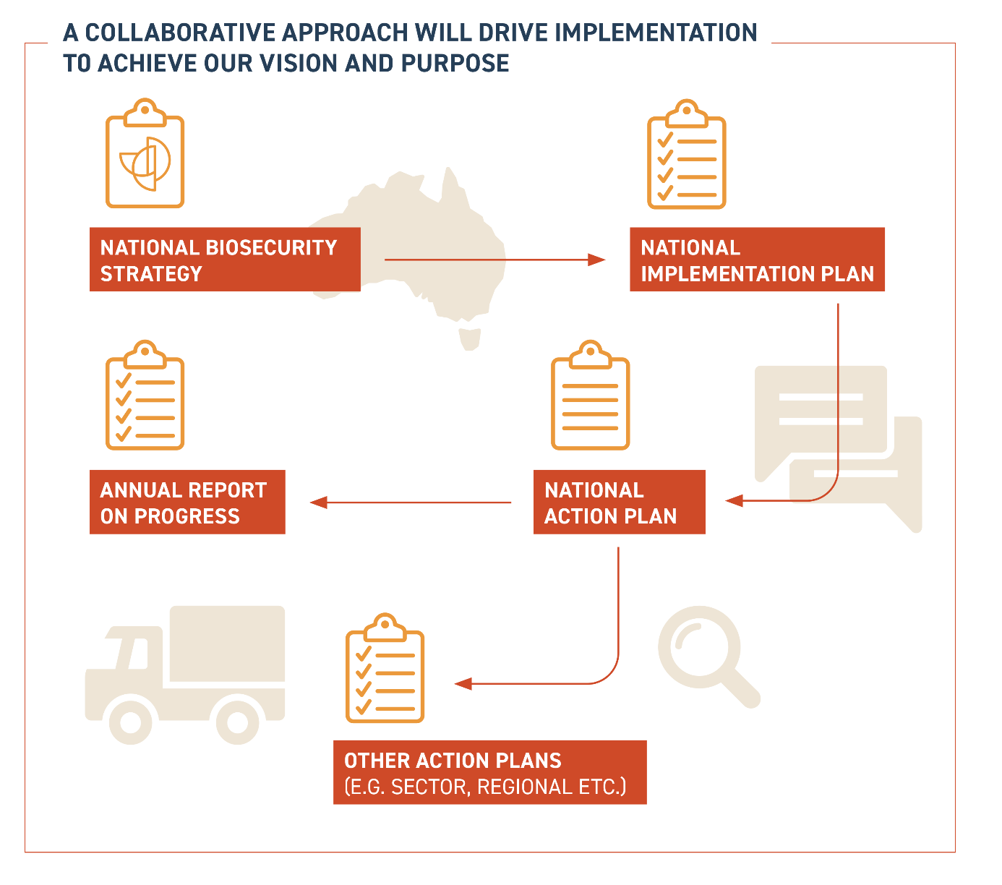

### Implementation principles

**We will work together to develop and implement actions in our priority areas to strengthen our system.**

To be successful, implementation will:

* be an **inclusive process** that includes collaboration with a broad range of stakeholders to develop, implement and monitor action plans
* provide **a range of different opportunities and avenues** for stakeholders to contribute and provide input
* **align with and complement** other relevant strategic agendas and activities where possible, to avoid duplication and siloing of effort
* have clear governance arrangements that embed opportunities for **greater stakeholder involvement in decision-making**, supporting our priority to enhance our shared biosecurity culture
* include mechanisms to ensure we are all **accountable** for implementation and that we **transparently** monitor and evaluate our progress
* focus on tangible actions in each of our priorities to deliver a **more resilient system** that can adapt to changes in our risk environment and is responsive to emerging opportunities and challenges.

### Coordinated implementation

**Implementing the strategy will be underpinned by a national implementation plan and national action plan, complemented by other local, regional or sector-based action plans.**

To kick-start the strategy’s implementation, we will identify those initial actions that can be implemented immediately and commence their delivery as soon as possible.

To guide our longer-term efforts, **a national implementation plan** will be developed during a 6 to 12 month planning stage. This will outline the governance structure and framework for implementation over the next 10 years.

The implementation plan will support a **national action plan**, which will also be developed during the planning stage. The plan will build upon the initial actions in this strategy and detail the efforts needed to deliver our vision and priorities, ensuring they are specific, measurable, achievable, realistic and timely. It will include a monitoring and evaluation framework to provide transparency on who is responsible for specific activities and to support ongoing monitoring and reviews.

The national action plan will be complemented by sector based, regional or other action plans developed by stakeholders.

Box 12: Engaging with our stakeholders

**Engaging with our stakeholders** – implementation will be informed by ongoing broader consultation, such as surveys, meetings, workshops and other fora, to ensure it is a collaborative and inclusive process.

Box 13: Monitoring our progress

* Progress against the national action plan will be monitored regularly to keep us on track and ensure that we adapt where needed, remaining focused on the continual improvement of our system.
* An annual report will be developed to provide an update on the strategy’s implementation, emerging issues and stakeholder priorities.
* A formal review of the strategy will be undertaken after 5 years, or sooner if there is significant change to the risks, challenges or opportunities facing us.

Figure : Overview of the implementation process

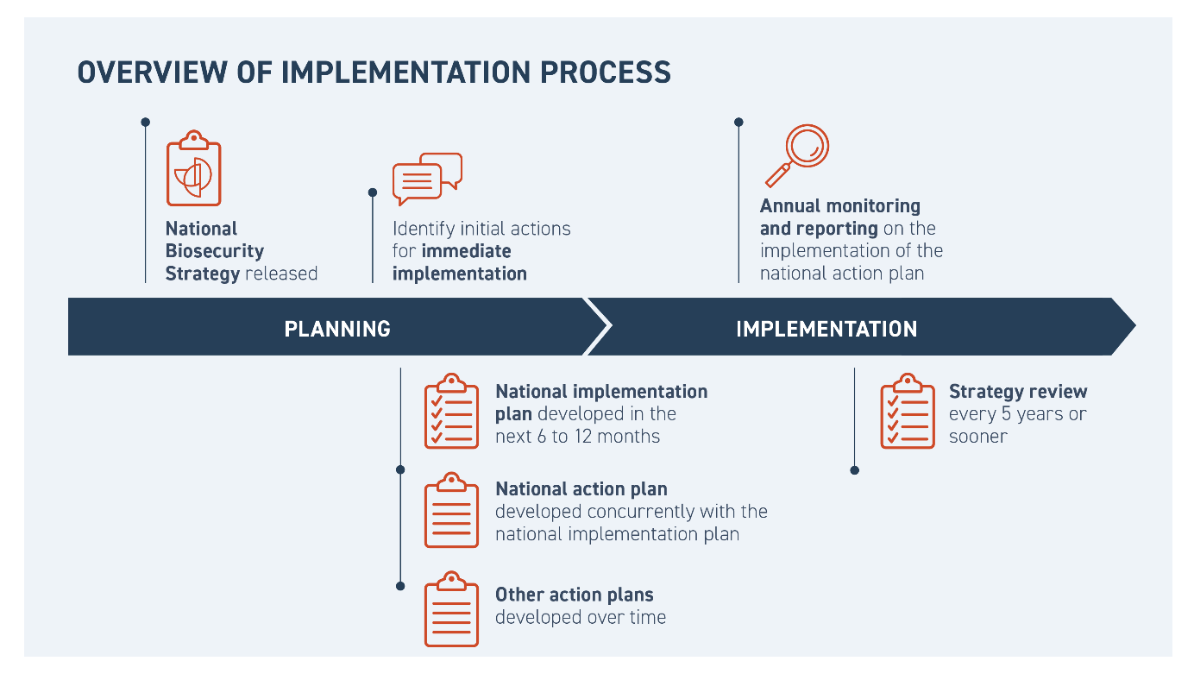

## Appendix

### Our biosecurity system architecture

Our system is supported by a mature and dynamic architecture of agreements, arrangements, deeds and statements between governments, plant and animal industries, environmental groups and research organisations. This is complemented by reviews undertaken by the Inspector-General of Biosecurity, CSIRO and other stakeholders.

Australia is also a signatory to a range of international biosecurity, trade, health and environmental agreements, including measures outlined by the World Trade Organization, International Plant Protection Convention, World Organisation for Animal Health and the World Health Organization.

**The Intergovernmental Agreement on Biosecurity (IGAB)** sets out commitments for governments, outlines agreed national goals and objectives and clarifies roles and responsibilities.

The IGAB also establishes the NBC. The NBC provides advice to the Agriculture Senior Officials Committee (AGSOC) on national biosecurity issues, and progresses the implementation of the IGAB. AGSOC reports to ministers responsible for primary industries.

The NBC is responsible for managing a national, strategic approach to biosecurity risks that could impact agricultural production, the environment, community wellbeing and urban amenity.

The NBC is supported by several sectoral committees – the Animal Health Committee, Environment and Invasives Committee, Marine Pest Sectoral Committee and Plant Health Committee – and the National Biosecurity Communication and Engagement Network, as well as ongoing expert groups and short-term, task-specific groups.

**Formal emergency preparedness and response agreements** establish arrangements for responding to exotic pests, weeds and diseases that are detected within Australia and have the potential to impact animal, plant or human health, or the environment. These agreements are the:

* Emergency Animal Disease Response Agreement (EADRA)
* Emergency Plant Pest Response Deed (EPPRD), and
* National Environmental Biosecurity Response Agreement (NEBRA).

These arrangements are formal agreements between governments and (where relevant) industry signatories, and as appropriate, Animal Health Australia (AHA) and Plant Health Australia (PHA).

The arrangements cover the management and funding of responses to pest, weed and disease outbreaks, or where a pest, weed or disease primarily impacts the environment and/or social amenity (where the response is for the public good).

AHA and PHA are the custodians of the EADRA and EPPRD respectively and are national coordinators of key government-industry biosecurity partnerships in the areas of animal and plant health, producing and inputting into strategies and plans to guide these efforts. AHA and PHA, as well as other peak bodies such as Wildlife Health Australia (WHA), facilitate a national approach to enhancing Australia's animal and plant biosecurity systems, through awareness, preparedness and emergency response management.

**The National Biosecurity Statement** was finalised in 2018 and outlines national biosecurity goals, roles and responsibilities and principles for managing biosecurity risk. The strategy builds from this strong foundation.

Example documents: The Intergovernmental Agreement on Biosecurity (IGAB), Formal emergency preparedness and response agreements (Emergency Animal Disease Response Agreement (EADRA), Emergency Plant Pest Response Deed (EPPRD), and National Environmental Biosecurity Response Agreement), One Biosecurity: The Independent Review of Australia’s Quarantine and Biosecurity Arrangements Report to the Australian Government, The National Biosecurity Statement.

**Government strategies.** The Australian, state and territory, and local governments have published a range of strategies, roadmaps and reviews that outline the goals, objectives, priorities and frameworks for the biosecurity system within their jurisdiction.

Example documents: Government strategies: Commonwealth Biosecurity 2030, Western Australian Biosecurity Strategy, Queensland Biosecurity 2018-2023, South Australia's Biosecurity Policy 2020-2023, Biosecurity: Government, Industry, Community – Protecting Victoria, New South Wales Biosecurity Strategy 2013-2021, ACT Biosecurity Strategy 2015-2025, Tasmanian Biosecurity Strategy 2013-2017.

**Peak research organisations and environmental biosecurity stakeholder publications.**

Research organisations and environmental groups are instrumental in the protection and continual enhancement of our biosecurity system. This includes organisations such as the CSIRO, Rural Research and Development Corporations and tertiary institutions. Research organisations develop strategies, research and position papers, and actions that explore and inform initiatives and outline innovative approaches in science, research and collaboration.

Environmental groups, such as regional NRM organisations, play a critical role in environmental biosecurity, regional planning, natural resource management and policy advocacy. A diverse range of Indigenous stakeholders, including Indigenous organisations and land-holding and native title bodies, are involved in biosecurity-related land and water management including surveillance activities. Surveillance activities are also enhanced by on-farm biosecurity and citizen science initiatives which support education, collaboration and capacity building.

Example documents: Animal Health Australia Strategic Plan 2020-2025, Overview of ACERA/CEBRA projects October 2018, The National Plan Biosecurity Status Report 2020, Environment Health Australia Keeping Nature Safe 2012, CSIRO Australia's Biosecurity Future 2020-2030, Australian Government Department of Agriculture Developing models for the spread and management of National Priority Plant Pests February 2020, Australian Government Inspector General of Biosecurity Environmental Biosecurity Risk Management in Australia 2018-19.

**Industry strategies and position papers.**

Industry peak bodies who understand and acknowledge the shared benefits of a strong and resilient biosecurity system are consistent advocates for its improvement. Importantly, they publish, in consultation with their members, an array of ambitious and considered strategies and position papers that seek to make a case for reform, action and investment.

System stakeholders work together on a range of holistic plans and strategies, such as PlantPlan 2021 and Animalplan 2022 to 2027. Animalplan was recently developed through collaboration between relevant animal health stakeholders from government, industry, research and other sectors as Australia’s first national action plan to strengthen our animal health system, including our preparedness and ability to respond to emergency animal diseases such as foot-and-mouth disease.

Example documents: Torres Strait Regional Biosecurity Plan 2018-2023, Plant Biosecurity Research Initiative Strategy 2018-2023, Australian Government AnimalPlan 2022-2027, National Sheep Industry Biosecurity Strategy 2019-2024, Biosecurity Plan for the Vegetable Industry May 2019, National Fruit Fly Strategy 2020-2025.

Figure 5: Our biosystem architecture diagram

