National Forest Industries Plan
Implementation, election commitments and other measures
September 2021

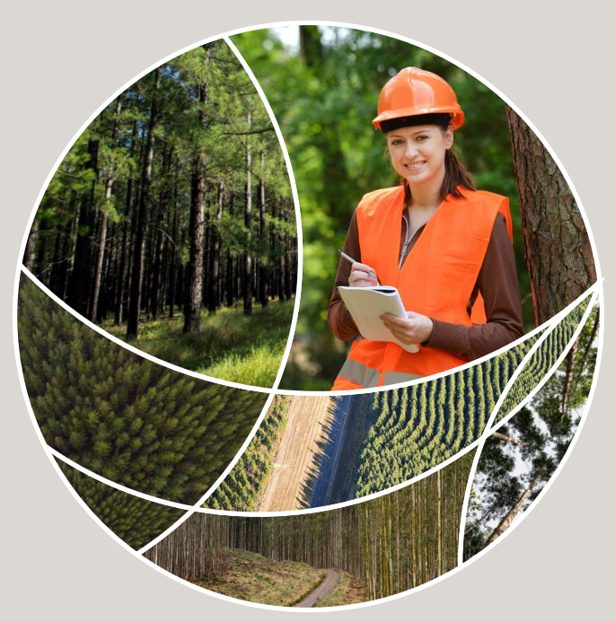

© Commonwealth of Australia 2021
Ownership of intellectual property rights
Unless otherwise noted, copyright (and any other intellectual property rights) in this publication is owned by the Commonwealth of Australia (referred to as the Commonwealth).
Creative Commons licence
All material in this publication is licensed under a Creative Commons Attribution 4.0 International Licence except content supplied by third parties, logos and the Commonwealth Coat of Arms.
Inquiries about the licence and any use of this document should be emailed to copyright@awe.gov.au.

Cataloguing data
This publication (and any material sourced from it) should be attributed as: Department of Agriculture, Water and the Environment 2021,
National Forest Industries Plan—implementation, election commitments and other measures
ISBN 978-1-76003-469-6
This publication is available at agriculture.gov.au/forestry/national-forest-industries-plan
Department of Agriculture, Water and the Environment
GPO Box 858 Canberra ACT 2601
Telephone 1800 900 090
Web awe.gov.au
Disclaimer
The Australian Government acting through the Department of Agriculture, Water and the Environment has exercised due care and skill in preparing and compiling the information and data in this publication. Notwithstanding, the Department of Agriculture, Water and the Environment, its employees and advisers disclaim all liability, including liability for negligence and for any loss, damage, injury, expense or cost incurred by any person as a result of accessing, using or relying on any of the information or data in this publication to the maximum extent permitted by law.

Contents
Summary 4
1 Regional forestry hubs 6
1.1 Reducing barriers to forestry expansion 8
1.2 Using our forest resources smarter 9
1.3 Growing community understanding of forestry 12
2 The Plan and Other measures 16
2.1 Regional Forestry Hubs 16
2.2 Reducing barriers to forestry expansion 17
2.3 Using our forest resources smarter 18
2.4 Growing community uinderstanding of forestry 19
2.5 Additional measures since the Plan was announced (Bushfire measures and Budget measures) 20

Summary
The National Forest Industries Plan was launched in 2018 to support the forest industries to:
- meet the challenges of the future
- underpin growth in the renewable timber and wood-fibre industries
- innovate and use our forest resources smarter
- assist industry to realise its ambition to plant a billion new plantation trees during the decade to 2030.
The plan reinforced the Australian Government’s commitment to securing a strong, sustainable forestry industry. It outlined a suite of key actions that:
- lay the foundations for the industry to grow
- assist with strategic planning in key forestry regions
- help to reduce barriers to investment.
It was developed by listening to the industry’s advice and responding to its needs.
The Australian Government remains committed to the plan and its core aims. This progress report shows the government has now delivered, or will deliver shortly, most of the actions identified in the plan, as well as additional measures announced after its release in 2018.
The Australian Government is also exploring areas where additional effort may be needed to continue to deliver on the goals of the plan and take it to the next stage. This includes engagement with state and territory governments and industry to understand the actions they are undertaking to deliver on the aims of the plan, and opportunities for partnerships and collaboration.

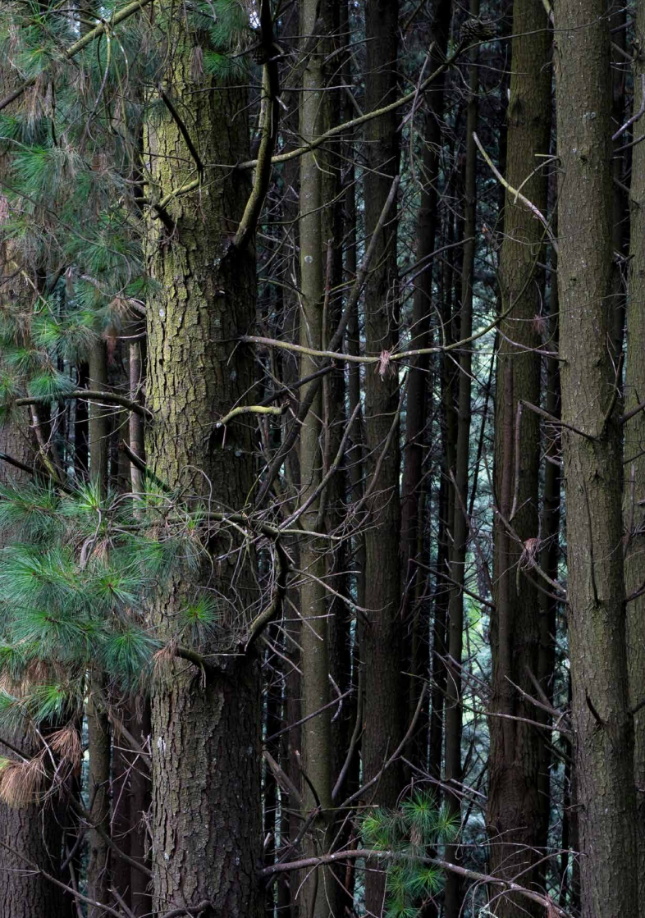

Regional forestry hubs
Actions
- Piloting the creation of a regional forestry hub, followed by the roll out to other regions across the country.
- Working with industry, state and local governments, other key stakeholders, and the community to assess the production forestry resources and processing capacity and infrastructure needs and limitations in key regional forestry hubs.
- Working with industry and state governments to allow regional forestry hubs to maximise their capacity to accommodate plantation expansion in the right places.
Progress
Delivered.
The locations for the 9 regional forestry hubs were announced by the Prime Minister on
16 February 2019. They are:
- north-east New South Wales (NSW)
- south-west slopes (New South Wales and north-east Victoria)
- central west NSW
- Gippsland, Victoria
- Green Triangle, (South Australia and south-west Victoria)
- south and central Queensland
- north Queensland
- south-west Western Australia
- northern Tasmania (later expanded to entire state).
Allocations to date total $9.2 million, with an additional $10.6 million provided in the 2021–22 Budget to extend the existing 9 hubs and create 2 new hubs in the Northern Territory and Eden NSW. This will bring total funding to $19.8 million.

Some of the tangible outcomes from the hubs include:
- a financial model to help landowners compare the impact of a tree-growing enterprise on their overall farm financial position
- trialled different methods for extracting logging residues from harvest sites—showing the best ways to reduce site preparation costs
- markets found for WA forest harvest residue – these can now be sold rather than burnt on site which reduces smoke taint on nearby agricultural commodities
- in the Green Triangle, undertaken comprehensive scientific water research to support increased allocation for forestry
- delivery of new training outcome for industry that is attracting new state government funding
- advising farmers on land access and land use policy for plantation forest investment.
Actions
- Undertaking an inventory of farm forestry resources on private land to determine their potential to supply wood for the processing sectors.
Progress
Inventory of farm forestry resources on private land to be delivered by end 2021 Delivered.
The Australian Bureau of Agricultural and Resource Economics and Sciences (ABARES) is mapping and modelling private and Indigenous farm forestry resources, to determine their extent and the role they could play in providing additional resource for wood processing. Total allocations are $0.98 million.
Actions
- Working with states/ territories and industry to help farmers explore opportunities for:
  - expanding farm forestry
  - creating future wood and fibre supplies, improving linkages with the forestry industries, increasing economic returns for farmers.
Progress
Farm forestry strategy to be delivered by end 2021
Delivered.
A National Farm Forestry Strategy is being developed for endorsement by Australian, state and territory forestry ministers in November 2021.
Farm forestry projects to begin to be delivered by end 2021
Delivered.
Proposals seeking funding for farm forestry, private native forestry and Indigenous forestry projects to be delivered through the states and territories are being assessed with $3.5 million to be allocated.
Actions
- Working with state/territory governments, private native forest owners and interested Indigenous communities to unlock potential timber supply, and to deliver economic returns to landowners.
Progress
Online guidance materials to be delivered by 30 May 2022
Delivered.
Online guidance materials are to be delivered by Forests and Wood Products Australia to encourage increased wood supply and diversify landholder income streams to support farm forestry and the use of existing forest resources on Indigenous owned and managed land, and privately owned land with $0.5 million allocated.

Reducing barriers to forestry expansion

Actions
- Undertaking a review of the water requirements in the Emissions Reduction Fund (ERF) farm forestry and plantation methodologies to enable forestry to fully participate in the ERF.
Progress
Amendments to the Emissions Reduction Fund water rule delivered in April 2020
Delivered.
Starting on 4 April 2020, the ERF water requirements were amended to include provisions that tree planting (including plantations and farm forestry) can be eligible for carbon credits:
- if the project is in an area that receives more than 600mm of rainfall
- where the planting of trees is unlikely to have a material adverse impact on the availability of water.
Applying the ERF changes to regional forestry hubs is ongoing
Delivered.
The changes apply initially to 5 regional forestry hubs:
- south-east Western Australia
- Green Triangle (south-east South Australian part only)
- north/north-east Tasmania
- north-east New South Wales
- south-west slopes (New South Wales and into Victoria).
This has significantly increased the areas in which plantations can earn additional income from carbon credits.
Assessments are underway for the rest of the hubs.
Action
- Reviewing other legislation, policies and processes that may be unintentionally restricting plantation expansion.
Progress
Industry representatives and state and territory governments have been invited to nominate existing legislation, policies and processes that are unintentionally acting as barriers to plantation expansion. While to date, none have been identified, we are encouraging industry and jurisdictions to continue to explore what might be needed.

Using our forest resources smarter

Actions
- Develop at least 2 additional research centres of the National Institute for Forest Products Innovation (NIFPI), in partnership with states and industry.
Progress
Partially Delivered.
A new NIFPI centre in Gippsland, Victoria was established in 2020. $2 million has been allocated (Cwlth) and $2 million from the Victorian Government and to date $2.075 million industry co-funding.
For the original Mount Gambier and Launceston NIFPI centres
$2 million each has been allocated (Cwlth), matched funding $2 million Tasmanian Government, $2 million South Australian Government and $10.5 million in industry
co-funding.

Some of the research undertaken to date includes:
- developing structurally reliable glue laminated products from fibre-managed plantation hardwood logs
- Implementation of single-step genomic selection of eucalypts—to improve tree breeding
- Eagle-eye—applying the internet of things to landscape scale Wedge-tailed eagle management
- sensing technology and digital tools to support decision making in hardwood timber drying
- installing state-of-the-art hyperspectral and thermal sensors on light aircraft for detecting nutrient deficiencies and stress in radiata pine plantations
- preparing a feasibility and cost benefit study for innovative forest fire detection technological solutions and optimising forest fire controlling decision making.
The Australian Government continues to engage in positive discussions with the states regarding establishing a second new centre, with the expectation that the state will match the Australian Government’s funding. We welcome the interest of state governments willing to provide this matched funding.
Actions
- Establish a National Steering Committee to oversee the NIFPI centres to:
  - provide national coordination and guidance
  - enable the nodes to move towards specialisation in priority areas for industry, such as bio-products, hardwood, softwood plantation and social license.
Progress
On hold.
National coordination and guidance services for the current NIFPIs are being provided by Forest and Wood Products Australia (FWPA). At the request of industry and in partnership with them, the 2021–22 Federal Budget provided $1.3 million for an Australia-wide NIFPI feasibility study.
This feasibility study will include an assessment of the need for, and potential make-up of, a national steering committee. The feasibility study is expected to report to government late in 2021. Its findings will inform further implementation of this action.
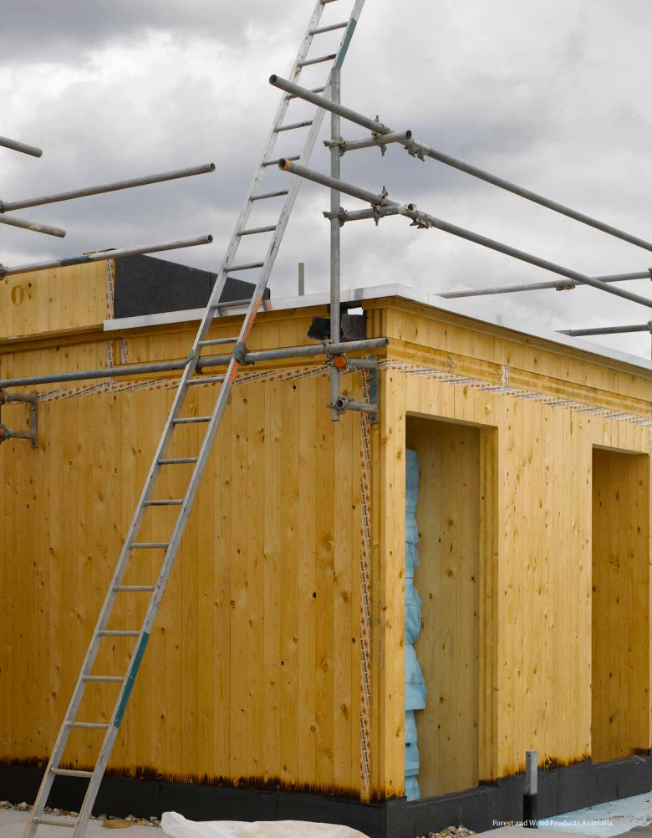
Actions
- Work with Forest and Wood Products Australia to support ongoing research, development and extension activities associated with the forestry industries.
Progress
Ongoing.
FWPA funding for its research, development, extension and marketing programs on behalf of the industry totalled some $12 million in 2019-20, of which some $4.4 million was co-contributed by the Australian Government. The Australian Government continues to work closely with FWPA and industry on ongoing research needs and extension needs.
Examples of projects supported by FWPA include:
- processing pruned Eucalyptus nitens plantation logs to produce high-value sawn and veneer products
- characterising and managing fire risks to plantations under changing climates
- preparing guidelines for salvage harvest, storage and processing of plantation-grown logs affected by fire
- the development and implementation of building specifications to encourage high-rise timber buildings
- the ‘The Ultimate Renewable™’ marketing and branding campaign
- improving the productivity of the private native forest resource in southern Queensland and northern New South Wales.
Actions
- Support forestry education at secondary and tertiary levels and encourage education institutions to promote further uptake of forestry-related courses.
Progress
In progress.
FWPA has been provided with $0.2 million to undertake 2 education activities:
The 2021 National University Wood Challenge
  - Supporting small teams of university students and academics to discover innovative ideas for using wood to produce new sustainable everyday products.
  - On 25 August 2021, 4 finalists were announced, and each is being awarded $20,000 to further develop and/or test their ideas over the following 3 months.
  - A final judging will occur in late November 2021, with the winner awarded a further $10,000 to continue to develop their idea.
- Further development and expansion of virtual reality experiences related to forestry, ForestVR.
  - The development of the virtual reality toolkit for schools showcases various forest environments and processing mills for forest products, see forestlearning.edu.au/forestvr.
  - Content includes information about the renewable cycle for forest and wood products and is expected to be completed by 31 October 2021.

Growing community understanding of forestry

Actions
- Working with industry to ensure it meets community expectations and engages with a broad range of stakeholders in a manner that builds trust and confidence.
Progress
Ongoing.
The regional forestry hubs continue to undertake extensive consultations within each of their regions with a range of community stakeholders to:
- determine the priorities for each region
- build understanding of values of the work of the industry.
The Australian Government, in partnership with participating states and industry, engaged a consultant to build understanding of the values and benefits of Australia’s forest industries by developing shared communications tools and conducting workshops with regional industry stakeholders. The Australian Government’s funding contribution was $88,000 (including GST).
A suite of videos focused on sustainability, economic and social benefits of the industry, innovation and technology, and highlighting wood as the ultimate renewable were released in September 2019 at a cost of $86,250.
Actions
Reporting on the management of Australia’s forests and forest industries through the State of the Forests reports.
Progress
Delivered.
Australia’s State of the Forests Report 2018 was published on 16 February 2019 and is available at agriculture.gov.au/abares/forestsaustralia/sofr/sofr-2018.
The next report in this series is scheduled to be released in 2023.
Actions
Reporting on the management of native forests in the Regional Forest Agreements (RFAs) regions every 5 years.
Progress
Ongoing.
Reporting on the implementation of Regional Forest Agreements is ongoing. The extended RFAs contain improved assurance mechanisms, including more outcome-focused 5 yearly reviews to monitor performance.
There are annual meetings between Australian and state government officials to monitor the implementation of the RFAs.
Since the release of the plan, the Australian Government has continued to support the forest industry to grow through a range of associated actions. These include actions to support the industry to respond to the bushfires and to continue to grow the plantation estate.
Action
After the 2019-2020 Black Summer bushfires, the government provided $65 million in targeted support to help forest industries, and the regional communities that rely on them, in fire damaged areas.
Progress
Delivered.
$40 million Forestry Recovery Development Fund Program. The Government has awarded grants to 14 businesses affected by the 2019-20 bushfires. The program is helping to drive efficiency by supporting business to develop new processing lines and invest in upgraded technology and new facilities. The program is delivering grants of between $1 million and $5 million to privately owned wood processing facilities that were directly or indirectly impacted by the 2019-20 bushfires.
For example, Australian Sustainable Hardwoods Pty Ltd have been awarded over $1.18 million to build a new manufacturing line for pine columns and beams. The new plant will be the first of its kind in Australia, enabling Australian Sustainable Hardwoods to manufacture columns and beams for multi-story commercial and residential buildings. Australian Sustainable Hardwoods has estimated that this investment will enable them to retain around 100 manufacturing jobs and create an additional 21 full time positions.
Delivered.
$10 million Salvage Log Storage Fund provided through the COVID-19 Relief and Recovery Fund, to establish storage facilities for fire-affected salvage logs and wood products in NSW and Victoria during the COVID-19 pandemic. The program supported the storage of more than 700,000 tonnes of timber, providing certainty to mills and helping them plan their long-term recovery.
Delivered.
$15 million Salvage Log Transport Assistance to support NSW and Victorian industry to transport salvaged timber to mills that have the capacity to process it before it degrades. The government has helped the forestry industry deal with the increased costs of transporting salvaged burnt logs to surviving timber mills or storage sites. The program has supported the transport of more than 944,000 tonnes of salvaged timber.
Actions
The Australian Government committed $37.5 million in the 2021-22 Budget for the loans to be offered through the Regional Investment Corporation.
Progress
In Progress.
$37.5 million Plantation Development Concessional Loans were an election commitment and are expected to begin in 2021. They will focus on encouraging new plantation developments and the replanting of bushfire-damaged plantations. The loans support the objectives of the National Forest Industries Plan, the forest sector’s long-term goals, regional economies dependent on the sector and affected by the 2019-20 bushfires.
Actions
The Australian Government committed $1.3 million in the 2021-22 Budget for an Australia-wide NIFPI feasibility study.
Progress
In progress.
A contract to progress the Australia-wide $1.3 million NIFPI feasibility study is being developed with the recommended applicant. The finalised study report is scheduled to be provided to government in late 2021.
Actions
Construction Softwood Transport Assistance Program.
Progress
In progress.
The $15.1 million program will support the transportation of wood salvaged from fire affected plantations to mills with immediate spare processing capacity.

The Plan and Other measures
Status (as of 17 September 2021)

Regional Forestry Hubs

Action and Project
Establish Regional Forestry Hubs.
Delivery
The locations for the 9 regional forestry hubs were announced by the Prime Minister on
16 February 2019. They are:
- north-east New South Wales (NSW)
- south-west slopes (New South Wales and north-east Victoria)
- central west NSW
- Gippsland, Victoria
- Green Triangle, (South Australia and south-west Victoria)
- south and central Queensland
- north Queensland
- south-west Western Australia
- northern Tasmania (later expanded to entire state).
Project Status
Delivered (including ongoing).
Action and Project
Inventory of farm forestry resources on private land.
Delivery
The Australian Bureau of Agricultural and Resource Economics and Sciences (ABARES) is mapping and modelling private and Indigenous farm forestry resources, to determine their extent and the role they could play in providing additional resource for wood processing.
Project Status
On track working to schedule.
Action and Project
Farm forestry strategy.

Delivery
A National Farm Forestry Strategy is being developed for endorsement by Australian, state and territory forestry ministers.
Project Status
On track working to schedule.
Action and Project
Farm forestry projects.
Delivery
Proposals seeking funding for farm forestry, private native forestry and Indigenous forestry projects to be delivered through the states and territories are being assessed with funding to be allocated.
Project Status
On track working to schedule.
Action and Project
Online guidance materials.
Delivery
Online guidance materials are to be delivered by Forests and Wood Products Australia to encourage increased wood supply and diversify landholder income streams to support farm forestry and the use of existing forest resources on Indigenous owned and managed land, and privately owned land.
Project Status
On track working to schedule.

Reducing barriers to forestry expansion

Action and Project
Amendments to the Emissions Reduction Fund (ERF) water rule.
Delivery
Starting on 4 April 2020, the ERF water requirements were amended to include provisions that tree planting (including plantations and farm forestry) can be eligible for carbon credits:
- if the project is in an area that receives more than 600mm of rainfall
- where the planting of trees is unlikely to have a material adverse impact on the availability of water.
Project Status
Delivered (including ongoing).
Action and Project
Applying the ERF changes to regional forestry hubs.
Delivery
The changes apply initially to 5 regional forestry hubs south-east Western Australia, Green Triangle (south-east South Australian part only) north/north-east Tasmania, north-east New South Wales south-west slopes (New South Wales and into Victoria). Assessments are underway for the rest of the hubs.
Project Status
On track working to schedule.

Using our forest resources smarter

Action and Project
Develop at least 2 additional research centres of the National Institute for Forest Products Innovation (NIFPI).
Delivery
A new NIFPI centre in Gippsland, Victoria was established in 2020, following on from the Mount Gambier and Launceston NIFPI centres.
Project Status
On track working to schedule.
Action and Project
Establish a National Steering Committee to oversee the NIFPI centres.
Delivery
National coordination and guidance services for the current NIFPIs are being provided by Forest and Wood Products Australia (FWPA). At the request of industry and in partnership with them, the 2021–22 Federal Budget provided $1.3 million for an Australia-wide NIFPI feasibility study.
This feasibility study will include an assessment of the need for, and potential make-up of, a national steering committee. Its findings will inform further implementation of this action.
Project Status
On hold.
Action and Project
Work with Forest and Wood Products Australia to support ongoing research, development and extension activities associated with the forestry industries.
Delivery
The Australian Government continues to work closely with FWPA and industry on ongoing research needs and extension needs.
Project Status
Delivered (including ongoing).
Action and Project
Support forestry education at secondary and tertiary levels and encourage education institutions to promote further uptake of forestry-related courses.
Delivery
Two education activities are underway:
- the 2021 National University Wood Challenge
- further development and expansion of virtual reality experiences related to forestry, ForestVR.
Project Status
On track working to schedule.

Growing community uinderstanding of forestry

Action and Project
Working with industry to ensure it meets community expectations and engages with a broad range of stakeholders in a manner that builds trust and confidence.
Delivery
The regional forestry hubs continue to undertake extensive consultations within each of their regions with a range of community stakeholders to:
- determine the priorities for each region
- build understanding of values of the work of the industry
- A suite of communication tools has been developed in partnership with states and industry, as well us conducting workshops with regional industry stakeholders.
Project Status
Delivered (including ongoing).
Action and Project
Reporting on the management of Australia’s forests and forest industries through the State of the Forests reports.
Delivery
Australia’s State of the Forests Report 2018 was published on 16 February 2019 and is available at agriculture.gov.au/abares/forestsaustralia/sofr/sofr-2018.
The next report in this series is scheduled to be released in 2023.
Project Status
Delivered (including ongoing).
Action and Project
Reporting on the management of native forests in the Regional Forest Agreements (RFAs) regions every 5 years.
Delivery
Reporting on the implementation of Regional Forest Agreements is ongoing. The extended RFAs contain improved assurance mechanisms, including more outcome-focused 5 yearly reviews to monitor performance.
Project Status
Delivered (including ongoing).

Additional measures since the Plan was announced (Bushfire measures and Budget measures)

Action and Project
Forest Recovery Development Fund Program.
Delivery
This fund has awarded grants to 14 businesses affected by the 2019-20 bushfires. The program is helping to drive efficiency by supporting business to develop new processing lines and invest in upgraded technology and new facilities.
Project Status
Delivered (including ongoing).
Action and Project
Salvage Log Storage Fund.

Delivery
This fund provided through the COVID-19 Relief and Recovery Fund, to establish storage facilities for fire-affected salvage logs and wood products in NSW and Victoria during the COVID-19 pandemic.
Project Status
Delivered (including ongoing).
Action and Project
Salvage Log Transport Assistance.
Delivery
This assistance has supported NSW and Victorian industry to transport salvaged timber to mills that have the capacity to process it before it degrades.
Project Status
Delivered (including ongoing).
Action and Project
Plantation Development Concessional Loans.
Delivery
The loans will focus on encouraging new plantation developments and the replanting of bushfire-damaged plantations.
Project Status
On track working to schedule.
Action and Project
Australia-wide NIFPI feasibility study.
Delivery
The finalised study report is scheduled to be provided to government in late 2021.
Project Status
On track working to schedule.
Action and Project
Construction Softwood Transport Assistance Program.
Delivery
The $15.1 million program will support the transportation of wood salvaged from fire affected plantations to mills with immediate spare processing capacity.
Project Status
On track working to schedule.

