National Hitchhiker (Contaminating) Plant Pest Action Plan 2022–2032
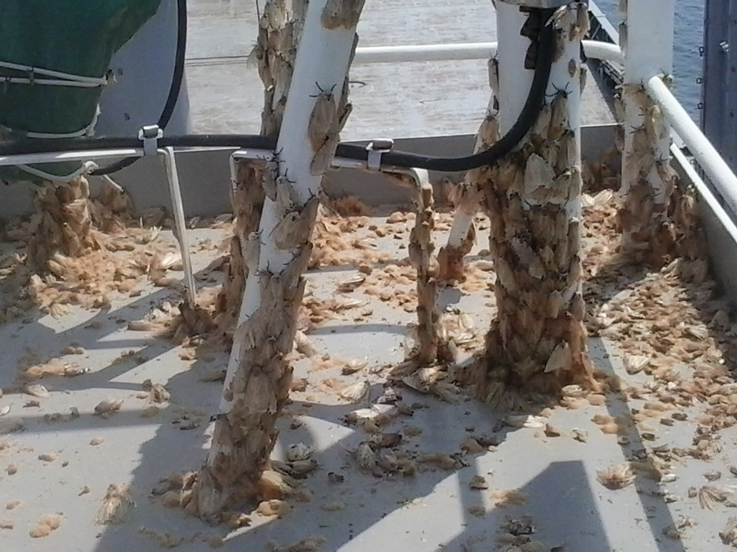

Plant Health Committee

© Commonwealth of Australia 2022
Ownership of intellectual property rights
Unless otherwise noted, copyright (and any other intellectual property rights) in this publication is owned by the Commonwealth of Australia (referred to as the Commonwealth).
Creative Commons licence
All material in this publication is licensed under a Creative Commons Attribution 4.0 International Licence except content supplied by third parties, logos and the Commonwealth Coat of Arms.
Inquiries about the licence and any use of this document should be emailed to copyright@agriculture.gov.au.

Cataloguing data
This publication (and any material sourced from it) should be attributed as: DAFF 2022, National Hitchhiker (Contaminating) Plant Pest Action Plan 2022-2032, Department of Agriculture, Fisheries and Forestry, Canberra, August. CC BY 4.0.
This publication is available at https://www.agriculture.gov.au/biosecurity-trade/pests-diseases-weeds/plant/national-action-plans.
Department of Agriculture, Fisheries and Forestry
GPO Box 858 Canberra ACT 2601
Telephone 1800 900 090
Website agriculture.gov.au
Disclaimer
The Australian Government acting through the Department of Agriculture, Fisheries and Forestry has exercised due care and skill in preparing and compiling the information and data in this publication. Notwithstanding, the Department of Agriculture, Fisheries and Forestry, its employees and advisers disclaim all liability, including liability for negligence and for any loss, damage, injury, expense or cost incurred by any person as a result of accessing, using or relying on any of the information or data in this publication to the maximum extent permitted by law.
Cover page
The image on the cover: Spongy moth (formerly Asian gypsy moth) — no free rides; March 2017. USDA, Animal and Plant Health Inspection Service [Heather Curlett is author of article USDA APHIS | No Free Rides]
Version control
27 Jul 2022 v1.0 Endorsed by Plant Health Committee

Contents
Contents 3
Figures 4
Information box 4
Tables 4
Acknowledgements 5
Executive summary 6
Introduction 7
Box 1 – Characteristics of hitchhiker plant pests (contaminating pests) 7
1. National Hitchhiker (Contaminating) Plant Pest Action Plan 9
1.1 Scope of the plan 9
1.2 Structure of the plan 9
2. National context 15
2.1 Legislation 15
2.2 National arrangements 17
3. Action areas 21
Action area 1: Prevention 21
Action area 2: Detection 26
Action area 3: Response 28
Action area 4: Cross-cutting issues 32
5. Monitoring, evaluation and review 35
6. References 36
7. Acronyms and abbreviations 37
8. Definitions and glossary 37

Figures
Figure 1 – A. Red imported fire ant, large worker; B. Khapra beetle (top) and larva (bottom) on grains of rice 8
Figure 2 – A. Africanised honey bee; B. Honey bee varroa mite 10
Figure 3 – Asian spongy moth 10
Figure 4 – Brown marmorated stink bugs 11
Figure 5 – A. Giant African snail; B. Golden apple snail 11
Figure 6 – Spotted lanternfly 12

Information box
Box 1 – Characteristics of hitchhiker plant pests (contaminating pests) 7

Tables
Table 1 – National Priority Plant Pest Hitchhikers included in this national action plan and existing national action plans 13
Table 2 – Biosecurity legislation relevant to the management of risks associated with hitchhiker pests 15
Table 3 – Peak plant industry bodies that have identified a hitchhiker NPPP as a High Priority Pest 18
Table 4 – Hitchhiker pests that have been categorised as Emergency Plant Pests under the EPPRD 20
Table 5 – Summary table of Action Area 1: Prevention 26
Table 6 – Summary table of Action Area 2: Detection 28
Table 7 – Summary table of Action Area 3: Response 32
Table 8 – Summary table of Action Area 4: Cross-cutting issues 34

Acknowledgements
The National Hitchhiker (Contaminating) Plant Pest Action Plan has been prepared by the Department of Agriculture, Fisheries and Forestry (DAFF), drawing on input and feedback from a diverse group of experts and stakeholders as well as from public consultation through the Have Your Say platform. The contribution of these people and organisations is acknowledged.
Our particular thanks go to the Hitchhiker Working Group within the Department of Agriculture, Fisheries and Forestry.

Executive summary
A hitchhiker (or contaminating) pest is carried by a commodity, packaging, conveyance or container, or is present in a storage place and, in the case of plants and plant products, does not infest them (International Plant Protection Convention 2010). The challenge for Australia in managing hitchhiker pests is increasing because of greater global trade and concurrent movement of pests and diseases around the world. Many other countries may not prioritise preventive measures to stop spread through trade because certain pests may be endemic or not pose as great a risk to them as they do to Australia (Inspector-General Biosecurity 2018).
The National Hitchhiker (Contaminating) Plant Pest Action Plan 2022–2032 sets out actions designed to enhance Australia’s capacity to prevent the introduction of hitchhiker plant pests, and to prepare for a response should they be detected in Australia, as part of a national approach. This plan focuses on six hitchhiking plant pests and five of these are National Priority Plant Pests. Further detail is provided under the pests in scope of this plan section. Actions under this plan have been divided into four areas: prevention; detection; response; and cross-cutting issues. This plan along with other preparedness national action plans will align with broader strategies such as the National Biosecurity Strategy.
A holistic approach is needed to manage the risk of hitchhikers by addressing critical points along the supply chain. This reduces reliance on any one biosecurity measure and assists identification of some of the core biosecurity activities to prevent and prepare for hitchhiker pests should they be detected in Australia. It will also validate the actions proposed in this plan.
The success of the plan is dependent on a high level of cooperation and collaboration between all levels of government, non-government organisations, industries, the general public, experts and research agencies. The plan is supported by an implementation schedule which will be used to: record the progress of actions; set out roles, responsibilities and proposed funding; and communicate with stakeholders on progress as well as their roles in the implementation of the plan.
Plant Health Committee, as the relevant national committee for plant biosecurity has endorsed the plan. Its Plant Biosecurity Preparedness Working Group (or similar) will formally oversee the implementation of the plan on behalf of states and territories. Progress of actions will depend on their priority, whether they are business-as-usual, or if resources can be identified and committed to address them. Relevant research and development corporations, relevant industry bodies, the Plant Biosecurity Research Initiative, and other research and development forums will be encouraged or used to promote opportunities for research and development to address gaps in our knowledge of hitchhiker plant pests.
The plan will be reviewed at an annual forum with a formal review after five years, or as determined by the Plant Health Committee. The forum will include representatives from governments and industry. The actions set out in the plan will evolve as knowledge is gained through local and overseas’ experience and research.
The plan is complemented by a range of the department’s other activities that are in progress, such as urgent actions being implemented to address the risks of khapra beetle entering Australia both on plant products, which are known hosts, and as a hitchhiker pest in sea containers, and work undertaken as part of the already published:
- National Invasive Ant Biosecurity Plan 2018–2028
- National Khapra Beetle Action Plan 2021–2031
- National Priority List of Exotic Environmental Pests, Weeds and Diseases: Implementation Plan.

Introduction
Australia has strong measures in place to prevent the entry, establishment and spread of pests and diseases that could threaten our economy, environment or human health. Goods, conveyances and travellers entering Australia are subject to biosecurity measures.
However, pests and diseases may also travel as hitchhiker (contaminating) pests:
- opportunistically on ships and aircraft, on and in sea and air containers, within containerised goods (regardless of the goods being imported), even within travellers’ luggage where they may or may not be associated with food items.
- on general, non-containerised (break-bulk) cargo such as cars, tyres or machinery (that would not otherwise pose any biosecurity risk).
This National Hitchhiker (Contaminating) Plant Pest Action Plan 2022–2032 will guide the implementation of nationally-agreed actions for a strategic and risk-based approach to prevent the entry of these pests and enhance our ability to respond to a detection of a hitchhiker plant pest. These actions are linked to broader biosecurity strategies and implementation of these actions will support these strategies. The plan recognises that there are many unknowns regarding the potential impact of some hitchhiker pests on the Australian environment and plant industries, but this uncertainty should not delay action. The plan identifies key areas relevant to understanding hitchhiker plant pests, poses a series of questions to take into consideration when determining the best response approach, and identifies key activities to be undertaken in progressing these actions. Box 1 outlines the characteristics of hitchhiker plant pests, highlighting the threat to Australia.
Box 1 – Characteristics of hitchhiker plant pests (contaminating pests)
Hitchhiker pests:
- may be carried by a good, packaging, conveyance or container, or be present in a storage place — some plant pests such as khapra beetle can both be a hitchhiker and infest goods
- often have a cryptic nature that enables them to hide and make detection challenging
- spread globally into new areas through human-assisted transportation
- can remain undetected for long periods of time allowing them to survive in transit, enter new countries, establish and spread
- may be able to emerge from hibernation and may also move onto clean cargo during its transport
- have the potential to have significant impacts totalling millions of dollars annually to plant industries, and unquantifiable impacts on communities and the environment
- could be challenging to eradicate given some species’ potentially wide host range.
Since the mid-20th century, increased income growth owing to globalisation has strongly correlated with increasing prevalence of invasive species in both island and continental countries (Hulme 2009). Advances in supply chain efficiency, along with growing commodity and transport demand, have increased the speed goods can be moved. This has in turn increased the risk that viable hitchhiker pests will arrive at the border and potentially enter, establish and spread. Risks to agriculture and the environment are exacerbated if the goods go to or through rural areas (Inspector-General of Biosecurity 2018).
With growing volumes of trade and increasing complexity of global supply chains, hitchhiker plant pest pathways are growing in significance, especially for sea containers and break-bulk cargo. Climate changes are also influencing the spread of hitchhiker pests.
Protecting plant health is vital to protect Australia’s agriculture, fisheries and forestry production industries, and to boost economic development and protect the environment. This has associated benefits such as supporting food security. Actions to address hitchhiker plant pests will have both production and environmental benefits.
From an environmental perspective, hitchhiker plant pests could jeopardise Australia’s unique fauna and flora and ecosystem services such as pollination, water purification and natural suppression of pests, diseases and weeds. They could also cause considerable cost and disruption to the way of life of all Australians; for example, by damaging infrastructure or rendering public spaces unusable.
In the Agriculture 2030 2021–22 Budget package, over $400 million was committed in new funding to expand investment in safeguarding Australia from exotic pests and diseases. Nationally, significant resources and funds of $96 million have been allocated to 2024-25 in national eradication programs to help manage hitchhiker plant pests arriving in imported cargo.
In 2019 the Plant Health Committee endorsed the National Priority Plant Pests (NPPP), some of which pose a significant risk to enter Australia as hitchhikers. This plan considers six groups of NPPP hitchhiker plant pests as outlined in Table 1. Where an NPPP is also on the Exotic Environmental Pest List (EEPL) this is noted in Table 1. While the plan focuses on these six groups of plant pests or pest vectors (carriers) of plant diseases, the procedures and protocols could be applied to other pests carried across Australian borders that may pose a significant risk to agricultural production or the environment. It is also important to note that the proposed National Pests of Trees and Timber Action Plan includes several NPPP hitchhiker species from the perspective of goods. In relation to tree and timber pests, this plan only addresses the hitchhiker pathway, which includes wood packaging material, which may harbour hitchhikers such as ants and snails.
Similarly, the Environment and Invasives Committee (EIC) endorsed the Exotic Environmental Pest List (EEPL), which includes a set of hitchhiker species. Many hitchhiker species listed in the EEPL are also listed in the NPPP but not all.
Separate plans have been developed for exotic invasive ants (Figure 1A), endorsed by the Environment and Invasives Committee, and for khapra beetle (Figure 1B), endorsed by the Plant Health Committee. These pests are also recognised hitchhiker plant pests.
Figure 1 – A. Red imported fire ant, large worker; B. Khapra beetle (top) and larva (bottom) on grains of rice
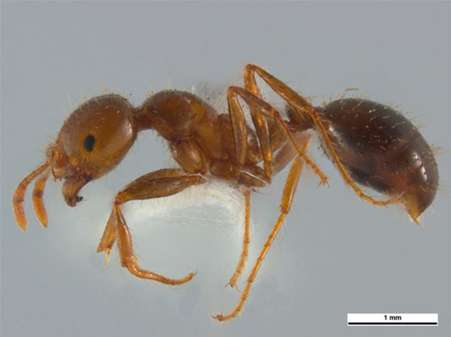
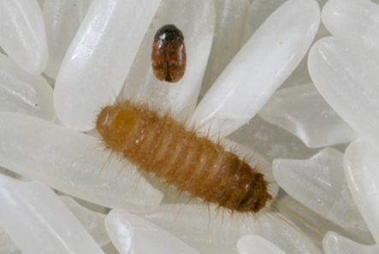
A
B

Source – A. Amy Carmichael, Queensland University of Technology; B. DAFF, Science and Surveillance Group

1. National Hitchhiker (Contaminating) Plant Pest Action Plan

1.1 Scope of the plan
The plan aims to develop preparedness, which is about building national capacity and capability to prevent and prepare for responses to plant biosecurity threats. It does so by describing the priority areas for a national approach across prevention, detection, and response, and setting out specific actions and priorities to improve the management of risks associated with hitchhiker (contaminating) plant pests. As Australia is free of these pests, the plan does not include actions relating to containment and asset-based protection or ongoing management.

1.2 Structure of the plan
The plan first describes the national context for biosecurity risk management in Australia and is then structured into the three priority action areas to address preparedness: prevention, detection, and response, and one additional priority action area for cross-cutting issues. Actions from the cross-cutting priority action area fit into two or more of the key priority action areas and are equally important to reduce risks and threats of hitchhiker plant pests. The final sections describe how the plan will be implemented and how progress will be monitored and evaluated.
Many specific actions provided in the document link to the Australian Biosecurity Act 2015 (Cth). Some actions may relate to Australian legislation or may be important for other reasons. Users of the plan should look to identify and implement, or contribute to, actions they have responsibility for. Priorities for implementation will need to be assessed against current work programs and budgets, and research project funding.
The hitchhiker pest taxa addressed in this plan except for spotted lanternfly are NPPP, first established in 2016 and reviewed in 2019 or could be EEPL species. All NPPP and EEPL are exotic to Australia, under eradication, or have limited distribution. These pests are the focus of government national preparedness capability investment and action, including the development of national action plans. Essentially all of the actions in this plan concurrently address plant and environmental hitchhiker pests, as the work is primarily pathway focussed. Plant and environmental pests diverge to some extent regarding surveillance approaches where there is a heavier emphasis on general surveillance of the environment for environmental pests compared to plant pests.
The Chief Environmental Biosecurity Officer (CEBO) is undertaking other specific work solely focussing on environmental pests, which in conjunction with this action plan, builds capacity and capability regarding environmental biosecurity surveillance and includes the hitchhiker pests.
National action plans for NPPP set out how we prepare for these threats. They identify the capabilities to improve the way we prevent these pests from entering Australia, and to better detect and respond if these pests were to enter Australia. This multi-layered approach to manage the hitchhiker pest risk will consider a range of activities including innovative technology, expanded offshore quality systems, advanced data analytics, supply chain assurance, expanded onshore approved arrangements, awareness material and enhanced electronic system capability.

Pests in scope of this plan
Species listed in Table 1 will be those included in the plan. These species are all NPPP (2019) and may also be an EEPL except for spotted lanternfly (Lycorma delicatula), which is included as an emerging hitchhiker plant pest.
Some of the NPPP included in the plan currently have tailored management measures in place to prevent entry. However, broader actions should be considered, such as progressing container cleanliness, or researching better detection methodologies, diagnostics and response.
Key hitchhiker pests targeted internationally and in Australia include:
- Exotic bees (NPPP 17) such as the Africanised honey bee (also an EEPL), see Figure 2A; and bee pests (NPPP 10) such as the varroa mite (Figure 2B), which could imperil Australia’s honey bee populations and crop pollination.
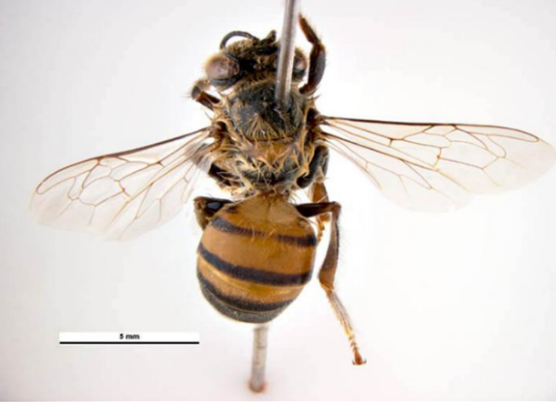
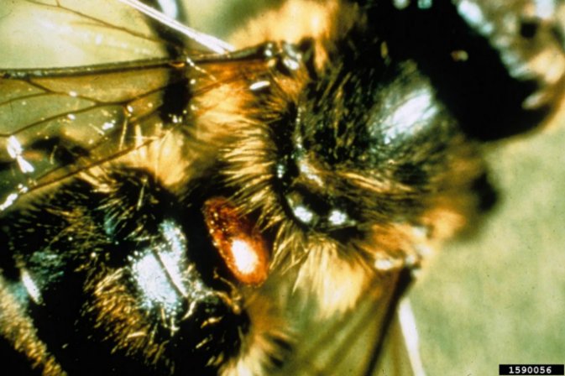
Figure 2 – A. Africanised honey bee; B. Honey bee varroa mite
A
B

Source A. Simon Hinley & Ken Walker, Museums Victoria; B. Georgia Department of Agriculture, Bugwood.org
Seasonal pests subject to targeted surveillance and control measures in Australia include:
- Asian spongy moth (formerly known as Asian gypsy moth, NPPP 8, EEPL), see Figure 3, which has a risk management program with a heightened vessel surveillance window for Asian spongy moth between January and May each year. During this time, vessels that in the previous 24 months have visited Asian spongy moth-regulated areas in East Russia during the moth’s flight season, will be risk assessed to determine the need for a targeted Asian spongy moth inspection on arrival.
Figure 3 – Asian spongy moth
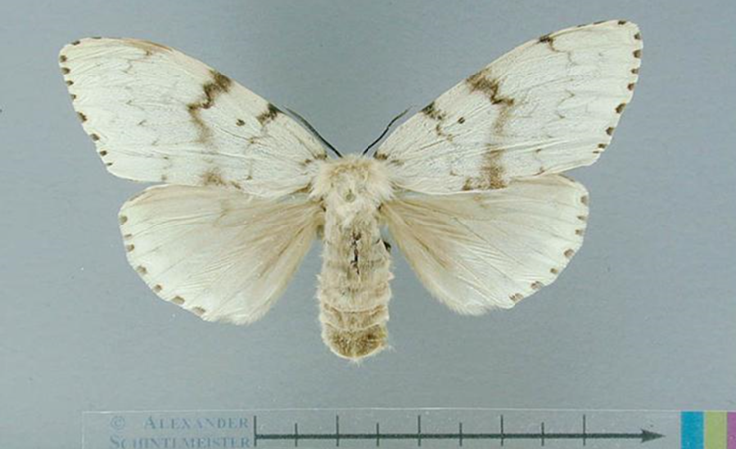
Source – Alexander Schintlmeister, Mission Biosecurity
- Brown marmorated stink bug (BMSB, NPPP 9, EEPL), see Figure 4, detections are being managed under the Strategy to respond to the detection of brown marmorated stink bug (Halyomorpha halys) in association with imported goods and conveyances.
Figure 4 – Brown marmorated stink bugs
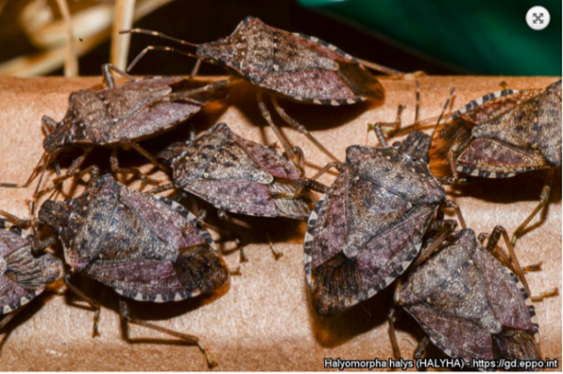
Source – EPPO image
- Giant African snail (included with other exotic snails in NPPP 12, EEPL), see Figure 5A. Sea containers that originate from or tranship through a country that has giant African snails are considered to be high risk and receive an intensive six-sided external inspection on arrival. Other exotic snails which are not necessarily NPPP recently detected at the border include: Acusta despecta Korean round snail; Bulimulus sp.; Carocolina lenticula; Cathaica fasciola, Bradybaenid snail, bush snail; Cepaea hortensis, white-lipped garden snail; Cornu aspersum, common garden snail; Cryptozona siamensis, Siamese common snail; Enidae, bulin snails; Euglandina rosea, rosy wolfsnail; Euhadra sp., land snail; Helix pomatia, Roman snail; Lauria cylindracea, common chrysalis snail; Macrogastra densestriata, door snail; Massylaea vermiculata, chocolate-band snail; Mirus hartmanni; Monacha sp., European invasive snails; Monacha cartusiana; Otala lactea, milk snail; Pomacea canaliculate (EEPL), golden apple snail (Figure 5B); c.f. Quantula striata, dyakiid snail, tropical land snail; Rachis punctata, dusky banded porcelain snail; Succinea sp., amber snails; Trochulus hispidus, hairy snail; Xeropicta krynickii, desert snail; and, Xesta sp., ariophantid snail.
Figure 5 – A. Giant African snail; B. Golden apple snail
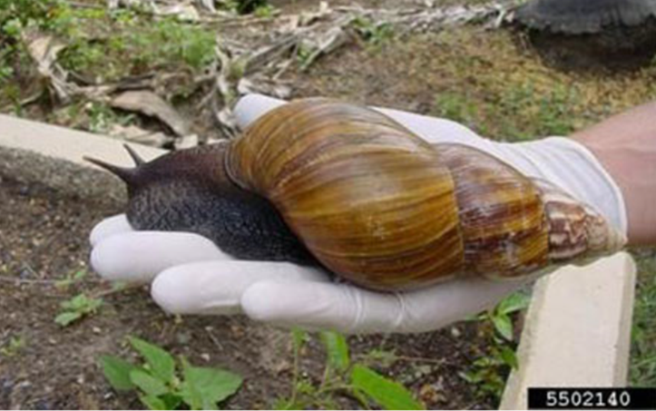
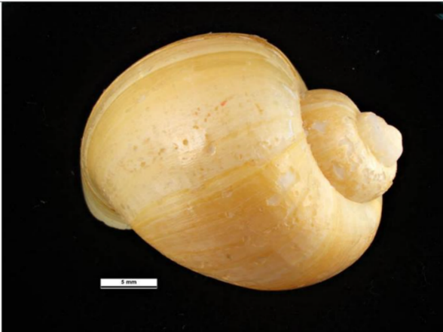
A
B

Source – A. Department of Agriculture, Fisheries and Forestry; B. Ken Walker, Museums Victoria
Another species, which is not a NPPP, has been included in this plan as an emerging hitchhiker pest:
- The spotted lanternfly (Lycorma delicatula, emerging pest), see Figure 6, is an emerging hitchhiker plant pest native to South-East Asia. It has been introduced to Japan, South Korea, Taiwan, Vietnam and the United States (EPPO 2020). It can feed on over 65 species of plants including important agricultural crops like grapes, apples, peaches, plums, blueberries, cherries, basil, apricot, nectarines and walnuts. It also affects maples, oaks, pines and poplar trees. Eggs, juveniles and adults can be on trees and plants and are also found on bricks, stone, metal, and other smooth surfaces as well as vehicles, trailers and people’s clothes. Once established spotted lanternfly can spread short distances by walking, jumping or flying. This pest spreads easily by hitchhiking on vehicles or laying its eggs on almost any flat surface — like the sides of vehicles, railway freight cars and equipment stored outside, manufactured articles, pallets and other timber.
Figure 6 – Spotted lanternfly
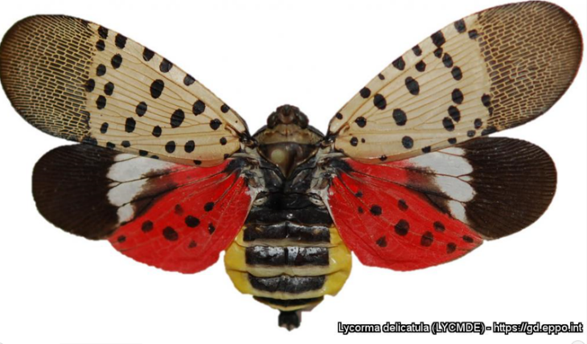
Source – Pennsylvania Department of Agriculture (USA)

Pests out of scope of this plan
This plan excludes National Priority Plant Pests (NPPP) that may rarely be hitchhikers but are nearly always found associated with their respective hosts. These are: spotted wing drosophila (NPPP 3); exotic, economic fruit fly (NPPP 4); leaf miners (NPPP 20); exotic drywood termites (NPPP 25); exotic subterranean termites (NPPP 29); wheat stem sawfly (exotic species) (NPPP 25); hessian fly (Mayetiola spp.) (NPPP 28); and armyworm (exotic species) (NPPP 31).
Khapra beetle (Trogoderma granarium), exotic invasive ants and the glassy winged sharpshooter (Homalodisca vitripennis), an important vector of Xylella fastidiosa, will be excluded from this plan, as these NPPP each have their own specific plans. These are the National Khapra Beetle Action Plan 2021–2031, National Xylella Action Plan 2019–2029; and the National Exotic Invasive Ant Biosecurity Plan 2018–2028 (National action plans for priority plant pests – DAFF).
Other hitchhiker pests not included in this plan, managed through ongoing specific and/or general programs, include:
- invasive vector mosquitoes that carry yellow fever, dengue, chikungunya and Zika viruses
- rats which can carry plague and other serious diseases
- toads like the Asian black-spined toad, which could become as significant a pest as the cane toad
- reptiles which could colonise ecosystems or carry exotic reptile diseases
- weeds and weed seeds
- timber pests including drywood termites/borers and the burnt pine longicorn beetle, Arhopalus ferus (a national action plan on trees and timber pests is under separate development)
- marine pests especially molluscs, carried on ships’ hulls (biofouling) or in ballast water.
Soil, plant seeds, fungal rust spores and Phytophthora spores considered contaminants, not hitchhikers, and are out of scope of this plan.
It is also important to note Plant Health Australia (PHA) has a range of industry specific preparedness plans. Some hitchhiker plant pests in this plan are included in various PHA documents such as fact sheets, contingency plans, Biosecurity Plant plans and business continuity plans.
Table 1 – National Priority Plant Pest Hitchhikers included in this national action plan and existing national action plans
NPPP No. | Pest/  pest group | Scientific name (s) | Common name | EEPL | Notes about the species and risk
1 |  | Homalodisca vitripennis | Glassy-winged sharpshooter (as a vector of Xylella fastidiosa) |  | The H. vitripennis — Xylella fastidiosa combination could potentially have a severe and adverse effect on agricultural industries. Homalodisca vitripennis may irrevocably change the ecology and movement of X. fastidiosa in wilderness areas as this polyphagous insect could expose a variety of native hosts to a pathogen with which these plants have had no evolutionary history.  See the National Xylella Action Plan 2019–2029.
2 |  | Trogoderma granarium | Khapra beetle |  | A serious pest of stored cereal grains and oilseeds causing significant losses.  See the National Khapra Beetle Action Plan 2021–2031.
7 | Exotic invasive ants | Brachyponera chinensis | Asian needle ant |  | Aggressive generalist foragers that occur in high densities and can dominate most potential food sources, out compete native species and may have human health impacts.  See the National Invasive Ant Biosecurity Plan 2018–2028
 |  | Lepisiota frauenfeldi | Browsing ant
 |  | Nylanderia fulva | Tawny crazy ant or raspberry ant
 |  | Solenopsis invicta | Red imported fire ant
 |  | Solenopsis richteri | Black imported fire ant
 |  | Wasmannia auropunctata | Electric ant
8 | Spongy moth | Lymantria dispar asiatica | Asian spongy moth |  | A destructive pest that attacks over 650 species of trees.
 |  | Lymantria dispar dispar | Northern American/ Europe spongy moth
 |  | Lymantria dispar japonica | Japanese spongy moth
 |  | Lymantria monacha | Nun moth, black arches moth
9 |  | Halyomorpha halys | Brown marmorated stink bug |  | A major horticultural, environmental and household pest.
10 | Internal and external mites of bees (Apis spp.) | Acarapis woodi | Tracheal mite (internal) |  | Mites pose a significant risk to Australia’s bees and the pollination services they provide.
 |  | Tropilaelaps clareae | Tropilaelaps mite (external)
 |  | Tropilaelaps mercedesae | Tropilaelaps mite (external)
 |  | Varroa jacobsoni | Varroa mite (external)
 |  | Varroa destructor | Varroa mite (external)
12 | Exotic invasive snails | Achatina fulica | Giant African snail
 |  | Monacha spp. | No common name
 |  | Massylaea spp | No common name
 |  | Pomacea canaliculata | Golden (or channelled) apple snail
 |  | Caracollina lenticula | No common name
17 | Exotic bees (Apis spp.) | Apis cerana (exotic) | Asian honey bee (exotic) |  | Exotic bees (such as the Africanised honey bee) and bee pests (such as the Varroa mite) could severely impact Australia’s honey bee populations and crop pollination.
 |  | Apis dorsata | Giant honey bee
 |  | Apis florea | Dwarf honey bee
 |  | Apis mellifera capensis | Cape honey bee
 |  | Apis mellifera scutellata | African honey bee
 |  | Apis mellifera scutellate (hybrid) | Africanised honey bee
N/A |  | Lycorma delicatula | Spotted lanternfly |  | Feeds on at least 65 species of crops, trees and woody ornamentals.

2. National context
Australia’s biosecurity system operates under Commonwealth, state and territory legislation administered and managed by the respective government agricultural and environmental agencies. These agencies also contribute to early detection, national response arrangements and committees, in collaboration and consultation with industry and other stakeholders.

2.1 Legislation
Legislation relevant to the management of hitchhiker pests, current as at March 2021, is listed in Table 2. Legislative provisions are used to prevent the entry, establishment and spread of hitchhiker plant pests in Australia.
Table 2 – Biosecurity legislation relevant to the management of risks associated with hitchhiker pests
Government | Administering authority | Primary legislation
Commonwealth | Department of Agriculture, Forestry and Fisheries | - Biosecurity Act 2015, except to the extent administered by the Health Minister  - Biosecurity (Consequential Amendments and Transitional Provisions) Act 2015, except to the extent administered by the Health Minister  - Biosecurity Regulation 2016  - Biosecurity (Exposed Conveyances – Exceptions from Biosecurity Control) Determination 2016)  - Biosecurity (Prohibited and Conditionally Non-prohibited Goods) Determination 2016  - Environment Protection and Biodiversity Conservation Act 1999  - Environment Protection and Biosecurity Conservation Regulations 2000
Australian Capital Territory | Environment Planning and Sustainable Development Directorate | - Pest Plants and Animals Act 2005  - Plant Disease Act 2002  - Animal Diseases Act 2005
New South Wales | Department of Primary Industries  Department of Planning, Industry and Environment | - Biosecurity Act 2015  - Biosecurity Regulation 2017  - Biosecurity Order (Permitted Activities) 2019 and other supporting legislation such as Control Orders  - Biological Control Act 1985  - Biodiversity Conservation Act 2016
Northern Territory | Department of Industry, Tourism and Trade | - Plant Health Act 2008  - Plant Health Regulations 2011  - Livestock Act 2008  - Livestock Regulations 2009
Queensland | Department of Agriculture and Fisheries  Department of Environment and Science | - Biosecurity Act 2014  - Biosecurity Regulations 2016  - Environmental Protection Act 1994
South Australia | Department of Primary Industries and Regions | - Plant Health Act 2009
Tasmania | Department of Natural Resources and Environment Tasmania | - Biosecurity Act 2019  - Nature Conservation Act 2002
Victoria | Department of Jobs, Precincts and Regions  Department of Health | - Plant Biosecurity Act 2010  - Agriculture and Veterinary Chemicals (Control of Use) Act 1992  - Public Health and Wellbeing Act 2008  - Livestock Act 2007  - Livestock Regulations 2013
Western Australia | Department of Primary Industries and Regional Development  Department of Water and Environmental Regulation  Department of Biodiversity, Conservation and Attractions | - Biosecurity and Agricultural Management Act 2007  - Biosecurity and Agriculture Management Regulations 2013  - Biosecurity and Agriculture (Identificiation and Movement of Stock and Apiaries) Regulatios 2013  - Biosecurity and Agriculture Management (Quality Assurance and Accrediation) Regulations 2013  - Biosecurity and Agriculture Management (Agriculture Standards) Regulations 2013  - Exotic Diseases of Animals Act 1993  - Environmental Protection Act 1986  - Conservation and Land Management Act 1984

Biosecurity Act 2015 (Cth)
The Biosecurity Act 2015 (Cth) established requirements and regulatory powers that affect how we manage the biosecurity risks associated with goods, travellers and conveyances entering Australia. These powers allow for the biosecurity risks posed by invasive pests, including hitchhiker pests, to be more effectively managed, and complement arrangements with states, territories and industry to support the management of detections. The definition of ‘biosecurity risk’ considers the risk posed to the environment, as well as human, animal and plant health and the economy.
While the focus of the Biosecurity Act is on the Australian border, many of the supporting activities around the border are focused on reducing the biosecurity risk or responding to where unwanted pests and diseases have hitchhiked to Australia on goods, travellers or conveyances. The actions in this plan related to prevention, detection and response all fall under the management of biosecurity risks under the Biosecurity Act.

Commonwealth land managers
In addition to roles specified under the Biosecurity Act, the Australian Government is also responsible for land management in some ports, and also national parks through Parks Australia, the Department of Defence estate, as well as Australia’s external territories.

2.2 National arrangements
Well-established relationships and national arrangements are in place between the Australian, state and territory governments and, where relevant, industry and other stakeholders to coordinate and implement national action on biosecurity issues.

National committees
Australia has established national committees to provide a formal mechanism for developing and coordinating key plant biosecurity policies and procedures to ensure national consistency, and to identify activities to enhance national biosecurity preparedness and response capability.
The National Biosecurity Committee is responsible for driving a national strategic approach to emerging and ongoing biosecurity policy issues across governments. This committee is supported by a number of sectoral committees which provide policy, technical and scientific advice on matters affecting their sectors for all pest and disease risks to terrestrial and aquatic (inland water and marine) animals and plants, and the environment.
Plant Health Committee (PHC) is the peak government plant biosecurity policy and decision-making forum and reports to the National Biosecurity Committee. The PHC is supported by: the Subcommittee on Plant Health Diagnostics; the Subcommittee on National Plant Health Surveillance; the Subcommittee on Domestic Quarantine and Market Access; the Australian Fruit Fly Technical Advisory Subcommittee and the Plant Biosecurity Preparedness Working Group.
The Environment and Invasives Committee (EIC) provides national policy leadership and advice to NBC on the identification, prevention and management of invasive plant, vertebrate and invertebrate species that adversely impact the environment, economy and community. The EIC provides national coordination of environmental biosecurity response and preparedness capability development.

Biosecurity planning and preparedness
Plant Health Australia (PHA) is the national coordinator of the government-industry partnership for plant biosecurity in Australia. The purpose of PHA is for government and industry to have a strong biosecurity partnership that minimises pest impacts on Australia, including in relation to hitchhiker pests, enhances market access and contributes to industry and community sustainability. PHA is the custodian for the Emergency Plant Pest Response Deed (EPPRD) and actively works with plant industries to strengthen their biosecurity capability. Further information is available on the PHA website.
PHA’s plant industry members (39 in October 2021) undertake biosecurity planning to identify the industry’s High Priority Pests (those assessed to pose the greatest risk) and risk mitigation measures. Through this process, 24 plant industries have identified NPPP hitchhiker pests as a High Priority Pest (Table 3).
National environmental pest biosecurity planning and preparedness is coordinated through the department. Environmental pests are included in departmental exercise programs that investigate and develop the role of the Commonwealth in a nationally significant biosecurity emergency response with the aim to improve national preparedness and capability. EEPL hitchhiker pest incursions, may be managed through sector-related emergency response committees and the National Environmental Biosecurity Response Agreement (NEBRA). Work in this action plan will bolster plant and environmental pest response and preparedness.
Table 3 – Peak plant industry bodies that have identified a hitchhiker NPPP as a High Priority Pest
Peak plant industry body | Hitchhiker pest
Almond Board of Australia | Trogoderma granarium (khapra beetle)  Xylella fastidiosa subsp. fastidiosa  Xylella fastidiosa subsp. multiplex⁵  Xylella fastidiosa subsp. piercei⁵
Apple and Pear Australia | Halyomorpha halys (BMSB)  Lymantria dispar (spongy moth)  Lymantria monacha (nun moth)  Tropilaelaps clareae, Tropilaelaps mercedesae (Tropilaelaps mites)  Varroa destructor (Varroa mite)
Australian Banana Growers’ Council | Achatina fulica (giant African snail)
Australian Blueberry Growers’ Association | Homalodisca vitripennis (GWSS)  Xylella fastidiosa subspecies not specified (Xylella)⁵
Australian Forest Products Association | Lymantria dispar (spongy moth)
Australian Grape and Wine | Lycorma delicatula (spotted lanternfly)  Xylella fastidiosa with vector (Xylella)⁵
Australian Processing Tomato Research Council | Achatina fulica (giant African snail)
Australian Table Grape Association | Halyomorpha halys (BMSB)  Lycorma delicatula (spotted lanternfly)  Xylella fastidiosa with vector (Xylella)⁵
Australian Truffle Growers Association | Halyomorpha halys (BMSB)  Lymantria monacha (nun moth)
Australian Walnut Industry Association | Lymantria dispar (Asian and European spongy moth strains)  Trogoderma granarium (khapra beetle)⁴
AUSVEG | Halyomorpha halys (BMSB)  Achatina fulica (giant African snail)
Cherry Growers of Australia | Halyomorpha halys (BMSB)  Homalodisca vitripennis (GWSS)⁷  Xylella fastidiosa subspecies not specified (Xylella)⁵
Chestnuts Australia | Lymantria dispar, (Asian and European spongy moth strains)
Citrus Australia | Homalodisca vitripennis (GWSS)⁷  Xylella fastidiosa subsp. pauca (Xylella)⁵
Dried Fruits Australia | Halyomorpha halys (BMSB)  Lycorma delicatula (spotted lanternfly)
Trogoderma granarium (khapra beetle)
Xylella fastidiosa with vector (Xylella)
Grain Producers Australia | Trogoderma granarium (khapra beetle)⁸
Greenlife Industry Australia | Achatina fulica giant African snail)  Homalodisca vitripennis (GWSS)  Lymantria dispar (Asian spongy moth)  Pomacea canaliculata (golden apple snail)  Xylella fastidiosa subspecies not specified (Xylella)⁹
Hazelnut Growers of Australia | Halyomorpha halys (BMSB)
 | Lymantria dispar, (Asian and European spongy moth strains)
Pistachio Growers’ Association | Lymantria dispar (Asian and European spongy moth strains)  Trogoderma granarium (khapra beetle)⁸
Raspberries and Blackberries Australia | Halyomorpha halys (BMSB)  Homalodisca vitripennis (GWSS)¹⁰  Lymantria dispar (spongy moth)  Xylella fastidiosa subspecies not specified (Xylella)⁹
Ricegrowers' Association of Australia Inc. | Pomacea canaliculata, golden apple snail  Trogoderma granarium (khapra beetle)⁸
Strawberries Australia | Halyomorpha halys (BMSB)
Summerfruit Australia | Halyomorpha halys (BMSB)  Homalodisca vitripennis (GWSS)¹⁰  Lymantria dispar (Asian spongy moths)  Xylella fastidiosa subspecies not specified (Xylella)⁹
The Australian Honey Bee Industry Council | Acarapis woodi (Tracheal mite)  Apis mellifera scutellate (African honey bee and Africanised honey bee)  Apis cerana (Asian honey bee (exotic))  Apis mellifera capensis (Cape honey bee)  Tropilaelaps clareae, Tropilaelaps mercedesae (Tropilaelaps mites)  Varroa destructor, Varroa jacobsoni (Varroa mites)

Emergency response arrangements
All governments and national plant industry body signatories to the EPPRD have agreed that eradication of economically important and nationally significant emergency plant pests should be pursued when it is technically feasible and cost beneficial to do so, and that the costs of eradication, including the potential for owner reimbursement costs for growers are shared across affected parties.
Hitchhiker pests that have been categorised as Emergency Plant Pests under the EPPRD are shown in Table 4. In the event of a detection involving an uncategorised hitchhiker emergency plant pest, cost sharing between affected industry parties and government will commence at 50:50 (Category 3) ratio until the pest is formally categorised.
Table 4 – Hitchhiker pests that have been categorised as Emergency Plant Pests under the EPPRD
Scientific name | Common name | Formal category
Halyomorpha halys | Brown marmorated stink bug | 2
Pomacea canaliculata | Golden apple snail | 2
Trogoderma granarium | Khapra beetle | 2
Varroa destructor | Varroa mite | 3

Under the EPPRD response framework the Consultative Committee on Emergency Plant Pests (CCEPP) is convened in response to a plant biosecurity incident. The CCEPP reports to the National Management Group on plant pest issues in accordance with the EPPRD.
For hitchhiker pests that have environmental impacts they may be considered under the National Environmental Biosecurity Response Agreement (NEBRA). The relevant sectorial committee to provide advice to the National Biosecurity Management Group is the National Biosecurity Management Consultative Committee. These national arrangements apply when responding to a detection of exotic pests and diseases that impact on the environment and our way of life.
Established pests and diseases, or localised eradication programs, are the responsibility of the state or territory government where they are located. These governments may choose to place biosecurity responsibilities on land managers. The Australian Government may assist with the management of established pests and diseases or localised eradication programs where these are affecting or have the potential to affect matters of national interest.

3. Action areas
This section describes a national approach covering the priority biosecurity action areas of prevention, detection and response. It sets out specific actions and priorities to improve the management of risks associated with hitchhiker plant pests. It is the most cost-effective way to prevent entry of a pest. The biosecurity focus for hitchhiker plant pests is on preventing entry into Australia, or early detection linked to a rapid and effective response aiming for eradication.
Specific actions and priorities to improve the management of biosecurity risks associated with hitchhiker plant pests are set out in the plan. Several cross-cutting actions are also identified which are relevant to two or more of the key biosecurity continuum action areas.

Action area 1: Prevention
Prevention is aimed at minimising the likelihood of entry of a new pest into Australia. A risk analysis may be conducted in response to new information about a biosecurity risk and undertaken as either a biosecurity import or non-regulated risk analysis. There are also a range of enforcement mechanisms already to address non-compliance. The prevention actions identified in this area of the plan aim to achieve a better understanding of the biology of the national high priority species that are not yet present in Australia or are under eradication, their potential pathways to Australia, how to minimise the risk of hitchhiker plant pests using the pathways, and resources needed to quickly identify hitchhiker plant pests.
These prevention actions are summarised in Table 5.

Action 1.1: Undertake pest risk assessments for hitchhiker pests, taking into account border interception data
Pest risk assessments are important tools that consider the changing global distribution of pests to ensure that effective risk management measures are implemented to prevent entry of the pests into Australia. This will support appropriate regulation at the Australian border to minimise the risk to a very low level.
We maintain biosecurity controls at the Australian border to prevent the entry, establishment and spread of hitchhiker plant pests. Biosecurity risk consists of two major components: the likelihood of a hitchhiker pest entering, establishing and spreading in Australia from imports; and the consequences should this happen. In the pest risk assessment stage of a pest risk analysis, these two components are combined to give an overall estimate of the risk.
A pest risk assessment aims to ensure that import measures are appropriate to manage the changing risk of each hitchhiker pest. It is important that the risk assessment clearly identifies risks in the import pathway and how or where intervention (for example, commodities/countries, treatment options, pest free areas, systems approach, etc.) should occur. Further information on risk assessments can be found at Plant risk analyses.
Where data and risk assessment indicate legislative changes are needed to address the risk, emergency measures may be required as changes to legislation may take a long time to come into force.
A pest risk assessment has been completed for brown marmorated stink bug, the Final pest risk analysis for brown marmorated stink bug (‘Halyomorpha halys’) (Australian Government 2019). The department are conducting a pest risk assessment of the khapra beetle in response to increasing detections in the sea container pathway. The department is implementing a number of measures for a range of hitchhiker plant pests and will consider publishing risk assessments for other hitchhiking plant pests in the future as risks change.

Action 1.2: Undertake a sea container pathway review to reduce the risk of hitchhiker pests being transported
Recent border detections of khapra beetle in Australia and New Zealand strongly indicate that contaminated shipping containers are a significant biosecurity risk pathway for this pest and other hitchhiking plant pests.
On average, a sea container lasts for about 18 years and is used for four to five trips a year (Inspector-General of Biosecurity 2018). Each container passes through about 13 ports annually. In 2015 there was a worldwide annual throughput of about 679 million 20-foot equivalent units (TEU) (Brockerhoff et al. 2016). The number of containerised freight imports to Australia has grown significantly over the past 10 years. In 2016–17 there were over two million containerised sea freight imports. In 2014 the number was forecast to grow at an average rate of 5.1% for the next 20 years, so that the number of imported containers would reach 9.8 million TEU in 2032–33 compared with 2.5 million TEU in 2012–13 (BITRE 2014). From 2010 to 2017 over 21 million containers arrived in Australia, almost half from China. Sydney and Melbourne received over 72% of container arrivals. (Inspector-General of Biosecurity 2018.)
Assessment of biosecurity risk of these consignments is generally based on country of origin and the destination of the consignment within Australia. Tracing back history of the country of origin is being investigated by the department as it is currently a manual process and relies on voluntary industry information.
The department have introduced a range of urgent measures to address the risk of the hitchhiker sea container pathway for khapra beetle. This includes targeting at risk sea containers with mandatory offshore treatment prior to arrival in Australia. Options available include treating containers with heat for a specified time, fumigating with methyl bromide and spraying surfaces of the sea container with insecticide prior to loading. Targeted risk containers are: FCL/FCX containers carrying high-risk plant products packed in a khapra beetle target risk country; and FCL/FCX containers packed with other goods in a khapra beetle target risk country and destined to be delivered to a rural khapra risk area of Australia. It is important to consider similar measures when assessing the risk of other hitchhiker plant pests.
Empty sea containers being imported also pose a risk with some hitchhiker species, such as khapra beetle, being found under the floor lining. It is important to also consider measures for empty containers.

Action 1.3: Assess whether current random verification requirements for air freight containers will effectively manage the emerging biosecurity risks associated with this pathway
The air freight container pathway is considered low-risk for hitchhiker plant pests (but not for some other pests such as mosquitoes) and further analysis is required to determine if verification provisions are adequate to address the risk of hitchhiker pests.
Analysis of the air freight container Unit Load Device (ULD) random verification data for the period from 2015 to 2018 indicates an average non-compliance rate of 2.7%, with contaminants (soil, plant and animal material) accounting for more than 90.0% of the non-compliance. The majority of the ULDs (almost all baggage ULDs) do not leave airside, so the risks posed by any contaminants associated with air containers is very low. An assessment will check that current random verification requirements remain adequate for the hitchhiker pathway.

Action 1.4: The Cargo Compliance Verification program can be used to inform the biosecurity risk profile for hitchhiker pests
Cargo Compliance Verification is an important tool, which can be used to provide evidence of the robustness of the findings of the pest risk profile.
Sea containers arriving in Australia are risk assessed. Containers, goods and non-commodity that are assessed to have very low or negligible risk of carrying exotic pests are allowed to enter Australia without further intervention. Around 90% of the estimated three million 20-foot equivalent shipping containers that arrived in Australia in 2017–18 entered without further intervention. Random verification inspections are undertaken by the Cargo Compliance Verification (CCV) program for about 0.5% of consignments to monitor that the biosecurity import controls are operating effectively for the full container load (FCL) containerised sea cargo pathway.
These verification inspections are applied to consignments that would not normally be directed for inspection or treatment. Biosecurity officers will look for biosecurity risk material — contamination with soil, animal or plant material — and also check the paperwork presented for the consignment. The commodity and packing materials will be inspected, as well as the cleanliness of the internal and external surfaces of the container (Department of Agriculture, Water and the Environment 2020).
In order to increase the efficiency of biosecurity investment and to identify opportunities for improvement, the contribution of each activity and control measure towards biosecurity effectiveness needs to be reviewed annually. Feedback loops need to leverage the information available from CCV inspection result data to improve system performance. Policy areas can consider this data to review performance of biosecurity controls, for example, documentation for container cleanliness.
The verification program can be leveraged for enhanced data collection to inform the department’s policy decisions. An example of this is where the verification program was used to provide data on khapra beetle as a hitchhiker causing contamination of containers. A trial was conducted using enhanced sampling by vacuuming to collect air and dust inside the empty container at the completion of each verification inspection.

Action 1.5: Analysis of critical control points on the container pathway considering changes in known hitchhiker pest distribution
Critical control points in the import pathway include the systems in place in the exporting business, any export certification, import conditions including treatments, and verification inspections.
The major challenge of preparing for hitchhiker pests is that they can arrive on non-repeatable pathways. The department has successfully managed an increased number of khapra beetle detections at the border since 2020, the majority in imported non-host material goods that in the past have been categorised as low risk. For example, one of these detections was in a container of white goods and another in a consignment of highchairs, both imported by major retailers. Some of these detections have also been from countries not known to have khapra beetle. Tracing of goods is undertaken by the department if hitchhiking pests are found in imported goods (including break bulk commodities).
Critical control points are vital to effectively manage these non-repeatable pathways. A critical control point is an activity, procedure or process where control can be applied to hazards that represent high risks. Identification of a critical control point considers the hazards present in a particular system. Hazards that represent a high risk should be controlled at one or more critical control points to give a more robust layered approach to biosecurity. One critical control point may effectively control more than one biosecurity risk.
Action is also required to determine changes in known worldwide plant pest distribution. This will also influence critical control points and the number of pathways. Climatic changes have caused the worldwide distribution of plant insects and diseases to change over time. It is important to consider extensions to distribution to another country when analysing control points along the container pathway.

Action 1.6: Consider stronger measures associated with Approved Arrangements and First Points of Entry
Information on movement of containers from likely source ports or containing known host commodities from pack/unpack sites under Approved Arrangements, and volumes and destinations would be valuable to increase the possibility of early detection for post border surveillance and avoid having to undertake a response.
Responses at Approved Arrangements/First Points of Entry require liaison with Approved Arrangement/First Point of Entry staff and governments, as well as delimiting surveillance, treatment (if appropriate) and situation reporting. For responses on Commonwealth managed land (e.g. premises within regulatory control under the Biosecurity Act 2015 (Cth) or restricted premises managed by other Australian Government agencies), the department will lead response operations, including preparation of response plans (including treatment and/or surveillance plans). If there is a perceived risk of spread outside of the imported goods the response may involve consultation with the Consultative Committee on Emergency Plant Pests (if the Incident has been notified under the EPPRD) or the National Biosecurity Management Consultative Committee (if the Incident has been notified under the NEBRA). This process also entails targeted and general surveillance of First Points of Entry and Approved Arrangements as well as in the surrounding environment.
The project ‘Pilot prophylactic baiting for exotic invasive ants at high-risk sites’ aims to support implementation of the National Biosecurity Invasive Ant Plan 2018–2028 — Action 2.9. This pilot project — using potential treatment options for exotic invasive ants at several potentially high-risk sites — will test the hypothesis that effective baiting programs for invasive ants at First Points of Entry and Approved Arrangements reduce the likelihood of establishment and spread. Similar baiting programs should be considered for other invertebrate hitchhiker pests.

Action 1.7: Support an international shipping container hygiene standard and container cleanliness in general
Support development of an international standard for phytosanitary measures for shipping containers will reduce hitchhiker risks associated with shipping containers.
Contaminated shipping containers are a significant biosecurity risk pathway with improved container hygiene needed to address biosecurity risks. The knowledge we now have about the risk presented by hitchhikers such as khapra beetle, means that there are some critical areas such as hygiene of shipping containers that need to be addressed.
We are currently undertaking urgent activities to address the risk of khapra beetle hitchhiking in shipping containers. These activities improve shipping container cleanliness, treatment and tracking, which is also likely to improve the overall risk management of other hitchhiker plant pests.
Australia is engaging in national and international joint phytosanitary initiatives as a matter of priority. The Commission of Phytosanitary Measures (CPM) of the International Plant Protection Convention (IPPC) has indicated a desire to create more commodity class and conveyance-specific phytosanitary standards to supplement the existing suite of phytosanitary standards. Such standards have international benefits, particularly where there are generic phytosanitary risks and also widely accepted international phytosanitary measures. In recent years, the development of a phytosanitary standard for shipping containers has been on the agenda for the IPPC’s Standards Committee, which progresses the development of International Standards for Phytosanitary Measures (ISPM).
The IPPC has established a special Sea Containers Task Force to look at this issue. It is working towards implementing the Complementary Action Plan (developed by the Convention of Phytosanitary Measures) and other complementary actions to minimise the phytosanitary risks associated with the movement of sea containers in the global supply chain. The Plant Health Quadrilateral Security Dialogue countries (QUAD — comprising Australia, New Zealand, Canada and the USA) Sea Container Working Group is working towards identifying collaborative opportunities for jointly managing containers destined for QUAD countries.
Other initiatives include: the International Maritime Organization’s Code of Practice for Packing Cargo Transport Units; the World Shipping Council Joint Industry Guidelines for Cleaning of Containers; and the North American Sea Container Initiative. It is important to consider new container design, including containers without installed floors, for potential inclusion in the code of practice.
The IMO/ILO/UNECE Code of Practice for Packing of Cargo Transport Units (CTU Code) is a non-mandatory global code of practice for the handling and packing of cargo transport units, including shipping containers, for transportation by land and sea, designed to promote best practice and assist all actors involved in the global supply chain. Greater awareness and adherence to the CTU Code would help to minimise the phytosanitary risks associated with international trade. The Quick Guide to the Code has specific instruction when it comes to carrier, shipper and packer responsibilities for ensuring that containers and their cargoes are free from visible pest contamination, reflected also in a checklist. These therefore complement, and support, the IPPC’s Sea Container Task Force (SCTF)’s ‘Sea container supply chains and cleanliness: an IPPC best practice guide on measures to minimize pest contamination’ and related leaflet ‘Reducing the spread of invasive pests by sea containers’ (IPPC 2020a). A subsequent leaflet titled ‘Sea containers supply chains and cleanliness: an IPPC best practices guide on measures to minimize pest contamination’ summarises actions that can be undertaken to keep containers and cargos clean and reduce the spread of invasive plant pests and diseases (IPPC 2020b).
Strong ties already exist through bilateral, regional and multilateral forums. Commonwealth government departments can use these forums to strengthen hygiene requirements for shipping containers imported into Australia, irrespective of the cargo that is carried.
A potential new way to improve cargo compliance verification could be to investigate the introduction of a container passport system. Owing to some hitchhiker pests being able to survive long periods of time undetected in cargo it will be important to undertake container profiling to analyse using a ‘passport’ system to determine more than just the last country the container visited. A review of container travel over the last five-year period could contribute to the container’s risk profile in determining surveillance in detection provisions.
Consideration should be given to further supporting inspection by:
- reviewing hitchhiker pest resource material to provide up to date resource materials including training manuals
- align phytosanitary certification requirements on commercial pathways (Less Container Load with Full Container Load)
- training providers who deliver training courses for ‘dry box inspection’ in Australia undertaking training every three years in effective hitchhiker detection methods for shipping containers. This training should reflect the benefits that our knowledge and experience can bring to creating training resources to assist our staff and authorised officers
- specific hitchhiker pest focused guidelines for inspection of containers by authorised officers of companies receiving containers into upcountry areas with the intention of repacking them with susceptible commodities.
Table 5 – Summary table of Action Area 1: Prevention
Action Area 1: | Prevention | Priority | Timeframe
Action 1.1 | Undertake pest risk assessments for hitchhiker pest groupings, taking into account border interception data. | High | Short term
Action 1.2 | Undertake a sea container pathway review to reduce risk of hitchhiker pests being transported. | High | Medium term
Action 1.3 | Assess whether current random verification requirements for air freight containers will effectively manage the emerging biosecurity risks on the hitchhiker pest pathways. | High | Short term
Action 1.4 | The Cargo Compliance Verification program can be used to inform the biosecurity risk profile for hitchhiker pests. | High | Ongoing
Action 1.5 | Analysis of critical control points on the container pathway considering changes in known hitchhiker pest distribution. | High | Ongoing
Action 1.6 | Consider stronger measures associated with Approved Arrangements and First Points of Entry. | High | Ongoing
Action 1.7 | Support an international shipping container hygiene standard and container cleanliness in general. | High | Medium term
Note: Indicative timeframes = Short up to 3 years; Medium 4 to 8 years; Long up to 10 years.

Action area 2: Detection
Detection is focused on ensuring that the right tools and strategies are in place to find hitchhiker pests if they enter Australia, regardless of the means of transportation. In addition to crop commodities, tractors, cars and large machinery may be contaminated with hitchhiker pests while awaiting export to Australia. The nature of hitchhiker pest infestations can make it difficult to predict their association with various non-food related pathways. The use of interception records is the most useful evidence available (Toy & Newfield 2010). Other relevant data from all surveillance sources needs to be captured, stored and managed effectively, and appropriate analysis regularly undertaken to maximize the value of the captured surveillance data. The actions identified in this plan include appropriate strategies for surveillance and identification capacity.
These detection actions are summarised in Table 6.

Action 2.1: Support on-going investment in automatic scanning technology
These technologies have the potential to detect hitchhiker pests at the earliest point possible and their development to full utility and commercialisation is integral to preparedness activities.
It is crucial that further investment is made in promising automatic scanning technology to efficiently and effectively manage increased volumes of cargo and emerging biosecurity risks through increasingly more complex global pathways. These technologies have the potential to detect biosecurity risk material at the earliest point possible and their development to full utility and commercialisation will be an integral part of preparedness for hitchhiker pests. The department are successfully using 3D x-ray and auto-detection technologies to identify biosecurity risk material at the border. Our trials of the x-ray technology have been a success, and the department have used the 3D images to create the world’s first auto-detection algorithms for biosecurity risk material. Detection of biosecurity risk material then allows biosecurity officers to focus their surveillance for hitchhiker pests. As part of our Business Research and Innovation Initiative (BRII) challenge, two companies are testing scanning systems mounted on ship-to-shore cranes to detect pests and contaminants on sea containers. If successful, this may reduce inspection times and result in faster release of containers.

Action 2.2: Review surveillance and diagnostic methodologies and tools
Reliable and affordable fit for purpose surveillance and diagnostic methodologies will assist rapid and accurate identification of hitchhiker pests.
It can be challenging to carry out research and development for new surveillance and diagnostic techniques for hitchhiker pests when they are not present in Australia. Consequently, there is a need to rely on research overseas in countries where these pests already occur. The development, endorsement and implementation of targeted, effective and coordinated surveillance, supported by accurate diagnostics across all governments will increase confidence in detecting hitchhiker pests early. Comparison and evaluation of methods used in Australia and other countries, particularly New Zealand, would allow for identification of the most appropriate methodologies for particular situations.
A greater range of validated diagnostic and surveillance tools and procedures will enhance capacity for detecting and identifying hitchhiker pests in the field and laboratory. Investment in new technologies is important; for example, the testing and development of drones fitted with appropriate sensor systems to detect pests in/on shipping containers could be considered as part of innovative surveillance methodologies.
Further work to improve management of risk containers includes, for example, prototype technology being developed to allow a swab of particles to be taken from within the container and analysed for eDNA to determine what pests are present. As these technologies become commercially available, they will be assessed for inclusion as measures to detect risk in sea containers.
Surveillance may concentrate on cities and towns with a concentration of businesses with higher volumes of shipping container movements — imports and exports; for example, southern Queensland and northern New South Wales — Toowoomba, Dalby, Goondiwindi, Kingaroy and Moree.
Training workshops on identification of hitchhiker pests could be developed for all businesses involved in importing goods — including how to identify them, where to send samples for confirmation and how to report/escalate suspect positive detections. Some of these businesses may potentially participate in field-testing of cost-effective hitchhiker pest trapping/surveillance methods.
Stakeholder engagement strategies to educate the community about its general biosecurity obligation is important as, for example, two recent detections of khapra beetle have been reported by members of the public.

Action 2.3: Develop and implement national surveillance programs using best practice methodologies and tools
National surveillance activities need to focus on high-risk areas and consider the potential for different kinds of hitchhiker plant pests to enter Australia on non-commodity pathways, such as shipping containers and personal effects.
Surveillance is an integral part of biosecurity risk management. Surveillance relies on being able to detect and correctly identify pests and their entry pathways into Australia. A best practice surveillance system when detecting a pest is present should be transparent and defensible, aligned across all governments, enabling effective resource allocation based on risk and fostering shared responsibility.
It is important to use effective surveillance methodologies suitable to the pest, surveillance purpose and situation. Choice of surveillance sites should be based on thorough statistical analysis of high-risk pathways and this analysis should also be used to determine how much surveillance is needed and the confidence level of this surveillance.
Trialling implementation of intensive targeted surveillance programs for hitchhiker plant pests at specific high-risk ports, approved arrangement sites and post border sites to ensure early detection should be considered. It will be important that relevant data from all surveillance sources is captured, stored and managed effectively, and appropriate analysis regularly undertaken to maximize the value of the captured surveillance data. The national surveillance reporting system known as AUSPestCheck can provide authorised users a real-time picture of pest numbers and spread and can handle information collected from both general and targeted surveillance activities in agricultural and environmental settings. This tool allows for seamless data uploading and integration from multiple sources and in different formats. The system is also able to note positive or negative samples taken, and mark sites where sample results are still pending.
The Plant Health Committee’s Subcommittee on National Plant Health Surveillance currently guides the development and endorsement of national surveillance protocols and can guide the development of surveillance design processes for nationally agreed benefits. For sites and locations that are less accessible or suitable for structured specific surveillance, it is important to consider the use of general surveillance techniques, such as the development of a national survey similar to the Western Australian Department of Primary Industries and Regional Development’s Pantry Blitz and other community and industry surveillance programs. Evidence and data gained through surveillance activities, including negative data, underpin Australia’s claim for freedom from khapra beetle and other hitchhiker pests. Surveillance data would also be used to support regional freedom in the event of an exotic hitchhiker pest detection within Australia. There needs to be statistical robustness in the number of surveillance points needed to be confident the pest is not present. Information on sample collection, inspection, trapping, preliminary identification in the field and sending samples to the designated laboratory or persons should also be rigorous.
High risk sites include high volume ports, container terminals and empty container parks on approved arrangement facilities.
Table 6 – Summary table of Action Area 2: Detection
Action Area 2: | Detection | Priority | Timeframe
Action 2.1 | Support on-going investment in automatic scanning technology. | High | Short term
Action 2.2 | Review surveillance and diagnostic methodologies and tools. | High | Short term
Action 2.3 | Develop and implement national surveillance programs using best practice methodologies and tools. | High | Short term
Note: Indicative timeframes = Short up to 3 years.

Action area 3: Response
Responding to a detection of a hitchhiker pests may be a complicated and lengthy process depending on the biology of the pest, spread of the species and how long it has been present in Australia before detection. Tracing a hitchhiker pest is more difficult than identifying pests on plants as there is a greater number of pathways involved to trace. A response to a detection of a hitchhiker pest within Australia requires efficient tracing capability, effective treatments, and advanced planning to maximise the chance of successful eradication while minimising damage to goods. Experienced and well-trained staff will be critical to lead and conduct responses. For some hitchhiker pests, such as snails, there are a limited number of pesticides available, and this number may decline if more active ingredients are de-registered. Alternative measures including treatments will be required in an emergency response.
In the event that eradication is not achievable, Australia should be sufficiently prepared to minimise impact through effective management of the hitchhiker pest.
These response actions are summarised in Table 7.

Action 3.1: Continuous improvement of post biosecurity detection responses
Hitchhiker pests have been detected in Australia on imported cargo and containers at the border and post biosecurity. For example the department has successfully managed an increased number of khapra beetle detections at the border since 2020. The increase in khapra beetle interceptions highlights the importance of a robust national biosecurity system. However, this system requires everyone’s participation in protecting Australia from hitchhiker pests.
The department appoints a case manager role for high priority pest post biosecurity interceptions such as khapra beetle. This role provides a coordination point for response activities associated with a post biosecurity detection and involves reviewing response guidelines to improve future response planning, coordination and communication. An efficient, effective on-the-ground response team is critical to support a response to a post biosecurity hitchhiker plant pest detection.
Response strategies have been developed for specific pests such as brown marmorated stink bug (BMSB) and exotic invasive ants. Developing response strategies for other hitchhiker pests could expedite responses. These types of strategies may be more useful for a single pest, such as BMSB, rather than for groups of pests owing to their different biology and ecology.
The purpose of response strategies is to outline the actions the department will take to manage the detection of a pest associated with imported goods and conveyances. This includes detections on land owned or leased by the Commonwealth, First Points of Entry, or on premises operating under an Approved Arrangement (AA) where the Commonwealth has responsibility.
A response strategy may also serve as guidance for state and territory governments, in that it provides information and suggested approaches to trapping, surveillance and monitoring that can be implemented by state and territory governments as appropriate in responding to different situations. Continuing engagement with industry and the general public is needed to report detections and will form an important part of the communication strategy to be developed under cross cutting actions.

Action 3.2: Improve capability to trace shipping containers and to access their history
Effective tracking of goods and shipping containers following a detection of a hitchhiker pest is vital to reduce biosecurity risk.
As noted previously, containers may harbour persistent and potentially large populations of cryptic hitchhiker pests from previously carrying infested goods. An understanding of the history of shipping containers will assist in understanding the risk that individual containers pose when imported into Australia. This history includes what goods they have contained previously; where they have been opened, cleaned, and treated; what countries were visited and when; climatic conditions experienced (temperature and humidity); and food sources available during transit at sea.
The rapid turnaround time for reuse, often within a matter of days, combined with the current limitations to easily track container movements, can make it very difficult to determine the biosecurity risks associated with containers. Containers’ histories can currently be traced, including the countries they have visited and the goods they have carried. The Integrated Cargo System (ICS) can be used to detect high-risk containers following the direct pathway, where a container is packed in a country and then travels to Australia (Zirkarta 2021). However, tracing before the immediate voyage is a manual process, which is time consuming and is limited to a relatively short history of up to 12 months. It relies on external parties who may not have an interest in providing timely or accurate answers.
Improving container and goods tracking to target the movement of hitchhikers is essential for an effective response. Close cooperation from the shipper in providing shipping information is vital for expediency and minimising the threat. The development or enhancement of technology needs to be considered to address these issues.
This action should be progressed concurrently with Actions 1.2 and 1.3 and will require engagement with other Commonwealth departments, trading partners and businesses in Australia. Similar tracing ability is required within Australia to trace potentially contaminated goods and equipment.

Action 3.3: Identify and assess effective eradication treatment methods for buildings, goods and shipping containers
Identifying and assessing effective treatments for responding to hitchhiker pests in buildings, goods and shipping containers will assist to reduce the likelihood of hitchhiker pests establishing and spreading in Australia.
Related to Action 1.6, there is a need for effective treatments for the eradication of hitchhiker pests in buildings, goods and shipping containers. There is currently no single treatment that fits all goods and situations. Treatments need to be varied according to the scale of infestation and the situation; for example, whether the hitchhiker pest is detected in small food packets, packaging materials, shipping containers, or factory buildings. Fumigation or alternative treatment(s) may need to be adapted to kill the hitchhiker pest in infested goods, or to provide a surface treatment with a residual insecticide to prevent infestation.
Fumigation effectiveness may be limited as hitchhiker pest populations may be resistant to some fumigant treatments such as phosphine and methyl bromide. Other issues include: the high concentration of methyl bromide required for a hitchhiker pest like khapra beetle; the ability of small beetles and larvae to hide in cracks or crevices, and potential capacity of the pest to enter diapause when food is scarce, or temperature is suboptimal. Methyl bromide also has a limited future, as do some of the chemicals used as surface treatments due to their risk on human health. Understanding the appropriate treatment for a particular consignment or detection will reduce the risk of hitchhiker pest establishment and spread. Plant Health Quadrilaterals (PH Quads) consists of high-level representatives from the United States of America, Canada, Australia and New Zealand meeting annually to identify key priorities and initiatives to support plant health, share important information on issues of mutual concern and engage in collaborative technical projects There are various working groups under the PH Quad including a Methyl Bromide Alternatives Working Group. Australia is well placed with experienced researchers who could test various fumigation protocols with gas such as phosphine, sulfuryl fluoride, or a combination of gases to support projects identified by this working group and assist transition away from using methyl bromide.
The recent interceptions of khapra beetle highlight the need to develop new and effective means of applying eradication treatments in urban environments where non-chemical treatments may be both available and preferable. Non-chemical treatments such as heat treatments will have other challenges even if commercially available. Ensuring adequate treatment methods have been identified and validated as effective — in advance of a pest detection — will reduce time delays for treatment, and further reduce the risk of hitchhiker pests establishing and spreading within Australia. This needs to include chemical use permits and their applications and limitations to use.
The Australian Pesticides and Veterinary Medicines Authority (APVMA) has the provision for the allocation of emergency use permits for agvet chemical products or active constituents to be used in unforeseen situations such as a detection of an exotic pest or disease. These permits legalise the use of the otherwise unregistered product or active constituent for the duration of time that would be needed to resolve the emergency situation.

Action 3.4: Consider development of standardised response procedures for hitchhiker pests
Developing a standardised response for hitchhiker pests will strengthen procedures and minimise the risk of hitchhiker pests entering Australia and impacting our plant and forestry related industries.
Standardised response procedures can be used to provide a streamlined approach to respond to a new detection of a hitchhiker pest, which can be then tailored to suit the specific circumstances of the response. These procedures could potentially be based on a generic approach, using pest groups and/or biological traits. Procedures should address the following concepts and techniques, amongst others:
- surveillance for detection, delimitation and, later, proof of freedom
- definitive diagnostics to confirm the species, and diagnostics with the capability to process large numbers of samples
- tracing to assist in delimiting the spread of the species and to identify probable pathways of introduction
- movement and quarantine controls to limit spread
- potential treatment options that can be tailored for the specific species
- community engagement.
The procedures should also be consistent with the Food and Agriculture Organisation of the United Nations/International Plant Protection Convention Guidelines for pest eradication programs.
Information in previous response plans for nationally cost-shared eradication responses under the EPPRD and NEBRA could be used, as well as current strategies to respond to a detection of a pest, such as that in use to prevent potential establishment following detections of Halyomorpha halys (BMSB). This action will also be supported by a project completed in late 2021 ‘Streamlining Plant Pest Contingency Plans for Integration’. This project includes building an IT system to contain modular plans.
Table 7 – Summary table of Action Area 3: Response
Action Area 3: | Response | Priority | Timeframe
Action 3.1 | Improve management of post biosecurity detection responses. | High | Short term
Action 3.2 | Improve capability to trace shipping containers and to access their history. | High | Medium term
Action 3.3 | Identify and assess effective eradication treatment methods for buildings, goods and shipping containers. | High | Long term
Action 3.4 | Consider development of standardised response procedures for hitchhiker pests. | Medium | Medium term
Note: Indicative timeframes = Short up to 3 years; Medium 4 to 8 years; Long up to 10 years.

Action area 4: Cross-cutting issues
A range of cross-cutting issues apply to some or all of the prevention, detection and response action areas. These actions come from three issues of communication and engagement; governance; research, development, and extension. It is important when implementing relevant aspects of this plan to consider which of these cross-cutting issues apply to the situation.
- Building and retaining core skills — Mapping and coordinating human and infrastructure resources is needed to ensure successful planning and consistency of resource availability. This is covered in Action 4.1.
- Governance — Sound governance practices are required to ensure effective oversight and implementation of this plan. Action 4.2 is a specific item relating to governance that has been included as a cross-cutting action to apply to all actions in this plan and associated implementation schedule. All action leads need to incorporate governance into planning and monitoring when undertaking any actions in the plan.
- Research, development and extension — The action areas of prevention, detection and response for exotic invasive ants include some recommendations that are directly relevant to research, development, and extension for other hitchhiker pests. These are covered in Action 4.3.
These cross-cutting actions are summarised in Table 8.

Action 4.1: Develop an overarching communication and engagement strategy and deliver targeted activities relevant to each stakeholder group (industry, traveller, community, government)
There is a need for national awareness and understanding of the risks posed by hitchhiker pests, and to encourage reporting.
Education and awareness are needed to motivate individuals to report exotic pests and diseases. Providing enough information to help people identify a potential hitchhiker plant pest will be challenging, noting the different taxa involved.
The overarching communication and engagement strategy should encourage the public to report both plant pests and plant diseases.
Biosecurity is everyone’s responsibility, and the strategy will need to address the significant issue of non-reporting of suspect hitchhiker pests through fear of job loss or a detrimental impact on a business. Providing sufficient incentive to report suspect exotic pests and diseases is a challenge.
It is important that the communication strategy:
- uses several different motivators to encourage the maximum reporting from individuals, businesses and industries
- encourages people to report through an understanding of a moral perspective of the right thing to do
- motivates people who previously would not be motivated to report for what could be many reasons.
All businesses in the import supply chain should be targeted for communication activities, with messages customised for particular sectors. Interactive training on recognising exotic pests, including hitchhiker pests, could also be mandated for importers receiving consignments from high-risk pathways and for Approved Arrangements.
Businesses in the export supply chain are a key communication target in relation to at risk commodities. They need to understand the consequences for their business as well as for the industry if there is a hitchhiker pest detection in a shipment from their facility.
It is important that it is easy for individuals and businesses to report suspect pests and that they receive feedback on their submissions. Reporting should also include activities targeting the import supply chain, production industries, the general public and international travellers. Reporting volumes and feedback mechanisms should be included. The outbreak.gov.au website provides a central summary of current biosecurity responses across Australia. This site also details signs or symptoms of plant and animal pests and diseases and how to report them.
As plant pests and pathogens can arrive in Australia by a range of pathways, it is important to consider the development of a single, national communication and engagement strategy that addresses all pathways, with hitchhiker pests being an obvious component. Consideration needs to be given to various communication activities/campaigns that have occurred to date and to evaluate their effectiveness. Audiences are more likely to act when they can see the ‘what’s in it for me’ factor, and how a pest can impact on them, personally.
Audience fatigue is another consideration and broader messaging about ‘report any pest found on cargo/containers may be a better strategy than targeting the same audiences several times a year because it’s the season for a different pest. A communication budget for the development of a suite of training and awareness materials would be required to roll out a consistent and effective communication campaign.

Action 4.2: Establish governance arrangements to coordinate and monitor national actions
Clear governance arrangements will guide implementation of the plan and coordinate national effort to ensure Australia is prepared for a post border detection of a hitchhiker plant pest.
A high level of preparedness for hitchhikers requires commitment and collaboration between all stakeholders to support appropriate governance arrangements and drive the national work agenda on hitchhiker pest preparedness.
Any governance arrangement should include all relevant stakeholders, and technical, industry, policy, and communications expertise. Collaboration with New Zealand and other regional neighbours to align prevention and preparedness activities would be beneficial.
Determining priorities and deciding on ownership of each action through consultation across governments and industry promotes a structured and collaborative approach to preparedness and will aid in implementing the plan. The Plant Health Committee’s working group on plant biosecurity preparedness’s current Terms of Reference includes monitoring implementation of the pest-specific national action plans.

Action 4.3: Identify research and development priorities for investment and support national and international collaboration
Research and development, delivered in collaboration with national and international experts, is an important means to provide Australian governments and industries with the information, skills and tools they need to prevent entry of hitchhiker plant pests or to effectively respond, if detected in Australia.
A partnership approach to prioritising and undertaking RD&E activities, and maintaining active international linkages in relation to hitchhiker pest threats should be considered. An assessment is needed to identify gaps in our understanding around pest biology, ecology, diagnostics and surveillance, and treatment and control options — as outlined in several other actions, and to identify key priorities for research investment. The Plant Biosecurity Preparedness Working Group (or similar) is working through the NPPP to identify and address gaps. The department has engaged with external experts to review NPPP across all action areas of the plan. For instance, one stocktake has been undertaken for BMSB.
Research investment priorities should be informed by a stocktake of research being conducted or completed overseas and nationally, to consider gaps in research needed for Australia — including those components identified in this plan. There will be a need to collaborate with national and international experts and to engage local providers through relevant research and development corporations to deliver relevant research for Australia. Research priorities should be promoted for funding within the relevant research and development corporations, and the Plant Biosecurity Research Initiative.
Preparedness actions would benefit from partnership with any other relevant agencies (national or international), as well as science-based organisations to help build capacity and capability.
Table 8 – Summary table of Action Area 4: Cross-cutting issues
Action Area 4: | Cross-cutting issues | Priority | Timeframe
Action 4.1 | Building and retaining core skills  Develop an overarching communication and engagement strategy and deliver targeted activities relevant to each stakeholder group (industry, traveller, community, government). | High | Short term
Action 4.2 | Governance  Establish governance arrangements to coordinate and monitor national actions. | High | Short term
Action 4.3 | Research, development and extension  Identify research and development priorities for investment and support national, and international collaboration. | Medium | Medium term
Note: Indicative timeframes = Short up to 3 years; Medium 4 to 8 years.

4. Implementation
The success of this plan will depend on a high level of cooperation between all levels of government, industry, landholders, non-government organisations, community groups, hitchhiker plant pest experts and research agencies. Success will depend on all participants in this area of the biosecurity system assessing their roles and responsibilities around these hitchhiker pests and allocating adequate resources to achieve the necessary outcomes to protect Australia’s environment, primary industries, urban infrastructure and way of life. An annual forum is planned to be held each year during the term of the national action plan. The development of future national action plans will involve workshops to discuss issues as well. Key stakeholders including representatives from industry groups, government and non-government organisations would be invited to these meetings and expected to nominate a way to support activities or projects under national plan actions. Local council may also become involved in these meetings and maybe able to access National Resource Management or National Landcare Program funding to support activities or projects.
The plan is supported by an implementation schedule, which will be used to record the progress of actions; set out key performance indicators, roles, responsibilities, and funding mechanisms; and to communicate with stakeholders on progress. It is anticipated investment in hitchhiker plant pest preparedness related activities are guided by the plan, drawing on new or existing funding mechanisms such as research and development corporations.
The Plant Health Committee’s working group on plant biosecurity preparedness (or similar) will oversee implementation of the plan on behalf of governments as the relevant national committee for plant biosecurity. Updates on progress against the actions will be provided through the departmental website and to the Plant Health Committee after annual forums on implementation with key stakeholders.

5. Monitoring, evaluation and review
The Plant Health Committee is the owner of national action plans and monitors plan implementation of projects and activities, through its PBPWG. Once projects are completed the intention is they will be incorporated as business-as-usual activities. The PBPWG is made up of plant biosecurity agency representatives across the Commonwealth and state and territories level. Each year a forum will be held with members of the Plant Biosecurity Preparedness working group, in collaboration with industry representative organisations and other key stakeholders to discuss national action plan progress. After the forum an implementation report will be provided to the Plant Health Committee who will be responsible for providing an update to the National Biosecurity Committee. Relevant industry bodies will be responsible for communicating outcomes to their members.
The department is also responsible for plan administration and provides annual updates on its website summarising completed projects under plans. A formal review of the plan will occur within five years of its release using a monitoring and evaluation framework. The actions set out in the plan will evolve as knowledge is gained through research and international experience. Further refinements will be made to the plan’s implementation schedule after the first five-year review before an evaluation commences towards the end of the plan.

6. References
Australian Government (2019) Final pest risk analysis for brown marmorated stink bug (Halyomorpha halys), Department of Agriculture, Canberra. Available at final-bmsb-pra-report.pdf (agriculture.gov.au).
BITRE (2014) Containerised and non-containerised trade through Australian ports to 2032–33, Research report 138, Bureau of Infrastructure, Transport and Regional Economics, Canberra. Available at https://www.bitre.gov.au/publications/2014/report_138.
Brockerhoff EG, Bulman LS, Liebhold AM, Monge JJ (2016) Role of sea containers in unintentional movement of invasive contaminating pests (so-called ‘hitchhikers’), and opportunities for mitigation measures, Commission on Phytosanitary Measures, Eleventh session, Rome, 4–8 April 2016. Available at https://www.ippc.int/en/publications/82336/.
Department of Agriculture, Water and the Environment (2020) Cargo Compliance Verification frequently asked questions. Available at Cargo Compliance Verification frequently asked questions – Department of Agriculture.
EPPO Global Database (2020) Lycorma delicatula distribution. https://gd.eppo.int/taxon/LYCMDE/distribution. Accessed 30 March 2021.
Hulme PE (2009) Trade, transport and trouble: managing invasive species pathways in an era of globalization, Journal of Applied Ecology, vol. 46: 10–18. Available at https://doi.org/10.1111/j.1365-2664.2008.01600.x.
International Plant Protection Convention (2010) Glossary of Phytosanitary terms. Food and Agriculture Organization of the United Nations. Available at ISPM_05_2019_En_Glossary_2019-06-26_PostCPM-14-Fixed.pdf (ippc.int).
International Plant Protection Convention (2020a) An IPPC best practice guide on measures to minimize pest contamination. Available at http://www.fao.org/3/ca7963en/CA7963EN.pdf.
International Plant Protection Convention (2020b) Reducing the spread of invasive pests by sea containers Reducing the spread of invasive pests by sea containers (fao.org).
Inspector-General of Biosecurity (2018) Hitchhiker pest and contaminant biosecurity risk management in Australia Review report No. 2017–18/02. Department of Agriculture and Water Resources, Canberra. Available at https://www.igb.gov.au/current-and-completed-reviews.
Toy SJ, Newfield MJ (2010) The accidental introduction of invasive animals as hitchhikers through inanimate pathways: a New Zealand perspective. Scientific and Technical Review of the Office International des Epizooties (Paris) 29 (1): 123-133. Available at OIE - doc.oie.int - Record.
Zirkarta (2021) Data review for using a data driven approach to access the khapra beetle risk of shipping containers. Report commissioned by the Department of Agriculture, Water and the Environment.

7. Acronyms and abbreviations
Acronym | Abbreviation
AA | Approved Arrangement
CCEPP | Consultative Committee on Emergency Plant Pests
DAFF | Department of Agriculture, Fisheries and Forestry
EPPRD | Emergency Plant Pest Response Deed
HPP | High Priority Pest
IPPC | International Plant Protection Convention
ISPM | International Standards for Phytosanitary Measures
NEBRA | National Environmental Biosecurity Response Agreement
NMG | National Management Group
NPPP | National Priority Plant Pest
PHA | Plant Health Australia
RD&E | Research, Development and Extension

8. Definitions and glossary
Term | Definition | Source
Approved Arrangement | An approved arrangement (AA) is a voluntary legislative arrangement for a person or company (or other body corporate) to carry out specified activities to manage the biosecurity risks associated with specified goods, premises or other things. This can include managing the risks associated with imported goods. | Biosecurity Act 2015 (Cth) s. 10
Biosecurity Act | Refers to the Biosecurity Act 2015 legislation.gov.au | Biosecurity Act 2015
Border | First points of entry: specified ports and landing places in Australian territory that are first points of entry for aircraft, vessels and goods that are subject to biosecurity control; and including any areas within the first points of entry designated as a biosecurity entry point, as well as Approved Arrangements and the Post Entry Quarantine Facility. (See also post-border.)
Commodity | A type of organism, product, or other article being moved for trade or other purpose. | International Standards for Phytosanitary Measures (ISPM) No. 5,
Containment | Application of phytosanitary measures in and around an infested area to prevent spread of a pest. | ISPM No. 5,
Contaminating Pest | Also known as ‘hitchhiker pest’. A pest that is carried by a commodity. | ISPM No. 5,
Control (of a pest) | Suppression containment, or eradication of a pest population. | ISPM No. 5,
Conveyance | Conveyance means any of the following: (a) an aircraft; (b) a vessel; (c) a vehicle; (d) a train (including railway rolling stock); (e) any other means of transport prescribed by the regulations under the Biosecurity Act 2015 (Cth) | Biosecurity Act 2015 (Cth) s. 16
Delimitation | Determining the extent of the exotic pest’s spread through surveillance. See delimiting survey.
Delimiting survey | Survey conducted to establish the boundaries of an area considered to be infested by or free from a pest. | ISPM No. 5,
Department | Refers to the Department of Agriculture, Fisheries and Forestry.
Detection | Finding the species through inspection and/or surveillance.
Environment | ‘Environment’ includes:  - ecosystems and their constituent parts  - natural and physical resources. | Biosecurity Act 2015 (Cth) s. 9
Eradication | Application of phytosanitary measures to eliminate a pest from an area. Eradication is indicated by the pest or disease no longer being detectable. | ISPM No. 5,
Establishment (of a pest) | Perpetuation, for the foreseeable future, of a pest within an area after entry. | ISPM No. 5,
Exotic | A species that is not native to a particular country, ecosystem or ecoarea. | ISPM No. 5,
First Point of Entry | A place determined as eligible to land international aircraft, travellers and goods under section 223(1) of the Biosecurity Act 2015. In other words, any port or airport that has been designated as the entry point for vessels and aircraft subject to biosecurity control. | Biosecurity Act 2015 (Cth) s. 18
Goods | Goods includes the following: (a) an animal; (b) a plant (whether moveable or not); (c) a sample or specimen of a disease agent; (d) a pest; (e) mail; (f) any other article, substance or thing (including, but not limited to, any kind of moveable property). | Biosecurity Act 2015 (Cth) s. 19
Hitchhiker pest | A pest that is carried by a commodity and, in the case of plants and plant products, does not infest those plants or plant products. | ISPM No. 5,
Infestation (of a commodity) | Presence in a commodity of aliving pest of the plant or plant product concerned. Infestation includes infection. | ISPM No. 5,
Interception (of a pest) | The detection of a pest during inspection or testing of an imported consignment. | ISPM No. 5,
Invasive pest | Defined in the Biosecurity Act 2015 as a pest that:  - is an alien species (within the meaning of the Biodiversity Convention); but  - is not capable of:  - infesting humans, animals or plants; or  - acting as a vector for a disease; or  - causing disease in any other way. | Biosecurity Act 2015 (Cth) s. 9
Native | A species, subspecies, or lower taxon, occurring within its natural range (past or present) and dispersal potential (i.e., within the range it occupies naturally or could occupy without direct or indirect introduction or care by humans). | Invasive Species Compendium (ISC) – Definitions used in the ISC
Pathway | Any means that allows the entry or spread of a potential hazard. | ISPM No. 5,
Pest Risk Analysis | The process of evaluating biological or other scientific and economic evidence to determine whether an organism is a pest, whether it should be regulated, and the strength of any phytosanitary measures to be taken against it. | ISPM No. 5,
Post border detection | A post border detection occurs when an exotic pest or disease moves beyond the original imported good or conveyance with which it was imported to the surrounding environment. (A post border detection is also referred to as a suspect incident in the Department of Agriculture, Fisheries and Forestry’s Instructional Material, post border detection is used here to ensure consistency with terminology used in the national emergency response agreements). | Draft Near-border biosecurity incident response framework
Prevention | In relation to pests and diseases, includes regulatory and physical measures to ensure that incidents are prevented, or their impacts mitigated, and includes pre-border, border and post-border activities. | National Environmental Biosecurity Response Agreement (NEBRA) 2.0 2021, cl. 2.2
Response | The management actions undertaken when an invasive species/emergency plant pest is detected. The response may be formalised through a national agreement or response plan. | National Khapra Beetle Action Plan 2021-2031, National Xylella Action Plan 2019-2029
Sea container | sea container means a container that:  (a) is used to transport goods by sea; and  (b) is approved in accordance with the Container Convention.  container has the same meaning as in the Container Convention.  Container Convention means the International Convention for Safe Containers, done at Geneva on 2 December 1972, as in force for Australia from time to time.  Note: The Convention is in Australian Treaty Series 1981 No. 3 ([1981] ATS 3) and could in 2022 be viewed in the Australian Treaty Library on the AustLII website (http://www.austlii.edu.au). | Incoming goods determination amendment
Surveillance | An official process which collects and records data on pest occurrence or absence by survey, monitoring or other procedures. Surveillance includes active and passive approaches. See also ‘delimitation’ and ‘delimiting survey’. | ISPM No. 5,
Treatment | Official procedure for the killing, inactivation or removal of pests, or for rendering pests infertile or for devitalisation. | ISPM No. 5,

Table adapted from the National Plant Biosecurity Status Report (2020). Plant Health Australia, Canberra, ACT
This legislation is not specific to bee or plant biosecurity but rather goes towards when any kind of goods that enter the country may become subject to biosecurity control.
List current as of June 2022.
See the National Khapra Beetle Action Plan 2020–2030.
See the National Xylella Action Plan 2019-2029. Xylella is a bacterial disease and by itself is not a hitchhiker pest but has been included in this table given it is transmitted by common xylem sap-feeding insects that have the potential to be hitchhiker pests.
Note that the Australian Blueberry Growers’ Association are not signatories to the EPPRD.
A vector of Xylella and covered by the National Xylella Action Plan 2020-2030.
See the National Khapra Beetle Action Plan 2020–2030.
See the National Xylella Action Plan 2019-2029. Xylella is a bacterial disease and by itself is not a hitchhiker pest but has been included in this table given it is transmitted by common xylem sap-feeding insects that have the potential to be hitchhiker pests.
A vector of Xylella and covered by the National Xylella Action Plan 2020-2030.
The Africanized honey bee is a hybrid of several European honey bee subspecies (Apis mellifera mellifera, A. m. carnica, A. m. caucasia, or A. m. ligustica) and the African honey bee (Apis mellifera scutellata)
The EPPRD classifies Emergency Plant Pests into four categories. See Schedule 3 of the EPPRD, ‘Categories of Emergency Plant Pests’ and Pest categorisation — Plant Health Australia for further information.
FCX: a full container where all contents are consigned to one consignee in Australia and where there are two or more consignments within the container. FCL: a full container load.

