#### Light Pollution Guidelines

National Light Pollution Guidelines for Wildlife

*Including marine turtles, seabirds and migratory shorebirds*

January 2020

Version 1.0

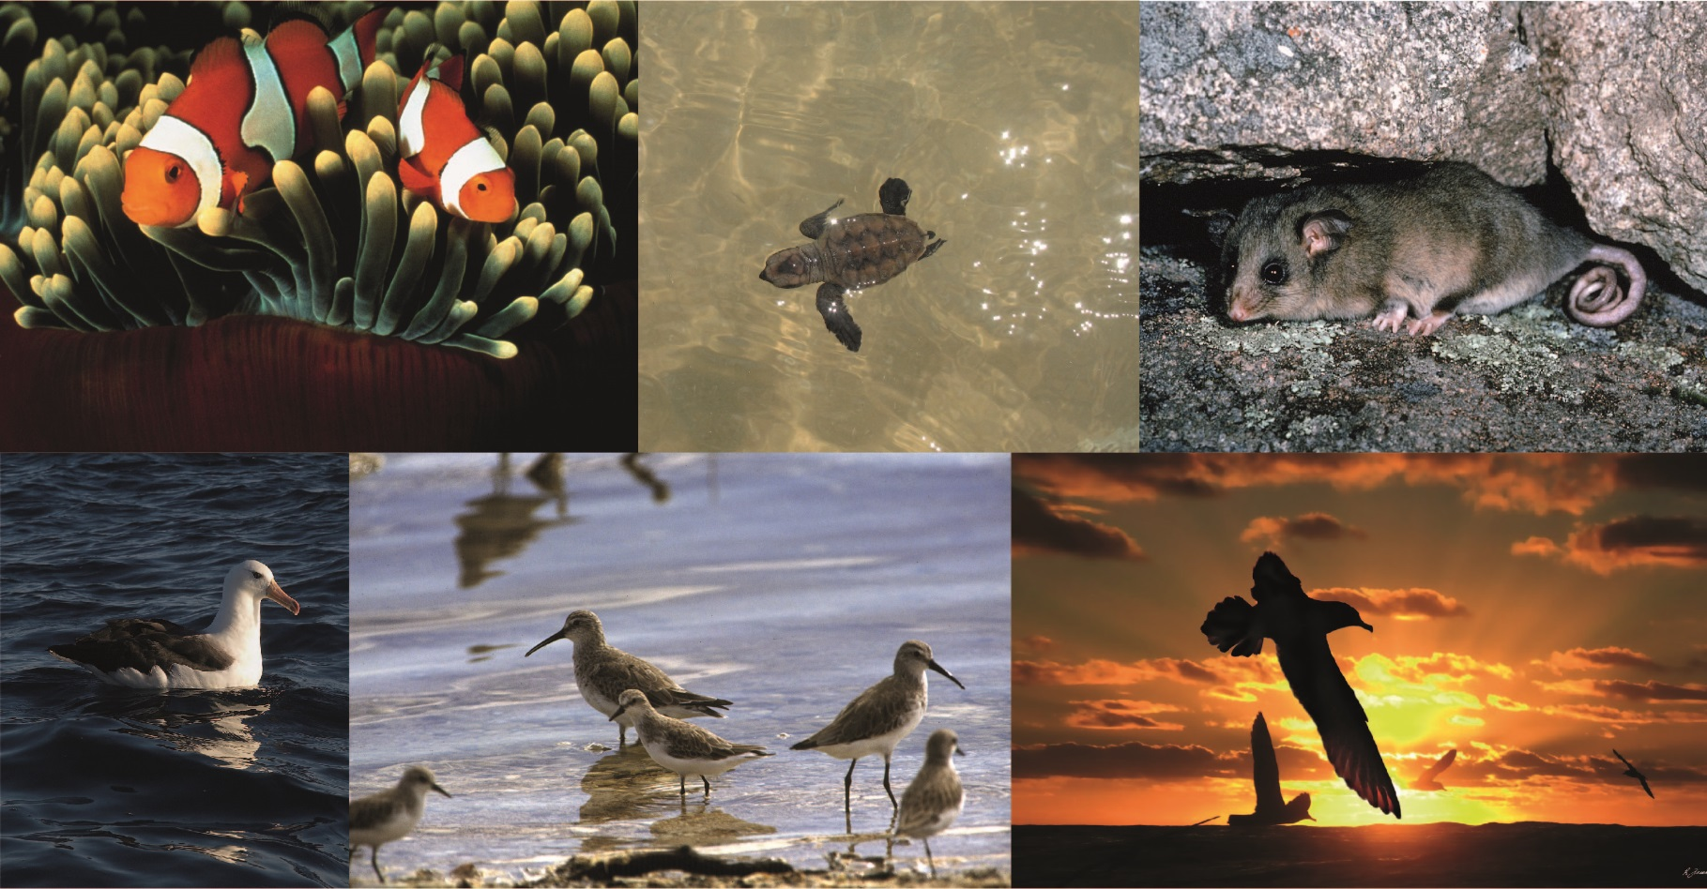

Acknowledgments

The Department of the Environment and Energy (the Department) would like to acknowledge those who contributed to the development of these Light Pollution Guidelines.

Funding for the development of the Guidelines was provided by the North West Shelf Flatback Conservation Program in the Western Australian Department of Biodiversity, Conservation and Attractions and by the Australian Government’s National Environmental Science Program (NESP) Emerging Priorities Funding.

These Guidelines are based on the draft written by Kellie Pendoley, Catherine Bell, Chris Surman and Jimmy Choi with contributions from Airam Rodriguez, Andre Chiaradia, Godfrey Bridger, Adam Carey, Adam Mitchell and Phillipa Wilson. Simon Balm, Steve Coyne, Dan Duriscoe, Peter Hick, Gillian Isoardi, Nigel Jackett, Andreas Jechow, Mike Salmon and Warren Tacey generously provided technical reviews of sections of this document.

The Department acknowledges the traditional owners of country throughout Australia and their continuing connection to land, sea and community. We pay our respects to them and their cultures and to their elders both past and present.

© Copyright Commonwealth of Australia, 2020.



The Light Pollution Guidelines are licensed by the Commonwealth of Australia for use under a Creative Commons Attribution 4.0 International licence with the exception of the Coat of Arms of the Commonwealth of Australia, the logo of the agency responsible for publishing the report, content supplied by third parties, and any images depicting people. For licence conditions see: <https://creativecommons.org/licenses/by/4.0/>

This report should be attributed as ‘*National Light Pollution Guidelines for Wildlife Including Marine Turtles, Seabirds and Migratory Shorebirds, Commonwealth of Australia 2020*’.

The Commonwealth of Australia has made all reasonable efforts to identify content supplied by third parties using the following format ‘© Copyright, [name of third party]’.

**Front cover images:** Clown fish - DSEWPaC; Hawksbill Turtle hatchling – Scott Whiting; Mountain Pygmy Possum – Linda Broom; Black Browed Albatross – Alan Danks; Curlew Sandpiper – Brian Furby; Fleshfooted Shearwater ‑ Richard Freeman.

Contents

National Light Pollution Guidelines 1

Introduction 1

How to use these Guidelines 2

Regulatory Considerations for the Management of Artificial Light around Wildlife 3

Wildlife and Artificial Light 5

When to Consider the Impact of Artificial Light on Wildlife? 8

Environmental Impact Assessment for Effects of Artificial Light on Wildlife 13

Case Studies 18

Appendix A – Best Practice Lighting Design 21

Lighting Objectives 21

Principles of Best Practice Lighting Design 22

Appendix B – What is Light and how does Wildlife Perceive it? 27

What is Light? 27

Vision in Animals 28

Factors Effecting Perception of Light 30

Measurement of Light 33

Light Emitting Diodes (LEDs) 34

Appendix C - Measuring Biologically Relevant Light 37

Radiometric vs Photometric Measurement Techniques 38

Instrumental Techniques 40

Modelling Predicted Light 49

Appendix D – Artificial Light Auditing 50

Step-by-Step Guide 50

Appendix E – Artificial Light Management Check List 52

Appendix F - Marine Turtles 55

Conservation Status 56

Distribution 56

Effects of Artificial Light on Marine Turtles 57

Environmental Impact Assessment of Artificial Light on Marine Turtles 59

Marine Turtle Light Mitigation Toolbox 64

Appendix G - Seabirds 67

Conservation Status 68

Distribution 68

Effects of Artificial Light on Seabirds 69

Environmental Impact Assessment of Artificial Light on Seabirds 72

Seabird Light Mitigation Toolbox 76

Appendix H - Migratory Shorebirds 81

Conservation Status 82

Distribution 82

Effects of Artificial Light on Migratory Shorebirds 83

Environmental Impact Assessment of Artificial Light on Migratory Shorebirds 86

Migratory Shorebird Light Mitigation Toolbox 89

Glossary 93

References 99

# National Light Pollution Guidelines

## Introduction

Natural darkness has a conservation value in the same way that clean water, air and soil has intrinsic value. Artificial light at night is increasing globally by about two per cent per year1. Animals perceive light differently from humans and artificial light can disrupt critical behaviour and cause physiological changes in wildlife2. For example, hatchling marine turtles may not be able to find the ocean when beaches are lit3, and fledgling seabirds may not take their first flight if their nesting habitat never becomes dark4. Tammar wallabies exposed to artificial light have been shown to delay reproduction5 and clownfish eggs incubated under constant light do not hatch6.

Consequently, artificial light has the potential to stall the recovery of a threatened species. For migratory species, the impact of artificial light may compromise an animal’s ability to undertake long-distance migrations integral to its life cycle.

Artificial light at night provides for human safety, amenity and increased productivity. Australian legislation and standards regulate artificial light for the purpose of human safety. These Guidelines do not infringe on human safety obligations. Where there are competing objectives for lighting, creative solutions may be needed that meet both human safety requirements for artificial light and threatened and migratory species conservation.

The Guidelines outline the process to be followed where there is the potential for artificial lighting to affect wildlife. They apply to new projects, lighting upgrades (retrofitting) and where there is evidence of wildlife being affected by existing artificial light.

The technology around lighting hardware, design and control is changing rapidly and biological responses to artificial light vary by species, location and environmental conditions. It is not possible to set prescriptive limits on lighting. Instead, these Guidelines take an outcomes approach to assessing and mitigating the effect of artificial light on wildlife**.**

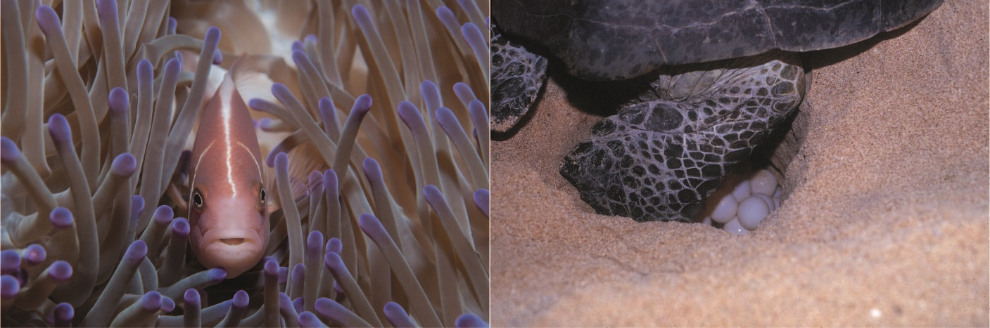

Figure 1 Pink anemone fish and marine turtle laying eggs. Photos: Nigel Marsh and Robert Thorn.

## How to use these Guidelines

These Guidelines provide users with the theoretical, technical and practical information required to assess if artificial lighting is likely to affect wildlife and the management tools to minimise and mitigate that affect. These techniques can be applied regardless of scale, from small, domestic projects to large-scale industrial developments.

**The aim of the Guidelines is that artificial light will be managed so wildlife is:**

1. **Not disrupted within, nor displaced from,** **important habitat****; and**
2. **Able to undertake critical behaviours such as foraging, reproduction and dispersal.**

The Guidelines recommend:

1. Always using Best Practice Lighting Design to reduce light pollution and minimise the effect on wildlife.
2. Undertaking an Environmental Impact Assessment for effects of artificial light on listed species for which artificial light has been demonstrated to affect behaviour, survivorship or reproduction.

### Technical Appendices

The Guidelines are supported by a series of technical appendices that provide additional information about Best Practice Lighting Design, What is Light and How Wildlife Perceive it, Measuring Biologically Relevant Light, and Artificial Light Auditing. There is also a checklist for artificial light management, and species-specific information for the management of artificial light for Marine Turtles, Seabirds and Migratory Shorebirds. The range of species covered in taxa-specific appendices will be broadened in the future.

## Regulatory Considerations for the Management of Artificial Light around Wildlife

These Guidelines provide technical information to guide the management of artificial light for *Environment Protection and Biodiversity Conservation Act (1999)* (EPBC Act)listed threatened and migratory species, species that are part of a listed ecological community, and species protected under state or territory legislation for which artificial light has been demonstrated to affect behaviour, survivorship or reproduction.

### Environment Protection and Biodiversity Conservation Act (1999)

The EPBC Act regulates any action that will have, or is likely to have, a significant impact on a Matter of National Environmental Significance (MNES), including listed threatened and migratory species. Any action likely to have a significant impact on a MNES must be referred to the Australian Government for assessment. Further, it is an offence under the EPBC Act to kill, injure, take or trade a listed threatened, migratory or marine species in a Commonwealth area. Anyone unsure of whether the EPBC Act applies, is strongly encouraged to seek further [information](http://www.environment.gov.au/epbc/do-you-need-approval).

### State and territory legislation and policy

State and territory environmental legislation and policy frameworks may also have provisions for managing threats, such as light, to listed species. For example, artificial light is a form of pollution regulated for impacts on humans and the environment under the Australian Capital Territory *Environment Protection Act 1997*. Consideration should be given to the function of relevant state and territory environment and planning legislation and policy concerning the protection of wildlife from artificial light.

### Local and regional government requirements

Advice should also be sought from local government as to whether specific requirements apply in the area of interest concerning artificial light and wildlife. For example, the [Queensland Government *Sea Turtle Sensitive Area Code*](https://dsdmipprd.blob.core.windows.net/general/sea-turtle-sensitive-area-code.pdf) provides for local governments to identify sea turtle sensitive areas within local government planning schemes. Development in these areas will need to avoid adverse effects to sea turtles from artificial lighting.

### Australian standards

Australian standards provide agreed limits for various lighting scenarios, generally for the purposes of human safety and for the provision of amenity. For example, Australian Standard DR AS/NZS 1158.3.1:2018 *Lighting for roads and public spaces pedestrian area (Category P) lighting* provides minimum light performance and design standards for pedestrian areas.

Australian standards also provide for consideration of environmental concerns. Australian Standard *AS/NZS 4282:2019 Control of the obtrusive effects of outdoor lighting* recognises the impact of artificial light on biota.

These Light Pollution Guidelines should be followed to ensure all lighting objectives are adequately addressed. This may require solutions to be developed, applied and tested to ensure lighting management meets the needs of human safety and wildlife conservation. The Case Studies illustrate examples of how a liquefied natural gas processing plant, a transport authority and a marine research vessel have addressed this challenge.

### Associated guidance

These Guidelines should be read in conjunction with:

* [EPBC Act 1999 Significant Impact Guidelines 1.1 Matters of National Environmental Significance](https://www.environment.gov.au/epbc/publications/significant-impact-guidelines-11-matters-national-environmental-significance)
* [EPBC Act 1999 Significant Impact Guidelines 1.2 Actions on, or impacting upon, Commonwealth land and Actions by Commonwealth Agencies](https://www.environment.gov.au/epbc/publications/significant-impact-guidelines-12-actions-or-impacting-upon-commonwealth-land-and-actions)
* [Recovery Plans](https://www.environment.gov.au/biodiversity/threatened/recovery-plans) and approved [conservation advices](https://www.environment.gov.au/biodiversity/threatened/conservation-advices) for listed threatened species
* approved [Wildlife Conservation Plans](https://www.environment.gov.au/biodiversity/publications/wildlife-conservation-plan-migratory-shorebirds-2016) for listed migratory species
* state and territory environmental legislation, regulations, and policy and guidance documents
* up-to-date scientific literature
* local and Indigenous knowledge.

## Wildlife and Artificial Light

Vision is a critical cue for wildlife to orient themselves in their environment, find food, avoid predation and communicate7. An important consideration in the management of artificial light for wildlife is an understanding of how light is perceived by animals, both in terms of what the eye sees and the animal’s viewing perspective.

Animals perceive light differently from humans. Most animals are sensitive to ultra-violet (UV)/violet/blue light8, while some birds are sensitive to longer wavelength yellow/orange9 and some snakes, can detect infra-red wavelengths10 (Figure 2). Understanding the sensitivity of wildlife to different light wavelengths is critical to assessing the potential effects of artificial light on wildlife.

The way light is described and measured has traditionally focused on human vision. To manage light appropriately for wildlife, it is critical to understand how light is defined, described and measured and to consider light from the wildlife’s perspective.

For a detailed explanation of these issues see What is Light and how do Wildlife Perceive it? The Glossary provides a summary of terms used to describe light and light measurements and notes the appropriate terms for discussing the effects of light on wildlife.

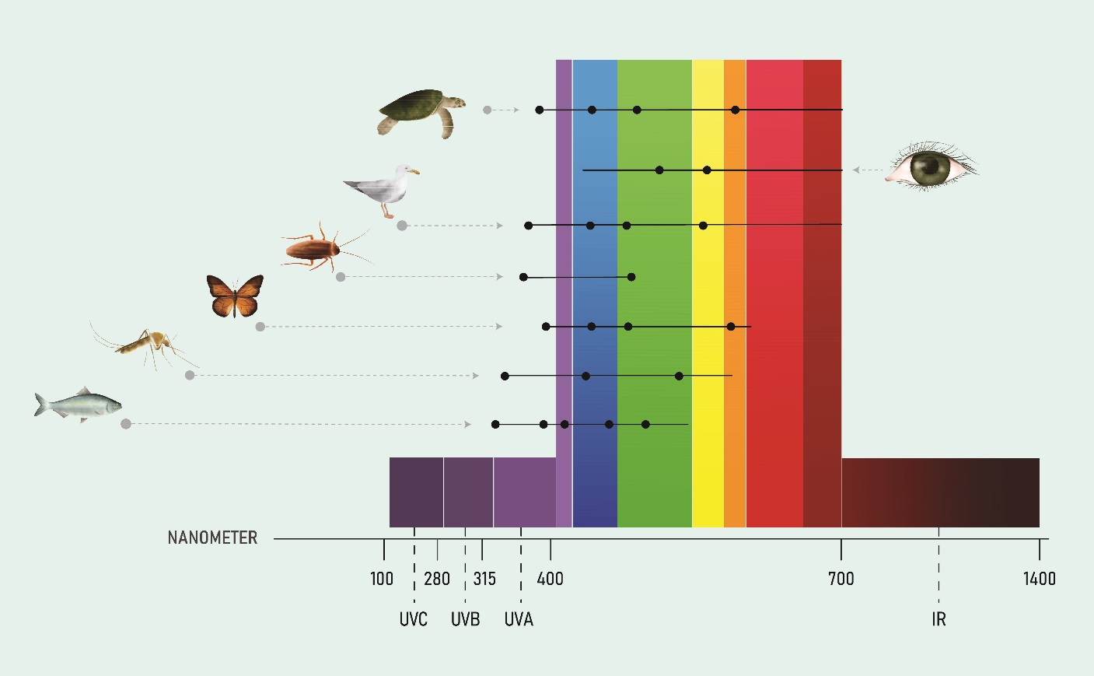

Figure 2 Ability to perceive different wavelengths of light in humans and wildlife is shown by horizontal lines. Black dots represent reported peak sensitivities. Figure adapted from Campos (2017)8.

### How light affects wildlife

Artificial light is known to adversely affect many species2,11 and ecological communities12,13. It can change behaviour and/or physiology, reducing survivorship or reproductive output. It can also have the indirect effect of changing the availability of habitat or food resources. It can attract predators and invasive pests, both of which may pose a threat to listed species.

Behavioural changes in wildlife have been well described for some species. Adult marine turtles may avoid nesting on beaches that are brightly lit14,15, and adult and hatchling turtles can be disoriented and unable to find the ocean in the presence of direct light or sky glow3,15,16. Similarly, lights can disorient flying birds, particularly during migration, and cause them to divert from efficient migratory routes or collide with infrastructure17. Birds may starve when artificial lighting disrupts foraging, and fledgling seabirds may not be able to take their first flight if their nesting habitat never becomes dark4. Migratory shorebirds may use less preferable roosting sites to avoid lights and may be exposed to increased predation where lighting makes them visible at night4.

Physiological changes have been described in the Tammar Wallaby when exposed to artificial light, resulting in delayed reproduction5, and clownfish eggs incubated under constant light do not hatch6. The stress hormone corticosterone in free living song birds has been shown to increase when exposed to white light compared with green or red light and those with high stress hormone levels had fewer offspring18. Plant physiology can also be affected by artificial light with changes to growth, timing of flowering and resource allocation. This can then have flow-on affects for pollinators and herbivores13.

The indirect effects of artificial light can also be detrimental to threatened species. The Mountain Pygmy Possum, for example, feeds primarily on the Bogong Moth, a long distance nocturnal migrator that is attracted to light19. Recent declines in moth populations, in part due to artificial light, have reduced the food supply for the possum20. Changes in food availability due to artificial light affect other animals, such as bats21, and cause changes in fish assemblages22. Lighting may also attract invasive pests such as cane toads23, or predators, increasing pressure on listed species24.

The way in which light affects a listed species must be considered when developing management strategies as this will vary on a case by case basis.

These Guidelines provide information on the management of artificial light for Marine Turtles, Seabirds and Migratory Shorebirds in the technical appendices. Consideration should be given to the direct and indirect effect of artificial light on all listed species for which artificial light has been demonstrated to negatively affect behaviour, survivorship or reproduction.

### Light Emitting Diodes (LEDs)

During the life of these Guidelines, it is anticipated that light technology may change dramatically. At the time of writing, LEDs were rapidly becoming the most common light type used globally. This is primarily because they are more energy efficient than earlier light sources. LEDs and smart control technologies (such as motion sensors and timers) provide the ability to control and manage the physical parameters of lighting, making them an integral tool in managing the effects of artificial light on wildlife.

Whilst LEDs are part of the solution, consideration should be given to some of the characteristics of LEDs that may influence the effect of artificial light on wildlife. White LEDs generally contain short wavelength blue light. Short wavelength light scatters more readily than long wavelength light, contributing more to sky glow. Also, most wildlife is sensitive to blue light (Figure 2). More detailed consideration of LEDs, their benefits and challenges for use around wildlife are provided in the Technical Appendix What is Light and how does Wildlife Perceive it?

## When to Consider the Impact of Artificial Light on Wildlife?

### Is Artificial Light Visible Outside?

Any action or activity that includes externally visible artificial lighting should consider the potential effects on wildlife (refer Figure 3 below). These Guidelines should be applied at all stages of management, from the development of planning schemes to the design, approval and execution of individual developments or activities, through to retrofitting of light fixtures and management of existing light pollution. Best Practice Lighting Design is recommended as a minimum whenever artificial lighting is externally visible.

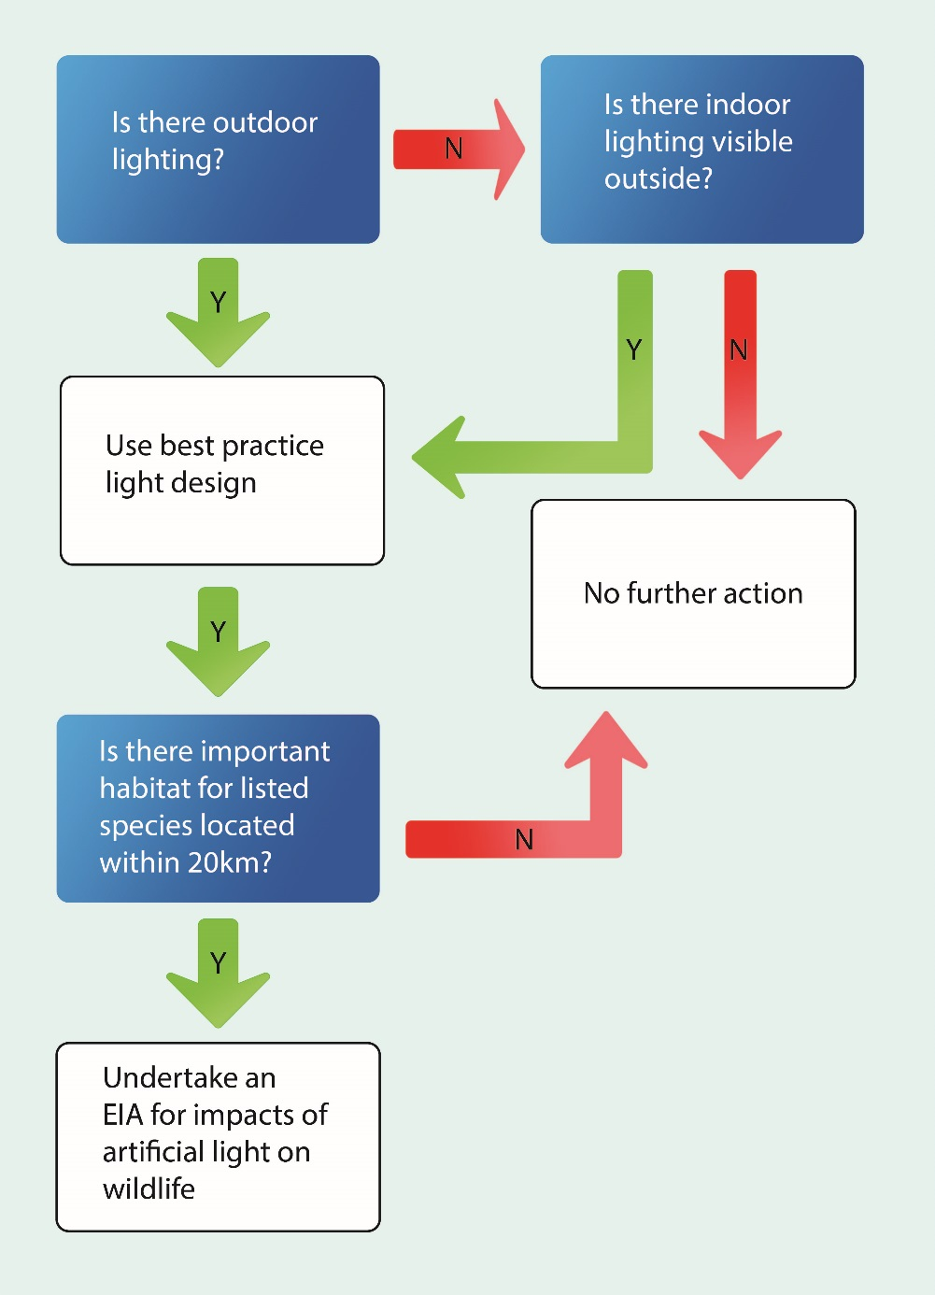

Figure 3 Decision tree to determine whether to undertake an environmental impact assessment for the effects of artificial light on wildlife.

#### Best practice lighting design

Natural darkness has a conservation value and should be protected through good quality lighting design and management for the benefit of all living things. To that end, all infrastructure that has outdoor artificial lighting or internal lighting that is externally visible should incorporate best practice lighting design.

Incorporating best practice lighting design into all infrastructure will not only have benefits for wildlife, but will also save energy and provide an economic benefit for light owners and managers.

**Best practice lighting design incorporates the following design principles.**

1. **Start with natural darkness and only add light for specific purposes.**
2. **Use adaptive light controls to manage light timing, intensity and colour.**
3. **Light only the object or area intended – keep lights close to the ground, directed and shielded to avoid light spill.**
4. **Use the lowest intensity lighting appropriate for the task.**
5. **Use non-reflective, dark-coloured surfaces.**
6. **Use lights with reduced or filtered blue, violet and ultra-violet wavelengths.**

Figure 4 provides an illustration of best practice light design principles. For a detailed explanation see Technical Appendix Best Practice Lighting Design.

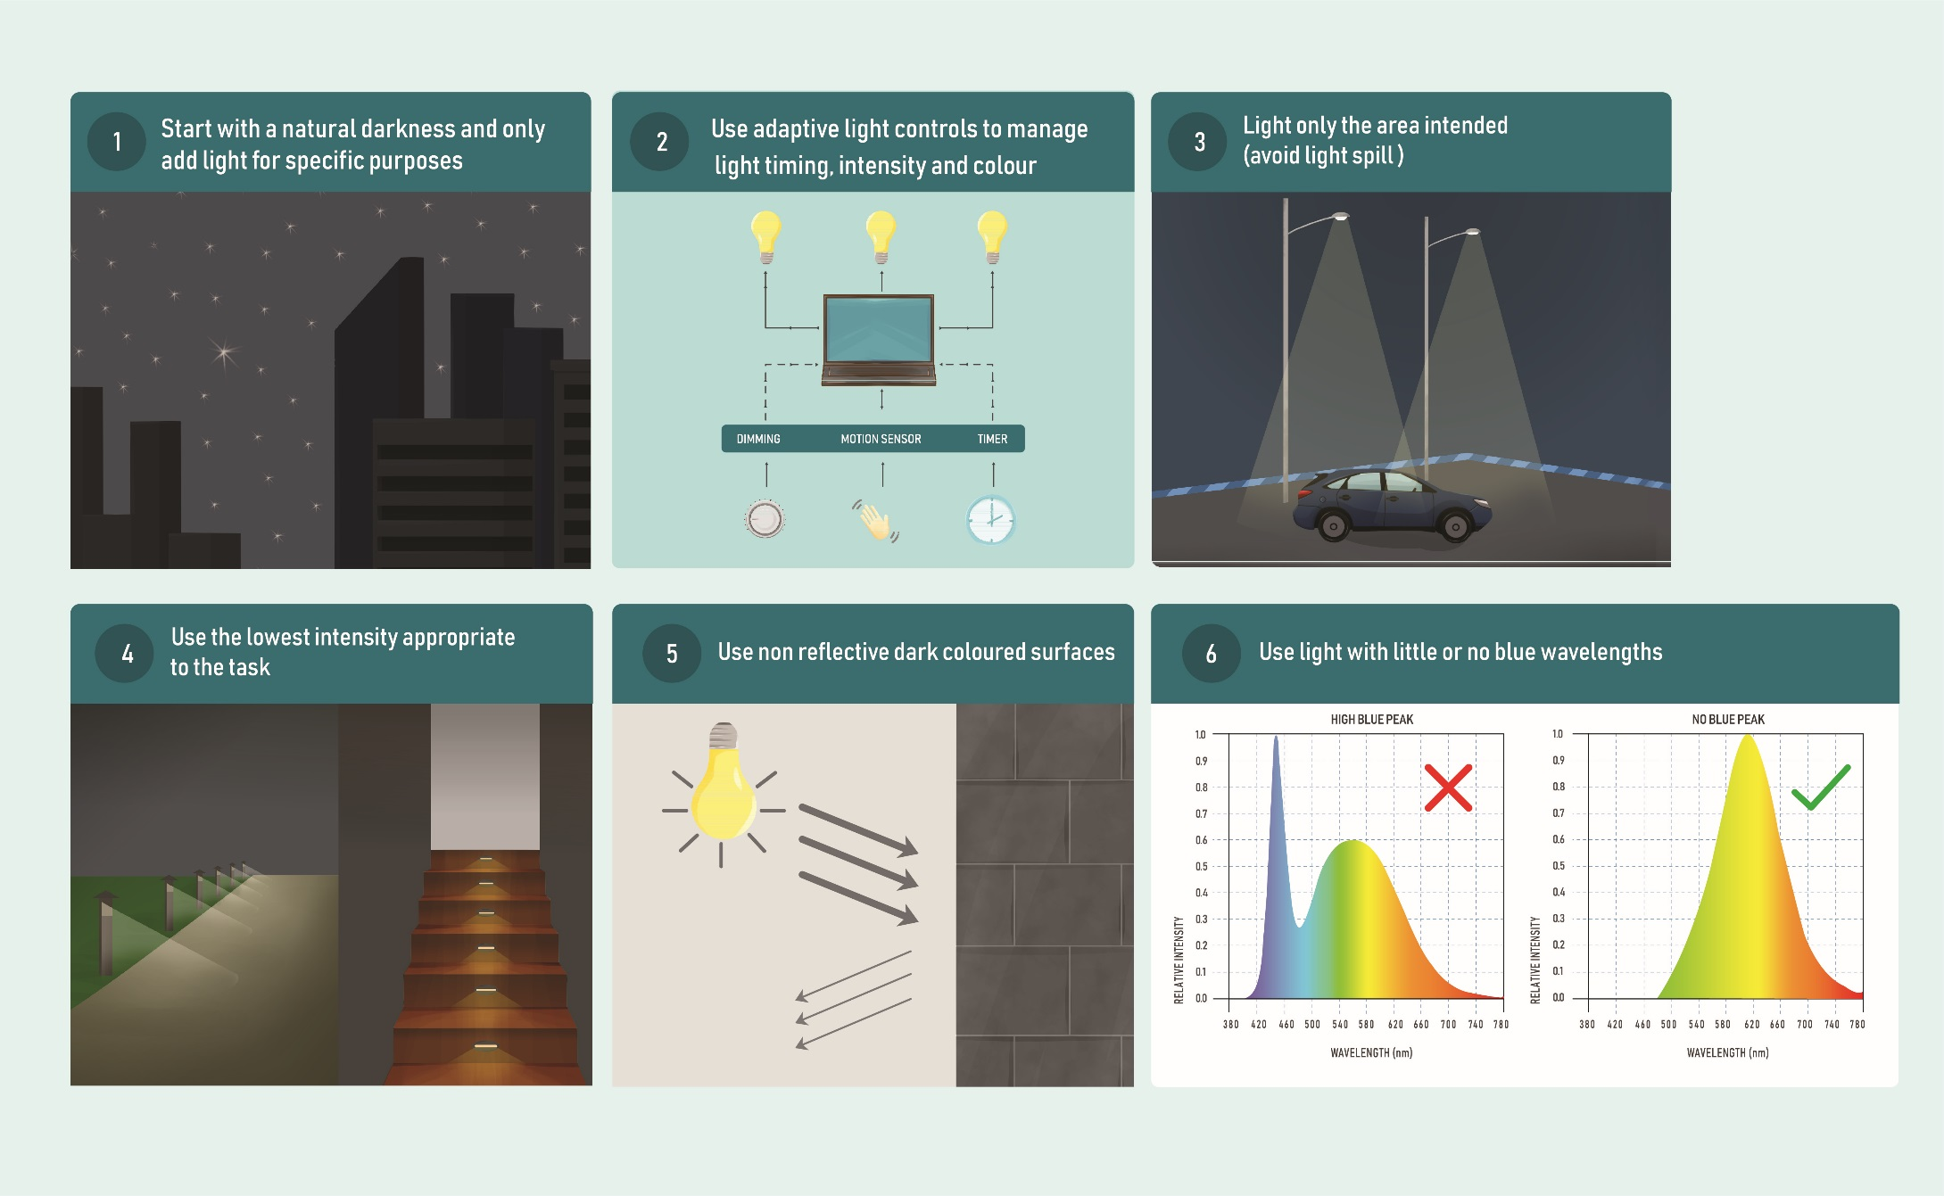

Figure 4 Principles for best practice lighting design.

### Is there Important Habitat for Listed Species Located within 20km?

Important habitats are those areas necessary for an ecologically significant proportion of a listed species to undertake important activities such as foraging, breeding, roosting or dispersal. This might include areas that are of critical importance for a particular life stage, are at the limit of a species range or habitat, or where the species is declining. They may also be a habitat where the presence of light pollution may cause a significant decline in a listed threatened or migratory species.

Important habitat will vary depending on the species. For some species, areas of importance have been designated through recovery plans, conservation advice, and under planning regulations (for example [Queensland Sea Turtle Sensitive Areas](https://dsdmipprd.blob.core.windows.net/general/sea-turtle-sensitive-area-code.pdf)). Important habitat would include those areas that are consistent with ‘habitat critical to the survival’ of a threatened species and ‘important habitat’ for listed migratory species as described in the [EPBC Act Significant Impact Guidelines](https://www.environment.gov.au/system/files/resources/42f84df4-720b-4dcf-b262-48679a3aba58/files/nes-guidelines_1.pdf)25. Important habitat may include areas designated as [Biologically Important Areas](https://www.environment.gov.au/marine/marine-species/bias) (BIAs), or in the case of migratory shorebirds, Internationally Important or Nationally Important Habitat. Consideration should be given to the ecological characteristics of Ramsar sites and the biological and ecological values of National and World Heritage Areas.

Species specific descriptions of important habitat can be found in Technical Appendices relating to Marine Turtles, Seabirds and Migratory Shorebirds. For other listed species see relevant information available in Associated guidance and Desktop Study of Wildlife.

Where there is important habitat for listed species that are known to be affected by artificial light within 20 km of a project, species specific impacts should be considered through an Environmental Impact Assessment (EIA) process.

The 20 km threshold provides a precautionary limit based on observed effects of sky glow on marine turtle hatchlings demonstrated to occur at 15-18 km26,27 and fledgling seabirds grounded in response to artificial light 15 km away28. The effect of light glow may occur at distances greater than 20 km for some species and under certain environmental conditions. The 20 km threshold provides a nominal distance at which artificial light impacts should be considered, not necessarily the distance at which mitigation will be necessary. For example, where a mountain range is present between the light source and an important turtle nesting beach, further light mitigation is unlikely to be needed. However, where island infrastructure is directly visible on an important turtle nesting beach across 25 km of ocean in a remote location, additional light mitigation may be necessary.

### Managing existing light pollution

The impact of artificial light on wildlife will often be the result of the effect of all light sources in the region combined. As the number and intensity of artificial lights in an area increases there will be a visible, cumulative increase in sky glow. Sky glow is the brightness of the night sky caused by the reflected light scattered from particles in the atmosphere. Sky glow comprises both natural and artificial sky glow. As sky glow increases so does the potential for adverse impacts on wildlife.

Generally, there is no one source of sky glow and management should be undertaken on a regional, collaborative basis. Artificial light mitigation and minimisation will need to be addressed by the community, regulators, councils and industry to prevent the escalation of, and where necessary reduce, the effects of artificial light on wildlife.

The effect of existing artificial light on wildlife is likely to be identified by protected species managers or researchers that observe changes in behaviour or population demographic parameters that can be attributed to increased artificial sky glow. Where this occurs, the population/behavioural change should be monitored, documented and, where possible, the source(s) of light identified. An Artificial Light Management Plan should be developed in collaboration with all light owners and managers to mitigate impacts.

## Environmental Impact Assessment for Effects of Artificial Light on Wildlife

There are five steps involved in assessing the potential effects of artificial light on wildlife, and the adaptive management of artificial light requires a continuing improvement process (Figure 5). The amount of detail included in each step depends on the scale of the proposed activity and the susceptibility of wildlife to artificial light. The first three steps of the EIA process should be undertaken as early as possible in the project’s life cycle and the resulting information used to inform the project design phase.

Marine Turtle, Seabird and Migratory Shorebird Technical Appendices give specific consideration to each of these taxa. However, the process should be adopted for other protected species affected by artificial light.

### Qualified personnel

Lighting design/management and the EIA process should be undertaken by appropriately qualified personnel. Management plans should be developed and reviewed by appropriately qualified lighting practitioners in consultation with appropriately qualified wildlife biologists or ecologists.

|  |  |
| --- | --- |
| **Step 1: Describe the project lighting** | **Step 2: Describe wildlife** |
| Describe existing light environment. Document the number, type, layout and purpose of proposed outdoor lighting. Define lighting objectives. | Undertake a desktop study of wildlife and where necessary conduct field surveys to describe population and behaviour. Define lighting objectives in terms of wildlife. |
|  | |
| **Step 3: Risk assessment** | |
| Using project light information, wildlife biological and ecological information, and proposed mitigation and light management, assess the risk of impact of artificial light to wildlife. | |
|  | |
| **Step 4: Artificial light management plan** | |
| Document information collated through Steps 1-3. Describe lighting management and mitigation. Develop and describe compliance and auditing scope, and schedule and triggers for revisiting Step 3. | |
|  | |
| **Step 5: Biological and artificial light monitoring and auditing** | |
| Monitor wildlife behaviour and audit on-site light to ensure compliance with artificial light management plan(Step 4). | |

**Review and Repeat**

Figure 5 Flow chart describing the environmental impact assessment process.

### Step 1: Describe the project lighting

Describe the existing light environment and characterise the light likely to be emitted from the site. Information should be collated, including (but not limited to): the location and size of the project footprint; the number and type of lights; their height, orientation and hours of operation; site topography and proximity to wildlife and/or wildlife habitat. This information should include whether lighting will be directly visible to wildlife or contribute to sky glow; the distance over which this artificial light is likely to be perceptible; shielding or light controls used to minimise lighting; and spectral characteristics (wavelength) and intensity of lights.

Project specific lighting should be considered in the context of the existing light environment and the potential for cumulative effects of multiple light sources. The information collected should be sufficient to assess the likely effects of artificial light on wildlife given the biology and ecology of species present (Step 2).

Where there will be a need to monitor the effectiveness of artificial light mitigation and management strategies (Step 5), baseline monitoring will be necessary. Measurements of the existing light environment should recognise and account for the biologically relevant short (violet/blue) and long (orange/red) wavelengths of artificial lighting (see Measuring Biologically Relevant Light).

#### Lighting objectives

During the planning phase of a project the purpose of artificial lighting should be clearly articulated, and consideration should be given as to whether artificial light is required at all. Lighting objectives should be specific in terms of location and times for which artificial light is necessary, whether colour differentiation is required and whether some areas should remain dark. The objectives should include the wildlife requirements identified in Step 2 and be consistent with the aims of these Guidelines.

For more information about developing lighting objectives see Best Practice Lighting Design.

### Step 2: Describe wildlife

Describe the biology and ecology of wildlife in the area that may be affected by artificial light (species identified during the screening process, Figure 3). The abundance, conservation status and regional significance of wildlife will be described, as will the location of important habitat. Recognise biological and ecological parameters relevant to the assessment, particularly how artificial light will be viewed by an animal. This includes an animal’s physiological sensitivity to wavelength and intensity, and its visual field.

Depending on the availability of information, scale of the activity and the susceptibility of wildlife to artificial light, this step may only require a desktop analysis. Where there is a paucity of information or the potential for effects is high, field surveys may be necessary. Where there will be a need to monitor the effectiveness of lighting mitigation and management strategies (Step 5), baseline monitoring will be necessary.

#### Desktop study of wildlife

A review of the available government databases, scientific literature and unpublished reports should be conducted to determine whether listed or protected wildlife that are susceptible to the effects of artificial light could be present. Tools to identify species or Important Habitat that may occur within 20 km of the area of interest include (but are not limited to):

* [Protected Matters Search Tool](https://www.environment.gov.au/epbc/protected-matters-search-tool)
* [National Conservation Values Atlas](https://www.environment.gov.au/topics/marine/marine-bioregional-plans/conservation-values-atlas)
* State and territory protected species information
* Scientific literature
* Local and Indigenous knowledge

To assess the risks to a species, an understanding of the animal’s susceptibility to the effects of light should be evaluated, as well as the potential for artificial light to affect the local population.

The species conservation status should be identified and relevant population demographic and behavioural characteristics that should be considered include population size, life stages present and normal behaviour in the absence of artificial light. This step should also identify biological and ecological characteristics of the species that will be relevant to the assessment. This may include understanding the seasonality of wildlife using the area; behaviour (i.e. reproduction, foraging, resting); migratory pathways; and life stages most susceptible to artificial light. Consideration should also be given to how artificial light may affect food sources, availability of habitat, competitors or predators.

#### Field surveys for wildlife

Where there are insufficient data available to understand the actual or potential importance of a population or habitat it may be necessary to conduct field surveys. The zone of influence for artificial lighting will be case and species specific. Surveys should describe habitat, species abundance and density on a local and regional scale at a biologically relevant time of year.

#### Baseline monitoring

Where it is considered likely that artificial lighting will impact on wildlife, it may be necessary to undertake baseline monitoring to inform mitigation and light management (Step 5).

Field survey techniques and baseline monitoring needs will be species specific and detailed parameters and approaches are described in the Marine Turtles, Seabirds and Migratory Shorebirds Technical Appendices. Guidance from species experts should be sought for other species.

### Step 3: Risk assessment

Using information collated in steps one and two, the level of risk to wildlife should be assessed. Risk assessments should be undertaken on a case by case basis as they will be specific to the wildlife involved, the lighting objectives and design, and the prevailing environmental conditions. Assessments should be undertaken in accordance with the *Australian Standard Risk Management – Guidelines (AS ISO 31000:2018)* (or superseding equivalent), which provides for adaptive management and continuous improvement. The scale of the assessment is expected to be commensurate with the scale of the activity and the vulnerability of the wildlife present.

In general, the assessment should consider how important the habitat is to the species (e.g. is this the only place the animals are found), the biology and ecology of wildlife, the amount and type of artificial light at each phase of development (e.g. construction/operation) and whether the lighting scenario is likely to cause an adverse response. The assessment should take into account the artificial light impact mitigation and management that will be implemented. It should also consider factors likely to affect an animal’s perception of light; the distance to the lighting source; and whether light will be directly visible or viewed as sky glow. The process should assess whether wildlife will be disrupted or displaced from important habitat, and whether wildlife will be able to undertake critical behaviours such as foraging, reproduction, and dispersal.

Where a likely risk is identified, either the project design should be modified, or further mitigation put in place to reduce the risk.

If the residual risk is likely to be significant, consideration should be given as to whether the project should be referred for assessment under the EPBC Act and/or relevant state or territory legislation.

### Step 4: Artificial light management plan

The management plan will document the EIA process. The plan should include all relevant information obtained in Steps 1-3. It should describe the lighting objectives; the existing light environment; susceptible wildlife present, including relevant biological characteristics and behaviour; and proposed mitigation. The plan should clearly document the risk assessment process, including the consequences that were considered, the likelihood of occurrence and any assumptions that underpin the assessment. Where the risk assessment deems it unlikely that the proposed artificial light will effect wildlife and an artificial light management plan is not required, the information and assumptions underpinning these decisions should be documented.

Where an artificial light management plan is deemed necessary, it should document the scope of monitoring and auditing to test the efficacy of proposed mitigation and triggers to revisit the risk assessment. This should include a clear adaptive management framework to support continuous improvement in light management, including a hierarchy of contingency management options if biological and light monitoring or compliance audits indicate that mitigation is not meeting the objectives of the plan.

The detail and extent of the plan should be proportional to the scale of the development and potential impacts to wildlife.

A toolbox of species specific options are provided in the Marine Turtles, Seabirds and Migratory Shorebirds Technical Appendices. Guidance from species experts should be sought for other species.

### Step 5: Biological and light monitoring and auditing

The success of the impact mitigation and artificial light management should be confirmed through monitoring and compliance auditing. Light audits should be regularly undertaken and biological and behavioural monitoring should be undertaken on a timescale relevant to the species present. Observations of wildlife interactions should be documented and accompanied by relevant information such as weather conditions and moon phase. Consideration should be given to monitoring control sites. Monitoring should be undertaken both before and after changes to artificial lighting are made at both the affected site and the control sites. The results of monitoring and auditing are critical to an adaptive management approach, with the results used to identify where improvements in lighting management may be necessary. Audits should be undertaken by appropriately qualified personnel.

Baseline, construction or post construction artificial light monitoring, wildlife biological monitoring and auditing are detailed in Measuring Biologically Relevant Light, Light Auditing and species specific Marine Turtles, Seabirds and Migratory Shorebirds Technical Appendices.

### Review

Once light audits and biological monitoring have been completed, a review of whether the lighting objectives have been met should be conducted. The review should incorporate any changing circumstances and make recommendations for continual improvement. The recommendations should be incorporated through upgraded mitigations, changes to procedures and renewal of the light management plan.

## Case Studies

Unlike many forms of pollution, artificial light can be removed from the environment. The following case studies show it is possible to balance the requirements of both human safety and wildlife conservation.

### Gorgon Liquefied Natural Gas Plant on Barrow Island, Western Australia

The Chevron-Australia Gorgon Project is one of the world’s largest natural gas projects. The liquefied natural gas (LNG) processing facility is on Barrow Island a Western Australian Class A nature reserve off the Pilbara Coast known for its diversity of fauna, including important nesting habitat for flatback turtles29.

The LNG plant was built adjacent to important turtle nesting beaches. The effect of light on the turtles and emerging hatchlings was considered from early in the design phase of the project and species-specific mitigation was incorporated into project planning29. Light management is implemented, monitored and audited through a light management plan and turtle population demographics and behaviour through the *Long Term Marine Turtle Management Plan*30.

Lighting is required to reduce safety risks to personnel and to maintain a safe place of work under workplace health and safety requirements. The lighting objectives considered these requirements while also aiming to minimise light glow and eliminate direct light spill on nesting beaches. This includes directional or shielded lighting, the mounting of light fittings as low as practicable, louvered lighting on low level bollards, automatic timers or photovoltaic switches and black-out blinds on windows. Accommodation buildings were oriented so that a minimal number of windows faced the beaches and parking areas were located to reduce vehicle headlight spill onto the dunes.

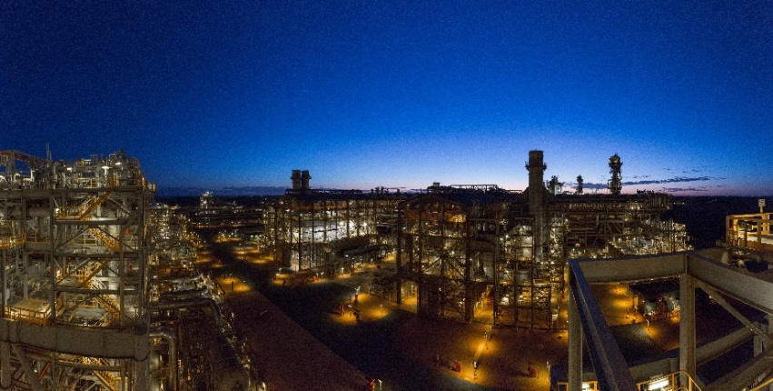Lighting management along the LNG jetty and causeway adopted many of the design features used for the plant and accommodation areas. LNG loading activity is supported by a fleet of tugs that were custom built to minimise external light spill. LNG vessels are requested to minimise non-essential lighting while moored at the loading jetty.

To reduce sky glow, the flare for the LNG plant was designed as a ground box flare, rather than the more conventional stack flare. A louvered shielding wall further reduced the effects of the flare.

Lighting reviews are conducted prior to the nesting season to allow time to implement corrective actions if needed. Workforce awareness is conducted at the start of each turtle breeding season to further engage the workforce in the effort to reduce light wherever possible.

Figure 6 Liquefied natural gas plant on Barrow Island. Photo: Chevron Australia.

The *Long Term Marine Turtle Management Plan*30 provides for the ongoing risk assessment of the impact of artificial light on the flatback turtles nesting on beaches adjacent to the LNG plant, including mitigation measures to minimise the risk from light to turtles. The plan also provides for an ongoing turtle research and monitoring program. The [plan](https://australia.chevron.com/-/media/australia/our-businesses/documents/gorgon-emp-long-term-marine-turtle-management-plan.PDF) is publicly available.

### Phillip Island

Victoria’s Phillip Island is home to one of the world’s largest colonies of listed migratory Short-tailed Shearwaters (*Ardenna* *tenuirostris*). It supports more than six per cent of the global population of this species28. Shearwaters nest in burrows and are nocturnally active at their breeding colonies. Fledglings leave their nests at night. When exposed to artificial light fledglings can be disoriented and grounded. Some fledglings may reach the ocean, but then be attracted back toward coastal lighting. Fledglings are also vulnerable to collision with infrastructure when disoriented and once grounded become vulnerable to predation or road kill4 (Figure 7).

Phillip Island also attracts over a million visitors a year during peak holiday seasons to visit the Little Penguin (*Eudyptula minor*) ecotourism centre, the Penguin Parade®. Most visitors drive from Melbourne across a bridge to access the island. The increase in road traffic at sunset during the Easter break coincides with the maiden flight of fledgling shearwaters from their burrows28.

In response to the deaths of fledglings, Phillip Island Nature Parks has an annual shearwater rescue program to remove and safely release grounded birds28. In collaboration with SP Ausnet and Regional Roads Victoria, road lights on the bridge to the island are turned off during the fledgling period31. To address human safety concerns, speed limits are reduced and warning signals put in place during fledgling season31,32. The reduced road lighting and associated traffic controls and warning signals, combined with a strong rescue program, have reduced the mortality rate of shearwaters28.

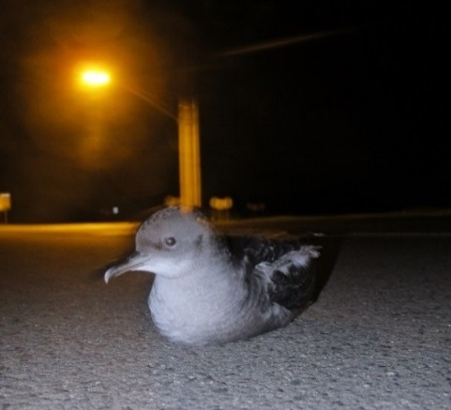

Figure 7 Short-Tailed Shearwater (*Ardenna tenuirostris*) fledgling grounded by artificial light, Phillip Island. Photo: Airam Rodriguez.

### Raine Island research vessel light controls

The Queensland Marine Parks primary vessel *Reef Ranger* is a 24 m catamaran jointly funded by the Great Barrier Reef Marine Park Authority and the Queensland Parks and Wildlife Service under the Field Management Program (FMP). The *Reef Ranger* is often anchored at offshore islands that are known marine turtle nesting sites and is regularly at Raine Island, one of the world’s largest green turtle nesting sites33 and a significant seabird rookery.

Vessels often emit a lot of artificial light when at anchor and the FMP took measures to minimise direct lighting spillage from the vessel. A lights-off policy around turtle nesting beaches was implemented, where the use of outdoor vessel lights was limited, except for safety reasons.

The original fit out of the vessel did not include internal block-out blinds (Figure 8A). These were installed before the 2018-19 Queensland turtle nesting season. The blinds stop light being emitted from inside the vessel, therefore limiting light spill around the vessel (Figure 8B). This can make an important difference at remote (naturally dark) sites such as Raine Island.

Anecdotal evidence suggests hatchlings previously attracted to, and captured in, light pools around the vessel are no longer drawn to the *Reef Ranger*.

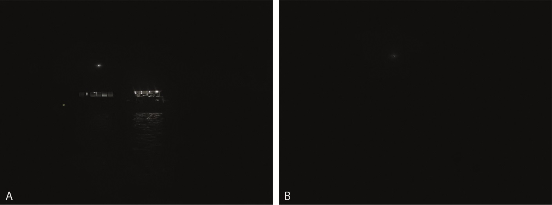

Figure 8 Vessel lighting management at Raine Island A. Vessel with decking lights, venetian blinds down and anchor light on; and B. Vessel with outside lights off, and block-out blinds installed (note the white anchor light is a maritime safety requirement). Photo: Queensland Parks and Wildlife Service.

# Appendix A – Best Practice Lighting Design

**Natural darkness has conservation value in the same way as clean water, air and soil and should be protected through good quality lighting design.**

**Simple management principles can be used to reduce light pollution, including:**

1. **Start with natural darkness and only add light for specific purposes.**
2. **Use adaptive light controls to manage light timing, intensity and colour.**
3. **Light only the object or area intended – keep lights close to the ground, directed and shielded to avoid light spill.**
4. **Use the lowest intensity lighting appropriate for the task.**
5. **Use non-reflective, dark-coloured surfaces.**
6. **Use lights with reduced or filtered blue, violet and ultra-violet wavelengths.**

The application of best practice lighting design for all outdoor lighting is intended to reduce sky glow and minimise the effects of artificial light on wildlife.

## Lighting Objectives

At the outset of a lighting design process, the purpose of artificial lighting should be clearly stated and consideration should be given as to whether it is required at all.

Exterior lighting for public, commercial or industrial applications is typically designed to provide a safe working environment. It may also be required to provide for human amenity or commerce. Conversely, areas of darkness, seasonal management of artificial light, or minimised sky glow may be necessary for wildlife protection, astronomy or dark sky tourism.

Lighting objectives will need to consider the regulatory requirements and Australian standards relevant to the activity, location and wildlife present.

Objectives should be described in terms of specific locations and times for which artificial light is necessary. Consideration should be given to whether colour differentiation is required and if some areas should remain dark – either to contrast with lit areas or to avoid light spill. Where relevant, wildlife requirements should form part of the lighting objectives.

A lighting installation will be deemed a success if it meets the lighting objectives (including wildlife needs) and areas of interest can be seen by humans clearly, easily, safely and without discomfort.

The following provides general principles for lighting that will benefit the environment, local wildlife and reduce energy costs.

## Principles of Best Practice Lighting Design

Good lighting design incorporates the following design principles. They are applicable everywhere, especially in the vicinity of wildlife.

### 1. Start with natural darkness

The starting point for all lighting designs should be natural darkness (Figure 9). Artificial light should only be added for specific and defined purposes, and only in the required location and for the specified duration of human use. Designers should consider an upper limit on the amount of artificial light and only install the amount needed to meet the lighting objectives.

Figure 9 Start with natural darkness.

In a regional planning context, consideration should be given to designating ‘dark places’ where activities that involve outdoor artificial light are prohibited under local planning schemes.

### 2. Use adaptive controls

Recent advances in smart control technology provide a range of options for better controlled and targeted artificial light management (Figure 10). For example, traditional industrial lighting should remain illuminated all night because the High-Pressure Sodium, metal halide, and fluorescent lights have a long warm up and cool down period. This could jeopardise operator safety in the event of an emergency. With the introduction of smart controlled LED lights, plant lighting can be switched on and off instantly and activated only when needed, for example, when an operator is physically present within the site.

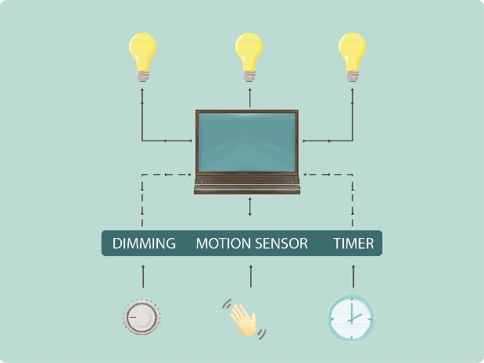Smart controls and LED technology allow for:

* remotely managing lights (computer controls)
* instant on and off switching of lights
* control of light colour (emerging technology)
* dimming, timers, flashing rate, motion sensors well defined directivity of light.

Adaptive controls should maximise the use of latest lighting technology to minimise unnecessary light output and energy consumption.

Figure 10 Use adaptive controls to manage light timing, intensity and colour.

### 3. Light only the intended object or area - keep lights close to the ground, directed and shielded

Light spill is light that falls outside the area intended to be lit. Light that spills above the horizontal plane contributes directly to artificial sky glow while light that spills into adjacent areas on the ground (also known as light trespass) can be disruptive to wildlife in adjacent areas. All light fittings should be located, directed or shielded to avoid lighting anything but the target object or area (Figure 11). Existing lights can be modified by installing a shield.

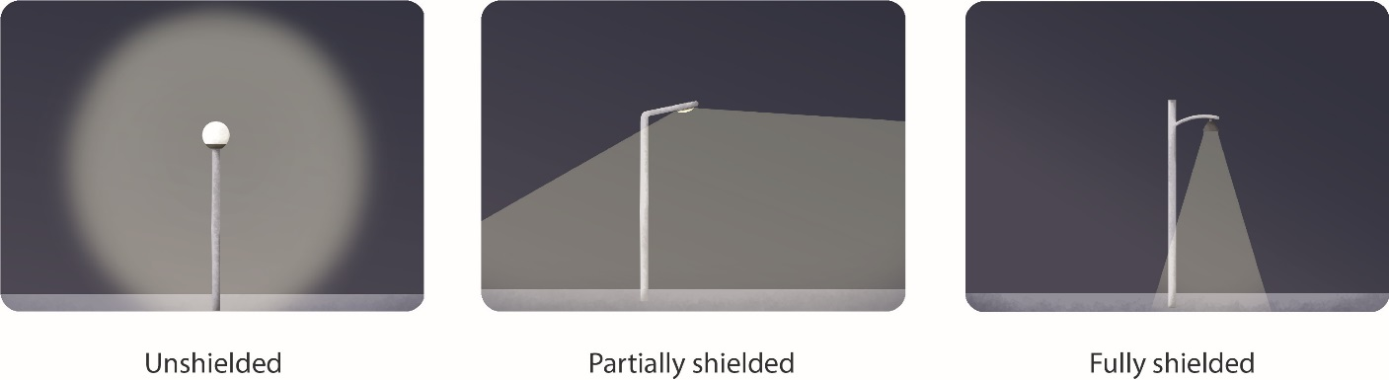

Figure 11 Lights should be shielded to avoid lighting anything but the target area or object. Figure adapted from Witherington and Martin (2003)3.

Lower height lighting that is directional and shielded can be extremely effective. Light fixtures should be located as close to the ground as possible and shielded to reduce sky glow (Figure 12).

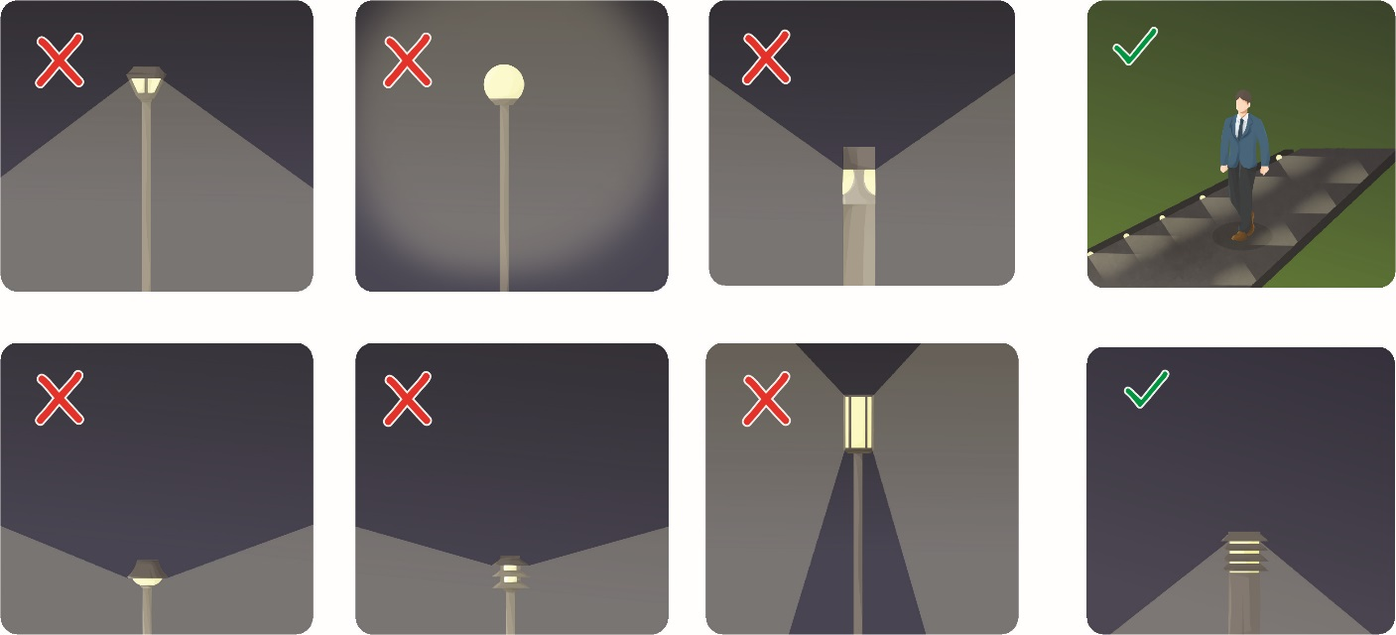

Figure 12 Walkway lighting should be mounted as low as possible and shielded. Figure adapted from Witherington and Martin (2003)3.

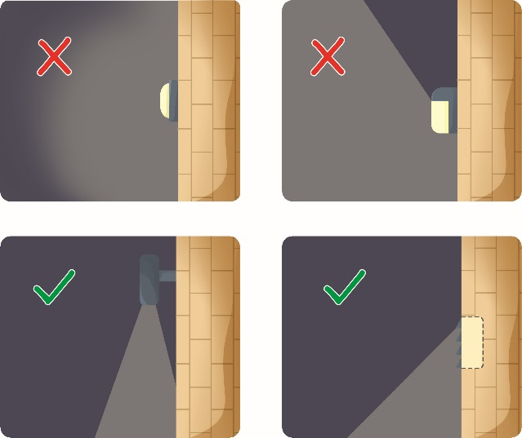Artificial light can be prevented from shining above the horizontal plane by ensuring the luminaire is mounted horizontally relative to the ground and not at an angle, or mounted on a building so that the structure prevents the light shining above the horizontal plane, for example recess a light into an overhanging roof eave. When determining angle of the mounting, consideration should be given to the reflective properties of the receiving environment.

If an unshielded fitting is to be used, consideration should be given to the direction of the light and the need for some form of permanent physical opaque barrier that will provide the shielding requirement. This can be a cover or part of a building (Figure 13). Care should be taken to also shield adjacent surfaces, if they are lightly coloured, to prevent excessive reflected light from adding to sky glow.

Figure 13 Lighting should be directed to ensure only the intended area is lit. Figure adapted from Witherington and Martin (2003)3.

Consideration should also be given to blocking light spill from internal light sources. This should include block-out blinds or shutters for transparent portions of a building, including sky lights, and use of glass in windows and balconies with reduced visible light transmittance values.

### 4. Use appropriate lighting

Lighting intensity should be appropriate for the activity. Starting from a base of no lights, use only the minimum number and intensity of lights needed to provide safe and secure illumination for the area at the time required to meet the lighting objectives. The minimum amount of light needed to illuminate an object or area should be assessed during the early design stages and only that amount of light installed. For example, Figure 14 provides options from best to worst for lighting for a parking lot.

Figure 14 Lighting options for a parking area. Figure adapted from Witherington and Martin (2003)3.

#### Off-the-shelf lighting design models

Use of computer design engineering packages that do not include wildlife needs and only recommend a standard lighting design for general application should be avoided or modified to suit the specific project objectives, location and risk factors.

#### Consider the intensity of light produced rather than the energy required to make it

Improvements in technology mean that new bulb types produce significantly greater amount of light per unit of energy. For example, LED lights produce between two and five times the amount of light as incandescent bulbs. The amount of light produced (lumen), rather than the amount of energy used (watt) is the most important consideration in ensuring that an area is not over lit.

#### *Consider re-evaluating security systems and using motion sensor lighting*

Technological advances mean that techniques such as computer managed infra-red tracking of intruders in security zones is likely to result in better detection rates than a human observer monitoring an illuminated zone.

#### Use low glare lighting

High quality, low glare lighting should always be a strong consideration regardless of how the project is to be designed. Low glare lighting enhances visibility for the user at night, reduces eye fatigue, improves night vision and delivers light where it is needed.

### 5. Use non-reflective, dark coloured surfaces

Light reflected from highly polished, shiny or light-coloured surfaces such as white painted infrastructure, polished marble or white sand can contribute to sky glow. For example, alternatives to painting storage tanks with white paint to reduce internal heating should be explored during front-end engineering design. In considering surface reflectance, the need to view the surface should be taken into consideration as darker surfaces will require more light to be visible. The colour of paint or material selected should be included in the Artificial Light Management Plan.

Figure 15 Use non-reflective dark coloured surfaces.

### 6. Use lights with reduced or filtered out blue, violet and ultraviolet wavelengths

Short wavelength light (blue) scatters more readily in the atmosphere and therefore contributes more to sky glow than longer wavelength light. Further, most wildlife are sensitive to short wavelength (blue/violet) light (for detailed discussion see What is Light and how do Wildlife Perceive it?). As a general rule, only lights with little or no short wavelength (400 – 500 nm) violet or blue light should be used to avoid unintended effects. Where wildlife are sensitive to longer wavelength light (e.g. some bird species), consideration should be given to wavelength selection on a case by case basis.

When determining the appropriate wavelength of light to be used, all lighting objectives should be taken into account. If good colour rendition is required for human use, then other mitigation measures such as tight control of light spill, use of head torches, or timers or motion sensors to control lights should be implemented.

It is not possible to tell how much blue light is emitted from an artificial light source by the colour of light it produces (see Light Emitting Diodes). LEDs of all colours, particularly white, can emit a high amount of blue light and the Colour Correlated Temperature (CCT) only provides a proxy for the blue light content of a light source. Consideration should be given to the spectral characteristics (spectral power distribution curve) of the lighting to ensure short wavelength (400 – 500 nm) light is minimised.

# Appendix B – What is Light and how does Wildlife Perceive it?

**A basic understanding of how light is defined, described and measured is critical to designing the best artificial light management for the protection of wildlife.**

**Humans and animals perceive light differently. However, defining and measuring light has traditionally focused exclusively on human vision. Commercial light monitoring equipment is calibrated to the sensitivity of the human eye and has poor sensitivity to the short wavelength light that is most visible to wildlife. Impacts of artificial light on wildlife vary by species and should be considered on a case by case basis. These issues should be considered when describing, monitoring and designing lighting near important wildlife habitat.**

## What is Light?

Light is a form of energy and is a subset of the electromagnetic spectrum that includes visible light, microwaves, radio waves and gamma rays (Figure 16). In humans, visible light ranges from 380 nm to 780 nm - between the violet and red regions of the electromagnetic spectrum. In animals, visible light ranges from 300 nm to greater than 700 nm, depending on the species. White light is a mixture of all wavelengths of light ranging from short wavelength blue to long wavelength red light.

The perception of different wavelengths as ‘colour’ is subjective and is described and characterised by how the human eye perceives light, ranging from red (700 nm), orange (630 nm), yellow (600 nm), green (550 nm), blue (470 nm), indigo (425 nm) and violet (400 nm) (Figure 16). Generally, this is not how animals see light (Figure 2).

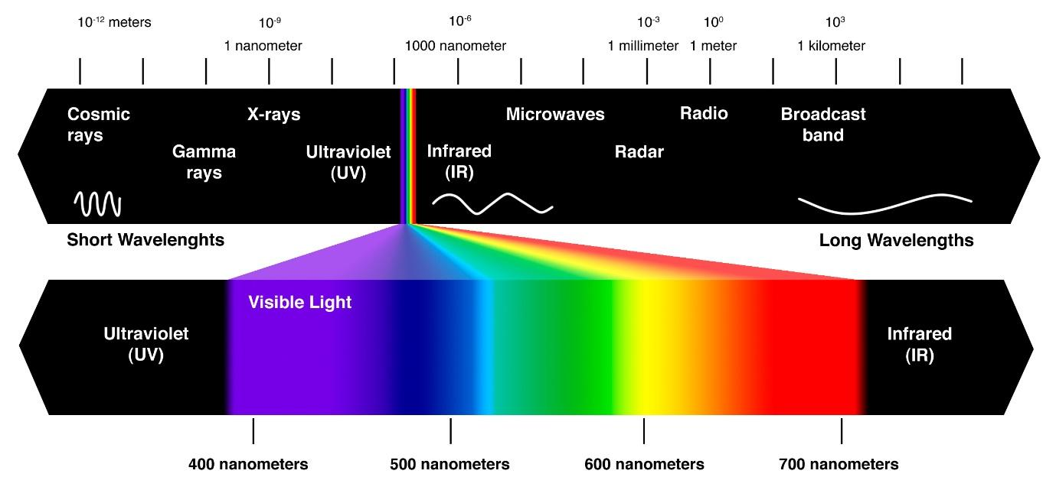

Figure 16 The electromagnetic spectrum. The 'visible light spectrum' occurs between 380-780 nm and is the part of the spectrum that the human eye can see. Credit: Mihail Pernichev34.

### Artificial light

Artificial light at night has many positive attributes. It can enhance human safety and provide for longer periods of work or recreation. However, it can also have a negative effect. For example, it can cause:

* physiological damage to retinal cells in human and animal eyes35
* disruption of the circadian cycles in vegetation, animals and humans2,13,36
* changes in animal orientation, feeding or migratory behaviour19,37-39.

The biological mechanisms that cause these effects vary. It is necessary to understand some basic light theory and language in order to assess and manage the effect of light on wildlife. Some basic principles are briefly described in this section.

## Vision in Animals

Vision is a critical cue for animals to orient themselves in their environment, find food, avoid predation and communicate7. Humans and wildlife perceive light differently. Some animals do not see long wavelength red light at all, while others see light beyond the blue-violet end of the spectrum and into the ultraviolet (Figure 17).

Both humans and animals detect light using photoreceptor cells in the eye called cones and rods. Colour differentiation occurs under bright light conditions (daylight). This is because bright light activates the cones and it is the cones that allow the eye to see colour. This is known as photopic vision.

Under low light conditions (dark adapted vision), light is detected by cells in the eye called rods. Rods only perceive light in shades of grey (no colour). This is known as scotopic vision and it is more sensitive to shorter wavelengths of light (blue/violet) than photopic vision.

The variation in the number and types of cells in the retina means animals and humans do not perceive the same range of colours. In animals, being ‘sensitive’ to light within a specific range of wavelengths means they can perceive light at that wavelength, and it is likely they will respond to that light source.



Figure 17 Ability to perceive different wavelengths of light in humans and wildlife is shown by horizontal lines. Black dots represent reported peak sensitivity. Note the common sensitivity to short wavelength light across all wildlife. Figure adapted from Campos (2017)8.

### Sensitivity to blue light

Sensitivity to high energy, short wavelength UV/violet/blue light is common in wildlife (Figure 17). This light is strongly detected under scotopic (dark adapted) vision, particularly in nocturnal species. Short wavelength light at the blue end of the spectrum has higher energy than longer wavelength light at the red end of the spectrum. This is important to understanding the physical impact that the short wavelength, high energy UV/blue light has on damaging photoreceptor cells in the human eye40. Although not well described in wildlife, it is not unreasonable to expect that at high intensities blue light has the potential to damage photoreceptors in wildlife.

In addition to the potential for physical damage to the eye from exposure to blue light (400 ‑ 490 nm), there is mounting evidence that exposure to these wavelengths at night may affect human and wildlife physiological functions. This is because a third type of photoreceptor cell has recently been identified in the retina of the mammalian eye – the photosensitive retinal ganglion cells (pRGCs). The pRGCs are not involved in image-forming vision (this occurs in the rods and cones), but instead are involved in the regulation of melatonin and in synchronising circadian rhythms to the 24-hour light/dark cycle in animals41. These cells are particularly sensitive to blue light42. Melatonin is a hormone found in plants animals and microbes. Changes in melatonin production can affect daily behaviours such as bird waking43, foraging behaviour and food intake44 and seasonal cues such as the timing of reproduction in animals, causing off-spring to be born during non-optimal environmental conditions5.

## Factors Effecting Perception of Light

Factors affecting how wildlife perceive light include the type of cells being employed to detect light (photopic vs scotopic vision); whether the light is viewed directly from the source or as reflected light; how the light interacts with the environment; and the distance from the light source. These influences are discussed below.

### Perspective

Understanding an animal’s perception of light will include consideration of the animal’s visual field. For instance, when flying, birds will generally be looking down on artificial light sources, whereas turtles on a nesting beach will be looking up. Further, some birds’ field of view will stretch around to almost behind their head.

### Bright vs dim light

Understanding photopic and scotopic vision is important when selecting the colour (wavelength) and intensity of a light. In animals scotopic (dark adapted) vision allows for the detection of light at very low intensities (Figure 18). This dark adaption may explain why nocturnal wildlife are extremely sensitive to white and blue light even at low intensities.

Figure 18 Scotopic and photopic luminosity functions in humans. Data source: [Luminosity functions](http://www.cvrl.org/lumindex.htm).

### Direct vs reflected

Understanding the difference between light direct from the source (luminance) and how much incident light illuminates a surface (illuminance) is important when selecting methods for measuring and monitoring light. Equipment used to measure illuminance and luminance is not interchangeable and will lead to erroneous conclusions if used incorrectly.

Luminance describes the light that is emitted, passing through or reflected from a surface that is detected by the human eye. The total amount of light emitted from a light is called luminous flux and represents the light emitted in all directions (Figure 19). Luminance is quantified using a Spectroradiometer or luminance meter.

Illuminance measures how much of the incident light (or luminous intensity) illuminates a surface. Illuminance is quantified using an Illuminance spectrophotometer or Lux meter.

The total amount of light emitted by a bulb is measured in lumens and is different to watts, which are a measure of the amount of power consumed by the bulb. Lumens, not watts, provide information about the brightness of a bulb.

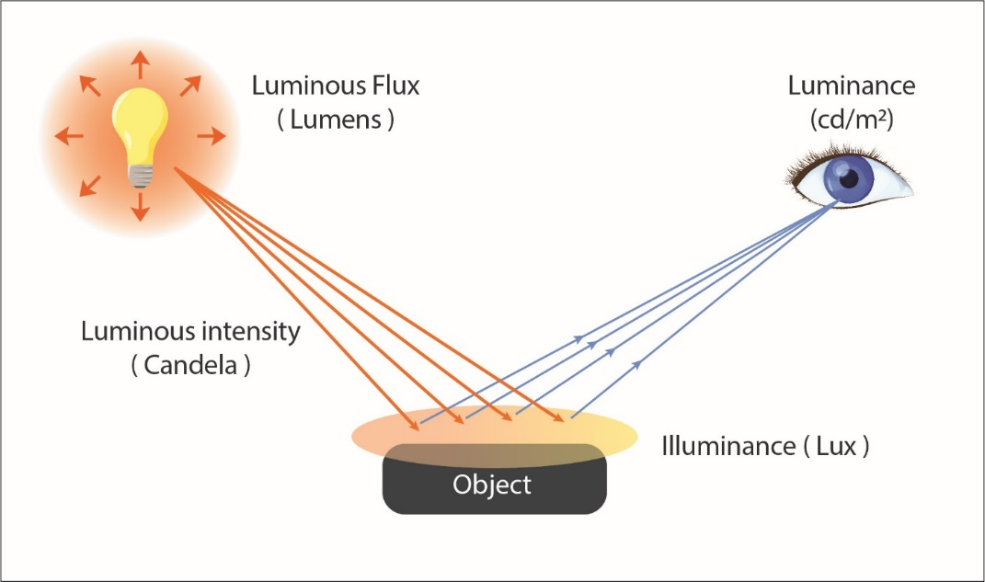

Figure 19 Luminous flux, luminance and illuminance.

### Visibility of light in the environment

The physical properties of light include reflection, refraction, dispersion, diffraction and scattering. These properties are affected by the atmosphere through which light travels. Short wavelength violet and blue light scatters in the atmosphere more than longer wavelength light such as green and red, due to an effect known as Rayleigh scattering45.

Scattering of light by dust, salt and other atmospheric aerosols increases the visibility of light as sky glow while the presence of clouds reflecting light back to earth can substantially illuminate the landscape46. Hence the degree of overhead sky glow is a function of aerosol concentration and cloud height and thickness.

#### Direct light vs sky glow

Light may appear as either a direct light source from an unshielded lamp with direct line of sight to the observer, or as sky glow (Figure 20). Sky glow is the diffuse glow caused by source light that is screened from view, but through reflection and refraction the light creates a glow in the atmosphere. Sky glow is affected by cloud cover and other particles in the air. Blue light scatters more in the atmosphere compared with yellow-orange light. Clouds reflect light well adding to sky glow.

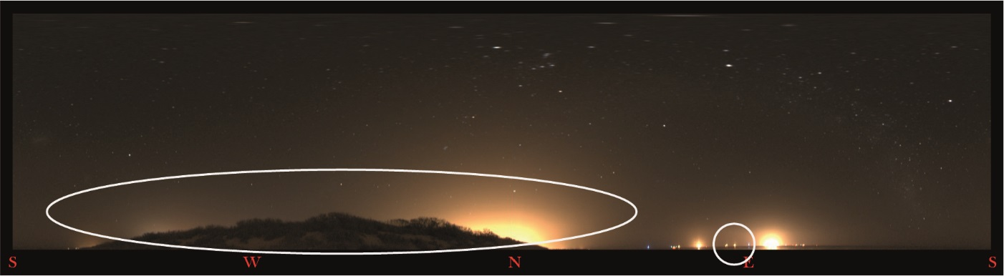

Figure 20 Sky glow created by lights shielded by a vegetation screen (circled left) and point sources of light directly visible (circled right).

#### Distance from light source

The physical properties of light follow the inverse square law which means that the visibility of the light, as a function of its intensity and spatial extent, decreases with distance from the source (Figure 21). This is an important factor to consider when modelling light or assessing the impact of light across different spatial scales, for example across landscape scales compared to within development footprint.

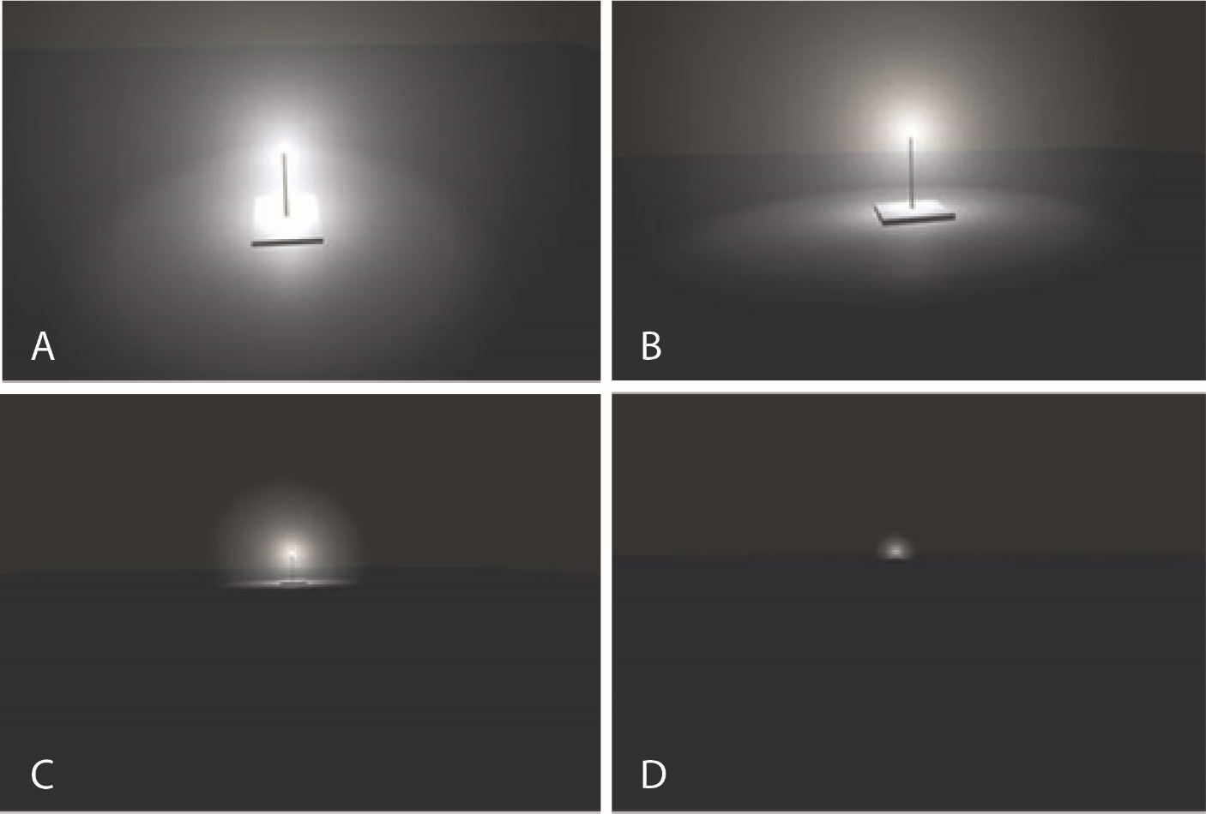

Figure 21 Modelled changes in the visibility of an unshielded 1000 W white LED viewed from A. 10 m; B. 100 m; C. 1 km and D. 3 km.

## Measurement of Light

Light has traditionally been measured photometrically or using measurements that are weighted to the sensitivity of the human eye (peak 555 nm). Photometric light is represented by the area under the Commission International de l’Eclairage (CIE) curve, but this does not capture all light visible to wildlife (Figure 22).

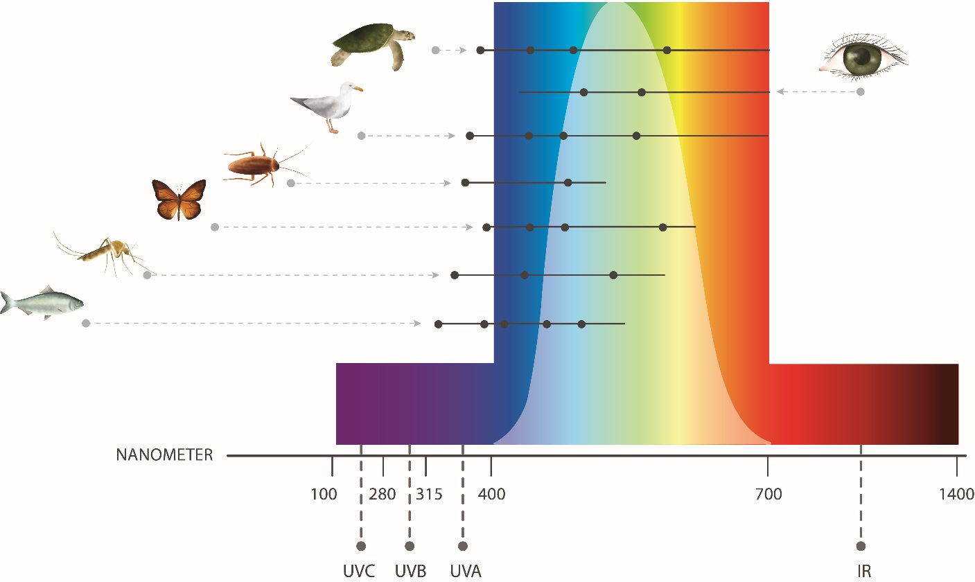

Figure 22 Photometric light represented by the area under the CIE curve (white area) compared with ability to perceive different wavelengths (black lines) and reported peak sensitivity (black dots) in humans and wildlife. Note the area under the CIE curve does not include much of the violet and ultra-violet light visible to many animals. Figure adapted from Campos (2017)8.

Light can also be measured radiometrically. Radiometric measurements detect and quantify all wavelengths from the ultra-violet (UV) to infrared (IR). The total energy at every wavelength is measured. This is a biologically relevant measure for understanding wildlife perception of light. Terminology, such as radiant flux, radiant intensity, irradiance or radiance all refer to the measurement of light across all wavelengths of the electromagnetic spectrum.

Understanding the difference between photometry (weighted to the sensitivity of the human eye) and radiometry (measures all wavelengths) is important when measuring light since many animals are highly sensitive to light in the blue and the red regions of the spectrum and, unlike photometry, the study of radiometry includes these wavelengths.

Photometric measures (such as, illuminance and luminance) can be used to discuss the potential impact of artificial light on wildlife, but their limitations should be acknowledged and taken into account as these measures may not correctly weight the blue and red wavelengths to which animals can be sensitive.

### Spectral curve

White light is made up of wavelengths of light from across the visible spectrum. A spectral power curve (Figure 23) provides a representation of the relative presence of each wavelength emitted from a light source. A lighting design should include spectral power distribution curves for all planned lighting types as this will provide information about the relative amount of light emitted at the wavelengths to which wildlife are most susceptible.

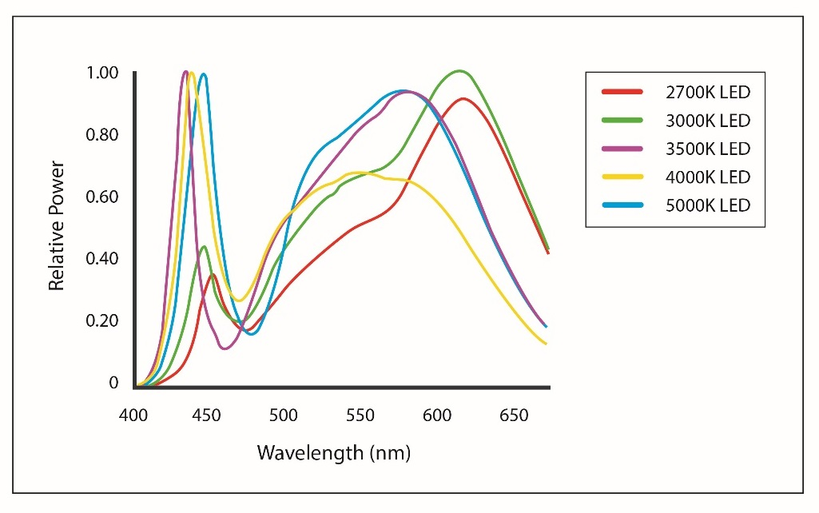

Figure 23 Spectral curves showing the blue content of white 2700‑5000 K LED lights. Note the difference in relative power output in the blue (400 ‑ 500 nm) wavelength range. Figure courtesy of Ian Ashdown.

## Light Emitting Diodes (LEDs)

Light emitting diodes are rapidly becoming the most common light type globally as they are more energy efficient than previous lighting technology. They can be smart controlled, are highly adaptable in terms of wavelength and intensity, and can be instantly turned on and off.

Characteristics of LED lights that are not found in older types of lamps, but which should be considered when assessing the impacts of LEDs on wildlife, include:

* With few exceptions, all LED lights contain blue wavelengths (Figure 23 and Figure 24).
* The wattage of an LED is a measure of the electrical energy needed to produce light and is not a measure of the amount or intensity of light that will be produced by the lamp.
* The output of light produced by all lamps, including LEDs, is measured in lumens (lm).
* LED lamps require less energy to produce the equivalent amount of light output. For example, 600 lm output of light requires 40 watts of energy for an incandescent light bulb and only 10 watts of energy for a LED lamp. Another was to look at this is that a 100 W incandescent bulb will produce the same amount of light as a 20 W LED. Consequently, it is important to not replace an old-style lamp with the equivalent wattage LED.
* Different LED lights with the same correlated colour temperature (CCT) can have very different blue content (Figure 24) yet can appear, to the human eye, to be a similar colour. As the colour temperature of a white LED increases so can the blue content (Figure 23). Little or none of this increase in blue wavelength light is measured by photometric equipment (i.e. lux meter, luminance, illuminance meter, Sky Quality Meter – see Measuring Biologically Relevant Light).
* LED technology allows for tuneable RGB colour management. This has the potential to allow for species specific management of problematic wavelengths (e.g. blue for most wildlife, but also yellow/orange).

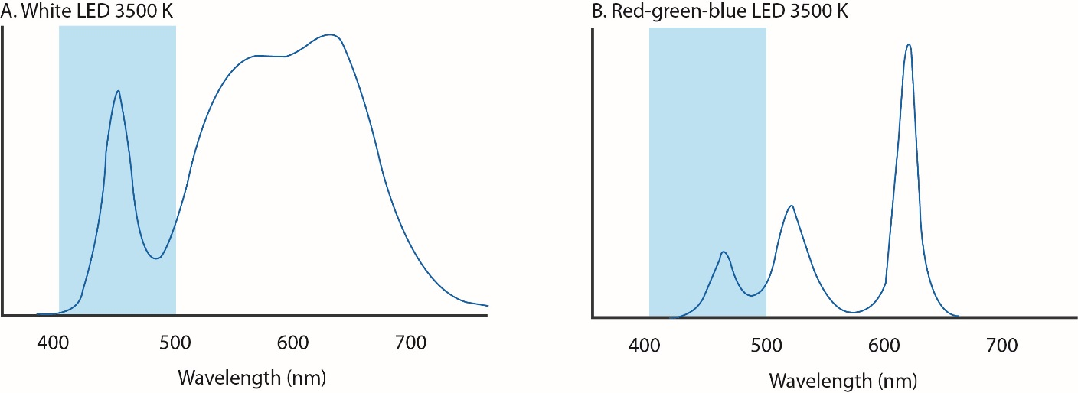

Figure 24 A comparison of the blue wavelength spectral content of two LED lights with the same CCT (3500k). The blue band shows the blue region of the visible spectrum (400–500 nm). The light in A has a much greater blue light content than B yet the two appear to the human eye as the same colour. For animals with differing sensitivities to light wavelength from humans, they may appear very different. Figure courtesy of Ian Ashdown.

### Correlated colour temperature (CCT)

This describes the colour appearance of a white LED. It is expressed in degrees Kelvin, using the symbol K, which is a unit of measure for absolute temperature. Practically, colour temperature is used to describe light colour and perceived “warmth”; lamps that have a warm yellowish colour have low colour temperatures between 1000K and 3000K while lamps characterised by a cool bluish colour have a colour temperature, or CCT, over 5000K (Figure 25).

Correlated colour temperature does not provide information about the blue content of a lamp. All LEDs contain blue light (Figure 23) and the blue content generally increases with increased CCT. The only way to determine whether the spectral content of a light source is appropriate for use near sensitive wildlife is to consider the spectral curve. For wildlife that are sensitive to blue light, an LED with low amounts of short wavelength light should be chosen, whereas for animals sensitive to yellow light9 LEDs with little or no light at peak sensitivity should be used47.

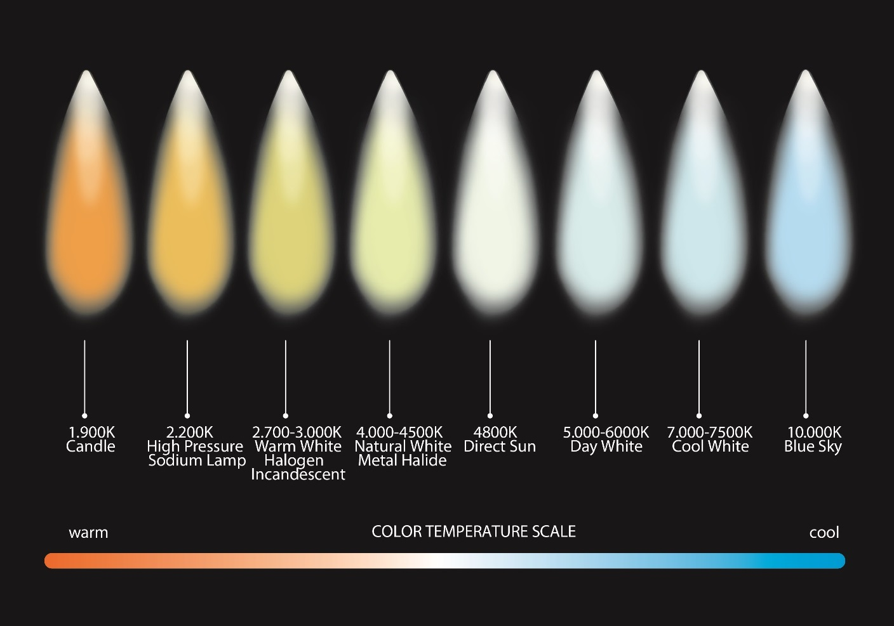

Figure 25 Correlated colour temperature (CCT) range from warm 1,000 K to cool 10,000 K.

# Appendix C - Measuring Biologically Relevant Light

**Animals and humans perceive light differently. Commercial light monitoring instruments currently focus on measuring the region of the spectrum most visible to humans. It is important to recognise and account for this fact when monitoring light for wildlife impact assessment purposes.**

**Commercial light modelling programs also focus on light most visible to humans and this should also be recognised and accounted for in the impact assessment of artificial light on wildlife.**

**Information critical to monitoring the effects of artificial light on wildlife include:**

* **Spatial extent of sky glow**
* **Bearings and intensity of light sources along the horizon**
* **Visibility of light (direct and sky glow) from wildlife habitats**
* **Spectral distribution of lights sources.**

## Describing the Light Environment

When describing the light environment consideration should be given to how wildlife is likely to perceive artificial light. Light measurements should be obtained from within important habitat and taken from a biologically relevant perspective (i.e. close to the ground/from the sky/under water). Consideration should also be given to elevation from the horizon, the spatial extent of sky glow and the wavelength distribution (spectrum) of light present.

It is important that light measurements are taken at appropriate times. This may include biologically relevant times (e.g. when wildlife is using the area). Baseline measurements should be taken when the moon is not in the sky and when the sky is clear of clouds and in the absence of temporary lighting (e.g. road works). Conditions should be replicated as closely as possible for before and after measurements.

## Measuring Light for Wildlife

Measuring light to assess its effect on wildlife is challenging and an emerging area of research and development. Most instruments used to measure sky glow are still in the research phase with only a few commercial instruments available. Further, the wide range of measurement systems and units in use globally makes it difficult to choose an appropriate measurement metric and often results cannot be compared between techniques due to variations in how the light is measured. There is currently no globally recognised standard method for monitoring light for wildlife.

### Radiometric vs photometric measurement techniques

Radiometric instruments detect and quantify light equally across the spectrum (see Measurement of Light) and are the most appropriate instruments for monitoring and measuring light for wildlife management. However, while the techniques to measure radiometric light are well developed in physics, astronomy and medicine, they are less well developed in measurement of light in the environment. The instruments currently being developed are largely the result of academic and/or commercial research and development, are expensive, and require specialised technical skills for operation, data analysis, interpretation and equipment maintenance.

The majority of both commercial and research instruments quantify photometric light, which is weighted to the sensitivity of the human eye, as per the CIE luminosity function curve described in Measurement of Light. Due to many photometers being modified with filters to mimic human vision, they do not accurately represent what an animal with high sensitivity to the blue (400 ‑ 500 nm) or the red (650 ‑ 700 nm) regions of the spectrum will see (Figure 22). In these cases, the sensitivity to this additional light must be accounted for when reporting results.

When using photometric instruments for monitoring light this insensitivity to the short and long wavelength regions of the spectrum should be recognised and accounted for in the assessment of impact. Information on the spectral power distribution of commercial lights is readily available from manufacturers and suppliers and should be used to inform any artificial light impact assessment or monitoring program. An example of the spectral power distribution curves for various light sources is shown in Figure 26, along with an overlay of the CIE curve that represents the light that is measured by all commercial photometric instruments.

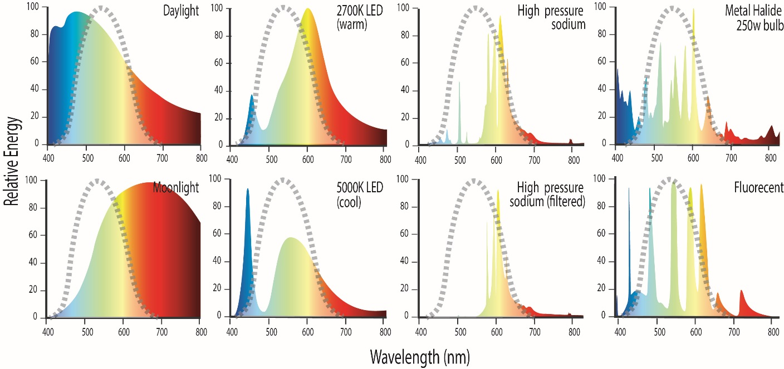

Figure 26 Photometric instruments only quantify light that is within the CIE curve (area under grey dashed line). This is shown in comparison with the spectral curves of a range of different light sources.

Recognising that light monitoring instruments for wildlife are in the developmental stage and that there is a lack of agreed methods and measurement units, monitoring programs should aim to measure relevant short and long wavelengths (if possible). The measurement methods should be clearly described including the region of the spectrum measured, and where not measures, how the short and long wavelength regions are being accounted for. Methods to do this might include a visual assessment of the colour of light in the sky from direct observation or imagery, where orange glow is typically associated with long wavelength rich lights (High Pressure Sodium, HPS, Low Pressure Sodium, LPS, PC Amber LED or Amber LED) and white glow is associated with white light sources rich in short wavelength blue light (white LEDs, halogens, fluorescents, metal halide etc.).

Alternatively photometric instruments can be used under conditions where the majority of light sources are the same, for example street lighting or industrial facilities. Monitoring results can be compared for measurements taken of the same light types (e.g. comparing two HPS sources, spatially or temporally), but in the context of wildlife monitoring cannot be used to compare light from an HPS and an LED since they have different wavelength distributions. This limitation must be taken into account when using photometric instruments to measure cumulative sky glow, which may include light from multiple sources and light types. Detailed qualitative spectral information on light types can also be collected to ground truth and confirm light types contributing to sky glow.

A light monitoring program might therefore include the collection of a range of different characteristics of light (e.g. colour, light type, areal extent, spectral power distribution, and intensity) using various instruments and techniques. These methods and techniques, including all of the limitations and assumptions, should be clearly stated and considered when interpreting results. A review of various instrumental techniques for monitoring light is provided below.

In selecting the most appropriate measuring equipment to monitor the biological impacts of light on wildlife, it is important to decide what part of the sky is being measured: horizon, zenith (overhead) or whole sky. For example, marine turtles view light on the horizon between 0° and 30° vertically and integrate across 180° horizontally48, so it is important to include measurement of light in this part of the sky when monitoring for the effects on hatchling orientation during sea-finding. In contrast, juvenile shearwaters on their first flight view light in three dimensions (vertically, from below and above) as they ascend into the sky. Overhead sky glow (zenith) measurements are important when the observer is trying to avoid glare contamination by point sources of light low on the horizon. Quantifying the whole of sky glow is important when measuring the effects of cloud cover, which can reflect light back to illuminate an entire beach or wetland.

The effect of light on wildlife is a function of the animal’s sensitivity and response to light, and the cues it uses during orientation, dispersal, foraging, migrating etc. Most wildlife appear to respond to high intensity short wavelength light, point sources of light, sky glow and directional light. Consequently, the information likely to be needed to monitor light for wildlife includes:

* The brightness of the entire sky from horizon to horizon.
* The bearing to, intensity of and spectrum of light (point sources and sky glow) on the horizon. This will dictate the direction in which wildlife can be disoriented.
* The spatial extent of glow near the horizon. A large area of glow on the horizon is likely to be more visible and disruptive to wildlife than a small area of glow.
* Presence or absence of clouds. Clouds reflect light from distant sources very well, making an inland source highly visible on the coast, for example. Sky glow is a function of cloud height, albedo and thickness.
* Qualitative information on the light visible to wildlife. An image of light pollution visible from wildlife habitat can show the spatial extent of light in the sky and direction (see Figure 20) and in some cases provide information on the light source type (e.g. orange sky glow will be caused by HPS lights or amber LEDs).
* Emission spectra (colour) of the light. It is particularly important to identify light in the UV-blue region of the visible spectrum (<500 nm) since this is the light commonly visible and disruptive to wildlife.

## Measurement Techniques

Currently, there are no generally agreed methods for measuring biologically relevant light for wildlife or for quantifying sky glow49. This is because most conventional methods of measuring light are photometric, quantifying only the light under the CIE curve that is most relevant to the human perception of light. Further, they do not consider the entire night sky.

There is a need to develop reasonably priced, easily accessible and deployable, repeatable methods for monitoring biologically relevant light that captures the whole visual field to which wildlife may be exposed (generally horizon to horizon)49. These methods should be capable of quantifying all wavelengths of light equally (radiometric) including at least 380 – 780nm, or capable of being calibrated over the range of wavelengths of relevance for the species of interest. Optimal methods will have a sensitivity to detect and measure change at the low light levels represented by artificial light sky glow and must have the ability to differentiate between individual point sources of light (on a local scale) and sky glow on a landscape scale (i.e. over tens of kilometres).

It should be noted that measurements needed to assess the impact of sky glow to wildlife may need to be different from the measurements required to assess light for human safety.

Recognising that techniques to monitor biologically meaningful light are expected to continuously develop and improve, this section summarises the state of the science as of 2020 as an example of current techniques. It is anticipated novel methods will be developed with time that will meet the objectives of monitoring biologically meaningful light and where that occurs, the methods and techniques, including all of the limitations and assumptions, should be clearly stated for all monitoring programs.

Recent reviews have considered various commercial and experimental instrumental techniques used around the world for quantifying sky glow49,50. The reviews assessed the benefits and limitations of the various techniques and made recommendations for measuring light pollution. Some of these instruments, their benefits and limitations are discussed below and summarised in Table 1.

Light can be measured in different ways, depending on the objective, landscape scale and point of view and include:

* remote sensing
* one dimensional (single channel) instruments
* calibrated all-sky imagery (numerical and imaging)
* spectroscopy/spectroradiometry.

### Remote sensing

The upward radiance of artificial light at night can be mapped via remote sensing using satellite or aerial imagery and optical sensors. This information has been used as a socioeconomic indicator to observe human activity, and increasingly as a tool to consider the impacts of artificial light on ecosystems51. Examples are:

* [The New World Atlas of Artificial Night Sky Brightness](https://advances.sciencemag.org/content/2/6/e1600377/tab-figures-data)
* [Light Pollution Map](https://www.lightpollutionmap.info)

Benefits: The images are useful as broad scale indicators of light pollution and for targeting biological and light monitoring programs. This technique may be a good starting point to identify potentially problematic areas for wildlife on a regional scale. Images collected via drones or aircraft maybe useful for consideration of artificial light impacts on bird and bat migrations.

Limitations: Maps derived from satellite collected information have limited value in quantifying light for wildlife. The images are a measure of light after it has passed though the atmosphere and been subject to scattering and absorption. They do not give an accurate representation of the light visible to wildlife at ground level. The annual composite images are made from images collected under different atmospheric conditions and therefore they cannot be used to confidently quantify light within or between years. The most commonly used instrument (VIIRS DNB) is not sensitive to blue light, so light in this part of the spectrum is under sampled. As satellite with more sophisticated sensors are launched it is expected the value of this technique to biological monitoring will improve.

Application to wildlife monitoring programs: Whilst remote sensing tools may provide a good starting point for identifying artificial light that is problematic for wildlife on a regional scale, they are currently not an appropriate approach for measuring light as part of a wildlife monitoring program as they do not accurately quantify light as observed from the ground, they underestimate the blue content of light, and results are not repeatable due to environmental conditions. Images collected via aircraft or drone may have application for monitoring impacts on airborne wildlife.

### One dimensional (single channel) instruments

These instruments measure sky glow using a single channel detector, producing a numerical value to represent sky glow, typically at the zenith. They are generally and portable and easy to use. They measure sky glow, but cannot derive point source information unless they are close enough such that most of the light detected is emitted from those sources. Examples of single channel instruments are discussed below.

Sky Quality Meter (SQM)

This is a small handheld unit that quantifies the light in an area of sky (normally directly overhead at the zenith). Early models had a field of view of around 135° with the more recent SQM-L model having a narrower 40° diameter field of view. It measures photometric light in units of magnitudes/arcsec2 at relatively low detection limits (i.e. it can measure sky glow). Instrument accuracy is reported at ±10 per cent though a calibration study on a group of SQM instruments in 2011 found errors ranging from ‑16 per cent to +20 per cent52. Long term stability of SQMs has not been established.

Reviewers suggest that the first 3-4 measurements from a handheld SQM should be discarded, then the average of four observations should be collected by rotating the SQM 20° after each observation to obtain a value from four different compass directions so that the effects of stray light can be minimised or identified50. If the measurements vary by more than 0.2 mag/arcsec2 the data should be discarded and a new location for measurements selected. Data should not be collected on moonlit nights to avoid stray light contaminating the results.

Benefits: The SQM is cheap, easy to use and portable. Some versions have data-logging capabilities that enable autonomous operation in the field. The sensitivity of the SQM is sufficient to detect changes in overhead night time artificial lighting under a clear sky.

Limitations: SQMs cannot be used to resolve individual light sources a distance, identify light direction nor can they measure light visible to many wildlife species. The precision and accuracy of the instrument can vary substantially and an intercalibration study is recommended to quantify the error of each instrument. Although the SQM is designed to have a photopic response, it is generally more sensitive to shorter wavelengths (i.e. blue) than a truly photopic response, but this will depend on the individual instrument. It is not very sensitive to longer (orange/red) wavelengths50. The SQM should not be used to measure light within 20° of the horizon as the detector is designed to measure a homogeneous sky (such as occurs at the zenith) and does not produce valid data when point at a heterogeneous field of view as observed at the horizon.

Application to wildlife monitoring programs: A sky quality meter can be used to measure sky glow directly overhead (zenith) at the wildlife habitat, however, it is important to recognise its limitations (such as the absence of whole of sky information and inability to measure point sources of light on the horizon) and follow methods recommended by Hänel et al (2018)50 to ensure repeatability.

#### Dark Sky Meter

This is an iPhone app that uses the phone camera to collect light and generate a sky brightness value.

Benefits: It’s cheap and easy to use.

Limitations: The Dark Sky Meter is a photometric instrument. It’s restricted to Apple iPhones. It will not work on models older than the 4S and cannot be used to resolve individual lights or identify light direction. It is relatively imprecise and inaccurate50 and cannot reliably measure light on the horizon.

Application to wildlife monitoring programs: The Dark Sky Meter app is not an appropriate tool for monitoring light impacts on wildlife as it doesn’t measure biologically relevant light. It doesn’t provide whole of sky information, it isn’t able to resolve individual light sources and it is relatively imprecise and inaccurate. The Dark Sky Meter should be considered more of an educational tool than a scientific instrument.

#### Lux Meters and Luminance Meters

Lux meters are commercially available instruments commonly used to measure individual light sources at close range (i.e. over metres rather than landscape scale). However, the inverse square law can be used to calculate the illuminance if the distance is known. Lux and luminance meters measure photometric light. Lux meters measure the light falling on a surface and luminance meters measure the light incident from a specific solid angle.

Benefits: Both can be cheap (with more expensive models available) and easy to use.

Limitations: Both types of devices are photometric, but measurements are weighted to human perception rather than wildlife. Depending on the sensitivity of equipment, detection limits may not be low enough to measure typical night sky brightness or illuminance and therefore cannot measure sky glow for wildlife monitoring purposes. Lux meters have no angular resolution and luminance meter are coarse so they cannot be used to measure distant light sources at the horizon precisely.

Application to wildlife monitoring programs: Commercial lux and luminance meters are not appropriate for the measurement of light in wildlife monitoring programs because they have low sensitivity and low accuracy at low light levels. Expensive tailored devices with enhanced sensitivity may exist, but are still not applicable to wildlife monitoring as they do not measure biologically relevant light and are not appropriate for use on a landscape scale.

### Calibrated all-sky imagery

These instruments map and measure sky brightness by analysing photographic images of the whole sky. The images are processed to derive a luminance value for all or parts of the sky. One of the advantages of two dimensional (wide angle) imaging is that models of natural sources of light in the night sky can be subtracted from all sky imagery to detect anthropogenic sources53. Some examples of devices and techniques to map and measure night sky brightness using wide-angle images are discussed below.

#### All*-Sky Transmission Monitor (ASTMON)*

This charge-coupled device (CCD) astronomical camera with fish-eye lens has been modified by the addition of a filter wheel to allow collection of data through four photometric bands in the visible spectrum. The spectral range of the instrument is dependent on the sensitivity of the detector and the filters used, but has the advantage of being accurately calibrated on stars.

Benefits: The ASTMON was designed for outdoor installation and the Lite version is portable with a weather-proof enclosure allowing it to remain outdoors operating robotically for weeks. It reports data in magnitudes/arcsec2 for each band and has good precision and accuracy50. Once the system is calibrated with standard stars, it can provide radiometric data for the whole night sky as well as resolve individual light sources.

Limitations: The ASTMON is expensive and requires specialised knowledge to operate and interpret data. The software provided is not open source and so cannot be modified to suit individual requirements. The ASTMON may no longer be commercially available. The CCD cameras used also have a limited dynamic range.

Application to wildlife monitoring programs: The ASTMON is appropriate for monitoring artificial light for wildlife as it provides whole night sky measurements that can be calibrated to give biologically relevant information that is accurate and repeatable.

#### Digital Camera Equipped with Wide Angle and Fisheye Lenses

This approach is similar to the ASTMON, except using a commercial digital camera with an RGB matrix rather than a CCD camera with filter wheel, making the system cheaper and more transportable. This system provides quantitative data on the luminance of the sky in a single image54,55.

Benefits: The cameras are easily accessible and portable. When precision is not critical, the directional distribution of night sky brightness can be obtained. At the very least, the use of a digital camera with a fisheye lens allows for qualitative imagery data to be collected and stored for future reference and data analysis. If standard camera settings are used consistently in all surveys, it is possible to compare images to monitor spatial and temporal changes in sky brightness. This system also provides multi-colour options with red green and blue spectral bands (RGB).

Limitations: Cameras must be calibrated before use and this, together with the specific camera model, will dictate the precision of the measurements. Calibration for data processing requires lens vignetting (also known as flat fielding), geometric distortion, colour sensitivity of the camera, and sensitivity function of the camera. Specialised knowledge is required to process and interpret these images. Also, like CCD cameras, the detectors in digital cameras have a limited dynamic range which can easily saturate in bright environments. In addition, fisheye systems often produce the poorest quality data at the horizon where the distortion due to the lens is the greatest.

Calibrating the camera is difficult and standard methods have not been developed. Laboratory or astronomical photometric techniques are generally used which require specialist knowledge and expertise. A precision of ~10 per cent can be achieved using this technique. Standard commercial cameras are calibrated to the human eye (e.g. photometric), however, the ability to obtain and process an image allows for qualitative assessment of light types (based on the colour of sky glow), which provides additional data for interpreting the biological relevance of the light.

Application to wildlife monitoring programs: A digital camera equipped with wide angle or fisheye lenses is appropriate for measuring light in wildlife monitoring programs as it provides horizon to horizon information with enough sensitivity and accuracy to detect significant changes in low light environments. Images allow for detection of both sky glow, light source type, and point source information. When data is manually processed biologically relevant measurements can be obtained. Because the system is fast, dynamics of sky glow and direct light can be monitored56.

#### All Sky Mosaics

This technique was developed by the US National Parks Service and provides an image of the whole of the sky by mosaicking 45 individual images. The system comprises a CCD camera, a standard 50 mm lens, an astronomical photometric Bessel V filter with IR blocker and a computer controlled robotic telescope mount. Data collection is managed using a portable computer, commercial software and custom scripts.

Benefits: The angular resolution, precision and accuracy of the system is good, and it is calibrated and standardised on stars. The images produced have high resolution. The system is best suited for long term monitoring from dark sky sites. However, with the addition of a neutral density filter, the luminance or illuminance of a near-by bright light source can be measured. Also, other photometric bands can be measured with the use of additional filters.

Limitations: The system is expensive and requires specialised knowledge to operate the system, analyse and interpret the data. These cameras are calibrated to the human eye with the inclusion of a visible filter, however the ability to obtain and process an image allows for qualitative assessment of light types in the (based on the colour of sky glow), which provides additional data for interpreting the biological relevance of the light. Measurement procedures are time consuming and require perfect clear sky conditions and single spectral band, or repeated measurements are required.

Application to wildlife monitoring programs: All sky mosaics would be an appropriate tool for monitoring of artificial light for wildlife. They provide whole of sky images with high resolution and with appropriate filters can be used to measure biologically relevant wavelength regions.

### Spectroscopy/spectroradiometry

Different light types produce a specific spectral signature or spectral power distribution (for example Figure 26). Using a spectrometer it is possible to separate total sky radiance into its contributing sources based on their spectral characteristics. Being able to assess the impacts of different light sources is of relevance during this time of transition in lighting technology.

Where wildlife sensitivity to particular wavelength regions of light is known, being able to capture the spectral power distributions of artificial light and then predict how the light will be perceived by wildlife will be of particular benefit in assessing the likely impacts of artificial light.

This type of approach has been utilised in astronomy for a long time, but only recently applied to measurement and characterisation of light pollution on earth. An example of a field deployable spectrometer - the Spectrometer for Aerosol Night Detection (SAND) is described below.

#### Spectrometer for Aerosol Night Detection (SAND)

SAND uses a CCD imaging camera as a light sensor coupled with a long slit spectrometer. The system has a spectral range from 400 – 720 nm and is fully automated. It can separate sampled sky radiance into its major contributing sources.

Benefits: This approach can quantify light at specific wavelengths across the spectrum (radiometric) so it can measure light visible to wildlife. It can also be used to ‘fingerprint’ different light types.

Limitations: Calibration, collection and interpretation of these data requires specialist knowledge and equipment and is expensive. SAND does not provide whole sky information.

Application to wildlife monitoring programs: The use of a portable spectrometer that can identify light types based on their spectral power distribution or measure light at specific wavelengths of interest would be a useful contribution to a wildlife monitoring program. Unfortunately, the prototype SAND instrument is no longer in operation. However, this instrument exemplifies the type of approaches that will be of benefit for measuring light for wildlife in the future.

### Most appropriate instrument for measuring biologically relevant light

The most appropriate method for measuring light for wildlife will depend on the species present and the type of information required. In general, an appropriate approach will quantify light across the whole sky, across all spectral regions, differentiating point light sources from sky glow and it will be repeatable and easy to use.

At the time of writing, the digital camera and fisheye lens technique was recommended by Hänel et al (2018) and Barentine (2019) as the best compromise between cost, ease-of-use and amount of information obtained when measuring and monitoring sky glow. Hänel et al (2018) did, however, recognise the urgent need for the development of standard software for calibration and displaying results from light monitoring instruments50. In the future, hyperspectral cameras with wide field of view might become available combining the advantages of spectroradiometry and all-sky imagery. However, such devices do not currently exist.

It should be noted that this field is in a stage of rapid development and this Technical Appendix will be updated as more information becomes available.

Table 1 Examples of instrumental light measurement techniques (modified from Hänel et al, 201850). Abbreviations: Num. val. = Numerical value; Spec. Knowl. = Specialist Knowledge required; Req. calibration = requires calibration.

|  |  |  |  |  |  |  |  |  |  |
| --- | --- | --- | --- | --- | --- | --- | --- | --- | --- |
| **Instrument** | **Measurement Units** | **Detect Sky Glow** | **Data Type** | **Spectrum measured** | **Scale** | **Measures biologically relevant light** | **Commercially Available** | **Data Quality** | **Price#** |
| *Remote sensing:* |  |  |  |  |  |  |  |  |  |
| Satellite imagery | Various | Yes* | Images + num. val. | Single band | Landscape | No | Yes | Mod-high | Some datasets free |
| *One dimensional*: |  |  |  |  |  |  |  |  |  |
| Sky Quality Meter (SQM) | magSQM/arcsec2 | Yes | Num. val. | Single band | Overhead | No§ | Yes | Mod | < $300 |
| Dark Sky Meter (iPhone) | ~magSQM/arcsec2 | Yes | Num. val. | Single band | Overhead | No | Yes | Low | $0 |
| Luxmeter | lux | No | Num. val. | Single band | Metres | No | Yes | Low | < $300 |
| *Two dimensional*: |  |  |  |  |  |  |  |  |  |
| ASTMON | magv/arcsec2 | Yes | Image + num. val. | Multi band filter wheel | Whole sky | Req. calibration | No | High | >$15,000 |
| DSLR + fisheye | ~cd/m2, ~magv/arcsec2 | Yes | Image + num. val.. | Multi band RGB | Whole sky | Req. calibration | Yes | Mod-high | >$2,500 |
| All sky mosaic | cd/m2, magv/arcsec2 | Yes | Image + num. val.. | Single band | Whole sky | Req. calibration | No | High | ~ $20,000 |
| *Spectroradiometry:* |  |  |  |  |  |  |  |  |  |
| SAND¥ | W/(m2nm sr) | Yes | Spectral power curve | Multi band hyperspectral | Landscape | Yes | No | Mod-high | $7,000 |

# Price as at 2018.

* Via modelling

§ Some sensitivity to short (blue) wavelengths, but not long (orange red) wavelengths.

¥ Spectrometer for Aerosol Night Detection (SAND).

## Modelling Predicted Light

### Available commercial light models

Most modelling software that is currently available is problematic as the models are weighted towards a human perception of light as represented by the CIE/photometric curve and do not account for the light to which wildlife are most sensitive. For example, most wildlife is sensitive to short wavelength violet and blue light (Figure 17), but little or none of this light is measured by commercial instruments and consequently it is not accounted for in current light models.

A second limitation of many light models for biology is the inability to accurately account for environmental factors, such as: atmospheric conditions (moisture, cloud, rain, dust); site topography (hills, sand dunes, beach orientation, vegetation, buildings); other natural sources of light (moon and stars); other artificial sources of light; the spectral output of luminaires; and the distance, elevation, and viewing angle of the observing species. Such a model would involve a level of complexity that science and technology has yet to deliver.

A final major limitation is the lack of biological data with which to confidently interpret a model outcome. Therefore, it is not possible to objectively estimate how much artificial light is going to cause an impact on a particular species, or age class, over a given distance and under variable environmental conditions.

Recognising these limitations, it can still be valuable to model light during the design phase of new lighting installations to test assumptions about the light environment. For example, models could test for the potential for light spill and line of sight visibility of a source. These assumptions should be confirmed after construction.

Development of modelling tools that can take account of broad spectral data and environmental conditions are in the early stages of development but rapidly improving49.

# Appendix D – Artificial Light Auditing

**Industry best practice requires onsite inspection of a build to ensure it meets design specifications. An artificial light audit should be undertaken after construction to confirm compliance with the artificial light management plan.**

**An artificial light audit cannot be done by modelling of the as-built design alone and should include a site visit to:**

* **Confirm compliance with the artificial light management plan**
* **Check as-built compliance with engineering design**
* **Gather details on each luminaire in place**
* **Conduct a visual inspection of the facility lighting from the wildlife habitat**
* **Review the artificial light monitoring at the project site**
* **Review artificial light monitoring at the wildlife habitat.**

Following completion of a new project or modification/upgrade of the lighting system of an existing project, the project should be audited to confirm compliance with the artificiallight management plan.

## Step-by-Step Guide

The steps to carry out an artificial light audit include:

* Review of the artificiallight management plan
* Review of best practice light management or approval conditions
* Review of as-built drawings for the lighting design
* Check for compliance with the approved pre-construction (front end) lighting design;
* Conduct a site inspection both during the day and at night to visually check and measure the placement, number, intensity, spectral power output, orientation, and management of each lamp and lamp type. Where possible this should be done with the lighting in operation and with all lighting extinguished.
* Measurements should be taken in a biologically meaningful way. Where there are limitations in measurements for wildlife these should be acknowledged.
* Record, collate and report on the findings and include any non-conformances. This should consider any differences between baseline and post construction observations. Where lighting outputs were modelled as part of the design phase, actual output should be compared with modelled scenarios.
* Make recommendations for any improvements or modifications to the lighting design that will decrease the impact on wildlife.

The audit should be conducted by an appropriately qualified environmental practitioner/technical specialist during a site visit. The audit should also include:

* A visual inspection of the facility lighting from the location of the wildlife habitat and where feasible the perspective of the wildlife (i.e. sand level for a marine turtle)
* Artificial light monitoring at the project site
* Artificial light monitoring at the wildlife habitat.

A post-construction site visit is critical to ensure no previously unidentified lighting issues are overlooked.

# Appendix E – Artificial Light Management Check List

Table 2 provides a check list of issues to be considered during the environmental assessment of new infrastructure involving artificial light, or upgrades to existing artificial lighting for both proponents and assessors. Table 3 provides a check list of issues to be considered for existing infrastructure with external lighting where listed species are observed to be impacted by artificial light. Relevant sections of the Guidelines are provided for each issue.

Table 2 Checklist for new developments or lighting upgrades.

| Issue to be considered | Light owner or manager | Regulator | Further information |
| --- | --- | --- | --- |
| *Pre-development* | | | |
| What are the regulatory requirements for artificial light for this project? | Is an environmental impact assessment required? What other requirements need to be addressed? | What information should be sought from the proponent as part of the assessment process? | Regulatory considerations for the management of artificial light |
| Does the lighting design follow principles of best practice? | What is the purpose of the artificial light for this project? | Does the project use the principles of best practice light design? | Best practice light design |
| What wildlife is likely to be affected by artificial light? | Review species information within 20 km of the proposed development. | Assess species information. | Wildlife and artificial light |
| What light management and impact mitigation will be implemented? | What light mitigation and management will be most effective for the affected species? | Is the proposed management and mitigation likely to reduce the effect on listed species? | Species specific technical appendices and species expert guidance |
| How will light be modelled? | Is light modelling appropriate? How will the model be used to inform light management for wildlife? | Are the limitations of light modelling for wildlife appropriately acknowledged? | Modelling predicted light |
| Have all lighting-relevant considerations been included in the light management plan? | Have all steps in the EIA process been undertaken and documented in the light management plan? | Does the light management plan comprehensively describe all steps in the EIA process? | Environmental impact assessment for effects of artificial light on wildlife  Light Management Plan |
| How will continuous improvement be achieved? | How will light management be evaluated and adapted? | Is a continuous review and improvement process described? | Light Management Plan |
| *Post development* | | | |
| How will lighting be measured? | What is the most appropriate technique(s) for measuring biologically relevant light and what are the limitations? | Ensure appropriate light measurement techniques are used and limitations of the methods recognised. | Measuring biologically relevant light |
| How will lighting be audited? | What is the frequency and framework for in-house light auditing? | How will the results of light audits feedback into a continuous improvement process? | Artificial light auditing |
| Is artificial light affecting wildlife? | Does the biological monitoring indicate an effect of artificial light on fauna and what changes will be made to mitigate this impact? | Is there a process for addressing monitoring results that indicate there is a detectable light impact on wildlife, and is it appropriate? | Wildlife and artificial light  Light Management Plan  Managing existing light pollution |
| What adaptive management can be introduced? | How will the results of light audits and biological monitoring be used in an adaptive management framework, and how will technological developments be incorporated into artificial light management? | What conditions can be put in place to ensure a continuous improvement approach to light management? | Light Management Plan |

Table 3 Checklist for existing infrastructure

|  |  |  |  |
| --- | --- | --- | --- |
| Consideration | Light owner or manager | Regulator | Further information |
| Are wildlife exhibiting a change in survivorship, behaviour or reproduction that can be attributed to artificial light? | What listed species are found within 20 km of light source? Are there dead animals or are animals displaying behaviour consistent with the effects of artificial light? | Is there evidence to implicate artificial light as the cause of the change in wildlife survivorship, behaviour or reproductive output?  Review existing environmental approvals. | Describe wildlife  Wildlife and artificial light  Regulatory considerations for the management of light  Species expert advice |
| Is lighting in the area best practice? | Are there modifications or technological upgrades that could be made to improve artificial light management? | Are there individual light owners or managers who can be approached to modify current lighting? | Principles of best practice light management |
| Is the light affecting wildlife from a single source or multiple sources? | Are there multiple stakeholders that need to come together to address the cumulative light pollution? | Is there a role for government to facilitate collaboration between light owners and managers to address light pollution? | Managing existing light pollution  Light Management Plan |
| Can appropriate monitoring be undertaken to confirm the role of artificial light in wildlife survivorship, behavioural or reproductive output changes? | How much light is emitted from my property and is it affecting wildlife? | Facilitate wildlife monitoring. | Field surveys for wildlife  Measuring biologically relevant light  Species expert advice |
| How will artificial light be audited? | What is the frequency and framework for in-house light auditing? | Can a light audit be undertaken on a regional scale? | Artificial light auditing |
| What adaptive light management can be introduced? | Are there improvements in lighting technology that can be incorporated into existing lighting? | What changes can be implemented in response to biological monitoring and light audits? | Specialist lighting engineer advice |

# Appendix F - Marine Turtles

**Marine turtles nest on sandy beaches in northern Australia. There is a robust body of evidence demonstrating the effect of light on turtle behaviour and survivorship. Light is likely to affect the turtles if it can be seen from the nesting beach, nearshore or adjacent waters.**

**Adult females may be deterred from nesting where artificial light is visible on a nesting beach. Hatchlings may become misoriented or disoriented and be unable to find the sea or successfully disperse to the open ocean. The effect of light on turtle behaviour has been observed from lights up to 18 km away.**

**The physical aspects of light that have the greatest effect on turtles include intensity, colour (wavelength), and elevation above beach. Management of these aspects will help reduce the threat from artificial light.**

Six species of marine turtles are found in Australia: the green (*Chelonia mydas*), loggerhead (*Caretta caretta*), hawksbill (*Eretmochelys imbricata*), olive ridley (*Lepidochelys olivacea*), flatback (*Natator depressus*) and leatherback (*Dermochelys coriacea*) turtles.

Light pollution was identified as a high-risk threat in the *Recovery Plan for Marine Turtles in Australia (2017)* because artificial light can disrupt critical behaviours such as adult nesting and hatchling orientation, sea finding and dispersal, and can reduce the reproductive viability of turtle stocks57. A key action identified in the Recovery Plan was the development of guidelines for the management of light pollution in areas adjacent to biologically sensitive turtle habitat.

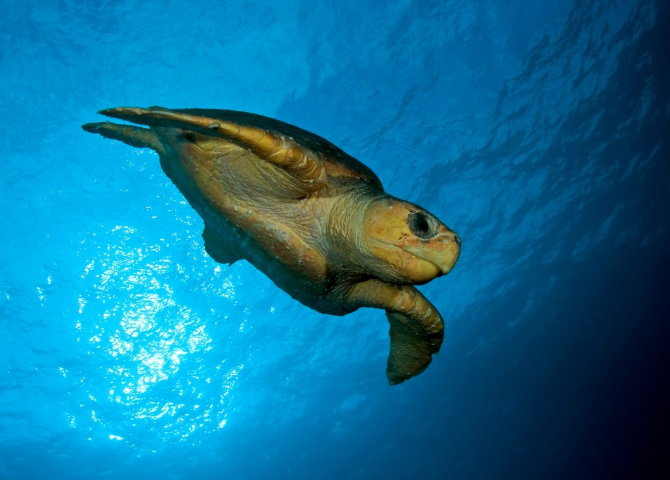

Figure 27 Loggerhead turtle. Photo: David Harasti.

## Conservation Status

Marine turtles in Australia are protected under international treaties and agreements including the Convention on the Conservation of Migratory Species of Wild Animals (CMS, Bonn 1979), the Convention on International Trade in Endangered Species of Flora and Fauna (CITES, Washington 1973), and the CMS Memorandum of Understanding on the Conservation and Management of Marine Turtles and their Habitats of the Indian Ocean and South-east Asia (IOSEA, 2005). In Australia, the *Environment Protection and Biodiversity Conservation Act 1999* (EPBC Act) gives effect to these international obligations.

All six species are listed under the EPBC Act as threatened, migratory and marine species. They are also protected under state and territory legislation.

The *Recovery Plan for Marine Turtles in Australia* (2017) identifies threats to marine turtles and actions required to recover these species57. To ensure the maintenance of biodiversity, the Plan considers marine turtles on a genetic stock basis rather than the species level. The Plan found light pollution to be a high-risk threat to five of 22 genetic stocks of marine turtles. The development and implementation of best practice light management guidelines was identified as a key action for promoting the recovery of marine turtles57.

## Distribution

Turtle nesting habitats include sub-tropical and tropical mainland and offshore island beaches extending from northern New South Wales on the east coast around northern Australia to Shark Bay in Western Australia. The extent of the known nesting range for each genetic stock can be found on the Department of the Environment and Energy’s [Species Profile and Threats Database](http://www.environment.gov.au/cgi-bin/sprat/public/sprat.pl) and in the [Recovery Plan](http://www.environment.gov.au/marine/publications/recovery-plan-marine-turtles-australia-2017)57.

### Timing of nesting and hatching

Marine turtles nesting in the far north, between the Kimberley and Cape York, typically nest year round, but have a peak during the cooler winter months, while summer nesting is favoured by turtles nesting from the Central Kimberley south in Western Australia and along the Pacific coast of Queensland and Northern New South Wales. Specific timing of nesting and hatching seasons for each stock can be found in the [Recovery Plan](http://www.environment.gov.au/marine/publications/recovery-plan-marine-turtles-australia-2017)57.

### Important habitat for marine turtles

The effect of artificial lights on turtles is most pronounced at nesting beaches and in the nearshore waters, which might include internesting areas, through which hatchlings travel to reach the ocean. For the purposes of these Guidelines, Important Habitat for turtles includes all areas that have been designated as **Habitat Critical to Survival of Marine Turtles** and **Biologically Important Areas (BIAs)**, or in Queensland areas identified under local planning schemes as **Sea Turtle Sensitive Areas**.

* **Habitat Critical to the Survival of Marine Turtles** was identified for each stock as part of the development of the [*Recovery Plan for Marine Turtles in Australia (2017)*](http://www.environment.gov.au/marine/publications/recovery-plan-marine-turtles-australia-2017). Nesting and internesting areas designated as Habitat Critical to the Survival of Marine Turtles can be found in the Recovery Plan or through the Department of the Environment and Energy’s [National Conservation Values Atlas](http://www.environment.gov.au/webgis-framework/apps/ncva/ncva.jsf).
* **Biologically Important Areas** (BIAs) are areas where listed threatened and migratory species display biologically important behaviour such as breeding, foraging, resting and migration. BIAs of highest relevance for the consideration of light impacts are nesting and internesting BIAs for each species. Marine turtle BIAs can be explored through the Department of the Environment and Energy’s [National Conservation Values Atlas](http://www.environment.gov.au/topics/marine/marine-bioregional-plans/conservation-values-atlas).
  + The presence of a BIA recognises that biologically important behaviours are known to occur, but the absence of such a designation does not preclude the area from being a BIA. Where field surveys identify biologically important behaviour occurring, the habitat should be managed accordingly.
* **Sea Turtle Sensitive Areas** have been defined in local government planning schemes in accordance with the Queensland Government Sea Turtle Sensitive Area Code. These may be shown in local government biodiversity of coastal protection overlay maps in the planning scheme.

## Effects of Artificial Light on Marine Turtles

The effect of artificial light on turtle behaviour has been recognised since 191158 and since then a substantial body of research has focused on how light affects turtles and its effect on turtle populations - for review see Witherington and Martin (2003)3; Lohmann et al (1997)48; and Salmon (2003)59. The global increase in light pollution from urbanisation and coastal development60 is of particular concern for turtles in Australia since their important nesting habitat frequently overlaps with areas of large-scale urban and industrial development61, which have the potential to emit a large amount of light, including direct light, reflected light, sky glow and gas flares62,63. Nesting areas on the North West Shelf of Western Australia and along the south-eastern coast of Queensland were found to be at the greatest risk from artificial light61.

### Effect of artificial light on nesting turtles

Although they spend most of their lives in the ocean, females nest on sandy tropical and subtropical beaches, predominantly at night. They rely on visual cues to select nesting beaches and orient on land. Artificial night lighting on or near beaches has been shown to disrupt nesting behaviour3. Beaches with artificial light, such as urban developments, roadways, and piers typically have lower densities of nesting females than dark beaches59,64.

Some light types do not appear to affect nesting densities (Low Pressure Sodium, LPS15, and filtered High Pressure Sodium, HPS), which excludes wavelengths below 540 nm)65. On beaches exposed to light, females will nest in higher numbers in areas that are shadowed14,66. Moving sources of artificial light may also deter nesting or cause disturbance to nesting females (e.g. flash photography)67 .

### Effect of artificial light on hatchlings emerging from the nest

Most hatchling turtles emerge at night68 and must rapidly reach the ocean to avoid predation69. Hatchlings locate the ocean using a combination of topographic and brightness cues, orienting towards the lower, brighter oceanic horizon and away from elevated darkened silhouettes of dunes and/or vegetation behind the beach37,48,70. They can also find the sea using secondary cues such as beach slope48.

Sea finding behaviour may be disrupted by artificial lights, including flares62, which interfere with natural lighting and silhouettes3,26,37. Artificial lighting may adversely affect hatchling sea finding behaviour in two ways: disorientation - where hatchlings crawl on circuitous paths; or misorientation - where they move in the wrong direction, possibly attracted to artificial lights3,39. On land, movement of hatchlings in a direction other than the sea often leads to death from predation, exhaustion, dehydration, or being crushed by vehicles on roads69.

### Wavelength, intensity and direction

Brightness is recognised as an important cue for hatchlings as they attempt to orient toward the ocean. Brightness refers to the intensity and wavelength of light relative to the spectral sensitivity of the receiving eye3. Both field and laboratory-based studies indicate that hatchlings have a strong tendency to orient towards the brightest direction. The brightest direction on a naturally dark beach is typically towards the ocean where the horizon is open and unhindered by dune or vegetation shadows70.

The attractiveness of hatchlings to light differs by species63,71,72, but in general, artificial lights most disruptive to hatchlings are those rich in short wavelength blue and green light (e.g. metal halide, mercury vapour, fluorescent and LED) and lights least disruptive are those emitting long wavelength pure yellow-orange light (e.g. high or low pressure sodium vapour)63,73. Loggerhead turtles are particularly attracted to light at 580 nm74, green and flatback turtles are attracted to light <600 nm with a preference to shorter wavelength light over longer wavelength light63,73, and many species are also attracted to light in the ultra violet range (<380 nm)72,73.

Although longer wavelengths of light are less attractive than shorter wavelengths, they can still disrupt sea finding37,63,75, and if bright enough can elicit a similar response to shorter wavelength light76-78. Hence, the disruptive effect of light on hatchlings is also strongly correlated with intensity. Red light must be almost 600 times more intense than blue light before green turtle hatchlings show an equal preference for the two colours76. It is therefore important to consider both the wavelength and the intensity of the light.

Since the sun or moon may rise behind the dunes on some nesting beaches, hatchlings attracted to these point sources of light would fail to reach the ocean. Hatchlings orientate themselves by integrating light across a horizontally broad (180° for green, olive ridley and loggerhead turtles) and vertically narrow (“few degrees” for green and olive ridleys, and 10° - 30° for loggerheads) “cone of acceptance” or “range of vision”. This integration ensures that light closest to the horizon plays the greatest role in determining orientation direction, so it is important to consider the type and direction of light that reaches the hatchling48.

As a result of these sensitivities, hatchlings have been observed to respond to artificial light up to 18 km away during sea finding26.

### Shape and form

Horizon brightness and elevation are also important cues for hatchling orientation. In laboratory and field studies hatchlings move away from elevated dark horizons and towards the lowest bright horizon70,79. However, in situations where both cues are present, hatchlings are more responsive to the effects of silhouettes and darkened horizon elevation than to differences in brightness. On a natural beach this behaviour would direct the hatchlings away from dunes and vegetation and towards the more open horizon over the ocean.

This hypothesis has been supported by field experiments where hatchling sea finding was significantly less ocean oriented when exposed to light at 2° elevation compared with 16° elevation, emphasising the importance of horizon elevation cues in hatchling sea-finding37.

### Effect of artificial light on hatchlings in nearshore waters

Artificial lights can also interfere with the in water dispersal of hatchlings72. Hatchlings leaving lit beaches spend longer crossing near shore waters and can be attracted back to shore80,81. At sea, hatchlings have been reported swimming around lights on boats33,82 and in laboratory studies lights have attracted swimming hatchlings83. Recent advances in acoustic telemetry technology has allowed hatchlings to be passively tracked at sea, demonstrating that hatchlings are attracted to lights at sea and spend longer in the nearshore environment when lights are present16,84. This attraction can divert hatchlings from their usual dispersal pathway, causing them to linger around a light source, or become trapped in the light spill84. Hatchlings actively swim against currents to reach light, which is likely to reduce survival either from exhaustion and/or predation. An additional problem is that light sources are associated with structures that also attract fish (such as jetties), as there will be increased predation24.

## Environmental Impact Assessment of Artificial Light on Marine Turtles

Infrastructure with artificial lighting that is externally visible should implement Best Practice Lighting Design as a minimum. Where there is important habitat for turtles within 20 km of a project, an EIA should be undertaken. The following sections step through the EIA process with specific consideration for turtles.

The 20 km buffer for considering important habitat is based on sky glow approximately 15 km from the nesting beach affecting flatback hatchling behaviour26 and light from an aluminium refinery disrupting turtle orientation 18 km away27.

Where artificial light is likely to influence marine turtle behaviour, consideration should be given to employing mitigation measures as early as possible in a project’s life cycle and used to inform the design phase.

### Associated guidance

* [*Recovery Plan for Marine Turtles in Australia* (2017)](http://www.environment.gov.au/system/files/resources/46eedcfc-204b-43de-99c5-4d6f6e72704f/files/recovery-plan-marine-turtles-2017.pdf)
* [*Single Species Action Plan for the Loggerhead Turtle (*Caretta caretta*) in the South Pacific Ocean*](https://www.cms.int/sites/default/files/document/COP11_Doc_23_2_2_Rev1_Annex_2_SSAP_Loggerhead_Turtle_E.pdf)
* [Queensland Government Sea Turtle Sensitive Area Code](https://dsdmipprd.blob.core.windows.net/general/sea-turtle-sensitive-area-code.pdf)

### Qualified personnel

Lighting design/management and the EIA process should be undertaken by appropriately qualified personnel. Light management plans should be developed and reviewed by appropriately qualified lighting practitioners who should consult with an appropriately qualified marine biologist or ecologist.

People advising on the development of a lighting management plan, or the preparation of reports assessing the impact of artificial light on marine turtles should have relevant qualifications equivalent to a tertiary education in marine biology or ecology, or equivalent experience as evidenced by peer reviewed publications in the last five years on a relevant topic, or other relevant experience.

### Step 1: Describe the project lighting

Information collated during this step should consider the Effects of Light on Marine Turtles. Turtles are susceptible to the effect of light on beaches and in the water, so the location and light source (both direct and sky glow) should be considered. Turtles are most sensitive to short wavelength (blue/green) light and high intensity light of all wavelengths. Hatchlings are most susceptible to light low on the horizon. They orient away from tall dark horizons so the presence of dunes and/or a vegetation buffer behind the beach should be considered at the design phase.

### Step 2: Describe marine turtle population and behaviour

The species and the genetic stock nesting in the area of interest should be described. This should include the conservation status of the species; stock trends (where known); how widespread/localised nesting for that stock is; the abundance of turtles nesting at the location; the regional importance of this nesting beach; and the seasonality of nesting/hatching.

Relevant species and stock specific information can be found in the [*Recovery Plan for Marine Turtles in Australia* (2017)](http://www.environment.gov.au/marine/publications/recovery-plan-marine-turtles-australia-2017), [Protected Matters Search Tool](https://www.environment.gov.au/epbc/protected-matters-search-tool), [National Conservation Values Atlas](https://www.environment.gov.au/topics/marine/marine-bioregional-plans/conservation-values-atlas) state and territory listed species information; scientific literature and local/Indigenous knowledge.

Where there is insufficient data to understand the population importance or demographics, or where it is necessary to document existing turtle behaviour, field surveys and biological monitoring may be necessary.

#### Biological monitoring of marine turtles

Any monitoring associated with a project should be developed, overseen and results interpreted by appropriately qualified personnel to ensure reliability of the data.

The objectives of turtle monitoring in an area likely to be affected by artificial light are to:

* understand the size and importance of the population;
* describe turtle behaviour before the introduction/upgrade of light; and
* assess nesting and hatchling orientation behaviour to determine the cause of any existing or future misorientation or disorientation.

The data will be used to inform the EIA and assess whether mitigation measures are successful. Suggested minimum monitoring parameters (what is measured) and techniques (how to measure them) are summarised in Table 4.

As a minimum, qualitative descriptive data on visible light types, location and directivity should also be collected at the same time as the biological data. Handheld-camera images can help describe the light. Quantitative data on existing sky glow should be collected, if possible, in a biologically meaningful way, recognising the technical difficulties in obtaining these data. See Measuring Biologically Relevant Light for a review.

Table 4 Recommended minimum biological information necessary to assess the importance of a marine turtle population and existing behaviour, noting that the risk assessment will guide the extent of monitoring (e.g. a large source of light visible over a broad spatial scale will require monitoring of multiple sites whereas a smaller localised source of light may require fewer sites to be monitored).

|  |  |  |  |
| --- | --- | --- | --- |
| Target Age Class | Survey Effort | Duration | Reference |
| Adult Nesting | Daily track census over 1–1.5 internesting cycles at peak57 of the nesting season (14–21 days).  If the peak nesting period for this population/at this location has not been defined, then a study should be designed in consultation with a qualified turtle biologist to determine the temporal extent of activity (i.e. systematic monthly surveys over a 12-month period). | Minimum  two breeding seasons | Eckert et al (1999)85  Pendoley et al (2016)86  [Queensland Marine Turtle Field Guide](https://environment.des.qld.gov.au/wildlife/pdf/marine-turtle-field-guide.pdf)  [NWSFTCP Turtle Monitoring Field Guide](https://trove.nla.gov.au/work/218813175?q&versionId=252869908)  [Ningaloo Turtle Monitoring Field Guide](http://www.ningalooturtles.org.au/pdf_downloads/training-guides/NTP-Turtle-Monitoring-Field-Guide-Edition_7-wCover.pdf)  [SWOT Minimum Data Standards for Sea Turtle Nesting Beach Monitoring](https://static1.squarespace.com/static/5b80290bee1759a50e3a86b3/t/5baba6f6419202c5985626d8/1537976057241/SWOT_MDS_handbook_v1.0.pdf) |
| Hatchling Orientation | Minimum of 14 days over a new moon phase about 50 days* after the peak of adult nesting.  Beach: Hatchling fan monitoring.  In water: Hatchling tracking | Minimum two breeding seasons | Pendoley (2005)63  Kamrowski et al (2014)26  Witherington (1997)87  Thums et al (2016)16 |

*Incubation time will be stock specific. Consult the Recovery Plan for Marine Turtles in Australia for stock specific information.

To understand existing hatchling behaviour, it will be necessary to undertake monitoring (or similar approach) to determine hatchling ability to locate the ocean and orient offshore prior to construction/lighting upgrades.

A well-designed monitoring program will capture:

* hatchling behaviour26,63,87 at the light exposed beach and a control/reference beach
* hatchling behaviour before project construction begins to establish a benchmark to measure against possible changes during construction and operations
* hatchling behaviour on a new moon to reduce the influence of moonlight and capture any worst case scenario effects of artificial light on hatching orientation
* hatchling behaviour on full moon nights to assess the relative contribution of the artificial light to the existing illuminated night sky.

Ideally, survey design will have been set up by a quantitative ecologist/biostatistician to ensure that the data collected provides for meaningful analysis and interpretation of findings.

### Step 3: Risk assessment

The [Recovery Plan](http://www.environment.gov.au/system/files/resources/46eedcfc-204b-43de-99c5-4d6f6e72704f/files/recovery-plan-marine-turtles-2017.pdf) states that management of light should ensure turtles are not displaced from habitat critical to their survival and that anthropogenic activities in important habitat are managed so that the biologically important behaviour can continue. These consequences should be considered in the risk assessment process. The aim of these Guidelines is that light is managed to ensure that at important nesting beaches females continue to nest on the beach, post nesting females return to the ocean successfully, emerging hatchlings orient in a seaward direction and dispersing hatchlings can orient successfully offshore.

Consideration should be given to the relative importance of the site for nesting. For example, if this is the only site at which a stock nests, a higher consequence rating should result from the effects of artificial light.

In considering the likely effect of light on turtles, the risk assessment should consider the existing light environment, the proposed lighting design and mitigation/management, and the behaviour of turtles at the location. Consideration should be given to how the turtles will perceive light. This should include wavelength and intensity information as well as perspective. To assess how/whether turtles are likely to see light, a site visit should be made at night and the area viewed from the beach (approximately 10 cm above the sand) as this will be the perspective of the nesting turtles and emerging hatchlings. Similarly, consideration should be given to how turtles (both adults and hatchlings) will see light when in nearshore water.

Using this perspective, the type and number of lights should be considered to assess whether turtles are likely to be able to perceive light and what the consequence of the light on their behaviour is likely to be. The risk assessment should take into account proposed mitigation and management.

### Step 4: Light management plan

A light management plan for marine turtles should include all relevant project information (Step 1) and biological information (Step 2). It should outline proposed mitigation. For a range of specific mitigation measures see the Mitigation Toolbox below. The plan should also outline the type and schedule for biological and light monitoring to ensure mitigation is meeting the objectives of the plan and triggers for revisiting the risk assessment phase of the EIA. The plan should outline contingency options if biological and light monitoring or compliance audits indicate that mitigation is not meeting the objectives of the plan (e.g. light is visible on the nesting beach or changes in nesting/hatchling behaviour are observed).

### Step 5: Biological and light monitoring and auditing

The success of risk mitigation and light management should be confirmed through monitoring and compliance auditing. The results should be used to inform continuous improvement.

Relevant biological monitoring is described in Step 2: Describe marine turtle population and behaviour above. Concurrent light monitoring should be undertaken and interpreted in the context of how turtles perceive light and within the limitations of monitoring techniques described in Measuring Biologically Relevant Light. Auditing as described in the light management plan should be undertaken.

### Review

The EIA should incorporate a continuous improvement review process that allows for upgraded mitigations, changes to procedures and renewal of the light management plan.

## Marine Turtle Light Mitigation Toolbox

Appropriate lighting design/lighting controls and light impact mitigation will be site/project and species specific. Table 5 provides a toolbox of options for use around important turtle habitat. These options would be implemented in addition to the six Best Practice Light Design principles. Not all mitigation options will be relevant for every situation. Table 6 provides a suggested list of light types appropriate for use near turtle nesting beaches and those to avoid.

Two of the most effective approaches for management of light near important nesting beaches is to ensure there is a tall dark horizon behind the beach such as dunes and/or a natural vegetation screen and to ensure there is no light on or around the water through which hatchlings disperse.

Table 5 Light management options specific to marine turtle nesting beaches.

| **Management Action** | **Detail** |
| --- | --- |
| Implement light management actions during the nesting and hatching season. | Peak nesting season for each stock can be found in the [Recovery Plan for Marine Turtles in Australia](http://www.environment.gov.au/system/files/resources/46eedcfc-204b-43de-99c5-4d6f6e72704f/files/recovery-plan-marine-turtles-2017.pdf)57. |
| Avoid direct light shining onto a nesting beach or out into the ocean adjacent to a nesting beach. | Adult turtles nest in lower numbers at lit beaches14. |
| Maintain a dune and/or vegetation screen between the nesting habitat and inland sources of light. | Hatchlings orient towards the ocean by crawling away from the tall, dark horizon provided by a dune line and/or vegetation screen. |
| Maintain a dark zone between turtle nesting beach and industrial infrastructure | Avoid installing artificial light within 1.5 km of an industrial development78. |
| Install light fixtures as close to the ground as practicable. | Any new lighting should be installed close to the ground and reduce the height of existing lights to the extent practicable to minimise light spill and light glow. |
| Use curfews to manage lighting. | Mange artificial lights using motion sensors and timers around nesting beaches after 8 pm. |
| Aim lights downwards and direct them away from nesting beaches. | Aim light onto the exact surface area requiring illumination. Use shielding on lights to prevent light spill into the atmosphere and outside the footprint of the target area. |
| Use flashing/intermittent lights instead of fixed beam. | For example, small red flashing lights can be used to identify an entrance or delineate a pathway. |
| Use motion sensors to turn on lights only when needed. | For example, motion sensors could be used for pedestrian areas near a nesting beach. |
| Prevent indoor lighting reaching beach. | Use fixed window screens or window tinting on fixed windows, skylights and balconies to contain light inside buildings. |
| Limit the number of beach access areas or construct beach access such that artificial light is not visible through the access point. | Beach access points often provide a break in dune or vegetation that protects the beach from artificial light. By limiting the number of access points or making the access path wind through the vegetation, screen light spill can be mitigated. |
| Work collectively with surrounding industry/private land holders to address the cumulative effect of artificial lights. | Problematic sky glow may not be caused by any one light owner/manager. By working with other industry/stakeholders to address light pollution, the effect of artificial light may be reduced more effectively. |
| Manage artificial light at sea, including on vessels, jetties, marinas and offshore infrastructure. | Hatchlings are attracted to, and trapped by, light spill in the water. |
| Reduce unnecessary lighting at sea. | Extinguish vessel deck lights to minimum required for human safety and when not necessary. Restrict lighting at night to navigation lights only. Use block-out blinds on windows. |
| Avoid shining light directly onto longlines and/or illuminating baits in the water. | Light on the water can trap hatchlings or delay their transit through nearshore waters, consuming their energy reserves and likely exposing them to predators. |
| Avoid lights containing short wavelength violet/blue light. | Lights rich in blue light can include: metal halides, fluorescent, halogens, mercury vapour and most LEDs. |
| Avoid white LEDs. | Ask suppliers for an LED light with little or no blue in it or only use LEDs filtered to block the blue light. This can be checked by examining the spectral power curve for the luminaire. |
| Avoid high intensity light of any colour. | Keep light intensity as low as possible in the vicinity of nesting beaches. Hatchlings can see all wavelengths of light and will be attracted to long wavelength amber and red light as well as the highly visible white and blue light, especially if there is a large difference between the light intensity and the ambient dark beach environment. |
| Shield gas flares and locate inland and away from nesting beach. | Manage gas flare light emissions by: reducing gas flow rates to minimise light emissions; shielding the flame behind a containment structure; elevating glow from the shielded flare more than 30o above hatchling field of view; containing pilot flame for flare within shielding; and scheduling maintenance activity requiring flaring outside of turtle hatchling season. |
| Industrial/port or other facilities requiring intermittent night-time light for inspections should keep the site dark and only light specific areas when required. | Use amber/orange explosion proof LEDs with smart lighting controls and/or motions sensors. LEDs have no warmup or cool down limitations so can remain off until needed and provide instant light when required for routine nightly inspections or in the event of an emergency. |
| Industrial site/plant operators to use head torches. | Consider providing plant operators with white head torches (explosion proof torches are available) for situations where white light is needed to detect colour correctly or when there is an emergency evacuation. |
| Supplement facility perimeter security lighting with computer monitored infra-red detection systems. | Perimeter lighting can be operated if night-time illumination is necessary, but remain off at other times. |
| No light source should be directly visible from the beach. | Any light that is directly visible to a person on a nesting beach will be visible to a nesting turtle or hatchling and should be modified to prevent it being seen. |
| Manage light from remote regional sources (up to 20km away). | Consider light sources up to 20 km away from the nesting beach, assess the relative visibility and scale of the night sky illuminated by the light e.g. is a regional city illuminating large area of the horizon and what management actions can be taken locally to reduce the effect i.e. protect or improve dune systems or plant vegetation screening in the direction of the light. |

Table 6 Where all other mitigation options have been exhausted and there is a human safety need for artificial light, this table provides commercial luminaire types that are considered appropriate for use near important marine turtles nesting habitat and those to avoid.

|  |  |
| --- | --- |
| **Light type** | **Suitability for use near marine turtle habitat** |
| Low Pressure Sodium Vapour |  |
| High Pressure Sodium Vapour |  |
| Filtered*LED |  |
| Filtered*metal halide |  |
| Filtered* white LED |  |
| Amber LED |  |
| PC Amber |  |
| White LED |  |
| Metal halide |  |
| White fluorescent |  |
| Halogen |  |
| Mercury vapour |  |

*‘Filtered’ means LEDs can be used *only* if a filter is applied to remove the short wavelength (400 – 500 nm) light.

# Appendix G - Seabirds

**Seabirds spend most of their lives at sea, only coming ashore to nest. All species are vulnerable to the effects of lighting. Seabirds active at night while migrating, foraging or returning to colonies are most at risk.**

**Fledglings are more affected by artificial lighting than adults due to the synchronised mass exodus of fledglings from their nesting sites. They can be affected by lights up to 15 km away.**

**The physical aspects of light that have the greatest impact on seabirds include intensity and colour (wavelength). Consequently, management of these aspects of artificial light will have the most effective result.**

Seabirds are birds that are adapted to life in the marine environment (Figure 28). They can be highly pelagic, coastal, or in some cases spend a part of the year away from the sea entirely. They feed from the ocean either at or near the sea surface. In general, seabirds live longer, breed later and have fewer young than other birds and invest a great deal of energy in their young. Most species nest in colonies, which can vary in size from a few dozen birds to millions. Many species undertake long annual migrations, crossing the equator or circumnavigating the Earth in some cases88.

Artificial light can disorient seabirds and potentially cause injury and/or death through collision with infrastructure. Birds may starve as a result of disruption to foraging, hampering their ability to prepare for breeding or migration. High mortality of seabirds occurs through grounding of fledglings as a result of attraction to lights4 and through interaction with vessels at sea.

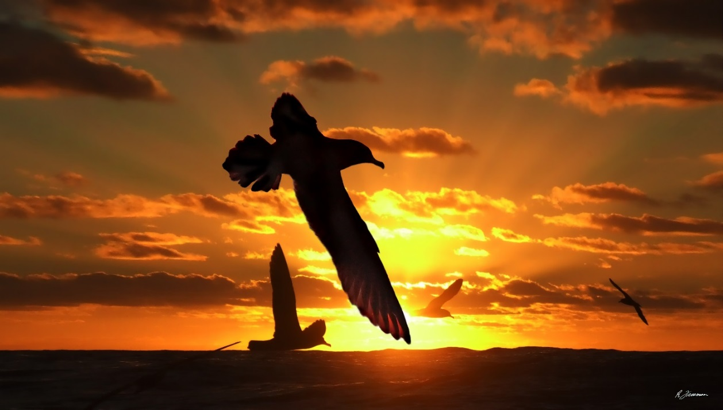

Figure 28 Flesh-footed Shearwater at sunset. Photo: Richard Freeman.

## Conservation Status

Migratory seabird species in Australia are protected under international treaties and agreements including the *Convention on the Conservation of Migratory Species of Wild Animals* (CMS, Bonn Convention), the *Ramsar Convention on Wetlands*, the *Agreement on the Conservation of Albatrosses and Petrels* (ACAP), and through the East Asian - Australasian Flyway Partnership (the Flyway Partnership). The Australian Government has bilateral migratory bird agreements with Japan (Japan-Australia Migratory Bird Agreement, JAMBA), China (China-Australia Migratory Bird Agreement, CAMBA), and the Republic of Korea (Republic of Korea-Australia Migratory Bird Agreement, ROKAMBA). In Australia the *Environment Protection and Biodiversity Conservation Act 1999* (EPBC Act) gives effect to these international obligations. Many seabirds are also protected under state and territory environmental legislation.

An estimated 15.5 million pairs of seabirds, from 43 species, breed at mainland and island rookeries4. Of the 43 species, 35 are listed as threatened and/or migratory under the EPBC Act. Of the 35 EPBC Act listed species, 90 per cent are Procellariiformes (petrels, shearwaters, storm petrels, gadfly petrels and diving petrels) that breed in burrows, only attend breeding colonies at night89, and are consequently most at risk from the effects of artificial light. Short-tailed Shearwaters comprise 77 per cent (11.9 million pairs) of the total breeding seabird pairs.

## Distribution

Seabirds in Australia belong to both migratory and residential breeding species. Most breeding species include both temperate and tropical shearwaters and terns that undergo extensive migrations to wintering areas outside Australia’s Exclusive Economic Zone (EEZ). However, there are significant numbers of residential species that remain within the EEZ throughout the year and undergo shorter migrations to non-breeding foraging grounds within the EEZ.

### Timing of habitat use

Most seabird breeding occurs during the austral spring/summer (September-January), but may extend in some species to April/May. The exceptions are the austral winter breeders, a handful of species largely comprised of petrels that may commence nesting in June. Breeding occurs almost exclusively on many of the offshore continental islands that surround Australia. Seabirds spend most of their time flying, at sea, and so are usually found on breeding islands only during the breeding season, or along mainland coastal sand bars and spits or island shorelines when roosting during their non-breeding period.

### Important habitat for seabirds

Seabirds may be affected by artificial light at breeding areas, while foraging and migrating. For the purposes of these Guidelines, Important Habitat for seabirds includes all areas that have been designated as Habitat Critical to the Survival of Seabirds and Biologically Important Areas (BIAs) and those areas designated as important habitat in wildlife conservation plans and in species specific conservation advice.

* The [*National Recovery Plan for Threatened Albatrosses and Giant Petrels 2011-2016*](https://www.environment.gov.au/system/files/resources/bb2cf120-0945-420e-bdfa-d370cf90085e/files/albatrosses-and-giant-petrels-recovery-plan.pdf)*[1]* provides designated Habitat Critical to the Survival of these species. Where a recovery plan is not in force for a listed threatened species, please see relevant approved conservation advice.
* Actions in Antarctica should consider [Important Bird Areas in Antarctica](http://www.era.gs/resources/iba/Important_Bird_Areas_in_Antarctica_2015_v5.pdf)90.
* Biologically Important Areas (BIAs) are areas where listed threatened and migratory species display biologically important behaviour, such as breeding, foraging, resting and migration. Seabird BIAs can be explored through the Department of the Environment and Energy’s [National Conservation Values Atlas](http://www.environment.gov.au/topics/marine/marine-bioregional-plans/conservation-values-atlas).
  + The presence of a BIA recognises that biologically important behaviours are known to occur, but the absence of such a designation does not preclude the area from being a BIA. Where field surveys identify biologically important behaviour occurring, the habitat should be managed accordingly.

## Effects of Artificial Light on Seabirds

Seabirds have been affected by artificial light sources for centuries. Humans used fire to attract seabirds to hunt them for food91 and reports of collisions with lighthouses date back to 188092. More recently artificial light associated with the rapid urbanisation of coastal areas has been linked to increased seabird mortality93 and today, 56 petrel species worldwide are known to be affected by artificial lighting4,31. Artificial light can disorient seabirds causing collision, entrapment, stranding, grounding, and interference with navigation (being drawn off course from usual migration route). These behavioural responses may cause injury and/or death.

All species active at night are vulnerable as artificial light can disrupt their ability to orient towards the sea. Problematic sources of artificial light include coastal residential and hotel developments, street lighting, vehicle lights, sporting facility floodlights, vessel deck and search lights, cruise ships, fishing vessels, gas flares, commercial squid vessels, security lighting, navigation aids and lighthouses31,93-99. Seabirds, particularly petrel species in the Southern Ocean, can be disoriented by vessel lighting and may land on the deck, from which they are unable to take off. The effect of artificial light may be exacerbated by moon phase96, wind direction and strength28,100, precipitation, cloud cover and the proximity of nesting sites or migrating sites to artificial light sources101-103. The degree of disruption is determined by a combination of physical, biological and environmental factors including the location, visibility, colour and intensity of the light, its proximity to other infrastructure, landscape topography, moon phase, atmospheric and weather conditions and species present.

Seabirds that are active at night while migrating, foraging or returning to colonies and are directly affected include petrels, shearwaters, albatross, noddies, terns and some penguin species. Less studied are the effects of light on the colony attendance of nocturnal Procellariiformes, which could lead to higher predation risks by gulls, skuas or other diurnal predators, and the effects on species that are active during the day, including extending their activities into the night as artificial light increases perceived daylight hours.

High rates of fallout, or the collision of birds with structures, has been reported in seabirds nesting adjacent to urban or developed areas4,104,105 and at sea where seabirds interact with offshore oil and gas platforms106,107. A report on interactions with oil and gas platforms in the North Sea identified light as the likely cause of hundreds of thousands of bird deaths annually. It noted that this could be a site specific impact108.

Gas flares also affect seabirds. One anecdote describes 24 burnt carcasses of seabirds (wedge-tailed shearwaters) in and around an open pit gas flare. The birds were likely to have been attracted to the light and noise of the flare and as they circled the source, became engulfed, combusting in the super-heated air above the flame (pers. obs. K Pendoley, 1992).

### Mechanisms by which light affects seabirds

Most seabirds are diurnal. They rest during dark hours and have less exposure to artificial light. Among species with a nocturnal component to their life cycle, artificial light affects the adult and fledgling differently.

Adults are less affected by artificial light. Many Procellariiformes species (i.e. shearwaters, storm petrels, gadfly petrels) are vulnerable during nocturnal activities, which make up part of the annual breeding cycle. Adult Procellariiformes species are vulnerable when returning to and leaving the nesting colony. They may leave or enter to re-establish their pair bonds with breeding partners, repair nesting burrows, defend nesting sites or to forage. Adults feed their chick by regurgitating partially digested food109. A recent study shows artificial light disrupts adult nest attendance and thus affects weight gain in chicks110.

Fledglings are more vulnerable due to the naivety of their first flight, the immature development of ganglions in the eye at fledging and the potential connection between light and food104,111. Burrow-nesting seabirds are typically exposed to light streaming in from the burrow entrance during the day. The young are fed by parents who enter the burrow from the entrance creating an association between light and food in newly fledged birds31.Much of the literature concerning the effect of lighting upon seabirds relates to the synchronised mass exodus of fledglings from their nesting sites96,98,101,102,112,113. Fledging Procellariiformes leave the nesting colony for the sea at night89, returning to breed several years later. In Australia, the main fledgling period of shearwaters occurs in April/May114.

Emergence during darkness is believed to be a predator-avoidance strategy115 and artificial lighting may make the fledglings more vulnerable to predation113. Artificial lights are thought to override the sea-finding cues provided by the moon and star light at the horizon116 and fledglings can be attracted back to onshore lights after reaching the sea28,105. It is possible that fledglings that survive their offshore migration cannot imprint their natal colony, preventing them from returning to nest when they mature98. The consequences of exposure to artificial light on the viability of a breeding population of seabirds is unknown117.

#### Eye structure and sensitivities

Seabirds, like most vertebrates, have an eye that is well adapted to see colour. Typically, diurnal birds have six photoreceptor cells which are sensitive to different regions of the visible spectrum118. All seabirds are sensitive to the violet – blue region of the visible spectrum (380 ‑ 440 nm)119. The eyes of the Black Noddy (*Anous minutus*) and Wedge-tailed Shearwaters (*Puffinus pacificus*) are characterised by a high proportion of cones sensitive to shorter wavelengths120. This adaptation is likely due to the need to see underwater, and the optimum wavelength for vision in clear blue oceanic water is between 425 and 500 nm. There is no ecological advantage to having many long-wavelength-sensitive photoreceptors in species foraging in this habitat120.

Many diurnal birds can see in the UV range (less than 380 nm121), however, of the 300 seabird species, only 17 have UV sensitive vision119. In all seabirds, their photopic vision (daylight adapted) is most sensitive in the long wavelength range of the visible spectrum (590 – 740 nm, orange to red) while their scotopic (dark adapted) vision is more sensitive to short wavelengths of light (380 – 485 nm, violet to blue).

Petrel vision is most sensitive to light in the short wavelength blue (400 – 500 nm), region of the visible spectrum. Relative to diurnal seabirds, such as gulls and terns, petrels have a higher number of short wavelength sensitive cones. This is thought to be an adaptation that increases prey visibility against a blue-water foraging field favoured by petrels120.

Little has been published on vision in penguins. Penguins are visual foragers with the success of fish capture linked directly to the amount of light present122. The eyes of the Humbolt Penguin (*Spheniscus humboldti)* are adapted to the aquatic environment, seeing well in the violet to blue to green region of the spectrum, but poorly in the long wavelengths (red)123.

### Wavelength, intensity and direction

The intensity of light may be a more important cue than colour for seabirds. Very bright light will attract them, regardless of colour98. There are numerous, although sometimes conflicting, reports of the attractiveness of different wavelengths of artificial light to seabirds. White light has the greatest effect on seabirds as it contains all wavelengths of light7,96,124. Seabirds have reportedly been attracted to the yellow/orange colour of fire91, while white Mercury Vapour and broad-spectrum LED is more attractive to Barau’s Petrel (*Pterodroma baraui*) and Hutton’s Shearwater (*Puffinus huttoni*) than either Low or High-Pressure Sodium Vapour lights96. Bright white deck lights and spot lights on fishing vessels attract seabirds at night, particularly on nights with little moon light or low visibility95,97,104.

A controlled field experiment on Short-tailed Shearwaters at Phillip Island tested the effect of metal halide, LED and HPS lights on fledging groundings32. The results suggested the shearwaters were more sensitive to the wider emission spectrum and higher blue content of metal halide and LED lights relative than to HPS light. The authors strongly recommended using HPS, or filtered LED and metal halide lights with purpose designed LED filtered to remove short wavelength light for use in the vicinity of shearwater colonies32.

The first studies of penguins exposed to artificial light at a naturally dark site found they preferred lit paths over dark paths to reach their nests125. While artificial light might enhance penguin vision at night, reducing predation risk and making it easier for them to find their way, the proven attraction to light could attract them to undesirable lit areas. This study concluded that the penguins were habituated to artificial lights and were unaffected by a 15 lux increase in artificial illumination125. However, the authors were unable to rule out an effect of artificial light on penguin behaviour due natural differences between the sites; potential complexity of penguin response to the interaction between artificial light and moonlight; and probable habituation of penguins to artificial lights.

## Environmental Impact Assessment of Artificial Light on Seabirds

As a minimum, infrastructure with artificial lighting that is externally visible should have Best Practice Lighting Design implemented. Where there is important habitat for seabirds within 20 km of a project, an EIA should be undertaken. The following sections step through the EIA process with specific consideration for seabirds.

The 20 km buffer for considering important seabird habitat is based on the observed grounding of seabirds in response to a light source at least 15 km away28.

The spatial and temporal characteristics of migratory corridors are important for some seabird species. Species typically use established migratory pathways at predictable times and artificial light intersecting with an overhead migratory pathway should be assessed in the same way as ground-based populations.

Where artificial light is likely to affect seabirds, consideration should be given to mitigation measures at the earliest point in a project development and used to inform the design phase.

### Associated guidance

* [National Recovery Plan for Threatened Albatrosses and Giant Petrels 2011-2016](https://www.environment.gov.au/system/files/resources/bb2cf120-0945-420e-bdfa-d370cf90085e/files/albatrosses-and-giant-petrels-recovery-plan.pdf)[2]
* [EPBC Act Policy Statement 3.21—Industry guidelines for avoiding, assessing and mitigating impacts on EPBC Act listed migratory shorebird species](https://www.environment.gov.au/system/files/resources/67d7eab4-95a5-4c13-a35e-e74cca47c376/files/bio4190517-shorebirds-guidelines.pdf)

### Qualified personnel

Lighting design/management and the EIA process should be undertaken by appropriately qualified personnel. Light management plans should be developed and reviewed by appropriately qualified lighting practitioners who should consult with appropriately trained marine ornithologists and/or ecologists. People advising on the development of a lighting management plan, or the preparation of reports assessing the effect of artificial light on seabirds, should have relevant qualifications equivalent to a tertiary education in ornithology, or equivalent experience as evidenced by peer reviewed publications in the last five years on a relevant topic, or other relevant experience.

### Step 1: Describe the project lighting

The type of information collated during this step should consider the biological Impact of Light on Seabirds. Seabirds are susceptible when active at night while migrating, foraging or returning to colonies. The location and light source (both direct and sky glow) in relation to breeding and feeding areas should be considered. Seabirds are sensitive to both short wavelength (blue/violet) and long (orange/red)9 light with some species able to detect UV light. However, the intensity of lights may be more important than colour.

### Step 2: Describe seabird population and behaviour

The species, life stage and behaviour of seabirds in the area of interest should be described. This should include the conservation status of the species; abundance of birds; how widespread/localised is the population; regional importance of the population; and seasonality of seabirds utilising the area.

Relevant seabird information can be found in the, [*National Recovery Plan for Threatened Albatrosses and Giant Petrels 2011-2016*](https://www.environment.gov.au/system/files/resources/bb2cf120-0945-420e-bdfa-d370cf90085e/files/albatrosses-and-giant-petrels-recovery-plan.pdf); [Protected Matters Search Tool](https://www.environment.gov.au/epbc/protected-matters-search-tool); [National Conservation Values Atlas](https://www.environment.gov.au/topics/marine/marine-bioregional-plans/conservation-values-atlas); relevant conservation advice; relevant wildlife conservation plans; state and territory listed species information; scientific literature; and local/Indigenous knowledge.

Where there are insufficient data available to understand the population importance or demographics, or where it is necessary to document existing seabird behaviour, field surveys and biological monitoring may be necessary.

#### Biological monitoring of seabirds

Any biological monitoring associated with a project should be developed, overseen and results interpreted by an appropriately qualified biologist or ornithologist to ensure reliability of the data.

The objectives of monitoring in an area likely to be affected by light are to:

* understand the habitat use and behaviour of the population (e.g. migrating, foraging, breeding)
* understand the size and importance of the population
* describe seabird behaviour prior to the introduction/upgrade of light.

The data will be used to inform the EIA process and assess whether mitigation measures are successful. Suggested minimum monitoring parameters (what is measured) and techniques (how to measure them) are summarised in Table 7.

Table 7 Recommended minimum biological information necessary to assess the importance of a seabird population. Note: the information in this table is not prescriptive and should be assessed on a case-by-case basis.

|  |  |  |  |
| --- | --- | --- | --- |
| Target Age Class | Survey Effort | Duration | Reference |
| Adult Nesting | In colonial nesting burrow or surface nesting species with fixed or transient nesting sites, a single survey timed to coincide with predicted peak laying period.   * A minimum of three sampling areas (transects/quadrats) appropriate for nest density to capture ~100 nests per transect. Status of nests recorded (used/unused- chick stage).   Transient surface nesting species - estimate of chicks in crèches using aerial or drone footage.   * A minimum of three sampling areas (transects/quadrats) appropriate for nest density to capture ~100 nests per transect. Status of nests recorded (used/unused- egg or chick). | Minimum of two breeding seasons | Henderson and Southwood (2016)126  Surman and Nicholson (2014)127  [Survey Guidelines for Australia’s Threatened Birds](https://www.environment.gov.au/system/files/resources/107052eb-2041-45b9-9296-b5f514493ae0/files/survey-guidelines-birds-april-2017.pdf)128 |
| Fledging | In colonial nesting burrow or surface nesting species with fixed nesting sites, a single survey timed to coincide with predicted max fledging period. | Minimum of two breeding seasons | Henderson and Southwood (2016)126  Surman and Nicholson (2014)129 |

#### Additional seabird monitoring

* Monitor fledging behaviour before a project begins to establish a benchmark for assessing changes in fledging behaviour during construction and operations.
* Monitor fallout by assessing breeding colonies prior to fledging to assess annual breeding output/effort and measure against fallout (expecting greater fallout in years with higher reproductive output).
* Install camera traps at key locations to monitor fallout.
* Conduct nightly assessments of target lighting/areas to identify and collect grounded birds.
* Conduct observations post-dusk and pre-dawn with night vision goggles to assess activity/interactions.
* Track movement using land-based radar to determine existing flightpaths98.

As a minimum, qualitative descriptive data on visible light types, location and directivity should also be collected at the same time as the biological data. Handheld camera images can help to describe the light. Quantitative data on existing sky glow should be collected, if possible, in a biologically meaningful way, recognising the technical difficulties in obtaining these data. See Measuring Biologically Relevant Light for a review.

### Step 3: Risk assessment

The objective is that light should be managed in a way that seabirds are not disrupted within, or displaced from, important habitat, and they are able to undertake critical behaviours, such as foraging, reproduction and dispersal. These consequences should be considered in the risk assessment process. The aim of the process is to ensure that at important seabird rookeries, burrow usage remains constant, adults and fledglings are not grounded, and fledglings launch successfully from the rookery.

In considering the likely effect of light on seabirds, the assessment should consider the existing light environment, the proposed lighting design and mitigation/management, and behaviour of seabirds at the location. Consideration should be given to how the birds perceive light. This should include both wavelength and intensity information and perspective. To discern how/whether seabirds are likely to see light, a site visit should be made at night and the area viewed from the seabird rookery. Similarly, consideration should be given to how seabirds will see light when in flight.

Using this perspective, the type and number of lights should be considered/modelled to determine whether seabirds are likely to perceive light and what the consequence of the light on their behaviour is likely to be.

### Step 4: Light management plan

This should include all relevant project information (Step 1) and biological information (Step 2). It should outline proposed mitigation. For a range of seabird specific mitigation measures please see the Seabird Mitigation Toolbox below. The plan should also outline the type and schedule for biological and light monitoring to ensure mitigation is meeting the objectives of the plan and triggers for revisiting the risk assessment phase of the EIA. The plan should outline contingency options if biological and light monitoring or compliance audits indicate that mitigation is not meeting objectives (e.g. light is visible in seabird rookeries or fallout rates increase).

### Step 5: Biological and light monitoring and auditing

The success of the impact mitigation and light management should be confirmed through monitoring and compliance auditing and the results used to facilitate an adaptive management approach for continuous improvement.

Relevant biological monitoring is described in Step 2: Describe the Seabird Population above. Concurrent light monitoring should be undertaken and interpreted in the context of how seabirds perceive light and within the limitations of monitoring techniques described in Measuring Biologically Relevant Light. Auditing, as described in the light management plan, should be undertaken.

### Review

The EIA should incorporate a continuous improvement review process that allows for upgraded mitigations, changes to procedures and renewal of the light management plan.

## Seabird Light Mitigation Toolbox

Appropriate lighting design/lighting controls and mitigating the effect of light will be site/project and species specific. Table 8 provides a toolbox of management options relevant to seabirds. These options should be implemented in addition to the six Best Practice Light Design principles. Not all mitigation options will be practicable for every project. Table 9 provides a suggested list of light types appropriate for use near seabird rookeries and those to avoid.

A comprehensive review of the effect of land based artificial lights on seabirds and mitigation techniques found the most effective measures were:

* turning lights off during the fledgling periods
* modification of light wavelengths
* removing external lights and closing window blinds to shield internal lights
* shielding the light source and preventing upward light spill
* reducing traffic speed limits and display of warning signs
* implementing a rescue program for grounded birds4.

Additional mitigation measures listed, but not assessed for effectiveness were:

* using rotating or flashing lights because research suggests that seabirds are less attracted to flashing lights than constant light
* keeping light intensity as low as possible. Most bird groundings are observed in very brightly lit areas4.

Table 8 Light management options for seabirds.

| **Management Action** | **Detail** |
| --- | --- |
| Implement management actions during the breeding season. | Most seabird species nest during the Austral spring and summer. Light management should be implemented during the nesting and fledgling periods. |
| Maintain a dark zone between the rookery and the light sources. | Avoid installing lights or manage all outdoor lighting within three kilometres of a seabird rookery102. This is the median distance between nest locations and grounding locations. Avoiding the installation of lights in this zone would reduce the number of grounding birds by 50 per cent. |
| Turn off lights during fledgling season. | If not possible to extinguish lights, consider curfews, dimming options, or changes on light spectra (preferably towards lights with low blue emissions). Fledglings can be attracted back towards lights on land as they fly out to sea. |
| Use curfews to manage lighting. | Extinguish lights around the rookery during the fledgling period by 7 pm as fledglings leave their nest early in the evening. |
| Aim lights downwards and direct them away from nesting areas. | Aim light onto only the surface area requiring illumination. Use shielding to prevent light spill into the atmosphere and outside the footprint of the target area. This action can reduce fallout by 40 per cent4. |
| Use flashing/intermittent lights instead of fixed beam. | For example, small red flashing lights can be used to identify an entrance or delineate a pathway. |
| Use motion sensors to turn lights on only when needed. | Use motion sensors for pedestrian or street lighting within three kilometres of a seabird rookery. |
| Prevent indoor lighting reaching outdoor environment. | Use fixed window screens or window tinting on fixed windows and skylights to contain light inside buildings. |
| Manage artificial light on jetties, wharves, marinas, etc. | Fledglings and adults may be attracted to lights on marine facilities and become grounded or collide with infrastructure. |
| Reduce unnecessary outdoor, deck lighting on all vessels and permanent and floating oil and gas installations in known seabird foraging areas at sea. | Extinguishing outdoor/deck lights when not necessary for human safety and restrict lighting at night to navigation lights.  Use block-out blinds on all portholes and windows. |
| Night fishing should only occur with minimum deck lighting.  Avoid shining light directly onto fishing gear in the water.  Ensure lighting enables recording of any incidental catch, including by electronic monitoring systems. | Night is between nautical dusk and nautical dawn (as defined in the Nautical Almanac tables for relevant latitude, local time and date).  Light on the water at night can attract seabirds to deployed fishing gear increasing the risk of seabird bycatch (i.e. killing or injuring birds).  Minimum deck lighting should not breach minimum standards for safety and navigation.  Record bird strike or incidental catch and report these data to regulatory authorities. |
| Avoid shining light directly onto longlines and/or illuminating baits in the water. | Light on the water can attract birds and facilitate the detection and consumption of baits, increasing bycatch in fisheries (i.e. killing or injuring birds).  Record bird strike or incidental catch and report these data to regulatory authorities. |
| Vessels working in seabird foraging areas during breeding season should implement a seabird management plan to prevent seabird landings on the ship, manage birds appropriately and report the interaction. | For example, see the International Association of Antarctica Tour Operators (IAATO) [Seabirds Landing on Ships](https://iaato.org/documents/10157/14479/IAATO_SeaBirdPoster3.pdf/8d96aac8-fd1f-40d6-bd84-27b6263532c5?version=1.0) information page. |
| Use luminaires with spectral content appropriate for the species present. | Consideration should be given to avoid specific wavelengths that are problematic for the species of interest. In general this would include avoiding lights rich in blue light, however, some birds are sensitive to yellow light and other mitigation may be required. |
| Avoid high intensity light of any colour. | Keep light intensity as low as possible in the vicinity of seabird rookeries and known foraging areas. |
| Shield gas flares and locate inland and away from seabird rookeries. | Manage gas flare light emissions by: reducing gas flow rates to minimise light emissions; shielding the flame behind a containment structure; containing the pilot flame for flare within shielding; and scheduling maintenance activity requiring flaring outside of shearwater breeding season or during the day. |
| Minimise flaring on offshore oil and gas production facilities. | Consider reinjecting excess gas instead of flaring, particularly on installations on migratory pathways. |
| In facilities requiring intermittent night-time inspections, turn on lights only during the time operators are moving around the facility. | Use appropriate wavelength explosion proof LEDs with smart lighting controls. LEDs have no warmup or cool down limitations so can remain off until needed and provide instant light when required for routine nightly inspections or in the event of an emergency. |
| Ensure industrial site/plant operators use head torches. | Consider providing plant operators with white head torches (explosion proof torches are available) for situations where white light is needed to detect colour correctly or in an emergency. |
| Supplement facility perimeter security lighting with computer monitored infrared detection systems. | Perimeter lighting can be operated when night-time illumination is necessary but otherwise remain off. |
| Tourism operations around seabird colonies should manage torch usage so birds are not disturbed. | Consideration should be given to educational signage around seabird colonies where tourism visitation is generally unsupervised. |
| Design and implement a rescue program for grounded birds. | This will not prevent birds grounding, but it is an important management action in the absence of appropriate light design. Rescue programs have proven useful to reducing mortality of seabirds. The program should include documentation and reporting of data about the number and location of rescued birds to regulatory authorities. |

Table 9 Where all other mitigation options have been exhausted and there is a human safety need for artificial light, this table provides commercial luminaires recommended for use near seabird habitat and those to avoid.

|  |  |
| --- | --- |
| **Light type** | **Suitability for use near seabird habitat** |
| Low Pressure Sodium Vapour |  |
| High Pressure Sodium Vapour |  |
| Filtered*LED |  |
| Filtered*metal halide |  |
| Filtered* white LED |  |
| LED with appropriate spectral properties for species present |  |
| White LED |  |
| Metal halide |  |
| White fluorescent |  |
| Halogen |  |
| Mercury vapour |  |

*‘Filtered’ means this type of luminaire can be used *only* if a filter is applied to remove the problematic wavelength light.

# Appendix H - Migratory Shorebirds

**There is evidence that night-time lighting of migratory shorebird foraging areas may benefit the birds by allowing greater visual foraging opportunities. However, where nocturnal roosts are artificially illuminated, shorebirds may be displaced, potentially reducing their local abundance if the energetic cost to travel between suitable nocturnal roosts and foraging sites is too great.**

**Artificial lighting could also act as an ecological trap by drawing migratory shorebirds to foraging areas with increased predation risk. Overall the effect of artificial light on migratory shorebirds remains understudied and consequently any assessment should adopt the precautionary principle and manage potential effects from light unless demonstrated otherwise.**

Shorebirds, also known as waders, inhabit the shorelines of coasts and inland water bodies for most of their lives. Most are from two taxonomic families, the Sandpipers (*Scolopacidae*) and the Plovers (*Charadriidae*). They are generally distinguished by their relatively long legs, often long bills, and most importantly, their associations with wetlands at some stages of their annual cycles130.

At least 215 shorebird species have been described131 and their characteristics include long life-spans, but low reproductive output, and they are highly migratory132. Many species have special bills for feeding on different prey in wetlands. Their bills contain sensory organs to detect the vibrations of prey inside the substrate. Shorebirds are often gregarious during the non-breeding season, which is perhaps a mechanism to reduce individual predation risk133 and increase the chance of locating profitable feeding patches132. About 62 per cent of shorebird species migrate. Some are transoceanic and transcontinental long-distance migrants capable of flying up to eight days non-stop, with examples of individuals covering distances up to 11,500 km134.

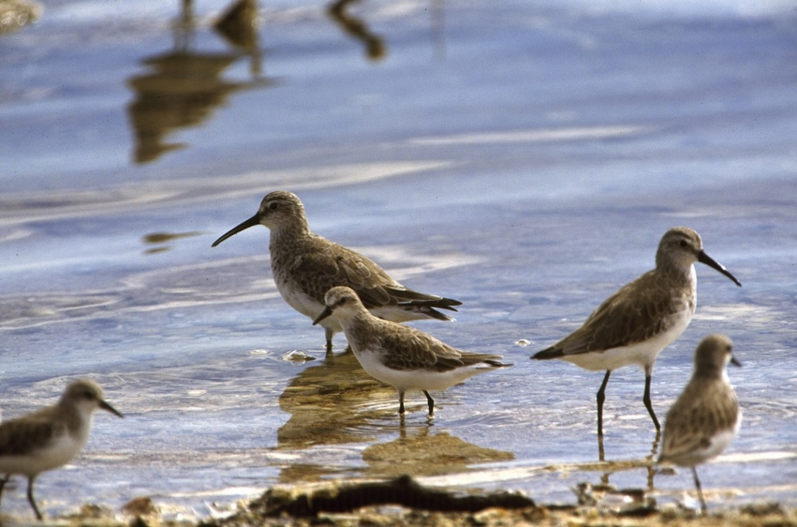

Figure 29 Curlew Sandpipers. Photo: Brian Furby.

## Conservation Status

Migratory shorebird species in Australia are protected under international treaties and agreements including the *Convention on the Conservation of Migratory Species of Wild Animals* (CMS, Bonn Convention), the Ramsar Convention on Wetlands, and through the East Asian - Australasian Flyway Partnership (the Flyway Partnership). The Australian Government has bilateral migratory bird agreements with Japan (Japan-Australia Migratory Bird Agreement, JAMBA), China (China-Australia Migratory Bird Agreement, CAMBA), and the Republic of Korea (Republic of Korea-Australia Migratory Bird Agreement, ROKAMBA). In Australia, the *Environment Protection and Biodiversity Conservation Act 1999* (EPBC Act) gives effect to these international obligations. Many species are also protected under state and territory environmental legislation.

There are 37 species listed as threatened and/or migratory species under the EPBC Act and are hence Matters of National Environmental Significance (MNES) in Australia. At least 56 trans-equatorial species belonging to three families: Pratincoles(*Glareolidae*)*,* Plovers(*Charadriidae*) and Sandpipers(*Scolopacidae*) have been recorded in Australia135. Of these, 36 species and one non-trans-equatorial species are listed under the EPBC Act. Three species (and one subspecies) of migratory shorebird are listed as “Critically Endangered”, two species as “Endangered” and one species (and one subspecies) as “Vulnerable” under the EPBC Act.

These Guidelines should be read in conjunction with EPBC Act [*Policy Statement 3.21 Industry guidelines for avoiding, assessing and mitigating impacts on EPBC Act listed migratory shorebird species*](https://www.environment.gov.au/system/files/resources/67d7eab4-95a5-4c13-a35e-e74cca47c376/files/bio4190517-shorebirds-guidelines.pdf)*136*.

## Distribution

Migratory shorebirds are found in all states and territories, and are found in Australia throughout the year. Peak abundance occurs between August and April, however, sexually immature birds defer their northward migration for several years and can be found in Australia during the Austral winter months.

They are predominantly associated with wetland habitats including estuaries and intertidal wetlands, coastal beaches, saltmarsh, mangrove fringes, wet grasslands, and ephemeral freshwater and salt lakes in inland Australia. Shorebirds are also opportunists and exploit artificial habitats such as pastures, tilled land, sewage treatment plants, irrigation canals, sports fields and golf courses. Of 397 internationally recognised sites considered important for migratory shorebirds along the East Asian–Australasian Flyway, 118 are found in Australia137.

### Important habitat for migratory shorebirds

For the purposes of these Guidelines, Important Habitat for migratory shorebirds includes all areas that are recognised, or eligible for recognition as nationally or internationally important habitat. These habitats are defined in *EPBC Act* [*Policy Statement 3.21 Industry guidelines for avoiding, assessing and mitigating impacts on EPBC Act listed migratory shorebird species*](https://www.environment.gov.au/system/files/resources/67d7eab4-95a5-4c13-a35e-e74cca47c376/files/bio4190517-shorebirds-guidelines.pdf)*136* and the [*Wildlife Conservation Plan for Migratory Shorebirds (2015)*](http://www.environment.gov.au/system/files/resources/9995c620-45c9-4574-af8e-a7cfb9571deb/files/widlife-conservation-plan-migratory-shorebirds.pdf)*138*.

* **Internationally important** habitat are those wetlands that support one per cent of the individuals in a population of one species or subspecies; or a total abundance of at least 20 000 waterbirds.
* **Nationally important** habitat are those wetlands that support 0.1 per cent of the flyway population of a single species; 2000 migratory shorebirds; or 15 migratory shorebird species.

## Effects of Artificial Light on Migratory Shorebirds

Artificial light can disorient flying birds, affect stopover selection, and cause their death through collision with infrastructure139. Birds may starve as a result of disruption to foraging, hampering their ability to prepare for breeding or migration. However, artificial light may help some species, particularly nocturnally foraging shorebirds as they may have greater access to food140,141.

### Annual cycle and habitat use in migratory shorebirds

Migratory shorebird species listed on the EPBC Act breed in the northern hemisphere, except the Double-banded Plover (*Charadrius bicinctus*), which breeds in New Zealand. Many of the northern hemisphere breeders nest in the arctic or sub-arctic tundra during the boreal summer (May – July) and spend the non-breeding season (August – April) in Australia or New Zealand. They usually spend five to six months on the non-breeding grounds, where they complete their basic (non-breeding plumage) moult, and later commence a pre-alternate (breeding plumage) moult prior to their northward migration. While undergoing their pre-alternate moult, shorebirds also consume an increased amount of prey to increase their fat storages, permitting them to travel greater distances between refuelling sites. Shorebirds refuel in East Asia during their northward migration, but during southward migration, some individuals travel across the Pacific, briefly stopping on islands to refuel. Shorebirds migrating across the Pacific typically have non-breeding grounds in Eastern Australia and New Zealand. Shorebirds returning to non-breeding grounds in Western and Northern Australia, once again pass through East Asia on their southward journey.

A common feature for many birds is their reliance on inland or coastal wetland habitats at some stages in their annual life-histories. In many migratory shorebirds, despite the vast distances they cover every year, they spend most of their time on coastal wetlands except for the two months of nesting when they use the tundra or taiga habitats. However, productive coastal wetland is localised, which means large proportions, or even entire populations, gather at a single site during stopover or non-breeding season. The Great Knot and Greater Sand Plover, is an example, with 40 per cent and 57 per cent respectively of their entire flyway population spends their non-breeding season at Eighty-Mile Beach in Western Australia137. Wetlands commonly used include coastal mudflats and sandflats, sandy beaches, saltmarsh and mangrove fringes, ephemeral freshwater wetlands and damp grasslands.

The coastal intertidal wetlands favoured by many migratory shorebirds are a dynamic ecosystem strongly influenced by the tidal cycle. This is part of the critical transition zones between land, freshwater habitats, and the sea. Throughout the East Asian-Australasian Flyway, intertidal wetlands have been susceptible to heavy modification for the development of farmlands, aquaculture, salt mining, ports and industry.

### Daily activity pattern and habitat use of migratory shorebirds

The daily activity pattern of shorebirds at coastal wetlands is not only determined by daylight, but also tidal cycle131. They feed on the exposed tidal wetland during low tide and roost during high tide as their feeding areas are inundated. The birds feed during both the day and night, especially in the lead-up to migration142,143.

Roost site selection can vary between day and night. Shorebirds often use diurnal roosts nearest to the intertidal feeding area and may travel further to use safer nocturnal roosts – but at greater energetic cost144,145. Roosting habitat can also vary between day and night. For example, the Dunlin (*Calidris alpina*),in California,had a greater use of pasture at night (which tended to be less affected by artificial light and disturbances) and relied less on their diurnal roosts of islands and artificial structures such as riprap and water pipes146.

Foraging behaviours differ between day and night, and between seasons143,147. Shorebirds typically show a preference for daytime foraging, which occurs over a greater area, and at a faster rate, than nocturnal foraging143. Increased prey availability, avoidance of daytime predation and disturbance are some reasons for nocturnal foraging147. Two basic types of foraging strategies have been described: visual and tactile (touch-based) foraging, with some species switching between these strategies. Tactile feeders such as sandpipers can use sensory organs in their bills to detect prey inside the substrate in the dark and can switch to visual foraging strategy during moonlit nights to take advantage of the moonlight147. Visual feeders such as plovers, have high densities of photo receptors, especially the dark adapted rods, which allow foraging under low light conditions147,148. Plovers have been shown to employ a visual foraging strategy during both the day and night, whereas sandpipers can shift from visual foraging during the day, to tactile foraging at night, likely due to less efficient night vision143.

### Vision in migratory shorebirds

There is a dearth of literature on light perception in migratory shorebirds with most studies confined to the role of vision in foraging and nothing on the physiology of shorebirds’ eyes or their response to different wavelengths of light.

Birds in general are known to be attracted to, and disoriented by, artificial lights. This could be a result of being blinded by the intensity of light that bleaches visual pigments and therefore failing to see visual details149 or interference with the magnetic compass used by the birds during migration150. An attraction to conventional artificial night lightings may lead to other adverse consequences such as reducing fuel stores, delaying migration, increasing the chance of collision and thereby, injury and death151.

Gulls and terns (*Anous minutus, Anous tenuirostris* and *Gygis alba*) share visual pigments that give them vision in the short wavelength ultraviolet region of the spectrum in addition to the violet (blue) region of the spectrum. However, this sensitivity to very short wavelength light is rare in seabirds, which are characterised by photopic vision (daylight adapted) sensitivity in the mid to long wavelength range of the visible spectrum (590 – 740 nm, orange to red) while their scotopic (low light, dark adapted) vision is more sensitive to short wavelengths of light (380 ‑ 485 nm, violet – blue)119.

### Biological impacts on migratory shorebirds

The exponential increase in the use of artificial light over the past decade means ecological light pollution has become a global issue60. Although the extent to which intertidal ecosystems are being affected is unclear152, several studies have assessed both the positive and negative aspects of light pollution on migratory shorebirds.

Artificial lighting has been shown to influence the nocturnal foraging behaviour in shorebirds141,153. Santos et al (2010) demonstrated three species of plover (Common Ringed Plover *Charadrius hiaticula*, Kentish Plover *Charadrius alexandrina* and Grey Plover *Pluvialis squatarola*) and two species of sandpiper (Dunlin *Calidris alpina* and Common Redshank *Tringa totantus*) improved foraging success by exploiting sites where streetlights provided extra illumination153.

Similarly, Dwyer et al (2013) showed artificial light generated from a large industrial site significantly altered the foraging strategy of Common Redshanks within an estuary. The greater nocturnal illumination of the estuary from the industrial site allowed the birds to forage for extended periods using a visual foraging strategy, which was deemed a more effective foraging behaviour when compared to tactile foraging141.

Although shorebirds may be attracted to foraging areas with greater nocturnal illumination, artificial light near nocturnal roosting sites may displace the birds. Rogers et al (2006) studied the nocturnal roosting habits of shorebirds in north-western Australia, and suggested nocturnal roost sites with low exposure to artificial lighting (e.g. streetlights and traffic) were selected, and where the risk of predation was perceived to be low140. The study also found nocturnal roosts spatially differed from diurnal roosts and required increased energetic cost to access as the distance between nocturnal roosts and foraging areas was greater than the distance between diurnal roost sites and the same foraging areas145. The overall density of shorebirds in suitable foraging areas is expected to decline with increased distance to the nearest roost, due to the greater energetic cost travelling between areas144,145. The artificial illumination (or lack thereof) of nocturnal roost sites is therefore likely to significantly influence the abundance of shorebirds in nearby foraging areas.

Intermittent or flashing lights could flush out the shorebirds and force them to leave the area, especially if the light is persistent (Choi pers. obs. 2018, Straw pers. comm. 2018).

Artificial light can affect birds in flight. Not only can bright light attract airborne migrants154, but artificial light can also affect stop-over selection in long distance migrators which can impact on successful migration and decrease fitness139. Similarly, Roncini et al (2015) reported on interactions between offshore oil and gas platforms and birds in the North Sea and found these were likely to include migratory shorebirds. The review estimated that hundreds of thousands of birds were killed each year in these interactions and light was the likely cause. The review recognised the gaps in monitoring and concluded that impacts are likely to be region, species and platform specific108.

## Environmental Impact Assessment of Artificial Light on Migratory Shorebirds

As a minimum, Best Practice Lighting Design should be implemented on infrastructure with externally visible artificial lighting. Where there is important habitat for migratory shorebirds within 20 km of a project, consideration should be given as to whether that light is likely to have an effect on those birds. The following sections step through the framework for managing artificial light, with specific consideration for migratory shorebirds. The 20 km buffer is based on a precautionary approach that sky glow can cause a change in behaviour in other species up to 15 km away28.

Where artificial light is likely to affect migratory shorebirds, consideration should be given to mitigation measures at the earliest point in a project and used to inform the design phase.

It is important to recognise the spatial and temporal characteristics of migratory corridors for some migratory shorebird species. Species typically use established migratory pathways at predictable times and artificial light intersecting with an overhead migratory pathway should be assessed in the same way as for ground-based populations.

### Associated guidance

* [*Wildlife Conservation Plan for Migratory Shorebirds* (2015)](http://www.environment.gov.au/system/files/resources/9995c620-45c9-4574-af8e-a7cfb9571deb/files/widlife-conservation-plan-migratory-shorebirds.pdf)
* Approved conservation advice

### Qualified personnel

### Lighting design/management and the EIA process should be undertaken by appropriately qualified personnel. Plans should be developed and reviewed by appropriately qualified lighting practitioners who should consult with an appropriately trained marine ornithologist or ecologist. People advising on the development of a lighting management plan, or the preparation of reports assessing the effect of artificial light on migratory shorebirds, should have relevant qualifications equivalent to a tertiary education in ornithology, or equivalent experience as evidenced by peer reviewed publications in the last five years on a relevant topic, or other relevant experience.

### Step 1: Describe the project lighting

The information collated during this step should consider the biological impact of light on migratory shorebirds. They can be affected by light when foraging or migrating at night. Artificial light at night may also affect their selection of roost site. The location and light source (both direct and sky glow) in relation to feeding and resting areas should be considered, depending on whether the birds are active or resting at night. Shorebirds are sensitive to short wavelength (blue/violet) light with some species able to detect UV light. However, the intensity of lights may be more important than colour.

### Step 2: Describe the migratory shorebird population and behaviour

The species, and behaviour of shorebirds in the area of interest should be described. This should include the conservation status of the species; abundance of birds; how widespread/localised is the population; the migratory corridor location and timing or usage; the regional importance of the population; the number of birds in the area in different seasons; and their night-time behaviour (resting or foraging).

Relevant shorebird information can be found in the *EPBC Act* [*Policy Statement 3.21 Industry guidelines for avoiding, assessing and mitigating impacts on EPBC Act listed migratory shorebird species*](https://www.environment.gov.au/system/files/resources/67d7eab4-95a5-4c13-a35e-e74cca47c376/files/bio4190517-shorebirds-guidelines.pdf)*136*, [*Wildlife Conservation Plan for Migratory Shorebirds (2015)*](http://www.environment.gov.au/system/files/resources/9995c620-45c9-4574-af8e-a7cfb9571deb/files/widlife-conservation-plan-migratory-shorebirds.pdf)*138,* the[Protected Matters Search Tool](https://www.environment.gov.au/epbc/protected-matters-search-tool), the [National Conservation Values Atlas](https://www.environment.gov.au/topics/marine/marine-bioregional-plans/conservation-values-atlas), state and territory listed species information, scientific literature, and local/Indigenous knowledge.

Where there is insufficient data to understand the population importance or demographics, or where it is necessary to document existing shorebird behaviour, field surveys and biological monitoring may be necessary.

#### Biological monitoring of migratory shorebirds

Monitoring associated with a project should be developed, overseen and results interpreted by appropriately qualified biologists to ensure reliability of the data.

The objective is to collect data on the abundance of birds and their normal behaviour. Please see [Survey guidelines for Australia’s threatened birds](http://www.environment.gov.au/epbc/publications/survey-guidelines-australias-threatened-birds-guidelines-detecting-birds-listed-threatened)128.

The data will be used to inform the EIA and assess whether mitigation measures are successful. Suggested minimum monitoring parameters (what is measured) and techniques (how to measure them) are summarised in Table 10.

Table 10 Recommended minimum biological information necessary to assess the importance of a migratory shorebird population. Note: the information in this table is not prescriptive and should be assessed on a case-by-case basis.

|  |  |  |  |
| --- | --- | --- | --- |
| **Target Age Class** | **Survey Effort** | **Duration** | **Reference** |
| Adult | Four surveys of roosting birds (one in December, two in January and one in February), with an additional three to four surveys within the same neap-spring tide cycle is recommended. | Two hours before and after predicted high tide. | [*Industry guidelines for avoiding, assessing and mitigating impacts on EPBC Act listed migratory shorebird species*](http://www.environment.gov.au/system/files/resources/67d7eab4-95a5-4c13-a35e-e74cca47c376/files/bio4190517-shorebirds-guidelines.pdf)136 |
| Immature | One to two surveys on roosting birds between mid-May and mid-July. | Two hours before and after predicted high tide. |  |

#### Monitoring migratory shorebird populations

* Monitor the population (during different seasons) to establish a benchmark for assessing abundance before, during and after construction, and during operations to detect project-related change.
* Quantify the diurnal and nocturnal habitat use and movement in relation to tidal cycle (both high and low tides during the neap and spring tide cycles) in the area under baseline conditions to compare with light-affected conditions during construction and operations.
* Measure nocturnal light levels at foraging sites and nocturnal roost sites before and after the construction period of a project.
* Monitor nocturnal roost sites using acoustic recording devices and/or infrared cameras to determine nocturnal roost site use following the introduction of artificial light.

As a minimum, qualitative descriptive data on visible light types, location and directivity should also be collected at the same time as the biological data. Handheld camera images can help to describe the light. Quantitative data on existing sky glow should be collected, if possible, in a biologically meaningful way, recognising the technical difficulties in obtaining these data. See Measuring Biologically Relevant Light for a review.

### Step 3: Risk assessment

The objective of these Guidelines is that light should be managed so that shorebirds are not disrupted within or displaced from important habitat and are able to undertake critical behaviours such as foraging, roosting and dispersal. These consequences should be considered in the risk assessment process. At important shorebird habitats, roosting and foraging numbers should remain constant and foraging birds should not be startled or at increased risk from predators as a result of increased illumination.

The assessment should consider the existing light environment, the proposed lighting design and mitigation/management, the behaviour of shorebirds at the location, and how the birds perceive light. This should include wavelength and intensity information and perspective. To understand how/whether shorebirds are likely to see light, a site visit should be made at night and the area viewed from the intertidal flats and roosting areas. Similarly, consideration should be given to how shorebirds will see light when in flight and along flyways during migration periods.

The type and number of artificial lights should then be considered to assess whether the birds are likely to perceive the light, and the possible consequences of light on their behaviour.

### Step 4: Light management plan

This plan should include all relevant project information (Step 1) and biological information (Step 2). It should outline proposed mitigation. For a range of shorebird specific mitigation measures see the Migratory Shorebird Light Mitigation Toolbox below. The plan should also outline the type and schedule for biological and light monitoring to ensure mitigation is meeting the objectives of the plan and triggers for revisiting the risk assessment phase of the EIA. The plan should outline contingency options if biological and light monitoring or compliance audits indicate that mitigation is not meeting the objectives of the plan (e.g. light is visible on intertidal flats, shorebirds cease using resting areas, or birds are grounding or colliding with fixed or floating infrastructure, or migrating birds cease using a migratory corridor).

### Step 5: Biological and light monitoring and auditing

The success of the plan should be confirmed through monitoring and compliance auditing. The results should be used to facilitate an adaptive management approach for continuous improvement.

Biological monitoring is described in Step 2: Describe the Migratory Shorebird Population. Concurrent light monitoring should be undertaken and interpreted in the context of how the birds perceive light and within the limitations of monitoring techniques described in Measuring Biologically Relevant Light. Auditing, as described in the plan, should be undertaken.

### Review

The EIA should incorporate a continuous improvement review process that allows for upgraded mitigations, changes to procedures and renewal of the light management plan.

## Migratory Shorebird Light Mitigation Toolbox

All projects should incorporate the Best Practice Light Design Principles. Appropriate lighting controls and light impact mitigation will be site/project and species specific. Table 11 provides a toolbox of options that would be implemented in addition to the six Best Practice Light Design principles. Not all mitigation options will be relevant for all situations. Table 12 provides a suggested list of light types appropriate for use near rookeries or roosting sites and those to avoid.

Table 11 Light management actions specific to migratory shorebirds.

| **Management Action** | **Detail** |
| --- | --- |
| Implement actions when birds are likely to be present. This includes peak migration periods (flyway locations). | Birds are found in Australia year-round. Major movements along coastlines take place between March and April, and August and November. Between August and April, shorebird abundance peaks. Smaller numbers are found from April to August. |
| No light source should be directly visible from foraging or nocturnal roost habitats, or from migratory pathways. | Any light that is directly visible to a person standing in foraging or nocturnal roost habitats will potentially be visible to a shorebird and should be modified to prevent it being seen. Similarly, lights should be shielded such that they are not visible from the sky. |
| Do not install fixed light sources in nocturnal foraging or roost areas. | Installing light sources (e.g. light poles) within shorebird habitat may permanently reduce the available area for foraging or roosting and provide vantage points for predators (e.g. raptors) during the day. |
| Prevent mobile light sources shining into nocturnal foraging and roost habitat. | The light from mobile sources such as mobile lighting towers, head torches or vehicle headlights should be prevented from aiming into nocturnal foraging or roost areas, as this can cause immediate disturbance. |
| Maintain a natural barrier (e.g. dune and/or vegetation screen) between nocturnal foraging and roost areas, and sources of artificial light. | Reducing the exposure of shorebirds to artificial light will reduce the risk of predation and disturbance. |
| Maintain a dark zone between nocturnal foraging and roost habitats and sources of artificial lights. | Creating a dark zone between artificial lights and shorebird habitat will reduce disturbances to shorebirds. |
| Use curfews to manage lighting near nocturnal foraging and roosting areas in coastal habitats. For example, manage artificial lights using motion sensors and timers from 7pm until dawn. | Curfews should also consider the tidal cycle if the artificial lighting is located coastally, e.g. extinguish lighting from two hours before high tide, until two hours after high tide, while shorebirds are potentially roosting. |
| Use of flashing/intermittent lights instead of fixed beam. | For example, small red flashing lights can be used to identify an entrance or delineate a pathway. The timing of when lights flash must follow a predictable, well-spaced pattern. |
| Use motion sensors to turn lights on only when needed. | For example, installing motion-activated pedestrian lighting within 500 m of nocturnal foraging or roost areas may reduce the amount of time the habitat is exposed to artificial light. |
| Manage artificial light on jetties and marinas. | Shorebirds will often roost on breakwaters and jetties, so allowing dark areas in such places may provide a safe area for shorebirds to roost. |
| Reduce deck lighting to minimum required for human safety on vessels moored near nocturnal foraging and roost areas, and those operating offshore. | Extinguish deck lights when not necessary and restrict lighting at night to navigation lights only. Offshore vessels should direct light inwards, particularly during the migration periods when shorebirds are potentially overhead.  Record bird strike or incidental capture and report these interactions to regulatory authorities. |
| Minimise night-time flaring on offshore oil and gas production facilities. | Consider reinjecting excess gas instead of flaring. Schedule maintenance flaring during daylight hours.  Record bird strike or incidental capture and report these interactions to regulatory authorities. |
| Use luminaires with spectral content appropriate for the species present. | Consideration should be given to avoid specific wavelengths that are problematic for the species of interest. In general this would include avoiding lights rich in blue light, however, some birds are sensitive to yellow light and other mitigation may be required. |
| Avoid high intensity light of any colour. | Keeping light intensity as low as possible in the vicinity of nocturnal foraging and roost areas will minimise impact. |
| Prevent indoor lighting reaching migratory shorebird habitat. | Use fixed window screens or window tinting on fixed windows and skylights to contain light inside buildings. |
| In facilities requiring intermittent night inspections, turn lights on only during the time operators are moving around the facility. | Use appropriate wavelength, explosion proof LEDs with smart lighting controls and/or motions sensors. LEDs have no warmup or cool down limitations so can remain off until needed and provide instant light when required for routine nightly inspections or in the event of an emergency. |
| Industrial site/plant operators to use personal head torches. | Consider providing plant operators with white head torches (explosion proof torches are available) for situations where white light is needed to detect colour correctly, or in the event of an emergency. Operators should avoid shining light across nocturnal foraging or roost areas as this can cause disturbance. |
| Supplement facility perimeter security lighting with computer monitored infrared detection systems. | Perimeter lighting can be operated when night-time illumination is necessary but remain off at other times. |

Table 12 Where all other mitigation options have been exhausted and there is a human safety need for artificial light, the following table provides commercial luminaires recommended for use near migratory shorebird habitat and those to avoid.

|  |  |
| --- | --- |
| **Light type** | **Suitability for use near migratory shorebird habitat** |
| Low Pressure Sodium Vapour |  |
| High Pressure Sodium Vapour |  |
| Filtered*LED |  |
| Filtered*metal halide |  |
| Filtered* white LED |  |
| LED with appropriate spectral properties for species present |  |
| White LED |  |
| Metal halide |  |
| White fluorescent |  |
| Halogen |  |
| Mercury vapour |  |

* ‘Filtered’ means this type of luminaire can be used *only* if a filter is applied to remove the problematic wavelength light.

# Glossary

**ACAP** is the *Agreement on the Conservation of Albatrosses and Petrels*.

**ALAN** is Artificial Light At Night and refers to artificial light outside that is visible at night.

**Artificial light** is composed of visible light as well as some ultraviolet (UV) and infrared (IR) radiation that is derived from an anthropogenic source.

**Artificial sky glow** is the part of the sky glow that is attributable to human-made sources of light (see also **sky glow**).

**Baffle** is an opaque or translucent element to shield a light source from direct view, or to prevent light reflecting from a surface like a wall.

**Biologically Important Area** **(BIA)** is a spatially defined area where aggregations of individuals of a species are known to display biologically important behaviour, such as breeding, feeding, resting or migration.

**Biologically relevant** is an approach, interpretation or outcome that considers either the species to which it refers, or factors in biological considerations in its approach.

**Brightness** is the strength of the visual sensation on the naked eye when lit surfaces are viewed.

**Bulb** is the source of electric light and is a component of a luminaire.

**CAMBA** is the *China-Australia Migratory Bird Agreement*.

**Candela (cd)** (**photometric term**) is a photometric unit of illumination that measures the amount of light emitted in the range of a (three-dimensional) angular span. Luminance is typically measured in candela per square meter (cd/m2).

**Charge Coupled Device (CCD)** is the sensor technology used in digital cameras. It converts captured light into digital data (images) which can be processed to produce quantifiable data.

**CIE** is the Commission Internationale de l’Eclairage (International Light Commission), which sets most international lighting standards.

**CMS** is the *Convention on the Conservation of Migratory Species of Wild Animals* or the Bonn Convention.

**Colour temperature** is the perceived colour of a light source ranging from cool (blue) to warm (yellow), measured in Kelvin (K). A low correlated colour temperature such as 2500K will have a warm appearance while 6500K will appear cold.

**Correlated Colour Temperature** **(CCT)** is a simplified way to characterize the spectral properties of a light source and is correlated to the response of the human eye. Colour temperature is expressed in Kelvin (K).

**Cumulative light** refers to increased sky brightness due to light emissions contributions from multiple light producers. Measured as **sky glow**.

**Disorientation** refers to any species moving in a confused manner e.g. a turtle hatchling circling and unable to find the ocean.

**EEZ** is the Australian Exclusive Economic Zone.

**EIA** is an environmental impact assessment process.

**Electromagnetic radiation** is a kind of radiation including visible light, radio waves, gamma rays, and X-rays, in which electric and magnetic fields vary simultaneously.

**EPBC Act** is the Commonwealth *Environment Protection and Biodiversity Act 1999*.

**Fallout** refers to birds that collide with structures when disoriented.

**Footcandle (fc or ftc) (photometric term**) is a unit of light intensity used in America, it is based on the brightness of one candle at a distance of one foot. Measured in lumens per square foot, one ftc is equal to approximately 10.7639 lux. This is not an appropriate measure for understanding how animals perceive light.

**FMP** refers to the Field Management Program.

**Genetic stock** is a discrete grouping of a species by genetic relatedness. Management of the species may be undertaken on a genetic stock basis because each genetic stock represents a unique evolutionary history, which if lost cannot be replaced.

**Grounding** refers to events where birds fail to take their first flight from the nest or collide with a structure (adults and juveniles) and are unable to launch back into the air.

**Habitat critical to the survival** **of the species** is an area defined in a Recovery Plan for a listed threatened species that provides for the recovery of the species.

**Horizontal plane**, in relation to the light fitting, means the horizontal plane passing through the centre of the light source (for example the bulb) of the light fitting.

**HPS** is a high-pressure sodium lamp that produces a characteristic wavelength near 589 nm.

**IAATO** is the International Association of Antarctica Tour Operators.

**Illuminance** is a **photometric** measure of the total luminous flux incident on a surface, per unit area. It is a measure of how much the incident light illuminates the surface, wavelength-weighted to correlate with human brightness perception. Illuminance is measured in **lux** (lx) or equivalently in **lumens** per square metre (lm/m2).

**Important habitats** are those areas that are necessary for an ecologically significant proportion of a listed species to undertake important activities such as foraging, breeding, roosting or dispersal. Important habitats will be species specific and will depend on their listing status. It will include areas that have been designated as **Habitat Critical to Survival** of a threatened species.

**Incandescent bulb** is a bulb that provides light by a filament heated to a high temperature by electric current.

**Intensity** is the amount of energy or light in a given direction.

**Internationally important** refers to wetland habitat for migratory shorebirds that support one per cent of the individuals in a population of one species or subspecies; or a total abundance of at least 20 000 waterbirds.

**IR** is infrared radiation and represents a band of the electromagnetic spectrum with wavelength from 700 nm to 1 mm.

**Irradiance** (**radiometric term**)is a measurement of radiant flux at or on a known surface area, W/m2. This measure is appropriate for understanding animal perception of light.

**IUCN** is the International Union for the Conservation of Nature.

**JAMBA** is the *Japan-Australia Migratory Bird Agreement*.

**Kelvin** **(K)** is the absolute unit for temperature and is equal in magnitude to one degree Celsius. Kelvin is typically used to describe **Correlated Colour Temperature (CCT)**.

**Lamp** is a generic term for a source of optical radiation (light), often called a “bulb” or “tube”. Examples include incandescent, fluorescent, high-intensity discharge (HID) lamps, and low-pressure sodium (LPS) lamps, as well as light-emitting diode (LED) modules and arrays.

**LED** is a light-emitting diode, or a semiconductor light source that emits light when current flows through it.

**Light fitting** (**luminaire**) is the complete lighting unit. It includes the bulb, reflector (mirror) or refractor (lens), the ballast, housing and the attached parts.

**Light** is the radiant energy that is visible to humans and animals. Light stimulates receptors in the visual system and those signals are interpreted by the brain making things visible.

**Light pollution** is the brightening of the night sky caused by **artificial light**.

**Light spill** is the light that falls outside the boundaries of the object or area intended to be lit. Spill light serves no purpose and if directed above the horizontal plane, contributes directly to **artificial sky glow**. Also called spill light, obtrusive light or light trespass.

**Lighting controls** are devices used for either turning lights on and off, or for dimming.

**Listed species** are those species listed under the **EPBC Act,** or under relevant state or territory environment/conservation legislation. Species may be listed as threatened, migratory or part of a listed threatened ecological community.

**LNG** is liquefied natural gas.

**LPS** is a low pressure sodium lamp that produces a characteristic wavelength near 589 nm.

**Luminaire** refers to the complete lighting unit (fixture or light fitting), consisting of a lamp, or lamps and ballast(s) (when applicable), together with the parts designed to distribute the light (reflector, lens, diffuser), to position and protect the lamps, and to connect the lamps to the power supply.

**Luminous flux** is the total light emitted by a bulb in all directions which is measured in **lumen**.

**Lumen (lm) (photometric term)** is the unit of **luminous flux**, a measure of the total quantity of visible light emitted by a source per unit of time. This is a **photometric** unit, weighted to the sensitivity of the human eye. If a light source emits one **candela** of luminous intensity uniformly across a solid angle of one steradian, the total **luminous flux** emitted into that angle is one lumen.

**Luminance (cd/m2)** is a **photometric** measure of the luminous intensity per unit area of light travelling in a given direction, wavelength-weighted to correlate with human brightness perception. Luminance is measured in candela per square metre (cd/m2). Luminance and **illuminance** ("**Lux**") are related, in the sense that luminance is a measure of light emitted from a surface (either because of reflection or because it's a light-emitting surface), and illuminance is a measure for light hitting a surface.

**Lux (lx)** is a **photometric** measure of illumination of a surface. The difference between lux and **candela** is that lux measures the illumination of a surface, instead of that of an angle. This is not an appropriate measure for understanding how animals perceive light.

**Magnitudes per square arc second** (**magnitudes/arcsec2)** (**radiometric term**) is a term used in astronomy to measure sky brightness within an area of the sky that has an angular area of one second by one second. The term magnitudes per square arc second means that the brightness in magnitudes is spread out over a square arcsecond of the sky. Each magnitude lower (numerically) means just over 2.5 times more light is coming from a given patch of sky. A change of 5 magnitudes/arcsec2 means the sky is 100x brighter.

**Misorientation** occurs when a species moves in the wrong direction, e.g. when a turtle hatchling moves toward a light and away from the ocean.

**MNES** are Matters of National Environmental Significance as defined by the **EPBC Act** and include listed threatened and listed migratory species.

**Mounting height** is the height of the fitting or bulb above the ground.

**Nationally important** habitat are those wetlands that support 0.1 per cent of the flyway population of a single species of migratory shorebird; or 2 000 migratory shorebirds; or 15 migratory shorebird species.

**Natural sky glow** is that part of the **sky glow** that is attributable to radiation from celestial sources and luminescent processes in the Earth’s upper atmosphere.

**Outdoor lighting** is the night-time illumination of an area by any form of outside light fitting (luminaire).

**Outside light fitting** means a light fitting (luminaire) that is attached or fixed outside or on the exterior of a building or structure, whether temporary or permanent.

**Photocells** are sensors that turn lights on and off in response to natural light levels. Some advanced mode can slowly dim or increase the lighting (see also **smart controls**).

**Photometric terms** refer to measurements of light that are weighted to the sensitivity of the human eye. They are not include the shortest or the longest wavelengths of the visible spectrum and so are not appropriate for understanding the full extent of how animals perceive light.

**Photometry** is a subset of radiometry that is the measurement of light as it is weighted to the sensitivity of the human eye.

**Point source** is light from an unshielded lamp (i.e. directly visible).

**Radiance** (**radiometric term**) is a measure of radiant intensity emitted from a unit area of a source, measured in W/m2.

**Radiant flux/power** (**radiometric term**) is expressed in watts (W). It is the total optical power of a light source. It is the radiant energy emitted, reflected, transmitted or received, per unit time. Sometimes called radiant power, and it can also be defined as the rate of flow of radiant energy.

**Radiant intensity** (**radiometric term**) is the amount of flux emitted through a known solid angle, W/steradian, and has a directional quantity.

**Radiometric** **terms** refer to light measured across the entire visible spectrum (not weighted to the human eye). These are appropriate for understanding how animals perceive light.

**Radiometry** is the measurement of all wavelengths across the entire visible spectrum (not weighted to the human eye).

**Reflected light** is light that bounces off a surface. Light coloured surfaces reflect more light than darker coloured surfaces.

**ROKAMBA** is the *Republic of Korea-Australia Migratory Bird Agreement*.

**Sensitive receptor** is any living organism that has increased sensitivity or exposure to environmental contaminants that may have adverse effects.

**Shielded light fitting** is a physical barrier used to limit or modify the light paths from a luminaire.

**Sky glow** is the brightness of the night sky caused by the cumulative impact of reflected radiation (usually visible light), scattered from the constituents of the atmosphere in the direction of observation. Sky glow comprises two separate components: natural sky glow and artificial sky glow (see also **natural sky glow** and **artificial sky glow**).

**Smart controls** are devices to vary the intensity or duration of operation of lighting, such as motion sensors, timers and dimmers used in concert with outdoor lighting equipment.

**Spectral power curve** provides a representation of the relative presence of each wavelength emitted from a light source.

**Task lighting** is used to provide direct light for specific activities without illuminating the entire area or object.

**Upward Light Ratio (ULR)** is the proportion of the light (flux) emitted from a **luminaire** or installation that is emitted at and above the horizontal, excluding reflected light when the luminaire is mounted in its parallel position. ULR is the upward flux/total flux from the luminaire.

**UV** is ultraviolet light and represents a band of the electromagnetic spectrum with wavelength from 10 nm to 400 nm.

**Visible light transmittance** is the proportion of light transmitted by window glass which is recorded as either TVw (visible transmittance of the window) and is reported as a dimensionless value between 0 and 1, or 0 and 100%. A low TVw (e.g. < 30%) indicates little light is transmitted through the glass while higher TVw values are associated with increasing light transmittance. While the VLT/Tvw rating varies between 0 and 1, most double glazed windows rate between 0.3 and 0.7, which means that between 30% and 70% of the available light passes through the window.

**W/m2** is ameasure of radiance, the radiant intensity emitted from a unit area of a source (see **radiance**). This is an appropriate measure for understanding how animals perceive light.

**Wattage** is the amount of electricity needed to light a bulb. Generally, the higher the wattage, the more **lumens** are produced. Higher wattage and more lumens give a brighter light.

**Wavelength** as light travels through space it turns a wave with evenly spaces peaks and troughs. The distance between the peaks (or the troughs) is called the wavelength of the light. Ultraviolet and blue light are examples of short wavelength light while red and infrared light is long wavelength light. The energy of light is linked to the wavelength; short wavelength light has much higher energy than long wavelength light.

**Zenith** is an imaginary point directly above a location, on the imaginary celestial sphere.

# References

1. Kyba CCM, Kuester T, Sánchez de Miguel A, Baugh K, Jechow A, Hölker F, Bennie J, Elvidge CD, Gaston KJ & Guanter L (2017) Artificially lit surface of Earth at night increasing in radiance and extent*.* *Science Advances* 3:e1701528.

2. Russart KLG & Nelson RJ (2018) Artificial light at night alters behavior in laboratory and wild animals*.* *JEZ-A Ecological and Intergrative Physiology* 329(8-9):401-408.

3. Witherington B & Martin RE (2003) *Understanding, Assessing, and Resolving Light-Pollution Problems on Sea Turtle Nesting Beaches* Florida Fish and Wildlife Conservation Commission FMRI Technical Report TR-2: Jensen Beach, Florida. 84p.

4. Rodríguez A, Holmes ND, Ryan PG, Wilson K-J, Faulquier L, Murillo Y, Raine AF, Penniman J, Neves V, Rodríguez B, Negro JJ, Chiaradia A, Dann P, Anderson T, Metzger B, Shirai M, Deppe L, Wheeler J, Hodum P, Gouveia C, Carmo V, Carreira GP, Delgado-Alburqueque L, Guerra-Correa C, Couzi F-X, Travers M & Le Corre M (2017) A global review of seabird mortality caused by land-based artificial lights*.* *Conservation Biology* 31:986-1001.

5. Robert KA, Lesku JA, Partecke J & Chambers B (2015) Artificial light at night desynchronizes strictly seasonal reproduction in a wild mammal*.* *Proceedings of the Royal Society B* 282:20151745.

6. Fobert EK, Burke da Silva K & Swearer SE (2019) Artificial light at night causes reproductive failure in clownfish*.* *Biology Letters* 15:e20190272.

7. Rich C & Longcore T, eds. (2006) *Ecological consequences of artificial night lighting*. Island Press: Washington DC. 480p.

8. Campos SMC (2017) The impact of artificial lighting on nature. In *6th SENAC MEETING of Integrated Knowledge Senac Sorocaba*.

9. Reed JR (1986) *Seabird vision: Spectral sensitivity and light-attraction behavior* University of Wisconsin: Madison, Wisconsin. 190p.

10. Newman EA & Hartline PH (1981) Integration of visual and infrared information to biomodal neurons in the rattlesnake optic tectum*.* *Science* 213(4509):789-91.

11. Gaston KJ, Visser ME & Holker F (2018) The biological impacts of artificial light at night: the research challenge*.* *Philosophical Transactions of the Royal Society B* 370:e20140133.

12. Sanders D & Gaston KJ (2018) How ecological communities respond to artificial light at night*.* *Journal of Experimental Zoology* 329(8-9):394-400.

13. Bennie J, Davies TW, Cruse D & Gaston J (2016) Ecological effects of artificial light at night on wild plants*.* *Journal of Ecology* 104(3):611-620.

14. Price JT, Drye B, Domangue RJ & Paladino FV (2018) Exploring the role of artificial light in Loggerhead turtle (*Caretta caretta*) nest-site selection and hatchling disorientation*.* *Herpetological Conservation and Biology* 13(2):415-422.

15. Witherington BE (1992) Behavioural response of nesting sea turtles to artificial lighting*.* *Herpetologica* 48:31-39.

16. Thums M, Whiting SD, Reisser JW, Pendoley KL, Pattiaratchi CB, Proietti M, Hetzel Y, Fisher R & Meekan M (2016) Artificial light on water attracts turtle hatchlings during their near shore transit*.* *Royal Society Open Science* 3:e160142.

17. Cabrera-Cruz SA, Smolinsky JA & Buler JJ (2018) Light pollution is greatest within migration passage areas for nocturnally-migrating birds around the world*.* *Nature Scientific Reports* 8:e3261.

18. Ouyang JQ, de Jong M, Hau M, Visser ME, van Grusven RHA & Spoelstra K (2015) Stressful colours: Corticosterone concentrations in a free-living songbird vary with the spectral composition of experimental illumination*.* *Biology Letters* 11:20150517.

19. Warrant EJ, Frost B, Green K, Mouritsen H, Dreyer D, Adden A, Brauburger K & Heinze S (2016) The Australian Bogong moth *Agrotis infusa*: A long-distance nocturnal navigator*.* *Frontiers in Behavioural Neuroscience* doi: 10.3389/fnbeh.2016.00077.

20. Commonwealth of Australia (2016) *National Recovery Plan for the Mountain Pygmy-possum Burramys parvus* Prepared by the Victorian Department of Environment, Land, Water and Planning: Canberra, Australia. 43p.

21. Haddock JK, Threlfall CG, Law B & Hochuli DF (2019) Responses of insectivorous bats and nocturnal insects to local changes in street light technology*.* *Austral Ecology* 44(6):doi.org/10.1111?aec.12772.

22. Bolton D, Mayer-Pinto M, Clark GF, Dafforn KA, Brassil WA, Becker A & Johnston EL (2017) Coastal urban lighting has ecological consequences for multiple trophic levels under the sea*.* *Science of the Total Environment* 576:1-9.

23. Gonza´lez-Bernal E, Brown G & Shine R (2014) Invasive cane toads: Social facilitation depends upon an individual’s personality*.* *PLoS ONE* 9(7):e102880.

24. Wilson P, Thums M, Pattiaratchi CB, Whiting S, Pendoley K, Ferreira L & Meekan M (2019) High predation of marine turtle hatchlings near a coastal jetty*.* *Biological Conservation* 236(2019):571-579.

25. Commonwealth of Australia (2013) *Matters of National Environmental Significance Significant Impact Guidelines 1.1 Environmental Protection and Biodiversity Conservation Act 1999*: Canberra, Australia. 39p.

26. Kamrowski RL, CJ L, Pendoley K & Hamann M (2014) Influence of industrial light pollution on the sea-finding behaviour of flatback turtle hatchlings*.* *Wildlife Research* 41:421-434.

27. Hodge W, Limpus CJ & Smissen P (2007) *Queensland turtle conservation project: Hummock Hill Island Nesting Turtle Study December 2006* *Conservation Technical and Data Report* Environmental Protection Agency, Queensland. p:1-10.

28. Rodríguez A, Burgan G, Dann P, Jessop R, Negro JJ & Chiaradia A (2014) Fatal attraction of short-tailed shearwaters to artificial lights*.* *PLoS ONE* 9(10):e110114.

29. Moro D, van de Merwe J, Thomas M, Smith A & Lagdon R (2018) Integrating resource development with island conservation: Barrow Island as a model for conservation and development. In: *Australian Island Arks: Conservation, Management and Opportunities*, Moro D, Ball D & Bryant S, Editors. CSIRO Publishing: Melbourne, p:131-146.

30. Chevron Australia (2018) *Gorgon Gas Development and Jansz Feed Gas Pipeline Long-term Marine Turtle Management Plan*. 83p.

31. Rodrıguez A, Moffet J, Revoltos A, Wasiak P, McIntosh RR, Sutherland DR, Renwick L, Dann P & Chiaradia A (2017) Light pollution and seabird fledglings: Targeting efforts in rescue programs*.* *Journal of Wildlife Management* 81:734-741.

32. Rodríguez A, Dann P & Chiaradia A (2017) Reducing light-induced mortality of seabirds: High pressure sodium lights decrease the fatal attraction of shearwaters*.* *Journal for Nature Conservation* 39:68-72.

33. Limpus CJ, Miller JD, Parmenter CJ & Limpus DJ (2003) The green turtle, *Chelonia mydas*, population of Raine Island and the Northern Great Barrier Reef: 1843-2001*.* *Memoirs of the Queensland Museum* 49:349-440.

34. Irsitech (2018) [*https://iristech.co/how-iris-reduces-blue-light/visible-spectrum*](https://iristech.co/how-iris-reduces-blue-light/visible-spectrum). 2018 [cited Accessed 1stOctober 2018.

35. Algvere PV, Marshall J & Seregard S (2006) Age‐related maculopathy and the impact of blue light hazard*.* *Acta Ophthalmologica Scandinavica* 84(1):4-15.

36. West KE, Jablonski MR, Warfield B, Cecil KS, James M, Ayers MA, Maida J, Bowen C, Sliney DH, Rollag MD & Hanifin JP (2010) Blue light from light-emitting diodes elicits a dose-dependent suppression of melatonin in humans*.* *Journal of applied physiology* 110(3):619-626.

37. Pendoley K & Kamrowski RL (2015) Influence of horizon elevation on the sea-finding behaviour of hatchling flatback turtles exposed to artificial light glow*.* *Marine Ecology Progress Series* 529:279-288.

38. Bird BL, Branch LC & Miller DL (2004) Effects of coastal lighting on foraging behaviour on beach mice*.* *Conservation Biology* 18:1435-1439.

39. Salmon M (2006) Protecting sea turtles from artificial night lighting at Florida's oceanic beaches. In: *Ecological Consequences of Artificial Night Lighting*, Rich C & Longcore T, Editors. Island Press: Washinton DC p:141-168.

40. Tosini G, Ferguson I & Tsubota K (2016) Effects of blue light on the circadian system and eye physiology*.* *Molecular Vision* 22:61-72.

41. Ecker JL, Dumitrescu ON, Wong KY, Alam NM, Chen S, LeGates T, Renna JM, Prusky GT, Berson DM & Hattar S (2010) Melanopsin-expressing retinal ganglion-cell photoreceptors: Cellular diversity and role in pattern vision*.* *Neuron* 67(1):49-60.

42. Berson DM (2007) Phototransduction in ganglion-cell photoreceptors*.* *Pflügers Archiv* 454(5):849-855.

43. de Jong M, Ouyang JQ, Da Silva A, van Grunsven RHA, Kempenaers B, Visser ME & Spoelstra K (2015) Effects of nocturnal illumination on life-history decisions and fitness in two wild songbird species. *Philosophical Transactions of the Royal Society of London. Series B, Biological Sciences* 370:20140128–20140128.

44. Angers K, Haddad N, Selmaoui B & Thibault L (2003) Effect of melatonin on total food intake and macronutrient choice in rats*.* *Physiology & Behavior* 80:9-18.

45. Benenson W, Harris JW, Stöcker H & Lutz H, eds. (2006) *Handbook of Physics*. Springer Science & Business Media.

46. Kyba CCM, Ruhtz T, Fishcher J & Holker F (2011) Cloud coverage acts as an amplifier for ecological light pollution in urban ecosystems*.* *PLoS ONE* 6(e17307).

47. Longcore T, Rodríguez A, Witherington B, Penniman JF, Herf L & Herf M (2018) Rapid assessment of lamp spectrum to quantify ecological effects of light at night*.* *Journal of Experimental Zoology Part A Ecological and Integrative Physiology* 2018:1-11.

48. Lohmann KJ, Witherington B, Lohmann CMF & Salmon M (1997) Orientation, navigation, and natal beach homing in sea turtles. In: *The Biology of Sea Turtles. Volume I*, Lutz PL & Musick JA, Editors. CRC Press: Washington D.C. p:107-135.

49. Barentine JC (2019) Methods for assessment and monitoring of light pollution around ecologically sensitive sites*.* *Journal of Imaging* 5(54):e5050054.

50. Hänel A, Posch T, Ribas SJ, Aubé M, Duriscoe D, Jechow A, Kollath Z, Lolkema D, Moore C, Schmidt N, Spoelstra H, Wuchterl G & Kyba CCM (2018) Measuring night sky brightness: Methods and challenges*.* *Journal of Quantitative Spectroscopy and Radiative Transfer* doi: 10.1016/j.jqsrt.2017.09.008

51. Levin N, Kyba CCM, Zhang Q, Sánchez de Miguel A, Román MO, Li X, Portnov BA, Moltman AL, Jechow A, Miller SD, Wang Z, Shrestha RM & Elvidge CD (2020) Remote sensing of night lights: A review and an outlook for the future*.* *Remote Sensing of the Environment* 237:111443.

52. den Outer P, Lolkema D, Haaima M, Hoff RVD, Spoelstra H & Schmidt W (2011) Intercomparisons of nine sky brightness detectors*.* *Sensors* 11(10):9603.

53. Duriscoe DM (2013) Measuring anthropogenic skyglow using a natural sky brightness model*.* *Publications of the astronomical society of the Pacific* 125:1370-1382.

54. Jechow A, Kyba CCM & Hölker F (2019) Beyond all-sky: Assessing ecological light pollution using multi-spectral full-sphere fisheye lens imaging *Journal of Imaging* 5(46):doi:10.3390/jimaging5040046.

55. Kolláth Z (2010) Measuring and modelling light pollution at the Zselic Starry Sky Park*.* *Journal of Physics: Conference Series* 2018 (5th Workshop of Young Researchers in Astronomy & Astrophysics) e012001.

56. Jechow A, Ribas SJ, Domingo RC, Hölker F, Kolláth Z & Kyba CC (2018) Tracking the dynamics of skyglow with differential photometry using a digital camera with fisheye lens*.* *Journal of Quantitative Spectroscopy and Radiative Transfer* 209:212-223.

57. Commonwealth of Australia (2017) *The Recovery Plan for Marine Turtles in Australia* Department of the Environment and Energy: Canberra, Australia. 146p.

58. Hooker D (1911) Certain reactions to color in the young loggerhead turtle*.* *Papers from the Tortugas Laboratory - Carnegie Institute* 13:71-76.

59. Salmon M (2003) Artificial night lighting and sea turtles*.* *Biologist* 50:163-168.

60. Falchi F, Cinzano P, Duriscoe D, Kyba CCM, Elvidge CD, Baugh K, Portnov BA, Rybnikova NA & Furgoni R (2016) The new world atlas of artificial night sky brightness*.* *Science Advances* 2(6):e1600377.

61. Kamrowski RL, Limpus CJ, Moloney J & Hamann M (2012) Coastal light pollution and marine turtles: Assessing the magnitude of the problem*.* *Endangered Species Research* 19:85-98.

62. Pendoley K (2000) *The influence of gas flares on the orientation of Green Turtle hatchlings at Thevenard Island, Western Australia* in Pilcher NJ & Ismail G, Editors, *Second ASEAN Symposium and Workshop on Sea Turtle biology and Conservation* ASEAN Academic Press. Kota Kinabalu, Borneo. p:130-142.

63. Pendoley KL (2005) *Sea Turtles and the Environmental Management of Industrial Activities in North Western Australia* Murdoch University. 330p.

64. Hu Z, Hu H & Huang Y (2018) Association between nighttime artificial light pollution and sea turtle nest density along Florida coast: A geospatial study using VIIRS remote sensing data*.* *Environmental Pollution* 239:30-42.

65. Pennell JP (2000) *The Effect of Filtered Roadway Lighting on Nesting by Loggerehad Sea Turtles (Caretta caretta) and Green Turtle (Chelonia mydas) Hatchlings* Florida Atlantic University: Boca Raton.

66. Salmon M, Reiners R, Lavin C & Wyneken J (1995) Behavior of loggerhead sea turtles on an urban beach. I. Correlates of nest placement*.* *Journal of Herpetology* 29(4):560-567.

67. Campbell C (1994) The effects of flash photography on nesting behavior of green turtles (*Chelonia mydas*) at Tortuguero, Costa Rica. In *Proceeding of the fourteenth annual symposium on sea turtle biology and conservation*. 1994. NOAA Technical Memorandum - NMFS-SEFSC.

68. Mrosovsky N (1968) Nocturnal emergence of hatchling sea turtles: Control by thermal inhibition of activity*.* *Nature* 220:1338-1339.

69. Erb V & Wyneken J (2019) Nest-to-Surf Mortality of Loggerhead Sea Turtle (*Caretta caretta*) Hatchlings on Florida’s East Coast*.* *Frontiers in Marine Science* 6(271):doi: 10.3389/fmars.2019.00271.

70. Limpus CJ & Kamrowski RL (2013) Ocean-finding in marine turtles: The importance of low horizon elevation as an orientation cue*.* *Behaviour* 150:863-893.

71. Horch KW, Gocke JP, Salmon M & Forward RB (2008) Visual spectral sensitivity of hatchling loggerhead (*Caretta caretta* L.) and leatherback (*Dermochelys coriacea* L.) sea turtles, as determined by single-flash electroretinography*.* *Marine and Freshwater Behaviour and Physiology* 41(2):107-119.

72. Witherington BE & Bjorndal KA (1991) Influences of artificial lighting on the seaward orientation of hatchling loggerhead turtles *Caretta caretta.* *Biological Conservation* 55(2):139-149.

73. Fritches KA (2012) Australian loggerhead sea turtle hatchlings do not avoid yellow*.* *Marine and Freshwater Behaviour and Physiology* 45(2):79-89.

74. Levenson DH, Eckert SA, Crognale MA, Deegan II JF & Jacobs GH (2004) Photopic spectral sensitivity of green and loggerhead sea turtles*.* *Copeia* 2004(2):908-914.

75. Robertson K, Booth DT & Limpus CJ (2016) An assessment of ‘turtle-friendly’ lights on the sea-finding behaviour of loggerhead turtle hatchlings (*Caretta caretta*)*.* *Wildlife Research* 43:27-37.

76. Mrosovsky N (1972) The water finding ability of sea turtles*.* *Brain Behaviour and Evolution* 5:202-225.

77. Mrosovsky N & Shettleworth SJ (1968) Wavelength preferences and brightness cues in the water finding behaviour of sea turtles. *Behaviour* 32:211-257.

78. Pendoley K & Kamrowski RL (2015) Sea-finding in marine turtle hatchlings: What is an appropriate exclusion zone to limit disruptive impacts of industrial light at night? *Journal for Nature Conservation* 30:1-11.

79. Salmon M, Wyneken J, Fritz E & Lucas M (1992) Sea finding by hatchling sea turtles: Role of brightness, silhouette and beach slope as orientation cues*.* *Behaviour* 122:56-77.

80. Harewood A & Horrocks J (2008) Impacts of coastal development on hawksbill hatchling survival and swimming success during the initial offshore migration*.* *Biological Conservation* 141:394-401.

81. Truscott Z, Booth DT & Limpus CJ (2017) The effect of on-shore light pollution on sea-turtle hatchlings commencing their off-shore swim*.* *Wildlife Research* 3(5):127-134.

82. White D & Gill J (2007) A “lost years” flatback turtle *Natator depressus* (Garman, 1858) found*.* *Northern Territory Naturalist* 19:51-53.

83. Salmon M & Wyneken J (1990) Do swimming loggerhead turtles (*Caretta caretta* L.) use light cues for offshore orientation? *Marine Behavioural Physiology* 17:233-246.

84. Wilson P, Thums M, Pattiaratchi CB, Meekan M, Pendoley K, Fisher R & Whiting S (2018) Artificial light disrupts the nearshore dispersal of neonate flatback turtles *Natator depressus.* *Marine Ecology Progress Series* 600:179-192.

85. Eckert KL, Bjorndal KA, Abreu-Grobois FA & Donnelly M, eds. (1999) *Research and Management Techniques for the Conservation of Sea Turtles*. IUCN/SSC Marine Turtle Specialist Group Publication No. 4. Washington, DC. 235.

86. Pendoley KL, Whittock PA, Vitenbergs A & Bell CD (2016) Twenty years of turtle tracks: marine turtle nesting activity at remote locations in the Pilbara, Western Australia*.* *Australian Journal of Zoology* 64:217-226.

87. Witherington B (1997) The problem of photopollution for sea turtles and other nocturnal animals. In: *Behavioral Approaches to Conservation in the Wild*, Clemmons JR & Buchholz R, Editors. Cambridge University Press: Cambridge. p:303-328.

88. Ross GJB, Burbidge AA, Canty P, Dann P, Fuller PJ, Kerry KR, Norman FI, Menkhorst PW, Shaughnessy G, Shaughnessy PD & Smith GC (1996) Status of Australia's Seabirds. In: *State of the Environment Report*. CSIRO Sustainable Ecosystems: Perth, p:167-182.

89. Warham J (1990) *The Behaviour, Population Biology and Physiology of the Petrels*. London: Academic Press. 440p.

90. Harris CM, Lorenz K, Fishpool LDC, Lascelles B, Cooper J, Croxall JP, Emmerson LM, Fraser WR, Fijn R, Jouventin P, LaRue MA, Le Maho Y, Lynch HJ, Naveen R, Patterson-Fraser DL, Peter H-U, Poncet S, Phillips RA, Southwell CJ, van Franeker JA, Weimerskirch H, Wienecke B & Woehler EJ (2015) *Important Bird Areas in Antarctica 2015 Summary*. Cambridge: BirdLife International and Environmental Research & Assessment Ltd. p:45.

91. Murphy RC (1936) *Oceanic birds of South America*. New York: Macmillan.

92. Allen JA (1880) Destruction of birds by light-houses*.* *Bulletin of the Nuttall Ornithological Club* 5:131-138.

93. Gineste B, Souquet M, Couzi F-X, Giloux Y, Philippe J-S, Hoarau C, Tourmetz J, Potin G & Le Corre M (2016) Tropical shearwater population stability at Reunion Island, despite light pollution*.* *Journal of Ornithology* 158:385-394.

94. Ainley DG, Podolsky R, Nur N, Deforest L & Spencer GA (2001) Status and population trends of the Newell’s shearwater on Kauai: A model for threatened petrels on urbanized tropical oceanic islands*.* *Studies in Avian Biology* 22:108-123.

95. Black A (2005) Light induced seabird mortality on vessels operating in the Southern Ocean: Incidents and mitigation measures*.* *Antarctic Science* 17:67-68.

96. Deppe L, Rowley O, Rowe LK, Shi N, McArthur N, Gooday O & Goldstien SJ (2017) Investigation of fallout events in Hutton’s shearwaters (*Puffinus huttoni*) associated with artificial lighting*.* *Notornis* 64(4):181-191.

97. Merkel FR & Johansen KL (2011) Light-induced bird strikes on vessels in Southwest Greenland*.* *Marine Pollution Bulletin* 62:2330-2336.

98. Raine H, Borg JJ, Raine A, Bariner S & Cardona MB (2007) *Light Pollution and Its Effect on Yelkouan Shearwaters in Malta; Causes and Solutions* BirdLife Malta: Malta: Life Project Yelkouan Shearwater. p:1-54.

99. Rodríguez A, Rodríguez B & Lucas MP (2012) Trends in numbers of petrels attracted to artificial lights suggest population declines in Tenerife, Canary Islands*.* *Ibis* 154:167-172.

100. Syposz M, Goncalves F, Carty M, Hoppitt W & Manco F (2018) Factors influencing Manx Shearwater grounding on the west coast of Scotland*.* *Ibis* 160:846-854.

101. Rodrıguez A, García D, Rodríguez B, Cardona EP, L. & Pons P (2015) Artificial lights and seabirds: Is light pollution a threat for the threatened Balearic petrels? *Journal of Ornithology* 156:893-902.

102. Rodríguez A, Rodríguez B & Negro JJ (2015) GPS tracking for mapping seabird mortality induced by light pollution*.* *Scientific Reports* 5:10670.

103. Troy J, Holmes N, Veech J & Green M (2013) Using observed seabird fallout records to infer patterns of attraction to artificial light*.* *Endangered Species Research* 22:225-234.

104. Montevecchi WA (2006) Influences of Artificial Light on Marine Birds. In: *Ecological consequences of artificial night lighting*, Rich C & Longcore T, Editors. Island Press: Washington D.C. 480p.

105. Podolsky R, Ainley D, Spencer G, Deforest L & Nur N (1998) Mortality of Newell’s shearwaters caused by collisions with urban structures on Kauai*.* *Colonial Waterbirds* 21:20-34.

106. Bourne WRP (1979) Birds and gas flares*.* *Marine Pollution Bulletin* 10:124-125.

107. Burke CM, Davoren GK, Montevecchi WA & Wiese FK (2005) Seasonal and spatial trends of marine birds along offshore support vessel transects and at oil platforms on the Grand Banks. In: *Offshore oil and gas environmental effects monitoring: approaches and technologies*, Armsworthy SL, Cranford PJ & Lee K, Editors. Battelle Press: Columbus, Ohio. p:587–614

108. Ronconi RA, Allard KA & Taylor PD (2015) Bird interactions with offshore oil and gas platforms: Review of impacts and monitoring techniques*.* *Journal of Environmental Management* 147:34-45.

109. Imber MJ (1975) Behaviour of petrels in relation to the moon and artificial lights*.* *Notornis* 22:302-306.

110. Cianchetti-Benedetti M, Becciu P, Massa B & Dell’Omo G (2018) Conflicts between touristic recreational activities and breeding shearwaters: short-term effect of artificial light and sound on chick weight*.* *European Journal of Wildlife Research* 64:19.

111. Mitkus M, Nevitt GA, Danielsen J & Kelber A (2016) Vision on the high seas: spatial resolution and optical sensitivity in two procellariform seabirds with different foraging strategies*.* *Journal of Experimental Biology* 219:3329-3338.

112. Le Corre M, Ollivier A, Ribes S & Jouventin P (2002) Light-induced mortality of petrels: a 4-year study from Réunion Island (Indian Ocean)*.* *Biological Conservation* 105:93-102.

113. Reed JR, Sincock JL & Hailman JP (1985) Light attraction in endangered procellariform birds: Reduction by shielding upward radiation*.* *Auk* 102:377-383.

114. Serventy DL, Serventy VN & Warham J (1971) *The Handbook of Australian Sea-birds*. Sydney. 255p.

115. Watanuki Y (1986) Moonlight avoidance behavior in leach's storm-petrels as a defense against slaty-backed gulls*.* *The Auk* 103(1):14-22.

116. Telfer TC, Sincock JL, Byrd GV & Reed JR (1987) Attraction of Hawaiian seabirds to lights: Conservation efforts and effects of moon phase*.* *Wildlife Society Bulletin* 15:406-413.

117. Griesemer AM & Holmes ND (2011) *Newell’s shearwater population modeling for Habitat Conservation Plan and Recovery Planning* *Technical Report No. 176. The Hawai`i-Pacific Islands Cooperative Ecosystem Studies Unit & Pacific Cooperative Studies Unit* University of Hawai`i: Honolulu, Hawai`i. 68.

118. Vorobyev M (2003) Coloured oil droplets enhance colour discrimination*.* *Proceedings Biological Sciences* 270:1255–1261.

119. Capuska GEM, Huynen L, Lambert D & Raubenheimer D (2011) UVS is rare in seabirds*.* *Vision research* 51(12):1333-1337.

120. Hart NS (2001) The visual ecology of avian photoreceptors*.* *Progress in Retinal and Eye Research* 20:675-703.

121. Bowmaker JK, Heath LA, Wilkie SE & Hunt DM (1997) Visual pigments and oil droplets from six classes of photoreceptor in the retinas of birds*.* *Vision Research* 37:2183-2194.

122. Cannell BL & Cullen JM (1998) The foraging behaviour of little penguins *Eudyptula minor* at different light levels*.* *Ibis* 140(3):467-471.

123. Bowmaker JK & Martin GR (1985) Visual pigments and oil droplets in the penguin, *Spheniscus humboldti.* *Journal of Comparative Physiology A* 156(1):71-77.

124. Wiltschko W & Wiltschko R (1999) The effect of yellow and blue light on magnetic compass orientation in European robins, *Erithacus rubecula.* *Journal of Comparative Physiology A* 184:295-299.

125. Rodríguez A, Holmberg R, Dann P & Chiaradia A (2018) Penguin colony attendance under artificial lights for ecotourism*.* *JEZ-A Ecological and Intergrative Physiology* 329(8-9):457-464.

126. Henderson PA & Southwood TRE (2016) *Ecological Methods 4th Edition.* Wiley-Blackwell. 656p.

127. Surman CA & Nicholson LW (2014) *The Integrated Shearwater Monitoring Project (ISMP): Annual Report for the 2013/14 Season. Unpublished report prepared for Apache Energy Ltd.* Halfmoon Biosciences. 47p.

128. Commonwealth of Australia (2010) *Survey guidelines for Australia’s threatened birds Guidelines for detecting birds listed as threatened under the Environment Protection and Biodiversity Conservation Act 1999* Australian Government: Canberra, Australia. 278p.

129. Surman CA & Nicholson LW (2014) *Monitoring of annual variation in seabird breeding colonies throughout the Lowendal Group of islands: 2014 Annual Report. Lowendal Island Seabird Monitoring Program (LISMP)*. Unpublished report prepared for Apache Energy Ltd. by Halfmoon Biosciences. 59p.

130. van de Kam J, Ens B, Piersma T & Zwarts L (2004) *Shorebirds: An illustrated behavioural ecology*. KNNV Publishers: Utrecht, the Netherlands. p. 368.

131. Colwell MA (2010) *Shorebird ecology, conservation, and management*. Berkeley, California: University of California Press. 344p.

132. Piersma T & Baker AJ (2000) Life history characteristics and the conservation of migratory shorebirds. In: *Behaviour and conservation*, Gosling LM & Sutherland WJ, Editors. Cambridge University Press: Cambridge, United Kingdom. p:105-124.

133. Cresswell W (1994) Flocking is an effective anti-predation strategy in redshanks, *Tringa tetanus.* *Animal Behaviour* 47(2):433-442.

134. Battley PF, Warnock N, Tibbitts TL, Gill RE, Piersma T, Hassell CJ, Douglas DC, Mulcahy DM, Gartrell BD, Schuckard R, Melville DS & Riegen AC (2012) Contrasting extreme long-distance migration patterns in bar-tailed godwits *Limosa lapponica.* *Journal of Avain Biology* 43(1):21-32.

135. Menkhorst P, Rogers D, Clarke R, Davies J, Marsack P & K. F (2017) *The Australian bird guide*. Clayton South, Victoria: CSIRO Publishing. 576p.

136. Commonwealth of Australia (2017) *EPBC Act Policy Statement 3.21—Industry guidelines for avoiding, assessing and mitigating impacts on EPBC Act listed migratory shorebird species* Australian Government: Canberra, Australia. 24p.

137. Bamford M, Watkins D, Bancroft W, Tischler G & J. W (2008) *Migratory Shorebirds of the East Asian-Australasian Flyway; Population Estimates and Internationally Important Sites: Wetlands International - Oceania*: Canberra, Australia. 249p.

138. Commonwealth of Australia (2015) *Wildlife Conservation Plan for Migratory Shorebirds*. Australian Government: Canberra, Australia. 32p.

139. McLaren JD, Buler JJ, Schreckengost T, Smolinsky JA, Boone M, van Loon E, Dawson DK & Walters EL (2018) Artificial light at night confounds broad-scale habitat use by migrating birds*.* *Ecology Letters* 21(3):356-364.

140. Rogers DI, Battley PF, Piersma T, Van Gils JA & Rogers KG (2006) High-tide habitat choice: Insights from modelling roost selection by shorebirds around a tropical bay*.* *Animal Behaviour* 72(3):563-575.

141. Dwyer RG, Bearhop S, Campbell HA & Bryant DM (2013) Shedding light on light: benefits of anthropogenic illumination to a nocturnally foraging shorebird*.* *Journal of Animal Ecology* 82:478-485.

142. Santiago-Quesada F, Estrella SM, Sanchez-Guzman JM & Masero JA (2014) Why water birds forage at night: A test using black-tailed godwits *Limosa limosa* during migratory periods*.* *Journal of Avian Biology* 45(4):406-409.

143. Lourenço PM, Silva A, Santos CD, Miranda AC, Granadeiro JP & Palmeirim JM (2008) The energetic importance of night foraging for waders wintering in a temperate estuary*.* *Acta Oecologica* 34:122-139.

144. Dias MP, Granadeiro JP, Lecoq M, Santos CD & Palmeirim JM (2006) Distance to high-tide roosts constrains the use of foraging areas by dunlins: Implications for the management of estuarine wetlands*.* *Biological Conservation* 131:446-452.

145. Rogers DI, Piersma T & Hassell CJ (2006) Roost availability may constrain shorebird distribution: Exploring the energetic costs of roosting and disturbance around a tropical bay*.* *Biological Conservation* 133(2):225-235.

146. Conklin JR & Colwell MA (2007) Diurnal and nocturnal roost site fidelity of Dunlin (*Calidris alpina pacifica*) at Humboldt Bay, California*.* *The Auk* 124(2):677-689.

147. McNeil R, Drapeau P & Pierotti R (1993) Nocturnality in Colonial Waterbirds: Occurrence, Special Adaptations, and Suspected Benefits. In: *Current Ornithology*, Power DM, Editor. Springer US: Boston, MA. p:187-246.

148. Rojas LM, McNeil R, Cabana T & Lachapelle P (1999) Diurnal and nocturnal visual capabilities in shorebirds as a function of their feeding strategies*.* *Brain Behavior and Evolution* 53(1):29-43.

149. Verheijen FJ (1985) Photopollution - artificial light optic spatial control systems fail to cope with incidents, causations, remidies*.* *Experimental Biology* 44(1):1-18.

150. Poot H, Ens B, Vries H, Donners MAH, Wernand MR & Marquenie JM (2008) Green light for nocturnally migrating birds*.* *Ecology and Society* 13(2):47.

151. Gauthreaux SA & Belser CG (2006) Effects of artificial night lighting on migrating birds. In: *Ecological Consequences of Artificial Night Lighting*, Rich C & Longcore T, Editors. Island Press: Washington, D.C., USA. p:67-93.

152. Depledge MH, Godard-Codding CAJ & Bowen RE (2010) Light pollution in the sea*.* *Marine Pollution Bulletin* 60(9):1383-1385.

153. Santos CD, Miranda AC, Granadeiro JP, Lourenço PM, Saraiva S & Palmeirim JM (2010) Effects of artificial illumination on the nocturnal foraging of waders*.* *Acta Oecologica* 36:166-172.

154. Longcore T, Rich C, Mineau P, MacDonald B, Bert DG, Sullivan LM, Mutrie E, Gauthreaux SA, Avery ML, Crawford RL, Manville AM, Travis ER & Drake D (2013) Avian mortality at communication towers in the United States and Canada: Which species, how many, and where? *Biological Conservation* 158:410-419.

1. This legislative instrument is in force until 2021.
2. Please note that this legislative instrument is in force until 2021.