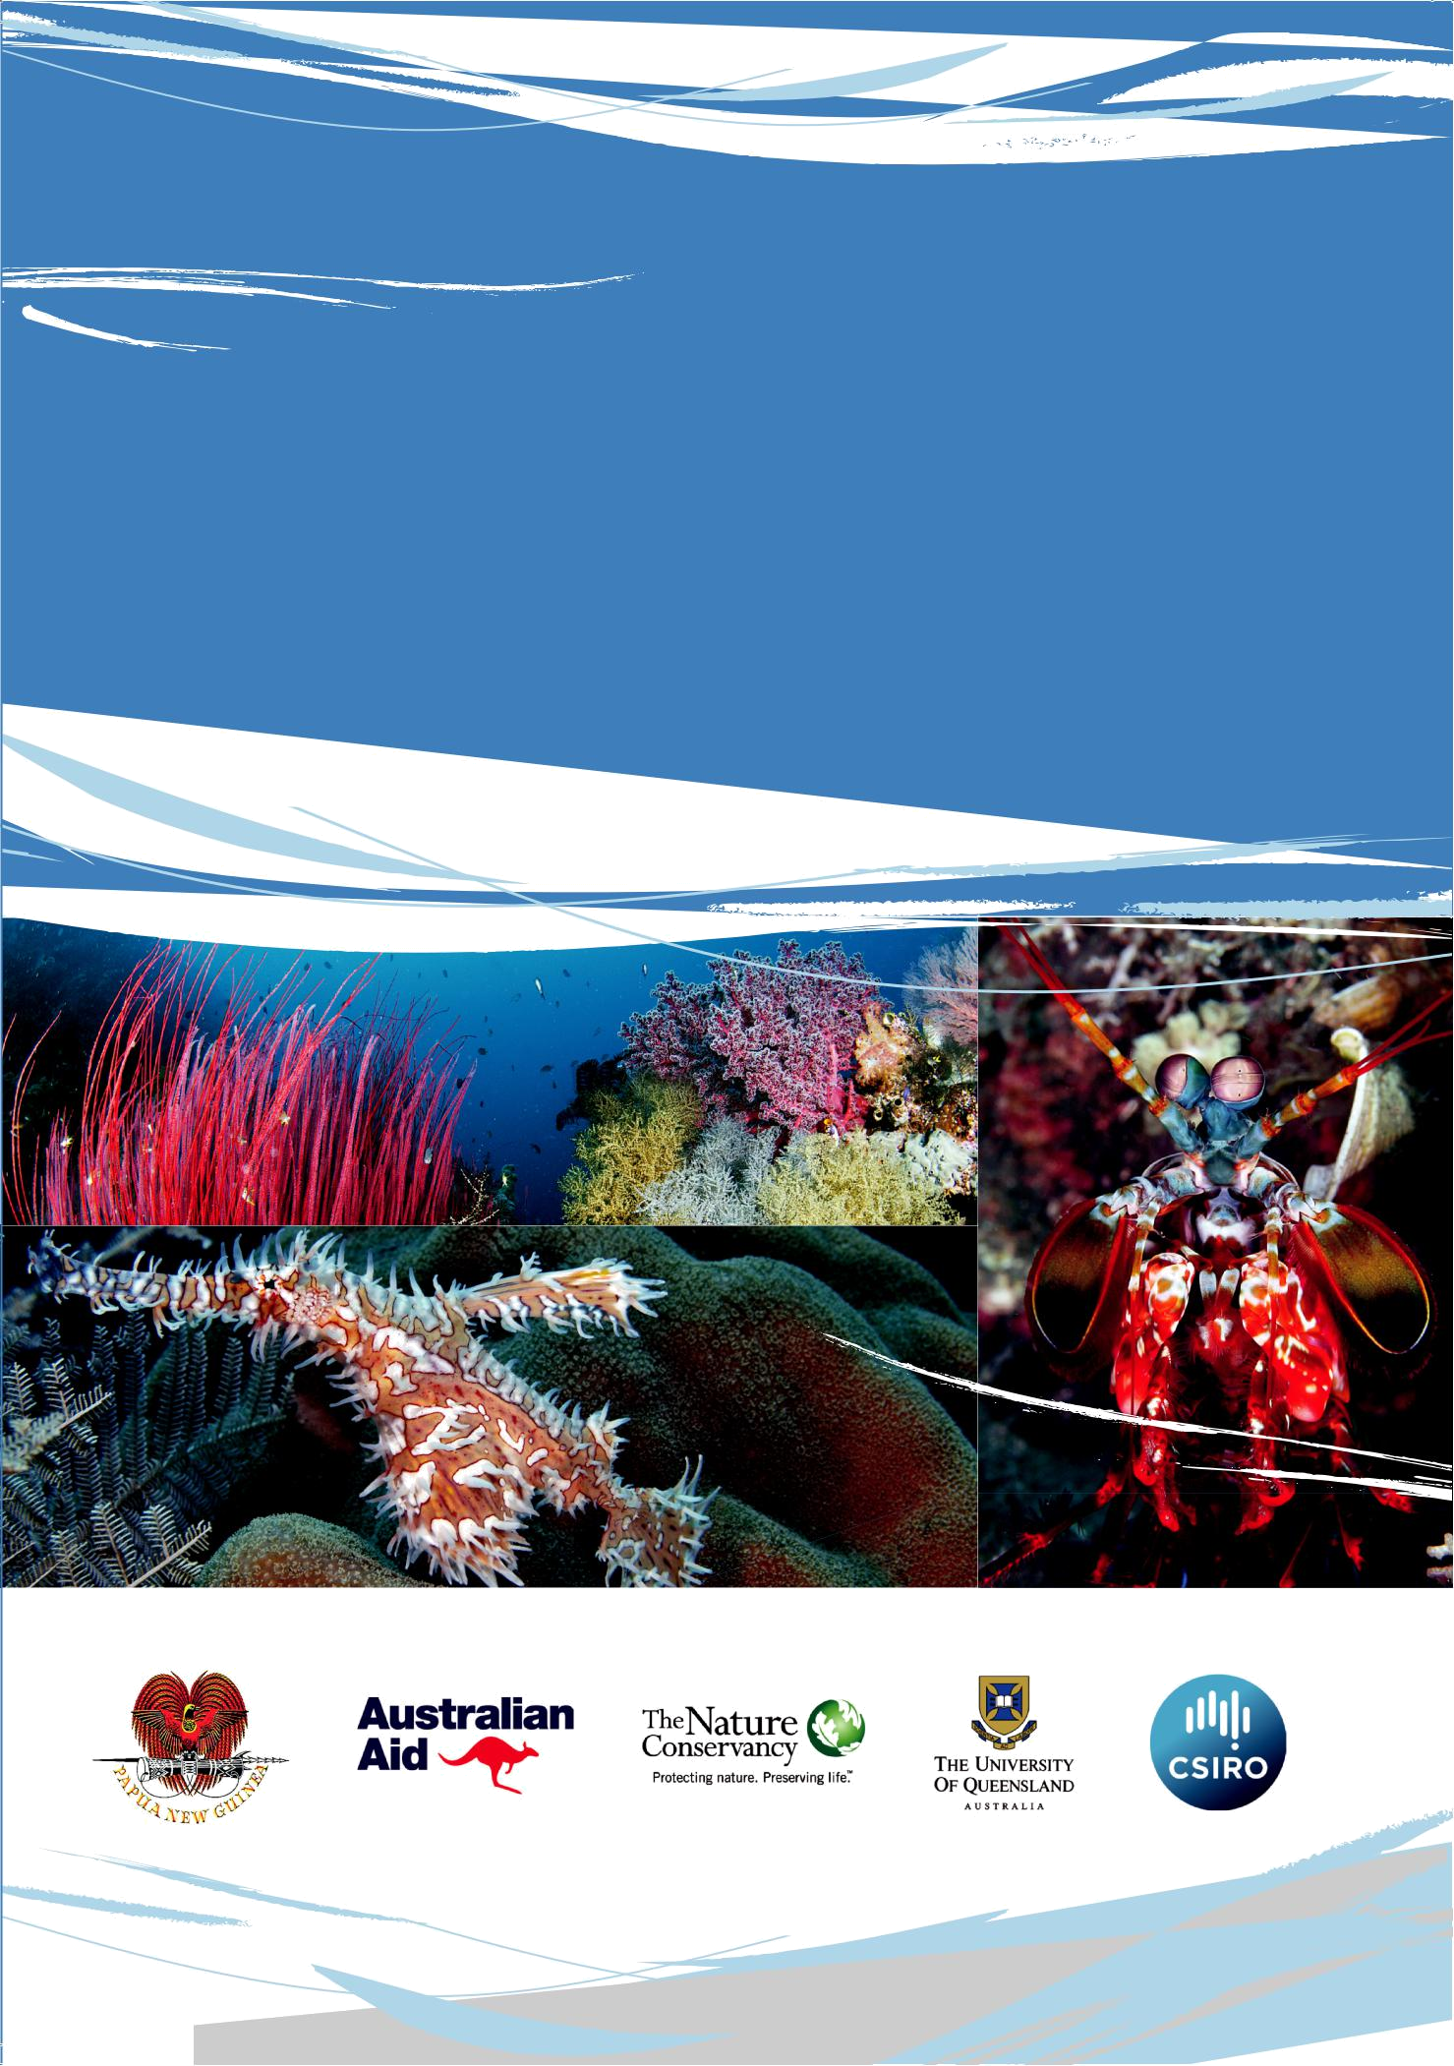

National Marine Conservation

Assessment for Papua New Guinea

© Copyright Papua New Guinea Conservation and Environment Protection Authority, 2015

All Rights Reserved.

Reproduction for any purpose is prohibited without prior permission

Citation:

Government of Papua New Guinea (2015) National Marine Conservation Assessment for Papua New Guinea; Conservation and Environment Protection Authority, 51pp.

Contact:

Kay Kalim kkalim@dec.gov.au

Cover images (clockwise from top left): Reef with sea whips, Mantis Shrimp (unknown species), Ornate ghostpipefish (Solenostomus paradoxus).

© Copyright Jayne Jenkins. Used with permission.

National Marine Conservation

Assessment for Papua New

Guinea

Acknowledgements

This project was funded through the Australian Aid Public Sector Linkages Program, administered through the Australian Government Department of the Environment. This project was a collaboration through the Department of Environment and Conservation (now the Conservation and Environment Protection Authority) bringing together PNG Government agencies and a range of implementing partners including the Australian Government (Department of the Environment, CSIRO), The Nature Conservancy and The University of Queensland. The PNG Department of Environment and Conservation would like to acknowledge the following organisations for their support and efforts:

- Australian Government Department of the Environment – Mr Travis Bover, Ms Simone Retif, Mr Mat Kertesz, Mr Mark Nizette and Ms Katy Nicholls

- Australian Government Department of Foreign Affairs and Trade

- The Nature Conservancy – Mr Nate Peterson and Dr Alison Green

- The University of Queensland – Dr Carissa Klein, Ms Vivitskaia Tulloch, Ms Jennifer McGowan and Prof. Hugh Possingham

- CSIRO – Mr Tim Skewes, Dr Piers Dunstan

- Tierra Mar Consulting – Mr Peter Thomas and Ms Anissa Lawrence

- APEX Environmental – Dr Benjamin Kahn

- Institut de recherche pour le développement – Dr Serge Andréfouët

And the following organizations for their participation in the project:

- Centre of Environmental Law and Community Rights
- Conservation International

- JICA - PNG
- Nautilus Minerals Niugini Ltd
- PNG Centre for Locally Managed Areas

- PNG Coastal Fisheries Development Agency
- PNG Department of Mineral Policy and Geohazards

- PNG Forest Authority
- PNG LNG (Exxon Mobil)
- PNG National Fisheries Authority

- PNG National Maritime Safety Authority
- PNG Ports Ltd

- Provincial Administrations of New Ireland, East New Britain and West New Britain
- Seaweb
- University of PNG

- Wildlife Conservation Society
- WWF
Table of Contents

LIST OF FIGURES, TABLES AND MAPS I

FOREWORD II

EXECUTIVE SUMMARY 1

1. INTRODUCTION 2

1.1 THE MARINE ENVIRONMENT OF PAPUA NEW GUINEA 2

1.2 NATIONAL COMMITMENTS TO ESTABLISHING PROTECTED AREAS 3

- TRACKING PROGRESS TOWARDS MEETING NATIONAL COMMITMENTS – THE NATIONAL MARINE CONSERVATION

 | ASSESSMENT .......................................................................................................................................................... |  | 5
2. | METHODS AND DATA ............................................................................................................................. |  | 6
 | 2.1 | DESIGN CRITERIA ........................................................................................................................................... | 6
 | 2.2 | DATA .......................................................................................................................................................... | 6
 | 2.2.1 Existing Protected Areas....................................................................................................................... |  | 8
 | 2.2.2 Biodiversity Data (Special Features) ..................................................................................................... |  | 8
 | 2.2.3 Coastal (Shallow Water) Habitats ...................................................................................................... |  | 10
 | 2.2.4 Biophysical Data – Deep Water Habitats ........................................................................................... |  | 11
 | 2.2.5 Human Use Data ................................................................................................................................ |  | 11
 | 2.3 | ANALYSIS ................................................................................................................................................... | 13
 | 2.3.1 Conservation Priorities Analysis ......................................................................................................... |  | 13
 | 2.3.2 Stratification Of Biophysical Data ...................................................................................................... |  | 14
 | 2.4 | SCENARIOS ................................................................................................................................................. | 16
 | 2.4.1 Base Scenario ..................................................................................................................................... |  | 16
 | 2.4.2 Target And Features Scenarios ........................................................................................................... |  | 17
 | 2.4.3 Clumping Scenarios ............................................................................................................................ |  | 17
 | 2.4.4 Lock-In Vs Lock-Out ............................................................................................................................ |  | 17
 | 2.5 | STAKEHOLDER INPUT AND CAPACITY DEVELOPMENT ........................................................................................... | 18
3. | RESULTS AND DISCUSSION ................................................................................................................... |  | 19
 | 3.1 | ANALYSIS RESULTS ....................................................................................................................................... | 19
 | 3.1.1 Overview ............................................................................................................................................ |  | 19
 | 3.1.2 Representation ................................................................................................................................... |  | 20
 | 3.1.3 Threats ............................................................................................................................................... |  | 21
 | 3.2 | IDENTIFICATION OF PRIORITY AREAS OF CONSERVATION INTEREST .......................................................................... | 22
 | 3.3 | KEY DATA GAPS IN THIS ANALYSIS .................................................................................................................... | 22
 | 3.3.1 Overview ............................................................................................................................................ |  | 22
 | 3.3.2 Fishing Data ....................................................................................................................................... |  | 23
 | 3.3.3 Other Key Data Gaps For Finer-Scale Planning .................................................................................. |  | 23
 | 3.4 | IMPLEMENTING MARINE PLANNING AT A SUB-NATIONAL SCALE IN PNG.................................................................. | 23
 | 3.4.1 Implementing Planning At A Finer Scale: Additional Factors To Consider ......................................... |  | 23
 | 3.4.2 Implementing Marine Environment Planning At A Finer Scale .......................................................... |  | 25
 | 3.5 | LESSONS LEARNED ....................................................................................................................................... | 26
4. | REFERENCES ......................................................................................................................................... |  | 28
GLOSSARY ...................................................................................................................................................... |  |  | 33
ACRONYMS .................................................................................................................................................... |  |  | 34
APPENDIX 1 – PROJECT WORKSHOPS ............................................................................................................ |  |  | 35
APPENDIX 2 - MAPS ....................................................................................................................................... |  |  | 37

List of Figures, Tables and Maps

Table 1: Overview Of Datasets Used For The Conservation Priority Analysis 7

Table 2: Fish Spawning Aggregation Species And The Total Area Of Associated Shelf Habitat Across Papua New

Guinea. 9

Table 3: Types Of Geomorphologic Seafloor Habitats And Their Area Found In PNGs EEZ. 11

Table 4: Representation Of Habitat Types In Existing Protected Areas 20

Table 5: Priority Areas Of Conservation Interest Identified By PNG CEPA 22

Figure 1: Planning Units Used For The Conservation Priorities Analysis 14

MAP 1: Protected/Managed Areas Of PNG 38

MAP 2: Marine Ecoregions And Bioregions For Papua New Guinea 39

MAP 3: Turtle And Whale Critical Areas 40

MAP 4: Important Bird Areas (IBA) For Seabirds And Shorebirds 41

MAP 5: Indicative Map Of Coral Reefs Classification 42

MAP 6: Distribution Of Mangroves In PNG 43

MAP 7: Indicative Map Showing Classification Structure For Deep Water Features 44

MAP 8: Cost Distribution 45

MAP 9: Mining And Shipping Activity 46

MAP 10: Conservation Priorities Analysis – Base Scenario 47

MAP 11: Conservation Priorities Analysis – MPAs “Locked-In” 48

MAP 12: Conservation Priorities Analysis – CTMPAS Target 49

MAP 13: Conservation Priorities Analysis – Base Scenario + Mining Leases 50

MAP 14: Conservation Priorities Analysis – Base Scenario + Shipping 51

i National Marine Conservation Assessment for PNG
Foreword

The marine environment of Papua New Guinea is vast and diverse, and is globally recognised for its coral reefs and iconic marine species. It directly supports the livelihoods of our people through fisheries and development activities, draws tourists to our country, and provides the ecological foundation for our prosperity.

However the marine environment is under threat, with a growing population that relies on the ocean for food and economic development, and from increased threats from land-based activities and the expanding impacts of climate change.

The Government of Papua New Guinea is committed to the protection and conservation of our marine environment for the benefit of the PNG people. Now more than ever, strategic approaches to marine conservation and management are critical. This report is the culmination of a significant body of work to build the capacity of the Conservation and Environment Protection Authority (CEPA) to plan for future marine conservation and management activities. The maps, data and frameworks generated through this project are being used by CEPA and the broader PNG Government to improve our environmental decision-making and form the basis for ongoing work through the Coral Triangle Initiative. This project has also strengthened relationships between CEPA, the Australian Government and key project partners, notably The Nature Conservancy and the University of Queensland. It also provides the tools and information to allow CEPA to better support our fellow PNG Government agencies such as the Department of Minerals and Geohazards, the Coastal Fisheries Development Agency and the National Fisheries Authority.

As this report highlights, the conservation and management of the marine environment is a difficult and complex task. Based on the foundations of this project though, and the support of our partners, CEPA is well-placed to continue this work into the future.


National Marine Conservation Assessment for PNG ii

Executive summary

Papua New Guinea is committed to the establishment of a network of marine protected areas to fulfil national and international commitments. In order to assist this, the conservation priority areas analysis identified a range of areas of high conservation interest in the PNG marine environment, based on the principles of comprehensiveness, adequacy, representation and resilience (CARR). The analysis collated available national-scale data on biodiversity features and biodiversity surrogates.

Conservation planning software (Marxan) was used to identify key areas that addressed the CARR principles against the conservation features identified under a range of scenarios (including against representativeness targets of 10% [Convention on Biological Diversity, CBD] and 20%] Coral Triangle Marine Protected Area System]). The resultant maps identify areas of high conservation interest that should be prioritised by the PNG Government for further assessment.

Although the goal of the CBD is to protect at least 10% of coastal and marine areas, this analysis found only 12% of the 1106 features targeted in this analysis meet or exceed the 10% representation target. The current marine protected area system protects only 2.2% of the total reef habitat of Papua New Guinea. Some habitat features, such as seamounts, are completely unprotected. Additional conservation areas are needed to meet targets particularly for deep water habitats and reefs, which require significantly more area to adequately protect spawning aggregations, turtles, seabirds and cetaceans.

The results of the conservation priorities analysis demonstrates that there are a range of ways that these targets could be met when based entirely on the CARR principles. The areas identified in the conservation priorities analysis are not proposed marine protected areas.

The identification and inclusion of specified conservation values, and accounting for the range of human uses of marine resources, will have a significant effect on the design of an MPA system for PNG.

The analysis also identified a range of key data gaps and issues that could not be addressed practically in a national scale analysis.

The results of this analysis, and the resultant discussions of key data gaps and priorities, have led to the development of a proposal for finer scale analysis at a sub-national/regional scale.

In addition to the aggregate analysis, the individual components of this project (most notably the regionalisation, comprehensive assessment of existing protected areas, and distribution maps of habitat types and species) are being used by CEPA and other PNG Government agencies to inform marine resource management decision making

1 National Marine Conservation Assessment for PNG

1. Introduction

1.1 The marine environment of Papua New Guinea

Papua New Guinea (PNG) encompasses the eastern sector of the island of New Guinea and more than 600 atolls/offshore islands in the south-west Pacific Basin and to the north of Australia. PNG has a land area of 461,690 km² with tropical forests, savannah grass plains, big rivers and deltas, swamps and lagoons, with numerous islands and atolls to the east and north east of the country (GoPNG, 2009). The larger islands of PNG include Manus, New Ireland, New Britain and Bougainville, while the Milne Bay Province is comprised with a diversity of island chains.

The marine environment of PNG is large, complex and highly biodiverse. It includes inshore lagoons, fringing and barrier reef systems, shallow banks and extends into very deep offshore areas encompassing slope, abyssal plain, trenches and ridges, seamounts and deep ocean vents. The exclusive economic zone (EEZ) of PNG encompasses an area of 1.7 million km² (Joe Buleka pers. comm.), while the coastal habitats encompass 46,000 km² of estuaries, bays, lagoons and coral reefs with the estuaries accounting for 6,000 km² (Manoka and Kolkolo, 2001).

Marine and coastal ecosystems are a vital part of the livelihood of the PNG people, ranging from subsistence activities at a community scale, to economic development at a national scale. In particular, fishing resources are vital, extending from coastal waters into the open ocean. These resources provide subsistence for local communities, support rural livelihoods and provide significant revenue for the government. The total market value for PNG’s fisheries catch is estimated at PGK 350–400 million annually. Despite the richness of PNG fisheries resources and the substantial value of fisheries production, in absolute terms the contribution of fishing resources to national GDP is the smallest as compared to other Pacific Island countries. As such, there is significant potential to increase the economic value and returns to PNG in the fisheries sector through improved management and development programs (DEC and NFA 2009, DNPM 2010).

The rich resources and vast size of the PNG marine environment provides significant opportunities for the PNG people. However, there are also associated difficulties in implementing effective and sustainable management for this resource in the face of increasing pressure from a growing population, development and land-based activities, and climate change.

Threats to the marine biodiversity in PNG are varied and interlinked. Key threats identified as priorities in the PNG Marine Program (DEC, NFA and NCC 2013) include:

- Population growth (especially in coastal areas);

- Development activities (in coastal and upstream areas) and related impacts including increased runoff and habitat fragmentation and degradation;

- Overexploitation of resources, particularly fisheries resources;

- Pollution, especially related to runoff from inland mining activities and poor land management practices, and debris and sewage; and

National Marine Conservation Assessment for PNG | 2

- Impacts of climate change, including potential disruption of oceanographic processes, changes in species distribution, changes in water temperature and salinity, and sea level rise.

There is significant interest in potential seabed mining activities in parts of the PNG marine environment (DEC and NFA 2009).

1.2 National commitments to establishing protected areas

PNG is committed to the establishment of Protected Areas (PAs). This commitment is rooted in the national constitution, key international agreements and in national legislation and policy, as outlined below.

Papua New Guinea Policy on Protected Areas

The Papua New Guinea Policy on Protected Areas (2014, hereafter ‘the Policy’) provides the framework for the implementation of actions to achieve Goal Four of the National Constitution, as well as fulfil PNG’s obligations under international agreements, the key ones being the Convention on Biological Diversity and the Coral Triangle Initiative on Coral Reefs, Fisheries and Food Security.


Papua New Guinea’s natural resources and environment should be conserved for the collective benefit of all and should be replenished for future generations.

4th Goal of the National Constitution

Under the Policy, Conservation and Environment Protection Authority (CEPA) is committed to the establishment of the PNG Protected Area Network. This act provides the guidelines for the selection, design and management of protected areas in PNG.

The PNG Protected Area Network will be comprised of two groups of Protected Areas:

- National protected areas – gazetted and managed under national legislation. Includes national marine sanctuaries.

- Regional protected areas – gazetted through provincial government legislation. Includes Locally Managed Marine Areas.

The Policy articulates the following targets for marine protected areas:

- 10% of territorial waters and the coastline within a variety of marine protected areas by 2025 (CBD targets). Minimum of one million hectares (PNG 2050 Vision).

- 25% of the above target (i.e. 2.5% of territorial waters) under a combination of no-take zones and zones which allow fishing only by customary landowners for subsistence use by 2025.

10% of offshore areas outside territorial waters but within the EEZ will be included in national marine sanctuaries by 2025.

3 National Marine Conservation Assessment for PNG
Convention on Biological Diversity

PNG is a signatory to the Convention on Biodiversity (CBD) which requires that member Nations set aside at least 10% of coastal and marine areas in protected areas to slow the global loss of biodiversity.

Coral Triangle Initiative on Coral Reefs, Fisheries and Food Security

PNG is a member country of the Coral Triangle Initiative on Coral Reefs, Fisheries and Food Security (CTI-CFF, hereafter CTI). The CTI is a multilateral partnership between six countries in the “Coral Triangle” area (PNG, Solomon Islands, Indonesia, Timor Leste, Philippines and Malaysia) working together to sustain marine and coastal resources by addressing crucial issues such as food security, climate change and marine biodiversity.

PNG’s implementation of its commitments as a member country of the CTI is outlined by the

PNG Marine Program on Coral Reefs, Fisheries and Food Security. The goals of the Marine Program are adopted from the CTI Regional Plan of Action. The Goals are:

Goal 1 Priority seascapes designated and effectively managed;

Goal 2 Ecosystem approach to management of fisheries and other marine resources fully applied;

Goal 3 Marine protected areas established and effectively managed;

Goal 4 Climate change adaptation measured achieved; and

Goal 5 Threatened species status improving.

Goal 3 of the CTI states that:

A comprehensive, ecologically representative and well-managed region-wide Coral Triangle MPA System (CTMPAS) in place -- composed of prioritized individual MPAs and networks of MPAs that are connected, resilient, and sustainably financed, and designed in ways that (i) generate significant income, livelihoods, and food security benefits for coastal communities; and (ii) conserve the region’s rich biological diversity.

The CTMPAS includes the following ultimate quantitative target for the region as a whole:

Significant percentage of total area of each major near-shore habitat type within the Coral Triangle region (e.g., coral reefs, seagrass beds, mangroves, beach forests, wetland areas and marine/offshore habitat) will be in some form of designated protected status, with 20% of each major marine and coastal habitat type in strictly protected “no-take replenishment zones” (to ensure long-term, sustainable supplies of fisheries).

(CTI-CFF, 2009).

National Marine Conservation Assessment for PNG | 4

- Tracking progress towards meeting national commitments – the National Marine Conservation Assessment

The CBD Program of Work on Protected Areas (PoWPA), adopted by the 7th CBD Conference of Parties in 2004, identified a range of actions to address impediments to implementing protected areas. Within this, Action 1.1.5 aims to complete protected area gap analyses at national and regional levels based on the requirements for representative systems of protected areas that adequately conserve terrestrial, marine and inland water biodiversity and ecosystems.

In 2010, PNG completed a National Terrestrial Conservation Assessment with technical support from TNC (Lipsett-Moore et al., 2010) to inform the development of terrestrial protected areas to meet PNG’s national and international commitments.

The then PNG Department of Environment and Conservation (DEC) (now the Conservation and Environment Protection Authority, CEPA¹) identified the development of a National Marine Conservation Assessment (following the principles of the PoWPA process) as a key step in the development, finalisation and implementation of marine components of a national protected areas policy.

- The goal of the National Marine Conservation Assessment is to identify current status and progress towards achieving goals under the CBD and CTI; and

- Identify gaps in the MPA system and priority areas for expanding PNG’s MPA network to achieve stated goals under the CBD and CTI.

To undertake the National Marine Conservation Assessment, a collaborative project was undertaken by DEC, the Australian Government (Department of the Environment and CSIRO), The Nature Conservancy (TNC) and the University of Queensland (UQ) with several components:

- Development of a new regionalisation of PNG’s marine area (Green et al. 2014)

- Cataloguing and mapping PNG’s existing marine protected areas (including Locally Managed Marine Areas) (Peterson 2014)

- Collation of existing national-scale data sets on PNG’s marine habitats and species (e.g. turtle nesting sites, fish spawning aggregation sites, important seabird areas)

- Development of a national-scale analysis to identify areas of high conservation interest, based on principles in the Policy

- Production of maps identifying areas of high conservation interest and relationship to existing human uses and associated threats (such as mining leases, shipping lanes)

- Training in systematic conservation planning (including the use of Marxan) to interpret and further develop the priority analysis

This report describes components three to five. For information on components one and two, see the references above. Component six was carried out throughout the course of the project – for an overview of capacity development activities, see Appendix 1.

¹ CEPA officially came into being on 1 July 2015. In this report, references to activities (such as decisions and participation in workshops or project activities) prior to this date will refer to DEC.
5 National Marine Conservation Assessment for PNG
2. Methods and Data

2.1 Design criteria

The Policy identifies that the aim for the National Protected Area Network is to meet the principles of R-CAR-R, that is:

Relevant to all PNG people;

Comprehensive and Representative of the diversity of life, landscapes and seascapes; and

Adequate, resilient and viable into the future to withstand and recover from stresses including climate change.

This analysis was aimed at identifying and addressing ecological gaps in PNG’s marine protected areas system, with the design criteria derived from a subset of the RCAR-R principles articulated in the Policy aimed at addressing ecological factors. The design criteria are based on the CARR principles as follows:

Comprehensiveness: includes the full range of terrestrial, freshwater and marine communities recognized by an agreed national classification at an appropriate hierarchical level.

Adequacy: this refers to the maintenance of ecological viability and integrity of populations, species and terrestrial, freshwater and marine communities. Thus protected areas should be large enough to sustain the viability, quality and integrity of populations (species).

Representativeness: ensure that those sample areas that are selected for inclusion in reserves should reasonably reflect the biotic diversity of the terrestrial, freshwater and marine communities.

Resilience: considers the capacity of an ecosystem to tolerate disturbance without

collapsing.

2.2 Data

The scale and availability of data is an important consideration when planning a national scale analysis. Given that marine habitats are generally remote and expansive, ground data pertaining to these habitats are often limited, inconsistent or unavailable. The use of inconsistent data across a broad region has been found to produce biased results (Mills et al. 2010; Pressey 2004), limiting the usefulness and real-world application of an analysis upon a marine environment. Fortunately, remote sensing spatial data for important costal habitats was found to be available at global scales. This type of spatial data has been collected from a range of available datasets and has been utilised within this study.

Biodiversity surrogates were utilised when marine biodiversity spatial data was not available. For the development of conservation target features for the conservation priorities analysis, 3 types of features were considered:

National Marine Conservation Assessment for PNG | 6

- Broad surrogates “coarse filter”, e.g. coral reef habitat types, depth zones

- Special features “fine filter”, e.g. threatened species

- Ecological and evolutionary processes, e.g. migration corridors, breeding sites

A new regionalisation for PNG’s marine area was developed to provide the spatial framework for the conservation priority analysis (see Green et al. 2014).

Existing marine protected areas (including MPAs, LMMAs, and conservation areas) were catalogued and a GIS layer developed as an input to the conservation priority analysis (Peterson 2014).

Table 1 and the following sections provide an overview of the data used for this analysis. Indicative maps of these data sets (where available) are at Appendix 2 as outlined below.

Table 1: Overview of datasets used for the conservation priority analysis

Data set |  | Map Reference
 |  | (Appendix 2)
Protected/Managed Areas of PNG |  | Map 1
Map of PNG protected areas included in this analysis. Developed through the
Protected Area mapping exercise as described in Peterson 2014.
Marine Ecoregions and Bioregions for Papua New Guinea |  | Map 2
Map of deep water ecoregions and shallow water bioregions for PNG’s marine
area. Developed through the regionalisation exercise described in Green et al.
(2014).
Distribution of species (special features) throughout the Exclusive Economic Zone
Leatherback and green turtles (WWF-Malaysia and seaturtle.org) |  | Map 3
Blue Whales (Kahn and Vance-Borland 2014)
Important Bird Areas (IBA) for seabirds (Birdlife International 2012) |  | Map 4
Spawning & Aggregation Sites (Society for the Conservation of Reef Fish |  | Not available
Aggregations (SCRFA): Sadovy de Mitcheson et al., 2008).
Distribution of Shallow Habitat Features throughout the Exclusive Economic Zone
Coral reefs (Millennium Coral Reef Mapping Project: Andrefouet et al., 2006; |  | Map 5
UNEP-WCMC, WorldFish Centre, WRI, TNC 2010. |  | Indicative map
 |  | only
Mangroves (World Mangrove Atlas: Spalding et al. 1997a, 1997b) |  | Map 6
Distribution of Deep Sea Habitat Features throughout the Exclusive Economic |  | Map 7
Zone |  | Indicative map
Aggregated map of deep water features including: |  | only
Bathymetry: 7 Depth Zones (GEBCO global 30 arc-second grid: IOC,
IHO and BODC 2003)
Oceanic geomorphological features: 19 classes (shelf, seamounts,
abyssal plains) (GRID-Arendal: Harris et al., 2014)
7 | National Marine Conservation Assessment for PNG

Cost Distribution based on Distance to 13 ports (higher cost near ports) and | Map 8
Landings data from 2008-2013
Map showing the proxy cost layer developed for this analysis based on port
landings data and distance from port. See 2.2.5 for further information.
Mineral exploration leases (as at March 2014) and important shipping lanes | Map 9
Mineral exploration leases data provided by PNG Department of Environment
and Conservation.
Shipping lane data from Halpern et al. 2008

2.2.1 Existing Protected Areas

The most recent data on existing protected areas were provided as polygons by TNC and sourced from the Coral Triangle Atlas database (http://ctatlas.reefbase.org/) (Peterson 2014). This included all delineated areas focused on conservation (in any form) for terrestrial or marine environments. In this analysis, only protected areas identified as either “gazetted,” “voluntary” or “designated” in status were considered. It was assumed that coastal terrestrial protected areas offer some protection to mangrove habitats falling in their jurisdiction and consider their contribution to existing conservation efforts in PNG. We considered 55 out of 110 marine and terrestrial protected areas in certain aspects of this analysis and use them to compare and contrast our results (see Map 1 Appendix 2).

2.2.2 Biodiversity Data (Special Features)

Seabirds and shorebirds

Birdlife International has identified several Important Bird Areas (IBA) in Papua New Guinea (Birdlife International 2012). IBAs are areas recognized as globally important habitat for the conservation of bird populations, based on a number of criteria available at http://www.birdlife.org/action/science/sites/. These areas were based partly on the location of threatened and endemic species, and so relate to conservation and representation objectives. However, the usefulness of these areas in the study could be limited by the broad scale to which they were mapped. The coverage of IBAs was sourced from Birdlife International (Birdlife International 2012), with three proposed IBAs found in Papua New Guinea for: Beck’s Petrels (Pseudobulweria becki), Heinroth’s shearwaters (Puffinus heinrothi), and Streaked Shearwaters (Calonectris leucomelas).

Additional data on important migratory shorebird sites was obtained from Wetlands International. This data set included the Red-necked Phalarope (Phalarope lobatus), Brown Noddy (Anous stolidus), and the Greater Sand Plover (Charadrius leschenaultia) (Bamford et al., 2008) as important areas for the conservation of migratory shorebirds in Papua New Guinea. These areas were hand-digitized and included as special features in the analysis.

These areas are shown in Map 4 Appendix 2.

Marine megafauna

Data describing critical sites in PNG for migratory turtles were obtained from WWF-Indonesia. These data identify point locations of nesting, foraging, or other identified critical habitat for green (Chelonia mydas) and leatherback (Dermochelys coriacea) turtles. The IUCN Red List of Threatened Species have identified green turtles as endangered and requiring conservation action (Seminoff 2004), whilst leatherback turtles are listed as vulnerable (Wallace et al.

National Marine Conservation Assessment for PNG | 8

2013). In alignment with the requirements of the CBD, the Papua New Guinea government has determined that threatened species should be protected throughout the region. To meet these requirements, catchments of a 30km radius were identified around important turtle habitat to incorporate the typical spatial extent of beaches and foraging areas (Beger et al., 2013).

Data on important areas for blue whales (Balaenoptera musculus) were obtained and used identify critical breeding areas for the species (Ben Kahn, Pers. Comm.). The International Whaling Commission granted protection to blue whales in 1966; however these species are still listed as endangered by the IUCN (Reilly et al., 2008) due to a dramatic population reduction from historic commercial whaling. Because of this, important areas for blue whales were targeted in this analysis.

These areas are shown in Map 3 Appendix 2.

Spawning aggregations

Various fish species aggregate to spawn in locations inside (resident spawning aggregations) and sometimes outside (transient spawning aggregations) their normal territory (Sadovy de Mitcheson et al., 2008). Fish spawning aggregations are a crucial and predictable part of fish life cycles that create an easy and often heavily exploited fisheries target (Hamilton et al., 2012). Protecting spawning aggregation sites is important to maintain regional larval supplies, and has been effectively demonstrated in Melanesia and Micronesia, where fish biomass increased up to 10 fold after fishing ceased (Golbuu and Friedlander 2011; Hamilton et al. 2011).

In this analysis spawning aggregation data for 12 fish families was used, including groupers (Serranidae), snappers (Lutjanidae) and emperors (Lethrinidae), under license from the Society for the Conservation of Reef Fish Aggregations (SCRFA) (Sadovy de Mitcheson et al., 2008). To represent fish spawning aggregations, the aim was to protect all known active and historical aggregation site locations. As transient spawning aggregations may draw individuals from a large catchment, catchments were identified as reef areas within a 20 km radius from known fish spawning aggregation coordinates; this size was selected as it is representative for the home range of large spawners such as Plectropomus areolatus or Epinephelus polyphekadion (Beger et al., 2013; Green et al., 2014). All shelf and slope areas falling within the 20km buffer was designated as associated spawning aggregation habitat. Due to the variability in the data records of habitat associations and individual spawning aggregations, reefs and non-reef habitat were not distinguished.

Owing to confidentiality, these data are not available in map form, but are summarised in Table 2 below.

Table 2: Fish spawning aggregation species and the total area of associated shelf habitat across Papua New Guinea.

Species | Total Area (km²) | Species | Total Area (km²)
Caranx tille | 692 | Lethrinus erythropterus | 797
Cephalopholis argus | 628 | Lutjanus argentimaculatus | 799
Cephalopholis boenak | 767 | Lutjanus bohar | 929
9 |  | National Marine Conservation Assessment for PNG

Cephalopholis miniata | 1,395 | Lutjanus boutton | 928
Cephalopholis sexmaculata | 767 | Lutjanus gibbus | 1,774
Cephalopholis sonnerati | 767 | Plectorhinchus chrysotaenia | 928
Cephalopholis urodeta | 767 | Plectropomus areolatus | 10,245
Cheilinus undulates | 1,177 | Plectropomus laevis | 793
Crenimugil crenilabris | 1.815 | Plectropomus leopardus | 2,293
Epinephelus coioides | 808 | Plectropomus maculatus | 1,662
Epinephelus corallicola | 861 | Plectropomus oligacanthus | 1,478
Epinephelus fuscoguttatus | 5, 032 | Siganus canaliculatus | 681
Epinephelus lanceolatus | 1,230 | Siganus lineatus | 754
Epinephelus multinotatus | 627 | Siganus vermiculatus | 702
Epinephelus ongus | 873 | Sphyraena barracuda | 870
Epinephelus polyphekadion | 4,991 | Sphyraena qenie | 733
Epinephelus polystigma | 1,609 | Symphorichthys spilurus | 1,629

While there are other significant biogenic habitats found throughout Papua New Guinea, such as seagrass, the resolution of the available data covering the extent of Papua New Guinea was too coarse to be used for this analysis. Similarly, many of the global distributions for important threatened and endangered species in Papua New Guinea are only available in resolutions too coarse to be useful at the scale of this analysis. This includes the distribution of dugong and humphead wrasse, which are highlighted as species of concern by conservation groups working in the Coral Triangle.

2.2.3 Coastal (Shallow Water) Habitats

Due to the coarse resolution of the GEBCO bathymetric grid, the shallow shelf region (< 200 m) was unable to be divided into sensible depth classes. Millenium Coral Reef Mapping Project (MCRMP) provided the most detailed classification for coral reefs available for Papua New Guinea (see Andrefouet et al., 2006, Andrefouet and Hamel 2014 for more details). The finest resolution habitat classifications were used which detail any given reef polygon based on a combination of depth and exposure as well as identified geomorphological characteristics for a total of 333 different classified reef habitats.

Map 5 Appendix 2 provides an indicative overview of the reef classification data used in the analysis. Owing to the complexity of the classification structure and the large geographical area, it is not feasible to show the full extent of the classification on a single map.

To the southwest of the Gulf of Papua, in regions not included in the scientific boundary of the Coral Triangle, data from the Global Distribution of Coral Reefs 2010 (UNEP-WCMC 2010) was used in addition to the MCRMP data. While not classified as coral reefs under the MCRMP, unclassified polygons were able to provide coarse information on shallow habitats present in the region. These polygons were split into inshore and offshore shallow bathymetric features and treated as unique features to represent in the analysis.

National Marine Conservation Assessment for PNG | 10

Mangroves are important ecosystems across Papua New Guinea (Elevitch 2007). Not only do they provide important ecosystem services through coastal protection for coastal villages and filtering run-off from the land, they are also important nursery grounds for marine species.

Global mangrove distribution data was obtained from UNEP World Conservation Monitoring Centre (UNEP-WCMC) who compiled distributional data in collaboration with the International Society for Mangrove Ecosystems (ISME).

These areas are shown in Map 6 Appendix 2.

To account for other important benthic habitats where there was no distributional data (i.e. sand, rock, mud bottoms), a non-reef shelf habitat class was created for the remaining shelf areas not-classified as reefs and extending out to the continental slope (< 200 m).

2.2.4 Biophysical Data – Deep Water Habitats

Data on 19 seafloor habitats were obtained from GRID-ARENDAL Geomorphic Seafloor Features database (Harris et al., 2014), describing broad marine habitat classes, from abyssal plains to shallow shelf regions existing in PNG’s EEZ (Table 3).

Table 3: Types of geomorphologic seafloor habitats and their area found in PNGs EEZ.

Feature | Total Area (km²) | Feature | Total Area (km²)
Abyss | 146,47,784 | Rift Valley | 4,697
Basins | 1,376,669 | Rises | 192,299
Bridges | 441 | Seamounts | 20,040
Canyons | 70,232 | Shelf Valley | 5,575
Escarpments | 346,965 | Slope | 1,844,422
Guyots | 13,742 | Spreading Ridges | 47,080
Hadal | 42,998 | Terraces | 4,888
Plateaus | 1,203,402 | Trenches | 74,952
Ridges | 162,994 | Troughs | 95,025

In order to estimate the ocean floor depth the General Bathymetric Chart of the Oceans (GEBCO) with 30 arc-second resolution was used (the GEBCO_08 Grid, version 20090202, http://www.gebco.net). This digital bathymetry was generated by combining ship depth soundings, with the interpolation between the sounding points being guided by satellite gravity data (Becker et al., 2009).

Map 7 Appendix 2 provides an indicative overview of the deep water classification data used in the analysis. Owing to the complexity of the classification structure and the large geographical area, it is not feasible to show the full extent of the classification on a single map.

2.2.5 Human Use Data

Fishing – Cost Layer

To explore the influence of different cost constraints on the prioritisation, several scenarios were tested in which different cost layers were used as inputs, as follows:

11 National Marine Conservation Assessment for PNG
- Area of planning unit: each planning unit had the same cost (the area of the planning unit hexagon).

- Surrogate distance cost: cost was determined using a distance from ports matrix. The relative value of a planning unit was determined by calculating the distance of the planning unit from nearby ports. Areas close to ports were given a high surrogate cost value (versus areas further away from ports that were given a low surrogate cost value).

- Surrogate distance landings-weighted cost: the relative cost of conservation was determined in terms of the opportunity cost to fisheries, calculated by determining the distance of each planning unit from ports, weighted by fisheries landings at those ports. This layer is shown in Map 8 Appendix 2.

The development of these cost scenarios reflected the absence of detailed cost information. Although attempts were made to secure data that could be used to develop an appropriate cost layer (based on national-scale fisheries catch and effort data), this data could not be sourced.

Mining and shipping

Mining and shipping data were used as spatial overlays for post-analysis comparisons. Mining exploration leases provided by the Mineral Resources Authority of Papua New Guinea came as polygons for both terrestrial and marine areas. Shipping lane footprints were hand digitized based on the areas with the highest concentrated vessel densities provided by Halpern (2008) (http://www.nceas.ucsb.edu/globalmarine/impacts).

These data were collected from 2004 information from the World Meteorological Organization Voluntary Observing Ships Scheme and reflect patterns of commercial and research vessels passing through PNG’s EEZ.

These data are shown in Map 9 Appendix 2.

National Marine Conservation Assessment for PNG | 12

2.3 Analysis

2.3.1 Conservation Priorities Analysis

Based on the data collated, this analysis explored conservation objectives using the spatial decision support tool for conservation, Marxan (freely available at www.biology.uq.edu.au/marxan) (Ball et al., 2009). Marxan implements the objective of achieving user-defined conservation targets (i.e. amounts of habitat in protected areas) for biodiversity representation and connectivity constraints whilst minimizing the overall cost of a protected area system (Ball et al., 2009). For example, a conservation goal could be to identify protected area systems that represent 10% of all habitats and species with minimal losses to fisheries profit. Management efficiency is modelled by maximizing spatial compaction and minimizing the cost of the resulting reserve system (Watts et al., 2009).


SYSTEMATIC CONSERVATION PLANNING

Systematic conservation planning (Margules and Pressey 2000) provides a framework for identifying priority areas that ensure the fundamental CARR conservation principles of comprehensiveness, adequacy, representation, and resilience are met. It ensures an efficient, repeatable, transparent and equitable process for making conservation decisions.

The stages in systematic conservation planning include:

- identifying and involving stakeholders;

- identification of conservation goals;
- collection of data;

- formulating conservation targets;
- evaluation of the existing protected area network;
- selecting new conservation areas;

- implementation of conservation action; and

- long-term maintenance of biodiversity in the network (Margules and Pressey 2000).

Systematic conservation planning requires clear choices to be made about the features to be used as surrogates for overall biodiversity in the planning process, and uses transparent and explicit methods for locating priority conservation areas. Spatial prioritisation, a key systematic conservation planning approach, is used for identifying where important areas for biodiversity are, and how conservation goals might be achieved efficiently. There are many decision support tools available, including Marxan (Ball et al. 2009). This analysis used spatial prioritisation to identify areas that are priorities for biodiversity conservation through protected areas and other means, based on ecosystem features, values and climate change resilience considerations. A gap analysis was conducted to assess the extent to which the current protected area system meets protection goals set by Papua New Guinea to represent its biological diversity. Finally, the analysis aimed to identify future conservation priority areas for different objectives on a regional scale, as well as risks and data gaps.

13 National Marine Conservation Assessment for PNG
To carry out the Marxan analysis, the EEZ of Papua New Guinea was divided into 50,215 hexagonal planning units encompassing both deep and shallow water habitats and adjacent coastal areas where mangroves were present (Fig. 1). These hexagons were used to ensure the planning unit shape aligned with that used in the National Terrestrial Gap analysis (Lipsett-Moore et al., 2010). Hexagonal planning units share an equal boundary with all neighbouring planning units, which helps maximize the efficiency of reserve selection when using the boundary length modifier in Marxan (see 2.4.1). In an effort to provide seamless comparisons to the Terrestrial Gap Analysis, each hexagon had an area of 5,000 hectares; a size deemed appropriate for both the scale of the analysis and the computing and processing time required by Marxan.

Figure 1: Planning units used for the conservation priorities analysis
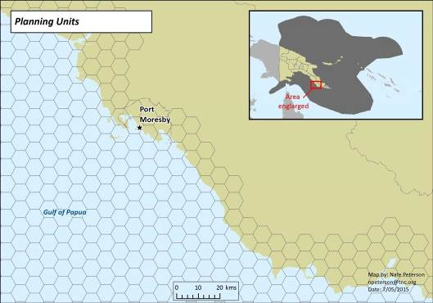

2.3.2 Stratification Of Biophysical Data

Stratification in spatial planning addresses several key components of systematic conservation plans (Pressey et al 2004). Primarily, by dividing the planning region into smaller sub-units, we ensure that each important habitat or special feature is represented multiple times in the identified priority areas. The spreading the distribution of conservation efforts also spreads the risk of habitat degradation or loss in the face of threats from natural disturbances or negative human impacts. Stratification also assists in capturing the full suite of natural variability in key habitat types and species assemblages that might not be documented in coarse-scale data. Finally, it prevents the inequitable distribution of conservation areas across the shelf. This means that no one province or population receives all of the benefits or challenges from implementing conservation plans.

The EEZ of Papua New Guinea consists of 5 large-scale biologically distinct ecoregions: Bismarck Sea, Coral Sea, Eastern Arafura Sea, Pacific Warm Pool, and Solomon Sea (see Map 2, Appendix 2). These eco-regions were used as the basis of a primary stratification scheme

National Marine Conservation Assessment for PNG | 14

that breaks down the EEZ into smaller subunits for targeted conservation. Each of these 5 eco-regions is further stratified by dividing the planning area into shallow and deep bioregions (see Green et al., 2014 for thorough description). Shallow bioregions (n=21) are stratified within the ecoregions in which they reside and encompass all shelf areas up to 200m depth as defined by a General Bathymetric Chart of the Oceans (GEBCO) 30 arc-second gridded bathymetric map (IOC, IHO,BODC 2003). Deep bioregions (n=5) cover the remaining seafloor (200 m-max depth), one within each ecoregion.

The GEBCO bathymetric data was used to divide the seafloor into seven different depth classes:

- Class one: <200 m

- Class two: 200-1500 m
- Class three: 1500-2500 m

- Class four: 2500-4000 m
- Class five: 4000-5000 m
- Class six: 5000-6000 m

- Class seven: >6000 m

Bathymetric associations are known to drive regional patterns in biodiversity. The rationale for depth zone distinctions are as follows:

- 200-1500 m: the slope of the continental shelf.

- 2500 m is based on the apparent faunal break in fish communities; the 2,500 m depth break is the approximate depth of continental slope-continental rise boundary and upper bound of Deep Water.

- 4,000 m Abyssal plain depth break is a traditional geological boundary point.

- 5,000 m depth break is the calcite compensation (oceanographic) boundary point.

- 6,000 m Hadal zone depth break is a traditional geological boundary point; all below the calcite compensation depth.

Each of the 19 geomorphic seafloor features were allocated to every depth zone and bioregional combination present in the EEZ.

15 National Marine Conservation Assessment for PNG
2.4 Scenarios

The scenarios produced in this analysis were aimed to meet conservation goals whilst simultaneously minimising negative impact on the regional fisheries. In each scenario, 100 runs were performed to assess the spatial variability in conservation priorities in the different solutions found.

The “selection frequency” refers to the frequency that an individual cell is selected across the 100 solutions. This gives an indication of the irreplaceability of an area, or its importance in meeting representation targets and achieving an efficient reserve network, and is commonly used to identify high priority conservation areas (Possingham et al., 2000; Game & Grantham 2008). The best solution (the one with the minimum objective function score) and selection frequency (i.e. number of times a planning unit was selected across the 100 solutions) were compared between scenarios. Different maps were used to compare how the location of priority areas would change when we used different constraints, by subtracting the planning unit selection frequency of one scenario from the other.

Targets were analysed to determine if they would be missed if different constraints were put on the analysis. This was achieved overlaying the planning units selected in the best solution of the “habitats-only” scenario over the conservation features layer, and evaluated how many features failed to meet their target under the base scenario parameters.

The proportion of conservation features found in the locked-in reserves were determined to evaluate the effectiveness of existing reserves.

2.4.1 Base Scenario

The planning unit layer and available data were used to conduct a Marxan analysis. This analysis was based on the principles of systematic marine protected area design, which aims to identify priority areas that comprehensively, adequately, and efficiently protect representative samples of biodiversity (Possingham et al., 2006).

Through consultation with DEC, a “base scenario” was developed. The base scenario comprised the following inputs:

- 26 bioregion stratification units (comprising 5 deep and 21 shallow bioregions) (as per Map 2, Appendix 2);
- GIS layers of surrogate habitat conservation targets representing the spatial distribution of the major ecological and geomorphological features (as per Table 1);

- 10 GIS layers of special conservation targets representing threatened or unique species or features (as per Table 1);

- A goal of 10% for all habitat conservation features, 20% for special features, and 50% for reef fish spawning aggregation sites;

- The surrogate fisheries cost layer, that identified the relative cost of conservation in terms of opportunity cost to fisheries, calculated by determining the distance of each planning unit from ports, weighted by fisheries landings at those ports (as per Map 8, Appendix 2); and

- Existing MPAs (as per Map 1, Appendix 2) not locked-in.

All conservation targets were considered to be equally important. To help ensure the selected network comprised a compact set of protected areas we utilized the boundary length modifier

National Marine Conservation Assessment for PNG | 16

(BLM) function within Marxan. Although a compact network required protecting a greater total area to meet our representation goals, the resulting protected areas are more likely to be successful than a highly fragmented and dispersed network. After testing a wide range of values we applied a compactness constraint that provided a network satisfying the principles of marine protected area design and suggested a series of protected areas of moderate size relative to the seascape.

2.4.2 Target And Features Scenarios

A representation target of 10% was chosen for the base scenario in accordance with the requirements of the CBD. However a higher target has been set by CTMPAS, to protect 20% of all conservation features in the Coral Triangle. To explore the influence of different targets on the final reserve network several scenarios were tested in which different target values were afforded to different features, as follows:

- CBD scenario (base): 10% representation target for habitats, 20% for special features, and 50% for reef fish spawning aggregation sites.

- CTMPAS scenario: using the base scenario criteria but with a 20% representation target for all habitats.

- Habitats-only scenario: using base scenario criteria, but changing the number of features to only target habitat classes, excluding the special features from the analysis.
- Special features scenario: using base scenario criteria, but improving the coverage of special features by increasing the targets to 50% for all special features.

2.4.3 Clumping Scenarios

To explore the influence of different constraints on the final reserve network, several scenarios were tested where different Boundary Length Modifier (BLM) values were applied to reduce or increase clumping of the final reserve network.

2.4.4 Lock-In Vs Lock-Out

To explore the influence of other constraints on the final reserve network, several scenarios were tested in which different areas were either locked in or out of the reserve network. Locking areas into the reserve network influences the final network configuration because Marxan will preferentially build on existing protected areas by always including them in the solutions. In the base scenario, existing managed marine areas were not locked in, as some research suggests that existing reserves may not be effective or may not be located in optimal areas for biodiversity conservation (Pressey 1994), so this allowed the Marxan analysis to pick an unconstrained set of planning units throughout the planning region.

The following scenarios were explored:

- Lock-in reserves: In this scenario we locked-in any planning units that had more than 75% of their area overlapping an existing reserve that was identified as designated, voluntary or gazetted. This included any reserves touching the coastline of Papua New Guinea, as these areas might be important for conserving wetlands or mangrove habitats and associated biodiversity. By locking-in existing reserves, we assume that these areas are effective at protecting biodiversity within their boundaries.

- Lock-out mining leases: In this scenario we locked-out any planning units that had more than 75% of their area overlapping a current mining lease as per the PNG

17 National Marine Conservation Assessment for PNG
Mineral Resources Authority (MRA) data. This meant that these planning units would not be selected by Marxan, and assumes that mining exploration would be occurring in these areas either currently or at some time in the future and thus be unsuitable for conservation action.

2.5 Stakeholder input and capacity development

The development of this analysis was undertaken collaboratively between the project partners and stakeholders through a range of project workshops. These workshops also provided opportunities for capacity development, with officers from DEC and other agencies receiving training in systematic conservation planning and the use of Marxan. Appendix 1 provides an overview of project workshops, including participating stakeholders.

National Marine Conservation Assessment for PNG | 18

3. Results and Discussion

3.1 Analysis Results

3.1.1 Overview

Each of the different marine ecoregions in Papua New Guinea contains distinct assemblages of marine organisms (Spalding et al., 2007). Although the goal of the CBD and CTI is to protect at least 10% and 20% respectively of coastal and marine areas, the gap analysis of the existing marine reserve network found only 132 of the 1106 features targeted in this analysis meet or exceed the lower 10% coastal feature representation target.

The current marine protected area system protects only 2.2% of the total reefal habitat of Papua New Guinea. These numbers are based on the amount of coral reef habitat found within protected areas with known boundaries. The levels of protection and enforcement within these areas vary both individually by MPA and by the managing authority (community, local/provincial/national government). However, certain reefal habitats are better protected than others, with 100% of some outer shelf barrier reef and patch reef habitats contained within reserves. Looking at all types of marine protected areas, the protected habitats for reefs and mangroves are not equitably distributed among ecoregions or bioregions (Table 4) for main habitat types. In some bioregions, such as the Pacific Warm Pool, very little protection is currently in place for reef habitat, while others such as the Bismarck Sea bioregion have more than 8% represented in existing protected areas.

Only 1% of deep water habitats are currently protected. Seamounts, which provide important habitat for rich communities of 'emergent' filter-feeding animals such as corals, sponges, seastars and anemones, are completely unrepresented in current reserves. There is little variability between ecoregions, although Eastern Arafura has more of its deep water habitats (almost 5%) in conservation areas than any of the other ecoregions.

Throughout Papua New Guinea, 13% of all mangroves are contained within protected areas. There is significant spatial variation in the amount of mangrove habitat protected between regions. Over half of the Coral Sea Southern Gulf and almost all (>99%) of the Arafura Sea bioregion mangroves are protected. In contrast, throughout the Solomon Sea ecoregion, less than 3% of mangrove habitats are within protected areas. Reefs and mangroves have the highest protection in the Bismarck Sea ecoregion. Madang and the Kimbe-Witu Islands have the largest amount of reef and mangroves represented in protected areas (Kimbe-Witu reef 25%, mangroves 33%; Madang reef 33%, mangroves 46%). However other areas that contain high amounts of coral and mangroves, such as the Tbar-Lihir Islands in the Pacific Warm Pool ecoregion, West New Ireland and the St George Channel in the Bismarck Sea, and Tobriand/Woodlark Islands and the Louisiade Archipelago in the Solomon Sea lack any protection of these critical marine habitats. These are summarised in Table 4.

19 National Marine Conservation Assessment for PNG
Table 4: Representation of habitat types in existing protected areas

 |  |  | BIOREGIONS
 | % of total
 | habitat
 | area
 | contained
 | in existing | Pacific | Bismarck | Solomon | Coral | Eastern
 | reserves | warm pool | Sea | Sea | Sea | Arafura
Important
Bird Areas | 0.31 | 0.31 | 0.00 | 0.00 | 0.00 | 0.00
(IBA)
Coral Reef | 2.20 | 1.90 | 5.95 | 0.07 | 0.00 | 0.00
Deep | 0.36 | 0.08 | 0.73 | 0.35 | 0.39 | 4.33
Habitats
Mangroves | 13.73 | 10.38 | 13.76 | 2.01 | 55.60 | 13.42
Spawning | 15.61 | 15.61 | 0.00 | 0.00 | 0.00 | 0.00
aggregations
Important | 1.69 | 1.69 | 0.00 | 0.00 | 0.00 | 0.00
Turtle Sites
Important | 0.00 | 0.00 | 0.00 | 0.00 | 0.00 | 0.00
Whale Areas

Critical habitats for marine turtles are significantly under-represented (<2% of total area in reserves), and there are no reserves currently protecting critical whale habitat. Similarly, less than 1% of important bird areas are protected, however there is variation in the levels of protection between areas. Although the proposed Bougainville Marine IBA has 50% of its area represented by reserves, critical bird habitats in the Bismarck Sea, Lake Dakataua, West Central, Southern New Ireland, and Tench are completely unrepresented in the existing marine protected area network.

Over 15% of all fish spawning grounds are currently protected by reserves, with only 2 species, the Humphead wrasse (Cheilinus undulates) and the Orange-spotted Grouper (Epinephelus coioides) meeting the 50% representation target set in this analysis. However, 14 of the spawning species identified as needing protection in this analysis are completely unprotected, including important food species such as the Blue-lined Grouper (Plectropomus oligacanthus) and the Two-spot Red Snapper (Lutjanus bohar).

3.1.2 Representation

More conservation areas are needed to meet PNG’s targets as outlined above, particularly for deep water habitats and reefs, with significantly more area required to adequately protect spawning aggregations, turtles, seabirds and cetaceans.

The base scenario aimed to represent all habitats and species for which data was available, and did not consider existing protected areas as locked-in. High conservation priorities included large areas off the west coast of New Ireland Province, likely due to the prevalence of important turtle and bird areas, the Louisiade Archipelago, and scattered areas off the coast of Manus (Map 10, Appendix 2). Some deep sea regions were also highlighted as high

National Marine Conservation Assessment for PNG | 20

priority for conservation, in the Pocklington Trough, where there is crucial whale habitat, the western Manus islands along the West Melanesian Trench, the Northern Coral Sea, and the Pacific Offshore. Although these high priority areas are likely due to the prevalence of key habitats not found elsewhere in the seascape, it may also be a product of their remote location (low socio-economic cost index).

When existing protected areas were locked-in, conservation priorities included large areas off the coast of Madang and Milne Bay in the Madang bioregion, West New Britain in the Kimbe-Witu Islands bioregion, East Bougainville, and the north coast of Manus (Map 11, Appendix 2). Some of these high priority conservation areas were located in close proximity or adjacent to existing protected areas, due to the level of clumping (boundary length modifier) used in the Marxan analysis. Some deep sea regions were also highlighted as high priority for conservation, namely in far eastern region of the Southwest Pacific Warm Pool ecoregion due to the prevalence of deep water habitats not found elsewhere in the seascape, and the western Manus islands along the West Melanesian Trench, most likely because of the low cost in these areas.

If costs were equal across the region (i.e. no cost layer was included in the analysis), several areas were no longer priority conservation areas, including the far eastern region of the Southwest Pacific Warm Pool ecoregion, areas in the Western Manus Islands, Northern Coral Sea, and off the coast of Madang, New Britain, and southern Papua New Guinea.

When representation of habitats was increased to 20% to meet the CTMPAS target, some areas were no longer high priority, such as the straits between New Ireland and New Britain, and northern regions of the Louisiade Archipelago, whilst other regions in the Northern Coral Sea, Bismarck Sea, and Solomon Sea became high priority for conservation (Map 12, Appendix 2). There were some regions that were consistently high priority, regardless of the representation targets, such as the Pocklington Trench, around Normanby Island, the west coast of New Ireland and New Britain, and the Western Manus islands and surrounding marine area.

3.1.3 Threats

Existing threats and their impact on marine and coastal biodiversity were analysed by overlaying the planning units selected in the best solution of the base scenario over the “current mining exploration lease” layer. The proportion of area and of features contained within these regions was also evaluated.

The impact of shipping on priority conservation areas was analysed by overlaying the planning units selected in the best solution of the base scenario over the “shipping threat” layer, and evaluated the proportion of area and of features contained within these high intensity shipping regions.

The threat analysis identified many high priority conservation areas are located adjacent to terrestrial mining leases (Map 13, Appendix 2). There is a high risk of degradation from land-based runoff from mining activities, particularly for areas containing coral reef habitats, and further research is needed to effectively manage these areas and mitigate and risk from land-based threats. The overlap of high priority conservation areas and high shipping traffic, particularly in the Western Manus Islands and Milne Bay, was identified (Map 14, Appendix 2). Attention should be given to minimizing the impacts of these threats in high priority areas.

21 National Marine Conservation Assessment for PNG
3.2 Identification of priority areas of conservation interest

Based on the conservation priorities analysis, CEPA identified a number of areas of conservation interest, as outlined in Table 5 (refer Base Scenario, Map 10, Appendix 2).

The areas selected were classified into two general categories, large areas and small areas.

The areas selected by CEPA are based on estimated size from the base map. The actual size of these areas will be calculated to enable CEPA to prioritise and meet the requirements set by the NPAS policy.

Table 5 Priority areas of conservation interest identified by PNG CEPA

LARGE AREAS | SMALL AREAS
Western Manus | South of Port Moresby
North of Manus | South-east of Kavieng
North-east of Alotau | North of Kavieng
South-west of Port Moresby | Popondetta
South-east of Alotau | Western Province
East of Alotau near | Madang
East of Alotau far | West Gulf of Papua
East of Kavieng | East of Milne Bay
North of Kavieng | North of West New Britain
South-east of Kavieng
North-east of Solomon Islands (PNG waters)
Southern West New Britain
Northern East New Britain
Sepik

3.3 Key data gaps in this analysis

3.3.1 Overview

As discussed in Section 2, this analysis collated available national-scale data to identify areas of potential conservation interest in PNG’s marine area. The analysis was based on the CARR principles (as the ecological subset of the R-CAR-R principles identified in the Policy), where surrogates for biodiversity were used. Although efforts were made to source the best available data, a number of key data sets were not available for use in this analysis. Key amongst these was the distribution of seagrass habitats, hydrological data and pressures on conservation values (including but not limited to human activities). In addition, cultural values (including heritage values) were not considered.

Climate change effects were not directly considered in this analysis. Climate change is a key pressure on marine ecosystems (Walther et al 2002), and consideration of effects of climate

National Marine Conservation Assessment for PNG | 22

change on the marine environment of PNG will be a key factor in any follow on work from this analysis, including development of further marine protected areas.

Consultation with key stakeholders, including the PNG National Fisheries Authority (NFA), identified that socio-economic values, especially artisanal fishing and cultural values, and pressures could be more appropriately and comprehensively included in a finer (Provincial or sub-national) analysis compared with a national analysis.

3.3.2 Fishing Data

A key benefit of using Marxan to identify priority areas for conservation is that it can preferentially select areas with a lower “cost” provided these meet the desired conservation values; however to do this, a “cost” layer must be provided (see Section 2.2.5). For marine planning in PNG, fisheries use is the only comprehensive and available data layer that could usefully serve as a cost layer for Marxan analysis (other uses, such as mining tenements and shipping lanes are difficult to include in analysis, but can be used in finer scale planning or implementation). To develop a proper cost layer for analysis, spatially-defined catch data (species and location data) is necessary. By including such information, Marxan will look for areas that meet the required conservation values, but avoid important fishing areas.

As noted in 2.2.5, a proxy cost layer for the Marxan analysis was developed using DEC-provided port-landings data and distance from port. This cost layer was based on weak assumptions – i.e. that the majority of fishing effort is clustered around the port of landing and that catch and effort decreases linearly with distance from the port. It also fails to take into account subsistence fishing, which is a highly significant use of the marine environment in PNG. Although useful for understanding the functionality of the analysis, and providing some insight into the strength of conservation interest in priority areas, caution should therefore be exercised when interpreting results.

Discussions with stakeholders identified the inclusion of fishing data (both commercial and subsistence) as absolutely critical for further refinement of this analysis and any future implementation activities. However, it was also noted that to do this at a national-scale may be impractical and that data would be more readily accessible at finer-scales.

3.3.3 Other Key Data Gaps For Finer-Scale Planning

In stakeholder discussions regarding development of follow-on work to build on this analysis, a range of key data needs were identified. These are identified in 3.4.1 below.

3.4 Implementing marine planning at a sub-national scale in PNG

3.4.1 Implementing Planning At A Finer Scale: Additional Factors To Consider

The marine environment of PNG is large and highly diverse, as shown by the scale of data used in this analysis. There is a large range of threats, both natural and anthropogenic, on the species, habitats and communities in the PNG marine environment. The marine environment is also an important resource for the PNG people, and governance of the marine area is complex involving communities and Local, Provincial and National Governments. Given this scale and complexity, this analysis was designed to be a first step analysis. As in many other countries, the move towards an integrated approach to marine planning in PNG will be

23 National Marine Conservation Assessment for PNG
iterative. Similarly, the implementation of work following on from this process – which may include protected areas planning and implementation, improvements in environmental impact assessment processes, and other conservation and management activities – will require further analysis and consideration of a range of factors not addressed in this national-scale analysis.

This analysis provides a preliminary basis for the implementation of follow-on activities at a finer scale. This may be within a single Province’s marine jurisdiction, or across several Provinces; it may be restricted to deeper offshore areas or include a cross-section of deep and shallow environments.

Through stakeholder consultation as part of this analysis, several discussions were held to identify what additional range of factors would (or could) be included in developing this analysis at a finer scale. The data that would need to be collected for such a study would be dependent on the type of analysis being carried out and the planning and management outcomes sought (e.g. protected area planning, environmental impact assessment, threatened species conservation etc.). More detailed data for the distribution of key habitats (e.g. coral reefs, mangroves, seagrasses), species and critical areas (fish spawning aggregations, turtle nesting, seabird and pigeon nesting areas, dugong feeding etc.) may be available to inform finer scale analyses.

Collating information within a smaller area is likely to be more practical than at a national level, and a range of methods, including through participatory processes, may be employed. Incorporation of physical and oceanographic information may be used to inform a range of outcomes including biodiversity protection and threat mitigation, especially related to the effects of climate change. Physical information such as location/strength of currents, upwellings and increased productivity from terrestrial influences (i.e. river runoff) may inform the development of more sophisticated surrogates for biodiversity, and are especially important for including connectivity patterns for species and communities. Likewise, data on other physical processes, such as geological and climactic events, will provide information related to connectivity.

A more detailed understanding of biodiversity and ecological characteristics (including connectivity) would allow the incorporation of climate change objectives into conservation planning interventions at a finer scale (most notably in protected areas planning). Fernandes (2012) provides a set of principles for the development of protected areas that take account of climate change (and food security) considerations. Additionally, information on local impacts of climate change may be more readily available at finer scales based on localised research programs (e.g. Wise et al., 2013).

Lastly, any finer scale analysis would essentially include identification of socioeconomic values and analysis of pressures on conservation and socioeconomic values; neither of these were included in this analysis for reasons outlined above. Pressure analysis, identifying threats to agreed conservation values, would provide a foundation for identifying appropriate conservation interventions. A range of well-established methods may be used for this including participatory mapping and community-led processes.

Stakeholder consultation identified that fisheries information related to commercial, subsistence and artisanal fishing in both near shore and pelagic waters would be more comprehensive at smaller scales compared with a national analysis. Inclusion/consideration of local management requirements and practices (such as tambu areas and totem species) could also be included. Similarly, local cultural values, such as historic or sacred sites, or important

National Marine Conservation Assessment for PNG | 24

tourism sites would be critical for inclusion in finer scale analyses, but are impossible to include in a national level analysis.

3.4.2 Implementing Marine Environment Planning At A Finer Scale

A concept for further work at national and sub-national scales has been developed. The activities in this concept seek to build on this analysis at a national level, and at a sub-national level focused on eastern areas of the Bismarck Sea.

The project proposes three interlinked areas of activity:

- the collation and synthesis of data, and building of systems and capabilities to hold, maintain and analyse data;

- the analysis of data to identify important biodiversity, heritage and other values; and

- using data and analysis to support planning and decision-making, including marine protected areas planning, environmental impact assessment and state of the environment reporting (and/or State of the Coral Triangle reporting).

25 National Marine Conservation Assessment for PNG
3.5 Lessons Learned

Identification of conservation priority areas is an iterative process.

This analysis aimed to provide the building blocks for marine planning, including:

- Development of a new regionalisation that includes the entire PNG marine jurisdiction;

- Identification and collation of national-scale datasets;

- Identification of key data gaps; and

- Identification of broad-scale priority areas of conservation interest, based on the CARR principles.

This is an initial assessment aimed at identifying and mapping priority environmental values for conservation and sustainable management. This assessment draws together a range of activities aimed at building capacity for management of the PNG marine environment.

This analysis used the best information that could be attained that was appropriate for a national level analysis. This analysis did not include definition of specific conservation values and related assessment of pressures and threats.

The outputs developed for this analysis, including the regionalisation, the mapping of existing protected areas, the data collated and the conservation priority areas, are being used by CEPA and other PNG Government agencies to inform marine resource management. These will be refined and updated as new information becomes available and as PNG moves towards integrated management of its marine environment.

Planning for multiple uses of the marine environment requires a more comprehensive

process; practicality dictates this will be at a more limited geographic scale.

The conservation priorities analysis presented here provides information for selecting geographies to focus future work in, and provides the foundation for such work (regionalisation, identification of possible conservation values, collation of data, identification of data gaps).

Many factors, most notably related to pressures on biodiversity and human use (including livelihood opportunities), cannot be practically addressed in a national-scale analysis, but could be addressed in detail at a Provincial (or similar sub-national) scale.

Provincial Government policies, including Provincial Development Plans, will provide additional policy and information basis for finer scale planning.

Community and stakeholder consultation will be an essential part of such work in both determining conservation values and objectives, and providing information for finer scale analyses.

Information sharing between agencies is critical to ensure marine management is based on

the best available data

This project brought together a broad range of users of the marine environment, including PNG Government agencies, non-government organisations, community groups, researchers and industry. As a result of the strong engagement in this project, there are stronger links between stakeholders, most notably between PNG Government agencies. There is a broader

National Marine Conservation Assessment for PNG | 26

understanding and acceptance of the benefits of a multi-sectoral approach to managing the marine environment.

Where there are data gaps, or further data are required to refine this analysis (including at finer scales), no single agency (or partner) will be able to provide (or collate) these; to effectively build on this analysis will require cooperation and collaboration between PNG Government agencies, Provincial Administrations (dependent on scope of work), stakeholders and implementing partners (such as NGOs). Establishing an interagency forum for relevant government agencies to share information and progress cross-sectoral marine planning should be a priority for the National Government to ensure the momentum from this project is not lost.

For integrated management, including MPA planning, open and constructive dialogue and information flow between agencies will ensure that objectives and principles are clear from the outset.

27 National Marine Conservation Assessment for PNG
4. References

Andréfouët, S., Hamel, M. A., (2014), ‘Tropical islands quick data gap analysis guided by coral reef geomorphological maps’, Marine pollution bulletin, 81(1), 191-199.

Andréfouët, S., Muller-Karger, F.E., Robinson, J.A., Kranenburg, C.J., Torres-Pulliza, D., Spraggins, S.A., Murch, B., (2006), ‘Global assessment of modern coral reef extent and diversity for regional science and management applications: a view from space’, in: Suzuki, Y., Nakamori, T., Hidaka, M., Kayanne, H., Casareto, B.E., Nadaoka, K., Yamano, H., Tsuchiya, M., Yamazato, K. (Eds.), Opening presentation 10th Int. Coral Reef Symposium, Japanese Coral Reef Society, Okinawa, Japan, 2:1732-1745.

ANZECC TFMPA., (1999), ‘Understanding and applying the principles of comprehensiveness, adequacy and representativeness for the NRSMPA, Version 3.1’, Report prepared by the Action Team for the ANZECC Task Force on Marine Protected Areas, Marine Group, Environment Australia, Canberra. (www.environment.gov.au/system/files/resources/3a269c60-4fc0-4bc4-aa8b-3fd7bbf3e145/files/nrsmpa-strategy.pdf)

Atkinson S., Esters N., Farmer G., Lawrence K., McGilvray F., (2011), ‘The Seascapes Guidebook: How to Select, Develop and Implement Seascapes’, Conservation International, Arlington, Virginia, USA, p 60.

Ball I.R., Possingham, H.P., Watts M., (2009), ‘Marxan and relatives: Software for spatial conservation prioritisation’. In: Spatial conservation prioritisation: Quantitative methods and computational tools (eds. Moilanen A, Wilson KA & Possingham HP), Oxford University Press Oxford, UK, pp.185-195.

Becker, J.J., Sandwell, D.T., Smith, W.H.F., Braud, J., Binder, B., Depner, J., Fabre, D., Factor, J., Ingalls, S., Kim, S.H., Ladner, R., Marks, K., Nelson, S., Pharaoh, A., Trimmer, R., Von Rosenberg, J., Wallace, G., Weatherall, P., (2009), ‘Global bathymetry and elevation data at 30 arcsec resolution:SRTM30_PLUS’, Mar. Geodesy, 32 (2009), pp. 355–371 http://dx.doi.org/10.1080/01490410903297766

Beger, M., McGowan, J., Heron, S. F., Treml, E. A., Green, A., White, A. T., Wolff, N. H., Hock, K., van Hooidonk, R., Mumby, P. J., Possingham, H.P., (2013), ‘Identifying conservation priority gaps in the Coral Triangle Marine Protected Area System’, Coral Triangle Support Program of USAID, The Nature Conservancy, and The University of Queensland, Brisbane, Australia, pp 57.

Birdlife International, (2012), ‘Marine IBA Atlas’, Accessed 10/10/2014. Available from http://maps.birdlife.org/marineIBAs/default.html.

Ceccarelli, D.M., McKinnon, A.D., Andréfouët, S., Allain, V., Young, J., Gledhill, D.C., Flynn, A., Bax, N.J., Beaman, R., Borsa, P., Brinkman, R., Bustamante, R.H., Campbell, R., Cappo, M., Cravatte, S., D’Agata, S., Dichmont, C.M., Dunstan, P.K., Dupouy, C., Edgar, G., Farman, R., Furnas, M., Garrigue, C., Hutton, T., Kulbicki, M., Letourneur, Y., Lindsay, D., Menkes, C., Mouillot, D., Parravicini, V., Payri, C., Pelletier, B., Richer de Forges, B., Ridgway, K., Rodier, M., Samadi, S., Schoeman, D., Skewes, T., Swearer, S., Vigliola, L., Wantiez, L., Williams, A., Williams, A., Richardson, A.J., (2013), ‘The coral sea: physical environment, ecosystem status and biodiversity assets’, Advanced Marine Biology, vol. 66, pp. 213–290.

National Marine Conservation Assessment for PNG | 28

Coral Triangle Initiative on Coral Reefs, Fisheries and Food Security (CTI-CFF), (2009), ‘CTI Regional Plan of Action’. Available at http://www.coraltriangleinitiative.org/library/cti-regional-plan-action

Department of Environment and Conservation and National Fisheries Authority., (2009), ‘PNG Marine Program on Coral Reefs, Fisheries and Food Security, National Plan of Action 2010 – 2013’, Department of Environment and Conservation, Waigani.

Department of Environment and Conservation, National Fisheries Authority and the National Coordination Committee, (2013), ‘PNG Marine Program on Coral Reefs, Fisheries and Food Security, National Plan of Action 2014 – 2017’, Department of Environment and Conservation, Waigani.

Department of National Planning and Monitoring, (2010), ‘Papua New Guinea Development Strategic Plan: 2010-2030, Our Guide to Success, Department of National Planning and Monitoring’, Waigani.

Dudley N., Parish J., (2006), ‘Closing the Gap. Creating Ecologically Representative Protected Area Systems: A Guide to Conducting the Gap Assessments of Protected Area Systems for the Convention on Biological Diversity (2010)’., Secretariat of the Convention on Biological Diversity, Montreal, Technical Series no. 24, vi + 108 pages.

Elevitch, C. (2007) Traditional Trees of Pacific Islands: Their Culture, Environment, and Use, Native Plants Journal 07/2007; 8(2):125-125.

Fernandes L., Green A., Tanzer J., White A., Alino P.M., Jompa J., Lokani P., Soemodinoto A., Knight M., Pomeroy B., Possingham H. & Pressey B., (2012), ‘Biophysical principles for designing resilient networks of marine protected areas to integrate fisheries, biodiversity and climate change objectives in the Coral Triangle’, Report prepared by The Nature Conservancy for the Coral Triangle Support Partnership, pp. 152.

Game, E.T., Grantham, H.S., (2008),’Marxan User Manual: For Marxan version 1.8.10. 1.8.10’, University of Queensland, St. Lucia, Queensland, Australia, and Pacific Marine Analysis and Research Association, Vancouver, British Columbia, Canada.

Golbuu Y., Friedlander A.M., (2011), ‘Spatial and temporal characteristics of grouper spawning aggregations in marine protected areas in Palau, western Micronesia. Estuarine Coastal and Shelf Science, vol. 92, pp. 223-231.

Government of Papua New Guinea, (2009), ‘Papua New Guinea Vision 2050, National Planning Committee and National Strategic Plan Task Force, Parliament House, Waigani.

Government of Papua New Guinea, (2010), ‘Climate-compatible Development for Papua New Guinea’, Office of Climate Change and Development, Ministry of Forests, Hohola, Port Moresby.

Green A., Kertesz M., Peterson N., Retif S., Skewes T., Dunstan P., McGowan J., Tulloch V., Kahn, B., (2014), ‘A Regionalisation of Papua New Guinea’s Marine Environment’, Technical report for PNG DEC, pp.19

Green, A., Maypa A., Rhodes, K., Weeks R., Mumby P., Gleason M., Abesamis R., White., A.T., (in prep), ‘, Connectivity of coral reef and coastal pelagic fishes and implications for marine reserve network design.

29 National Marine Conservation Assessment for PNG
Green, A.L., Mous, P.J, (2008), ‘Delineating the Coral Triangle, its Ecoregions and Functional Seascapes’, The Nature Conservancy Coral Triangle Program Report 1/08, pp. 44 Weblink: https://www.conservationgateway.org/Files/Pages/delineating-coral-triangl.aspx

Halpern, B.S., Walbridge, S., Selkoe, K.A., Kappel, C.V., Micheli, F., D’Agrosa, C., Bruno, J.F., Casey, K.S., Ebert, C., Fox, H.E., Fujita, R., Heinemann, D., Lenihan, H.S., Madin, E.M.P., Perry, M.T., Selig, E.R., Spalding, M., Steneck, R., Watson, R., (2008), ‘A Global Map of Human Impact on Marine Ecosystems’, Science, vol. 319 no. 5865, pp. 948-952.

Hamilton R.J., Potuku T., Montambault, J.R., (2011), ‘Community-based conservation results in the recovery of reef fish spawning aggregations in the Coral Triangle’, Biological Conservation, vol. 144, pp. 1850-1858.

Hamilton R.J., Giningele M., Aswani S., Ecochard J.L., (2012), ‘Fishing in the dark--local knowledge, night spearfishing and spawning aggregations in the Western Solomon Islands’, Biological Conservation, vol. 145, pp. 246-257.

Harris, P. T., Macmillan-Lawler, M., Rupp, J., & Baker, E. K., (2014), ‘Geomorphology of the oceans’, Marine Geology, vol. 352, pp. 4-24.

Heap, A.D., Sbaffi, L.,(2008) ), ‘Composition and distribution of seabed and suspended sediments in north and central Torres Strait, Australia Continental Shelf Research, vol. 28, pp. 2174–2187.

IOC, IHO,BODC, (2003), ‘Centenary Edition of the GEBCO Digital Atlas, published on CD-ROM on behalf of the Intergovernmental Oceanographic Commission and the International Hydrographic Organization as part of the General Bathymetric Chart of the Oceans’, British Oceanographic Data Centre, Liverpool, U.K

Kahn, B., Vance-Borland, K., (2014), ‘Marine Conservation Planning and the Offshore Oil & Gas and Deep-Sea Mining, and Shipping Industries in the Coral Triangle and South West Pacific: Large-Scale Spatial Analysis of the Overlap between Priority Conservation Areas with Marine Extraction Blocks and International Shipping Lanes’, Technical Report prepared for WWF Australia, pp. 66 .

Lipsett-Moore, G., Game E., Peterson, N., Saxon, E., Sheppard, S., Allison, A., Michael, J., Singadan, R., Sabi, J., Kula, G., Gwaibo, R., (2010), ‘Interim National Terrestrial Conservation Assessment for Papua New Guinea: Protecting Biodiversity in a changing Climate’, Pacific Island Report No. 1/2010. P. 92.

Manoka, B., Kolkolo, U., (2001), ‘Fisheries Resource Development and Management in Papua New Guinea: Law, Biology and Economics’, In Kwa, E. L. (ed)., (2001), ‘Natural Resources Law of Papua New Guinea’, Lawbook Co, Sydney.

Margules, C.R., Pressey, R.L., (2000), ‘Systematic Conservation Planning’, Nature, vol. pp. 405, 243-253

McKinnon, A.D., Williams, A., Young, J., Ceccarelli, D., Dunstan, P., Brewin, R.J.W., Watson, R., Brinkman, R., Cappo, M., Duggan, S., Kelley, R., Ridgway, K., Lindsay, D., Gledhill, D., Hutton, T., Richardson, A.J., (2014), ‘Tropical Marginal Seas: Priority Regions for Managing Marine Biodiversity and Ecosystem Function’, Annual Review of Marine Science, vol. 6:17. pp1–23.

Mills, M., Pressey, R. L., Weeks, R., Foale, S. and Ban, N. C. (2010), A mismatch of scales: challenges in planning for implementation of marine protected areas in the Coral Triangle. Conservation Letters, 3: 291–303. doi: 10.1111/j.1755-263X.2010.00134

National Marine Conservation Assessment for PNG | 30

Peterson, N. (2014), ‘Cataloguing PNG’s protected areas’, Technical report for PNG DEC.

Possingham, H.P., Ball, I., Andelman, S.J., (2000), ‘Mathematical methods for identifying representative reserve networks’, pp 291-305 in Ferson, S., Burgman, M.A., (eds) ‘Quantitative Methods for Conservation Biology’, Springer-Verlag, New York.

Possingham, H.P., Wilson, K.A., Andelman, S.J., Vynne C.H., (2006), ‘Protected Areas: Goals, Limitations and Design’, pp 509-533 in Groom, M.J., Meffe, G.K., Carroll, C.R., (eds) ‘Principles of Conservation Biology’, 3rd edition, Sinauer Associates, Inc. Sunderland, MA.

Pressey, R.L. (1994), Ad Hoc Reservations: Forward or Backward Steps in Developing Representative Reserve Systems?. Conservation Biology, 8: 662–668. doi: 10.1046/j.1523-1739.1994.08030662.x

Pressey, R. L. (2004), Conservation Planning and Biodiversity: Assembling the Best Data for the Job. Conservation Biology, 18: 1677–1681. doi: 10.1111/j.1523-1739.2004.00434

Reilly, S.B., Bannister, J.L., Best, P.B., Brown, M., Brownell Jr., R.L., Butterworth, D.S., Clapham, P.J., Cooke, J., Donovan, G.P., Urbán, J. & Zerbini, A.N., (2008), ‘Balaenoptera musculus’, In: IUCN, (2013), ‘IUCN Red List of Threatened Species’, Version 2013.2. <www.iucnredlist.org>. Downloaded on 26 March 2014.

Sadovy de Mitcheson Y., Cornish A., Domeier M., Colin P.L., Russell M. & Lindeman K.C., (2008), ‘A global baseline for spawning aggregations of reef fishes’, Conservation Biology, vol. 22, pp. 1233‐1244.

Seminoff, J.A. (Southwest Fisheries Science Center, U.S.), (2004), ‘Chelonia mydas’. In: IUCN, (2013), ‘IUCN Red List of Threatened Species’, Version 2013.2. <www.iucnredlist.org>. Downloaded on 26 March 2014.

Skewes, T. Lyne, V. Butler, J., Mitchell, D., Poloczanska, E., Williams, K., Brewer, D., McLeod, I., Rochester, W., Sun, C., Long, B., (2011), ‘Melanesian coastal and marine ecosystem assets: assessment framework and Milne Bay case study’. CSIRO Final Report to the CSIRO AusAID Alliance.

Skewes, T., Kinch, J., Polon, P., Dennis, D., Seeto, P., Taranto, T., Lokani, P., Wassenberg, T., Koutsoukos, A, Sarke, J. Manson, F., (2003), ‘Distribution and abundance of reef resources in Milne Bay Province, Papua New Guinea: Analysis of environmental data’, CSIRO Division of Marine Research Final Report, Cleveland Australia.

Spalding, M.D., Blasco, F., Field C.D., (Eds.) (1997a), ‘World Mangrove Atlas. Okinawa (Japan): International Society for Mangrove Ecosystems, Pp. 178.

Spalding, M.D., Blasco, F., Field C.D., (1997b), ‘Global distribution of mangroves (version 3). Compiled by UNEP-WCMC, in collaboration with the International Society for Mangrove Ecosystems (ISME)’. In Supplement to: Spalding et al., (1997a)), ‘Cambridge (UK): UNEP World Conservation Monitoring Centre’, URL: data.unep-wcmc.org/datasets/6.

Spalding, M.D., Fox, H.E., Allen, G.R., Davidson, N., Ferdana, Z.A., Finlayson, M., Halpern, B.S., Jorge, M.A., Lombana, A., Lourie, S.A., Martin, K.D., McManus, E., Molnar, J., Recchia, C.A., Robertson, J., (2007), ‘Marine ecoregions of the world: a bioregionalisation of coastal and shelf areas’, BioScience, vol. 57(2):, pp. 573-583.

UNEP-WCMC, WorldFish Centre, WRI, TNC, (2010), ‘Global distribution of warm-water coral reefs, compiled from multiple sources including the Millennium Coral Reef Mapping Project’. Includes contributions from IMaRS-USF and IRD (2005), IMaRS-USF (2005). Spalding et al.

31 National Marine Conservation Assessment for PNG
(2001), Cambridge (UK): UNEP World Conservation Monitoring Centre. URL: http://data.unep-wcmc.org/datasets/1.

Walther, G.R., Post, E., Convey, P., Menzel, A., Parmesan, C., Beebee, T.J.C., Fromentin, J., Hoegh-Guldberg, O., Bairlein, F. (2002). "Ecological responses to recent climate change." Nature 416, no. 6879: 389-395.

Wallace, B.P., Tiwari, M., Girondot, M. (2013). ‘Dermochelys coriacea. In: IUCN, (2013), ‘IUCN Red List of Threatened Species’, Version 2013.2. <www.iucnredlist.org>. Downloaded on 26 March 2014.

Watts, M.E., Ball, I.R., Stewart, R.R., Klein, C.J., Wilson, K., Steinback, C., Lourival, R., Kircher, L., Possingham, H.P. (2009). ‘Marxan with Zones: software for optimal conservation based land- and sea-use zoning’, Environmental Modelling & Software (2009), doi:10.1016/j.envsoft.2009.06.005.

Wise, R.M., Butler, J.R.A., Skewes, T., Bohensky, E., Peterson, N., (2013), ‘The future economics of coral reef ecosystem services in Kimbe Bay, Papua New Guinea: implications for Locally Managed Marine Areas. Report prepared for the Department of Sustainability, Environment, Water, Population and Communities as part of the Coral Triangle Initiative on Coral Reefs’, Food Security and Fisheries. CSIRO, Australia, pp31.

National Marine Conservation Assessment for PNG | 32

Glossary

Biodiversity - The totality of genes, species, and ecosystems in a region or the world

Convention on Biological Diversity (CBD) - The Convention on Biological Diversity is one of the most broadly subscribed international environmental treaties in the world. Opened for signature at the Earth Summit in Rio de Janeiro in 1992, it currently has 190 Parties—189 States and the European Community (PNG is one of these) —who have committed themselves to its three main goals

- the conservation of biodiversity;
- sustainable use of its components and

- equitable sharing of the benefits arising from the utilization of genetic resources.

Ecosystem - A dynamic complex of plant, animal, fungal, and microorganism communities and their associated non- living environment interacting as an ecological unit.

Endemic - Restricted to a specified region or locality.

Marxan - Conservation planning software to assist with decision support

The Policy – the Papua New Guinea Policy on Protected Areas (2015)

Protected Areas - An area of land and/or sea especially dedicated to the protection and maintenance of biological diversity, and of natural and associated cultural resources, and managed through legal or other effective means.

Species - A group of organisms capable of interbreeding freely with each other but not with members of other species.

Surrogate of Biodiversity – a component of the entire biodiversity that one can more easily measure than others, that is used as an indicator of the greater biodiversity in a particular area.

33 National Marine Conservation Assessment for PNG
Acronyms

BLM – Boundary Length Modifier

CARR – Comprehensive, Adequate, Representative and Resilient CBD – Convention on Biological Diversity
CELCOR – Centre of Environmental Law and Community Rights CEPA – Conservation and Environment Protection Authority CFDA – Coastal Fisheries Development Agency

CI – Conservation International
CLMA – Centre for Locally Managed Areas (PNG)
CSIRO – Commonwealth Scientific and Industrial Research Organisation - Australia CTI – Coral Triangle Initiative
CTMPAS – Coral Triangle Marine Protected Area System DEC – Department of Environment and Conservation

CEPA – Conservation and Environment Protection Authority EEZ – Exclusive Economic Zone
GDP – Gross Domestic Product
GEBCO – General Bathymetric Chart of the Oceans GIS – Geographic Information System(s)
IBA – Important Bird Areas
IUCN – International Union for Conservation of Nature
JICA-PNG – Japan International Cooperation Agency Papua New Guinea Office LMMA – Locally Managed Marine Area
MCRMP – Millennium Coral Reef Mapping Project MPA – Marine Protected Area
MRA – PNG Mineral Resources Authority
NBSAP - National Biodiversity Strategy and Action Plan NFA – PNG National Fisheries Authority
NPoA – National Plan of Action
PoWPA – Program of Work on Protected Areas NGO – Non Government Organization
PA – Protected Area
PNG – Papua New Guinea
Red list – IUCN Red List of Threatened Species TNC – The Nature Conservancy
UQ – The University of Queensland USAID – United States Aid
WCS – Wildlife Conservation Society
WRI – World Resources Institute
WWF – World Wildlife Fund
ZC – Zonae Cogito

National Marine Conservation Assessment for PNG | 34

Appendix 1 – Project Workshops

Workshop | Objectives | Participants
Inception workshop (Sept | Discussion of the policy context, including input into | PNG Government (DEC,
2013, Port Moresby) | the development of marine aspects of the draft | National Maritime Safety
 | protected areas policy | Authority), PNG Centre for
 | Introduction to gap analysis, including | Locally Managed Areas
 | Introduction to gap analysis, including | (CLMA), Seaweb, Centre
 | understanding/agreement on how it will be used to | (CLMA), Seaweb, Centre
 | understanding/agreement on how it will be used to | of Environmental Law and
 | support implementation of marine aspects of the | of Environmental Law and
 | support implementation of marine aspects of the | Community Rights
 | protected areas policy | Community Rights
 | protected areas policy | (CELCOR), TNC, WWF,
 | Assessment of key capacity needs associated with | (CELCOR), TNC, WWF,
 | Assessment of key capacity needs associated with | Australian Government
 | implementation of marine aspects of the policy, | (Department of the
 | particularly Geographic Information Systems (GIS) | Environment, CSIRO),
 | capabilities | TierraMar Consulting
 | Agreement on process for the gap analysis | (facilitation).
Workshop – analysis of | Collection of information on existing marine | DEC, TNC
existing protected area | protected areas in PNG
coverage (Feb 2014, Port | Mapping existing protected areas
Moresby) | Mapping existing protected areas
Regionalisation workshop | Workshop to develop a new bioregionalisation for | Australian Government
(Mar 2014, Brisbane) | PNG’s marine jurisdiction. | (Department of the
 |  | Environment, CSIRO),
 |  | TNC, UQ, APEX
 |  | Environmental
Fundamentals of | Fundamentals of conservation planning (including | DEC, UQ, Australian
conservation planning | the use of Marxan) training for DEC staff (provided | Government (Dept of the
training and analysis | by UQ). | Environment)
development (Mar 2014, | Discussion of initial results of analysis to seek
Brisbane) | Discussion of initial results of analysis to seek
Brisbane) | feedback from DEC and confirm parameters for
 | refinement of the analysis.
First gap analysis workshop | Presentation of design criteria for conservation | PNG Government (DEC,
(Apr 2014, Port Moresby) | priorities analysis | Dept of Mineral Policy and
 | Presentation of bioregionalisation for discussion | Geohazards, Coastal
 | Presentation of bioregionalisation for discussion | Fisheries Development
 | and feedback | Fisheries Development
 | and feedback | Agency (CFDA), National
 | Presentation of preliminary gap analysis for | Agency (CFDA), National
 | Presentation of preliminary gap analysis for | Maritime Safety
 | discussion and feedback | Authority, PNG Forest
 | o Identification of further data for inclusion in | Authority, University of
 | o Identification of further data for inclusion in | PNG, PNG CLMA,
 | analysis. | CELCOR, TNC, Wildlife
 | Discussion of ways to implement gap analysis, | CELCOR, TNC, Wildlife
 | Discussion of ways to implement gap analysis, | Conservation Society
 | including links with finalisation of draft Protected | (WCS), Conservation
 | Areas Policy | International (CI), JICA-
 |  | PNG, Nautilus Minerals
 |  | Niugini Ltd, PNG Ports Ltd,
 |  | PNG LNG (Exxon Mobil),
 |  | Australian Government
 |  | (Department of the
 |  | Environment, CSIRO),
 |  | Baimuru District Village
 |  | (Gulf Province)
35 | National Marine Conservation Assessment for PNG

Second gap analysis | Presentation of final gap analysis results and DEC | PNG Government (DEC,
workshop and partner | priority areas | National Fisheries
agency discussions (July |  | Authority, Dept of Mineral
2014, Port Moresby) | Discussion of key priorities for development and | Policy and Geohazards,
 | Discussion of key priorities for development and | CFDA, National Maritime
 | follow-on work | Safety Authority), East
 |  | New Britain Provincial
 |  | Administration, West New
 |  | Britain Provincial
 |  | Administration, New
 |  | Ireland Provincial
 |  | Administration, University
 |  | of PNG, PNG CLMA,
 |  | CELCOR, TNC, WCS, CI,
 |  | Nautilus Minerals Niugini
 |  | Ltd, PNG Ports Ltd, PNG
 |  | LNG (Exxon Mobil),
 |  | Australian Government
 |  | (Department of the
 |  | Environment, CSIRO)
Capacity-building for | Capacity development with DEC and other PNG | DEC, CFDA, UQ
implementation – Marxan | agencies for implementation of finer-scale planning | (facilitation and training)
training workshop (Sept
2014, Port Moresby)

National Marine Conservation Assessment for PNG | 36

Appendix 2 - Maps

37 National Marine Conservation Assessment for PNG
Map 1: Protected/Managed Areas of PNG

Map of PNG protected areas included in this analysis. Developed through the Protected Area mapping exercise as described in Peterson 2014.
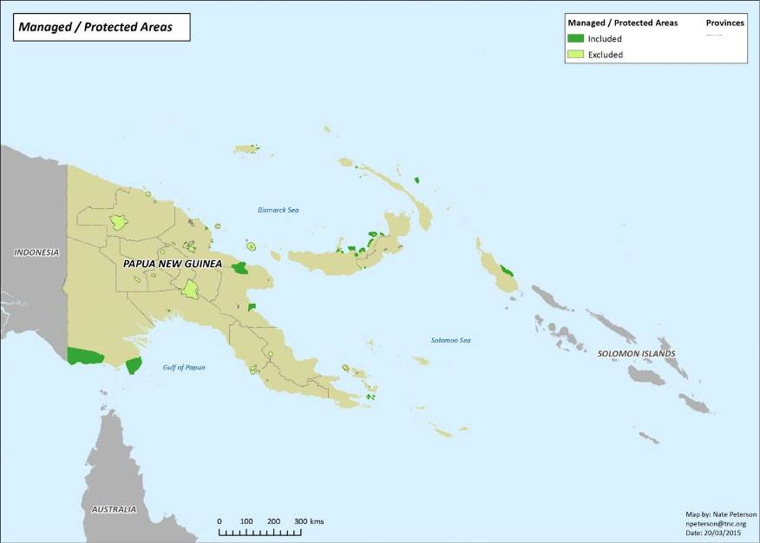

National Marine Conservation Assessment for PNG | 38

Map 2: Marine Ecoregions and Bioregions for Papua New Guinea

Map of deep water ecoregions and shallow water bioregions for PNG’s marine area. Developed through the regionalisation exercise described in Green et al. (2014).
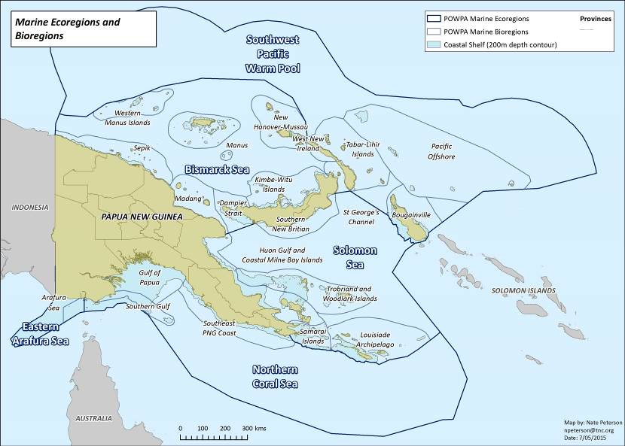

39 National Marine Conservation Assessment for PNG
Map 3: Turtle and Whale Critical Areas

Leatherback and green turtles aggregation areas (WWF-Malaysia and seaturtle.org) and Blue Whale critical habitat (Kahn and Vance-Borland 2014)
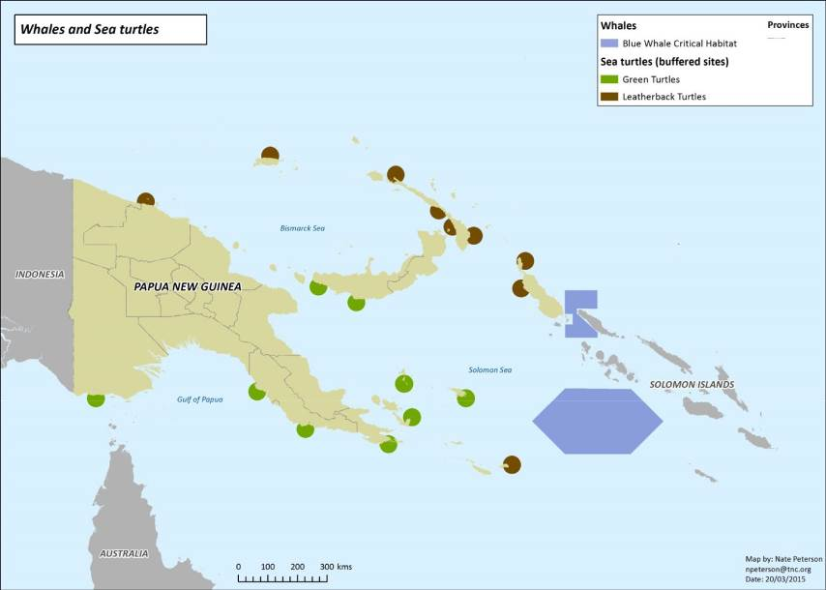

National Marine Conservation Assessment for PNG | 40

Map 4: Important Bird Areas (IBA) for seabirds and shorebirds

(Birdlife International 2012)
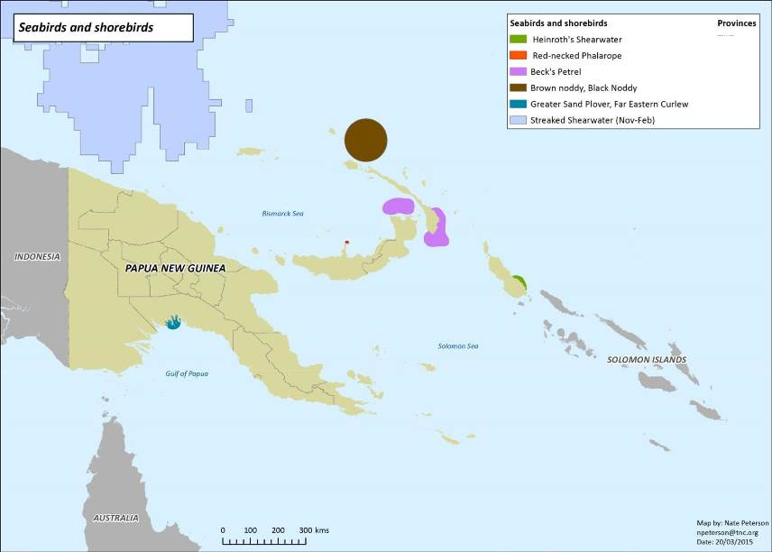

41 National Marine Conservation Assessment for PNG
Map 5: Indicative map of coral reefs classification

(Millennium Coral Reef Mapping Project: Andrefouet et al., 2006; UNEP-WCMC, WorldFish Centre, WRI, TNC 2010)
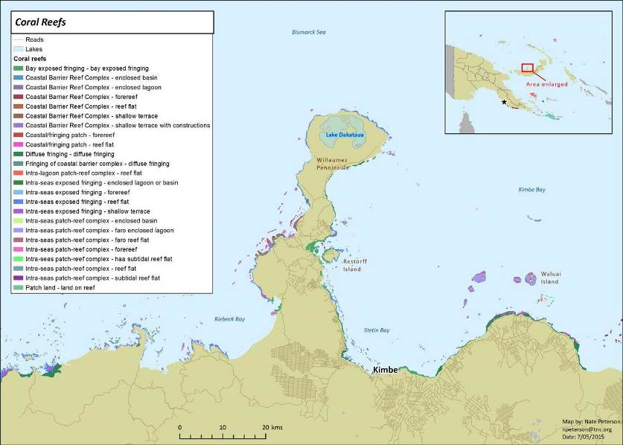

National Marine Conservation Assessment for PNG | 42

Map 6: Distribution of mangroves in PNG

(World Mangrove Atlas: Spalding et al. 1997a, 1997b)
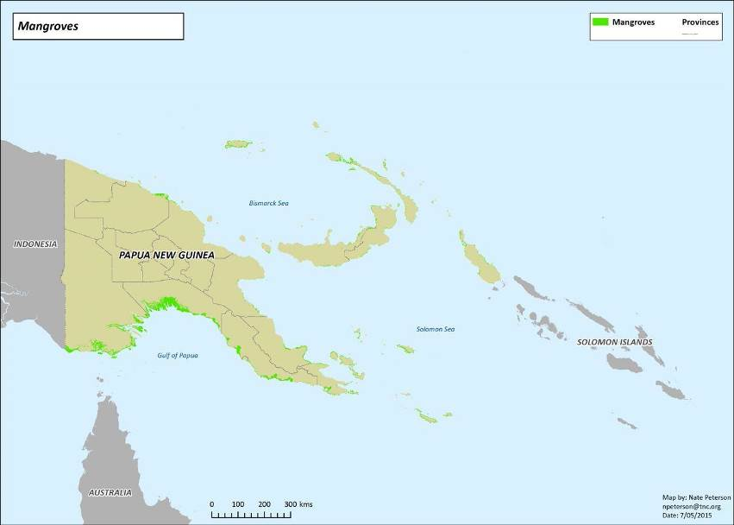

43 National Marine Conservation Assessment for PNG
Map 7: Indicative map showing classification structure for deep water features

(based on GEBCO global 30 arc-second grid: IOC, IHO and BODC 2003 and GRID-Arendal: Harris et al., 2014)
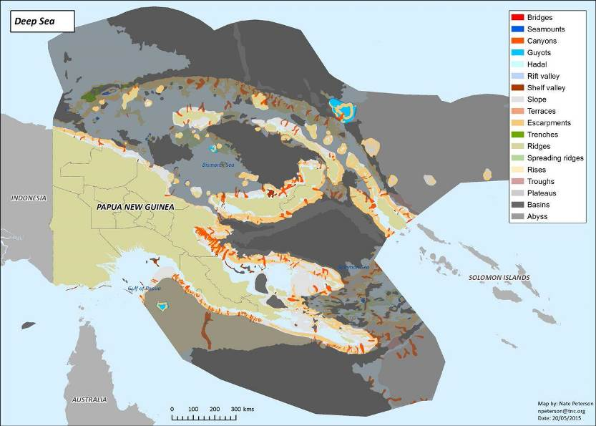

National Marine Conservation Assessment for PNG | 44

Map 8: Cost Distribution

(based on Distance to 13 ports (higher cost near ports) and Landings data from 2008-2013)
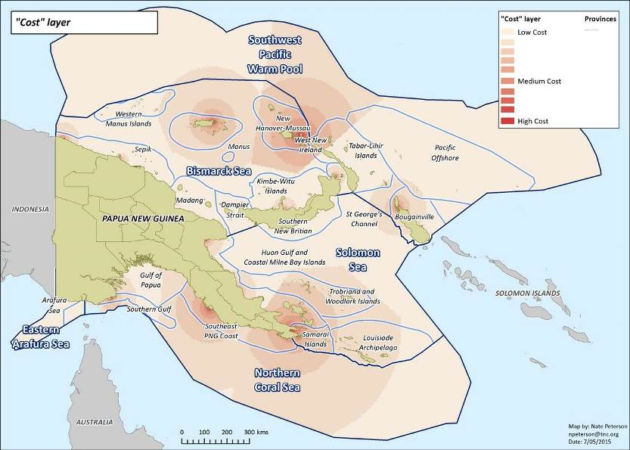

45 National Marine Conservation Assessment for PNG
Map 9: Mining and shipping activity

Mineral exploration leases (as at March 2014) (PNG Department of Environment and Conservation) and important shipping lanes (Halpern 2008)
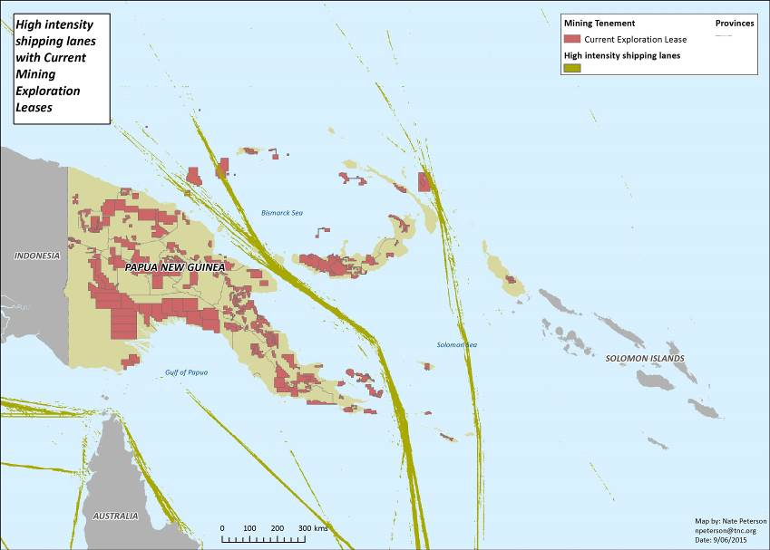

National Marine Conservation Assessment for PNG | 46

Map 10: Conservation priorities analysis – Base Scenario

Sum solution for “base” scenario (n=100) (refer page 20)
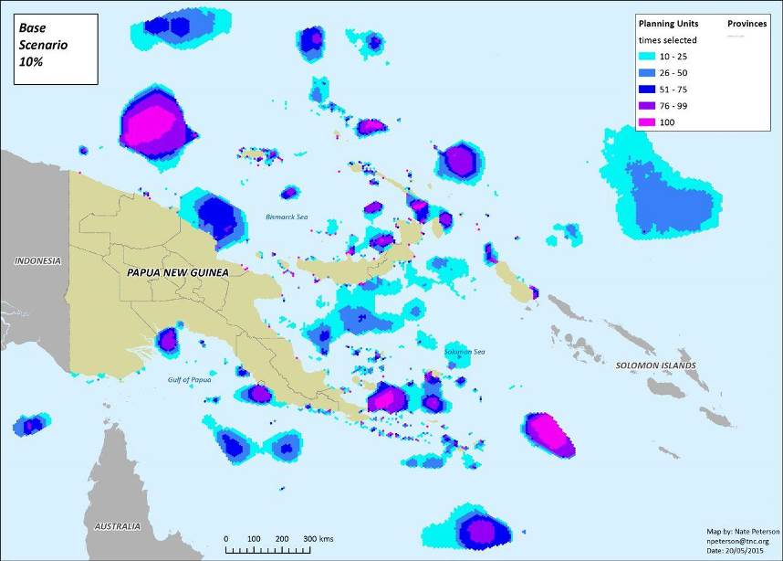

47 National Marine Conservation Assessment for PNG
Map 11: Conservation priorities analysis – MPAs “locked-in”

Sum solution with existing protected areas “locked in” (n=100) (refer page 21)
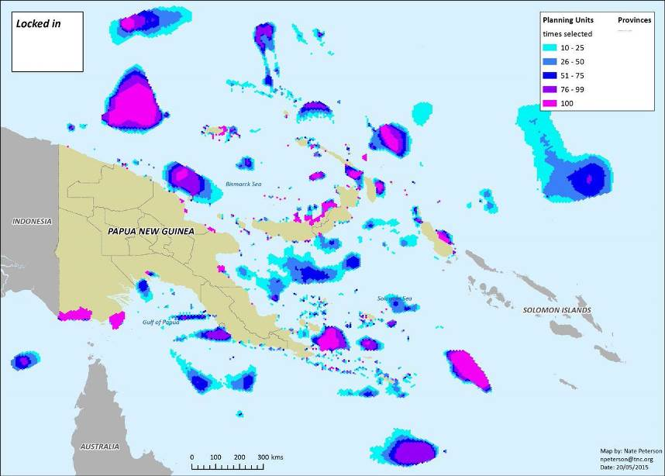

National Marine Conservation Assessment for PNG | 48

Map 12: Conservation priorities analysis – CTMPAS target

Sum solution with 20% (CTMPAS) habitat target (n=100) (refer page 21)
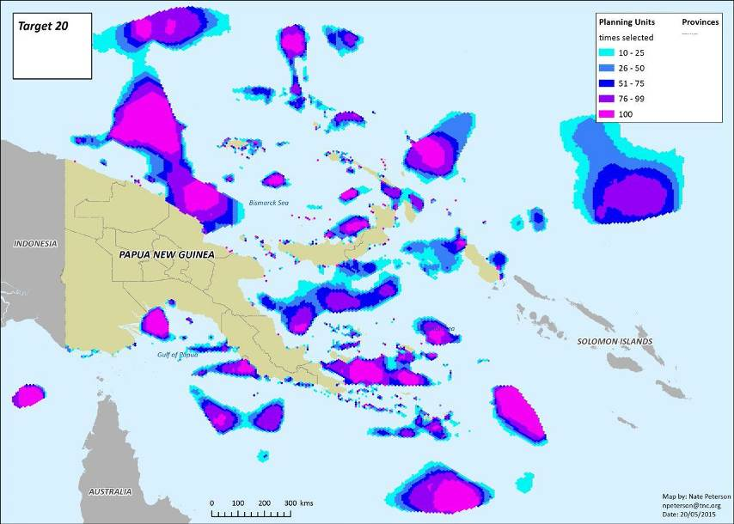

49 National Marine Conservation Assessment for PNG
Map 13: Conservation priorities analysis – Base scenario + mining leases

Sum solution for “base” scenario (n=100) plus current mining exploration leases (PNG Department of Environment and Conservation) (refer page 21)
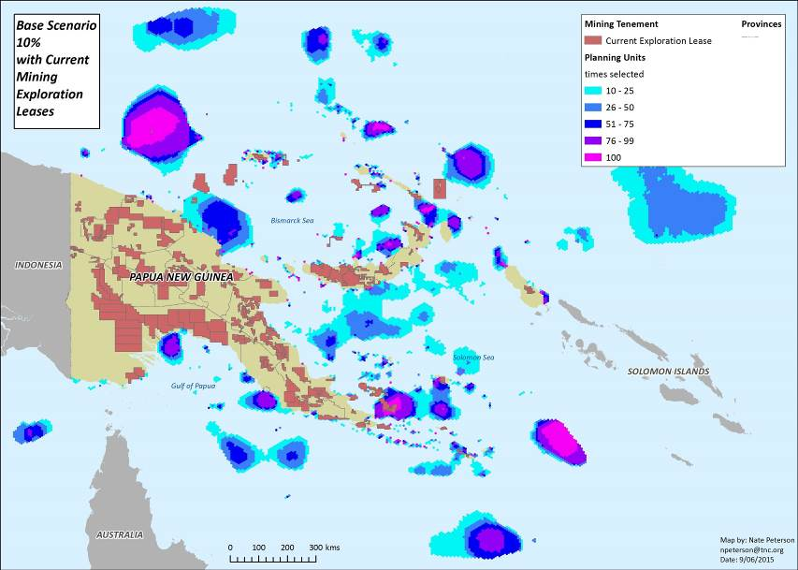

National Marine Conservation Assessment for PNG | 50

Map 14: Conservation priorities analysis – Base scenario + shipping

Sum solution for “base” scenario (n=100) plus high intensity shipping lanes (Halpern 2008) (refer page 22)
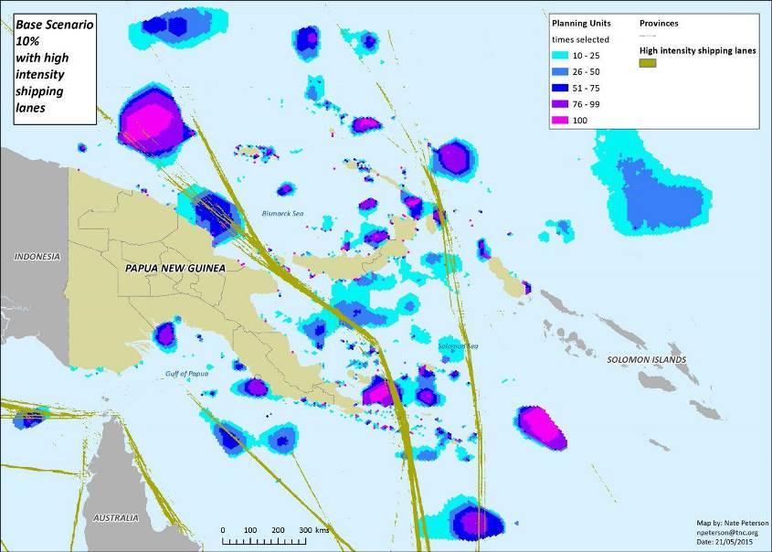

51 National Marine Conservation Assessment for PNG


Australia and the Coral Triangle Initiative (CTI) on Coral Reefs, Fisheries and Food Security

The CTI is a partnership—between Indonesia, Malaysia, Papua New Guinea, the Philippines, Solomon Islands and Timor Leste—focused on improving marine conservation and management, and through this, sustainable livelihoods, food security and economic development. Australia is a strong supporter of the CTI and is one of six formal partners. Australian Government support for the CTI is outlined in a series of documents that can be found online at environment.gov.au/cti

MAR315.0715

