# The National Soil Strategy

© Commonwealth of Australia 2021

**Ownership of intellectual property rights**

Unless otherwise noted, copyright (and any other intellectual property rights) in this publication is owned by the Commonwealth of Australia (referred to as the Commonwealth).

**Creative Commons licence**

All material in this publication is licensed under a Creative Commons Attribution 4.0 International Licence except content supplied by third parties, logos and the Commonwealth Coat of Arms.

Inquiries about the licence and any use of this document should be emailed to copyright@awe.gov.au.

Creative commons licence logo

**Cataloguing data**

This publication (and any material sourced from it) should be attributed as: DAWE 2021, *National Soil Strategy*, Department of Agriculture, Water and the Environment, Canberra, April. CC BY 4.0.

ISBN ISBN 978-1-76003-395-8

This publication is available at awe.gov.au/publications.

Department of Agriculture, Water and the Environment  
GPO Box 858 Canberra ACT 2601  
Telephone 1800 900 090  
Web [awe.gov.au](http://awe.gov.au/)

**Disclaimer**

The Australian Government acting through the Department of Agriculture, Water and the Environment has exercised due care and skill in preparing and compiling the information and data in this publication. Notwithstanding, the Department of Agriculture, Water and the Environment, its employees and advisers disclaim all liability, including liability for negligence and for any loss, damage, injury, expense or cost incurred by any person as a result of accessing, using or relying on any of the information or data in this publication to the maximum extent permitted by law.

**Aboriginal and Torres Strait Islander Cultural Warning**

Aboriginal and/or Torres Strait Islander Peoples should be aware that this publication may contain images, names and quotations of people who have passed away.

**Acknowledgements**

The Department of Agriculture, Water and the Environment acknowledges the Traditional Custodians of Australia and their continuing connection to land, sea environment, water and community. We pay our respect to the Traditional Custodians, their culture, and elders both past, present and future. In doing so, we value Indigenous knowledge systems as a vital part of the knowledge capital of Australia.

Appropriate consent was gained for the depiction and identification of the Noongar Budjar Rangers featured in case study 4 of this Strategy.

The authors thank interview and survey participants for their input, the National Soil Strategy Steering Committee for their invaluable contribution and feedback, as well as contributing authors for their invaluable work on case studies.

Contents

Our vision 4

1. Executive summary 5

2. What is soil and why is it important? 6

Australia’s soil 9

Case study 1: Investment in soil mapping and information creates a new agricultural region and lays a foundation for tackling Aboriginal economic disadvantage 11

3. Australia’s soil needs our help 13

Case study 2: Gully remediation reducing sediment run-off to the Great Barrier Reef 14

Case study 3: Organic enrichment of soil boosts agricultural output at lower cost1* 16

4. The National Soil Strategy 17

5. The story so far 18

Case study 4: Noongar Budjar Rangers caring for soil in the WA Wheatbelt 18

International links and obligations 20

6. Goals and objectives 22

Guiding principles 22

Goal 1: Prioritise soil health 22

Goal 2: Empower soil innovation and stewards 25

Goal 3: Strengthen soil knowledge and capability 28

7. How will we get there? 32

The Strategy 32

The Commonwealth Interim Action Plan 32

The National Action Plan 32

Governance and evaluation 33

Glossary 34

References 35

**Figures**

Figure 1 From our vision to a National Action Plan 5

Figure 2 Soil ecosystem and production services 8

Figure 5 The Process-Factor-Cause Nexus as a driver of soil degradation 14

Figure 6 The development and governance of the National Soil Strategy and National Action Plan 33

**Maps**

Map 1 Range of catchment-scale land uses across Australia 11

Map 2 Diversity of soil types across Australia, using broad soil classification boundaries, noting that soil types vary considerably even at local scales. 12

## Our vision

**Australia’s soil is recognised and valued as a key national asset by all stakeholders. It is better understood and sustainably managed, to benefit and secure our environment, economy, food, infrastructure, health, biodiversity, and communities – now and in the future.**

Figure 1 From our vision to a National Action Plan

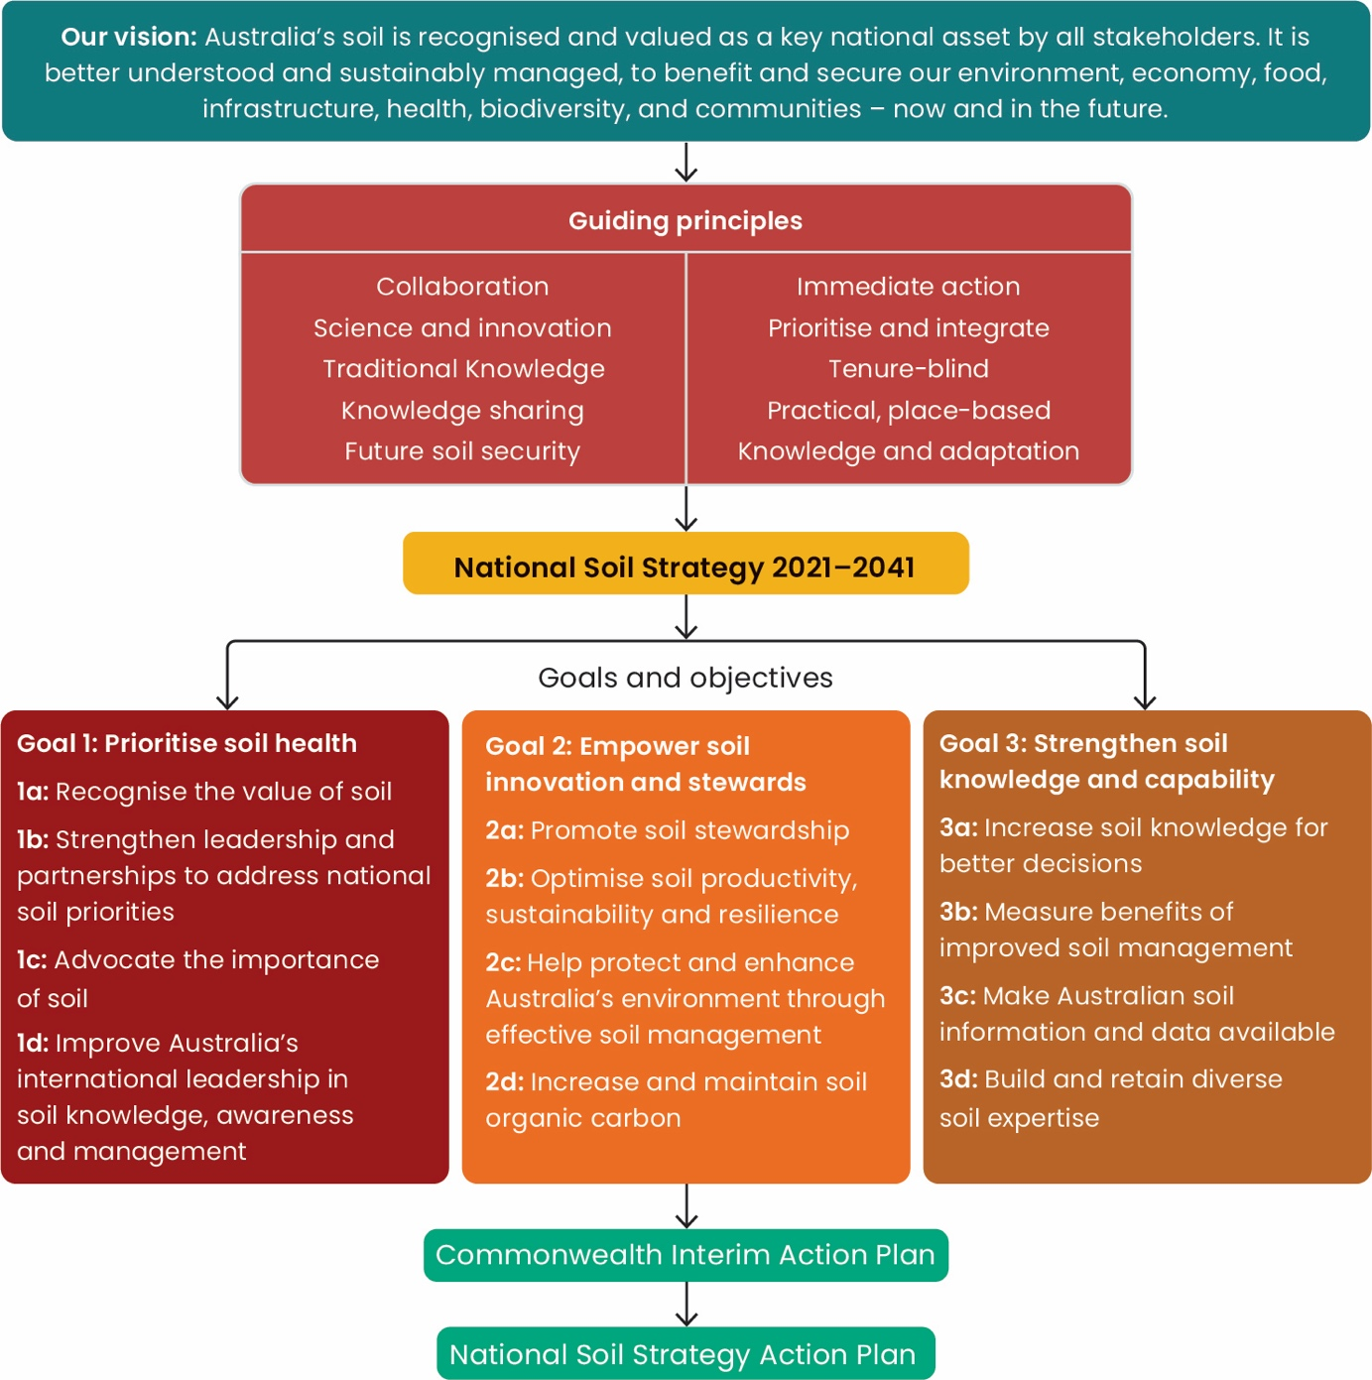

## 1. Executive summary

**Healthy soils are central to delivering resilience to climate change and natural disasters, meeting our emission reduction targets, growing our agriculture industry, and securing human health, food and water security, biodiversity and economic growth.**

The National Soil Strategy (the Strategy) is a 20-year strategy that sets out how Australia will value, manage and improve its soil. The Strategy has been developed in collaboration with state and territory governments, the National Soils Advocate and other major stakeholders in soil science and land management.

The goals and objectives in the Strategy are aimed at restoring and protecting soil nationally, by driving collaborative and coordinated on-ground action, research, education, monitoring and governance. All levels of government, industry, research institutions, private soil science practitioners and land managers have a role to play in caring for our soil resources.

The Strategy outlines 3 key goals: prioritise soil health, empower soil innovation and stewards, and strengthen soil knowledge and capability.

By June 2022, the Australian Government will work with the states and territories to develop and release a National Soil Strategy Action Plan. The Action Plan will detail specific actions (programs and activities) required to achieve the vision, goals and objectives of the Strategy. These actions will meet the SMART principles — that is, Specific, Measurable, Achievable, Relevant and Time-bound.

Prior to the release of the Action Plan in June 2022, the Australian Government will implement soil-related measures which contribute to the objectives of the Strategy under a Commonwealth Interim Action Plan.

## 2. What is soil and why is it important?

**Soil is an integral part of the Australian landscape. It supports us all, no matter where we live, and provides essential ecosystem and production services that support and contribute to Australia’s economic, environmental and social wellbeing.**

Australia has some of the most stunning natural landscapes on the planet and is internationally renowned for our high-quality and sustainably produced agriculture. We would have none of these benefits without our soil.

Including the ecosystem services provided by soil, Australia’s soil provides an estimated value equivalent to roughly $930 billion per year to the economy (Soil Science Australia 2019), based on analysis by McBratney et al. (2017). Through agricultural production alone, soil directly contributes approximately $63 billion per year to the Australian economy (Jackson et al. 2018).

To demonstrate the value of well-managed soil a number of case studies have been included throughout this document. These case studies highlight some of the important work that has been undertaken for many years across Australia, as well as exciting innovations and new opportunities for soil management in Australia. Look out for the **Case study** boxes.

Figure 2 Soil ecosystem and production services

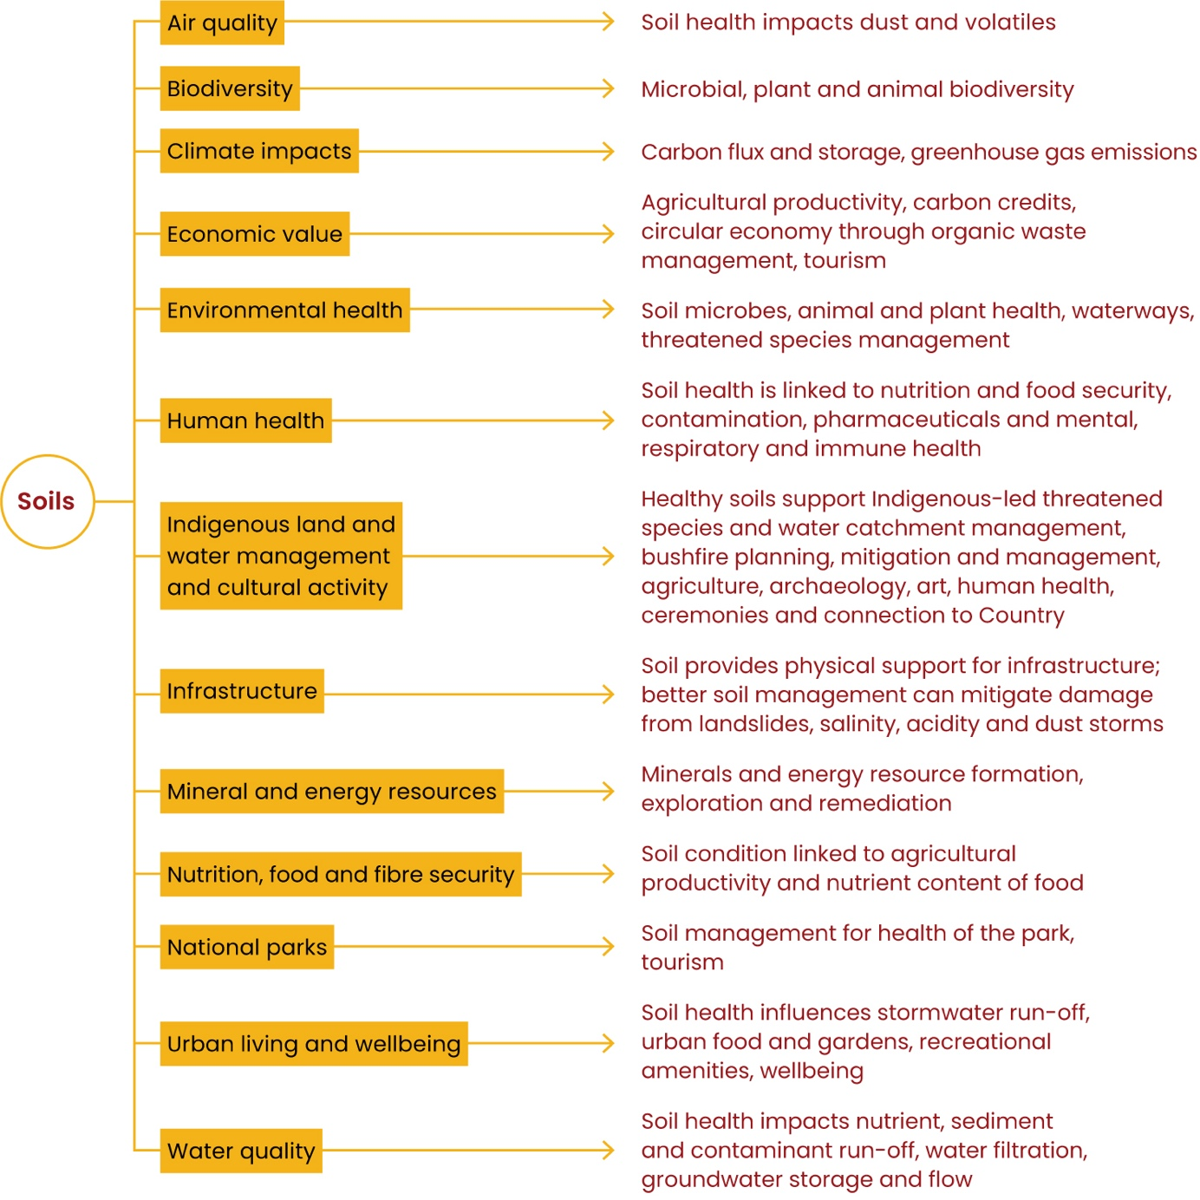

Soil formation is a slow and complex process, but degradation can happen swiftly. Soil is essentially a non-renewable resource. It is also the most complex biological material on the planet (Young & Crawford 2004) and one of the most biologically rich and diverse habitats on earth. One teaspoon of soil contains more living organisms than there are people in the world (FAO 2020).

Soil is the physical, chemical and biological matrix that supports plant growth and provides habitat for a vast number and variety of soil biota. Soil enables:

* **Food and fibre production:** Soil is key to producing our food and fibre. Almost all of what we eat is grown in our soil or fed by what is grown in it. The United Nations Food and Agriculture Organization (FAO) reports that around 95% of the world’s food comes from soil and soil organisms. Carbon cycling in soil is responsible for making available nutrients that support plant growth and help plants withstand biotic stresses. The FAO estimates that increasing the adoption of sustainable soil management practices could increase food production globally by up to 58% (FAO 2015a).
* **Water storage, filtration and nutrient cycling:** Healthy landscapes retain water, sediment and nutrients, which are then available for plants and other living organisms. As water moves through the landscape to rivers, creeks, catchments and underground waterways, soil acts as a natural filter for water by removing pollutants from water and retaining them in the soil matrix. By filtering water and retaining sediment and nutrients, soil ensures that high-quality water reaches our rivers, lakes and the ocean, conserving marine and freshwater biodiversity. When water flows through soil as it moves across the landscape, the water stored in soil increases plant productivity.
* **Resilience against the impact of natural disasters:** Healthy soils are often recognised as being well structured, high in organic matter, well drained, sufficient in nutrients, and having good ground cover. These soils are resilient to the impacts caused by natural disaster such as drought, flood and fire. They allow water to easily infiltrate into their profile and store water for plants during dry periods. They also reduce sediment and nutrient movement caused by water and wind.
* **Protection and enhancement of the natural environment:** Soil underpins a range of functions critical to environmental health. For example, it supports the growth of plant life; stores and filters water; stores and recycles nutrients and waste; aids in chemical decomposition; provides habitat for microbial communities; and globally stores more organic carbon than the atmosphere and vegetation (Schulte et al. 2014; Vogel et al. 2018; FAO 2017).
* **Support for human health:** The United Nations FAO has declared soil nutrition as the basis for human nutrition. Soil nutrients provide the food needed for plants and animals to survive, and these nutrients are transferred to humans once consumed. Soil is also the source of many vaccines, anti-cancer agents and drugs upon which humans rely, such as antibiotics. Low-level exposure to the natural microbial diversity of healthy soil is also increasingly seen as necessary for the priming and education of the immune system in infants and for maintaining immune fitness into adulthood (Roslund et al. 2020; Ottman et al. 2019; Matthews & Jenks 2013).
* **Stable basis for infrastructure:** It is important that we understand the geotechnical properties of soil, so that we know the soil’s ability to support infrastructure and prevent damage to housing, bridges, roads and other built infrastructure from soil degradation processes (for example, acid sulfate soil, contamination), and landslides. Soil is also the core component of many materials used for development.
* **Indicators of valuable natural resources:** Soil chemical and physical properties are used to explore and detect buried mineral, energy and groundwater resources and in some cases form resources in their own right (for example, residual deposits such as bauxite). They are also vital for informing any remediation efforts.
* **Maintenance of air quality:** When landscapes are degraded, poor ground cover leaves soil exposed to dust storms through wind erosion. These dust storms lead to large quantities of fine particles in the air, which can have detrimental effects on human health (Merrifield et al. 2013) and cause a loss of agricultural productivity (Stefanski & Sivakumar 2009) and costly transport disruptions (Tozer & Leys 2013). They also lead to the volatilisation of organic chemicals such as pesticides and act as a transport mechanism for sediment and nutrients. Healthy soil with good ground cover and organic matter holds together surface soil particles and therefore builds resilience against wind and water erosion.
* **Ongoing Indigenous traditions and deep cultural relationship with Country:** Ochre is derived from natural pigments and minerals from soil. It is used in body and rock painting, on artefacts, in traditional ceremonies and on communication tools. It has been and continues to be an essential tool for First Nations cultural and heritage management and celebration.

Work is continuing to better quantify in economic terms the value of all services that soil provides. For example, the Australian Government is working on an environmental‑economic accounting framework (ABS 2019) which organises information to better understand how the environment, including soil, and the economy interact.

While more work is needed to better quantify the value of soil-related services, the benefits of sustainable soil management are well understood and far outweigh the costs associated with the impacts of soil degradation. It is also less expensive to adopt sustainable soil management practices to maintain soil health than to remediate soil after it has been degraded (Kiri-ganai Research 2012).

To preserve this key natural asset and strengthen Australia’s economy, it is vital that we prevent soil degradation by boosting our understanding of how to sustainably manage our soils through research, development and translational science and then support their appropriate and broad adoption.

The Strategy, through its application for guiding integrated approaches to land management and planning, will facilitate soil security. Soil security is concerned with the maintenance and improvement of the global soil resource to produce food, fibre and fresh water, contribute to energy and climate sustainability, and maintain the biodiversity and the overall protection of the ecosystem (McBratney et al. 2014).

### Australia’s soil

While it is rich in biodiversity, Australian soil is among the oldest and most nutrient poor in the world. This is due mainly to the country’s geological stability — among other things, Australia is characterised by a lack of significant seismic activity and other natural processes, such as glaciation, that weather and erode rock and create new soil.

Australia and its external territories (for example, Norfolk Island, Australian Antarctic Territory and Christmas Island) have a wide variety of different landscapes, climates, soil types and land use histories. Figures 3 and 4 demonstrate the variability in land use and soil types across the country.

Map 1 Range of catchment-scale land uses across Australia

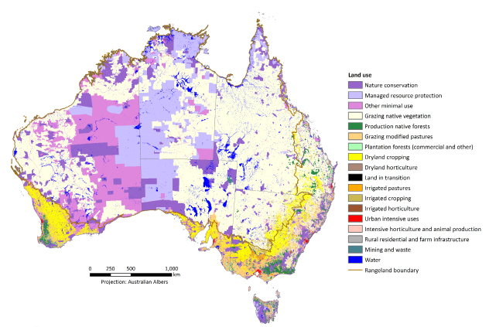

Source: ABARES 2021

Each soil type comes with its own unique characteristics which influence the land use and management across the country. While most high-level soil and land management principles (for example, maintaining sufficient ground cover to prevent erosion) are similar around the world, we also need regionally and locally specific approaches to the planning and application of strategies and actions in Australia. While some actions can be taken on a national scale, with collaboration across different groups, the implementation will vary — for example, between the rangelands and deserts of northern and western Australia, the cropping lands of the east and west coasts and the forests of Tasmania and the Great Dividing Range. Effective soil and land management is a multifaceted and complex challenge.

To ensure that Australia’s soil is sustainably managed and any downward trends in soil health metrics are halted, and where possible, reversed, collaboration will be required across a large range of existing and emerging networks, organisations and land managers who have detailed knowledge of the challenges involved — for example, the Natural Resource Management (NRM) bodies, Rural Research and Development Corporations (RDCs), agricultural industries, government agencies, land use planners, universities and land managers.

Map 2 Diversity of soil types across Australia, using broad soil classification boundaries, noting that soil types vary considerably even at local scales.

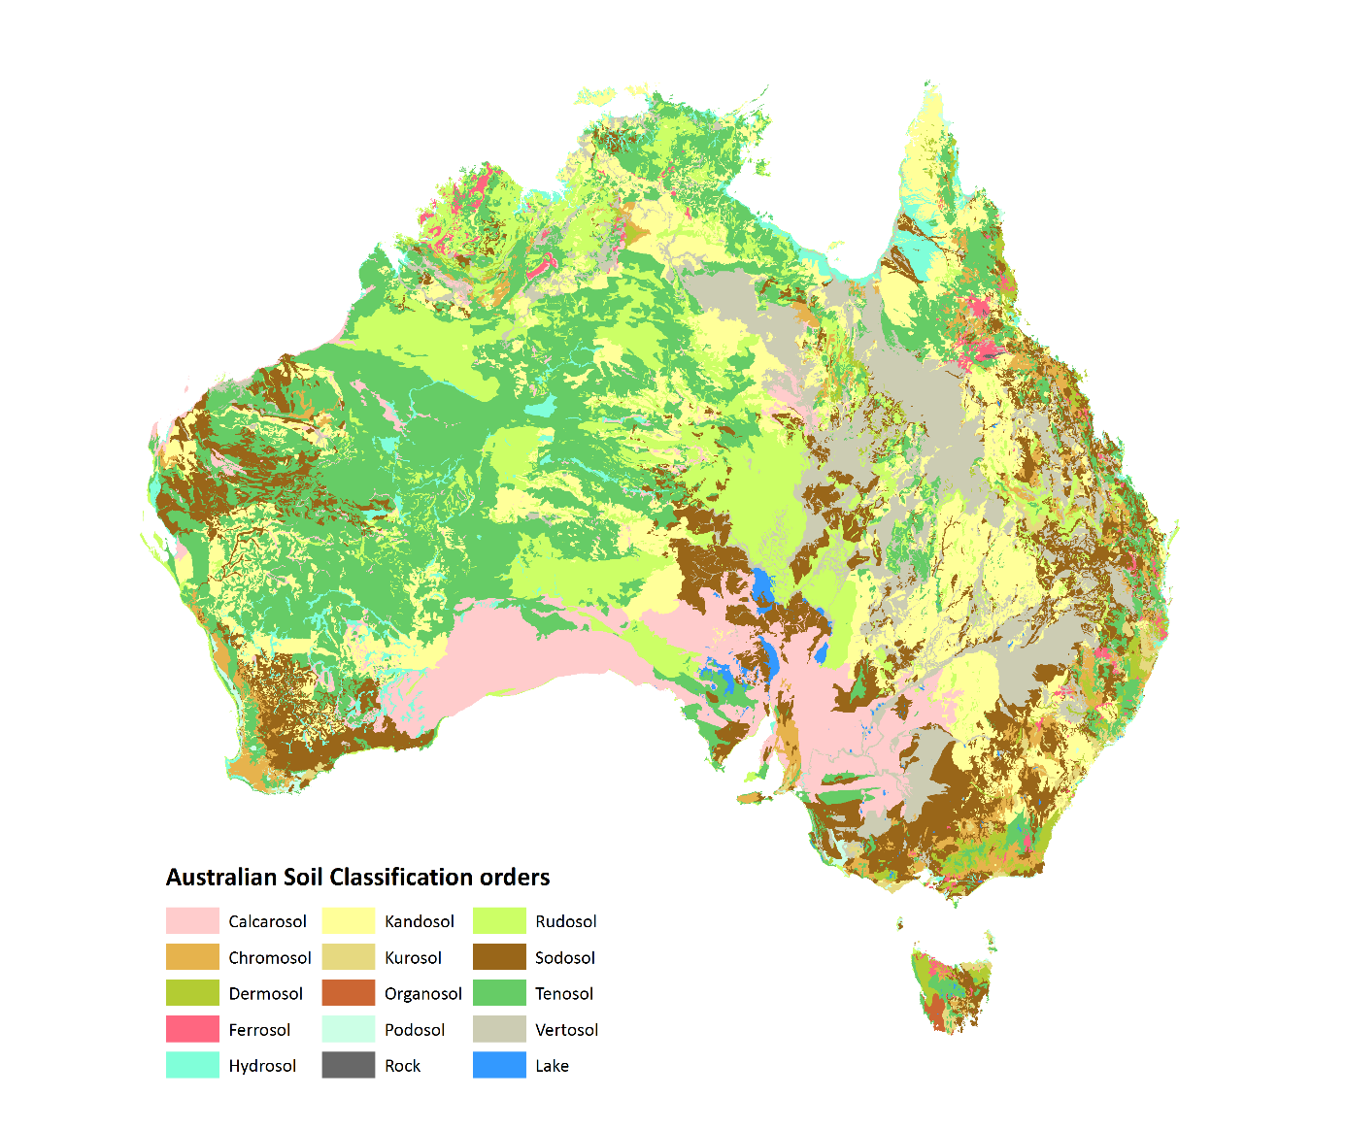

Source: Department of Agriculture, Water and the Environment & Australian Collaborative Rangelands Information System 2014

Case study 1 below highlights the positive outcomes when soil is understood and mapped at a local scale to inform land use planning that is undertaken in collaboration between state governments, the agricultural industry and First Nations Communities.

Case Study 1 Investment in soil mapping and information creates a new agricultural region and lays a foundation for tackling Aboriginal economic disadvantage

Well-planned new agricultural precincts in the Northern Territory have the potential to grow Australia’s $60 billion agricultural industry in ways that provide a real opportunity to address Aboriginal and regional disadvantage while ensuring protection of key environmental and cultural assets.

For decades the Australian and Northern Territory governments have focused on intensifying agriculture across northern Australia. An example of what can be achieved is the Litchfield municipality just outside Darwin.

For the last 30 years land use planners and the plant industry have been using appropriately scaled soil and groundwater assessments to found and develop one of northern Australia’s most successful horticultural regions. In 2015–2016 the 5,360 ha of land under irrigation in Litchfield for agricultural and horticultural production1 was valued at $120 million per year.2

Litchfield’s success can be largely attributed to high-resolution soil mapping and groundwater investigations undertaken in the 1980s. The estimated $10 million investment to establish Litchfield’s agricultural industry is now, assuming inflation, returning 12 times that original amount annually. This local industry now employs a workforce of over 600 during peak harvest periods.3

Without this strategic approach to soil mapping, high-value horticultural land in the Darwin region would not have been identified and the land may have been subdivided for peri-urban development, leading to a loss of $120 million to the regional economy. Expanding on the successful approach in the Darwin region, since 2014 the Northern Territory Government has worked in close collaboration with the Aboriginal Land Economic Development Agency (ALEDA) to identify highly suitable agricultural soils and commercial-scale groundwater resources across a number of Aboriginal Land Trusts.4 Established with the support of Traditional Owners and the Northern and Central Land Councils in the Northern Territory, ALEDA has used the outcomes of government land and water assessments to prioritise and take the necessary steps to coordinate agricultural investment on Aboriginal land. This work highlights the role high-resolution soil mapping can play in supporting Traditional Owners to make informed development decisions that ultimately will benefit both their people and the economy.

1 Staben, G & Edmeades, B 2017, Northern Territory land use mapping for biosecurity 2016, Technical Report 18/2017D, Department of Environment and Natural Resources, Northern Territory Government, Darwin.

2 Northern Territory Farmers Association 2015, Economic profile of plant based industries in the Northern Territory, Coolalinga, NT.

3 NT Farmers 2019, NT plant industries harvest labour report, Coolalinga, NT.

4 Burgess, J, McGrath, N, Andrews, K & Wright, A 2016, Agricultural Land Suitability Series, Report 5: Soil and land suitability assessment for irrigated agriculture in the Ali Curung area, Western Davenport District, Technical Report 16/2016D. Department of Environment and Natural Resources, Northern Territory Government, Darwin, NT.

## 3. Australia’s soil needs our help

**Since European settlement, human activities have caused or exacerbated degradation processes in Australia’s soil, leading to a decline in soil quality and function.**

Reduced soil quality and function impacts our economy, environment and way of life. The Process-Factor-Cause Nexus as a driver of soil degradation is shown in Figure 5.

A changing climate is bringing more frequent and intense events like drought, bushfires and storms, increasing risks to our soil health. These events are increasing soil degradation processes such as loss of carbon, changes in soil biology and soil erosion, causing sediment movement and pollution of our air and water. Land use conflicts are exacerbating these climatic pressures through both urban expansion into prime agricultural land and increased global food and fibre demands. The rise of new market forces, the cumulative impact of climate change and resource consumption are all also placing pressure on our soil and on effective and sustainable soil management. It is important to also recognise the episodic nature of some degradation caused by extreme weather events and the need to focus more resources on soil management during particularly vulnerable times.

Figure 5 The Process-Factor-Cause Nexus as a driver of soil degradation

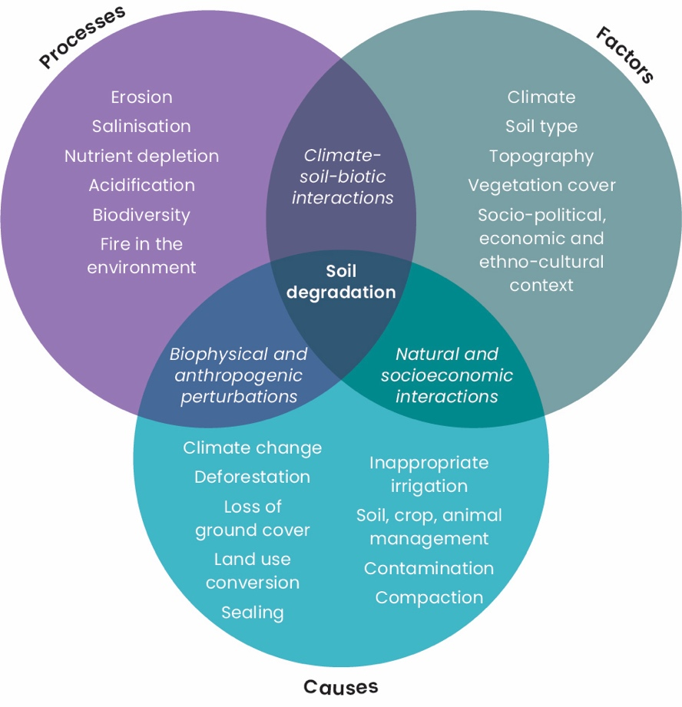

Source: adapted from Lal 2015

Historically, both government and the non-government sector have invested in soil management at various levels to address soil-related threats. There have been notable local and regional successes – for example, the reform of acid sulfate soil management during peat fires in Victoria, the mapping of gully erosion in Sydney’s drinking water catchment by the NSW Government to inform water management in the context of bushfires, and reduced severity of dust storms due to increases in ground cover (Guerschman & Hill 2017, McTainsh et al. 2011). Another example is the significant reduction in the amount of sediment being released from a local catchment into the Great Barrier Reef — see case study 2. The success of such actions is supported in the Reef Water Quality Report Card 2019 (2021).

Case Study 2 Gully remediation reducing sediment run-off to the Great Barrier Reef

**Sediment run-off presents a serious threat to the Great Barrier Reef, as it interferes with coral and seagrass photosynthesis and creates algal blooms.**

It is estimated that almost 50% of the sediment that makes its way to the Great Barrier Reef comes from the Burdekin River catchment.

The Innovative Gully Remediation Project, jointly funded by the Queensland Government’s Reef Water Quality Program and Greening Australia, is testing the most effective ways to manage gully erosion that contributes to sediment deposit in waterways that feed into the Great Barrier Reef.

Part of the project was a program of substantial gully remediation at Strathalbyn Station in the Burdekin River catchment, near Bowen in Queensland. Following extensive landscape assessments, approximately 17.5 ha of the grazing property was remediated. Water quality monitoring and LiDAR change detection indicated that this caused a 90% reduction, on average, in suspended sediment run-off across different gully treatments.

As a result of these works, since 2017 more than 4,600 tonnes per year of sediment from this area alone have been prevented from entering the Great Barrier Reef.

However, the level and timing of overall investment have not been sufficient to result in broadscale improvements in soil health.

Despite some regional soil monitoring efforts, there is currently no unified, strategic national soil monitoring approach to help understand how soil condition has changed across the country. We have little information on how soil health contributes to the provision of environmental services outlined in Section 1. Equally, there is a need to view soil as an interconnected and dynamic part of the landscape, and to understand that changes in its physical, chemical, hydrological and biological processes result in dynamic responses in the landscape.

There is also a need to focus more on fundamental aspects of soil science that provide crucial knowledge to address national priorities, such as agriculture productivity.

Innovation in the way we manage our soil and advances in soil science and technology will be fundamental if we are to produce more from less, and overcome food, fibre and fuel shortages while sustaining the environment. New technologies offer the opportunity to transform how we use, manage and monitor soil for the future.

National leadership and coordination are required across government and non-government sectors if we are to address issues of soil degradation and the increased pressure on land managers; enhance collaboration; make better land use planning decisions; usher in the next generation of soil experts; and build our knowledge base. We need consistent national standards and approaches to ensure our national soil asset is understood, recognised, restored and protected across the country.

National leadership, coordination and consistency will allow us to better leverage past and present work to accelerate efforts to protect and enhance Australia's soil health, including in areas such as improving soil carbon sequestration, driving agriculture innovation, and improving planning and on-ground interventions to ensure ongoing soil security.

One such area that will require cooperation between the government and non-government sectors but presents exciting opportunities for commercial agricultural innovation derived from improved soil health is organic waste management.

Organic waste is an inevitable by-product of Australian life. Managing it well is a key priority of the Australian Government. Organic waste recycling is an exemplar of a circular economy. In 2018–2019, the national greenhouse gas emissions savings from organics recycling were approximately 3.8 million tonnes of CO2 (that is the equivalent of planting 5.7 million trees, or the emissions that 876,663 cars would produce in one year). It is also estimated that the Australian organic recycling industry contributes $724 million in industry value to the Australian economy (AORA 2020). The addition of organic materials, including those from waste streams, have the potential to increase soil carbon and agricultural productivity with the benefit of creating a circular economy.

Case study 3 highlights the improved quality and productivity outcomes of applying better organic waste management in viticulture.

Case Study 3 Organic enrichment of soil boosts agricultural output at lower cost1*

**Torbreck Vintners has been making wine in the Barossa Valley, South Australia, since 1994.**

In 2005, viticulturist Nigel noticed that a small area of one of his vineyards was performing better than the rest. When he investigated, he found out that the area had been next to a pig farm more than 25 years earlier and that it had received regular manure and straw applications as a result. Ten years later, using a microscope, Nigel compared soil from that area with soil from elsewhere in the vineyard. The difference was profound: the soil with organic matter inputs from the pig farm was richer, more fertile and teeming with life.

So began a structured program of composting and mulching in the weakest areas of the vineyard. The addition of nutrients and improved soil fertility from the compost and mulch produced noticeable benefits within the first year:

* Vineyard variability reduced despite rainfall being 48% lower than in the previous year.
* Leaf condition improved.
* Grape yields increased.
* Water use efficiency improved by 30–40%.
* Within 7 years the changes were remarkable:
* There had been an improvement in wine quality valued at $132,000 per hectare per year.
* Grape yields had consistently improved.
* Access to nutrient rich compost and mulch meant that equivalent nutrient additions by way of synthetic fertiliser were not required.

Whilst this approach is not viable for all agricultural enterprises, Nigel estimates that the program cost approximately $1,350 per hectare per year, making this a highly cost-effective and sustainable strategy.

1 Adapted from the Australian Organics Recycling Association Ltd Torbreck Vintners case study (AORA 2019).

* This case study was supported by the Adelaide and Mount Loft Ranges Natural Resources Management Board through funding from the Australian Government’s National Landcare Program.

## 4. The National Soil Strategy

**This Strategy provides a national vision and shared goals and objectives between the Australian, state and territory governments for managing soil across all landscapes.**

The goals and objectives in the Strategy are aimed at restoring and protecting soil nationally, by driving collaborative and coordinated on-ground action, research, education, monitoring and governance (Figure 1). The Strategy recognises that all levels of government, industry, research institutions, private soil science practitioners and land managers have a role to play in caring for our soil resources.

This 20-year Strategy sets the direction for innovative sustainable soil science and land management nationally, while still allowing for a regional and local focus given that every soil management issue is unique.

The Strategy will ensure that soil health is appropriately prioritised and considered in government decision-making processes. It will give those who manage our soil, in government and non-government organisations, the knowledge, tools, networks and capabilities that will empower them to ensure that soil is preserved while sustaining and increasing productivity. By strengthening soil knowledge and capability, the Strategy will ensure that research is conducted in a coordinated fashion and the results are shared with those who need them.

The Strategy forms part of current Australian Government priorities including Delivering Ag2030 and National Agricultural Innovation Agendas and builds on current investments related to soil such as the Australian Government’s National Landcare Program, Agriculture Stewardship Program, Emissions Reduction Fund, Technology Investment Roadmap, Future Drought Fund and Reef 2050 Plan (2018). The Strategy will develop a national approach to soil monitoring so that we can gain a better understanding of soil condition and trends across the country. The information that is gathered will help land managers, policymakers, regulators, land use planners, the private sector and non-government organisations to understand how soil condition changes over time. This information, along with research, innovation, development, extension, communication and adoption of new practices, will be used to prioritise investments and actions to restore the country’s soil function and to show how land management practices can be improved to prevent future degradation.

The time for a National Soil Strategy is now. Governments, industry and many others are increasingly recognising the importance of soil to the country’s economic, social, cultural and environmental future: more questions are being asked, gaps are being identified and new interventions are being developed.

The Strategy is supported by a Commonwealth Interim Action Plan, which will be followed and replaced by a National Soil Strategy Action Plan. More information on this is provided in Section 7.

## 5. The story so far

**Australia’s 8 million square kilometres of soil has been formed from a range of parent material, under differing climatic conditions and topography over millennia. It is also intimately related to native vegetation.**

For tens of thousands of years, the lives and cultural identity of Australia’s First Nations Peoples have been inextricably linked to land and water and their forms; stories; and biodiversity. To this day, Indigenous Australian Peoples and Communities hold legal rights and responsibility for land and sea management over much of Australia, including more than half of Australia’s mainland, through the Indigenous estate, which includes native titles and other land tenures.

Indigenous land and sea management (ILSM), or caring for country, combines traditional ecological and cultural knowledge with western conservation science. ILSM remains one of the first lines of defence against environmental threats including biosecurity invasions, threatened species and extreme bushfire events. ILSM also provides invaluable economic, health, social and cultural improvements for local and surrounding communities.

Case study 4 describes the ecological work being performed by an Aboriginal Ranger group in Western Australia, demonstrating the key contribution of ILSM in soil and land management.

Case Study 4 Noongar Budjar Rangers caring for soil in the WA Wheatbelt

**Since 2014, the Noongar Budjar Rangers have had their boots on the ground in Western Australia’s Wheatbelt region, applying First Nations cultural knowledge and modern scientific research to the management of lands and soils.**

The Ranger team is drawn from the Ballardong People of the Noongar Nation and supported by the Wheatbelt NRM. The team now provides on-country employment for 17 people.

Noongar Budjar Rangers are vital soil stewards in the Avon River Basin. They are developing new skills in soil sampling to measure soil carbon; undertaking valuable seed collection; and branching out into commercial work for landcare, agriculture and mining industries.

John McGuire, a Ballardong Whadjuk Elder, notes that the Noongar Budjar Rangers are playing a key role in tackling the impacts of climate change.

‘The real value for those people individually is knowing that they’re healing country, healing the land that our old people have walked on and talked on a long time ago’, he says.

Right now the Noongar Budjar Rangers have been involved in a major seeding and replanting operation. They are planting up to 2.4 million seedlings to revegetate agricultural land and offset carbon emissions.

Much has been learned since European land management began in Australia nearly 250 years ago. European settlement led to a dramatic and rapid shift in land. In particular, there were significant changes to agriculture, urban expansion, and the introduction of mining and industrial activity. As a result, many areas were exposed to threats that caused extensive and ongoing decline in soil health.

By the 1930s, episodes of widespread soil erosion revealed the severity of land degradation across Australia’s landscapes (Campbell 1994). By 1936, federal, state and territory governments recognised the need for a consistent national approach. In 1938, the New South Wales Government introduced the Soil Conservation Act 1938 — the first direct piece of soil conservation legislation to be enacted. Other state and territory governments quickly followed suit (Campbell 1994). In 1946 the Australian Government established the Standing Committee on Soil Conservation.

Despite the early action of farmers who were learning and developing their soil conservation knowledge, adapting innovations such as stubble retention and minimum tillage to Australia’s soils, over the next 50 years broadscale land degradation continued across the country, driven by a combination of factors.

In February 1983, during a long and severe drought, a major dust storm swept across the state of Victoria and engulfed Melbourne (Commonwealth of Australia 2020). ‘Fixing’ the problem became a matter of national urgency. Governments focused on working with farmers and pastoralists to support their uptake of better land use and management practices.

In 1986 the Victorian Government established its Landcare program, which would later become the model for the national Decade of Landcare framework. Action being undertaken through Landcare was complemented by the National Dryland Salinity Program (1993–2004), the National Action Plan for Salinity and Water Quality (NAP) (2001–2008) and the National Land and Water Resources Audit (1997–2008). The Australian Government’s National Landcare Program, which continues today, currently invests over $1 billion over 5 years in strategic natural resource management actions and priorities.

In addition to these government-supported programs there have been a range of non-government and RDC-funded strategies and investments to improve soil health.

In 2012, the Australian Government appointed the first National Soils Advocate — the late Hon. Major General Michael Jeffery, AC, AO (Mil), CVO, MC.

In 2014, the National Soil Research, Development and Extension Strategy (RD&E Strategy) was released (Commonwealth of Australia 2014), which has a focus on securing Australian soil for profitable industries and healthy landscapes. In 2017, the Cooperative Research Centre for High Performance Soils (Soils CRC) was established to give farmers the knowledge and tools they need to make decisions on extremely complex soil management issues.

In 2019, following recommendations made by the first National Soils Advocate to Prime Minister the Hon. Scott Morrison MP, the Australian Government committed to the delivery of a National Soil Strategy in collaboration with states and territories. While much has been done in Australia to understand, conserve and improve soil, there is still much to achieve.

The National Soil Strategy recognises and aims to build on the work being achieved by federal, state, territory and local governments, research institutions, universities, non-government and natural resource management organisations, industry and community groups across Australia, including land managers, Soil Science Australia, soil-related CRCs, the National Committee for Soil and Terrain, the Australian Soil Network, Terrestrial Ecosystem Research Network, CSIRO, and many more. These groups, alongside the RDCs and the financial sector, have been instrumental in improving soil sustainability, research and extension in Australia over the last several decades.

### International links and obligations

Australia has ratified 3 United Nations (UN) conventions that have an intrinsic link to better management and conservation of the world’s soil. In 1992 the UN Conference on Environment and Development (commonly known as the Earth Summit) established 3 key overarching environmental instruments:

* the United Nations Framework Convention on Climate Change
* the United Nations Convention to Combat Desertification
* the United Nations Convention on Biological Diversity.

Australia is also a signatory to the Revised World Soil Charter (FAO 2015b) and is a leading participant in the UN FAO Global Soil Partnership and the International Union of Soil Sciences.

In 2015, countries around the world, including Australia, adopted a set of goals to end poverty, protect the planet and ensure prosperity for all as part of a new sustainable development agenda. These goals are known as the UN Sustainable Development Goals. Each goal has specific targets, which are to be achieved by 2030.

The National Soil Strategy is aligned with the following UN Sustainable Development Goals:

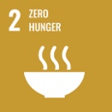

**Goal 2:** Zero hunger

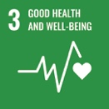

**Goal 3:** Good health and well-being

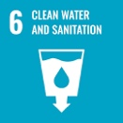

**Goal 6:** Clean water and sanitation

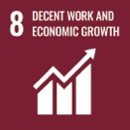

**Goal 8:** Decent work and economic growth

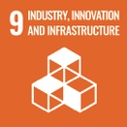

**Goal 9:** Industry, innovation and infrastructure

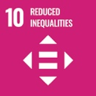

**Goal 10:** Reduced inequalities

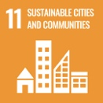

**Goal 11:** Sustainable cities and communities

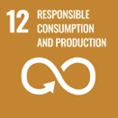

**Goal 12:** Responsible consumption and production

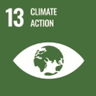

**Goal 13:** Climate action

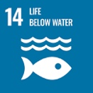

**Goal 14**: Life below water

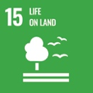

**Goal 15:** Life on land

## 6. Goals and objectives

### Guiding principles

This strategy contains 3 goals and 12 objectives which will guide Australia’s efforts to better manage its soil. The goals and objectives are underpinned by the following principles:

* **Collaboration:** Collaborative decision-making, alignment of effort and partnerships contribute to effective research, policymaking and implementation.
* **Science and innovation:** Delivery of world‑leading research, innovation, monitoring and evaluation.
* **Traditional Knowledge:** The culture, values, knowledge, innovations and practices shared by First Nations Peoples are valued and respected and should inform, where appropriate, planning, management and conservation of our soil resource.
* **Knowledge sharing:** Sharing knowledge, contributing to evidence-based and cost-effective decisions and actions.
* **Future soil security:** Sustainable use of our soil must meet the needs of today without compromising the needs of future generations.
* **Immediate action:** Immediate action is required to better manage, prevent or remediate degradation of soil and the environment where there are threats of serious or irreversible environmental damage.
* **Prioritise and integrate:** Accounting for soil in all relevant decision-making significantly enhances outcomes in terms of agricultural production and ecosystem services.
* **Tenure-blind:** The impact of soil degradation processes and soil management does not abide by legal tenure boundaries and therefore management responses must also transcend ownership and boundaries.
* **Practical, place-based knowledge and adaptation:** Enabling bioregional and local knowledge to be used in the development of place-based and locally adapted and generated solutions.

### Goal 1: Prioritise soil health

**Soil plays a fundamental role in the carbon (energy) cycle, nutrient cycle and the water cycle, as well as being the engine room of food production, an archive of human and natural history, and host to extraordinary biodiversity. Soil underpins all terrestrial life.**

Australia will struggle to improve soil health, manage its water supply, improve the resilience and profitability of its farming systems or meet its emissions reduction objectives without a renewed focus on, and re-energising of, efforts to improve soil management.

All Australians including industry, the private sector, land managers and governments at federal, state, territory and local levels have a role to play in properly managing our soil.

#### Objective 1a: Recognise the value of soil

We recognise the value of soil by making sustainable soil management a critical consideration in policy development, research and practice change across other national priorities. This objective not only aims to raise the profile of soil and the importance of soil biodiversity to maintain soil health and support terrestrial living systems. It also increases the likelihood that landscape-scale degradation will be appropriately addressed, as the cause may often start with the soil and its management.

As part of work to improve recognition of the value of soil, the federal, state and territory governments are working to quantify the value of all services provided by soil. Environmental-economic accounting, which quantifies the interactions between the environment (including soil) and the economy, is an effective way of recognising value.

##### Progress measures

1. Services provided by soil are recognised, understood, measured, mapped and valued within environmental, socio-cultural and economic accounting frameworks.
2. Soil and the impact of an action or activity on soil is recognised as a critical consideration for relevant government portfolios, policy and programs.

#### Objective 1b: Strengthen leadership and partnerships to address national soil priorities

We must strengthen national leadership, partnerships, coordination and collaboration at all levels and scales in soil activities across Australia — for example, by leveraging and connecting to existing work, building and fostering relationships and networks, and providing an integrated information platform to better support soil management decisions and actions. Collaboration between the private and public sectors across regions, industries and disciplines will be critical to the success of the Strategy.

##### Progress measures

1. Engagement across multiple jurisdictions, portfolios, industries, sectors and First Nations Peoples on soil-related matters is improved.
2. Leadership and partnerships that increase cooperation and co-investment for joint soil programs across governments, industry, the private sector, First Nations Peoples and others are improved.
3. National, regional and local coordination of soil activities is improved to increase leverage from past and present investments.

#### Objective 1c: Advocate the importance of soil

Not all Australians (including the public, government agencies, industry and the private sector) have a good understanding or appreciation of soil. Many see it as ‘just dirt’.

There is a strong and obvious link between soil and agriculture. However, many are unaware of or overlook soil’s critical linkages and the benefits it provides to the environment, infrastructure and human health.

The Australian Government recognises the value of soil and acknowledges the need to embed an appreciation of this value across relevant portfolios and services. It established a National Soils Advocate for this reason. The role of the National Soils Advocate is to be an independent voice for the importance of good soil management and health and to advocate to ministers, industry and senior executives across governments and the private sector. This is a great foundation. However, to build a better understanding of the value of soil, more is needed across all levels of government, industry, the private sector and society in general.

If governments, industry and the private sector have a greater appreciation of the value of sustainable soil management, they are more likely to increase their commitment to conserving and improving soil health.

##### Progress measures

1. An independent, influential and effective voice for soil health is continued by maintaining government support for a National Soils Advocate.
2. Governments, industry, the private sector, First Nations Peoples and others have an increased knowledge and awareness of the importance of soil to Australia’s environmental, socio-cultural and economic wellbeing.

#### Objective 1d: Improve Australia’s international leadership in soil knowledge, awareness and management

Australia is well placed to contribute our expertise in soil science and management to a range of international fora where soil policy, research and outreach activities are shared between nations and contribute to global soil security efforts — for example, the Global Soil Partnership, the International Union of Soil Sciences and several UN conventions.

Australia is a signatory to many international conventions, and under these has mandatory reporting obligations on our contribution towards global outcomes (for example, the United Nations Framework Convention on Climate Change and the United Nations Convention on Biological Diversity). The Strategy reaffirms Australia’s commitment to soil research and management and will provide the mechanism to better report and promote our efforts to a global audience.

The Strategy also provides the opportunity to support industry sustainability frameworks and encourages the use of sustainably grown Australian food and ingredients into local and international supply chains.

##### Progress measures

1. Australia effectively contributes to significant international fora to progress efforts to improve soil health.
2. Australian soil policy, research, standards and other relevant information, skills and capabilities are shared with other countries, demonstrating leadership and commitment internationally.
3. National soil data and information is publicly available in a format that supports Australia’s international reporting obligations under international conventions.

### Goal 2: Empower soil innovation and stewards

**Soil is complex and has varying capabilities across Australian landscapes. Therefore, our management practices must be flexible and tailored to support productivity and reduce soil degradation in all landscapes.**

The future of the Australian agriculture and food sector is highly dependent on its ability to remain productive and competitive while protecting the resources it relies on, given fierce competition.

Agricultural research and adoption of innovation are primary drivers of productivity growth. Various economic analyses and reviews undertaken over the past 30 years show that investments in agricultural research and innovation have been profitable for Australian producers, with Mullen (2007) reporting rates of return of between 15% and 40%.

Despite governments, industry, the private sector and other stakeholders providing significant funding to improving soil health over the years, soil continues to degrade, impacting Australia’s economy, environment and society. To address this, governments need to plan for and create opportunities for innovation and partnerships in soil management so that land managers are empowered to understand and manage their soil.

#### Objective 2a: Promote soil stewardship

Soil supports our vegetation, provides habitat to many animals and is critical to our land, air and water. To support the environment and business bottom lines, it makes sense to provide mechanisms to support organisations, individuals and land managers, at all levels and scales, to more effectively manage our soil.

There are a range of ongoing land management practices that are particularly important for maintaining soil and soil health, enhancing soil ecosystem services, and maximising resource use efficiency — for example, maintaining year-round vegetation and ground cover, increasing areas of rehabilitated and replanted native vegetation, maintaining or improving soil structure, minimising soil disturbance, minimising acidification in low-pH soil, reducing soil contamination, and encouraging soil organic carbon and biota. Additionally, there can be a need to manage soil constraints by strategic, infrequent or ‘one-off’ practices that ameliorate limitations.

For example, liming to increase soil pH and methods to address non-wetting surfaces, or peak sub-surface compaction. Collectively these practices underpin thriving ecosystems and enhance agricultural productivity.

##### Progress measures

1. The factors that motivate land managers to adopt better soil and landscape management practices are better understood and applied to program design.
2. Initiatives that support land managers to adopt best-practice soil and landscape management practices are in place.
3. Best-practice soil management is better promoted within and across industry boundaries.
4. Soil information and tools are available to support land managers in the development and adoption of locally appropriate management practices.
5. First Nations Peoples are engaged and employed in the planning, management and implementation of soil initiatives.

#### Objective 2b: Optimise soil productivity, sustainability and resilience

The Australian agriculture sector has set a goal to increase agriculture farm gate output to over $100 billion per year by 2030 and has identified improved soil management as critical in reaching this target. If we are to continue to expand our exports and meet emerging global food security needs, our soil must be sustainably managed to ensure it is a resilient resource that supports long‑term production.

Optimising soil sustainability and resilience is important in assisting land managers to recover from natural disasters such as storms, bushfires and floods. Improved soil condition also increases soil’s resilience to climate change and associated natural disasters, including droughts, through improved capture and retention of rainfall.

##### Progress measures

1. Land managers are supported to make better soil management decisions through effective extension and knowledge management tools and services.
2. Areas are identified where changes to soil management could significantly and sustainably increase agricultural productivity, environmental outcomes and the health and resilience of soil.
3. Innovative soil management, science and technologies that enable sustainable productivity growth are supported.
4. Trade and marketing opportunities for food, fibre, forestry and soil technologies are improved by demonstrating the use of sustainable soil management practice.

#### Objective 2c: Help protect and enhance Australia’s environment through effective soil management

To ensure that soil can continue to provide environmental services such as buffering against climate variability and recovery from natural disasters, it is important that soil health and resilience be maintained and improved.

Degradation of soil in situ can cause significant productivity impacts; however, it can also affect surrounding environments and human populations. For example:

* Soil contaminants such as chemicals, antibiotics and waste from urban, farming, industrial and mining activities can affect land in situ or be carried into waterways and groundwater supplies, impacting aquatic ecosystems, wetlands and human health.
* Clearing of native vegetation, lack of ground cover (including from fire) and tillage of agricultural lands exposes soil to water and wind erosion with significant onsite and offsite impacts, including:
  + Wind erosion
* Onsite impacts include land degradation, nutrient loss and topsoil loss.
* Offsite it causes air pollution, health concerns and unwanted deposits on infrastructure and agricultural lands.
  + Water erosion
* Onsite impacts include gully and sheet erosion, and loss of topsoil and associated nutrients.
* Offsite water erosion contributes significant sediment and nutrient loads into waterways, resulting in significant decline of water quality.
* Urban development, earthworks (for example, for irrigation), sand mining and erosion can disturb acid sulfate soil, allowing sulphuric acid and other toxic chemicals to enter nearby waterways, causing fish kills and destroying natural ecosystems.

##### Progress measures

1. An accurate assessment of the costs of soil degradation on the environment has been made.
2. Land managers understand and mitigate the risks of their land management practices on the broader environment and community.
3. A baseline of strategic soil assets (including ‘at risk’ soils) is identified, valued in land use planning frameworks and policy and utilised in decision making processes.

#### Objective 2d: Increase and maintain soil organic carbon

Organic carbon is a vital part of soil matrix and the global carbon cycle. It comprises living and decaying biological material and residual charcoal. The amount of soil organic carbon is largely determined by rainfall, temperature, soil texture and structure, soil chemistry and other soil and biological processes.

Increasing soil organic carbon generally improves plant growing conditions. From a climate perspective, carbon incorporated into soil organic carbon can be drawn from the atmosphere and sequestered into the soil. This assists global efforts to limit the magnitude of climate change.

To quantify soil organic carbon stocks and to better link soil carbon contents to management practices, it will be important to extend our knowledge of carbon stocks and flows in Australian soil.

It can be challenging to achieve increases in soil organic carbon. A number of incentives and initiatives are required to encourage land managers to adopt practices that are likely to improve soil health and may increase soil organic carbon.

##### Improved knowledge

Given the complexity of soil ecosystems it is unsurprising that, compared with the large amounts of information available on above‑ground plant and atmospheric performance and condition, knowledge about the physical and biological soil–plant interface is still preliminary.

To better support individual and national‑scale decision-making, we need to have a greater understanding, in both fundamental and applied science, of how different management practices impact soil organic carbon levels across different soil types, production systems, land uses, landscapes and climates.

##### Purchase of Australian Carbon Credit Units and the Emissions Reduction Fund

The Commonwealth will continue to incentivise land management practices that increase soil carbon, including through the world's largest government-led carbon offsets scheme.

##### Develop more cost-effective ways to measure, estimate and model soil organic carbon content

Further work is needed to develop techniques to cost-effectively and reliably measure, estimate and model soil organic carbon. This will enable us to verify the link between sustainable land management practices, soil organic carbon storage and flux and future productivity, economic and environmental sustainability. This will facilitate financial incentives for better soil health, such as improved land valuation and reduced borrowing risk for investments in sustainable agricultural productivity.

##### Progress measures

1. Improved management of soil organic carbon is achieved through improved understanding of the mechanistic processes, the carbon storage potential of soil, its current status, and threshold levels of soil carbon loss at which irreversible impacts occur.
2. Locations with the greatest potential to increase soil organic carbon stocks through the adoption and maintenance of appropriate management practices have been identified.
3. There is an increased understanding of the costs and benefits of adopting different management and landscape practices attempting to increase soil organic carbon content.
4. Effective, aligned approaches have been developed to promote the adoption of best management practices to increase soil organic carbon.
5. A cost-effective way to measure, estimate and model soil organic carbon has been developed which will enable better monitoring of stocks at an appropriate scale and confidence.

### Goal 3: Strengthen soil knowledge and capability

Australia is one of the world leaders in soil research. Initially our focus was on fundamental research but over time that has changed – we are now more focused on applied research for specific agricultural and environmental problems.

There are major shortcomings in national monitoring, modelling and mapping of soil characteristics and functions. For example, there are deficiencies in reliable soil condition and trend analysis, forecasting and scenario planning. This information would be beneficial to a range of stakeholders – for example, it would support governments to strategically address soil degradation in areas at greatest risk. It would also help industry to better understand the relationship between management practices and soil characteristics and their trends, enabling them to decide what practices are best for land managers.

Governments, industry, the private sector, land managers and others all undertake various monitoring, research, and innovation activities for discrete purposes. Despite this wide interest, there is no clear national perspective on a set of priority purposes for soil monitoring and no unified or agreed application of the data from a coordinated program. Therefore, there is no standardised approach to soil monitoring and evaluation at a national level and very limited capacity to assess and report on the current condition and trend of our soil resources.

We need to improve the quantity, quality, accessibility and temporal continuity of soil data and information to ensure soil research and technologies are having the desired impact through policy, program and land management practice change adoption.

#### Objective 3a: Increase soil knowledge for better decisions

A sustained, cooperative and strategic research effort across all levels of government and industry and within academia is required to enhance our soil knowledge.

A range of soil knowledge and management tools, systems and methodologies are currently in use by governments, industry, the private sector, land managers and others across Australia. In most cases data and information are not collected or managed in a way that allows for consolidation at a national scale to understand soil condition and trends in soil characteristics. There are opportunities to use this data and information to better target research to ensure project outcomes meet the needs of land manager, and planners.

Verified, timely and nationally consistent and comparable soil data will provide evidence that will help us to:

* monitor trends in sustainable agricultural production, resilience and profitability while maintaining and, where possible, improving soil health
* improve market access internationally for high-value, high-quality, safe and sustainable food, fibre and forestry production
* monitor triple-bottom-line financial performance metrics that could reduce risks and costs of finance to those sectors accessing it
* provide opportunities for land managers to access diversified income streams – such as the Emissions Reduction Fund
* achieve effective and integrated land use planning
* adopt better land management practices.

##### Progress measures

1. The National Soil Monitoring Program to assess the condition of Australian soil and enable a commitment to long-term data collection is established.
2. National standards for the generation, management and exchange of soil data and information have been developed.
3. There is a national understanding of baseline soil condition, targets and trends that helps inform cross-sectoral decisions at the national, regional and local levels.
4. Soil research that provides knowledge to improve productivity and sustainability is applied.

#### Objective 3b: Measure benefits of improved soil management

Tracking change in the condition of soil characteristics can effectively demonstrate the outcomes of our efforts in improved soil management. There are opportunities to streamline and coordinate existing reporting mechanisms, to design new measures of success, and to increase participation in reporting to develop a coordinated national picture of soil.

##### Progress measures

1. Nationally consistent key performance indicators and methods are used to measure and report on the impact of soil investment on soil condition and trend.
2. There is a better understanding of the relationship of soil condition and trend to land management practices, soil organisms and climate for different soil classes in different landscapes.

#### Objective 3c: Make Australian soil information and data available

Soil data and information are currently stored on many systems, in different formats and on various platforms across Australia. This often makes it difficult to find relevant and consistent data and information. Land managers, including First Nations Peoples, the private sector, and industry, also collect soil data and information but, due to privacy, commercial and cultural confidentiality concerns, they do not always make this publicly available.

Because we do not know what soil data and information is available, there has been duplication of effort, and opportunities to leverage existing work and integrate soil data and information into landscape‑scale monitoring and modelling for environmental‑economic accounting, integrated land use planning and other uses have been missed.

There is an opportunity to better coordinate soil data and information nationally and develop agreed rules to help manage the storage, exchange and use of data and information in the future. In doing this, consideration must be given to data privacy, ethical concerns and cultural concerns of different parties. For example, it is crucial that data sovereignty for Indigenous Australians is provided for in accordance with the UN Declaration on the Rights of Indigenous Peoples and North Australian Indigenous Land and Sea Management Alliance and CSIRO’s Our Knowledge Our Way Guidelines (Woodward, Hill, Harkness & Archer 2020).

It is also critical that the FAIR principles underpin such future actions – that is, making information and data more Findable, Accessible, Interoperable and Reusable. This will ensure maximum potential and impact is achieved from information and data assets.

##### Progress measures

1. Soil data and information is captured, stored, managed and made available (where appropriate) through an agreed, nationally consistent approach that recognises stakeholders’ needs and the multiple scales and uses for soil information.
2. A coordinated national soil information framework is developed and maintained to improve accuracy, governance, accessibility and usability of soil data.

#### Objective 3d: Build and retain diverse soil expertise

Australia needs to ensure succession of soil professionals so that effective research, development and extension continues to support land managers to better manage their soil. More action is also needed to support this research.

It is essential to retain knowledge and expertise in soil science and soil-related fields. When compared with many other natural resource science and management fields, soil science is not necessarily recognised as providing a career path. Also, there coul be increased support for soil science tertiary education and research to encourage a new era of soil scientists in Australia. Although valiant efforts have been made, soil is also largely missing from core primary and secondary school education curricula and therefore younger people may not have been exposed to basic soil science and possible soil-related career opportunities.

Australia needs to tailor soil science accreditations at a national level to address the needs of the industries that require these skills. This will include building better partnerships between these soil professionals and those developing new emerging technologies (for example, remote sensing, real-time sensors and machine learning). It is also important to recognise and consider the role of Vocational Education and Training to better facilitate individuals without tertiary accreditations to support soil science, or transition into tertiary study.

##### Progress measures

1. Prospective soil professionals show increased interest in, uptake of and greater retention of career opportunities in diverse soil-related disciplines.
2. Universities, TAFEs and other suitably qualified providers have tailored qualifications to attract new students, and courses are better aligned to new career opportunities and industry needs.
3. There is engagement with national and state curricular authorities to review the teaching of soil science in primary and secondary schools.
4. Programs have been developed that appropriately engage with and apply Aboriginal and Torres Strait Islander Traditional Knowledge in soil science.
5. Initiatives are in place to improve and support diversity in soil-related training and careers.

## 7. How will we get there?

### The Strategy

This Strategy provides a national vision and shared goals and objectives between the Australian, state and territory governments for managing soil across all landscapes. The Strategy also provides the framework under which non-government organisations and individuals can collaboratively and cooperatively develop actions at a range of levels in a coordinated way to support the achievement of the vision and each of the Strategy’s goals and objectives. For example, when regional NRM organisations are updating their regional NRM plans (which are developed with local communities and stakeholders and delivered with partners), activities to enable the Strategy’s goals and objectives can be included in what are, essentially, the only integrated environmental management plans that are regionally based across the nation.

Figure 6 The development and governance of the National Soil Strategy and National Action Plan

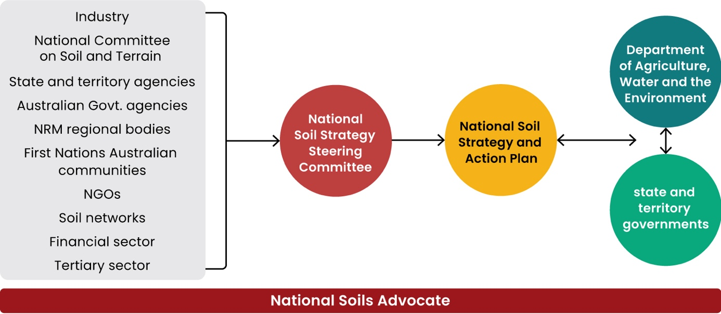

### The Commonwealth Interim Action Plan

Prior to the release of the National Soil Strategy Action Plan in June 2022, the Australian Government will implement soil-related measures which contribute to the objectives of this Strategy under a Commonwealth Interim Action Plan, to be released alongside the Strategy. State and territory governments may also progress with measures under their own interim Action Plans in the lead-up to the release of the National Action Plan in June 2022.

### The National Action Plan

By June 2022, the National Soil Strategy Action Plan (the National Action Plan) will be developed to implement this 20-year Strategy. The National Action Plan will detail specific actions (programs and activities) required to achieve the vision, goals and objectives of the Strategy. These actions will meet the SMART principles – that is, Specific, Measurable, Achievable, Relevant and Time-bound.

The National Action Plan will replace the Commonwealth Interim Action Plan. Actions from the Interim Action Plan will be integrated into and inform the actions in the National Action Plan, alongside any new actions at a state, territory, and national level. The National Action Plan will be developed in conjunction with state and territory governments, along with relevant major stakeholders and partners such as First Nations Peoples, Soil Science Australia, soil-related CRCs, the rural RDCs, the National Soils Advocate, conservation and environment groups, major land management conservancies and various industry groups and sectors (see Figure 6). It will be underpinned by the best available science, Aboriginal and Torres Strait Islander Traditional Knowledge, and experience gained from previous soil programs. It will include specific and measurable targets to underpin the progress measures and ensure the success of the Strategy can be clearly measured, monitored and communicated.

The National Action Plan will set out 3–5 year milestones and actions. It will be subject to 5-yearly reviews to incorporate changing or emerging soil-related priorities. The National Action Plan will focus on tangible projects and programs that will deliver against the progress measures – for example, projects that will:

* increase soil advocacy and extension services
* improve soil monitoring and data sharing to support sustainable soil management
* increase investment in soil research and development
* improve communication and collaboration between researchers, landholders, industry, government, First Nations Peoples, and educators
* give greater support to land managers to change practice to improve soil health
* increase focus on education, training, accreditation and career paths for soil professionals.

The National Action Plan will complement, support and build upon existing schemes and will not duplicate current initiatives.

### Governance and evaluation

The Strategy and National Action Plan are the joint responsibility of the Australian Government and state and territory governments. Development at all stages will be guided by the Australian Government and the governing group overseeing the implementation of the Strategy, which is likely to comprise the National Soils Advocate and representatives from the Australian Government and each state and territory government, in consultation with major stakeholders with an interest in soil (see Figure 6).

At the jurisdictional level, greater attention needs to be given to the establishment of multi-sector governance arrangements to provide advice to governments, industries, universities, researchers, land managers and the broader community about the importance of soil. Governance arrangements will also need to recognise and consider that the implementation of the National Action Plan will occur on land held by the Australian Government, states, First Nations Peoples and private landowners.

The National Soil Strategy and supporting National Action Plan will be reviewed every 5 years and revised to ensure changes to priorities and emerging science are reflected appropriately.

## Glossary

Table 1 Glossary of Terms

| Term | Definition |
| --- | --- |
| **Ecosystem services** | Ecosystem services are services provided by the natural environment to humans including food and water, flood mitigation and nutrient cycling. |
| **Environmental-economic accounting** | Environmental-economic accounting is analysis that helps us to understand the condition of the environment and its relationship with the economy. By bringing together environmental and economic information it is possible to observe and quantify the contribution the natural environment makes to our economy. |
| **NGOs** | non-government organisations |
| **Soil health** | Soil health is the capacity of soil to function as a living system. Soil health can vary across different geological conditions, ecosystems and land uses. Soil health can influence elements such as plant and animal productivity; water and air quality; and plant and animal health. Healthy soils maintains a diverse community of soil organisms that support other important services, such as: help to control plant disease, insect and weed pests; form beneficial symbiotic associations with plant roots; recycle essential plant nutrients; and improve soil structure which can have positive repercussions for water and nutrient holding capacity with flow-on effects to increase crop production (FAO 2008). |
| **Soil organic carbon** | Soil organic carbon is the carbon stored in soil organic matter. Soil organic carbon is a function of major factors including climate, soil type, vegetative growth, topography and tillage, and is crucial to soil health, fertility and ecosystem services, such as food production. |
| **Soil organic matter** | Soil organic matter is all living organisms, such as animals, plants or micro organisms, and the decomposing remains of previous living organisms in the soil matrix. |
| **Translational science** | Translational science is the practical application of the findings of scientific research. |

## References

ABARES 2021, [Catchment Scale Land Use of Australia – Update December 2020](https://aus01.safelinks.protection.outlook.com/?url=https%3A%2F%2Fdoi.org%2F10.25814%2Faqjw-rq15&data=04%7C01%7CAlison.Mount%40environment.gov.au%7Ca38d738a0e28459c789a08d8d4900b87%7C78f05d85d6b34eeba5c3948d2dcdae8a%7C0%7C0%7C637493062421362367%7CUnknown%7CTWFpbGZsb3d8eyJWIjoiMC4wLjAwMDAiLCJQIjoiV2luMzIiLCJBTiI6Ik1haWwiLCJXVCI6Mn0%3D%7C1000&sdata=Kv%2Fg3q4Ajt8V%2Fqa8GcmxRtDbNKoxENpU37LSym%2BxV14%3D&reserved=0), Australian Bureau of Agricultural and Resource Economics and Sciences, Canberra.

ABS 2019, Australian Environmental-Economic Accounts, cat. no. 4655.0, Australian Bureau of Statistics, Commonwealth of Australia, Canberra, August.

AORA 2019, ‘The use of compost and mulch in vineyards: a case study from Torbreck Vintners, Barossa Valley’, Australian Organics Recycling Association, April.

AORA 2020, The economic contribution of the Australian organics recycling industry, prepared by Australian Economic Advocacy Solutions, March.

Australian Government & Queensland Government 2021, [Reef Water Quality Report Card 2019,](https://reportcard.reefplan.qld.gov.au/) Queensland Department of Environment and Science.

Campbell, A 1994, Landcare: communities shaping the land and the future – with case studies by Greg Siepen, Allen and Unwin Pty Ltd, Sydney.

Commonwealth of Australia 2014, The National Soil Research, Development and Extension Strategy, Securing Australia’s Soil, For profitable industries and healthy landscapes, Canberra.

Commonwealth of Australia 2018, Reef 2050 Long-Term Sustainability Plan, July, Canberra.

Commonwealth of Australia 2020, ‘Previous droughts’, Bureau of Meteorology website, April.

Coutts, J, Murray-Prior, R, Long, P & Coutts, B 2017, REVIEW report, practice change, education and extension in Reef Catchments Project, Coutts J&R Consulting, June.

Department of Agriculture, Water and the Environment & Australian Collaborative Rangelands Information System (ACRIS) 2014, Australian Rangeland Boundaries [database], Australian Government Department of Agriculture, Water and the Environment and Australian Collaborative Rangelands Information System (ACRIS) Management Committee.

Department of Agriculture, Water and the Environment & ABARES 2016, [Land use of Australia 2010–11](https://www.agriculture.gov.au/abares/aclump/land-use/land-use-of-australia-2010-11), Australian Bureau of Agricultural and Resource Economics and Sciences.

FAO 2008, ‘An international technical workshop. Investing in sustainable crop intensification: The case for improving soil health’. *Integrated Crop Management*, vol. 6-2008, Food and Agriculture Organisation of the United Nations, Rome.

FAO 2015a, ‘Healthy soils are the basis for healthy food production’, Food and Agricultural Organization of the United Nations, Rome.

FAO 2015b, Revised World Soil Charter, Food and Agriculture Organization of the United Nations, Rome.

FAO 2017, ‘World’s most comprehensive map showing the amount of carbon stocks in the soil launched’, Food and Agricultural Organisation of the United Nations, Rome.

FAO 2020, State of knowledge of soil biodiversity: status, challenges and potentialities, Report 2020, Food and Agricultural Organization, Rome.

Guerschman, JP & Hill, MJ 2017, ‘Calibration and validation of the Australian fractional cover product for MODIS collection 6’, International Journal of Remote Sensing, vol. 9, pp. 696-705.

Jackson, T, Zammit, K & Hatfield-Dodds, S 2018, Snapshot of Australian agriculture, Australian Bureau of Agricultural and Resource Economics and Sciences, Canberra.

Kiri-ganai Research 2012, on behalf of the Commonwealth of Australia, The relationship between land management practices and soil condition and the quality of ecosystem services delivered from agricultural land in Australia, Canberra, September.

Lal, R 2015, [Restoring Soil Restoration to Mitigate Soil Degradation](https://www.mdpi.com/2071-1050/7/5/5875/htm), Sustainability, vol. 7, no. 5.

Matthews, D, & Jenks, S 2013, ‘Ingestion of Mycobacterium vaccae decreases anxiety-related behavior and improves learning in mice’, Behavioural Processes, vol. 96, pp. 27–35, DOI: 10.1016/j.beproc.2013.02.007.

McBratney, A, Field, DJ & Koch, A 2014, ‘The dimensions of soil security’, Geoderma, vol. 213, pp. 203–13.

McBratney, AB, Morgan, CLS & Jarrett, LE 2017, ‘The value of soil’s contributions to ecosystem services’, in D Field, C Morgan & A McBratney (eds), Global soil security, progress in soil science, Springer, Switzerland.

McTainsh, G, Leys, J, O’Loingsigh, T & Strong, C 2011, Wind erosion and land management in Australia during 1940–1949 and 2000–2009, Australian Government Department of Sustainability, Environment, Water, Population and Communities, Canberra, p. 45.

Merrifield, A, Schindeler, S, Jalaludin, B & Smith, W 2013, ‘Health effects of the September 2009 dust storm in Sydney, Australia: did emergency department visits and hospital admissions increase?’, Environmental Health, vol. 12, no. 32, DOI: 10.1186/1476-069X-12-32.

Mullen, J 2007, ‘Productivity growth and the returns from public investment in R&D in Australian broadacre agriculture’, Australian Journal of Agricultural and Resource Economics, vol. 51, no. 4, pp. 359–84.

Ottman, N, Ruokolainen, L, Suomalainen, A, Sinkko, H, Karisola, P, Lehtimaki, J, Lehto, M, Hanski, I, Alenius, H & Fyhrquist, N 2019, ‘Soil exposure modifies the gut microbiota and supports immune tolerance in a mouse model’, Journal of Allergy and Clinical Immunology, vol. 143, no. 3, pp. 1198–206, e12, DOI: 10.1016/j.jaci.2018.06.024.

Roslund, MI, Puhakka, R, Gronroos, M, Nurminen, N, Oikarinen, S, Gazali, AM, Cinek, O, Kramna, L, Siter, N, Vari, HK, Soininen, L, Parajuli, A, Rajaniemi, J, Kinnunen, T, Laitinen, OH, Hyoty, H, Sinkkonen, A & ADELE research group 2020, ‘Biodiversity intervention enhances immune regulation and health-associated commensal microbiota among daycare children’, Science Advances, vol. 6, no. 42, eaba2578, DOI: 10.1126/sciadv.aba2578.

Schulte, RPO, Creamer, RE, Donnellan, T, Farrelly, N, Fealy, R, O’Donoghue, C & O’hUallachain, D 2014, ‘Functional land management: a framework for managing soil-based ecosystem services for the sustainable intensification of agriculture’, Environmental Science & Policy, vol. 38, pp. 45–58.

Soil Science Australia 2019, ‘SOS value and services of Australia’s soils’, 2019 World Soil Day Campaign, Soil Science Australia.

Stefanski, R & Sivakumar, MVK 2009, ‘Impacts of sand and dust storms on agriculture and potential agricultural applications of a SDSWS’, IOP Conf. Series: Earth and Environmental Science, vol. 7, March.

Tozer, P & Leys, J 2013, ‘Dust storms – what do they really cost?’, The Rangeland Journal, vol. 13, pp. 131–42.

Vogel, H-J, Bartke, S, Daedlow, K, Helming, K, Kögel‑Knabner, I, Lang, B, Rabot, E, Russell, D, Stößel, B, Weller, U, Wiesmeier, M & Wollschläger, U 2018, ‘A systemic approach for modelling soil functions’, SOIL, vol. 4, no. 1, pp. 83–92.

Woodward, E, Hill, R, Harkness, P & Archer, R (eds) 2020, Our Knowledge Our Way in caring for Country: Indigenous-led approaches to strengthening and sharing our knowledge for land and sea management. Best Practice Guidelines from Australian experiences. NAILSMA and CSIRO.

Young, IM & Crawford, JW 2004, ‘Interactions and self‑organisation in the soil–microbe complex’, Science, vol. 304, no. 5677, pp. 1634–7.