National statement on First Nations in agriculture, fisheries and forestry

© Commonwealth of Australia 2026
Ownership of intellectual property rights
Unless otherwise noted, copyright (and any other intellectual property rights) in this publication is owned by the Commonwealth of Australia (referred to as the Commonwealth).
Creative Commons licence
All material in this publication is licensed under a Creative Commons Attribution 4.0 International Licence except content supplied by third parties, logos and the Commonwealth Coat of Arms.

Cataloguing data
This publication (and any material sourced from it) should be attributed as: Commonwealth of Australia 2026, National statement on First Nations in agriculture, fisheries and forestry, Department of Agriculture, Fisheries and Forestry, Canberra. CC BY 4.0.
This publication is available at https://www.agriculture.gov.au/about/commitment/first-nations-aust-ag-fish-forestry/national-statement.
Department of Agriculture, Fisheries and Forestry
GPO Box 858 Canberra ACT 2601
Telephone 1800 900 090
Web agriculture.gov.au
Disclaimer
The Australian Government acting through the Department of Agriculture, Fisheries and Forestry has exercised due care and skill in preparing and compiling the information and data in this publication. Notwithstanding, the Department of Agriculture, Fisheries and Forestry, its employees and advisers disclaim all liability, including liability for negligence and for any loss, damage, injury, expense or cost incurred by any person as a result of accessing, using or relying on any of the information or data in this publication to the maximum extent permitted by law.
Acknowledgements
We acknowledge and thank everyone who have shared their time, experience and insights to inform the development of the statement.
Credits
Cover photo: © Sebastian Bourges.

Acknowledgement of Country
We acknowledge the continuous connection of Traditional Custodians to the lands and waters of Australia. We recognise all First Nations peoples and their ongoing care and cultivation of Country. We pay respect to Elders past, present and emerging and recognise their knowledges and contributions to the productivity, innovation and sustainability of Australia’s agriculture, fisheries and forestry industries.
In developing the National statement on First Nations in agriculture, fisheries and forestry, governments engaged with First Nations and agricultural communities across Australia’s lands and waters. We thank those who shared their knowledges, histories and experiences with us.
We are committed to supporting First Nations economic self-determination across agriculture, fisheries and forestry. This includes working in genuine partnership with First Nations peoples and reflecting their perspectives in shared decision-making through ongoing engagement. We recognise the enduring connection to Country and the aspirations of First Nations peoples for sustainable, productive and economically strong land- and water-based futures.

Language
In this statement, we use the terms First Nations, Traditional Custodians, Indigenous and Aboriginal and Torres Strait Islander interchangeably to respectfully refer to the First Peoples of Australia.

Definitions
The following definitions clarify key terms used throughout the statement.
Term | Definition
accountability | Being responsible and transparent about relevant actions, decisions and outcomes for First Nations peoples.
agribusiness | Businesses in each of the agriculture, fisheries and forestry industries. This includes the entire supply chain such as production, processing, value-adding, manufacturing, branding and related support services.
Country | First Nations understanding of land and waters as a living, interconnected system that includes place, custom, language, spiritual belief, cultural practice, kin and identity.
culturally informed | Guided by an understanding of First Nations cultures, values, histories and lived experiences. Characterised by respect for cultural authority, appreciation of appropriate community methods and inclusion of Indigenous knowledges and perspectives.
culturally safe | An environment where First Nations peoples are respected, empowered and supported to express their identities and values without discrimination. It goes beyond passive tolerance to promote equity and inclusivity.
economic self-determination | The ongoing process enabling First Nations peoples secure their economic rights and pursue their economic opportunities. This occurs through genuine decision-making power, meaningful participation and freedom from discrimination.
food and fibre | Products that provide food and bio-based raw materials, including textiles and timber, for domestic and global supply chains.
Free, Prior and Informed Consent | Ensuring First Nations peoples are given clear, timely and complete information so they can make decisions freely about activities that may affect their rights, interests or knowledges. It requires that consent be sought without pressure and before any action proceeds. This includes the right of First Nations peoples to exercise cultural authority and decide how their Indigenous Cultural and Intellectual Property or cultural knowledges are used (UN 2024).
Indigenous Cultural and Intellectual Property (ICIP) | Refers to the rights and interests First Nations peoples hold in their cultural heritage, products, expressions, knowledges and practices, in both tangible and intangible forms. This includes ecological, agricultural and traditional foods knowledge systems, as well as food and land management practices. ICIP may be shared or used in research, policy or commercial contexts. Any use or reproduction should occur only with the permission of the relevant First Nations custodians. This includes material that may be commercialised, whether or not it is protected under Australian Intellectual Property laws.
Indigenous Data Sovereignty | The right of First Nations peoples to govern the collection, ownership and application of data relating to their communities, lands and resources. This includes Indigenous Cultural and Intellectual Property.
Indigenous estate | Areas of land and water over which First Nations peoples and communities hold legal rights or interests. This includes ownership, management and other recognised rights under Australian, state and territory law. ABARES (2024) provides a map of the Indigenous land and forest estate.
Indigenous Knowledges | Wisdom, beliefs and practices developed, sustained and passed down generations within a community. These often form part of cultural and spiritual identity.
place-based | Partnerships or initiatives designed, led or agreed to by the communities and organisations in that specific region.
shared decision-making | Working with First Nations peoples to make decisions together, guided by their knowledges, priorities and cultural authority from the start.

Agriculture ministers foreword
This statement is a shared commitment by its signatories to increase the meaningful involvement of First Nations peoples in the agriculture, fisheries and forestry sector. A competitive and forward-looking sector must constantly evolve. This includes supporting both new entrants and existing First Nations agribusinesses. Strengthening First Nations participation enhances Australia’s food security, productivity and competitiveness. It contributes to new market opportunities and improves environmental and social outcomes.
First Nations peoples are actively involved in Australian agriculture, fisheries and forestry. Drawing on generations of expertise and stewardship, they contribute across the full value chain. This includes resource management, food and fibre production, food security, supply chain diversification, innovation, biosecurity surveillance and trade.
As longstanding custodians of Country, First Nations peoples play a vital and wide-reaching role in land management across Australia. This reflects enduring cultural connection and stewardship of Country, supported by ongoing contributions to sustainable land and water management across diverse environments.
The statement aligns with broader national priorities. These include the First Nations Economic Partnership Agreement, the National Agreement on Closing the Gap and the development of Feeding Australia: A National Food Security Strategy.
Throughout engagement on the statement, First Nations peoples shared their aspirations for economic reconciliation. They emphasised approaches that are place-based, self-determined and shaped by their cultural, economic, social and environmental priorities. They also called for a sector that respects First Nations leadership and enables equitable participation. These aspirations are consistent with broader efforts to build a more resilient and productive sector.
We acknowledge and thank the First Nations peoples and industry stakeholders who shared their time, experience and insights throughout the consultation process. Their perspectives have shaped the priorities reflected in this statement. By strengthening systems, engagements and pathways, governments can help create economic opportunities and build lasting partnerships that benefit both First Nations communities and primary industries into the future.

Signatories
Hon Julie Collins MP
Minister for Agriculture, Fisheries and Forestry
Hon Tara Moriarty MLC
Minister for Agriculture, Minister for Regional New South Wales and Minister for Western New South Wales
Hon Michaela Settle MP
Minister for Agriculture and Regional Development
Hon Jackie Jarvis MLC
Minister for Agriculture and Food, Minister for Fisheries, Minister for Forestry, Minister for Small Business and Minister for the Mid West
Hon Clare Scriven MLC
Minister for Primary Industries and Regional Development and Minister for Forest Industries
Hon Gavin Pearce MP
Minister for Primary Industries and Water and Minister for Veterans’ Affairs
Hon Gerard Maley MLA
Minister for Agriculture and Fisheries, Minister for Mining and Energy, Minister for Corrections, Minister for Renewables and Minister for Recreational Fishing
Ms Suzanne Orr MLA
Minister for Climate Change, Environment, Energy and Water, Minister for Aboriginal and Torres Strait Islander Affairs, Minister for Disability, Carers and Community Services and Minister for Seniors and Veterans
Contents
Acknowledgement of Country iii
Language iii
Definitions iv
Agriculture ministers foreword v
Signatories vi
Introduction 1
Vision… 1
Purpose 1
Background 1
Scene setting 3
Historical context 3
Current participation 3
Our commitment 5
Priority areas 6
Leadership and workforce 6
Finance and business support 7
Knowledge-sharing and safeguards 7
Indigenous Estate 8
Trade and market access 9
Government coordination 10
Reporting and accountability 11
Closing the Gap outcomes 11
Reporting to agriculture ministers 11
References 12

Tables
Table 1 Statement priority areas and related Closing the Gap outcomes 19

Figures
Figure 1 Development of the national statement 9
Figure 2 National statement priority areas and outcomes 12

Introduction
Australia’s agriculture, fisheries and forestry industries are shaped by diverse places, peoples and histories. First Nations peoples have long contributed knowledge, skills and leadership to the sector including through their enduring role in the stewardship and management of land and waters. This statement recognises the existing and growing contribution of First Nations peoples to the sector and affirms the shared responsibility of governments to support First Nations self-determined participation through more coordinated and effective action.

Vision
Our vision is a productive, competitive and sustainable agriculture, fisheries and forestry sector that embeds First Nations peoples as decision-makers, land and water managers, business owners, workers and innovators. This creates a sector where Indigenous Knowledges, rights and cultural authority are respected and where First Nations peoples can pursue self-determined aspirations, shared economic prosperity and the long-term stewardship of Country.

Purpose
This statement sets a nationally agreed policy direction to advance First Nations economic self‑determination across agriculture, fisheries and forestry. It provides sector-specific guidance to support more coherent action by governments, industry and First Nations peoples.
It aligns with international, whole-of-government and industry agendas to deliver stronger outcomes for First Nations peoples (Figure 1). This includes the First Nations Economic Partnership, the priority reforms and outcomes of the National Agreement on Closing the Gap (see Table 1) and reflects the principles of the United Nations Declaration on the Rights of Indigenous Peoples (UNDRIP).
By strengthening meaningful First Nations participation, the statement supports sustainable livelihoods, food security and culturally aligned employment and business opportunities, while contributing to environmental stewardship, food resilience and a stronger more inclusive economy.

Background
At the October 2023 Australian Agriculture Ministers’ Meeting (AMM), ministers agreed to task senior officials to work in consultation with First Nations peoples to identify opportunities to increase meaningful involvement in the sector. In March 2024, ministers endorsed the development of a national statement driven by the principles of self-determination and an ambitious commitment to advance First Nations perspectives, experiences and interests to support greater Indigenous economic inclusion in the agriculture, fisheries and forestry sector.
A broad consultation process with over 500 stakeholders informed the development of the statement. Engagement began with understanding First Nations agribusiness experiences, before extending consultation to relevant industry stakeholders and governments to build a holistic view of the sector (Figure 1). A discussion paper released in November 2025 outlined key themes raised during engagement and invited feedback on practical ways to address barriers and strengthen opportunities for greater First Nations participation. This statement reflects ideas shared by First Nations peoples, industry and agribusinesses through this consultation process.
Figure 1 Development of the national statement
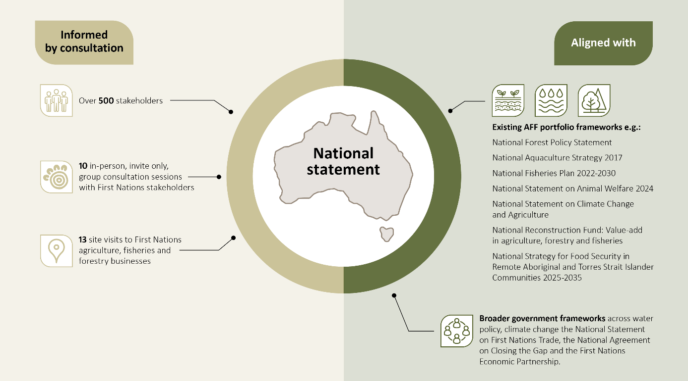

Scene setting

Historical context
For more than 65,000 years, Aboriginal and Torres Strait Islander peoples have cared for and managed the lands and waters of Australia. First Nations agriculture, fisheries and forestry are grounded in deep connection with Country. Practices include using fire to shape and manage the land, tending and planting species used for food, fibre, medicine and cultural purposes, improving soils, building fish traps, guiding animal movement and sustainably harvesting plants and animals to protect future supply and build landscape resilience. These are sophisticated and adaptive systems of land and water management that have supported people and Country for millennia.
First Nations peoples also sustained complex trade networks and economic relationships that spanned the continent and connected with neighbouring regions. These systems enabled the exchange of goods, knowledges, cultural practices, reflect strong governance, innovation and economic organisation long before colonisation.
Colonisation disrupted these systems through frontier conflict, forced and unpaid labour, rations-based payment systems, the separation of families and dispossession of communities from Country, culture and kin. These impacts continue to affect access to land and water, traditional land management practices and ability to care for Country. These in turn impact the transfer of cultural practices and current economic opportunities. First Nations communities still face barriers accessing and using the Indigenous Estate for food and fibre production as well as navigating financial and government systems. These systems were designed without consideration of First Nations governance, decision-making or production approaches.
Despite these challenges, First Nations peoples have continued to contribute valuable knowledge, skills and labour to the modern agriculture, fisheries and forestry sector across Australia. Their innovation and stewardship have helped inform land and water management practices and continues to strengthen sustainable production, local economies and cultural connection across the sector today.

Current participation
First Nations peoples have an active and established presence across Australian agriculture, fisheries and forestry. Participation spans primary production, biosecurity and the sector’s value and supply chains. Activities include pastoral operations, aquaculture, horticulture, cropping, viticulture, silviculture, forestry, carbon and biodiversity farming, wild harvest, bushfood processing and manufacturing and ranger-led land and water management. These activities are shaped by local priorities, governance arrangements and opportunities across Country.
First Nations participation varies in scale, structure and enterprise type. Just as First Nations communities are diverse, so too are the agricultural systems in which they operate. First Nations agribusinesses range from family‑owned and community-based enterprises to large‑scale commercial operations. They reflect a wide range of land and water tenure arrangements and draw on Indigenous Knowledges, collective decision-making and long‑term stewardship to support productive, sustainable and place‑based businesses.
Holistic approaches to caring for Country underpin First Nations agriculture, fisheries and forestry practices. Economic activity is undertaken alongside cultural, social and environmental responsibilities. These relationships are place-based and reflect spiritual and custodial responsibilities that cannot shift to areas considered more economically viable. Stewardship practices protect and support land and water health, strengthen long-term productivity and resilience and support participation in food and fibre production alongside nature repair and environmental market activities.
Many First Nations agribusiness operate through self-determined, place-based models that enable an ongoing connection to Country. This supports community wellbeing and sustainable production. It also generates economic value for First Nations peoples and the broader Australian economy. Engagement in agriculture, fisheries and forestry provides pathways for First Nations peoples to exercise economic self-determination through enterprise development, innovation, employment and leadership.
First Nations participation in the sector contributes to food security, particularly in regional and remote communities. Local production strengthens access to culturally appropriate, nutritious food, reduces reliance on external supply chains and supports Indigenous-led food systems. These activities create opportunities for intergenerational knowledge transfer and Indigenous-led economic development. While the agricultural sector is often a major economic driver in regional and remote communities, food security and economic benefits for First Nations communities in these regions remain limited.
There is currently limited data available to adequately capture the breadth and diversity of First Nations participation across the sector. Available estimates indicate that in 2023–24, First Nations agriculture contributed more than $1.4 billion to the Australian economy and is projected to exceed $2 billion by 2030 (NFF 2025). Despite this, First Nations peoples remain under-represented in leadership roles, the workforce and business ownership across the sector (Gilbert et al. 2025).
The Indigenous Estate covers around 70% of Australia’s landmass, and approximately one quarter of Australia’s landmass is under Indigenous management or co-management (ABARES 2024). This underpins a significant and ongoing contribution to land and water management across Australia. At the same time, variation in land capability, access, tenure and infrastructure means not all areas are currently positioned to support viable agricultural activity.
While there are existing opportunities for First Nations agribusinesses, barriers continue to limit First Nations participation. These barriers include access to fit-for-purpose financing, business and technical support; constraints on using the Indigenous Estate for agricultural production; cultural and structural barriers across the sector; gaps in culturally informed training and workforce pathways; and limited access to data, research partnerships and Indigenous Cultural and Intellectual Property protections.
Addressing these barriers will strengthen an already active and contributing First Nations presence in the sector. Empowering First Nations peoples to lead negotiations, build commercial capability and partner with industry and government supports a more inclusive, resilient and sustainable sector. This also supports shared economic, cultural and environmental outcomes for current and future generations.

Our commitment
Signatories to the statement recognise the longstanding contribution of First Nations peoples to the broader economy. We are committed to working in partnership to support First Nations self-determined economic participation in the sector.
The statement supports governments to work more cohesively and to recognise where policies, initiatives and partnership approaches can better support First Nations participation in the sector. It outlines 6 priority areas that focus national effort to support long-term participation and economic development for First Nations peoples across the sector. Each priority area sets out enabling opportunities to guide future work across governments, industry and First Nations stakeholders.
In addressing these priority areas and corresponding opportunities, signatories will work with First Nations peoples and industry to support First Nations-led participation, strengthen partnerships, respect cultural knowledge and heritage. At the same time this work will maintain the legal certainty, scientific integrity and commercial viability of Australia’s agriculture, fisheries and forestry sector.
The priority areas chart a pathway toward achieving the statement’s short, medium and long-term goals (Figure 2). Continued collective effort will support a sector that embeds First Nations peoples as decision-makers, business owners, workers and innovators. This creates a sector with shared economic prosperity for current and future generations.
Figure 2 National statement priority areas and outcomes
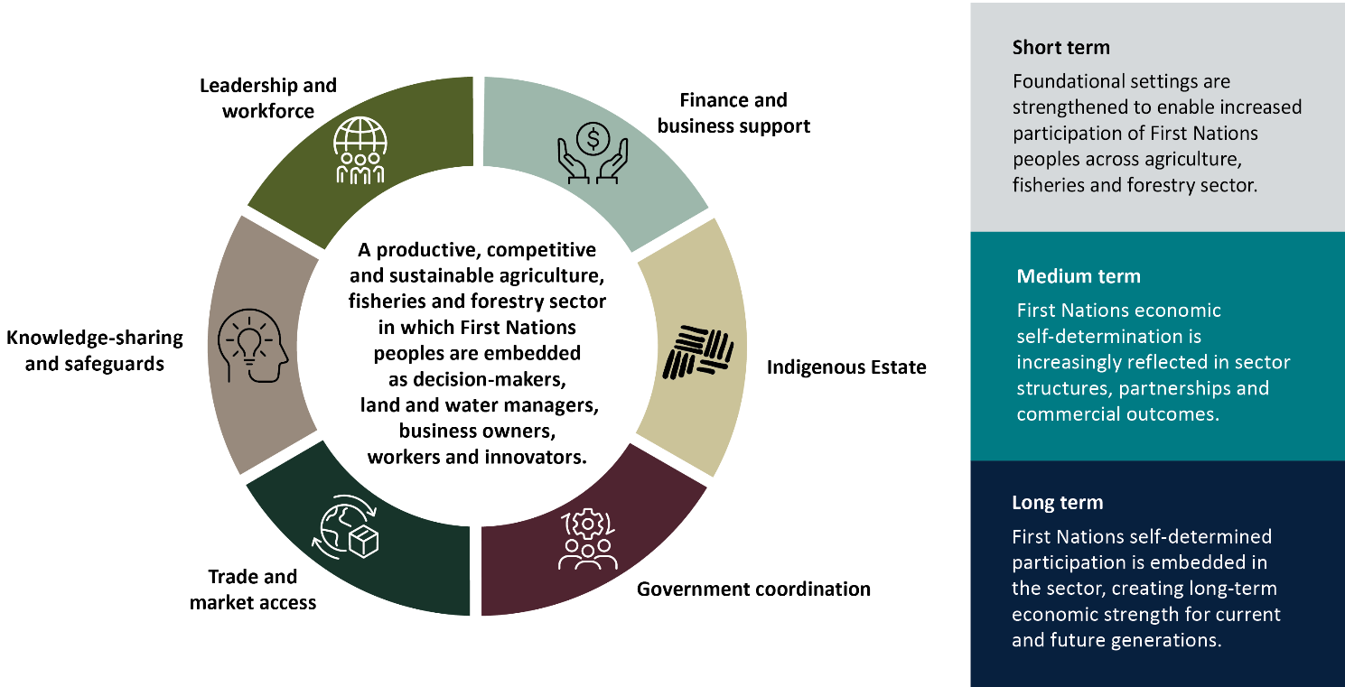

Priority areas
The priority areas reflect the key barriers and opportunities for First Nations economic participation identified through the development of this statement. They guide future decision-making, partnerships, investment and policy and program design.
The priority areas complement existing government strategies, regulatory settings and investments across the agricultural sector, including those relating to water management, climate resilience, productivity and trade. Improved alignment between these efforts can strengthen outcomes for First Nations peoples and support a more coherent national approach.

Leadership and workforce
Intent
Recognise and strengthen the contribution of First Nations peoples by supporting skills development, employment pathways, leadership capability and participation in decision-making.
First Nations peoples bring cultural authority, knowledge systems, stewardship and leadership that are integral to the productivity, sustainability and resilience of Australia’s agriculture, fisheries and forestry industries. However, First Nations representation in the workforce, leadership roles and decision-making structures is low and does not fully reflect these strengths. Many communities emphasise the importance of living and working on Country to strengthen cultural connection and enable locally driven economic development. Supporting place-based participation through culturally informed skills development, education, training and leadership pathways is central to strengthening the sector and its workforce. Working in partnership with First Nations representative institutions, community-controlled organisations and Traditional Owner groups will strengthen governance, build long-term capability and support sustainable growth across the sector.

Enabling opportunities
- Work with First Nations peoples to identify where support is needed to build capability through skills, mentoring and development pathways that support participation in sector leadership, governance and decision-making across the sector.
- Support and foster work health and safety practices that enable a culturally safe and inclusive sector. This includes promoting leading practice approaches that improve sector settings and environments for recruitment, retention and progression of First Nations peoples.
- Enable place-based skills development, education and employment pathways that recognise cultural leadership and community-led approaches, alongside formal education and training.
- Promote early engagement and genuine partnerships between governments, industry and First Nations peoples to shape workforce and leadership pathways.

Finance and business support
Intent
Improve access to finance and business support that addresses economic, cultural and structural barriers affecting First Nations participation.
First Nations agribusinesses make strong contributions to the sector. However, they face ongoing barriers to accessing finance, business support and technical skills needed to start, grow or sustain their operations. A range of public and private finance pathways already exist but these do not always work effectively or transparently for First Nations agribusinesses. Communal land tenure arrangements and limited access to collateral add to these challenges. Making existing pathways work better for new and growing First Nations agribusinesses, alongside developing fit-for-purpose options where required, will support greater economic participation, increased productivity and long-term sector growth.

Enabling opportunities
- Support improved business readiness through culturally informed advisory services, business mentoring, governance skills and technical experience across production and enterprise development.
- Work with and encourage mainstream, philanthropic and First Nations lenders to better leverage existing Agri-finance pathways and where needed, provide tailored Agri-finance products that reflect First Nations governance arrangements, risk profiles and community priorities.
- Support culturally grounded partnerships, joint-ventures and cooperative models between First Nations agribusinesses and industry to unlock investment, build capability and create shared commercial benefits.
- Support ongoing reform of government frameworks and institutions to improve access to capital for First Nations agribusinesses, consistent with the First Nations Economic Partnership Agreement.

Knowledge-sharing and safeguards
Intent
Encourage two-way knowledge-sharing and ensure that research development and extension (RD&E) practices respect Indigenous Data Sovereignty and protect Indigenous Cultural and Intellectual Property.
Two-way knowledge sharing strengthens outcomes across the sector by improving collaboration between First Nations peoples, government, industry and researchers. This includes supporting more First Nations led research, alongside codesigned and science-based research approaches, to improve sustainability, productivity and long-term sector resilience.
Ethical and culturally informed research and data principles, supported by strong protections, enable all stakeholders to confidently share and manage their data and practices. Applying Indigenous Data Sovereignty (IDS) and Free, Prior and Informed Consent (FPIC) supports respectful research practices and fair benefit‑sharing arrangements. Supporting culturally grounded agricultural RD&E and protecting Indigenous Cultural and Intellectual Property (ICIP) helps ensure that Indigenous Knowledges, practices and products are used and commercialised responsibly.

Enabling opportunities
- Support First Nations-led RD&E and promote leading practice in ethical research standards drawing on models such as the AIATSIS Code of Ethics for Aboriginal and Torres Strait Islander Research.
- Promote benefit-sharing arrangements and the return of knowledge to First Nations communities as standard practice for research and commercialisation involving Indigenous Knowledges, practices and data, consistent with relevant legal frameworks and Australia’s commitments under the Convention on Biological Diversity and the Nagoya Protocol on Access and Benefit-sharing.
- Strengthen accountability of industry service providers to ensure the culturally informed, ethical and respectful use of Indigenous Knowledges and materials. This includes ensuring First Nations branding and artwork is used ethically.
- Support consistent, best practices for protecting, using and commercialising ICIP. This includes guiding the respectful and transparent use of First Nations data across industry and government institutions and strengthening education for First Nations businesses on the opportunities and protections ICIP provides. Drawing on existing domestic and international models and frameworks such as
  - CSIRO’s Indigenous Cultural and Intellectual Property Principles
  - National Indigenous Australians Agency’s Framework for Governance of Indigenous Data
  - World Intellectual Property Organization’s Treaty on Intellectual Property, Genetic Resources and Associated Traditional Knowledge.

Indigenous Estate
Intent
Support First Nations peoples to exercise their rights and leverage opportunities to enable agriculture, fisheries and forestry activities on the Indigenous Estate.
Development on the Indigenous Estate often involves navigating complex and overlapping tenure arrangements across states and territories, with differing levels of access to land and water. These settings can create uncertainty and delay or discourage First Nations stakeholders and non-Indigenous partners from pursuing agribusiness opportunities. This highlights the need for clearer information, coordination and support across engagement and tenure processes.
Much of the Indigenous Estate is in regional and remote areas (ABARES 2024). In these locations, inadequate infrastructure and limited access to reliable data can further constrain commercially viable opportunities. Taken together, these factors suggests that sectoral growth is best advanced through coordinated policy settings. This includes place-based development approaches, strong regional planning, targeted infrastructure investment and the early integration of cultural and environmental values in projects. Reducing barriers and providing clearer pathways will support opportunities where communities seek them.

Enabling opportunities
- Support improved access to clear, practical information and regulatory settings, including reliable data, to assist First Nations peoples, industry and other stakeholders to navigate land and water tenure arrangements and engagement processes on the Indigenous Estate.
- Strengthen First Nations commercial governance and agreement-making capability to support equitable economic partnerships with industry and governments.
- Align planning and investment with proven place-based approaches that reflect cultural, environmental, social and economic priorities. This includes improving infrastructure, technology and other services needed to support agriculture, fisheries and forestry activities on the Indigenous Estate.
- Explore self-determined ways to use land and water that support First Nations priorities. This may include planning support, partnerships, new businesses and land and water management work such as biosecurity services.

Trade and market access
Intent
Grow domestic opportunities and unlock international markets for First Nations producers and agribusinesses.
Demand for First Nations food and fibre products is growing, with strong market interest in Indigenous produced goods and native foods and fibres. However, First Nations producers and suppliers continue to face challenges in accessing both domestic and international markets. Complex and costly trade systems, limited access to tailored export support and the lack of formal First Nations product credentials continue to further constrain producers. Strengthening domestic pathways will help First Nations agribusinesses to meet growing demand and will support their participation in global markets, where buyers are increasingly seeking products with clear and trusted origins. Supporting First Nations representation and leadership in international trade events – while upholding cultural integrity, ICIP protections and community aspirations – will strengthen First Nations economic inclusion and contribute to broader national trade objectives.

Enabling opportunities
- Support and stimulate demand for First Nations products and strengthen pathways for First Nations agribusinesses to start, grow and scale.
- Expand First Nations participation and leadership in international markets by supporting trade readiness. This includes providing clearer pathways into export markets and increasing inclusion in trade delegations and market access activities. This aligns with the National Statement on First Nations Trade and Investment led by the Department of Foreign Affairs and Trade.
- Build global understanding and appreciation of First Nations products, their cultural and economic value. This may occur through targeted engagement in relevant international forums and trade-related platforms.
- Promote leading practice in agreement-making and benefit-sharing across trade and export systems, drawing on relevant frameworks and guidance such as
  - the Indigenous Agricultural Product Framework which supports authenticity, provenance and trusted supply chains
  - the First Nations chapter in the Australia-UAE Comprehensive Economic Partnership Agreement which embeds benefit sharing into trade arrangements.

Government coordination
Intent
Ensure consistent whole-of-government decision-making to reduce duplication and provide clearer accountability for outcomes.
Effective coordination and transparent decision‑making are essential to improving outcomes for First Nations peoples. First Nations participation is influenced by policy as well as regulatory and tenure systems that vary across states and territories. This creates complexity for First Nations peoples and industry partners. Clearer alignment and communication between governments, departments and programs can help reduce this complexity and support pathways for participation. Engagement should move towards ongoing, culturally informed consultation and data collection that values shared perspectives and supports collaborative decision‑making. Exploring opportunities to better connect, streamline and align systems will help ensure government efforts strengthen First Nations participation across the sector.

Enabling opportunities
- Strengthen alignment across government policies, strategies and regulatory settings. Government frameworks should consider and reflect First Nations economic priorities such as those identified through the First Nations Economic Partnership Agreement.
- Improve whole-of-government coordination to deliver transparent, accessible and consistent support. This aligns with national frameworks such as the National Agreement on Closing the Gap and its focus on ongoing partnerships and collaborative decision-making.
- Improve communication and information pathways so that First Nations agribusinesses can more easily identify and access funding opportunities.
- Explore opportunities for cross-governmental coordination to reduce complexity and provide clearer regulatory and policy settings for First Nations agribusinesses. This is especially important where commercial industries operate across multiple states and territories.
- Strengthen sector insights by improving the availability, consistency and use of data on First Nations participation. This includes establishing baseline data to better understand the scale, distribution and impact of First Nations participation. This data will help better inform government decision-making, reporting and policy development.

Reporting and accountability
Signatories to the statement are the accountable parties. Signatories will report on progress against the priority areas of the statement and outcomes that advance First Nations’ participation across the sector.

Closing the Gap outcomes
The priority areas of this statement align with both the Closing the Gap priority reforms and their corresponding socio-economic outcomes. Table 1 outlines where these intersections occur.
Commitments that arise through the application of this statement can be reported through the existing Closing the Gap annual report and implementation reporting across governments.
Table 1 Statement priority areas and related Closing the Gap outcomes
National statement priority area | Relevant Closing the Gap outcomes
Leadership and Workforce | Outcome 8
Finance and business support | Outcomes 8 and 17
Knowledge-sharing and safeguards | Outcomes 8 and 17
Indigenous Estate | Outcome 15
Trade and market access | Outcome 8 and 17
Government coordination | Outcome 17
- Outcome 8 – Strong economic participation and development of Aboriginal and Torres Strait Islander people and communities.
- Outcome 15 – Aboriginal and Torres Strait Islander people maintain a distinctive cultural, spiritual, physical and economic relationship with their land and waters.
- Outcome 17 – Aboriginal and Torres Strait Islander people have access to information and services enabling participation in informed decision-making regarding their own lives.

Reporting to agriculture ministers
Signatories will annually report to the Agriculture Ministers’ Meeting for at least 5 years on progress against the statement’s priority areas and how actions are contributing to the statement’s long-term vision (Figure 2).
Regular reporting will provide a consistent, shared evidence base to support transparency and accountability, improve visibility of progress across governments and identify emerging opportunities and challenges. These reports will support ongoing refinement of priorities, policy settings and approaches over time to strengthen coordination and enable sustained, effective implementation as the sector evolves. Annual reporting may cover existing and/or new policies or funding that support First Nations peoples in the sector and how it may align with the national statement and its priority areas.

References
ABARES 2024, Australia’s Indigenous land and forest estate, Australian Bureau of Agricultural and Resource Economics and Sciences, Canberra, accessed 1 April 2026.
AMM 2024, Meeting Communiqué, Agriculture Ministers’ Meeting, Canberra, accessed 5 August 2025.
Gilbert, J, Pratley, J, Prenzler, P, McCormick, J 2025, ‘Defining ‘Indigenous agriculture’ in Australia’, Australian Aboriginal Studies, vol. 1, pp.97-107, DOI: 10.3316/informit.T2025052200007302134309169, accessed 13 April 2026.
NFF 2025, Indigenous Agricultural Product Framework Project, National Farmers’ Federation, Canberra, accessed 13 January 2026.
UN 2024, Consultation and free, prior and informed consent (FPIC), United Nations Human Rights Office of the High Commissioner, accessed 12 April 2026.

