**National Waste Data Viewer – User Guide**



© Commonwealth of Australia 2021

**Ownership of intellectual property rights**

Unless otherwise noted, copyright (and any other intellectual property rights) in this publication is owned by the Commonwealth of Australia (referred to as the Commonwealth).

**Creative Commons licence**

All material in this publication is licensed under a [Creative Commons Attribution 4.0 International Licence](https://creativecommons.org/licenses/by/4.0/legalcode) except content supplied by third parties, logos and the Commonwealth Coat of Arms.

Inquiries about the licence and any use of this document should be emailed to [copyright@awe.gov.au](mailto:copyright@awe.gov.au).



**Disclaimer**

The Australian Government acting through the Department of Agriculture, Water and the Environment has exercised due care and skill in preparing and compiling the information and data in this publication. Notwithstanding, the Department of Agriculture, Water and the Environment, its employees and advisers disclaim all liability, including liability for negligence and for any loss, damage, injury, expense or cost incurred by any person as a result of accessing, using or relying on any of the information or data in this publication to the maximum extent permitted by law.

Contents

Overview page i

Snapshot page ii

Material category page iii

Source stream page iv

Facilities page v

About the data page vi

## Overview page

The National waste data viewer visualises the data in the National Waste Database 2020. This is the overview page that shows yearly trend information across material category and streams. See the tooltips below on how to explore and interact with the data visualisations.

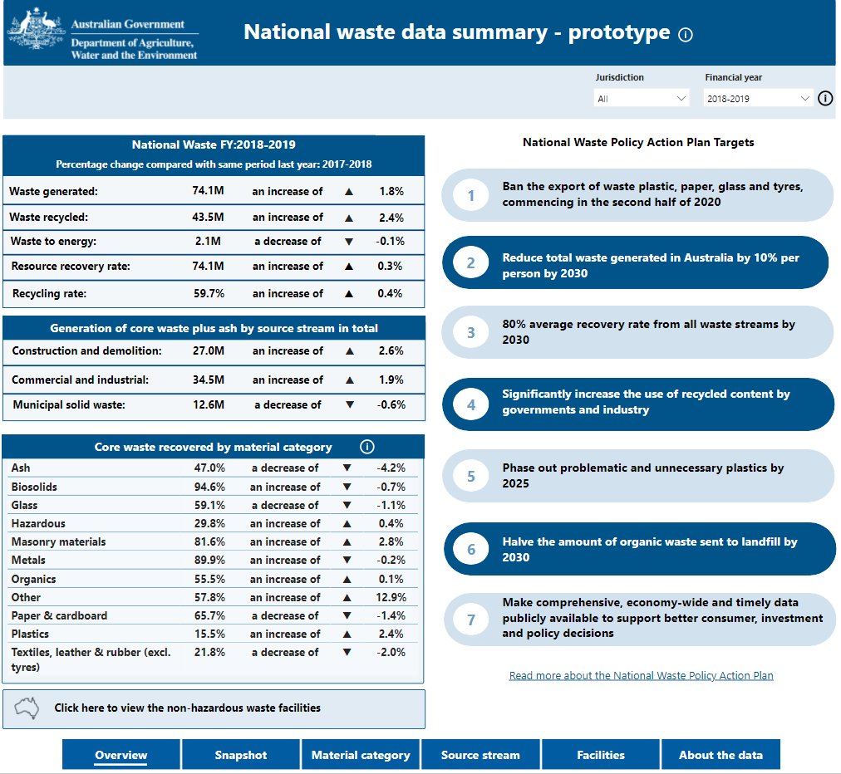

**C**

**A**

**C**

The default view as set by the filter is FY2018-19 and all states / territories. You can select an individual state or another financial year by clicking on the down arrow and checking the required box.

**Filters**

At the bottom of viewer are six navigational buttons. Each button will take you to a different page of the viewer.

**B**

**A**

This section displays headline waste and resource recovery figures by financial year, and the percentage change compared to the previous year.

**Overview**

**Navigation**

**B**

## Snapshot page

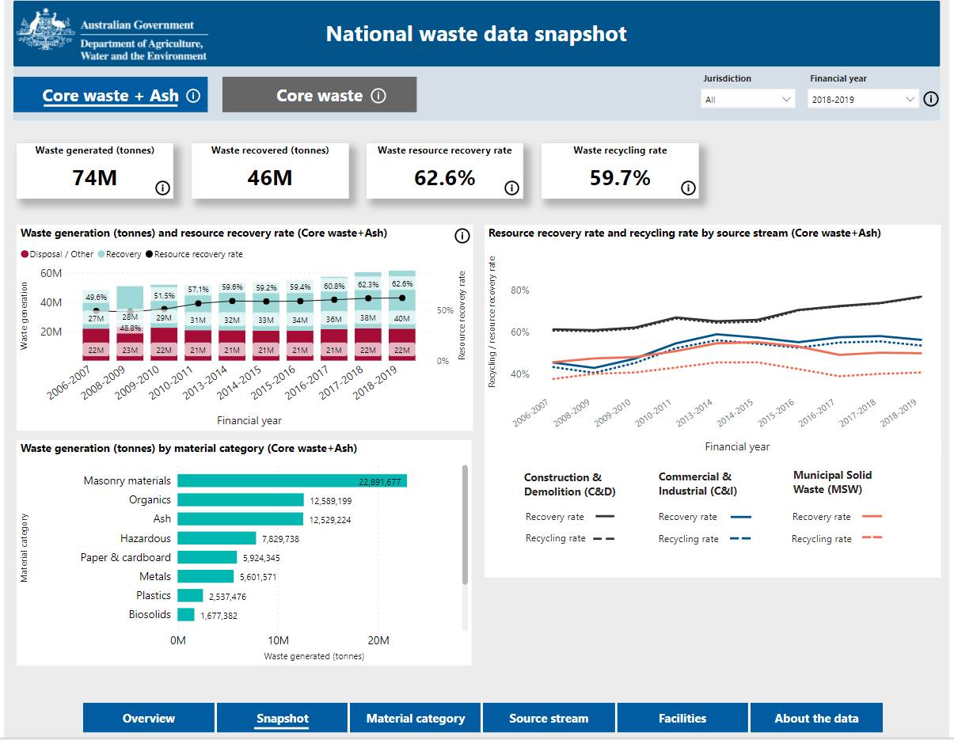

The Snapshot page shows yearly trend information for waste generation and resource recovery across material category and streams.

**C**

**A**

**D 1**

**B**

**D 3**

**D 2**

**C**

The default view as set by the filter is FY2018-19 and all states / territories. You can select an individual state or another financial year by clicking on the down arrow and checking the required box.

**Filters**

**A**

You can filter by core waste plus ash or core waste, and you’ll see the data on the page changes.

In short, core waste plus ash shows total waste and resource recovery figures and are used for measuring how Australia is progressing against national waste targets. Core waste shows figures relating to the waste sector only.

**Core waste plus ash or core waste**

**D**

**Charts**

The first chart shows the amount of waste generated over time, overlaid with the resource recovery rate trend line. Waste generated each year is further broken down to the amount sent to disposal, and recovery fates.

The second chart shows the amount of waste generated by material category for the year selected in the top right-hand corner of the screen.

The third chart presents the resource recovery rate and recycling rate for each waste stream over time.

**Headline figures**

**B**

Headline figures are displayed in the four cards across the top of the page. We have Waste generated, waste recovered, recovery rate and recycling rate. These will match the reporting year selected in the Financial year drop down filter.

## Material category page

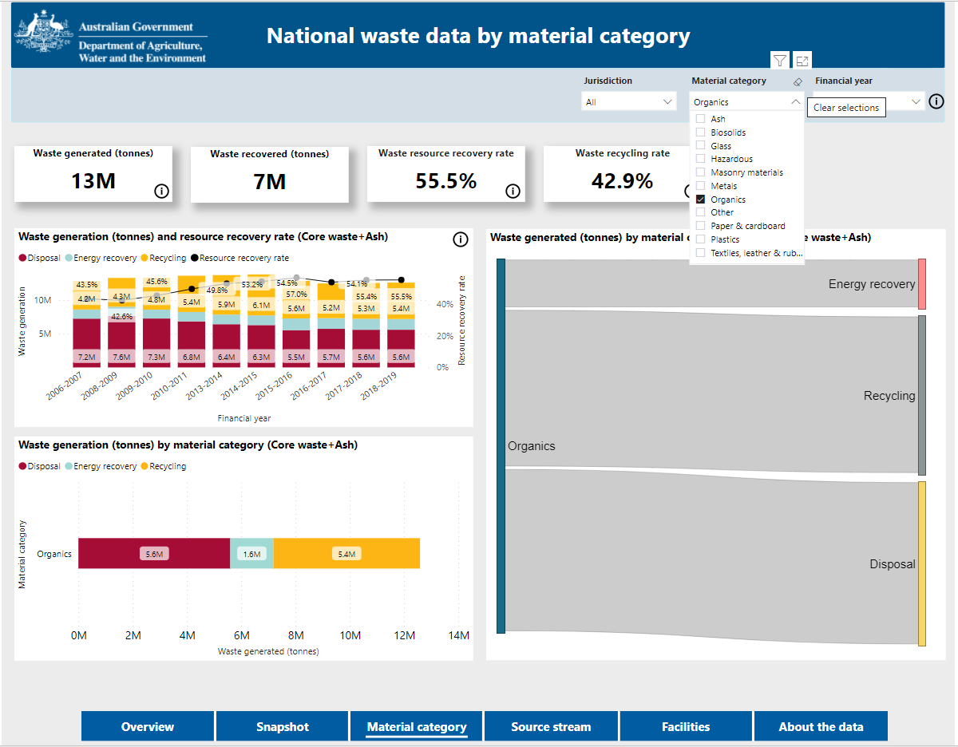

Just like the overview page, this page also includes filters. They are jurisdiction, waste material category and financial year.

**C**

**D**

To clear the filters and changes made to your view of the data, select the eraser button near the filters

**C**

**Clear filters**

**A**

Let’s have a look at filtering a chart by individual material category. If you click on organics. The chart and headline figures in the four cards at the top change to this selection.

**Filtering**

**D**

**B**

By hovering over the Sankey diagram visual on the right, you can see the waste fate figures by disposal, recycling and energy recovery..

**A**

**Information**

Hover over the information symbol in red to view additional information in relation to the definition of organic waste.

**B**

**Hovering**

## Source stream page

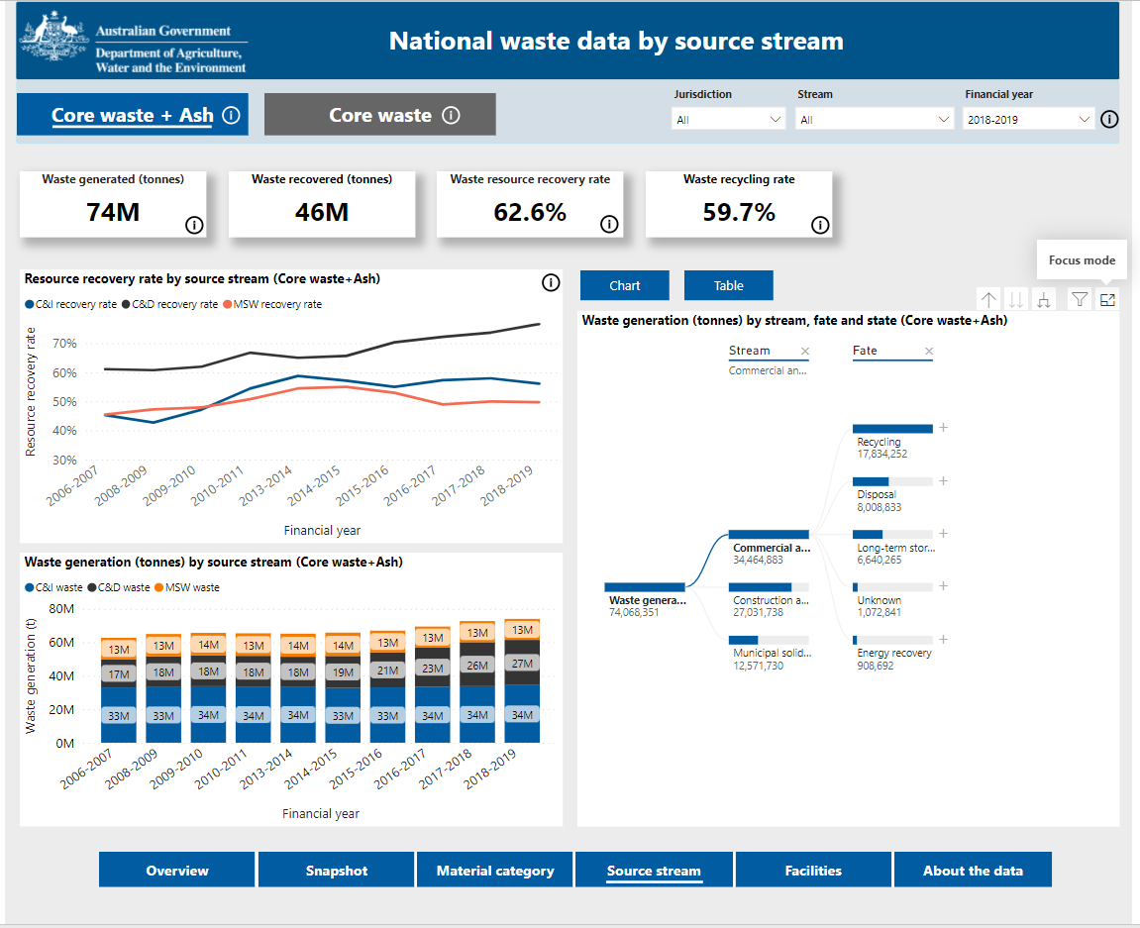

The decomposition tree enables you to conduct your own analysis over total waste generation. The analysis fields available are by stream, by fate and by jurisdiction. You can make your selection in any order by clicking on the plus button next to the black data bar. Click on the cross to remove your existing selection or view another analysis pathway.

**C**

**Pathway analysis**

The stream page shows more detailed analysis by waste stream.

**B**

**D**

**C**

**D**

**B**

**Filters**

**A**

**Table view**

**E**

**View full screen**

**E**

**A**

The default view is set to core waste plus ash. To change this view to view core waste only, click on the core waste button. After you select the core waste view, the headline figures and data visualisations will no longer include ash as a material category within each stream.

**Core waste plus ash or core waste**

Click on the Tabular button To view a table with waste generation by stream and fate. To return to the decomposition tree, click on the Visual button.

The stream page can be filtered three ways:

• by jurisdiction,

• by source stream, and

• by financial year.

To view a chart in full screen mode, click on the focus button.

## Facilities page

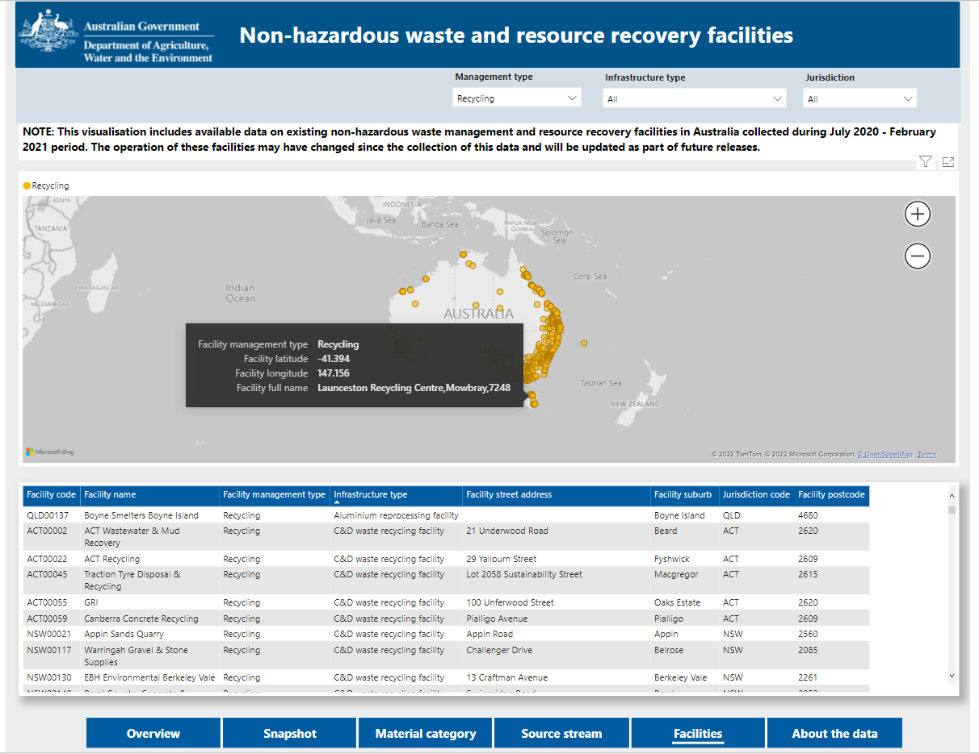

Hovering your mouse over a facility on the map will display the facility type, geographical coordinates and the facility name. Clicking on the facility will display the full details of the facility in the list below.

**C**

**Hover**

The Facilities page shows non-hazardous waste management and resource recovery facilities in Australia in an interactive map.

**B**

**D**

**C**

**D**

**B**

**List of facilities**

**A**

**Zoom**

**E**

**View full screen**

**E**

**A**

There are also three filter options above the map which allow users to narrow down the facilities displayed on the map by management type, infrastructure type and jurisdiction.

**Filters**

You can zoom in or out on the map by clicking the plus and minus button on the map itself. .

You can find a facility on the map by clicking and dragging your mouse or scrolling down the list of facilities below the map.

To view a chart in full screen mode, click on the focus button.

## About the data page

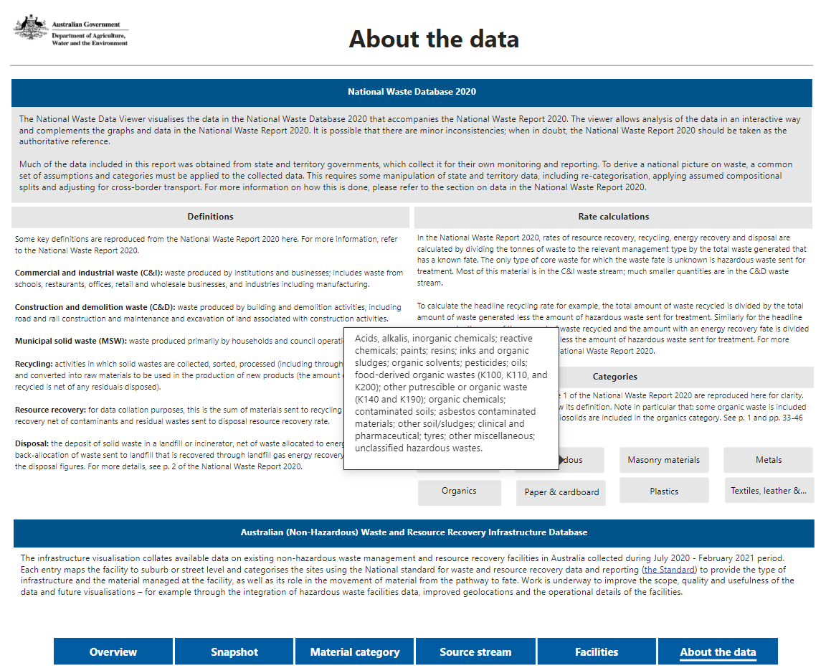

The ‘about the data’ page includes more information about data in the viewer.

**A**

Hover over each of the category buttons to view what specific material has been included in each material category.

**Buttons**

**A**