NATIONAL  
WASTE  
POLICY

Less Waste, more resources

2018

This policy was prepared by the Australian Government,   
state and territory governments and the   
Australian Local Government Association.

Introduction 3

Why does Australia need a national waste policy? 5

About the policy 7

We all have a role to play 10

Waste as a resource – the circular economy 12

Applying circular economy principles for waste, recycling and resource recovery 15

Glossary 19

# Introduction

We can better support our economy, protect the health of our communities and reduce environmental impacts if we harness the value of materials we dispose of and return them to productive use.

For every Australian, 2.7 tonnes of waste is generated every year. The materials lost to landfill, such as plastics, paper, glass, metals, textiles, masonry, food and other organic materials, are resources that are going to waste.

Governments and businesses have a long history of working together to improve waste management practices. Communities are also increasingly making informed choices about the production, purchase and disposal of goods they consume.

Since 2006, the amount of waste generated per person in Australia has declined by 10 per cent. The recovery rate (including recycling and energy recovery from waste) has increased from 50 per cent in 2006–07 to 58 per cent in 2016–17. Despite this, waste generation overall continues to rise, driven by growing populations.

New products and new technologies are changing the way we create and manage materials. Changing international markets are affecting the final destinations for recycled materials. Together, this means that improving Australia’s domestic resource recovery capacity and sustainable consumption is critical. A hypothetical five per cent improvement in efficient use of materials across the Australian economy could benefit Australia’s GDP by as much as $24 billion.**[1]**

The 2018 National Waste Policy embodies a circular economy, shifting away from ‘take, make, use and dispose’ to a more circular approach where we maintain the value of resources for as long as possible.

Australia is moving towards a circular economy, with businesses and governments recognising the opportunities waste materials provide and the economic value they retain. This move is also happening across the globe, including in the European Union, Canada, and Australia’s major trading partners, including China.

By working together to improve waste management, we can create opportunities for jobs, protect the environment and better manage valuable and finite resources.

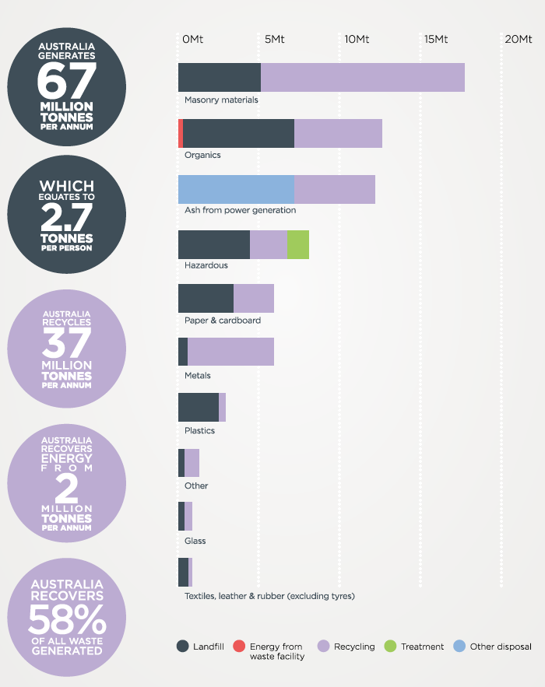

# Why does Australia need a national waste policy?

Australia’s attitudes about waste and resource management have shifted. The value of resources and embodied energy in waste are now recognised. There is an economic opportunity and growing desire to see our resources recaptured and recirculated within our economy.

Waste management, recycling and material recovery activities are a significant part of Australia’s economy. We need to reduce the amount of waste we generate and accelerate the recovery rate of our resources.

In 2014–15, waste management services in Australia were valued at $12.6 billion, and sale of recovered materials was valued at $2.9 billion. Waste-related activities added a total value of $6.9 billion to the economy, accounting for 0.43 per cent of GDP.

Around 50,000 people are directly employed in waste related activities, including employees in the waste and material recovery industries, the business sector and local governments.**[2]**

For every 10,000 tonnes of waste that is recycled, 9.2 jobs are created (compared with 2.8 jobs if the same amount of waste was sent to landfill).**[3]**

Better management of waste can have financial benefit for everyday Australians. For example, Australian households spend between $2200 and $3800 per year on food that becomes waste.**[4]**

Moving to a more circular economy has the potential to create new jobs and benefit the economy overall.[5]

Better waste management also helps reduce health and environmental problems and prevent pollution of our land and oceans. It will help address increasing volumes of plastics in the marine environment, now estimated globally to be upward of 150 million tonnes.**[6]**

Improving collection and processing systems, particularly for organic waste, will reduce greenhouse gas emissions by cutting emissions from landfills. Waste is responsible for approximately two per cent of Australia’s emissions consisting largely of methane gas from decay of organic material in landfill.**[7]**

Challenges and opportunities in waste management, waste material export, recycling, and plastic pollution in our oceans has led to increased public awareness and interest in waste issues. Australian communities expect the products separated for recycling are processed and remanufactured into new products.

Differences in policy and regulation of waste management and resource recovery across Australia are hindering effective action. Many businesses operate in national markets and must meet different requirements in every state, territory and local council area.

Where there are challenges that would benefit from coordinated action, national and common approaches will improve the efficiency of Australia’s waste and resource recovery processes, as well as grow markets for goods and infrastructure that avoid waste or contain recycled materials.

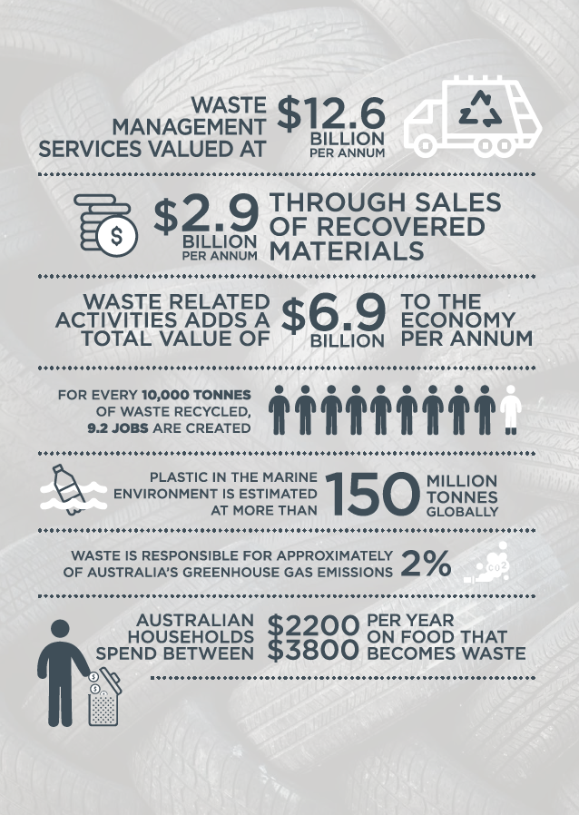

# About the policy

The 2018 National Waste Policy provides a framework for collective action by businesses, governments, communities and individuals until 2030.

Waste occurs at all stages of materials management and product development, from extraction, transformation and use, to reprocessing and disposal. Waste is also linked to the capabilities of technologies, processes and infrastructure as well as procurement and lifestyle choices.

This policy:

* Responds to the challenges facing waste management and resource recovery in Australia – excluding radioactive waste
* Reflects the global shift towards a circular economy – this includes the need for better resource-efficient systems, products and services to avoid waste, conserve resources and maximise the value of all materials used. It also acknowledges the need to improve our capacity to better design, reuse, repair and recycle the goods we use
* Provides a framework for businesses to embrace innovation and develop technologies that create new opportunities.

It sets a national framework for action by governments, the business sector, the waste and resource recovery industries, and communities to achieve sustainable waste management. Greater participation and collaboration between these groups will ensure policy implementation is effective, efficient and timely.

Giving effect to Australia’s international obligations is critical. In particular, this policy supports Australia’s engagement in the United Nations’ Sustainable Development Goal 12 on responsible consumption and production.

The directions and strategies presented in the 2009 National Waste Policy: Less waste, more resources have been important in improving waste management, introducing stewardship of goods and resources, and establishing national reporting of national waste and resource recovery data to inform policy and decisions.

The 2018 National Waste Policy builds on the 2009 policy, focusing on waste avoidance, improved material recovery and use of recovered materials. It presents a common vision on priorities for responding to changing international waste markets. It will help Australia move closer to a more circular economy that eliminates waste and improve economic, social and environmental outcomes. It will help to increase the capacity of resource recycling systems and restore confidence in Australian resource management.

This policy guides continuing collaboration between all Australian governments, businesses and industries. It does not remove the need for governments, businesses and industries to implement tailored solutions in response to local and regional circumstances.

## Australian waste flows

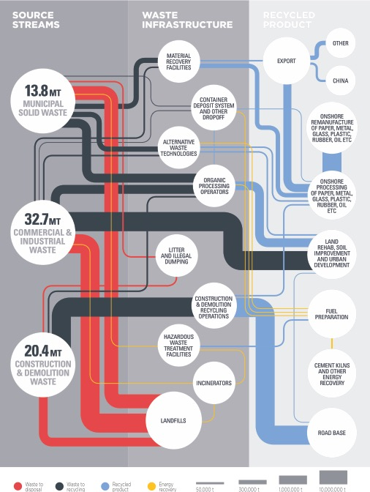

## United Nations Sustainable Development Goals

On 25 September 2015, countries around the world, including Australia, adopted a set of goals to end poverty, protect the planet and ensure prosperity for all as part of a new sustainable development agenda. Each goal has specific targets to be achieved over the next 15 years. Sustainable Development Goal 12 is specifically focused on responsible consumption and production patterns.

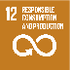 ‘***Achieving Goal 12 requires a strong national framework*** for sustainable consumption and production that is integrated into national and sectoral plans, sustainable business practices and consumer behaviour, together with adherence to international norms on the management of hazardous chemicals and wastes.’

Targets associated with Sustainable Development Goal 12 include:

* Implement the 10-year framework of programmes on sustainable consumption and production, all countries taking action, with developed countries taking the lead, taking into account the development and capabilities of developing countries
* Promote public procurement practices that are sustainable, in accordance with national policies and priorities
* Encourage companies, especially large and transnational companies, to adopt sustainable practices and to integrate sustainability information into their reporting cycle
* By 2020, achieve the environmentally-sound management of chemicals and all wastes throughout their life cycle, in accordance with agreed international frameworks, and significantly reduce their release to air, water and soil in order to minimize their adverse impacts on human health and the environment
* By 2030, achieve the sustainable management and efficient use of natural resources
* By 2030, halve per capita global food waste at the retail and consumer levels and reduce food losses along production and supply chains, including post-harvest losses
* By 2030, substantially reduce waste generation through prevention, reduction, recycling and reuse
* By 2030, ensure that people everywhere have the relevant information and awareness for sustainable development and lifestyles in harmony with nature.

Other Sustainable Development Goals relevant to improved resource recovery and waste management are:

SDG 3: Good Health and Well Being  
SDG 6: Clean Water and Sanitation  
SDG 8: Decent Work and Economic Growth  
SDG 9: Industry, Innovation and Infrastructure  
SDG 11: Sustainable Cities and Communities  
SDG 13: Climate Action  
SDG 14: Life below Water  
SDG 17: Partnerships for the Goals

More information on the Sustainable Development Goals is available at: [un.org/sustainabledevelopment/sustainable-development-goals/](http://un.org/sustainabledevelopment/sustainable-development-goals/)

# We all have a role to play

All Australians have a role to play in implementing a circular economy, supporting resource recovery and recycling, and reducing the generation of waste.

The choices we make in what we buy, how we use products and how we dispose of them is central to improving the way we manage waste in Australia. Following the waste hierarchy we can all choose to:

* Avoid purchasing products with excessive or unnecessary packaging
* Repair or reuse items rather than throwing them away
* Purchase products we can use multiple times and that are long-lived, rather than single-use or poor quality items that are thrown away quickly
* Improve our recycling habits by sorting our waste appropriately into recycling and compost bins
* Use products that are recyclable and include recycled content.

The role of businesses and industries, including manufacturers and brand owners, is critical in improving the design of products to both avoid waste and for reuse, repair and appropriate packaging. Some businesses lead the development of manufacturing systems that use recycled materials, avoid waste and improve financial sustainability of resource recovery systems. Other businesses develop and operate infrastructure to manage, reprocess, recycle and produce material for use in new products. Businesses and industries also play an important role in investing in new processes, products, business systems and technologies that can lead to significant changes in the generation, management and disposal of waste.

Figure of the waste hierarchy.

## The role of governments

Waste management and resource recovery regulation in Australia is directed by the Australian Constitution, international agreements, Commonwealth laws, agreements between all Australian governments, and laws and policies implemented by state and territory governments and local councils.

The Australian Government’s role in waste is focused on ensuring our international obligations are met, supporting global environmental outcomes through cooperation and international engagement, and providing effective national leadership and coordination. The Australian Government promotes innovation, develops standards for products and materials, addresses national market failures and provides national data and reporting.

Australia also has a system of laws that give effect to international commitments. These include agreements that govern import and export of hazardous waste, product stewardship, synthetic greenhouse gases, and environment protection and biodiversity conservation.

The regulation and management of waste and resource recovery in Australia is primarily the responsibility of state and territory governments. All state and territory governments have their own laws and policies to protect the environment, conserve natural resources, and regulate and manage waste.

The roles and responsibilities of local governments depend on the requirements of the state or territory in which they are located.

Local governments play an important role in providing household waste collection and recycling services, managing and operating landfill sites, delivering education and awareness programs, and providing and maintaining litter infrastructure. Local governments may also form regional bodies to address waste management issues of regional significance and they can manage compliance and enforcement for littering and illegal waste disposal.

All governments have a role to play as responsible consumers. Sustainable procurement practices, and increasing purchasing of goods and infrastructure containing recycled materials, supports our transition towards a circular economy. It also helps to grow the recycling and reprocessing industry. Governments also provide funding that supports infrastructure development, waste and resource recovery management processes, and innovation.

By working together, all governments have an opportunity to adopt a common approach to waste management, reduce barriers to market development and align policy, funding and regulatory effort towards improvements in resource recovery.

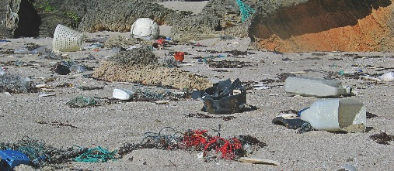

# Waste as a resource – the circular economy

The 2018 National Waste Policy reflects new ways of thinking about waste and the use of resources.

It incorporates the waste hierarchy, and a focus on high order uses, while building on the idea of continually reusing, recycling and reprocessing materials.

By applying the principles of a circular economy, we can support better and repeated use of our resources.

A circular economy retains the value of materials in the economy for as long as possible, reducing the unsustainable depletion of natural resources and impacts on the environment.

A circular economy has economic benefits, creating new industries, markets and products, and leading to new revenue streams and creation of jobs.**[8]**

There is a global movement towards applying circular economy principles. For example, in 2015 the European Commission committed to a Circular Economy Action Plan. Better management of waste, including application of the waste hierarchy, is a key part of the transition to a circular economy.

Applying the circular economy principles to waste management in Australia requires changes to product design, production, use and reuse, recycling and disposal. It is a whole-of-system approach that requires accounting of the full cost and life-cycle of materials. It is also an approach that will help to minimise reliance on virgin materials and maximise the economic value of resources.

Some materials, such as particular hazardous waste products, may still need to be disposed of. Most other manufactured goods and materials are resources that can be reused, recycled and reprocessed over and over.

The following five principles underpin waste management, recycling and resource recovery in a circular economy.

1. Avoid waste:

* Prioritise waste avoidance, encourage efficient use, reuse and repair
* Design products so waste is minimised, they are made to last and we can more easily recover materials.

1. Improve resource recovery:

* Improve material collection systems and processes for recycling
* Improve the quality of recycled material we produce.

1. Increase use of recycled material and build demand and markets for recycled products.
2. Better manage material flows to benefit human health, the environment and the economy.
3. Improve information to support innovation, guide investment and enable informed consumer decisions.

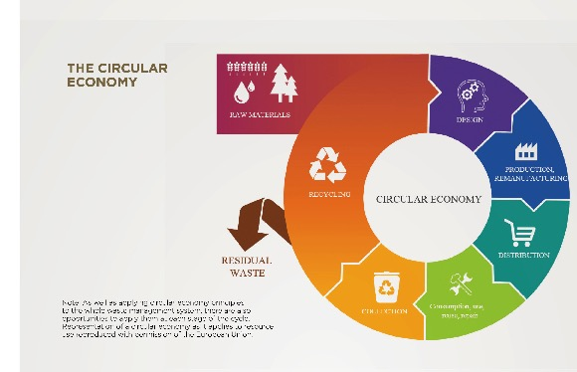

## European Commission Circular Economy Action Plan

The European Commission Circular Economy Action Plan is one example of how circular economy approaches are being implemented around the world.

The European Commission has adopted a Circular Economy Package which includes a suite of measures to transition to a circular economy. One of these measures is the Circular Economy Action Plan, which promotes efficient resource use throughout the economy.

The European Commission has estimated that shifting to a circular economy will save €30 billion over 20 years through more efficient waste management, and increase GDP by seven per cent. By 2035, up to 170,000 jobs will be created in the waste management sector and around three million jobs in the wider economy.

The Circular Economy Package includes clear targets for reduction of waste. These targets establish an ambitious and credible long-term path for waste management and recycling. They include:

* A common target for recycling 65 per cent of municipal waste by 2030
* A common target for recycling 75 per cent of packaging waste by 2030
* A binding landfill target to reduce landfill to a maximum of 10 per cent of municipal waste by 2030
* Separate collections of hazardous household waste by 2022, biowaste by 2023 and textiles by 2025
* A ban on landfilling of separately collected waste
* Promoting economic instruments to discourage landfilling
* Simplified and improved definitions and harmonised calculation methods for recycling rates
* Concrete measures to promote reuse and stimulate industrial symbiosis - turning one industry's by-product into another industry's raw material
* Economic incentives for producers to put greener products on the market and support recovery and recycling schemes (such as packaging, batteries, electric and electronic equipment and vehicles).

More information is available at: [ec.europa.eu/environment/circular-economy/index_en.htm](http://ec.europa.eu/environment/circular-economy/index_en.htm)

# Applying circular economy principles for waste, recycling and resource recovery

## Principle 1: Avoid waste

***Prioritise waste avoidance, encourage efficient use, reuse and repair.***

***Design products so waste is minimised, they are made to last and we can more easily recover materials.***

Measures of the total amount of waste created include the waste we recycle, as well as the waste we send to landfill.

In 2016-17, Australians generated 67 million tonnes of waste. Of that, we recycled 37 million tonnes.

The amount of waste we generate has been growing. This is driven partly by population growth and partly by changes in our economy and society, such as increased consumption and increased packaging. Other factors such as natural disasters can also dramatically increase waste.

The simplest way to manage waste is to create less in the first place. The waste hierarchy calls for prioritising waste avoidance and minimisation, including through product and packaging design, and reusing or repairing products and items.

Avoiding waste and reducing the amount of waste generated will reduce pollution, reduce greenhouse gas emissions, reduce the pressure on our recycling infrastructure and protect our oceans. It will also curb unsustainable use of virgin resources.

Governments, businesses and communities all have a role to play in waste avoidance. Changing consumer behaviour is also critical. By repairing or reusing items rather than throwing them away, and buying products containing recycled content that can be used multiple times and have a long useful life, we can avoid creating waste.

### Strategy 1 Waste avoidance

Deliver coordinated actions that help the community and businesses avoid and minimise waste, including through better design, reuse, repair, and sharing of products and services.

### Strategy 2 Design

Design systems and products to avoid waste, conserve resources and maximise the value of all materials used at every stage of a product’s life.

### Strategy 3 Knowledge sharing, education and behaviour change

Implement coordinated knowledge sharing and education initiatives, focused on the waste hierarchy and the circular economy, that address the needs of governments, businesses and individuals, and encourages the redesign, reuse, repair, resource recovery, recycling and reprocessing of products.

## Principle 2: Improve resource recovery

***Improve material collection systems and processes for recycling.***

***Improve the quality of recycled material we produce.***

To improve recycling and resource recovery, we need to improve access to waste management processes; ensure that the right infrastructure, facilities and rules are in place; and ensure they are financially sustainable. This includes developing common approaches in regulations and standards.

We can increase the overall recycling rate and return of resources to the economy by increasing the capacity of the recycling and resource recovery sector, reducing contamination of materials that go into resource recovery processes, introducing sustainable packaging and developing markets for recycled goods.

### Strategy 4 Product stewardship

Develop and implement partnerships across government and business to ensure ownership and responsibility for action to minimise the negative impacts from products, ensure the minimisation of waste and maximise reuse, repair and recycling of products and materials throughout their life cycle.

### Strategy 5 A common approach

Implement a common approach towards waste policy and regulation, particularly in relation to national opportunities to support development of markets for recycling.

### Strategy 6 Improving access

Identify and improve regional, remote and Indigenous communities’ ability to access, influence and participate in a circular economy.

### Strategy 7 Increasing industry capacity

Identify and address opportunities across municipal solid waste, commercial and industrial waste, and construction and demolition waste streams for improved collection, recycling and energy recovery, to deliver ongoing improvements in diversion from landfill, improved quality of recycled content and use of the waste hierarchy.

## Principle 3: Increase use of recycled material and build demand and markets for recycled products.

Growth in demand for recovered and recycled materials will drive improved resource recovery in Australia. Support for post consumption recovery of products and materials is also required. This includes paper and cardboard, plastic, metal, glass and organics from kerbside collection systems, as well as materials collected from businesses and construction and demolition sites.

Businesses are critical in driving innovation, developing new markets and designing products that maximise recycling opportunities. Individual consumers can also generate bigger markets for recycled goods by choosing products that contain recycled materials.

Governments have an important role to play in supporting markets for recycled goods domestically and internationally. They also develop standards, policies and procurement guidelines that focus on products that include recycled materials.

### Strategy 8 Sustainable procurement by governments

All Australian governments consider environmental issues in their approach to goods and infrastructure procurement and promote demand for recycled materials and products containing recycled content.

### Strategy 9 Sustainable procurement by business and individuals

Businesses and individuals in Australia take environmental issues into account when purchasing or manufacturing goods and services, and promote domestic demand for recycled materials and products containing recycled content.

## Principle 4: Better manage material flows to benefit human health, the environment and the economy.

Waste is often thought of as a problem to be managed, rather than a resource with value.

Applying circular economy principles encourages different ways of thinking about waste, the aim being to keep materials cycling in productive use rather than being lost to landfill or escaping to the environment and oceans through irresponsible disposal.

Some hazardous materials require safe disposal or destruction to protect human health and the environment.

Better management of the flows of materials within our economy can benefit human health, the environment and deliver opportunities for wealth creation.

### Strategy 10 Plastics and packaging

Reduce the impacts of plastic and packaging on the environment and oceans, reduce plastic pollution, and maximise benefit to the economy and society.

### Strategy 11 Sound management of chemicals and hazardous waste

Manage and regulate chemicals and wastes throughout their lifecycle to minimise environmental and human health impacts and meet Australia’s national and international obligations.

### Strategy 12 Reduce organic waste

Reduce organic waste, including garden and food waste, by avoiding their generation and supporting diversion away from landfill into soils and other uses, supported by appropriate infrastructure.

## Principle 5: Improve information to support innovation, guide investment and enable informed consumer decisions.

Good decisions are based on good information. To ensure that efforts to improve Australia’s waste management achieve the best outcomes, we need to improve information on where Australia’s waste comes from and where it goes.

High quality information on flows of resources and material, and markets for recycled materials and products is also critical to business investment, and developing targeted strategies to influence consumer behaviour.

By increasing the detail and regularity of reporting, more contemporary and accurate information will be available to inform government, business and industry decisions.

### Strategy 13 Data and reporting

Continue to support consumers and manufacturers to make more informed decisions by improving national data and reporting on material flows, wastes and recycling, including economic aspects and reporting indices.

### Strategy 14 Market development and research

All Australian governments and businesses generate and report information to support creating and maintaining markets for recycled materials, both domestically and internationally.

# Glossary

| **TERM** | **DESCRIPTION** |
| --- | --- |
| Business sector | This sector includes manufacturers, wholesalers, importers and retailers, both in Australia and overseas, that generate waste in Australia as part of their business processes. |
| Circular economy | At the broadest level, a circular economy aims to change the patterns of natural resource use in the economy in order to achieve sustainable growth by slowing, narrowing or closing material loops. |
| Commercial and industrial waste | Waste produced by institutions and businesses, including offices, schools, restaurants, retail and wholesale businesses, and industries such as manufacturing. |
| Construction and demolition waste | Waste produced by demolition and building activities, including road and rail construction and maintenance, and land excavation associated with construction activities. |
| Food waste | Food that does not reach the consumer, or reaches the consumer but is thrown away. More information is available at: [environment.gov.au/protection/waste-resource-recovery/publications/national-food-waste-strategy](http://environment.gov.au/protection/waste-resource-recovery/publications/national-food-waste-strategy) |
| Hazardous waste | Wastes requiring higher levels of control to avoid impacts on human health and the environment. They may contain hazardous substances or have hazardous characteristics. |
| Material flows | The way materials pass through production, distribution and use processes in an economy. |
| Municipal solid waste | Waste produced by households and council operations, including hard waste collections, street sweepings, and waste dropped off at waste and resource recovery facilities by members of the public. |
| Organic waste | Wastes derived from material that was once living, excluding petroleum-based materials. |
| Product | An article or substance that is manufactured or refined for sale. |
| Product stewardship | The process of taking responsibility for the life cycle impacts, flows and fates, of products or materials. This may involve business, governments and consumers sharing responsibility. |
| Recycling | Converting materials that would have otherwise been disposed of into new materials. |
| Repair | Altering a product or material to correct damage or fault, maintaining its use. |
| Reprocessing | Processes for converting recovered materials into new products. |
| Resource recovery | Making use of a waste material, including recycling of waste matter and recovering energy or other resources from waste. |
| Reuse | Reallocation of a product or material without reprocessing or remanufacture. This may be applied to products or materials before or after they become waste, including via sale of goods from a tip shop. |
| Repair | Altering a product or material to correct damage or fault, maintaining its use. This may be applied to products or materials before or after they have become waste. |
| Waste | Material that has finished initial use and entered a waste stream. This includes the waste we recycle as well as the waste we send to landfill. |
| Waste and resource recovery industry | This is inclusive of business and organisations involved in collecting, sorting, processing, trading, transporting and disposing of waste. |
| Waste avoidance | Preventing waste generation, including through design of products and changing consumer behaviour to preference durable, reusable and reparable products. |
| Waste generation | The process of producing waste. For data and reporting purposes, waste generation is the sum of the quantities of waste taken to waste management facilities or added to on-site stockpiles. Measures of the total amount of waste generated include the waste we recycle as well as the waste we send to landfill. |
| Waste hierarchy | An order of preference for the management of waste, with avoidance being the most preferred option and disposal being the least. |

© Copyright Commonwealth of Australia, 2018

Creative Commons Logo

The 2018 National Waste Policy: less waste more resources is licensed by the Commonwealth of Australia for use under a Creative Commons Attribution 4.0 International licence with the exception of the Coat of Arms of the Commonwealth of Australia, the logo of the agency responsible for publishing the policy, content supplied by third parties, and any images depicting people.

For licence conditions see Creative Commons website - Attribution 4.0 International page

This policy should be attributed as 2018 National Waste Policy: less waste more resources, Commonwealth of Australia 2018.

The Commonwealth of Australia has made all reasonable efforts to identify content supplied by third parties using the following format ‘© [name of third party] ’.

1. Centre for International Economics, Final report: Headline economic value for waste and materials efficiency in Australia, 27 October 2017.
2. Centre for International Economics, Final report: Headline economic value for waste and materials efficiency in Australia, October 2017.
3. Access Economics, Employment in waste management and recycling, commissioned by the Department of Environment, Water, Heritage and the Arts, July 2009.
4. National Food Waste Strategy: Halving Australia’s food waste by 2030, Commonwealth of Australia 2017.
5. Lifecycles et al, Creating value: the potential benefits of a circular economy in South Australia, commissioned by Green Industries SA, 2017.
6. Ocean Conservancy, Stemming the Tide: land based strategies for a plastic-free ocean, September 2015.
7. Quarterly Update of Australia’s National Greenhouse Gas Inventory: December 2017, Commonwealth of Australia 2018.
8. Centre for International Economics, Final report: Headline economic value for waste and materials efficiency in Australia, 27 October 2017.