

NATIVE AND INVASIVE FISH DISPERSAL, SPAWNING AND TROPHIC DYNAMICS DURING A MANAGED RIVER- FLOODPLAIN CONNECTION

Commonwealth Environmental Water Office Long Term Intervention Monitoring Project Murrumbidgee Selected Area

Murrumbidgee Selected Area Monitoring and Evaluation Plan FINAL REPORT

NATIVE AND INVASIVE FISH DISPERSAL, SPAWNING AND TROPHIC DYNAMICS DURING A MANAGED RIVER-FLOODPLAIN CONNECTION

R. Keller Kopf (CSU), Skye Wassens (CSU), Luke McPhan (CSU), James Dyer (NSW DPIE), James Maguire (NSW DPIE), Jennifer Spencer (NSW DPIE), Carmen Amos (NSW DPIE), Stacey Kopf (CSU), Nick Whiterod (Aquasave)

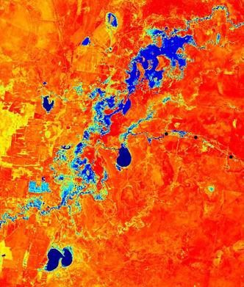

Cover image
Sentinel satellite image of the Murrumbidgee River and floodplain in December 2018 showing the extent of environmental flow inundation near Tala and Yanga Lakes.

Reference
Kopf R.K., Wassens S., McPhan L., Dyer J., Maguire J., Spencer J., Amos C., Kopf S., Whiterod N. (2019). Native and invasive fish dispersal, spawning and trophic dynamics during a managed river- floodplain connection. Commonwealth Environmental Water Office. Murrumbidgee Selected Area Final report, pp 1-49.

Date completed
31 October 2019

“WHENEVER a flood occurs in the Murrumbidgee River…channels, variously called creeks, lagoons, billabongs, and ana-branches, traverse the low-lying river flats in all directions…

When the flood recedes, much of the water left in the creeks soaks away, leaving chains of water holes of varying depth…

All these waterholes teem with fish life, but the number of fishes, shrimps, yabbies and insect life they contain can hardly be realised, except by those who have seen a fine-mesh net drawn through such waters and observed for themselves the incredible number of
living creatures they contain.”

H.K. Anderson (1920)
Rescue operations on the Murrumbidgee River

Executive Summary

The Commonwealth Environmental Water Office, in conjunction with the NSW Department of Planning, Industry and Environment (DPIE; formerly NSW Office of Environment and Heritage), estimate that 109.8 GL (40.5 GL CEWO and 69.3 GL of NSW DPIE) of environmental water was delivered through Yanga National Park onto the Murrumbidgee floodplain. This event started in September 2018 and ended on 1/2/2019 at the 1AS regulator and 25/1/2019 from Nimmie-Caira. Environmental flows were aimed at supporting native fish populations and waterbirds, and helping to prevent Yanga Lake from drying-out, including the protection of resident golden perch.
The environmental flow reached eight species of native fish and four invasive species across larval, juvenile and adult stages in Yanga and Tala floodplain environments. Successful floodplain spawning and recruitment of golden perch was detected in Tala Creek and the hatch-dates of recruits over-lapped with environmental water delivery. Neither spawning nor recruitment of golden perch was detected in the main channel of the Murrumbidgee River or in Yanga Lake in 2018/19. Larval and juvenile Murray cod were collected drifting from the Murrumbidgee River into the Yanga floodplain system via the environmental flow in November and December 2018.
Following blue-green algae blooms and extreme variation in air temperature, fish-kills of common carp, golden perch, Murray cod and other species occurred upstream of Redbank Weir on the Murrumbidgee River during January and February 2019 (A. Conallin; NSW DPIE; personal communication). The fish-kill did not extend to the connected floodplain system where adult fish and juvenile recruits remained present as of March 2019 monitoring activities. Results from stable isotopes analyses and catch data indicate that spawning and recruitment of golden perch most likely occurred from within the floodplain system, rather than movement from the river channel.
However, monitoring also detected widespread recruitment of invasive common carp, and their diet overlapped with recruit stages of golden perch, suggesting that the two species are in competition for food resources provided by floodplain inundation.
Piscivorous (fish eating) birds were the most abundant functional group of waterbirds at both Tala and Yanga lakes in all survey months. Australian pelicans were the most abundant of these with a maximum count of 2021 birds at Yanga Lake in January 2019. Over the survey period, the estimated total consumption of fish by resident waterbirds at Yanga Lake alone ranged from an estimated minimum of 32 tonnes to a maximum of 275 tonnes of fish. Waterbird abundance increased the month after water for the environment connected to each of the lakes and piscivore abundance particularly increased at Yanga Lake in January 2019. When looking at annual spring counts by DPIE overtime, waterbird abundance was the second highest since 2010 and piscivores were the most abundant functional group in all years. This event also provided habitat for a number of other waterbird species across multiple functional groups. Migratory shorebird species including the sharp-tailed sandpiper was observed at Tala Lake in September 2018 and sharp-tailed sandpiper, marsh sandpiper and red-necked stint were observed at Yanga Lake in March 2019 (listed JAMBA, CAMBA and ROKAMBA). A small number of Australasian darters were observed nesting at Tala Lake and fledglings were observed in one nest in February 2019. A freckled duck, listed as vulnerable in NSW (BC Act 2016), was observed at Yanga Lake in the September 2018 survey.

The 2018/19 monitoring results suggest that management decisions to deliver environmental water to inundate floodplain habitats during spring and summer were important to maintain viable native fish populations, and provide food and habitat for resident populations of fish-eating waterbirds. The golden perch recruitment event in 2018/19 was not widespread, but its potential importance to local populations should not be underestimated in a year following fish-kills and drought. During the extreme drought conditions and the fish-kills experienced in the Murrumbidgee and other areas of the Murray-Darling, these inundated floodplain habitats and lakes have provided refuges and productivity which support a diverse assemblage of waterbirds and contribute to fish spawning, growth and recruitment.

Table of Contents
Executive Summary 4
Background 7
Linking floodplain productivity to fish recruitment and survival 8
Environmental water management in the Murrumbidgee 9
Objectives 11
Methods 12
Survey areas 13
Fish movement during floodplain–lake reconnection flow 14
Spawning and larval drift 15
Stable isotopes 15
Fish community demographic structure 16
Waterbirds 16
Results/Discussion 18
Fish distribution and movement 19
Fish reproduction and recruitment 25
Fish growth and diversity of food resources 32
Waterbird species richness 38
Waterbird abundance 39
Waterbird spring counts (DPIE) 40
Links between waterbird and fish communities 42
Links to adaptive management 43
Recommendations 45
Acknowledgements 46
References 47
Appendix 1 – Species List 49

Background
Floodplains are critical habitats for native fish, providing highly productive nursery habitats and food resources (Beesley et al. 2011, 2014; Lyon et al. 2010; Humphries et al. 2019). Fish movement, spawning and recruitment in response to environmental watering has been studied extensively in river and creek systems during flow freshes and overbank flows (King et al., 2003, Rolls et al., 2013). However, relatively few studies have investigated responses of native fish occupying floodplain wetlands, creek lines and lakes, following the delivery of environmental flows. In the Murrumbidgee River system, annual monitoring of larval fish has identified larval golden and silver perch and Murray cod with the probability of recording larval perch increasing with increasing temperature and lower discharge (Wassens et al. 2016). Despite evidence of spawning in the main river channel, relatively few young of year individuals are collected during annual fish surveys (Wassens et al.
2016). One possible reason for apparent low recruitment of large bodied native fish into adult populations is reduced access to productive floodplain habitats (Zampatti et al. 2015). That is, low productivity and the heavily incised channel structure of the Murrumbidgee River, with reduced connectivity to floodplain environments, may contribute to reduce recruitment success.
Large bodied native fish in the Murray-Darling are able to spawn and recruit successfully in main river channel environments and in low-flow conditions (Humphries et al. 1999). However, historical records show that the large lake systems and associated floodplains in the Lowbidgee supported commercial Murray cod, golden and silver perch fisheries until the 1950s (Cadwallader 1977; Brown 1994) and were recruitment zones following flooding (Anderson 1920). The loss of persistent floodplain habitat due to river regulation and water extraction is associated with the loss of a number of native fish species, including the Murray hardyhead and olive perchlet (Wedderburn et al. 2007) and may be a key factor contributing to the lower levels of recruitment among large bodied native fish populations.
Floodplain wetlands also provide critical breeding and foraging habitat for many waterbirds (Kingsford et al. 2010). Unregulated floodplain lakes typically have higher waterbird diversity than regulated lakes and water storages. However, larger more permanent water bodies, both regulated and unregulated have also been seen to support similar numbers of piscivorous waterbirds (Kingsford et al. 2004). Due to this productivity, floodplain habitats may also have significantly higher predation rates than in-channel habitats, with fish eating and other waterbirds often occurring in very high abundances.

Linking floodplain productivity to fish recruitment and survival
Floodplains are highly productive environments, and flow regimes drive energy production and influence how different sources of nutrients and carbon (basal resources) enter food webs and support larval fish growth and development (Humphries et al. 2014; 2019; Thorpe & Bowes 2017). River regulation has impacted both the diversity and availability of food resources as well as and their movement between floodplain and river channel ecosystems. These changes act to simplify aquatic food webs, reducing the quality of available nutrients, altering the trophic niche of top predators and other consumers, and ultimately may affect growth and recruitment. Understanding how particular watering strategies influence the availability of food resources and the stability of aquatic food webs is essential to the decision-making needed to support recruitment and larval fish survival, as well as supporting populations of higher vertebrates such as waterbirds.
The use of stable isotopes and otolith growth analyses provides information on the key sources of energy being utilised by fish at different ages. For larval fish, particularly golden perch which have a very small yolk sac, the availability suitable food (prey) for their first feed is a critical factor that determines survival. As individuals grow and age their prey also changes, meaning that an individual fish might shift its prey preference multiple times in the first few months of life. In flow regulated systems, food webs become simplified, and the diversity of food resources generally decreases, which decreases the likelihood that suitable prey will be available to meet the food needs of larval fishes at each stage of their development. From a management perspective, the timing and delivery methods employed to deliver environmental flows can influence the diversity of food resources and strengthen the relationship between larval fish and the availability of suitable prey.
These food resources and other environmental factors combine to determine larval survival and ultimately recruitment to adult fish populations.
Management of fish on floodplain wetlands is complex. Floodplain lakes, creeks and wetlands are orders of magnitude more productive then the Murrumbidgee river channel, and are therefore expected to support faster growth rates and improved fitness of floodplain fish. However, wetland inundation can sometimes promote spawning and recruitment of introduced species, particularly common carp (Forsyth et al. 2013, Lyon et al. 2010). In addition, the long-term contribution of wetlands to native fish populations is dependent on the maintenance of persistent habitat of suitable quality and opportunities for fish to move between the main river channel and the floodplain (Koster et al. 2014, Leigh and Zampatti 2013). Floodplain habitat may also have significantly higher predation rates than in-channel habitats, with fish eating waterbirds often occurring in very high abundances.

Environmental water management in the Murrumbidgee
Juvenile golden perch along with other important native fishes such as bony bream have been identified from persistent lakes through the lower Murrumbidgee (Sharpe 2018). Environmental watering actions undertaken by the Commonwealth Environmental Water Holder and NSW in 2014- 15 and 2017-18 appear to have assisted in the re-establishment of native species within Yanga and Tala lakes. However, there has been limited monitoring and evaluation of these watering actions on which to base recommendations for future environmental watering strategies and key questions regarding the population dynamics and food resources utilised by these populations remain unknown.
There are three potential pathways driving native fish spawning, recruitment and survival in the lower Murrumbidgee floodplain lake systems: (1) Larval fish may spawn in the Murrumbidgee River and then may drift into the floodplain lakes via open regulator structures during environmental watering actions; (2) Flows to the lakes could be sufficient to trigger movement of adults from the lakes into connected creek lines (for example Woolshed, Devils and Tala Creeks) where spawning occurs after which larvae and juveniles are expected to drift downstream back into the lakes, and/or
- Larval fish may be spawned in zero-flow floodplain environments without larval drift.
From an adaptive management perspective, identifying the relative importance of these processes has significant implications for long-term environmental water planning and management. In years of low water availability, floodplain to lake actions, as was undertaken in 2018-19 and described in Table 1, may be desirable because they use significantly less water, have potential to benefit multiple floodplain taxa (e.g. waterbirds) in addition to fish, and may contribute to a higher diversity of basal food production to support growth and recruitment of native fish. In some instances it may also be desirable for fish to remain on the more productive floodplain lake habitats because growth and development rates may be higher on floodplains due to greater food availability. A risk of floodplain to lakes watering strategies is the potential to trigger breeding and recruitment of invasive common carp.

Table 1. Priority actions for the Lower Murrumbidgee floodplain 2018-19 proposed to be addressed in the Yanga watering event.

Priority watering actions | Primary BWS Objective | Primary and secondary ecological objectives from annual plan | MDBA Priorities
A2: Two bridges to Piggery (Including Mercedes) | Fish  Waterbird | Primary: 2. Improve or maintain the condition of floodplain habitat for populations of native fish, waterbirds and other aquatic species  Secondary: 9. Improve or maintain the condition of habitat to enhance the resilience of populations of listed species (e.g. threatened species or migratory bird agreements)
B8: A2 event + Yanga full system to Yanga Lake for golden perch habitat. Possibility of return flows as water availability increases (Wet scenario) | Fish  Waterbird | Primary: 8 (B8). Maintain Critical refuge habitats for native fish, frogs and turtles  Secondary: 2 (B8). Improve or maintain the condition of floodplain habitat for populations of native fish, waterbirds and other aquatic species
8b. Lowbidgee floodplain - Basin-wide waterbird habitat and future population recovery: Improve the complexity and health of priority waterbird habitat to maintain species richness and aid future
population recovery.

Objectives
This study addressed a range of environmental flow questions related to the importance of river- floodplain connections supporting fish and waterbird populations. This program aimed to describe the responses of fish and waterbirds to the above environmental watering action (Table 1) which was intended to support native species in persistent floodplain lakes. The program evaluated key processes expected to occur in response to the environmental watering action:

  - Identify fish movements during environmental water delivery.

  - Evaluate fish spawning outcomes and key food resources supporting growth and development.

  - Evaluate fish recruitment into adult populations (young of year).

  - Evaluate the response of waterbirds to the environmental watering action and estimate the impact of fish-eating waterbirds on fish populations.

It is expected that information from this study will be used to understand the importance of environmental flow-driven floodplain connections on providing food resources for fish spawning and recruitment, and for waterbirds. This information will be used to inform adaptive management by guiding the timing, location and magnitude of environmental watering actions which connect river channel environments and floodplains.

Methods
The methods and proposed evaluation framework are aligned with the CEWO outcomes framework and basin plan objectives related to biodiversity, resilience and ecosystem function (Table 2).

Table 2 Alignment of monitoring activities with Basin Plan objectives and CEWO outcomes framework

Basin Plan Objective | CEWO environmental water  outcomes framework* | Evaluation questions | Proposed evaluation activities
Biodiversity (Basin Plan S. 8.05) | Larval and juvenile recruitment (Fish Larval Growth and Survival)  Condition (Fish condition)  Larval abundance and survival  Waterbird species richness and abundance | What did environmental water contribute to native fish reproduction?  What did environmental water contribute to native larval and juvenile fish growth?  What did environmental water contribute to the availability and diversity of basal resources to support fish growth and survival?  What did environmental water contribute to waterbird species diversity?  What did environmental water contribute to waterbird abundance? | Flow cued movement  Larval and juvenile fish surveys(Abundance, size structure and age structure)  Stable isotopes (larval and adult fish)  Waterbird surveys
Resilience (Basin Plan S. 8.07) | Individual survival and condition (population condition Individual refuges) | What did environmental water contribute to native fish populations? | Fish community surveys and population structure within lake systems
Ecosystem Function (Basin Plan S. 8.06) | Connectivity  Biotic dispersal and movement | What did environmental water contribute to native fish dispersal?  Did environmental water stimulate target species to exhibit movement  consistent with spawning behaviour? | Flow cued movement Directional fyke netting  Larval surveys

*(Commonwealth Environmental Water, 2013)

Survey areas
Evaluations were carried out on the Lowbidgee floodplain (Yanga National Park system) with a focus around Yanga and Tala Lakes and key floodplain and Lake inflow points: The 1AS regulator which links the floodplain to the Murrumbidgee River at Redbank weir 1AS channel (inflow to floodplain), Tala Lake, Talpee Creek (inflow to Tala upstream of Lake) and Devils Creek (Inflow to Yanga Lake) (Figure 1). Five floodplain sites and three control sites were included in the Murrumbidgee River to compare ecological responses. The methods employed varied among sites with the key focus being fish community, recruitment and movement analyses (sites 1-5 and 7-8), larval fish and recruitment (sites 3, 5, 6 and 7-9) and waterbird surveys (sites 1, 2 and 4; Figure 1).

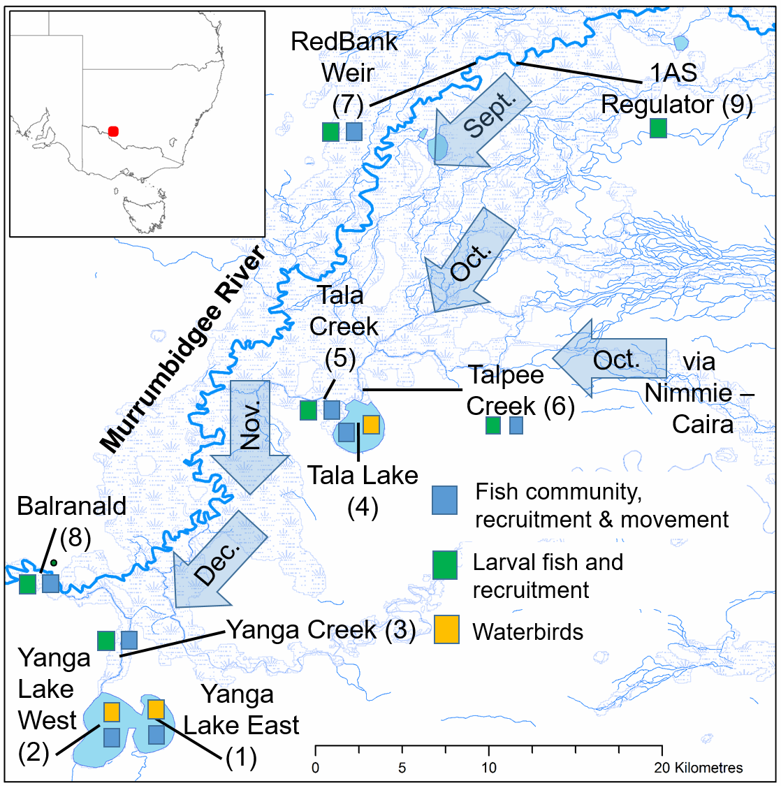

Figure 1. Map of the Murrumbidgee River and of floodplain study area, including sampling site numbers and names for fish community, recruitment and movement monitoring (blue), larval fish and recruitment monitoring (green), and waterbird (yellow) survey areas.
Arrows with months illustrate the progression of the environmental flow across the floodplain in 2018. See Wassens et al. (2019) for analyses of floodplain inundation.

Table 3. Summary of Key monitoring activities.
Activity | Site | Frequency | Key data collection | Associated data  collection
Fish movement Directional fyke netting | 1AS  Tala Creek Devils Creek, River Channel at Redbank (Murrumbidgee  River control x 3) | 3 x surveys, beginning, middle and end of the spawning season(Oct- Dec 2018) | Directional movement of native and invasive fish Size structure of moving individuals  Condition and origin of individuals | Tissue sample for stable isotopes/fatty acids. Juvenile otoliths for aging
Fish spawning and larval drift and food resources |  | 6 x Oct.-Dec. 2018 surveys | Abundance of native and invasive fish larvae Larval origin (floodplain/river)  Larval food sources | Collection of individuals for otolith aging, stable isotopes/fatty acids
Fish community lake and river | Tala Lake, Yanga Lake, River Channel (control  3x) | 3 x Oct., Nov. Dec. and a March 2019 recruitment trip | Population demographics (size and age structure) Collect individuals for and  daily aging | Tissue sample for stable isotopes/fatty acids. Juvenile otolith  collection for aging
Waterbird community | Yanga Lake, Tala Lake | Monthly Sep 2018-  March 2019 | Abundance of each species (including total fish-eating waterbirds), total species richness | Complementary DPIE spring surveys (multiple sites) and LTIM quarterly surveys  (12 sites)

Fish movement during floodplain–lake reconnection flow
The spatial extent and direction of fish movement during environmental watering actions was evaluated using directional fyke netting consisting of two pairs of large and small nets (1 pair upstream and 1 pair downstream) at four locations. Large fyke nets had a central wing (8 m x 0.65
m) attached to the first supporting hoop (= 0.55 m) with a mesh entry (0.32 m, stretched) and a stretched mesh size of 28 mm. Small fyke nets had a stretched mesh size of 2 mm, dual wings (each
  - m x 1.2 m), with a first supporting hoop (= 0.4 m) fitted with a square entry (0.15 m x 0.15 m) covered by a plastic grid with rigid square openings (0.05 m x 0.05 m). Directional fyke netting was carried on three occasions overlapping the environmental watering action. Nets were set over night and cleared regularly to avoid debris build up, all fish collected were counted, measured and weighed. Tissues (non-destructive caudal fin clip and muscle biopsy) from native and invasive fishes were taken for stable isotope analyses which provided information on the dominant food sources that adult fish have been consuming. Juvenile native and invasive fish (less then 75mm) were collected and euthanized to evaluate age structure. The net set arrangement and data collection matched those employed in the Murrumbidgee LTIM program (Wassens et al. 2019) ensuring that data collected is complementary with the broader program.

Spawning and larval drift
Larval drift nets were deployed during the environmental watering action at the same four locations as the directional fyke netting. Although the surveys targeted golden and silver perch, the survey method is appropriate for a range of species and provided information on spawning activities occurring on the floodplain as well as larval drift onto the floodplain from the Murrumbidgee River. As perch are periodic spawners, intensive (every 10 days; 6 sites x 6 surveys) larval fish sampling was recommended given the short duration of spawning events by this species, as well as the rapid development from eggs (which are semi buoyant and contain an oil droplet) to larvae. Sampling started in September at the beginning of the environmental watering actions and ended in December 2018. Four drift nets were deployed at each site and the contents of two nets were immediately frozen for stable isotope analysis, while the contents of the other 2 nets were stored in ethanol for larval fish community analysis.

Stable isotopes
Tissues from golden perch and other native and invasive fishes collected during surveys were analysed for bulk stable isotope nitrogen (N) and carbon (C) concentrations. Fish tissues were collected during directional fyke netting, larval sampling and during fish community sampling in Tala and Yanga Lakes and the Murrumbidgee River. Biological tissues including a muscle tissue biopsies (20 mg for stable isotope), a caudal fin-clip (15 mg wet weight /30 mm², stable isotope) and whole fish for individuals smaller than 150 mm total length (TL) were collected during directional fyke netting and larval surveys. Biological tissues were collected from larval fish, young of year; juveniles and adults. Whole fish (WF) were euthanized for individuals less than 150 mm TL and in larger fish, a muscle biopsy (MB) and caudal fin-clip (FC) was collected. All samples were stored frozen.
Basal food resources including aquatic plants (macrophytes), biofilms (periphyton), suspended particulate matter (seston), terrestrial vascular plants, leaves and grasses were collected from each site and sampled on three occasions. Periphyton was brushed from rocks, macrophytes, and logs, pre- filtered through 250‐μm mesh to remove large invertebrates, and then filtered onto precombusted Gellman A/E glass fiber filters (Pall Gelman Laboratory, Ann Arbor, Michigan). Seston was collected from integrated epilimnetic water samples, pre-filtered through 250‐μm mesh and then filtered onto pre-combusted Whatman A/E glass fiber filters. A minimum of three samples of each terrestrial and aquatic plant species present at each site was cut-up (including stems, leaves and seeds) and placed into a zip-lock bag and frozen prior to stable isotope analyses. Frozen basal resources, fin-clips and tissues were thawed and rinsed (excluding seston filter papers) with reverse osmosis purified water and dried in glass vials or petri dishes in an oven at 60°C for 48 h. Tissues were processed for bulk stable isotope ratios of nitrogen (15N/14N) and carbon (13C/12C) at the University of Western Australia. Samples were analysed for δ15N and δ13C, using a continuous flow system consisting of a Delta V Plus mass spectrometer connected with a Thermo Flush 1112 via Conflo IV (Thermo- Finnigan/Germany). The isotope values δ15N and δ13C were reported in relation to [‰, Air] and [‰, VPDB] respectively according to international standards.

Fish community demographic structure
Sampling for the fish community at sites (Figure 1) in the floodplain and river were matched to Sustainable Rivers Audit methodology and Sharpe (2018) including boat mounted electrofishing protocols at each survey site (12 x 90 sec electrofishing shots/site for a total of 18 minutes) and deployment of two pairs of large meshed and small meshed fyke nets described previously. Sampling was undertaken in October, November and December 2018 using boat electrofishing and fyke netting and an additional recruitment sampling trip was undertaken in March 2019. All fish collected were enumerated, measured and weighed. Native and invasive fish tissue samples (non-destructive caudal fin clip) were taken for stable isotope. Size structure data was complimented with daily aging of young-of-year individuals. Conducting daily ageing on periodic species enabled us to link spawning events of these flow responders to specific stages of the environmental watering action. This information is particularly useful to inform adaptive management.

Waterbirds
Monthly waterbird surveys were completed by boat at both Tala Lake and Yanga Lake between September 2018 and March 2019, with a pilot survey at Tala Lake in June 2018. This was in response to the delivery of water for the environment to the two lakes in September and December 2018.
Surveys could not be completed by boat at Yanga Lake in December 2018 and March 2019 due to water depth, so established ground points, from DPIE annual spring surveys, were used to complete a partial survey. Boats circumnavigated each lake and total number of waterbirds observed and species was recorded. Complementary waterbird data for spring 2018 (mid October 2018) and previous years (2010-2018) is also available from DPIE’s annual spring surveys (Spencer et al. 2018). Tala Creek was also observed in all months but October and September 2018 and January 2019 as it as too shallow to enter.
Due to the large size of the lakes, boat-based or aerial surveys are the most effective methods for completing waterbird surveys over a greater area (Kingsford 1999; Baldwin et al. 2005). Boat surveys allow a larger survey area than ground surveys that can only provide an estimate for a small proportion of each lake. During the boat-based surveys the boat circumnavigated each lake with two observers positioned one either side of the boat. Counts of all waterbirds observed were recorded by the observers using binoculars to aid species identification. When circumnavigating the lakes the observers counted all waterbirds on the water or in flight in a sampling window roughly 100m either side, ahead and above the boat (Agler et al. 1999). Tala Lake was surveyed using a flat bottom airboat with a maximum seating of four people. Yanga Lake was surveyed in a flat bottomed metal boat with a maximum seating of four people. Speeds travelled in both boats were similar and were set so as not to cause large disturbance of waterbirds on the lakes. When a large number of birds were encountered the boat was stopped for a maximum of five minutes to aid in accurate counting and identification. The boat surveys were not done during adverse weather conditions, including high winds or rain, as this would have affected the detection of waterbird species.
November surveys of both lakes were not completed due to high winds and dust storms.

Ground surveys of waterbirds were also conducted at 12 long term intervention monitoring (LTIM) wetland sites spread across the mid-Murrumbidgee, Gayini Nimmie-Caira and Redbank zones (four sites per zone). These are part of the Commonwealth Environmental Water Office funded LTIM program. Methods followed those employed previously to survey waterbirds in the Murrumbidgee Catchment and are documented in Wassens et al. (2014). Results from these surveys can be found in Wassens et al. (2019). Complementary waterbird data for spring 2018 (mid October 2018) and previous years (2010-2018) is also available from DPIE’s annual spring surveys (Spencer et al. 2018). These data were also examined for trends over time.

Results/Discussion
The Commonwealth Environmental Water Office, in conjunction with DPIE, estimated that 109.8 GL (40.5 GL CEWO and 69.3 GL NSW) of environmental water was delivered through Yanga National Park onto the Murrumbidgee floodplain (Figure 2) between September 2018 and February 2019.

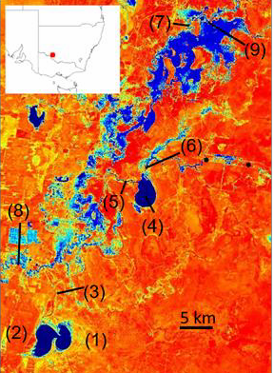

Figure 2. Sentinel satellite image showing the Murrumbidgee River and maximum spatial extent of floodplain inundation (Blue) on 21 December 2018. Sampling sites correspond to Figure 1. See Wassens et al. (2019) for analyses of floodplain inundation.

Sentinel satellite imagery (Figure 2) and on-ground monitoring reported here and in Wassens et al. (2019) confirm that the environmental flow inundated large areas (>100 km²), of otherwise dry floodplain. The inundation area included Yanga National Park, most notably downstream of the 1AS regulator (site 9) and flowed into Tala and Yanga Lakes (Sites 1, 2, 4). The environmental flow continued southwest on the floodplain toward Tala Lake (site 4) via Tala and Talpee Creeks (site 5 and 6) during September and October 2018. Environmental water was also delivered via the South Caira Channel in Nimmie-Caira to Tala Lake. Due to infrastructure works in Nimmie-Caira, the South Caira Channel was unavailable to support delivery to Tala Lake until late September 2018. Owing to record dry and hot conditions, environmental water moved slower than expected and did not reach Yanga Creek or Lake (sites 1-3) until late December 2018 at which time its arrival helped to prevent the lake from drying.
Water levels in Yanga lake were maintained as of March 2019, despite significant evaporation during summer, while the depth of Tala Lake increased by >160 cm between September 2018 and March 2019. Environmental water deliveries ended on 1/2/2019 at 1AS regulator and 25/1/2019 from Nimmie-Caira. Further details of floodplain inundation and environmental flow delivery are detailed in Wassens et al. (2019). Below we report on monitoring activities undertaken to evaluate the responses of fish and waterbirds to the above environmental watering action aimed at supporting native species in persistent floodplain lakes.

Fish distribution and movement
Eight native and four invasive fish species (Table 4) were sampled as adults or sub-adults (ie. not larvae or young-of-year) over the course of the 2018/19 environmental flow which connected the Murrumbidgee River to the Tala and Yanga floodplain. Monitoring here detected a similar fish species composition compared to the previous year (Sharpe 2018) but, likely due to higher sampling effort and site coverage in 2019, we detected additional species including Murray rainbowfish, flatheaded gudgeon and silver perch. However, more than eight species, that were historically abundant and widespread in the lower Murrumbidgee river and floodplain system (Anderson 1920), were not detected in monitoring here or in most recent records. These now rare or extirpated species include Macquarie perch, trout cod, river blackfish, eel-tailed catfish, southern pygmy perch, Murray hardyhead, purple spotted gudgeon and species of Galaxidae.

Table 4. Total number of adult and sub-adult native and invasive fishes sampled in different regions of the Murrumbidgee River-Yanga floodplain. Sites correspond to figure 1.
Species | Yanga floodplain  (sites 1-3) | Tala floodplain  (sites 4-6) | Murrumbidgee  River (sites 7-8)
Native
Murray cod | 0 | 1 | 0
Golden perch | 12 | 5 | 5
Silver perch | 3 | 5 | 1
Bony bream | 753 | 168 | 10
Australian smelt | 739 | 159 | 0
Carp gudgeon | 3507 | 5578 | 490
Flatheaded gudgeon | 1 | 16 | 1
Rainbow fish | 0 | 1 | 1
Alien
Common carp | 360 | 194 | 50
Eastern gambusia | 177 | 114 | 2324
Goldfish | 0 | 0 | 4
Oriental weatherloach | 6 | 8 | 2

Golden perch, silver perch, bony bream and invasive common carp likely capable of spawning, according to published estimates of minimum size-at-maturity of females (Mallen-Cooper et al.
2003; Puckridge and Walker 1990; Brown et al. 2005; Figure 3), were detected at multiple sites in the Murrumbidgee River and connected Tala and Yanga floodplain system over the course of the environmental flow.

The direction of adult large-bodied native fish movement showed no consistent pattern (Figure 4). However, adult golden perch were present in Tala Creek (site 5) and Talpee Creek (site 6) prior to the arrival of the environmental flow (Figure 4), but were not detected at the same sites as adults thereafter. One explanation for the absence of adult golden perch during the environmental flow is that individuals moved further upstream into the creeks and connected floodplain to spawn. A separate line of evidence supporting this hypothesis is that golden perch larvae and recruitment (see Fish Reproduction and Recruitment) was detected in the creeks connected to Tala Lake. The length distributions of golden perch following the fish-kills (courtesy of A. Conallin) in the river channel were composed primarily of mature-sized fishes (Figure 3), while in contrast the floodplain length distributions sampled during monitoring here were dominated by recruits, but with mature- sized adults present (see Fish Reproduction and Recruitment).

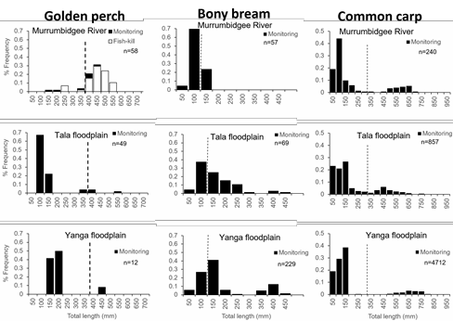
Figure 3. Length-structure of golden perch, bony bream and common carp at Murrumbidgee River sites (7-9), Tala floodplain lake and creek sites (4-6) and Yanga floodplain lake and creek sites (1-3). Dashed vertical lines show minimum length at maturity of females from Mallen-Cooper et al. (2003), Puckridge and Walker (1990) and Brown et al. (2005). Samples included fyke netting, electrofishing and dead golden perch opportunistically measured following fish-kills (courtesy of A. Conallin) between sites 7 and 9 in February 2019.

Only one adult (690 mm TL; Tala Lake) Murray cod was detected over the course of monitoring in 2018/19. Although fyke netting and boat-electrofishing did not detect adult Murray cod in the Murrumbidgee River, we detected the species as larvae (see below) and small numbers of adults have previously been reported upstream of Redbank Weir (site 7; Sharpe 2018) and at the same site, but dead, following the fish-kills in February 2019 (A. Conallin Pers. Com.).

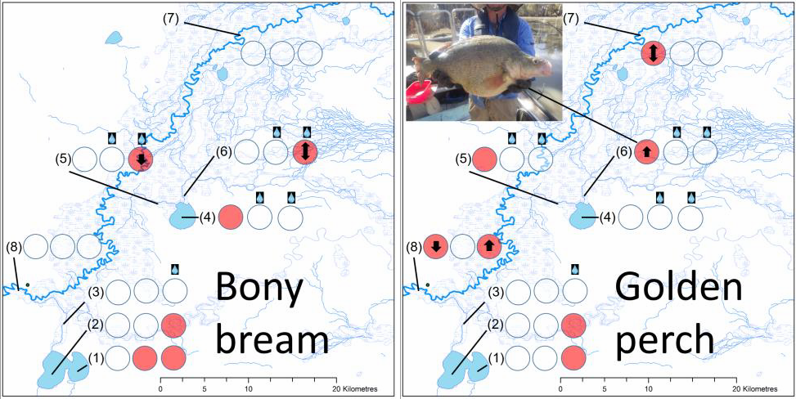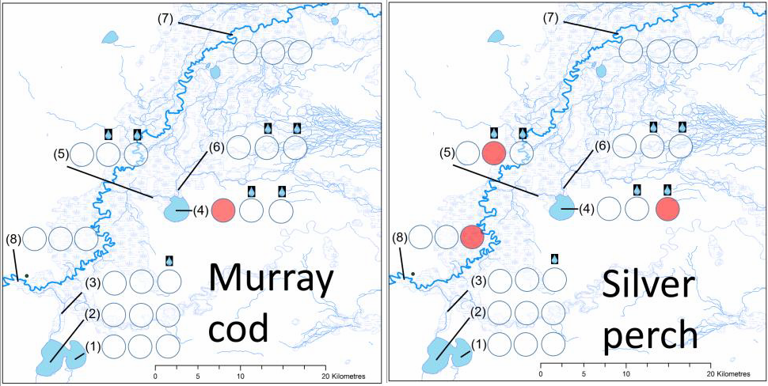

Figure 4. Presence of large-bodied adult and sub-adult native fishes in Murrumbidgee River and floodplain monitoring sites (Figure 1), across monthly fyke net and boat electrofishing sampling trips (October, November and December 2018; denoted respectively by circles) during the environmental flow. Shaded circles represent species present, and arrows indicate the direction of movement including upstream, downstream or both. No arrows indicate fish were not sampled by directional fyke nets. Water drop symbols above circles indicate whether a site had received environmental water during the time of sampling.

No consistent directional movements of small-bodied native fishes were detected in response to the environmental flow (Figure 5). Australian smelt were only sampled in Tala floodplain creeks during the environmental flow delivery, but were consistently sampled in Yanga Lake during all surveys. The most wide-spread small-bodied native fish species, with adults present at all sites, was carp gudgeon. Flatheaded gudgeon occurred regularly in the creeks flowing into Tala Lake, while only two adult rainbowfish were detected during monitoring. Historical surveys using seines in water holes following floods on the Murrumbidgee floodplain typically yielded “many of thousands of miniature fish… of several kinds including Pigmy Perch, Midget Perch, Smelts, Antherins, Hardy
heads, Galaxias, etc. The second haul usually brings forth….River Blackfish, Purple-striped Gudgeon, and Carp and as a rule is the most productive of edible fishes…” (Anderson 1920). Given the apparent absence of many small-bodied native fishes in monitoring here and in recent records, it is unlikely that these species are capable of re-establishing in Tala and Yanga floodplain systems, or benefitting from environmental flows, without a complimentary conservation stocking and rehabilitation program. Observations that common carp were present in the early 1900’s (Anderson 1920), prior

to the completion of large modifications to flow regimes, and that they co-existed with extremely high abundances of small native fishes suggests that appropriate flow regimes delivered to Murrumbidgee floodplains can benefit native species, despite the presence of carp.
Invasive common carp are now the most wide-spread and abundant large-bodied fish in the Murray-Darling (Kopf et al. 2018), and our monitoring here of the lower Murrumbidgee River and floodplain has shown that this region is no exception. Adult carp were detected at all sites sampled, irrespective of the timing of environmental flow arrival on the floodplain, with up and down-stream movements (Figure 6). Historical descriptions (Anderson 1920) of chains of drying water holes on the Murrumbidgee floodplain teeming with fish life still exist today (see picture inlay Figure 6), but the native species have now largely been displaced by invasive common carp. For example, in our monitoring, four fyke nets set in a drying waterhole in Yanga Creek, prior to the arrival of the environmental flow, were completely full and yielded 226 kg of ripe adult (confirmed by macroscopic examination of gonads), mostly female (24:1 sex ratio), and large common carp (mean total length 605 ± 52 mm standard deviation). Dozens more large common carp were visibly stranded (see picture inlay Figure 6) in this shallow Yanga Creek waterhole which subsequently dried before the environmental flow arrival in December 2018.
Three other invasive fishes were detected in monitoring activities, but these were generally less abundant and less widespread than common carp (Figure 6). However, following the fish-kills in the Murrumbidgee River in February 2019, the only species sampled during monitoring activities at RedBank Weir in March were 90 common carp, 2323 Eastern gambusia and 2 oriental weather loach. Pre-fish-kill trips at the same site recorded adult golden perch, carp gudgeon, carp and one Eastern gambusia.

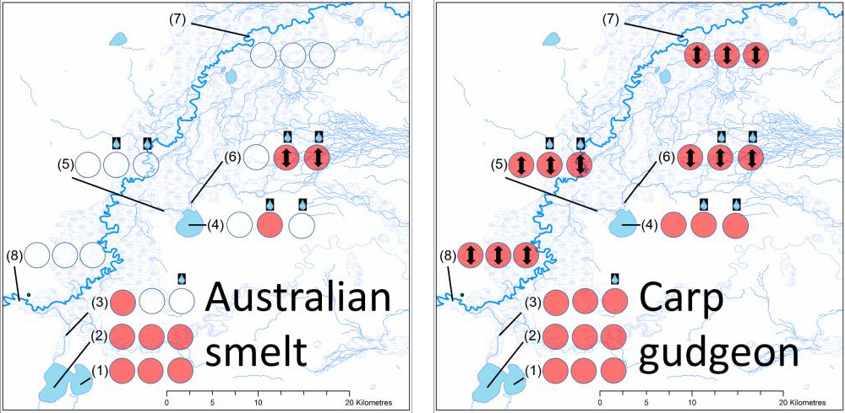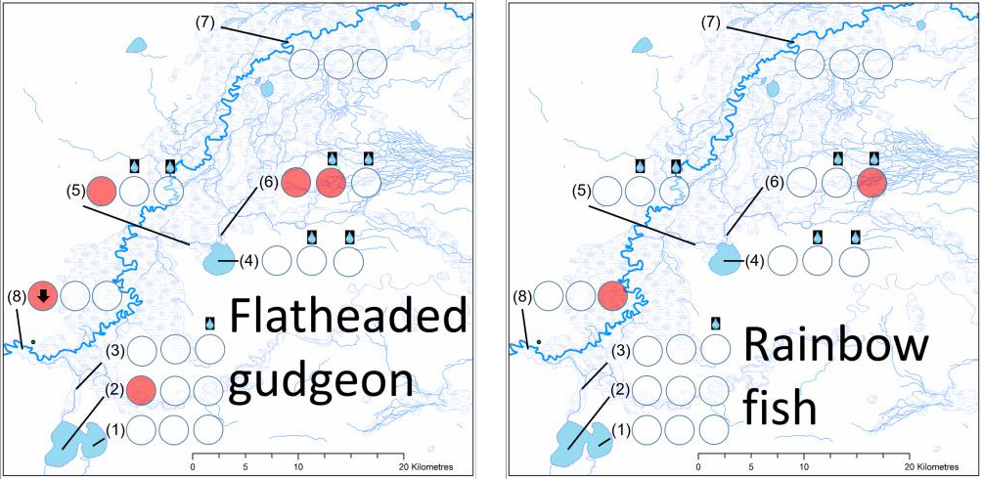
Figure 5. Presence of small-bodied adult and sub-adult native fishes in the Murrumbidgee River and floodplain monitoring sites (Figure 1), across monthly sampling trips (October, November and December 2018; denoted respectively by circles) during the environmental flow. Shaded circles represent species present, and arrows indicate the direction of movement including upstream, downstream or both. No arrows indicate fish were not sampled by directional fyke nets. Water drop symbols above circles indicate whether a site had received environmental water during the time of sampling.

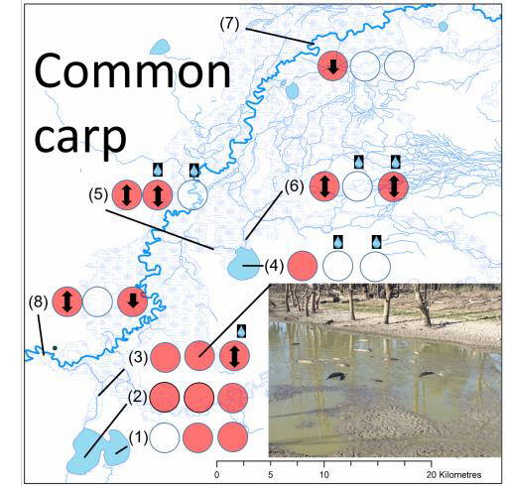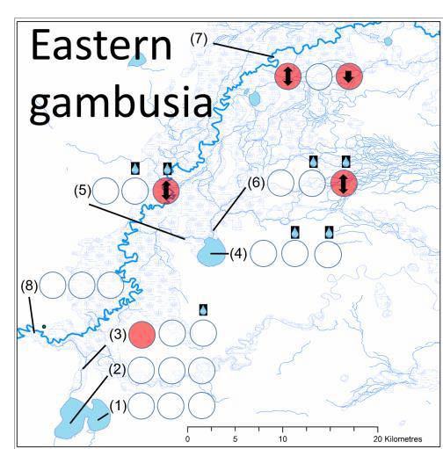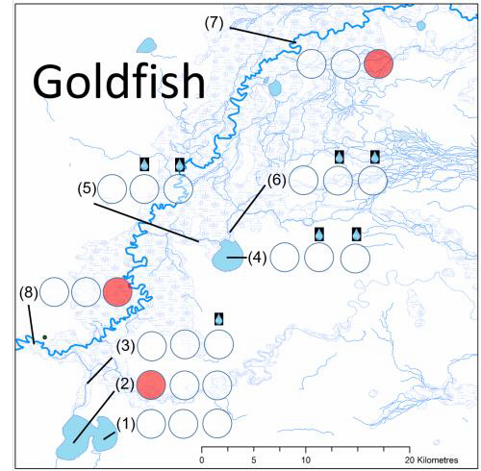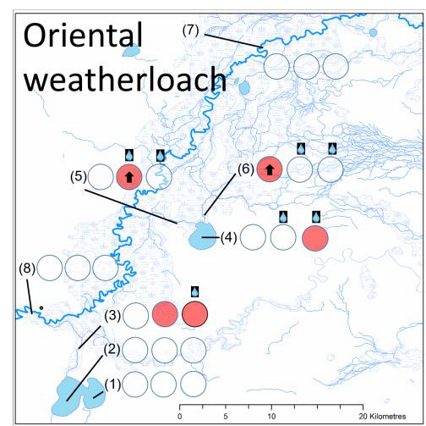

Figure 6. Presence of adult and sub-adult invasive fishes in the Murrumbidgee and floodplain monitoring sites (Figure 1), across monthly sampling trips (October, November and December 2018; denoted respectively by circles) during the environmental flow. Shaded circles represent species present, and arrows indicate the direction of movement, including upstream, downstream or both. No arrows indicate fish were not sampled by directional fyke nets. Water drop symbols above circles indicate whether a site had received environmental water during the time of sampling.

Fish reproduction and recruitment
Six native fish species and invasive common carp were detected as larvae, and were therefore spawning, in the Murrumbidgee River and connected floodplain over the course of the 2018/19 environmental flow (Table 5). Australian smelt, Carp gudgeon and common carp larvae were the most abundant and widespread fishes detected as larvae (Figure 7). Murray cod larvae were consistently collected drifting into the Yanga floodplain via the environmental flow (site 9; 1AS regulator) from the Murrumbidgee River during November and December 2018 (Figure 7). However, only one Murray cod young-of-year recruit was detected at this site, and no successful recruitment of this species was detected at floodplain or river channel sites during or after environmental flow delivery (Figure 8).

Table 5. Total number of larvae sampled in different regions of the Murrumbidgee River, Yanga floodplain. Sites correspond to figure 1.

 | Yanga floodplain (sites 1-3) | Tala floodplain (sites 4-6) | Murrumbidgee River (sites 7- 9)
Native
Murray cod | 0 | 0 | 107
Golden perch | 0 | 7 | 0
Silver perch | 0 | 0 | 0
Bony bream | 0 | 0 | 0
Australian smelt | 0 | 14 | 219
Carp gudgeon | 7 | 75 | 54
Flatheaded gudgeon | 0 | 43 | 28
Rainbow fish | 0 | 1 | 0
Alien
Common carp | 0 | 48 | 157
Eastern gambusia | 0 | 0 | 0
Goldfish | 0 | 0 | 0
Oriental weatherloach | 0 | 0 | 0

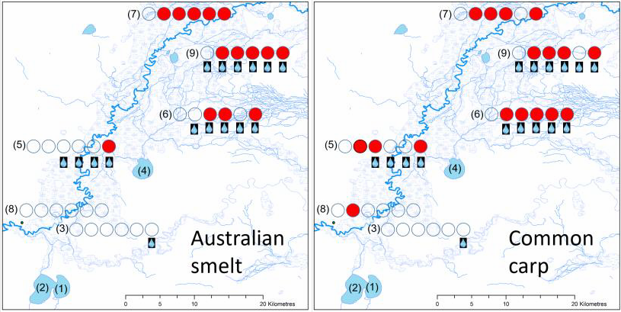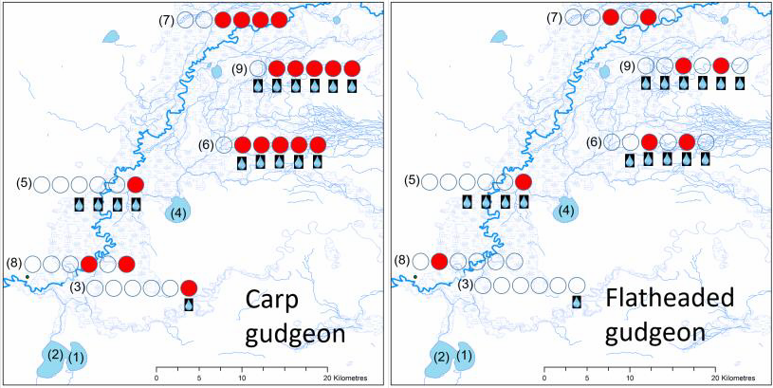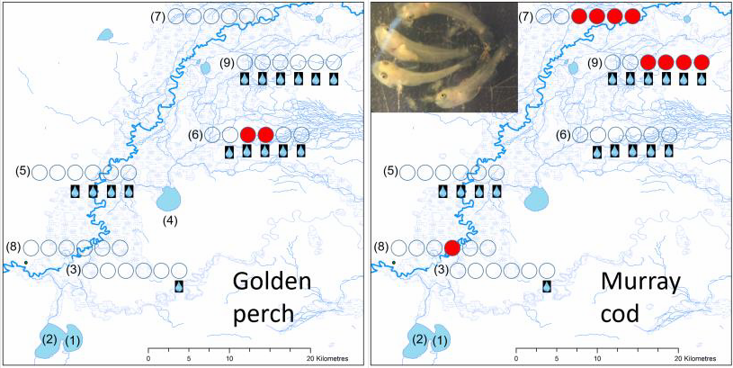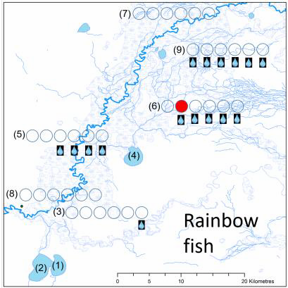

Figure 7. Presence (Red circles) of larval fishes in Murrumbidgee River and floodplain monitoring sites (Figure 1). Shaded red circles represent species present across fortnightly sampling trips (left to right) drift net sampling trips beginning 01 October and ending 20 December 2018. Water drop symbols indicate whether a site had received environmental water.

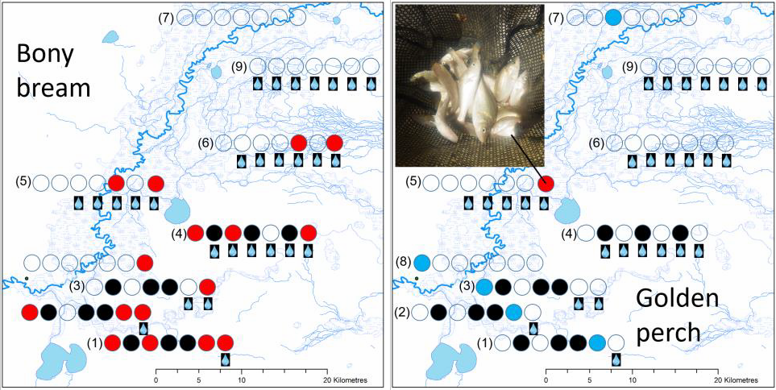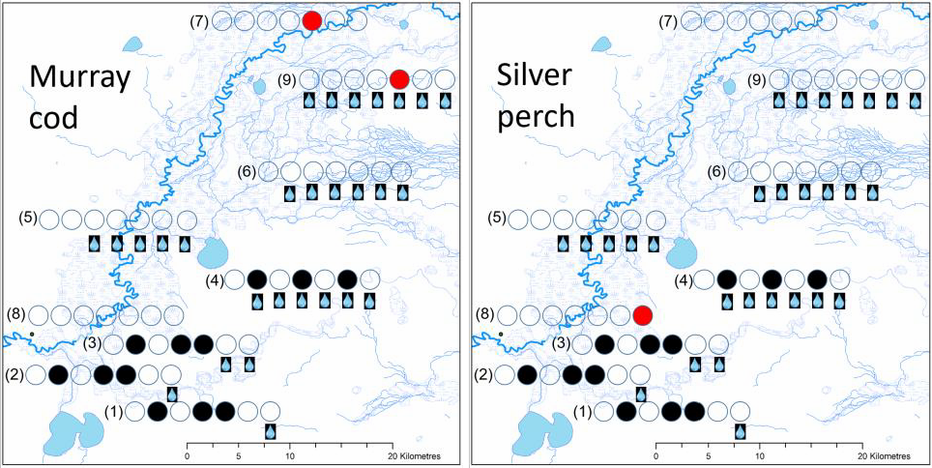

Figure 8. Presence of 2018 recruits (Red circles) and absence (White circles) of large-bodied native fishes in Murrumbidgee River and floodplain monitoring sites (Figure 1) between October and December 2018. Shaded red circles represent presence across fortnightly sampling trips (left to right) beginning 01 October and ending 20 December 2018. The far right circle represents species present during fyke netting and boat-electrofishing surveys in March 2019. Water drop symbols indicate whether a site had received environmental water during the time of sampling. Blue circles for golden perch illustrate 2017 recruits, and black circles indicate no sampling undertaken

Large-bodied native fishes that were detected as a young-of-year recruits (Table 6) following environmental flows on the floodplain were bony bream and golden perch. Murray cod have adapted to spawn and recruit successfully within river channel environment alone (Humphries et al. 1999; King et al. 2003), but historical records also indicate that floodplains offered important and productive habitats for recruitment of Murray cod and many others fishes on the Murrumbidgee floodplain. For example, Anderson (1920) account that in some small floodplain waterholes of the Murrumbidgee following flooding, “more than 1,060 Murray Cod and Golden Perch, up to about 3 inches in length were collected, also a number of Macquarie Perch, Blackfish, Catfish, with an occasional Silver Perch.” Of the species that historically recruited successfully within the system, only golden perch were detected in floodplain monitoring here.

Table 6. Total number of 2018/19 recruits sampled in different regions of the Murrumbidgee River, Yanga floodplain. Sites correspond to figure 1.

 | Yanga floodplain (sites 1-3) | Tala floodplain (sites 4-6) | Murrumbidgee River (sites 7-9)
Native
Murray cod | 0 | 0 | 4
Golden perch | 9a | 44 | 2a
Silver perch | 0 | 0 | 0
Bony bream | 136 | 46 | 47
Australian smelt | 1 | 34 | 118
Carp gudgeon | 959 | 2571 | 152
Flatheaded gudgeon | 0 | 0 | 0
Rainbow fish | 0 | 116 | 42
Alien
Common carp | 3673 | 1030 | 715
Eastern gambusia | 54 | 121 | 0
Goldfish | 0 | 5 | 1
Oriental weatherloach | 0 | 5 | 0

    - recruits hatched in 2017.

Unlike Murray cod, golden perch larvae were not detected drifting from the river into the floodplain. Instead, golden perch larvae were detected on the floodplain during two trips at Talpee Creek which coincided with the environmental flow (Figure 7). Talpee Creek was previously one of the sites where mature-sized adults were present earlier in the spawning season (see Figure 4), before the system was connected to the river by the environmental flow. The spawning of golden perch as indicated by larvae in the creeks flowing into Tala Lake resulted in successful young-of-year recruitment in Tala Creek, but recruits were not detected at any other site (Figure 8; Table 6). All other juvenile golden perch sampled throughout the system, especially Yanga Lake and Creek, were confirmed by otolith age estimation to have hatched in 2017 (Figure 9). Despite more than double the sampling effort at Yanga Lake this year compared to the previous year, and using the same methods, no recruitment of golden perch at Yanga lake was detected in 2018/19, and the total number of golden perch (n=12) detected was more than four-fold lower than the previous monitoring year (n=51; Sharpe 2018). Natural mortality rates of juvenile golden perch have not been quantified in the published literature, but the apparent reduction in golden perch relative abundance may be normal and attributed in part to resident piscivorous waterbird populations (see below).

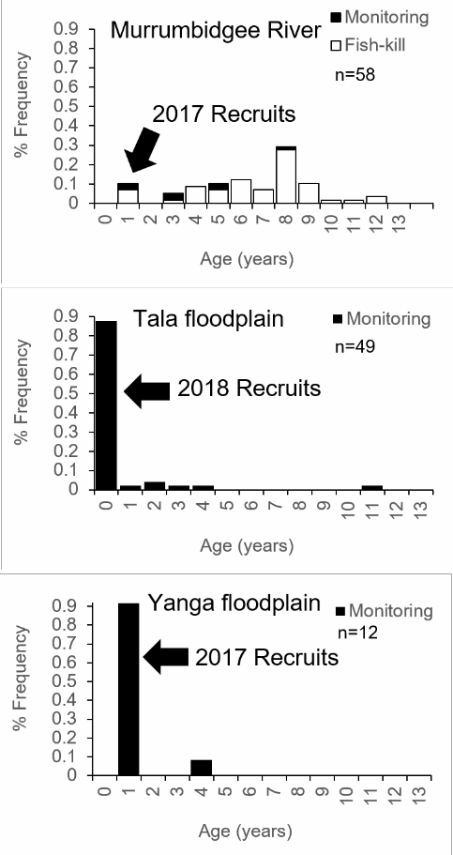
Figure 9. Age-structure of golden perch at Murrumbidgee River sites (7-9), Tala floodplain lake and creek sites (4-6) and Yanga floodplain lake and creek sites (1-3) showing differences in 2017 and 2018 young-of-year recruits in the different systems. Samples were collected from fyke netting, electrofishing and from dead fish following fish-kills (courtesy of A. Conallin) upstream of Redbank Weir in February 2019.

Collectively, the presence of: 1) mature-sized adult golden perch within the Tala floodplain system before the environmental flow; 2) absence of larvae drifting in from the river, and 3) successful spawning and recruitment on the floodplain, suggests that environmental flows which connected the lakes to the floodplain creeks and low-lying areas represents a viable management option to benefit golden perch populations (see Links to Adaptive Management). However, our monitoring results do not discount the possibility, or potential importance, of adults and juveniles moving into or out of the floodplain from the river, especially since adult movements to lowland reaches and spawning of golden perch during environmental flows has been reported elsewhere (Koster et al. 2016). Furthermore, other native species, such as Murray cod, Australian smelt and carp gudgeon were detected drifting into the floodplain and some species recruited successfully (Table 6; Figure 10).

Common carp larvae and recruits (Figure 11) were widespread throughout river channel and floodplain sites, drifting into the floodplain and from spawning within the system before the environmental flow. However, the majority (3598/5418) of common carp recruits detected occurred at a single site/trip (Figure 11; Yanga Creek/site 3) in mid-December which coincided with the leading edge of the environmental flow traveling through an otherwise dry Yanga Creek toward Yanga Lake. Water temperatures on the leading edge of the environmental flow reached 32.6° C and dissolved oxygen dropped to 0.8 mg/L at night.

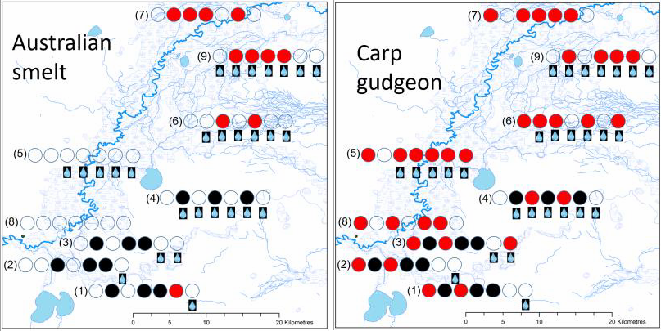
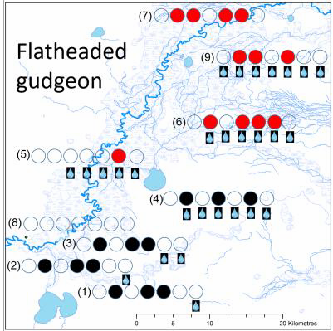

Figure 10. Presence of 2018 recruits (Red circles) of small-bodied native fishes in Murrumbidgee River and floodplain monitoring sites (Figure 1) between October and December 2018. Shaded red circles represent presence across fortnightly sampling trips (left to right) beginning 01 October and ending 20 December 2018. The far right circle for recruits represents species present during fyke netting and boat-electrofishing surveys in March 2019. Water drop symbols indicate whether a site had received environmental water during the time of sampling. Black circles indicate no sampling undertaken.

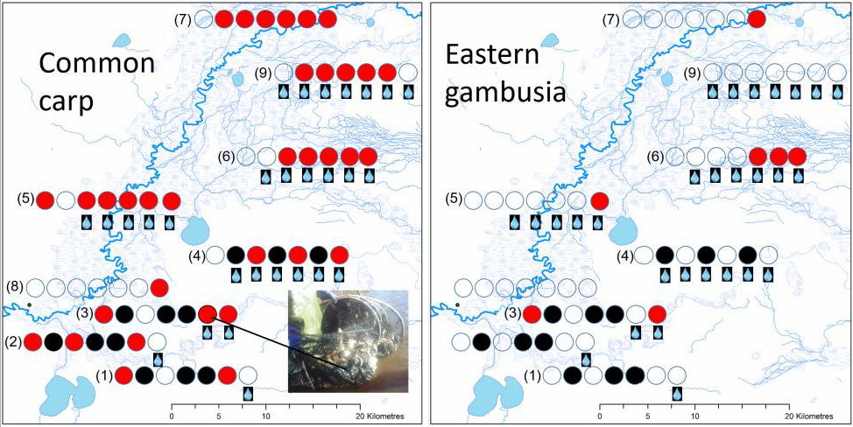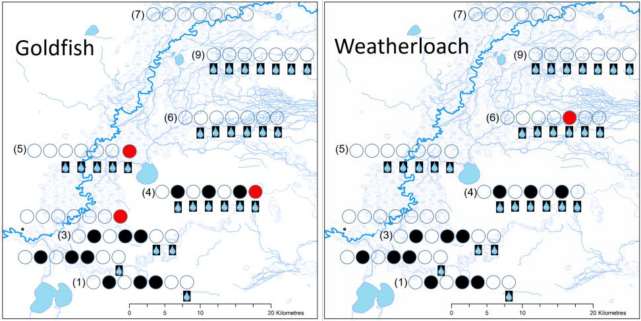

Figure 11. Presence of 2018 recruits (Red circles) of invasive fishes in Murrumbidgee River and floodplain monitoring sites (Figure 1) between October and December 2018. Shaded circles represent presence across fortnightly sampling trips (left to right) beginning 01 October and ending 20 December 2018. The far right circle for recruits represents species present during fyke netting and boat- electrofishing surveys in March 2019. Water drop symbols indicate whether a site had received environmental water during the time of sampling. Black circles indicate no sampling undertaken.

Fish growth and diversity of food resources

Growth rates of Murray cod, golden perch and common carp larvae and recruits differed among species and for common carp the growth rates of recruits differed between Murrumbidgee River and environmental flow inundated floodplain sites (Figure 12). Daily growth rates of Murray cod larvae (median 1.22 mm/day) sampled in the river channel, were generally faster than golden perch larvae (0.89 mm/day) and common carp larvae irrespective of river (median 0.81 mm/day) or floodplain (0.81 mm/day) environments.

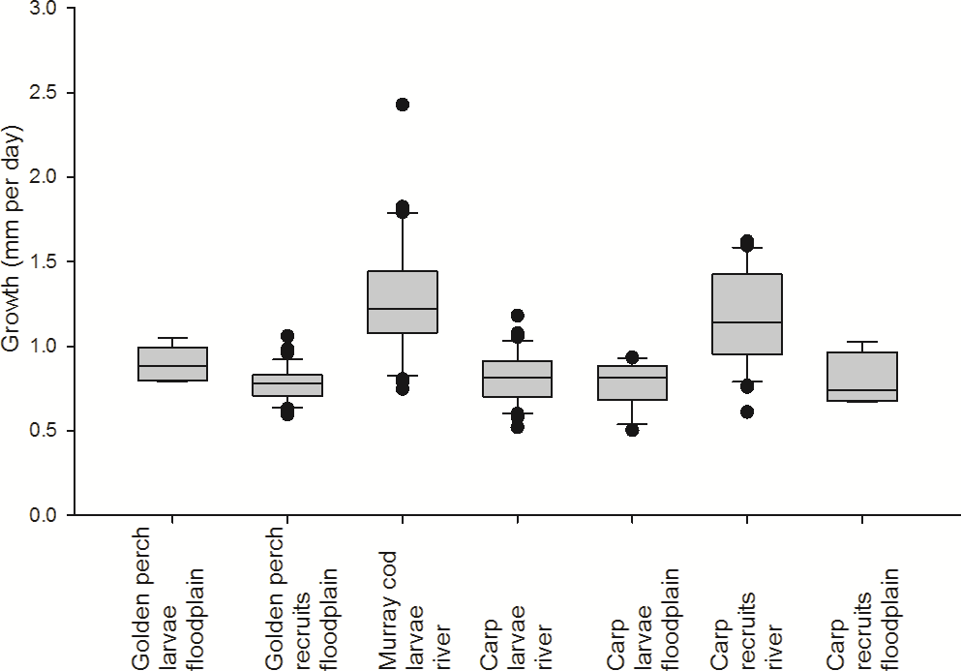

Figure 12. Growth rates of Murray cod larvae, Golden perch and Common carp recruits in the Murrumbidgee River and Tala Floodplain.

Both Murray cod and common carp larvae sampled in the Murrumbidgee river channel had stable isotope signatures (13C; Figure 13) suggesting that basal food sources were phytoplankton (benthic or pelagic) based, and to a lesser extent terrestrial vascular plant related. However, within the environmental flow inundated floodplain around Tala Lake, golden perch and common carp larval food sources were more strongly related to macrophyte and terrestrial vascular plant inputs. These data indicate that both macrophyte and terrestrial plant production on the environmental flow-inundated floodplain were important basal food resources supporting larvae, both native and invasive, most likely via food web connections of spawning females (and subsequently their eggs and larvae), since the larvae analysed typically still had yolk-sacs. In support of this hypothesis, the stable isotope signatures of mature-sized golden perch sampled on the Tala Floodplain (Figure 14), were aligned with macrophyte-based food web production.
A strong over-lap in the food resources supporting golden perch recruits (Figure 13) and adult common carp (Figure 14) was observed in the Tala floodplain system. The basal 13C signatures of both groups suggested that production was supported by food resources ranging from macrophytes to algae, while the 15N signatures indicated that both groups were feeding at similar trophic levels.

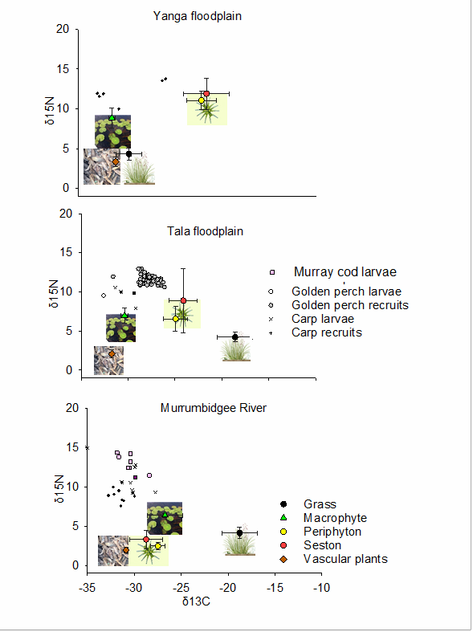
Gut content analyses were not conducted here to confirm details of the prey items consumed, but the isotopic over-lap suggests that adult carp compete for food resources with golden perch recruits in river-floodplain environments. This important result in combination with the high biomass of adult carp in river-floodplain environments of the Murray-Darling is consistent with emerging evidence suggesting that this invasive species has strong food web effects which adversely affect native fish populations (Kopf et al. 2018; Marshall et al. 2019).
Figure 13. Stable isotope N and C values of basal food resources (Grass, Marcrophytes, Periphyton, Seston and Terrestrial vascular plants) in relation to fish larvae and recruits in Murrumbidgee River sites (7-9), Tala floodplain lake and creek sites (4-6) and Yanga floodplain lake and creek sites (1-3).

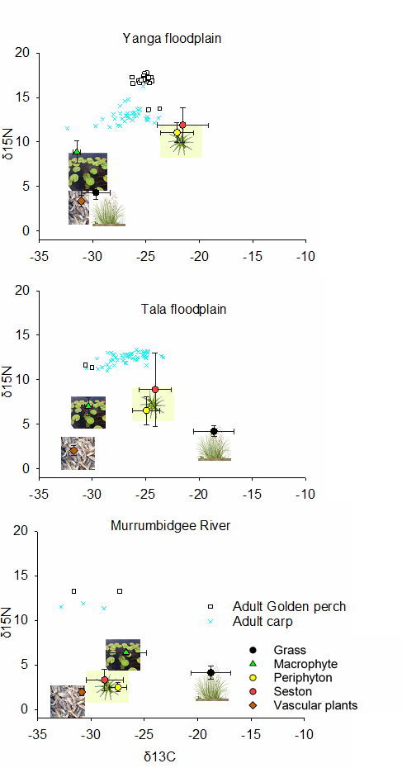

Figure 14. Stable isotope N and C values of basal food resources (Grass, Marcrophytes, Periphyton, Seston and Terrestrial vascular Plants) in relation to juvenile and adult fish in Murrumbidgee River sites (7-9), Tala floodplain lake and creek sites (4-6) and Yanga floodplain lake and creek sites (1-3)

The hatch dates of golden perch recruits sampled in the Tala Floodplain over-lapped with the period of the environmental flow (Figure 15). The hatch date distribution of common carp recruits followed a similar pattern to golden perch, although successful recruitment of this invasive species occurred earlier in the Murrumbidgee River (Figure 15). Recruits were sampled in March 2019 and the hatch dates were back-calculated from otoliths. Given the over-lap between the arrival of the environmental flow and hatch date distribution of golden perch, either: 1) the arrival of the environmental flow was timed appropriately with spring/summer temperatures that are associated with spawning, and/or the environmental flow arrival provided a cue to initiate spawning. In either scenario, the event appears to have contributed to successful recruitment and growth of young-of- year golden perch in the Tala floodplain system. In contrast, the delayed arrival of the environmental flow and reduced volume of water entering Yanga Lake toward the end of December 2018 may have contributed to the apparent recruitment failure of golden perch in this part of the system.
The hatch date distribution of golden perch recruits (Figure 15) suggests that the timing of environmental flow deliveries targeting this species in the lower Murrumbidgee should be initiated to achieve maximum floodplain inundation from November through December. High flows earlier than October in cooler water temperatures appear more likely to facilitate common carp recruitment on the floodplain (Figure 15) and we detected no successful golden perch recruitment before 11 November. Therefore, shortening the window of opportunity for carp to spawn, while providing suitable conditions for golden perch recruitment in November and December may be a useful environmental flow delivery strategy.
Young-of Year recruit golden perch (median 0.78 mm/day) and common carp (median 0.73 mm/day) sampled on the Tala floodplain had similar daily growth rates (Figure 12), but the food resources supporting them were different (Figure 13). Floodplain production of phytoplankton (benthic or pelagic) and macrophytes were important in supporting recruitment of golden perch, while stable isotope signatures of common carp recruits were more macrophyte associated (Figure 13). Differences in growth rates and food sources of golden perch larvae and recruits between river channel and environmental flow inundated floodplain habitats could not be compared because no larvae or 2018 recruits were detected in the river channel. Growth rates of common carp larvae (Figure 12) did not differ between river channel and floodplain sites, despite differences in underlying food resources. However, the growth rates of common carp recruits were highest in river channel environments. One possible explanation for this was that the relative abundance of carp recruits was highest in the floodplain and therefore competition for food resources may have been lower in the river channel.

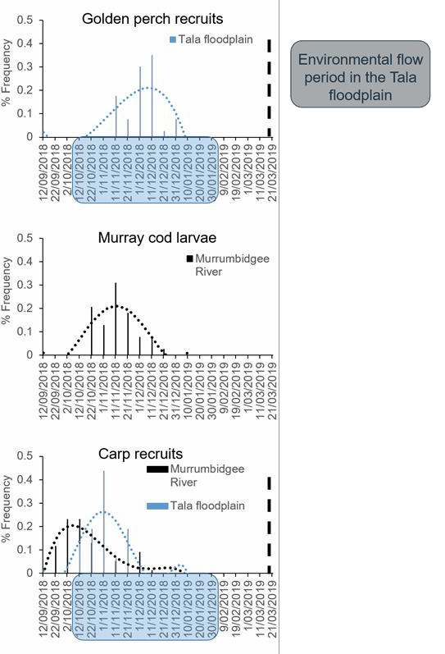

Figure 15. Back-calculated hatch dates of Murray cod larvae and 2018 recruits of golden perch and common carp in relation to the timing of environmental flows (blue shaded dates) arrival at Tala lake and creek sites (4-6), and Murrumbidgee River sites (7-9). The vertical dashed line shows the sampling date of recruits.

The fish-kills in February 2018 provided an opportunity to collect otoliths (provided by A. Conallin; NSW DPIE) from adults to describe the growth of golden perch in the Murrumbidgee River (Figure 16). The absence of young-of-year recruits in the river following the fish-kills aligns with monitoring data indicating that there was little or no successful recruitment of golden perch within local river channel environments during 2018/19. Therefore, it appears that within the system monitored, the only successful recruitment of golden perch in 2018/19 occurred within the Tala floodplain system connected by the environmental flow. The impact of the fish-kills on the biomass of mature-sized golden perch in the region is unquantified, but monitoring here following the fish- kills only detected surviving golden perch within the floodplain system.
The age-structure of golden perch in the Murrumbidgee River following the fish-kills had a mode of 8 year old fish that would have recruited following floods in 2010/11. With the exception of the recruitment event in the Tala system in 2018/19, smaller numbers of golden perch were detected in most age-classes, suggesting that large recruitment events of this species do not occur every year and coincide with high flow events, both uncontrolled flooding and via environmental flows. These results are consistent with predictions of fishes with a periodic life-history strategy of producing large numbers of small off-spring which undergo large recruitment events in association with suitable conditions provided by high flows (Humphries et al. 2019).

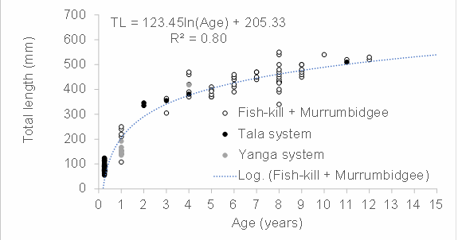
Figure 16. Growth curve fitted to Golden perch sampled as part of environmental flow monitoring and following fish-kills in the Murrumbidgee River in February 2019. Note, samples collected in the Tala and Yanga systems were sourced from monitoring and no fish- kills were observed in these systems.

Waterbird species richness
Across all surveys, including incidental sightings, 38 waterbird species were observed across both lakes including 16 fish eating species (Appendix 1 – Species List). Migratory shorebird species, including the sharp-tailed sandpiper (Calidris acuminata), were observed at Tala Lake in September 2018 and sharp-tailed sandpiper, marsh sandpiper (Tringa stagnatilis) and red-necked stint (Calidris ruficollis) were observed at Yanga Lake in March 2019 (listed JAMBA, CAMBA and ROKAMBA). A small number of Australasian darters (Anhinga novaehollandiae) were observed nesting at Tala Lake and fledglings were observed in one nest in February 2019. A freckled duck (Stictonetta naevosa), listed as vulnerable in NSW (BC Act 2016), was observed at Yanga Lake in the September 2018 survey.
Species diversity varied between the survey months. On average 15-16 waterbird species were observed at each lake during the boat surveys completed between June 2018 and March 2019 (Figure 17). There was a range of 9 to 21 species at Tala Lake and 14 to 18 at Yanga Lake (Figure 17). Species diversity was highest at Tala Lake in June 2018 when 21 species were recorded. The variation in number of species could be attributed to the variation in water heights and the differing habitat availability that occurred. The greatest diversity of waterbird species is often seen when there is varying water depths and habitat types available (Taft et al. 2002). Extreme temperatures (maximum
>40°C each month) could account for lower species number at Tala Lake in December 2018 and January 2019 as birds are often sheltering in those conditions. Alternatively the filling of Tala Lake during September and October 2018 could have provided a larger amount of deep water habitat, reducing available habitat types utilised by species such as wader and shorebirds (Figure 17 and 18).

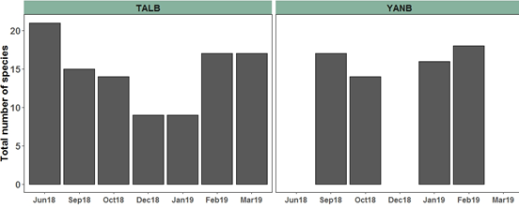

Figure 17. Total number of waterbird species observed at Tala Lake (left) and Yanga Lake (right) during boat surveys completed from June 2018 to March 2019. Note that Yanga Lake boat surveys were not completed in June and December 2018 and March 2019 due to issues accessing the lake. Environmental flow connected to Tala Lake in October 2018 and connected to Yanga Lake in December 2018.

Waterbird abundance
Piscivorous waterbirds were the most abundant functional group across all months at both lake sites (Figure 18). The most abundant species recorded were the Australian pelican (Pelecanus conspicillatus), pied cormorant (Phalacrocorax varius) and grey teal (Anas gracilis). Piscivorous waterbird fish consumption has received attention due to their potential competition with fisheries and because sudden changes in fish abundance can influence waterbird movement, survival and recruitment (McGinness et al. 2019). Estimates on large natural waterbodies have indicated that piscivorous waterbird assemblages, from four to seven species, can consume 17kg/Ha to 48.3kg/Ha of fish (Mous 2000, Zydelis et al. 2008).
A higher number of functional groups was observed in boat surveys at Tala Lake compared to Yanga Lake, with rails and shoreline gallinules observed in March 2019 and migratory Charadriiform shorebirds in September and October 2018 at Tala Lake only (Figure 18). This could potentially be attributed to a greater variability in habitat types for varying waterbird functional groups at Tala Lake compared to Yanga Lake. However, it could also be attributed to survey visibility. Yanga Lake is a larger lake and had lower water levels throughout surveys, reducing the possibility of seeing the shallower water’s edge where species within functional groups such as rails and shoreline gallinules are often observed.
Waterbird abundance increased at both lakes the month after delivery of water for the environment (September- October 2018 for Tala Lake and December 2018 for Yanga Lake; Figure 18). Yanga Lake (Figure 18 top panel) saw a large increase in fish-eating birds in January 2019 and the most abundant fish sampled on the leading edge of the environmental flow from Yanga Creek in December were the 3598 young-of-year common carp discussed previously.

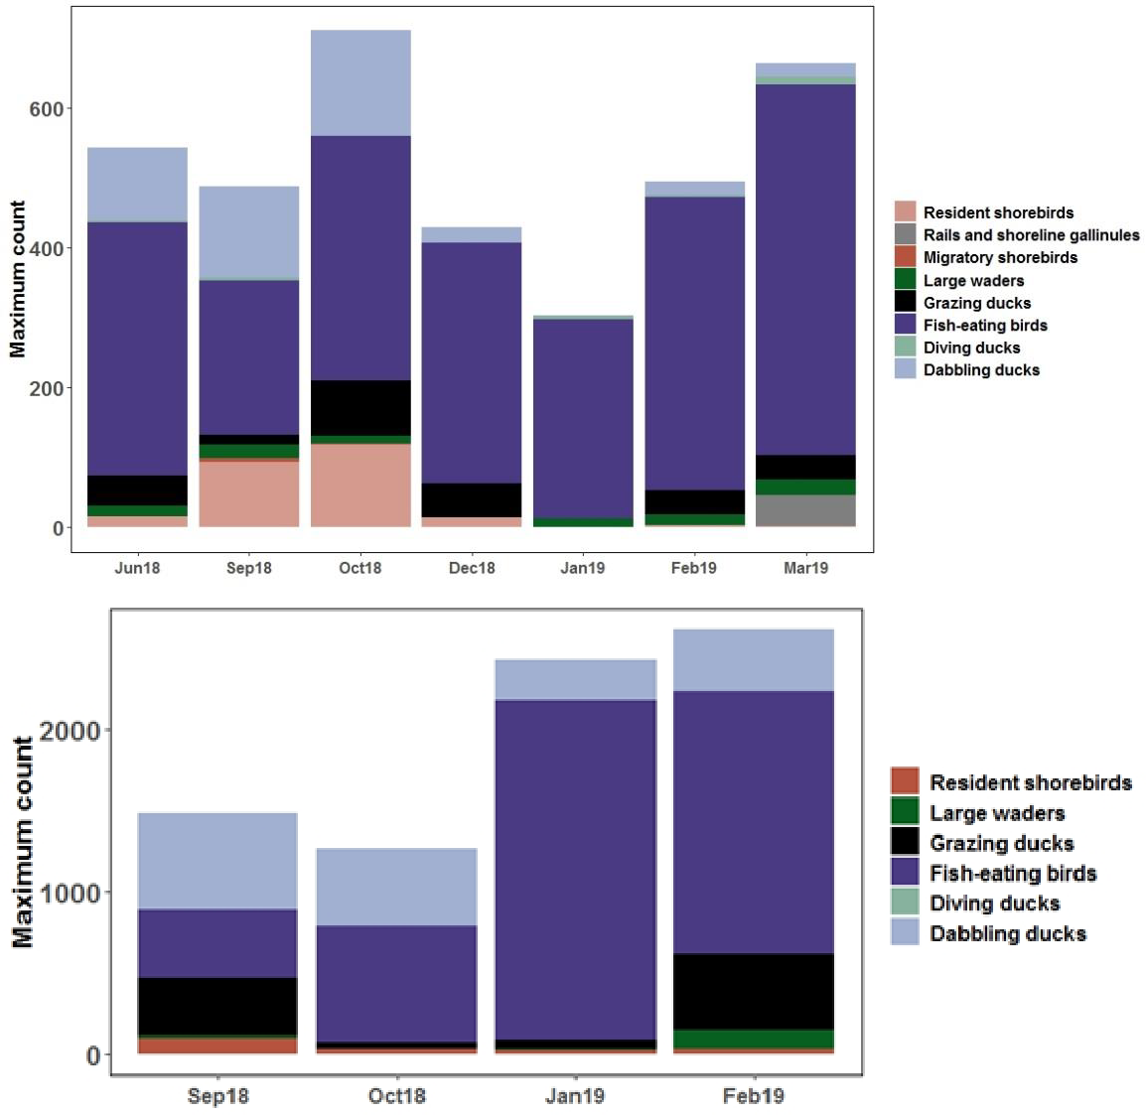
Figure 18. Top panel: Abundance of six waterbird functional groups at Yanga Lake from boat surveys between September 2018 and February 2019. Bottom panel: Abundance of eight waterbird functional groups at Tala Lake from boat surveys completed between June 2018 and March 2019. Environmental flow connected to Tala Lake in October 2018 and connected to Yanga Lake in December 2018.

Waterbird spring counts (DPIE)
October 2018 saw the highest diversity of species at Yanga Lake from all DPIE spring counts since October 2010 (20 species) (Figure 19). It also had the highest number of functional groups since 2010 (six) and the second highest abundance of waterbirds from all DPIE spring ground counts between October 2010 and October 2018, with piscivorous waterbirds being the most abundant functional group (Figure 20). Tala Lake is not a DPIE spring count site so we do not have annual records to compare.

The high species diversity and abundances at Yanga Lake is probably indicative of good food availability within the lake at the time of the surveys. Fish-eating waterbirds were a dominant functional group at the lake during all surveys suggesting that Yanga Lake provides suitable foraging habitat for this group. The surrounding dry landscape conditions may have also influenced waterbird activity. This could include the high abundance at Yanga Lake in 2018 as it, and several other sites that received water for the environment in 2018-19 season, acted as a floodplain refuge in the lower Murrumbidgee. Waterbirds are known to concentrate on freshwater and saline lakes during intermediate stages of floodplain drying (Kingsford et al. 2010).

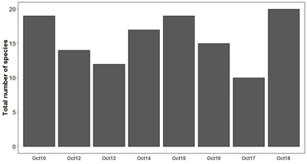
Figure 19. Total number waterbird species recorded in Yanga Lake during ground surveys completed by DPIE from October 2010-October 2018. Note that no surveys were completed in October 2011.

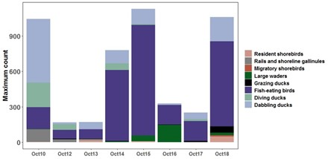

Figure 20. Maximum abundance of each functional group recorded in Yanga Lake during ground surveys completed by DPIE from October 2010-October 2018. Note that no surveys were completed in October 2011.

Links between waterbird and fish communities
Australian pelicans were the most abundant waterbird species across the surveys at both Yanga and Tala lakes. Large numbers of Australian pelicans (>700 birds) were observed at Yanga Lake in three out of four boat surveys, between September 2018 and February 2019, and estimates ranged from 394 (September 2018) to 2021 (January 2019). Tala Lake had smaller numbers of pelicans, ranging from 77 (January 2019) to 292 (October 2018) individuals.
An Australian pelican was found dead and observed to have been feeding on a large golden perch, during the September survey of Tala Lake (Figure 21). They were also observed feeding on smaller native fish, including golden perch and bony bream, upstream in Tala Creek in the June 2018 survey. Estimates for a comparable species, the American White Pelican (Pelecanus erythrorhynchos), indicate they need to consume 10% of their body mass for daily maintenance, and this increases during breeding (Ferguson et al. 2011). If similar maintenance applies to Australian pelicans, an individual would consume 400-680 g of fish daily. This would equate to a daily consumption of fish ranging from 808 – 1,374 kg at the maximum estimated pelican abundance at Yanga Lake (2,021), to a minimum of 158 – 268 kg at their lowest (394) estimated abundance.
Over the waterbird survey period lasting approximately 200 days (1 September 2018 to 20 March 2019), the estimated total consumption of fish by resident waterbirds at Yanga Lake alone ranged from an estimated minimum of 32 tonnes to a maximum of 275 tonnes of fish. Without directly studying the diets and movements of pelicans at the lakes, it is not possible to discern what fish species have been consumed most or the total biomass of fish removed from the lakes.
However, at size ranges of less than 52 cm (the apparent upper size limit for prey of Australian pelicans) and larger than 2 cm, the potential fish prey items for pelicans at Yanga Lake, in order of relative abundance from monitoring here were juvenile common carp, carp gudgeon, bony bream

and Australian smelt, followed by golden perch. Given the reduction in relative abundance of juvenile golden perch in Yanga Lake between 2017/18 and 2018/19 discussed previously, it is plausible that predation by pelicans contributed to natural mortality.
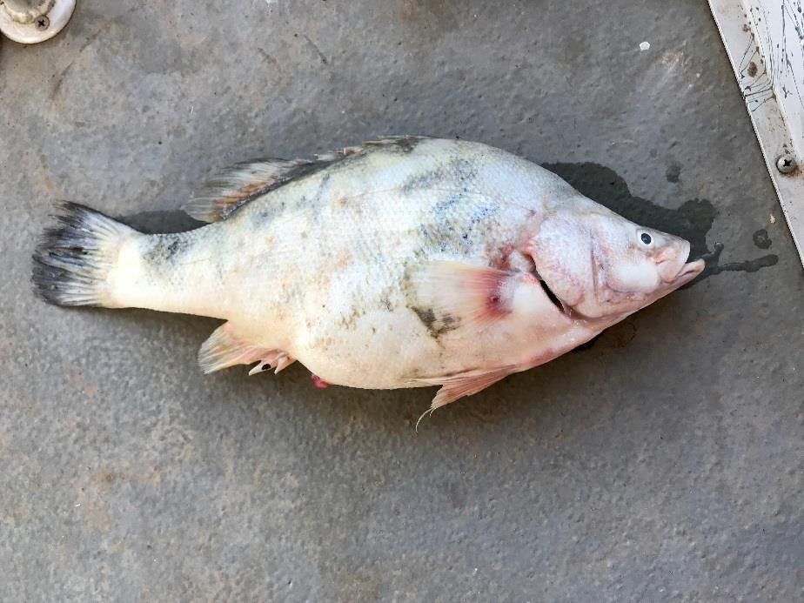

Figure 21. A fifty-one centimetre dead golden perch in spawning condition found in a dead Australian pelican bill at Tala Lake September 2018. Photo: C Amos (September 2018).

Links to adaptive management
The inundation of floodplain environments to support objectives related to native fish can provide additional benefits that propagate through food webs and lead to benefits for other organisms including internationally protected waterbirds, but also invasive species. During the extreme drought conditions and the fish-kills experienced in New South Wales in 2018 and continuing through 2019, these inundated floodplain habitats and lakes provided rare refuges of high quality habitat and productivity that attracted a diverse waterbird assemblage and contributed to native and invasive fish growth, spawning and recruitment. In particular, the successful recruitment of native golden perch in the Tala floodplain system should be carefully managed, and justifies long-term support via environmental flows since this system and Yanga Lake is vulnerable to drying-out completely during the extreme drought conditions. Although the golden perch recruitment event in 2018/19 was not widespread, its potential importance to local populations should not be underestimated, especially in a year following fish-kills in the Murrumbidgee River.
Unfortunately, the benefits of floodplain inundation to native fishes extend similarly to invasive common carp which were widespread throughout the system and at various stages of development competed with native species for food resources on the floodplain. However, the abundance of juvenile invasive common carp were also a likely food source for resident fish-eating waterbirds. There is currently no feasible way to prevent carp from using environmental water at large spatial scales on floodplains. In spite of the potential benefits for invasive common carp, we recommend a long-term strategy of continuing to deliver environmental flows on floodplains using targeted approaches known also to support native species.

If a long-term strategy of delivering more natural flows to floodplains is implemented, we are confident in the resilience of native species and their ability to compete with common carp.
Historically, common carp existed in this system prior to the development of large dams and river regulation (Anderson 1920), but given the more natural flow regimes at the time, native floodplain specialists proliferated. This suggests that the loss of native species and recruitment failure on Murrumbidgee floodplains is primarily a function of flow alteration, particularly the loss of lateral river-floodplain connectivity, which may be mitigated in part by environmental flows such as those implemented here. Given the loss of over eight native fishes from the local area over the past 100 years, complementary adaptive management actions, including re-introductions of floodplain specialists back into floodplain ecosystems is likely to be necessary for environmental flows to benefit these species. Both, Tala and Yanga Lakes and the connected floodplain creeks provide large areas of high quality floodplain habitat that may be suitable for reintroduction programs. A re- introduction strategy would need to consider other factors including macrophyte habitat, competition with invasive common carp and predation by waterbirds which could be manipulated in field experiments to optimise release strategies.
From an environmental flow management perspective, there are four potential scenarios that our monitoring program addressed which will influence adaptive management measures targeted at benefiting native fish:

Scenario 1. If native fish recruitment in the lakes is supported by larvae, juveniles and food resources derived from the main river channel, then environmental water delivery to the system may not require floodplain inundation to maintain populations. In this scenario, relatively small volumes of environmental water and regulatory structures would be used to ensure the free movement of adults, juveniles and larvae from the main river channel into the lakes.

Scenario 2. If native fish recruitment in the lakes is supported by floodplain re- connection and inundation, then the delivery of large over-bank environmental flows across the floodplain may be necessary to trigger adult movements, spawning and the production of food resources necessary to support populations. This scenario would provide strong justification for the delivery of sufficiently large volumes of environmental water to inundate floodplain habitats during spring in order to maintain viable fish populations in the lakes.

Scenario 3. Scenarios 1 and 2 are not mutually exclusive since fish populations in the lake may be sustained by both river channel and floodplain derived sources of food, adults and recruits. In this case, small environmental flows would be used to consistently ensure the free movement of adults, juveniles and larvae from the main river channel into the lakes and in addition large volumes of environmental water would be delivered in other years to inundate floodplain habitat and promote recruitment.

Scenario 4. If larval fish are spawned in zero-flow floodplain lake, or creek environments then small environmental flow diversions may be help maintain water levels and fish populations.

Although golden perch can spawn and recruit within main river channel environments (Mallen‐Cooper and Stuart 2003), the results from monitoring of environmental flows here suggests that both spawning and recruitment of this species occurred primarily in slow flowing floodplain creeks (Scenario 2), while other species such as Murray cod (Scenario 1) were only detected drifting into the floodplain from the Murrumbidgee River, and small-bodied species including carp gudgeon and Australian smelt spawned and recruited in both river channel and floodplain environments (Scenario 3). These results contribute to evidence supporting management decisions to deliver over- bank environmental flows across the floodplain to maximise the production of food resources supporting golden perch and bony bream spawning and recruitment. This requires the delivery of sufficiently large volumes of environmental water to inundate floodplain habitats during spring in order to maintain viable fish populations in the lakes and connected creeks. Environmental water could also be coupled with opportunistic high-flow periods, or strategic releases of hatchery-reared native fishes in order to maximise fish recruitment outcomes.

Recommendations

- There is a need to develop a long-term environmental flow management strategy for river- floodplain ecosystems in the Murrumbidgee which incorporates results from monitoring in 2018/19, previous long-term intervention monitoring, as well as historical flow and species composition data. Based on the diverse flow requirements of fish and waterbird assemblages, Scenario 3 is most likely to help meet the range of ecological requirements necessary to maintain biodiversity. A long-term strategy would quantify the frequency and extent of different types of flows historically and optimize current releases, whilst accounting for how anthropogenic changes (e.g. weirs; common carp) have modified the system.

- Large over-bank floods have a long history of sustaining golden perch populations in the region and therefore frequent and large magnitude flows during November and December will promote recruitment of golden perch in addition to supporting diverse floodplain ecosystems. Given moderate water availability in 2018/19, the delivery of a larger sustained environmental flow through the Redbank system supported a range of significant biodiversity values, supported golden perch spawning and recruitment and helped to sustain high quality refuge habitats. These large, long duration watering actions should continue to be considered a priority in future management actions.

- Floodplain creeks, such as Tala Creek and Talpee Creek, appear to provide important refuge and recruitment habitat for juvenile and adult golden perch. In dry conditions when large over-bank flows cannot be delivered, using environmental flows to maintain water levels and good water quality in floodplain creeks is likely to help sustain populations during drought and hypoxic conditions in the main river channel.

- Given the loss of over eight native fishes from the local area over the past 100 years, re- introductions of floodplain specialists back into these ecosystems is likely to be necessary for environmental flows to benefit these fishes. Small-scale release-recapture trials in

floodplain habitats would be necessary to optimize release strategies that maximize survival and control for other threatening processes (e.g. macrophyte loss; presence of carp). Trials could be conducted on southern pygmy perch, juvenile golden and silver perch in these high quality floodplain habitats in order to augment natural recruitment in conjunction with environmental flows.

- To maintain high waterbird species richness it is recommended that floodplain lakes are not fully inundated at all times. The diversity of habitats that can be provided through fluctuating water levels at these sites can support multiple functional groups of waterbirds from waders through to fish-eating water birds when levels are managed appropriately. Fluctuating water levels in the lakes are likely to provide more productive aquatic environments for both fish and waterbirds. In years following large-scale flooding when there have been high levels of waterbird breeding, the floodplain and lakes are likely to provide important foraging areas for juveniles.

Acknowledgements
Thanks to Clayton Sharpe and Matt Kayne for assistance selecting field sites and for providing valuable advice, property access and equipment. Thanks very much to Simone Carmichael and the staff at Yanga National Park for their hospitality and support for the project and to Rex Conallin for collecting otoliths following the fish-kill. Thanks to Ruan Gannon, Taylar Pay, Jason Healy, Liu Xiaoying (Sha Sha), Daniel Svozil and Edwardo Brambilla for assistance with lab and fieldwork. The waterbird surveys were completed by Carmen Amos, Alison Borrell and Amelia Walcott (DPIE). We are very grateful to support from our boat drivers Matt Kayne, Ken Grisdale, Matt Jess and Mark Henderson. Fish sampling was carried out under NSW Fisheries Permit S37 P11/0043-2.0 and animal care and ethics approval through CSU, ACEC A18066. DPIE Waterbird surveys were approved under NSW NPWS scientific licence SL100100 and NSW OEH Animal Ethics Approval AEC091214/01.

References
AGLER, B.A., KENDALL, S., J., IRONS. D.B., KLOSIEWSKI, S.P. (1999). Declines in Marine Bird
Populations in Prince William Sound, Alaska Coincident with a Climatic Regime Shift. Waterbirds: The International Journal of Waterbird Biology 22 (1): 98-103.
ANDERSON, H.K., (1920). Rescue operations on the Murrumbidgee River. Proceedings of the Royal Zoological Society of NSW, 1, pp.157-160.
BALDWIN, D.S, NIELSEN, D.L., BOWEN, P.M. AND WILLIAMS, J. (2005). Recommended Methods for Monitoring Floodplains and Wetlands. Murray–Darling Basin Commission, Canberra.
BEESLEY, L., KING, A. J., GAWNE, B., KOEHN, J. D., PRICE, A., NIELSEN, D., AMTSTAETTER, F. & MEREDITH, S. N. (2014).
Optimising environmental watering of floodplain wetlands for fish. Freshwater Biology, 59, 2024-2037.
BEESLEY, L., PRICE, A., KING, A., GAWNE, B., NIELSEN, D. L., KOEHN, J. D., MEREDITH, S., VILIZZI, L. & HLADYZ, S. (2011).
Watering floodplain wetlands in the Murray-Darling Basin for native fish, Canberra, National Water Commission BROWN, P. (1994). The Murrumbidgee River fishery a historical perspective. In: ROBERTS, J. & OLIVER, R. (eds.) The
Murrumbidgee, Past and Present. Griffith: CSIRO Division of Water Resources.
BROWN, P., SIVAKUMARAN, K. P., STOESSEL, D., & GILES, A. (2005). Population biology of carp (Cyprinus carpio L.) In the mid-Murray River and Barmah Forest Wetlands, Australia. Marine and Freshwater Research, 56(8), 1151-1164.
CADWALLADER, P. L. 1977. JO Langtry's 1949-50 Murray River investigations. Fisheries and Wildlife Division, Victoria. COMMONWEALTH ENVIRONMENTAL WATER (2013). The Environmental Water Outcomes Framework, Canberra,
Commonwealth Environmental Water Holder for the Australian Government.
FERGUSON, T.L., RUDE, B.J. AND KING, D.T., 2011. Nutrient utilization and diet preference of
American White Pelicans consuming either a mono-or multi-species diet. Waterbirds: The International Journal of Waterbird Biology, pp.218-224.Kingsford, R.T. (1999). ‘Aerial survey of waterbirds on wetlands as a measure of
river and floodplain health’. Freshwater Biology 41: 425-438.
FORSYTH, D., KOEHN, J., MACKENZIE, D. & STUART, I. (2013.) Population dynamics of invading freshwater fish: common carp (Cyprinus carpio) in the Murray-Darling Basin, Australia. Biological Invasions, 15, 341-354.
HUMPHRIES, P., KING, A. J. & KOEHN, J. D. (1999). Fish, flows and floodplains: links between freshwater fishes and their environment in the Murray-Darling River System, Australia. Environmental Biology of Fishes, 56, 129-151.
HUMPHRIES, P., BROWN, P., DOUGLAS, J., PICKWORTH, A., STRONGMAN, R., HALL, K. & SERAFINI, L. (2008). Flow-related
patterns in abundance and composition of the fish fauna of a degraded Australian lowland river. Freshwater Biology, 53, 789-813.
HUMPHRIES, P., KING, A. J., MCCASKER, N., KOPF, R. K., STOFFELS, R., ZAMPATTI, B. P., & PRICE, A. E. (2019). Riverscape
recruitment: a conceptual synthesis of drivers of fish recruitment in rivers. Canadian Journal of Fisheries and Aquatic Sciences, (ja).
KING, A. J., HUMPHRIES, P. & LAKE, P. S. (2003). Fish recruitment on floodplains: the roles of patterns of flooding and life history characteristics. Canadian Journal of Fisheries and Aquatic Sciences, 60, 773-786.
KINGSFORD, R.T. (1999). Aerial survey of waterbirds on wetlands as a measure of river and floodplain health’. Freshwater Biology 41: 425-438.
KINGSFORD, R.T., JENKINS, K.M. AND PORTER, J.L., (2004). Imposed hydrological stability on lakes in Arid Australia and effects on waterbirds. Ecology 85(9), pp.2478-2492.
KINGSFORD, R.T., ROSHIER, D.A. AND PORTER, J.L., (2010). Australian waterbirds–time and space Travellers in dynamic desert landscapes. Marine and Freshwater Research, 61(8), pp.875-884.
KOPF, R. K., HUMPHRIES, P., BOND, N. R., SIMS, N. C., WATTS, R. J., THOMPSON, R. M., ET AL. (2018). Macroecology of fish
community biomass–size structure: effects of invasive species and river regulation. Canadian Journal of Fisheries and Aquatic Sciences, 76(1), 109-122.
KOSTER, W. M., DAWSON, D. R., O'MAHONY, D. J., MOLONEY, P. D. & CROOK, D. A. (2014). Timing, frequency and
environmental conditions associated with mainstem-tributary movement by a lowland river fish, golden perch (Macquaria ambigua). Plos one, 9.
KOSTER, W. M., DAWSON, D. R., LIU, C., MOLONEY, P. D., CROOK, D. A., & THOMSON, J. R. (2017). Influence of streamflow
on spawning‐related movements of golden perch M acquaria ambigua in south‐eastern Australia. Journal of Fish Biology, 90(1), 93-108.
LEIGH, S. & ZAMPATTI, B. 2013. Movement and mortality of Murray cod (Maccullochella peelii) during overbank flows in the lower River Murray, Australia. Australian Journal of Zoology.
LYON, J., STUART, I. G., RAMSEY, D. & O'MAHONY, J. M. (2010). The effect of water level on lateral movements of fish between river and off-channel habitats and implications for management. Marine and Freshwater Research, 61, 271-278.
MALLEN‐COOPER, M., & STUART, I. G. (2003). Age, growth and non‐flood recruitment of two potamodromous fishes in a large semi‐arid/temperate river system. River research and applications, 19(7), 697-719.
MARSHALL, J. C., BLESSING, J. J., CLIFFORD, S. E., HODGES, K. M., NEGUS, P. M., & STEWARD, A. L. (2019). Ecological
impacts of invasive carp in Australian dryland rivers. Aquatic Conservation: Marine and Freshwater Ecosystems.
MCGINNESS, H. M., PATON, A., GAWNE, B., KING, A. J., KOPF, R. K., MAC NALLY, R., & MCINERNEY, P. J. (2019). Effects of
fish kills on fish consumers and other water-dependent fauna: exploring the potential effect of mass mortality of carp in Australia. Marine and Freshwater Research.

MOUS, P.J., (2000). Interactions between fisheries and birds in Ijsselmeer, The Netherlands. Phd Thesis, Wageningen University, Wageningen, The Netherlands.
PORTER, J.L., KINGSFORD, R.T., AND BRANDIS, K. (2018). Aerial Survey of Wetland Birds in Eastern
Australia – October 2018 Annual Summary Report. Centre for Ecosystem Science, University of New South Wales, Sydney.
PUCKRIDGE, J. T., & WALKER, K. F. (1990). Reproductive biology and larval development of a gizzard shad, Nematalosa erebi (Gunther)(Dorosomatinae: Teleostei), in the River Murray, South Australia. Marine and Freshwater Research, 41(6), 695-712.
ROLLS, R. J., GROWNS, I. O., KHAN, T. A., WILSON, G. G., ELLISON, T. L., PRIOR, A. & WARING, C. C. (2013). Fish recruitment
in rivers with modified discharge depends on the interacting effects of flow and thermal regimes. Freshwater Biology.
SHARPE, C.(2018). Lower Murrumbidgee floodplain fish surveys 2018. Summary of findings Report for the NSW Office of Environment and Heritage by CPS Enviro P/L.
SPENCER, J., OCOCK, J., AMOS, C., BORRELL, A., SUTER, S., PRESTON, D., HOSKING, T., HUMPHRIES, J., HUTTON, K., BERNEY, P., LENON, E., BROOKHOUSE, N., KEYTE, P., DYER, J., AND LENEHAN, J. (2018). Monitoring Waterbird Outcomes in
NSW: Summary Report 2016-17.
SVOZIL, D. P., KOPF, R. K., WATTS, R. J., & NICHOLLS, A. O. (2019). Temperature-dependent larval survival and growth differences among populations of Murray cod (Maccullochella peelii). Marine and Freshwater Research, 70(4), 459-468.
WASSENS, S., JENKINS, K., SPENCER, J., THIEM, J., BINO, G., LENON, E., THOMAS, R., KOBAYASHI, T.,
BAUMGARTNER, L., BRANDIS, K., WOLFENDEN, B., HALL, A., WATSON, M., AND SCOTT, N. (2014). Murrumbidgee
Selected Area Monitoring and Evaluation Plan. Prepared for the Commonwealth Environmental Water Office.
WASSENS, S., SPENCER, J., THIEM, J., WOLFENDEN, B., JENKINS, K., HALL , A., OCOCK, J., KOBAYASHI, T., THOMAS, R., BINO,
G., HEATH, J. & LENON, E. (2016). Commonwealth Environmental Water Office Long-term Intervention Monitoring project Murrumbidgee River System Selected Area evaluation, Canberra, Commonwealth of Australia.
WASSENS, S., SPENCER, J., WOLFENDEN, B., THIEM, J., THOMAS, R., JENKINS, K., HALL, A., OCOCK, J., KOBAYASHI, T, BINO,
G., DAVIS, T. , HEATH, J ., KUO, W., AMOS, C. AND MICHAEL, D. (2019). Commonwealth Environmental Water Office Long-term Intervention Monitoring Project Murrumbidgee River System Selected Area Technical Report, 2014-2019. Commonwealth of Australia 2019.
WEDDERBURN, S. D., WALKER, K. F. & ZAMPATTI, B. P. (2007). Habitat separation of Craterocephalus (Atherinidae) species and populations in off-channel areas of the lower River Murray, Australia. Ecology of Freshwater Fish, 16, 442- 449.
ZAMPATTI, B. P., WILSON, P. J., BAUMGARTNER, L., KOSTER, W., LIVORE, J. P., MCCASKER, N., THIEM, J., TONKIN, Z. & YE,
Q. 2015. Reproduction and recruitment of golden perch (Macquaria ambigua ambigua) in the southern Murray- Darling Basin in 2013-2014: an exploration of river-scale response, connectivity and population dynamics, Adelaide, South Australian Research and Development Institute (Aquatic Sciences).
ŽYDELIS, R. AND KONTAUTAS, A. (2008). Piscivorous birds as top predators and fishery competitors in the lagoon ecosystem. Hydrobiologia, 611(1), pp.45-54.

Appendix 1 – Species List
Wetland-dependent bird species recorded in 2018-19 STIM project at Yanga and Tala Lakes.
Functional Group | Common Name | Scientific Name | CAVS Code
Dabbling ducks | Australasian Shoveler | Anas rhynchotis | 212
 | Freckled Duck | Stictonetta naevosa | 214
 | Grey Teal | Anas gracilis | 211
 | Pacific Black Duck | Anas superciliosa | 208
 | Pink-eared Duck | Malacorhynchus membranaceus | 213
Diving ducks | Black Swan | Cygnus atratus | 203
 | Eurasian Coot | Fulica atra | 59
 | Hardhead | Aythya australis | 215
Fish-eating birds (piscivores) | Australasian Darter | Anhinga novaehollandiae | 8731
 | Australasian Grebe | Tachybaptus novaehollandiae | 61
 | Australian Gull-billed Tern | Gelochelidon macrotarsa | 8794
 | Australian Pelican | Pelecanus conspicillatus | 106
 | Caspian Tern | Hydroprogne caspia | 112
 | Eastern Great Egret | Ardea alba modesta | 8712
 | Great Cormorant | Phalacrocorax carbo | 96
 | Great Crested Grebe | Podiceps cristatus | 60
 | Intermediate Egret | Ardea intermedia | 186
 | Little Black Cormorant | Phalacrocorax sulcirostris | 97
 | Little Pied Cormorant | Microcarbo melanoleucos | 100
 | Pied Cormorant | Phalacrocorax varius | 99
 | Sacred Kingfisher | Todiramphus sanctus | 326
 | Silver Gull | Chroicocephalus novaehollandiae | 125
 | Whiskered Tern | Chlidonias hybrida | 110
 | White-faced Heron | Egretta novaehollandiae | 188
 | White-necked Heron | Ardea pacifica | 189
Grazing ducks | Australian Shelduck | Tadorna tadornoides | 207
 | Australian Wood Duck | Chenonetta jubata | 202
Large waders | Australian White Ibis | Threskiornis molucca | 179
 | Royal Spoonbill | Platalea regia | 181
 | Yellow-billed Spoonbill | Platalea flavipes | 182
Migratory shorebirds | Marsh Sandpiper | Tringa stagnatilis | 159
 | Red-necked Stint | Calidris ruficollis | 162
 | Sharp-tailed Sandpiper | Calidris acuminata | 163
Rails and shoreline  gallinules | Black-tailed Native-hen | Tribonyx ventralis | 55
Raptor | Black Kite | Milvus migrans | 229
 | Brown Falcon | Falco berigora | 239
 | Whistling Kite | Haliastur sphenurus | 228
 | White-bellied Sea-Eagle | Haliaeetus leucogaster | 226
Resident shorebirds | Black-fronted Dotterel | Elseyornis melanops | 144
 | Black-winged Stilt | Himantopus leucocephalus | 146
 | Masked Lapwing | Vanellus miles | 133
 | Red-capped Plover | Charadrius ruficapillus | 143
 | Red-necked Avocet | Recurvirostra novaehollandiae | 148
Functional groups as described by Hale et al. (2014). Nomenclature follows Christidis and Boles (2008).

