## The framework’s vision

Native vegetation across the Australian landscape is managed in an ecologically sustainable way in recognition of its enduring environmental, economic, social, cultural and spiritual values.

# Australia’s Native Vegetation Framework

Australia’s Native Vegetation Framework has been developed by the Australian Government and state and territory governments to maintain or build healthier and more connected native vegetation. The framework is a strategic document with five goals to guide government, the community and the private sector in native vegetation management across Australia. It is not prescriptive or binding.

Governments across Australia are working together to implement the framework as well as to monitor and report on progress. The COAG Standing Council on Environment and Water will formally oversee implementation of the framework and coordinate regular reviews and updates.

# National goals for native vegetation management

The five goals and supporting targets of Australia’s Native Vegetation Framework are vital for long-term sustainable management of native vegetation. The goals will guide us in maintaining ecosystem resilience, improving the productive capacity of the land and promoting healthy ecosystem function across the landscape. Realising the framework goals will involve people from all levels of governance, the business and industry sectors, private landholders and the community.

National Goals

**Goal 1. Increase the national extent and connectivity of native vegetation**

**Goal 2. Maintain and improve the condition and function of native vegetation**

**Goal 3. Maximise the native vegetation benefits of ecosystem service markets**

**Goal 4. Build capacity to understand, value and manage native vegetation**

***Goal 5. Advance the engagement and inclusion of Indigenous peoples in management of native vegetation***

*Wildflowers at Mount Hotham, VIC (Photo by Trevor J Ierino)*

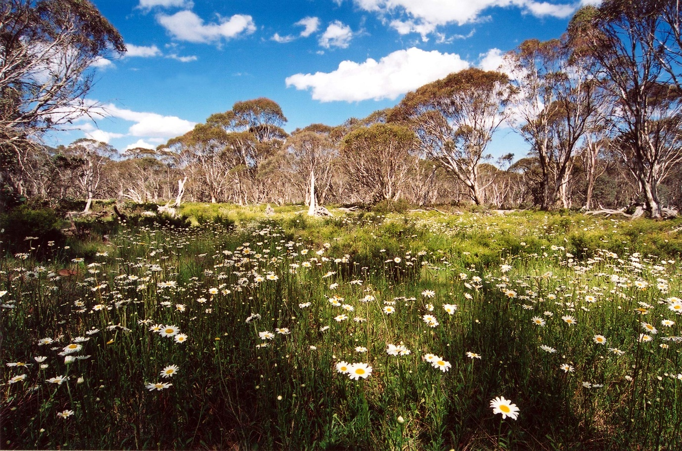

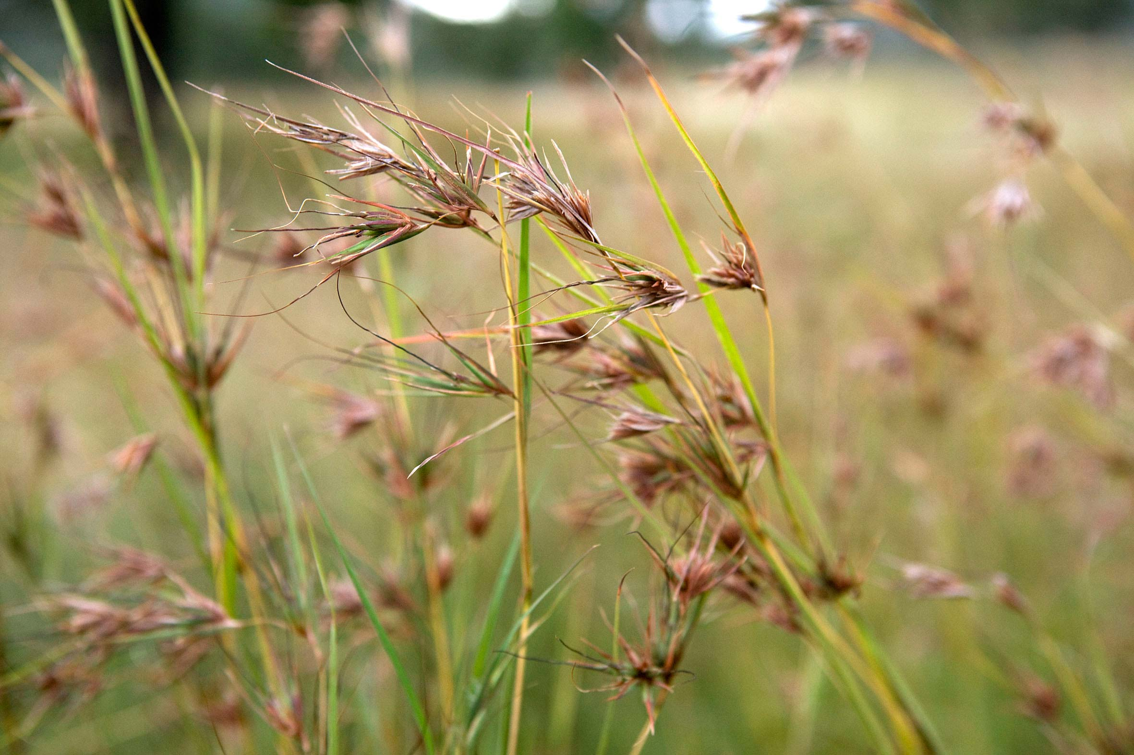

*Kangaroo Grass* (Themeda australis) *on Carnarvon Station, QLD (Photo by Dragi Markovic)*

## Why is native vegetation important?

Ecological value — Australia’s native vegetation is extraordinarily diverse, rich in species and complexity and has many unique physical features. About 85 per cent of Australia’s plant species are endemic to the continent. Native vegetation is a vital component of Australia’s biodiversity. It plays a crucial role in sustaining ecosystem function and processes, buffering the impacts of harsh and extremely variable climates, binding and nourishing soils, cleansing the air and filtering water.

Economic value — Economically, native vegetation and its direct soil and water functions support the productive capacity of many important sectors of the Australian economy. These include agriculture, forestry, fisheries and aquaculture and tourism. Native vegetation management also has the potential to generate significant employment and enterprise development opportunities for rural and regional Australians including Indigenous peoples, for example as part of sustainable agriculture.

Social and cultural value — Native vegetation shapes the Australian culture and national identity. For Indigenous Australians, the land and its resources have underpinned Indigenous history, innovation, culture, spirituality and economics for tens of thousands of years.

## Why do we need a plan of action?

Native vegetation is of value to all Australians. In many parts of Australia, however, it has been cleared or degraded and fragmented as a result of human activity and influence.

According to the Australia state of the environment 2011 report

* only around 25 per cent of Australia’s original estimated extent of native vegetation remains intact
* 62 per cent has been subject to disturbance and modification
* 13 per cent has been completely converted to other land uses, predominantly agriculture.

Threats to native vegetation have potentially serious consequences for Australia. The impact of these threats includes the decline of biodiversity and reduced ecosystem functioning, reduced water quality, increased erosion and salinity, increased greenhouse gas emissions, reduced productivity and impacts on cultural and spiritual identity.

Over the years, Australian governments, industry and the community have invested significantly in the sustainable use and conservation of native vegetation. Nevertheless, further action is needed from all land users and managers to achieve the long-term sustainability of Australia’s native vegetation.

Australia’s Native Vegetation Framework guides the way to an Australian landscape that maintains and promotes healthy, diverse and connected native vegetation communities, while providing environmental, social and economic benefits for all Australians.

## Goal 1: Increase the national extent and connectivity of native vegetation

Because it is difficult to put back native vegetation once lost, we need to retain and protect existing native vegetation communities as the first priority for management. In extensively cleared landscapes, regeneration and revegetation will also be needed to connect and extend native vegetation to improve landscape function. Achieving this important goal will require widespread collaboration between land managers, the community, non-government organisations, industry and all Australian governments.

### Targets

Target 1: By 2014 all Australian state and territory governments will have developed targets for the extent of native vegetation in their jurisdictions.

Target 2: By 2016 targets for native vegetation extent will have been recognised and reflected by all tiers of government and regional organisations in environment and natural resource management planning, land use planning and land management.

Target 3: By 2020 there will be a net national increase in the extent of native vegetation, including where it can contribute to landscape connectivity.

## Case Study: The Gondwana Link program — towards 1000 km of ecologically functioning landscape

The Gondwana Link program, established in 2002, is a landscape-scale vision to restore ecological connectivity across south-west Western Australia, and to build a ‘living link’ that extends eastward across part of the continent. The connectivity conservation area covers more than 20 million hectares over a 1000 kilometre swathe of habitats — from the Karri forests of the south-west across the Great Western Woodlands to the edge of the Nullarbor Plain and beyond. More than 900 kilometres of this remains structurally intact and holds more than 75 per cent of the flowering plant taxa of the south west botanical hotspot. It is also arguably the part of the south west most buffered from accelerated climate change.

In the agricultural sections of Gondwana Link, more than 8000 hectares of strategically located bushland have been protected and some 2400 hectares of paddock restored. In one key section of the link, between Fitzgerald River and Stirling Range National Parks, the cleared gaps between secure habitat areas have already been reduced by an average of 55 per cent.

The Gondwana Link program involves collaboration across a wide spectrum of private sector organisations, at local, national and international levels. For more information see: [www.gondwanalink.org/](http://www.gondwanalink.org/)

*Tree plantings on the raised shoreline at the Kitty Miller Wetlands, Phillip Island, VIC (Photo by John Baker)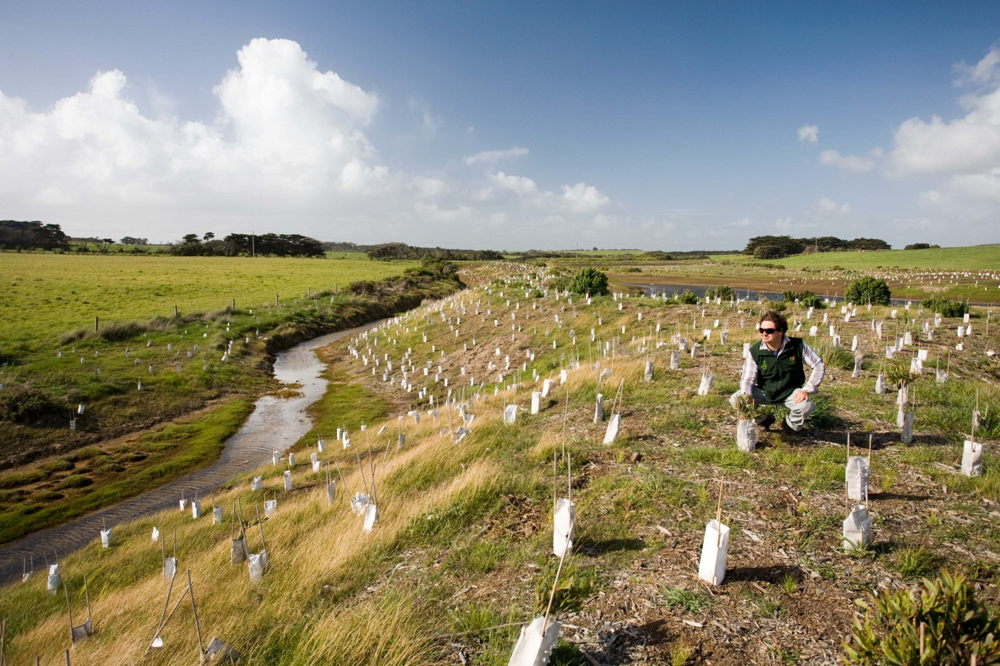*

## Goal 2: Maintain and improve the condition and function of native vegetation

Managing the threats to native vegetation condition and ecosystem function is critical for Australia’s ecosystems. Working to improve the condition and function of native vegetation will promote and maintain a healthy and resilient landscape, and will support both biodiversity and the productive capacity of land into the future.

### Targets

Target 4: By 2014 agreed protocols are in place and by 2016 monitoring systems are in place to measure changes in the condition of representative native vegetation communities across Australia.

Target 5: By 2015 strategic plans are developed for Australia’s native vegetation, including plans aimed at reducing priority threats to condition and their underlying drivers.

Target 6: By 2025 there will be a net national improvement in condition of native vegetation.

## Caring for our Country — Environmental Stewardship

The Environmental Stewardship Program is an element of the Australian Government’s Caring for our Country initiative. It focuses on creating markets for the purchase of long-term conservation improvements on private land. Under the program, eligible land managers can receive funding for up to 15 years to undertake agreed conservation management actions. Since 2008, the Environmental Stewardship Program has been working with land managers to protect and restore more than 58 000 hectares of endangered and critically endangered ecological communities. During 2011–2012 the program delivered its second funding round targeting ecological communities in South Australia, building on the earlier program work in New South Wales and Queensland. Environmental assets targeted through the program are matters of national environmental significance listed under the Environment Protection and Biodiversity Conservation Act 1999. For more information see: [www.nrm.gov.au/stewardship](http://www.nrm.gov.au/stewardship)

## Goal 3: Maximise the native vegetation benefits of ecosystem service markets

Ecosystem service markets provide important opportunities for improving native vegetation and biodiversity outcomes. Market-based instruments can place an economic value on ecosystem services, and thereby provide economic incentives for environmental protection and actions, as well as an alternative revenue stream for land users and managers. They will be particularly important as we face the challenges of climate change.

### Targets

Target 7: By 2014 systems and guidelines have been developed for accreditation and reporting of the biodiversity co‑benefits of carbon markets.

Target 8: By 2015 credible and consistent accounting tools are developed to measure and report on carbon sequestration and avoidance initiatives across Australia, related to the establishment and management of native vegetation communities, including permanent, biodiverse, locally native plantings.

## Goal 4: Build capacity to understand, value and manage native vegetation

Engaging all Australians is important if we are to succeed in achieving the vision of the framework. People play a central role in the management of native vegetation; particularly private and leasehold land managers and Indigenous Australians as custodians of large land areas across Australia. Strategic actions to increase the capacity of people, networks and infrastructures will improve our ability to effectively manage and protect Australia’s native vegetation.

### Targets

Target 9: By 2014 targeted communication programs and community engagement programs are in place to enable a range of stakeholder groups to better understand the values of native vegetation.

Target 10: By 2016 there has been an increase in the number of Australians who understand the benefits and values of native vegetation.

Target 11: By 2016 major public and private land managers and industries recognise the benefits of native vegetation by undertaking practices that promote the ecologically sustainable management of native vegetation.

## Goal 5: Advance the engagement and inclusion of Indigenous peoples in management of native vegetation

Indigenous ecological knowledge has an important role to play in native vegetation management. Indigenous Australians are already significant contributors to biodiversity conservation and native vegetation management, managing an estimated 23 per cent of Australia including some of our most biodiverse and intact ecosystems.

### Targets

Target 12: By 2014 Indigenous peoples have been engaged in developing culturally appropriate approaches to their involvement in native vegetation management across Australia.

Target 13: By 2016 culturally appropriate approaches have been implemented that involve Indigenous peoples in native vegetation management.

Target 14: By 2016 relevant decision-makers in all levels of government understand the significance of native vegetation to Indigenous peoples and reflect this in decision making.

## Case Study: The ACT Caring for the Cotter River Catchment Project

The ACT Government and the Ngunnawal people are working together in a cross-cultural partnership aimed at restoring and protecting the Cotter River catchment west of Canberra. Indigenous trainees with the ACT Government — known as the Yurung Dhaura team — work to restore high value ecosystems and achieve various conservation targets.

A key feature of the project is the combination of traditional knowledge and vocational training. Trainees undertake tertiary studies and work with the Ngunnawal people to document their traditional ecological knowledge and to apply this, with permission, to biodiversity conservation within the catchment.

The team has already exceeded some restoration targets including managing feral animals over more than 200 hectares, completing more than 50 hectares of weed control, including removal of dense thickets of pine wildlings in a 10 hectare area of Xanthorrhoea (grass trees) and planted nearly 6 hectares of bare ground to native trees and shrubs.

# What can we do?

The framework calls for the collaborative effort of all Australians to manage and protect our native vegetation sustainably for future generations. Collectively, we have the knowledge, skills, capacity and community momentum to tackle biodiversity decline and the degradation of native vegetation. It is important that we use a mixture of different types of actions and draw from a broad pool of resources and support to achieve the goals of the framework.

**Threats to native vegetation**

* loss, fragmentation and degradation of habitat
* unsustainable use of natural resources
* invasive species
* changes to the aquatic environment and water flows
* inappropriate fire regimes
* urban development
* lack of valuation of the environment
* climate change

“Individually and collectively we can, and must, find ways of living sustainably and without destroying the biodiversity around us.”

*Summary of Australia’s Biodiversity Conservation Strategy* 2010–2030, NRMMC, 2010

# Making changes

Government at all levels, businesses, communities, individuals, Indigenous peoples, researchers, private landholders and non‑government organisations all have a part to play in the conservation of native vegetation. Across Australia there is important work already underway that contributes to the goals of the framework. For example:

* Community groups and non-government organisations, individuals and private and public landholders can undertake activities that allow natural regeneration, or actively seed or plant areas of native vegetation to buffer, link and improve vegetation function at a landscape scale.
* State and territory and local governments can:
* use strategic regional and land use planning to avoid unsustainable development; manage fire and fire risk, considering both native vegetation and human needs; integrate native vegetation and change land management practices towards sustainability; and integrate native vegetation and its sustainable management into the urban and peri-urban environments.
* implement initiatives that manage threats and promote sustainable native vegetation management to improve the extent, connectivity and condition of native vegetation.
* Private and public landholders could consider becoming involved in ecosystem service markets to achieve biodiversity co-benefits.
* All Australians, the private sector and governments can support and invest in businesses, industries and private/public partnerships that prioritise and demonstrate good native vegetation management and biodiversity conservation.

*The vision of the framework will be achieved when our efforts towards the goals of   
the framework result in an Australian landscape that maintains and promotes healthy, diverse and connected native vegetation communities. This will, in turn, provide environmental, social and economic benefits for all Australians.*

The Department of Sustainability, Environment, Water, Population and Communities has prepared this publication on behalf of the COAG Standing Council on Environment and Water.

More information and a copy of the framework is available at: <http://www.environment.gov.au/nvf>

Community Information Unit, Department of Sustainability, Environment, Water, Population and Communities  
GPO Box 787, Canberra ACT 2601  
Telephone: 1800 803 772  
Email: [ciu@environment.gov.au](mailto:ciu@environment.gov.au)

Secretariat  
Australia’s Native Vegetation Framework Review Task Group Secretariat  
c/- National Biodiversity Section,   
Biodiversity Policy Branch  
Department of Sustainability, Environment, Water, Population and Communities  
GPO Box 787, Canberra ACT 2601

### References

COAG Standing Council on Environment and Water (2012) *Australia’s Native Vegetation Framework*, Australian Government, Department of Sustainability, Environment, Water, Population and Communities, Canberra[www.environment.gov.au/nvf](http://www.environment.gov.au/nvf)

Natural Resource Management Ministerial Council, NRMMC (2010) *Australia’s Biodiversity Conservation Strategy 2010–2030*, Australian Government, Department of Sustainability, Environment, Water, Population and Communities, Canberra [www.environment.gov.au/biodiversity/strategy/index.html](http://www.environment.gov.au/biodiversity/strategy/index.html)

© Standing Council on Environment and Water 2012  
This work is copyright. You may download, display, print and reproduce this material in unaltered form only (retaining this notice) for your personal, non-commercial use or use within your organisation. Selected passages may be reproduced provided due acknowledgement is made. Permission will be required for the reproduction of any photographs. Apart from any use as permitted under the Copyright Act 1968, all other rights are reserved. Requests and inquiries concerning reproduction and rights should be addressed to the Secretariat.

The views and opinions expressed in this publication do not necessarily reflect those of the Commonwealth or the members of the COAG Standing Council on Environment and Water and its associated committees, including the Native Vegetation Framework Review Task Group.

Victoria supports the Framework in-principle and is not opposed to setting national directions relating to native vegetation management. However, Victoria is currently reviewing the state native vegetation regulations and the Victorian Minister for Environment and Climate Change is not in a position to consider endorsing the Framework until the Victorian review is complete.

The Commonwealth of Australia acting through the Department of Sustainability, Environment, Water, Population and Communities has exercised due care and skill in the preparation and compilation of the information set out in this publication and the information provided in this publication is considered to be correct at the time of publication. However changes in the circumstances after the time of publication may impact on the accuracy of this information. The Commonwealth therefore disclaims all representations and warranties regarding the currency, completeness, accuracy and suitability of the content of this publication and, disclaims all legal liability for any loss, damage, expense and/or costs incurred by any person arising out of use of or reliance on this publication.

The Commonwealth recommends that users exercise their own skill and care with respect to their use of this publication and that users carefully evaluate the accuracy, currency, completeness and relevance of the material in this publication for their purposes.