Natural capital:

unlocking private sector investment
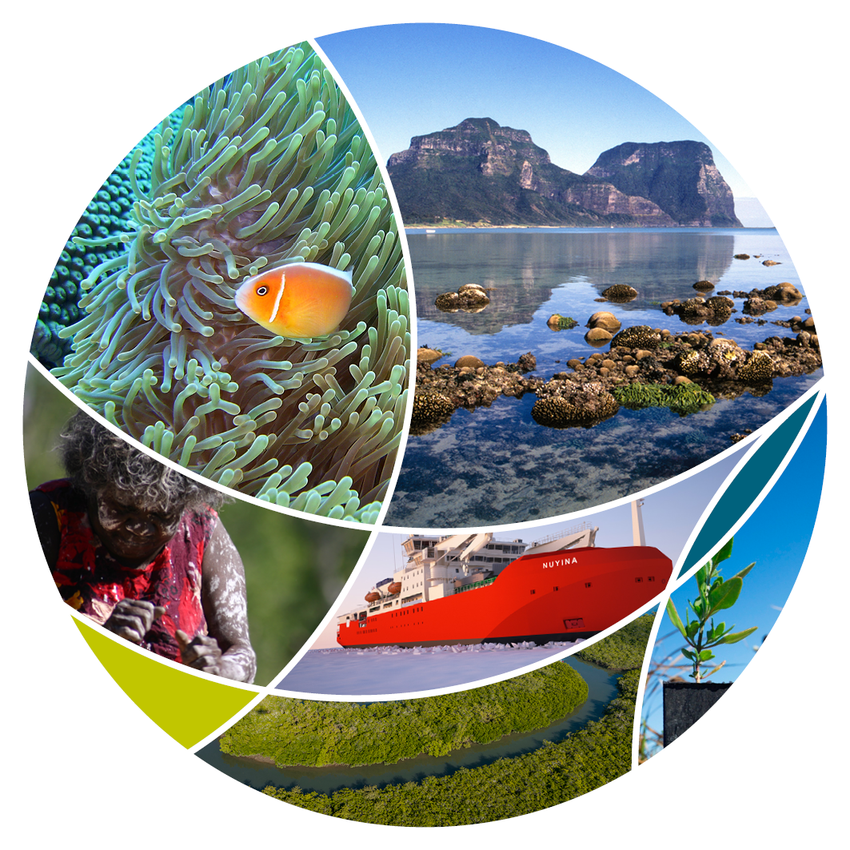
© Commonwealth of Australia 2021
Ownership of intellectual property rights
Unless otherwise noted, copyright (and any other intellectual property rights) in this publication is owned by the Commonwealth of Australia (referred to as the Commonwealth).
Creative Commons licence
All material in this publication is licensed under a Creative Commons Attribution 4.0 International Licence except content supplied by third parties, logos and the Commonwealth Coat of Arms.
Inquiries about the licence and any use of this document should be emailed to copyright@awe.gov.au.

Cataloguing data
This publication (and any material sourced from it) should be attributed as: DAWE 2021, Natural capital: unlocking private sector investment, Department of Agriculture, Water and the Environment, Canberra. CC BY 4.0.
ISBN 978-1-76003-474-0
This publication is available at awe.gov.au/publications.
Department of Agriculture, Water and the Environment
GPO Box 858 Canberra ACT 2601
Telephone 1800 900 090
Web awe.gov.au
Disclaimer
The Australian Government acting through the Department of Agriculture, Water and the Environment has exercised due care and skill in preparing and compiling the information and data in this publication. Notwithstanding, the Department of Agriculture, Water and the Environment, its employees and advisers disclaim all liability, including liability for negligence and for any loss, damage, injury, expense or cost incurred by any person as a result of accessing, using or relying on any of the information or data in this publication to the maximum extent permitted by law.

Minister’s foreword

Australia is renowned for its natural capital – it nourishes us by providing us with the food we eat, strengthens our regional communities, provides jobs and stunning landscapes to behold.
We have a duty to manage this natural wealth now and into the future. We all have a role to play and work together – government, industry, businesses, financial sector, philanthropy, community and individuals.
The Australian Government is committed to improving how we manage and value our natural capital. The Government is investing to improve our understanding of natural capital at the national, regional and local scale.
Improved management of our natural capital provides direct productivity outcomes to the businesses that are dependent on it. It can also reduce the risks posed to productivity from our changing climate. Improved understandings of these links will unlock private sector investment in our environment on private lands.
In addition, the financial and banking sectors can make more informed decisions about their existing investments, as well as engaging with new opportunities in emerging environmental and natural capital markets.

We are working together to seize these opportunities to increase the well-being of Australia’s environment, our economy, and our regional community. With all participants in the land and financial sectors working together, we can value, protect and restore Australia’s wealth of natural capital.
The Hon Sussan Ley MP
Minister for the Environment

Contents
Minister’s foreword iii
Natural capital underpins our prosperity 1
Economic value 1
The role of Government 2
Supporting market opportunities 3
Improving measurement 4
Pilot ocean account, Geographe Marine Park 5
Demonstrating the productivity and resilience benefits of natural capital 7
Market recognition of natural capital 7
Working with the private sector 8
Government initiatives 9

Figures
Figure 1 Natural capital infographic 5
Figure 2 Geographe Marine Park pilot ocean account 10
Figure 3 Tools and approaches to measuring and integrating natural capital in financial products and solutions 14

Natural capital underpins our prosperity
Natural capital is our natural resources including the vegetation, soils, water, oceans and biodiversity and the services that they provide to our businesses, people and the economy.
Figure 1 Natural capital infographic
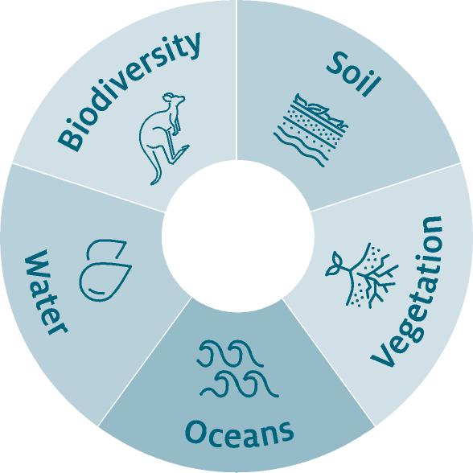
Australian communities are dependent on natural capital for our continued prosperity, health and wellbeing. Natural capital is key to the success of many Australian industries including agriculture, fishing and forestry, tourism and resource sectors. The role of natural capital in driving our productivity and resilience to a changing climate is being recognised.
- Investors, businesses and consumers are increasingly focused on businesses’ dependencies and impacts on natural capital.
- The international community is seeking to support increased private investment in natural capital and nature-positive business activities.

Economic value
Australia’s agricultural, forestry and fishing industries employed 461,000 people (June 2021). Gross value of agricultural production is forecast to reach $73.0 billion in 2021-22, with exports forecast to reach $54.7 billion.
Our natural assets are one of the biggest draw-cards for tourism in Australia, an industry which employed 666,000 people, or 5% of Australia’s workforce and contributed $60.8 billion to our GDP in 2018-19.
Globally nature underpins all economic activity, worth an estimated $US125 trillion in 2018. Despite our growing understanding of the contribution of natural capital to the economy it is still undervalued as it is not considered in financial and business decision making.
The Australian finance and banking sectors are increasingly looking to invest in conserving and restoring our natural capital. The Responsible Investment Association Australasia reports that $1,149 billion (37%) of Australia’s total professionally managed assets under management is now responsibly invested, with 6% in sustainability-themed investments in 2019. Sustainability-themed investing grew from 4% of assets under management in 2018 to 6% in 2019. Consumers are also increasingly interested in making more sustainable choices and expect businesses to demonstrate how their products and services positively impact the environment.

International context
- The Taskforce on Nature-related Financial Disclosures (TNFD) is developing a framework to support corporates and financial institutions to assess, value and manage their impacts and dependencies on nature, aiding the redirection of global financial flows away from nature-negative outcomes and towards nature-positive outcomes. Australia is supportive of this initiative as both a financial contributor and participant of the TNFD forum.
- The G7 Climate and Environment Ministers, at their meeting in May 2021, recognised the importance of mobilising private and public finance to tackle the twin challenges of climate change and biodiversity loss, including through promoting enabling environments to increase mobilisation of private finance.
- The G20 in October 2021 is considering actions that will direct adequate financial flows to support nature’s conservation and sustainable use, recognising this work is essential for stable, sustainable development of the world’s economies, citizens’ needs, and the survival of the world’s ecosystem.
- The United Nations Statistical Division, in March 2021, agreed the System for Environmental Economic Accounting (SEEA). This is designed to be applied by countries to recognise the contribution of natural capital to the broader economy.

The role of Government
The Australian Government is seeking to increase private investment in Australia’s natural capital by:
- supporting the development of markets to achieve biodiversity outcomes in Australia
- improving the measurement of natural capital across the landscape
- demonstrating the productivity and resilience links of our natural capital to business
- helping embed natural capital considerations in commercial and financial decision making

Supporting market opportunities
Many farmers, fishers, eco-tourism operators and other landholders are seeking to demonstrate the management of their natural capital and embed sustainable or restorative land management practices in their business models. This provides a range of additional market opportunities to landholders while delivering environmental outcomes.

New and emerging markets for biodiversity credits
As part of the Australian Government’s Agricultural Biodiversity Stewardship package, the government has developed a Carbon+Biodiversity pilot, which is trialling a market-based approach to reward land managers undertaking environmental plantings projects that improve biodiversity as well as storing carbon. Land managers can receive payment for the biodiversity benefits in addition to carbon credits.

Participating in carbon markets
A new soil carbon method being developed under the Emissions Reduction Fund in 2021, will enable landholders to earn carbon credits, improve farm productivity and boost resilience to drought and erosion. Uptake of soil carbon projects has grown considerably since 2019, accounting for half of all abatement projects registered under the Emissions Reduction Fund in the first quarter of 2021.

Increased access to premium markets
Landholders that demonstrate their sustainable management of their natural resources are gaining access to premium markets and new trade opportunities. Consumers and overseas markets are increasingly looking for sustainability credentials when purchasing produce.

Attracting global capital
Sustainably managed natural capital assets can attract capital from the growing pool of sustainable investment funds that will be recognising their risks under TNFD and are driven by the broader global sustainable development agenda. Global investment in nature-based solutions is currently $US18.6 billion. The Australian Government backed Clean Energy Finance Corporation recently invested in an Australian biotechnology company that aims to lift organic soil carbon to improve the drought resilience of farming land, increase productivity and remove carbon from the atmosphere.

Improving measurement
The government is seeking to support increased private investment in Australia’s natural capital by improving the measurement and visibility of natural capital across the landscape.
Table 1 Natural Capital measurements
Initiative | Detail
National Strategy for Environmental Economic Accounting | - Delivering a nationally consistent approach for environmental information and links to the economy.  - Standard approach will inform private sector sustainability initiatives and investment decisions.  - The Commonwealth is working in collaboration with the States and Territories through the National Strategy for Environmental Economic Accounting.
National Land Account | - Released by the Australia Bureau of Statistics in June 2021.  - Delivers a time series and spatially explicit description of land use, change, tenue to measure change over time.  - Uses advancements in technology, such as satellite imagery, to improve the granularity of available information.  - Integrates environmental data and information to help landholders and Natural Resource Management regional organisations make management decisions at regional and national levels.
Oceans Accounting | - National ocean accounting will provide robust measurement of the blue economy and ecosystem services, such as blue carbon.  - Ocean accounts will help quantify the environmental and socio-economic benefits of restoring blue carbon ecosystems including the financial benefits on fishing and tourism.  - A pilot account released in December 2020 for Geographe Marine Park off Western Australia.
Ecosystems Accounts | - Approaches to measure environmental services being provided by ecosystems.  - Includes services like clean water, bee pollination, tourism and recreational fishing.  - This will support corporates and financial institutions to assess, value and manage their dependencies and impacts on nature.
Blue Carbon Ecosystem Restoration and Accounting | - Delivering blue carbon restoration and conservation projects to demonstrate the financial values of ecosystem services and biodiversity benefits of these ecosystems.  - Project level environmental-economic accounts will measure and value climate, biodiversity and livelihood benefits.  - Information from restoration projects and environmental-economic accounts will support biodiversity and carbon crediting initiatives and enable private sector engagement.
Agriculture Biodiversity Stewardship | - Developing standard approaches to measure biodiversity improvements on farm, including linked to carbon sequestration.  - Using robust protocols developed by the Australian National University.  - Demonstrating market-based approaches for farmers to deliver biodiversity improvements on farm for the private sector.  - Applying this standard measurement to additional market opportunities including the Farm Biodiversity Certification Scheme.
National Soils Strategy, Pilot Soil Monitoring and Incentives Program | - Captures historic soil data and incentivise collection of new soil data.  - Will improve the understanding of Australian soil health and links to increased productivity, enhanced water retention and drought resilience, which in turn will help drive the uptake of, and investment in new management practices.  - Access to data and improved understanding will support participation in soil carbon projects, which will enable landholders to earn carbon credits.
Environmental Information | - Comprehensive improvement to the information available about our biodiversity.  - The Digital Environmental Assessments Program is transforming environmental assessments and integrated digital systems.
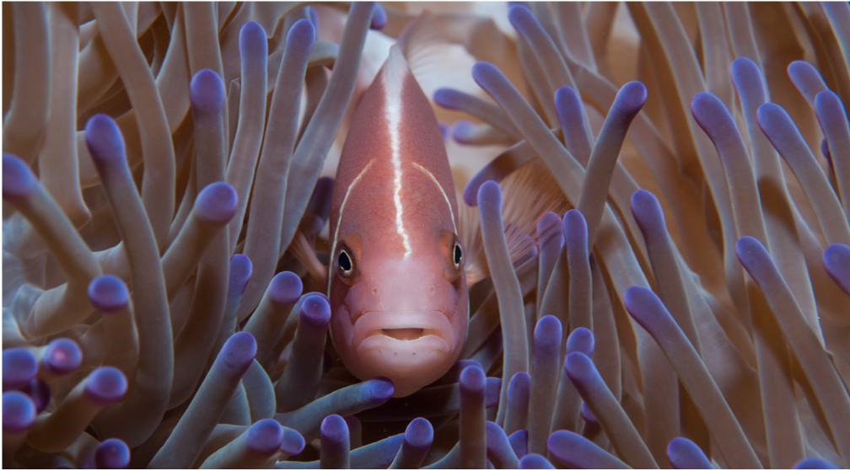

Pilot ocean account, Geographe Marine Park
In 2020 a pilot ocean account was developed for Geographe Marine Park. This applied a consistent approach to measure ecosystem assets and their financial contribution. The Department of Agriculture, Water and the Environment (the department) will work with the finance sector to build on this type of information to develop innovative finance approaches to enhance conservation of our marine environment.
Figure 2 Geographe Marine Park pilot ocean account
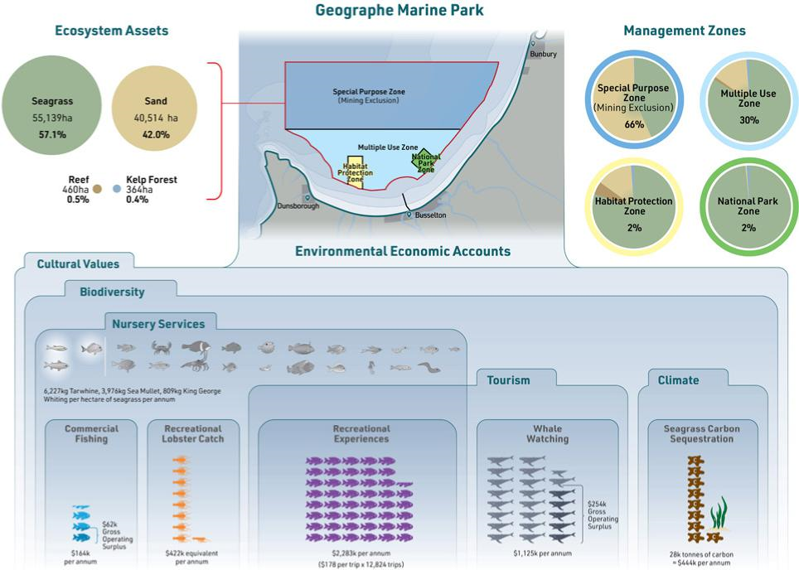

Demonstrating the productivity and resilience benefits of natural capital
Farmers, landholders, Indigenous land owners and managers, tourism operators and businesses want to embed the benefits of natural capital into their financial decision making and recognise its value. This value and the benefits are not well understood or recognised.
The department is working with the Australian Bureau of Agricultural and Resource Economics and Sciences (ABARES) and other experts to compile the evidence base linking improved management of natural capital to improved productivity and reduced risk, as well as identifying any gaps in information.
Farm-scale Natural Capital Accounting, La Trobe University
Funded through the Australian Government’s Smart Farm program, La Trobe University’s Farm-scale Natural Capital Accounting project uses a user-friendly tech solution to generate farm-scale natural capital accounts that will demonstrate the value of natural capital at the farm scale. This project will provide tools for farmers, investors and consumers to evaluate a producer’s environmental performance and sustainability credentials.
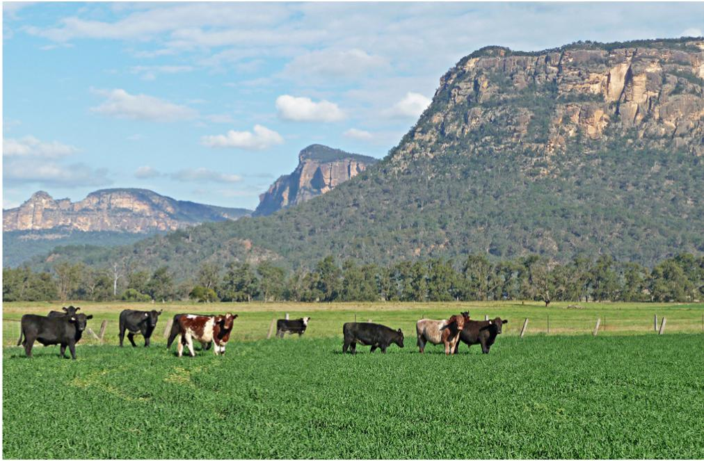

Market recognition of natural capital
The development of successful natural capital approaches to inform financial solutions in the agriculture and land sector and for sectors of the oceans economy, will help pave the way for increased private sector investment in maintaining and improving our natural capital across a broad range of economic sectors.

Working with the private sector
Greater engagement with the finance sector helps embed natural capital in financial decision making. Improved natural capital accounting and metrics is not sufficient to facilitate private sector investment. This information needs to be nationally consistent and in a format that allows the banking and finance sector to use this information in financial products and decision making.
The department also needs to explore how to enable farmers and land holders to recognise and demonstrate how the condition of their natural capital impacts their financial performance in terms of productivity, profitability and resilience in a changing climate.
The department is engaging with representatives from the finance and banking sector, peak bodies from natural resource management and agriculture sectors and Indigenous organisations, to better understand:
- how to incorporate natural capital into investment and risk management decisions
- the types of information and the format that is needed
- develop potential approaches to trial the incorporation of natural capital tools and metrics into financial products and decision making
The advice and perspectives of these stakeholders is coordinated through a Natural Capital Working Group.
Finance sector approaches to natural capital
Macquarie Bank
Macquarie Asset Management’s (MAM) agriculture platform recognises that farmers are stewards of the land and manages its portfolio under the ethos that sustainability and profitability are inherently linked. The platform’s actively managed operating companies, Viridis Ag and Paraway Pastoral, manage their farmland assets by identifying and valuing their natural capital base. The team works to coordinate with governments and local communities to boost biodiversity, pursue carbon sequestration activities and ultimately enhance the resilience and sustainability of landscapes. More information can be found here.
NAB
NAB were the inaugural signatory to the Natural Capital Declaration, a global statement that recognises that natural capital poses significant potential risks and opportunities to the finance sector. To support the integration of natural capital in day-to-day decision making, NAB have partnered with ClimateWorks to deliver the Natural Capital Investment Initiative which aims to develop consistent metrics for the measurement of and reporting on natural capital. More information can be found here.
Kilter Rural
Kilter Rural’s natural capital investment model has been refined over 16 years to deliver sustainable outcomes and financial returns by enabling investment at scale in the regeneration of Australian farmland, water and environmental protection. The Australian Farmlands Fund is repurposing underutilised farming properties with quality infrastructure to produce higher value crops, while reforesting up to 30% of the landscape for ecological and climate change mitigation outcomes. More information can be found here.
HSBC
HSBC Global Asset Management and Pollination have partnered to establish the world’s largest asset management company dedicated to natural capital. It will aim to attract institutional investors into natural capital investments by providing wide exposure to global natural capital themes and opportunities at scale, in addition to stewardship and evaluation of the investments. More information can be found here.

Government initiatives
The Australian Government has committed:
- $4.7 million over three years to facilitate the development of approaches and tools to measure and integrate natural capital in financial products and solutions.
- $1.9 million over four years to establish a Blue Finance Unit, which will work with leaders in marine restoration and coastal infrastructure to catalyse private sector investment in the restoration of coastal ecosystems. This will build resilience of coastal assets and communities and enhance blue carbon and biodiversity.
Figure 3 Tools and approaches to measuring and integrating natural capital in financial products and solutions
