# Non-road diesel engines – evaluating a national approach to managing emissions

Discussion paper

October 2020



© Commonwealth of Australia 2021

**Ownership of intellectual property rights**

Unless otherwise noted, copyright (and any other intellectual property rights) in this publication is owned by the Commonwealth of Australia (referred to as the Commonwealth).

**Creative Commons licence**

All material in this publication is licensed under a [Creative Commons Attribution 4.0 International Licence](https://creativecommons.org/licenses/by/4.0/legalcode) except content supplied by third parties, logos and the Commonwealth Coat of Arms.

Inquiries about the licence and any use of this document should be emailed to [copyright@awe.gov.au](mailto:copyright@awe.gov.au).



**Cataloguing data**

This publication (and any material sourced from it) should be attributed as: DAWE 2020, *Non-road diesel engines – evaluating a national approach to managing emissions: discussion paper*, Department of Agriculture, Water and the Environment, Canberra, October. CC BY 4.0.

ISBN 978-1-76003-380-4

This publication is available at <http://www.environment.gov.au/protection/air-quality/national-clean-air-agreement/evaluation-non-road-diesel-engine-emissions>.

Department of Agriculture, Water and the Environment

GPO Box 858 Canberra ACT 2601

Telephone 1800 900 090

Web [awe.gov.au](https://www.awe.gov.au/)

**Disclaimer**

The Australian Government acting through the Department of Agriculture, Water and the Environment has exercised due care and skill in preparing and compiling the information and data in this publication. Notwithstanding, the Department of Agriculture, Water and the Environment, its employees and advisers disclaim all liability, including liability for negligence and for any loss, damage, injury, expense or cost incurred by any person as a result of accessing, using or relying on any of the information or data in this publication to the maximum extent permitted by law.

Contents

1 Purpose of the document 1

2 Consultation overview 2

2.1 Consultation objectives 2

2.2 Consultation timeline 2

2.3 How to engage 3

3 Background and policy context 4

3.1 Non-road diesel engines 4

3.2 International standards for non-road diesel engines 4

3.3 Policy context 5

3.4 Scope of evaluation 6

4 Nature and extent of the problem 9

4.1 Need for action 11

5 Objectives of government action 18

6 Statement of options 19

6.1 The options for action 19

Appendix 1: Consultation questions 31

Appendix 2: Analysis method 33

Quantitative modelling 33

Appendix 3: International emission standards 39

Appendix 4: US emission standards for non-road diesel engines 40

Appendix 5: EU emission standards for non-road diesel engines 42

Appendix 6: Australian diesel fuel quality and non-road diesel engines 44

References 46

**Tables**

Table 1 NRDE equipment responsible for the majority of noxious emissions 10

Table 2 Summary of NRDE management scenarios 19

Table 3 Scenario 1 roles for suppliers and consumers of NRDE and government 26

Table 4 Scenario 2 features and options for industry consideration 27

Table 5 Scenario 2 roles for suppliers and consumers of NRDE and Government 27

Table 6 Scenario 3 features and options for industry consideration 29

Table 7 Scenario 3 roles for suppliers and consumers of NRDE and government 29

Table 8 US and EU standards for different engine power 39

Table 9 US emission standards 40

Table 10 EU emission standards 42

**Figures**

Figure 1 Key consultation activities 2

Figure 2 Uses of non-road diesel engines 4

Figure 3 US and broadly equivalent EU non-road diesel engine standards 4

Figure 4 Introduction of NRDE emission standards to other countries 5

Figure 5 Analytical stages of the evaluation 6

Figure 6 Key steps in the evaluation 6

Figure 7 NRDE equipment types included in the evaluation 7

Figure 8 Key emissions characteristics of Australian NRDE in 2018 9

Figure 9 Those most vulnerable to health impacts from noxious NRDE emissions 12

Figure 10 Mechanisms that contribute formation of secondary particles 13

Figure 11 2018 Australian NRDE sales by tier rating 14

Figure 12 Net changes in business as usual NRDE emissions forecast between 2018 and 2043 16

Figure 13 Predicted tiering as a proportion of the national NRDE stock (fleet) 21

Figure 14 Emissions model 35

Figure 15 Exposure model 36

**Boxes**

Box 1 Non-road diesel engines in Australia 15

Box 2 Future market conditions in the absence of intervention 21

Box 3 Questions regarding the management scenario overarching assumptions 24

Box 4 Base case 26

Box 5 Scenario 1 features and options for industry consideration 28

Box 6 Questions regarding scenario 1 30

Box 7 Questions regarding scenario 2 32

Box 8 Questions regarding scenario 3 34

Box 9 Consolidated consultation questions 35

## Purpose of the document

This discussion paper presents information on scenarios for a national approach to manage non-road diesel engine emissions in Australia. The costs and benefits of these management scenarios will be evaluated in a cost-benefit analysis.

No decision has been made to implement a national approach. Environment ministers from all jurisdictions will review the cost-benefit analysis findings and decide whether to progress formal consideration of any potential regulatory impacts. In a regulatory impact analysis, the design and operation of the management scenarios would be comprehensively developed through public consultation.

The primary purpose of this discussion paper is to support targeted engagement with business, industry and community representatives to inform the cost-benefit analysis.

Consultation on the management scenarios will include:

* an online meeting on 14 October 2020 – a key meeting objective is to gather sufficient information to develop practical management scenarios for the cost-benefit analysis
* subsequent consultation on costs and benefits of the management scenarios, once the scenarios are finalised. A timeline for the cost-benefit analysis is provided in section 2.2.

This discussion paper includes the following:

* a consultation overview and forward process for engagement
* the background and context for a cost-benefit analysis
* the nature and extent of the problem
* the objectives of government action and scope
* the management scenarios being considered for the cost-benefit analysis.

Out of scope for this discussion paper and the meeting are:

* costs and benefits for the management scenarios. These will be discussed in later engagements
* how a future national approach to manage non-road diesel engine emissions could be designed.

Guidance on providing feedback is in section 2.3.

## Consultation overview

### Consultation objectives

The Department of Agriculture, Water and the Environment is undertaking consultation on the management options to:

* provide stakeholders with up-to-date information about the evaluation
* listen to stakeholders, understand their perspectives and use this to inform the evaluation and advice to government
* clearly identify and explain the engagement process, the role of stakeholders in the evaluation, and communicate how their input will inform the evaluation
* manage stakeholder expectations by increasing transparency around actions and timing
* ensure that any stakeholder views that may impact the development of the cost-benefit analysis are supported with evidence, including the collection of further data where required.

### Consultation timeline

The evaluation includes two main analytical stages: a market analysis completed in 2019 and a cost-benefit analysis which commenced in 2019 (see section 3.3). During the market analysis phase of the evaluation, importers and suppliers of non-road diesel engines and equipment supported the analysis by providing data on equipment and use characteristics. The cost-benefit analysis involves further targeted consultation to:

* inform which management scenarios are to be tested (the online meeting on 14 October 2020)
* collect additional data on costs and benefits of each management scenario (October 2020 meeting)
* discuss cost-benefit analysis findings with industry asociations (2021-22).

Key stakeholder consultation activities are shown in Figure 1.

Figure 1 Key consultation activities

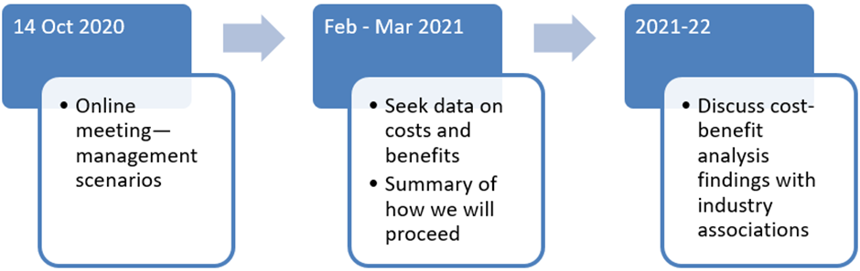

Figure 1 was updated in January 2021 to reflect changed timeline.

Targeted consultation may also be used to test modelling assumptions and management scenarios parameters.

### How to engage

#### Consultation questions

Throughout this discussion paper, a series of consultation questions are posed (for example, see section 4.1) to encourage stakeholders to respond.

#### Providing feedback

Stakeholders are invited to provide feedback on the management scenarios by:

* responding to a small number of questions during the meeting using the Mentimeter online tool that we will make available
* responding to a questionnaire which includes all questions in this discussion paper. The questions are detailed throughout the document and are also consolidated in Appendix 1.

Responses can be provided by email. If you would like to provide verbal feedback, please email the Air Quality Policy Section to set up a time.

To provide feedback, contact the Air Quality Policy Section at [airquality@awe.gov.au](mailto:airquality@awe.gov.au).

## Background and policy context

### Non-road diesel engines

Diesel engines are installed in a wide range of non-road vehicles and equipment. Specific examples of equipment include tractors, cranes, loaders, excavators, bulldozers, forklifts, pumps, compressors and generators. Non-road diesel engines (NRDE) are used in a wide range of sectors and applications, including industrial, construction, power generation, mining, agriculture, marine and forestry (Figure 2).

Figure 2 Uses of non-road diesel engines

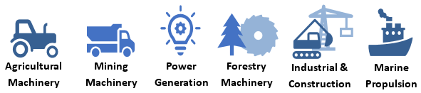

### International standards for non-road diesel engines

Diesel engine exhaust contains many different pollutants which can cause harm to human health and the environment. Standards to limit NRDE emissions have been in place in the United States (US) and European Union (EU) since the mid-1990s.

Over time both the US and EU have developed a number of ‘tiers’ or ‘stages’ of emission standards with increasingly stringent pollutant limits (see Figure 3).

Figure 3 US and broadly equivalent EU non-road diesel engine standards

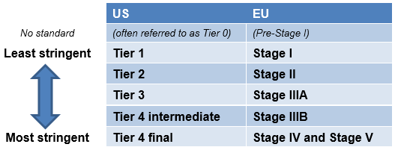

Each tier or stage has different emission limits for different pollutants which are defined in relation to rated engine power output (power bands).

Engines sold today in the US and EU are required to meet emission limits for key air polluntants that are approximately 95% lower than the limits first introduced in the 1990s.

More information about US and EU NRDE standards are available in Appendix 3, Appendix 4 and Appendix 5.

Since their introduction in the US and EU, NRDE emission standards have been applied in other countries including Canada, Japan, China, India, Brazil, Hong Kong and Singapore (see Figure 4).

Figure 4 Introduction of NRDE emission standards to other countries

The USA was the first country to introduce NRDE emission standards in 1994, followed by EU in 1997 and Canada in 1999.
Some other countries to introduce standards were India in 2006, China in 2007, Brazil in 2011 and Russia in 2014.

Most countries have implemented NRDE emission standards and use either the [US NRDE emission standards](https://www.epa.gov/emission-standards-reference-guide/epa-emission-standards-nonroad-engines-and-vehicles) or [EU NRDE emission standards](https://ec.europa.eu/growth/sectors/automotive/environment-protection/non-road-mobile-machinery_en), or a combination of these standards. Various countries have now adopted either the US ‘tier 3’ or EU ‘stage IV’ standards. Several countries have implemented (or are phasing in) stricter limits as:

* awareness of the impact of diesel emissions grows
* advances in emission-control technology allow for a lower level of pollutants in diesel exhaust.

### Policy context

Australia has not adopted standards to limit emissions from NRDE. In 2010 it was found that in Australia (NSW EPA 2010):

* there was low passive uptake of international NRDE emission standards
* significant emissions reductions and health benefits may be achieved by introducing national NRDE emission limits based on existing overseas standards.

In December 2015, Australia’s environment ministers established the [National Clean Air Agreement](http://www.environment.gov.au/protection/air-quality/publications/national-clean-air-agreement) to identify national priorities and coordinate efforts to reduce air pollution. The Agreement is implemented through biennial work plans.

In 2018 environment ministers agreed to progress an evaluation of the potential for a national approach to manage non-road diesel engine emissions (the evaluation), as a priority emission reduction measure under the National Clean Air Agreement work plans. The evaluation is being led by the department and the NSW Department of Planning, Industry and Environment.

The evaluation includes two main analytical stages as shown in Figure 5.

Figure 5 Analytical stages of the evaluation

The first stage of the evaluation was a market analysis to understand the nature and emissions profile of the sector in Australia. This was completed in December 2019.
The second stage is a cost-benefit analysis of potential management scenarios to manage emissions.

The market analysis identified that NRDE in Australia produce significant emissions and there has been a low uptake of international NRDE emission standards. Further examination was supported and in December 2019 the cost-benefit analysis commenced. It is anticipated it will be completed by late 2021.

The evaluation findings will inform a recommendation to environment ministers on whether to progress to formal consideration of the management scenarios (regulation impact analysis). Key steps in the evaluation are shown in Figure 6.

Figure 6 Key steps in the evaluation

Figure 6 was updated in March 2021 to reflect changed timeline.

Information on the cost-benefit analysis method is provided in Appendix 2.

### Scope of evaluation

Diesel engines are installed in a wide range of non-road vehicles and equipment. The scope of NRDE equipment types included in the evaluation are summarised in Figure 7.

Figure 7 NRDE equipment types included in the evaluation

This evaluation includes construction and mining equipment. agricultural equipment, generators and pumps, forestry and logging equipment, marine engines with power ratings below 130 kW and air and sea port ground service equipment.
Out of scope from this evaluation are other non-road diesel equipment including large marine engines, aircraft engines and locomotives.

**a** This list is not exhaustive of all NRDE that may be captured under any possible management options. The evaluation captures any diesel-powdered (compression ignition) engine that does not fall under the excluded categories **b** Large marine diesel engines with a power rating of or above 130 kW are excluded as they are covered by international MARPOL regulations

All transport modes are excluded from this evaluation including aircraft engines or railway locomotives. These are not typically included in international NRDE regulations and have economic impacts that are distinct from managing emissions from non-transport NRDE. For example, changing how locomotive emissions are managed may shift some rail freight to on-road and increase road congestion.

This evaluation categorises NRDE consistent with the US tier systems. Other international standards that are equivalent to a US tier also apply. The emission standards for new NRDE are implemented by the USEPA and are published in the [US Code of Federal Regulations, Title 40, Part 89](https://www.ecfr.gov/cgi-bin/text-idx?tpl=/ecfrbrowse/Title40/40cfr89_main_02.tpl).

Section 6 provides information about scope specific to:

* equipment introduced into Australia for the first time (both new and used)
* loose replacement engines.

## Nature and extent of the problem

Diesel engine exhaust contains many different pollutants which can cause harm to human health and the environment. Harmful components include particulate matter (PM), carbon monoxide (CO), hydrocarbons (HC), oxides of nitrogen (NOX) and oxides of sulfur (SOX).

The market analysis identified that in 2018 NRDE in Australia were a significant source of air pollutants and greenhouse gas emissions and had a low uptake of emission control technology (see Figure 8).

Figure 8 Key emissions characteristics of Australian NRDE in 2018

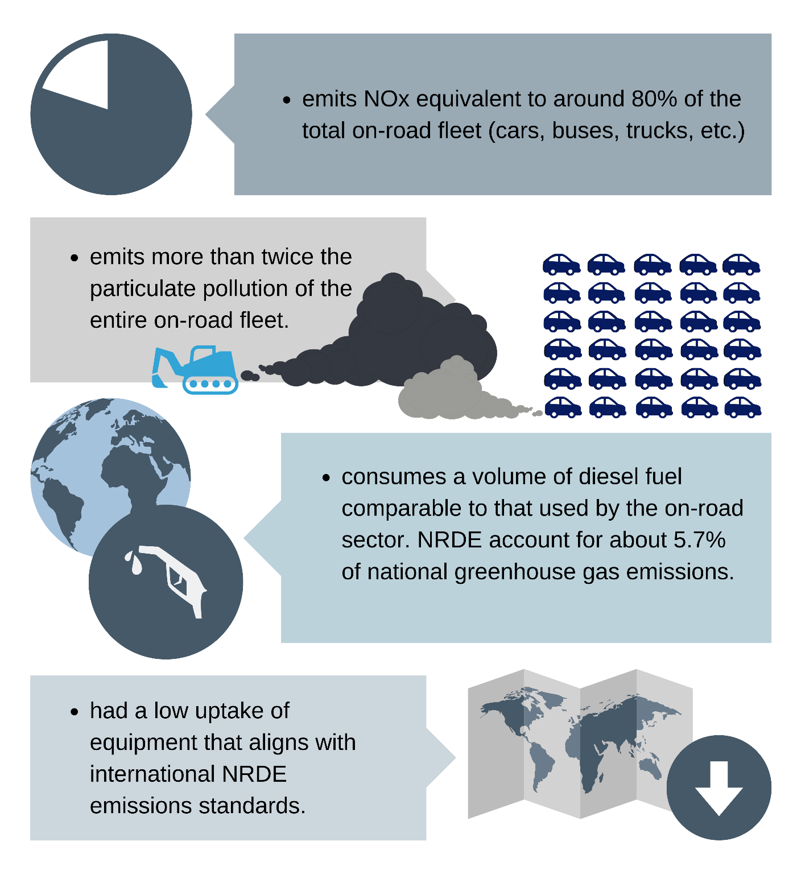

The market analysis found that of 28 equipment types, 6 emitted more than three quarters of key NRDE noxious emissions (see Table 1).

Table 1 NRDE equipment responsible for the majority of noxious emissions

| Equipment type | Percentage of total NRDE noxious emissions | | Examples of equipment |
| --- | --- | --- | --- |
| PM2.5 (%) | NOX (%) |
| Agricultural tractors and harvesters | 25 | 19 | Tractors, combine harvesters, commercial mowers, headers |
| Gen sets standb | 16 | 19 | Standby and auxiliary power generators sold as complete sets |
| Industrial construction | 11 | 9 | Backhoes, cranes, dozers, compactors, dumpers, excavators, graders, loaders, pavers, rammers, rollers, trenchers |
| Industrial pumps | 11 | 12 | Fire pumps, other types of pump for liquids and slurries |
| Gen sets prime power | 8 | 10 | Prime power generators sold as complete sets |
| Industrial surface mining | 6 | 7 | Off road trucks, crushing equipment, dozers, drilling rigs |

These equipment types are generally higher-powered engines or equipment that is used frequently. Apart from tractors and harvesters, a high proportion of these equipment types are used in the mining sector.

The market analysis findings are further described in Box 1.

Box 1 Non-road diesel engines in Australia

NRDE are not manufactured in Australia; they are all imported, either as loose engines or already incorporated into equipment. In 2018 around 70,000 NRDE were imported into Australia with a combined market value of $1.9 billion. Most imported NRDE are new, although some are reconditioned (both loose and incorporated engines). Imported engine numbers have generally been increasing over time.

NRDE are imported into Australia from approximately 25 countries; China (30%), EU countries (26%) and the US (22%) were the major sources in 2018. There are around 40 importers or suppliers of diesel engines and equipment in Australia.

Most loose engines are:

* sold to various local equipment manufacturers, or
* used for replacing engines in existing equipment.

NRDE differ from all on-road engines in various other ways. For example:

* on-road engine exhaust emissions are regulated by national standards via the Australian Design Rules based on Euro 5 and Euro V standards for light and heavy vehicles respectively
* the equipment in which NRDE are used is extremely diverse, with often the same engine being used in widely varying equipment applications and by many different industry sectors
* NRDE include broader ranges of engine capacity and rated power (for example, from less than 1 kW (1.3 hp) to more than 2,000 kW (2,680 hp)). On-road vehicles typically range from 80 to 160 kW for light vehicles and 330 to 450 kW for large trucks
* many NRDE are static and operated under steady-state conditions (for example, generators and generator sets) at high load factors (fraction of rated power used during operation), whereas on-road diesel engines are operated under highly transient conditions where engines typically operate at well below their rated power (although some NRDE are also operated under transient conditions)
* the spatial and temporal patterns of activity for NRDE can be less predictable than those for on-road engines.

Consultation questions:

1) Can you more accurately describe the NRDE market in Australia?

2) What drivers might influence the purchase of cleaner alternatives, even if they cost more? How much more?

3) How does the emissions performance of non-road diesel equipment influence purchasing decisions?

4) Have you participated in a voluntary scheme to reduce NRDE emissions? If so, was it effective and why?

### Need for action

**Problem summary:**

* diesel engine emissions can be deadly and have costly health impacts
* NRDE are a key source of noxious diesel engine emissions in Australia
* Australia has no standards to limit emissions from NRDE, unlike other countries
* there has been slow uptake of lower emitting technology
* NRDE are likely to remain a key source of noxious emissions in Australia without intervention.

#### Diesel engine emissions are harmful and costly

The World Health Organization has declared diesel exhaust to be a carcinogen (WHO 2012). It can be inhaled deep into the lungs and enter the bloodstream and can cause cancer, heart disease and respiratory conditions.

Numerous studies have found that exposure to particulate matter (PM) with an aerodynamic diameter of less than 2.5µm (PM2.5) is linked to a variety of cardiovascular and respiratory diseases and contributes to premature death. There is no known threshold for PM exposure below which health effects do not occur, meaning any exposure can be harmful.

Air pollution in Australia is low by world standards, but still an important public health issue. In Australia each year about 2,500 deaths are attributable to urban air pollution (AIHW 2019). This is more than double the number of deaths caused by traffic accidents in any year since 2012 (NRSS 2021).

Vehicle exhaust particles are particularly damaging to health as they often contain metals and sulfates (Parliament of Australia n.d.). The market analysis identified that in 2018 NRDE emitted more than twice the particulate matter pollution of the entire on-road fleet.

Around 29,000 healthy life years are lost each year due to premature deaths attributable to urban air pollution. Those most affected are the elderly, children, pregnant women, and those with existing health conditions (see Figure 9).

Figure 9 Those most vulnerable to health impacts from noxious NRDE emissions

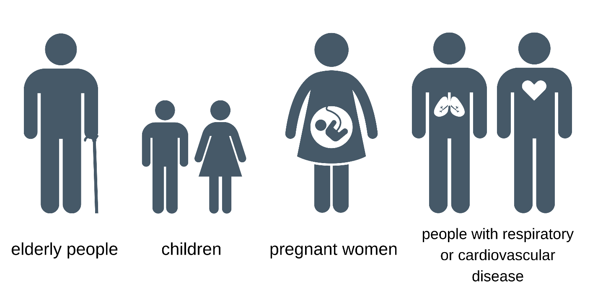

Air pollution also significantly diminishes the quality of life for people suffering chronic respiratory disease. Approximately 1 in every 9 Australians – around 2.8 million people – suffer from chronic asthma (Asthma Australia n.d.). In 2017-18 around 39,000 Australians were hospitalised due to asthma. Of these almost half (44%) were children (0 to 14 years).

The pollutants emitted directly into the atmosphere in diesel exhaust (termed ‘primary’ pollutants) also contribute to the formation of ‘secondary’ pollutants through chemical reactions (see Figure 10). The impacts of these secondary pollutants (such as organic and inorganic aerosols) can be higher in rural areas than urban areas due to the time (and distance) required for their formation.

Figure 10 Mechanisms that contribute formation of secondary particles

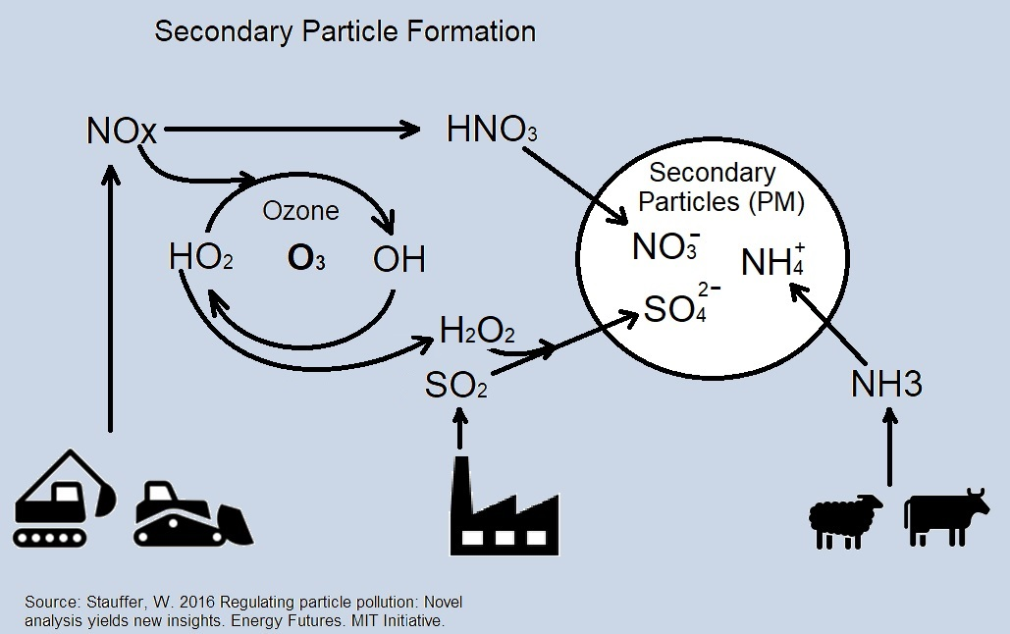

Source: Stauffer 2016

Oxides of nitrogen and hydrocarbon emissions also contribute to photochemical smog, and notably the formation of ground-level ozone (O3). Ozone exposures can induce serious respiratory tract responses including reduction in lung function, aggravation of pre-existing respiratory diseases (such as asthma), increases in daily hospital admissions, emergency department visits for respiratory causes, and excess mortality (US EPA n.d.).

Pollutants such as PM can travel long distances from their source both within a state or territory, and between states and territories.

At an individual level in Australia, the health burden of exposure to ambient air pollution may be relatively small. However, these individual effects translate to a large public health burden when multiplied by the large number of people exposed.

Ambient air pollution translates into large economic costs – for the NSW greater metropolitan area alone it has been estimated that the health costs of air pollution are around $4.7 billion (2003 AUD) annually (NSW DEC 2005). This equates to $892 per capita or 1.9% of gross state product.

In 2010 a study identified and recommended measures to support the supply and purchase of cleaner NRDE into the Australian market from 2009 to 2030. For compliance with the most stringent emission standards at the time, the benefits were estimated to be in the range $2.5 to $4.7 billion (2008 AUD) by 2030.

More recently, there is a growing body of evidence linking poor air quality to reduced worker productivity, even at the levels of pollution below the guidelines recommended by the World Health Organization (Neidell 2017).

In addition to health impacts, air pollution may have significant impacts on the environment, either directly or indirectly. Impacts may include damage to crops and other vegetation through impaired growth; acidification of soils and freshwater, which depletes essential nutrients that support flora and fauna; eutrophication which depletes oxygen levels and can lead to a change in species diversity; and chronic health problems in wildlife from heavy metals and organic pollutants (DSEWPaC 2011, UNEP 2014). Additionally, NRDE emit CO2, N2O and methane which are greenhouse gases that contribute to climate change.

#### Australia does not regulate emissions from non-road diesel engines

Unlike road vehicles there are no standards in place to limit emissions from non-road diesel engines in Australia.

NRDE are high polluters relative to their usage. In Australia in 2018 they:

* consumed a comparable amount of diesel to the entire on-road diesel fleet
* emitted more than double the particulate matter of the entire on-road fleet (all fuel types)
* had NOx emissions that were 80% of the entire on-road fleet.

Australia has benefited from some uptake of NRDE that meet the requirements for the latest international emission standards. These have contributed to reduced emissions from this sector, but they are not widespread as evidenced by the 2018 sales (see Figure 11).

Figure 11 2018 Australian NRDE sales by tier rating

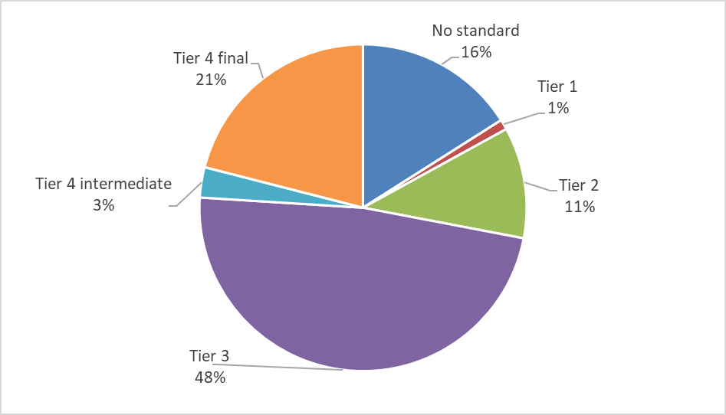

Some states and territories have targeted NRDE emission reduction programs. For example, the NSW government has undertaken diesel retrofit programs to raise the profile of cleaner NRDE (NSW EPA 2010). Individual state or territory-based programs which utilise retrofitting have been shown to provide net benefits. However, the marginal cost of emissions reductions from retrofitting is higher than procuring new low emitting NRDE (NSW EPA 2014, Pacific Environment 2013).

Individual states or territories cannot effectively limit NRDE emissions by applying emission standards in their individual jurisdictions. Any such policy would result in cross-border movement of non-compliant NRDE as allowed under the [Mutual Recognition Act 1992](https://www.legislation.gov.au/Details/C2013C00485). This act allows goods produced or imported lawfully in any individual state or territory to be sold in another, regardless of any differences in regulatory standards or other sale-related regulatory requirements.

All states and territories could choose to harmonise NRDE emissions standards through cooperative legislation. Cooperative legislation may result in regulatory inconsistency and different environmental outcomes if compliance and enforcement differ between jurisdictions. NRDE suppliers selling into more than one jurisdiction would also need to deal with more than one regulatory agency, which is likely to have a higher regulatory burden than a national approach to reducing NRDE emissions.

#### NRDE are likely to remain a key source of noxious emissions in Australia without intervention

Despite a projected transition towards higher tiered technology, emissions reduction are unlikely to be realised. Projected increases in NRDE use and annual fuel consumption will partially offset the emissions improvements offered by higher tiered technology. For example, NRDE fuel use is forecast to rise by 25% at the national level between 2018 and 2028, and an increase of 63% between 2018 and 2043. Modest decreases of some NRDE emissions are projected, while others are projected to increase (see Figure 12).

Figure 12 Net changes in business as usual NRDE emissions forecast between 2018 and 2043

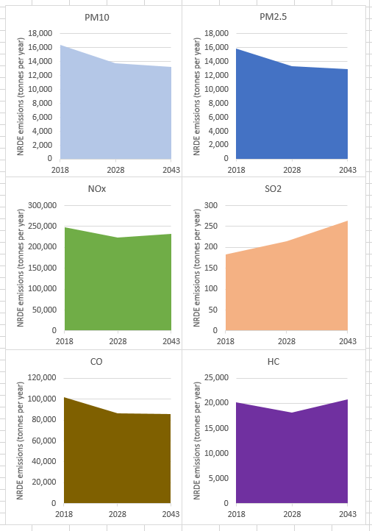

The net changes in emissions between 2018, 2028 and 2043 represent a trade-off between an increased national fleet (and hence activity and fuel consumption) and general reduction in average unit emissions (average g/kWh) resulting from the transition to better emission standards.

The accuracy of these forecasts is subject to the market transitioning towards tier 4. The estimated transition may be slowed by cost differentials as tier 4 engines are more expensive and may be subject to market failure (see Box 2). Un-forecasted increases in NRDE pollution are possible in the absence of intervention or cost effective NRDE alternatives as there will be a continuing domestic market for cheaper and more polluting (or ‘dirtier’) engines.

Box 2 Future market conditions in the absence of intervention

Technologies on the horizon for the non-road diesel sector are mainly electrification (hybrid, plug-in hybrid and battery electric vehicles) and hydrogen fuel cell technology. But such changes are not considered to be imminent. This slower transition to horizon technology will be primarily due to the high load factors of NRDE which require much larger energy sources than on-road applications to operate for the same time period.

Further, increasingly strict international NRDE emission standards are likely to increase the cost differential between cleaner engines which align with international best practice and cheaper dirtier engines which do not. This cost differential is expected to impede the future uptake of cleaner engines in Australia. As international standards tighten it is likely that the market for lower tiered products will contract while supply does not. Such a situation risks increased competition between these lower tiered products and potentially dumping of the dirty engines in Australia at below cost. The presence of discounted lower tier engines would further increase the cost differential and lessen the predicted uptake of clean engines which align with international best practice.

Consultation questions:

5) Can you suggest or provide evidence for alternative assumptions about transitioning to alternative energy for NRDE applications?

6) Are you able to demonstrate more reasonable assumptions about future market conditions in the absence of intervention?

The scale of air pollution from these sources and the current and forecast low uptake of low emissions technology supports an examination of possible national options to manage emissions from this source as:

* there is no threshold below which adverse health effects are avoided for some pollutants emitted from NRDE. Even a small reduction in emissions may result in substantial health and economic benefits (through reducing the incidence of health impacts and reducing health costs)
* in the absence of intervention there may be a potential risk of higher-than-forecast sales of cheaper and more polluting engines and hence higher emissions.

## Objectives of government action

The government is undertaking this evaluation to understand the nature and emissions profile of the NRDE sector and if there is an opportunity to reduce emissions. If an opportunity exists, then the government may analyse options to manage emissions.

The market analysis identified that NRDE in Australia produce significant emissions and that Australia has a low uptake of international NRDE emission standards.

The overarching objectives of the evaluation are:

* to reduce the adverse impacts of non-road diesel engine emissions on the environment and human health
* to ensure nationally consistent, cost-effective management of non-road diesel engine emissions comparable with international approaches.

These objectives are aligned with the principles of emissions reduction measures under the National Clean Air Agreement. These measures:

* are targeted towards reducing air pollution and/or population exposure to air pollution, with associated health outcomes
* require options to manage emissions to include costs and benefits as appropriate
* have an objective to develop practical, cost-effective and outcome-focused solutions.

## Statement of options

### The options for action

The cost-benefit analysis will examine 4 management scenarios (see Table 2). Three scenarios involve a change in management and all these scenarios:

* draw on international NRDE emission standards (references to standards are for US EPA tiers. However, other international standards that are equivalent to a US tier apply)
* apply to all within-scope NRDE equipment introduced into Australia for the first time. This means all new NRDE, whether manufactured in Australia or overseas, and imported second hand NRDE
* loose replacement engines in NRDE equipment must match or exceed the emission standard that applied to the equipment when it was built (internationally, NRDE emission regulations typically apply to new equipment only. Some jurisdictions do require replacement engines are of a higher emission standard than applied to the equipment when it was built. Such requirements are not common and highly varied. For example, this requirement often only applies to a certain power band, tier/stage, and end use.).

Table 2 Summary of NRDE management scenarios

| Regulation type | Scenario | Description |
| --- | --- | --- |
| Non-regulatory | Base Case - No action | Business as usual |
| 1. Industry standards | Industry-led standards to meet targets aligning with international best practice (currently tier 4 final) |
| Commonwealth regulation | 1. Phased introduction of standards | Introducing lower emission standards as soon as practicable (tier 3) and moving to standards aligning with international best practice over time (currently tier 4 final) |
| 1. Best practice standards as soon as practicable | Introducing standards aligning with international best practice as soon as practicable (currently tier 4 final) |

These options:

* use international emission standards, as other countries have found them to be a cost-effective measure for reducing urban air pollution (DIRD 2016)
* directly follow the Australian Government principle to adopt or align with accepted international standards to reduce the regulatory burden for business and remove barriers to trade
* assume there are no technical barriers for non-road diesel engine emissions technology such as fuel quality (see Appendix 6).

All government cost-benefit analysis requires at least one option that is non-regulatory. For this cost-benefit analysis this is Scenario 1 – industry standards. Every management scenario considered should be practical and implementable, and options should not be discounted just because they haven’t been considered before or there are risks associated with them. Consultation questions about the overarching assumptions of the management scenarios are listed in Box 3.

Box 3 Questions regarding the management scenario overarching assumptions

These questions relate to the overarching assumptions that inform the options for action, or management scenarios. Each management scenario is further described in the following sections, each with questions that relate to the specific scenario.

**Consultation questions:**

7) Do you have any insights or concerns regarding how the management scenarios address:

* NRDE equipment introduced into Australia for the first time; or
* loose replacement engines in NRDE equipment?

8) Do you have any insights or concerns regarding the overarching assumption regarding technical barriers associated with management scenarios? If so, please provide as much information as possible such as:

* equipment types
* power bands
* use, such as geographic considerations.

#### Base case – No action

This is the base case against which the incremental costs and benefits of scenarios 1 to 3 are determined. The no action scenario is business as usual.

The base case was developed during the market analysis stage of this evaluation. The base case is currently under review following targeted feedback from the supply industry and consumers. This feedback is not incorporated into this discussion paper.

The base case had a baseline year of 2018 where the national stock (equipment in use) was quantified and characterised. The baseline was derived using a combination of bottom up and top down methods:

* bottom up estimates were based on
  + Australian Border Force (Customs) data on annual imports (and re-exports)
  + industry sales data and asset emissions, service lifetime and use provided by the NRDE supply sector.
* this was then adjusted using a top down approach using diesel use as recorded for Australian industry sectors in Australian energy statistics and in ABS fuel-use data. Equipment allocations from the bottom up estimate were adjusted to each industry sector and state or territory.

The baseline model also includes projections for 2028 and 2043, with interpolation for the intervening years. Projections were developed for each equipment type, power band, industry sector and state or territory based on the following assumptions:

* take-up (expressed as a proportion of new sales ) of tier 4 for each equipment category and power band continues to grow at the same rate it did between 2015 (when tier 4 emission standards had been fully phased-in in the United States) and 2018
* there is no uptake of alternative technology such as electrification (hybrid, plug-in hybrid and battery electric vehicles) and hydrogen fuel cell technology
* changes in the numbers and composition of stocks over time were derived from overlaying these predictions with assumed equipment life span
* that fuel use continues to grow based on historical trends (about 2.0% per year nationally).

Combining these assumptions has the effect of slowly transitioning the fleet towards higher tiered technology as legacy engines are retired. Figure 13 shows this transition by representing alignment with tiering as a proportion of the national NRDE stock (fleet). The national NRDE stock includes all types of equipment and engine sizes.

Figure 13 Predicted tiering as a proportion of the national NRDE stock (fleet)

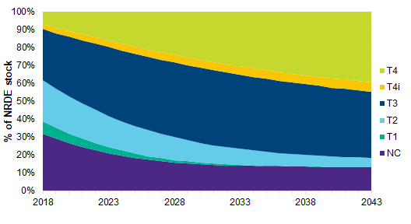

Key findings of the projections were:

* annual sales will continue to increase over the next decade to up from 72,000 in 2018 to 84,000 units by 2028 and 107,000 by 2043
* the stock of NRDE in 2018 was estimated to be around 637,000. That number is projected to increase to around 736,000 by 2028 and 929,000 in 2043
* in all three model years agricultural equipment represented the largest aggregated equipment type in the stock, reflecting the large annual sales in the agricultural sector and the long lifetime of many engines
* the largest growth between 2018 and 2043 was projected for generator sets, agriculture and forestry, industry, and G-drive (a loose engine for a generator set).

Anoverview of the base case review process is provided in Box 4 below.

Box 4 Base case

The information above is a simplification of a very diverse market and is not intended to fully represent the base case. How business as usual is defined in a cost-benefit analysis can be as influential as the scenarios modelled. For that reason, it is important to spend time on making the right assumptions/predications on the best possible data available at the time.

The base case is currently under review by the cost-benefit analysis consultant following targeted feedback from the NRDE supply industry and consumers:

* this process was initiated in early 2020, with the last submissions made 30 September 2020
* by the end of October 2020, the cost-benefit analysis consultant will have reviewed feedback on the base case and made appropriate changes.

If you have not had an opportunity to review the base case and would like to do so, email the department at [airquality@awe.gov.au](mailto:airquality@awe.gov.au).

#### Scenario 1 – Industry standards

Industry develops standards in cooperation with governments to meet targets for sales of new non-road diesel engines which align with international best practice for emissions.

This scenario seeks to reduce the impacts of non-road diesel emissions without regulation through industry standards that increase the proportion of sales for NRDE which align with international best practice emission standards. By utilising existing international standards and using non-regulatory oversight this scenario could potentially provide the most cost-effective emissions reductions and manage potential drawbacks of regulation.

This scenario:

* may avoid regulation in the future
* may offer competitive advantage to participating industries. Participating industries have opportunity to enhance their reputation and promote their activities. Increased public or consumer recognition could increase market shares or provide advantage in segments of the market (for example, procurement policies that preference cleaner engines)
* aims to balance NRDE emissions reductions in populated areas while continuing the supply of higher emitting technology to some applications where tier 4 final may not be practical
  + some stakeholders have indicated there may be practical challenges with moving to tier 4 final for certain applications and would prefer these applications to be exempt from standards. Those identified at this stage are standby generators, standby fire pumps and agricultural pumps
  + the practical challenges relate mainly to tier 4 equipment requiring maintenance and repairs to be undertaken by a registered technician using proprietary software. This would be particularly difficult for Australia’s remote and regional areas
  + the market analysis indicated these applications were around 20% of new sales and that the highest proportions of agricultural type equipment were less than 37KW.

Through non-regulatory oversight this scenario also meets the objectives of the Australian Government’s regulation reform agenda.

##### Features

Under scenario 1, standards would be adopted by industry in cooperation with governments. Implementation and compliance with the standards would be driven by industry and not underpinned by a Commonwealth regulatory framework. The standards would be non-binding. Industry would agree to report on levels of compliance with the standards.

This scenario could utilise labelling of NRDE products that align with industry emission standards. Labelling could enable consumers to choose between a lower emission, labelled product and a higher emission, non-labelled product. Scenario 1 features and options for industry consideration are shown in Box 5.

Box 5 Scenario 1 features and options for industry consideration

Industry agrees to move its fleet to meet international standards or alternative technology and report on compliance. This would be achieved by an Industry Agreement involving members of peak industry bodies who represent the majority of the Australian NRDE supply and consumer industries.

We are seeking industry input into this scenario. Below are two options for industry consideration that may meet the objectives of reducing the adverse impacts of NRDE emissions on the environment and human health. Neither option includes 100% coverage:

* to allow for continued supply of higher emitting technology to some applications where tier 4 final may not be practical, while promoting NRDE emissions reductions in populated areas
* because this is not practical for a voluntary scenario in a diverse market.

We welcome feedback on the following options, including alternate options that reduce NRDE emissions nationally without regulation.

Option A

Within 2 years after any hypothetical decision to introduce this management option, 50% of NRDE type equipment introduced into Australia for the first time by each industry group:

* align with international best practice for NRDE emissions (at least tier 4 final or equivalent), or
* are an alternative technology that can be substituted for a NRDE product (hybrid, plug-in hybrid, battery electric or hydrogen fuel cell technology).

Industry groups are:

* mining
* agriculture
* forestry
* construction and commercial
* manufacturing
* marine (<130kW only).

Ensuring emissions improvements occur in all industry groups should minimise the likelihood of perverse outcomes where higher emissions intensities are concentrated in one industry.

Option B

Within 2 years after any hypothetical decision to introduce this management option, NRDE type equipment introduced into Australia for the first time align with international practice for NRDE emissions as follows:

* For >/= 37KW, 50% of equipment are at least tier 4 final (or equivalent), or an alternative technology that can be substituted for a NRDE product
* For < 37KW, 50% of equipment are at least tier 3 (or equivalent), or an alternative technology that can be substituted for a NRDE product.

##### Stakeholder roles for scenario 1

For scenario 1, Table 3 lists the roles for suppliers and consumers of NRDE and government.

Table 3 Scenario 1 roles for suppliers and consumers of NRDE and government

| Participant | Role |
| --- | --- |
| Government | Support industry in development of industry standard |
| Supply sectors | Participate in the development of industry standards  Undertake education to understand their obligations under the industry standards  Import/manufacture/supply equipment that complies with the relevant stage of the management option  Ensure NRDE are labelled in accordance with the industry standard where required  Manage sales to meet targets for international best practice emission standards or alternative technology  Track and independently audit adherence to the industry standard  Publicly report on compliance |
| Consumers | Participate in the development of industry standard (if lead by consumers, not suppliers)  Work with supply sector to achieve compliance (if lead by consumers, not suppliers) |

##### Benefits and drawbacks

Partnership opportunities include industry codes of practice developed with government involvement, guidance notes, and accreditation schemes. These are known as quasi-regulation. This approach would have the following potential benefits and drawbacks:

* Potential benefits
  + offers industry greater flexibility and adaptability
  + potentially lower compliance and administrative costs
  + ability to harness industry knowledge and expertise to address industry-specific and consumer issues directly
  + offers participating industries competitive advantage, such as access to certain segments of the market
  + encourages the uptake of alternative technology that can be substituted for a NRDE product
  + uptake of cleaner engines resulting in reduced emissions and greater health benefits.
* Potential drawbacks
  + the possibility of raising barriers to entry within an industry
  + unintended monopoly power gained by participants that could restrict competition
  + danger of regulatory capture where rather than acting in the interests of reducing the impacts of NRDE emissions the scenario has the potential to act in the interests of some or all NRDE suppliers or consumers.

##### Consultation questions

Box 6 shows questions regarding scenario 1.

Box 6 Questions regarding scenario 1

****General questions****

9) Do you prefer option A or option B and why?

10) Do you think labelling would be an important feature for any voluntary approach? If so why?

11) Can you suggest a better way for industry to manage NRDE emission rather than those suggested in option A and B? If so, please provide as much detail as possible about scope, timing and roles for government, suppliers and consumers.

Option A

12) We have suggested a 50% target. Is this percentage a reasonable balance between emission reductions and flexibility? If no, what percentage offers that balance and why?

13) Is there another way to ensure that emissions reductions are occurring in populated areas other than the industry grouping approach?

14) Is it practical to commence this scenario within two (2) years after any hypothetical decision to introduce this management option? If no what is an appropriate date to commence this scenario and why?

15) Are there other possible benefits or drawbacks?

Option B

16) We have suggested a 50% target. Is this percentage a reasonable balance between emission reductions and flexibility? If no, what percentage offers that balance and why?

17) Is there a better power threshold to use (than 37KW) to move from tier 3 to tier 4f technology which ensures that emissions reductions are occurring in populated areas? If yes, please provide an alternative power threshold and why?

18) Is it practical to commence this scenario within 2 years after any hypothetical decision to introduce this management option? If no what is an appropriate date to commence this scenario and why?

19) Are there other possible benefits or drawbacks?

#### Scenario 2 – phased introduction of standards

Non-road diesel engines introduced into Australia are required to meet emission standards. Commonwealth regulation would require imported and manufactured NRDE to align with lower emission standards (equivalent to tier 3) as soon as practicable, followed by a required transition to international best practice standards.

This scenario examines a management option that fits between scenarios 1 and 3 in terms of both emissions’ reduction and probable costs. This scenario aims to:

* introduce a minimum emission standard to imported and manufactured NRDE products as soon as practical using technology that cost less than tier 4
* provide a transition period where consumers can purchase imported and manufactured NRDE products that can be maintained or repaired without specialist personnel or software that is required for tier 4 equipment
* phase to international best practice NRDE emission standards after an adjustment period.

##### Features

Under scenario 2, the introduction of NRDE emission standards would be regulated by the Commonwealth. All within-scope NRDE first introduced into Australia would be required to meet the standards specified in the regulation.

* Phase 1 would see an introduction of less stringent standards followed 3 years later by phase 2 applying best practice international standards:
  + Phase 1 implementation would commence 2 years after any hypothetical decision to introduce this management option
  + Phase 2 implementation would commence 5 years after any hypothetical decision to introduce this management option.
* For both phases, the standards apply to import and manufacture first. Then 1 year after the import and manufacture restrictions, supply restrictions would apply.

Scenario 2 features for industry consideration are shown in Table 4.

Table 4 Scenario 2 features and options for industry consideration

| Restriction type | Phase 1 | Phase 2 |
| --- | --- | --- |
| **Import and manufacture restrictions** | Decision + 2 years – tier 3 **a** standards(or equivalent) apply to the import or manufacture of NRDE introduced into Australia for the first time | Decision + 5 years – current international standards (tier 4 final) apply to the import or manufacture of NRDE introduced into Australia for the first time |
| **Supply restrictions** | Decision + 3 years – tier 3 a standards apply to the sale of NRDE introduced into Australia for the first time | Decision + 6 years – current international standards (tier 4 final) apply to the sale of NRDE introduced into Australia for the first time |

**a** where a power band has no tier 3 standard the next best available standard applies. For example, US tier 2 applies to < 37 kw (< 50) and ≥ 560 kw (hp ≥ 750)

##### Stakeholder roles for scenario 2

For scenario 2, Table 5 lists the roles for suppliers and consumers of NRDE and government.

Table 5 Scenario 2 roles for suppliers and consumers of NRDE and Government

| Participant | Role |
| --- | --- |
| Government | Administer the NRDE emission standards including the import restrictions for each phase as implemented by the Australian Border Force (Customs) and undertake compliance activities  Support the regulated community to understand their obligations under the emission standards  Process applications (such as for Australian certification), collect fees and levies, and undertake activities to ensure compliance with the standards |
| Supply sectors | Undertake education to understand their obligations under the emission standards  Import/manufacture/supply equipment that complies with the relevant stage of the management option  Ensure NRDE are labelled in accordance with the emission standard where required  Keep the appropriate records and report to government each financial year  Pay the government potential charges imposed on NRDE products to fund the regulatory scheme |
| Consumers | Continue to use NRDE you already own. It will not need to be retrofitted to meet the standards and can continue to be used. Replacement engines in NRDE equipment do not need to be to a higher emission standard than applied to the equipment when it was built  Continue to sell, buy, swap or give away used products (providing the used NRDE is not being imported into Australia at a lower emission standard than required by this management option)  Before purchasing NRDE equipment that is new to Australia, you can ask the retailer if the product meets the emission standards and ask to see the appropriate emissions label that is required to be fixed to the engine  Report non-compliance to government |

##### Benefits and drawbacks

This approach would have the following potential benefits and drawbacks:

* Potential benefits
  + a phased introduction allows for new solutions to be developed for applications where higher tier technology is less practical
  + staggering the introduction of standards for import and supply at each phase (sales restrictions a year after import restrictions) avoids stockpiles of non-compliant stock in Australia
  + ensures public health outcomes are improved due to some form of emissions controls applied to all NRDE introduced into Australia for the first time
  + the NRDE supply sector no longer needs to have distinct manufacturing and training processes required when producing equipment with multiple emissions technologies
  + higher emissions reductions are possible during phase 1 if consumers choose to purchase tier 4 technology
  + public health impacts from NRDE can be more accurately predicted
  + uptake of cleaner engines resulting in reduced emissions and greater health benefits.
* Potential drawbacks
  + costs for implementing the standards are borne by suppliers and/or consumers
  + consumers may delay purchasing new equipment due to higher costs or other disbenefits, extending high emissions from old equipment and reducing sales for suppliers
  + could restrict market entry for a small market like Australia, reducing competition or creating monopolies for certain NRDE applications and/or power bands
  + may suppress or prevent innovation by imposing technical barriers.

##### Consultation questions

Box 7 shows questions regarding scenario 2.

Box 7 Questions regarding scenario 2

20) Are these appropriate dates to initiate each phase of this scenario after any hypothetical decision to introduce this management option? If no, what dates are appropriate and why?

21) Are there other possible benefits or drawbacks?

#### Scenario 3 – Best practice standards as soon as practicable

Non-road diesel engines introduced into Australia are required to meet emission standards. Commonwealth regulation would require that imported and manufactured NRDE align with international best practice standards as soon as practicable.

This scenario examines a management option that is likely to provide the greatest health benefits of the three potential management scenarios presented.

##### Features

Under scenario 3, the introduction of NRDE emission standards would be regulated by the Commonwealth. All NRDE introduced into Australia would be required to meet the standards specified in the regulation.

* The implementation of international best practice standards would commence 2 years after any hypothetical decision to introduce this management option
* The standards apply to import and manufacture first. Then 1 year after the import and manufacture restrictions, supply restrictions would apply.

Scenario 3 features and options for industry consideration are shown in Table 6.

Table 6 Scenario 3 features and options for industry consideration

| Restriction type | Restrictions |
| --- | --- |
| Import restrictions | Decision + 2 years – Current international standards (tier 4 final) apply to the import or manufacture of NRDE introduced into Australia for the first time |
| Supply restrictions | Decision + 3 years – Current international standards (tier 4 final) apply to the sale of NRDE introduced into Australia for the first time |

##### Stakeholder roles for scenario 3

For scenario 3, the roles for suppliers and consumers of NRDE and government are the same as scenario 2 (phased introduction of emission standards). These are reproduced below in Table 7.

Table 7 Scenario 3 roles for suppliers and consumers of NRDE and government

| Participant | Role |
| --- | --- |
| Government | Administer the NRDE emission standards including the import restrictions for each phase as implemented by the Australian Border Force (Customs) and undertake compliance activities  Support the regulated community to understand their obligations under the emission standards  Process applications (such as for Australian certification), collect fees and levies, and undertake activities to ensure compliance with the standards |
| Supply sectors | Undertake education to understand their obligations under the emission standards  Import/manufacture/supply equipment that complies with the relevant stage of the management option  Ensure NRDE are labelled in accordance with the emission standard where required  Keep the appropriate records and report to government each financial year  Pay the government potential charges imposed on NRDE products to fund the regulatory scheme |
| Consumers | Continue to use NRDE you already own. It will not need to be retrofitted to meet the standards and can continue to be used. Replacement engines in NRDE equipment do not need to be to a higher emission standard than applied to the equipment when it was built  Continue to sell, buy, swap or give away used products (providing the used NRDE is not being imported into Australia at a lower emission standard than required by this management option)  Before purchasing NRDE equipment that is new to Australia, you can ask the retailer if the product meets the emission standards and ask to see the appropriate emissions label that is required to be fixed to the engine  Report non-compliance to government |

##### Benefits and drawbacks

This approach would have the following potential benefits and drawbacks:

* Potential benefits
  + staggering the introduction of standards for import and supply (sales restrictions a year after import restrictions) avoids stockpiles of non-compliant stock in Australia
  + ensures NRDE introduced into Australia provides the highest possible public health outcomes
  + tier 4 final equipment is proven technology having been available for many years for most applications and power bands as it is already available overseas
  + the NRDE supply sector no longer needs to have distinct manufacturing and training processes required when producing equipment with multiple emissions technologies
  + public health impacts from NRDE can be more accurately predicted
  + higher costs for tier 4 equipment may encourage innovation in non-diesel technology or accelerate a transition from diesel
  + uptake of cleaner engines resulting in reduced emissions and greater health benefits.
* Potential drawbacks
  + consumers will have less lower cost options as only tier 4 equipment can be introduced into Australia
  + consumers in remote or rural areas may not be able to practically use tier 4 equipment
  + costs for implementing the standards are borne by suppliers and/or consumers
  + consumers may delay purchasing new equipment due to higher costs or other disbenefits, increasing emissions from old equipment and reducing sales for suppliers
  + could restrict market entry for a small market like Australia, reducing competition or creating monopolies for certain NRDE applications and/or power bands
  + may suppress or prevent innovation by imposing technical barriers.

##### Consultation questions

Box 8 shows questions regarding scenario 3.

Box 8 Questions regarding scenario 3

22) What is an appropriate date to initiate each phase of this scenario?

23) Are there other possible benefits or drawbacks?

## Appendix 1: Consultation questions

Throughout this discussion paper, a series of consultation questions are posed to encourage stakeholders to respond. These have been consolidated in Box 9.

A separate questionnaire has been sent with this document:

* it includes all questions in this discussion paper as a form
* please provide feedback by answering those questions which interest you
* responses are welcome until **COB Friday 23 October 2020.**

Responses can be provided by email. If you would like to provide verbal feedback, email the Air Quality Policy Section to set up a time.

To provide feedback, please contact the Air Quality Policy Section at [airquality@awe.gov.au](mailto:airquality@awe.gov.au).

Box 9 Consolidated consultation questions

Topic - Non-road diesel engines in Australia (Box 1)

1) Can you more accurately describe the NRDE market in Australia?

2) What drivers might influence the purchase of cleaner alternatives, even if they cost more? How much more?

3) How does the emissions performance of non-road diesel equipment influence purchasing decisions?

4) Have you participated in a voluntary scheme to reduce NRDE emissions? If so, was it effective and why?

Topic - Future market conditions in the absence of intervention (Box 2)

5) Can you suggest or provide evidence for alternative assumptions about transitioning to alternative energy for NRDE applications?

6) Are you able to demonstrate more reasonable assumptions about future market conditions in the absence of intervention?

Topic - Management scenario overarching assumptions (Box 3)

7) Do you have any insights or concerns regarding how the management scenarios address:

* NRDE equipment introduced into Australia for the first time; or
* loose replacement engines in NRDE equipment?

8) Do you have any insights or concerns regarding the overarching assumption regarding technical barriers associated with management scenarios? If so, please provide as much information as possible such as:

* equipment types
* power bands
* use, such as geographic considerations.

Topic - Scenario 1, industry standards (Box 6)

9) Do you prefer option A or option B and why?

10) Do you think labelling would be an important feature for any voluntary approach? If so why?

11) Can you suggest a better way for industry to manage NRDE emission rather than those suggested in option A and B? If so, please provide as much detail as possible about scope, timing and roles for government, suppliers and consumers.

Questions related to scenario 1 option A – consistent targets for industry groups

12) We have suggested a 50% target. Is this percentage a reasonable balance between emission reductions and flexibility? If no, what percentage offers that balance and why?

13) Is there another way to ensure that emissions reductions are occurring in populated areas other than the industry grouping approach?

14) Is it practical to commence this scenario within 2 years after any hypothetical decision to introduce this management option? If no what is an appropriate date to commence this scenario and why?

15) Are there other possible benefits or drawbacks?

Questions related to scenario 1 option B – power band targets

16) We have suggested a 50% target. Is this percentage a reasonable balance between emission reductions and flexibility? If no, what percentage offers that balance and why?

17) Is there a better power threshold to use (than 37KW) to move from tier 3 to tier 4f technology which ensures that emissions reductions are occurring in populated areas? If yes, please provide an alternative power threshold and why?

18) Is it practical to commence this scenario within 2 years after any hypothetical decision to introduce this management option? If no what is an appropriate date to commence this scenario and why?

19) Are there other possible benefits or drawbacks?

Topic - Scenario 2, phased introduction of standards (Box 7)

20) Are these appropriate dates to initiate each phase of this scenario after any hypothetical decision to introduce this management option? If no, what dates are appropriate and why?

21) Are there other possible benefits or drawbacks?

Topic - Scenario 3, best practice standards as soon as practicable (Box 8)

22) What is an appropriate date to initiate each phase of this scenario?

23) Are there other possible benefits or drawbacks?

## Appendix 2: Analysis method

The department has commissioned EMM Consulting, supported by RPS Consulting, CSIRO and the University of Sydney to undertake a cost-benefit analysis of scenarios to manage NRDE emissions in Australia. The cost-benefit analysis will be presented using a combination of:

* placing a financial value upon costs and benefits (monetising costs and benefits)
* quantified but not monetised costs and benefits
* qualitative but not quantified or monetised costs and benefits.

This combination will enable decision-makers to consider the best available information.

Quantitative modelling:

* will build on the market analysis and model population exposure to NRDE emissions for each management scenario and associated health impacts (the impacts of air pollution on health cannot be directly counted (for example as per traffic accidents) and must be evaluated from estimates of health risk based on scientific research)
* is designed to allow the modelled output for each management scenario to be manipulated after the cost-benefit analysis. This would allow a possible future regulatory impact analysis to formulate alternate management scenarios, such as different start dates, and quantify the subsequent effects on costs and benefits.

### Quantitative modelling

#### Process

Cost-benefit analysis modelling involves five steps:

1. Industry model
2. Emissions model
3. Exposure model
4. Health effects model
5. Economic model

These steps are replicated for each management scenario and are described below.

1. **Industry model** – How each management scenario modifies the sales and stock of NRDE (and subsequent emissions) and the associated costs and benefits. Sectoral calculations may include such matters as marginal costs for replacement with lower emissions equipment and changes in running costs that may be associated with changes in fuel efficiency.
2. **Emissions model** – Spatial modelling of NRDE emissions is illustrated in Figure 14.

Figure 14 Emissions model

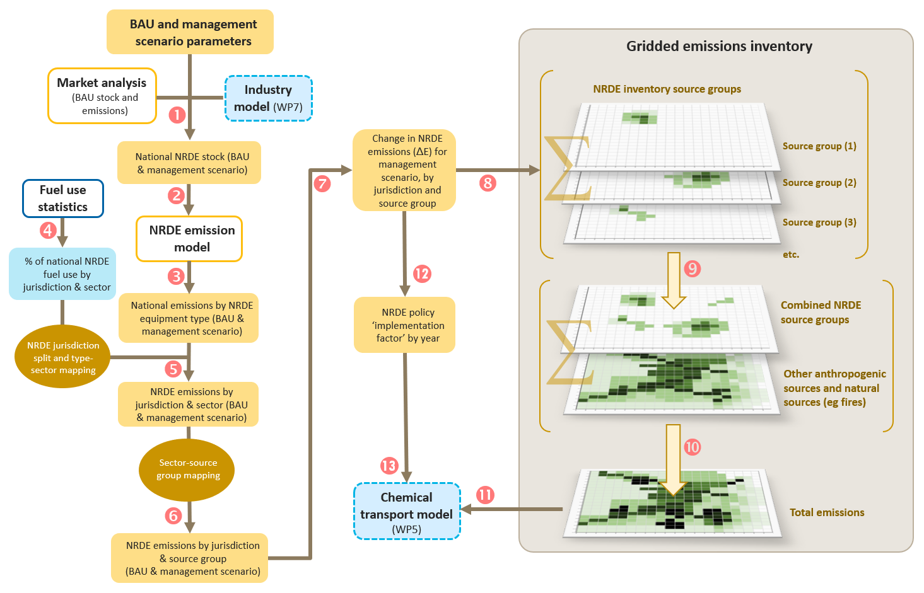

**Emissions of concern for health modelling are PM2.5 and NOx (which includes NO2 and NO). Ultrafine particles (UFPs) are particles with a diameter of less than 0.1 μm. There is some evidence that particles in this size range are associated with adverse health effects, however it is not currently practical to incorporate them into this cost-benefit analysis. The World Health Organization Regional Office for Europe (2013) stated a health impact assessment for ultrafine particles is not recommended. For the purpose of the project assessment, it has therefore been assumed that the effects of UFPs on health are adequately represented by those of PM2.5**

**Also modelled will be other NRDE emissions that impact health and climate change.**

1. **Exposure model** – National atmospheric modelling will be undertaken on a supercomputer for BAU and each management scenario to accurately model the airborne dispersion and chemical transformation of NRDE emissions. The predicted concentrations of ground level pollutants will be overlayed with gridded age specific population data to determine population exposure. Anthropogenic and natural emissions other than NRDE emissions will be included in the model to account for chemical transformation. The modelling will estimate the impacts of both primary and secondary pollution resulting from NRDE emissions.

Natural emissions sources include sea salt, biogenic, regional dust and landscape fires. This data will be derived from jurisdictional air emissions inventories. Secondary NRDE pollution are formed as a result of chemical reactions between pollutants in the atmosphere.

The national atmospheric modelling will use 9-12 km grid spacing on the national scale, and a 1-3 km grid spacing at the city scale for the larger Australian capital cities. The finer-scale modelling will aim to capture more than 90% of the national population exposure. Population data is at 1km grid spacing.

Figure 15 below illistrates the exposure model for NRDE.

Figure 15 Exposure model

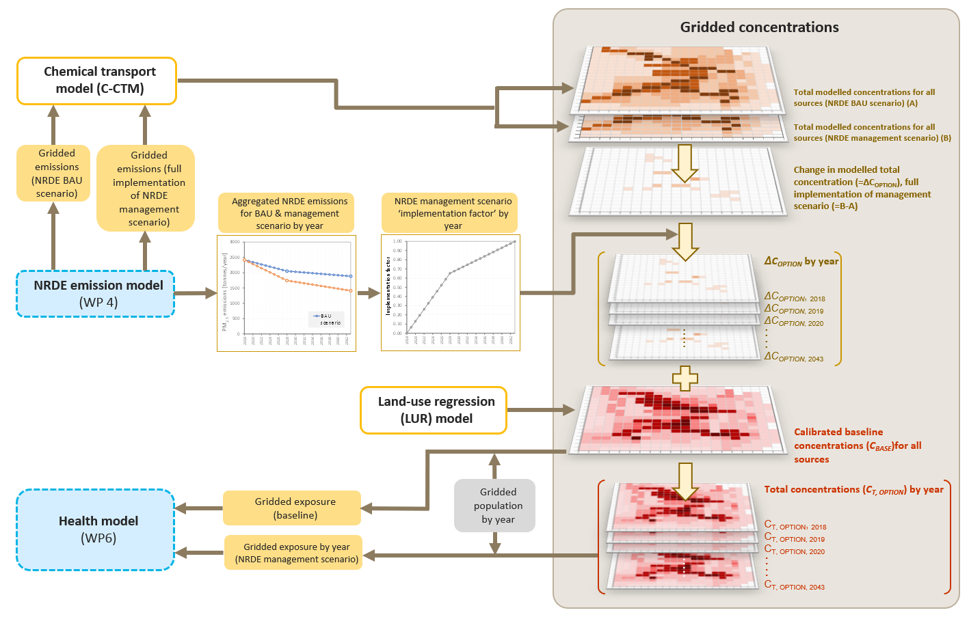

1. **Health effects model** – This model will assess the health effect of population exposure to NRDE emissions, but not micro-environments such as workplace exposure. It will use concentration response functions (CRFs) available from a variety of readily available sources, such as the World Health Organization and include a national health impact assessment (HIA). The HIA will use measured impacts of health in Australia (such as mortality data).

A reduction in workplace exposure to NRDE-related pollutants will be included as an ‘unquantifiable benefit’. Health data to quantify workplace exposure is not available and exposure is at too fine a resolution to be quantified in the evaluation’s modelling resolution of 1 km (spatial) and 1 hour (temporal):

* the concentration-response functions are based on epidemiological data (for example, ambient concentrations and bulk health statistics)
* workplace exposure standards include 15-minute short-term exposure limits (STELs).

Similarly, the evaluation will not distinguish between other different ‘micro-environments’, such as:

* indoor vs outdoor exposure
* different types of location (for example, residence, industrial workplace, commercial property)
* people living near NRDE emissions sources.

1. **Economic model** – The last stage of the cost-benefit analysis is financial, covering monetisation of health burden, any climate change impacts and benefits and cost of any proposed changes to NRDE emission limits. Economic impacts examined include:

* costs for complying with management scenario
* social discount rate
* Value of a Statistical Life (VSL)
* economic costs of morbidity impacts (for example, health system costs)
* value of non-health impacts from air pollution exposure (for example, materials damage, ecological impacts)
* ouplift factor (reflecting expected increases in the willingness to pay (WTP) to avoid health risk over time)
* potential productivity impacts from air pollution exposure.

#### International emission standards

The emissions modelling is only considering management scenarios that can practically be modelled:

* modelling will distinguish between tier 4i and tier 4f
* european stage V is out of scope as it is was being phased in during the commencement of the project and not incorporated into the emissions model used by the project
  + stage V departs from the international harmonisation of NRDE standards and introduces a particle number emission limit for NRDE engines between 19 and 560 kW which will require adoption of diesel particulate filters
  + if in practice any stage V equipment is imported, then both health benefits and costs may be underestimated for this equipment.

#### Time steps

Modelling is by calendar year:

* the dispersion modelling will be conducted for one (representative) year
* emission modelling will be conducted for the three years of the market analysis (2018, 2028, 2043)
  + each emissions modelling year will use the same dispersion model and all non-NRDE pollutants will remain unchanged
  + intervening years will be interpolated
* the health analysis and the economic analysis will cover the period of the cost-benefit analysis.

#### Sensitivity analysis

Sensitivity analysis test a range of parameters which will develop during the study, but they are likely to include, for example:

* high and low estimates for business as usual emissions, based on low-compliance (high-emissions) and high-compliance (low-emissions) assumptions
* sensitivity discount rates of 3% and 10% (real)
* a high and low estimate for incremental costs
* a high and low estimate for damage costs.

## Appendix 3: International emission standards

The US and EU regulations have evolved over time to cover a wider range of engine power ratings, to define increasingly stringent standards, and to (generally) improve harmonisation between countries.

For most power bands the USEPA standards are practically equivalent to European Union non-road diesel engine standards as follows:

* US Tier 1 = EU Stage I
* US Tier 2 = EU Stage II
* US Tier 3 = EU Stage IIIA
* US Tier 4 intermediate = EU Stage IIIB
* US Tier 4 final = EU Stage IV and EU Stage V

Both US and EU standards allocate non-road diesel engines to categories of rated engine power, named power bands (see Table 8).

Table 8 US and EU standards for different engine power

| US (kW) | EU (kW) |
| --- | --- |
| < 8 | < 8 |
| 8–19 | 8–19 |
| 19–37 | 19–37 |
| 37–56 | 37–56 |
| 56–75 | 56–75 |
| 75–130 | 75–130 |
| 130–225 | 130–560 |
| 225–450 |
| 450–560 |
| 560+ | 560+ |

Appendix 4 and Appendix 5 summarise US and EU NRDE emission standards for all levels and power bands.

## Appendix 4: US emission standards for non-road diesel engines

Table 9 below shows the US emission standards for NRDE.

Table 9 US emission standards

| Power | Tier | Year | Emission standard (g/kWh) | | | | |
| --- | --- | --- | --- | --- | --- | --- | --- |
| CO | NMHC | NMHC+NOX | NOX | PM |
| < 8 kW | Tier 1 | 2000 | 8.0 | – | 10.5 | – | 1.0 |
| Tier 2 | 2005 | 8.0 | – | 7.5 | – | 0.8 |
| Tier 3 | – | – | – | – | – | – |
| Tier 4 | 2008 | 8.0 | – | 7.5 | – | 0.4 |
| 8 ≤ kW < 19 | Tier 1 | 2000 | 6.6 | – | 9.5 | – | 0.8 |
| Tier 2 | 2005 | 6.6 | – | 7.5 | – | 0.8 |
| Tier 3 | – | – | – | – | – | – |
| Tier 4 | 2008 | 6.6 | – | 7.5 | – | 0.4 |
| 19≤ kW < 37 | Tier 1 | 1999 | 5.5 | – | 9.5 | – | 0.8 |
| Tier 2 | 2004 | 5.5 | – | 7.5 | – | 0.6 |
| Tier 3 | – | – | – | – | – | – |
| Tier 4i/Tier 4f | 2008/2013 | 5.5/5.5 | – | 7.5/4.7 | – | 0.3/0.03 |
| 37 ≤ kW < 56 | Tier 1 | 1998 | – | – | – | 9.2 | – |
| Tier 2 | 2004 | 5.0 | – | 7.5 | – | 0.4 |
| Tier 3 | 2008 | 5.0 | – | 4.7 | – | **a** |
| Tier 4i/Tier 4f | 2008/2013 | 5.0/5.0 | – | 4.7/4.7 | – | 0.3/0.03 |
| 56 ≤ kW < 75 | Tier 1 | 1998 | – | – | – | 9.2 | – |
| Tier 2 | 2004 | 5.0 | – | 7.5 | – | 0.4 |
| Tier 3 | 2008 | 5.0 | – | 4.7 | – | **a** |
| Tier 4i/Tier 4f | 2012/2014 | 5.0/5.0 | 0.19/0.19 | – | 2.3**b**/0.40 | 0.02/0.02 |
| 75 ≤ kW < 130 | Tier 1 | 1997 | – | – | – | 9.2 | – |
| Tier 2 | 2003 | 5.0 | – | 6.6 | – | 0.3 |
| Tier 3 | 2007 | 5.0 | – | 4.0 | – | **a** |
| Tier 4i/Tier 4f | 2012/2014 | 5.0/5.0 | 0.19/0.19 | – | 2.3**b**/0.40 | 0.02/0.02 |
| 130 ≤ kW < 225 | Tier 1 | 1996 | 11.4 | 1.3 | – | 9.2 | 0.54 |
| Tier 2 | 2003 | 3.5 | – | 6.6 | – | 0.2 |
| Tier 3 | 2006 | 3.5 | – | 4.0 | – | **a** |
| Tier 4i/Tier 4f | 2011/2014 | 3.5 | 0.19 | – | 2.0**b**/0.40 | 0.02/0.02 |
| 225 ≤ kW < 450 | Tier 1 | 1996 | 11.4 | 1.3 | – | 9.2 | 0.54 |
| Tier 2 | 2001 | 3.5 | – | 6.4 | – | 0.2 |
| Tier 3 | 2006 | 3.5 | – | 4.0 | – | **a** |
| Tier 4i/Tier 4f | 2011/2014 | 3.5 | 0.19 | – | 2.0**b**/0.40 | 0.02/0.02 |
| 450 ≤ kW < 560 | Tier 1 | 1996 | 11.4 | 1.3 | – | 9.2 | 0.54 |
| Tier 2 | 2002 | 3.5 | – | 6.4 | – | 0.2 |
| Tier 3 | 2006 | 3.5 | – | 4.0 | – | **a** |
| Tier 4i/Tier 4f | 2011/2014 | 3.5 | 0.19 | – | 2.0**b**/0.40 | 0.02/0.02 |
| kW ≥ 560 | Tier 1 | 2000 | 11.4 | 1.3 | – | 9.2 | 0.54 |
| Tier 2 | 2006 | 3.5 | – | 6.4 | – | 0.2 |
| Tier 3 | – | – | – | – | – | – |
| Tier 4i/Tier 4f | 2011/2015 | 3.5/3.5 | 0.4/0.19 | – | 3.5**c**/3.5**d** | 0.1/0.04**e** |

**a** tier 3 not adopted for PM; engines must meet the tier 2 PM standard **b** value taken from Dallman & Menon (2016) **c** tier 4i NOX standard for generator sets >900 kW is 0.67 g/kWh **d** tier 4f NOX standard for generator sets ≥560 kW is 0.67 g/kWh **e** tier 4f PM standard for generator sets ≥560 kW is 0.03 g/kWh

Sources: Dallman & Menon 2016, DieselNet 2017

## Appendix 5: EU emission standards for non-road diesel engines

For most power bands the USEPA standards are practically equivalent to European Union non-road diesel engine standards as follows:

* US Tier 1 = EU Stage I
* US Tier 2 = EU Stage II
* US Tier 3 = EU Stage IIIA
* US Tier 4 intermediate = EU Stage IIIB
* US Tier 4 final = EU Stage IV and EU Stage V

Table 10 below shows the EU emission standards for NRDE.

Table 10 EU emission standards

| Power | Stage | Year (month) | Emission standard (g/kWh) | | | | |
| --- | --- | --- | --- | --- | --- | --- | --- |
| CO | HC | HC+NOX | NOX | PM |
| < 8 kW | Stages I-IV | delete | – | – | – | – | – |
| Stage V | 2019 | 8.0 | – | 7.5 | – | 0.40 |
| 8 ≤ kW < 19 | Stages I-IV | – | – | – | – | – | – |
| Stage V | 2019 | 6.6 | – | 7.5 | – | 0.40 |
| 19≤ kW < 37 | Stage I | – | – | – | – | – | – |
| Stage II | 2001 (01) | 5.5 | 1.5 | – | 8.0 | 0.8 |
| Stage IIIA | 2007 (01) | 5.5 | – | 7.5 | – | 0.6 |
| Stages IIIB-IV | – | – | – | – | – | – |
| Stage V | 2019 | 5.0 | – | 4.7 | – | 0.015**a** |
| 37≤ kW < 56 | Stage I | 1999 (04) | 6.5 | 1.3 | – | 9.2 | 0.85 |
| Stage II | 2004 (01) | 5.0 | 1.3 | – | 7.0 | 0.4 |
| Stage IIIA | 2008 (01) | 5.0 | – | 4.7 | – | 0.4 |
| Stage IIIB | 2013 (01) | 5.0 | – | 4.7 | – | 0.025 |
| Stage IV | – | – | – | – | – | – |
| Stage V | 2019 | 5.0 | – | 4.7 | – | 0.015**a** |
| 56 ≤ kW < 75 | Stage I | 1999 (04) | 6.5 | 1.3 | – | 9.2 | 0.85 |
| Stage II | 2004 (01) | 5.0 | 1.3 | – | 7.0 | 0.4 |
| Stage IIIA | 2008 (01) | 5.0 | – | 4.7 | – | 0.4 |
| Stage IIIB | 2012 (01) | 5.0 | 0.19 | – | 3.3 | 0.025 |
| Stage IV | 2014 (10) | 5.0 | 0.19 | – | 0.4 | 0.025 |
| Stage V | 2020 | 5.0 | 0.19 | – | 0.4 | 0.015**a** |
| 75 ≤ kW < 130 | Stage I | 1999 (01) | 5.0 | 1.3 | – | 9.2 | 0.70 |
| Stage II | 2003 (01) | 5.0 | 1.0 | – | 6.0 | 0.3 |
| Stage IIIA | 2007 (01) | 5.0 | – | 4.0 | – | 0.3 |
| Stage IIIB | 2012 (01) | 5.0 | 0.19 | – | 3.3 | 0.025 |
| Stage IV | 2014 (10) | 5.0 | 0.19 | – | 0.4 | 0.025 |
| Stage V | 2020 | 5.0 | 0.19 | – | 0.4 | 0.015**a** |
| 130 ≤ kW ≤ 560 | Stage I | 1999 (01) | 5.0 | 1.3 | – | 9.2 | 0.54 |
| Stage II | 2002 (01) | 3.5 | 1.0 | – | 6.0 | 0.2 |
| Stage IIIA | 2006 (01) | 3.5 | – | 4.0 | – | 0.2 |
| Stage IIIB | 2011 (01) | 3.5 | 0.19 | – | 2.0 | 0.025 |
| Stage IV | 2014 (01) | 3.5 | 0.19 | – | 0.4 | 0.025 |
| Stage V | 2019 | 3.5 | 0.19 | – | 0.4 | 0.015**a** |
| kW ≥ 560 | Stages I-IV | – | – | – | – | – | – |
| Stage V | 2019 | 3.5 | 0.19 | – | 3.5**b** | 0.045 |

**a** also includes a particle number standard of 1 × 1012/kWh **b** stage V NOX standard for generator sets >560 kW is 0.67 g/kWh

Source: DieselNet 2016

## Appendix 6: Australian diesel fuel quality and non-road diesel engines

Australian diesel fuel quality and NRDE emissions technology

**Assumption**

The management scenarios assume the quality of diesel fuel supplied in Australia is high and allows for lower emissions technology used on NRDE to be effectively used in Australia.

**Background**

The quality of fuel supplied in Australia is regulated under the Fuel Quality Standards Act 2000 (Cth) (the Act). The objectives of the Act include to reduce the level of pollutants and emissions arising from the use of fuel that may cause environmental and health problems; facilitate the adoption of better engine and emission control technology; and allow the more effective operation of engines.

Diesel fuel quality standards under the Act have been in place since 2002 and define diesel as ‘automotive diesel’. On 1 October 2019 the Fuel Standard (Automotive Diesel) Determination 2001 was revoked and replaced with the Fuel Quality Standards (Automotive Diesel) Determination 2019. The most significant change to the diesel standard is a clarification in the definitions that this standard applies to any fuel supplied or represented as automotive diesel. Fuel standards are administered by the Department of Industry, Science, Energy and Resources. The diesel fuel quality standards specify components, additives or properties to reduce emissions and therefore improve air quality and human health, and to improve engine and vehicle operability and efficiency.

One of the most important fuel metrics addressed in fuel regulations is sulfur content. High-sulfur fuel is associated with high PM emissions and risks damaging emission-control equipment – particularly the more advanced technologies that reduce PM and NOx. The maximum level for sulfur content in diesel has been reduced from above 500 ppm in 2002 to its current level of 10 ppm from 1 January 2006.

Engines tested to the most recent US and EU NRDE standards were tested with fuel of an equivalent to Australian fuel standard. US being 7-15 ppm sulfur content and EU 10 ppm maximum sulfur content,

Depending on their configurations, diesel engines can operate on a variety of fuels that do not meet the automotive diesel standard. Non-standard diesel fuel can legally be used in NRDE equipment, but not supplied to another party. This means an entity can import non-standard diesel directly for their own use but cannot use existing fuel supply chains or supply to any other entity such as contractors. In practice almost the entire NRDE fleet uses automotive diesel that meets the Australian fuel quality standard (NSW EPA 2010). This evaluation assumes that all fuel used by NRDE is automotive diesel.

## References

AIHW 2019, [Australian Burden of Disease Study: impact and causes of illness and death in Australia 2015](https://www.aihw.gov.au/reports/burden-of-disease/burden-disease-study-illness-death-2015/contents/table-of-contents). Australian Burden of Disease series no. 19. Cat. no. BOD 22. Australian Institute of Health and Welfare, Canberra: AIHW, 167.

Asthma Australia n.d. [Asthma Statistics & Facts](https://asthma.org.au/about-asthma/understanding-asthma/statistics/).

Dallmann, T. and Menon, A. 2016, [Technology pathways for diesel engines used in non-road diesel vehicles and equipment](https://theicct.org/publications/technology-pathways-diesel-engines-used-non-road-vehicles-and-equipment), The International Council on Clean Transportation.

DIRD 2016, [Vehicle emissions for cleaner air – Draft regulation impact statement (pdf 1.38mb)](https://www.infrastructure.gov.au/vehicles/environment/forum/files/Vehicle_Noxious_Emissions_RIS.pdf), Department of Infrastructure and Regional Development.

DieselNet 2016, [EU Nonroad engines](https://dieselnet.com/standards/eu/nonroad.php)

DiselNet 2017, [United States nonroad diesel engines](https://dieselnet.com/standards/us/nonroad.php).

DSEWPaC 2011, [Australian State of the Environment 2011 report (pdf 116mb)](https://soe.environment.gov.au/sites/default/files/soe2011-report-complete.pdf?v=1488164460), Department of Sustainability, Environment, Water, Population and Communities.

Neidell, M. 2017, [Air Pollution and Worker Productivity](https://wol.iza.org/articles/air-pollution-and-worker-productivity/long). IZA World of Labor. doi: 10.15185/izawol.363.

NRSS 2021, [Road deaths by road user](https://www.roadsafety.gov.au/performance/road-deaths-road-user), National Road Safety Strategy.

NSW DEC 2005, [Health Costs of Air Pollution in the Greater Sydney Metropolitan Region (pdf 374kb)](https://www.environment.nsw.gov.au/-/media/OEH/Corporate-Site/Documents/Air/air-pollution-economics-health-costs-greater-sydney-metropolitan-region-050623.pdf) New South Wales Department of Environment and Conservation.

NSW EPA 2010, [Cleaner Non-road Diesel Engine Project – Final Report (pdf 831kb)](https://www.epa.nsw.gov.au/~/media/EPA/Corporate%20Site/resources/air/nonroaddieselrpt.ashx), New South Wales Environment Protection Authority.

NSW EPA 2014, [NSW Coal Mining Benchmarking Study (pdf 3mb)](https://www.epa.nsw.gov.au/-/media/epa/corporate-site/resources/epa/140075coalminestudy.pdf), New South Wales Environment Protection Authority.

Pacific Environment 2013, [Economic analysis to inform the national plan for clean air (particles) (pdf 3.4mb)](https://www.environment.gov.au/system/files/pages/dfe7ed5d-1eaf-4ff2-bfe7-dbb7ebaf21a9/files/nepc-economic-analysis-final-report.pdf).

Parliament of Australia n.d., [Chapter 5 Diesel and non-road engines](https://www.aph.gov.au/Parliamentary_Business/Committees/Senate/Community_Affairs/Completed_inquiries/2010-13/airquality/report/c05).

Stauffer, W. 2016, [Regulating particulate pollution: Novel analysis yields new insights](http://energy.mit.edu/news/regulating-particulate-pollution-novel-analysis-yields-new-insights/), MIT Energy Initiative.

UNEP 2014, [Air pollution: World's worst environmental health risk (pdf 462 kb)](http://home.iitk.ac.in/~anubha/H6.pdf), United Nations Environment Programme.

US EPA n.d., [Health Effects of Ozone Pollution](https://www.epa.gov/ground-level-ozone-pollution/health-effects-ozone-pollution), United States Environmental Protection Agency.

WHO 2012, [IARC: Diesel Engine Exhaust Carcinogenic (pdf 185.7kb)](https://www.iarc.who.int/wp-content/uploads/2018/07/pr213_E.pdf), World Health Organisation.