# National Environmental Science Program

# Clean Air and Urban Landscapes Hub impacts

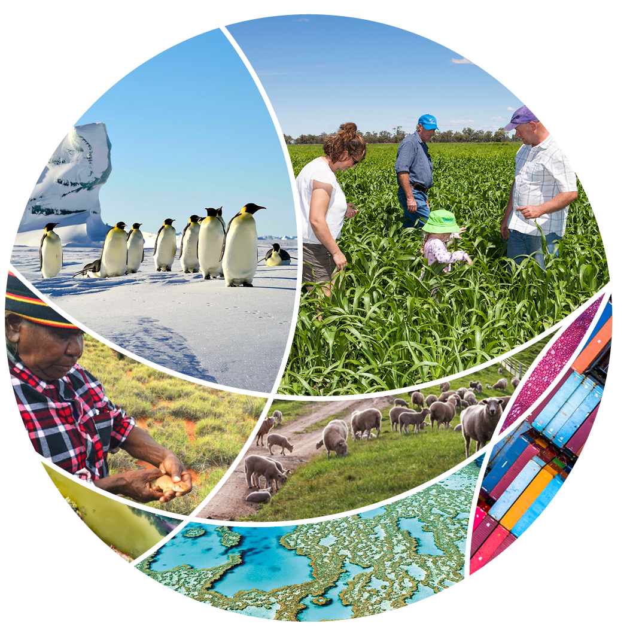

© Commonwealth of Australia 2022

**Ownership of intellectual property rights**

Unless otherwise noted, copyright (and any other intellectual property rights) in this publication is owned by the Commonwealth of Australia (referred to as the Commonwealth).

**Creative Commons licence**

All material in this publication is licensed under a [Creative Commons Attribution 4.0 International Licence](https://creativecommons.org/licenses/by/4.0/legalcode) except content supplied by third parties, logos and the Commonwealth Coat of Arms.

Inquiries about the licence and any use of this document should be emailed to [copyright@awe.gov.au](mailto:copyright@awe.gov.au).



**Cataloguing data**

This publication (and any material sourced from it) should be attributed as: Science Partnerships 2022, *National Environmental Science Program Clean Air and Urban Landscapes Hub impacts*, Department of Agriculture, Water and the Environment, Canberra, March. CC BY 4.0.

This publication is available at [awe.gov.au/science-research/nesp](https://www.awe.gov.au/science-research/nesp).

Department of Agriculture, Water and the Environment

GPO Box 858 Canberra ACT 2601

Telephone 1800 900 090

Web [awe.gov.au](https://www.awe.gov.au/)

**Acknowledgements**

The authors thank the National Environmental Science Program (NESP) research hubs for their input. Aboriginal and Torres Strait Islander research partnerships are a valued and respected component of NESP. We acknowledge the Traditional Owners of Country throughout Australia and their continuing connection to Country, land, sea and community. We pay our respects to them, their cultures and to their Elders past, present and emerging.

The Australian Government acting through the Department of Agriculture, Water and the Environment has exercised due care and skill in preparing and compiling the information and data in this publication. Notwithstanding, the Department of Agriculture, Water and the Environment, its employees and advisers disclaim all liability, including liability for negligence and for any loss, damage, injury, expense or cost incurred by any person as a result of accessing, using or relying on any of the information or data in this publication to the maximum extent permitted by law.

Links to external websites are for your information only. They do not represent an endorsement of any website, publication, organisation or product. You are responsible for deciding if information on other sites is accurate, current and reliable. The Australian Government takes no responsibility for the content that you may encounter on any website or in publications on those websites.

Contents

Clean Air and Urban Landscapes Hub 1

Cities are Indigenous places 2

The future of the Three-category approach 2

Indigenous engagement for urban professionals 2

Indigenous led and co-designed research 3

Noongar water knowledge in the Djarlgarro Beeliar catchment 3

Urban greening 4

Indigenous plant use 4

Where will all the trees be? 4

Transforming street verges in Perth 4

Supporting a cooler, greener Melbourne 5

Urban biodiversity 6

Harnessing people power for urban-ecological research 6

Connecting nature in the city 6

Lessons from environmental managers 6

Building nature into the urban fabric 7

Air quality 8

Characterising smoke from the 2019−20 bushfires 8

The future of electric vehicles 8

Combatting air pollution with moss 8

Mapping noise in Australian cities 9

.

## Clean Air and Urban Landscapes Hub

The [Clean Air and Urban Landscapes Hub](http://www.nespurban.edu.au/) is 1 of 6 hubs from the first phase of the [National Environmental Science Program](https://www.awe.gov.au/science-research/nesp) (NESP). It conducted research to support environmental quality in urban areas. Cities are important environments that are home to millions of Australians and wildlife. A key question for this hub was how cities can be made better for people and for biodiversity.

* NESP funding: $8.88 million
* Host organisation: The University of Melbourne
* Hub leader: Professor Kirsten Parris
* Hub partners: RMIT University, University of Wollongong, University of Western Australia

Key themes:

* Cities are Indigenous places
* Urban greening
* Urban biodiversity
* Air quality

[Find out more about the Clean Air and Urban Landscapes Hub’s projects.](https://www.awe.gov.au/science-research/nesp/current-projects/clean-air)

## Cities are Indigenous places

Indigenous knowledge systems and Indigenous science, developed over thousands of generations, are key to living sustainably in Australia’s urban environments. The hub acknowledged that every place in Australia – cities, towns and regional centres – is also Aboriginal and Torres Strait Islander Country.

The opportunity to highlight cities as Indigenous places, to make space for Indigenous voices and perspectives in cities, and to promote Indigenous-led research is one that the hub has taken seriously. The hub pursued this not only through their research but also through outreach activities including [The Living Pavilion](https://nespurban.edu.au/wp-content/uploads/2020/02/The-Living-Pavilion-Report.pdf), Indigenous Science Conversations at Questacon, events at the MPavilion and Melbourne Design Week, annual NAIDOC Week editions of the hub’s newsletter, [Urban Beat](https://nespurban.edu.au/wp-content/uploads/2020/08/First-Nations-Edition_Urban-Beat.pdf), and development of the [Three-category approach toolkit](https://nespurban.edu.au/3-category-workbook/) to facilitate cross-cultural work between Indigenous and non-Indigenous Australians.

Partnerships with Indigenous Australians have formed an important component of the hub’s urban research and practice. Under the guidance of its Indigenous Advisory Group (IAG), members and a network of Indigenous contributors, the hub sought to highlight Indigenous perspectives in cities. The IAG members included Stan Lui, Jason Barrow (Co-Chair), Maddison Miller (Co-Chair), Timmah Ball, Jade Kennedy, Kirstine Wallis, Luke Briscoe and Lauren Arabena.

### The future of the Three-category approach

The [Three-category approach toolkit](https://nespurban.edu.au/3-category-workbook/) is a workbook and workshop guiding non-Indigenous researchers and practitioners in supporting Indigenous-led research and co-design. In 2020, the hub delivered 2 online workshops led by IAG member Kirstine Wallis. The sell-out workshops were a success – 1 participant highlighted: “I work in the Aboriginal housing space and the tiered way to approach working with communities has come in handy when advocating for greater space for self-determination and empowerment.

The workbook is available to support researchers and projects in phase 2 of NESP.

### Indigenous engagement for urban professionals

Urban professionals have an opportunity to consider their responsibility to Indigenous voices and perspectives in their practice. To support this, the hub developed a [series of resources](https://protect-au.mimecast.com/s/2mrJCL7rxDsRvvAvyiB7Bs2?domain=nespurban.edu.au) intended to provide professionals with roadmaps for practice change. The Planning Institute of Australia (PIA) says the resources can support professionals to deepen and extend professional capacity for Indigenous engagement.

According to PIA CEO David Williams, “This project combines well with our other initiatives to ensure that town planning plays its role and in a small way corrects the wrongs of the past.

### Indigenous led and co-designed research

The hub worked towards improving the collaboration and co-design of urban research projects with Indigenous Australians. This work was supported by the hub’s IAG, which helped identify opportunities for Indigenous perspectives at the scoping stage of research projects.

The IAG advised that Indigenous knowledge be made a key component of a [sub-project](https://nespurban.edu.au/research-projects/urban-habitat/) investigating opportunities to bring nature back into cities. The IAG’s advice led to a [paper](https://nespurban.edu.au/wp-content/uploads/2020/04/Bringing-nature-back-into-cities.pdf), co-authored by Indigenous and non-Indigenous researchers, that explores bringing nature back to urban environments and the cultural importance of place.

### Noongar water knowledge in the Djarlgarro Beeliar catchment

The Swan and Canning rivers, their tributaries and the many wetlands that cover the Swan Coastal Plain are a fundamental biophysical component of Perth’s environment, and have immense cultural value. A [project](https://nespurban.edu.au/research-projects/urban-greening/) involving 2 Noongar researchers gathered archived Noongar water knowledge for the Canning River area and invited the community to lead its interpretation and mapping.

This valuable knowledge will provide a voice to the Noongar community and help guide stakeholders tasked with land use and water planning in Perth.

## Urban greening

Urban greening has never been so important for liveability and sustainability. Australian cities have expanded rapidly since the 1960s, driving widespread land clearing and habitat loss, and pushing the green belts surrounding metropolitan regions further and further away from city residents. Australian cities have become denser too, with a corresponding loss of backyards, larger semi-rural lots and the trees that used to spread throughout private and public spaces. In many instances, local public urban green spaces are the only nature people can access.

As well as being aesthetically pleasing, green spaces provide [many functions and benefits for people](https://nespurban.edu.au/wp-content/uploads/2018/11/CAULHub_BenefitsUrbanGreeningReport_20160912.pdf) and the other species that call our cities home. They cool our cities, improve our mental and physical health, treat air and water, provide space for recreation and connection, and support habitat for biodiversity.

Through the development of state-of-the-art mapping exercises on public and private land, the hub’s research is helping local and state governments understand changes in urban green cover and how we can combat future losses.

From transforming [neglected streetscapes](https://nespurban.edu.au/wp-content/uploads/2020/11/Understanding-nature-strip-transformations.pdf) to increased use of native plants, the hub’s research has also drawn attention to the ways home gardeners can support greener urban environments.

### Indigenous plant use

Barkandji woman Zena Cumpston created the [Indigenous plant use](https://nespurban.edu.au/wp-content/uploads/2020/08/Indigenous-plant-use.pdf) booklet to help individuals, schools and community groups connect with Indigenous knowledge of plant use. The free resource has been downloaded thousands of times and received widespread [mainstream](https://pursuit.unimelb.edu.au/articles/illuminating-indigenous-culture-through-plants) and [industry](https://www.adamrobinsondesign.com/blog-posts/indigenous-plant-use) media coverage.

The booklet is promoted to schools as part of the Victorian Department of Education and Training’s Cultural Understanding and Safety Training program. Through this program, the booklet is raising awareness in schools about Aboriginal histories and perspectives of plant use.

### Where will all the trees be?

How do we ensure that as our cities and suburbs grow, our green cover grows with them? The project, [Where will all the trees be?](https://www.greenerspacesbetterplaces.com.au/media/163315/where-will-all-the-trees-be-benchmarking-report-2020.pdf) – led by RMIT University and Greener Spaces Better Places, and co-funded by Hort Innovation – measured green cover and its rate of change in Australian cities.

Through an [interactive website](https://www.greenerspacesbetterplaces.com.au/guides/where-will-all-the-trees-be/), the project supports 131 local government areas to visualise their future outlook and learn from councils that were successful in maintaining or growing green cover since 2016.

### Transforming street verges in Perth

There is a growing trend for Australian suburbanites to transform their verge to native gardens. The hub’s research uncovered the [benefits and challenges](https://nespurban.edu.au/wp-content/uploads/2021/02/The-social-and-ecological-values-of-native-gardens-along-streets-1.pdf) of these garden makeovers.

The research received media attention on several radio stations, local newspapers and [online](https://www.abc.net.au/news/2021-03-27/perth-verge-gardens-grow-community-as-well-as-plants/100026918). It also influenced verge conversion workshops run through Western Suburbs Regional Organisation of Councils in Perth. The course convenor referred to the 18 key findings from the research, such as the importance of visual appeal, to inspire community interest in verge gardens.

### Supporting a cooler, greener Melbourne

As cities grow and change, green cover is often lost. The Victorian Government’s *Plan Melbourne 2017−2050* aims to enhance the city’s urban forests to create more liveable and climate-adapted communities.

To support this work, the hub partnered with the [Victorian Government](https://www.planning.vic.gov.au/policy-and-strategy/planning-for-melbourne/plan-melbourne/cooling-greening-melbourne/mapping-and-analysis-of-vegetation,-heat-and-land-use), RMIT University and CSIRO to map vegetation and assess its relationship to land use, urban heat and planning policy. This [evidence](https://www.planning.vic.gov.au/__data/assets/pdf_file/0023/441464/Urban-Vegetation-Cover-Change-in-Melbourne-2014-2018_Final.pdf) is already informing greening targets, supporting policy reform, identifying areas needing investment and providing a baseline to track the progress of greening strategies.

## Urban biodiversity

Cities are built on biodiversity-rich landscapes and they continue to provide space and resources for thousands of species. An amazing diversity of native flora and fauna occurs in cities across Australia, from the well-recognised birds, bees and possums, to the lesser-known threatened orchids, colourful grevilleas and secretive bandicoots.

There can be many challenges to sharing our cities with nature. Cities are built as habitat for people and present a range of threats to biodiversity including habitat loss, barriers to movement, pollution, anthropogenic noise and predation by domestic pets.

But our urban environments also present many opportunities to promote native plants and animals. The tools and resources developed by the hub – such as the [CAUL Urban Wildlife app](https://nespurban.edu.au/platforms/caul-urban-wildlife-app/), [Urban biodiversity conservation booklet](https://nespurban.edu.au/wp-content/uploads/2021/01/Urban-Conservation-Actions_Final.pdf), and [ecological connectivity](https://nespurban.edu.au/wp-content/uploads/2020/01/Kirk-et-al.-2018.pdf) and [Biodiversity Sensitive Urban Design](https://nespurban.edu.au/wp-content/uploads/2019/01/Garrard_et_al-2018-Conservation_Letters.pdf) frameworks – are currently being used to improve the practice of urban biodiversity conservation.

### Harnessing people power for urban-ecological research

The [CAUL Urban Wildlife app](https://nespurban.edu.au/platforms/caul-urban-wildlife-app/) allows citizen scientists to contribute data to research questions about the distribution and behaviour of wildlife in cities. Over 4 years, the app engaged more than 300 users who have contributed more than [3,500 records](https://nespurban.edu.au/wp-content/uploads/2020/12/Summary-of-findings-from-the-CAUL-Urban-Wildlife-App-2020.pdf) to date.

The app was developed in consultation with decision-makers to identify key information gaps in urban-wildlife management. By using the same field protocols used by scientists, users recorded important ecological interactions that are shedding light on how urban spaces can be better managed.

### Connecting nature in the city

Wildlife in cities needs freedom to move, just as human residents do. The hub’s [ecological connectivity framework](https://nespurban.edu.au/wp-content/uploads/2020/01/Kirk-et-al.-2018.pdf) identifies the best places to add new habitat that will help make urban landscapes more connected and hospitable for animals.

The City of Melbourne is using the [framework](https://nespurban.edu.au/wp-content/uploads/2021/02/Linking-nature-in-the-city-Part-2.pdf) to identify which segments of the central business district road network should be selected for new urban-greening initiatives. Elton Consulting is also using the framework to identify potential green corridors across the City of Sydney.

### Lessons from environmental managers

Across Australia, government, private and community groups are increasingly taking part in activities designed to bring nature back into cities. To better understand these activities, hub researchers spoke with environmental managers to find out what actions they took for urban biodiversity, the challenges they faced and how they achieved their goals.

This work generated several resources, including a [national inventory of conservation actions](https://nespurban.edu.au/wp-content/uploads/2021/01/Actions-for-Biodiversity-PART-III.pdf) and a [guide featuring practical lessons](https://nespurban.edu.au/wp-content/uploads/2021/01/Urban-Conservation-Actions_Final.pdf). These resources can be used to inform and inspire future biodiversity conservation action.

### Building nature into the urban fabric

New urban developments can offer opportunities to create and enhance the environmental value of an area through the process of the hub’s [Biodiversity Sensitive Urban Design](https://nespurban.edu.au/wp-content/uploads/2019/01/Garrard_et_al-2018-Conservation_Letters.pdf) (BSUD). Researchers from the hub and the Threatened Species Recovery Hub applied the framework in a real-life planning scenario at [Fishermans Bend, Melbourne](https://www.sciencedirect.com/science/article/pii/S1618866721002016?via%3Dihub) – Australia’s largest urban renewal project. The BSUD approach allowed urban nature to be incorporated into the development’s planning process, engaging a range of stakeholders and establishing clear biodiversity objectives and actions. Mainstreaming BSUD in the development industry is now the focus of a new [Ian Potter Foundation 4-year project](https://www.ianpotter.org.au/news/blog/grants-round-up-funding-round-3-2020/).

## Air quality

There is no more fundamental human need than clean air to breathe. Yet increasingly we live in densely populated cities where air pollution is a common problem. The United Nations identified air pollution as the largest environmental health risk for the global population. Australian cities typically enjoy cleaner air than other major cities worldwide, but we cannot be complacent: climate change and population growth are both expected to worsen air pollution in Australia.

The most severe air pollution episodes in Australian cities are usually caused by events such as bushfires and dust storms. Outside these episodes, human-made pollution from sources such as [traffic, wood-combustion heaters and hazard-reduction burns](https://www.mdpi.com/2073-4433/10/12/774) dominate over natural sources. The [air we breathe indoors](https://nespurban.edu.au/wp-content/uploads/2020/02/Steinemann-2019b-Ten-questions-concerning-fragrance-free-policies-and-indoor-environments-005.pdf) is also important; exposure to potentially harmful air pollutants occurs in our homes, workplaces, schools and other buildings.

So, what can be done to improve urban air quality in the future? Hub researchers brought a multi-disciplinary perspective to urban air-quality research. They sought to better understand the major sources of air pollution, including from traffic and smoke, and identified effective ways to detect and manage air pollution in urban areas.

### Characterising smoke from the 2019−20 bushfires

The 2019−20 ‘black summer’ bushfires exposed millions of Australians to hazardous air for weeks on end. A hub [report](https://nespurban.edu.au/wp-content/uploads/2021/01/Report-on-Air-Quality-and-Smoke.pdf) presented 3 weeks of heavily smoke-influenced greenhouse gas and aerosol measurements from a comprehensive field campaign in early 2020.

These data will be valuable for future research, for example, by informing epidemiological studies determining the health impacts of the bushfires and studies aiming to improve smoke-plume forecasting in major cities. These findings can also inform public messaging during extreme smoke events, particularly over long periods.

### The future of electric vehicles

The increased use of electric vehicles in Australia could significantly reduce greenhouse-gas emissions and other air pollutants. The hub’s research [explored current patterns](https://nespurban.edu.au/wp-content/uploads/2020/11/Projecting-EV-charging-demand-in-Melbourne-.pdf) of electric-vehicle use and infrastructure, forecasting up to 85,000 battery-powered vehicles in Melbourne by 2030.

The [findings](https://nespurban.edu.au/wp-content/uploads/2020/09/Future-distribution-of-Electric-Vehicles.pdf) can be used to inform policy and regulatory opportunities to accelerate the move to low-emission vehicles, such as legislated vehicle fuel-efficiency standards, industry support and financial incentives. The research can also help planners evaluate their transport investment strategies, in particular locations where they should focus future charging infrastructure.

### Combatting air pollution with moss

Urban greening has the co-benefit of mitigating air pollution. A hub [study](https://www.mdpi.com/2073-4433/10/4/224) conducted along roadsides in Wollongong, New South Wales, found moss was up to 4 times more effective at removing particulate matter from the atmosphere on a dry-weight basis than the leaves of selected native tree species.

The study has inspired further research by designers and architects considering different ways to incorporate moss into building designs that capitalise on these benefits. The findings also attracted significant media interest, including coverage in *New Scientist* and ABC’s ‘Off Track’ podcast.

### Mapping noise in Australian cities

Like air pollution, chronic exposure to noise pollution can be harmful. The hub supported the development of [noise maps](https://nespurban.edu.au/wp-content/uploads/2021/05/Mapping-noise-in-Australian-cities-1.pdf) for 3 Australian cities to estimate traffic-related noise exposure. These exposure estimates will be used to investigate the relationship between noise and health.

The maps can also be used by councils developing health plans and by city planners to better pinpoint where they need to employ noise-minimisation strategies or where development should be avoided altogether, especially to protect vulnerable groups such as children.