# National Environmental Science Program

# Earth Systems and Climate Change Hub impacts

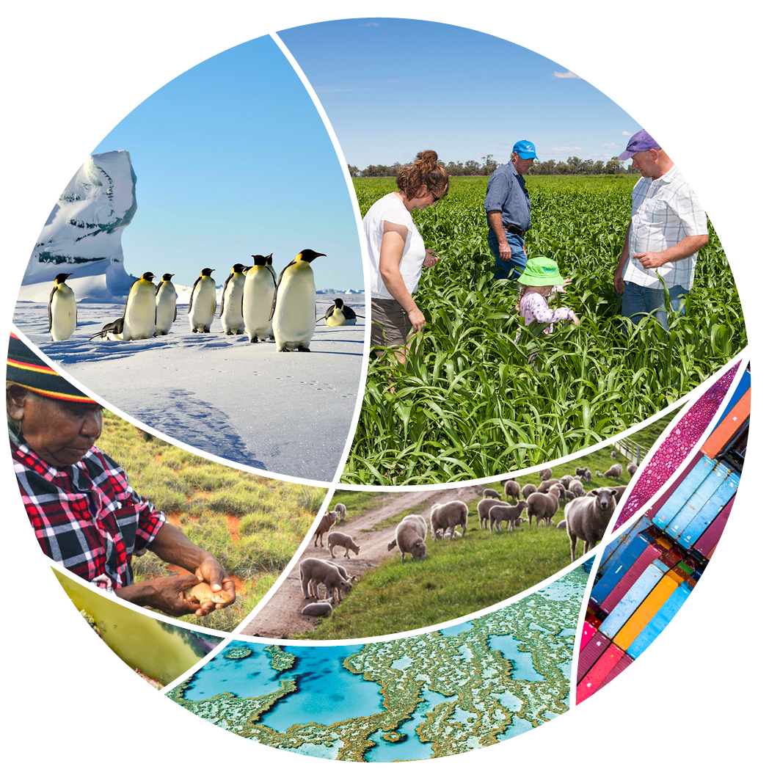

© Commonwealth of Australia 2022

**Ownership of intellectual property rights**

Unless otherwise noted, copyright (and any other intellectual property rights) in this publication is owned by the Commonwealth of Australia (referred to as the Commonwealth).

**Creative Commons licence**

All material in this publication is licensed under a [Creative Commons Attribution 4.0 International Licence](https://creativecommons.org/licenses/by/4.0/legalcode) except content supplied by third parties, logos and the Commonwealth Coat of Arms.

Inquiries about the licence and any use of this document should be emailed to [copyright@awe.gov.au](mailto:copyright@awe.gov.au).



**Cataloguing data**

This publication (and any material sourced from it) should be attributed as: Science Partnerships 2022, *National Environmental Science Program Earth Systems and Climate Change Hub impacts*, Department of Agriculture, Water and the Environment, Canberra, March. CC BY 4.0.

This publication is available at [awe.gov.au/science-research/nesp](https://www.awe.gov.au/science-research/nesp).

Department of Agriculture, Water and the Environment

GPO Box 858 Canberra ACT 2601

Telephone 1800 900 090

Web [awe.gov.au](https://www.awe.gov.au/)

**Acknowledgements**

The authors thank the National Environmental Science Program (NESP) research hubs for their input. Aboriginal and Torres Strait Islander research partnerships are a valued and respected component of NESP. We acknowledge the Traditional Owners of Country throughout Australia and their continuing connection to Country, land, sea and community. We pay our respects to them, their cultures and to their Elders past, present and emerging.

The Australian Government acting through the Department of Agriculture, Water and the Environment has exercised due care and skill in preparing and compiling the information and data in this publication. Notwithstanding, the Department of Agriculture, Water and the Environment, its employees and advisers disclaim all liability, including liability for negligence and for any loss, damage, injury, expense or cost incurred by any person as a result of accessing, using or relying on any of the information or data in this publication to the maximum extent permitted by law.

Links to external websites are for your information only. They do not represent an endorsement of any website, publication, organisation or product. You are responsible for deciding if information on other sites is accurate, current and reliable. The Australian Government takes no responsibility for the content that you may encounter on any website or in publications on those websites.

Contents

Earth Systems and Climate Change Hub 1

Protecting Australia’s coasts through nature-based methods 2

Supporting blue carbon ecosystems for climate mitigation benefits 2

Understanding past coastal erosion to predict future erosion 2

Eco-engineering solutions for coastal hazard risk reduction 3

Australian guidelines on nature-based coastal protection 3

Towards climate resilient emergency and water management in Australia 4

Understanding trends in dangerous bushfire weather to inform emergency management 4

Supporting the national conversation on changing bushfire weather risks 4

Increasing knowledge of current and future extreme wet events 5

Understanding extreme dry periods for better future water management 5

Our changing oceans and coasts 6

Ocean monitoring and data analysis to track ocean change 6

Understanding future trends in marine heatwaves 6

Updated sea-level rise projections and a sea-level rise calculator tool for coastal planning 7

Supporting the development of Australia’s blue economy 7

Co-produced climate vulnerability and impact assessments for future-proofed industries 8

Climate change impact assessment for the NT mango industry 8

Climate change science to inform climate-related financial risk and disclosure 9

Climate change information for the Gondwana Rainforests of Australia World Heritage Area 9

Working with Tasmanian industry to determine their multi-year climate forecast needs 9

Building strong and lasting partnerships with First Nations peoples 10

Giving First Nations peoples a voice on climate change and research 10

Developing Indigenous co-design principles for climate change research 10

National First Peoples Gathering on Climate Change 11

Understanding Indigenous perspectives of risk 11

## Earth Systems and Climate Change Hub

The [Earth Systems and Climate Change Hub](http://www.nespclimate.com.au/) is 1 of 6 hubs from the first phase of the [National Environmental Science Program](https://www.awe.gov.au/science-research/nesp) (NESP). It conducted research to better understand Australia's past, present and future climate and our climate drivers. The hub produced world-leading climate and Earth systems science capability to supply useful and accessible climate change information for Australia.

* NESP funding: $23.90 million
* Host organisation: CSIRO
* Hub Leader: Professor David Karoly
* Hub partners: Bureau of Meteorology, University of New South Wales, Australian National University, Monash University, University of Melbourne, University of Tasmania

Key themes:

* Protecting Australia’s coasts through nature-based methods
* Towards climate resilient emergency and water management in Australia
* Our changing oceans and coasts
* Co-produced climate vulnerability and impact assessments for future-proofed industries
* Building strong and lasting partnerships with First Nations peoples

Find out more about the [Earth Systems and Climate Change Hub’s projects](https://www.awe.gov.au/science-research/nesp/current-projects/earth-systems).

## Protecting Australia’s coasts through nature-based methods

Our coastal environments are being impacted by coastal erosion, inundation and marine heatwaves as the climate continues to warm.

Natural, created or restored habitats such as oyster reefs, mangroves and salt marshes have the potential to provide coastal protection, as well as enhance biodiversity and other ecosystem services. These ‘living shorelines’ also have the potential to play an important role in climate mitigation and adaptation because of their ability to sequester carbon and reduce the threats of coastal erosion and flooding.

The hub, through the National Centre for Coasts and Climate, has researched, developed and trialled on-ground nature-based coastal protection options.

This has enabled the hub to better understand and [provide guidance](https://nespclimate.com.au/wp-content/uploads/2021/05/Nature-Based-Methods_Final_05052021.pdf) to coastal managers on how and when these management options can be used to protect important coastal ecosystems, enhance Australia’s blue carbon ecosystems and better manage coastal erosion.

### Supporting blue carbon ecosystems for climate mitigation benefits

Vegetated coastal ecosystems are hotspots of atmospheric carbon dioxide storage and therefore act as sources of [blue carbon](http://nespclimate.com.au/wp-content/uploads/2019/05/2.11-1_A4_4pp_Brochure_Blue_Carbon_in_Australia_NCCC_ESCC_Feb26_2020_WEB.pdf). Hub researchers have developed a recommended new standard method for estimating blue carbon, and evaluated the ability of key coastal management strategies to protect and increase blue carbon storage.

As a result, Australia is now closer to including a methodology for blue carbon in carbon crediting schemes, and coastal managers are better able to manage coastal ecosystems for both blue carbon and ecosystem health benefits.

### Understanding past coastal erosion to predict future erosion

Climate change is likely to increase the vulnerability of Australia’s coastline to [coastal erosion](http://nespclimate.com.au/wp-content/uploads/2019/05/2.11_1_A4_4pp_Brochure_Coastal_Erosion_NCCC_ESCC_Feb26_2020_WEB.pdf). Hub researchers analysed past shoreline changes to improve understanding of shoreline resilience to future erosion.

This provides coastal managers with a better understanding of how future changes in the frequency and intensity of erosion events will impact the recovery capacity of beaches. The hub’s work also provides coastal management-related insights into the important role of vegetation in mitigating current and future coastal erosion.

### Eco-engineering solutions for coastal hazard risk reduction

[Nature-based coastal protection methods](http://nespclimate.com.au/wp-content/uploads/2019/05/2.11-1_A4_4pp_Brochure_Eco-Engineering_NCCC_ESCC_Feb26_2020_WEB.pdf) aim to protect shorelines by creating or restoring coastal habitats. As living systems, these habitats have the ability to adapt to a changing climate and self-repair after storm events.

Hub researchers have worked with local stakeholders to develop and trial a number of innovative nature-based methods for coastal hazard risk reduction, including custom-designed mangrove planters across 3 Victorian locations and a shellfish reef in Port Phillip Bay. The hub monitored these approaches to better understand their effectiveness in managing the coastlines, and to inform future management decisions.

### Australian guidelines on nature-based coastal protection

Australian coastal decision-makers and managers need clear guidelines to decide whether a soft, hybrid or hard coastal defence approach is most appropriate. The hub, through the National Centre for Coasts and Climate, has developed the [first national guidelines](https://nespclimate.com.au/wp-content/uploads/2021/05/Nature-Based-Methods_Final_05052021.pdf) for nature-based methods of coastal protection.

The guidelines provide a framework for implementing nature-based methods and conducting benefit-cost analysis, thereby providing a practical tool to support coastal management decisions and promote wider adoption of these methods nationally.

## Towards climate resilient emergency and water management in Australia

Australia has a variable climate, with a history of bushfires, droughts and extreme rainfall. These climate extremes have far-reaching costs, ranging from financial costs to governments, businesses and households, to environmental impacts, to physical and psychological impacts on individuals.

Under a warming climate, extreme events and water availability are likely to change. To ensure Australia’s management activities remain effective and efficient as our climate continues to change, information on Australia’s likely future climates is required to provide managers with better quality, relevant and targeted climate change science information and data.

The hub has investigated changing current and future trends in dangerous bushfire weather and risks, extreme wet and extreme dry periods and events.

The hub worked with managers to provide climate change information, data and expert advice to feed into emergency and water resource management policies, planning activities and initiatives. The end result? Enhanced climate resilience for Australia’s emergency and water management sectors, now and into the future.

### Understanding trends in dangerous bushfire weather to inform emergency management

Extreme fire weather has also become more frequent and extreme for some seasons and regions of Australia. Hub research has shown a [clear link](http://nespclimate.com.au/more-dangerous-bushfire-conditions-due-to-climate-change/) between climate change and bushfire conditions over the past 60+ years. Looking to the future, hub projections show a clear [trend towards more dangerous conditions for bushfires](http://nespclimate.com.au/increased-future-bushfire-risk-under-climate-change/) in Australia.

The hub has shared its expert advice and information on [bushfire conditions](https://nespclimate.com.au/wp-content/uploads/2021/05/ESCC_Fire-generated-Thunderstorms_Brochure.pdf) with key emergency management stakeholders, such as the Australasian Fire and Emergency Services Authorities Council for use in their Australian-wide climate policies.

### Supporting the national conversation on changing bushfire weather risks

The Black Summer bushfire season of 2019-20 was one that few Australians will ever forget. Hub research and expert opinion helped to inform the national conversation about trends in [current and future bushfire conditions](http://nespclimate.com.au/wp-content/uploads/2019/11/A4_4pp_brochure_NESP_ESCC_Bushfires_FINAL_Nov11_2019_WEB.pdf) in Australia. Hub research and researchers were quoted in national and international media, and hub research was used to inform the [Royal Commission into National Natural Disaster Arrangements report](https://naturaldisaster.royalcommission.gov.au/).

This ensured the national conversation was informed by credible and [up-to-date science](https://nespclimate.com.au/wp-content/uploads/2021/05/ESCC_Fire-generated-Thunderstorms_Brochure.pdf) and encouraged balanced and informed discussions across Australia.

### Increasing knowledge of current and future extreme wet events

Climate change will affect the frequency and intensity of extreme events that bring extreme rainfall to regions of Australia, such as [east coast lows](http://nespclimate.com.au/wp-content/uploads/2021/04/ESCC_Intense-east-coast-lows_Brochure.pdf) and [tropical cyclones](http://nespclimate.com.au/wp-content/uploads/2021/04/ESCC_Tropical-cyclones-in-the-GBR_Brochure.pdf). Hub research has found that, although the occurrence of these 2 types of extremes is projected to decrease slightly, future resulting rainfall is likely to increase in intensity.

This has implications for future flood risk factors in highly populated urban areas, and for water pollution changes in the Great Barrier Reef region because of agricultural runoff. This could lead to devastation of seagrass in the reef region and cause an increase in Crown-of-thorns Starfish outbreaks.

### Understanding extreme dry periods for better future water management

For many Australians, the future is going to be hotter and drier. Hub research has shown that under a warming climate Australia will spend more time in drought, with longer and more intense [drought](http://nespclimate.com.au/wp-content/uploads/2021/04/ESCC_Drought-projections_Factsheet.pdf) conditions, particularly across southern and eastern Australia. There is also likely to be a reduction in [streamflow and mean run-off](http://nespclimate.com.au/wp-content/uploads/2021/04/ESCC_Projections-of-Water-Futures_Brochure.pdf) in southern Australia. The hub has also investigated the causes of flash droughts in Australia.

This research provides decision-makers with a glimpse into Australia’s possible water futures and equips them with the knowledge to adjust management strategies accordingly.

## Our changing oceans and coasts

The oceans play a vital role in the Earth’s complex and variable climate system. Not only do they support a variety of biodiversity, industries and communities, but they also act as the largest sink on Earth, storing heat, nutrients and carbon dioxide.

In this way, the oceans contribute to efforts to mitigate human-induced greenhouse gas emissions. But this comes at a cost, with significant ocean warming, acidification and changes to circulation affecting Australian coasts through impacts such as sea-level rise, marine heatwaves and coastal inundation.

To better understand our oceans and how they are changing, the hub has participated and provided leadership in international and national ocean observation systems and initiatives. These initiatives ensure ocean measurements are coordinated around the world and provide critical long-term observation records for tracking and understanding current and future change.

The hub has also updated global and regional projections of future sea-level rise to take into account new understanding of possible contributions from melting Antarctic ice shelves. These projections, along with research into understanding [regional extreme sea-level rise](https://nespclimate.com.au/wp-content/uploads/2021/05/ESCC_Extreme-sea-level-events-for-Sydney_Factsheet.pdf), provide critical information to feed into current and future coastal infrastructure and asset planning and protection.

### Ocean monitoring and data analysis to track ocean change

Monitoring the ocean is vital for managing and mitigating human impacts on our environment and for making climate and weather predictions. Through the hub, Australia has [provided leadership in international ocean observation initiatives](https://nespclimate.com.au/wp-content/uploads/2021/04/ESCC_Oceans-observations_Factsheet.pdf) and in the production, quality control and analysis of high-resolution ocean datasets.

These efforts contribute to a better understanding of many ocean processes such as ocean circulation, temperature, heat uptake, salinity and acidity. They shine a light on how these processes may change in the future and what this means for global efforts to mitigate greenhouse gas emissions.

### Understanding future trends in marine heatwaves

The [Western Australian (WA) coast](https://nespclimate.com.au/wp-content/uploads/2021/04/ESCC_WA-marine-heatwaves_Factsheet.pdf) and the [Tasman Sea](https://nespclimate.com.au/wp-content/uploads/2021/05/ESCC_Marine-heatwaves_Tasman-Sea_Factsheet.pdf) have both experienced their most devastating marine heatwave events within the last 10 years, causing widespread impacts to the local environment, ecology and industries. Hub research shows that for both regions, maximum intensity events are likely to become an annual occurrence under a high-emissions scenario by around 2060 (Tasman Sea) and 2100 (WA coast). Information on likely future changes to marine heatwaves enables marine managers to better plan for and manage their future risks.

### Updated sea-level rise projections and a sea-level rise calculator tool for coastal planning

Up-to-date and accurate information on sea-level rise and regional extreme sea-level events is required to help identify and mitigate risks to coastal societies and infrastructure. Hub researchers contributed to international research on estimating future sea-level rise, including revised contributions from Antarctic processes. These processes are estimated to contribute to sea-level rise by as much as 2.5 metres by 2100, with implications for Australian coasts. The hub has also updated a sea-level rise calculator tool ([Canute3.0](https://shiny.csiro.au/Canute3_0/)) to allow coastal practitioners to explore how [extreme sea-level events](https://nespclimate.com.au/wp-content/uploads/2021/05/ESCC_Extreme-sea-level-events-for-Sydney_Factsheet.pdf) will change at locations around Australia’s coastline.

### Supporting the development of Australia’s blue economy

[Blue economy](https://nespclimate.com.au/wp-content/uploads/2021/05/ESCC_Climate-services-for-Australias-blue-economy_Factsheet.pdf) is an emerging concept that refers to the sustainable use of ocean resources for economic growth, improved livelihoods and ocean ecosystem health. Australia’s blue economy industry sectors are all exposed to climate change-related risks to associated offshore infrastructure and operations.

The hub has produced a range of climate change projection products to support development of offshore adaptation strategies. Hub products include projected 21st Century changes in extreme sea levels, wind and surface wave fields under a range of future climate scenarios.

## Co-produced climate vulnerability and impact assessments for future-proofed industries

Producing world-class climate science and data is 1 important step along the path towards a more climate-resilient Australia. The hub has significantly contributed towards this step. Climate science and data are certainly not the end of the story, though. Many Australian stakeholders need support in accessing, understanding, incorporating and using this information for decision-making purposes.

The hub has therefore focused on co-designing and producing climate information and tools with stakeholders. This has built the capacity of the hub’s stakeholders to use climate information to assess their climate vulnerability, impacts and risks. The use of co-design principles in hub activities has resulted in an increase in the uptake and use of the hub’s climate-change information, resulting in more informed and prepared industries in Australia.

The hub has showcased the benefits of co-designing climate change research and communication with industries through a range of activities, including:

* working with the Northern Territory mango industry to determine future climate risks and thresholds for mango production
* collaborating with the Australian financial services sector to produce scientific guidelines for climate-related financial risk reporting and disclosure
* co-producing regional climate change projections with World Heritage Area managers on future water availability for the Gondwana Rainforests
* conversations with Tasmanian industries to better understand the decisions they make on annual to multi-year timescales that can be influenced by climate outcomes.

### Climate change impact assessment for the NT mango industry

Mangoes are the Northern Territory’s (NT’s) largest horticultural crop. Mango production depends on flowering of mango trees, which is likely to be affected under a changing climate. Working with the NT Department of Primary Industry and Resources, the hub carried out an [impact assessment](http://nespclimate.com.au/climate-change-impacts-in-the-northern-territory-mango-industry/) to determine future [impacts and thresholds](http://nespclimate.com.au/wp-content/uploads/2019/05/A4-2p-IA-process-NT-mangoes_web.pdf) for the industry.

The assessment suggests a [future decline](http://nespclimate.com.au/wp-content/uploads/2019/05/A4-2p-IA-results-NT-mangoes_web.pdf) in conditions suitable for triggering flowering, but that the decline will not be the same across the 12 growing regions considered. With this information, the industry can make more informed planning decisions about mango production.

### Climate change science to inform climate-related financial risk and disclosure

Australia’s financial services sector is increasingly considering the physical impacts of climate change on its operations, risk management, planning and financial disclosures.

To inform these activities, the hub provided climate change expertise and data to the industry-led [Climate Measurement Standards Initiative](http://nespclimate.com.au/designing-climate-change-risk-information-standards-for-the-financial-services-sector/), which developed [science-based standards](https://www.cmsi.org.au/reports) for scenario analysis of climate-related financial risk and disclosure. The standards allow for better reporting of physical risk, providing better risk information – and so, better decisions – for investors.

### Climate change information for the Gondwana Rainforests of Australia World Heritage Area

The impacts of climate change are already being experienced in the Gondwana Rainforests World Heritage Area. The hub worked with Gondwana Rainforests managers to deliver information about future climate conditions, such as rainfall and cloud cover, to help them plan and respond to climate impacts.

The resulting [climate-risk assessment](http://nespclimate.com.au/informing-world-heritage-area-climate-change-adaptation-planning/) indicates that by 2070 the rainforests can expect a continued temperature increase, a decline in humidity and moderate increases in the elevation of the area’s cloud base. These impacts may have significant implications for cloud-water dependent species and may increase water stress for some species.

### Working with Tasmanian industry to determine their multi-year climate forecast needs

Climate information and forecasts on the multi-year to decadal timescales would benefit many Australian sectors and industries, including agriculture and water management. This is still an emerging area of global and Australian science capability.

The hub teamed up with the CSIRO Decadal Climate Forecasting Project to [facilitate engagement](http://nespclimate.com.au/understanding-tasmanias-climate-sensitivities-and-information-needs/) between industry groups and scientists to better understand industry-specific climate sensitivities and identify climate information required for industry decision-making. This valuable stakeholder information will contribute to the development of applications for multi-year to decadal forecasts.

## Building strong and lasting partnerships with First Nations peoples

First Nations peoples have managed the land, seas and skies sustainably for thousands of years, with this knowledge passed down from generation to generation. For more than 100,000 years, First Nations peoples have lived through and adapted to massive climatic changes, from the depths of the last Ice Age to the current inter-glacial period.

Today, there is growing recognition that their traditional knowledge can inform the climate science community, as well as provide adaptation and mitigation solutions for Australia.

The hub has worked with a range of First Nations peoples and communities to provide opportunities to share their stories and experiences of climate change on Country with policy-makers and the climate science community. To do so, the hub has built strong, trusted and sustainable relationships with First Nations communities around Australia.

These relationships have been informed and reinforced by co-design protocols, which have been improved over the life of the hub through engagement with First Nations peoples. These protocols will form the foundation for lasting future 2-way knowledge exchange between First Nations peoples and climate scientists. They will also ensure better integration of traditional knowledge and western science to improve understanding of our changing climate.

Co-design and co-production of climate change science activities has resulted in multi-benefits for hub and the hub’s key stakeholders.

### Giving First Nations peoples a voice on climate change and research

First Nations peoples are particularly vulnerable to the impacts of human-induced climate change because of their close connection to Country. Tailored and co-produced climate change information can help inform adaptation planning and decision-making in communities to minimise their climate risks.

In 2018, the hub worked with First Nations stakeholders to hold the first [National Dialogue on Climate Change](https://nespclimate.com.au/wp-content/uploads/2019/05/191209-NICCD-report-final.pdf). The dialogue brought to light the importance of protecting and respecting First Peoples’ intellectual and cultural property, and the need to build ethical frameworks that ensure reciprocity and mutual respect in research involving First Nations peoples.

### Developing Indigenous co-design principles for climate change research

The benefits of incorporating traditional knowledge into western science are obvious, but the steps to do so are not. The hub supported First Nations people to present their knowledge and experience of research on Country with the climate science community. This discussion led to the development of important protocols to underpin climate change research involving First Nations peoples. These [co-design research protocols](https://nespclimate.com.au/co-design-cross-cultural-communication-and-climate-change/) offer a framework for ensuring that First Nations peoples are included in research planning, development and delivery and that research outcomes are mutually beneficial. The protocols were also used to develop a code of conduct to guide research being performed on Country.

### National First Peoples Gathering on Climate Change

After 2 years of close collaboration with a First Nations-led steering committee, the hub helped to prepare a co-designed framework to deliver the [2021 National First Peoples Gathering on Climate Change](https://nespclimate.com.au/wp-content/uploads/2021/10/National-First-Peoples-Gathering-on-Climate-Change-Report_final.pdf). The Gathering brought together over 100 First Nations people from around Australia. It allowed for robust and passionate discussions of climate change experiences on Country framed around the continuing generational impacts that can be expected. Participants also explored ways in which traditional knowledge and western science could deliver solutions to the impacts of climate change on Country.

Watch the [7NEWS Cairns news segment](https://www.facebook.com/7NEWSCairns/videos/148454583823779) on the Gathering.

### Understanding Indigenous perspectives of risk

Indigenous peoples across Australia bring a particular perspective of climate risk and resilience related to their socio-economic, historical, political, cultural and environmental circumstances. Risk perspectives are influential in shaping the priorities for adaptation planning. The hub and the Marine Biodiversity Hub worked with Malgana people (including Elders, board members and Gutharraguda (Shark Bay) rangers) to [discuss how traditional knowledge tools and cultural mapping of values](https://nespclimate.com.au/reports-books-and-book-chapters/escc_-indigenous-perspectives-of-risk_report-30/) on Country can be used to improve the participation and inclusion of Indigenous peoples in understanding and using climate information for the management and protection of Country.