# National Environmental Science Program

# Marine Biodiversity Hub impacts

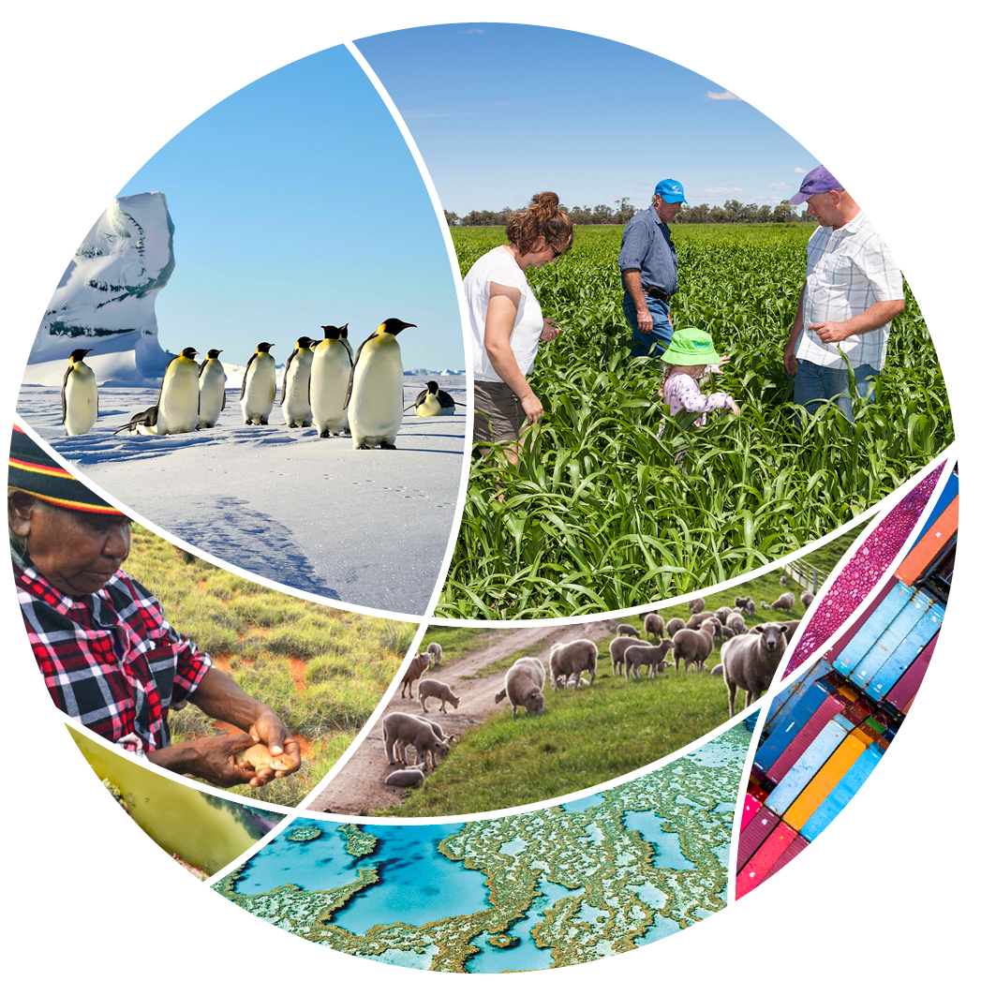

© Commonwealth of Australia 2022

**Ownership of intellectual property rights**

Unless otherwise noted, copyright (and any other intellectual property rights) in this publication is owned by the Commonwealth of Australia (referred to as the Commonwealth).

**Creative Commons licence**

All material in this publication is licensed under a [Creative Commons Attribution 4.0 International Licence](https://creativecommons.org/licenses/by/4.0/legalcode) except content supplied by third parties, logos and the Commonwealth Coat of Arms.

Inquiries about the licence and any use of this document should be emailed to [copyright@awe.gov.au](mailto:copyright@awe.gov.au).



**Cataloguing data**

This publication (and any material sourced from it) should be attributed as: Science Partnerships 2022, *National Environmental Science Program Marine Biodiversity Hub impacts*, Department of Agriculture, Water and the Environment, Canberra, March. CC BY 4.0.

This publication is available at [awe.gov.au/science-research/nesp](https://www.awe.gov.au/science-research/nesp).

Department of Agriculture, Water and the Environment

GPO Box 858 Canberra ACT 2601

Telephone 1800 900 090

Web [awe.gov.au](https://www.awe.gov.au/)

**Acknowledgements**

The authors thank the National Environmental Science Program (NESP) research hubs for their input. Aboriginal and Torres Strait Islander research partnerships are a valued and respected component of NESP. We acknowledge the Traditional Owners of Country throughout Australia and their continuing connection to Country, land, sea and community. We pay our respects to them, their cultures and to their Elders past, present and emerging.

The Australian Government acting through the Department of Agriculture, Water and the Environment has exercised due care and skill in preparing and compiling the information and data in this publication. Notwithstanding, the Department of Agriculture, Water and the Environment, its employees and advisers disclaim all liability, including liability for negligence and for any loss, damage, injury, expense or cost incurred by any person as a result of accessing, using or relying on any of the information or data in this publication to the maximum extent permitted by law.

Links to external websites are for your information only. They do not represent an endorsement of any website, publication, organisation or product. You are responsible for deciding if information on other sites is accurate, current and reliable. The Australian Government takes no responsibility for the content that you may encounter on any website or in publications on those websites.

Contents

Marine Biodiversity Hub 1

Getting to know Australian Marine Parks 2

Mapping natural values 2

Social and economic baselines and monitoring 2

Understanding the risks that pressures pose to natural values 3

Developing a monitoring, evaluation, reporting and improvement system for AMPs 3

Assessing threatened and migratory species 4

Expanded range and population size for the Northern River Shark 4

Sizing up Australia’s White Shark populations 4

The Action Plan for Australia’s Sharks and Rays 2021 5

Exploring the status of Australian sea snakes 5

Indigenous engagement, participation and partnerships 6

Research partnerships to restore coastal habitats 6

Mapping culture and marine life across south-west coastlines 6

A national baseline for Indigenous engagement in marine science 7

Malak Malak Ranger patrol saves Largetooth Sawfish 7

Intervening to restore coastal habitat 8

Laying the groundwork for shellfish reef restoration 8

Saltmarsh: a powerhouse of productivity 8

Heat-tolerant giant kelp families show promise for restoration 8

Seagrass (wirriya jalyanu): giving life to sea Country of Shark Bay (Gathaagudu) 9

## Marine Biodiversity Hub

The [Marine Biodiversity Hub](http://www.nespmarine.edu.au/) is 1 of 6 hubs from the first phase of the [National Environmental Science Program](https://www.awe.gov.au/science-research/nesp) (NESP). It conducted research into Australia's marine environments to build national capacity for monitoring and reporting on coastal and marine species and ecosystems, as well as support national approaches to marine planning by delivering research to guide evidence-based decision-making.

* NESP funding: $24.00 million
* Host organisation: University of Tasmania
* Hub leader: Dr Alan Jordan
* Hub partners: Geoscience Australia, New South Wales Department of Primary Industries, New South Wales Office of Environment and Heritage, Charles Darwin University, Australian Institute of Marine Science, CSIRO, University of Tasmania, Integrated Marine Observing System, Museums Victoria, University of Western Australia

Key themes:

* Getting to know Australian Marine Parks
* Assessing threatened and migratory species
* Indigenous engagement, participation and partnerships
* Intervening to restore coastal habitat

Find out more about the [Marine Biodiversity Hub’s projects](https://www.awe.gov.au/science-research/nesp/current-projects/marine-biodiversity).

## Getting to know Australian Marine Parks

Mapping the distribution, extent and structure of biodiversity is fundamental to understanding and managing Australia’s marine environment. The hub surveyed habitats and marine life across tropical and cold temperate regions, from the coast to the abyssal plain. High-resolution maps and imagery generated by the surveys provide baseline information to understand and monitor the natural values of Australian Marine Parks (AMPs) and support management planning and evaluation.

This work advanced the use of technologies such as swath acoustics, remotely operated vehicles and stereo underwater cameras, and developed marine sampling best practices. The marine-sampling best practices are being adopted by researchers and industry, and have been endorsed by key national and international organisations.

Detailed mapping and sampling supported by the hub revealed [evolutionary secrets](https://www.nespmarine.edu.au/news/research-abyss-reveals-new-species-are-evolving-fastest-antarctica) of Australia’s eastern abyss and studied the [recovery of deep-sea corals](https://www.youtube.com/watch?v=6_e70X_ZepI&t) on Tasmanian seamounts.

The hub also inventoried the predators and prey that aggregate at Bremer Marine Park, and spectacular corals and fishes in deeper waters of the [Ningaloo](https://www.youtube.com/watch?v=Le6ZlnaBrA4), Hunter and [Lord Howe](https://www.youtube.com/watch?v=mgqmnCjkIxY) AMPs.

### Mapping natural values

Hub researchers worked with Parks Australia to conduct surveys that have vastly extended knowledge of life in [AMPs](https://www.nespmarine.edu.au/australian-marine-parks-wha). Best-practice approaches developed by the hub were used to map bathymetry and sample biodiversity in 15 AMPs using high-resolution sonar and remote cameras.

Existing datasets were reviewed and combined with results from the targeted surveys, providing baseline knowledge required for Parks Australia to identify key natural values and set monitoring priorities for AMPs. The program also advanced national collaborations in marine data sharing, and visualisation tools to improve user accessibility.

### Social and economic baselines and monitoring

Social and economic values are important to marine park management, but are rarely integrated with biodiversity monitoring programs. Hub researchers worked with Parks Australia to develop ways of measuring changes in the way people experience and value the marine environment, in response to the establishment and management of AMPs. The approaches included surveys of AMP users such as fishers and tour operators.

The resulting [key measures](https://www.nespmarine.edu.au/document/measures-social-and-economic-monitoring-australian-marine-parks) are designed to be incorporated in the Monitoring, Evaluation, Reporting, and Improvement System being developed for AMPs, and in state-based marine park management.

### Understanding the risks that pressures pose to natural values

Parks Australia managers need to understand pressures on the marine environment to protect and enhance the benefits of AMPs. Hub researchers collated pressure datasets for oil and gas extraction and infrastructure, seismic surveys, shipping movements, aquaculture leases, pollution events and changes in ocean temperature. They developed new approaches to measuring individual and cumulative pressures, and made the [information](https://www.nespmarine.edu.au/document/options-assessing-cumulative-impact-and-risk-environmental-values-matters-national) accessible to guide decision-making about management and monitoring priorities. The pressures datasets were used in a collaborative project between the hub and Parks Australia that identified monitoring priorities for the South-east Marine Parks Network.

### Developing a monitoring, evaluation, reporting and improvement system for AMPs

Regular monitoring, evaluation, reporting and improvement (MERI) is essential to AMP management. Hub researchers worked closely with Parks Australia to help the Australian Government [develop a MERI system](https://www.nespmarine.edu.au/document/designing-targeted-monitoring-program-support-evidence-based-management-australian-marine) for AMPs. They collated baseline environmental and pressure datasets, conducted risk assessments, and developed monitoring evaluation and reporting approaches as part of a consistent, best-practice approach to AMP management. The monitoring prioritisation approach will be incorporated in science plans being developed for each of the 5 AMP networks and the Coral Sea Marine Park.

## Assessing threatened and migratory species

Hub research supports the recovery and conservation of threatened and migratory sharks, marine mammals, fishes and sea snakes. Hub projects have built Australia’s capacity to meet regional, national and international conservation commitments; from research prioritisation and strategic planning and reporting to on-ground action.

Tropical and temperate sharks have been a major focus. The hub published the first comprehensive review of the status of Australia's 329 shark, ray and chimaera species, assessed White Shark, [Grey Nurse Shark](https://www.nespmarine.edu.au/news/sizing-australia%E2%80%99s-eastern-grey-nurse-shark-population) and Northern River Shark populations, and defined regional stocks of [hammerhead sharks](https://www.nespmarine.edu.au/document/examination-connectivity-hammerhead-sharks-northern-australia). It also worked with Traditional Owners to rescue Largetooth Sawfish in the Daly River.

[Annual surveys](https://www.nespmarine.edu.au/document/monitoring-population-dynamics-%E2%80%98western%E2%80%99-right-whales-southern-australia-2018-2021-progre-0) of right whales off southern Australia, and development of the Australasian Right Whale Photo-Identification Catalogue provide evidence to monitor their recovery in Australian waters. Mapping the risk posed by [vessel strike](https://www.nespmarine.edu.au/news/australian-shipping-grows-how-can-we-avoid-collisions-marine-animals) to large marine mammals contributed to national and international planning and risk management. The hub’s [catalogue of ship noise signatures](https://www.nespmarine.edu.au/document/underwater-noise-signatures-ships-australian-waters-technical-report) and identification of acoustic zones in Australian waters brought researchers closer to understanding the effects of underwater noise on marine life.

### Expanded range and population size for the Northern River Shark

A decade of hub surveys [discovered several new populations](https://www.nespmarine.edu.au/document/close-kin-mark-recapture-population-size-estimate-glyphis-garricki-northern-territory) of the threatened Northern River Shark and found nursery grounds in the Kakadu National Park and World Heritage Area. Genetic studies enabled the first population size estimates and identified 5 distinct populations: 4 in Australia and 1 in Papua New Guinea.

The new understanding of Northern River Shark populations highlights the need for localised management and provides up-to-date information for assessments conducted under Australia’s *Environment Protection and Biodiversity Conservation Act 1999*(EPBC Act) in the context of northern Australia’s development. [This video](https://www.nespmarine.edu.au/brighter-prospects-northern-river-shark-video) shows the research in action.

### Sizing up Australia’s White Shark populations

White Sharks are protected in Australian waters and scientific evidence is needed to support national and regional strategies for management. Hub researchers combined acoustic tagging and genetic and statistical techniques to produce the [first evidence-based population estimates](https://www.nespmarine.edu.au/document/genetic-relatedness-reveals-total-population-size-white-sharks-eastern-australia-and-new) for Australia’s White Sharks.

Their novel approach to estimating status and trends of White Shark populations reduced uncertainty about conservation listings and provided a means of measuring the effectiveness of risk mitigation and recovery and actions under the EPBC Act and state legislation.

### The Action Plan for Australia’s Sharks and Rays 2021

Shark conservation is an increasing priority globally as their overexploitation becomes increasingly apparent. The [Action Plan for Australian Sharks and Rays 2021](https://www.nespmarine.edu.au/node/4406) reviews the extinction risk for Australia’s 329 sharks, rays and chimaeras. It shows that sharks and their relatives are faring better in Australia than in the rest of the world, with relatively few threatened species.

Managers and other stakeholders have a shared understanding of the status of Australia’s shark species, including those most in need of protection, and a benchmark for measuring future change. The EPBC Act is as up-to-date as possible in protecting sharks, rays and chimaeras.

### Exploring the status of Australian sea snakes

Northern Australia has been a global hotspot for sea snakes, but reported population declines in many locations raised concerns about their status. Hub researchers compiled existing information and conducted surveys to identify areas of high diversity and endemism, and species vulnerable as bycatch in trawl fisheries. Distribution modelling uncovered new localities for 3 threatened species.

The [new understanding](https://www.nespmarine.edu.au/document/distribution-fisheries-interactions-and-assessment-threats-australia%E2%80%99s-sea-snakes) of species distributions and threatening processes reduces uncertainty about the conservation status of sea snake species. It supports species listings and recovery actions under the EPBC Act, research planning, fisheries ecological assessments and bycatch strategies, and State of the Environment reporting. It also contributes to the baseline inventory of natural values available for monitoring AMPs.

## Indigenous engagement, participation and partnerships

Traditional Owners, Indigenous organisations and their ranger groups have an increasing interest in driving the marine and coastal research agenda, leading research, and establishing partnerships that benefit Indigenous people. Their research interests often reflect powerful obligations to the custodianship of Country.

The hub strategically planned and developed its focus on Indigenous partnerships for research and monitoring on sea Country. The hub fostered innovative collaborations with Indigenous organisations and the [Australian Marine Sciences Association](https://www.amsa.asn.au/indigenous-engagement-marine-science) to promote engagement at the national scale. Numerous hub projects identified and advanced Indigenous research interests, priorities and capabilities.

The hub provided benefits to many Indigenous people across several communities by offering employment and [training opportunities](https://www.nespmarine.edu.au/news/workshopping-seagrass-wirriya-jalyanu-restoration-shark-bay-gathaagudu) in field research and environmental management. This increased the capacity of Indigenous communities to provide leadership for managing sea Country and to partner with research and management agencies. Additionally, Indigenous peoples were commissioned to organise workshops and prepare research communication materials including artwork, interpretive signs, educational videos (including [in language](https://www.youtube.com/watch?v=u22S1zVwiLE)) and reports.

Indigenous engagement and participation in hub research significantly increased understanding and respect for Indigenous rights, interests, responsibilities and cultural values among hub researchers and their stakeholders and collaborators.

### Research partnerships to restore coastal habitats

Many Indigenous communities have strong interests in research partnerships to restore coastal habitats. At Shark Bay, Western Australia, the Malgana Aboriginal Corporation and the hub co-led a project to [restore seagrasses](https://www.nespmarine.edu.au/document/seagrass-wirriya-jalyanu-giving-life-sea-country-shark-bay-gathaagudu-fact-sheet-2021) destroyed by marine heatwaves. Collaborative workshops, training and community events built trust and understanding, leading to successful seagrass restoration and the certification of 6 Malgana Rangers. In Tasmania, the Weetapoona Aboriginal Corporation helped hub researchers shape research to restore giant kelp forests.

In both cases, Indigenous people identified their interests, contributed to research design, and advised on culturally respectful site access.

### Mapping culture and marine life across south-west coastlines

Traditional custodians and hub scientists partnered with Parks Australia to [design biodiversity surveys](https://www.nespmarine.edu.au/node/4686) for the management and protection of AMPs off south-western Western Australia.

The collaboration helped scientists understand and map the pathways of ancient rivers in the submerged landscape. It also illustrated the interconnected nature of land and sea, and provided insight essential to developing management strategies for AMPs that recognise and appreciate cultural heritage.

### A national baseline for Indigenous engagement in marine science

Australian marine scientists demonstrate positive aspirations to engage Aboriginal and Torres Strait Islander peoples in their research. Many scientists are unsure about where the responsibility for engagement lies, and what research is of interest to Indigenous communities.

These were key findings of the [first national-scale survey](https://ecos.csiro.au/indigenous-engagement-marine-science/) of Indigenous engagement in marine science, conducted by the hub. As well as profiling the motivations, perceptions and practices of researchers, the survey established an empirical baseline for monitoring changes through time.

### Malak Malak Ranger patrol saves Largetooth Sawfish

The hub worked with Malak Malak Traditional Owners and Rangers on the [recovery of Largetooth Sawfish](https://www.nespmarine.edu.au/news/making-art-videos-signs-and-steps-save-sawfish-australias-northern-rivers) in northern Australian rivers. The rangers decided to carry out an annual on-Country patrol to find sawfish that might need rescuing from drying waterholes. More than 60 Largetooth Sawfish have been relocated by rangers and scientists.

Malak Malak Rangers now have the capability to undertake annual on-Country sawfish patrols, backed by protocols on safe handling practices, sampling and data collection. This is part of the Malak Malak community’s contribution to protecting the sawfish for future generations.

## Intervening to restore coastal habitat

In Australia, interest and investment is growing in coastal habitat restoration that offers a hands-on approach in the face of chronic degradation and climate change. Best-practice restoration requires scientific understanding of historical habitat decline, and the full range of available methods for reinstating the structure and function of coastal habitats.

Hub research generated an evidence base and fostered the participation required to accelerate coastal habitat restoration by Australian governments, industries and communities. This included evaluating existing and emerging restoration practices and providing [ecological](https://www.nespmarine.edu.au/document/habitat-value-sydney-rock-oyster-saccostrea-glomerata-reefs-soft-sediments) and [economic](https://www.nespmarine.edu.au/document/benefit-cost-analysis-windara-shellfish-reef-restoration-project) analyses to underpin policy development and community investment.

The [Australian Coastal Restoration Network](https://www.acrn.org.au/) supports knowledge-sharing and maintains a database covering numerous coastal and marine restoration projects. The network also connects the [Shellfish Reef Restoration Network](https://www.shellfishrestoration.org.au/), the [Seagrass Restoration Network](https://seagrassrestorationnetwork.com/) and the [Mangrove and Saltmarsh Network](https://www.amsn.net.au/).

### Laying the groundwork for shellfish reef restoration

Traditional Owners, industry, community groups, non-government organisations and policy-makers worked with the hub to review the history, status and ecology of Australia’s shellfish reefs, and develop methods to rebuild them. New knowledge presented in the resulting [report](https://www.nespmarine.edu.au/document/shellfish-reef-habitats-synopsis-underpin-repair-and-conservation-australias-environmental) underpinned policies, investment and participation in restoration projects. Evidence of national shellfish reef status underpins the nomination for native flat oysters and Sydney rock oysters to be listed as a Critically Endangered Ecological Community under the EPBC Act.

See the hub’s animated introduction to [shellfish reef restoration in Australia](https://www.nespmarine.edu.au/shellfish-reefs-animation-0) and meet an unlikely [ecological hero](https://www.nespmarine.edu.au/news/hitching-ride-hercules-how-oyster-reefs-form-mud-banks-absence-hard-surfaces).

### Saltmarsh: a powerhouse of productivity

Hub researchers demonstrated the substantial benefits that can accrue from reinstating ecosystem services such as fisheries productivity. Repair strategies such as reconnecting tidal flows to boost habitat for prawns and fish were studied at Queensland’s Burdekin floodplain, the New South Wales (NSW) Clarence River estuary, and Circular Head in Tasmania. The [findings](https://www.nespmarine.edu.au/document/australias-saltmarshes-synopsis-underpin-repair-and-conservation-australias-environmentally) provide a foundation for repairing and conserving Australia's environmentally, socially and economically important bays and estuaries.

Saltmarshes are now being repaired in several NSW estuaries, including the Wooloweyah wetland in the lower Clarence River estuary.

### Heat-tolerant giant kelp families show promise for restoration

Ocean warming has reduced the giant kelp forests of south-eastern Australia to isolated patches. Hub researchers [collected and cultivated](https://www.nespmarine.edu.au/project/project-e7-%E2%80%93-assessing-feasibility-restoring-giant-kelp-beds-eastern-tasmania) giant kelp plants and established a seed bank from remnant Tasmanian forests. Family-lines tolerant of warmer waters were bred in large quantities, and juvenile plants were successfully out-planted at trial restoration sites.

The new techniques and understanding provide a platform for future breeding and selection programs and the refinement and upscaling of restoration. A seed-bank of thermally tolerant giant kelp strains has been created for use in future restoration efforts.

### Seagrass (wirriya jalyanu): giving life to sea Country of Shark Bay (Gathaagudu)

In the summer of 2010–2011, a marine heatwave devastated the [seagrass meadows](https://www.nespmarine.edu.au/document/seagrass-wirriya-jalyanu-giving-life-sea-country-shark-bay-gathaagudu-fact-sheet-2021) of Western Australia’s Shark Bay World Heritage Area – known as Gathaagudu (2 waters) to Malgana Traditional Owners. In 4 workshops, hub researchers and Malgana Rangers [developed and trialled](https://www.nespmarine.edu.au/news/workshopping-seagrass-wirriya-jalyanu-restoration-shark-bay-gathaagudu) innovative, [cost-effective methods](https://www.nespmarine.edu.au/document/benefits-and-costs-alternate-seagrass-restoration-approaches) to assist seagrass recovery. The partnership allowed traditional knowledge and skills focused on managing Country to be integrated with western science, and developed the capacity of Malgana Rangers to participate in restoration. A strategy for nature-based restoration presents a solution to the effects of climate change on seagrasses in the Shark Bay World Heritage Area.