# National Environmental Science Program

# Northern Australia Environmental Resources Hub impacts

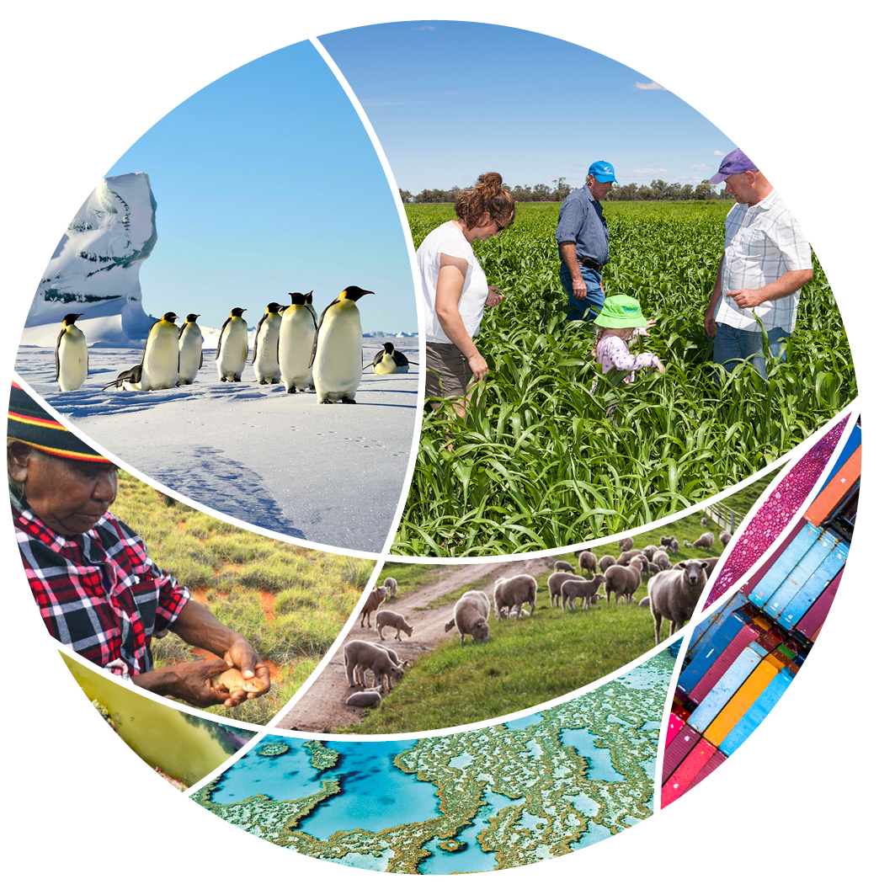

© Commonwealth of Australia 2022

**Ownership of intellectual property rights**

Unless otherwise noted, copyright (and any other intellectual property rights) in this publication is owned by the Commonwealth of Australia (referred to as the Commonwealth).

**Creative Commons licence**

All material in this publication is licensed under a [Creative Commons Attribution 4.0 International Licence](https://creativecommons.org/licenses/by/4.0/legalcode) except content supplied by third parties, logos and the Commonwealth Coat of Arms.

Inquiries about the licence and any use of this document should be emailed to [copyright@awe.gov.au](mailto:copyright@awe.gov.au).



**Cataloguing data**

This publication (and any material sourced from it) should be attributed as: Science Partnerships 2022, *National Environmental Science Program Northern Australia Environmental Resources Hub impacts*, Department of Agriculture, Water and the Environment, Canberra, March. CC BY 4.0.

This publication is available at [awe.gov.au/science-research/nesp](https://www.awe.gov.au/science-research/nesp).

Department of Agriculture, Water and the Environment

GPO Box 858 Canberra ACT 2601

Telephone 1800 900 090

Web [awe.gov.au](https://www.awe.gov.au/)

**Acknowledgements**

The authors thank the National Environmental Science Program (NESP) research hubs for their input. Aboriginal and Torres Strait Islander research partnerships are a valued and respected component of NESP. We acknowledge the Traditional Owners of Country throughout Australia and their continuing connection to Country, land, sea and community. We pay our respects to them, their cultures and to their Elders past, present and emerging.

The Australian Government acting through the Department of Agriculture, Water and the Environment has exercised due care and skill in preparing and compiling the information and data in this publication. Notwithstanding, the Department of Agriculture, Water and the Environment, its employees and advisers disclaim all liability, including liability for negligence and for any loss, damage, injury, expense or cost incurred by any person as a result of accessing, using or relying on any of the information or data in this publication to the maximum extent permitted by law.

Links to external websites are for your information only. They do not represent an endorsement of any website, publication, organisation or product. You are responsible for deciding if information on other sites is accurate, current and reliable. The Australian Government takes no responsibility for the content that you may encounter on any website or in publications on those websites.

Contents

Northern Australia Environmental Resources Hub 1

Supporting Indigenous natural resource management and alternative economies 2

Strengthening and sharing knowledge 2

Keeping Country healthy in Kakadu 2

Fire management and carbon farming 3

Caring for Country and improving lives 3

New approaches for monitoring and communicating about environmental resources 4

Finding finches using eDNA 4

Detecting unwanted visitors 4

Using AI to protect baby turtles 5

Symbols for science communication 5

The importance of northern Australian rivers and their flows 6

Gulf river flows and fisheries 6

Veins of the Country: a story by Mervyn Street 6

Shoring up food supplies for migratory birds 6

Fitzroy River water planning 7

Managing threatened species and threatening processes 8

Modelling, mapping for conservation 8

Knowledge for mine rehabilitation 8

Managing Gamba Grass and fire 9

Managing endangered tropical rainforest 9

## Northern Australia Environmental Resources Hub

The [Northern Australia Environmental Resources Hub](http://www.nespnorthern.edu.au/) is 1 of 6 hubs from the first phase of the [National Environmental Science Program](https://www.awe.gov.au/science-research/nesp) (NESP). It addressed key research questions to deliver practical, on-ground solutions to some of the north’s most complex environmental challenges. Its research is informing planning for sustainable development, supporting communities, and conserving natural and cultural environments.

* NESP funding: $23.88 million
* Host organisation: Charles Darwin University
* Hub Leader: Professor Michael Douglas
* Hub partners: Northern Territory Department of Environment and Natural Resources; North Australian Indigenous Land and Sea Management Alliance Ltd; Griffith University; CSIRO; Queensland Department of Environment and Science; James Cook University; University of Western Australia; Queensland Department of Agriculture and Fisheries; Western Australian Department of Biodiversity, Conservation and Attractions

Key themes:

* Supporting Indigenous natural resource management and alternative economies
* New approaches for monitoring and communicating about environmental resources
* The importance of northern Australian rivers and their flows
* Managing threatened species and threatening processes

Find out more about the [Northern Australia Environmental Resources Hub’s projects](https://www.awe.gov.au/science-research/nesp/current-projects/northern-australia).

## Supporting Indigenous natural resource management and alternative economies

In Australia, Indigenous peoples’ rights and responsibilities for their traditional territories have been recognised across almost half the lands and waters, and traditional custodial responsibility extends across most of the remainder.

Indigenous land and sea managers draw on their knowledge, developed over tens of thousands of years, to make decisions about caring for Country. Working effectively and ethically with Indigenous peoples is central to addressing the nation’s environmental challenges.

The hub is supporting Indigenous natural resource management and development of sustainable business opportunities that benefit Indigenous people and are economically profitable. Indigenous-led guidelines are giving Indigenous peoples a voice about what is best practice in working with their knowledge in collaborative partnerships, and these guidelines are being taken up across Australia.

For example, an Indigenous-led project in Kakadu National Park is mixing responsible artificial intelligence (AI), modern science and traditional knowledge to solve complex environmental management problems.

Improving the methods used to calculate carbon credits for savanna burning projects can further incentivise emissions reductions and carbon storage, supporting many Indigenous-owned carbon businesses. And research has demonstrated that – in addition to their environmental benefits – Indigenous land and sea management programs are a pathway to Indigenous economic independence and regional development, as well as providing significant wellbeing outcomes.

### Strengthening and sharing knowledge

More than 100 Indigenous contributors created Australia’s first guidelines on how to best strengthen and share Indigenous knowledge in land and sea management. [Our knowledge our way in caring for Country](https://www.nespnorthern.edu.au/impact/strengthening-and-sharing-knowledge-for-land-and-sea-management/) features 23 Indigenous-led, best-practice case studies identifying ways partners can support good knowledge practice through strong partnership agreements, support for cultural governance arrangements, and protocols.

A key takeaway for organisations interested in building partnerships with traditional custodians for land and sea management is to develop genuine partnerships that are founded on respect for Indigenous knowledge, culture and Country.

### Keeping Country healthy in Kakadu

Invasive Para Grass threatens important cultural and ecological values of Nardab floodplains in Kakadu National Park. Hub researchers have [built on long-term collaborations](https://www.nespnorthern.edu.au/impact/keeping-country-healthy-in-kakadu-national-park/) with *Bininj/Mungguy* Traditional Owners in the park to develop and apply *Bininj* indicators of cultural–ecosystem health for the floodplains.

These indicators are being used to identify priority areas for targeted Para Grass control and monitor the effectiveness of treatments. Supported by innovative AI drone technology, rangers can easily survey the floodplains and *Bininj* have been excited to see the rapid recovery of floodplain habitat and the return of traditional foods such as turtles, Magpie Geese and other waterfowl.

### Fire management and carbon farming

Scientists and Traditional Owners have worked together for more than a decade to understand how to best calculate changes in greenhouse gas emissions and carbon storage in savanna landscapes due to changes in fire management.

This [research](https://www.nespnorthern.edu.au/impact/supporting-savanna-fire-management-through-carbon-farming/) has, and continues to, improve these methods used to calculate carbon credits for savanna burning projects, leading to reduced greenhouse gas emissions and increased carbon storage. The credits in turn provide important income for remote Indigenous communities and more incentives for fire management across the north.

### Caring for Country and improving lives

Indigenous land and sea management programs – which include Indigenous ranger, Caring for Country and Indigenous Protected Area programs – have well-documented environmental and ecological benefits.

This [research](https://www.nespnorthern.edu.au/impact/caring-for-country-and-improving-indigenous-lives/) demonstrated that these programs also deliver significant socio-economic and wellbeing outcomes to Indigenous people and communities beyond those employed by the programs. Moreover, just being involved in this research has had many positive impacts for communities in Western Australia’s Fitzroy River valley and north Queensland, including positive impacts for land management.

## New approaches for monitoring and communicating about environmental resources

Northern Australia is a unique place. Its heat, seasonal inaccessibility and sheer scale mean that new monitoring approaches are necessary to know where in these vast landscapes to safely and efficiently focus monitoring and management efforts.

The hub has developed new approaches to better detect threatened or invasive species. Researchers have successfully developed an eDNA (environmental DNA) test to detect the endangered Gouldian Finch at waterholes where the birds drink and bathe. An eDNA test for Cane Toads has also been developed that can detect this invasive species if it’s visited a waterhole for as little as 5 minutes. An eDNA test for the aquatic weed Cabomba is also protecting the quality of Darwin’s drinking water supply.

From waterholes to the air, hub research has also been combining the power of Microsoft AI and cloud computing with Indigenous knowledge to monitor and protect sea turtle nests from feral pigs, helping more baby turtles reach the ocean.

Communicating these discoveries is critical in ensuring broad uptake of these methods, and a new set of publicly available graphical symbols – including a Gouldian Finch, Cane Toad and feral pig – is being used to better tell the research stories of northern Australia.

### Finding finches using eDNA

Hub researchers have developed an [eDNA test](https://www.nespnorthern.edu.au/impact/finding-finches-using-edna-to-track-endangered-birds/) for the Gouldian Finch – a first for an endangered bird species. Gouldian Finches live in small and mobile groups and are difficult to find using standard survey methods.

The test allows the finches to be detected from water samples collected from the small pools where they drink, and the Northern Territory Government is using the test in their regional surveys that provide baseline information for proposed development activities and in their collaborative monitoring of the finches with Jawoyn Rangers in the Katherine region.

### Detecting unwanted visitors

An eDNA test [developed by hub researchers](https://www.nespnorthern.edu.au/impact/a-giant-leap-forward-in-detecting-unwanted-visitors/), can tell if invasive Cane Toads have visited a waterhole for as little as 5 minutes – an important early warning in places they are yet to invade. An eDNA test for the aquatic weed Cabomba is also allowing weed managers to monitor Darwin’s drinking water supply for this pest that can choke waterways and degrade water quality.

The power of eDNA methods means that cryptic or uncommon organisms can be detected without being directly observed, and water bodies can be sampled quickly and safely to minimise risks to those monitoring invasive threats across northern Australia.

### Using AI to protect baby turtles

Indigenous knowledge and artificial intelligence are helping protect baby turtles from predators on Cape York. Sea turtle nests are particularly vulnerable to predation by feral pigs, and a [partnership](https://www.nespnorthern.edu.au/impact/using-ai-to-protect-baby-turtles-from-feral-pigs/) between CSIRO, Aak Puul Ngantam Cape York and Microsoft has given Indigenous rangers a helping hand in analysing tens of thousands of images of Cape York coastline. This analysis is guiding where to focus their nest protection and predator management activities.

What used to take 1 month of difficult on-ground work can now be achieved in hours. This is increasing the chances of survival for these threatened and culturally important species.

### Symbols for science communication

A free collection of more than [100 graphical symbols](https://www.nespnorthern.edu.au/impact/engagement-is-a-two-way-street-creating-symbols-for-science-communication/) has been developed to better represent northern Australia in science communication products. Initially conceived and developed for use by hub research projects – where the symbols are effectively delivering research messages to key partners and research-users – they have also been released publicly and are being taken up in diverse fields and in exciting and unexpected ways.

The range and diversity of symbols, including plants, animals, people, land uses, livelihoods and aspirations, are fostering inclusive 2-way communication, and better representing the landscapes and stories unique to northern Australia.

## The importance of northern Australian rivers and their flows

River flows in northern Australia support healthy ecosystems that provide a wealth of economic, social and cultural goods and services such as fisheries, recreation and tourism attractions, bush tucker, clean water, fertile floodplains, biodiversity, connections to Country and more. Understanding the links between river flows and healthy ecosystems is critical to determining how much water is needed to maintain these goods and services.

The hub is demonstrating the immense value and significance of Australia’s tropical rivers.

River flows to the Gulf of Carpentaria sustain commercially important prawn and barramundi fisheries and nourish threatened shorebirds on their long annual migrations.

Indigenous peoples’ valued relationships with Western Australia’s Fitzroy River, along with new knowledge of environmental water needs, are informing a series of principles that are being developed for water planning and management to guide sustainable water use in the region. And in a powerful short film from WA’s Kimberley region, senior Gooniyandi artist Mervyn Street has shared the vital significance of the Warlibiddi and Martuwarra (Margaret and Fitzroy rivers) to Country and people’s lives through his art and storytelling.

### Gulf river flows and fisheries

River flows to the Gulf of Carpentaria are an essential part of the lifecycle of numerous important fishery species, particularly prawns and barramundi. Hub research has built on long-term partnerships with these fisheries to [improve understanding](https://www.nespnorthern.edu.au/impact/what-a-catch-understanding-links-between-gulf-river-flows-and-fisheries/) of the possible impacts on these fisheries of water extraction from Gulf rivers.

This research is not just supporting good fisheries management, it’s also highlighting the water needs of the region’s aquatic biodiversity to ensure that water planners can make informed decisions about future water development in the region.

### Veins of the Country: a story by Mervyn Street

In the face of growing interest in the waters of the Warlibiddi and Martuwarra (Margaret and Fitzroy rivers) in north-west Western Australia, hub researchers partnered with Traditional Owners to increase our understanding of the rivers’ important cultural and environmental requirements.

In this [short film](https://www.nespnorthern.edu.au/publications/veins-of-the-country-video), senior Gooniyandi artist Mervyn Street shares his art and storytelling about the waters of the Warlibiddi and Martuwarra, and the waters’ vital significance to Country and people’s lives. Mervyn hopes it will help viewers understand the importance of the Warlibiddi and Martuwarra waters to not only sustain life, but also enable social connections and sustain culture for future generations.

### Shoring up food supplies for migratory birds

River flows in the Gulf of Carpentaria are critical for ensuring that food is available for migratory shorebirds on their long annual migrations between Australia and the far northern hemisphere.

Collaborative research has revealed how important the animals living in the mudflats and sandflats are as a [food source for sustaining shorebirds](https://www.nespnorthern.edu.au/impact/shoring-up-food-supplies-for-migratory-birds/) in the Gulf of Carpentaria. This research is supporting Australia’s commitments to protecting migratory shorebirds and their habitats and informing upstream water development in these catchments.

### Fitzroy River water planning

The mighty National Heritage-listed Fitzroy River in the west Kimberley has the largest flow of any river in Western Australia. With increasing interest in irrigated agriculture in the region, hub research is increasing knowledge of the important environmental and cultural [water requirements of the river](https://www.nespnorthern.edu.au/impact/a-transdisciplinary-approach-to-was-fitzroy-river-water-planning/), working in partnership with Fitzroy River Traditional Owners.

Principles being developed for water planning and management will be used to guide sustainable water use to maintain critical ecological processes and Indigenous peoples’ valued relationships with the river and its billabongs, floodplains and groundwater.

## Managing threatened species and threatening processes

Northern Australia is rugged, remote and sparsely populated – a good thing for ecosystems and biodiversity. But the sheer vastness of the region makes it challenging to understand, quantify and manage threatened species and threatening processes. For management of species and habitats to be targeted and effective, we need to know where they are and how they respond to these threatening processes.

The hub is supporting better development decisions and informing management by producing high-resolution maps of threatened species and habitats – such as Northern Quolls and tropical littoral rainforest – and threatening processes such as invasive Gamba Grass and altered fire regimes.

It’s not enough just to know where the species, habitats and threats are. Understanding the impacts of threatening processes can support targeted management and mitigation actions.

Hub research has shown it is possible to break the destructive Gamba Grass–fire cycle and create an alternative ecosystem trajectory towards restoration. Understanding how salty mine wastewater might affect nearby freshwater ecosystems will inform the rehabilitation of Ranger uranium mine, which is adjacent to the World Heritage- and Ramsar-listed Kakadu National Park.

### Modelling, mapping for conservation

This [successful collaboration](https://www.nespnorthern.edu.au/impact/modelling-and-mapping-for-conservation-outcomes-across-the-north/) between researchers and government responded to increasing calls for agricultural expansion and other development across northern Australia by generating over 1,500 maps of ‘conservation concern’ species, threatening processes and species’ vulnerability to threatening processes.

These maps are already being used in development and conservation planning and prioritisations through protected area evaluation and investment, strategic regional assessments, catchment-level development guidance, land rehabilitation and several research projects.

### Knowledge for mine rehabilitation

How do you restore the site condition of a former uranium mine? Hub researchers are [tackling this restoration challenge](https://www.nespnorthern.edu.au/impact/filling-knowledge-gaps-for-the-rehabilitation-of-ranger-uranium-mine/) at Ranger uranium mine, producing new knowledge about the possible impacts on fish and riparian vegetation from potential leachate into creeks, and developing guidelines and targets for the return of local native fauna to the site.

The Australian Government’s Supervising Scientist Branch will use this research to inform its impact assessments and develop rehabilitation strategies at the Ranger mine, with guidelines and standards that are transferable to other hard rock mine rehabilitation sites across northern Australia.

### Managing Gamba Grass and fire

Invasive Gamba Grass is transforming Australia’s northern savannas, replacing native species with a dense stand of highly flammable grass that burns with up to 8 times the intensity of native grasses.

Hub research is [helping the rangers](https://www.nespnorthern.edu.au/impact/new-ways-to-manage-gamba-grass-fire-in-mary-river-national-park-nt/) at Mary River National Park in the Northern Territory turn this invasion around, through supporting adaptive management activities and documenting the effectiveness of these in reducing fire frequency. These management changes are enabling the regeneration of the native savanna woodlands in areas formerly infested with Gamba Grass.

### Managing endangered tropical rainforest

This [research](https://www.nespnorthern.edu.au/impact/managing-north-queenslands-endangered-tropical-littoral-rainforest/) produced fine-scale maps of the current distribution of critically endangered littoral rainforest in Queensland’s Wet Tropics. It also produced overlay maps showing potential flooding associated with climate change and severe storms. This research has informed the recovery plan for this ecological community, and state and local governments are using the mapping. The overlay maps have significantly improved understanding of the threats to littoral rainforest from sea-level rise, storm surge and extreme weather events, and are being used, along with the base mapping, to improve policy, planning and on-ground action to better protect and manage this unique forest.