# Knowledge brokering and communications strategy

National Environmental Science Program

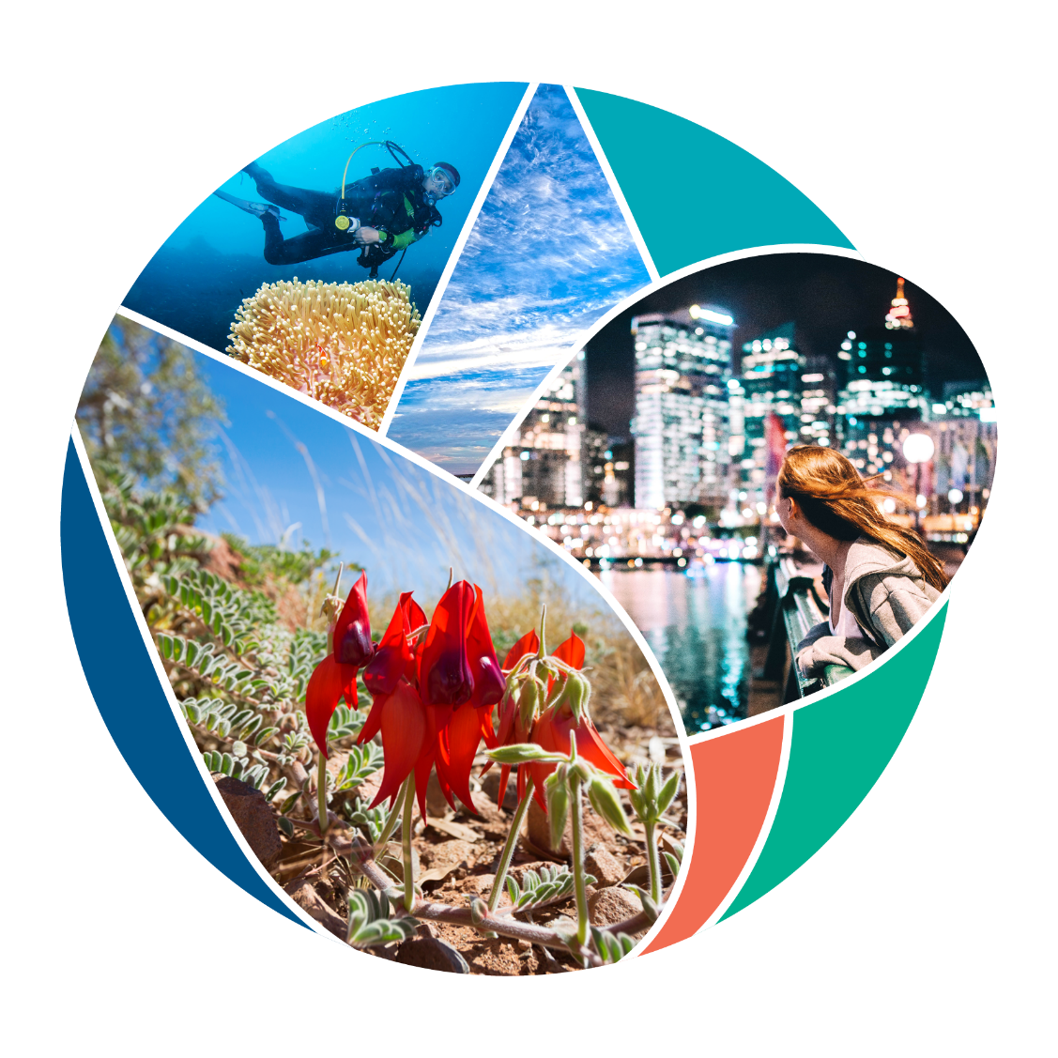

© Commonwealth of Australia 2021

**Ownership of intellectual property rights**

Unless otherwise noted, copyright (and any other intellectual property rights) in this publication is owned by the Commonwealth of Australia (referred to as the Commonwealth).

**Creative Commons licence**

All material in this publication is licensed under a [Creative Commons Attribution 4.0 International Licence](https://creativecommons.org/licenses/by/4.0/legalcode) except content supplied by third parties, logos and the Commonwealth Coat of Arms.

Inquiries about the licence and any use of this document should be emailed to [copyright@awe.gov.au](mailto:copyright@awe.gov.au).



**Cataloguing data**

This publication (and any material sourced from it) should be attributed as: National Environmental Science Program 2021, Knowledge brokering and communications strategy, Department of Agriculture, Water and the Environment, Canberra, March. CC BY 4.0.

ISBN 978-1-76003-408-5

This publication is available at [environment.gov.au/science/nesp](https://www.environment.gov.au/science/nesp).

Department of Agriculture, Water and the Environment

GPO Box 858 Canberra ACT 2601

Telephone 1800 900 090

Web [awe.gov.au](https://www.awe.gov.au/)

**Disclaimer**

The Australian Government acting through the Department of Agriculture, Water and the Environment has exercised due care and skill in preparing and compiling the information and data in this publication. Notwithstanding, the Department of Agriculture, Water and the Environment, its employees and advisers disclaim all liability, including liability for negligence and for any loss, damage, injury, expense or cost incurred by any person as a result of accessing, using or relying on any of the information or data in this publication to the maximum extent permitted by law.

**Acknowledgements**

The authors thank the National Environmental Science Program research hubs for their input.

**Document control**

| Version | Date of issue | Author | Reason for change |
| --- | --- | --- | --- |
| 1.0 | February 2021 | Science Partnerships | First draft |
| 2.0 | April 2021 | Science Partnerships | Include hub input |

Contents

Acknowledgement of Country 1

Background 2

Strategy aims 3

Communication objectives 3

Audiences 4

Communication approach 5

Key messages 6

Knowledge-brokering goals 8

Knowledge brokering and communication strategies 9

Monitoring and evaluation 10

Related materials 11

## Acknowledgement of Country

We acknowledge the Traditional Owners of Country throughout Australia and their continuing connection to land, sea and community.

We pay our respects to them and their cultures and to their elders past, present and emerging.

Our Indigenous research partnerships are a valued and respected component of National Environmental Science Program (NESP) research.

## Background

The National Environmental Science Program (NESP) is the Australian Government’s enduring commitment to environment and climate research. We manage the program on behalf of the Australian Government.

Our targeted research provides an evidence base for environmental decision-makers and climate policymakers. Informed decision-making using the best research greatly improves our chances of protecting our environment, conserving our biodiversity and developing climate policies and services. The Australian Government invested more than $145 million in NESP from 2014–15 to 2020–21. This funded 6 research hubs, which are due to produce research until mid-2021:

* Clean Air and Urban Landscapes Hub
* Earth Systems and Climate Change Hub
* Marine Biodiversity Hub
* Northern Australia Environmental Resources Hub
* Threatened Species Recovery Hub
* Tropical Water Quality Hub.

This initial investment also funded emerging priority research over the lifetime of the program. Research funded by the program has helped deliver many environmental outcomes. The high-level outcomes are showcased in the 2020 Outcomes report.

In early 2020 the Minister for the Environment, the Hon. Sussan Ley MP, announced a further $149 million investment for the program over the next 7 years (2020–21 to 2026–27). This funds targeted research through 4 new hubs:

* Climate Systems Hub
* Marine and Coastal Hub
* Resilient Landscapes Hub
* Sustainable Communities and Waste Hub.

Hubs have national capability, but deliver through regional nodes, where appropriate. Each hub also conducts research to support cross-cutting initiatives that focus on management options for:

* climate adaptation
* protected places
* threatened and migratory species and ecological communities
* waste.

A key focus for the second phase of the program is closer engagement with research end-users early in the program design, capturing and responding to their research needs. Hub liaison officers and hubs should work with end-users to embed NESP research into policy-making. The program also links hub outcomes to the overarching NESP narrative, and those of the cross-cutting initiatives. This must be managed from the outset of the second phase by using consistent engagement with stakeholders, messaging, branding and templates provided by the department.

Program impacts are only possible with effective partnerships, communication and brokering between researchers, decision-makers, and other key stakeholders. Buy-in and adoption of this communication approach is needed by end-users and hubs. To this end, hubs are required to build the overarching program communication narrative and objectives into their own strategies and tactics.

### Strategy aims

NESP aims to inform environmental and climate decision-making by funding research to address national science and research priorities in environmental change.

The success of the program hinges on the ability of decision-makers to articulate their needs to researchers; the quality and usefulness of the outcome-focused research outputs; and how effectively the outputs are communicated to their intended end-users.

In implementing this strategy, we ensure alignment with the broader departmental *Science strategic action plan* and activities of the Climate Adaptation and Resilience Division.

The NESP knowledge brokering and communications strategy has been developed to inform the program, but should be reviewed annually to ensure it aligns with current departmental and program priorities.

### Communication objectives

This strategy supports the closure of the first phase (2014–15 to 2020–21) and positions the communication approach for the second phase of the program (2020–21 to 2026–27).

The communication objectives are to (in priority order):

1. engage end-users in the design, development and implementation of NESP-funded research and its outputs, enabling and encouraging uptake and use to inform policy development and environmental management
2. make NESP-funded research findings and products available, discoverable and searchable
3. highlight how NESP is helping achieve Australian Government environmental priorities through applied research and informed decisions
4. raise awareness of the work of the 4 new hubs and their cross-cutting initiatives.

## Audiences

We have a diverse audience for our program’s communication activities and products (Table 1).

Table 1 Program audiences

| Government | Primary | Secondary |
| --- | --- | --- |
| * Ministers’ offices * Department staff * State/territory and local governments, and natural resource management regional managers * Other Commonwealth agencies | * Hubs * Policy-makers * Universities, research organisations, scientists and researchers * Indigenous land and sea managers * Industry including environmental, agricultural and/or financial sectors * General public | * Environment non-government organisations (NGOs) * Other portfolio ministers |

## Communication approach

Communication activities are tailored according to each stage of the program:

1. Closure – wrapping up the existing hubs from the first phase of NESP
2. Continuing program – encouraging development of partnerships and uptake of research, and highlighting hub projects, their outcomes and ‘good news’ stories.

Each phase may use a mix of existing departmental channels and products (Table 2).

Table 2 Communication channels

|  |  |
| --- | --- |
| Internal | External |
| * *Secretary’s Newsletter* * Intranet page updates * Events/conferences (for example, National Science Week, Outlook) * Talking points/PowerPoint slides * In AWE articles * Science Network | * NESP News * department’s website * Social media posts, including with engaging images/videos using existing footage that shows on-the-ground work (not talking heads) * Media releases/op-eds/articles (for example, The Conversation) * Events/conferences (for example, Outlook) * Ambassador for the Environment’s social media feeds (including to reach international NGOs) * Articles in other departmental newsletters and web platforms (for example, *Water Matters*, *Biosecurity Matters*, Threatened Species Commissioner, National Landcare Program, Parks Australia) * Earned and targeted media placements (for example, by pitching stories to *Landline* and other science- and industry-based TV programs) * Sponsorship of at least 1 conference or event that is most relevant to each of the priority target audiences and industries * Searchable repository of key research information, outputs and products |

## Key messages

Use the following messages as agreed standard words and themes for communication products:

* The National Environmental Science Program (NESP) is a long-term commitment by the Australian Government. The program funds environmental and climate research.
  + The first phase of NESP invested $145 million from 2014–15 to 2020–21 into 6 research hubs: the Clean Air and Urban Landscapes Hub, the Earth Systems and Climate Change Hub, the Marine Biodiversity Hub, the Threatened Species Recovery Hub, the Northern Australia Environmental Resources Hub and the Tropical Water Quality Hub.
  + The second phase of NESP invests $149 million from 2020–21 to 2026–27 into 4 new research hubs: the Sustainable Communities and Waste Hub, the Climate Systems Hub, the Marine and Coastal Hub, and the Resilient Landscapes Hub.
  + The hubs deliver world-class, practical, evidence-based research to inform decisions. This research is developed in partnership with local communities to sustainably manage the environment.
  + The hubs bring together leading scientists to work with local communities, government and industry to deliver applied environmental science. This investment helps build adaptation capacity and resilience in our natural environment and communities.
  + The second phase of NESP builds on the foundations of past work.
* NESP research hubs deliver world-class research to help ensure we care for Australia’s environment based on the best scientific evidence.
  + NESP research has real impact through the partnerships and collaboration between policymakers and researchers to deliver proven outcomes.
  + NESP projects deliver collaborative, practical and applied research to inform decision-making and on-ground action.
  + Environmental and agricultural decision-makers are key partners and are encouraged to articulate their needs to researchers; provide feedback on the quality and usefulness of the research outputs; and be engaged in the communication of how this information has informed policy.
* NESP research listens to and prioritises the research needs of Indigenous land and sea managers, weaves together Indigenous and western environmental knowledge systems and celebrates Indigenous-led approaches to strengthening and sharing knowledge.
  + Indigenous partnerships and a deep respect for traditional knowledge are embedded into the program. NESP deepens our shared leadership role in looking after Country and meeting our mutual aspirations for the future.
  + NESP addresses Indigenous environmental research needs as identified by Traditional Owners and Indigenous communities, and works with Indigenous people to build research capacity.
  + The hubs embed strong cultural capability as a key to working respectfully and effectively with Indigenous custodians and communities to achieve culturally fit-for-purpose, practical research outcomes.
* New and existing NESP research findings are available to use, accessible at Australian Government, new and existing hub websites.
* The environmental science priorities of the NESP – as determined through consultation with end-users and other stakeholders – are to:
  + deliver new climate information to better predict extreme events and guide our interventions to preserve natural assets across Australia
  + build Australia’s climate resilience by synthesising adaptation research across the program
  + provide critical information and management tools to look after our threatened and migratory species, ecological communities, and protected areas including the Great Barrier Reef and Kakadu National Park
  + improve our understanding of the impact of waste material on our communities and natural ecosystems to support action to address this waste
  + help governments understand the implications of planning decisions on the liveability of communities
  + help provide industries with information that supports climate, water and waste management, and the circular economy
  + help Indigenous communities ensure traditional ecological knowledge is incorporated in research that affects communities, land and cultural resources through delivering tangible, practical research co-designed by and for Indigenous communities
  + help scientists develop knowledge, tools, data and products that can inform environmental and climate decision-making by the Australian Government
  + help communities create pathways that enable individual, family and community wellbeing in the environment.

## Knowledge-brokering goals

* NESP enables and facilitates meaningful and efficient engagement between researchers and end-users, including:
  + maximising collaboration across initiatives while minimising duplication of communication activities of hubs and other environmental research investments
  + ensuring that hubs develop and implement knowledge-brokering and communication plans aligned to this strategy and the templates provided by NESP
  + planning for data custodianship and other legacy issues so that NESP outputs are well known and accessible long after the initial funding period.
* NESP projects connect scientists, policy-makers, industries, Indigenous people and communities:
  + NESP scientists work with end-users to co-design research that produces relevant, accessible and effectively communicated outputs, and assists environmental and climate decision-making.
  + NESP works with industries to apply the relevant research and highlight the value delivered for the Australian Government and the portfolio through the government’s investment in practical approaches to environmental challenges.
  + NESP values Indigenous research partnerships and respects traditional knowledge. It works with Traditional Owners and communities to deliver culturally fit-for-purpose research and increase cultural capacity in the environmental research sector. Learning together and incorporating shared knowledge into NESP research provides a range of perspectives and acknowledges First Nation’s peoples’ expertise and continuing connection to land, sea and community.
  + NESP works with communities to reduce the impact of plastic, support climate adaptation and sustainable people-environment interactions, and offer management options for hazardous substances and pollutants through their lifecycle to minimise environmental and human-health impacts.

To achieve these goals, NESP to adhere to the following principles and guidelines:

* the department’s data management framework which refers to the Australian Research Data Commons' (ARDC) Findable, Accessible, Interoperable, Reusable (FAIR) data principles and broader Australian Public Service whole-of-government data principles
* Our knowledge our way in caring for Country: Indigenous-led approaches to strengthening and sharing knowledge for land and sea management
* Three-category approach to guide non-Indigenous researchers and practitioners, and support Indigenous engagement.

Note: Refer to the Related materials section for these principles and guidelines.

## Knowledge brokering and communication strategies

The program’s success is highly dependent on the knowledge sharing between researchers and end-users. To achieve this, the NESP grant opportunity guidelines outline that each hub must commit to the development and implementation of a knowledge brokering strategy and a communication strategy, along with and their implementation. These must be completed within the timeframe specified in the funding agreement’s milestone schedule.

Each hub’s strategy must be consistent with the *NESP knowledge-brokering and communications strategy*. Further information regarding the aims and contents of these strategies are detailed in the hub knowledge brokering strategy and communication strategy templates.

The Science Partnerships team is preparing a communication plan, outlining the specific activities that the department plans to undertake to complement and build upon the work of the hubs, and contribute to achieving this strategy. The team will circulate this plan to hubs to encourage collaboration across NESP.

All NESP-related communication and knowledge-brokering activities and materials must comply with the:

* protocols detailed in the NESP brand standards
* Australian Government style manual.

Note**:** Refer to the Related materials section for the NESP brand standards and Australian Government style manual.

## Monitoring and evaluation

NESP knowledge brokering and communication activities are evaluated in accordance with the NESP monitoring and evaluation plan.

Communication and knowledge brokering activities will be evaluated at the program level every 12 months using the measures and metrics provided in Table 1.

Table 3 Evaluation methods

| Measure | Metric |
| --- | --- |
| Reach | * Media coverage * Social media reach |
| Advocacy | * Public relations (PR) – mentions by research organisations |
| Satisfaction | * Hub sentiment * Media and social media sentiment * Feedback from hub liaison staff * Annual and mid-program review |
| Behaviour | * Research citations * Research partnerships * Social media engagement |
| Engagement and uptake | * Feedback from end-users * Number of articles in internal publications (for example *Secretary’s Newsletter*, *AWEsome Update*, *Business Bulletin*, *In AWE*), MailChimp/NESP News click-throughs, email bounce-backs * Mid-program review survey (Have Your Say) |

For example, for media coverage:

* Media **monitoring −** occurs each day, including a Google Alert set up for the words ’National Environmental Science Program’
* **Evaluation** – occurs via the Isentia media portal, from which NESP-related articles (including social media) are exported monthly
* **Reporting** – occurs every 12 months through examination of the number of media and social media articles and the type of engagement (positive, negative, neutral)
* **Improvement –** is facilitated by 12-monthly retrospective analysis to encourage proactive media engagements.

## Related materials

The following related materials provide guidance for the development of communication products and are available on the internet:

* [ARDC's FAIR data principles](https://ardc.edu.au/resources/working-with-data/fair-data/)
* [Australian Government branding – guidelines on the use of the Australian Government logo by Australian government departments and agencies](https://www.pmc.gov.au/resource-centre/government/australian-government-branding-guidelines-use-australian-government-logo-australian-government-departments-and-agencies)
* [Australian Government public data policy statement](https://apo.org.au/node/61042)
* [Australian Government style manual](https://www.dta.gov.au/our-projects/australian-government-style-manual)
* [Australia’s science and research priorities](https://www.industry.gov.au/data-and-publications/science-and-research-priorities)
* [Indigenous collaboration for Australia’s environmental science](https://www.environment.gov.au/science/nesp/publications/indigenous-collaboration-australia-environmental-science-brochure)
* [NRM monitoring, evaluation, reporting and improvement (MERI) framework](http://nrm.gov.au/my-project/monitoring-and-reporting)
* [NESP brand standards](https://www.environment.gov.au/science/nesp/about)
* [NESP data and information guidelines](https://www.environment.gov.au/science/nesp/about)
* [NESP grant opportunity guidelines](https://www.environment.gov.au/science/nesp/about)
* [Our knowledge, our way in caring for Country: Indigenous-led approaches to strengthening and sharing knowledge for land and sea management](https://www.csiro.au/en/Research/LWF/Areas/Pathways/Sustainable-Indigenous/Our-Knowledge-Our-Way)
* [Three-category approach workbook](https://nespurban.edu.au/3-category-workbook/#:~:text=The%20new%20Three%2DCategory%20Approach,their%20work%20and%20research%20approach.).