National Environmental Science Program Outcomes 2020
Science Partnerships
Climate Adaptation and Resilience Division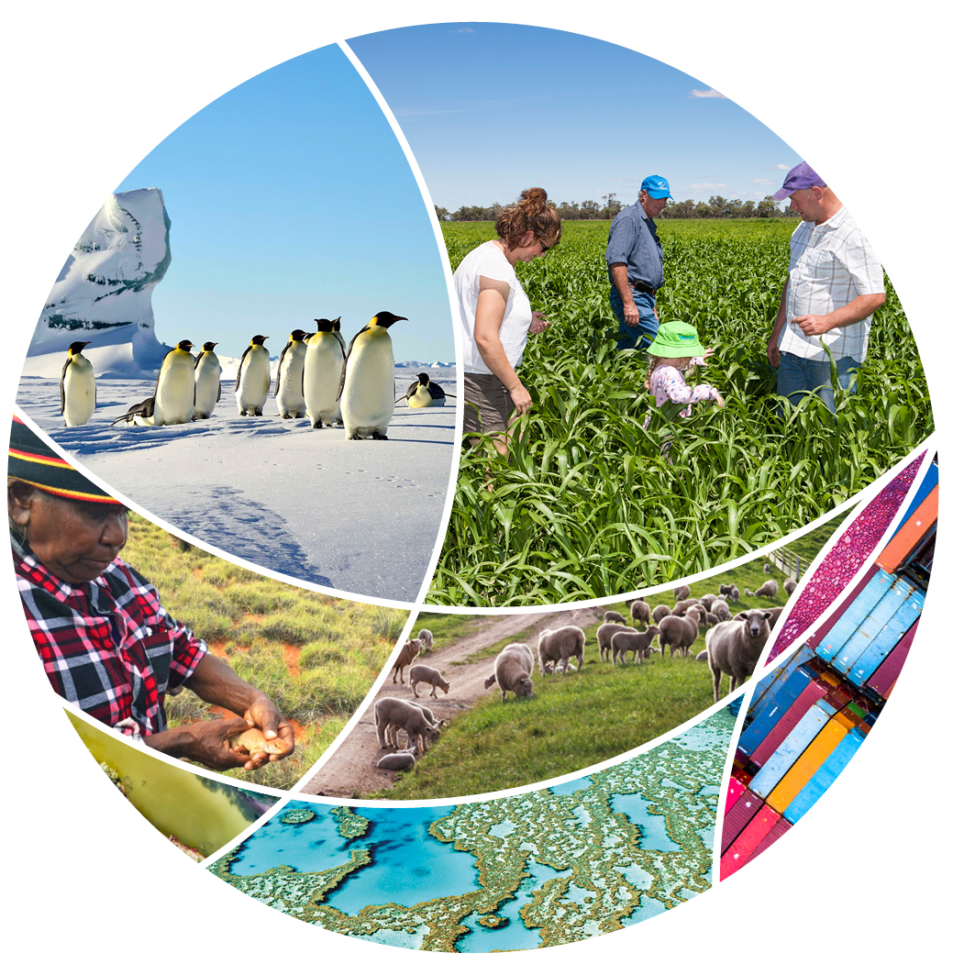
© Commonwealth of Australia 2020
Ownership of intellectual property rights
Unless otherwise noted, copyright (and any other intellectual property rights) in this publication is owned by the Commonwealth of Australia (referred to as the Commonwealth).
Creative Commons licence
All material in this publication is licensed under a Creative Commons Attribution 4.0 International Licence except content supplied by third parties, logos and the Commonwealth Coat of Arms.
Inquiries about the licence and any use of this document should be emailed to copyright@awe.gov.au.

Cataloguing data
This publication (and any material sourced from it) should be attributed as: Science Partnerships 2020, National Environmental Science Program Outcomes 2020, Department of Agriculture, Water and the Environment, Canberra, June. CC BY 4.0.
ISBN 978-1-76003-289-0
This publication is available at environment.gov.au/science/nesp.
Department of Agriculture, Water and the Environment
GPO Box 858 Canberra ACT 2601
Telephone 1800 900 090
Web awe.gov.au
The Australian Government acting through the Department of Agriculture, Water and the Environment has exercised due care and skill in preparing and compiling the information and data in this publication. Notwithstanding, the Department of Agriculture, Water and the Environment, its employees and advisers disclaim all liability, including liability for negligence and for any loss, damage, injury, expense or cost incurred by any person as a result of accessing, using or relying on any of the information or data in this publication to the maximum extent permitted by law.
Acknowledgements
The authors thank the National Environmental Science Program Research Hubs for their input.

Foreword from the Minister
The National Environmental Science Program (NESP) is generating new ideas and practical applications that impact every aspect of our environment, from the preservation of our unique wildlife and protected places to improving the quality of life in our cities. The work of NESP scientists is informing public policy and environmental regulation, along with our ability to plan for and adapt to a climate that is already changing.
The newly published National Environmental Science Program Outcomes 2020 showcases the latest multi-disciplinary research and innovative partnerships across the 6 research hubs.
Over the last 5 years the program has fostered collaborations between Australia's Traditional Owners which are seeing knowledge passed down through the world's oldest living cultural and ecological systems, combined with the latest scientific discovery and artificial intelligence technologies. The result is a shared management of country and culture. NESP has also used technology to understand people's values and attitudes to the Great Barrier Reef, as well as developed on-farm tools to improve water quality and help manage this iconic natural wonder.
I look forward to seeing the amazing outcomes the National Environmental Science Program will continue to deliver for our environment.
The Hon. Sussan Ley MP

Contents
Foreword from the Minister iii
About the program 1
Investment 1
Portfolio outcomes 1
Developing Indigenous partnerships 2
Outcomes spotlight: Indigenous partnerships 2
Outcomes snapshots: Indigenous collaboration 2
Outcomes showcase: Reef restoration and Crown-of-Thorns Starfish control 3
Investigating emerging priorities 5
Investment 5
Outcomes snapshots: Emerging priorities 5
Outcomes spotlights 6
Outcomes spotlight: Partnerships for protected places 6
Outcomes spotlight: Supporting climate resilience 6
Outcomes spotlight: Providing on-farm information 7
Outcomes spotlight: Reducing the impact of feral pests on native wildlife 7
Outcomes spotlight: Protecting important ecosystems 8
Current research hubs 9
Outcomes spotlight: Cross-hub collaboration 9
Future program 11
Investment 11
Future hubs 11
Program missions 12

.

About the program

Investment
The National Environmental Science Program (NESP) is a long-term commitment by the Australian Government to environment and climate research.
The program builds on its predecessors—the National Environmental Research Program and the Australian Climate Change Science Programme—to support decision-makers to understand, manage and conserve Australia's environment with the best available information, based on world-class science.
NESP funding of $145 million over 6 years from 2015 to 2021 supports 6 themed research hubs. A further $149 million will be invested over the next 6 years into 4 new hubs.

Portfolio outcomes
Across the Agriculture, Water and Environment portfolio NESP delivers research that values partnerships that bring scientists together with Traditional Owners, land managers, policy makers, and a range of government and non-government organisations.
This report focuses on just some of the key program achievements. There are over 800 research reports available on-line that showcase the breadth and depth of research achieved. Here, we highlight a few of the key areas of partnership, impact and outcomes, including:
- developing Indigenous partnerships
- investigating emerging priorities
- supporting climate resilience
- providing on-farm information
- tackling feral pests
- protecting important ecosystems
- showcasing the valuable work of each hub.

Developing Indigenous partnerships
For thousands of years Indigenous knowledge systems have formed and shaped Australia's environment: a resource-rich landscape offering an abundance of food, shelter and water. Indigenous knowledge systems are holistic and value the connection of all things. This means that knowledge is relational. Knowledge is produced and shared through relationships between people, place and all living creatures. (words adapted from Clean Air and Urban Landscapes Hub (2019) Three-Category Approach Workbook, prepared by Jirra Lulla Harvey with Cathy Oke and Libby Porter).
Watch as the Clean Air and Urban Landscape Hub asks the question: what would future cities look like if the design was grounded in traditional Indigenous knowledge.
Through the development of tools like the Indigenous led the Three-Category Approach and Our Knowledge Our Way Guidelines, the program is showing how researchers and practitioners can build relationships with Indigenous experts in similar fields to their own, and with Traditional Owner groups in the regions where they work.
Read more in Indigenous collaboration for Australia's environmental science.

Outcomes spotlight: Indigenous partnerships
Shark Bay, or Gutharraguda (two-waters), is recognised on the World Heritage List as a place of exceptional natural features. The bay's 13 species of temperate and tropical seagrasses provide food and habitat for dugongs, turtles and sharks, as well as many fish species.
The Marine Biodiversity Hub researchers are working with the Malgana people to assist the recovery of seagrasses following the extreme marine heatwave in 2010–11.
Six Malgana Indigenous rangers have completed training in conservation and land management. The ranger program is restoring a sense of belonging, enabling Malgana peoples to reconnect to country and rediscover their lost culture and language.
By combining western science and traditional knowledge to develop appropriate field methods, scientists and Traditional owners are working together, to restore temperate seagrass meadows.
How does fire affect desert country? This is a key question that Karajarri Rangers and Traditional Owners want to understand to help them best manage fire and biodiversity on their 2.4 million hectare Indigenous Protected Area south of Broome. The rangers are working with the Threatened Species Recovery Hub and other partners to answer this question.
We are adding to our understanding of air-quality variations in Western Sydney by combining Indigenous knowledge of local weather patterns with climate data to define a set of weather cycles more relevant to understanding variations in the region's air quality than the 4 European seasons.
This work through the Clean Air and Urban Landscapes Hub, is helping us to better identify the time of the year when cold, still weather conditions result in higher levels of fine particulate matter and other types of air pollution. While the weather cycles identified in this study apply to Western Sydney, the methods behind it can be used anywhere in the world.

Outcomes snapshots: Indigenous collaboration

Co-design and cross-cultural communication for climate change information
There are many benefits for western science by incorporating traditional knowledge to help understand the past and current changes to our climate. The report Co-design, cross-cultural communication and climate change: considerations for engaging with First Nations peoples, produced by the Earth Systems and Climate Change Hub, provides a summary of important considerations for co-designing climate change-related research projects with First Nations peoples.

Techniques to care for sea country
Traditional Owner organisations are partnering with reef scientists from the Tropical Water Quality Hub to implement new reef restoration techniques to care for their sea country. Reef Traditional Owners are being taught innovative reef restoration and monitoring techniques to improve the health of the Great Barrier Reef.

Improving cities for people and for biodiversity
Embedding Indigenous knowledge systems in urban research and practice is an important way to improve cities for people and for biodiversity. The Clean Air and Urban Landscapes Hub has developed a Three-Category Approach toolkit that provides guidance for cross-cultural work with Aboriginal and Torres Strait Islander peoples and organisations. Through a workbook and workshop, the toolkit is changing the way professionals think about and do their work as they come to understand the opportunities of co-designed projects.

Surveying and monitoring the Greater Bilby
The Greater Bilby (Macrotis lagotis) is an iconic Australian marsupial that is known for its conservation significance and high cultural importance to Traditional Owners. The Northern Australia Environmental Resources Hub is working with Traditional Owners, Indigenous rangers and pastoralists to survey and monitor bilbies, refine survey methods, and help build local capacity in these areas to protect bilbies in the West Kimberley region.

Outcomes showcase: Reef restoration and Crown-of-Thorns Starfish control
The Great Barrier Reef is vital to Australia, ecologically and economically, but has experienced dramatic declines in coral cover due to bleaching events, cyclones and ongoing Crown-of-Thorns Starfish outbreaks.
Forty-two per cent of hard coral loss recorded between 1985 and 2012 on the Great Barrier Reef is attributable to Crown-of-Thorns Starfish, and, of the 3 major threats the reef faces, only managing this starfish can directly and immediately reduce coral loss.
Developing an effective and efficient Crown-of-Thorns Starfish management program is vital for the reef. The scale of the problem; however, seemingly swamps the resources available. In such situations management must work smarter, not just harder, using an understanding of the pest species' ecology and of management's capabilities to structure control actions at ecologically meaningful scales.
Youth, many of whom are Reef Traditional Owners, apply cutting-edge starfish control techniques to improve the health of the Great Barrier Reef. The Crown-of-Thorns Starfish Control Program, led by the Great Barrier Reef Marine Park Authority, has reduced starfish damage to environmentally and economically important reefs and supported hundreds of young trainees to gain employment in marine and tourism industries.
A new decision-making framework developed by Tropical Water Quality Hub is underpinning the approach of the expanded control program to protect the reef from outbreaks of the coral-eating starfish. This framework outlines the decision process that guides control operations across the entire program, from divers to individual vessels and the entire control fleet.
Groups operating on the Great Barrier Reef will now be better equipped to care for their sea country after attending a Reef Leadership and Restoration workshop on Orpheus Island (Goolboddi), north of Townsville.

Investigating emerging priorities

Investment
The NESP has an additional budget (on average $420,000 each year) to allow the program to be responsive to the changing needs of environmental decision-makers. These research needs can be identified by the Minister for the Environment, the department or external parties.
Funding recipients contribute at least an equivalent co-investment to the project, with the research required to support the Australian Government and other decision-makers develop evidence-based policy and improve environmental management.
Projects awarded Emerging Priority funding will differ in their nature but must meet the majority of the NESP funding criteria.
This includes aligning with a high priority need for environmental decision-makers that is not being delivered through other mechanisms, contributing the equivalent co-investment, meeting data and accessibility guidelines, as well as building knowledge brokering, communications and Indigenous engagement into projects.

Outcomes snapshots: Emerging priorities

National flying fox monitoring
This project is building reliable population estimates and supporting responsive management of 2 nationally protected flying fox species. The project provides key data for decision making not just for flying-fox conservation and regulation but also to inform responses to public concerns about the impact of flying foxes on industry, amenity and public health.

A national review and proposed action plan for Myrtle Rust
This project addressed the environmental threat posed by the exotic and aggressive fungal plant pathogen Myrtle Rust (Puccinia psidii, known overseas as Eucalyptus Rust). It delivered a comprehensive review of the myrtle rust threat in Australia and a draft Action Plan.

Climate change and bushfire research initiative—Tasmania
This project led to the development of high priority tools and research products to enable protection of the Tasmanian Wilderness World Heritage Area from adverse impacts of wildfire. The findings are presented in the Tasmanian Wilderness World Heritage Area Climate Change and Bushfire Research Initiative final report.

Spatial distribution of marine wildlife in Bremer Bay—Western Australia
This project surveyed marine life across the Bremer region, Western Australia, both inside and adjacent to the Bremer Commonwealth Marine Reserve. Knowledge gained will support Australian Government decision-making to protect the environment and biodiversity and allow for sustainable marine use and prioritise future research.

Outcomes spotlights

Outcomes spotlight: Partnerships for protected places
Partnerships are at the heart of the NESP. The Northern Australia Environmental Resources Hub is combining cutting-edge technology, the wisdom of Traditional Owners, and the skills of leading scientists from many different disciplines, to build an understanding of management challenges from our decision-makers and the views of our communities. The work has created some innovative evidence-based solutions for our complex problems.
One example is the partnering between Microsoft and their high-tech drone and computer technology with the knowledge of Traditional Owners and leading Australian scientists to provide incredible information on how to target the management of weed and pest invasion.
Under the direction of Traditional Owners, artificial intelligence was woven with Indigenous knowledge to provide fast and vast information on where to target the management of para grass weed, which reduces magpie goose habitat. With better weed control, the habitat increased, and the count of magpie geese in one wetland jumped from 50 to 1,800 birds in 9 months.

Outcomes spotlight: Supporting climate resilience
Extreme climate events such as heatwaves, floods and droughts have huge impacts on Australia's communities and natural and economic resources. These events, and the costs associated with their impacts, are likely to increase in a changing climate.
Understanding what causes these extreme events is important for managers of a range of systems, including ecosystems, energy, urban planning and water resources, to allow them to better plan for and respond to current and future extreme events. Earth Systems and Climate Change Hub researchers have been working to better understand current and future changes to extreme events and their causes, with a focus on tropical cyclones, bushfires, thunderstorms, east coast lows and the extreme weather hazards they can produce. Resulting information, data and tools will help to inform planning and management activities to improve Australia's resilience into the future.
Another important focus for hub researchers is advancing the scientific field of 'attribution' of extreme events to determine the factors, including human-induced climate change, behind many events recently experienced in Australia.
The attribution system can be used operationally by weather and climate services, meaning we can get access to information about what has caused an extreme event much more quickly, potentially before an extreme event even occurs.
This project provides a science update on recent research conducted by hub researchers on changing trends in a number of key extreme weather events and hazards for Australia, and how project outputs are being used by stakeholders across a range of Australian sectors.

Outcomes spotlight: Providing on-farm information
NESP Tropical Water Quality Hub supported research has led to the development of a software tool, IrrigWeb, that can be accessed on a PC, tablet or smartphone enabling a farmer to easily and remotely control automated irrigation systems on their property.
This prevents over-watering and helps cut down on excess runoff (which in turn helps reduce sediment, fertiliser and pesticides leaving the farm boundary and entering the Great Barrier Reef) and also saves farmers significant time, effort and money.
By bringing farmers and water quality scientists together, this research is helping the scientists understand what's happening on-farm and design practical tools to leverage irrigation management changes.
The Internet of Things-enabled sensors, will be deployed to connect IrrigWeb's recommended irrigation schedules with infield irrigation systems, so that the irrigation system applies the right amount of irrigation, at the right time, in the right paddock, with minimal fuss to the farmer. By automating irrigation practices, farmers will save money, water, electricity and they will help save the environment too.
Not only is this research enabling farm-level practice change, by mitigating land-based run-off, it will over time improve water quality in the Great Barrier Reef lagoon and can be applied across other regions to help protect Australia's tropical marine ecosystems.
The IrrigWeb computer program, which estimates crop water requirements, is helping farmers. IrrigWeb provides optimal irrigation schedules on a paddock-by-paddock basis by linking information about the sugarcane crop, climate, soils and irrigation management regimes.

Outcomes spotlight: Reducing the impact of feral pests on native wildlife
Cats have contributed to the extinctions of over 20 native mammal species, and continue to imperil over 120 threatened animal species in Australia.
The wildlife of no other continent has been affected by cats as severely as Australia's. Threatened Species Recovery Hub research has greatly increased our understanding of how many feral cats are in Australia, what influences cat density, and what the impacts of cats are on mammals, birds, reptiles, frogs and invertebrates.
The native species that are at greatest risk from cats have been identified, which will help target efforts to protecting these species. Across Australia researchers have also been investigating how to improve existing cat control methods such as baiting, exploring new cat control options (for example, using guardian dogs) and investigating which actions are likely to be most effective or important in different circumstances.
Feral cats and foxes are a major factor in the decline of native species. Australia's new Threatened Mammal Index from the Threatened Species Recovery Hub combines data from almost 1,200 sites across the country to tell us how threatened mammals have fared over the last 20 years and if our management investments are working. Research leader Dr Elisa Bayraktarov from the University of Queensland talks about the findings in this video.
Feral cats pose a serious threat to wildlife on Kangaroo Island. Working with local partners the Australian Government has committed to eradicating cats from the island. Program managers wanted to know if the poison bait 'Eradicat' was suitable for controlling cats in the island's (pre-fire) densely vegetated national parks. To answer this, Threatened Species Recovery Hub researchers undertook a trial of non-toxic 'Eradicat' baits. They found that native animals consumed more than 60% of the baits, suggesting that other cat baits currently being developed may be a better fit for the island.
Learn more about 'Taking the threat out of threatened species.'

Outcomes spotlight: Protecting important ecosystems
The Marine Biodiversity Hub is helping in the conservation and protection of important reef ecosystems.
Elizabeth and Middleton reefs are atoll-like structures associated with the Lord Howe seamount chain. These remote reefs lie within the Lord Howe Marine Park, some 550 kilometres east of Port Macquarie, New South Wales. They are listed as wetlands of international significance under the Ramsar Convention and support unique and diverse tropical, subtropical and temperate marine life.
A deeper knowledge of the area's habitat, biodiversity and ecology, including at mesophotic depths (approximately 80 to 120 metres) is needed to support monitoring and management by Parks Australia. A key challenge is to understand the role of seamount reefs as refuges for coral and other seafloor and pelagic (open ocean) communities in a warming ocean.
Learn more about 'Setting out to survey our southern-most coral reefs'.
A multidisciplinary survey onboard TV Bluefin explored lagoon and shelf areas of the seamount reefs. Robotic underwater vehicles and baited cameras gathered imagery across reef and sediment habitats; divers surveyed the lagoons; and sediment samples were taken to characterise substrate types.
Overall, the survey mapped 86 km² of seafloor revealing complex seabed features, including low profile mounds and ridges colonised by hard corals. Galapagos sharks and black cod—a protected species rarely observed elsewhere—were abundant at both reefs. This new knowledge provides a baseline for monitoring and comparing marine life in different protection zones of Lord Howe Marine Park.
Mapping is the first step in understanding where different animals live on the seafloor and is essential to the management of marine parks. Watch the Seamount Corals Survey 2018, a month long voyage on CSIRO Investigator to map and survey deep-sea coral reefs across an area of underwater seamounts south of Tasmania.

Current research hubs
The 6 NESP hubs deliver collaborative, practical and applied research to inform decision making and on-ground action.
The Clean Air and Urban Landscapes Hub conducts research to support environmental quality in urban areas. Cities are important environments that are home to millions of Australians and wildlife. A key question for this hub is: how can we make cities better for people and for biodiversity?
The Earth Systems and Climate Change Hub conducts research to better understand Australia's past, present and future climate and our climate drivers. The hub is building world-leading climate and Earth systems science capability to supply useful and accessible climate change information for Australia.
The Marine Biodiversity Hub conducts research into Australia's marine environments to build national capacity for monitoring and reporting on coastal and marine species and ecosystems, as well as supporting national approaches to marine planning by delivering research to guide evidence-based decision-making.
The Northern Australia Environmental Resources Hub conducts research to support the sustainable development of Australia's northern environments, to help plan for a sustainable future to support communities and natural and cultural environments through science and knowledge.
The Threatened Species Recovery Hub conducts research to inform and support on-ground responses that reduce threats and promote recovery of threatened species; and build a better understanding of their status, threats and management options.
The Tropical Water Quality Hub conducts research to help guide decisions about managing the Great Barrier Reef. This hub provides innovative research for practical solutions to maintain and improve tropical water quality from catchment to coast.
Hubs also work together on cross-hub collaborations and input to emerging priority projects.

Outcomes spotlight: Cross-hub collaboration
Australia is home to 7% of the world's mangroves, with the majority located in the tropical regions. During the summer of 2015–16, one of the worst mangrove dieback events ever recorded devastated around 7,400 hectares of mangrove forests along more than 1,000 km of Gulf of Carpentaria coastline.
This research is improving understanding of extent, patterns, condition, trend and the recovery of dieback-affected mangroves to inform monitoring and management responses.
This project is providing analysis of the extent and condition of dieback, to examine the extent, patterns, condition, trend and likely cause of dieback, as well as train local Indigenous ranger groups in mangrove assessment and monitoring methods.
This project was developed through collaboration between the:
- Northern Australia Environmental Resources Hub
- Tropical Water Quality Hub
- Marine Biodiversity Hub
- Earth Systems and Climate Change Hub.
The project is led by Professor Norm Duke from James Cook University, in partnership with Indigenous ranger groups in the region.
For more information, visit the Mangrove Research Hub and Australian Mangrove and Saltmarsh Network websites.

Future program

Investment
The Australian Government is investing a further $149 million over the next 6 years in climate and environmental science targeting plastic waste, threatened species, climate systems and a range of key environmental issues. The next program will build on our past achievements through multi-disciplinary and applied research that will be consolidated into 4 hubs and delivered through regional nodes where appropriate.
The next phase of NESP will draw on expertise from organisations, big and small, from all around Australia.
The hubs will be partnerships between organisations that collectively bring together multiple disciplines and multiple viewpoints to form a national capability.
Program guidelines and information are available at the Community Grants Hub.

Future hubs

Climate Systems Hub
This hub will provide fundamental and applied science to inform our understanding of our changing climate. The hub will focus on climate events such as rainfall and drought, heatwaves, fire weather, storms, flood and cyclones in our region. The hub will provide national leadership to support climate information to drive integrated adaptation research across the program to support evidence-based decision-making and improve Australia's climate resilience.

Marine and Coastal Hub
This hub will integrate our national temperate and tropical marine research capacity. It will deliver research on our marine, coastal and estuarine environments and address challenges like how to protect communities from storm damage and sea level rise while maximising opportunities for blue carbon. The hub will provide national leadership to support the management of our protected places and heritage including the national park estate and Ramsar sites in both marine and terrestrial environments.

Resilient Landscapes Hub
This hub will draw together a wide range of expertise to provide advice on increasing the resilience of our natural landscapes and biodiversity at continental, regional and local scales. The hub will provide national leadership on threatened species and will play a crucial role in bushfire preparedness and recovery of biodiversity and habitat.

Sustainable Communities and Waste Hub
This hub will deliver cutting-edge research on how to improve the liveability of our urban and rural environments while delivering critical advice on how to reduce the impact of waste, chemicals and air pollution on the environment, communities and the economy. The hub will provide national leadership to support decision maker policy development, program management and regulatory processes in both marine and terrestrial environments.

Program missions
All hubs will deliver on 4 cross-cutting missions:
- Threatened and migratory species and ecological communities mission: to support policy development by providing information that can assist with program management and regulatory processes to protect Australia's terrestrial, marine and freshwater species, communities and ecosystems.
- Protected place management mission: to help our protected places and heritage including national parks and Ramsar sites through providing key information for on-ground management.
- Waste impact management mission: to provide information that supports decision makers in policy development, program management and regulatory processes.
- Climate adaptation mission: to bring together adaptation research across the NESP that will inform decision-making to help improve Australia's climate resilience.
These missions will bring together scientists, economists, climate experts, Indigenous Australians and natural resource managers across the research portfolio.

