# New EPBC Act Business Portal user guide

Part 1: Access and overview



© Commonwealth of Australia 2022

**Ownership of intellectual property rights**

Unless otherwise noted, copyright (and any other intellectual property rights) in this publication is owned by the Commonwealth of Australia (referred to as the Commonwealth).

**Creative Commons licence**

All material in this publication is licensed under a [Creative Commons Attribution 4.0 International Licence](https://creativecommons.org/licenses/by/4.0/legalcode) except content supplied by third parties, logos and the Commonwealth Coat of Arms.

Inquiries about the licence and any use of this document should be emailed to [copyright@awe.gov.au](mailto:copyright@awe.gov.au).



**Cataloguing data**

This publication (and any material sourced from it) should be attributed as: DAWE 2022, *New EPBC Act Business Portal User Guide Part 1: Access and Overview*, Department of Agriculture, Water and the Environment, Canberra. CC BY 4.0.

ISBN 978-1-76003-542-6

This publication is available at [awe.gov.au/publications](https://www.awe.gov.au/publications).

Department of Agriculture, Water and the Environment

GPO Box 858 Canberra ACT 2601

Telephone 1800 900 090

Web [awe.gov.au](https://www.awe.gov.au/)

**Disclaimer**

The Australian Government acting through the Department of Agriculture, Water and the Environment has exercised due care and skill in preparing and compiling the information and data in this publication. Notwithstanding, the Department of Agriculture, Water and the Environment, its employees and advisers disclaim all liability, including liability for negligence and for any loss, damage, injury, expense or cost incurred by any person as a result of accessing, using or relying on any of the information or data in this publication to the maximum extent permitted by law.

**Acknowledgement of Country**

We acknowledge the Traditional Custodians of Australia and their continuing connection to land and sea, waters, environment and community. We pay our respects to the Traditional Custodians of the lands we live and work on, their culture, and their Elders past and present.

Contents

1 Context 1

1.1 What the document covers 1

1.2 Audience for this guidance document 1

2 Guidance 2

2.1 Accessing the EPBC Act Business Portal 2

2.2 Create an account 3

2.3 Overview of Dashboard 6

**Figures**

Figure 1 Business portal home page 2

Figure 2 EPBC Business portal sign in page 3

Figure 3 EPBC Business portal sign up page 3

Figure 4 Screen shot of verification email with verification code 4

Figure 5 Code verification page 4

Figure 6 Account creation page 5

Figure 7 Dashboard accessible after successful log in 6

Figure 8 Applications and projects dashboards 7

Figure 9 Applications dashboard area 7

Figure 10 Projects dashboard 8

Figure 11 Project summary view 8

Figure 12 Project updates view 9

Figure 13 Project related information 9

## Context

### What the document covers

This document provides guidance on accessing the EPBC Act Business Portal. Part 1 of the guidance documents covers the following aspects:

1. Accessing the Business Portal
2. Creating an account and logging into the Business Portal
3. Accessing the dashboards

For more guidance on how to create and submit a new referral and managing a project, please refer to other guides.

### Audience for this guidance document

This document is for:

* those who submit EPBC Referrals to the Department
* those who are project contacts for EPBC Referrals that are submitted to the Department.

## Guidance

### Accessing the EPBC Act Business Portal

1. The new EPBC Act Business Portal can be accessed [here](https://www.EPBCBusinessPortal.awe.gov.au).
2. Select **Sign in** at the top-right to sign in or create an account.

Figure Business portal home page

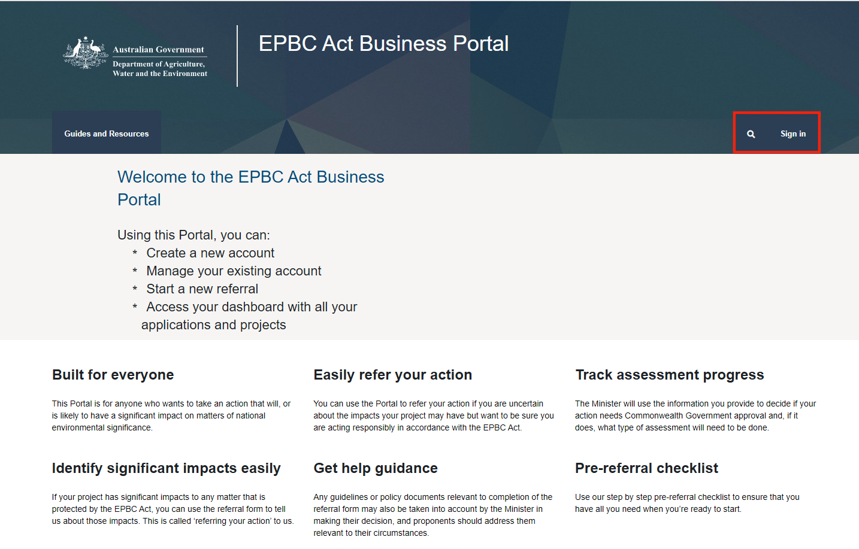

1. If you have an account already, you can enter your email address and password and sign in. If you do not have an account, you can create an account by selecting **Sign up**.

Figure EPBC Business portal sign in page

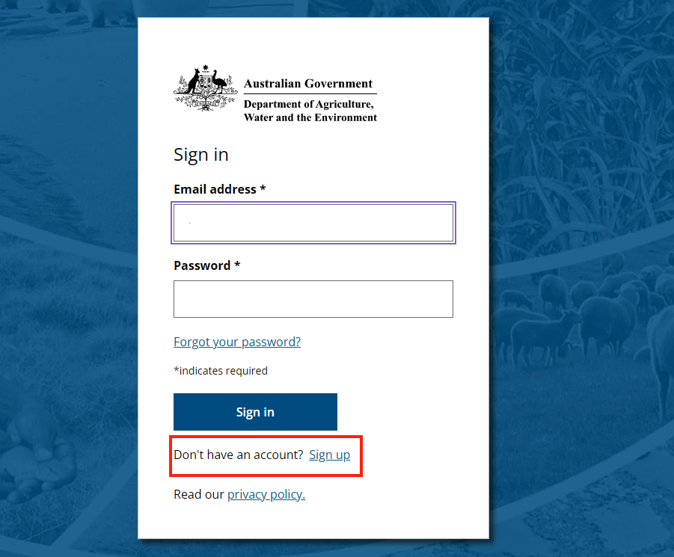

### Create an account

1. When you have selected **Sign up**, you will have to provide your preferred email address. Then select **Send verification code**.

Figure EPBC Business portal sign up page

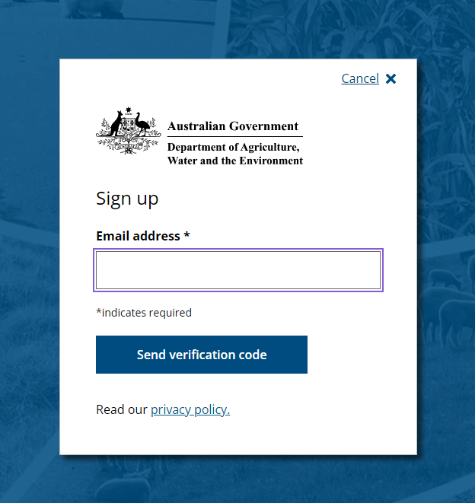

1. A verification code will be sent to the email provided, from the Department of Agriculture Water and the Environment. Please look for an email from [msonlineservicesteam@microsoftonline.com](mailto:msonlineservicesteam@microsoftonline.com)

Figure Screen shot of verification email with verification code

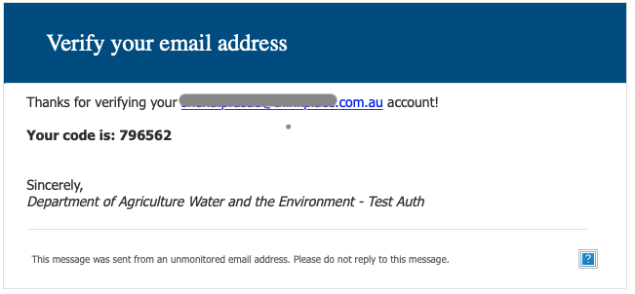

1. Type in the verification code provided and select **Submit.**

Figure Code verification page

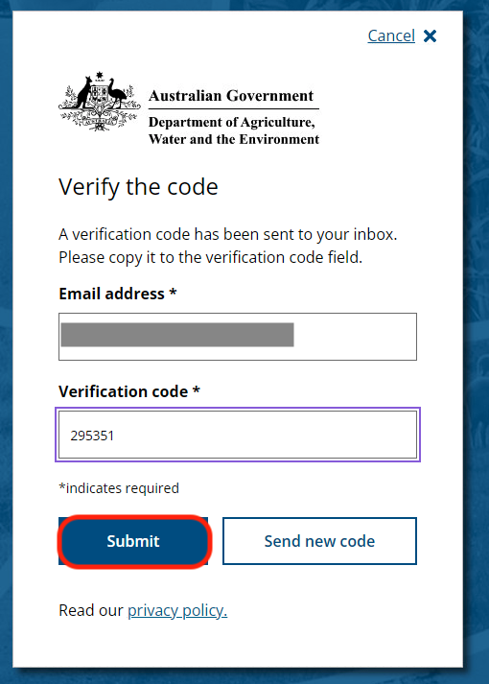

1. Create your account by providing a password, your first name and last name. Select **Create account.**
2. The password must be between 8-64 characters. The password must have at least 3 of the following:

* A lowercase letter
* An uppercase letter
* A digit
* A symbol

Figure Account creation page

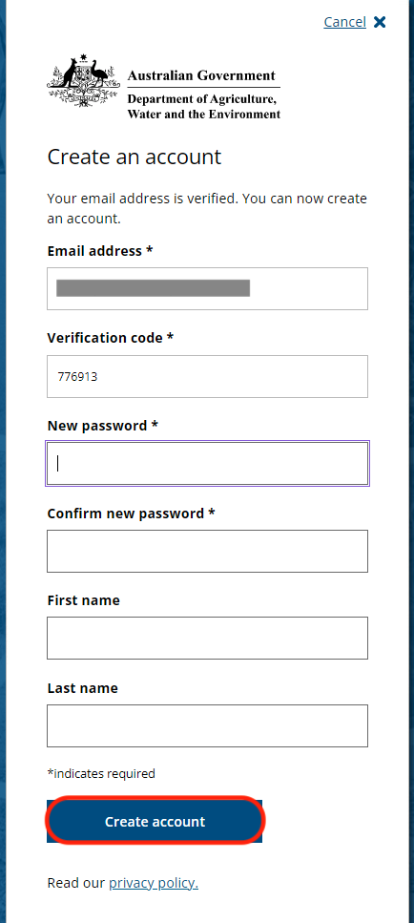

Once you have created an account, you will be able to see the **Dashboard** tab.

Figure Dashboard accessible after successful log in

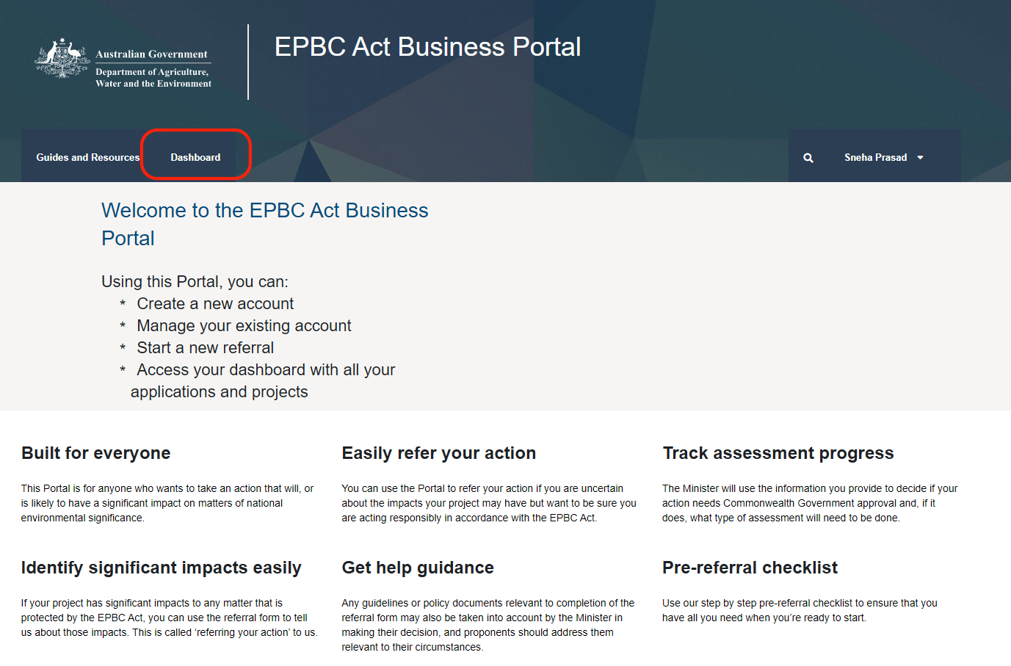

### Overview of Dashboard

When you have successfully signed into your EPBC Business Portal account, you can access the dashboard. The dashboard is the place where you can see your applications and your projects. Please note: You will have immediate access to see new projects you have submitted and existing projects where you are listed as a contact with the same email.

Figure Applications and projects dashboards

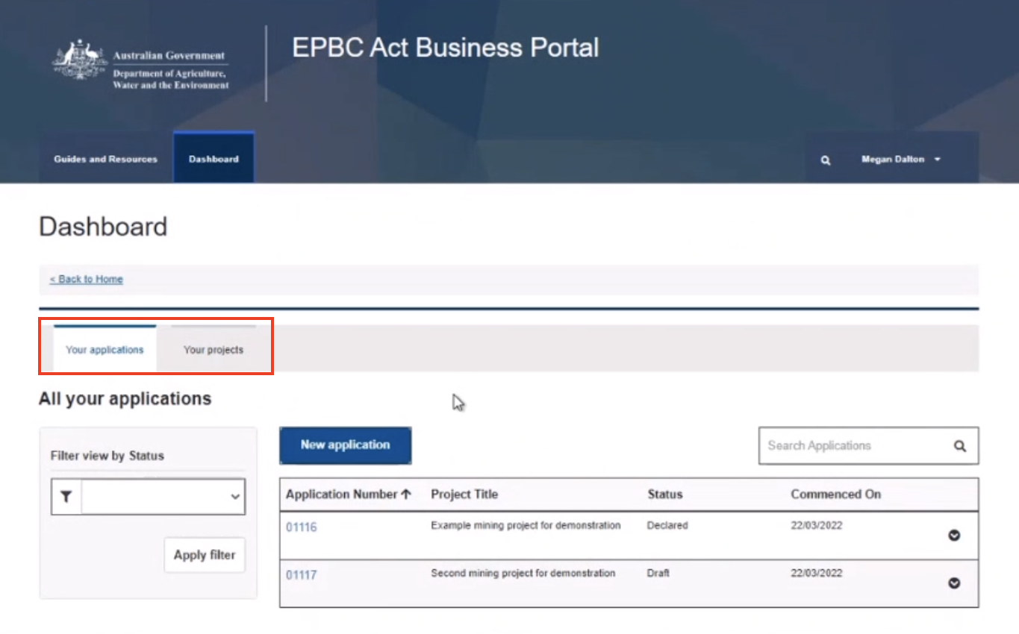

#### The Applications dashboard

The **applications** dashboard area lets you start new referral applications, progress them and submit them to the department. You can also see the progress of any referral applications that you have commenced.

Figure Applications dashboard area

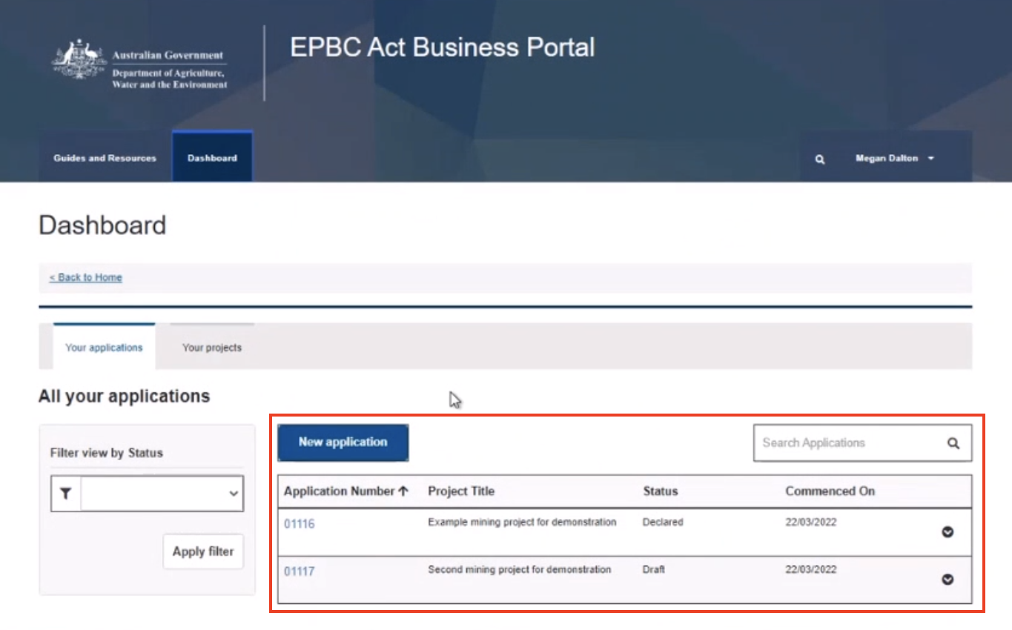

The creation of a new application will be covered in a separate guidance document.

#### The Projects dashboard

This is the dashboard that lets you see every project that has been submitted to the department where you are registered as a project contact. In this dashboard, you will be able to see the general details of the project and a visual indicator of where your project is up to.

Figure Projects dashboard

Screenshot of the Projects dashboard area that shows all projects that have been submitted to the Department where you are enlisted as a project contact.


1. Select a project to see its summary. The summary page shows the project’s name, EPBC number, assigned officer and its current status. There is also a visual indicator to show the progress and status of the project.

Figure Project summary view

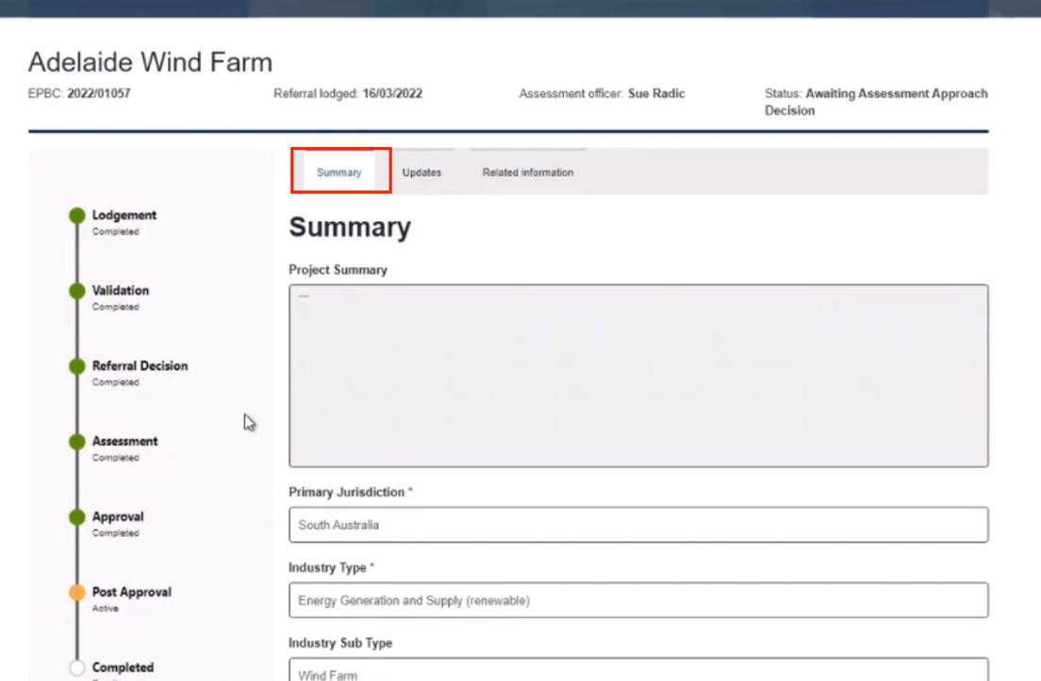

1. Select **Updates** (Figure 12). This view shows all notifications and emails between the project contacts and the Department related to this project.

Figure Project updates view

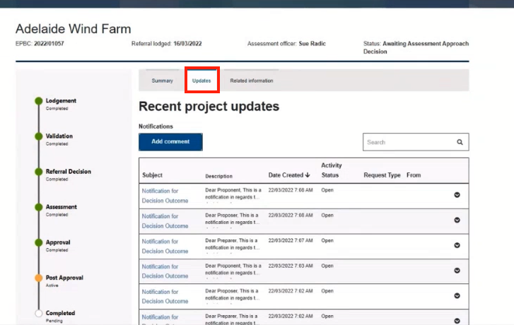

1. Select **Related information** (Figure 13). This is where you will be able to see any links, documents and linked referrals related to the project.

Figure Project related information

